
NATURAL LANGUAGE PROCESSING
Project Title
TRAVEL QUERY INTENT CLASSIFICATION USING NLP
Project ID: NLP-34
Programme | BBA (Artificial Intelligence)
Academic Year | 2026-27
Team Members | 1. Krishnav Rastogi (Team Leader) - PRN: 25030422060  2. Vinayak Goyal - PRN: 25030422133  3. Sakaar Vir Singh - PRN: 25030422104
Faculty | Dr. Nabanita Choudhury, Assistant Professor
SYMBIOSIS ARTIFICIAL INTELLIGENCE INSTITUTE (SAII)
Constituent of Symbiosis International (Deemed University)
Lavale, Pune - 412115

1. Abstract
People describe travel needs in free text: “show me the cheapest fare from boston to denver” asks for a fare, while “which airlines fly from boston to denver” asks for an airline. Recognising this intent is the first step of any travel assistant or booking chatbot. This project builds and evaluates a travel-query intent classifier on the ATIS (Airline Travel Information System) benchmark.
The raw files contain 4,978 training and 893 test queries across 22 and 20 intents. After repeated queries and train/test overlap were removed, 4,623 training and 850 test queries remained. The pipeline runs in Google Colab. It lower-cases and normalises the text, represents it with TF-IDF word unigrams and bigrams, and compares Logistic Regression, a Linear Support Vector Machine (SVM) and Multinomial Naive Bayes using 5-fold stratified cross-validation on the training data only.
The Linear SVM was selected (cross-validation Macro-F1 78.4% ± 3.3%). On the held-out test set it reached 95.4% accuracy (95% bootstrap interval 94.0%–96.7%) and 68.3% Macro-F1 (58.9%–71.4%). A majority-class baseline scores 4.2% Macro-F1.
The gap between accuracy and Macro-F1 comes from strong class imbalance: “flight” is 74.1% of the training data. Several rare intents, and four intents that appear only in the test set, pull Macro-F1 down. Of the 39 mistakes, 32 carry a low decision margin, and most confusions involve the dominant “flight” intent.
A local Streamlit application, Travel NLP Lab Studio, verifies every exported file with SHA-256, recomputes the metrics and explains the results interactively. It includes a live query lab, an autocomplete model and a 3D map of the intents.

2. Introduction

Background and context
Travel companies, airlines and online travel agencies receive large volumes of short customer questions through chat, search boxes and voice assistants. Before a system can answer, it must decide what the traveller is asking for: flight availability, fares, airline information, ground transport, airport details and so on. This task is called intent classification (or intent detection). It is a core component of natural-language understanding (NLU) in task-oriented dialogue systems.
The ATIS corpus [1], collected under the DARPA spoken language systems programme, remains the standard teaching and research benchmark for this task [2]. Its queries are transcribed spoken requests to an airline information system, so they are short, informal and unpunctuated.

Motivation for choosing the problem
- Practical relevance: intent detection decides which back-end service (search, pricing, booking) handles a request. A wrong intent produces a confidently wrong answer.
- A realistic NLP challenge: the data is highly imbalanced, several intents share most of their vocabulary (flight vs. airfare vs. flight+airfare), and some queries carry two intents at once.
- Measurability: labelled train/test splits allow honest, reproducible evaluation and a careful error analysis instead of a single headline number.

Role of NLP in the solution
NLP turns free text into a representation a classifier can use. Here the text is normalised, split into word n-grams and weighted with TF-IDF, so that informative words and phrases (“fare”, “which airlines”, “ground transportation”) receive high weight. A linear classifier then learns one weight per n-gram for every intent. The same representation supports explanation: the largest weights show which words drive each decision. The dataset's entity annotations (cities, dates, times, airlines) are analysed descriptively to understand the queries.

3. Problem Statement and Objectives
Problem statement. Given a single English travel query, automatically assign the intent the traveller expresses (for example flight, airfare, airline, ground_service or abbreviation). The evaluation must be honest: model selection may use the training data only, the test set may be used only once, and performance must be reported for rare intents as well as common ones.
Objectives.
- Prepare a clean, leakage-safe train/test split of the ATIS data (no repeated queries, no train/test overlap, no conflicting labels).
- Represent queries with TF-IDF features and compare at least three classical classifiers using stratified cross-validation.
- Evaluate the selected model once on the held-out test set with accuracy, precision, recall, Macro-F1 and Weighted-F1, plus confidence intervals and a majority-class baseline.
- Analyse errors: confusion matrix, most-confused intent pairs, subgroup audit (short vs. long, question vs. fragment) and per-query explanations.
- Export a reproducible, verifiable run bundle and build an interactive application to explore it, including live classification and autocomplete.
- Document the model with a model card and publish the code with tests, a Docker image and GitHub automation.

4. Dataset Description
Primary dataset: ATIS (Airline Travel Information System) [1]. English queries to an airline information system, provided as two CSV files with the columns id, intent, text and ner. The ner column holds one BIO slot tag per word, for example B-fromloc.city_name. Three small supplementary travel sets (hotels, car rental, rail) are also included in the project. They were used only to check that the pipeline works on other column names and intents, and were never mixed into the ATIS benchmark.
Source: ATIS corpus [1]. CSV copy used in this project: data/raw/train_atis.csv and data/raw/test_atis.csv [16].
Table 1: Raw data files in the project (data/raw).
File | Role | Rows | Intents | Text / label column | Repeated queries | Mean words
train_atis.csv | ATIS training | 4,978 | 22 | text / intent | 344 | 11.4
test_atis.csv | ATIS test | 893 | 20 | text / intent | 43 | 10.3
hotel_booking_queries.csv | Hotels (supplementary) | 207 | 8 | query / category | 0 | 9.2
car_rental_queries.csv | Car rental (supplementary) | 111 | 7 | text / label | 0 | 8.5
train_rail_queries.csv | Rail (supplementary) | 147 | 7 | user_query / intent_label | 0 | 9.1

Fields used. text (the query) and intent (the label). The ner column is used only for descriptive entity analysis. Annotated training queries contain 3.3 entities on average. Destination and origin cities dominate (4,343 and 4,326 mentions), followed by departure day (889) and airline name (701). All 4,978 annotated queries have exactly one tag per word.
Language and style. English only; lower-case transcripts of spoken requests without punctuation, with tokenised contractions (for example “i 'd like”). No URLs, hashtags, emojis or code-mixed text occur.
Class distribution and imbalance. The data is extremely imbalanced. In the final training split, “flight” has 3,424 of 4,623 queries (74.1%), while the smallest intents have a single query (imbalance ratio 3,424 : 1). Five training intents have fewer than five examples (airline+flight_no, ground_service+ground_fare, airfare+flight_time, cheapest, aircraft+flight+flight_no). Four test intents never appear in training (airfare+flight (1), day_name (2), flight+airline (1), flight_no+airline (1)), so they cannot be predicted correctly. Several labels combine two intents (for example flight+airfare), which ATIS uses for multi-intent queries.
Table 2: Largest intents after cleaning (number of queries).
Intent | Training | Test | Intent | Training | Test
flight | 3,424 | 613 | quantity | 49 | 3
airfare | 403 | 48 | distance | 20 | 10
ground_service | 233 | 36 | airport | 18 | 13
airline | 145 | 28 | city | 18 | 5
abbreviation | 104 | 26 | ground_fare | 17 | 7
aircraft | 78 | 8 | flight+airfare | 17 | 12
flight_time | 52 | 1 | capacity | 16 | 21
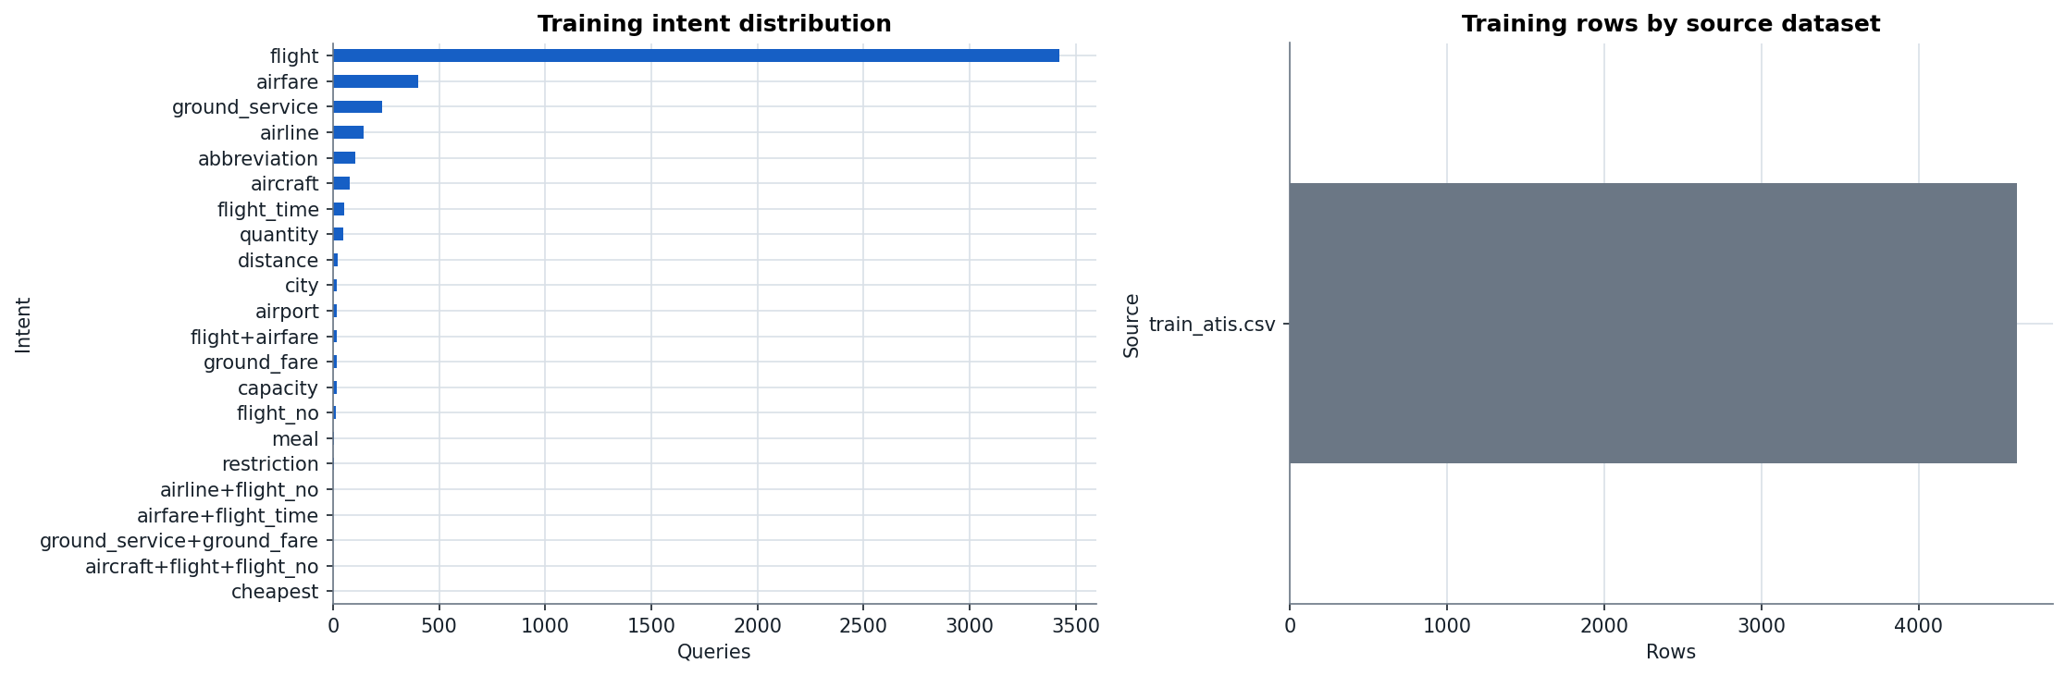
Figure 1: Intent distribution of the cleaned data (figure generated by the notebook).

5. Data Preprocessing
Only the steps listed below were performed. Each was chosen for a specific reason.
Table 3: Preprocessing steps actually performed and why.
Step | What was done | Why
Column detection | The text and label columns are found automatically from common names (text, query, user_query… / intent, label, category…); the notebook stops if two columns are equally plausible. | Lets the same notebook run on ATIS and on the supplementary sets with different column names, without silent mistakes.
Normalised text key | Lower-case and collapse whitespace to build a comparison key. | Detects repeats and conflicts that differ only in case or spacing.
Conflicting labels | Stop if the same normalised query has two different intents. | A contradictory label makes evaluation meaningless; 0 were found.
Remove repeated queries | Exact repeats of (query, intent) removed: 398 rows (344 repeats inside train_atis.csv, 43 inside test_atis.csv, and 11 queries present in both files). | Repeats inflate accuracy, and a query present in both files would leak the answer into training.
Train/test overlap check | After cleaning, normalised train/test overlap = 0 (checked again by a quality gate). Near-duplicates (cosine ≥ 0.9) are reported: 18 test queries. | Guarantees that the test set measures generalisation, not memory.
Lower-casing and whitespace | Text lower-cased and whitespace normalised before vectorisation. | Removes variation that carries no intent signal.
Tokenisation and punctuation | TF-IDF token pattern \b\w\w+\b: words of 2+ letters/digits; punctuation and single characters are dropped. | Standard scikit-learn default; ATIS has almost no punctuation. Single-letter fare codes (“q”, “y”) are therefore ignored.
Stop words, stemming, lemmatisation | Not applied (deliberately). | Function words such as “which”, “what”, “to” and “from” carry intent (“which airlines”); bigrams keep phrases. Effect of lemmatisation is listed as future work.
URLs, hashtags, emojis, multilingual text | Not needed. | ATIS contains none; all queries are English transcripts.
Missing values | Checked: 0 missing texts or labels. | Rows with missing values would otherwise be dropped silently.

6. Feature Representation / Embeddings
TF-IDF over word unigrams and bigrams (scikit-learn TfidfVectorizer, ngram_range = (1, 2), min_df = 1, sublinear_tf = True, L2 normalisation) [3][10]. The fitted vocabulary of the final model has 6,772 unigrams and bigrams.
- Why TF-IDF: intents in ATIS are signalled by a small number of keywords and short phrases (“fare”, “airline”, “ground transportation”, “what does … mean”). TF-IDF weights these highly while down-weighting words that occur everywhere, such as “flights from … to …”.
- Why bigrams: phrases such as “which airlines”, “fare code” and “ground transportation” are more specific than their single words and help separate overlapping intents.
- Why sublinear tf: a word repeated in a query (“milwaukee milwaukee”) should not count twice as much; 1 + log(tf) dampens repetition.
- Why not embeddings for the final model: the queries are short and keyword-driven, the dataset is small, and the course pipeline values transparency (each weight belongs to a readable word) and fast, reproducible CPU training. An optional Sentence-BERT benchmark is built into the notebook but switched off by default and never used for model selection; it is listed as future work.

7. Proposed Methodology / System Architecture
The system has two parts, connected by one file. The Google Colab notebook trains and evaluates the models and writes travel_nlp_run_bundle.zip. The bundle holds the processed data, metrics, predictions, the classifier exported as plain JSON, an n-gram autocomplete model, the figures and a run_manifest.json with a SHA-256 fingerprint for every file. Travel NLP Lab Studio (Streamlit) opens the bundle, verifies it and presents the results. It never retrains, so every number it shows can be traced back to the notebook run.
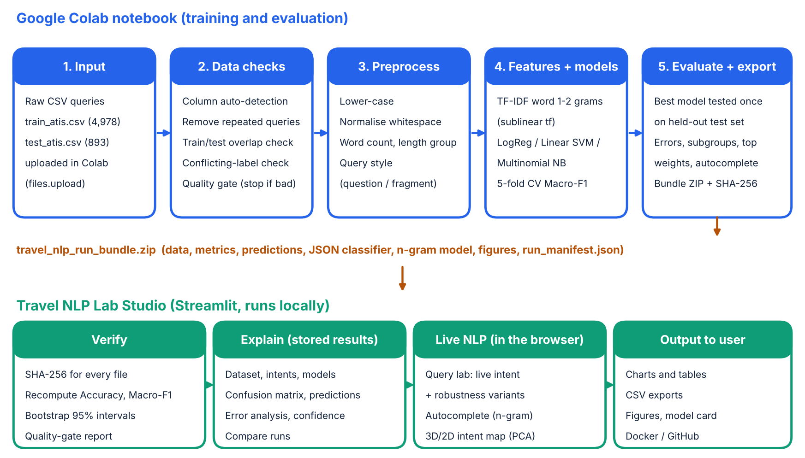
Figure 2: End-to-end architecture: input → checks → preprocessing → TF-IDF + classifiers → evaluation → bundle → verification and interactive analysis.
Workflow. (1) Upload the CSVs in Colab. (2) Detect columns, remove repeats and check for leakage, passing a data-quality gate. (3) Normalise the text. (4) Build TF-IDF features and compare three classifiers with 5-fold stratified cross-validation on the training data. (5) Fit the best model on all training data and evaluate it once on the test set. (6) Run error analysis, a subgroup audit and feature explanations. (7) Export the portable model and the bundle after a final quality gate. (8) Open the bundle in the Studio, where hashes and metrics are re-checked and the results explored.

8. NLP Model / Technique Used
Table 4: Candidate models and settings (all share the same TF-IDF features).
Model | Key settings | Idea
Logistic Regression | max_iter = 2000, class_weight = balanced, random_state = 42 | Linear model trained with log-loss; gives class probabilities.
Linear SVM (LinearSVC) [4][5] | class_weight = balanced, max_iter = 5000, random_state = 42 | Finds a maximum-margin hyperplane per class (one-vs-rest); outputs decision scores.
Multinomial Naive Bayes | default smoothing | Probabilistic word-count model; strong baseline for text.
Majority-class baseline | always predicts “flight” | Shows what imbalance alone achieves.

Training procedure. Every candidate is evaluated with 5-fold stratified cross-validation (seed 42) on the training split only, and the model with the highest mean Macro-F1 is chosen. Macro-F1 is used because it gives every intent equal weight and so does not reward ignoring rare intents. Intents with too few training rows to appear in every fold (5 intents, 6 rows) are left out of the cross-validation folds only, and kept for the final fit. The selected pipeline is then fitted on all 4,623 training queries and evaluated exactly once on the 850 test queries. class_weight = balanced increases the penalty for errors on rare intents.
Selected model: TF-IDF + Linear SVM. For each intent it learns one weight per n-gram plus a bias; the predicted intent is the one with the highest score. The decision margin (best score minus second-best score) is used as a confidence signal. The model is exported as JSON (vocabulary, IDF values, weights, biases). That export is accepted only if a NumPy re-implementation reproduces scikit-learn's prediction on every test query; the export passed on all 850.
Autocomplete model (additional). A word n-gram language model with stupid back-off [8] (maximum context 4 words, α = 0.2; settings chosen by grid search on a 15% validation slice of the training queries, test set not used), built from the training queries only. It suggests the next word, completes partial words and gives a hint of the intent the query is heading towards.

9. Implementation
- Language and libraries: Python 3.12.3; scikit-learn 1.8.0 [6], pandas 3.0.2 [12], NumPy 2.4.4 [11] and Matplotlib 3.10.8 in the notebook. The application uses Streamlit [13], Plotly [14] and FastAPI functions as its analysis back-end. Versions are taken from the run manifest.
- Notebook (notebooks/ATIS_Complete_Pipeline.ipynb, 51 cells): environment setup, CSV upload in Colab, configuration and column detection, cleaning, data-quality gate, preprocessing, model search, final evaluation, error analysis, subgroup audit, feature explanation, autocomplete, portable model export, figures, final quality gate and bundle export. It also runs on a normal computer through tools/run_notebook_local.py.
- Analysis back-end (app/): engine.py verifies bundles (hashes, ZIP safety limits, strict JSON parsing), analytics.py computes the confusion matrix, error groups and confidence bands, and autocomplete_plus.py re-scores the autocomplete model.
- Application (streamlit_app.py, studio/): 14 pages in five groups: Start (Home with a colour-theme picker, Data & Colab), Explore (Dataset, Intents), Evaluate (Models, Confusion matrix, Predictions, Error analysis, Confidence), Lab (Query lab, Autocomplete, 3D/2D Intent map) and Evidence (Compare runs, Files & checks). Everything runs offline; fonts and plotly.js are bundled.
- Quality and delivery: 151 automated tests (bundle verification, metrics, ZIP-bomb rejection, every page rendered on two datasets), 51 browser checks that click every page and control, Windows START.bat, a Docker image, and GitHub Actions that run the tests and build and publish the image.
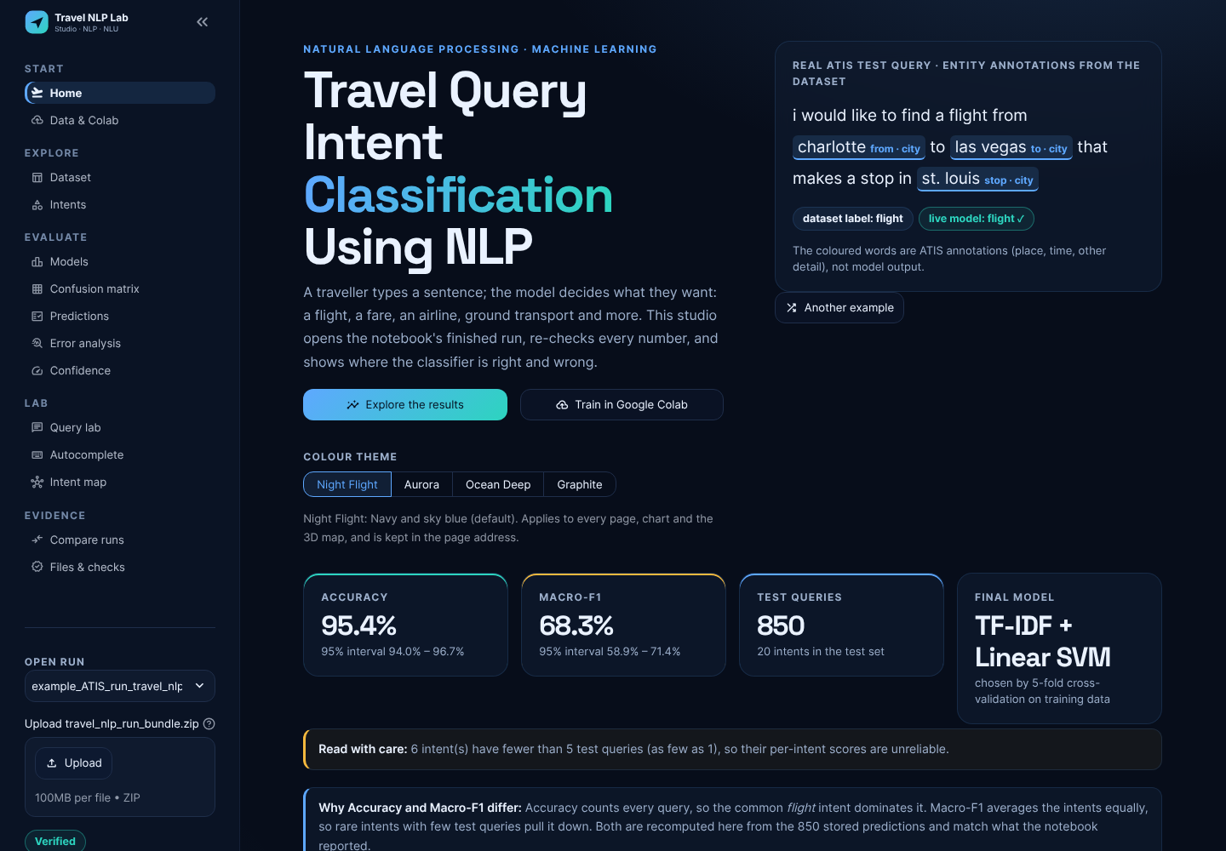
Figure 3: Home page of Travel NLP Lab Studio: a real ATIS test query with its entity annotations and the model's live prediction, plus the headline metrics.
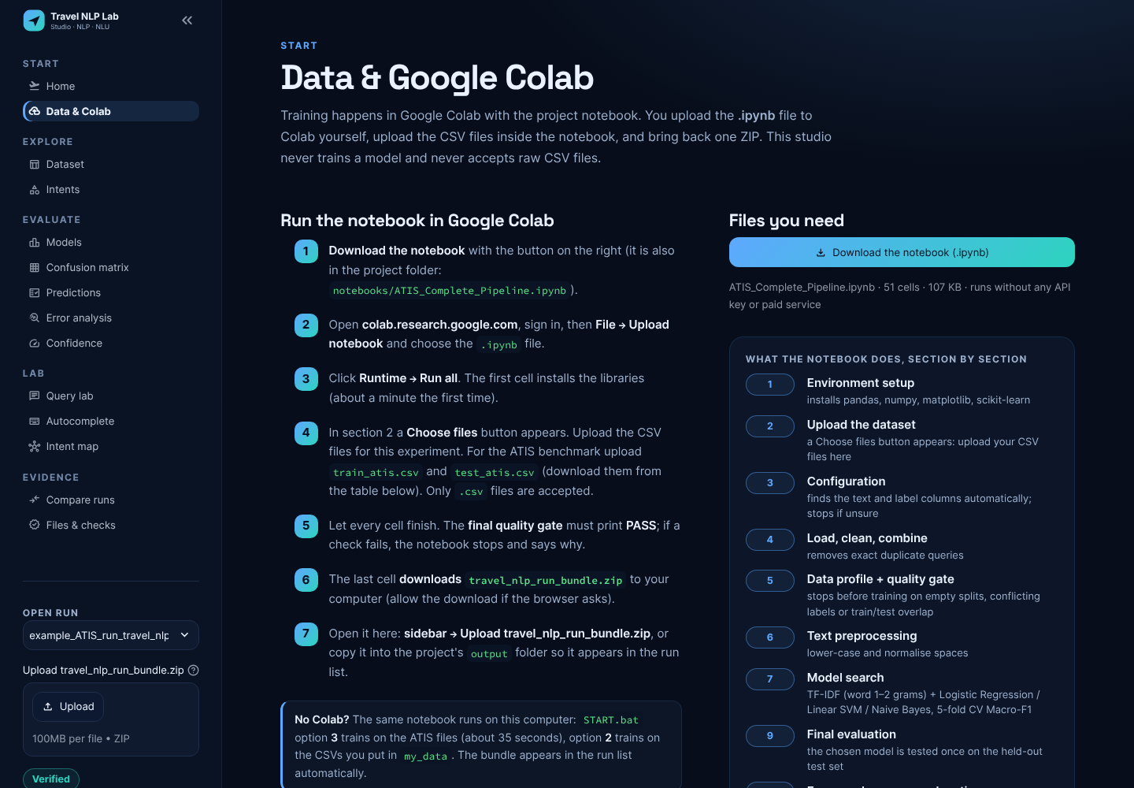
Figure 4: Data & Colab page: step-by-step manual Colab workflow, notebook download and the raw datasets.
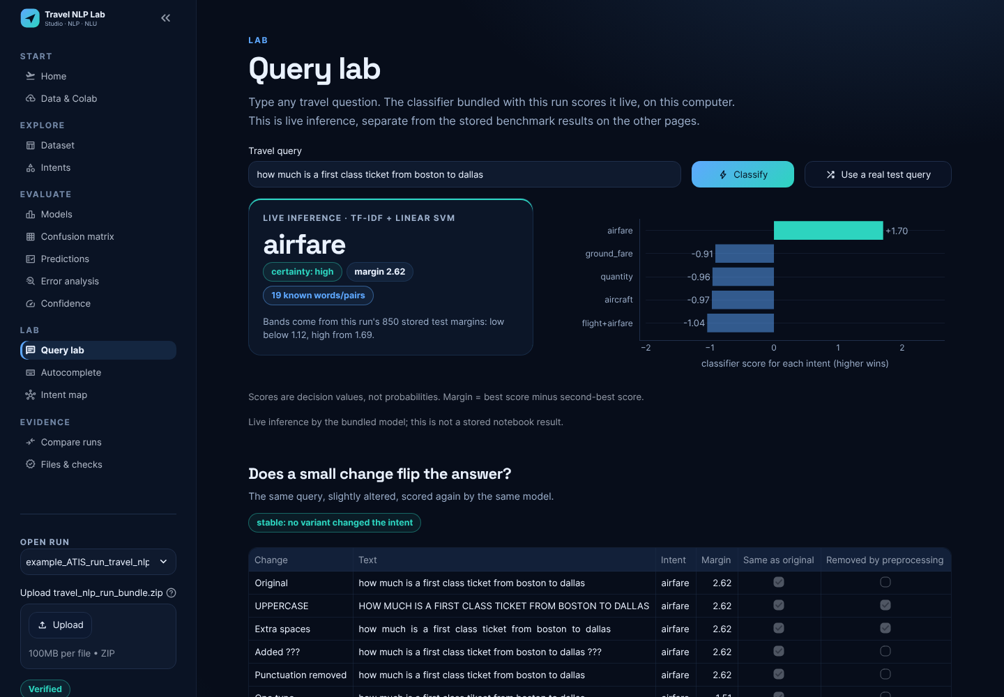
Figure 5: Query lab: live classification of a typed query with the top-5 intent scores and a robustness check.
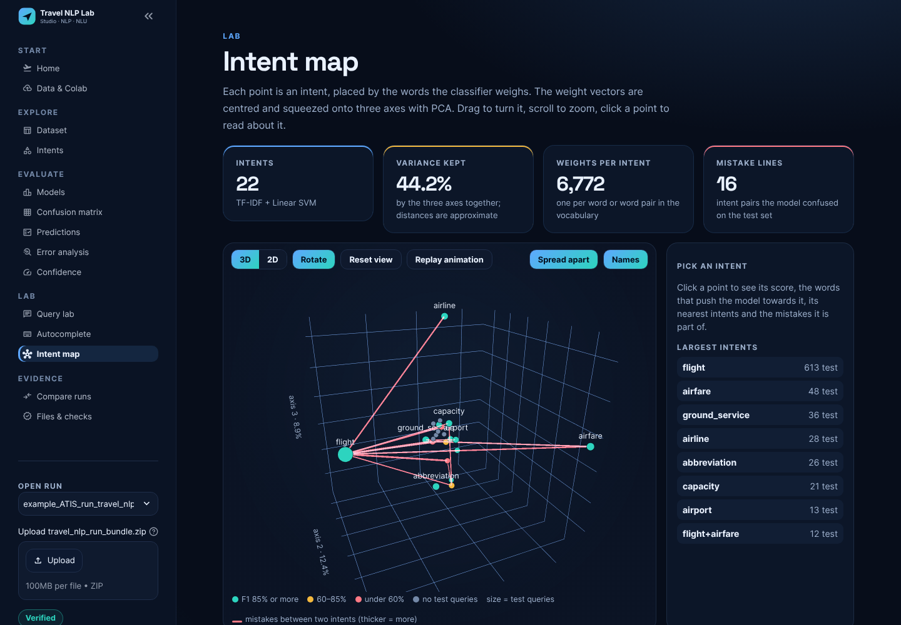
Figure 6: Intent map: intents placed by the classifier's weight vectors (PCA to three axes); red lines are pairs confused on the test set.

10. Results and Evaluation

Model selection (cross-validation on training data)
Table 5: 5-fold stratified cross-validation on the training split (mean ± standard deviation).
Model | CV Macro-F1 | ± SD | CV accuracy | Selected
TF-IDF + Linear SVM | 78.4% | 3.3% | 97.1% | Yes
TF-IDF + Logistic Regression | 74.8% | 3.7% | 93.6%
TF-IDF + Multinomial Naive Bayes | 17.8% | 1.0% | 81.5%
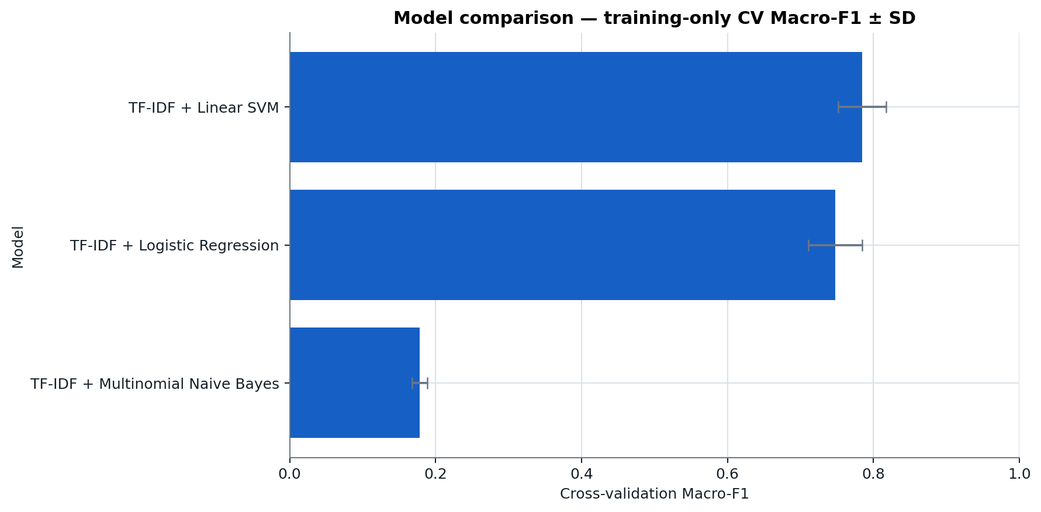
Figure 7: Cross-validation Macro-F1 of the candidate models (notebook figure).
The Linear SVM and Logistic Regression are close (78.4% vs. 74.8%; the difference is about one standard deviation), while Multinomial Naive Bayes collapses to 17.8% Macro-F1 because it almost always predicts the dominant intent.

Final test result (single evaluation)
Table 6: Held-out test performance of TF-IDF + Linear SVM (850 queries, 20 intents). Intervals: 1000 bootstrap resamples.
Metric | Value | 95% interval
Accuracy | 95.4% | 94.0% – 96.7%
Macro precision | 72.6%
Macro recall | 68.4%
Macro-F1 | 68.3% | 58.9% – 71.4%
Weighted-F1 | 95.0%
Majority-class baseline | accuracy 72.1%, Macro-F1 4.2%

Interpretation. 811 of 850 test queries are classified correctly. The Studio recomputed accuracy and Macro-F1 from the stored predictions, and they match the notebook. Accuracy is high because “flight” makes up 72.1% of the test set and is recognised with F1 97.6%. Macro-F1 is much lower because every intent counts equally: four test-only intents score 0 by construction, and several rare intents (meal, quantity, flight+airfare) score below 60%. The wide Macro-F1 interval (58.9%–71.4%) shows how much this metric depends on a handful of rare test queries.
Table 7: Per-intent test scores (selected intents).
Intent | Test queries | Precision | Recall | F1
flight | 613 | 97.1% | 98.2% | 97.6%
airfare | 48 | 87.0% | 97.9% | 92.2%
ground_service | 36 | 94.7% | 100.0% | 97.3%
airline | 28 | 96.3% | 92.9% | 94.5%
abbreviation | 26 | 100.0% | 100.0% | 100.0%
capacity | 21 | 100.0% | 85.7% | 92.3%
airport | 13 | 92.3% | 92.3% | 92.3%
flight+airfare | 12 | 83.3% | 41.7% | 55.6%
aircraft | 8 | 63.6% | 87.5% | 73.7%
ground_fare | 7 | 100.0% | 71.4% | 83.3%
meal | 6 | 100.0% | 33.3% | 50.0%
quantity | 3 | 37.5% | 100.0% | 54.5%
day_name | 2 | 0.0% | 0.0% | 0.0%
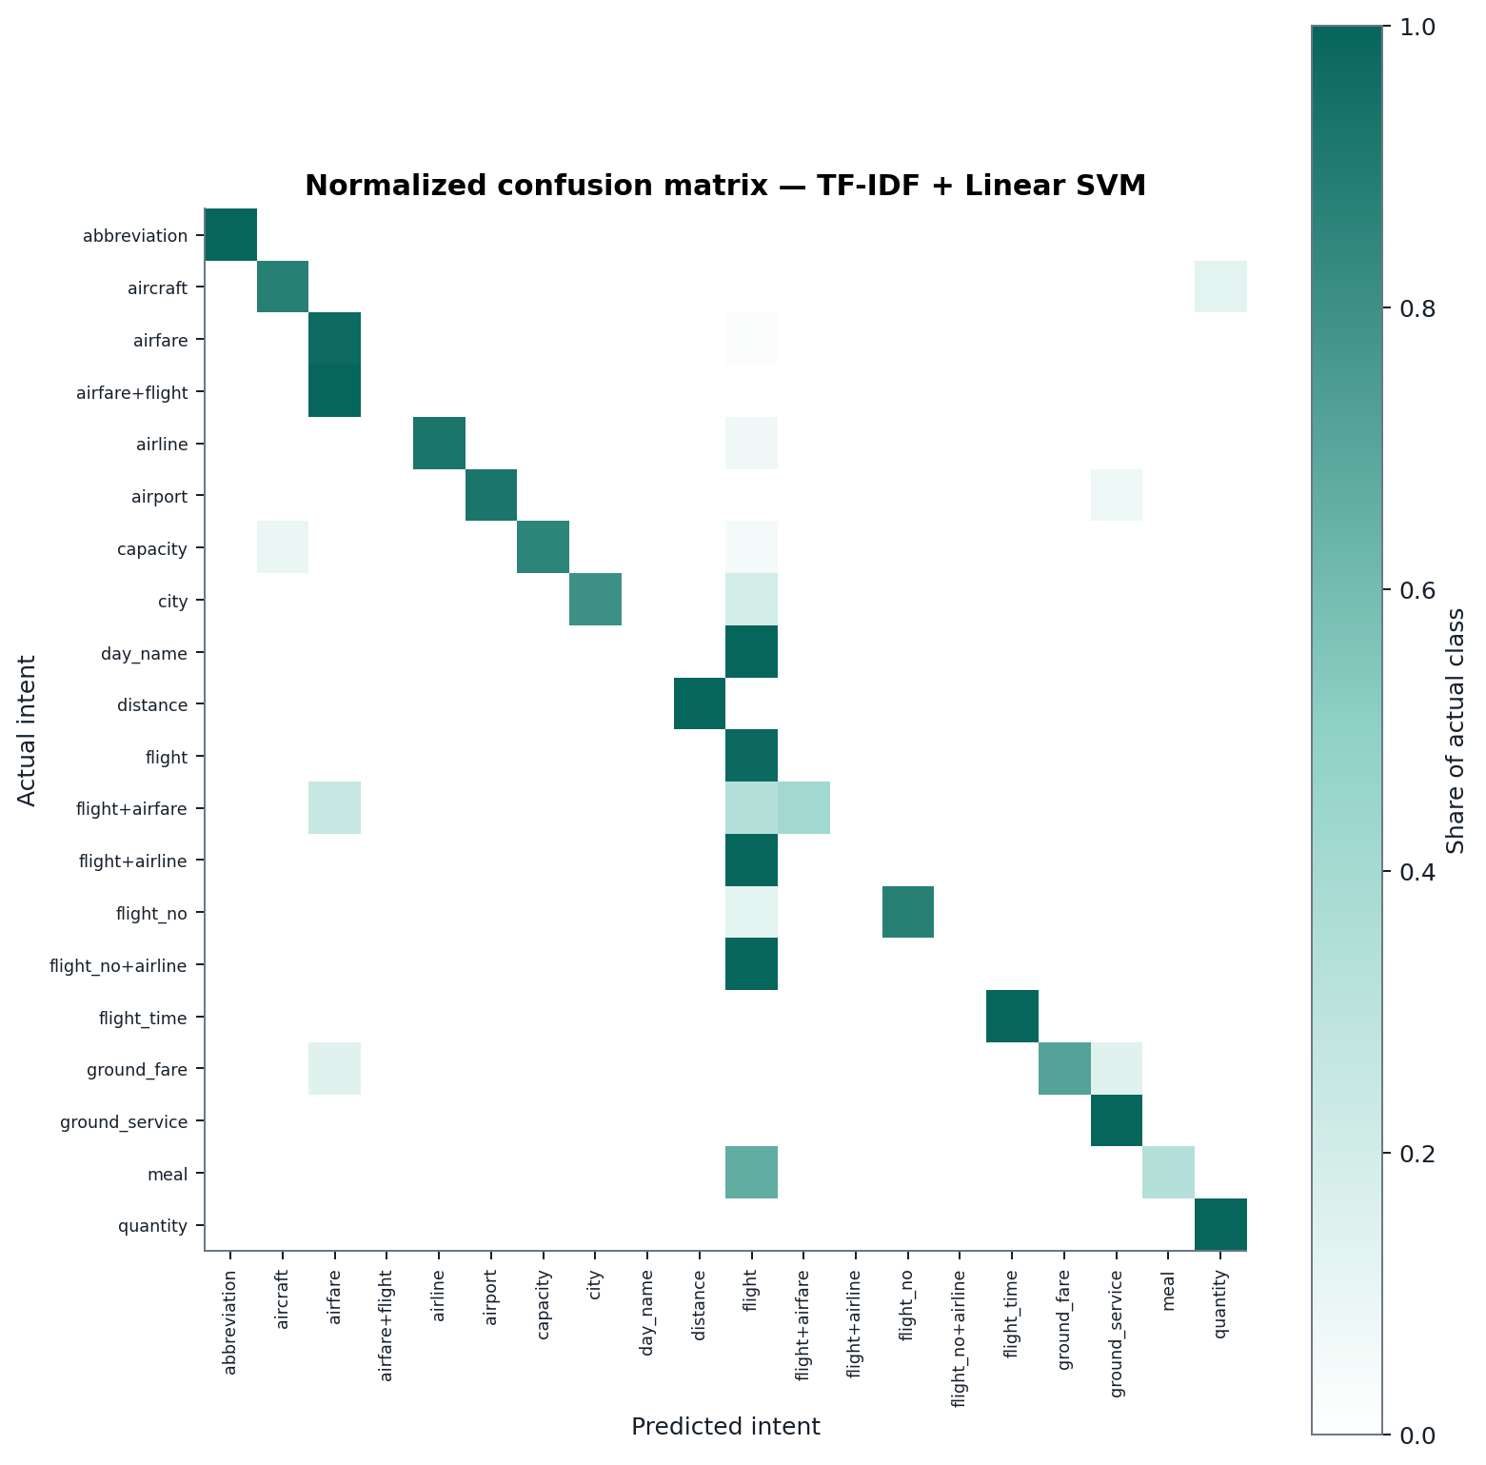
Figure 8: Row-normalised confusion matrix of the final model (notebook figure).

Confidence (decision margin)
The decision margin separates correct from wrong answers well. The median margin is 1.60 for correct answers and 0.43 for mistakes. In the least-certain fifth of the test set accuracy is 81.2%; in the other four fifths it is between 98.2% and 100.0%. If the 20% least-certain queries were sent to a human, the remaining 80% would be answered with 99.0% accuracy.

Autocomplete
Re-scored on all 9,770 word positions of the test queries, the correct next word is the first suggestion 42.2% of the time and among the top three 62.2% of the time, against 22.0% for a frequent-words baseline. These values match the numbers stored by the notebook exactly.

11. Error Analysis / NLP Failure Analysis
The model makes 39 mistakes on 850 test queries. The Studio tags each one with checkable properties (they describe the data, not the model's internal reasoning): low score (margin in the least-certain 20%, ≤ 1.12): 32; long query (≥ 13 words): 21; shared wording (a word common to both the true and the predicted intent): 10; short query (≤ 7 words): 6.
Table 8: Most-confused intent pairs on the test set (both directions).
Intent A | Intent B | Mistakes
flight | flight+airfare | 5
flight | meal | 4
flight | quantity | 4
airline | flight | 3
airfare | flight | 3
airfare | flight+airfare | 3

Because the model is linear, each decision can be explained exactly. The score difference between the predicted and the true intent equals the sum of word contributions (TF-IDF value × weight difference) plus the difference of the two class biases. Positive contributions below pushed towards the wrong intent; negative ones pushed towards the correct one.
Table 9: Real test-set failures and their likely causes (exact linear contributions).
Query (true → predicted) | Strongest word contributions | Likely reason
“which different airlines go from las vegas to new york city”  airline → flight | “airlines” -0.72, “which” -0.36, “airlines go” -0.25; class bias difference +0.51 | The words point to the right intent, but the bias of the frequent “flight” class outweighs them. The final scores differ by only 0.0008: a near-tie decided by class imbalance.
“list all sunday flights from cleveland to nashville and their fares”  flight+airfare → flight | “fares” -0.58, “and their” -0.49, “their” -0.34; bias +0.76 | A two-intent request (flights and fares). Only 17 training queries carry the combined label, so “flights” plus the flight bias wins.
“what are the fares for ground transportation in denver”  ground_fare → ground_service | “ground” +0.58, “transportation” +0.54, “ground transportation” +0.39 | Shared vocabulary: “ground transportation” is the strongest cue for ground_service, and ground_fare has only 17 training examples. The word “fares” is not enough to flip the decision.
“list the arizona airport”  airport → ground_service | “airport” -0.08, “list the” +0.07, “list” -0.05 | Very short query with little evidence; “arizona” (a state, not a city) carries almost no weight, so the class biases decide.

Other failure patterns observed:
- Unseen intents: day_name, airfare+flight, flight+airline and flight_no+airline (5 test queries) never occur in training, so they are always wrong. The model cannot output a label it has never seen.
- Rare intents: meal has 6 training queries and recall 33%; quantity has precision 37.5% because 4 flight queries were predicted as quantity.
- Long queries: the subgroup audit shows Macro-F1 43.8% on long queries (290) versus 84.9% on short ones (560); accuracy drops from 97.5% to 91.4%. Long queries more often mix several requests and dilute the key words.
- Spelling variation: the robustness check in the Query lab shows that a typo in a key word (for example “tikcet”) lowers the margin; the classifier has no character-level knowledge.
- Word order and negation: TF-IDF ignores word order beyond bigrams, so “flights not via denver” and “flights via denver” look almost identical. ATIS has few such cases, but real users produce them.
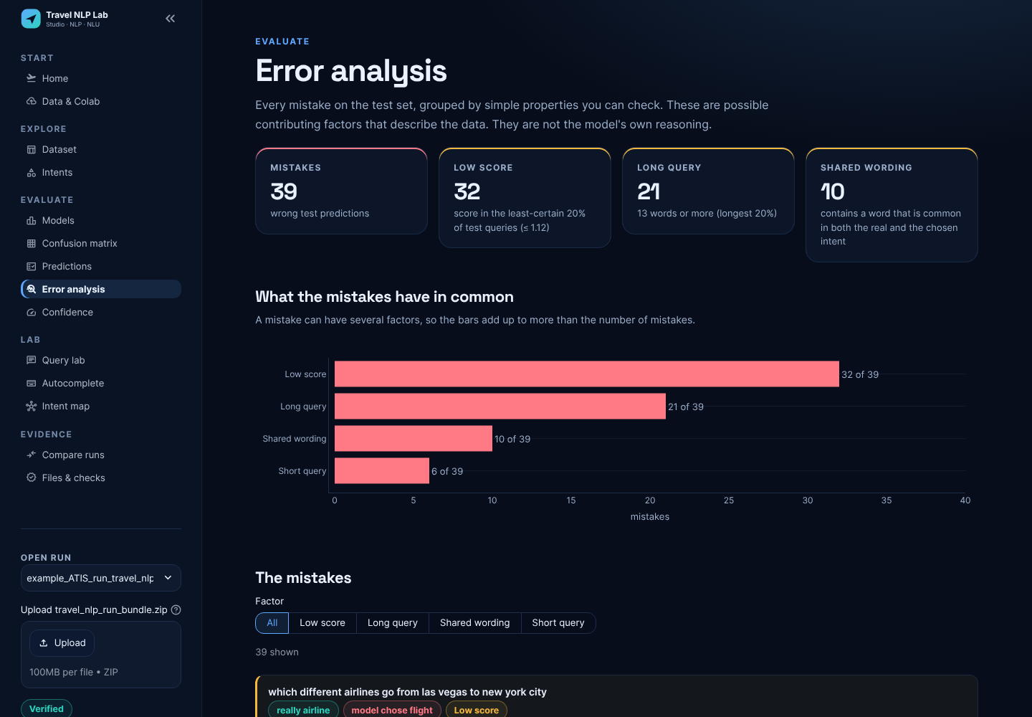
Figure 9: Error analysis page in the Studio: mistakes grouped by checkable factors, with similar queries the model got right.

12. Ethical Considerations and Limitations
- Dataset bias: ATIS is from early-1990s US domestic air travel: US cities, US airlines and a 1990s fare structure. It does not represent Indian or international travel, other languages, or code-mixed text such as Hinglish. A deployed system would treat such users worse.
- Imbalance hides failures: reporting only accuracy (95.4%) would hide that rare intents are often wrong. This report therefore leads with Macro-F1, per-intent scores and confidence intervals.
- Not a decision-maker: predictions should route a request or suggest an answer, never make binding bookings or refunds without confirmation. Low-margin predictions should go to a human (see Section 10).
- Privacy: ATIS contains no personal data. A production system would receive names, dates and itineraries; logs would need consent, minimisation and retention limits. The Studio itself runs fully offline and sends no data anywhere.
- Model limitations: one label per query (multi-intent requests are only partly covered by combined labels); no understanding of word order, negation or context from earlier turns; unseen intents cannot be predicted; a typo or an unseen city name reduces confidence.
- Evaluation limitations: 850 test queries with very small counts for many intents. Per-intent scores for intents with fewer than 5 test queries are unreliable; 18 test queries are near-duplicates of training queries (all correct), which slightly flatters accuracy (95.3% on the remaining 832).
- Honest reporting: the integrity hashes show that the files were not changed after the notebook wrote them; they do not prove authorship. Entity tags are dataset annotations, not model output.

13. Conclusion
The project delivers a complete, reproducible intent-classification system for travel queries. A leakage-safe ATIS split was prepared, and three TF-IDF classifiers were compared with cross-validation on the training data. The selected Linear SVM reaches 95.4% accuracy and 68.3% Macro-F1 on a single held-out evaluation, far above the 4.2% majority baseline. The objectives were met: clean data, model comparison, honest evaluation with intervals, a detailed error analysis, an explainable exported model, and an application that verifies and explains the run.
The main finding is that the headline accuracy is driven by the dominant “flight” intent. The real difficulty lies in rare and combined intents and in long, multi-request queries. The decision margin is a useful signal for deciding when to ask a human. The team also learned that careful data hygiene (deduplication, overlap checks, a test set used once) and transparent reporting matter as much as the choice of model.

14. Future Scope
- Fine-tune a contextual model (for example DistilBERT) or enable the notebook's Sentence-BERT benchmark, and re-run the same subgroup audit to compare.
- Handle multi-intent queries properly with multi-label classification instead of combined labels.
- Address imbalance with targeted data collection or augmentation for rare intents (meal, quantity, ground_fare, flight+airfare).
- Joint intent detection and slot filling using the ner column, so the system also extracts origin, destination and dates.
- Test lemmatisation or character n-grams (robustness to typos), for example with NLTK or spaCy, and measure the effect.
- Extend to Indian travel data and code-mixed (Hinglish) queries, and to the hotel, car-rental and rail domains with larger datasets.
- Calibrate scores into probabilities and add an “unknown intent” option for queries far from all intents.

15. References
- Hemphill, C. T., Godfrey, J. J., & Doddington, G. R. (1990). The ATIS spoken language systems pilot corpus. In Proceedings of the DARPA Speech and Natural Language Workshop (pp. 96–101).
- Tur, G., Hakkani-Tür, D., & Heck, L. (2010). What is left to be understood in ATIS? In 2010 IEEE Spoken Language Technology Workshop (pp. 19–24).
- Salton, G., & Buckley, C. (1988). Term-weighting approaches in automatic text retrieval. Information Processing & Management, 24(5), 513–523.
- Cortes, C., & Vapnik, V. (1995). Support-vector networks. Machine Learning, 20(3), 273–297.
- Fan, R.-E., Chang, K.-W., Hsieh, C.-J., Wang, X.-R., & Lin, C.-J. (2008). LIBLINEAR: A library for large linear classification. Journal of Machine Learning Research, 9, 1871–1874.
- Pedregosa, F., et al. (2011). Scikit-learn: Machine learning in Python. Journal of Machine Learning Research, 12, 2825–2830.
- Efron, B., & Tibshirani, R. J. (1993). An introduction to the bootstrap. Chapman & Hall.
- Brants, T., Popat, A. C., Xu, P., Och, F. J., & Dean, J. (2007). Large language models in machine translation. In Proceedings of EMNLP-CoNLL (pp. 858–867).
- Mitchell, M., et al. (2019). Model cards for model reporting. In Proceedings of the Conference on Fairness, Accountability, and Transparency (pp. 220–229).
- Manning, C. D., Raghavan, P., & Schütze, H. (2008). Introduction to information retrieval. Cambridge University Press.
- Harris, C. R., et al. (2020). Array programming with NumPy. Nature, 585, 357–362.
- McKinney, W. (2010). Data structures for statistical computing in Python. In Proceedings of the 9th Python in Science Conference (pp. 56–61).
- Streamlit. (2026). Streamlit documentation. https://docs.streamlit.io
- Plotly Technologies. (2026). Plotly Python open source graphing library. https://plotly.com/python/
- Google. (2026). Google Colaboratory. https://colab.research.google.com
- ATIS dataset, CSV version with intent and BIO slot columns (id, intent, text, ner). [Team: insert the exact download link used, e.g. the Kaggle page.]
- Jolliffe, I. T. (2002). Principal component analysis (2nd ed.). Springer.

16. GitHub Repository
- GitHub Repository Link: https://github.com/____________________ (insert after pushing; steps in README.md)
The repository contains everything needed to understand and reproduce the project:
- notebooks/ATIS_Complete_Pipeline.ipynb: the Colab notebook (upload it to Colab via File → Upload notebook, or open it from GitHub).
- data/raw/: the five CSV datasets; examples/: the example run bundle used in this report.
- streamlit_app.py, studio/, app/: the Streamlit application and its analysis back-end.
- tests/: 151 automated tests and the browser check; .github/workflows/: tests.yml (tests, notebook run, browser checks) and docker.yml (build, smoke test and publish the Docker image to GitHub Container Registry).
- Dockerfile and docker-compose.yml: run the app with docker run -p 8501:8501 or docker compose up.
- README.md, HOW_IT_WORKS.md, MODEL_CARD.md and docs/: documentation, this report and the model card.

17. Team Contribution
Team Member | PRN | Specific Contribution
Krishnav Rastogi (Team Leader) | 25030422060
Vinayak Goyal | 25030422133
Sakaar Vir Singh | 25030422104
[Each member's specific contribution is to be written by the team in the table above, so that it reflects the work actually carried out.]

18. Annexure

A. Sample inputs and outputs (live Query lab, bundled model)
Table 10: Example predictions (live inference on this computer).
Query | Predicted intent | Margin | Certainty band
what is the cheapest fare from boston to denver | airfare | 2.38 | high
which airlines fly from pittsburgh to atlanta | airline | 2.19 | high
what ground transportation is available in dallas | ground_service | 2.63 | high
show me flights from new york to miami tomorrow morning | flight | 1.80 | high
what does fare code y mean | abbreviation | 2.53 | high
how many passengers can a boeing 767 hold | capacity | 1.07 | low
how far is the airport from downtown san francisco | distance | 1.82 | high
what meals are served on the flight to chicago | meal | 0.48 | low

B. Additional screenshots
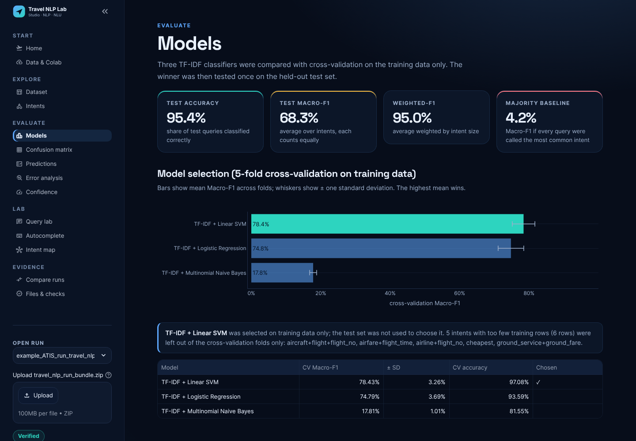
Figure 10: Models page: cross-validation comparison and final metrics.
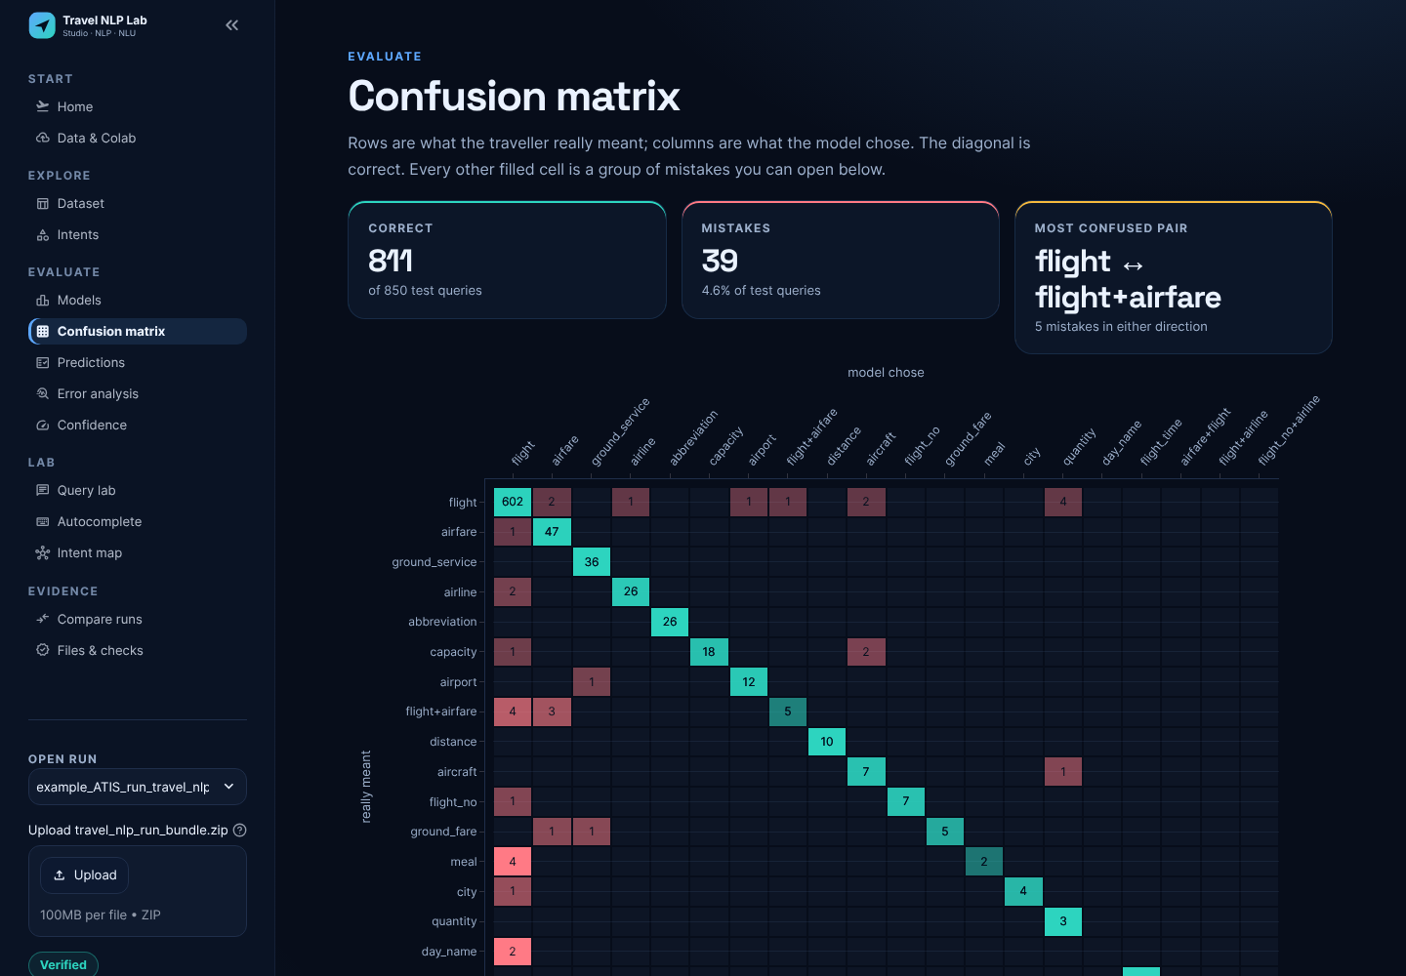
Figure 11: Confusion matrix page: click-through to the exact mistaken queries.
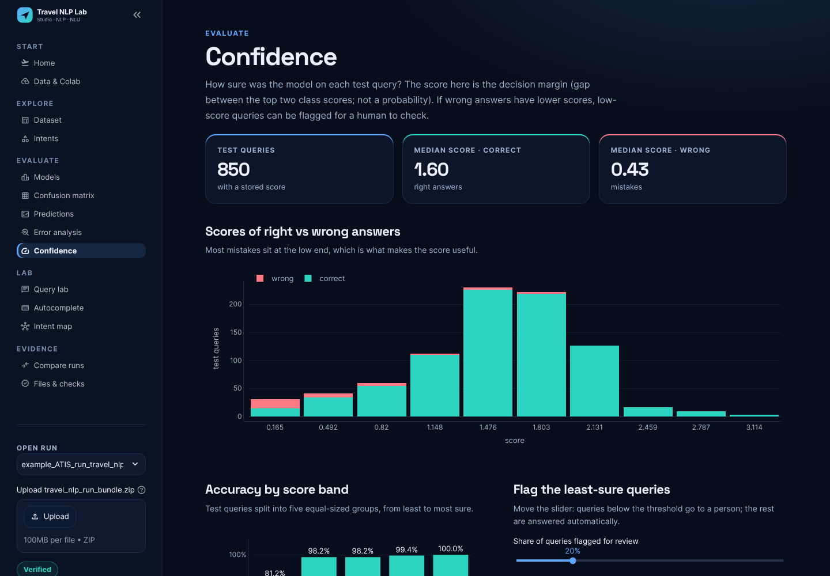
Figure 12: Confidence page: margins of right vs. wrong answers and the review-threshold simulator.

C. How to reproduce
- Open the notebook in Google Colab (File → Upload notebook), run all cells, and upload train_atis.csv and test_atis.csv when asked.
- Download travel_nlp_run_bundle.zip from the last cell.
- Run the Studio (START.bat option 1 on Windows, streamlit run streamlit_app.py, or Docker) and upload the bundle in the sidebar.
- Optional: python tools/compare_bundles.py <your bundle> examples/example_ATIS_run_travel_nlp_run_bundle.zip checks that your run reproduces the reported numbers (a local re-run matched 19 of 19 checks).

