NEPAL DON BOSCO
SECONDARY SCHOOL

A
Project on Webpage Using HTML, CSS, JS, Php

Submitted for the partial fulfillment of final examination
Computer Science
Grade XII, NEB
2025
Submitted By:
Submitted To:
Ms. Sharada Oli

Mr. Sachin Rastogi

ACKNOWLEDGEMENT

Designing a webpage & preparing an organized report requires a monumental effort, a lot of hard works & seeks a lot of helping hands. Up to the completion of this project report, we are not so far from this strategy or rule.
This is to thank all the people who have made contributions to this work. It is impossible to thank everybody, but a few people need special mention. We are mostly thankful to Ms. Sharada Oli (computer faculty) who guided us throughout the project. A large number of individuals provided us their valuable suggestions & assistance. We heartily thank them for their valuable suggestions, help & encouragements.
Everything we've done will be worthless if we forget our parents; we are thankful for their support, love & care.
Lastly we would also want to thank NEB for providing us an opportunity to develop & demonstrate such a wonderful project.

Sincerely,

Sachin Rastogi
Grade: XII Science

Table of Contents

BASIC CONCEPT OF WEB TECHNOLOGY 3
Internet 3
World Wide Web (WWW) 3
Web Browser 3
Web Page 3
INTRODUCTION TO TECHNOLOGIES USED 4
HTML (HyperText Markup Language) 4
CSS (Cascading Style Sheets) 4
JavaScript (JS) 4
PHP (Hypertext Preprocessor) 4
INTRODUCTION 5
Introduction 5
Objectives 5
ER DIAGRAM 6
Key Entities & Relationships 6
User Entity 6
Login Entity 6
Product Entity 6
Payment Entity 6
Relationships 6
USES OF ER DIAGRAM IN THIS PROJECT 7
Database Design 7
User Management 7
Product Display 7
Payment Processing 7
Scalability 7
Html code for index.html 8
CSS for styles.css 12
Conclusion 18

BASIC CONCEPT OF WEB TECHNOLOGY

Internet
The internet is a global network of interconnected computers & devices that communicate using standardized protocols. It facilitates the exchange of information, services, & resources across the globe. Through a combination of wired & wireless technologies, the internet enables users to access a vast array of data, connect with others, & utilize various online services. It serves as a platform for communication, collaboration, & the distribution of knowledge, playing a crucial role in shaping modern society by fostering connectivity & information sharing on an exceptional scale.

World Wide Web (WWW)
The WWW, or World Wide Web, is the part of the internet that consists of interconnected websites. It's like a huge collection of digital pages where you can find information, pictures, videos, & more. When you use a web browser, like Edge or Chrome, to explore the internet. Each website has a unique address, & you can click on links to jump from one page to another. The WWW plays a central role in how people access & share information online.

Web Browser
A web browser is a computer program or application that allows users to access & navigate the World Wide Web (WWW). It enables users to view & interact with various types of content, such as text, images, videos, & hyperlinks. Popular web browsers include Chrome, Firefox, Safari, & Edge. Users can enter a web address (URL) into the browser's address bar or click on hyperlinks to visit different websites. Additionally, web browsers often provide features like bookmarks, history, & extensions to enhance the user's browsing experience. They act as a gateway for individuals to explore & interact with the vast array of information available on the internet.

Web Page
A web page is a single document or page of information on the World Wide Web (WWW) that is designed to be viewed in a web browser. It can contain various elements such as text, images, hyperlinks, multimedia, & interactive features. Web pages are typically written in languages like HTML (Hypertext Markup Language) & may include CSS (Cascading Style Sheets) for styling & JavaScript for interactivity. When you visit a website, you're essentially viewing a collection of interconnected web pages. Each web page has a unique address called a URL (Uniform Resource Locator), & users can navigate between pages by clicking on hyperlinks or using other navigation elements.

INTRODUCTION TO TECHNOLOGIES USED

This Ecommerce Website project leverages a combination of modern web development technologies to deliver a seamless & interactive user experience. Below is a brief overview of the key technologies used:

HTML (HyperText Markup Language)
HTML is the foundational language used to structure content on the web. It provides the basic framework for the website, defining elements such as headers, paragraphs, images, links, & forms. In this project, HTML is used to create the layout & structure of the product pages, navigation menus, & other essential components.

CSS (Cascading Style Sheets)
CSS is used to style & visually enhance the HTML elements. It controls the layout, colors, fonts, & overall design of the website, ensuring a visually appealing & user-friendly interface. For this project, CSS is utilized to create responsive designs, animations, & a consistent theme across all pages.

JavaScript (JS)
JavaScript is a dynamic programming language that enables interactive & dynamic behavior on web pages. In this project, JavaScript is used to handle client-side functionalities such as form validation, dynamic content updates, & interactive features like the loading animation during payment processing. It enhances the user experience by making the website more engaging & responsive.

PHP (Hypertext Preprocessor)
PHP is a server-side scripting language designed for web development. It is used to handle backend operations, such as processing form data, managing user sessions, & interacting with databases. In this project, PHP is employed to manage product data, handle user authentication, & process orders, ensuring secure & efficient backend functionality.

INTRODUCTION

Introduction

As an application of computer technology, the internet was developed. The most crucial feature of the internet is World Wide Web, which is consisted of numerous web pages, which are maintained by different companies, schools, colleges for information sharing & communication with concerned people. Today it is very important for every institution to have an online presence. This project is a step for building a Demo web page.

Our website is a single-page website, website that consists of just one HTML page. Instead of navigating through different pages, users scroll down the page to access various sections or content. The HTML components along with CSS are applied in a web page. The first page a user lands on is home page i.e. index.html which contains information regarding our brand new product. The section ‘Featured’ contains our featured products. Another section ‘Products’ contains our products with their name & price along with a button for buying the very product. Section ‘Contact’ contains details of our team & a button for user to enter their email for contacting us. Footer contains our contact number, physical store location, our support center, customer support & so on.

All the images used are maintained in a separate folder named assets. This project is developed using HTML, CSS, JS & PHP.

Objectives

The general objectives of this project work are:
- To practically apply & understand the HTML, CSS, JS & Php components.
- To understand the steps in building a project.

ER DIAGRAM

An Entity-Relationship (ER) Diagram is a visual representation of the data structure & relationships within a database. It helps in designing & organizing the database by identifying entities (tables), their attributes (columns), & the relationships between them. In this Ecommerce Website project, the ER Diagram plays a crucial role in managing user data & payment processing.

Key Entities & Relationships

User Entity
Represents users who create accounts & log in to the website.
Attributes: UserID (Primary Key), Name, Email, Password.
The create account form collects Name, Email, & Password, which are stored in the User table.

Login Entity
Handles user authentication by verifying the Email & Password entered in the login form.
Attributes: Email (Foreign Key referencing User), Password.

Product Entity
Represents the products available on the website.
Attributes: ProductID (Primary Key), Name, Description, Price, ImageURL.

Payment Entity
Manages payment-related information when a user clicks "Buy" & is redirected to the Esewa payment page.
Attributes: PaymentID (Primary Key), UserID (Foreign Key referencing User), ProductID & PaymentStatus.

Relationships
A User can create one account & log in multiple times (one-to-many relationship between User & Login).
A User can purchase multiple products, & a Product can be purchased by multiple users (many-to-many relationship between User & Product, managed through the Payment entity).

USES OF ER DIAGRAM IN THIS PROJECT

Database Design
The ER Diagram provides a clear blueprint for creating the database schema, ensuring efficient storage & retrieval of user, product, & payment data.

User Management
It helps in managing user accounts, including account creation (create account form) & authentication (login form).

Product Display
The Product entity ensures that product details are stored and displayed dynamically on the website.

Payment Processing
The Payment entity tracks payment details when users are redirected to the Esewa payment page, ensuring a seamless transaction process.

Scalability
The ER Diagram allows for easy expansion of the database, such as adding new entities (e.g., Orders, Reviews) or attributes (e.g., User Address, Product Category).

Html code for index.html
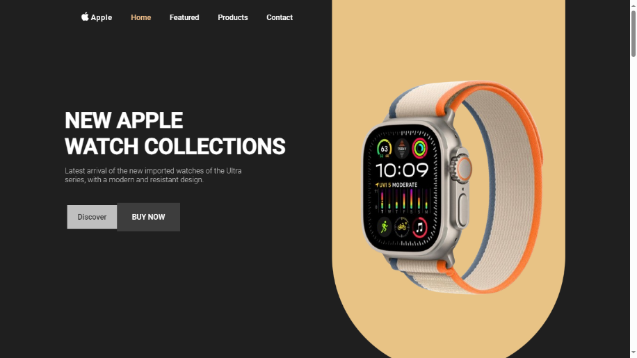
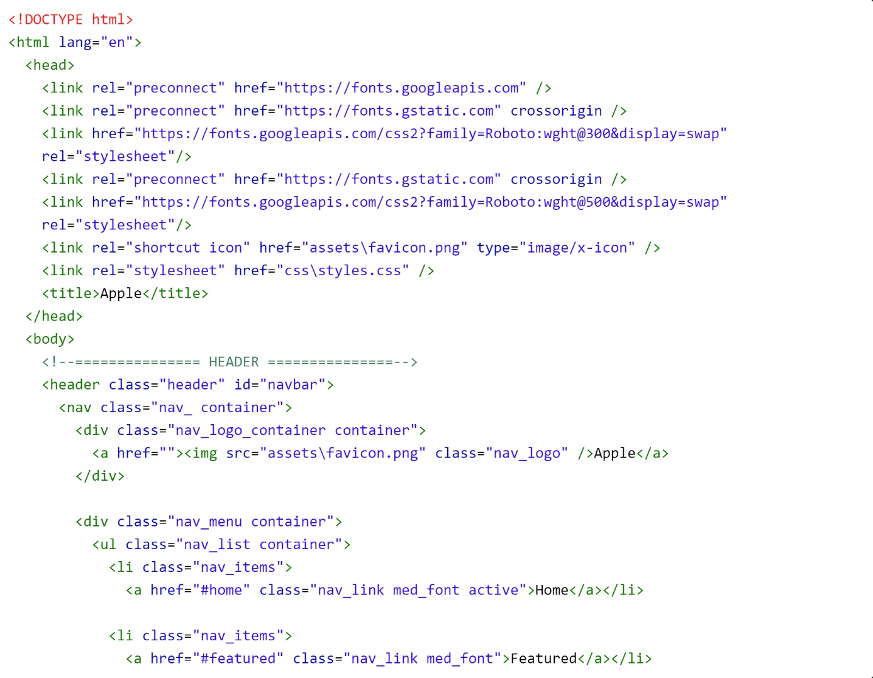

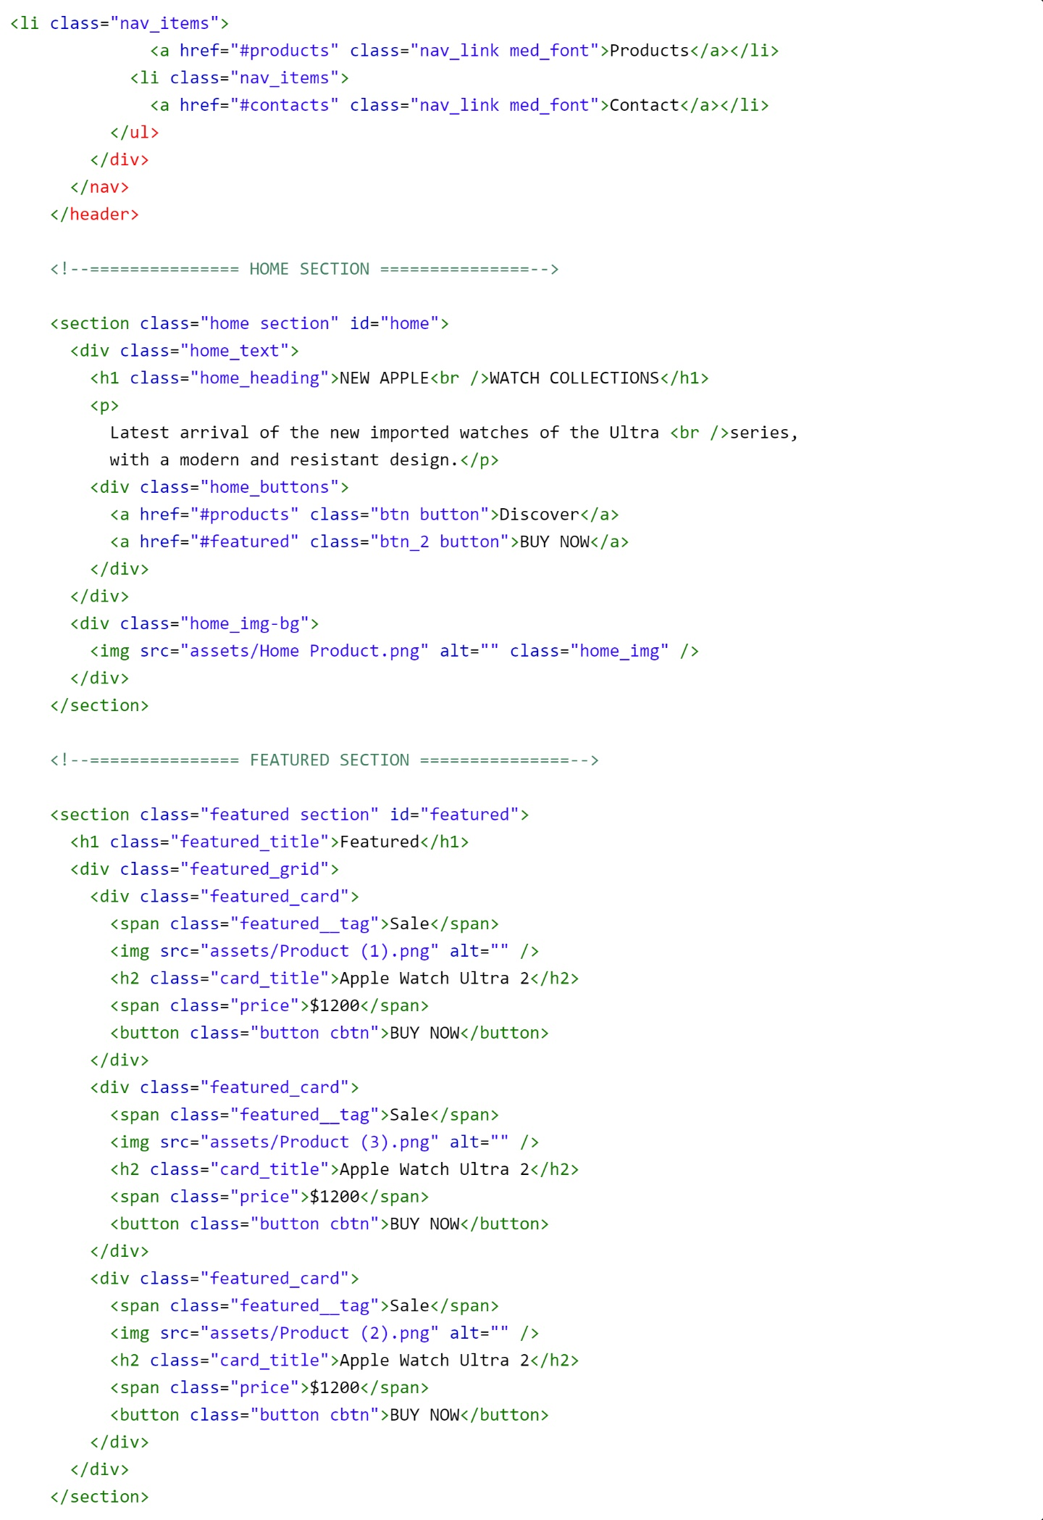
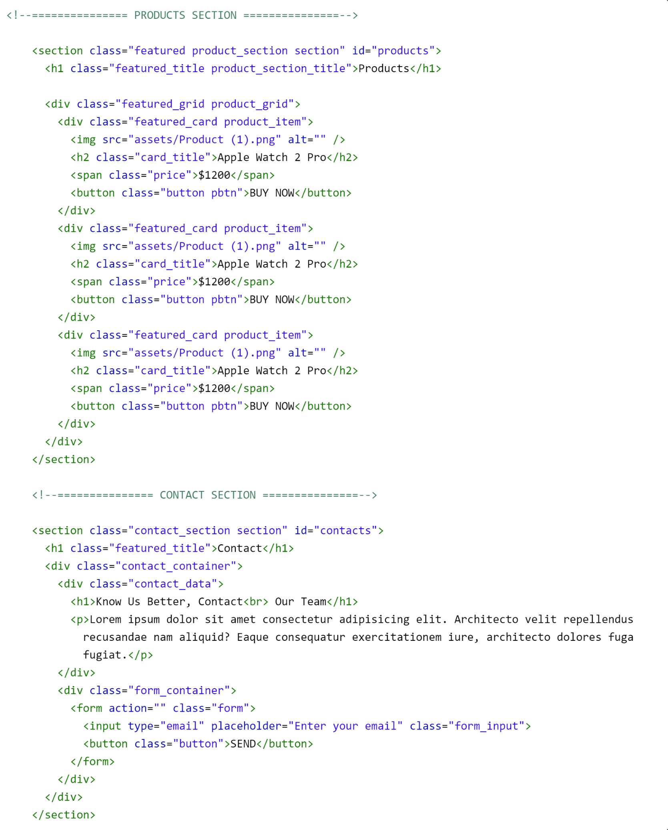
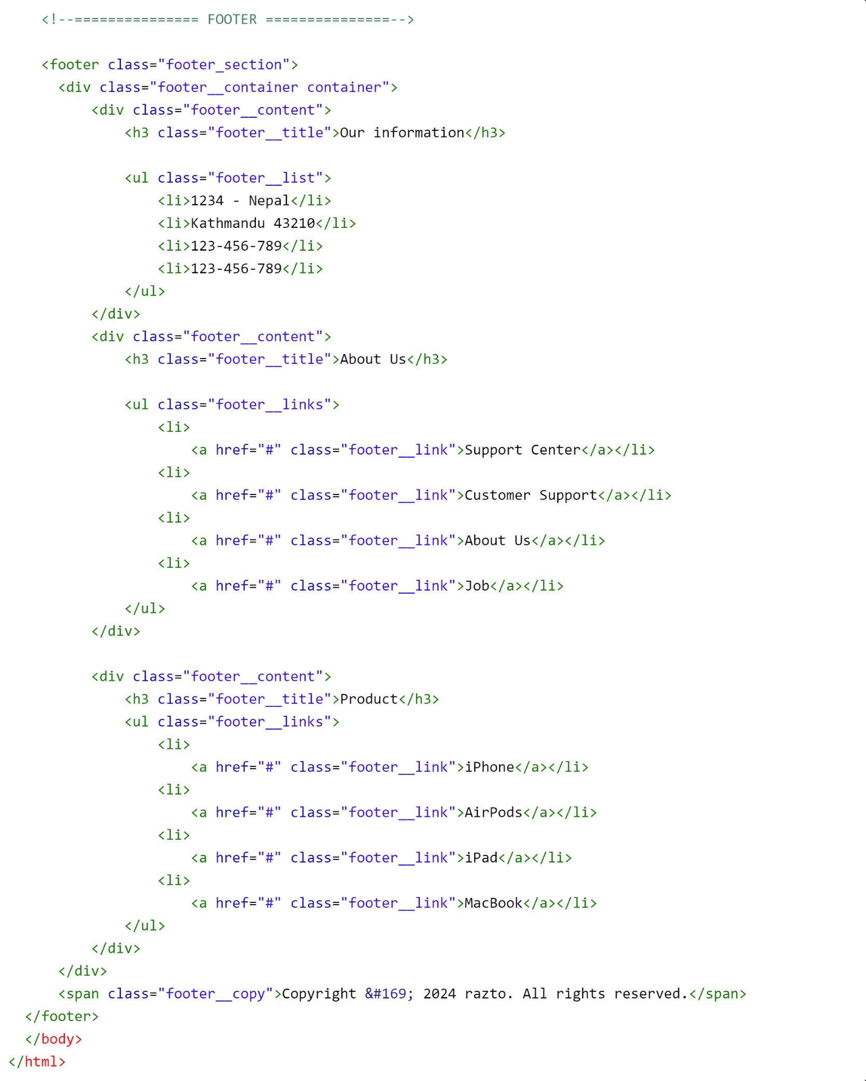

CSS for styles.css

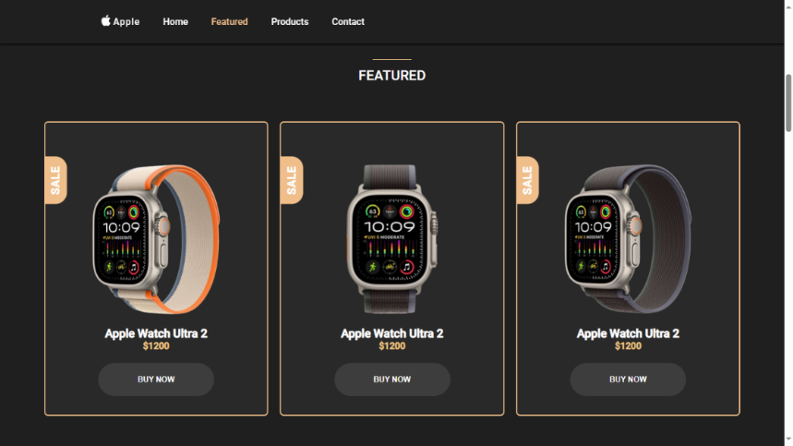
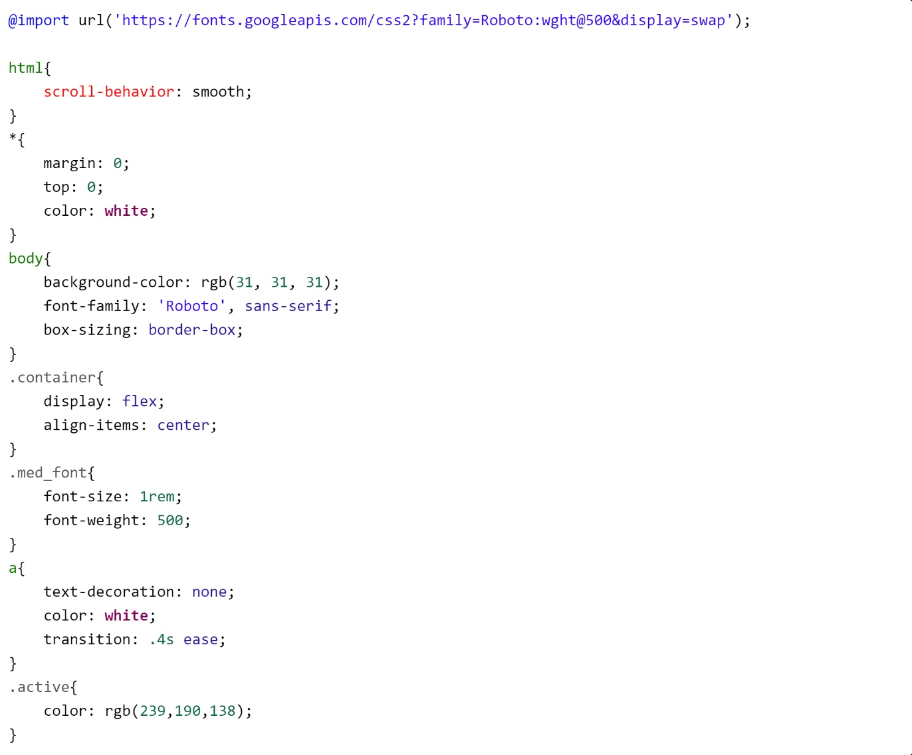
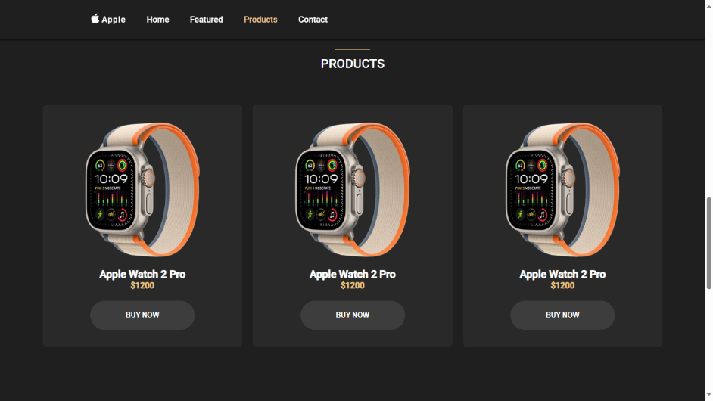
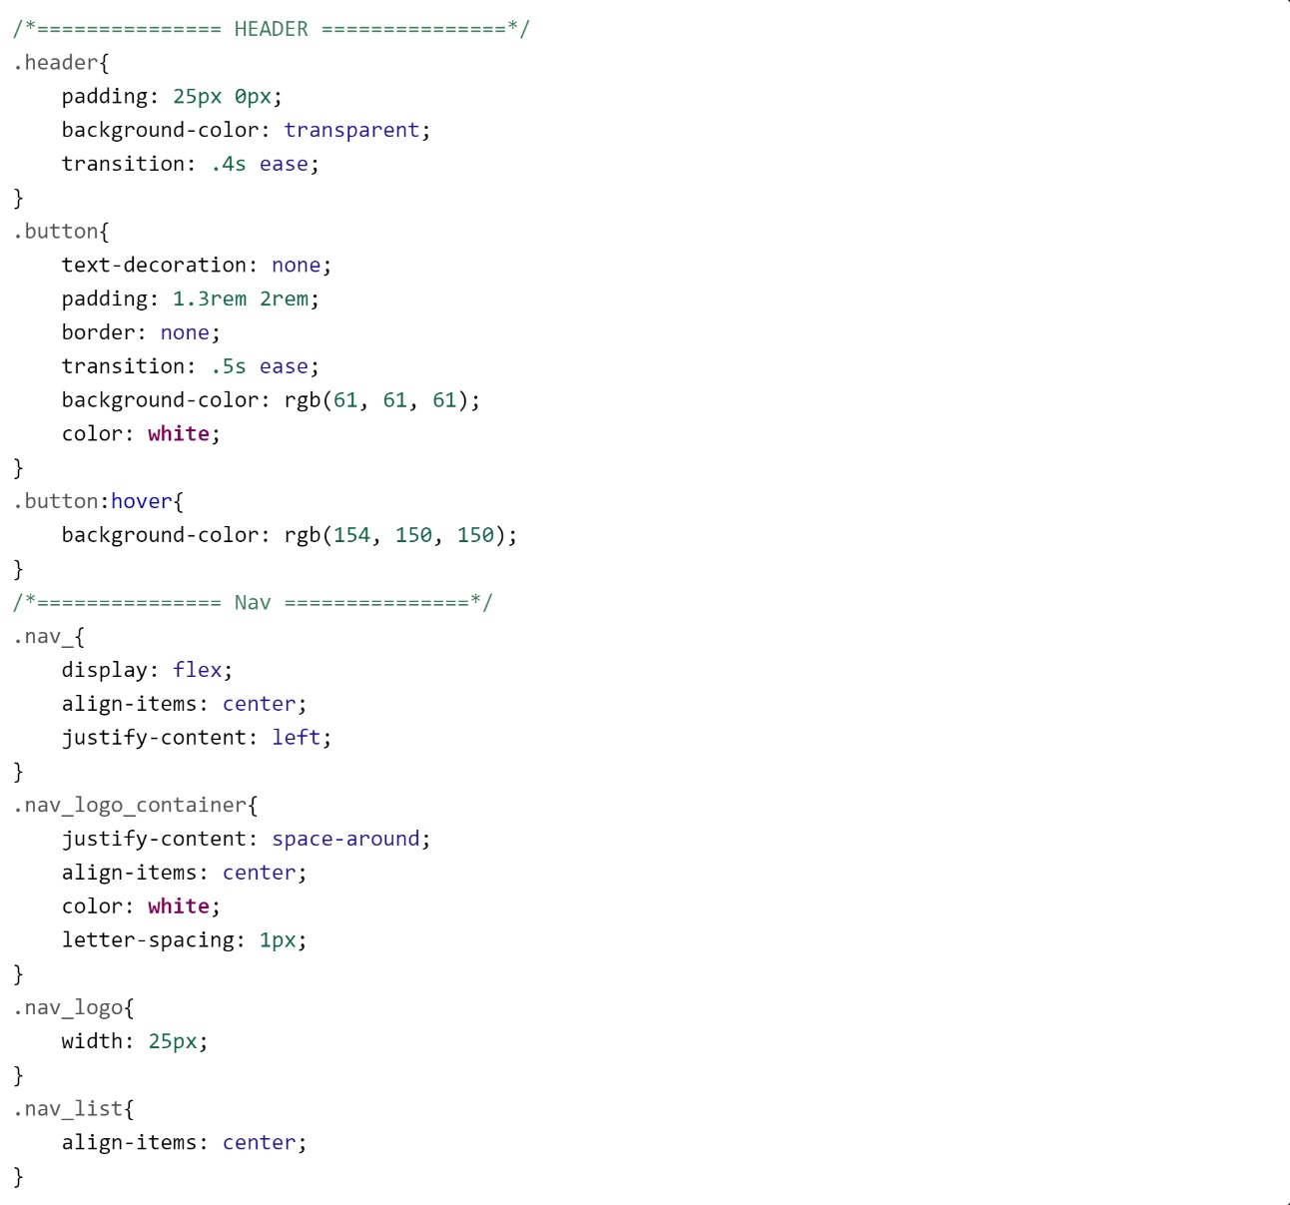
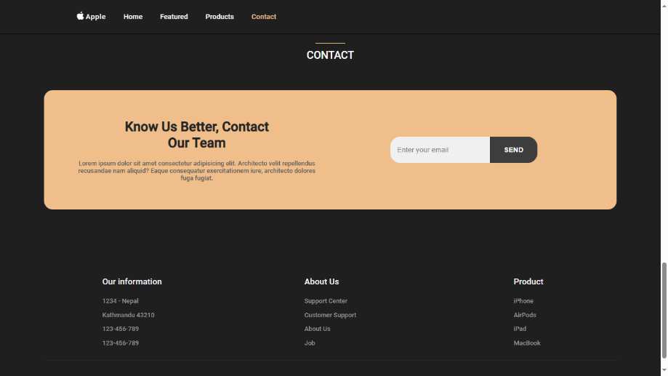
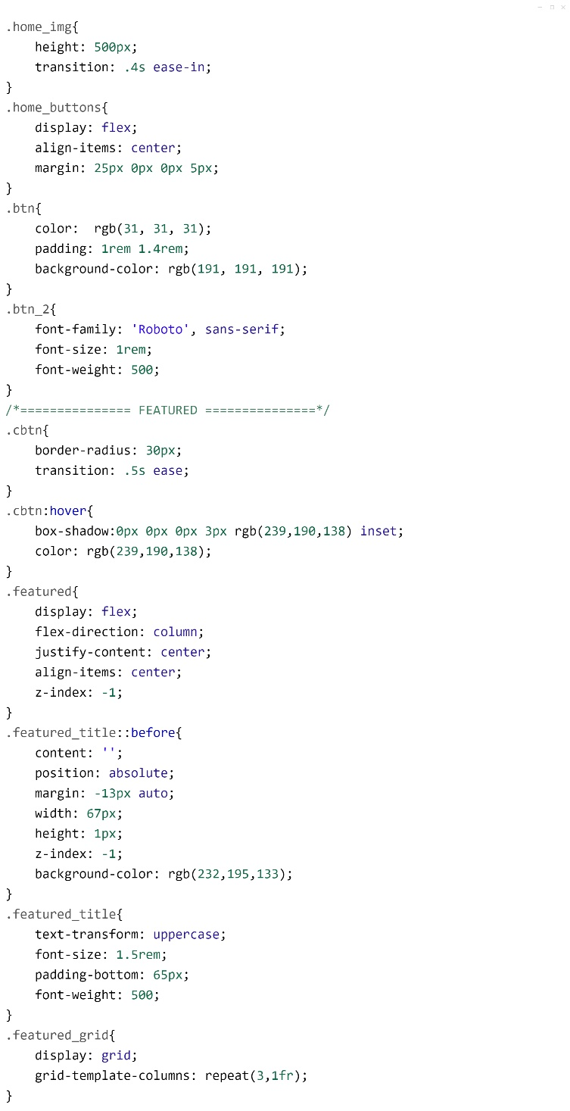
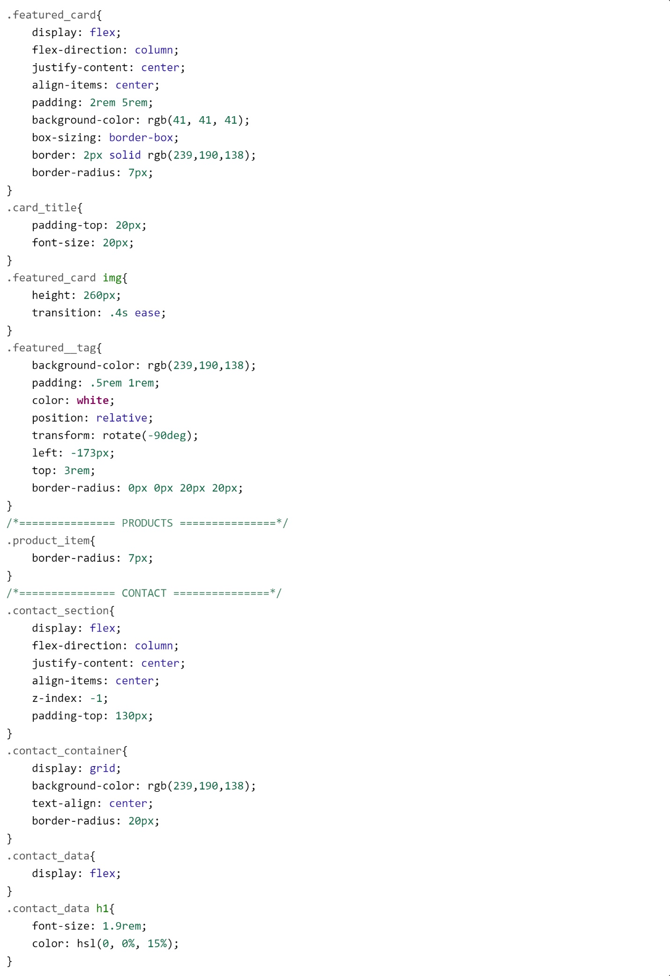
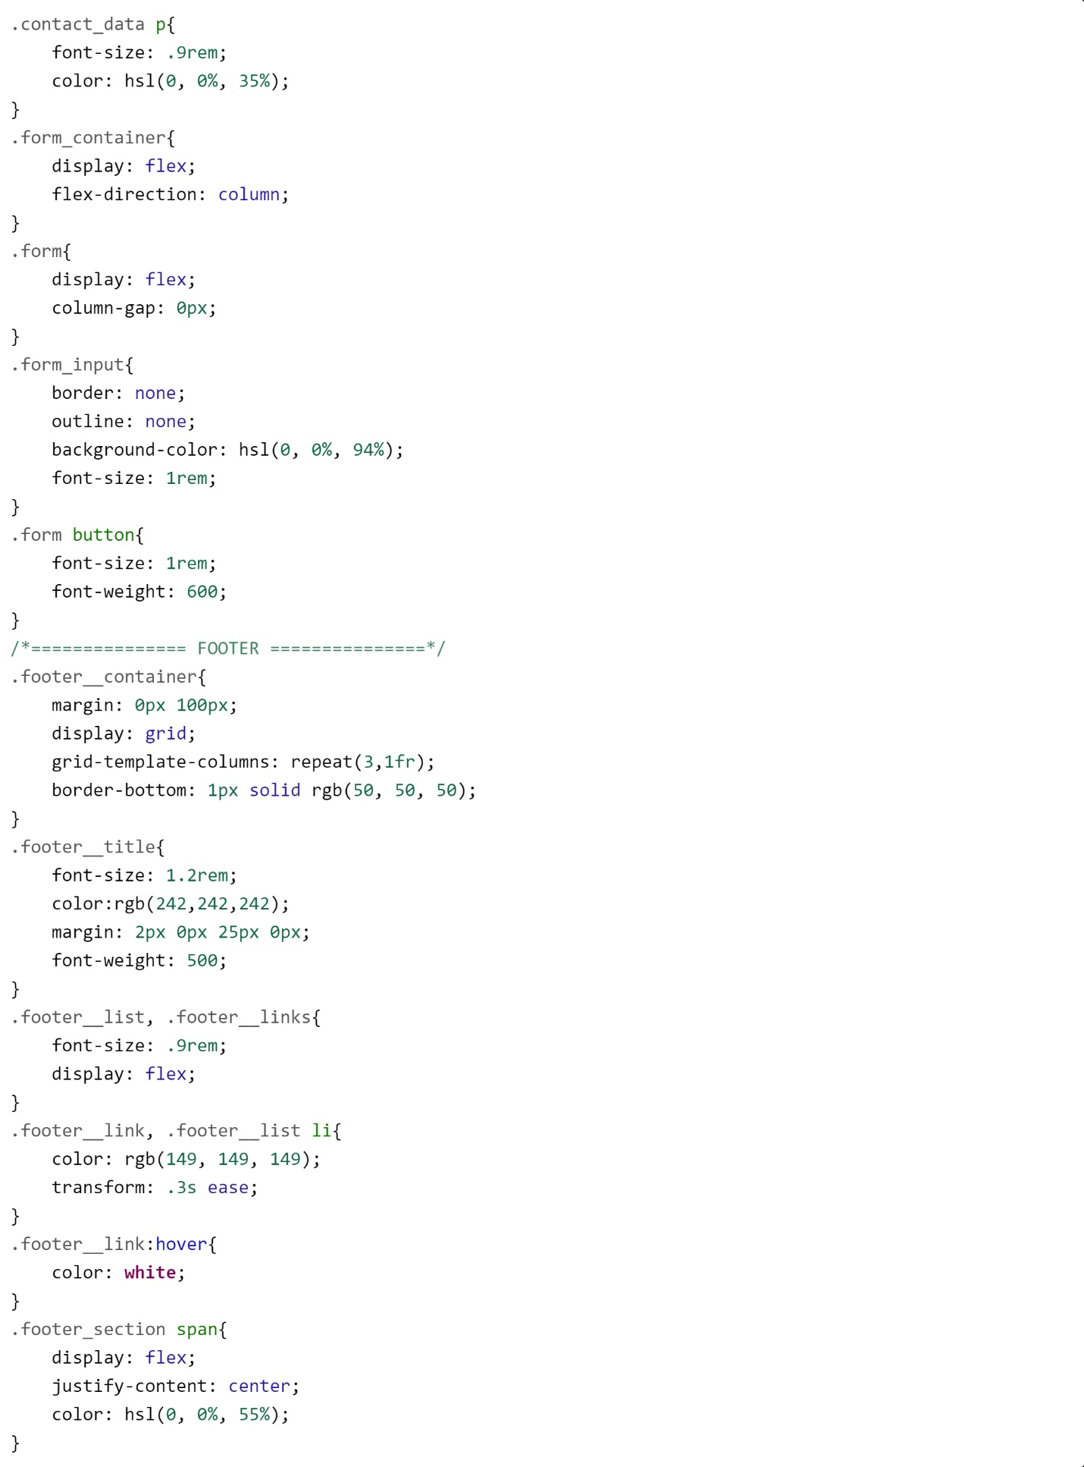

Conclusion

I would like to thank NEB for providing us such a wonderful opportunity to implement our classroom learning into real time application. The project was completed in 7 days where I have used HTML, CSS, JS & Php. Hence it is a demo website I have only worked on using the html components rather than building something useful too. My Web Pages are not responsive & is only suitable viewing on computers. Improvements can be made like making websites responsive & working more on the look & feel of pages using more CSS. External style sheet is better while building a project. More JavaScript make web pages more interactive & attractive. Also web pages are more attractive & good when they are dynamic. So, PHP, ASP can be used to make it dynamic.

REFERENCES
- https://en.wikipedia.org/
- https://www.technopedia.com/definition/1234/internet
- https://www.w3schools.com/html/
- https://www.w3schools.com/css/

