ARCHITECTURE BLUEPRINT | EPAM AI Capstone Project

Sentinel AI

Technical Architecture & Design Document
Author: Rasul Abilmazhinov
Date: May 2026
Version: 4.2 (MCP Integration)

This document accompanies the Sentinel AI capstone submission. It complements the Executive Summary by providing the technical depth required for code review, architectural critique, and reproducibility.

1. System Overview
Sentinel AI is a multi-agent, retrieval-augmented assistant for corporate use. It answers questions about company policies and Kazakhstani legislation by combining three sources of knowledge — an internal document store, external HTTP data sources, and the reasoning ability of a large language model — orchestrated through a deterministic LangGraph state machine.
The system is composed of five independent processes (one frontend, one backend, three MCP servers) and four shared infrastructure services (PostgreSQL, Redis, Ollama, external HTTPS APIs). The diagram below shows their relationships at a high level.
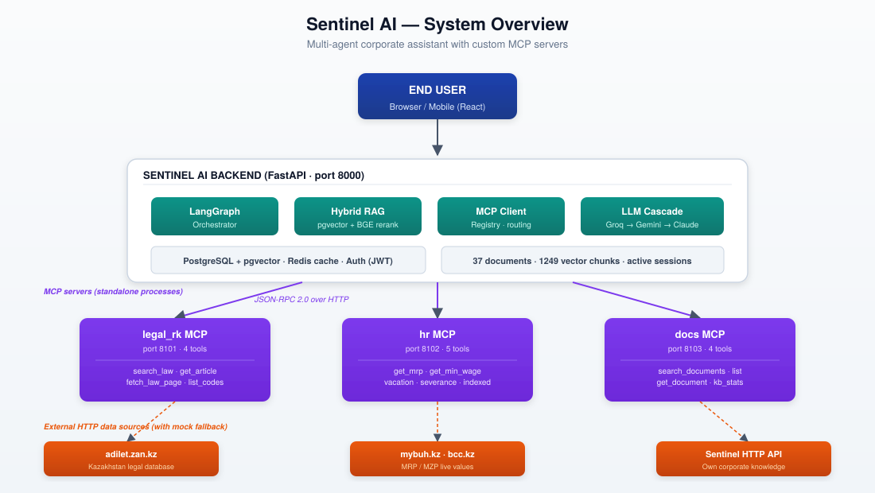
Figure 1.1 — High-level component map of Sentinel AI

2. Component Inventory
Each component in the system has a single, well-defined responsibility. The table below enumerates every component, its role, and the language / framework used.
Component | Role | Tech
Frontend | Chat UI, document upload, training dashboard | React, Zustand, Recharts
FastAPI backend | HTTP API, auth, request routing, RAG pipeline | Python 3.11, FastAPI 0.111
LangGraph | State graph for multi-step reasoning | Python (langgraph)
Knowledge base | Document store, chunks, embeddings | PostgreSQL + pgvector
SentenceTransformer | Bi-encoder for semantic search | paraphrase-multilingual-MiniLM-L12-v2
BGE Reranker | Cross-encoder for re-ranking top-K results (optional) | BAAI/bge-reranker-v2-m3
MCP Client | JSON-RPC 2.0 client with discovery & health checks | Python (httpx)
MCP server: legal_rk | Bridge to adilet.zan.kz, 4 tools | Python, standalone process
MCP server: hr | HR computations + bridge to mybuh.kz, 5 tools | Python, standalone process
MCP server: docs | Bridge to own Sentinel HTTP API, 4 tools | Python, standalone process
Auth subsystem | User registration, login, JWT sessions | bcrypt + secrets.token_hex
Cache layer | Response cache with TTL | Redis (or in-memory LRU)
LLM cascade | Sequential / parallel fallback across providers | Groq, Gemini, Anthropic, Ollama

3. Technology Stack & Rationale
Technology choices were guided by three principles: free / open-source tier availability, observability, and zero vendor lock-in. The table below documents every key dependency and the alternative considered.
Layer | Chosen | Why this · not that
Backend language | Python 3.11 | Best ecosystem for ML / LangChain / LangGraph. Considered: TypeScript (less mature for RAG)
Web framework | FastAPI 0.111 | Async, OpenAPI generation, Pydantic validation. Considered: Django (too heavy)
Orchestration | LangGraph | Deterministic state graph, full debug visibility. Considered: CrewAI / AutoGen (autonomous role-play; less observable)
Vector store | PostgreSQL + pgvector | Single store for everything (ACID). Considered: Pinecone (cost, latency); Chroma (less mature ops)
Bi-encoder | multilingual MiniLM-L12-v2 | Multilingual, fast on CPU. Considered: OpenAI ada-002 (paid, English-biased)
Cross-encoder | BGE-reranker-v2-m3 | Top performer on Russian texts. Considered: cohere/rerank (paid)
Primary LLM | Groq Llama-3.3-70B | Free, ~400 ms TTFB. Considered: OpenAI GPT-4 (paid, slower)
Fallback LLM | Gemini 2.0 Flash, Claude Haiku 4.5, Ollama llama3 | Provider diversity; offline option (Ollama)
MCP protocol | Custom JSON-RPC 2.0 implementation | Zero SDK dependency, full control. Considered: official mcp-python SDK (less transparent)
Auth | bcrypt + JWT sessions in DB | Industry standard. Considered: OAuth (overkill for single-org)
Cache | Redis with in-memory fallback | Free, common pattern. Considered: Memcached (less feature-rich)
Frontend | React + Zustand | Simple state, no Redux boilerplate. Considered: Vue / Svelte (less talent pool)

4. Data Flow — Request Lifecycle
The figure below traces a single user query end-to-end. The example shown is «Какой МРП в 2026 году?» (« What is the MRP for 2026? »), which triggers the hr MCP server.
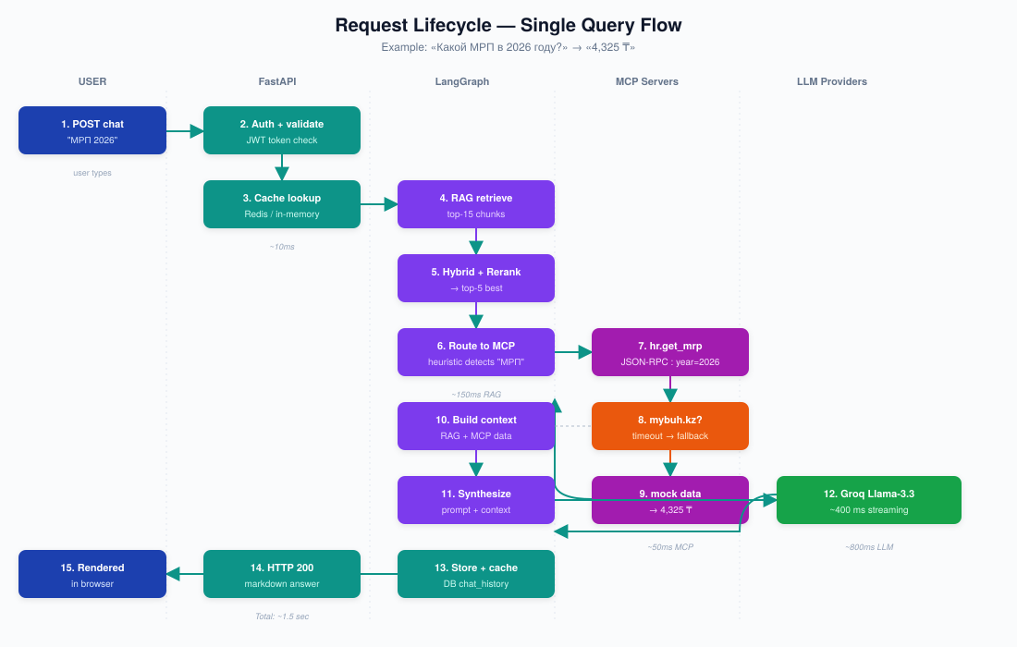
Figure 4.1 — Request lifecycle across five swim-lanes (User → FastAPI → LangGraph → MCP → LLM)

Key timings (cache miss, all features enabled)
- Auth + cache lookup: ~10 ms
- RAG retrieve (top-15): ~150 ms (PostgreSQL + bi-encoder)
- Hybrid + rerank → top-5: ~30 ms (skipped if reranker disabled)
- MCP heuristic routing + call: ~50 ms (mock fallback) / 300-2000 ms (live HTTP)
- LLM synthesis (Groq Llama-3.3): ~400-800 ms streaming
- Persist + return: ~20 ms (PostgreSQL chat_history insert)
- Total end-to-end: ~1.5 s typical, ~3 s with rerank on first load

5. MCP Tool Selection & Rationale
Three custom MCP servers were chosen to demonstrate three distinct integration patterns. Each is launchable as an independent process, externally consumable by any MCP-compatible client (Claude Desktop, other LangGraph apps, custom clients).

5.1 legal_rk — bridge to a public website (no API)
Tool | Purpose
search_law(query, limit) | Free-text search over adilet.zan.kz via DuckDuckGo site: filter; HTML scraping with BeautifulSoup; fallback to curated mock articles
get_article(code, num) | Retrieve a specific article of TK / GK / UK / KoAP RK by code & number
fetch_law_page(url) | Download and extract main text from any adilet.zan.kz page (4000 chars max)
list_codes() | Enumerate supported codes and their aliases

Pattern: HTTP scraping bridge. Demonstrates how to wrap a service that has no public API — common in enterprise contexts.

5.2 hr — computational tools + bridge
Tool | Purpose
get_mrp(year) | Monthly Calculation Index (МРП) for a given year
get_min_wage(year) | Minimum monthly wage (МЗП)
calculate_vacation_days(category) | Vacation days per TK RK Article 88 (base 24 + bonuses)
calculate_severance(salary, reason) | Severance pay per TK RK Article 131
get_indexed_amount(mrp_count, year) | Convert an МРП-denominated value into tenge

Pattern: Computational tool. Demonstrates that MCP is not limited to retrieval — it is any function the agent can call — including pure calculations.

5.3 docs — bridge to Sentinel AI's own backend
Tool | Purpose
search_documents(query) | Hybrid RAG search via Sentinel's own /api/kb/chat/debug endpoint
list_documents(category) | Enumerate all documents, optionally filter by category
get_document(doc_id) | Retrieve a single document's full content (up to 10000 chars)
get_kb_stats() | Total document count, chunk count, breakdown by category

Pattern: Self-bridge / inversion. The same backend that orchestrates the chat is also exposed as MCP — making Sentinel itself composable in larger AI ecosystems.

6. Agent Roles in LangGraph
LangGraph's state graph executes the following nodes for every chat query. Each node has a single responsibility, returns updated state, and is independently testable.
Node | Input → Output | Responsibility
rewrite_query | raw → normalised | Strip whitespace, expand abbreviations (МРП → Месячный расчётный показатель)
search_kb | query → top-15 chunks | Bi-encoder search over pgvector
hybrid_rerank | chunks → reranked chunks | Semantic + keyword score fusion; optional BGE cross-encoder
route_to_mcp | query → list of tool calls | Heuristic routing (keywords) to select MCP tools
call_mcp | tool calls → tool results | Parallel JSON-RPC calls to MCP servers
search_web | query → web snippets | DuckDuckGo HTML scraping if RAG confidence is low
synthesize | context → markdown answer | LLM call (Groq → Gemini → Claude → Ollama cascade)
persist | answer → DB | Save to chat_history; update cache

7. Storage Schema
All persistent state lives in a single PostgreSQL database with eight tables. The pgvector extension enables semantic search over the chunks table.
Table | Key columns | Purpose
users | id, username, password_hash, role | Authentication
sessions | token, username, expires_at | JWT session storage
documents | id, name, category, size | Uploaded documents metadata
chunks | id, doc_id, content, vector | Text chunks with embeddings (pgvector)
chat_history | id, session_id, question, answer | Persistent chat log
training_runs | id, dataset, status, best_acc | ML training run records

Why a single relational DB rather than a vector-specific service: a) simpler operations (one backup, one connection pool); b) ACID guarantees on user/session writes; c) pgvector approaches dedicated vector DBs in performance at this scale (<10k documents).

8. External Integrations & Fallback Strategy
Every external dependency is wrapped behind a bridge with a deterministic fallback. The system never silently fails — if a live source is down, the user receives a clearly-labelled response from the curated mock store.
Source | Used by | Fallback when down
Groq API | Primary LLM | Parallel: Gemini 2.0 Flash, Claude Haiku 4.5, then Ollama llama3
adilet.zan.kz | legal_rk MCP | Curated mock articles of TK / GK / UK / KoAP RK
DuckDuckGo HTML | legal_rk + web search | Mock data + RAG-only mode
mybuh.kz / bcc.kz | hr MCP (МРП/МЗП) | Built-in МРП/МЗП table 2020-2026
Sentinel HTTP backend | docs MCP | Error returned with explicit instruction to start backend
Redis | Response cache | In-memory LRU, capped at 500 entries
Ollama | Local LLM fallback | no-op if not installed

9. Security & Authentication

9.1 Password storage
- bcrypt with cost factor 10 (≈ 100 ms per hash). Fallback to sha256+salt if bcrypt is not installed (development only).
- Passwords never logged, never returned in API responses (always stripped via _safe_user filter).

9.2 Sessions
- JWT-like tokens stored in the sessions table with TTL (default 7 days, configurable via TOKEN_EXPIRE_HOURS env).
- Token = 64 hex chars from secrets.token_hex(32). Validated on every protected endpoint via Bearer header.
- Logout deletes the token row immediately (no JWT signature reuse risk).

9.3 Defence in depth
- All API tokens (Groq, Gemini, Anthropic) live in .env, never in source code. .env is gitignored.
- MCP HTTP endpoints bind to 127.0.0.1 by default — no network exposure unless explicitly configured.
- PostgreSQL is accessed only from the backend; no direct DB-to-frontend channel.

10. Deployment Topology
Sentinel AI runs as five independent processes on a single host (with optional separation for production). The figure below shows the dev-time layout.
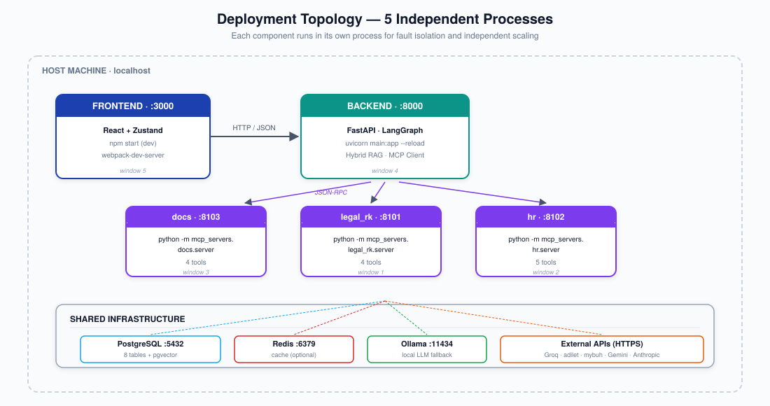
Figure 10.1 — Five-process deployment with shared infrastructure

Startup order
- Start PostgreSQL and (optionally) Redis & Ollama first.
- Start three MCP servers on ports 8101 / 8102 / 8103.
- Start the main backend (uvicorn :8000). It discovers MCP servers during startup; missing servers are marked unhealthy but do not block startup.
- Start the frontend (npm start :3000). Browser connects to backend.

Why five processes (not one)
- Fault isolation: an MCP server crash does not bring down the chat.
- Independent scaling: a heavily-used hr server can run with more workers without affecting legal_rk.
- Compliance with the MCP specification: stdio-launched servers can be plugged into Claude Desktop or other clients without modification.
- This is exactly the architecture pattern that the EPAM expert recommended: «build custom MCP wrappers for existing HTTP APIs ... developed independently rather than configured in orchestrators».

11. Trade-offs & Alternatives Considered
Every architectural decision came with alternatives. The table below records what was rejected and why, so the design can be revisited as requirements evolve.
Trade-off | Chosen | Rejected alternative
Multi-agent framework | LangGraph (state graph) | CrewAI / AutoGen — designed for autonomous role-play; harder to audit. Sentinel's enterprise context demands explicit state, not emergent behaviour.
MCP implementation | Custom JSON-RPC code | Official mcp-python SDK — more deps, less visibility. Custom code is 460 LoC and fully under our control.
MCP transport | Both stdio and HTTP | stdio only — harder to debug; HTTP only — diverges from canonical MCP.
Bridge strategy | Real HTTP → mock fallback | Mock only — looks unprofessional; real only — fails when source is down.
LLM strategy | Cascade across 4 providers | Single LLM — single point of failure. Cascade adds 50 LoC and removes a class of outages.
Frontend state | Zustand | Redux — boilerplate-heavy for a 5-screen app. Zustand is < 1 KB.
Vector store | pgvector | Pinecone (paid + latency); Chroma (immature ops); FAISS (no persistence).
Reranker | BGE-v2-m3 (optional) | OpenAI / Cohere paid rerankers. BGE is competitive and free.

12. Conclusion
Sentinel AI is built on the conviction that an enterprise AI assistant must be observable, reversible, and ownable by the team that runs it. Every architectural decision — from the choice of LangGraph over CrewAI, to the hybrid bridge pattern in each MCP server, to the parallel LLM fallback — is in service of those three properties.The system is intentionally modest in scope. It does not attempt to replace human judgement; it accelerates information lookup. It does not autonomously act; it answers questions. It does not lock the company into any single vendor; every integration has a documented fallback. These constraints are features, not limitationsThis blueprint is the working specification of the system as of May 2026. It is intended to be a living document — as new MCP servers are added, as the evaluation harness grows, and as the next iteration of Critic / Langfuse-based observability lands, this document will be updated alongside the code.« Every architectural choice deliberate, observable, and reversible. »

