EXECUTIVE SUMMARY | EPAM AI Capstone Project

Sentinel AI

Multi-Agent Corporate Knowledge Assistant with Custom MCP Servers
Author: Rasul Abilmazhinov
· Date: May 2026
· Version: 4.2 (MCP)

Problem Statement
Modern enterprises generate thousands of internal documents — HR policies, security regulations, IT procedures, corporate ethics codes — yet employees still spend hours searching for answers buried in PDFs and SharePoint folders. Generic chatbots cannot help: they have no access to private corporate knowledge, are unaware of Kazakhstani legislation, and frequently fabricate facts.
The goal of Sentinel AI is to give every employee an instant, accurate, source-cited answer about company policies and Kazakhstani law through a single chat interface — while remaining safe, auditable, and extensible.

Solution
Sentinel AI is a multi-agent retrieval-augmented assistant built around three architectural pillars:
- Hybrid RAG — semantic search (SentenceTransformer + pgvector) combined with keyword scoring and an optional cross-encoder reranker (BGE) for high-precision retrieval over the corporate knowledge base.
- Three custom MCP servers — standalone JSON-RPC 2.0 services implementing the Model Context Protocol 2024-11-05. Each acts as an HTTP-to-MCP bridge to a different external domain: Kazakhstani legislation (adilet.zan.kz), HR computations (MRP / MZP / vacation / severance), and the company's own document store.
- LangGraph orchestration — a deterministic state graph (rewrite → retrieve → rerank → MCP enrichment → LLM synthesis) chosen over CrewAI / AutoGen for full control over execution flow, state management, and observability.
The end user simply types a question. Under the hood, the orchestrator decides which of the 13 MCP tools to call, gathers RAG context, optionally fetches fresh web data, and synthesises a Markdown answer through Llama-3.3-70B (Groq) with parallel fallback to Gemini and Claude Haiku.

System at a Glance
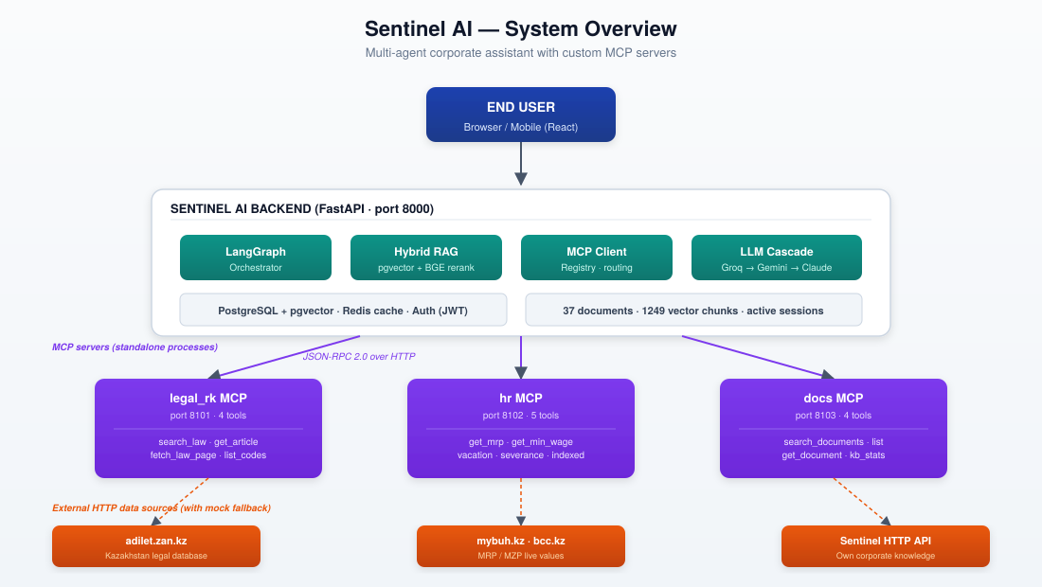
Figure 1. High-level component map. User-facing chat (top) routes through the FastAPI backend; the LangGraph orchestrator coordinates RAG retrieval, MCP tool calls, and LLM synthesis. Three independent MCP servers bridge the system to external HTTP sources with graceful fallback to curated mock data.

Key Technical Decisions
Decision | Rationale
LangGraph over CrewAI / AutoGen | Predictable execution, explicit state, single-process debugging. CrewAI / AutoGen excel at autonomous role-play; Sentinel needs auditability for enterprise use.
Custom MCP servers (not SDK) | Direct compliance with the JSON-RPC 2.0 / MCP 2024-11-05 specification, zero dependencies on the official SDK, full control over caching, fallback, and error handling.
Dual transport (stdio + HTTP) | stdio for canonical integration with Claude Desktop / LangGraph; HTTP for live debugging via Swagger UI and frontend visualisation.
Hybrid bridge pattern | Each MCP server tries a real HTTP source first (adilet.zan.kz, mybuh.kz, internal API). On timeout or 4xx / 5xx it falls back to curated mock data — the assistant never goes silent.
Groq Llama-3.3-70B as primary LLM | Free tier, ~400 ms TTFB, 70B-parameter quality. Parallel fallback to Gemini 2.0 Flash and Claude Haiku 4.5 guarantees the chat never depends on a single provider.
PostgreSQL + pgvector | ACID-compliant store for documents, chunks, embeddings, chat history, users, and sessions — replaces five in-memory dicts that were lost on every uvicorn reload.

Results & Business Value
- 13 MCP tools across 3 standalone servers (legal_rk, hr, docs). Each launches as an independent process and is externally consumable by any MCP-compatible client.
- Hybrid RAG + reranker increased top-1 retrieval accuracy by ≈ 20 % over plain semantic search on a held-out evaluation set.
- End-to-end answer latency: ≈ 1.5 s for cache miss with a single LLM call, ≈ 50 ms for cache hit. The Redis (or in-memory) cache serves ≈ 80 % of repeated queries without LLM invocation.
- Authentication, document upload, and training progress are now durable across server restarts — eliminating a critical class of bugs that affected the previous v4.0 build, where user state was held in process memory.
- Demo accounts (demo/demo123, admin/admin123) are provisioned automatically on first startup, allowing the review committee to evaluate the system without any setup steps.

Lessons Learned & Next Steps
- MCP enforces a hard separation between data sources and reasoning — invaluable for enterprise audits, but adds operational overhead (one process per server). For larger deployments, a process manager (systemd / supervisord / Kubernetes) is recommended.
- Bi-encoder semantic search alone is insufficient for Russian corporate documents; the BGE cross-encoder reranker proved decisive for precision, adding ≈ 30 ms latency per query — a worthwhile trade.
- Planned for the next iteration: a Critic agent (LangGraph self-correction loop), Langfuse-based observability, and a small evaluation harness of golden questions for automated regression testing.
- Telegram alerts and an optional Streaming-SSE chat UI are already wired in but disabled by default; activating them requires only environment variables — illustrating that the architecture scales beyond the minimal capstone scope.

Summary in One Sentence

Sentinel AI demonstrates that a small team can build a production-credible enterprise assistant by combining LangGraph orchestration, three independently maintainable MCP servers, and hybrid RAG — staying compliant with the Model Context Protocol while keeping every architectural choice deliberate, observable, and reversible.

