GRC360 Documentation
  - User guide, administration and technical reference
Strativu
October 2026 release
Table of Contents

About this guide

GRC360 Documentation
GRC360 is Strativu’s platform for governance, risk and compliance. One system holds the organisation’s assets, risks, controls, policies, compliance obligations, third parties, projects and incidents, and links them to each other, so a risk can be traced to the control that treats it, the policy behind that control and the framework requirement it satisfies.
This guide describes the product as built in the October 2026 release (frontend GRC_Frontend_Code main, backend GRC_Backend_Code develop). Every screen, field and rule in it was taken from the code and checked against a running instance. All screenshots use fictional demo data.
GRC360 Command Center

Who should read what
You are | Start with | Then
New to GRC360 | What is GRC360 | Key concepts, Signing in
A risk, compliance or control owner | Working with registers | The module you work in under Module reference
Setting up GRC360 for your organisation | First-time setup | Administration
An auditor | Relationship map | Preparing for an audit, System Log
A developer or installer | Technical reference | Installation and deployment

Contents

Part 0 — Introduction
- What is GRC360
- Key concepts
- Navigation and layout
- Working with registers
- Permissions and access, from the user’s side

Part 1 — Getting started
- Signing in and sessions
- Your profile, account, notifications and support
- First-time setup for a new organisation

Part 2 — Module reference
Module | Pages
Command Center | Dashboard
Governance Hub | Coverage · Issues · Objectives (+ Audits)
Organization Hub | Users · Departments · Groups
Third Parties | Vendors · Service Agreements
Asset Management | Assets (+ Reviews) · Data Flows
Control Center | Controls (+ Audits, Issues, Maintenances) · Policies & Standards (+ Reviews) · Policy Exceptions · Continuity Plans (+ Audits, Tasks)
Risk Management | Asset Risks · Third Party Risks · Business Risks (each + Reviews) · Risk Exceptions
Compliance Hub | Compliance Packages (+ Items) · Compliance Analysis · Obligations · Compliance Exceptions · External Audit Findings
Operations Center | Projects (+ Tasks, Expenses) · Security Incidents (+ Stages)
Trust Center | Public security posture
Integrations & Automation | Built and planned integrations
Settings | Authentication · About System · System Health · Updates · System Log · Clear Data

Part 3 — How the modules work together
- Relationship map
- Scenario: a risk assessment cycle
- Scenario: preparing for an ISO/IEC 27001 audit
- Scenario: onboarding a new vendor
- Scenario: handling a security incident
- Scenario: the annual policy review
- Scenario: business continuity planning and testing

Part 4 — Administration
Administration guide: users, groups and permissions; authentication and SSO; e-mail, webhooks and notifications; sessions and security; system maintenance.

Part 5 — Technical reference
Technical reference: architecture, installation and deployment, API, data model, security, operations, development.

Appendices
- Glossary
- Permission keys
- Status and Dynamic Status rules
- Notifications and scheduled jobs
- CSV import and export
- Known issues

Keeping this guide current
The screenshots and demo data are reproducible. With a local frontend and backend running:
cd doc/guide/tools
python3 seed_demo.py # fictional demo data, safe to run repeatedly
node screens.cjs --out /tmp/grc-shots # every screenshot in this guide (needs Playwright)
python3 convert.py /tmp/grc-shots ../images
python3 check_links.py # every link and image resolves
Each page follows the same template, so a changed screen means updating one page and re-running the scripts.

Part 0 — Introduction

What is GRC360
GRC360 is a web application for running an organisation’s governance, risk and compliance (GRC) programme in one place. It replaces the usual mix of spreadsheets, shared folders and e-mail threads with linked registers: each asset, risk, control, policy, compliance requirement, vendor, project and incident is a record, and records point to each other.
The method follows the ERAMBA model of GRC registers: a risk is treated by controls, policies, projects or exceptions; a control satisfies requirements in one or more compliance packages; and every register keeps its own reviews, audits and history.
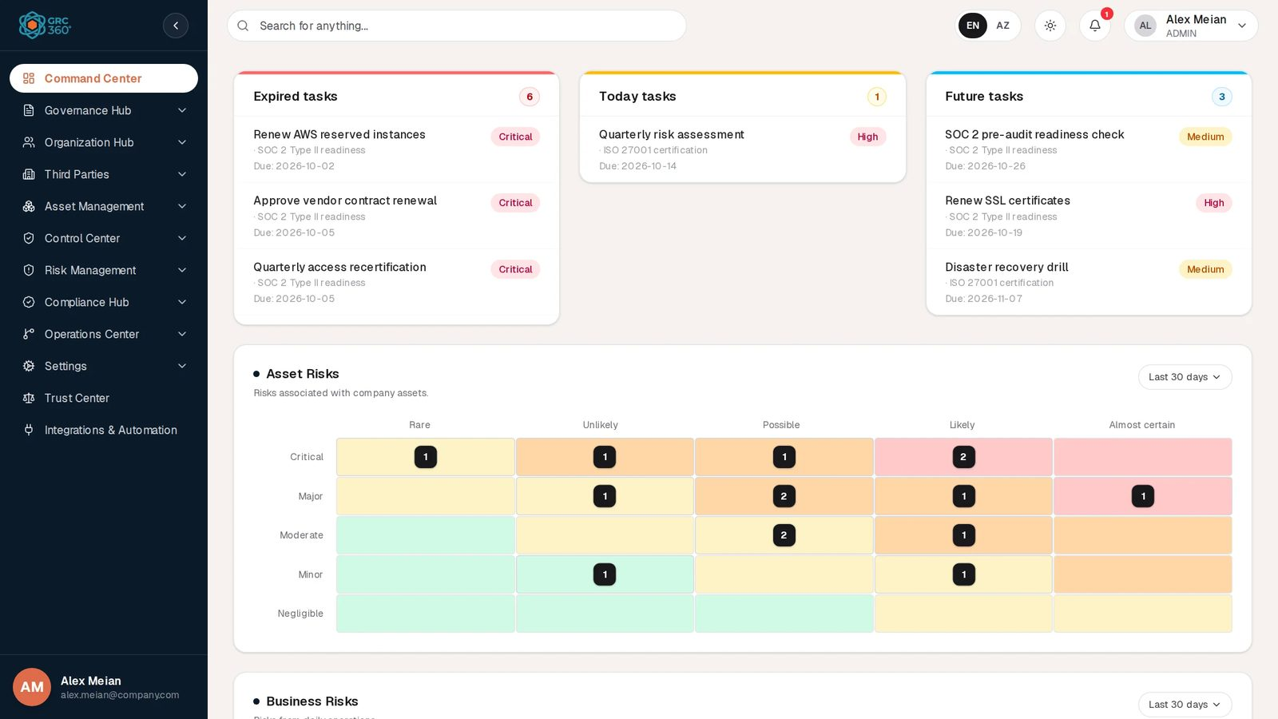
The GRC360 workspace

What you can do with it
Area | What GRC360 gives you | Module
Overview | Your expired, today’s and upcoming tasks, and heat maps of asset, business and third-party risks | Command Center
Scope and direction | What the programme covers, its objectives with periodic audits, and governance issues | Governance Hub
People | Users, departments and groups, with permissions per page and per action | Organization Hub
Suppliers | Vendors and their service agreements, with expiry warnings | Third Parties
Assets | The asset inventory, periodic asset reviews and data flows, including GDPR questions | Asset Management
Controls | Internal controls with scheduled audits, issues and maintenances; policies and standards with reviews; policy exceptions; business continuity plans | Control Center
Risk | Asset, third-party and business risk registers, scored on a likelihood × impact matrix against your risk appetite, with treatments and exceptions | Risk Management
Compliance | Compliance packages (frameworks and their requirement items), compliance analysis, legal obligations, compliance exceptions and external audit findings | Compliance Hub
Delivery | Security projects with tasks and expenses; security incidents with stages | Operations Center
Transparency | A public page describing your security practices | Trust Center
Platform | Sign-in (local passwords or LDAP / Active Directory), e-mail, system health, the system log | Settings, Integrations & Automation

How the pieces fit
The full map, with every link and where it is shown, is in How the modules work together.

Principles you will notice
- One record, many uses. A control is written once and linked to every risk it treats and every requirement it satisfies. Counts in the grids (for example Asset Risks: 15 on a control) are clickable and show the linked records.
- The system computes what it can. Besides the Status you choose, most records show a Dynamic Status the system works out from dates and linked records, such as an expired review or a risk above appetite. See Key concepts.
- Every change is recorded. Each record has an Activity Log that merges comments with the history of who changed which field, and the System Log records actions across the tenant.
- Buttons stay visible. If you lack a permission, the button is shown locked and clicking it lets you request access. See Permissions and access.
- Two languages. The interface can be switched between English and Azerbaijani at any time.

Deployment models
GRC360 runs as a multi-tenant cloud service, where every customer organisation is an isolated tenant, and can also be installed on the customer’s own servers with Docker Compose. See Installation and deployment.

About this guide
All screenshots show fictional demo data in a demo tenant with the users Alex Meian (Admin), Sara Johnson, Mike Brown and Olivia Reed (Read Only). Names of companies and people in the examples are invented.

Key concepts
This page defines the terms used throughout GRC360 and this guide. The full list is in the Glossary.

Tenant
A tenant is one customer organisation. Every record belongs to exactly one tenant, and users of one tenant can never see another tenant’s data. Your tenant identifier is shown on your Profile page. In a cloud installation each organisation is a separate tenant; an on-premise installation usually holds one.

Register and record
A register is a list of records of one kind, for example the Asset Risks register or the Controls register. Each register is a page in the sidebar. A record is one row in a register: one risk, one control, one vendor.
Some registers have tabs (sections) that hold child records. For example, a control has Audits, Issues and Maintenances; a project has Tasks and Expenses. Tabs carry their own permissions. See Working with registers.

Modules
The sidebar groups registers into modules:
Module | Registers (tabs in brackets)
Command Center | Dashboard
Governance Hub | Coverage · Issues · Objectives (Audits)
Organization Hub | Users · Departments · Groups
Third Parties | Vendors · Service Agreements
Asset Management | Assets (Reviews) · Data Flows
Control Center | Controls (Audits, Issues, Maintenances) · Policies & Standards (Reviews) · Policy Exceptions · Continuity Plans (Audits, Tasks)
Risk Management | Asset Risks (Reviews) · Third Party Risks (Reviews) · Business Risks (Reviews) · Risk Exceptions
Compliance Hub | Compliance Packages (Items) · Compliance Analysis · Obligations · Compliance Exceptions · External Audit Findings
Operations Center | Projects (Tasks, Expenses) · Security Incidents (Stages)
Settings | Authentication · About System · System Health · Updates · System Log · Clear Data
Trust Center | Public security page
Integrations & Automation | Overview of integrations

Status and Dynamic Status
Most registers show two different kinds of status. They are never interchangeable, and a column heading always tells you which one it shows.
 | Status | Dynamic Status
Who sets it | You, in the Add or Edit form | The system
Stored | Yes | Worked out every time the record is read (risk registers also keep a copy saved with the record, used by some summaries)
Changes when | Someone edits the record | Time passes or linked records change
Example | A policy is Published | The policy’s review date has passed, so it shows Review Expired
Because Dynamic Status is calculated when you open the page, a date-based value such as Expired appears without anyone doing anything. A risk register can show several Dynamic Status flags at once, for example Review Expired and Above Appetite.
Statuses are shown as coloured pills. The colours are the same everywhere:
Colour | Meaning | Examples
Green | Done, healthy, compliant | Active, Completed, Approved, Compliant, Published, Low
Amber | In progress or needs attention | In Progress, Pending, Under Review, Review Expired, Partial, Expiring, Medium
Red | Failed, overdue, above limit | Expired, Overdue, Failed, Rejected, Not Compliant, Above Appetite, High, Critical
Blue | Open or planned | Open, New, Planned, Scheduled, Assigned
Grey | Inactive or not applicable | Draft, Inactive, Archived, Cancelled, Revoked, and any value the system does not recognise
-- | No value
The complete list of values per register is in Status and Dynamic Status rules.

Risk terms
Term | Meaning in GRC360
Risk | An uncertain event that could harm the organisation. GRC360 keeps three registers: Asset Risks (tied to assets), Third Party Risks (tied to vendors) and Business Risks (tied to processes and business units).
Likelihood and Impact | The two scales used to analyse a risk. Each has five levels by default: Rare, Unlikely, Possible, Likely, Almost certain; and Negligible, Minor, Moderate, Major, Critical.
Inherent risk score | The score before treatment, from likelihood × impact (for example Likely 4 × Critical 5 = 20).
Residual risk score | The score after treatment, reduced by the Residual Percentage Coefficient chosen on the risk. Scores are calculated when the risk is saved.
Risk appetite / threshold | The level of risk the organisation accepts, set in the risk settings. A risk whose residual score is above the numerical appetite is flagged Above Appetite. Check the appetite value against your scale: with the default 5 × 5 matrix the highest score is 25.
Risk treatment | What is done about a risk: Mitigate, Accept, Transfer or Avoid, with the controls, policies, projects or exceptions that carry it out.
Risk exception | A formal, time-limited acceptance of a risk, with a requester, a contact and an expiry date, linked to the risks it covers.
See Risk Management for the full scoring model with worked examples.

Control and compliance terms
Term | Meaning in GRC360
Control (internal control) | A safeguard the organisation operates, such as multi-factor authentication. A control can be audited on a schedule, can have open issues and planned maintenances, and can be linked to risks, policies, projects and compliance packages.
Policy / Standard | A governing document with a version, publication date and review date. Policies can be reviewed periodically and linked to controls and risks.
Policy exception | Approved, time-limited permission to deviate from a policy.
Continuity plan | A business continuity or disaster recovery plan with step-by-step tasks and periodic audits (tests).
Compliance package | A framework, law or standard (for example ISO/IEC 27001:2022 or the Azerbaijani Law on Personal Data). GRC360 does not ship framework content: packages and their requirement items are created by your team or imported.
Compliance package item | One requirement of a package (for example A.8.5 Secure authentication), grouped by chapter.
Compliance analysis | The assessment of a package item by item, showing which controls and policies cover each requirement and what is missing.
Obligation | A legal or regulatory duty from a named act and article, with the authority, responsible team and review date.
Compliance exception | Approved, time-limited non-compliance with a requirement.
External audit finding | A finding raised by an external auditor, with severity, owner and due date.

Governance terms
Term | Meaning
Coverage | What the GRC programme covers: a region, business unit, process or IT system.
Objective | A goal of the programme with a target date, progress and periodic audits.
Issue | A governance issue found in an audit, a gap assessment or reported manually, with a severity.

People and access terms
Term | Meaning
User | A person who signs in. Every user belongs to a department and to one or more groups.
Department | An organisational unit. Assets, risks and users can be linked to departments.
Group | A set of permissions given to users (shown in the sidebar as Groups). Built-in groups are Admin, Read Only and Third Party; any other group, such as Respondent in the demo data, is created by the organisation.
Access level | What a group may do on one page or tab: No Access, View, Manage or Full Control.
Can Assign / Can Reassign | Group-wide rights to name other people in owner and contact fields, or to change who is named.
Contact | A person or group named on a record, such as Risk GRC Contact or Control Operator Contact. Contact fields accept users and groups.
Request Access | The flow a user follows when a button is locked: they explain why they need the right, and administrators approve or reject it.
See Permissions and access and the administration guide.

History terms
Term | Meaning
Activity Log | The per-record timeline of comments, attachments and changes (who changed which field from what to what).
System Log | The tenant-wide log of actions, kept under Settings and available to administrators.
Notification | A message in the bell menu, for example an access request or a service agreement about to expire.

Navigation and layout
Every page after sign-in has the same frame: the sidebar on the left, the top bar across the top and the page content in the middle.
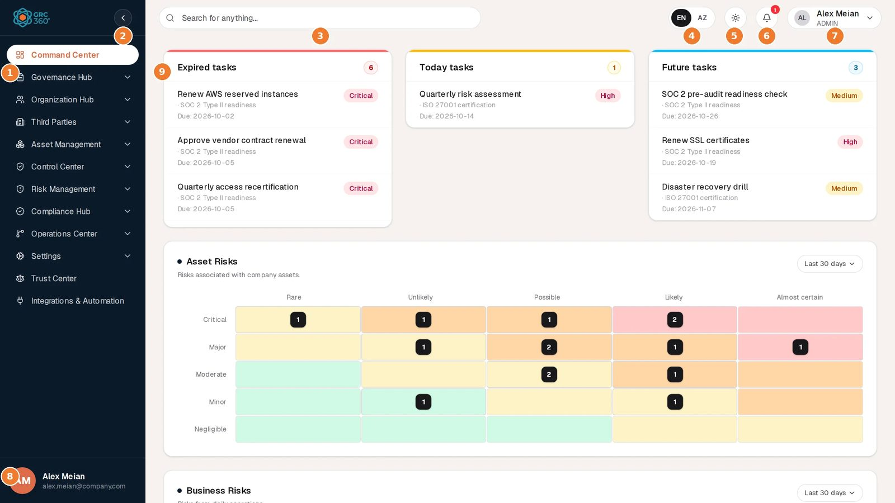
GRC360 layout
# | Element
1 | Sidebar: modules and pages
2 | Collapse or expand the sidebar
3 | Global search
4 | Language: English or Azerbaijani
5 | Theme: light, dark or system
6 | Notifications
7 | Profile menu
8 | Your name and e-mail
9 | Page content (here the Command Center)

Sidebar
The sidebar lists the modules in this order: Command Center, Governance Hub, Organization Hub, Third Parties, Asset Management, Control Center, Risk Management, Compliance Hub, Operations Center, Settings, Trust Center, Integrations & Automation.
Opening a page
- Clicking a module name (for example Risk Management) opens the first page of that module you are allowed to see. It does not just expand the list.
- The small chevron on the right of a module expands or collapses its page list without navigating.
- A module opens expanded when you are on one of its pages.
Where you are. The current module shows as a white pill with orange text, and the current page inside it is shown in orange.
Collapsing the sidebar. The round arrow button at the top of the sidebar shrinks it to icons only. Hovering an icon shows its name; clicking a module icon opens its first page. The sidebar returns to full width when you reload the page.
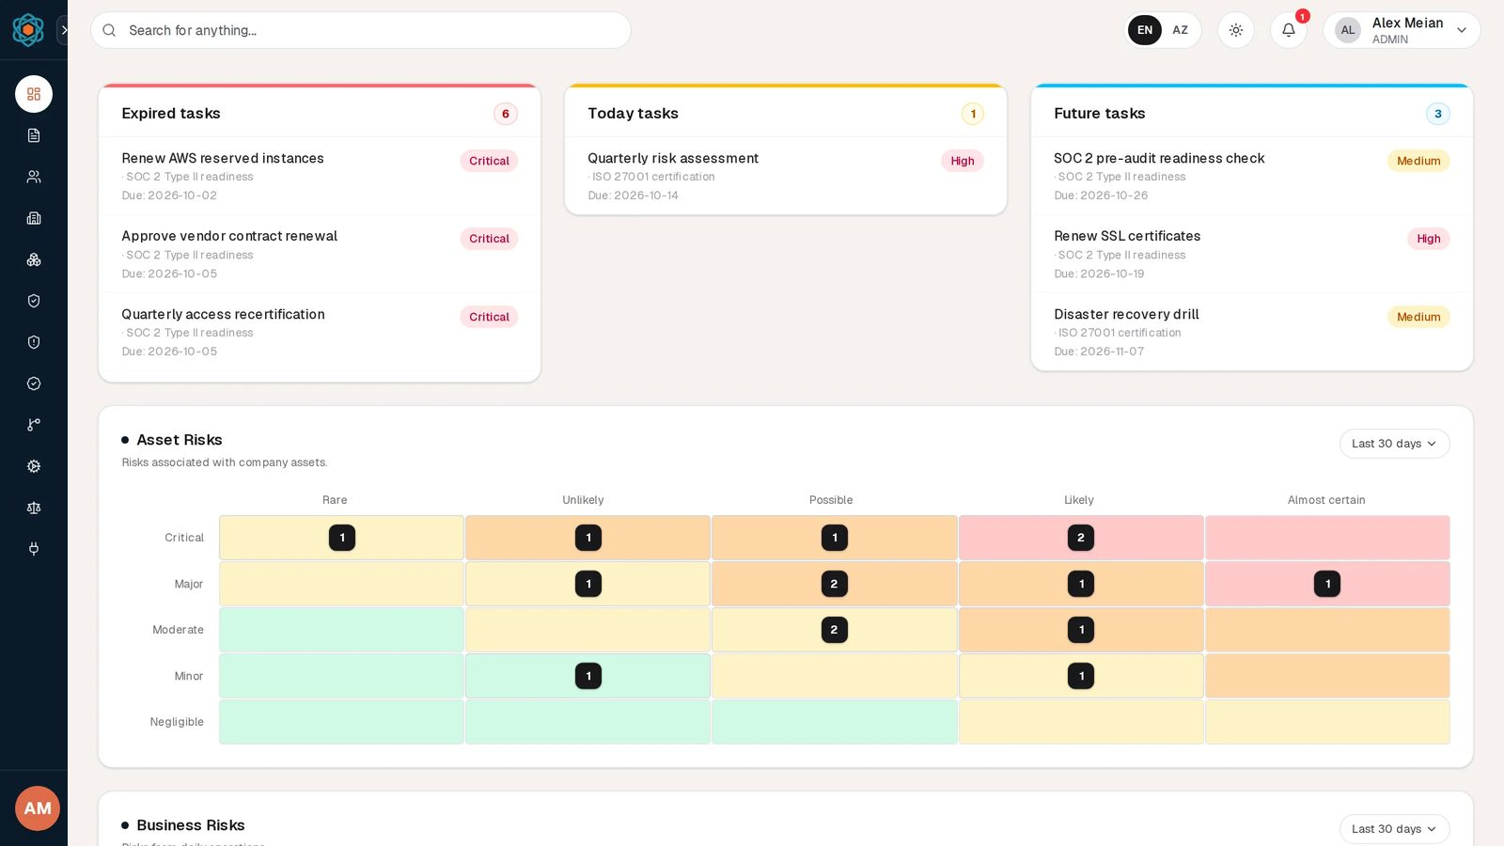
Collapsed sidebar
What you see depends on your permissions.
- Pages you cannot open are not shown in the sidebar.
- A module with no page you can open disappears entirely.
- Settings appears only for members of the Admin group.
- Trust Center is always shown. It opens in a new browser tab.
Compare an administrator’s sidebar above with the sidebar of a user who may open only a few pages:
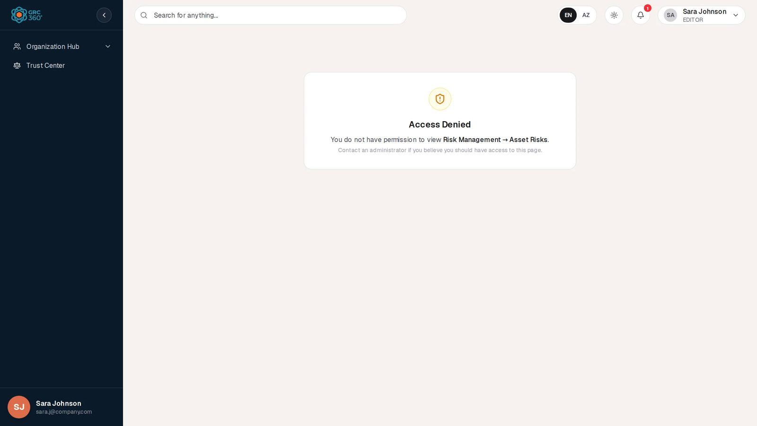
Sidebar of a user with limited access
Your name. The bottom of the sidebar shows your initials, name and e-mail address.

Top bar
From left to right: global search, language switch, theme switch, notifications, and your profile menu.

Global search
Type at least two characters in Search for anything…. Results appear after a short pause.
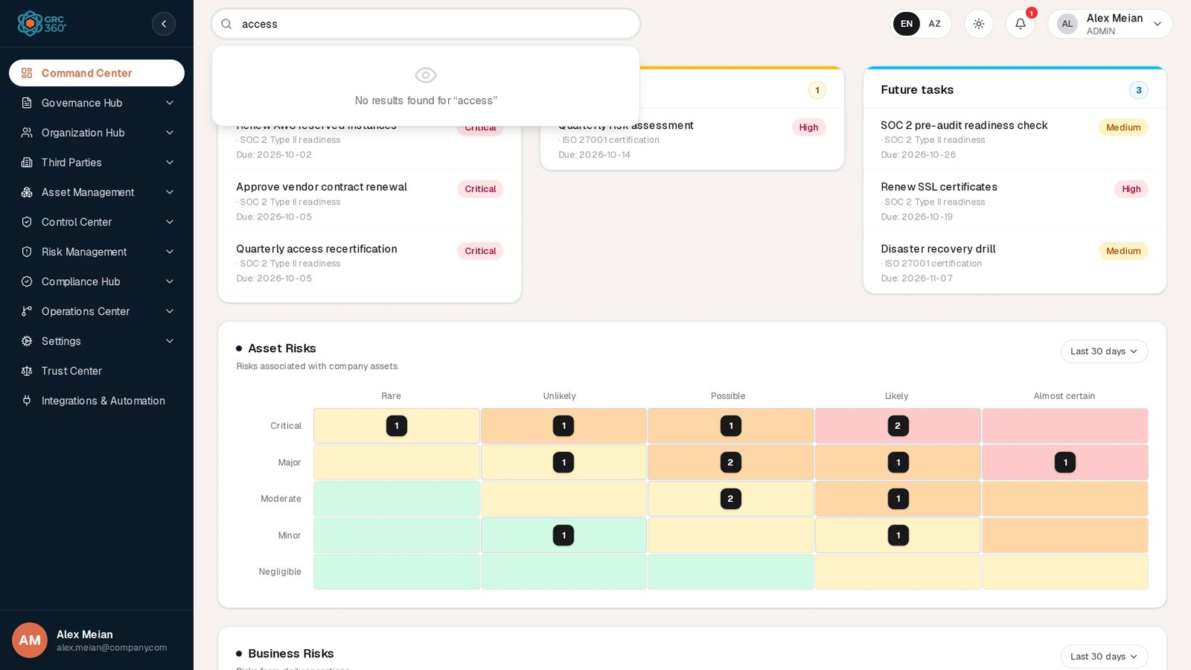
Global search
What is searched. Names, titles and descriptions of these records:
- assets
- the three risk registers
- controls
- policies
- vendors
- security incidents
- projects
- issues
- objectives
- compliance packages
- users (by first name, last name and e-mail)
How results show.
- Up to five matches per type, grouped by module.
- Each result shows its type and status.
Opening a result. Clicking a result opens the register the record belongs to. It does not open the record itself: use the register’s search box to find it there.

Language (EN / AZ)
The EN / AZ switch changes the interface between English and Azerbaijani. Your choice is remembered in this browser. The same switch is on the sign-in page.
What is translated: interface text, such as labels, buttons and messages built into the product.
What stays as typed or sent:
- your data;
- messages generated by the server, such as notification titles and some error messages;
- field names in the Activity Log.
Dates follow your browser’s language settings, not this switch.

Theme
The sun or moon button opens a menu with Light, Dark and System. System follows your operating system’s setting and changes with it. The choice is remembered in this browser.

Notifications
The bell shows a red badge with the number of unread notifications (9+ above nine). Clicking it opens the ten most recent:
Notifications menu
- Unread notifications have a light blue background.
- Clicking a notification marks it as read and, if it links somewhere, opens that page. For example, a service agreement notice opens the agreement.
- Mark all as read appears while there are unread notifications.
- See all opens the full Notifications page.
The badge updates by itself about every ten seconds.
Which notifications GRC360 sends today is listed in Notifications and scheduled jobs.

Profile menu
The pill on the right shows your name and your first group. It opens a menu:
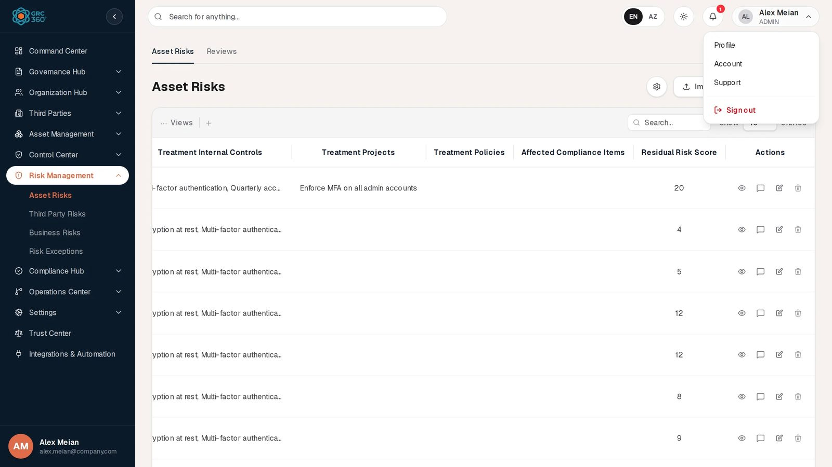
Profile menu
Item | Opens
Profile | Your details as the organisation holds them
Account | The pages you can open, and the browsers you are signed in on
Support | How to contact Strativu support
Sign out | Ends your session and returns you to the sign-in page
These pages are described in Your profile, account, notifications and support.

Page content
Most pages are registers: a title, buttons such as Import CSV and Add Item, a toolbar and a table. How to work with them is described in Working with registers.
Some pages have a row of tabs under the top bar, for example Asset Risks | Reviews. Each tab is its own register.

Changes by other people
GRC360 refreshes open pages by itself:
- Changes you make in one tab appear immediately in your other tabs.
- Changes made by other users appear within about ten to twelve seconds.
- You do not need to reload the page.

Working with registers
Almost every page in GRC360 is a register built on the same table, forms and dialogs. This page describes them once; the module pages only describe what is specific to each register.
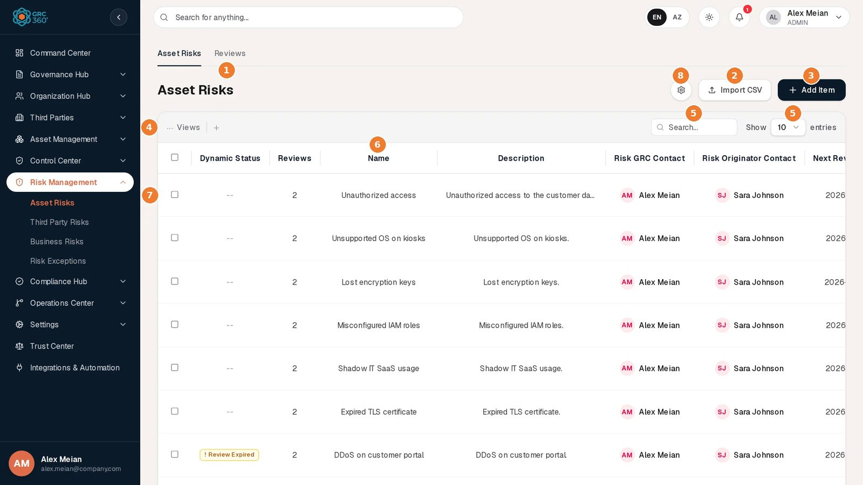
A register: Asset Risks
# | Element | What it does
1 | Title and tabs | The register’s name. Tabs, when present, switch to child registers such as Reviews.
2 | Import CSV | Imports records from a file. See Importing from CSV.
3 | Add Item | Opens the form for a new record.
4 | … Views | Chooses which columns are visible. Smaller registers also show a status filter and view chips here.
5 | Search… and Show n entries | Searches the register and sets rows per page (10, 25 or 50).
6 | Column headings | Click to sort; click again to reverse.
7 | Row checkbox | Selects a row; its View, Edit and Delete buttons then appear in the toolbar. The same buttons, with Activity Log, are at the end of each row.
8 | Page-specific buttons | Here the gear opens the risk scoring settings. Each module page describes its own.
The paging bar (“Showing 1–10 of 15” and page buttons) is under the last row.

The toolbar
The grey bar above the table holds, from left to right:
- Status filter (button with a table icon, showing All items). Lists every Status value found in the register and shows only rows with the chosen value. It filters on the user-chosen Status, not on Dynamic Status, and shows the values as stored (for example IN_PROGRESS).
- View chips (Projects and Security Incidents only). Ready-made filters with a live count, such as Expired Tasks 2. Click a chip to turn it on or off.
- … Views. Despite its name, this chooses which columns are visible. Untick a column to hide it. Your choice lasts until you leave the page.
- +. A shortcut for Add Item.
- Search… Finds rows containing the typed text in any column.
- Show 10 / 25 / 50 entries. Rows per page.
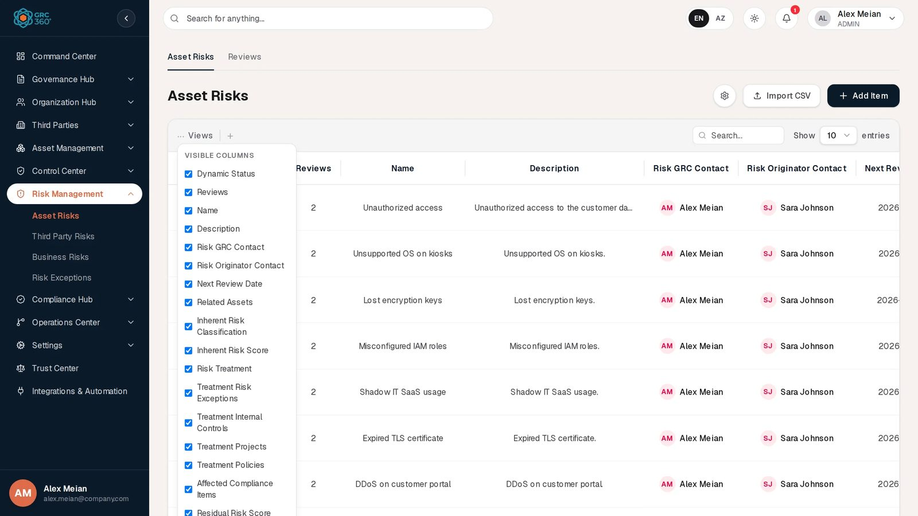
Choosing visible columns
Large registers. These registers are searched, sorted and paged by the server, so they stay fast with thousands of rows:
- Assets, Data Flows
- Controls, Policies & Standards
- the three risk registers and Risk Exceptions
- Vendors, Service Agreements
- Compliance Analysis, Obligations, Compliance Exceptions, External Audit Findings
- Security Incidents, Users
- Notifications, System Log
On these pages the status filter and view chips are not shown, and the search runs about a third of a second after you stop typing.

The table
Sorting. Click a column heading to sort by it (an arrow shows the direction); click again to reverse. When no column is chosen, the newest records come first. Dynamic Status columns cannot be sorted on the large registers listed above, because their values are calculated.
Long values. Cells do not wrap. Long text is cut with an ellipsis; hover over it to read all of it.
Clickable counts. A number in a relation column (for example 15 under Asset Risks on a control) is a link when it is above zero. Hovering it lists the linked records; clicking it opens a panel with each linked record’s details. The panel has Open register and Open in new tab buttons, which open the linked register.
Clicking a row. On most registers a row click does nothing; use the row actions. A few registers open something on row click:
- Assets: the asset’s reviews.
- Compliance Packages: the package’s requirement items.
- Notifications: marks the notification as read and follows its link.

Row actions
The Actions column at the end of each row has up to four buttons:
Button | Does
Eye — View | Opens the record read-only in the View item dialog.
Speech bubble — Activity Log | Opens the record’s comments and change history. A red badge shows the number of comments.
Pencil — Edit | Opens the record’s form with its current values.
Bin — Delete | Deletes the record after confirmation.
Wide registers push the Actions column off-screen. Tick a row’s checkbox instead: View, Edit and Delete buttons appear in the toolbar for that row.
A selected row with its actions in the toolbar

Selecting several rows
Tick the checkboxes of several rows (the heading checkbox ticks every row on the page). A red bin button with the number of selected rows appears in the toolbar; clicking it deletes them all after one confirmation. The selection is kept when you move between pages, so check the count before deleting.

Viewing a record
View opens a read-only list of every column of the register, including columns you have hidden. Empty values show as -. Some registers open their own, richer view instead. The module pages show each one.

Adding and editing a record
Add Item and Edit open the same form in a dialog. Fields marked with a red * are required. The Cancel and Save buttons stay at the bottom while you scroll through long forms.
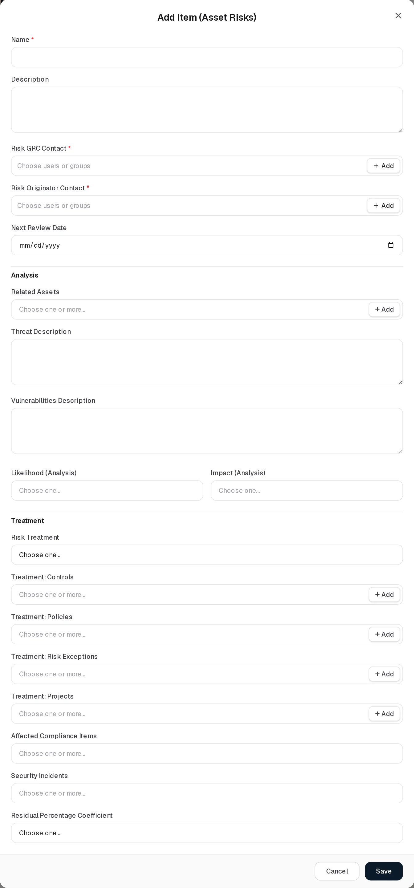
An Add form
When a form will not save
- Each field with a problem is outlined in red, with the reason underneath.
- Most forms also show a message listing every problem, under the heading This form cannot be saved yet.
- Typing in a field clears its error.
Closing without saving. Pressing Escape or clicking outside the dialog closes the form without asking, and what you typed is lost.

Choosing related records
Fields that link to other records (for example Treatment: Controls on a risk) open a list under the field when clicked:
- Type to filter the list.
- Tick one or more entries. In single-choice fields, one click picks the entry and closes the list.
- Picked records show as chips; the x on a chip removes it, and the x at the end of the field clears all.
- Multi-choice lists end with Clear all, the number selected and Done.

Choosing people
Owner and contact fields (for example Risk GRC Contact) accept users and groups in one list:
- Users are listed first.
- Groups follow under a Groups heading, each with its number of members.
Assignment rights. If your group lacks Can Assign or Can Reassign, owner fields on these registers may only name yourself:
- Assets
- Asset Risks, Third Party Risks, Business Risks
- Controls, Policies
- Vendors, Service Agreements
- Objectives
A note under the field explains which right is missing and lets you request it. See Permissions and access.

Creating a related record on the spot (+ Add)
Many link fields have a + Add button. It opens the full Add form of the other register in a second dialog; when you save it, the new record is created and selected in the field you came from. For example, while adding a risk you can create the control that treats it without leaving the form.
+ Add can create these record types:
- users and departments
- vendors and assets
- the three kinds of risk, and risk exceptions
- controls and policies
- compliance packages
- projects, coverages and issues
The button appears only if you may create that kind of record. It is not offered inside a form that was itself opened with + Add.

Deleting
Delete asks for confirmation (Delete name?). If the record cannot be deleted, for example because other records depend on it, the dialog stays open and explains why, and Delete becomes Try Again.
Delete confirmation

Activity Log: comments, attachments and history
The speech-bubble button opens the Activity Log for one record, in a panel on the right. It merges two things on one timeline:
- Comments, with attachments and replies.
- Change history:
  - Created and Deleted entries;
  - Updated entries listing each changed field as old value → new value, with who made the change and when.
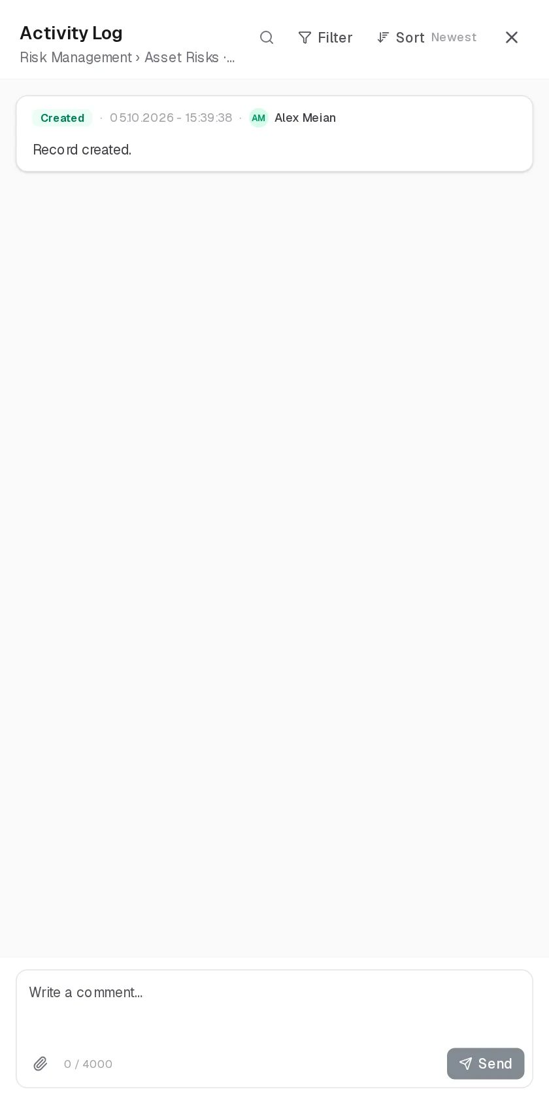
Activity Log
Finding entries. The panel has a search box, a Filter (Comment, Created, Updated, Deleted) and a Sort switch (Newest or Oldest).
Writing a comment
- Comments can be up to 4,000 characters.
- Attach files with the paperclip: up to 25 MB per file and 30 MB per comment.
- Send with Send or Ctrl/Cmd+Enter.
Replies. Click Comments & Attachments on a comment to open its thread. Replies are one level deep.
Deleting comments. You can delete your own comments. Deleting other people’s needs the Manage comment right.
Counts. The badge on the row button counts all comments, including replies. It is the same for everyone and does not change when you read the thread.
Visibility. Someone who cannot see a record cannot see its Activity Log either.
Not logged. Passwords and other secrets are never recorded in the history.
There are no @mentions in comments.

Tabs
Registers with child records show tabs at the top, for example Controls | Audits | Issues | Maintenances.
- Each tab is a full register with its own Add form and its own permissions.
- A tab you are not allowed to open is shown with a lock; clicking it lets you request access.
- A tab lists the child records of all parent records. On the Assets page, clicking an asset row opens the Reviews tab filtered to that asset, with ‹ Show All Reviews to remove the filter.

Importing from CSV
Import CSV is shown on every register.
The message you see first. In this release, clicking it always first shows the message CSV Import (register name): the import structure is not ready yet.
Registers where import works. On these, the import dialog then works:
- Users (imports straight away, without the validation preview)
- Compliance Package Items, on the page of one package
- Compliance Analysis (updates the compliance strategy of existing rows)
- Obligations
- Compliance Exceptions
- External Audit Findings
- Projects, with their Tasks and Expenses
- Security Incidents, and the stage definitions under the incidents’ Settings
How it works. 1. Choose or drop a .csv file of up to 10 MB. 2. Click Validate to check it without saving. The result shows how many rows are valid, with the errors per row. 3. Click Import n rows.
CSV import
On every other register the dialog opens but cannot validate a file yet. See CSV import and export for the state of each register and the file formats.
Exporting. Export CSV downloads the register as a file. It is available on Compliance Package Items, Obligations, Compliance Exceptions, External Audit Findings, Projects, Security Incidents and the System Log.

Messages
Pop-up messages. Confirmations and errors appear briefly at the bottom right. They close by themselves after 4 seconds, or 8 seconds for errors; click x to close one sooner.
Problems inside a form or dialog are shown in a box inside it, so the message stays next to what it is about.

Permissions and access
This page explains what you see when you lack a permission and how to ask for it. How administrators set permissions is described in Users, groups and permissions and Groups.

How permissions are organised
Where permissions come from. Permissions are given to groups, never directly to a user, except for temporary grants approved through an access request. Your rights are everything your groups allow, combined. One group cannot take away what another group gives.
What a group sets. For each page and each tab, a group has one access level:
Level | What you can do on that page or tab
No Access | Nothing. The page is hidden from your sidebar.
View | Open the page, view records, export.
Manage | View, plus create, edit, import, and record audit and maintenance results.
Full Control | Manage, plus delete, change the page’s settings, and grant access to others.
Rights that apply across the group. Two further settings apply to the whole group:
- Comments & Attachments controls the Activity Log:
  - None: no Activity Log.
  - View: read comments and history.
  - Contribute: also write comments.
  - Manage: also delete other people’s comments.
- Assignment Management: Can Assign and Can Reassign (see below).
Settings belongs to the Admin group only. It cannot be given to any other group or requested.

What you see without a permission

A page you cannot open
In the sidebar. The page is not listed.
If you open its address directly (for example from a link someone sent you), GRC360 shows Access Denied: “You do not have permission to view Risk Management → Asset Risks. Contact an administrator if you believe you should have access to this page.”
Access Denied
This panel has no request button. Ask an administrator, or use a locked button on a page you can open, as described next.

A button you cannot use
GRC360 keeps buttons visible even when you may not use them, so you can see what the page offers. A button you lack the right for is grey and shows a lock. Its tooltip reads “Requires permission — click to request access”.
This applies to:
- Add Item, Edit and Delete
- Import CSV and Export CSV
- tabs
- the Activity Log button and the comment box
Locked buttons for a Read Only user
Two exceptions are hidden rather than locked.
- Sidebar entries.
- The + Add buttons inside forms.

Requesting access
Click any locked button. The Permission Required dialog shows:
- what you tried to do, for example Create New Item;
- where, for example Risk Management › Asset Risks.
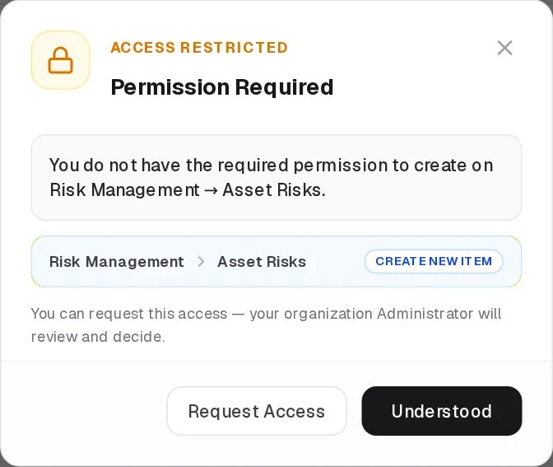
Request access
- Click Request Access.
- Explain why you need it. This is required, up to 2,000 characters, and the administrator reads it.
- Click Send Request.
Writing the justification
After you send it. Every administrator receives a notification. You receive a notification when your request is approved or rejected; a rejection includes the administrator’s note.
When access is granted. The locked buttons unlock within about ten seconds. You do not need to sign in again.
How an administrator can grant it.
- To you only, for 7 days, 30 days, 90 days or permanently.
- To one of your groups. Everyone in that group then receives it.
When there is no request form. If the server refuses an action without saying which permission is missing, the dialog says so and asks you to contact your administrator instead.

Assigning people
Which fields are affected. Owner and contact fields on these registers follow the two assignment rights:
- Assets
- Asset Risks, Third Party Risks, Business Risks
- Controls, Policies
- Vendors, Service Agreements
- Objectives
The two rights.
Situation when you opened the form | What you need to change the field
The field was empty or named only you | Can Assign to add anyone else
The field named someone else | Can Reassign to change it at all
Without the right.
- The list offers only you.
- Other people’s chips cannot be removed.
- + Add is hidden.
- A grey note under the field explains which right is missing; clicking it starts an access request.

Which records you see
A group can see either All Records or Assigned Records Only in a register. With Assigned Records Only you see only the records where you, or a group you belong to, are named in an owner or contact field.
Records you cannot see are left out everywhere:
- in the register itself;
- in linked-record counts;
- in the Activity Log;
- in most global search results.

Checking your own access
Open Account from the profile menu. It lists:
- your groups;
- every module and page you can open;
- the devices you are signed in on.
See Your profile and account.

Part 1 — Getting started

Signing in and sessions

Signing in
Open your organisation’s GRC360 address. If you are not signed in, every page sends you to the sign-in page.
Sign-in page
- Enter your work Email and Password. Use the eye icon (Show / Hide) to check what you typed.
- Optionally tick Keep me signed in (under the Sign in button). See Session length.
- Click Sign in.
After signing in. You arrive at the page you were trying to open, or at the Command Center.
Before signing in. The EN / AZ and theme switches in the top-right corner are already available.
If sign-in fails. A red message above the fields shows the reason, for example Invalid credentials or server error. Please try again.
What the sign-in page does not offer:
- Single sign-on buttons. If your organisation connects GRC360 to its directory (LDAP or Active Directory), you still type your usual directory e-mail and password here; GRC360 checks them against the directory. See Authentication and SSO.
- “Forgot password” link. Ask your administrator to set a new password in Users.
- Self-registration. Accounts are created by administrators.

Session length
 | Normal sign-in | With Keep me signed in
Signed out after inactivity | 30 minutes | 12 hours
Signed out at the latest | 8 hours after sign-in | 7 days after sign-in
What counts as activity. Clicking, typing, scrolling with the wheel and touching the screen. Moving the mouse alone does not count.
Several tabs. Activity in any GRC360 tab of the same browser keeps all tabs signed in.
Behind the scenes. Your sign-in is kept in a secure cookie that page scripts cannot read. Reloading the page does not sign you out.

“Still there?”
One minute before an inactivity sign-out, this dialog appears:
Still there? You have been inactive for a while. For security, this session will end in 60s.
- Stay signed in continues the session.
- Sign out now ends it.
Clicking elsewhere on the page does not dismiss the dialog; answer it with one of the buttons.
If no one answers, the session ends and the dialog changes to Your session has ended. Click Go to sign in and sign in again. In this release you then land on the Command Center, not on the page you were on.
The same session has ended message appears if your session was ended from another device or by an administrator.

Signing out
Signing out of this browser. Open the profile menu (your name, top right) and choose Sign out. This signs out every GRC360 tab in that browser.
Signing out other devices. On the Account page you can sign out:
- one specific device;
- every device except this one;
- every device including this one.

Limits
Devices. One user can be signed in on up to 10 browsers or devices at the same time.
Password rules.
- At least 8 characters.
- When an administrator sets a password, it must be typed twice.

Your profile, account, notifications and support
These pages are personal: every signed-in user can open them, whatever their permissions. Profile, Account and Support are in the profile menu (your name, top right). Notifications is reached from the bell’s See all link.

Profile
Profile shows your details as your organisation holds them. Nothing on this page is editable by you; your administrator maintains these details.
Profile
What it shows
- Full name
- Email
- Groups, or No groups assigned
- Organisation: the identifier of your tenant
If something is wrong
- Administrators see a link to Organization → Users to correct it.
- Other users are asked to contact an administrator.

Account
Account shows what your account can open and where it is signed in.
Account
Groups. The groups you belong to.
Access. Every module you can reach, with the pages you can read in it. This is the same list the sidebar is built from.
- Administrators see Admin: every module and every setting.
- A user with no readable pages sees a note explaining how to request access.
Signed in on. One row per browser or device where you are currently signed in.
Shown | Meaning
Device name | The browser and operating system
This device | The browser you are using now
Remembered | Signed in with Keep me signed in
IP address | Where the session was last used from
Signed in · Last activity · Ends | When the session started, was last used, and will end. Hover for the exact time.
Details | More technical information about the session
Sign out | Ends that one session
Buttons above the list
- Sign out other devices: ends every session except this one.
- Sign out everywhere: ends all sessions, including this one, so you return to the sign-in page.
- A refresh icon.
The list updates by itself every 30 seconds. Ended sessions are listed underneath, five at a time, with Show more.
Use this page if you signed in on a shared computer or think someone else is using your account.

Notifications
The Notifications page lists every notification you have received, newest first.
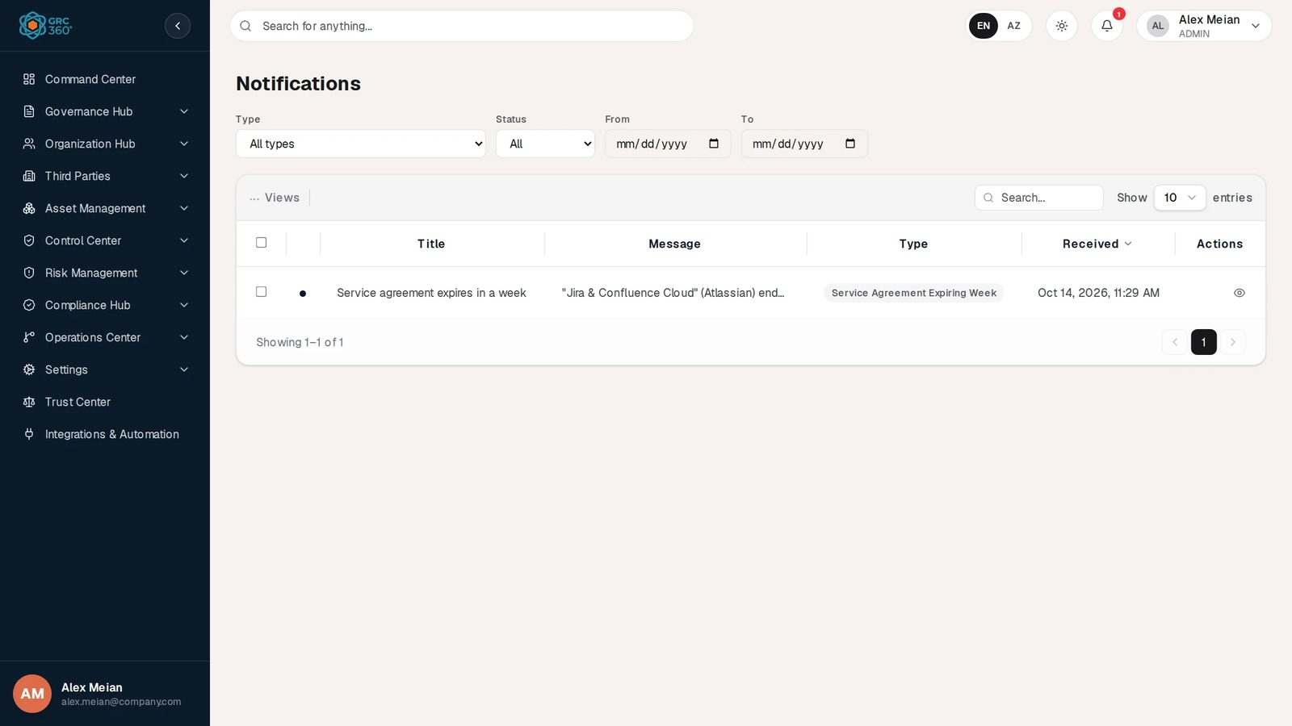
Notifications page
Filters
- Type: one notification type, or all.
- Status: All, Unread only or Read only.
- From and To: a date range.
Columns
Column | Content
(dot) | Blue while unread
Title | The notification’s subject
Message | The details
Type | The notification type, for example ACCESS_REQUEST
Received | Date and time
Working with notifications
- Clicking a row marks it read and opens the page it refers to, if it has one.
- Tick rows to use Mark as read, Mark as unread or delete them.
Which notifications exist. GRC360 currently sends notifications for:
- access requests and their decisions;
- being named in a continuity plan task;
- service agreements expiring in 7 days, in 3 days and on the end day.
The full list, with who receives each one, is in Notifications and scheduled jobs.

Support
Support explains how to report a problem or ask a question.
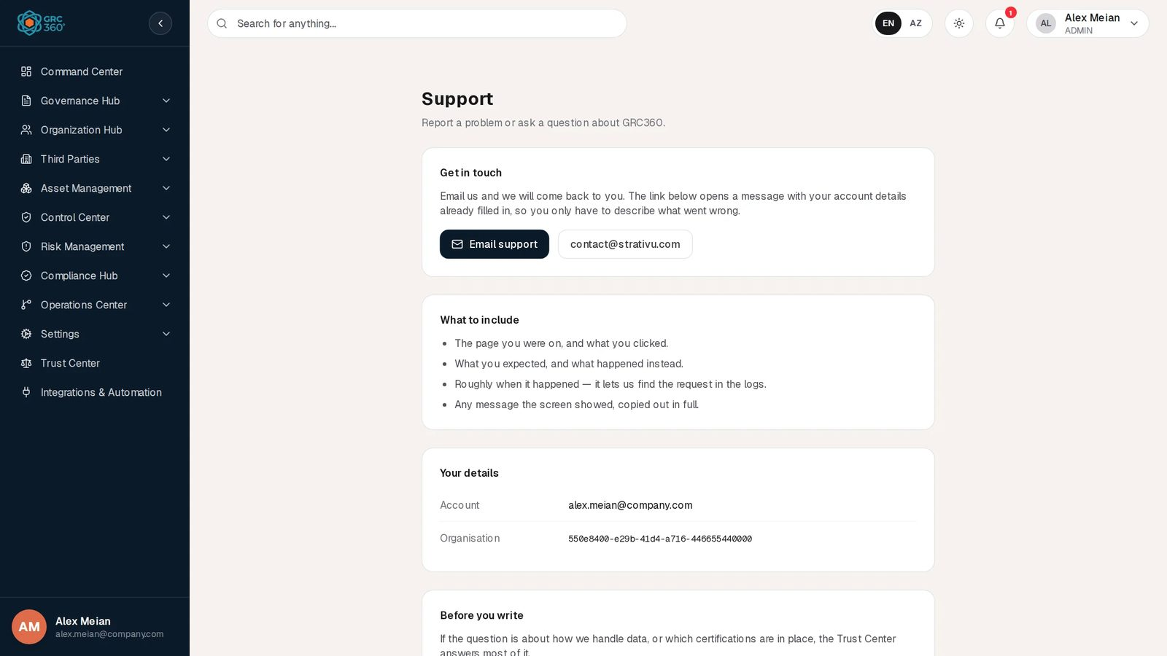
Support
Email support opens a new e-mail to contact@strativu.com. It is pre-filled with:
- your account and organisation;
- the time;
- three prompts: what you were doing, what you expected, and what happened instead.
The page also lists:
- what to include in your message, such as screenshots and the page address;
- your details to quote in the message;
- a link to the Trust Center for security and data-handling questions.

First-time setup for a new organisation
Records in GRC360 point to each other, so the order in which you enter them matters. A risk names its asset, owner and treating controls. A control names its policies and compliance packages. An asset names its department. If you enter records in the order below, every link you need already exists when you reach the form that uses it. You can still create a missing record on the spot with + Add, but working in this order is faster and avoids half-filled records.
The steps marked Admin need the Admin group.

1. Platform settings (Admin)
Task | Where
Choose how users sign in: local passwords or LDAP / Active Directory (OAuth and SAML connectors can be stored, but sign-in through them is not available in this release) | Settings › Authentication
Set up outgoing e-mail so invitations and notices can be sent | Integrations & Automation, E-mail, webhooks and notifications
Check that the database, storage and other services are healthy | Settings › System Health

2. Departments
Create your organisational units first; users, assets and risks refer to them.
- Where: Organization Hub › Departments.
- What to enter: one record per unit, for example IT, Finance, HR, Legal, Operations, Risk & Compliance.
- Contact: set each department’s contact once the users exist (step 4).
Departments

3. Groups and permissions (Admin)
GRC360 comes with three built-in groups: Admin, Read Only and Third Party. Create your own groups for the way your team works. Typical groups:
Group | Typical access
Risk owners | Manage on the risk registers; View on assets and controls
Control operators | Manage on Controls and their Audits and Maintenances; View on policies
Compliance team | Manage on Compliance Hub and Policies & Standards; View on everything else
Auditors | View on everything; Comments & Attachments: View
- Where: Organization Hub › Groups.
- For each group, decide:
  - the access level per page and tab;
  - Comments & Attachments;
  - whether members may assign other people (Can Assign / Can Reassign);
  - whether they see all records or only those assigned to them.

4. Users
Add each person with their department and group.
- Where: Organization Hub › Users.
- If you sign in with LDAP: users still need a GRC360 user record with the same e-mail address.

5. Coverage and objectives
Record what the programme covers and what it aims to achieve.
- Coverage: regions, business units, processes and IT systems in scope. See Governance Hub › Coverage.
- Objectives: for example Achieve ISO 27001 certification, with a target date and a periodic audit. See Governance Hub › Objectives.

6. Vendors and service agreements
- Where:
  - Third Parties › Vendors
  - Third Parties › Service Agreements
- What to enter: the suppliers that hold your data or run your services, then their agreements with start and end dates.
- Why the end date matters: contacts named on an agreement are notified 7 days and 3 days before it ends, and on its end day.

7. Assets and data flows
- Where:
  - Asset Management › Assets
  - Data Flows
- What to enter:
  - Systems, data sets, applications and hardware, each with its owner, department and criticality.
  - Where personal data moves between assets and vendors. Data flows include the GDPR questions.

8. Risk scales and appetite
- Where: the gear button on the Asset Risks page. See Risk Management.
- What to check:
  - the likelihood and impact scales;
  - the calculation method;
  - your risk appetite thresholds.
- Why before any risk: every risk score and the Above Appetite flag depend on these.

9. Compliance packages and obligations
GRC360 does not include framework texts. For each framework, law or standard you follow:
- Create a compliance package (for example ISO/IEC 27001:2022).
- Add its requirement items by chapter, or import them from CSV. See Compliance Packages.
- Record the legal duties under Obligations, for example the Law on Personal Data or Central Bank regulations.

10. Policies, controls and continuity plans
- Policies & Standards: your governing documents, with version and review dates.
- Controls: each safeguard, linked to its policies and the compliance packages it satisfies, with an audit schedule.
- Continuity Plans: your recovery plans with their steps and tests.

11. Risks and exceptions
Now each risk can point to everything it needs:
- its assets or vendors;
- its owners;
- its likelihood and impact;
- the controls, policies and projects that treat it.
Where: Asset Risks, Third Party Risks, Business Risks.
Accepting a risk. Record a formal acceptance in Risk Exceptions.

12. Compliance analysis
Assess each package item by item. See Compliance Analysis.

13. Projects and incident stages
- Projects: create projects for the improvements your risks and findings call for. See Projects.
- Incident stages: define the stages your incident response follows, for example Detection, Containment, Eradication, Recovery and Lessons learned. See Security Incidents › Stages.

Bringing in existing data
Where import works today. Import from CSV is available for:
- Users
- Compliance Package Items (inside a package), which is how framework requirements are usually loaded
- Obligations
- Compliance Exceptions
- External Audit Findings
- Projects, with their Tasks and Expenses
- Security Incidents and incident stage definitions
Other registers. Enter records through the forms, or ask your Strativu contact about a bulk load through the API.
See CSV import and export.

Part 2 — Module reference

Command Center
Module: Command Center › Command Center (dashboard) · Route: /command-center · Permission key: command_center.dashboard
The Command Center is the landing page after sign-in. It is a read-only dashboard: it shows the project tasks that are overdue, due today and due later, three risk heat maps (Asset Risks, Business Risks, Third Party Risks), the progress of each compliance package, and the overall progress of projects. Nothing is entered here. Every number is computed by the server from the registers each time the page loads, and every widget leads back to a register where the underlying records are maintained.
Command Center

At a glance
A record is | None. The page has no records of its own; it aggregates other registers.
Typical owner | Everyone with access; administrators see all task cards, other users see only their own.
Links to | Operations Center › Projects (Tasks tab), Risk Management › Asset Risks, Business Risks, Third Party Risks, Compliance Hub › Compliance Packages and Compliance Analysis
Linked from | The login page sends every user here after sign-in (unless the login URL carried another target).
Tabs | None
Automations | Live refresh (about every 10 to 12 seconds when another user changes a feeding register). No caching and no scheduled job is involved; see Automations.

The dashboard (list view)
The page is not a register grid, so the shared grid behaviour in Working with registers does not apply. From top to bottom it shows:
- Three task columns: Expired tasks, Today tasks, Future tasks.
- Three heat maps: Asset Risks, Business Risks, Third Party Risks, each with its own period selector.
- Two panels side by side: Compliance Status and Overall Progress.
While the data loads the page shows “Loading dashboard…”. If the request fails it shows “Failed to load dashboard” in red.
The full page with the demo data looks like this (all three heat maps, then Compliance Status and Overall Progress at the bottom):
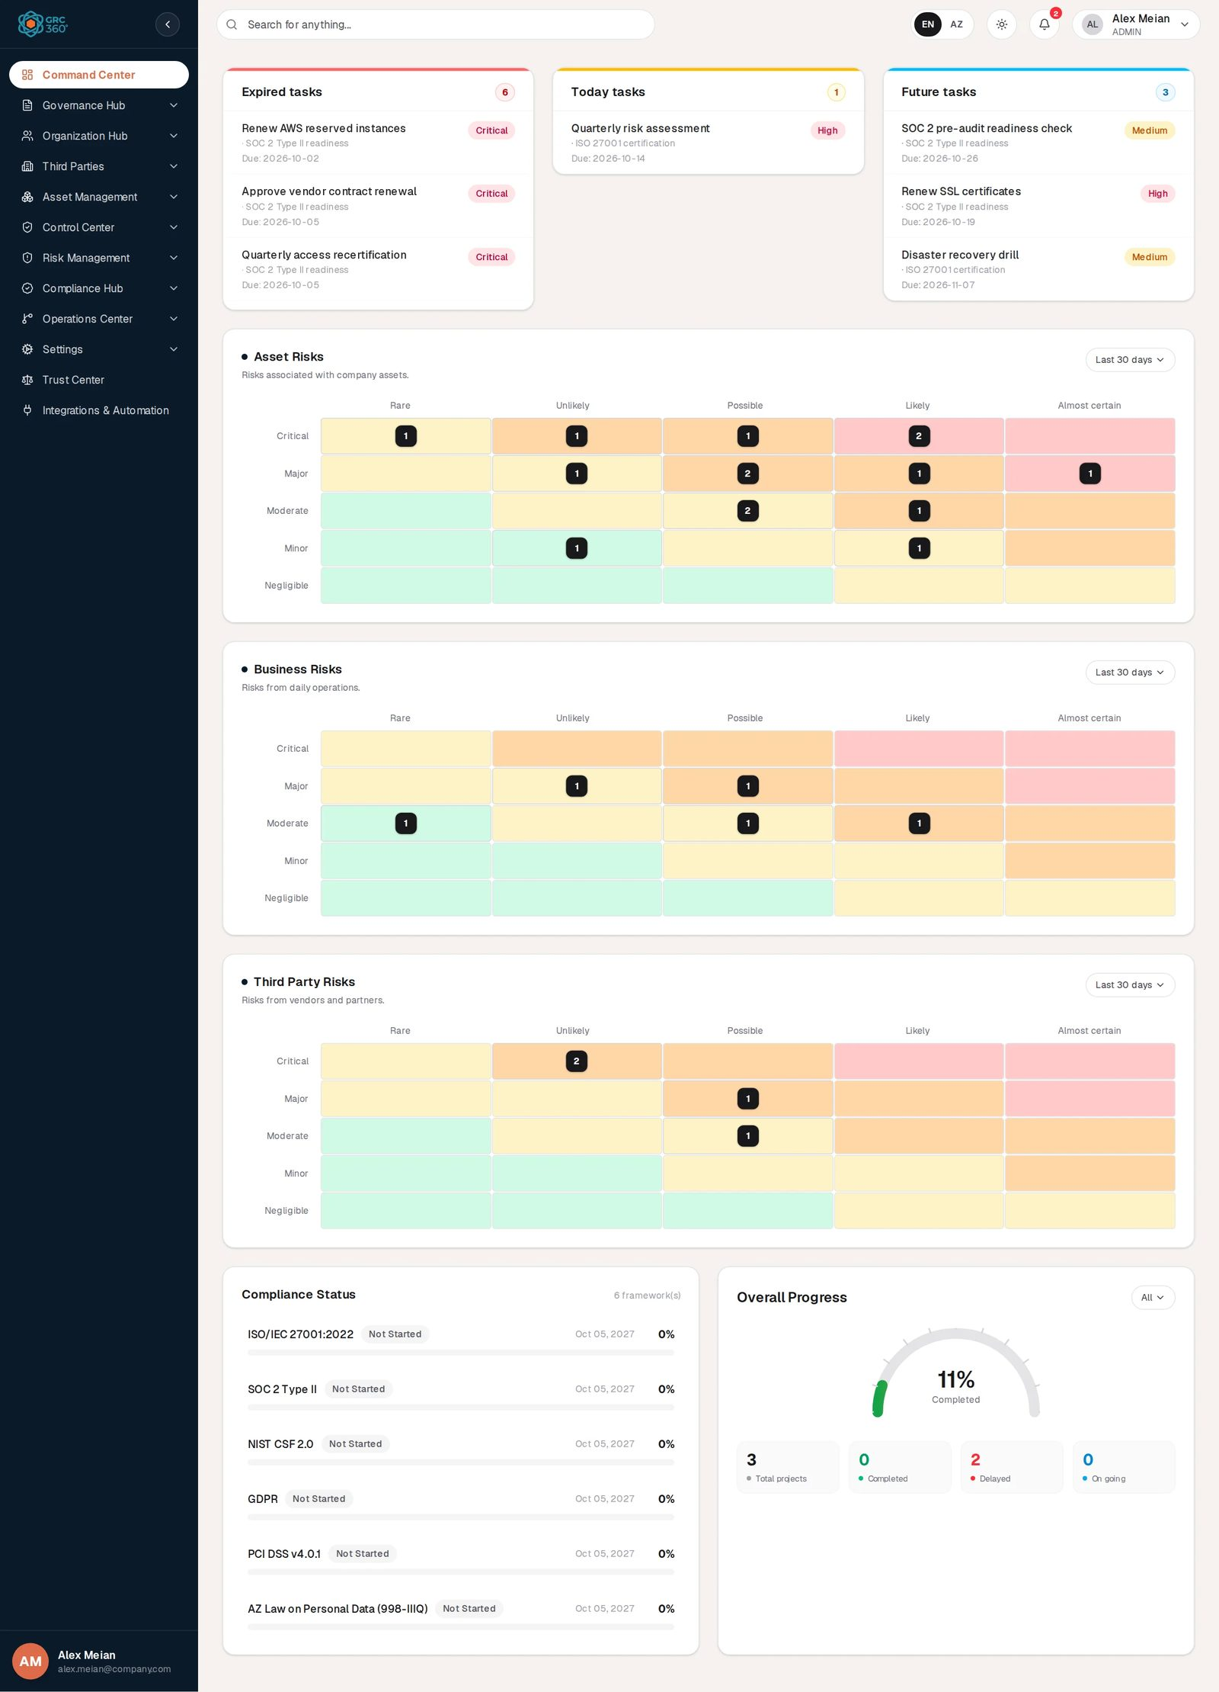
Command Center, full page

Task columns: Expired tasks, Today tasks, Future tasks
Each column is a card with a coloured top bar (red for Expired, amber for Today, blue for Future) and a count badge in the header. When a column is empty it reads “No tasks to show here”. A column shows about three tasks and scrolls inside the card when it holds more: in the demo Expired tasks has the badge 6 but shows three rows until you scroll it.
Which records feed the columns. The only source is the Tasks tab of Operations Center › Projects (project tasks). No other register (control maintenances, continuity plan tasks, objective audits, reviews) appears here. For each project task that is not deleted:
Condition | Column
The task has no Deadline | The task is not shown in any column.
Deadline is before today | Expired tasks
Deadline is today | Today tasks
Deadline is after today | Future tasks
“Today” is the server’s date. The columns do not look at Completion Rate: a task that is 100 % complete but whose deadline has passed still appears under Expired tasks. Tasks are listed in the order the server reads them, not sorted by date.
What one task row shows.
Element | Source
Title (first line) | The task’s Description
Second line, before the dot | The name of the linked Task Owner account (full name, or the e-mail address when the account has no name). When no account is linked, the legacy owner text is used; when that is empty too, nothing is shown before the dot.
Second line, after the dot | The Name of the project the task belongs to
Due: | The task’s Deadline (YYYY-MM-DD)
Badge on the right | A priority computed from the deadline (see below). It is not a field on the task.

Priority badge | Rule
Critical | Deadline before today (every task in Expired tasks)
High | Deadline today or within the next 7 days
Medium | Deadline 8 to 30 days ahead
Normal | Deadline more than 30 days ahead
Rows highlight on hover but are not links: clicking a task does not open it. To work on a task, open Operations Center › Projects, open the project and use its Tasks tab.
Administrator view versus everyone else.
Who | What the three columns contain
A user whose sign-in token carries the system role ADMIN or SUPER_ADMIN (for example the demo administrator Alex Meian, or a break-glass super-admin account) | Every dated project task in the organisation.
Everyone else | Only the tasks whose Task Owner is linked to their own user account. Tasks with only a typed owner name, or no owner, are not shown to them.
In the demo data the project tasks carry no linked owner, so a non-administrator sees three empty columns.

Risk heat maps: Asset Risks, Business Risks, Third Party Risks
Three cards with the same layout. Each has a title, a one-line description, a period selector on the right and a 5 × 5 grid.
Card | Description shown | Register counted
Asset Risks | “Risks associated with company assets.” | Risk Management › Asset Risks
Business Risks | “Risks from daily operations.” | Risk Management › Business Risks
Third Party Risks | “Risks from vendors and partners.” | Risk Management › Third Party Risks
Axes. Rows are impact, from top to bottom Critical, Major, Moderate, Minor, Negligible. Columns are likelihood, from left to right Rare, Unlikely, Possible, Likely, Almost certain.
How a risk is placed in a cell. The server reads two fields from every risk that is not deleted: Likelihood (Analysis) and Impact (Analysis). These fields hold a classification chosen from the risk settings of that register; the server looks up the numeric value of that classification in the organisation’s own classification scale and maps it as follows:
Classification value | Likelihood column | Impact row
5 or more | Almost certain | Critical
4 | Likely | Major
3 | Possible | Moderate
2 | Unlikely | Minor
1 | Rare | Negligible
A risk is counted in a cell only when both values are set and greater than zero. A risk with only one of the two analysis fields filled is not shown in the grid. Each risk counts once, in exactly one cell. Treatment (residual) values are not used: the heat maps show the analysis (inherent) position.
What a cell shows. A cell holding at least one risk shows a dark chip with the count. Empty cells show no number. Hovering a cell shows a tooltip such as “Major × Possible: 2”. Cells are not clickable.
Cell colours. The colour depends only on the cell’s position, not on the count. With the row counted 0 (Critical) to 4 (Negligible) and the column 0 (Rare) to 4 (Almost certain), the score is (4 − row) + column:
Score | Colour
7 or 8 | Red
5 or 6 | Orange
3 or 4 | Amber
0 to 2 | Green
These bands are fixed in the dashboard and are independent of the risk appetite or analysis matrix configured in Risk Management settings.
Period selector. The selector offers Last 7 days, Last 30 days (default) and Last 90 days. It keeps only risks created within that many days before now; a risk without a creation timestamp is always counted. The three cards share one selection: changing the period on any card changes it on all three and reloads the page data. The selection is not remembered when you leave the page.
In the demo data, with Last 30 days:
Card | Scored risks | Cells holding risks (impact × likelihood: count)
Asset Risks | 15 | Critical × Rare 1, Critical × Unlikely 1, Critical × Possible 1, Critical × Likely 2; Major × Unlikely 1, Major × Possible 2, Major × Likely 1, Major × Almost certain 1; Moderate × Possible 2, Moderate × Likely 1; Minor × Unlikely 1, Minor × Likely 1
Business Risks | 5 | Major × Unlikely 1, Major × Possible 1; Moderate × Rare 1, Moderate × Possible 1, Moderate × Likely 1
Third Party Risks | 4 | Critical × Unlikely 2; Major × Possible 1; Moderate × Possible 1

Compliance Status
The left panel at the bottom is headed Compliance Status, with “N framework(s)” in small grey text on the right. It lists every active compliance package as one row: the package name followed by its status badge, then on the right the date and the percentage in bold, and under the row a full-width progress bar. With no active packages it reads “No frameworks yet”. The percentages and bars fill with a short animation when the page loads.
Element | Rule
Package name | The package’s name from Compliance Hub › Compliance Packages. Inactive and deleted packages are left out.
Status badge | Completed at 100 %, In Progress above 0 %, Not Started at 0 %.
Date on the right | The package’s creation date plus one year, shown as “Oct 05, 2027”. Packages have no audit date of their own; this date is a placeholder, not a scheduled audit.
Percentage and bar | (items judged Compliant + half of the items judged Partially Compliant) ÷ all items of the package × 100, rounded. Items are the package’s requirement items as assessed in Compliance Analysis. A package without items shows 0 %.
Bar colour | Green at 80 % or more, amber at 50 % to 79 %, red below 50 %.
In the demo data the header reads “6 framework(s)” and the rows are ISO/IEC 27001:2022, SOC 2 Type II, NIST CSF 2.0, GDPR, PCI DSS v4.0.1 and AZ Law on Personal Data (998-IIIQ). Each shows a grey Not Started badge, the date “Oct 05, 2027”, 0% and an empty bar, because no requirement item has been judged yet.

Overall Progress
The right panel, headed Overall Progress with the scope selector (showing All) on the right, counts projects from Operations Center › Projects. It shows a half-circle gauge with the percentage in large type and “Completed” under it (the arc is coloured from green through amber to orange as it fills), and below the gauge four tiles side by side: Total projects (grey dot), Completed (green), Delayed (red) and On going (blue), each with its number above the label.
Element | Rule
Gauge, “% Completed” | The average of every counted project’s progress. A project’s progress is the average Completion Rate of its tasks (0 when it has no tasks).
Total projects | Every counted project that is not deleted.
Completed | Projects whose Dynamic Status is Closed (the owner closed it, or every task is at 100 %).
Delayed | Projects whose Dynamic Status is Expired (project deadline passed) or Task Expired (a task’s deadline passed).
On going | Projects whose Dynamic Status is Ongoing.
Projects in the Planned state (no active tasks) count only in Total projects, so the three coloured tiles do not always add up to the total.
Scope selector. The selector in the panel header offers All (default), Asset Risks, Business Risks and Third Party Risks. Choosing a register keeps only the projects that at least one risk of that register names in Treatment: Projects. The choice is not remembered when you leave the page.
In the demo data, with All, the gauge reads 11% Completed and the tiles read 3 Total projects, 0 Completed, 2 Delayed and 0 On going (the third project is Planned and so appears only in the total).

Creating a record
None. The dashboard has no Add button and no forms. Tasks, risks, packages and projects are created in their own registers.

Viewing and editing a record
None. No widget opens a record. Use the sidebar to open the register behind a widget.

Statuses
Value | Set by | Meaning
Critical / High / Medium / Normal (task badge) | System | Urgency computed from the task deadline, see Task columns.
Completed / In Progress / Not Started (Compliance Status badge) | System | Computed from the package percentage.
Completed / Delayed / On going (Overall Progress tiles) | System | Grouping of project Dynamic Status values Closed; Expired and Task Expired; Ongoing.

Tabs
None.

Relationships
Related record | Direction | How the link is made | Where it shows
Project task | Read | Every dated, non-deleted task | Task columns
Project | Read | Task’s project name; project progress and Dynamic Status | Task row second line; Overall Progress
Asset / Business / Third Party Risk | Read | Likelihood (Analysis) and Impact (Analysis) values, creation date | Heat maps
Risk → Project | Read | Treatment: Projects on the risk | Overall Progress scope filter
Compliance package and its items | Read | Item judgement (Compliant, Partially Compliant) | Compliance Status
None of these counts is clickable.

Automations and notifications
- Computed on every load. The server recalculates the whole dashboard on each request. There is no stored snapshot and no cache in this release (the application cache is configured off, and the dashboard result is not cached).
- Live refresh. While the page is open it reloads silently when another user or tab changes risks, project tasks, incidents, compliance assessments, internal controls or governance objectives. The change feed is polled about every 10 to 12 seconds.
- DashboardCacheScheduler. The code contains an hourly job that clears all caches. It is implemented but not active in this release: scheduled jobs are not enabled in the backend, and the job is also only created when a Redis cache is configured. It has no visible effect.
- Dashboard notification helpers. The code contains helpers for “Critical Risk Detected”, “Audit Date Approaching” and similar dashboard alerts, but nothing calls them and they only write a server log line. No notification is raised by the dashboard.
- Each dashboard request is recorded in the server’s application log (operation DASHBOARD_ACCESS). It does not appear in Settings › System Log.

Permissions
Action | Needed access
See the page and its sidebar entry | View on Command Center › Command Center (command_center_dashboard_read). The Groups dialog offers only No Access and View for this page.
See every task in the task columns | A sign-in token with the system role ADMIN or SUPER_ADMIN. Membership of the Admin group alone is not what the server checks.
See only own tasks | Any user with View access.
Create / Edit / Delete | Not applicable.
Comment / Assign | Not applicable (the dashboard has no comment thread).
The heat maps, Compliance Status and Overall Progress are not filtered by the user’s own permissions on the source registers, by the group’s Data visibility (All Records or Assigned Records Only) or by department. A user with View on the dashboard sees organisation-wide counts even for registers they cannot open. The server computes a department scope for the user but does not apply it to any widget.
A user without View on the dashboard still lands on /command-center after sign-in and sees the Access Denied panel (“You do not have permission to view Command Center → Command Center.”). They can continue from the sidebar.

How to

See which tasks are overdue
- Open Command Center.
- Read the Expired tasks column. In the demo data it shows 6 tasks, for example “Renew AWS reserved instances” (SOC 2 Type II readiness, Due: 2026-10-02).
- To update one, open Operations Center › Projects, open the project named after the dot (here “SOC 2 Type II readiness”) and go to its Tasks tab.

Compare the risk picture over different periods
- On the Asset Risks card, open the selector that reads Last 30 days.
- Choose Last 90 days. All three heat maps reload with risks created in the last 90 days.
- Hover a cell (for example Critical × Likely) to read its count in the tooltip.

Check how far treatment projects for business risks have got
- In Overall Progress, open the selector that reads All.
- Choose Business Risks. The gauge and tiles now count only projects named in Treatment: Projects on at least one business risk.
- A high Delayed count means those projects have a passed project or task deadline; open Operations Center › Projects and use the Expired Tasks view to find them.

Find out why a compliance package shows 0 %
- In Compliance Status, note the package name, for example “ISO/IEC 27001:2022”.
- Open Compliance Hub › Compliance Analysis and filter on that package.
- Judge its requirement items. Each item judged Compliant raises the percentage; Partially Compliant counts half.

CSV import
None. The dashboard has no import or export.

Limitations and known issues
- Completed tasks (Completion Rate 100 %) are still listed under Expired tasks, Today tasks or Future tasks according to their deadline.
- Only project tasks feed the task columns; continuity plan tasks, maintenances, audits and reviews are not shown.
- Task rows are not clickable and do not link to the task.
- The full-administrator task view depends on the system role ADMIN in the sign-in token. A user who was put in the Admin group through Organization Hub › Users does not get that system role, so (from the code) they see only their own tasks like any other user.
- The three heat maps share a single period selection.
- The heat maps, Compliance Status and Overall Progress ignore department scope, row visibility (Assigned Records Only) and the user’s permissions on the source registers.
- The heat-map colour bands are fixed and do not follow the risk appetite settings.
- The date beside each compliance package is the creation date plus one year, not a real audit date.
- After sign-in every user is sent here, including users without access to the dashboard, who see the Access Denied panel.

Governance Hub
Module: Governance Hub · Route: /governance (opens Coverage) · Permission module: governance
The Governance Hub frames the GRC programme itself: what it covers (Coverage), what is wrong with it (Issues) and what it is trying to achieve (Objectives). Objectives are the centre of the module. Each goal can be audited on a schedule, linked to the projects, controls, risks, policies and issues it depends on, and marked Achieved, which closes out the linked work.
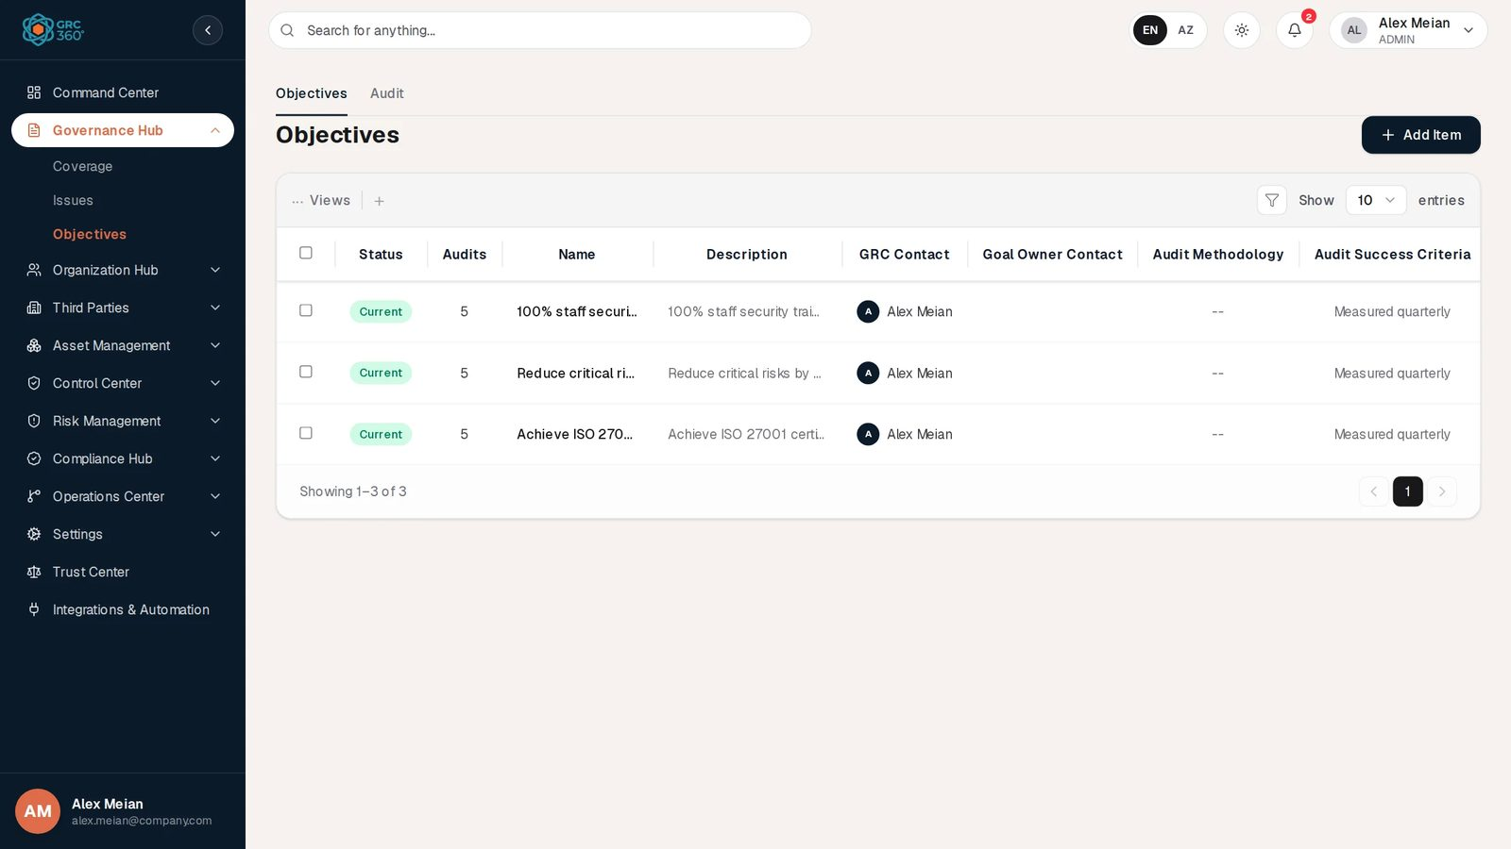
Objectives register

Pages
Page (sidebar label) | Route | Permission key | What it holds
Coverage | /governance/coverage | governance.coverage | The scope of the programme: regions, business units, processes and IT systems, with a version and a GRC contact.
Issues | /governance/issues | governance.issues | Governance issues found in the programme, with a GRC contact, an issue contact and a source (Internal, External).
Objectives | /governance/objectives | governance.objectives | Goals of the programme with their audit schedule and linked work.
Objectives › Audit | same route, Audit tab | governance.objectives_audits | The audits of all goals, generated from each goal’s schedule or added by hand, with results and evidence.
Opening /governance without a page redirects to Coverage.

How the records fit together
- An objective points at the work it depends on. All links are made on the objective’s form (tabs Activities and Issues); the linked records do not show the objective.
- An objective audit always belongs to one objective. Most are generated from the goal’s Audits tab (Specific dates or a Periodical schedule); others are added by hand on the Audit tab.
- Coverage records stand alone in the UI. The backend can link objectives to coverages, but no screen does.
- Issues are linked to objectives only. Control issues in the Control Center are a separate register.

Statuses at a glance
Register | Status a person sets | Computed by the system
Coverage | DRAFT, ACTIVE, ARCHIVED, SUPERSEDED offered; only DRAFT is actually stored | None shown
Issues | Current, Discarded, Draft | A hidden workflow state (Open, Resolved, …) set by the objective automation
Objectives | Draft, Current, Discarded, Achieved | Audits count; a progress percentage (not shown)
Objective audits | Audit Result (Failed, Passed, In review, or your own options) | Dynamic Status Pass, Fail or In Progress, derived from the result

Automations
- Audit schedule: saving a goal with Audits required creates its audit rows (each Specific date plus the same date a year later, or a Periodical series up to one year after the first date; past dates dropped) and removes generated rows that no longer fit and have no result.
- Goal achieved: saving a goal as Achieved sets its linked issues to Discarded (workflow Resolved), its controls to Production, its third party risks to Closed and its business risks to Mitigated. Projects are not changed.
- Progress: calculated on every read from the share of linked work that is finished. Returned by the API, not shown on screen.
- Reminders: the daily ObjectiveAlertScheduler job (09:00) that would send Objective Audit Due and Objective Target Overdue notifications is implemented but not active in this release, because scheduled jobs are not enabled in the backend. The Governance Hub sends no notifications.

Permissions
Each page, and the Audits section of Objectives, has its own access level in the group settings (No Access, View, Manage, Full Control), plus the group’s Comments & Attachments level. Recording an audit result needs the Audit Results right, which is part of Manage on Objectives › Audits. Objectives is an assignment register: naming other people as GRC Contact, Goal Owner Contact, Audit Owners or Audit Evidence Owners needs Can Assign (and Can Reassign to change people already named), and a group set to Assigned Records Only sees only the goals that name its members. See Permissions and access.

CSV import and export
None of the three pages has Import or Export CSV. The Audit tab of Objectives shows Import CSV, but it opens a demo dialog that cannot import. See CSV import and export.

Shared behaviour
Coverage, Issues and the Objectives tab draw their own tables, with … Views, a search box behind the funnel button and Show 10 / 25 / 50 entries. The Audit tab uses the shared grid. Comments, the Activity Log, the View dialog and the delete confirmation work as described in Working with registers.

Related pages
- Projects, Controls, Policies & Standards, Third Party Risks, Business Risks: the records an objective links to.
- Status and Dynamic Status rules, Notifications and scheduled jobs.

Coverage
Module: Governance Hub › Coverage · Route: /governance/coverage · Permission key: governance.coverage
The Coverage register describes the scope of your GRC programme: the regions, business units, processes and IT systems that the programme covers. One record is one scope element, with a version and the GRC contact who answers for it. The register is normally kept by the GRC or compliance office when the programme scope is defined or reviewed, for example before a certification audit.
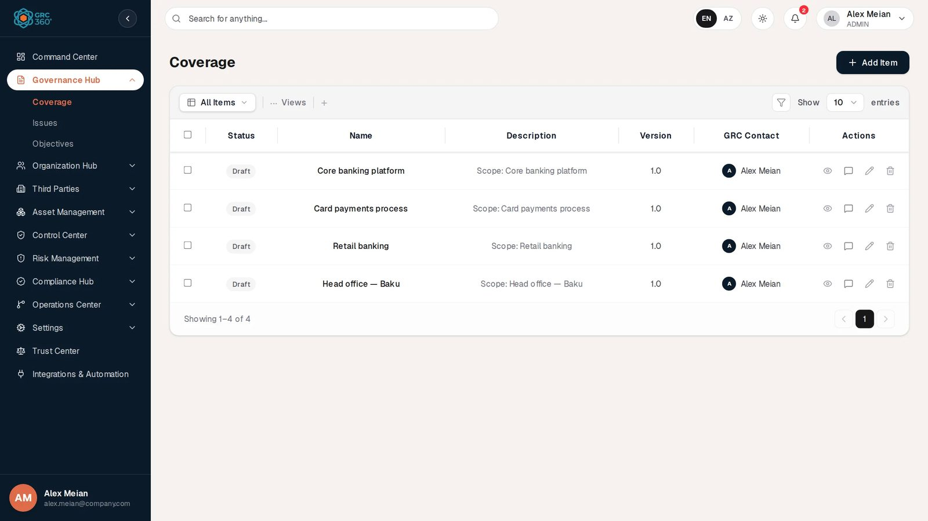
Coverage register

At a glance
A record is | One scope element of the GRC programme (a region, business unit, process or IT system)
Typical owner | GRC manager or compliance officer
Links to | Users and groups (GRC Contact)
Linked from | Objectives (in the backend only; the Objectives form has no Coverage field, see Relationships)
Tabs | None
Automations | None

The register (list view)
Coverage draws its own table rather than the shared grid, so a few things differ from Working with registers:
- The toolbar has an All Items drop-down that filters the list by Status. It lists only the status values that occur in the register (in the demo data, only DRAFT).
- … Views opens Visible Columns, where you switch columns on and off.
- The + next to … Views opens the same Add form as Add Item.
- The funnel button on the right shows or hides a Search… box. Search matches any field of the record, as you type.
- Show 10 / 25 / 50 entries sets the page size. Paging, filtering and search all work on the full list in your browser.
- There is no Import CSV and no Export CSV button.
- Rows are listed newest first.
Column | What it shows | Source
Status | The status chosen on the form, as a badge (Draft) | Entered
Name | Name of the scope element | Entered
Description | Description, cut to one line | Entered
Version | Version text. A record saved without a version shows 1.0 | Entered
GRC Contact | The people or groups named as GRC contact, with an initial avatar | Entered
Actions | View (eye), Activity Log (speech bubble), Edit (pencil), Delete (bin)
There is no Dynamic Status column on this register.
Ticking one or more rows shows a red bin button with the number of selected rows. It deletes them after the confirmation Delete N selected items? This cannot be undone.

Creating a record
Click Add Item. The form opens in a dialog titled Add Coverage.
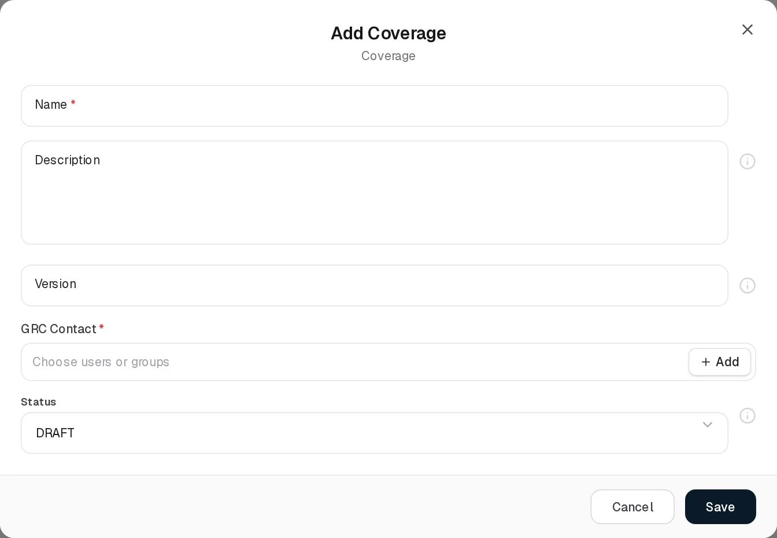
Add Coverage
Field | Type | Required | Rules and allowed values | Example
Name | Text | Yes | Message Name is required when empty. The server refuses more than 150 characters (Name must not exceed 150 characters). | Core banking platform
Description | Text area | No | Up to 1,000 characters (Description must not exceed 1000 characters). | Scope: Core banking platform
Version | Text | No | Up to 20 characters (Version must not exceed 20 characters). If left empty, the register shows 1.0 and that value is saved the next time the record is edited. | 1.0
GRC Contact | Users or groups, several allowed | Yes | Message GRC Contact is required when empty. + Add in the field creates a new user (shown only with Manage access to Organization Hub › Users). See Choosing people. | Alex Meian
Status | Drop-down | No | DRAFT, ACTIVE, ARCHIVED, SUPERSEDED. Default DRAFT. Only DRAFT is actually stored, see Statuses. | DRAFT
The fields with a grey i icon (Description, Version, Status) show no help text when clicked.
Saving shows the message Coverage added.
Coverage type. The backend also stores a type for each record: REGION, BUSINESS_UNIT, PROCESS or IT_SYSTEM. The demo data uses all four (Head office — Baku is a region, Retail banking a business unit, Card payments process a process, Core banking platform an IT system). The form has no field for it and the register does not show it. A record created from this page always gets the type BUSINESS_UNIT. The type is only visible through the API (GET /api/v1/governance/coverages, field type), where it can also be used as a filter (?type=IT_SYSTEM).

Viewing and editing a record
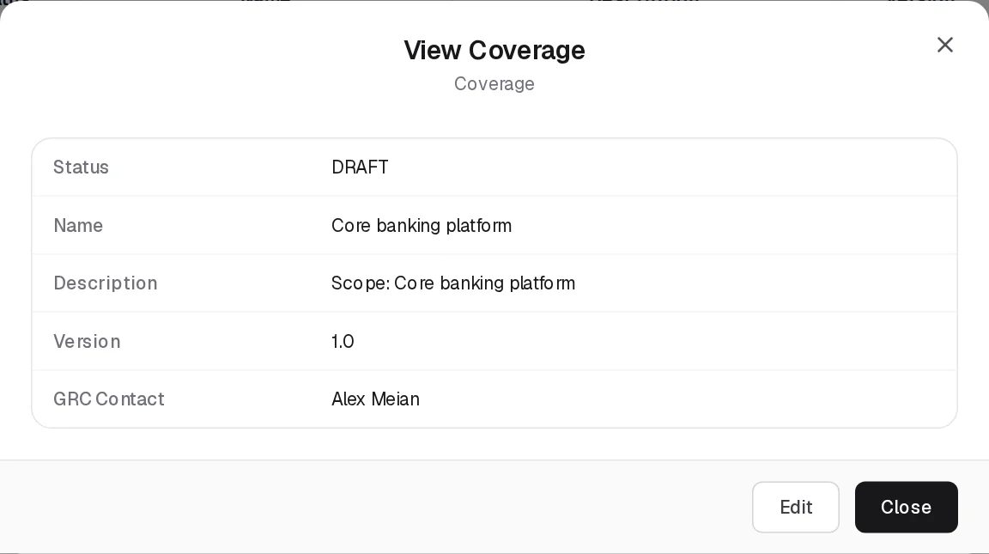
View Coverage
View opens View Coverage, a read-only list of Status, Name, Description, Version and GRC Contact. The status is shown as the stored value (DRAFT), not as a badge. Edit at the bottom switches to the Edit form; Close closes the dialog.
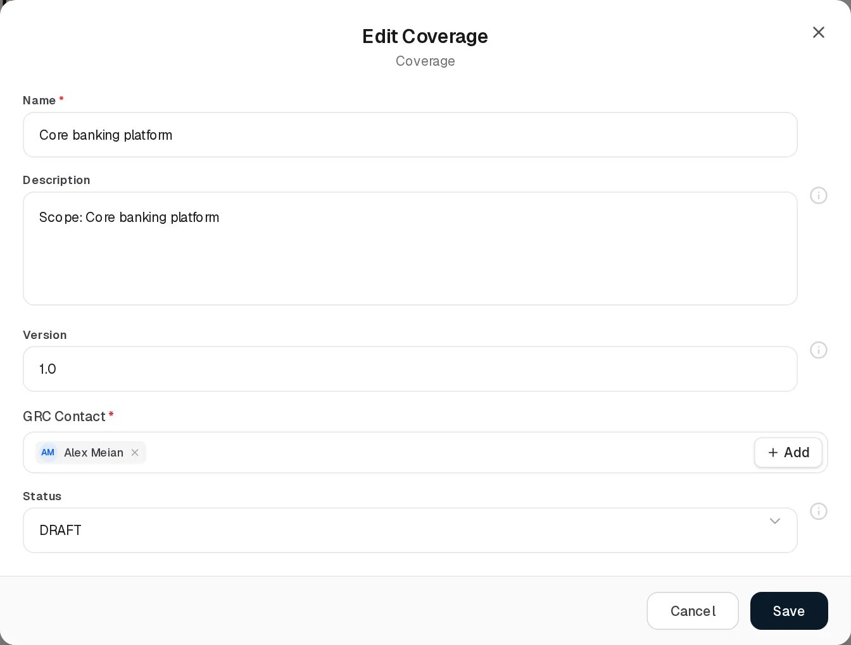
Edit Coverage
Edit Coverage has the same fields as the Add form. Saving shows Coverage updated.
Saving an edit also resets values that the form does not show. The record’s type goes back to BUSINESS_UNIT and its department link is cleared. For example, editing Core banking platform changes its type from IT_SYSTEM to BUSINESS_UNIT.

Statuses
Value | Set by | Meaning
DRAFT | User | The scope element is being prepared. This is the only status that is stored from this form.
ACTIVE, ARCHIVED, SUPERSEDED | User (offered on the form) | Offered in the drop-down, but the server does not recognise these values and saves the record as DRAFT.
CURRENT, DISCARDED | Server only | Accepted by the API (status: "CURRENT" or "DISCARDED"), not offered on the form. A record holding one of them shows it in the grid.
The backend also keeps a stored dynamic status (ACTIVE, PENDING, ARCHIVED, default ACTIVE). It is not computed, is reset to ACTIVE on every save from this page, and is not shown anywhere in the UI.

Tabs
None.

Relationships
Related record | Direction | How the link is made | Where it shows
Users and groups | Coverage → people, many | GRC Contact field. The names are stored as text; the first picked user is also stored as a user link. | GRC Contact column and View dialog
Objectives | Objective → Coverage, many to many | Only through the API (coverageIds on POST/PUT /api/v1/governance/objectives). The Objectives form has no Coverage field, and an unknown coverage id is refused. | Not shown in the UI. The API returns the coverages inside each objective (coverages).
Department | Coverage → Department, one | Only through the API (departmentId). Cleared when the record is edited from this page. | Not shown in the UI
A + Add shortcut that opens the Add Coverage form from another register exists in the product, but no form in this release has a Coverage field that uses it.
When a user is deleted, the user link on their coverages is removed and their name is kept in the GRC Contact text.

Automations and notifications
None. Coverage records have no dates, no computed status and no notifications. Every change is recorded in the record’s Activity Log history.

Permissions
Access is set per group on Governance Hub › Coverage (No Access, View, Manage, Full Control). See Permissions and access.
Action | Needed access
See the page | View on Governance Hub › Coverage. Without it the sidebar item is hidden.
Create / Edit | Manage on Governance Hub › Coverage
Delete (one or several) | Full Control on Governance Hub › Coverage
Comment / attach files | The group’s Comments & Attachments level (View to read, Contribute to add, Manage to delete other people’s)
Assign | No assignment rights on this register; any user or group can be named as GRC Contact.
Buttons you may not use stay visible with a lock; clicking one opens Request Access. All users of a group with View see all coverage records; there is no row-level filter on this register.

How to

Record a new scope element
- Open Governance Hub › Coverage and click Add Item.
- Enter a Name, for example Mobile banking app, and a Description such as Scope: customer mobile banking channel.
- Enter the Version, for example 1.0.
- In GRC Contact, pick Alex Meian.
- Leave Status on DRAFT and click Save. The record appears at the top of the list.

Find the coverage records a person is responsible for
- Click the funnel button on the toolbar.
- Type the person’s name, for example Alex. The list keeps only records where any field contains the text, including GRC Contact.

Hide columns you do not need
- Click … Views.
- Untick Description and Version. The choice lasts until you leave the page.

Remove several records at once
- Tick the rows, for example the two older demo entries Retail banking and Head office — Baku.
- Click the red bin button showing 2 and confirm with Delete.

CSV import
Not available. The Coverage page has no Import CSV or Export CSV button, and the permission catalogue gives this page no import or export right. The backend has no CSV endpoint for coverages.

Limitations and known issues
- Only DRAFT is saved. The Status drop-down offers ACTIVE, ARCHIVED and SUPERSEDED, but the server does not know these values and stores DRAFT instead, without an error.
- Editing resets the coverage type to BUSINESS_UNIT and clears the department link, because the form does not send these values.
- The type is invisible. The four coverage types exist only in the backend and the API.
- No link from Objectives in the UI. Objectives can be linked to coverages only through the API.
- Version shows 1.0 when empty, and that value is written back on the next edit.
- Load errors are not shown. If the list cannot be loaded (for example a permission error), the table simply shows No records found.; while the list loads it also shows No records found.

Issues
Module: Governance Hub › Issues · Route: /governance/issues · Permission key: governance.issues
The Issues register records governance problems found in the GRC programme: a gap, a weakness or a piece of work that is missing, such as an outdated runbook or service accounts without MFA. One record is one issue, with the GRC contact who follows it up, the contact on the business side and where it came from. Issues are usually raised by the GRC team and linked to the objectives they threaten (Program Issues on an objective).
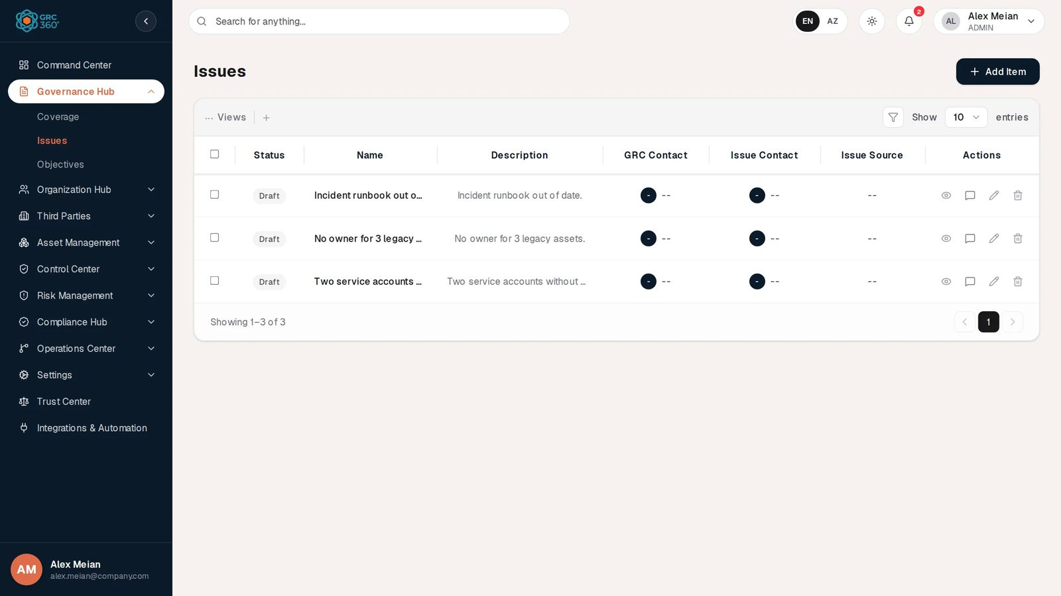
Issues register

At a glance
A record is | One governance issue found in the GRC programme
Typical owner | GRC manager (GRC Contact) with a business-side Issue Contact
Links to | Users and groups (GRC Contact, Issue Contact)
Linked from | Objectives (Program Issues, on the objective’s Issues tab)
Tabs | None
Automations | Achieving an objective discards and resolves its linked issues (see Automations)
Control issues (Control Center › Controls › Issues tab) are a different register and are not shown here.

The register (list view)
Issues draws its own table rather than the shared grid, so a few things differ from Working with registers:
- There is no status drop-down on the toolbar. Only … Views (column visibility) and + (opens the Add form) are on the left.
- The funnel button shows or hides a Search… box. Search runs on the server and matches the issue Name only (not the description or the contacts).
- Show 10 / 25 / 50 entries sets the page size; paging is done by the server. Rows are listed newest first.
- There is no Import CSV and no Export CSV button.
Column | What it shows | Source
Status | The status chosen on the form as a badge: Current, Discarded or Draft | Entered
Name | Issue name, cut to one line | Entered
Description | Description, cut to one line | Entered
GRC Contact | People or groups named as GRC contact, with an initial avatar. -- when empty | Entered
Issue Contact | People or groups named as issue contact. -- when empty | Entered
Issue Source | Internal or External. -- when not set | Entered
Actions | View, Activity Log, Edit, Delete
There is no Dynamic Status column on this register. Ticking rows shows a red bin button with the number selected, which deletes them after confirmation (Delete N selected items? This cannot be undone.).

Creating a record
Click Add Item. The form opens in a dialog titled Add Issue.
Add Issue
Field | Type | Required | Rules and allowed values | Example
Name | Text | Yes | Message Title is required when empty. The server refuses more than 200 characters (Name must not exceed 200 characters). | Two service accounts without MFA
Description | Text area | No | Up to 2,000 characters (Description must not exceed 2000 characters). | Two service accounts without MFA.
GRC Contact | Users or groups, several allowed | Yes | Message GRC Contact is required. + Add creates a new user. | Alex Meian
Issue Contact | Users or groups, several allowed | Yes | Message Issue Contact is required. | Sara Johnson
Issue Source | Drop-down | No | Internal, External. Empty by default. | Internal
Status | Drop-down | No | Current, Discarded, Draft. Default Draft. | Draft
Saving shows Issue added. The new issue gets the workflow state Open in the background (see Statuses).
The same form opens from an objective’s Issues tab: + Add on the Program Issues field creates the issue and links it to the objective you are editing.

Viewing and editing a record
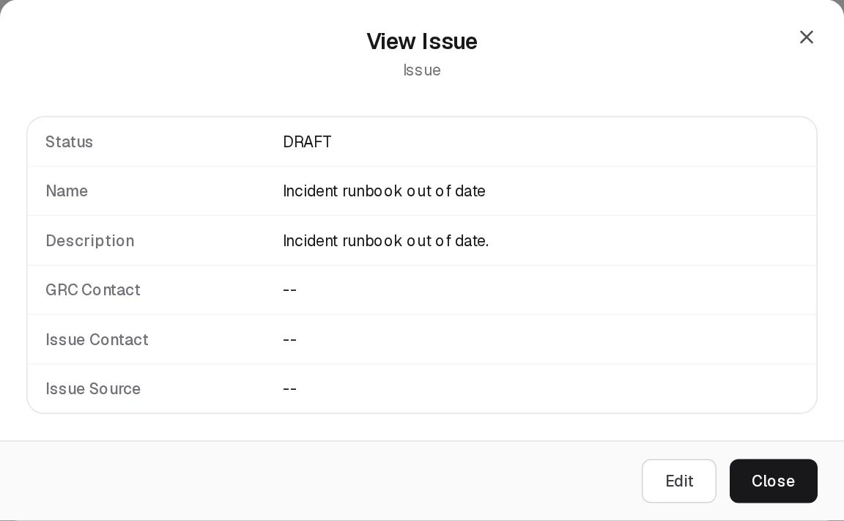
View Issue
View opens View Issue with Status, Name, Description, GRC Contact, Issue Contact and Issue Source. The status is shown as the stored value (DRAFT). Empty values show --. Edit switches to the Edit form.
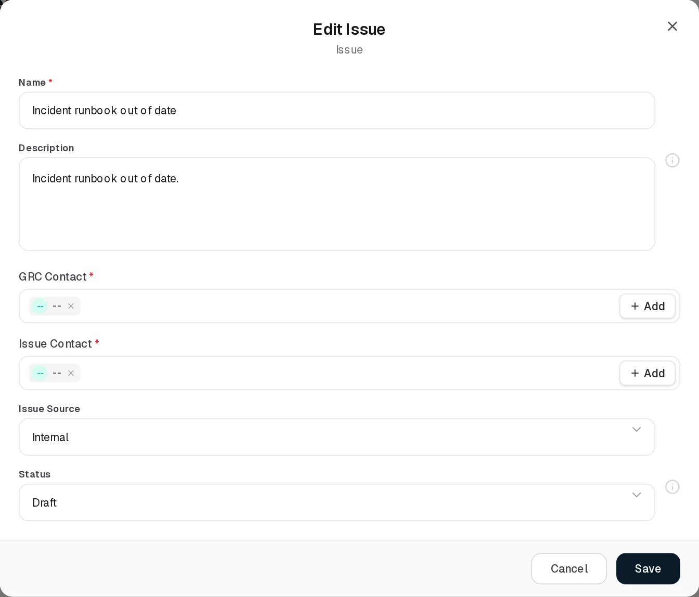
Edit Issue
Edit Issue has the same fields as the Add form. Saving shows Issue updated. Be aware of three display problems in this dialog (also listed under Limitations):
- An empty contact opens as a chip reading --. Remove it and pick a person, or -- is saved as the contact’s name.
- Issue Source always opens showing Internal, whatever is stored. If you do not pick a value, the stored value is kept for issues that have one, and the field stays empty for issues that had none.
- The issue’s priority, linked objective, risk, control, policy, assignee and due date (values held by the backend but not shown on any screen) are cleared or reset to their defaults when you save.

Statuses
An issue holds two statuses. Only the first is visible.
Value | Set by | Meaning
Draft | User | Default. The issue is recorded but not yet confirmed.
Current | User | The issue is confirmed and being worked on.
Discarded | User, or the system when a linked objective is achieved | The issue is no longer relevant.
Open | System | Workflow state of every new issue. Not shown on any screen.
Resolved | System | Set, with today’s resolved date, when an objective the issue is linked to becomes Achieved. Not shown on any screen.
In progress, Closed, Blocked, Deferred | API only | Other workflow states the backend accepts. Not used by the UI.
The workflow state matters in two places even though you cannot see it: an objective’s progress counts a linked issue as done when its workflow state is Resolved or Closed, and editing an issue from this page keeps its workflow state unchanged.

Tabs
None.

Relationships
Related record | Direction | How the link is made | Where it shows
Objectives | Objective → Issue, many to many | Program Issues on the objective’s Issues tab (Edit Objective) | Objectives register, Issues column (names, not clickable). Not shown on the Issues register.
Users and groups | Issue → people, many | GRC Contact and Issue Contact. Names are stored as text; the first picked user is also stored as a user link. | Grid and View dialog
The backend issue record also has fields for a department, objective, risk, control, policy, priority (Low, Medium, High, Critical, default Medium), assignee, due date and resolved date. No screen shows or sets them, and saving from this page resets them.
When a user is deleted, their user link on issues is removed and the name stays in the contact text.

Automations and notifications
- Objective achieved. When an objective is saved with status Achieved (or created as Achieved), every issue linked to it under Program Issues is updated at once: its Status becomes Discarded (unless it already is) and its workflow state becomes Resolved with today’s date (unless it is already Resolved or Closed). Each change is written to the system audit log as an OBJECTIVE_STATUS_AUTOMATION entry.
- Objective progress. An objective’s calculated progress counts each linked issue; it counts as finished when its workflow state is Resolved or Closed.
- Notifications. None. Issues send no notification.
- Every change is recorded in the record’s Activity Log history.

Permissions
Access is set per group on Governance Hub › Issues (No Access, View, Manage, Full Control). See Permissions and access.
Action | Needed access
See the page | View on Governance Hub › Issues
Create / Edit | Manage on Governance Hub › Issues. Creating an issue with + Add from an objective also needs it.
Delete (one or several) | Full Control on Governance Hub › Issues
Comment / attach files | The group’s Comments & Attachments level
Assign | No assignment rights on this register
All users with View see all issues; there is no row-level filter on this register.

How to

Raise an issue
- Open Governance Hub › Issues and click Add Item.
- Enter the Name, for example Incident runbook out of date, and a Description.
- Pick Alex Meian as GRC Contact and the owner on the business side as Issue Contact.
- Set Issue Source to Internal and leave Status on Draft.
- Click Save.

Confirm an issue
- Click the pencil on the issue, for example No owner for 3 legacy assets.
- If a contact shows a -- chip, remove it with its x and pick the right person.
- Set Issue Source explicitly (the field always opens on Internal).
- Change Status to Current and click Save.

Link an issue to an objective
- Open Governance Hub › Objectives and click the pencil on Achieve ISO 27001 certification.
- Open the Issues tab and click the Program Issues field.
- Tick Two service accounts without MFA and click Done, then Save.
- The objective’s Issues column now names the issue.

Find an issue by name
- Click the funnel button and type part of the name, for example runbook. Only the Name is searched.

CSV import
Not available. The Issues page has no Import CSV or Export CSV button, the permission catalogue gives it no import or export right, and the backend has no CSV endpoint for governance issues.

Limitations and known issues
- Empty contacts open as --. Editing an issue without contacts shows a -- chip in GRC Contact and Issue Contact, and saving without replacing it stores -- as the contact name. The demo issues all have empty contacts.
- Issue Source always opens on Internal in the Edit dialog, even for External issues or issues without a source.
- Hidden fields are wiped on save. Priority returns to Medium and the linked objective, risk, control, policy, department, assignee and due date are cleared, because the form does not send them.
- The workflow state is invisible. Whether an issue is Open or Resolved cannot be seen or changed on screen, yet it drives objective progress.
- Search covers the name only.
- A second, separate issue store exists in the backend (/api/v1/issues, with severity Low to Critical and source types AUDIT, GAP_ASSESSMENT, MANUAL). No screen uses it, and its records never appear on this page. It is governed by the same Governance Hub › Issues permission.

Objectives
Module: Governance Hub › Objectives · Route: /governance/objectives · Permission key: governance.objectives (tab Audit: governance.objectives_audits)
The Objectives register holds the goals of the GRC programme, such as Achieve ISO 27001 certification or 100% staff security training. One record is one goal: who owns it, how and how often it is audited, and which projects, controls, risks, policies and issues it depends on. The page has a second tab, Audit, which lists the audits of every goal, most of them generated from the goal’s audit schedule. Goals are usually set by the CISO or GRC manager; audit owners record the audit results.
Objectives register

At a glance
A record is | One goal of the GRC programme, with its audit schedule and the work it depends on
Typical owner | CISO or GRC manager (GRC Contact) and a business goal owner (Goal Owner Contact)
Links to | Projects, Controls, Third Party Risks, Business Risks, Policies, Issues, users and groups
Linked from | Objective audits (each audit belongs to one goal)
Tabs | Objectives, Audit
Automations | Audit rows generated from the schedule on every save; Achieved closes linked issues, controls and risks; calculated progress

The register (list view)
The Objectives tab draws its own table, so a few things differ from Working with registers:
- The toolbar has … Views (column visibility) and + (opens the Add form). There is no status drop-down.
- The funnel button shows a Search… box. Search runs on the server and matches the objective Name only.
- Show 10 / 25 / 50 entries; paging is done by the server; newest first.
- There is no Import CSV or Export CSV button on this tab.
Column | What it shows | Source
Status | The goal’s status as a badge: Current, Discarded, Draft, Achieved | Entered
Audits | Number of audits the Audit tab holds for this goal (generated and manual) | Computed by the system
Name | Goal name | Entered
Description | Description, cut to one line | Entered
GRC Contact | People named as GRC contact, one avatar chip per name | Entered
Goal Owner Contact | People named as goal owner | Entered
Audit Methodology | How the goal is audited (from the form’s Audits tab) | Entered
Audit Success Criteria | What counts as success | Entered
Projects | Names of linked projects | Linked
Controls | Names of linked controls | Linked
Third Party Risk | Number of linked third party risks. Click a non-zero number to open the linked risks. | Linked
Business Risk | Number of linked business risks, clickable the same way | Linked
Policy | Names of linked policies | Linked
Issues | Names of linked issues (Program Issues) | Linked
Actions | View, Activity Log, Edit, Delete
There is no Dynamic Status column. The backend calculates a progress percentage for each goal (see Automations), but the page does not show it.

Creating a record
Click Add Item. The dialog Add Objective (subtitle Governance Hub) has four tabs: General, Audits, Activities, Issues. If a required field is missing on another tab, saving switches to that tab and outlines the field.
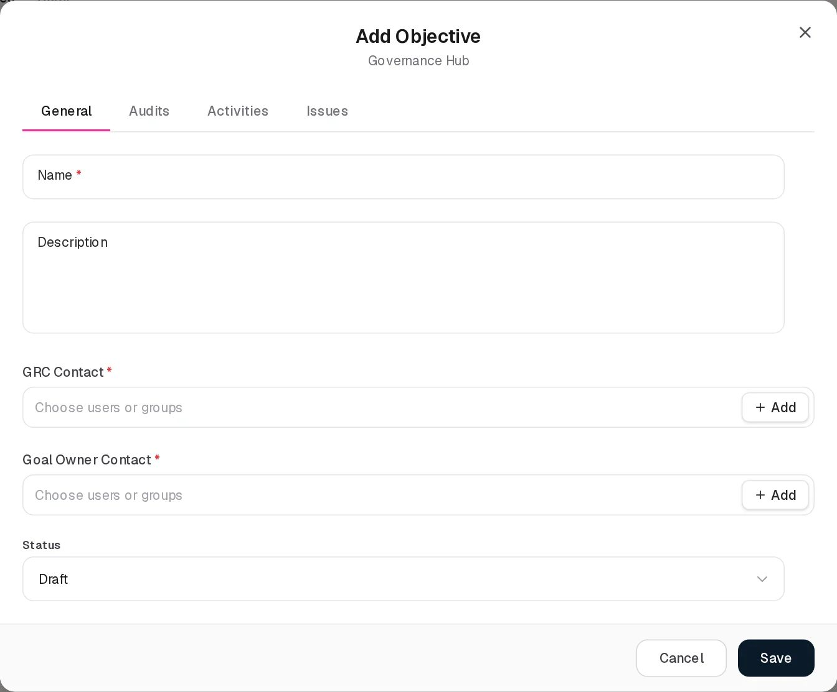
Add Objective
General
Field | Type | Required | Rules and allowed values | Example
Name | Text | Yes | The field is required under the field (the message box says Name is required). The server refuses more than 150 characters. | Achieve ISO 27001 certification
Description | Text area | No | Up to 2,000 characters. | Achieve ISO 27001 certification.
GRC Contact | Users or groups, several allowed | Yes | GRC Contact is required. Subject to Can Assign / Can Reassign (see Permissions). | Alex Meian
Goal Owner Contact | Users or groups, several allowed | Yes | Goal Owner Contact is required. Up to 1,000 characters of names. Subject to the assignment rights. | Alex Meian
Status | Drop-down | No | Current, Discarded, Draft, Achieved. Default Draft. | Current
Audits
Field | Type | Required | Rules and allowed values | Example
Audit Dates | Radio buttons | Yes | No audits required (default) or Audits required. With No audits required nothing else on this tab is shown or checked. | Audits required
Occurrence type | Switch | When audits are required | Specific (default) or Periodical | Periodical
Audit date rows | Date, one per row | Specific: at least one | Add new + adds a row; the bin removes one. Message Pick at least one audit date. | 2026-11-30
First audit date | Date | Periodical: yes | The field is required | 2026-10-29
Frequency | Drop-down | Periodical: yes | Weekly, Monthly, Quarterly, Twice a Year, Yearly | Quarterly
Audit Methodology | Text area | When audits are required | Up to 2,000 characters. Becomes the Audit Metric of every generated audit. | Review of the ISMS evidence pack
Audit Success Criteria | Text area | When audits are required | Up to 1,000 characters. Copied to every generated audit. | Measured quarterly
Audit Owners | Users or groups, several allowed | When audits are required | Copied to every generated audit. Subject to the assignment rights. | Alex Meian
Audit Evidence Owners | Users or groups, several allowed | When audits are required | Copied to every generated audit. Subject to the assignment rights. | Sara Johnson
Activities
Field | Type | Required | Rules | Example
Projects | Pick list of Operations Center projects, several | No | + Add opens the full Add Item (Projects) form | ISO 27001 certification
Controls | Pick list of Control Center controls, several | No | + Add opens the Add Control form
Third Party Risks | Pick list, several | No | + Add available
Business Risks | Pick list, several | No | + Add available
Policies | Pick list of Policies & Standards, several | No | + Add available
Issues
Field | Type | Required | Rules | Example
Program Issues | Pick list of Governance Hub issues, several | No | + Add opens the Add Issue form | Two service accounts without MFA
Pick lists work as described in Choosing related records. A record whose name is shown but which no longer exists stays as text and is not linked.
Saving shows Objective added. and, when audits are required, creates the goal’s audit rows at once (see The audit schedule).

Viewing and editing a record
View Objective
View opens View Objective with every grid column. Third Party Risk and Business Risk show the counts; a non-zero count opens the linked risks on top of the dialog. Edit switches to the Edit form.
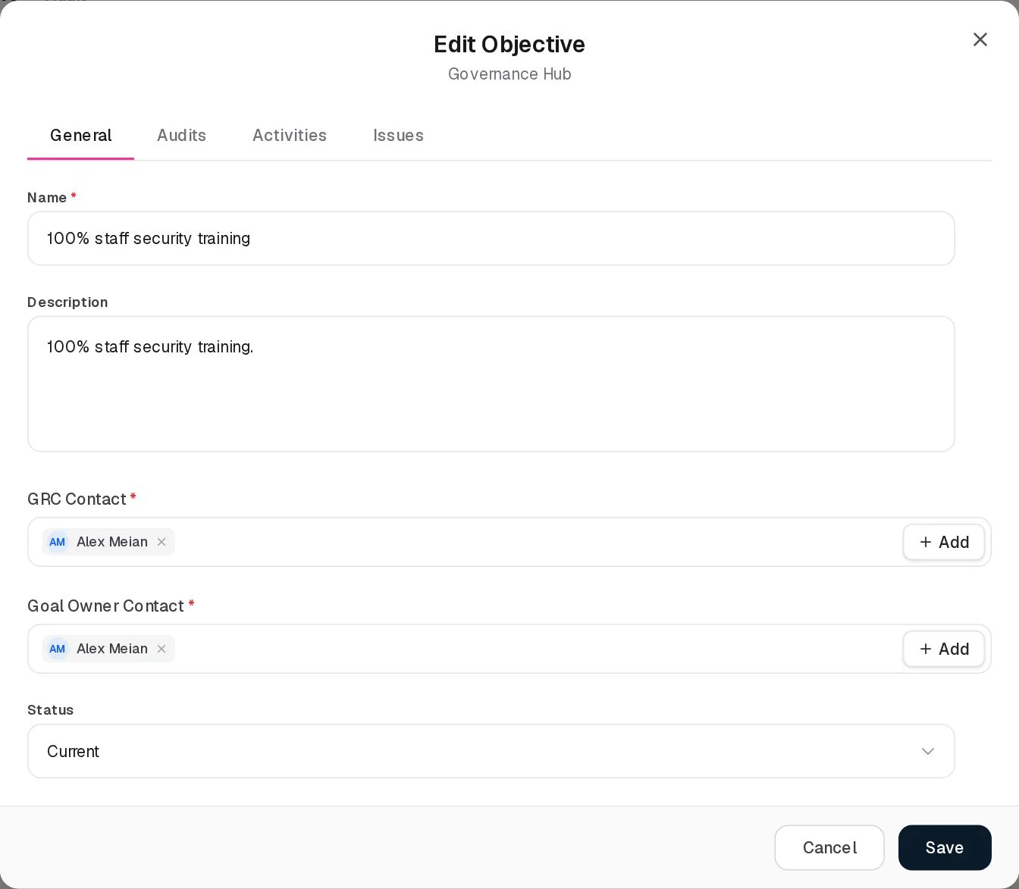
Edit Objective
Edit Objective has the same tabs and fields as the Add form. Saving shows Objective updated. and re-synchronises the audit schedule.
Saving also clears values that only the API can set and the form does not send: the goal’s target date, its owner and internal user links and its manual progress percentage. The demo goals have target dates (for example Achieve ISO 27001 certification: 11 February 2027); editing one from this page removes it.

Statuses
Value shown | Stored value | Set by | Meaning
Draft | DRAFT | User | Default for a new goal
Current | ACTIVE | User | The goal is being pursued
Discarded | ABANDONED | User | The goal was dropped
Achieved | ACHIEVED | User | The goal is met. Saving a goal into Achieved triggers the automation below.
The status is never changed by the system. Finishing all linked work does not make a goal Achieved; only a person sets it.

The audit schedule
When Audits required is selected, every save of the goal brings its generated audits in line with the schedule:
- Specific: each picked date yields two planned audits, the date itself and the same day one year later.
- Periodical: the first audit date and then one audit per frequency step (weekly, monthly, every 3 months, every 6 months, yearly), up to and including one year after the first date. A quarterly schedule starting 29 October 2026 therefore yields 5 audits: 29 Oct 2026, 29 Jan, 29 Apr, 29 Jul and 29 Oct 2027. This is what the demo goals show.
- Dates before today are dropped.
- Each generated audit gets the planned date, Audit Methodology as its Audit Metric (the goal name when the methodology is empty), Audit Success Criteria, Audit Owners and Audit Evidence Owners.
- When the schedule changes, generated audits that no longer fit are deleted, but only if nobody has recorded an Audit Result on them. Audits added by hand on the Audit tab and audits with a result are never removed.
- Switching to No audits required removes the generated audits that have no result.

Tabs

Audit
The Audit tab lists the audits of all goals you can see. It is a register of its own with its own permission (Objectives › Audits in the group settings).
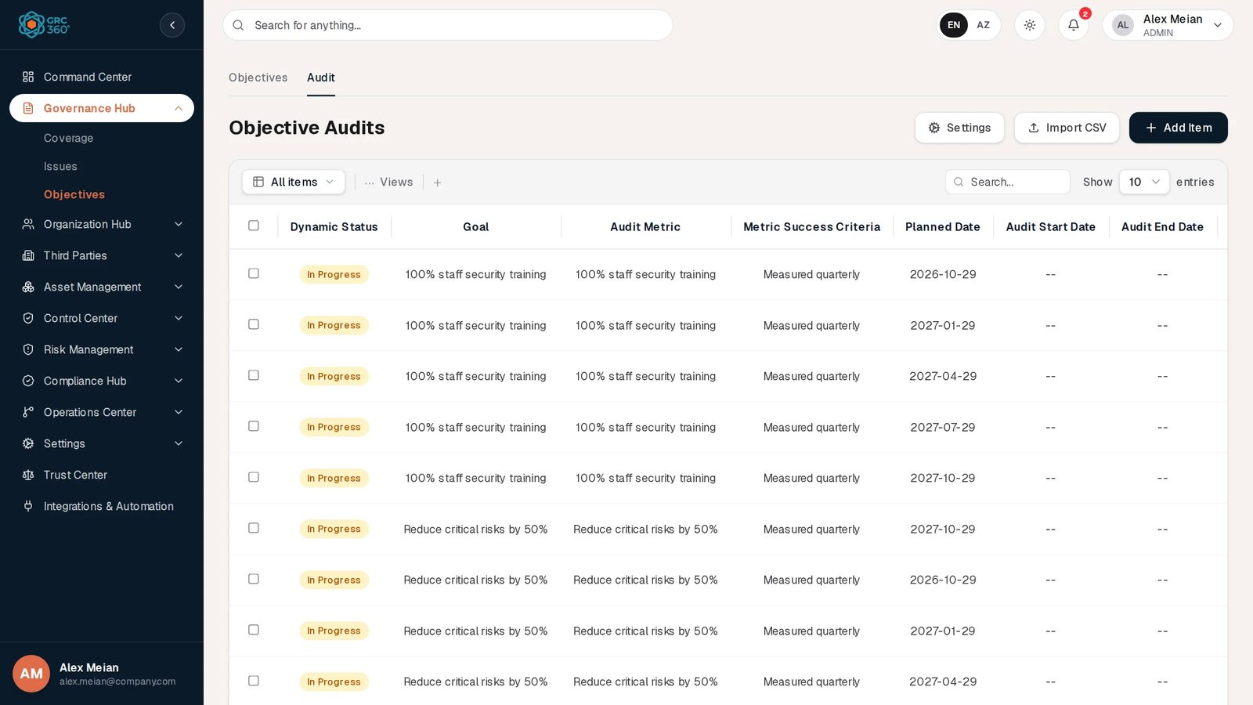
Objective Audits
The register is titled Objective Audits and uses the shared grid: All items filters by Dynamic Status, and there is a Search… box. The header has Settings (audit result options), Import CSV and Add Item. In the demo data every goal has five generated audits, all In Progress with no result yet.
Column | What it shows | Source
Dynamic Status | Pass, Fail or In Progress, derived from the Audit Result (rule below) | Computed by the system
Goal | Name of the objective | Linked
Audit Metric | What is measured | Entered or generated
Metric Success Criteria | Success criteria | Entered or generated
Planned Date | When the audit is due | Entered or generated
Audit Start Date, Audit End Date | When the audit actually ran | Entered
Audit Result | The chosen result option | Entered
Audit Conclusion | Free text | Entered
Audit Owner, Audit Evidence Owner | People, one chip per name | Entered or generated
Evidence | Attached files; click a file name to download it | Uploaded
Dynamic Status rule. No result: In Progress. Otherwise the outcome configured for the result option of that name (Failed = Fail, Passed = Pass, In review = In Progress by default). If the name matches no current option (it was renamed or deleted later), a result containing “fail” reads Fail, one containing “pass” reads Pass, anything else In Progress. Colours: Pass green, Fail red, In Progress amber.
View opens the shared View item dialog with all twelve columns; empty values show -- and an audit without files shows No evidence under Evidence.
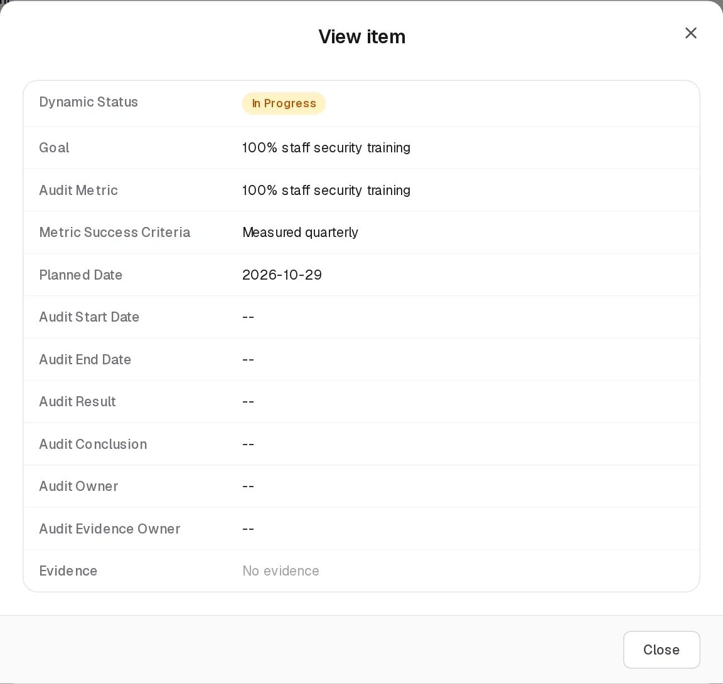
View objective audit
Add Audit / Edit Audit (subtitle Objective Audits). Both forms have the same fields; Edit opens with the stored values, for example a generated audit of 100% staff security training with Planned Date 2026-10-29 and Metric Success Criteria Measured quarterly.
Add Audit
Field | Type | Required | Rules and allowed values | Example
Goal | Drop-down of all objectives you can see | Yes | The field is required. Changing it on Edit moves the audit to another goal. | Achieve ISO 27001 certification
Audit Metric | Text area | Yes | The field is required | Achieve ISO 27001 certification
Metric Success Criteria | Text area | No |  | Measured quarterly
Planned Date | Date | No |  | 2026-10-29
Audit Start Date | Date | No |  | 2026-10-29
Audit End Date | Date | No |  | 2026-10-30
Audit Result | Drop-down of the result options | No | Options from Settings; default list Failed, Passed, In review. Up to 255 characters. | Passed
Audit Conclusion | Text area | No |  | Evidence pack complete
Audit Owner | Users or groups, several | No | Names, up to 255 characters | Alex Meian
Audit Evidence Owner | Users or groups, several | No | Names, up to 255 characters | Sara Johnson
Evidence | File upload (Choose File) | No | One file per pick, Remove to delete. Files up to 25 MB. On a new audit the files are uploaded after the audit is saved; a failed upload shows Could not attach file name. | iso-evidence.pdf
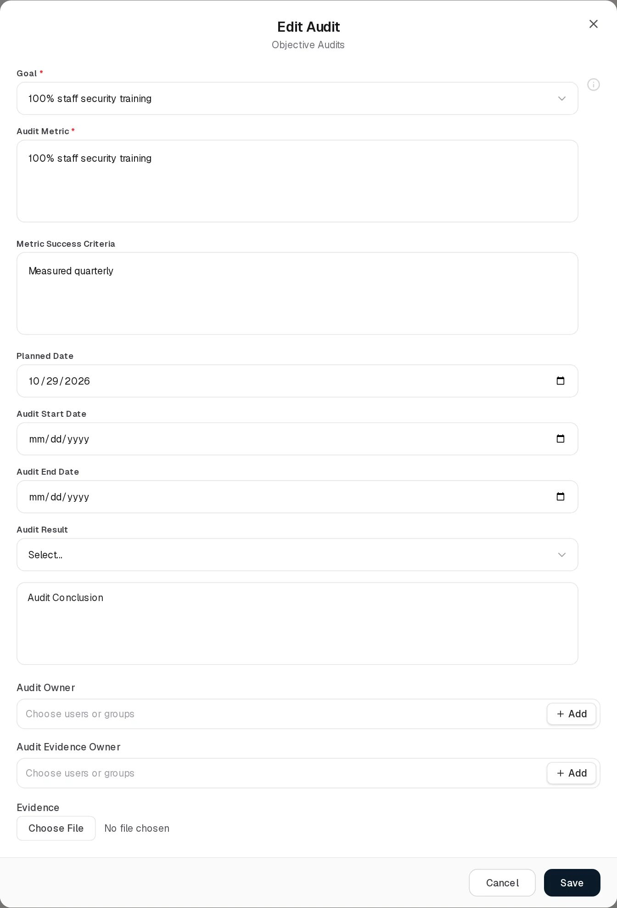
Edit Audit
The Goal and Audit Result drop-downs show Select… until a value is picked; the i icon next to Goal shows no help text. Messages: Audit added., Audit updated., Audit deleted. Deleting asks Delete audit (metric)?.
Settings: Audit Result Options. The Settings button opens a list of result options with Type to filter…, a Title column and Edit / Delete per row. Add New opens a New entry box with Save and Cancel. The note under the list reads Removing an entry only stops it being offered — records that already carry it keep their value.
- The three default options are created the first time anyone opens the list.
- A name must be unique (An audit result named ‘X’ already exists).
- An option that any audit uses cannot be deleted (Cannot delete this audit result because it is currently used by objective audits).
- New options always get the outcome In Progress, and the outcome cannot be changed on screen. So an audit with a new option named, for example, Passed with remarks reads In Progress, not Pass.

Relationships
Related record | Direction | How the link is made | Where it shows
Projects | Objective → Project, many to many | Activities › Projects | Projects column (names, not clickable). Not shown on the project.
Controls | Objective → Control, many to many | Activities › Controls | Controls column (names)
Third Party Risks | Objective → risk, many to many | Activities › Third Party Risks | Third Party Risk column, count, clickable
Business Risks | Objective → risk, many to many | Activities › Business Risks | Business Risk column, count, clickable
Policies | Objective → Policy, many to many | Activities › Policies | Policy column (names)
Issues | Objective → Issue, many to many | Issues › Program Issues | Issues column (names)
Coverage | Objective → Coverage, many to many | API only (coverageIds) | Not shown
Objective audits | Audit → Objective, many to one | Goal on the audit, or generated by the schedule | Audits count column; Goal column on the Audit tab
People | Objective → users/groups | GRC Contact, Goal Owner Contact, Audit Owners, Audit Evidence Owners | Grid columns; these people also decide who sees the goal (see Permissions)
Deleting a goal deletes all its audits. Deleting a linked record elsewhere leaves its name in the goal’s text column but removes the link.

Automations and notifications
- Audit schedule (on every save of a goal): see The audit schedule.
- Audits count: recalculated whenever an audit is added, moved to another goal or deleted, and on every save of the goal.
- Goal achieved (when a goal is saved into Achieved, or created as Achieved):
  - linked issues: Status Discarded and workflow state Resolved with today’s date;
  - linked controls: lifecycle status Production (their Dynamic Status then follows from their own audits, issues and maintenances);
  - linked third party risks: status Closed (unless already Closed or Archived);
  - linked business risks: status Mitigated (unless already Mitigated or Closed);
  - linked projects: unchanged. Each change is written to the system audit log (OBJECTIVE_STATUS_AUTOMATION).
- Calculated progress (on every read): the share of linked issues, controls, projects, third party risks and business risks that are finished, each counting the same, rounded to a whole percent. Finished means: issue Resolved or Closed; control Dynamic Status Compliant; project status Completed or every task at 100%; third party risk Closed or Archived; business risk Mitigated or Closed. With nothing linked the manual percentage applies (0 from this page). The value is returned by the API but not shown on screen.
- Reminders: an ObjectiveAlertScheduler job (daily at 09:00) that would send Objective Audit Due (OBJECTIVE_AUDIT_DUE, next audit date reached) and Objective Target Overdue (OBJECTIVE_TARGET_OVERDUE, target date passed and goal not Achieved) notifications is implemented but not active in this release, because scheduled jobs are not enabled in the backend. No objective notification is sent.

Permissions
Each of Governance Hub › Objectives and Objectives › Audits has its own access level (No Access, View, Manage, Full Control). See Permissions and access.
Action | Needed access
See the Objectives tab | View on Objectives
Create / Edit a goal | Manage on Objectives
Delete a goal | Full Control on Objectives
Name other people in GRC Contact, Goal Owner Contact, Audit Owners, Audit Evidence Owners | Can Assign on Objectives; changing or removing people already named needs Can Reassign. Without them the fields offer only yourself.
Open the Audit tab | View on Objectives › Audits (the tab shows a lock otherwise)
Add an audit | Manage on Objectives › Audits
Change an audit’s dates, metric, owners or goal | Manage on Objectives › Audits (Edit)
Record Audit Result or Audit Conclusion | The Audit Results right, part of Manage on Objectives › Audits
Delete an audit | Full Control on Objectives › Audits
Open Settings (result options) | The button needs Manage on Objectives; adding an option needs Manage on Objectives › Audits and deleting one Full Control on Objectives › Audits
Comment / attach to a goal or audit | The group’s Comments & Attachments level
Which goals you see. A group set to Assigned Records Only sees only the goals where the user (or a group they belong to) is named as GRC Contact, Goal Owner Contact, Audit Owner or Audit Evidence Owner. The Audit tab then shows only the audits of those goals, and the Goal drop-down offers only those goals.

How to

Set up a goal with quarterly audits
- Open Governance Hub › Objectives and click Add Item.
- On General, enter Reduce phishing click rate below 5%, pick Alex Meian as GRC Contact and Goal Owner Contact, and set Status to Current.
- On Audits, choose Audits required, switch Occurrence type to Periodical, set First audit date and Frequency Quarterly.
- Fill Audit Methodology, Audit Success Criteria, Audit Owners and Audit Evidence Owners.
- On Activities, pick the project SOC 2 Type II readiness.
- Click Save. The Audits column shows the number of generated audits.

Record the result of an audit
- Open the Audit tab.
- Tick the audit of Achieve ISO 27001 certification planned for 2026-10-29 and click Edit.
- Enter Audit Start Date and Audit End Date, choose Audit Result Passed and write the Audit Conclusion.
- Under Evidence, attach the evidence file.
- Click Save. The Dynamic Status becomes Pass.

Mark a goal as achieved
- Edit 100% staff security training and set Status to Achieved.
- Click Save. Linked issues become Discarded, linked controls move to Production, linked third party risks close and linked business risks become Mitigated.

Add a result option
- On the Audit tab, click Settings, then Add New.
- Type the name, for example Not tested, and click Save. It reads In Progress as Dynamic Status when used.

CSV import
- Objectives tab: no Import CSV or Export CSV button. The backend has no CSV endpoint for objectives.
- Audit tab: Import CSV is shown. It first shows CSV Import (Objective Audits): the import structure is not ready yet. and then opens a demo dialog that cannot validate a file. Import of objective audits is not available in this release. There is no Export CSV.

Limitations and known issues
- The Audit tab is labelled “Audit” on the page but Audits in the sidebar’s permission settings.
- Editing a goal removes its target date (and its owner/internal user links and manual progress), because the form does not have or send these fields.
- Objective reminders are not sent. The scheduled job exists but scheduled jobs are not enabled.
- Progress is not visible even though the backend calculates it.
- Coverage cannot be linked from the form. The backend supports objective–coverage links; the form has no field for them.
- New result options always read In Progress, because their outcome is fixed at creation and cannot be edited on screen.
- Goal Owner Contact may show only in Edit. On demo goals created through the API, the View dialog and the grid show an empty Goal Owner Contact while the Edit form shows a chip, because the form reads the stored person links and the grid reads the stored names.
- Settings is checked against the Objectives page right, not against Objectives › Audits, in the browser. Renaming a result option needs only View on Objectives › Audits on the server.
- Import CSV on the Audit tab does not work (demo dialog).

Organization Hub
Module: Organization Hub · Route: /organization (opens Users) · Permission module: organization
The Organization Hub holds the people who use GRC360 and the structure they work in: the user accounts, the departments of the organisation, and the groups that decide what each person may open and change. Everything else in GRC360 refers back to this module. Every “contact”, “owner” or “reviewer” picker in the other registers offers the users and groups kept here, departments are named on assets, business risks and data flows, and the access level of every page is set on a group.
Users register

Pages
Page (sidebar label) | Route | Permission key | What it holds
Users | /organization/users | organization.users | One record per person who can sign in: name, email, department, group membership, status and REST API access. Also the place where an administrator gives a person an individual, time-limited permission (Additional Permissions).
Departments | /organization/departments | organization.departments | The organisation’s departments, each with a department contact and two computed counts: the business risks and asset risks that concern it.
Groups | /organization/roles | organization.roles | The groups (called roles in the code and in the permission codes) that carry permissions: one access level per page and tab, a comments level, the assignment rights and the data visibility. Also the queue of Access Requests.
Opening /organization without a page redirects to Users.
The sidebar label Groups is a label only. The route stays /organization/roles and the permission codes stay organization_roles_*, so a group that could open “Roles” in an earlier release still opens Groups today.

How the three pages relate
- A user belongs to at most one department and to one or more groups. The Add/Edit User form picks one group; a user who already holds several keeps them as long as the Groups field is not changed (see Users).
- A user’s rights are the combination of every group they belong to, plus any active additional permission granted to them personally. Nothing can take a right away: there is no “deny”.
- A department names one or more contacts, picked from users and groups. The first picked user is also stored as a link to that user record.
- A group decides which pages a member can open (access levels) and which records they find there (data visibility). Groups are also offered as contacts in every user-and-group picker, so a record can name a whole group as its GRC contact or reviewer.
- Access requests connect the three: a user who meets a locked button asks for the missing permission, members of the Admin group are notified, and a decision either adds a personal grant to the user or adds the permission to one of the user’s groups.

Built-in groups at a glance
Every organisation starts with three built-in groups. They are marked Default in the Groups table and cannot be deleted or renamed. Full details are on the Groups page.
Group | Starting permissions | Data visibility | Can be edited
Admin | Everything in the catalogue, Settings included | All Records | No. It is locked and rewritten from the catalogue at every server start.
Read Only | View on every page and tab except Settings | All Records | Yes
Third Party | Read and edit on Vendors, Service Agreements, Third Party Risks and Compliance Analysis | Assigned Records Only | Yes
The demo data also contains a group called Respondent. It was a built-in group in earlier releases; the current release demotes it to an ordinary group, so it carries no Default badge and can be edited and deleted like any group created by hand.

Permissions for the module
Page | What View allows | What Manage adds | What Full Control adds
Users | See the users list and each user’s details | Add and edit users, import users from CSV | Delete users
Departments | See the departments list | Add and edit departments | Delete departments
Groups | See the groups, their access and their members | Add a group with no access set, and edit a group’s name and description | Delete groups, set or change a group’s access and data visibility, clone a group that has permissions, give individual permissions, decide access requests
Changing what a group may do, or giving a person an individual permission, requires the right shown in the code as Manage Access Control (organization_roles_manage-access). It is part of Full Control on Organization Hub › Groups. A user who has only Manage on Groups can create a group and edit its name and description, but every change to its access is refused.

Automations and notifications
What | When | Who is told
ACCESS_REQUEST notification | A user files an access request | Every member of the group named exactly Admin, except the requester. The notification links to /organization/roles?accessRequests=1, which opens the Access Requests queue.
ACCESS_APPROVED / ACCESS_REJECTED notification | An administrator decides a request | The requester
Permission refresh in open sessions | A group’s permissions, a user’s groups or an individual grant change | Every signed-in user of the organisation picks up the change within about 10 seconds, without signing in again
Expiry of individual grants | The grant’s end date passes | No job runs. A grant is simply no longer counted after its end date, and the Users page shows it under History as EXPIRED.
Permission catalogue sync | Every server start | The catalogue of pages and actions is rewritten, the Admin group receives every permission again, and Settings permissions are removed from every other group

CSV import
Only Users has a working CSV import. On Departments and Groups the Import CSV button shows the message “CSV Import (Departments): the import structure is not ready yet.” (or Groups) and then opens a demonstration upload dialog whose validation fails, because no import exists behind it. See Working with registers.

See also
- Permissions and access: what a user sees without a permission and how to request it.
- Working with registers: the toolbar, Views, search, paging, row actions, Activity Log and pickers shared by every page in this module.

Users
Module: Organization Hub › Users · Route: /organization/users · Permission key: organization.users
The Users register lists every person who can sign in to GRC360 in your organisation. A record holds the person’s name and email (the email is also the sign-in name), their department, the groups that give them their permissions, whether the account is active, and whether the person may use the REST API. Creating a user here also creates the sign-in account, with the password you enter. Administrators and whoever handles joiners and leavers work in this page; everyone else mostly meets these records as names in the contact pickers of other registers.
Users register

At a glance
A record is | One person who can sign in, with their sign-in account
Typical owner | GRC360 administrator, HR or IT onboarding
Links to | Department (0..1), Groups (one or more), individual permission grants
Linked from | Every user-and-group picker in GRC360 (GRC Contact, Reviewers, Data Owner and similar), Department Contact, access requests
Tabs | None
Automations | None on the record. Changes to a user’s groups reach that user’s open session within about 10 seconds.

The register (list view)
The grid is paged on the server and opens newest first (by creation date). The shared grid behaviour (search, Views, paging, selection, Activity Log) is described in Working with registers.
Column | What it shows | Source
Status | Active (green) when the account status is ACTIVE; Inactive (grey) for every other stored status (INACTIVE, PASSIVE, SUSPENDED, PENDING) | Entered
Name | First name | Entered
Surname | Last name | Entered
Email | Email address, also the sign-in name | Entered
Department | The department’s name, or - | Linked
Groups | One grey chip per group the user belongs to, or - | Linked
Row actions. Besides the shared View, Activity Log, Edit and Delete buttons, each row has a key icon, Additional Permissions. It is shown only to users who hold Manage Access Control on Groups (part of Full Control on Organization Hub › Groups); without that right the icon is not drawn at all.
Who is listed. A user whose groups include any group with “admin” anywhere in its name (for example Admin, or a group someone called “IT Admins”) is hidden from the list for viewers who are not themselves in such a group. The page total counts only the rows you may see.

Creating a record
Click Add Item. The Add User dialog opens.
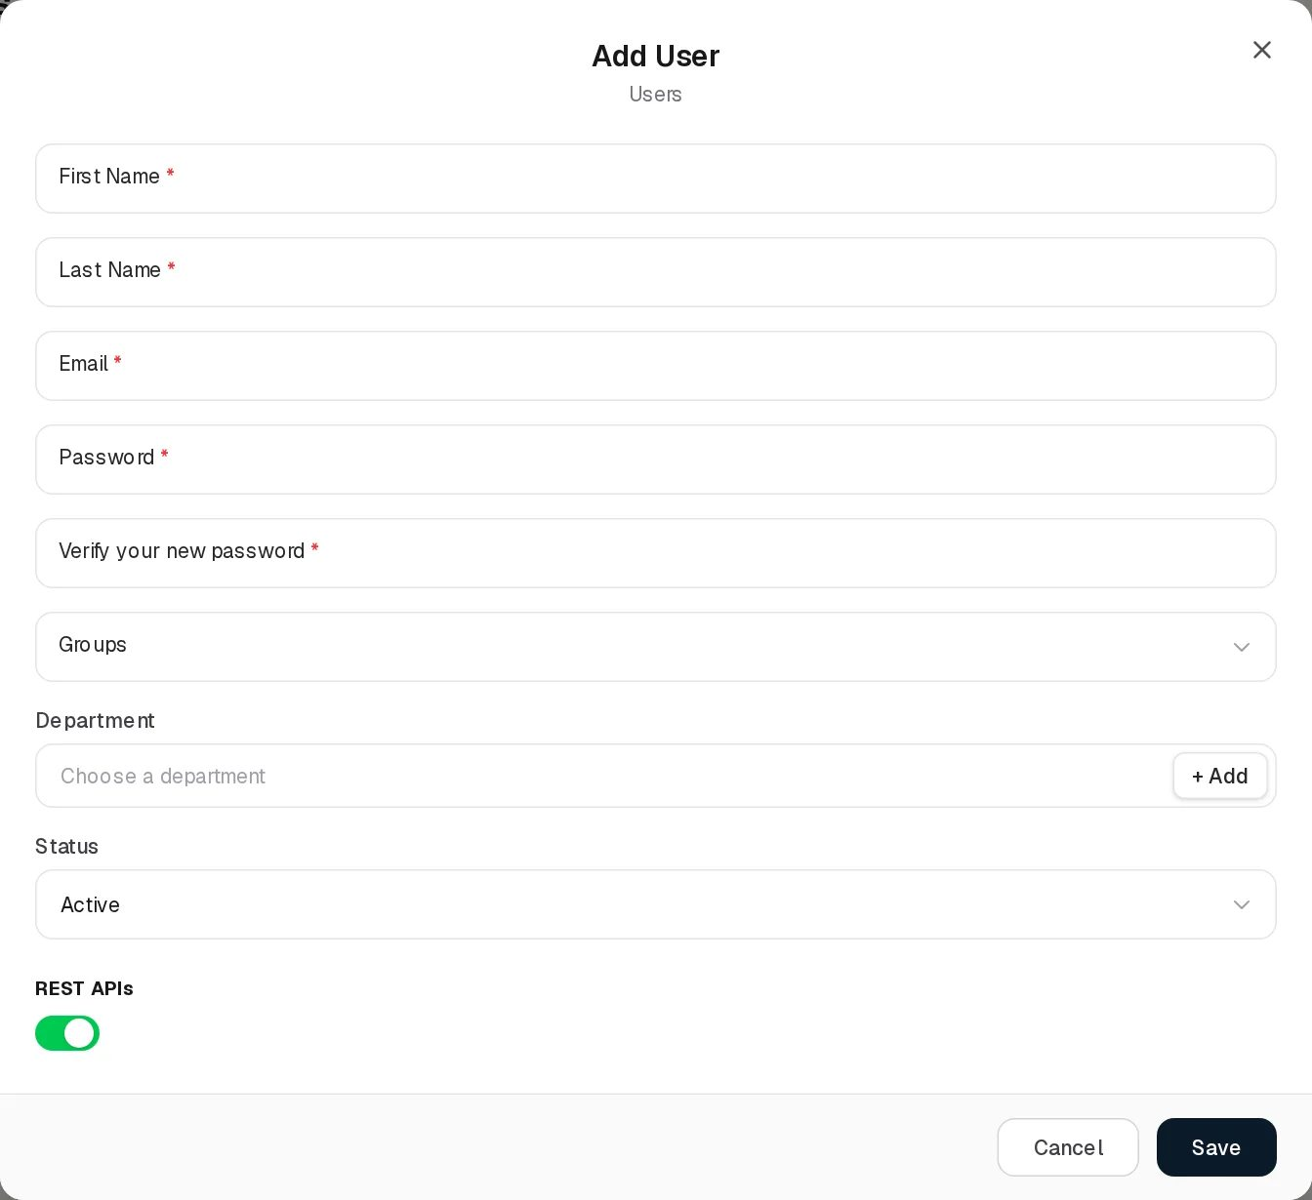
Add User
Field | Type | Required | Rules and allowed values | Example
First Name | Text | Yes | Must not be blank (“First name is required”). Up to 100 characters. | Olivia
Last Name | Text | Yes | Must not be blank (“Last name is required”). Up to 100 characters. | Reed
Email | Text | Yes | Must look like an email address (“Invalid email”). Up to 255 characters. Must be unique in the organisation (“User with this email already exists”). | olivia.reed@company.com
Password | Password | Yes on Add | At least 8 characters (“Password must be at least 8 characters”). | (not shown)
Verify your new password | Password | Yes on Add | Must equal Password (“Passwords do not match”). | (not shown)
Groups | Drop-down | No | One group from the Groups register. The list shows every group, built-in ones included. | Read Only
Department | Picker with + Add | No | One department. Clicking the field opens a searchable list; clicking the picked department again, or the chip’s ×, clears it. + Add opens the Add Department form and selects the new department. | IT
Status | Drop-down | No | Active or Inactive. Default Active. | Active
REST APIs | Switch | No | On allows the user to call the REST API with their own credentials. Default on for a new user. | Off
Click Save. The user can sign in immediately with the email and password you entered if the status is Active.
Rules applied when you save (the server’s message is shown at the bottom of the form):
- You cannot put anyone into the Admin group, or take anyone out of it, unless you are an administrator yourself: “Only an administrator can add people to the Admin group or remove them from it.”
- You cannot change your own groups: “You cannot change your own group membership. Ask an administrator.”
- The last member of Admin cannot be taken out of it: “Cannot remove the Admin role. At least 1 Admin must remain in the system.”

Viewing and editing a record
View User
View User lists Status, Name, Surname, Email, Department, User Group, Groups, SSO, MFA, REST API Access, Created and Updated. User Group is an older field that the form no longer sets; it shows - for users created in this release. SSO and MFA are read-only here: MFA is turned on by each user for their own account.
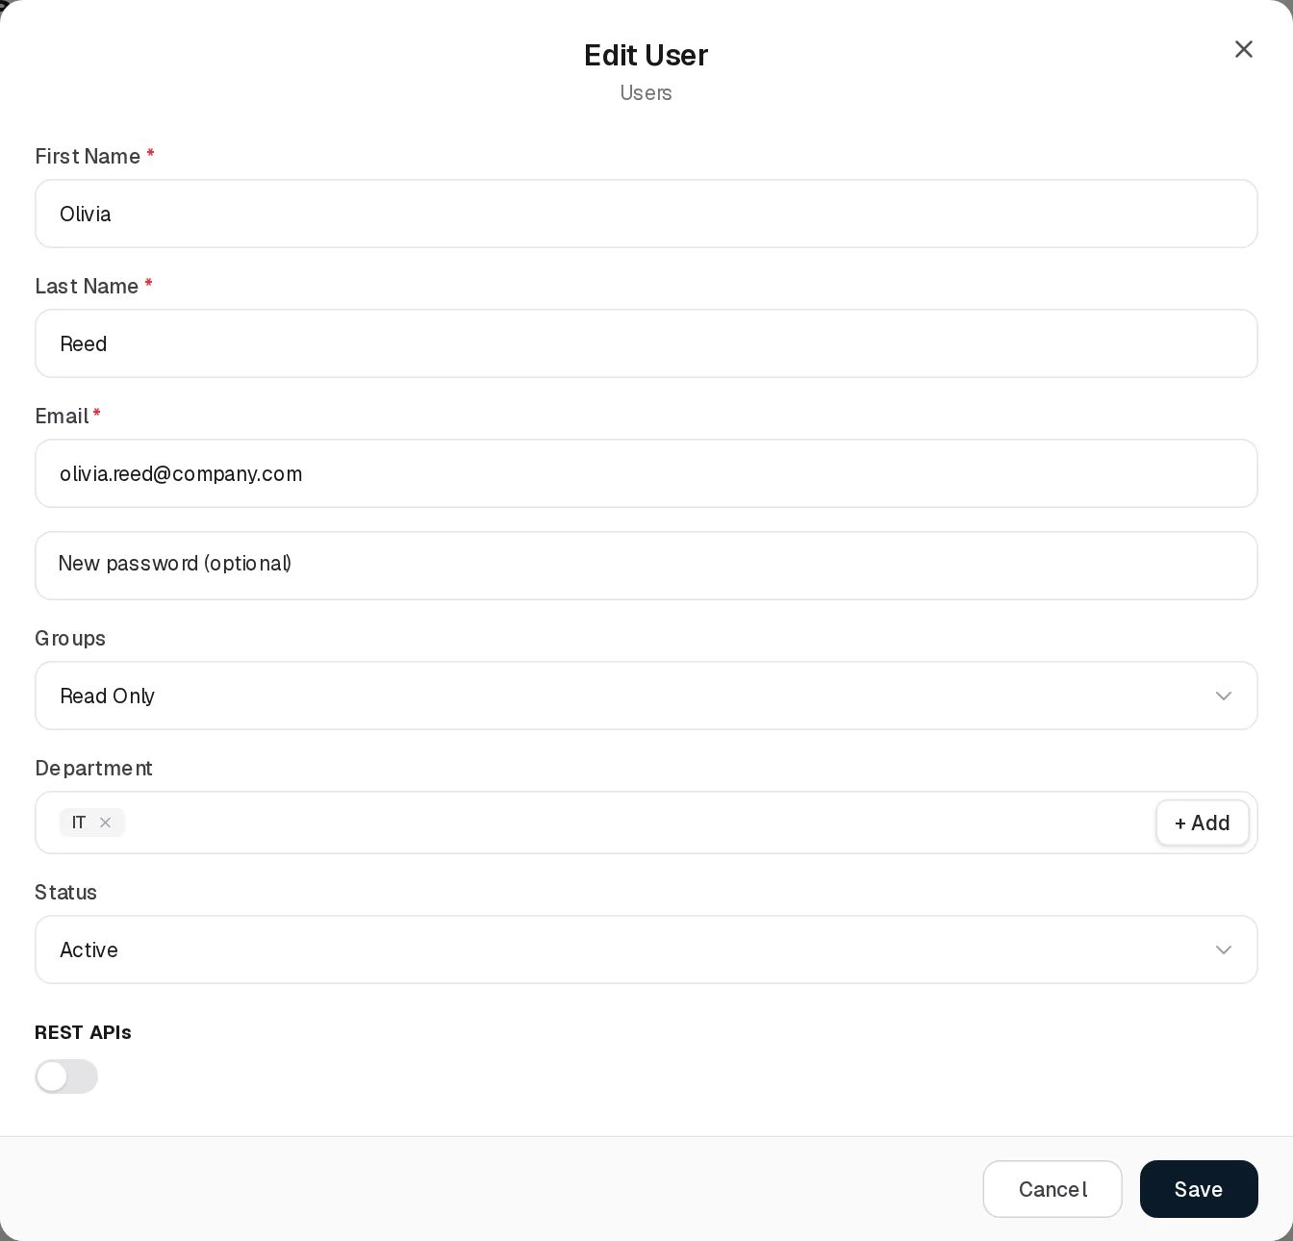
Edit User
Edit User has the same fields as Add, with two differences:
- The password field is New password (optional). Leave it empty to keep the current password. When you type one, Verify your new password appears and both rules above apply.
- The labels sit above the filled-in fields.
Changing the email also changes the sign-in name. Changing the status to Inactive stops the person from signing in.

Statuses
Value | Set by | Meaning
Active | User (Status field) | The person can sign in.
Inactive | User (Status field) | The person cannot sign in. The record, its group membership and every reference to the person stay.
Inactive (shown for PASSIVE, SUSPENDED, PENDING) | System or API | Other stored states. The grid shows them all as Inactive. Opening Edit on such a user shows Inactive, and saving writes INACTIVE.
There is no Dynamic Status on this page.

Additional Permissions
An additional permission (an individual grant) gives one person one permission on top of their groups, usually for a limited time. It does not change the person’s groups. Open it with the key icon on the user’s row.
Element | What it does
Grant a permission drop-down | Every permission of the catalogue, grouped as Module → Page (or Module → Page → Tab), each named Page: action, for example Departments: Create New Item. Settings is not offered.
Duration | 7 days, 30 days (recommended) (default), 90 days, Permanent
Reason | Free text, up to 1,000 characters, shown in the audit trail
Grant | Saves the grant
Active (n) | Current grants: permission name, Until date or Permanent, who granted it, the reason, an ACTIVE badge and a Revoke button
History (n) | Revoked and expired grants with a REVOKED (red) or EXPIRED (grey) badge
Rules:
- If the permission is not a Section Index (read) permission, the read permission of the same page is granted with it, with the same end date and the reason “Read prerequisite of …”. For a tab, the read permission of the parent page is added as well.
- Revoking a page’s read grant also revokes the person’s other active grants on that page and on its tabs.
- You cannot grant to yourself (“You cannot grant a permission to yourself”), grant something the person already has through a group (“The user already has this permission through their roles”) or already holds as an active grant, or grant a permission you do not hold yourself unless you are an administrator (“You cannot give permissions you do not hold yourself.”).
- An end date must be in the future. Expiry needs no job: the grant stops counting at that moment.
- Approving an access request with Grant to this user only creates the same kind of grant, with the reason “Approved access request: …”. In the demo data, approving Olivia Reed’s pending request for Asset Risks: Create New Item would add that grant to her row. See Groups › Access requests, which shows the queue.
Individual grants use the permission names of the catalogue (Section Index, Create New Item, Edit Accessible Items and so on), not the access levels of the Groups page. A person given Create New Item on Vendors by grant does not automatically get Can Assign; it must be granted separately.

Tabs
None.

Relationships
Related record | Direction | How the link is made | Where it shows
Department | User → Department, many to one | Department field on the form | Department column and View
Group | User → Group, many to many | Groups field on the form; CSV import; access request approval does not change it | Groups column; the Users count and Assigned Users tab of the Groups page
Individual grant | User → Permission, one to many | Additional Permissions dialog or an approved access request | Additional Permissions dialog only
Department Contact | Department → User | Department Contact on the Departments form (the first picked user) | Departments grid
Contact fields of other registers | Other record → User | Every user-and-group picker (GRC Contact, Asset Reviewer Contact, Reviewers, Data Owner and so on) | The other register’s columns
Deleting a user. The Delete button removes the person for good, together with their sign-in account. Before the row goes, every module that names the person as a contact, owner or assignee drops its link but keeps the displayed name, and departments that had the person as contact stop naming a linked user. The last member of Admin cannot be deleted: “Cannot delete the last Admin. At least 1 Admin must remain in the system.” The confirmation reads “Delete user Olivia Reed? This cannot be undone.”

Automations and notifications
None for the user record itself. When a user’s groups or individual grants change, every open session of that user receives the new permission list within about 10 seconds, without signing in again.

Permissions
Action | Needed access
See the page | View on Organization Hub › Users
Create a user, import users | Manage on Organization Hub › Users
Edit a user | Manage on Organization Hub › Users
Delete a user | Full Control on Organization Hub › Users
Fill the Groups and Department pickers | The pickers read the Groups and Departments lists; a user who cannot read them still gets a usable form, with empty lists
Put someone into or out of Admin | Membership of Admin
Additional Permissions (view, grant, revoke) | Full Control on Organization Hub › Groups (the Manage Access Control right)
Activity Log | The group’s Comments & Attachments level (View, Contribute, Manage)
Assign / Reassign | Not used on this page

How to

Add a new colleague with read-only access
- Open Organization Hub › Users and click Add Item.
- Enter First Name Olivia, Last Name Reed, Email olivia.reed@company.com, and a password of at least 8 characters in both password fields.
- In Groups choose Read Only. In Department click the field and pick IT.
- Switch REST APIs off unless the person needs the API.
- Click Save. The new row appears at the top of the list with status Active.

Stop someone from signing in without deleting them
- Find Mike Brown in the list (use the search box).
- Click Edit, set Status to Inactive, click Save.
- The row shows Inactive. Every record that names Mike Brown keeps doing so.

Give one person temporary extra access
- On the row of Sara Johnson, click the key icon (Additional Permissions).
- In Grant a permission choose Organization Hub → Departments › Departments: Create New Item.
- Keep 30 days (recommended), type a reason such as Covering for the HR lead, click Grant.
- The grant appears under Active together with Departments: Section Index, which was added automatically. Sara’s open session picks it up within about 10 seconds.

Reset a user’s password
- Click Edit on the user.
- Type the new password in New password (optional) and again in Verify your new password.
- Click Save and give the person the new password through a safe channel.

CSV import
Import CSV works on this page. Clicking it first shows the general message “CSV Import (Users): the import structure is not ready yet.” and then opens a file chooser; the chosen file is imported immediately, without a preview.
Column header (any letter case) | Required | Meaning
firstname | Yes | First name
lastname | Yes | Last name
email | Yes | Email and sign-in name
password | No | Password. If blank, a random 12-character password is set that nobody is told, so the person cannot sign in until an administrator sets a password through Edit.
department | No | Department name, matched exactly. An unknown name is ignored.
role | No | Group name, matched exactly. An unknown name is ignored. One group only.
Every imported user is Active. Values are split on commas with no quoting, so a value cannot contain a comma. Rows go through the same checks as the form (unique email, Admin group rules). The server reports per-row errors, but the page only shows “Users imported.” even when some rows failed, so check the list afterwards.

Limitations and known issues
- One group in the form. The Groups field picks a single group. A user who holds several groups keeps all of them as long as you do not touch the field; choosing another group in it replaces all of them with the one chosen.
- “Admin” by substring. Users in any group whose name contains “admin” are hidden from non-administrators in this list, although permissions treat only the group named exactly Admin as the administrator group.
- CSV import feedback. The page shows “Users imported.” even when rows were rejected, and the “not ready yet” message appears before every import.
- Statuses collapsed. PASSIVE, SUSPENDED and PENDING all show as Inactive, and saving such a user writes INACTIVE.
- User Group in the View dialog belongs to an older model and cannot be set from the UI.

Departments
Module: Organization Hub › Departments · Route: /organization/departments · Permission key: organization.departments
The Departments register lists the organisation’s departments (business units). A record is one department with its name, a description and one or more department contacts. Departments are the organisational dimension of GRC360: users belong to one, assets are booked against one or more, business risks name the business units they apply to, and data flows name the departments they pass through. The grid shows, for each department, how many business risks and asset risks concern it. Administrators maintain the list; risk and asset owners use it through pickers.
Departments register

At a glance
A record is | One department or business unit
Typical owner | GRC360 administrator or the organisation’s GRC lead
Links to | Department Contact (users and groups)
Linked from | Users (Department), Assets (Related Departments), Business Risks (applicable business units), Data Flows (Departments)
Tabs | None
Automations | The Business Risks and Asset Risks counts are computed on every read

The register (list view)
The whole list is loaded at once (no server paging) and refreshes when departments, business risks, asset risks or assets change anywhere in GRC360. Shared grid behaviour is described in Working with registers.
Column | What it shows | Source
Status | Active (green). See Statuses. | Stored
Name | Department name | Entered
Department Contact | Avatar and name of each contact, or -- | Entered
Business Risks | Number of business risks that name this department as an applicable business unit. A number above 0 is a link: clicking it opens the list of those risks. | Computed
Asset Risks | Number of asset risks whose assets are booked against this department (through the asset’s Related Departments). A number above 0 is a link that opens the risks. | Computed
In the demo data, IT shows 15 asset risks (the assets booked against IT carry them) and Alex Meian as contact; HR has Sara Johnson as contact.

Creating a record
Click Add Item. The Add Department dialog opens.
Add Department
Field | Type | Required | Rules and allowed values | Example
Name | Text | Yes | Must not be blank (“The field is required”). Up to 255 characters. Must be unique in the organisation (“Department with this name already exists”). | Risk & Compliance
Description | Text area | No | Up to 1,000 characters | Second-line risk and compliance function
Department Contact | User-and-group picker, several allowed, with + Add | Yes | At least one user or group (“Department Contact is required”). + Add creates a new user on the spot. | Alex Meian
How the contact is stored: the names of everyone picked are saved together, and the first picked user (not group) is also saved as a link to that user record. If you pick only groups, the department has contacts but no linked user.
Click Save; the message “Department added.” confirms it.

Viewing and editing a record
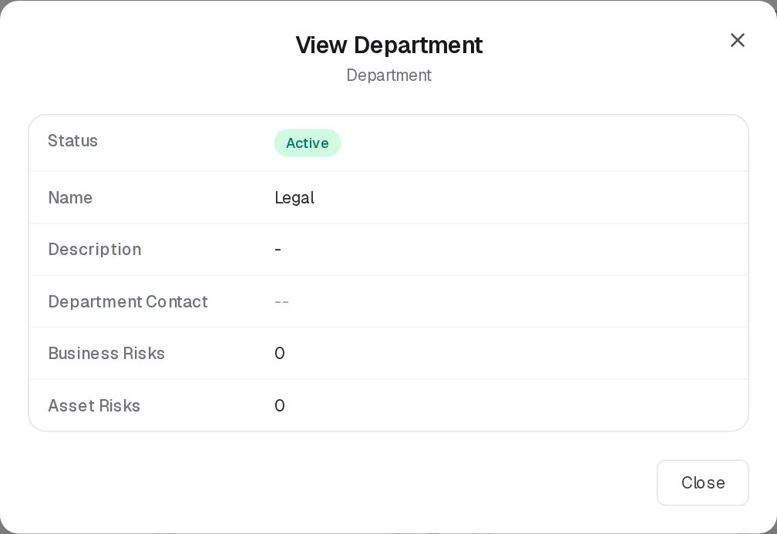
View Department
View Department shows Status, Name, Description, Department Contact, Business Risks and Asset Risks. The counts are plain numbers in this dialog; they are clickable only in the grid.
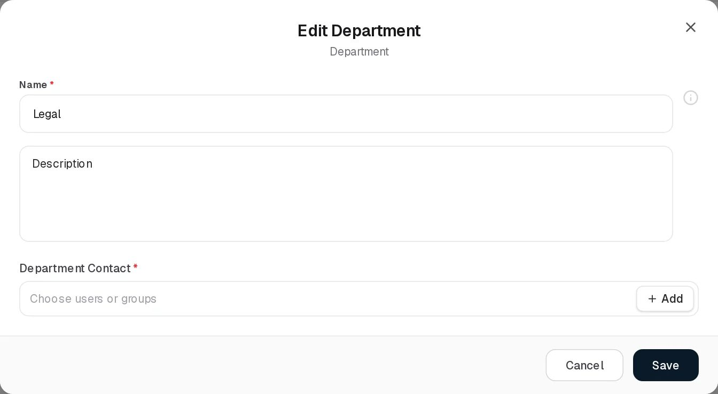
Edit Department
Edit Department has the same three fields as Add. The contact is required on Edit too, so a department imported or created without a contact (such as Legal in the demo data) cannot be saved until a contact is picked.
Renaming a department also renames it on every asset that lists it in Related Departments, so the asset counts keep working.

Statuses
Value | Set by | Meaning
Active | System (every new department) | The department is in use.
The backend also knows a deactivated state (PASSIVE), but the page offers no way to set it: there is no Status field and Delete removes the department outright. A department deactivated through the API still shows Active in this grid.
There is no Dynamic Status on this page.

Tabs
None.

Relationships
Related record | Direction | How the link is made | Where it shows
Users and groups (contact) | Department → people, one to many | Department Contact on this form | Department Contact column
Users | User → Department, many to one | Department on the Add/Edit User form | Users grid Department column
Assets | Asset → Department, many to many | Related Departments on the asset form | Assets grid; feeds this page’s Asset Risks count
Business Risks | Business risk → Department, many to many | The risk’s applicable business units field in Risk Management | Business Risks count (clickable)
Asset Risks | Asset risk → Asset → Department | Indirect, through the assets the risk applies to | Asset Risks count (clickable)
Data Flows | Data flow → Department, many to many | Departments on the data flow form | Data Asset Flows grid

Automations and notifications
None. The two risk counts are recalculated each time the list is read.

Permissions
Action | Needed access
See the page | View on Organization Hub › Departments
Create / Edit | Manage on Organization Hub › Departments
Delete | Full Control on Organization Hub › Departments
Create a department from the + Add button in another form (for example the Department field of Add User) | Manage on Organization Hub › Departments; without it the + Add button is hidden
Open the risks behind a count | View on the risk register concerned
Activity Log | The group’s Comments & Attachments level
Assign / Reassign | Not used on this page
Deleting. Delete removes the department permanently, and is refused while anything still uses it:
- “Cannot delete department: 3 user(s) are still assigned to it”
- “Cannot delete department: 2 asset(s) are still assigned to it”
- “Cannot delete department: 1 risk(s) are still assigned to it”
The reason is shown inside the confirmation dialog. Move the users or assets to another department first. The risk check counts records of an older, generic risk table that the current risk registers do not use; business risks that name the department as a business unit do not block the deletion, and keep the deleted department’s id.

How to

Add a department and its contact
- Open Organization Hub › Departments, click Add Item.
- Name: Internal Audit. Description: Third-line assurance.
- In Department Contact pick Alex Meian. Add a group as well if the whole team should be named.
- Click Save.

Give the Legal department a contact
- Click Edit on Legal.
- Pick a user in Department Contact (the field is required, and Legal has none in the demo data).
- Click Save. The contact’s avatar appears in the grid.

See which asset risks concern IT
- In the IT row, click the number 15 in Asset Risks.
- The panel lists those asset risks; open any of them from there.

Remove a department that is no longer used
- Click Delete on the department and confirm.
- If the dialog reports users, assets or risks still assigned, reassign them (for example change the users’ Department on the Users page) and try again.

CSV import
Not available. Import CSV shows “CSV Import (Departments): the import structure is not ready yet.” and opens a demonstration dialog whose validation fails, because there is no department import behind it.

Limitations and known issues
- Departments cannot be deactivated from the page, only deleted; a department deactivated through the API still shows Active.
- The Department Contact is required in the form, while the backend accepts a department without one. Departments created by other means can therefore show -- and must get a contact before their next save.
- A department contact that is a group is stored as a name only; only the first picked user is stored as a link.
- Deleting a department is not blocked by the business risks that name it as an applicable business unit; those risks keep pointing at a department that no longer exists.

Groups
Module: Organization Hub › Groups · Route: /organization/roles · Permission key: organization.roles
A group is a set of permissions that users are members of. Permissions in GRC360 are given to groups, never directly to a role-less user (individual, usually time-limited grants are the one exception, see Users › Additional Permissions). This page lists the groups, lets administrators define for each group which pages and tabs its members can reach and what they may do there, which records they find, how they may use comments and attachments, and whether they may assign records to other people. It also holds the queue of access requests filed by users who met a locked button. The code and the permission codes call groups “roles”; the screen says Groups.
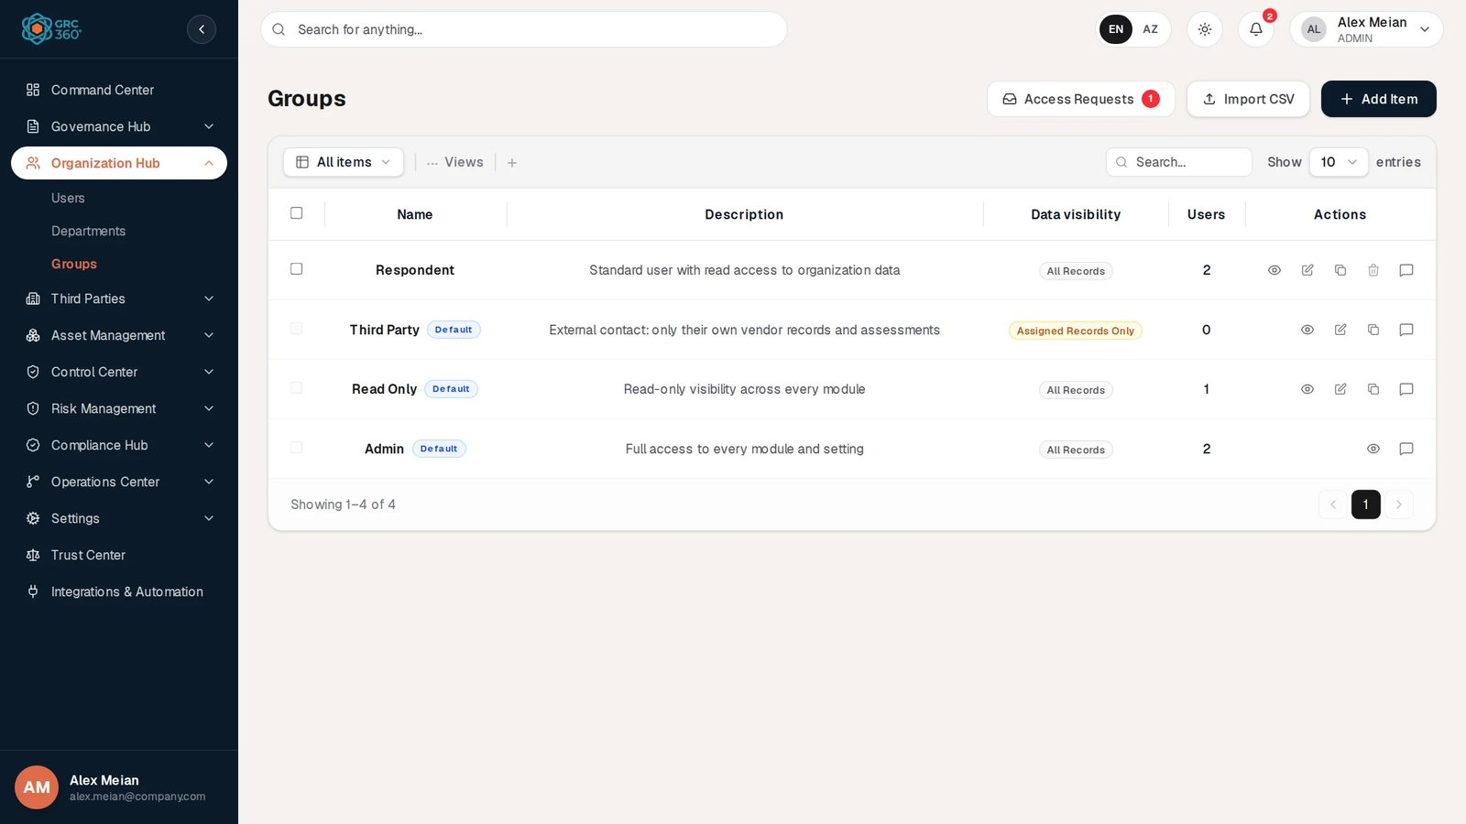
Groups register

At a glance
A record is | One group: a name, a description, a data visibility mode and a set of permissions
Typical owner | GRC360 administrator (members of Admin)
Links to | Permissions (the catalogue of pages, tabs and actions)
Linked from | Users (Groups), every user-and-group picker in GRC360, access requests, vendors (Vendor Role, set before this release)
Tabs | None on the page. The View dialog has Assigned Users and Access.
Automations | At every server start the permission catalogue is synchronised and the Admin group rewritten. Permission changes reach open sessions within about 10 seconds. Access requests notify the Admin group.

How the permission model works

The four layers
Layer | Set where | Decides
Access level per page and per tab | Groups › Access columns | Whether a member sees the page or tab at all, and which record actions it allows
Comments & Attachments | Groups, once per group | Whether a member can read, add or delete comments and attachments in the Activity Log of the pages the group opens
Assignment Management | Groups, once per group | Whether a member may name other people on a record (Can Assign) and change people already named (Can Reassign) on the nine assignable registers
Data visibility | Groups, once per group | Which records of the nine visibility registers a member finds on the pages they can open
A user’s effective rights are the union of all their groups plus their active individual grants. Nothing removes a right that another group gives.

Access levels
Every page of the sidebar is a permission unit, and so is every tab that carries its own permissions (for example Assets › Reviews). For each unit a group has exactly one level.
Level | Description shown in the form | Permission codes it grants on the unit
No Access | The user cannot see or open this section. | None. The page disappears from the sidebar; opening its address shows Access Denied.
View | The user can only read the section and the records they may see. | read (Section Index), export (View Reports)
Manage | View, plus creating new records and editing existing ones. | View, plus create (Create New Item), edit (Edit Accessible Items), import (Manage Import Tool), audit-results (Audit Results), maintenance-results (Maintenance Results)
Full Control | View, plus create, edit and delete. | Manage, plus delete (Delete Accessible Items), manage-settings (Manage Section Settings), manage-access (Manage Access Control). Any action added to the catalogue later and not yet mapped also falls under Full Control.
A level grants only the codes the unit actually has. Where two levels would grant the same thing, the higher one is not offered. Examples:
Unit | Levels offered | Notes
Command Center (dashboard) | No Access, View | The dashboard can only be read
A register page such as Third Parties › Vendors | No Access, View, Manage, Full Control
Risk Management › Asset Risks | All four | Full Control also gives Manage Section Settings (the risk calculation settings)
Organization Hub › Groups | All four | Full Control also gives Manage Access Control, the right to change groups’ access, give individual grants and decide access requests
A tab such as Asset Management › Assets › Reviews | All four | View = read; Manage = create, edit; Full Control = delete
Control Center › Controls › Audits | All four | Manage includes Audit Results (writing the audit result and conclusion)
Control Center › Controls › Maintenances | All four | Manage includes Maintenance Results
Settings (all pages) | Not shown | Settings belongs to Admin alone and cannot be given to any other group, grant or request
Tabs and their page. Setting a tab above No Access raises its page to at least View, because a tab cannot be opened on a closed page. Setting a page to No Access sets all its tabs to No Access. The server applies the same rule: any permission on a unit brings the unit’s read, and a tab’s permission also brings its page’s read.

Comments & Attachments
One choice per group, applied to every page and tab the group can open (View or higher) that has an Activity Log.
Choice | Description in the form | Codes
None | Comments and attachments are not shown. | none
View | Can see comments and attachments. | view-comments (View List of Comments and Attachments)
Contribute | Can see and add comments and attachments. | plus create-comments (Create Comments and Attachments)
Manage | Can see, add and delete comments and attachments. | plus delete-comments (Delete Comments and Attachments)
The author of a comment can always delete their own comment. The change history of a record comes with the page’s View level, not with this choice. The dashboard, Settings and Integrations & Automation have no Activity Log. When the group’s pages hold different comment rights (possible for groups created before this editor), the form shows “Sections differ today — choose one to apply it to all of them.” and the View dialog shows Mixed.

Assignment Management
Two checkboxes per group: Can Assign (Can assign a record to other users.) and Can Reassign (Can change an existing assignment.). They apply to the nine assignable registers on which the group has Manage or Full Control: Assets, Asset Risks, Third Party Risks, Business Risks, Controls, Policies & Standards, Vendors, Service Agreements and Objectives. The form notes: “Applies to the registers this group can manage. Without these rights a user can still assign themselves.”
The rule is applied field by field to each people field of a record (for example GRC Contact and Asset Reviewer Contact on an asset). The person saving never counts:
What happens to the other people in the field | Right needed
Unchanged, or the user only added or removed themselves | None
The field named nobody else before (always the case on a new record) and now names someone | Can Assign
The field named someone else before and the set of other people changes (replaced, added to, removed, cleared) | Can Reassign
Without the right, the picker switches to “only me” mode: it offers only the user themselves, keeps the chips of people already named, and its lock hint (“Assigning other people requires Can Assign — click to request access” or “Changing who is assigned requires Can Reassign — click to request access”) opens the access request dialog. The server refuses a save that breaks the rule with the usual access-request offer. The fields covered per register are listed in Permissions and access. Fields of tab records (review reviewers, audit and maintenance owners) are not covered.
If a checkbox is checked on some of the group’s registers and not on others, it shows as indeterminate; clicking it applies it to all.

Data visibility
Choice | Description in the form | Effect
All Records | Sees every record in the sections this group can open. | No narrowing. Default for a new group.
Assigned Records Only | Sees only the records they are assigned to or created, and records assigned to no one. | On the nine visibility registers (Assets, Asset Risks, Third Party Risks, Business Risks, Controls, Policies & Standards, Vendors, Service Agreements, Objectives), a member finds only records that name them or one of their groups in a people field, records they created, and records that name nobody. Tab records (reviews, audits, issues, maintenances, data flows) follow their parent record.
Their department | Sees the records of their own department. | Shown only on a group that already has this mode. It narrows only Assets today, so it is no longer offered for new choices.
A member of several groups gets the widest visibility of them. Data visibility does not affect pages outside the nine registers (for example Policy Exceptions, Projects or Compliance Hub pages), and the Command Center figures are always organisation-wide.
External contacts. A group set as a vendor’s Vendor Role (possible in earlier releases; the field is no longer on the Vendors form) confines its members to records linked to that vendor whatever the visibility choice, and its members cannot create, edit or delete vendors or service agreements.

Rules that stop people widening their own access
Every change to a group’s access, a user’s groups or an individual grant passes four checks. Administrators (members of the group named exactly Admin) are exempt from rules 2 to 4.
# | Rule | Message when broken
1 | A group’s permissions and data visibility change only with Manage Access Control (Full Control on Groups). With Manage you can still change name and description. | The access request dialog for Organization Hub › Groups › Manage Access Control
2 | Nobody may change the permissions or data visibility of a group they belong to. | “You cannot change the permissions or data visibility of a group you belong to. Ask an administrator.”
3 | Only an administrator adds people to Admin or removes them; nobody changes their own group membership. | “Only an administrator can add people to the Admin group or remove them from it.” / “You cannot change your own group membership. Ask an administrator.”
4 | Nobody gives a group, a clone or a person a permission they do not hold themselves. Removing permissions is always allowed. | “You cannot give permissions you do not hold yourself.” followed by the permission codes
Rule 4 does not apply to membership: someone allowed to edit users may put a new colleague into a group with more rights than their own (except Admin).

Built-in groups
Group | Description | Data visibility | Starting permissions | Edit | Delete / rename
Admin | Full access to every module and setting | All Records | Every permission in the catalogue, including Settings and Manage Access Control: Full Control everywhere, comments Manage, Can Assign and Can Reassign | No: no Edit or Clone button. The group is rewritten from the catalogue at every server start, so it can never lose a right. | No
Read Only | Read-only visibility across every module | All Records | View (read only, without export) on every page and tab except Settings; comments None; no assignment rights | Yes | No
Third Party | External contact: only their own vendor records and assessments | Assigned Records Only | Read and edit on Vendors, Service Agreements, Third Party Risks and Compliance Analysis; nothing else. Because read plus edit without create matches no level, these four pages show Manage with a purple Custom chip. Comments None. In a new organisation no assignment rights. | Yes | No
- The starting permissions of Read Only and Third Party are written once, when the group is first created. After that they belong to your organisation: changes you make survive restarts.
- All three keep the Default badge, cannot be selected for bulk delete (“Built-in groups cannot be deleted”), and their Name field is disabled on Edit. Renaming a built-in group is refused by the server.
- Settings permissions are removed from every group other than Admin at each server start.
- Respondent, Analyst, Approver, Domain manager and Department Manager were built-in in earlier releases. An organisation that has them keeps them as ordinary groups with their members and permissions; they lose the Default badge and can be edited and deleted. In the demo data Respondent (“Standard user with read access to organization data”) has View on Users, Departments and Groups only and two members (Sara Johnson, Mike Brown). Its View dialog shows Custom Role.
- In the demo data the Third Party group also holds Can Assign and Can Reassign on Vendors, Service Agreements and Third Party Risks. These were inherited once when the assignment rights were introduced (every group that could create or edit a register received Can Assign, and every group that could edit it Can Reassign). A new organisation’s Third Party group does not get them.

The register (list view)
The whole list is loaded at once. Shared grid behaviour is described in Working with registers.
Column | What it shows | Source
Name | Group name, with a blue Default badge on built-in groups | Entered
Description | Description, or -- | Entered
Data visibility | All Records (grey) or Assigned Records Only / Their department (amber) | Entered
Users | Number of members. Clicking it opens a small panel listing the members (“Show the group’s users”), searchable. | Computed
Row actions: View (eye), Edit Group & Permissions, Clone Group, Delete Group, and the Activity Log. Admin shows only View and the Activity Log; the other built-in groups have no Delete. Without the right, Edit, Clone and Delete stay visible with a lock and open the access request dialog.
Header: Access Requests (only for holders of Manage Access Control; a red badge shows the number of pending requests, 9+ above nine), Import CSV and Add Item.

Creating a record
Click Add Item. The Add Group dialog opens. It is one long form.
Add Group
Field | Type | Required | Rules and allowed values | Example
Name | Text | Yes | Must not be blank (“The field is required”). Up to 100 characters. Unique among groups (“Group with this name already exists”). | Risk Owners
Description | Text area | No | Up to 500 characters | Business owners of asset and business risks
Data visibility | Choice cards | Yes (one is always selected) | All Records (default), Assigned Records Only; Their department only on a group that already has it | All Records
Comments & Attachments | Choice cards | No | None, View, Contribute, Manage. A new group starts at None. | Contribute
Assignment Management | Two checkboxes | No | Can Assign, Can Reassign | Can Assign
Access | Four columns | No | See below | Risk Management › Asset Risks: Full Control
The Access columns. From left to right:
- Modules: the sidebar modules, Settings excluded. A small dot marks modules where the group has any access.
- Sections: the pages of the selected module (for a single-page module such as Command Center, the module itself).
- Sub-sections: the selected page itself, followed by its tabs (indented). Each row shows its current level as a chip: No Access (grey), View (blue), Manage (amber), Full Control (green), plus Custom (purple) for rights that match no level.
- The level cards of the selected unit, headed with its path (for example Asset Management › Assets › Reviews).
Each of the first three column headers has a Set all… drop-down that applies one level to everything in that column’s scope (all modules, all pages of the module, or the page and its tabs). Each unit gets the highest offered level not above the one chosen.
When you open a group whose rights on a unit match no level, the level column says “This section has a custom set of rights from the earlier editor. Choosing a level replaces it.” A unit you do not touch keeps exactly the permissions it had, so opening and saving an older group changes nothing you did not change.
Click Save. “Group added.” confirms it. A rejected save keeps the dialog open with the server’s reason at the top.

Viewing and editing a record
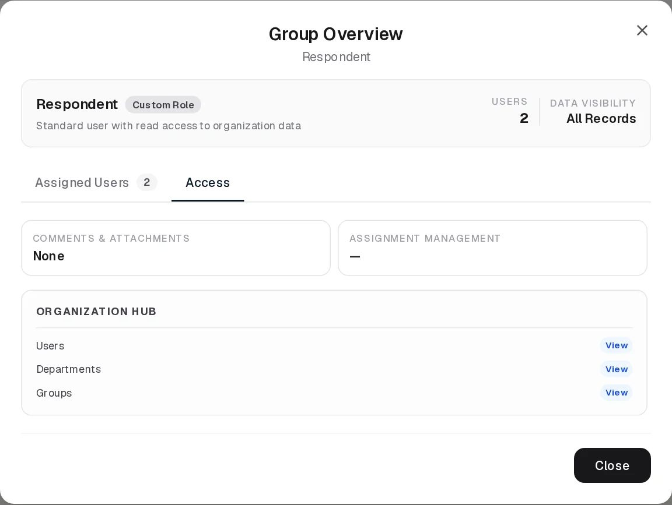
Group Overview
View opens Group Overview with the group name as subtitle. The header shows the name, a System Default or Custom Role badge, the description, the number of Users and the Data visibility. Two tabs follow:
- Access (opens first): the group’s Comments & Attachments level (or Mixed), its Assignment Management rights (or —), and, per module, one line per page and tab the group can reach with its level chip. The Admin group’s Settings pages are listed here too.
- Assigned Users (n): each member with initials, name, email, department and status. “No users assigned to this group yet.” when empty.
Edit Group & Permissions opens Edit Group (subtitle Group) with the same form as Add, filled in. On built-in groups the Name is greyed out.
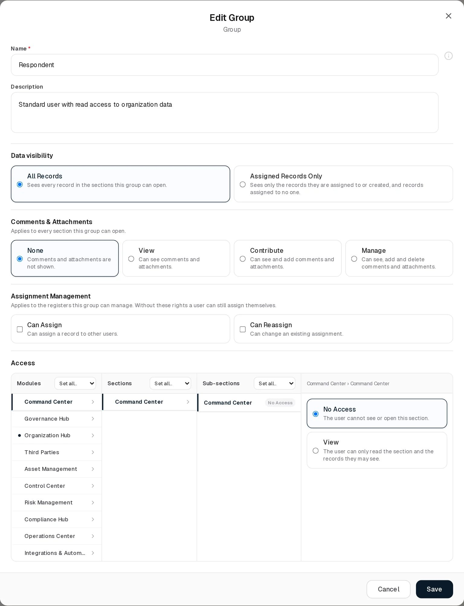
Edit Group
The example is Respondent: All Records, comments None, neither assignment right, and a dot beside Organization Hub in the Modules column, the only module where the group has access (View on Users, Departments and Groups).
Clone Group is meant to create a copy named “ (Copy)” with the same permissions and description; see Limitations.
Delete Group asks “Delete group Respondent?”. The server refuses:
- a built-in group: “Cannot modify or delete default/system group: Third Party”
- a group with members: “Cannot delete group”Respondent”: it is assigned to 2 users. Remove it from all members first.”
- a group used as a vendor’s Vendor Role: “Role”…” is assigned as a vendor’s Vendor Role. Clear it on the vendor before deleting the role.”
Bulk delete sends all selected groups at once and reports each refusal in an amber banner: “Deleted 1 of 3 roles.” followed by one line per refused group with its reason.

Statuses
Groups have no user-visible status and no Dynamic Status. Access requests have three states:
Value | Set by | Meaning
PENDING | System, when the request is filed | Waiting in the Access Requests queue
APPROVED | Administrator | Granted as a personal grant or added to a group
REJECTED | Administrator | Refused, optionally with a note sent to the requester

Access requests

How a request is filed
When a user clicks a locked button (or the server refuses an action), the Access Restricted / Permission Required dialog names the missing right as Module › Page › Tab with the action label, for example Organization Hub › Departments · CREATE NEW ITEM. Request Access opens a text box (“Why do you need this access? The administrator will see this justification.”, required, up to 2,000 characters); Send Request files it and shows “Request sent. Administrators have been notified and you will receive a notification once it is decided.” The request always names exactly one permission code. See Permissions and access › Requesting access.
The server refuses a request when:
- the permission belongs to Settings (the dialog says “Only the Admin group can access Settings. It cannot be granted to other groups or requested.” and offers no button);
- the user already has it: “You already have this permission”;
- the same request is already pending: “You already have a pending request for this permission”;
- the signed-in account has no user record in Organization Hub: “Your account has no organization profile, so access requests cannot be filed”.
Every member of the group named exactly Admin except the requester receives an ACCESS_REQUEST notification, “Access request from Olivia Reed”, with a Review request link to this page that opens the queue. Users cannot see a list of their own requests in the UI; they learn the outcome from the notification.

Deciding a request
Click Access Requests in the page header. The Access Requests dialog (Pending approvals) lists pending requests, newest first, or “No pending access requests.” Each card shows the requester’s name and email, the requested Module › Page › Tab and action, the justification in quotes, how long ago it was filed, and the requester’s groups (or No groups).
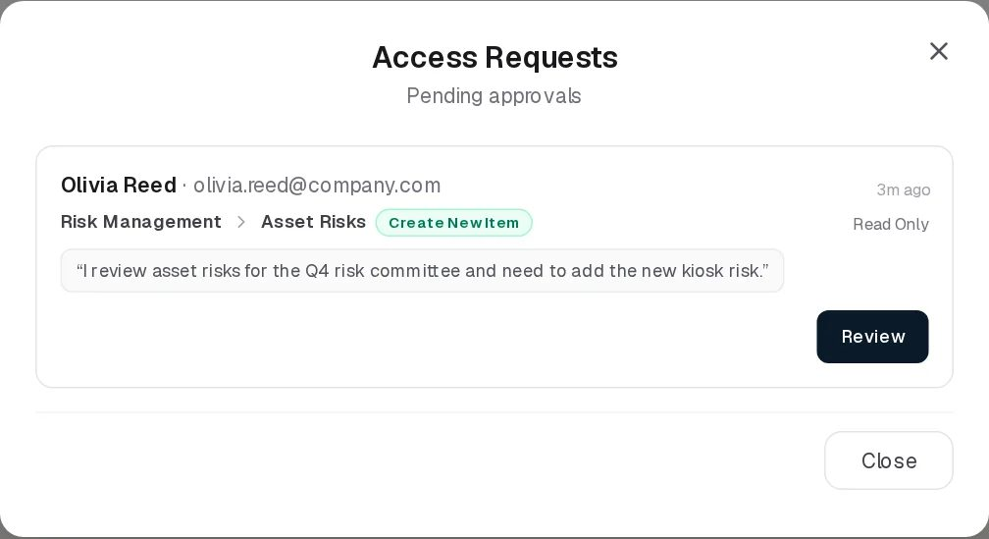
Access Requests
In the demo data, Olivia Reed (member of Read Only) has asked for Risk Management › Asset Risks · Create New Item with the justification “I review asset risks for the Q4 risk committee and need to add the new kiosk risk.” The header button shows the badge 1. Because Olivia holds only a built-in group, the only possible approval is Grant to this user only.
Click Review:
Element | Meaning
Grant to this user only (default) | Creates an individual grant for the requester. Duration 7 days, 30 days (recommended) (default), 90 days or Permanent. The grant carries the reason “Approved access request: ” and, like any grant, brings the page’s read permission with it.
Add to one of their groups | Adds the permission to one of the requester’s non-built-in groups (drop-down). A warning shows the reach: “⚠ 2 users hold this group — all of them will receive this permission.” Disabled with “Not available — the requester only holds system default groups, which cannot be edited.” when the requester has only built-in groups.
Decision note | Optional, up to 1,000 characters. “Decision note (optional — sent to the requester on reject)”.
Cancel / Reject / Approve | Close the card without deciding / refuse / grant
Rules: you cannot decide your own request (“You cannot approve your own access request” / “You cannot decide your own access request”); a request already decided cannot be decided again (“This request has already been decided”); adding to a group goes through the same four escalation rules as editing the group (so you cannot add to a group you belong to, or add a permission you do not hold yourself, unless you are an administrator). Adding a single code to a group can make that page show Custom in the group’s Access columns.
The requester receives ACCESS_APPROVED (“Your request for”Departments: Create New Item” was approved — granted to you until .”, “… granted to you permanently.” or “… added to your role”“.”) or ACCESS_REJECTED (*“Your request for”…” was rejected:
“*). Their permissions in open sessions refresh within about 10 seconds.

Tabs
None on the page. The View dialog’s Access and Assigned Users tabs are described above.

Relationships
Related record | Direction | How the link is made | Where it shows
Users | User → Group, many to many | Groups field on the Users form | Users count (clickable), Assigned Users tab
Permissions | Group → Permission, many to many | Access columns, Comments & Attachments, Assignment Management | Access tab of Group Overview
Access requests | Request → Group | Add to one of their groups on approval | The requester’s notification
Records in other registers | Record → Group | Every user-and-group picker; the group’s members then count as named for data visibility | The other register’s contact columns
Vendors | Vendor → Group | Vendor Role, no longer editable in the UI | Blocks deleting the group

Automations and notifications
What | When | Effect
Catalogue sync | Every server start | The permission catalogue is rewritten from the code, obsolete permissions are removed from all groups, Admin gets every permission again, Settings is withdrawn from every other group, and a group that was built-in in an earlier release is demoted to an ordinary group
One-time inheritance | The first start after a new permission is added to the catalogue | Groups receive the new permission if they held what it was carved from (a new tab inherits its page’s matching action; Can Assign comes from create or edit, Can Reassign from edit). Individual grants are not widened.
Session refresh | Any change to a group’s permissions, a user’s groups or an individual grant | Open sessions of the organisation reload their permission list within about 10 seconds
ACCESS_REQUEST | A request is filed | Members of Admin, except the requester
ACCESS_APPROVED / ACCESS_REJECTED | A request is decided | The requester

Permissions
Action | Needed access
See the page and open Group Overview | View on Organization Hub › Groups
Add a group without access, edit name and description | Manage on Organization Hub › Groups
Set or change access levels, comments, assignment rights or data visibility | Full Control on Organization Hub › Groups (Manage Access Control), and not being a member of that group (unless administrator)
Clone a group | Manage, plus Manage Access Control when the source group has permissions
Delete a group | Full Control on Organization Hub › Groups
See Access Requests and decide them | Full Control on Organization Hub › Groups (Manage Access Control)
Give Admin membership, change Settings | Membership of Admin
Activity Log | The group’s Comments & Attachments level
Assign / Reassign | Not used on this page

How to

Create a group for risk owners
- Click Add Item. Name: Risk Owners. Description: Business owners of asset and business risks.
- Data visibility: Assigned Records Only, so each owner finds the risks that name them.
- Comments & Attachments: Contribute. Assignment Management: leave both unchecked, so owners can name only themselves.
- In Modules click Risk Management, in Sections click Asset Risks, in Sub-sections click Asset Risks and choose Manage. Click Reviews and choose Manage.
- Do the same for Business Risks. Optionally give View on Asset Management › Assets.
- Click Save, then add members on the Users page.

Give an existing group read access to a whole module
- Click Edit Group & Permissions on the group.
- Click the module in Modules; in the Sections header choose Set all… › View.
- Click Save. Members see the new pages within about 10 seconds.

Decide an access request
- Open the notification “Access request from Olivia Reed” and click Review request, or click Access Requests (badge 1) on this page.
- Read the justification (“I review asset risks for the Q4 risk committee…”) and click Review.
- Keep Grant to this user only with 30 days (recommended): Olivia needs to add one risk for one committee. (Add to one of their groups is disabled for her, because Read Only is built-in; for a requester in a custom group, choose it only when every member of that group should have the right.)
- Click Approve. Olivia receives “Your request for”Asset Risks: Create New Item” was approved — granted to you until …“, and the grant appears (no read grant is added, because Read Only already gives her Asset Risks: Section Index) under her Additional Permissions on the Users page. To refuse, type a note and click Reject.

Check what a group can do
- Click the eye icon on Third Party.
- The Access tab lists Third Parties › Vendors, Service Agreements, Risk Management › Third Party Risks and Compliance Hub › Compliance Analysis, each Manage with a Custom chip, comments None, and the data visibility Assigned Records Only in the header.

CSV import
Not available. Import CSV shows “CSV Import (Groups): the import structure is not ready yet.” and opens a demonstration dialog whose validation fails.

Limitations and known issues
- Clone does not work. The page sends the new name in a field (newName) that the server does not read; the server requires name (its validation message is “New role name is required”), so every clone is refused and the page shows the server’s error as a toast. This follows from the code; it was not exercised on the read-only demo. Create the group with Add Item instead. Even if it worked, a clone would not copy the source group’s data visibility (a new group is All Records).
- Renaming to an existing name is not checked on Edit (only on Add and Clone), so two groups can end up with the same name.
- Full Control is more than delete. Its description says “View, plus create, edit and delete.”, but on Groups it also gives Manage Access Control and on the risk registers Manage Section Settings.
- View without export. Built-in Read Only holds read but not export; it still shows plain View.
- Individual grants and access requests use action names, not levels: approving a request for Create New Item adds one code, and the page may then show Custom.
- No list of one’s own requests in the UI; the requester relies on the notification.
- Assigned Users reads the Users list, which hides members of groups containing “admin” from non-administrators, so it can show fewer people than the Users count.

Third Parties
Module: Third Parties · Route: /third-parties (opens Vendors) · Permission module: third_parties
The Third Parties module is the register of outside organisations your organisation deals with (suppliers, customers and regulators) and of the service agreements in force with them. It answers two questions for third-party risk management: who are our third parties and who looks after each relationship, and which contracts do we hold with them, for how much and until when. The risk side (what can go wrong with a third party) lives in Risk Management › Third Party Risks, which points back at the vendors here.
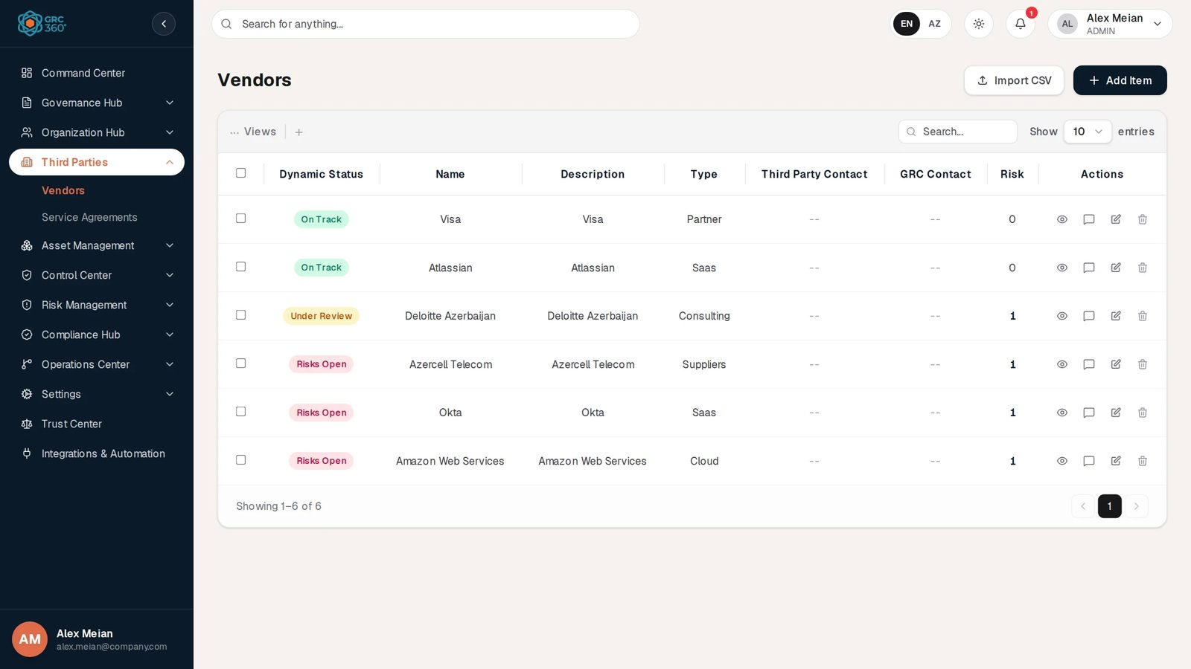
Vendors register

Pages
Page (sidebar label) | Route | Permission key | What it holds
Vendors | /third-parties/vendors | third_parties.vendors | One record per third party: name, description, type, our GRC contact and their contact. A computed Dynamic Status and a count of the third-party risks that name the vendor.
Service Agreements | /third-parties/service-agreements | third_parties.service_agreements | One record per contract with a vendor: contacts, supplier, service value, start and end dates. A Dynamic Status computed from the dates, and expiry notifications to the contacts.
Opening /third-parties without a page redirects to Vendors.

How the pages relate
- Every service agreement belongs to exactly one vendor (its Support Contract Supplier). A vendor can have any number of agreements.
- Third party risks list the vendors they apply to (Applicable Third Parties in Risk Management). The vendor’s Risk column counts them, and a vendor named by at least one such risk reads Risks Open.
- Data flows in Asset Management name the third parties that data passes to, and a data asset’s GDPR Processor Role is picked from the vendors.
- Security incidents in the Operations Center can name the vendors involved.
- A vendor cannot be deleted while service agreements or third-party risks still point at it.

Who sees what
Both pages are among the nine registers where a group’s data visibility applies and where Can Assign / Can Reassign govern the contact fields (see Groups). A group set to Assigned Records Only finds the vendors and agreements that name its members (or the group) as a contact, the ones its members created, and the ones that name nobody. Service agreements are not included in the global search.
The built-in Third Party group is meant for external contacts: it can read and edit vendors and service agreements but not create or delete them, and starts with Assigned Records Only.

Automations and notifications
What | Schedule | Effect
Vendor Dynamic Status | On every read | Computed from the vendor’s stored status and the third-party risks that name it
Service Agreement Dynamic Status | On every read | Computed from today’s date and the agreement’s start and end dates
Expiry notifications SERVICE_AGREEMENT_EXPIRING_WEEK, SERVICE_AGREEMENT_EXPIRING_SOON, SERVICE_AGREEMENT_EXPIRES_TODAY | Daily notification sweep at 08:00 server time, the first time each day someone in the organisation opens their notifications, and whenever an agreement is saved | The agreement’s GRC and support-contract contacts are told 7 days before, 3 days before and on the end date. Details in Service Agreements.
Nightly update of the stored agreement status to Expiring / Expired | Implemented (daily at 01:00) but not active in this release: scheduled jobs are not enabled on the server | None. The Dynamic Status shows Expiring and Expired anyway, because it is computed on read.

CSV import
Not available on either page. Import CSV shows “CSV Import (Vendors): the import structure is not ready yet.” (or Service Agreements) and then opens a demonstration dialog whose validation fails, because no import exists behind it. See Working with registers.

See also
- Risk Management › Third Party Risks
- Asset Management › Data Flows
- Working with registers

Vendors
Module: Third Parties › Vendors · Route: /third-parties/vendors · Permission key: third_parties.vendors
The Vendors register lists the outside organisations your organisation works with: suppliers, customers and regulators. A record is one third party, with a short description, its type, the person or team on your side who owns the relationship (GRC Contact) and the contact on the third party’s side (Third Party Contact). The register also shows how many third-party risks name the vendor and turns that into a Dynamic Status. Procurement, vendor managers and the GRC team maintain it; risk owners pick vendors from it in Third Party Risks and Data Flows.
Vendors register

At a glance
A record is | One third party (supplier, customer or regulator)
Typical owner | Vendor manager or GRC team
Links to | GRC Contact and Third Party Contact (users and groups)
Linked from | Service Agreements (Support Contract Supplier), Third Party Risks (Applicable Third Parties), Data Flows (Third Parties), data assets (Processor Role, by name), Security Incidents
Tabs | None
Automations | Dynamic Status and the Risk count are computed on every read

The register (list view)
The grid is paged on the server and opens newest first. It refreshes when vendors or third-party risks change anywhere. Shared grid behaviour is described in Working with registers.
Column | What it shows | Source
Dynamic Status | On Track, Risks Open, Under Review or Inactive; see Statuses | Computed by the system
Name | Vendor name | Entered
Description | First part of the description; the full text is the tooltip. - when empty. | Entered
Type | Customers, Regulators, Suppliers; vendors created in earlier releases can show an older type such as Partner, Saas, Cloud or Consulting | Entered
Third Party Contact | Avatar and name of each contact on the vendor’s side, or -- | Entered
GRC Contact | Avatar and name of each contact on your side, or -- | Entered
Risk | Number of live third-party risks that list this vendor under Applicable Third Parties. A number above 0 is a link that opens those risks. Not sortable. | Computed

Creating a record
Click Add Item. The Add Vendor dialog opens.
Add Vendor
Field | Type | Required | Rules and allowed values | Example
Name | Text | Yes | Must not be blank (“Required”). Up to 200 characters. Unique in the organisation (“Vendor with this name already exists”). | Amazon Web Services
Description | Text area | No | Up to 500 characters | Cloud hosting for production workloads
GRC Contact | User-and-group picker, several allowed, with + Add | Yes | At least one (“Required”). Subject to Can Assign / Can Reassign. | Alex Meian
Third Party Contact | User-and-group picker, several allowed, with + Add | Yes | At least one (“Required”). Subject to Can Assign / Can Reassign. | Sara Johnson
Type | Drop-down | Yes | Customers, Regulators, Suppliers. Default Suppliers. | Suppliers
The contact pickers offer the users and groups of the Organization Hub; + Add creates a user on the spot. The vendor’s own staff appear here only if they have a user account. Click Save; “Vendor added.” confirms it.
Assignment rule. Naming anyone other than yourself in an empty contact field needs Can Assign on Vendors; changing who else is named in a field needs Can Reassign. Without the right the picker only offers you. See Groups › Assignment Management.

Viewing and editing a record
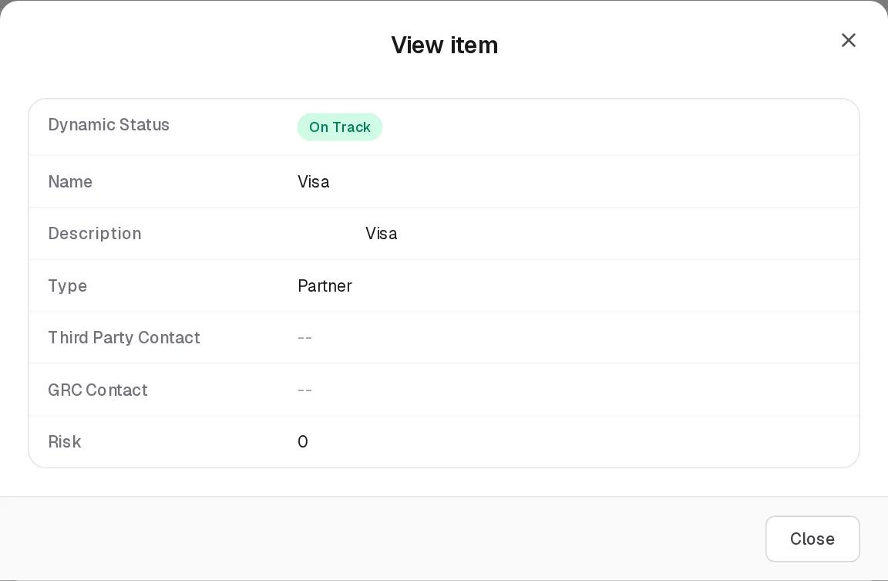
View Vendor
View opens the generic View item dialog with the grid’s columns: Dynamic Status, Name, Description, Type, Third Party Contact, GRC Contact and Risk (a plain number here).
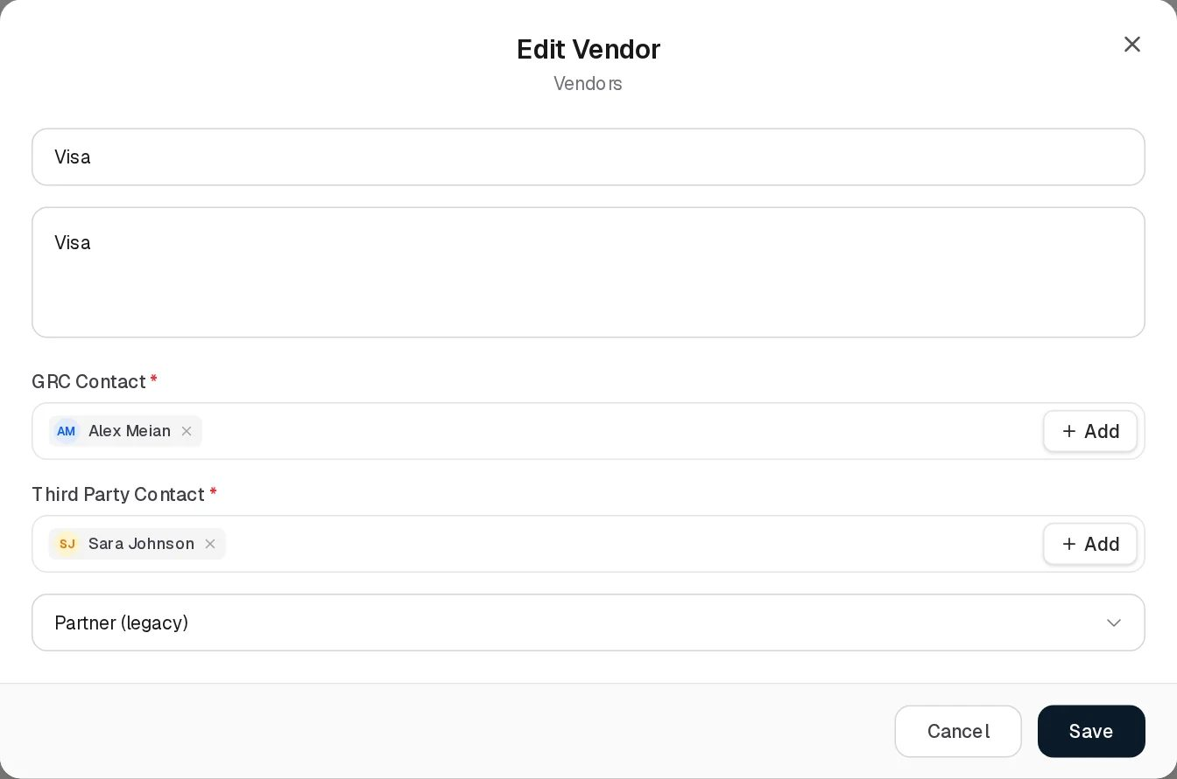
Edit Vendor
Edit Vendor has the same fields as Add. Text fields that already hold a value show no label (the label is a placeholder). A vendor with an older type shows it as (legacy), for example Partner (legacy), so saving keeps it; once you pick one of the three current types the legacy one is no longer offered.
Fields that are not on the form are kept as they are on save, in particular the vendor’s stored status and its Vendor Role (see Limitations).

Statuses
The form has no status field. Each vendor has a stored status (ACTIVE by default; INACTIVE, UNDER_REVIEW and TERMINATED exist and can only come from data loaded by other means). The Dynamic Status is computed on every read, first matching rule wins:
Value | Set by | Rule | Colour
Inactive | System | Stored status is INACTIVE or TERMINATED | Grey
Under Review | System | Stored status is UNDER_REVIEW | Amber
Risks Open | System | At least one live (not deleted) third-party risk lists the vendor under Applicable Third Parties, whatever that risk’s own status or treatment | Red
On Track | System | None of the above | Green
In the demo data Deloitte Azerbaijan is Under Review; Azercell Telecom, Okta and Amazon Web Services are Risks Open with one risk each; Visa and Atlassian are On Track.

Tabs
None.

Relationships
Related record | Direction | How the link is made | Where it shows
Users and groups | Vendor → people | GRC Contact and Third Party Contact on this form | The two contact columns
Service Agreements | Agreement → Vendor, many to one | Support Contract Supplier on the agreement form (with a + Add that creates a vendor) | Service Agreements grid; blocks deleting the vendor
Third Party Risks | Risk → Vendor, many to many | Applicable Third Parties on the risk | Risk count (clickable) and Dynamic Status; blocks deleting the vendor
Data Flows | Flow → Vendor, many to many | Third Parties on the data flow form. Picking a vendor there adds its third-party risks to the flow, and picking a risk adds its vendors. | Data Asset Flows grid
Data assets | Data asset → Vendor | Processor Role in a data asset’s GDPR analysis, picked from vendors but stored as the name | Data Assets grid
Security Incidents | Incident → Vendor | The incident form in Operations Center | Incidents; the link is removed when the vendor is deleted, the incident stays

Automations and notifications
None for vendors. The Dynamic Status and Risk count are recalculated on every read, so a risk saved in Risk Management changes them at once.

Permissions
Action | Needed access
See the page | View on Third Parties › Vendors
Create / Edit | Manage on Third Parties › Vendors
Delete | Full Control on Third Parties › Vendors
Name other people as contacts | Can Assign (empty field) / Can Reassign (field already naming others), on a group with Manage or Full Control on Vendors
Open the risks behind a count | View on Risk Management › Third Party Risks
Activity Log | The group’s Comments & Attachments level
Members of a group used as a vendor’s Vendor Role (external contacts) can only read their own vendor; creating, editing and deleting vendors is refused for them.
Deleting. The vendor is removed permanently. The server refuses while anything still depends on it and names all of it at once, for example “Cannot delete vendor”Okta”: it is still referenced by 1 service agreement, 1 third-party risk. Remove these references first.” Data flows that hold the vendor in an older vendor field also block deletion. Links from security incidents are removed; the incidents stay. The reason appears inside the confirmation dialog (“Delete vendor Okta?”).

How to

Register a new supplier
- Open Third Parties › Vendors, click Add Item.
- Name: Microsoft. Description: Office 365 and Azure AD.
- GRC Contact: Alex Meian. Third Party Contact: the account of Microsoft’s account manager, or a group that represents the vendor.
- Type: Suppliers. Click Save.
- Record its contract in Service Agreements and its risks in Third Party Risks.

Find the risks that make a vendor “Risks Open”
- In the Okta row, click 1 in the Risk column.
- The panel lists the third-party risks that name Okta; open one to review its analysis and treatment.

Retire a vendor
- Delete or reassign its service agreements on the Service Agreements page.
- Remove the vendor from the Applicable Third Parties of its third-party risks (or delete those risks).
- Click Delete on the vendor and confirm.

CSV import
Not available. Import CSV shows “CSV Import (Vendors): the import structure is not ready yet.” and opens a demonstration dialog whose validation fails.

Limitations and known issues
- No status field. Under Review, Inactive and Terminated can only come from data loaded by other means, so a vendor created in the UI is always On Track or Risks Open.
- Risks Open counts every live risk, including risks that are treated, accepted or closed.
- Vendor Role is not on the form. The field that confined a group to one vendor still exists and is kept on save, but can no longer be set or cleared in the UI. A group used as a Vendor Role cannot be deleted until it is cleared.
- Contacts shown in the form but not in the grid. In the demo data the vendors carry contact ids without stored names: the grid shows --, while Edit shows Alex Meian and Sara Johnson. Saving such a vendor without touching the contacts fails with “Required”, because the form checks the single first-contact field, which is empty; remove and re-pick the contacts, then save.
- No labels on filled text fields in Edit (Name, Description): the label is a placeholder that disappears once a value is present.

Service Agreements
Module: Third Parties › Service Agreements · Route: /third-parties/service-agreements · Permission key: third_parties.service_agreements
The Service Agreements register holds the contracts your organisation has with its vendors: support contracts, subscriptions, consulting engagements, connectivity and similar. A record is one agreement with one vendor (the Support Contract Supplier), its value, its validity window (start and end date), the GRC contact who follows it and the contact responsible for the support contract. GRC360 works out from the dates whether each agreement is upcoming, active, expiring or expired, and warns the contacts a week before, three days before and on the end date. Vendor managers and contract owners work in this page.
Service Agreements register

At a glance
A record is | One contract with one vendor
Typical owner | Vendor manager or contract owner
Links to | Vendor (Support Contract Supplier), GRC Contact and Support Contract Contact (users and groups)
Linked from | Vendors (an agreement blocks deleting its vendor)
Tabs | None
Automations | Dynamic Status computed from the dates on every read; expiry notifications SERVICE_AGREEMENT_EXPIRING_WEEK, SERVICE_AGREEMENT_EXPIRING_SOON, SERVICE_AGREEMENT_EXPIRES_TODAY

The register (list view)
The grid is paged on the server and opens newest first. It refreshes when agreements or vendors change. Shared grid behaviour is described in Working with registers.
Column | What it shows | Source
Dynamic Status | Draft, Terminated, Expired, Upcoming, Expiring or Active; see Statuses | Computed by the system
Name | Agreement name | Entered
Description | Description | Entered
Support Contract Supplier | The vendor’s name | Linked
Support Contract Contact | Avatar and name of each contact, or -- | Entered
GRC Contact | Avatar and name of each contact, or -- | Entered
Service Value | Amount and currency, for example 9800 USD | Entered
Start Date | First day of the agreement (YYYY-MM-DD) | Entered
End Date | Last day of the agreement (YYYY-MM-DD) | Entered
The grid is wider than the screen; scroll sideways for Service Value and the dates, or hide columns with Views.

Creating a record
Click Add Item. The Add Agreement dialog opens.
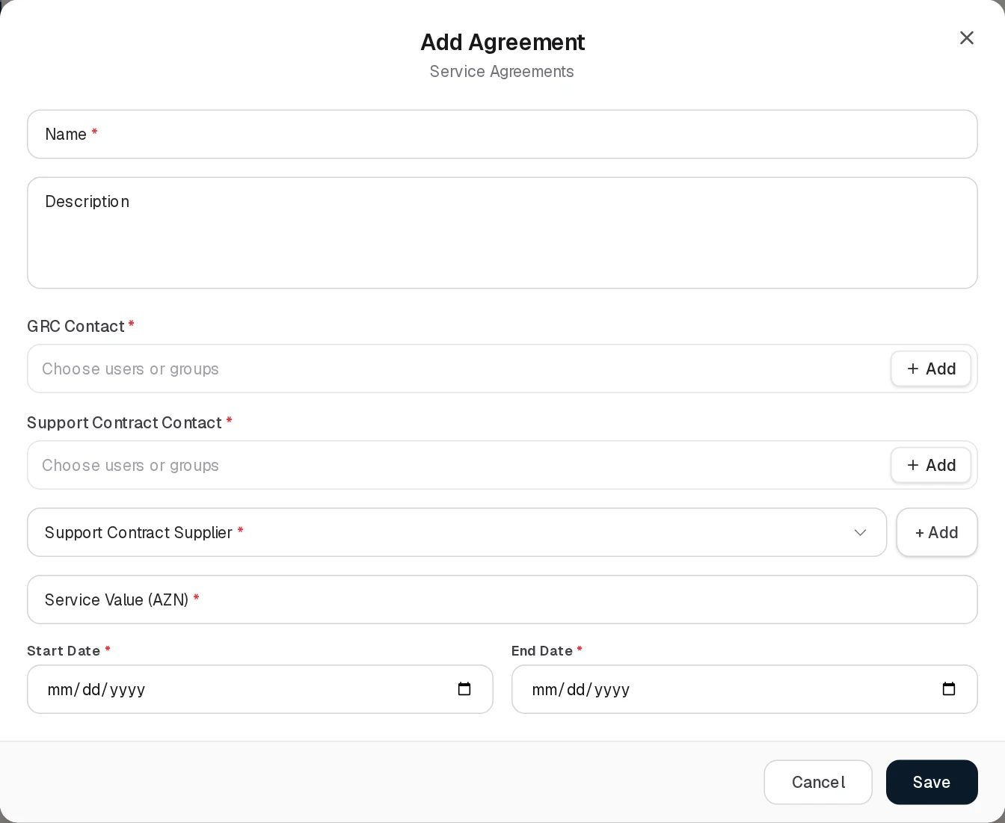
Add Agreement
Field | Type | Required | Rules and allowed values | Example
Name | Text | Yes | Must not be blank (“Required”). Up to 200 characters. | AWS Enterprise Support
Description | Text area | No | Up to 1,000 characters | 24x7 enterprise support plan
GRC Contact | User-and-group picker, several allowed, with + Add | Yes | At least one (“Required”). Subject to Can Assign / Can Reassign. | Alex Meian
Support Contract Contact | User-and-group picker, several allowed, with + Add | Yes | At least one (“Required”). Subject to Can Assign / Can Reassign. | Sara Johnson
Support Contract Supplier | Drop-down with + Add | Yes | One vendor from the Vendors register (“Required”). + Add opens the Add Vendor form and selects the new vendor. You must be able to see the vendor. | Amazon Web Services
Service Value (AZN) | Number | Yes | Must not be blank (“Required”). The currency in the label is the record’s currency: AZN for new agreements; an existing agreement keeps its own (the demo agreements are in USD). There is no currency picker. | 48000
Start Date | Date | Yes | “Required” | 2026-03-28
End Date | Date | Yes | “Required”; must not be before the Start Date (“End date must be after the start date”). The same day is accepted. | 2027-03-28
Click Save; “Service agreement added.” confirms it. If the agreement ends within the next seven days, the expiry notification for the current milestone is sent at once (see below).

Viewing and editing a record
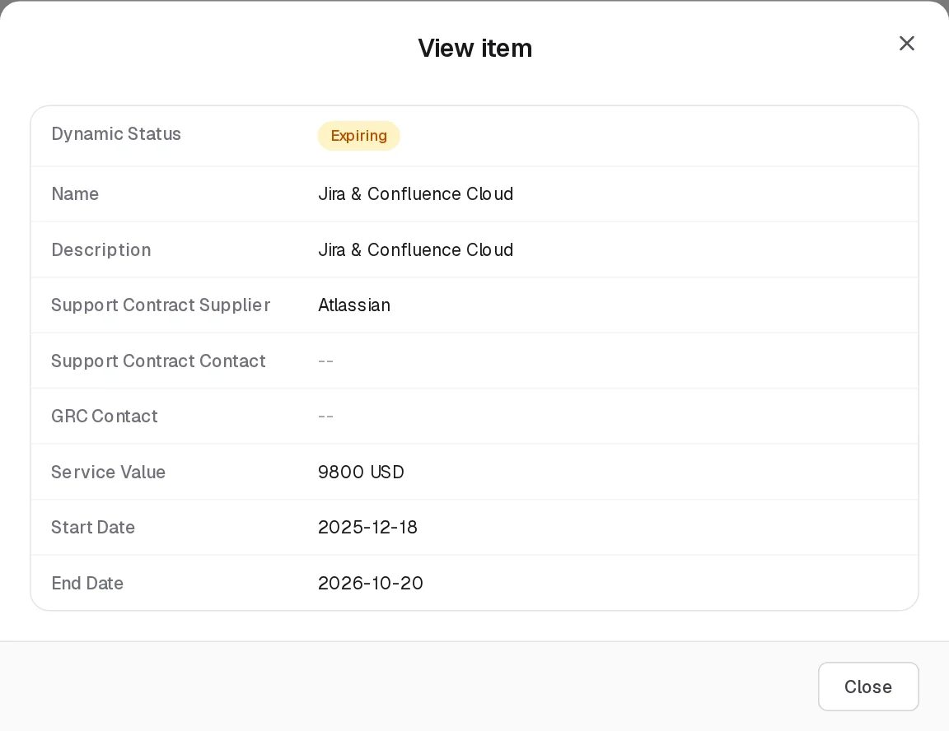
View Agreement
View opens the generic View item dialog with the grid’s columns: Dynamic Status, Name, Description, Support Contract Supplier, Support Contract Contact, GRC Contact, Service Value, Start Date and End Date. Clicking Open the agreement in an expiry notification opens the same information as View Agreement, read from the server even if the agreement is not on the page you are looking at.
Edit Agreement
Edit Agreement has the same fields as Add. The labels of filled text fields (Name, Description, Service Value) are not shown once a value is present. Changing the supplier to another vendor requires that you can see that vendor.

Statuses
The form has no status field: an agreement’s stored status is Active from creation (DRAFT, EXPIRING, EXPIRED and TERMINATED exist but cannot be set in the UI). The Dynamic Status is computed on every read from today’s date, first matching rule wins:
Value | Set by | Rule | Colour
Draft | System | Stored status is DRAFT | Grey
Terminated | System | Stored status is TERMINATED | Grey
Expired | System | End Date is before today | Red
Upcoming | System | Start Date is after today | Amber
Expiring | System | End Date is today or within the next 30 days | Amber
Active | System | Otherwise: started, and ending more than 30 days from today | Green
On 14 October 2026, Jira & Confluence Cloud (Atlassian, ending 2026-10-20) is Expiring; the other four demo agreements are Active.
A nightly job that would also move the stored status to EXPIRING and EXPIRED (daily at 01:00) exists in the code but is not active in this release, because scheduled jobs are not enabled on the server. This does not affect what you see: the Dynamic Status is computed on read.

Tabs
None.

Relationships
Related record | Direction | How the link is made | Where it shows
Vendor | Agreement → Vendor, many to one, required | Support Contract Supplier | Support Contract Supplier column. The vendor cannot be deleted while it has agreements.
Users and groups | Agreement → people | GRC Contact and Support Contract Contact | The two contact columns; recipients of the expiry notifications
The agreement is not shown on the vendor’s own row or View; filter this grid by the vendor name with the search box to see a vendor’s agreements.
Who sees an agreement. Under Assigned Records Only, an agreement is visible to the people and groups named in its two contact fields, to its creator, and to everyone when it names nobody. Members of a group set as the vendor’s Vendor Role also see the vendor’s agreements.

Automations and notifications
GRC360 tells an agreement’s contacts that it is about to run out.
Notification type | Title | When
SERVICE_AGREEMENT_EXPIRING_WEEK | Service agreement expires in a week | 4 to 7 days left
SERVICE_AGREEMENT_EXPIRING_SOON | Service agreement expires in 3 days | 1 to 3 days left
SERVICE_AGREEMENT_EXPIRES_TODAY | Service agreement expires today | The End Date is today (priority High)
- Message. The real number of days is given, for example “Jira & Confluence Cloud” (Atlassian) ends on 2026-10-20 - 6 days left., or … reaches its end date today, 2026-10-20. The link Open the agreement opens the agreement read-only.
- Recipients. Every user named in GRC Contact and Support Contract Contact. A group named there is expanded to its members.
- Which agreements. Those whose stored status is Active (or Expiring) and whose End Date falls between today and seven days ahead. Agreements in Draft or Terminated are not warned.
- When it runs.
  - A daily sweep at 08:00 server time (configurable by the installer).
  - The first time each day that anyone in the organisation opens their notifications.
  - Every time an agreement is saved.
- No duplicates. Each milestone is sent once per agreement and recipient. A later milestone is still sent to someone who received an earlier one. A milestone whose window has passed before the first check is skipped: an agreement entered two days before its end gets only the 3-day and the end-day notices.
In the demo data, Alex Meian has received “Service agreement expires in a week” for Jira & Confluence Cloud.

Permissions
Action | Needed access
See the page | View on Third Parties › Service Agreements
Create / Edit | Manage on Third Parties › Service Agreements; the supplier must be a vendor you can see
Delete | Full Control on Third Parties › Service Agreements
Name other people as contacts | Can Assign / Can Reassign on a group with Manage or Full Control on Service Agreements
Fill the supplier list | View on Third Parties › Vendors
Create a vendor with the supplier + Add | Manage on Third Parties › Vendors
Activity Log | The group’s Comments & Attachments level
External contacts (members of a vendor’s Vendor Role group) can read their vendor’s agreements but cannot create, edit or delete any. Deleting an agreement has no other restriction; the confirmation reads “Delete AWS Enterprise Support?”.

How to

Record a new contract
- Open Third Parties › Service Agreements, click Add Item.
- Name: Okta Workforce Identity. Support Contract Supplier: Okta.
- GRC Contact: Alex Meian. Support Contract Contact: Sara Johnson.
- Service Value (AZN): 22000. Start Date 2025-11-18, End Date 2026-11-18.
- Click Save. The agreement shows Active until 30 days before the end date, then Expiring.

Renew an expiring agreement
- Open the Service agreement expires in a week notification and click Open the agreement, or find Jira & Confluence Cloud (status Expiring).
- Click Edit on its row and move End Date to the new end, for example 2027-10-20.
- Click Save. The Dynamic Status returns to Active. If the date later comes within seven days again, new notices are sent for the new date only if their milestones were not already sent for this agreement and recipient.

See all contracts with one vendor
- Type the vendor’s name, for example Okta, in the grid’s search box.
- Check the Support Contract Supplier column of the rows found.

CSV import
Not available. Import CSV shows “CSV Import (Service Agreements): the import structure is not ready yet.” and opens a demonstration dialog whose validation fails.

Limitations and known issues
- No status field. Draft and Terminated exist but cannot be set, so an agreement ended early still reads Active, Expiring or Expired by its dates. Shorten the End Date to reflect an early termination.
- Renewal notices. The “already sent” record is kept per agreement, milestone and recipient, not per end date, so moving an agreement’s end date after its notices went out does not produce a second set of the same milestones.
- Currency. New agreements are always in AZN; there is no way to choose another currency.
- Contact names missing in the grid for the demo agreements, which carry contact ids without stored names: the grid shows --, Edit shows the people, and saving without re-picking the contacts fails with “Required”.
- Agreement documents. The backend has fields for an attached contract document (URL, name, type, size), but the page offers no way to set or see them.
- Search. Service agreements are not included in the global search.
- The nightly status job is implemented but not active in this release (see Statuses).

Asset Management
Module: Asset Management · Route: /asset-management (opens Assets) · Permission module: asset_management
Asset Management is the inventory of what your organisation needs to protect: applications, data, hardware, infrastructure, facilities, people and services. Every asset has an owner on the GRC side, a reviewer and a review cycle, and is the anchor for the asset risks and third-party risks recorded in Risk Management. For assets that hold data, the Data Flows page records the GDPR analysis of the data asset and how its data is collected, stored, modified, moved and deleted.
Assets register

Pages
Page (sidebar label) | Route | Permission key | What it holds
Assets | /asset-management/assets | asset_management.assets | The asset register: departments, name, type, contacts, next review date, and counts of linked risks, reviews and data flows.
Assets › Reviews | same route, Reviews tab | asset_management.assets_reviews | Planned and completed reviews of each asset, partly generated from the asset’s Next Review Date.
Data Flows | /asset-management/data-movement | asset_management.data_movement | Two tabs: Data Assets (the GDPR analysis of assets of type Data Asset) and Data Asset Flows (each step in the life of an asset’s data, with its GDPR questions, risks and controls).
Opening /asset-management without a page redirects to Assets. The sidebar label Data Flows is a label only: the route stays /asset-management/data-movement and the permission codes stay asset_management_data_movement_*.

How the pages relate
- An asset is created and edited only on the Assets page. The Data Flows page never creates an asset; its Data Assets tab is a filtered view of the same register (assets whose Type is exactly Data Asset) where the GDPR analysis is filled in.
- A review belongs to one asset. Saving an asset with a Next Review Date creates two planned reviews (that date and the same day a year later).
- A data flow belongs to one asset (its Related Asset). The asset’s Data Asset Flows count shows how many flows it has. Whether a flow is asked GDPR questions depends on its asset’s GDPR switch.
- Risks are linked from the risk side: an asset risk names its Related Assets, a third-party risk its Assets Shared with this Third Party. The asset grid counts them.

Who sees what
Assets is one of the nine registers where a group’s data visibility applies, and where Can Assign / Can Reassign govern the people fields (GRC Contact, Asset Reviewer Contact, and the Data Owner, DPO Role, Controller Role and Controller Representative of the GDPR analysis). Reviews and data flows follow their asset: a person who cannot see an asset does not see its reviews or flows either. See Groups.

Automations and notifications
What | When | Effect
Asset Dynamic Status | Every read | Computed from the Next Review Date
Review Dynamic Status | Every read | Computed from the review’s planned and actual dates
Review generation | Every save of an asset | Planned reviews are created for the Next Review Date and one year later, dates in the past are skipped, and untouched generated reviews for an old date are removed
Review and flow counters | Every read / every review save | The Reviews and Data Asset Flows counts on the asset
No notifications are sent by this module.

CSV import
Not available on any page of the module. Import CSV shows “CSV Import (): the import structure is not ready yet.” and opens a demonstration dialog whose validation fails. See Working with registers.

See also
- Risk Management › Asset Risks and Third Party Risks
- Third Parties › Vendors
- Working with registers

Assets
Module: Asset Management › Assets · Route: /asset-management/assets · Permission key: asset_management.assets (Reviews tab: asset_management.assets_reviews)
The Assets register is the inventory of what your organisation must protect. A record is one asset, for example an application, a database, a fleet of laptops or a cloud account, with the departments it serves, its type, the GRC contact responsible for it, the person who reviews it and the date of its next review. The grid also shows how many asset risks and third-party risks concern the asset, how many reviews and data flows it has, and a Dynamic Status that tells whether the review cycle is on time. The Reviews tab holds the planned and completed reviews of every asset. Asset owners and the GRC team maintain it; risk owners pick assets in the risk registers.
Assets register

At a glance
A record is | One asset to protect
Typical owner | Asset owner (GRC Contact) and the GRC team
Links to | Departments (Related Departments), GRC Contact and Asset Reviewer Contact (users and groups)
Linked from | Asset Risks (Related Assets), Third Party Risks (Assets Shared with this Third Party), Asset Reviews, Data Flows (Related Asset), Departments (Asset Risks count)
Tabs | Reviews
Automations | Dynamic Status computed from the Next Review Date; planned reviews generated from the Next Review Date on every save

The register (list view)
The grid is paged on the server and opens newest first. It refreshes when assets, asset risks or third-party risks change. Shared grid behaviour is described in Working with registers.
Clicking a row (not one of its buttons) switches to the Reviews tab filtered to that asset.
Column | What it shows | Source
Dynamic Status | Upcoming, Expired or Missing Date; see Statuses | Computed by the system
Name | Asset name | Entered
Related Departments | Department names, or -- | Linked
Type | Asset type, or -- | Entered
Next Review Date | YYYY-MM-DD, or -- | Entered
GRC Contact | Avatar and name of each contact, or -- | Entered
Asset Reviewer Contact | Avatar and name of each reviewer, or -- | Entered
Asset Risks | Number of asset risks that list the asset under Related Assets. A number above 0 is a link that opens those risks; hovering shows their names. Not sortable. | Computed
Third Party Risk | Number of third-party risks that list the asset under Assets Shared with this Third Party. Clickable like Asset Risks. Not sortable. | Computed
Reviews | Number of reviews of the asset (generated and manual) | Computed
Data Asset Flows | Number of data flows whose Related Asset is this asset. Not sortable. | Computed
Status | Active (green). There is no field to change it. | Stored
In the demo data, Payment gateway has 14 asset risks and Customer database (type Data Asset, so it also appears on the Data Flows page) has 4 third-party risks and 1 data flow; every asset has two generated reviews.

Creating a record
Click Add Item. The Add Item dialog (subtitle Assets) opens.
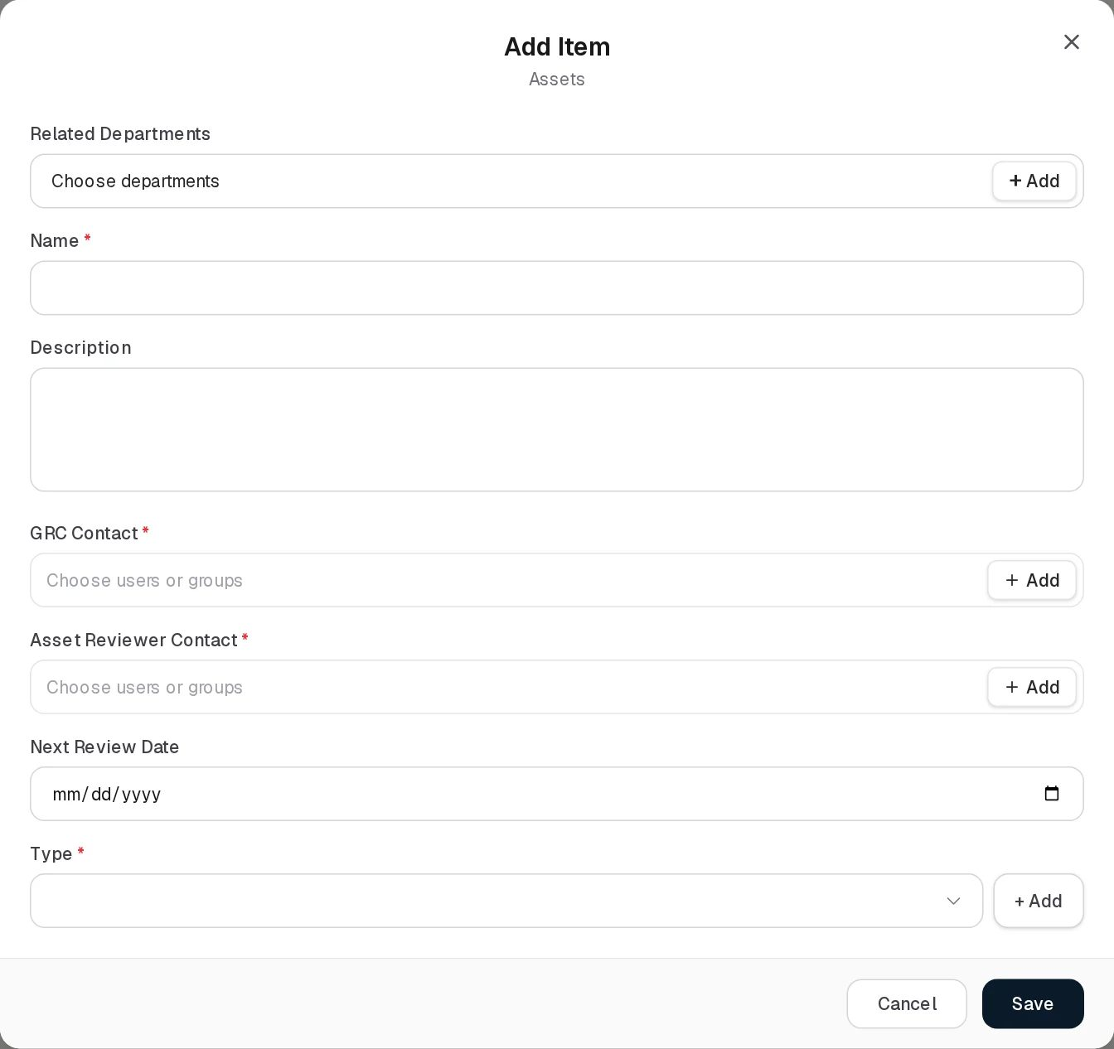
Add asset
Field | Type | Required | Rules and allowed values | Example
Related Departments | Department picker, several allowed, with + Add | No | Departments from Organization Hub. + Add creates a department. Up to 500 characters of names. | IT, Finance
Name | Text | Yes | “Required”. Up to 255 characters. Names do not have to be unique. | Payment gateway
Description | Text area | No | Up to 1,000 characters | Card payment processing service
GRC Contact | User-and-group picker, several allowed, with + Add | Yes | “GRC Contact is required”. Subject to Can Assign / Can Reassign. The names are stored in a 200-character field. | Alex Meian
Asset Reviewer Contact | User-and-group picker, several allowed, with + Add | Yes | “Asset Reviewer Contact is required”. Subject to Can Assign / Can Reassign. 200-character field. | Sara Johnson
Next Review Date | Date | No | Any date. Drives the Dynamic Status and the generated reviews. | 2026-10-30
Type | Drop-down with + Add | Yes | “Required”. The list holds Data Asset, Facilities, Financial, Hardware, IT Service, Network, People, Software, every type used by the assets on the page currently shown, and types added in this session, sorted alphabetically. + Add replaces the drop-down with a New Type box and Save / Cancel. Up to 100 characters. | Software
Choose Data Asset as the Type for an asset whose data you want to analyse on the Data Flows page; only assets of that exact type appear there.
Click Save; “Asset added.” confirms it. Saving with a Next Review Date creates the planned reviews at once (see Reviews).
Fields the form does not show are filled by the system: the category takes the Type, the owner text takes the GRC Contact names, criticality is Medium, status is Active, and the creator is recorded as the asset’s owner for data visibility.

Viewing and editing a record
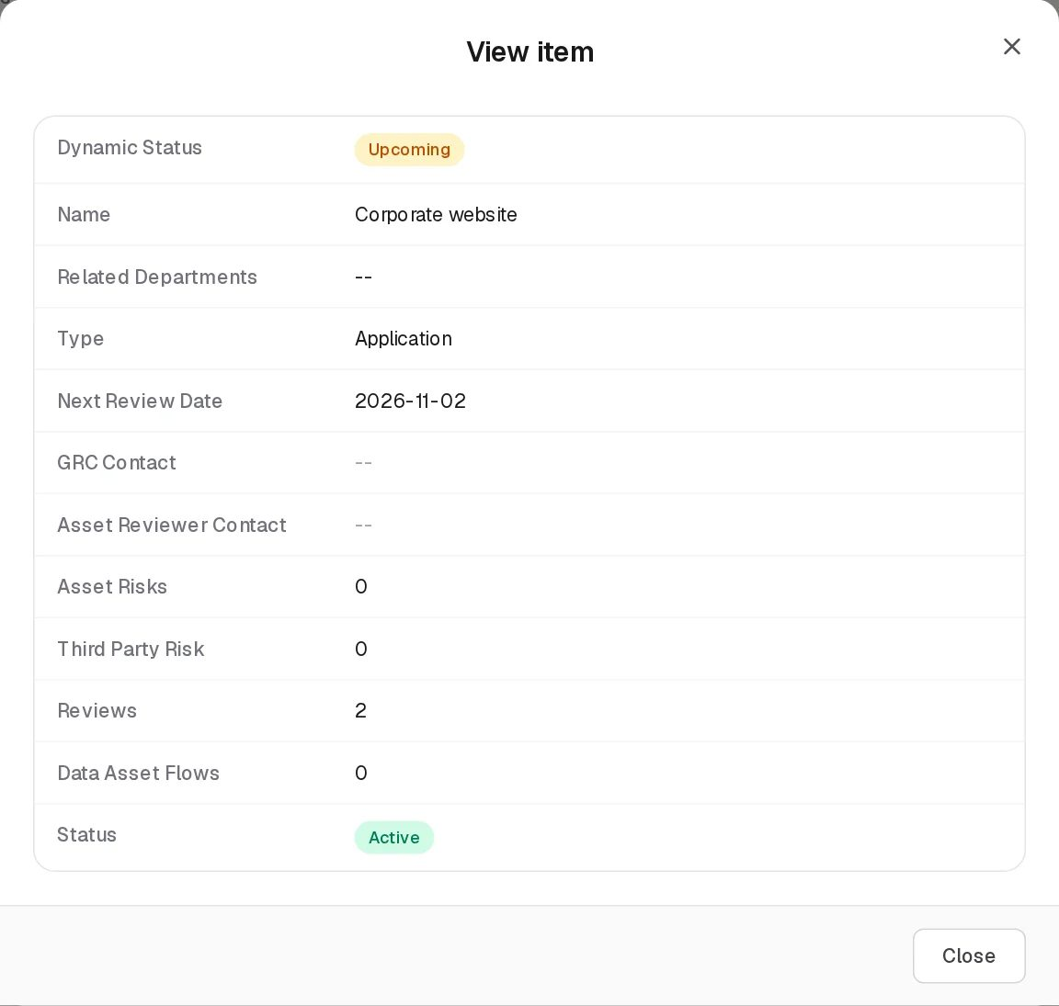
View asset
View opens the generic View item dialog with every grid column; counts are plain numbers there.
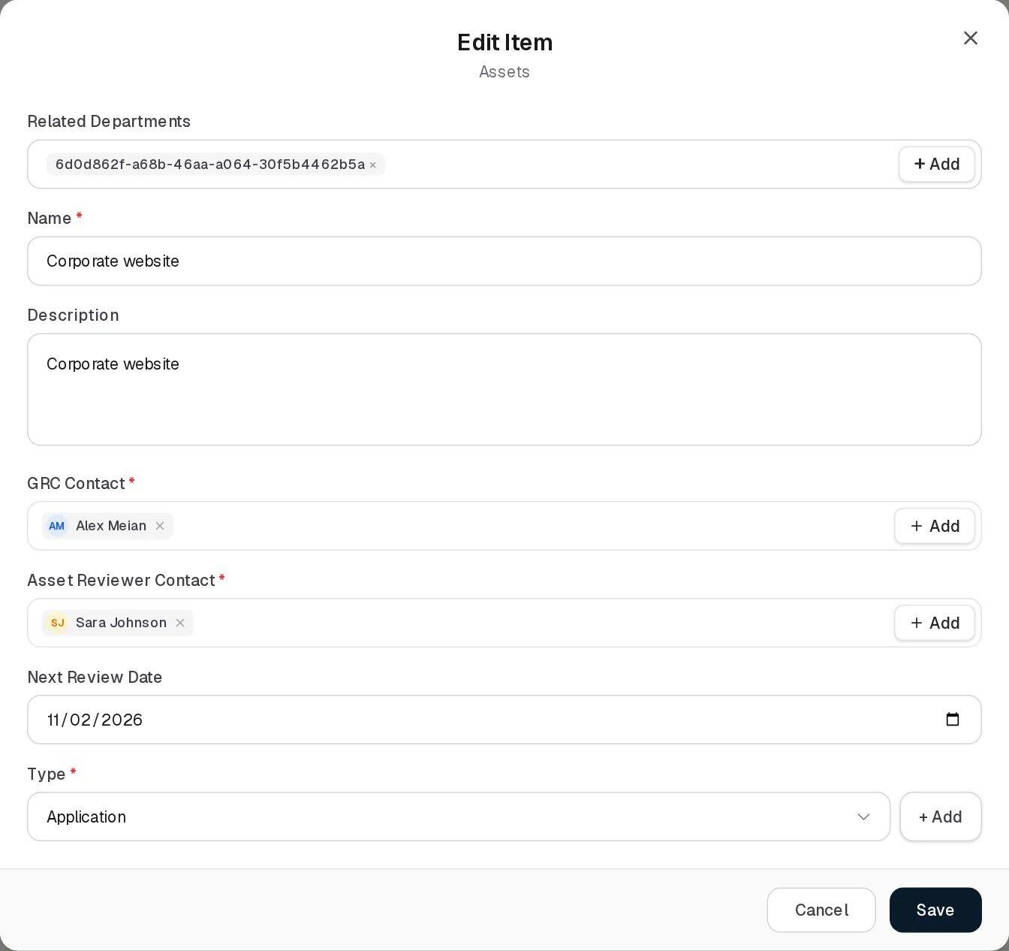
Edit asset
Edit Item has the same fields as Add. Saving keeps the asset’s risk links (they are owned by the risk registers), its GDPR analysis (owned by the Data Flows page), its criticality and status. Changing the Next Review Date regenerates the planned reviews.
Deleting an asset (confirmation “Delete asset Payment gateway?”) also deletes, without further warning:
- all its reviews;
- all its data flows (projects that listed those flows lose them);
- its links from asset risks and third-party risks, and from security incidents (the risks and incidents remain).

Statuses
Value | Set by | Rule | Colour
Missing Date | System | The asset has no Next Review Date | Amber
Expired | System | The Next Review Date is before today | Red
Upcoming | System | The Next Review Date is today or later | Amber
Active (Status column) | System | Every asset created in the UI; there is no field to change it | Green
The Dynamic Status looks only at the Next Review Date, not at whether the reviews in the Reviews tab were carried out.

Tabs

Reviews
The Reviews tab (permission key asset_management.assets_reviews) lists the reviews of all assets, titled Asset Reviews. After clicking an asset row it shows only that asset’s reviews, titled Reviews for , with a Show All Reviews link and Filtering for: above the grid. If your group has No Access on the tab, the tab is shown with a lock and clicking it opens the access request dialog.
Asset Reviews
Column | What it shows | Source
Dynamic Status | Completed, Missing Date, Expired or Upcoming; see below | Computed by the system
Assets | The asset reviewed | Linked
Reviewers | Reviewer names, or -- | Entered
Planned Date | YYYY-MM-DD, or -- | Entered
Actual Date | YYYY-MM-DD, or -- | Entered
Description | Text, or -- | Entered
Status | Planned (blue), In Progress (amber), Completed (green), Expired (red) | Entered

Adding a review
Click Add Item on the tab. The Add Item dialog (subtitle Asset Reviews) opens; when the tab is filtered, the asset is pre-filled.
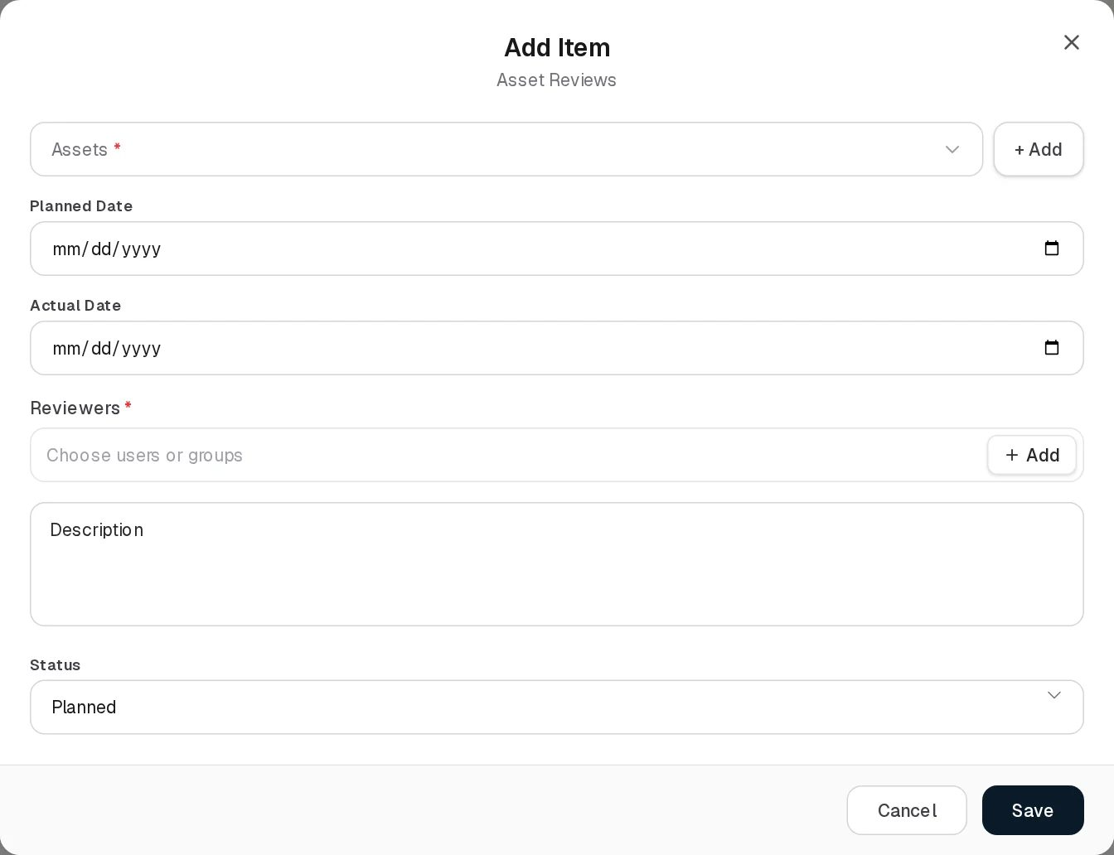
Add review
Field | Type | Required | Rules and allowed values | Example
Assets | Searchable list (Search for items) with + Add | Yes | One asset (“Required”). + Add creates an asset. | Corporate website
Planned Date | Date | No |  | 2026-11-02
Actual Date | Date | No | Filling it marks the review Completed in Dynamic Status | 2026-11-05
Reviewers | User-and-group picker, several allowed, with + Add | Yes | “Required”. Stored as names only (up to 500 characters); not subject to the assignment rights. | Sara Johnson
Description | Text area | No | Up to 1,000 characters | Annual access review of the CMS
Status | Drop-down | No | Planned (default), In Progress, Completed, Expired | Planned
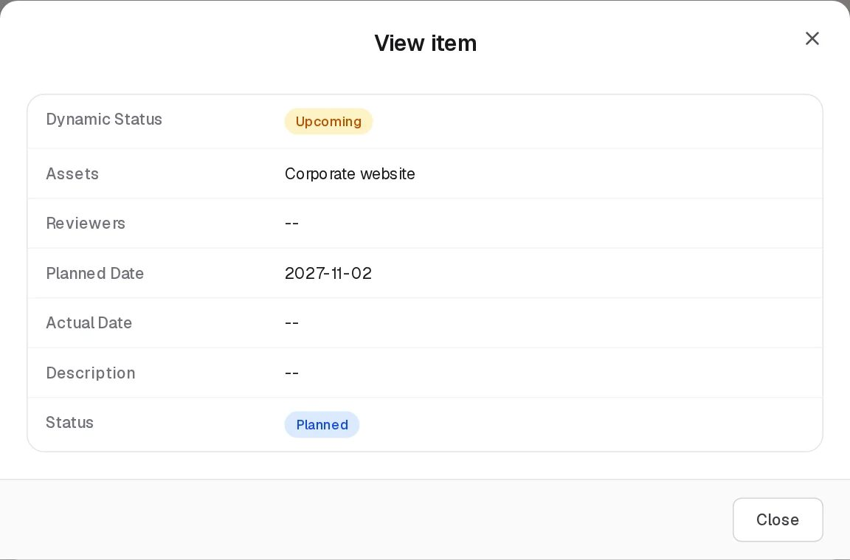
View review
View shows the review’s columns in the generic View item dialog. Edit opens the same form as Add:
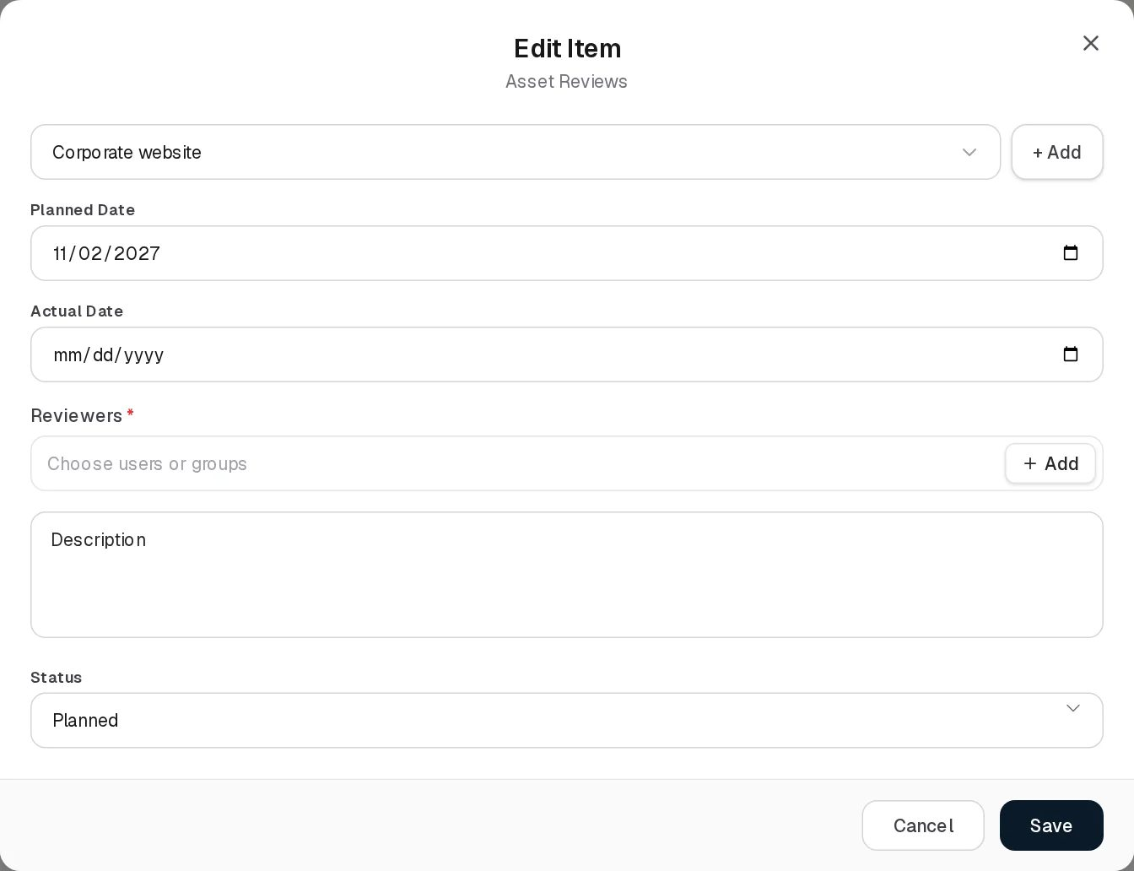
Edit review

Review statuses
Value | Set by | Rule | Colour
Completed | System | The review has an Actual Date | Green
Missing Date | System | No Actual Date and no Planned Date | Amber
Expired | System | No Actual Date and the Planned Date is before today | Red
Upcoming | System | No Actual Date and the Planned Date is today or later | Amber
Planned / In Progress / Completed / Expired | User (Status field) | The reviewer’s own statement; it does not change the Dynamic Status | Blue / amber / green / red

Generated reviews
Every time an asset is saved, GRC360 aligns its generated reviews with the Next Review Date:
- The target dates are the Next Review Date and the same day one year later; a target already in the past is dropped.
- A missing target date gets a new review: status Planned, Reviewers = the asset’s Asset Reviewer Contact names at that moment.
- Generated reviews that were not carried out (no Actual Date) and whose date is no longer a target are deleted.
- Reviews added by hand and generated reviews that have an Actual Date are never removed.
Example from the demo data: Corporate website has Next Review Date 2026-11-02, so the tab holds reviews planned for 2026-11-02 and 2027-11-02. Their Reviewers are -- because the asset had no reviewer names when they were generated; editing the reviewer later does not update existing reviews.

Relationships
Related record | Direction | How the link is made | Where it shows
Departments | Asset → Department, many to many | Related Departments | Related Departments column; the department’s Asset Risks count
Users and groups | Asset → people | GRC Contact, Asset Reviewer Contact | The contact columns
Asset Reviews | Review → Asset, many to one | Assets on the review form, or generated from the Next Review Date | Reviews count; row click opens them
Asset Risks | Risk → Asset, many to many | Related Assets on the asset risk (Risk Management) | Asset Risks count (clickable)
Third Party Risks | Risk → Asset, many to many | Assets Shared with this Third Party on the third-party risk | Third Party Risk count (clickable)
Data Flows | Flow → Asset, many to one | Related Asset on the data flow form | Data Asset Flows count; Data Flows page

Automations and notifications
No notifications. The Dynamic Status of assets and reviews is computed on every read; reviews are generated on every save of an asset; the Reviews count is kept up to date on every review save and delete.

Permissions
Action | Needed access
See the page | View on Asset Management › Assets
Create / Edit an asset | Manage on Asset Management › Assets
Delete an asset | Full Control on Asset Management › Assets
Name other people as GRC Contact or Asset Reviewer Contact | Can Assign (empty field) / Can Reassign (field already naming others)
Open the Reviews tab | View on Asset Management › Assets › Reviews (and View on Assets)
Add / Edit a review | Manage on Assets › Reviews
Delete a review | Full Control on Assets › Reviews
Open the risks behind a count | View on the risk register concerned
Activity Log (assets and reviews) | The group’s Comments & Attachments level
Under Assigned Records Only, a person sees the assets that name them or one of their groups in a people field (contacts, reviewer, GDPR roles), the assets they created, and assets that name nobody; reviews follow their asset. Under Their department they also see assets booked against their department.

How to

Register a new application
- Open Asset Management › Assets, click Add Item.
- Related Departments: IT. Name: HR system (BambooHR). Type: Software (or add Application with + Add).
- GRC Contact: Alex Meian. Asset Reviewer Contact: Sara Johnson.
- Next Review Date: 2026-12-17. Click Save.
- Open the Reviews tab: reviews planned for 2026-12-17 and 2027-12-17 have been created with Sara Johnson as reviewer.

Record a completed review
- Click the row of Corporate website; the Reviews tab opens filtered to it.
- Click Edit on the review planned for 2026-11-02.
- Fill Actual Date, set Status to Completed, add a Description of the outcome, click Save.
- The review’s Dynamic Status becomes Completed. To move the cycle on, edit the asset and set the next Next Review Date.

Find the risks attached to an asset
- In the Payment gateway row, click 14 in Asset Risks.
- The panel lists the 14 asset risks; open any of them from there.

Prepare an asset for GDPR analysis
- Edit the asset, for example HR system (BambooHR), and set Type to Data Asset (as was done for Customer database in the demo data).
- Open Data Flows; the asset now appears in the Data Assets tab, where its GDPR analysis is filled in.

CSV import
Not available. Import CSV (on both tabs) shows “CSV Import (Assets): the import structure is not ready yet.” (or Asset Reviews) and opens a demonstration dialog whose validation fails.

Limitations and known issues
- Deleting an asset deletes its reviews and data flows without saying so in the confirmation.
- Type list. Types already used by assets on other pages of the grid are not offered unless you are on that page; types added with + Add last only for the session until an asset uses them. In the demo data the types are Application, Hardware, Infrastructure and Data Asset; only Customer database is a Data Asset and therefore the only row of the Data Flows page’s Data Assets tab.
- Status is always Active; there is no way to retire an asset other than deleting it.
- Generated reviews keep the reviewer names of the moment they were created. Changing the Asset Reviewer Contact later does not update them.
- Dynamic Status ignores the reviews. An asset whose review was completed still reads Expired once its Next Review Date has passed, until the date is moved.
- Contact length. GRC Contact and Asset Reviewer Contact names are stored in 200 characters; very long selections are refused by the server.
- Demo data. The demo assets carry a GRC Contact id without a stored name, so the grid shows -- while Edit shows the person. Saving keeps the id but not a name; re-pick the contact if the grid should show it.

Data Flows
Module: Asset Management › Data Flows · Route: /asset-management/data-movement · Permission key: asset_management.data_movement
The Data Flows page is where the data protection analysis of your data assets is recorded. It has two tabs. Data Assets lists the assets whose type is Data Asset and holds each one’s GDPR analysis: who owns the data, whether GDPR applies, who is DPO, processor, controller and controller representative, and which supervisory authority is competent. Data Asset Flows lists the steps in the life of a data asset’s data (collected, stored, modified, in transit, deleted), each with its departments, third parties, risks, mitigating controls and, when the asset is under GDPR, the GDPR questions for that stage. Data protection officers, privacy and GRC teams work in this page. The sidebar label is Data Flows; the route and permission codes keep the older name data movement.
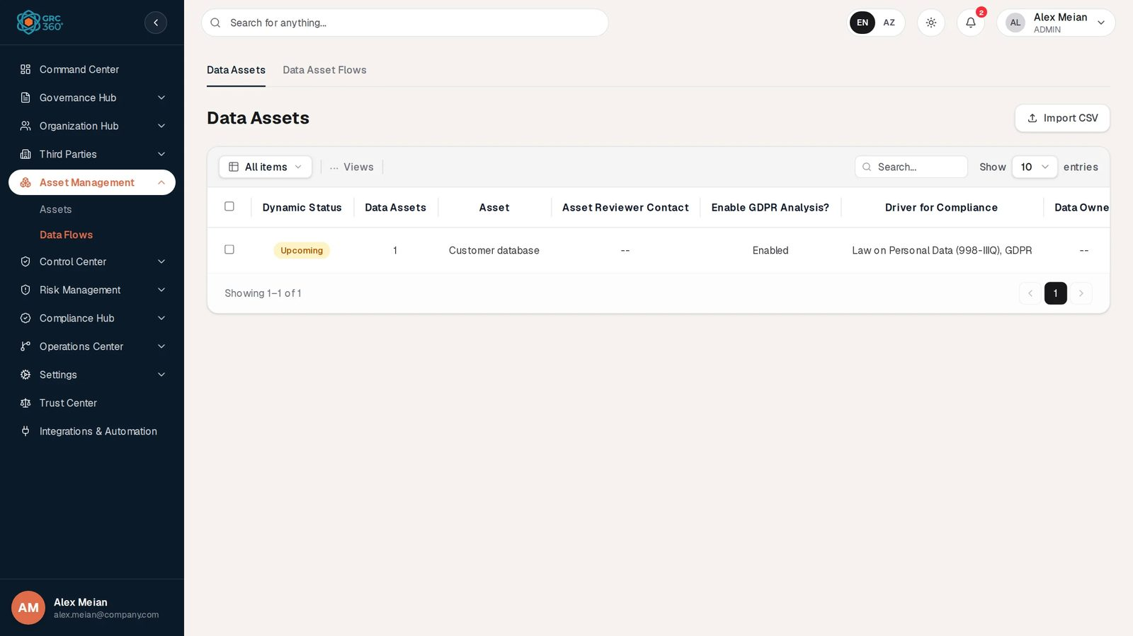
Data Flows, Data Assets tab

At a glance
A record is | On Data Assets: one asset of type Data Asset (the same record as on the Assets page). On Data Asset Flows: one step in the life of an asset’s data.
Typical owner | Data protection officer, privacy or GRC team
Links to | Data asset → people (Data Owner, DPO Role, Controller Role, Controller Representative), Processor Role (vendors, by name). Flow → Related Asset, Departments, Third Parties, Asset Risks, Third Party Risks, Business Risks, Compensating Controls, Improvement Projects, Policies.
Linked from | Assets (Data Asset Flows count)
Tabs | Data Assets (default), Data Asset Flows. They are views of one page and share its permission key.
Automations | Dynamic Status of data assets computed from the Next Review Date; Third Parties and Third Party Risks of a flow kept consistent with each other

The register
The page has two tabs, each with its own grid.

Data Assets tab
The grid lists every asset whose Type is exactly Data Asset (letter case and surrounding spaces ignored), newest first. Assets of any other type are not shown. There is no Add Item button: data assets are created on the Assets page. When none exist, the grid says “No data assets yet. Create an asset of type”Data Asset” in Asset Management → Assets.”. Shared grid behaviour is described in Working with registers.
Column | What it shows | Source
Dynamic Status | Upcoming, Expired or Missing Date, from the asset’s Next Review Date (same rule as Assets) | Computed by the system
Data Assets | Number of data flows whose Related Asset is this asset (despite the heading, a count of flows) | Computed
Asset | Asset name | From the asset
Asset Reviewer Contact | Names, or -- | From the asset
Enable GDPR Analysis? | Enabled, or blank when off | Entered here
Driver for Compliance | Text, or -- | Entered here
Data Owner | Names, or -- | Entered here
DPO Role | Names, Not applicable, or -- | Entered here
Processor Role | Vendor names, Not applicable, or -- | Entered here
Controller Role | Names, Not applicable, or -- | Entered here
Controller Representative | Names, Not applicable, or -- | Entered here
Supervisory Authority | Country, or -- | Entered here
In the demo data the tab holds one row, Customer database: Upcoming, 1 flow, Enabled, Driver for Compliance Law on Personal Data (998-IIIQ), GDPR, Processor Role Amazon Web Services, Controller Representative Not applicable.

Data Asset Flows tab
The grid is paged on the server, newest first, and refreshes when flows or assets change. In the demo data it holds three flows (Employee records sync on HR system (BambooHR), Nightly backup to AWS S3 on Customer database, Card data to payment processor on Payment gateway), all in department IT, with Okta, Amazon Web Services and Visa as third parties and no stage.
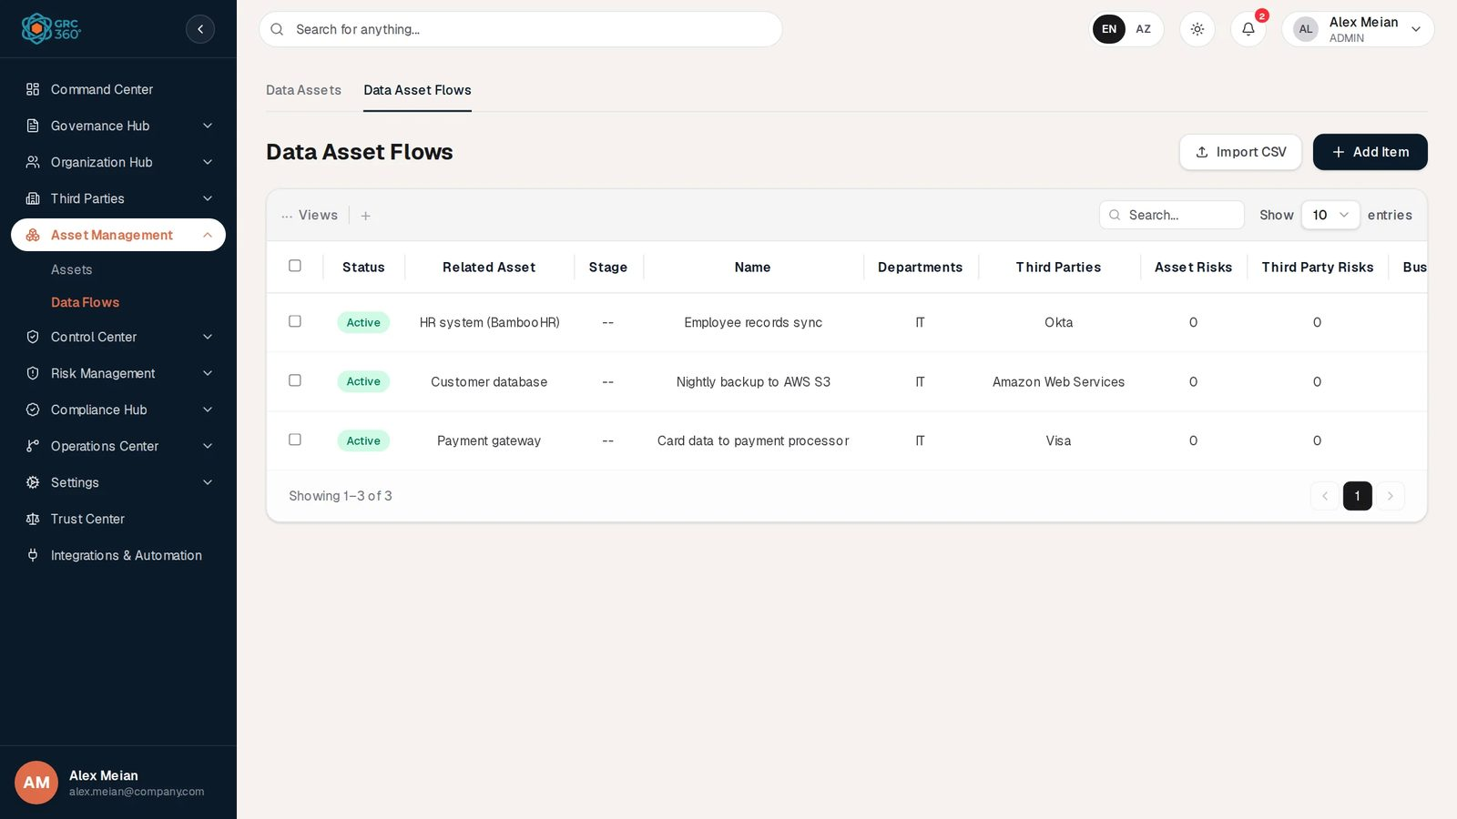
Data Asset Flows tab
Column | What it shows | Source
Status | Active (green); there is no field to change it | Stored
Related Asset | The asset the flow belongs to | Linked
Stage | Collected, Deleted, Modified, Stored or Transit, or -- | Entered
Name | Flow name, or -- | Entered
Departments | Department names, or -- | Linked
Third Parties | Vendor names, or -- | Linked
Asset Risks | Count of linked asset risks; above 0 it opens the risks. Not sortable. | Linked
Third Party Risks | Count of linked third-party risks; clickable. Not sortable. | Linked
Business Risks | Count of linked business risks; clickable. Not sortable. | Linked
Improvement Projects | Project names, or -- | Linked
Compensating Controls | Control names, or -- | Linked
Policies | Policy names, or -- | Linked
The flow’s Order and its GDPR answers are not shown in the grid; open Edit to see them.

Creating a record
Data assets are not created here: create an asset of type Data Asset on the Assets page and it appears on the Data Assets tab. Data flows are created on the Data Asset Flows tab.

Adding a data flow
Click Add Item on the tab. The Add Item dialog (subtitle Data Flows) opens. It is one scrolling form with the headings Risk Management, Mitigating Controls and, when applicable, GDPR.
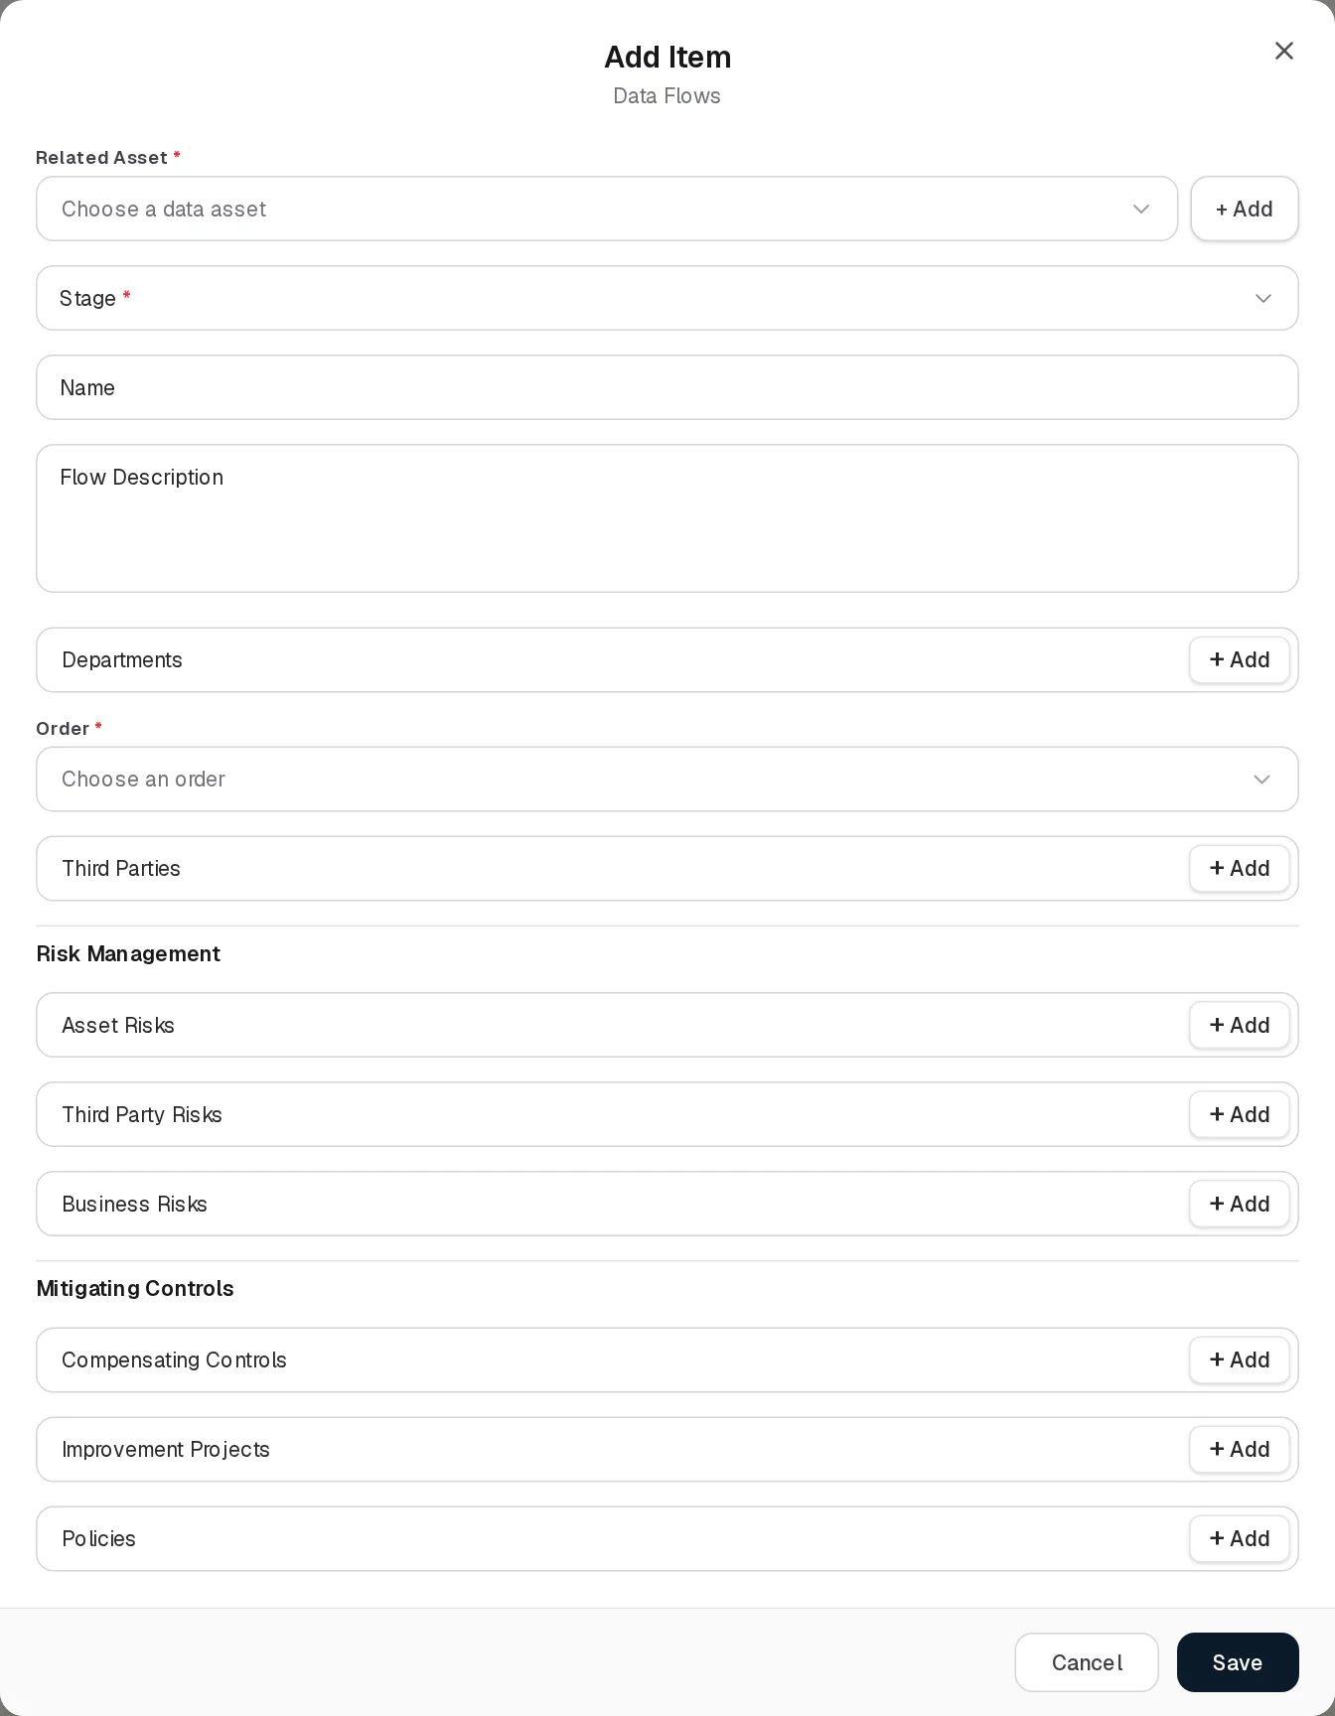
Add data flow
Field | Type | Required | Rules and allowed values | Example
Related Asset | Searchable list with + Add | Yes | “Asset is required”. Lists only assets of type Data Asset (the type is shown beside each name), plus the flow’s current asset when editing an older flow. Empty list: “No data assets found. Create an asset of type”Data Asset” in Asset Management → Assets.” + Add creates an asset. Picking an asset links it only; nothing is copied from it. In the demo data the list offers only Customer database. | Customer database
Stage | Drop-down | Marked with an asterisk, but not enforced | Collected, Deleted, Modified, Stored, Transit. Decides the GDPR questions. | Transit
Name | Text | No | Up to 255 characters | Nightly backup to AWS S3
Flow Description | Text area | No | Up to 1,000 characters | Encrypted database dump copied to S3 every night
Departments | Department picker, several allowed, with + Add | No | Departments from Organization Hub | IT
Order | Searchable list | Yes | “Order is required”. The position of this flow among the asset’s flows: 1 to one more than the asset’s other flows (first flow: only 1; second: 1–2; and so on). Filled with the next position as soon as the asset is chosen; before that the list says “Choose the related asset first.” Positions are not renumbered and two flows may share one. | 2
Third Parties | Vendor picker, several allowed, with + Add | No | Vendors from Third Parties › Vendors. Picking a vendor also adds the third-party risks that name it; removing one removes the risks no remaining vendor accounts for. | Amazon Web Services
Risk Management
Asset Risks | Risk picker, several allowed | No | From Risk Management › Asset Risks (first 200) | Database backup corruption
Third Party Risks | Risk picker, several allowed | No | From Third Party Risks (first 200). Picking a risk also adds the vendors it applies to. | Cloud provider regional outage
Business Risks | Risk picker, several allowed | No | From Business Risks (first 200)
Mitigating Controls
Compensating Controls | Control picker, several allowed | No | From Control Center › Controls | Encryption at rest
Improvement Projects | Project picker, several allowed | No | From Operations Center › Projects | Enforce MFA on all admin accounts
Policies | Policy picker, several allowed | No | From Control Center › Policies & Standards | Data Retention Standard
GDPR |  |  | See GDPR questions
The GDPR section appears only when the Related Asset has GDPR Fields switched on in the Data Assets tab and the Stage has questions. Its introduction reads “Asked because has its GDPR analysis switched on. The questions follow the stage — change it and this section changes with it.”
Click Save; “Data movement added.” confirms it. Every relation is stored by reference: a renamed vendor, risk or control shows its new name in the flow. The server checks every picked record exists in your organisation and, like the form, keeps Third Parties and Third Party Risks consistent. Edit (Edit Item) has the same form; “Data movement updated.” Deleting asks “Delete data flow ?”; projects that listed the flow simply lose it.

GDPR questions
All answers are optional. Text answers are free text; list answers allow several choices.
Collected
Question | Answer type and options
Type of Data | List: Child’s Data, Criminal Offences, Other, Personal Data, Pseudonymous Data, Sensitive Data, Special Category
Purpose | Text
Right To be Informed | Text
Data Subject | Text
Collection Method | List: Automated, Manual
Volume | Text
What exact data is received? | Text
What is the lawful base? | List: Consent, Contractual Obligation, Legal Obligation, Legitimate Interest, Public Interest, Vital Interest
Applicable Contracts, Code of Conducts and Privacy Notes | Text
Deleted: no GDPR questions; the section does not appear.
Modified
Question | Answer type
Stakeholders | Text
Right to Restrict | Text
Right to Access | Text
Right to Rectification | Text
Rights related to automated decision making and profiling | Text
Right to Object | Text
Stored
Question | Answer type and options
Retention | Text
Encryption | Text
Right to erasure | Text
Archiving Drivers | List: Historical, Public Interest, Scientific, Statistical Purposes. Followed by an Archiving Drivers Not applicable switch that clears and disables the list.
Transit
Question | Answer type and options | Rule
Origin | Text
Destination | Text
Data Transfers outside the EEA? | Switch | Unlocks the next three questions
Third Party Countries Involved | List of all countries of the world | Disabled and empty while the transfer switch is off, and while Anywhere in the world is on
Anywhere in the world | Switch | Disabled while the transfer switch is off. Turning it on clears the country list.
Lawful Base for Transfers outside EEA | List: Ad-Hoc Contracts, Administrative Arrangements, Binding Corporate Rules (BCR), Certifications, Code of Conduct, Contracts in between Data Subject and Controller, Controller Compelling Legitimate Interest, Court Judgements, Data Subject Consent, DPA Clauses, Interest of the Data Subject, Legal Proceedings, Model Clauses, Public Interest, Registers, Transfers in between Public Authorities, Vital Interests | Disabled while the transfer switch is off
Security | Text
Right to Data Portability | Text
Turning Data Transfers outside the EEA? off clears the countries, Anywhere in the world and the transfer lawful base, so no hidden answer is saved. Answers are stored per question; answers of another stage stay stored when the stage is changed but are not shown.

Viewing and editing a record
On both tabs the eye button opens the generic View item dialog with the grid’s columns.
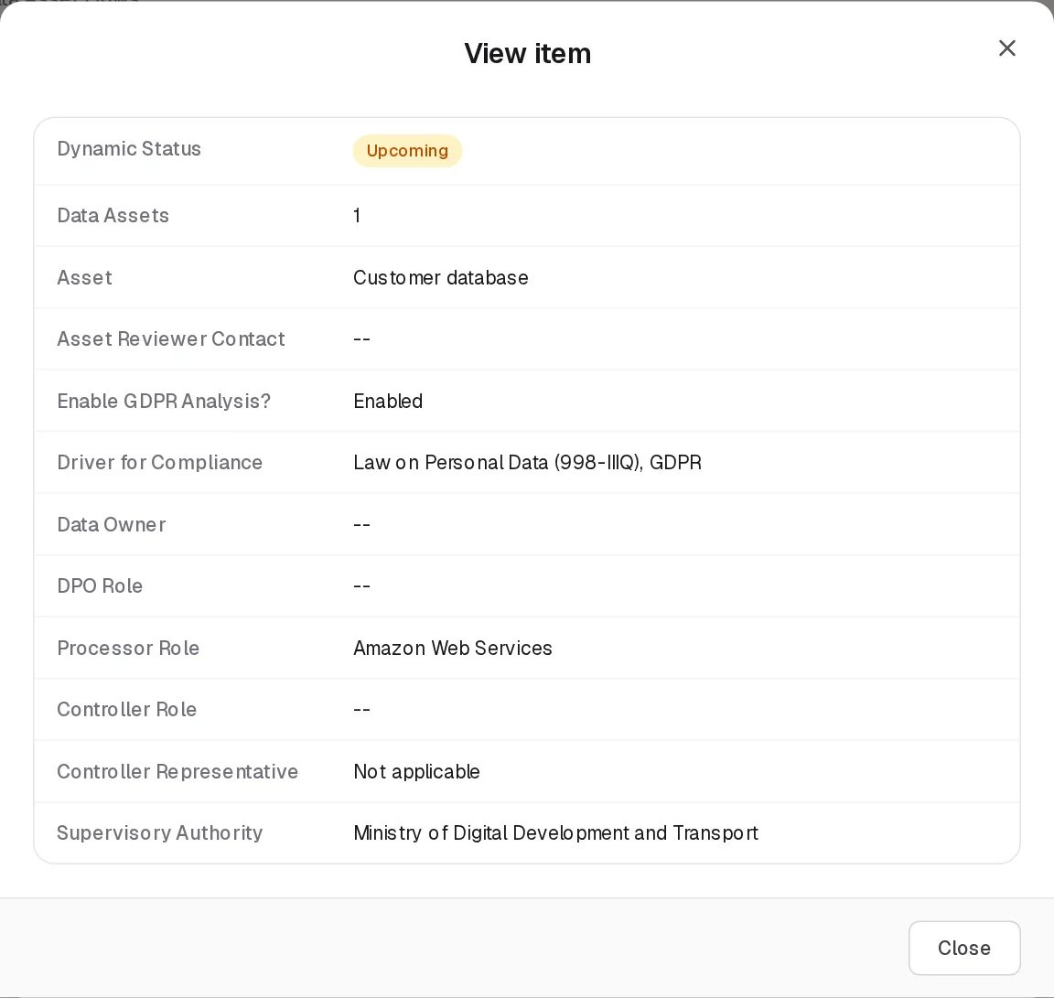
View data asset
View data flow
A flow’s Edit opens the same form as Add (title Edit Item); its Order list excludes the flow’s own position from the count of other flows. The example below is Employee records sync: its Related Asset HR system (BambooHR) is not a data asset but stays selected because the flow already points at it; Stage is empty, so no GDPR section is shown. Filled relation fields (Departments, Third Parties) lose their label once they hold a value.
Edit data flow

Editing the GDPR analysis of a data asset
Click Edit on a row. The Edit Item dialog (subtitle Data Assets) opens with the line “ — the asset’s own details are maintained in Asset Management.” Name, type, contacts and review date are not editable here.
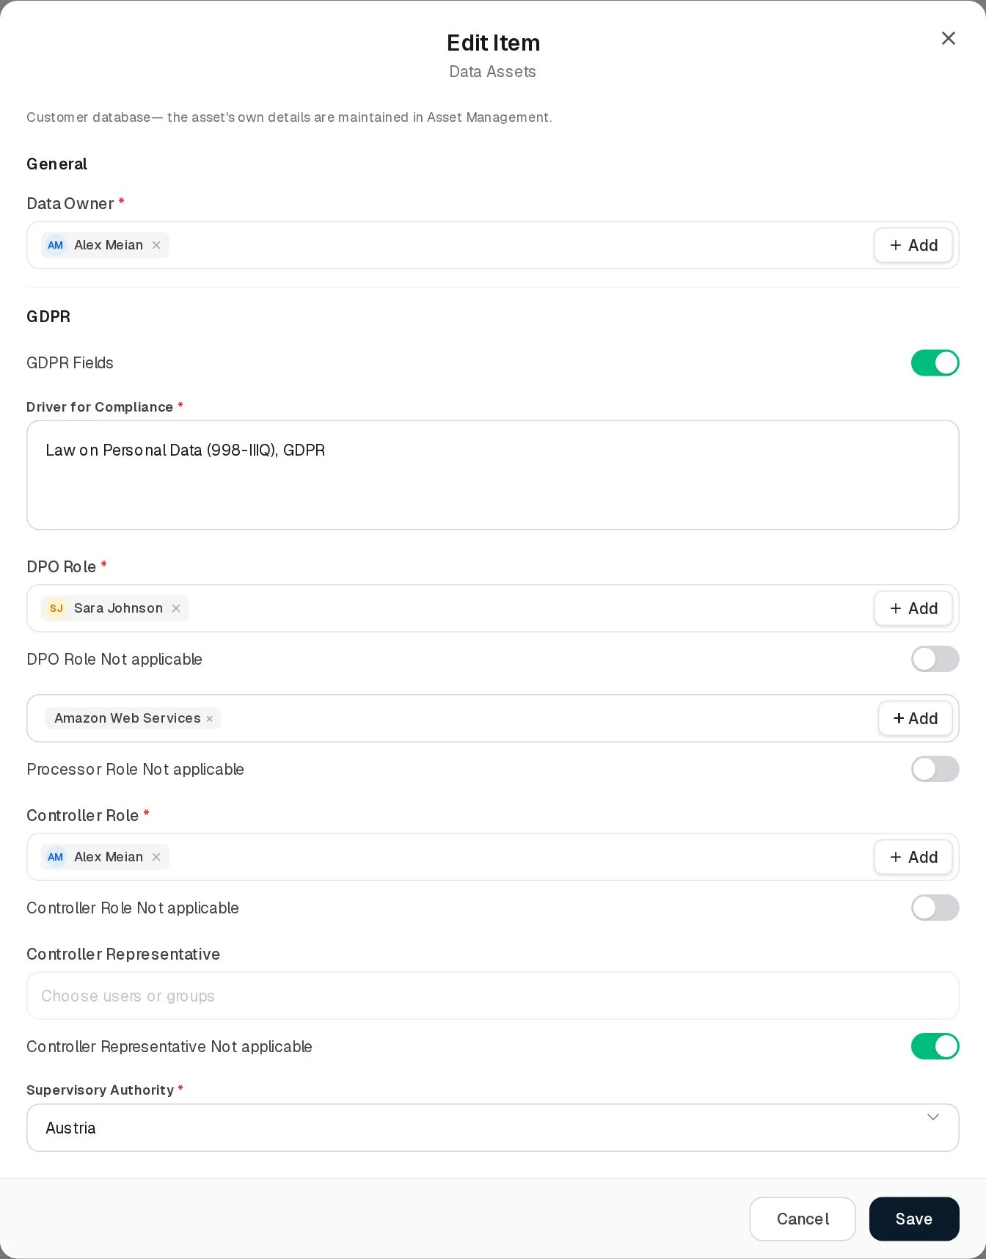
Edit data asset
Field | Type | Required | Rules and allowed values | Example
General
Data Owner | User-and-group picker, several allowed | Yes, always | “The field is required”. Subject to Can Assign / Can Reassign on Assets. Up to 500 characters of names. | Alex Meian
GDPR
GDPR Fields | Switch | No | Off by default. When on, the fields below appear and become required. Its value is the grid’s Enable GDPR Analysis? and decides whether the asset’s flows are asked GDPR questions. | On
Driver for Compliance | Text area | Yes when GDPR is on | “The field is required”. Up to 500 characters. | Law on Personal Data (998-IIIQ), GDPR
DPO Role | User-and-group picker, several allowed | Yes when GDPR is on, unless waived | Subject to Can Assign / Can Reassign | Sara Johnson
DPO Role Not applicable | Switch | No | Turning it on clears and disables DPO Role, and makes it optional | Off
Processor Role | Vendor picker (from Third Parties › Vendors), several allowed | Yes when GDPR is on, unless waived | Stored as vendor names | Amazon Web Services
Processor Role Not applicable | Switch | No | As for DPO | Off
Controller Role | User-and-group picker, several allowed | Yes when GDPR is on, unless waived | Subject to Can Assign / Can Reassign | Alex Meian
Controller Role Not applicable | Switch | No | As for DPO | Off
Controller Representative | User-and-group picker, several allowed | Yes when GDPR is on, unless waived | Subject to Can Assign / Can Reassign | Alex Meian
Controller Representative Not applicable | Switch | No | As for DPO | On
Supervisory Authority | Drop-down | Yes when GDPR is on | One of the 30 EEA countries: Austria, Belgium, Bulgaria, Croatia, Cyprus, Czech Republic, Denmark, Estonia, Finland, France, Germany, Greece, Hungary, Iceland, Ireland, Italy, Latvia, Liechtenstein, Lithuania, Luxembourg, Malta, Netherlands, Norway, Poland, Portugal, Romania, Slovakia, Slovenia, Spain, Sweden | Ireland
Not applicable means “answered, and the answer is none”. Turning a waiver on erases the names and the stored people behind them; turning it off does not bring them back. If other people are named in a role and you lack Can Reassign on Assets, the waiver switch is disabled, because waiving would remove them. Switching GDPR Fields off hides the section and clears its error messages; the answers already saved stay stored.
Click Save: the asset is updated through the Assets register, so Manage on Asset Management › Assets is what the server checks.
Delete on this tab deletes the asset itself: “Delete data asset ? This removes it from Asset Management too.” Its reviews and data flows are deleted with it.

Statuses
Value | Set by | Rule | Colour
Missing Date (data asset) | System | The asset has no Next Review Date | Amber
Expired (data asset) | System | The Next Review Date is before today | Red
Upcoming (data asset) | System | The Next Review Date is today or later | Amber
Active (flow Status) | System | Every flow; there is no field to change it | Green

Tabs
Tab | Default | Grid | Add | Edit | Delete
Data Assets | Yes | Assets of type Data Asset with their GDPR analysis | No (create on the Assets page) | The GDPR analysis | The asset itself, with its reviews and flows
Data Asset Flows | No | Data flows of all data assets the user can see | Yes | Yes | The flow only
Both tabs belong to the page’s single permission key; neither can be locked on its own.

Relationships
Related record | Direction | How the link is made | Where it shows
Asset | Flow → Asset, many to one, required | Related Asset | Related Asset column; the asset’s Data Asset Flows count and the Data Assets tab’s Data Assets count
People | Data asset → users and groups | Data Owner, DPO Role, Controller Role, Controller Representative | Data Assets columns; they also count as named for data visibility
Vendors | Data asset → Vendor (name only); Flow → Vendor, many to many | Processor Role; Third Parties | Data Assets and flows grids
Departments | Flow → Department, many to many | Departments | Departments column
Risks | Flow → risk, many to many | Asset Risks, Third Party Risks, Business Risks | Three clickable counts
Controls, Projects, Policies | Flow → record, many to many | Compensating Controls, Improvement Projects, Policies | Name columns

Automations and notifications
None. The data asset Dynamic Status is computed on every read. When a flow is saved, the server adds to it the vendors of its third-party risks and the third-party risks of its vendors.

Permissions
Action | Needed access
See the page and the Data Asset Flows tab | View on Asset Management › Data Flows
See the Data Assets tab and the Related Asset list | View on Asset Management › Assets as well
Add / Edit a flow | Manage on Asset Management › Data Flows
Delete a flow | Full Control on Asset Management › Data Flows
Edit a data asset’s GDPR analysis | Manage on Asset Management › Assets (checked by the server)
Delete a data asset | Full Control on Asset Management › Assets (checked by the server)
Name other people as Data Owner, DPO, Controller, Representative | Can Assign / Can Reassign on Assets
Fill the pickers of the flow form | View on the register each picker reads (Departments, Vendors, the three risk registers, Controls, Projects, Policies & Standards)
Activity Log | The group’s Comments & Attachments level
Flows follow their asset for data visibility: under Assigned Records Only you see a flow only if you can see its asset.

How to

Start the GDPR analysis of a data asset
- On Asset Management › Assets, set the asset’s Type to Data Asset (for example edit HR system (BambooHR); Customer database is already one in the demo data).
- Open Data Flows; on the Data Assets tab click Edit on the asset.
- Pick the Data Owner, switch GDPR Fields on, fill Driver for Compliance, the four roles (or switch their Not applicable on) and the Supervisory Authority.
- Click Save. Enable GDPR Analysis? shows Enabled.

Record how data leaves the EEA
- Open the Data Asset Flows tab and click Edit on Nightly backup to AWS S3 (Related Asset Customer database, whose GDPR analysis is on).
- Set Stage to Transit. The GDPR section appears.
- Third Parties already holds Amazon Web Services; picking it again after removing it would add its third-party risks automatically.
- In GDPR, fill Origin and Destination, switch Data Transfers outside the EEA? on, choose the countries (or Anywhere in the world) and the Lawful Base for Transfers outside EEA, for example Model Clauses.
- Add the compensating controls and policies, then Save.

Map the life cycle of one asset’s data
- Add one flow per stage for the same Related Asset: Collected (Order 1), Stored (Order 2), Transit (Order 3), Deleted (Order 4).
- The asset’s Data Asset Flows count on the Assets page, and the Data Assets count on this page, show 4.

CSV import
Not available on either tab. Import CSV shows “CSV Import (Data Assets): the import structure is not ready yet.” (or Data Asset Flows) and opens a demonstration dialog whose validation fails.

Limitations and known issues
- Two permissions behind one page. The Data Assets tab reads and writes the Assets register, so its Edit and Delete are checked by the server against Assets rights, while the buttons show locks according to Data Flows rights. A user with Manage on Data Flows but only View on Assets sees an unlocked Edit that the server refuses, and the reverse.
- Stage is marked required but not checked; a flow can be saved without a stage, and then has no GDPR section.
- Data Owner is always required, even with GDPR switched off.
- “Data Assets” column on the Data Assets tab is the number of flows, not of assets.
- Order is not shown in the grid, is not renumbered when flows are deleted, and two flows can hold the same position.
- Pickers stop at 200 records for the three risk registers.
- Flow status is always Active.
- Supervisory Authority outside the list. A value that is not one of the 30 EEA countries (the demo’s Customer database holds Ministry of Digital Development and Transport, loaded through the API) is shown in the grid and View, but the Edit drop-down displays Austria, the first option, because the stored value is not among its choices. Saving without touching the field keeps the stored value; choosing a country replaces it.
- People shown in Edit but -- in the grid. The demo data asset stores Data Owner, DPO Role and Controller Role as people without names, so the grid and View show -- while Edit shows Alex Meian, Sara Johnson and Alex Meian. Re-pick them and save to store the names.
- Labels of filled relation fields (Processor Role on the data asset form, Departments and Third Parties on the flow form) disappear once a value is present.
- Demo flows have no stage, so none of them shows GDPR questions until a stage is chosen.

Control Center
Module key: control_center · Route: /control-center (opens Controls)
The Control Center holds the organisation’s internal controls, the policies and standards those controls implement, the approved deviations from those policies, and the business continuity plans that keep operations running when something fails. It is the “how we manage it” half of GRC360: risks in Risk Management and requirements in the Compliance Hub point at the records kept here.
Controls register

Pages
Page (sidebar label) | Route | Permission key | Tabs | What a record is
Controls | /control-center/controls | control_center.controls | Audits, Issues, Maintenances | One internal control, with its audit and maintenance plan
Policies & Standards | /control-center/policies-standards | control_center.policies_standards | Reviews | One policy, standard or procedure document
Policy Exceptions | /control-center/exceptions | control_center.exceptions | None | One time-limited deviation from one or more policies
Continuity Plans | /control-center/continuity-recovery | control_center.continuity_recovery | Audits, Tasks | One business continuity or recovery plan
Opening /control-center redirects to /control-center/controls. The keys exceptions and continuity_recovery are kept from earlier versions of the product: only the sidebar labels changed (“Policy Exceptions”, “Continuity Plans”), so roles that already had those pages keep them.
Each tab is a permission unit of its own, keyed under its page: controls_audits, controls_issues, controls_maintenances, policies_standards_reviews, continuity_recovery_audits, continuity_recovery_tasks. A tab you have no access to is shown with a lock and opens the Request Access dialog. See Permissions and access.
The grid, toolbar, View dialog, pickers, Activity Log and Confirm Delete behave as described in Working with registers. The module pages only describe what is specific to them.

How the records relate
- Controls implement policies. A control names its Related Policies; the policy’s Internal Controls column reads the same link back.
- Policy exceptions deviate from policies. An exception names its Related Policies. Nothing on the policy shows the exceptions against it.
- Risks are treated by controls and policies. The risk registers own those links (fields Treatment: Controls and Treatment: Policies); the Controls grid shows them as the counts Asset Risks, Third Party Risks and Business Risks, and the Policies grid as Asset Risks Treatment and Third Party Risks Treatment.
- Compliance packages are linked to controls and policies from the Compliance Hub (Compliance Analysis); both registers show the result in their Compliance Package column.
- Continuity plans are linked from Business Risks (Mitigating Business Continuity Plans). A control also stores a list of continuity plans, but no screen in this release lets you set it (see Controls).
- Audits, issues, maintenances, reviews and tasks belong to exactly one parent record. Control audits, issues and maintenances and continuity plan audits and tasks are deleted with their parent.

Audit and maintenance scheduling
Three records in this module plan their own recurring work: a control plans its audits and its maintenances, and a continuity plan plans its audits. Policies plan their reviews from a single date. The plans are entered on the parent’s Add/Edit form; the system turns them into individual rows on the corresponding tab.

The schedule panel
On the Control form there is one panel titled Audits and one titled Maintenances (SchedulePanel.tsx). The Continuity Plan form has an equivalent Audits section, shown only when the plan’s Status is Production.
Field | Values | Notes
Dates * | No audits required / Audits required (maintenances: No maintenance required / Maintenance required) | Default: not required. Stored as auditsRequired / maintenanceRequired. The asterisk is shown, but either choice is valid.
Occurrence type | Specific / Periodical | Shown only when required. Default Specific.
Dates list (Specific) | One or more date pickers | Add new + adds a row, × removes one (only when there is more than one row). Saved as a comma-separated list of ISO dates.
First date (Periodical) | Date | Where the series starts. On the Continuity form the label is First audit date.
Frequency (Periodical) | Weekly, Monthly, Quarterly, Twice a Year, Yearly | Placeholder Choose one…. Steps: 1 week, 1 month, 3 months, 6 months, 1 year.
Inside the panel, after the schedule, come the fields copied onto every generated row:
Parent | Fields in the panel
Control › Audits | Audit Methodology, Audit Success Criteria, Audit Owners, Audit Evidence Owners
Control › Maintenances | Task Description, Maintenance Owners
Continuity Plan › Audits | Audit Owners (the plan’s Audit Methodology and Audit Success Metric Criteria are ordinary plan fields above the panel)
When the plan is switched off, the frontend sends the schedule fields empty, so no stale date can generate a row.

Which rows the system creates
Every time the parent is saved (create or edit), the backend recalculates the plan (InternalControlScheduleService, ContinuityPlanAuditScheduleService, PolicyReviewScheduleService). There is no background job: nothing is generated until somebody saves the parent.
Occurrence | Dates generated
Specific | Each picked date and the same day one year later.
Periodical | The first date, then one step of the frequency at a time, up to and including the first date plus one year. Weekly gives 53 dates, Monthly 13, Quarterly 5, Twice a Year 3, Yearly 2.
Policy Next Review Date | The date and the same day one year later.
Then, for all three:
- Dates before today are dropped.
- A date that already has a row (any row with that Planned Start / Planned Date, generated or added by hand) is not created again.
- Each new row is marked as auto-generated and gets its planned date plus the copied fields:
  - control audit: methodology, success criteria, audit owner and evidence owner names from the control;
  - control maintenance: task description and maintenance owner names;
  - continuity plan audit: the plan’s Audit Owners only. Audit Metric and Audit Success Metric Criteria are deliberately left empty for the auditor;
  - policy review: the policy’s Policy Reviewer Contact names, Version, and document link/text.
- A row is withdrawn only if it is auto-generated, its date is no longer in the plan, and nothing has been recorded on it: for audits and maintenances an empty Audit Result / Task Result; for policy reviews an empty Actual Date. Rows added by hand from the tabs are never withdrawn.
- For continuity plans, the schedule applies only while the plan’s status is Production. Moving a plan back to Design withdraws its blank generated audits.
Example from the demo data: Multi-factor authentication has Audits required, Periodical, first date 2026-10-15, Quarterly. Saving it produced audits planned for 2026-10-15, 2027-01-15, 2027-04-15, 2027-07-15 and 2027-10-15, shown on the Audits tab.

What the generated rows mean for status
Generated rows start with status Planned (audits) or Pending (maintenances). Their Dynamic Status turns Overdue the day after the planned date if nobody has completed them, which in turn makes the parent control Partially Compliant or the continuity plan Audit Overdue. The exact rules are on the Controls and Continuity Plans pages.

Shared settings: result and document type lists
Four drop-down lists in this module are maintained by users rather than fixed in the product. Each is edited from a Settings button on a grid (CatalogOptionsModal.tsx):
List | Where it is edited | Where it is used | Default entries
Audit Results | Controls › Audits › Settings | Audit Result on control audits | Failed, Passed
Maintenance Results | Controls › Maintenances › Settings | Task Result on control maintenances | Failed, Passed
Policy Document Types | Policies & Standards › Settings | Document Type on policies | Policy, Procedure, Standard
Continuity audit results | No Settings button in this release | Not used: the continuity audit form offers a fixed Passed / Failed list | Failed, Passed
The defaults are created per organisation the first time the list is read. The dialog is described on the Controls page.

Evidence and document files
Files can be attached to control audits, control maintenances, continuity plan audits, policies (the document itself) and policy reviews. They are uploaded to the system’s object storage (MinIO or another S3-compatible store; the database keeps only the name, size, type, checksum and storage key). One file can be at most 25 MB. Details are on the Controls page.

Automations in this module
What | When | Effect
Dynamic Status of every record | Every time a record is read | Computed from dates, results and status; never stored. Date-based values (Overdue, Needs Review, Expired) appear on their own on the day.
Audit / maintenance / review generation | When the parent record is saved | See above.
Policy Reviews count | On every save of a policy or a review | Recounted by the server.
Exception Start Date / Closure Date | On save of a policy exception | Start Date stamped on creation; Closure Date stamped when the status becomes Closed, cleared when reopened.
Continuity task notification | When a task’s Awareness Role names a new person or group | In-app notification of type TASK_ASSIGNED (see Continuity Plans). This is the only notification the module sends.
No scheduled job touches Control Center records. There are no reminders for upcoming audits, overdue issues, policy reviews or expiring exceptions in this release.

Import and export
Every grid in the module shows Import CSV. Clicking it shows the message “CSV Import (grid title): the import structure is not ready yet.” and then opens a demonstration dialog whose validation fails. The backend has import endpoints for controls, policies and continuity plans, but no screen uses them. There is no Export CSV button on these pages. See CSV import and export.

Controls
Module: Control Center › Controls · Route: /control-center/controls · Permission key: control_center.controls
The Controls register is the catalogue of the organisation’s internal controls: the safeguards that treat risks and implement policies, such as “Multi-factor authentication” or “Quarterly access review”. A record describes one control, who owns and operates it, the policies and projects it relates to, and how often it must be audited and maintained. The page has three further tabs where the individual audits, issues and maintenances of every control are recorded. Control owners, GRC staff and internal auditors work here.
Controls register

At a glance
A record is | One internal control, with its audit plan and maintenance plan
Typical owner | GRC Contact (GRC side) and Control Operator Contact (runs it day to day)
Links to | Policies & Standards (Related Policies), Projects (Related Projects)
Linked from | Asset Risks, Third Party Risks, Business Risks (Treatment: Controls), Compliance Analysis (Internal Controls), Data Flows (Compensating Controls), Objectives (Controls), Projects (Internal Controls column)
Tabs | Audits, Issues, Maintenances
Automations | Computed Dynamic Status on controls, audits, issues and maintenances; audits and maintenances generated from the control’s plan on save

The register (list view)
The Controls tab is a server-paged grid, newest first. The toolbar, search, … Views, paging and selection are described in Working with registers.
Column | What it shows | Source
Dynamic Status | Compliant, Partially Compliant or Not Compliant (rules under Statuses) | Computed by the system
Audits | Number of audits recorded against the control (generated and manual) | Computed
Maintenances | Number of maintenances | Computed
Issues | Number of issues | Computed
Name | Control name | Entered
Description | What the control does | Entered
Control Operator Contact | Names of the operator(s), with an initial avatar | Entered
Related Policies | Names of the linked policies, comma-separated | Linked (chosen on this form)
Related Projects | Names of the linked projects | Linked (chosen on this form)
Asset Risks | Number of asset risks whose Treatment: Controls names this control. A non-zero count is a link: click it to open the list of those risks. Hovering shows the names. | Linked (owned by the risk)
Third Party Risks | Same, for third party risks | Linked (owned by the risk)
Business Risks | Same, for business risks | Linked (owned by the risk)
Compliance Package | Names of the compliance packages linked from Compliance Analysis | Linked (set in Compliance Hub)
Status | Design or Production | Entered
The Audits, Maintenances and Issues counts are plain numbers; to see the rows, open the matching tab.

Creating a record
Click Add Item. The form Add Item (subtitle Controls) opens in a dialog.
Add Control
Field | Type | Required | Rules and allowed values | Example
Name | Text | Yes | “Name is required.” Max 255 characters. Must be unique in the organisation; otherwise the server refuses with “Internal Control with this name already exists”. | Multi-factor authentication
Description | Long text | Yes | “Description is required.” | MFA enforced for all workforce and admin accounts.
GRC Contact | Users or groups, several allowed, + Add | Yes | “GRC Contact is required.” Who owns the control on the GRC side. | Sara Johnson
Control Operator Contact | Users or groups, several allowed, + Add | Yes | “Control Operator Contact is required.” Who operates the control day to day. | Alex Meian
Related Policies | Picker of Policies & Standards records, + Add creates a policy | No | Empty hint “No policies defined yet.” | Incident Response Plan, Vendor Management Policy
Related Projects | Picker of Operations Center projects, + Add | No | Empty hint “No projects defined yet.” | None in demo data
Status | Drop-down | No | Design (default), Production. Only a Production control is meant to be linked to risks and requirements; the product does not enforce this. | Production
Audits panel | Schedule | Shown (Dates *) | No audits required (default) / Audits required. When required: Occurrence type Specific (date list, Add new +) or Periodical (First date, Frequency: Weekly, Monthly, Quarterly, Twice a Year, Yearly). | Audits required, Periodical, 2026-10-15, Quarterly
Audit Methodology | Long text (inside the Audits panel) | No | Copied onto each generated audit. | Sample 25 admin accounts and verify MFA enrolment
Audit Success Criteria | Long text (Audits panel) | No | Copied onto each generated audit. | 100% of admin accounts enrolled
Audit Owners | Users or groups (Audits panel) | No | Names copied onto each generated audit as Audit Owner.
Audit Evidence Owners | Users or groups (Audits panel) | No | Names copied as Audit Evidence Owner.
Maintenances panel | Schedule | Shown (Dates *) | No maintenance required (default) / Maintenance required, then the same occurrence fields. | No maintenance required
Task Description | Long text (Maintenances panel) | No | Copied onto each generated maintenance.
Maintenance Owners | Users or groups (Maintenances panel) | No | Names copied onto each generated maintenance.
The panel fields appear only when the corresponding “required” option is selected. How the plan becomes rows on the Audits and Maintenances tabs is explained in the module overview: Audit and maintenance scheduling. In short, a Specific date produces that date and the same day a year later; a Periodical plan produces dates from the first date up to one year after it; past dates are skipped and nothing already recorded is removed.
On save the message “Control added.” (or “Control updated.”) appears. A failed save is shown in a red banner above the tabs.
The people fields are subject to Can Assign and Can Reassign on Controls: without them you can only add or remove yourself. See Assigning people.

Viewing and editing a record
The eye button opens View item, which lists every grid column for the record. Counts of zero for Maintenances and Issues are shown as “-”.
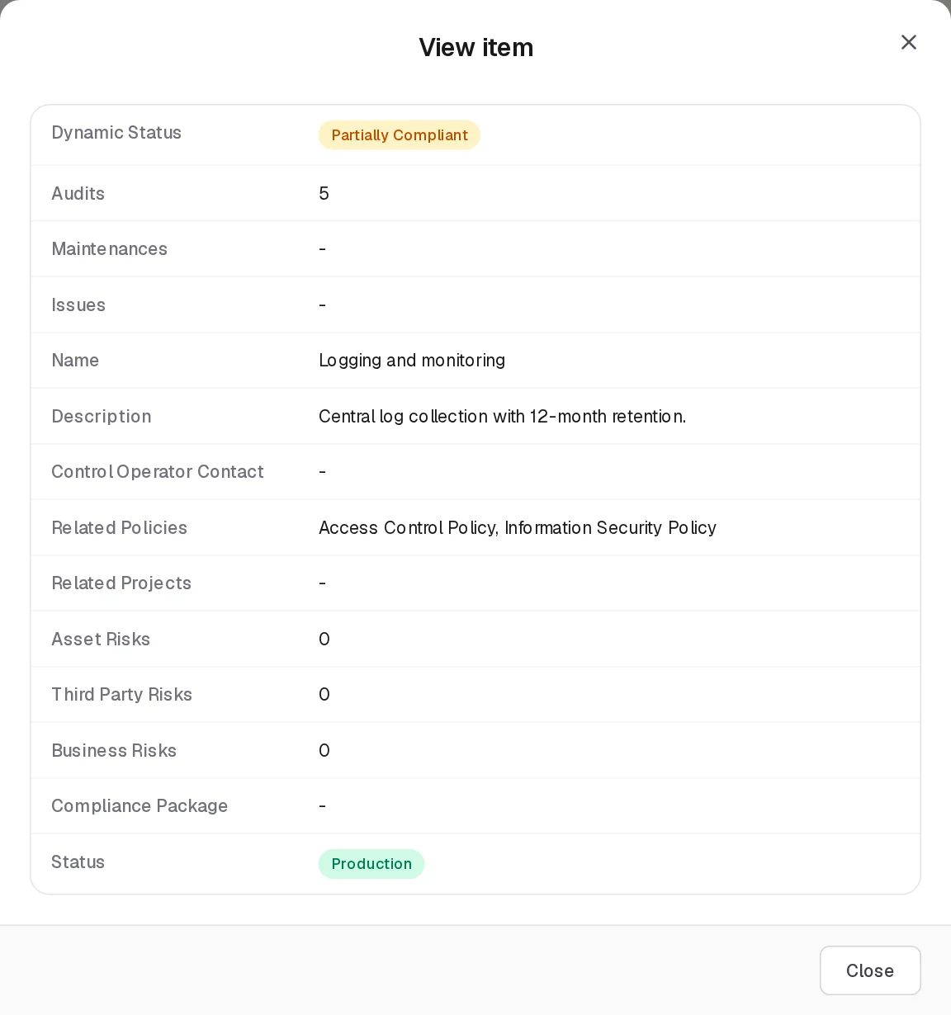
View Control
Edit opens the same form as Add, titled Edit Item, with the plan as stored. Changing the plan and saving recalculates the generated audits and maintenances immediately.
Edit Control
Deleting a control also deletes all its audits, issues and maintenances, and removes it from projects, incidents and objectives that link to it.

Statuses
Status (chosen on the form)
Value | Set by | Meaning
Design | User | The control is being designed. Default for a new control. Shown amber.
Production | User | The control is live. Shown green.
Dynamic Status of a control (computed on every read from its audits, issues and maintenances; checked in this order)
Value | Colour | Rule
Not Compliant | Red | Any of its audits has Dynamic Status Fail, or any of its issues has Dynamic Status Overdue.
Partially Compliant | Amber | Otherwise, if the control’s Status is Design, or any issue is Open, or any audit is Overdue, or any maintenance is Overdue.
Compliant | Green | Everything else: Production, with nothing outstanding.
In the demo data, Logging and monitoring is Partially Compliant because its audit planned for 2026-10-11 is overdue, and Multi-factor authentication because of its open issue.
Audit (Audits tab)
Field | Values
Status (stored) | Planned (default), In Progress, Completed. The audit form does not offer it: a new audit is Planned and an edit keeps the stored value.
Dynamic Status | If Status is Completed: Fail when Audit Result is exactly “fail” (any capitalisation), otherwise Pass. If not completed: Overdue when Planned Start is before today, or Audit End Date is before today; otherwise In Progress.
Issue (Issues tab)
Field | Values
Status | Open (default), Closed
Dynamic Status | Closed if Status is Closed; Overdue if End Date is before today; otherwise Open.
Maintenance (Maintenances tab)
Field | Values
Status (stored) | Pending (default), In Progress, Completed. Not on the form.
Dynamic Status | Completed if Status is Completed; Overdue if Planned Start or Maintenance End Date is before today; otherwise Active.
Badge colours: green for Compliant, Pass, Completed, Closed, Production; amber for Partially Compliant, In Progress, Pending, Design; red for Not Compliant, Fail, Overdue; blue for Open and Planned.

Tabs
The three tabs list the child rows of all controls you can see in one grid, newest first. Each row names its control in Internal Control. Every form on these tabs starts with a Control * drop-down (pre-filled with the first control, “Control is required.”) and a + Add button that creates a new control in place. If no control exists, the form says “Create a control first — audits are recorded against an existing control.” (issues and maintenances say the same).

Audits
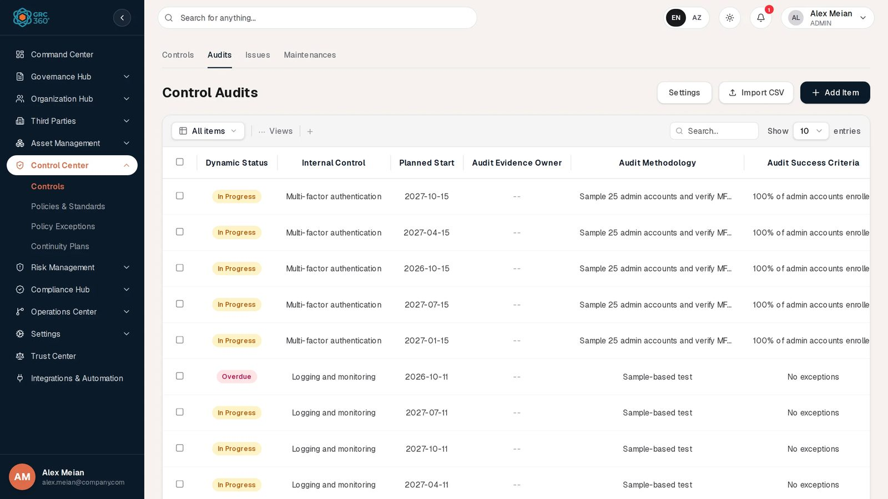
Control Audits
Grid Control Audits, with a Settings button for the Audit Results list.
Column | Meaning
Dynamic Status | See Statuses
Internal Control | The control the audit belongs to
Planned Start | Planned date (generated audits carry the plan date)
Audit Evidence Owner | Who supplies the evidence
Audit Methodology | How the audit is carried out
Audit Success Criteria | What counts as a pass
Start Date / End Date | When the audit actually ran
Audit Result | Value from the Audit Results list
Audit Conclusion | Free text
Evidence | Attached file names, each a download link, or “No evidence”
Audit Owner | Who carries out the audit
Status | Planned / In Progress / Completed
Add Item opens Add Item (Control Audits):
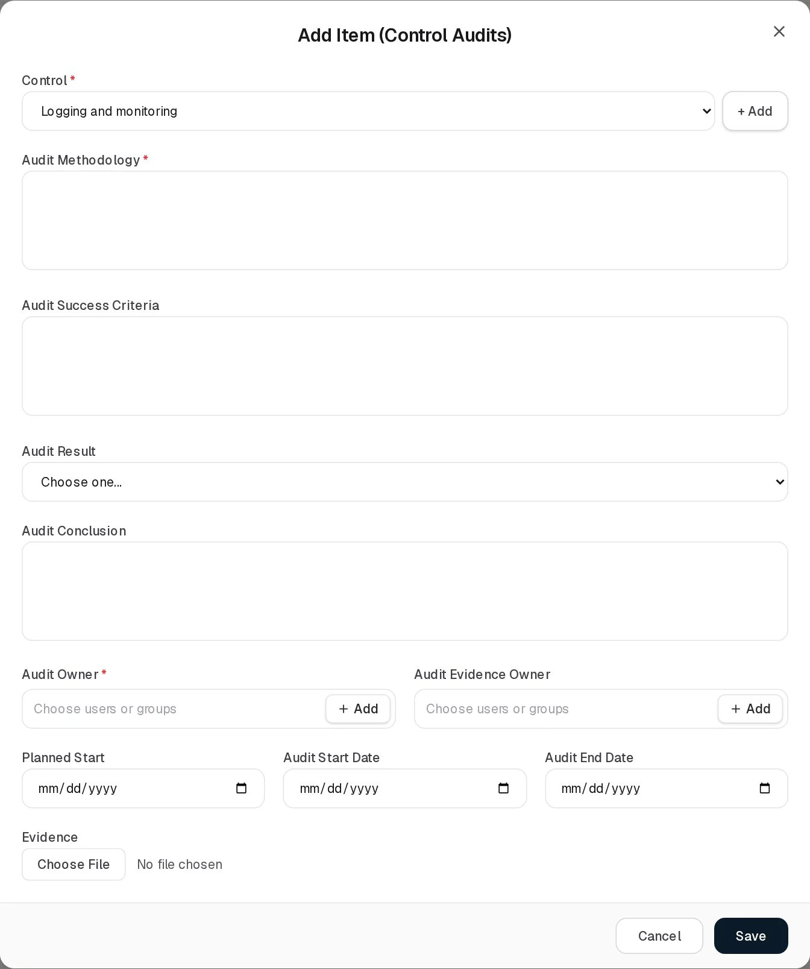
Add Control Audit
Field | Type | Required | Rules and allowed values | Example
Control | Drop-down + + Add | Yes | “Control is required.” | Multi-factor authentication
Audit Methodology | Long text | Yes | “Required.” | Sample 25 admin accounts and verify MFA enrolment
Audit Success Criteria | Long text | No |  | 100% of admin accounts enrolled
Audit Result | Drop-down | No | Placeholder Choose one…; values from the Audit Results list (default Failed, Passed)
Audit Conclusion | Long text | No
Audit Owner | Users or groups | Yes | “Required.”
Audit Evidence Owner | Users or groups | No
Planned Start | Date | No |  | 2026-10-15
Audit Start Date | Date | No
Audit End Date | Date | No
Evidence | File upload | No | One file per pick, any type, max 25 MB. See Evidence.
The View item dialog lists the grid columns; Edit Item (Control Audits) is the same form filled in.
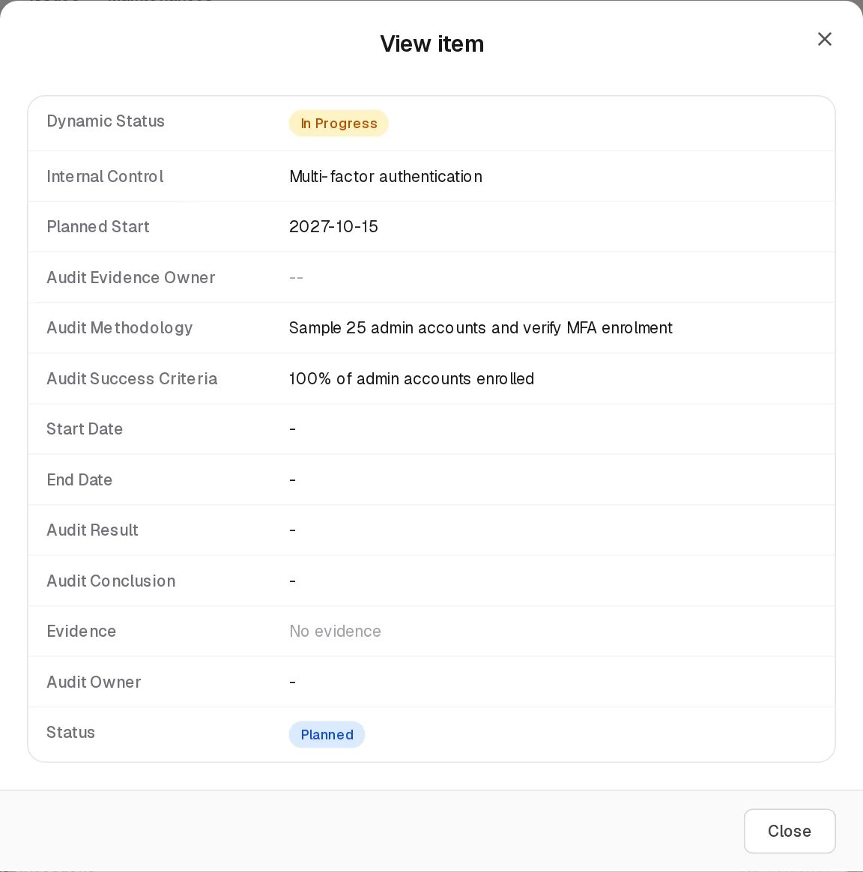
View Control Audit
Edit Control Audit
Generated audits have no Audit Owner unless the control’s plan named one, so the first edit of such an audit asks for it.

Issues
Control Issues
Grid Control Issues: Dynamic Status, Internal Control, Start Date, End Date, Description, Responsible Contact, Status.
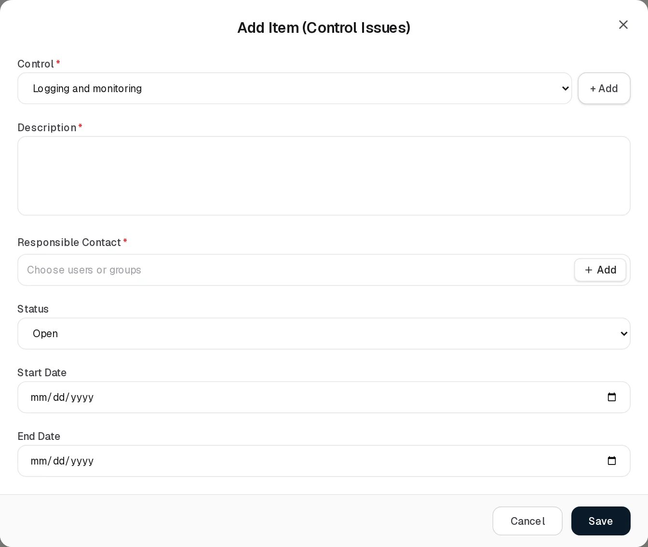
Add Control Issue
Field | Type | Required | Rules and allowed values | Example
Control | Drop-down + + Add | Yes | “Control is required.” | Multi-factor authentication
Description | Long text | Yes | “Required.” | Two service accounts found without MFA during Q3 audit.
Responsible Contact | Users or groups | Yes | “Responsible Contact is required.” Who must close the issue. | Sara Johnson
Status | Drop-down | No | Open (default), Closed | Open
Start Date | Date | No |  | 2026-10-02
End Date | Date | No | The date the issue should be closed by; once passed while Open, the issue is Overdue and the control becomes Not Compliant.
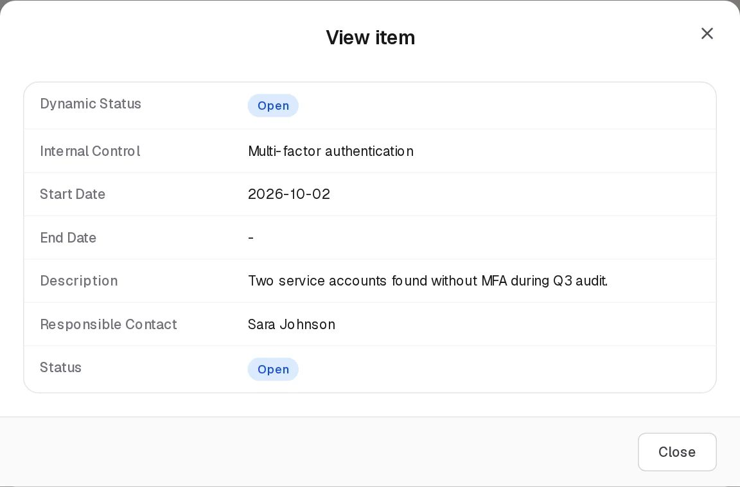
View Control Issue
Edit Control Issue
Issues are saved by sending the whole control back to the server (there is no separate issue save on this page), so adding, editing or deleting an issue also re-runs the control’s audit and maintenance plan.

Maintenances
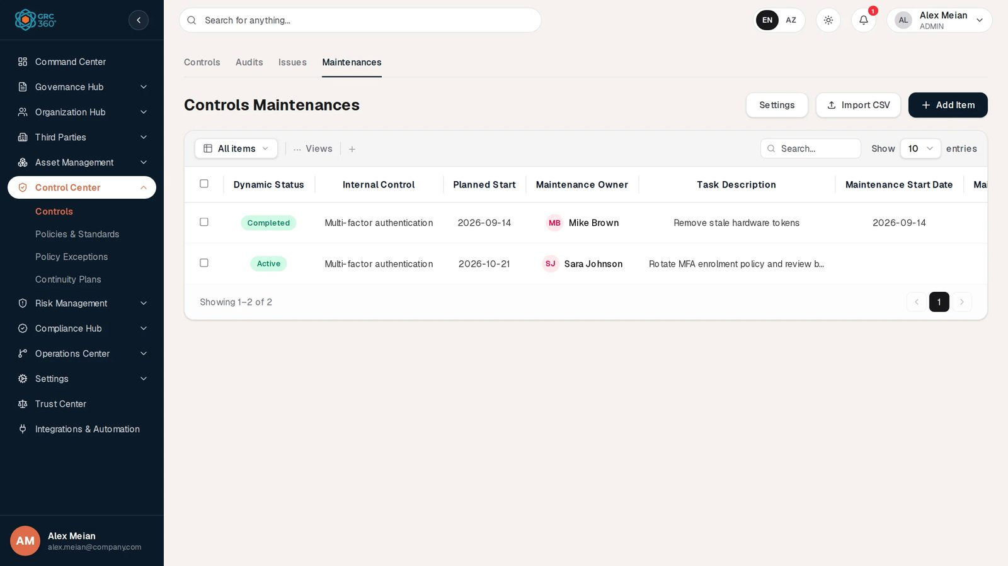
Controls Maintenances
Grid Controls Maintenances, with a Settings button for the Maintenance Results list. Columns: Dynamic Status, Internal Control, Planned Start, Maintenance Owner, Task Description, Maintenance Start Date, Maintenance End Date, Task Result, Task Conclusion, Evidence. The stored Status is not shown as a column.
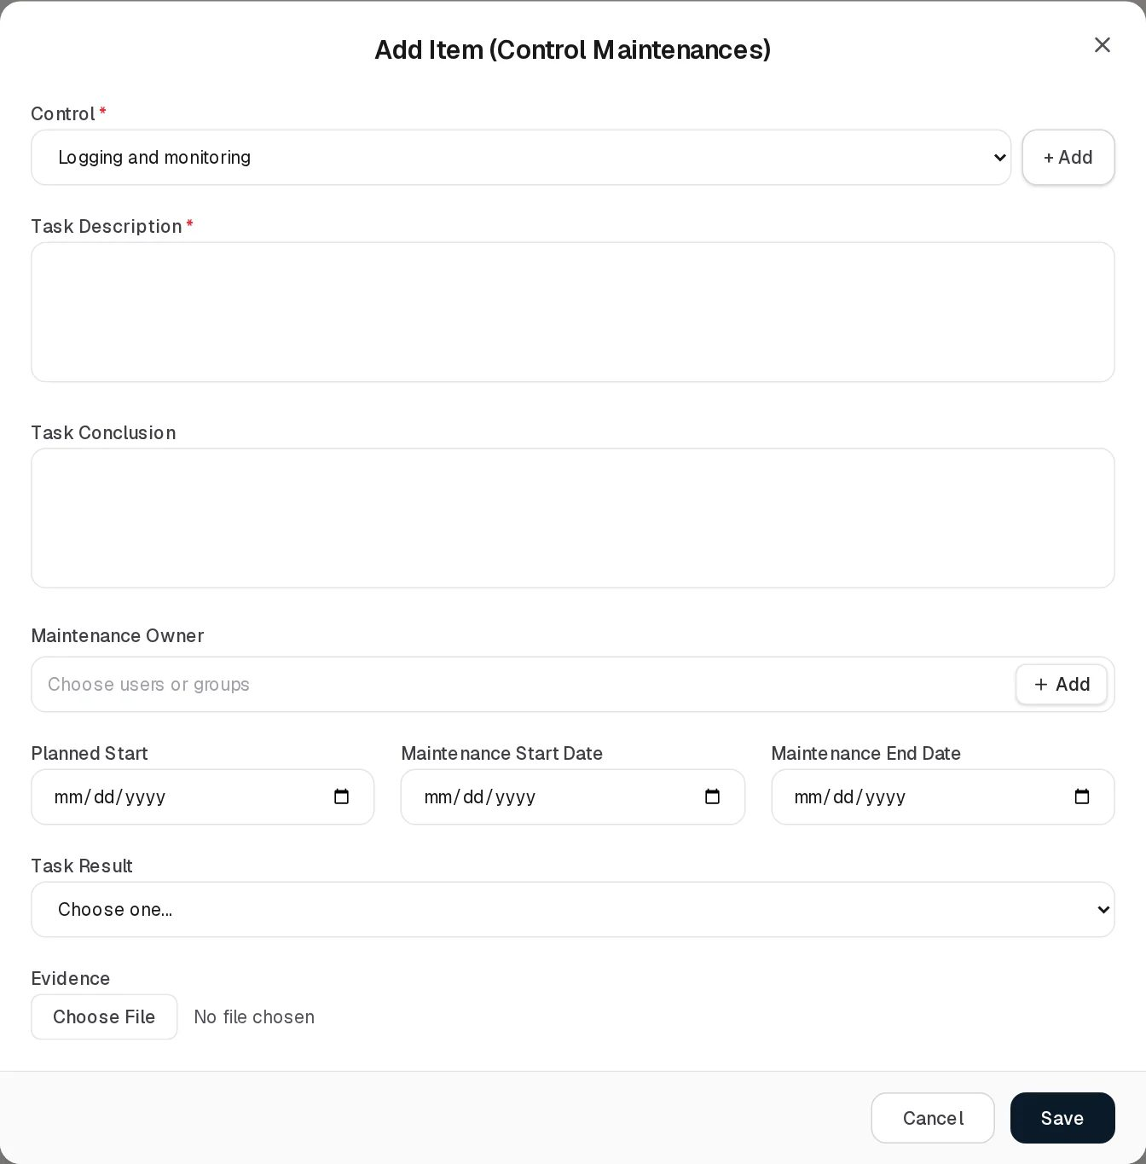
Add Control Maintenance
Field | Type | Required | Rules and allowed values | Example
Control | Drop-down + + Add | Yes | “Control is required.” | Multi-factor authentication
Task Description | Long text | Yes | “Required.” | Rotate MFA enrolment policy and review bypass codes
Task Conclusion | Long text | No |  | 14 tokens revoked.
Maintenance Owner | Users or groups | No |  | Sara Johnson
Planned Start | Date | No |  | 2026-10-21
Maintenance Start Date | Date | No
Maintenance End Date | Date | No
Task Result | Drop-down | No | Choose one…; values from the Maintenance Results list
Evidence | File upload | No | As for audits
View Control Maintenance
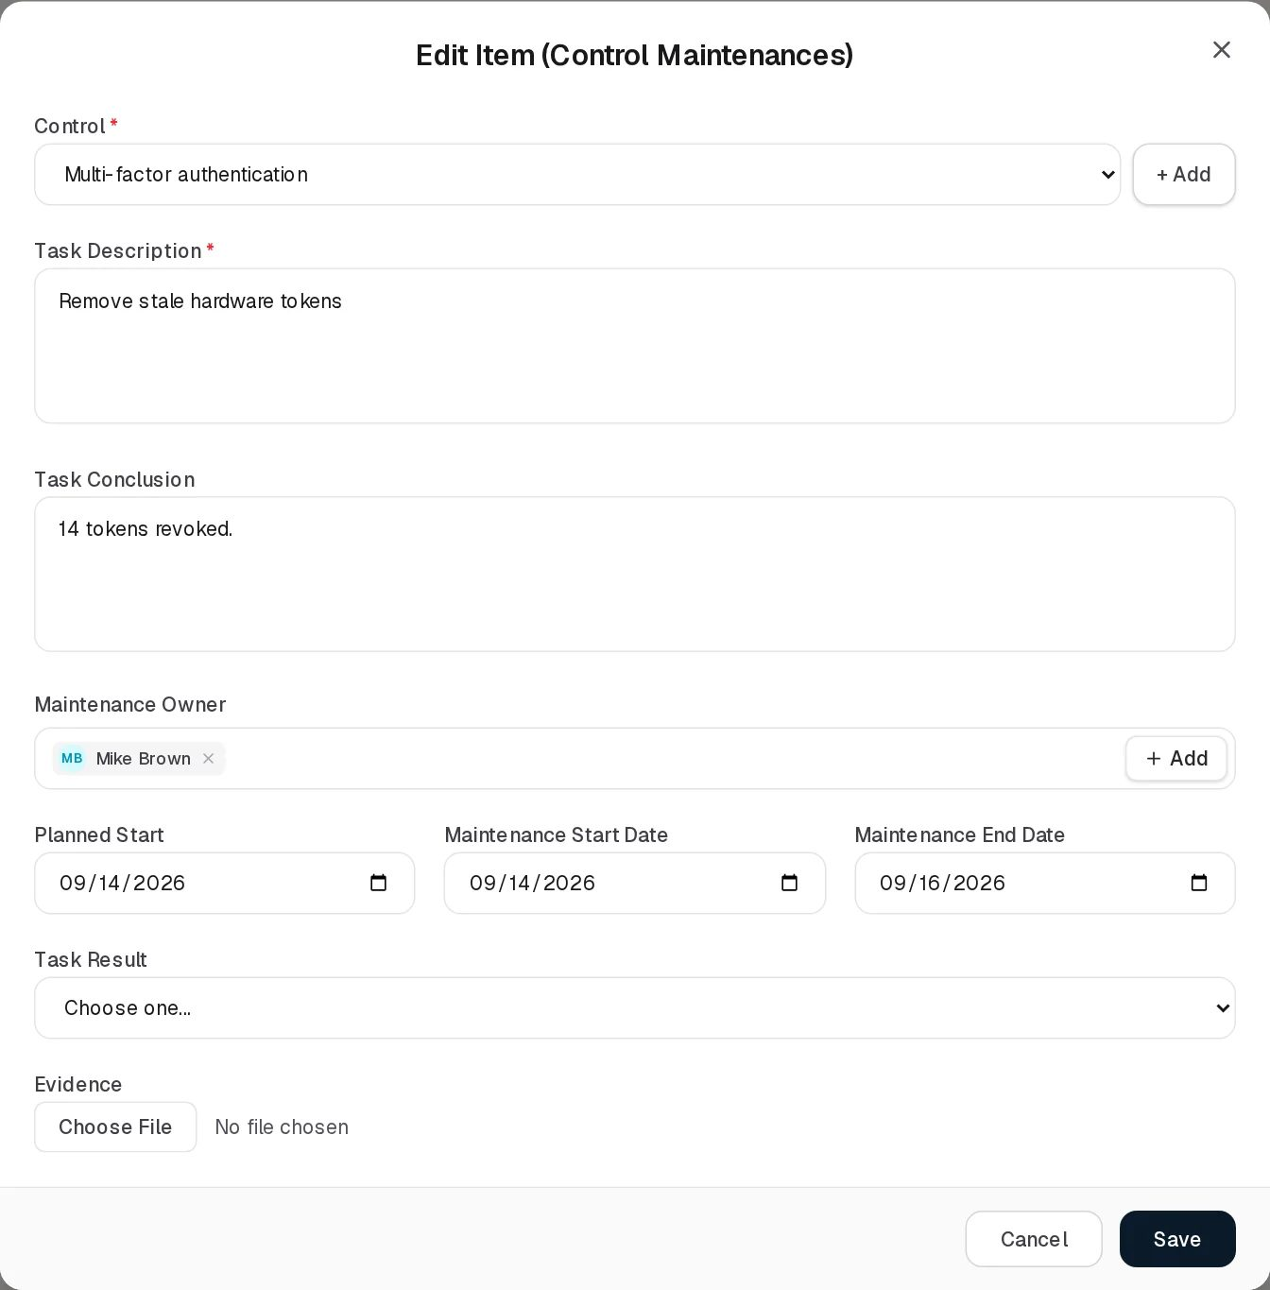
Edit Control Maintenance

Catalog settings (Audit Results and Maintenance Results)
The Settings button on the Audits and Maintenances grids opens a dialog titled Audit Results or Maintenance Results:
- A Type to filter… box and a table with Title and Actions. Each row has Edit (rename in place, then Save or Cancel) and Delete (asks “Delete title?”).
- Add New shows a New entry box with Save and Cancel. A title that already exists (ignoring capitalisation) is refused with “An entry with this title already exists”.
- Close closes the dialog. An empty list reads “Nothing defined yet.”
- The note under the table applies: “Removing an entry only stops it being offered — records that already carry it keep their value.”
Each organisation starts with Failed and Passed in both lists, created the first time the list is opened.

Evidence
Audits and maintenances take evidence files through the Evidence field (EvidenceField.tsx):
- Choose File picks one file at a time. On a record that is not saved yet, the file is listed with “uploads on save” and a Remove link, and is uploaded right after the record is created. On a saved record the file is uploaded at once (“Working…” shows meanwhile).
- Each stored file is listed with its size; the name is a download link, Remove deletes it after confirmation (“Evidence deleted.”).
- The grid’s Evidence column lists the file names as download links; “No evidence” when there are none.
- Files go to the system’s object storage (MinIO or another S3-compatible store) under a generated key; the database keeps the file name, size, type and a SHA-256 checksum. The original file name never becomes part of the storage path.
- Limits and errors from the server: a file over 25 MB (or a request over 30 MB) is refused as too large; an empty file is refused (“Evidence file cannot be empty”); if the storage service is unreachable the upload or download fails with a storage-unavailable error; a file whose stored object has gone missing returns “not found” with a request to upload it again. There is no size check in the browser before upload.
- A file is visible and downloadable only to users who can see the control the audit or maintenance belongs to.

Relationships
Related record | Direction | How the link is made | Where it shows
Policies & Standards | Control → many policies | Related Policies on the control form | Controls › Related Policies; Policies › Internal Controls column
Projects | Control → many projects | Related Projects on the control form | Controls › Related Projects; Projects › Internal Controls column
Audits / Issues / Maintenances | One control → many | Tabs of this page, or generated from the plan | Counts on the Controls grid (not clickable); the tabs
Asset / Third Party / Business Risks | Many risks → many controls | The risk’s treatment field | Controls › risk count columns (clickable, opens the risks)
Compliance packages | Many ↔ many | Compliance Analysis (Compliance Hub) | Controls › Compliance Package
Data Flows | Many ↔ many | Compensating Controls on the data flow | Data Flows page
Objectives | Many ↔ many | Controls on the objective | Objectives page
Continuity plans | Control → many plans | Stored on the control but not editable on any screen | Not shown

Automations and notifications
- Dynamic Status of controls, audits, issues and maintenances is recalculated on every read. A missed planned date shows as Overdue on the next day without any job running.
- Saving a control (from the Controls tab, or indirectly when an issue is saved or an audit, issue or maintenance is deleted) regenerates the planned audits and maintenances. See Audit and maintenance scheduling.
- No notifications or reminders are sent for controls, audits, issues or maintenances.

Permissions
Access is set per page and per tab, as one level: No Access, View, Manage or Full Control. See Permissions and access.
Action | Needed access
See the page and the Controls grid | View on Control Center › Controls
Add or edit a control | Manage on Control Center › Controls
Delete a control | Full Control on Control Center › Controls
Name other people in GRC Contact, Control Operator Contact, Audit Owners, Audit Evidence Owners, Maintenance Owners | Can Assign (new names) and Can Reassign (changing names already there) on Controls
Open the Audits tab | View on Controls › Audits
Add or edit an audit’s schedule fields | Manage on Controls › Audits
Record or change Audit Result / Audit Conclusion | Audit Results right on Controls › Audits (included in Manage)
Delete an audit | The button needs Full Control on Controls › Audits; the save itself is an update of the control, so Manage on Controls is also needed
Open the Issues tab | View on Controls › Issues
Add, edit or delete an issue | The buttons need Manage (add, edit) or Full Control (delete) on Controls › Issues; every issue save is an update of the control, so Manage on Controls is also needed
Open the Maintenances tab, add, edit, delete | As for Audits, on Controls › Maintenances; Task Result / Task Conclusion need the Maintenance Results right (included in Manage)
Upload evidence / delete evidence | Manage / Full Control on any Control Center page (the evidence service is checked at module level) and visibility of the control
Add, rename or delete entries in the Settings lists | Manage (add, rename) or Full Control (delete) on any Control Center page. The Settings button itself is never locked.
Comment and attach files in the Activity Log | The group’s Comments & Attachments level
Which controls appear in the grid can be limited to records that name the user: the people counted are the Control Operator Contact, GRC Contact, Audit Owners, Audit Evidence Owners and Maintenance Owners. The Audits, Issues and Maintenances tabs show only the rows of controls you can see.

How to

Add a control with a quarterly audit plan
- Open Control Center › Controls and click Add Item.
- Enter Name “Privileged access review” and a Description.
- Choose Sara Johnson as GRC Contact and Alex Meian as Control Operator Contact.
- In Related Policies, pick Access Control Policy. Set Status to Production.
- Under Audits, select Audits required, choose Periodical, set First date and Frequency Quarterly, and fill Audit Methodology and Audit Success Criteria.
- Click Save. Open the Audits tab: five quarterly audits from the first date onward are listed for the new control (fewer if the first date is in the past).

Record the outcome of an audit with evidence
- Open the Audits tab and find the Multi-factor authentication audit planned for 2026-10-15.
- Click Edit. Fill Audit Owner (required), Audit Start Date and Audit End Date.
- Choose Audit Result Passed and write the Audit Conclusion.
- Under Evidence, click Choose File and pick the export of MFA enrolments. Click Save.
- The row shows the file under Evidence. Note that the audit’s Status stays Planned, because the form has no Status field (see the known issues below).

Raise an issue against a control
- Open the Issues tab and click Add Item.
- Choose the Control (for example Multi-factor authentication), write the Description, choose the Responsible Contact and set an End Date.
- Click Save. The control’s Dynamic Status becomes Partially Compliant while the issue is open, and Not Compliant once the End Date has passed.
- When fixed, edit the issue and set Status to Closed.

Add your own audit result value
- On the Audits tab click Settings.
- Click Add New, type “Passed with observations” and click Save. Click Close.
- The new value is offered in Audit Result from now on.

See which risks a control treats
- On the Controls tab, find Encryption at rest.
- Click the number in Asset Risks (14 in the demo data). A dialog lists those asset risks.

CSV import
Not available. Import CSV on the Controls, Audits, Issues and Maintenances grids shows “CSV Import (title): the import structure is not ready yet.” and then opens a demonstration dialog whose validation fails. The backend has an import endpoint for controls (/control/internal-controls/import-csv), but no screen uses it. See CSV import and export.

Limitations and known issues
- Audits and maintenances cannot be marked Completed from the screen. Neither form has a Status field, so a new audit stays Planned and a new maintenance Pending. Their Dynamic Status therefore never becomes Pass, Fail or Completed through the UI: it shows In Progress / Active until the planned date passes and then Overdue, even after a result has been recorded. As a consequence a failed audit never makes the control Not Compliant, and a recorded audit still counts as overdue.
- “Failed” is read as a pass. Even for an audit with Status Completed, Dynamic Status is Fail only when the result is exactly “fail”. The default list entries are “Failed” and “Passed”, so “Failed” produces Pass. (Continuity plan audits match “fail” anywhere in the text and do not have this problem.)
- Deleted generated rows come back. Deleting an audit or maintenance that the plan generated, while its date is still in the plan and no result is recorded, re-creates it immediately (as a new row), because the delete is a save of the control and every save re-runs the plan. Change the plan instead.
- Moving an audit, issue or maintenance to another control does not work. The Control drop-down is editable on Edit. For audits and maintenances the server rejects the change (“Audit does not belong to the specified Internal Control” / “Maintenance does not belong to the specified Internal Control”). For an issue, the save adds a copy to the newly chosen control and leaves the original on the old one.
- Stored values missing from the Settings list are not displayed. If an audit or maintenance carries a result that is not in the list (for example the demo maintenance with result “PASS”), the drop-down shows Choose one… although the value is still stored.
- Control Operator Contact column can be empty. The grid shows the names stored as text. Records whose people were set only as user ids (as in the demo data) show an empty column and “-” in the view, although the Edit form shows the people.
- Saving an issue sends every audit back. Issues are saved as part of the whole control; the server re-validates all of the control’s audits, and an audit without Audit Methodology (possible for audits generated from a plan with an empty methodology) makes the save fail with “Audit methodology is required”.
- Continuity plans and compliance packages are not editable here. The control stores continuity plan and compliance package links, but the form offers neither; compliance packages are set from Compliance Analysis, and the continuity plan link cannot be set anywhere in this release.
- Permission mismatch on Issues and on deletes from tabs. The Issues tab buttons are governed by the Issues tab permission, but the server checks Edit on the Controls page, so a user with Manage on Issues but only View on Controls sees the button enabled and the save is refused.
- No reminders. Nothing notifies owners about upcoming or overdue audits, maintenances or issues.

Policies & Standards
Module: Control Center › Policies & Standards · Route: /control-center/policies-standards · Permission key: control_center.policies_standards
The Policies & Standards register holds the organisation’s governing documents: policies, standards and procedures. A record carries the document itself (written in place, linked, or attached as a file), its version, publication state and next review date, the people responsible for it, and its links to controls, risks, data flows and compliance packages. The Reviews tab records each review of a policy; reviews are also planned automatically from the policy’s Next Review Date. Policy owners, GRC staff and reviewers work here.
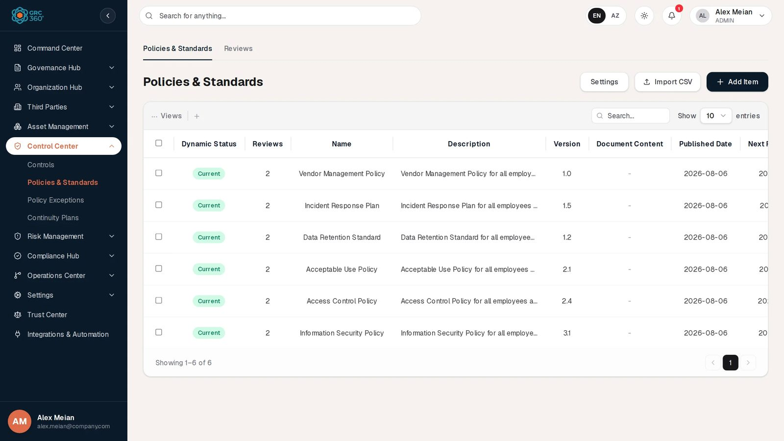
Policies & Standards register

At a glance
A record is | One policy, standard or procedure document
Typical owner | GRC Contact; reviewed by the Policy Reviewer Contact
Links to | Projects (Related Projects); compliance packages (set from Compliance Analysis)
Linked from | Controls (Related Policies), Asset Risks and Business Risks (Treatment: Policies), Third Party Risks (Treatment: Policies), Data Flows (Policies), Policy Exceptions (Related Policies), Objectives (Policies), Compliance Analysis (Policies)
Tabs | Reviews
Automations | Computed Dynamic Status; reviews generated from Next Review Date on save; Reviews count kept by the server

The register (list view)
Server-paged grid, newest first, with a Settings button for the Document Types list. The shared grid behaviour is described in Working with registers.
Column | What it shows | Source
Dynamic Status | Current or Needs Review (see Statuses) | Computed by the system
Reviews | Number of reviews recorded for the policy (generated and manual) | Computed by the server
Name | Document name | Entered
Description | Purpose and scope | Entered
Version | Version label | Entered
Document Content | The document: the written text (truncated), the link (opens in a new tab), or the attached file (download link). Shows “-” when there is none. | Entered
Published Date | Date of publication | Entered
Next Review Date | When the document is next due for review | Entered
Policy Labels | Confidential, Public or Private, as a grey chip | Entered
Document Type | Value from the Document Types list, as a coloured chip (Policy purple, Standard blue, Procedure cyan, others grey) | Entered
Compliance Package | Names of the compliance packages linked from Compliance Analysis | Linked (set in Compliance Hub)
Asset Risks Treatment | Number of asset risks naming this policy in Treatment: Policies. A non-zero count is clickable and opens those risks. | Linked (owned by the risk)
Third Party Risks Treatment | Same for third party risks | Linked (owned by the risk)
Data Asset Flow | Names of data flows naming this policy | Linked (owned by the data flow)
Internal Controls | Names of controls naming this policy in Related Policies | Linked (owned by the control)
Related Projects | Names of linked projects | Linked (chosen on this form)
Status | Draft or Published | Entered

Creating a record
Click Add Item. The dialog Add Item (Policies) (subtitle Control Center) has two tabs, General and Policy Content. The same form opens from the + Add button of every policy picker in other modules.
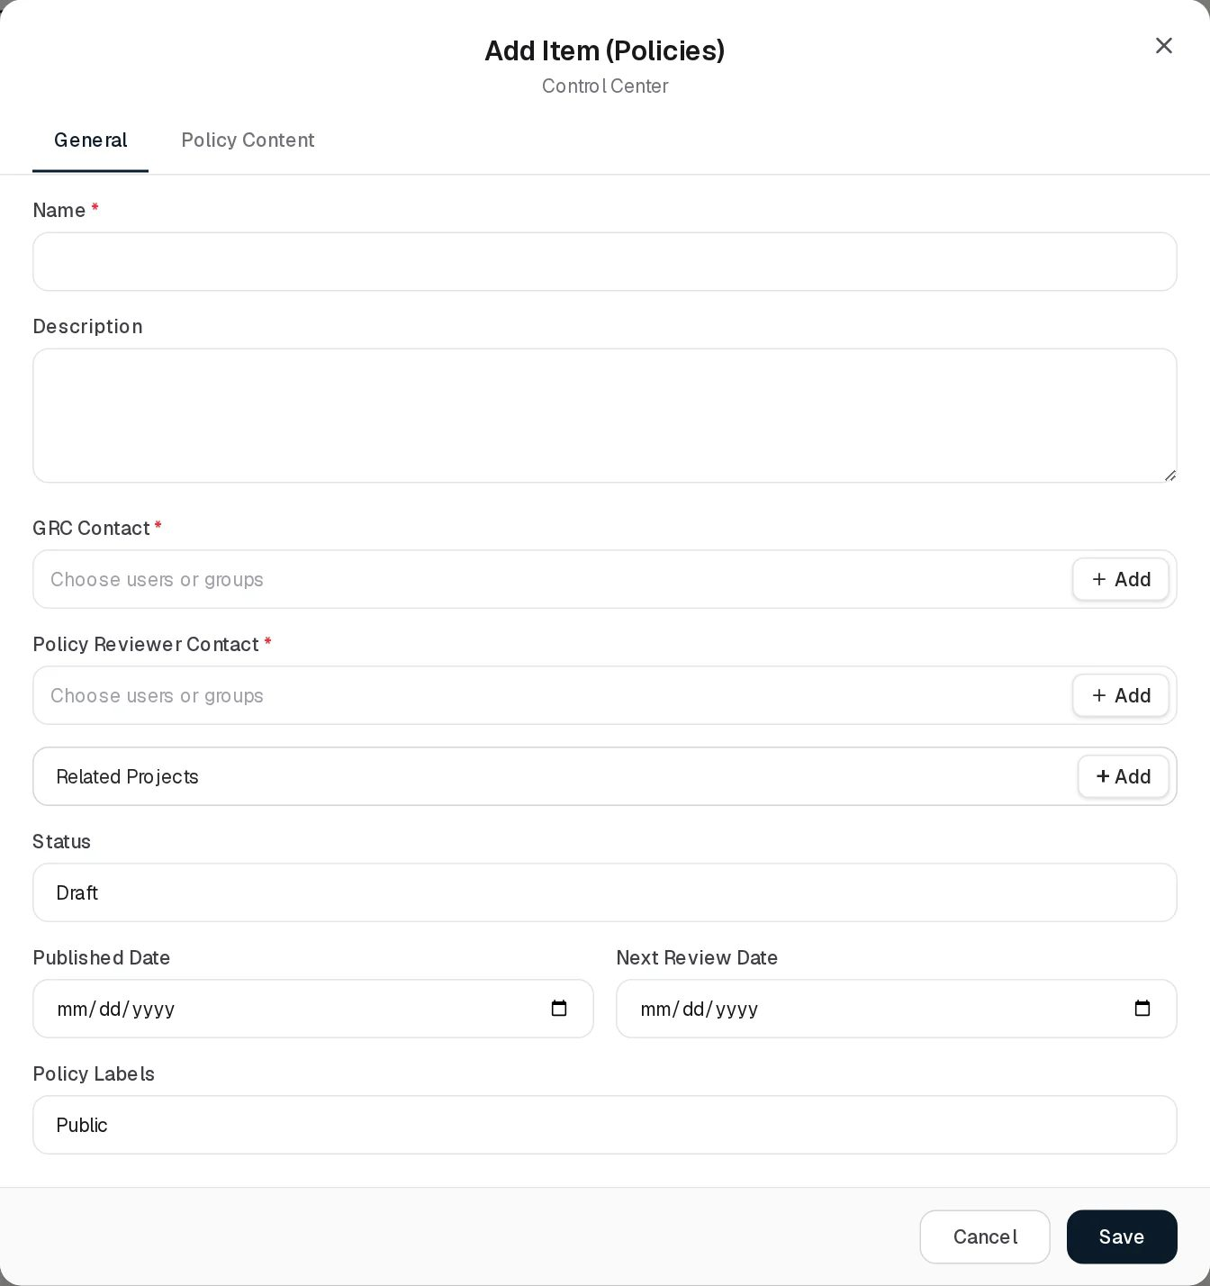
Add Policy
General tab
Field | Type | Required | Rules and allowed values | Example
Name | Text | Yes | “Required” under the field and “Name is required.” in the validation message. Must be unique in the organisation (“Policy Standard with this name already exists”). | Vendor Management Policy
Description | Long text | No |  | Vendor Management Policy for all employees and contractors.
GRC Contact | Users or groups, several allowed | Yes | “GRC Contact is required.” | Alex Meian
Policy Reviewer Contact | Users or groups, several allowed | Yes | “Policy Reviewer Contact is required.” The names are copied onto generated reviews. | Sara Johnson
Related Projects | Picker of projects, + Add | No | Empty hint “No projects created yet.”
Status | Drop-down | No | Draft (default), Published | Published
Published Date | Date | No |  | 2026-08-06
Next Review Date | Date | No | Drives the review schedule and the Dynamic Status. | 2027-01-08
Policy Labels | Drop-down | No | Confidential, Public (default), Private | Private
Policy Content tab
Field | Type | Required | Rules and allowed values | Example
Document Type | Drop-down | No | Values from the Document Types list (default Policy, Procedure, Standard). Default for a new record: Policy. | Policy
Version | Text | No | Default “1.0”. Max 50 characters. | 1.0
Document Content | Choice of three, see below | No | Use Content, URL Link, File Attachment
If a required field on General is empty when you click Save, the form switches back to the General tab.

The Document Content field
DocumentContentField.tsx offers three ways to give the document. Only the chosen one is saved; the other two are cleared on save.
Choice | What you enter | How it is stored and shown
Use Content | Plain text in a large box (“Write the document here.”) | Stored as plain text and always shown as text, never as formatted markup.
URL Link | A link, placeholder “Enter document URL (e.g. Google Docs, SharePoint link)” | Shown as a link that opens in a new tab.
File Attachment | One file via the file picker; Remove clears it | The file is uploaded to object storage as evidence of kind POLICY (max 25 MB). On a new policy it shows “uploads on save” and is uploaded right after the policy is created. Only the file name is kept on the policy; the grid and the View dialog offer the file for download.
When a record is reopened, the form shows the choice that holds a value, in the order text, then file, then link. Replacing an attachment uploads a new file; earlier files stay in storage but only the one whose name the policy carries is offered as the document.

Viewing and editing a record
The eye button opens View Policy: Name, Description, Version, Document Type, Published Date, Next Review Date, Policy Labels, Status, Compliance Package, Asset Risks Treatment, Third Party Risks, Data Asset Flow, Controls, Related Projects, GRC Contact, Reviewer Contact, and at the bottom Document Content (text, link or downloadable file).
View Policy
Edit opens Edit Item (Policies), the same two-tab form. Saving recalculates the generated reviews from the Next Review Date.
Edit Policy
Deleting a policy removes it from the controls, asset risks, third party risks and data flows that name it.

Versions, publication and portal permission
- Version is a free-text label on the policy, and each review has its own Version field. Nothing increments versions automatically, and completing a review does not change the policy’s version or document; update the policy yourself after a review.
- Status Draft / Published is informational. A Draft policy is still linked, reviewed and shown like a Published one, and still generates reviews.
- The policy record has a portal permission field (stored on the server, kept unchanged by every save), but no screen in this release shows or edits it.

Statuses
Status (chosen on the form)
Value | Set by | Meaning
Draft | User | Still being written. Default. Shown grey.
Published | User | The version in force. Shown green.
Dynamic Status (computed on every read)
Value | Colour | Rule
Needs Review | Amber | Next Review Date is before today.
Current | Green | Otherwise, including when no Next Review Date is set.
Status does not influence Dynamic Status.

Tabs

Reviews
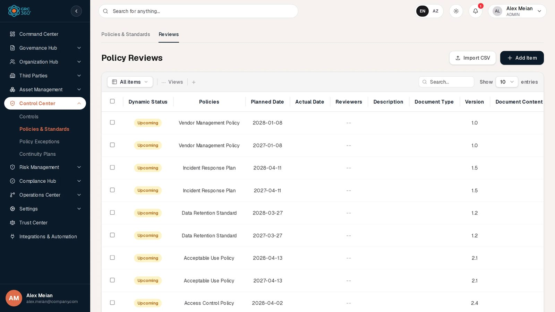
Policy Reviews
Grid Policy Reviews, all reviews of all policies you can see, newest first.
Column | Meaning
Dynamic Status | Completed, Missing Date, Expired or Upcoming (below)
Policies | The reviewed policy
Planned Date | When the review is due
Actual Date | When it was carried out
Reviewers | Reviewer names
Description | Review notes
Document Type | The policy’s current Document Type
Version | The policy’s current Version (not the review’s own)
Document Content | The review’s written text or link, or else the policy’s link
URL | The Document Content value when it is a web link
Content Attachment | The policy’s attached file name (see known issues)
Status | Planned / Completed (and In Progress, Expired on older rows)
Review Dynamic Status (computed on every read):
Value | Colour | Rule
Completed | Green | Actual Date is filled in.
Missing Date | Amber | No Actual Date and no Planned Date.
Expired | Red | No Actual Date and Planned Date before today.
Upcoming | Amber | No Actual Date and Planned Date today or later.
Review Status is not on the form: on save it is set to Completed if Actual Date is filled and Planned otherwise.
Add Item opens Add Item (Policy Reviews):
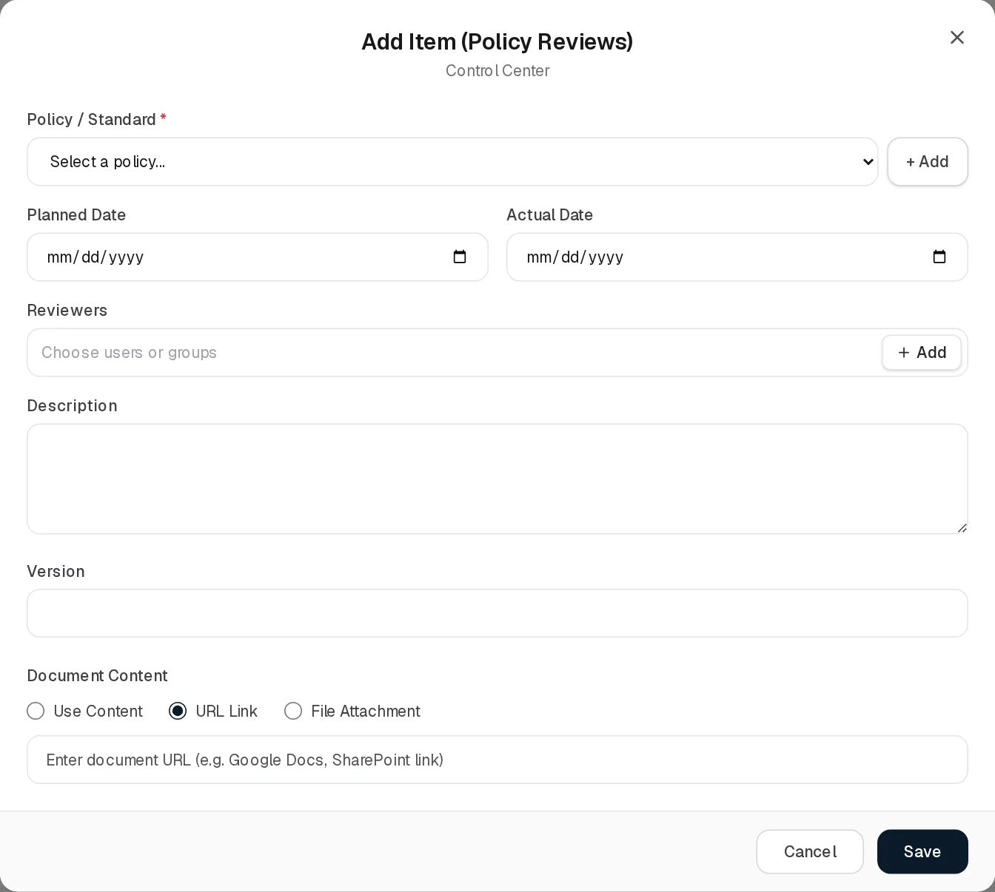
Add Policy Review
Field | Type | Required | Rules and allowed values | Example
Policy / Standard | Drop-down + + Add | Yes | Placeholder “Select a policy…”; error “Select the policy being reviewed.” If none exist: “Create a policy first — reviews are recorded against an existing policy.” | Vendor Management Policy
Planned Date | Date | No |  | 2027-01-08
Actual Date | Date | No | Filling it completes the review.
Reviewers | Users or groups | No | Names and ids stored. | Sara Johnson
Description | Long text | No
Version | Text | No | The version this review records. | 1.1
Document Content | Use Content / URL Link (default for a new review) / File Attachment | No | As on the policy; a file is uploaded as evidence of kind POLICY_REVIEW.
The eye button opens View item, which lists the grid columns of the review.
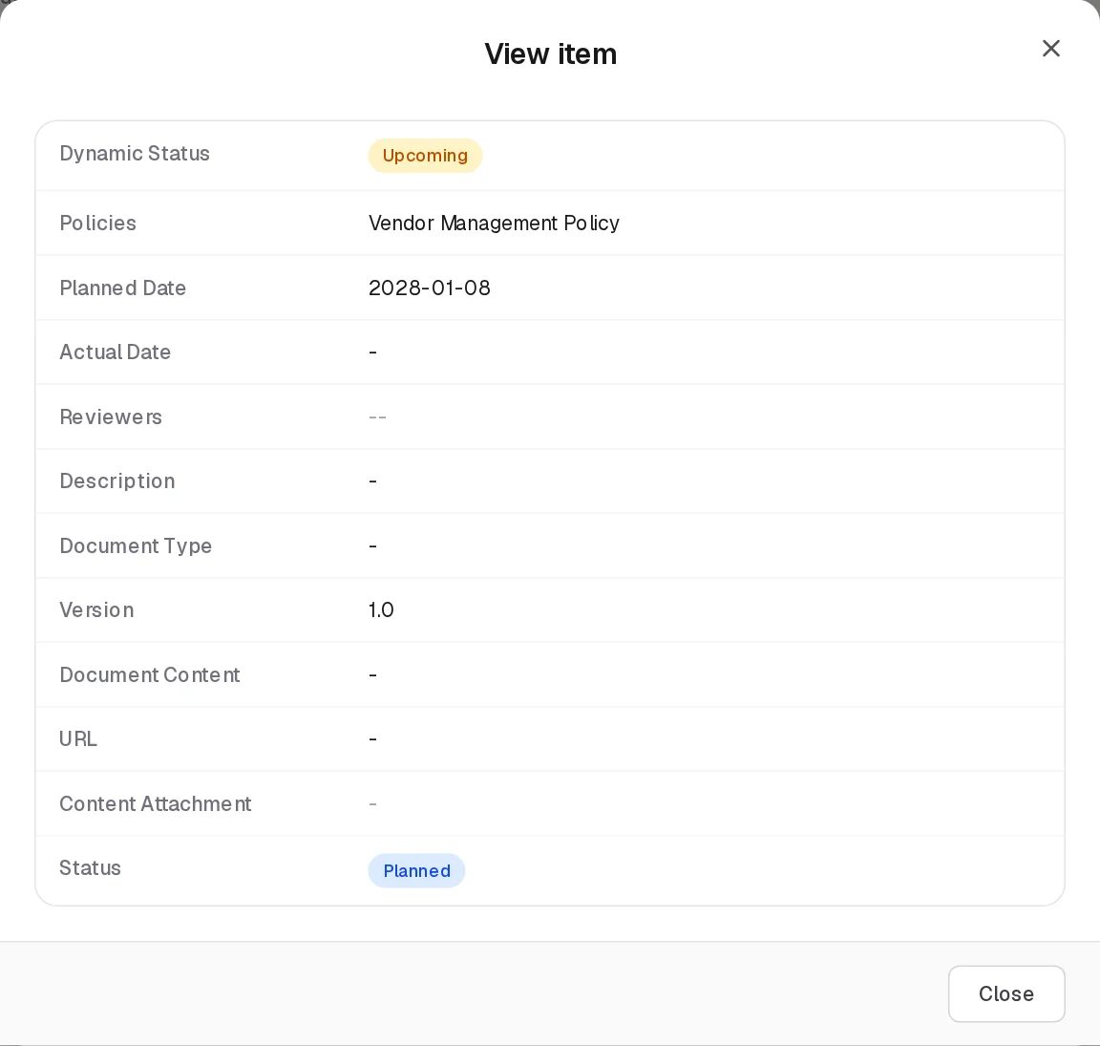
View Policy Review
Editing uses Edit Item (Policy Reviews), the same form.
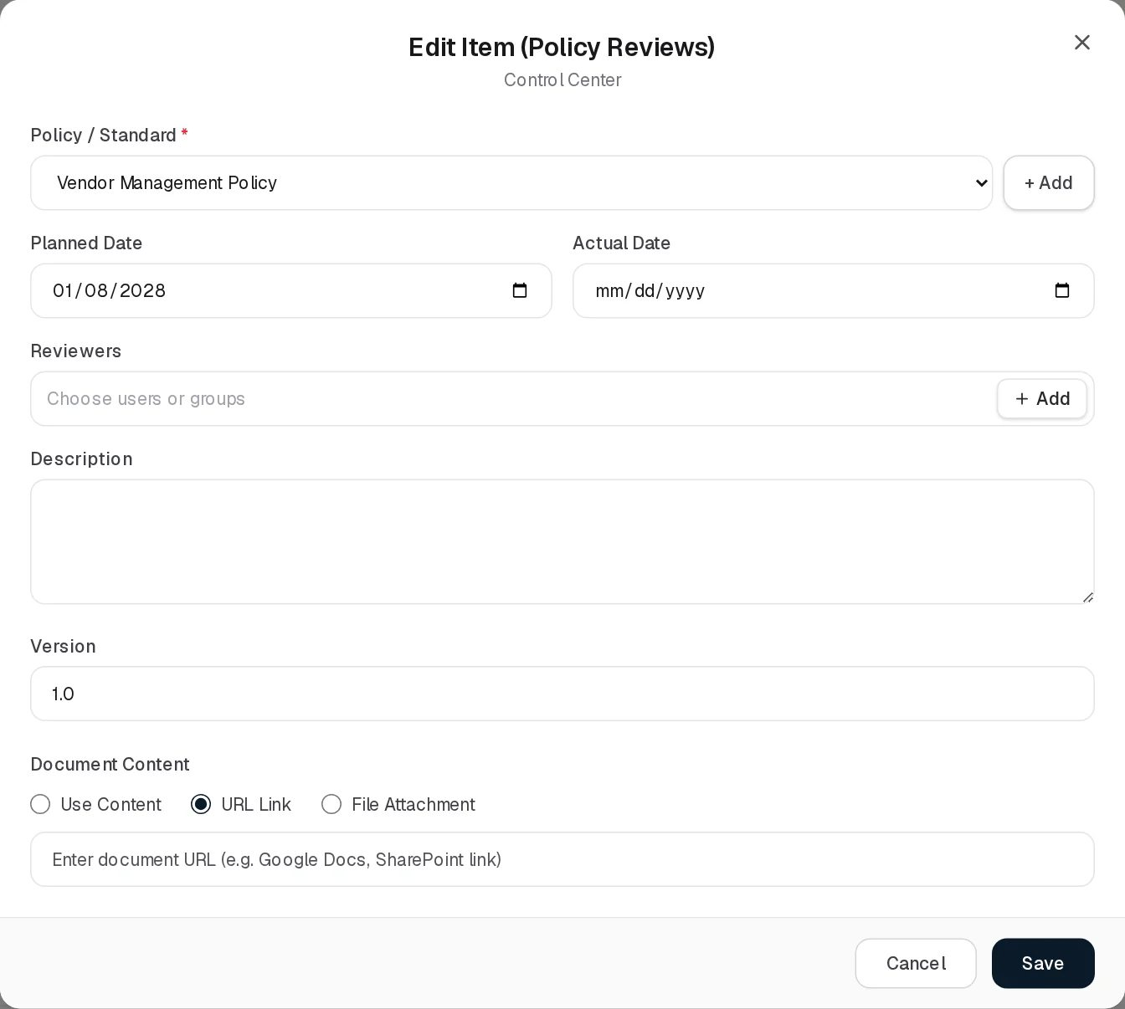 Deleting asks “Delete policy review for policy name?”. Adding, editing and deleting a review updates the policy’s Reviews count.

Generated reviews
Each save of a policy plans reviews from its Next Review Date: one on that date and one a year later, skipping dates already past. A generated review copies the policy’s Policy Reviewer Contact names, Version and document text or link. Changing the Next Review Date withdraws generated reviews that have no Actual Date and creates the new ones; completed reviews and reviews added by hand are kept. In the demo data every policy has two Upcoming reviews, for example Vendor Management Policy on 2027-01-08 and 2028-01-08.

Relationships
Related record | Direction | How the link is made | Where it shows
Projects | Policy → many | Related Projects on the policy form | Related Projects column
Reviews | One policy → many | Reviews tab, or generated from Next Review Date | Reviews count (not clickable), Reviews tab
Controls | Many ↔ many | Related Policies on the control | Internal Controls column, View Controls
Asset Risks, Third Party Risks | Many ↔ many | Treatment fields on the risk | Treatment count columns (clickable)
Data Flows | Many ↔ many | Policies on the data flow | Data Asset Flow column
Business Risks | Many ↔ many | Treatment: Policies on the business risk | Business Risks page only; no column here
Compliance packages | Many ↔ many | Compliance Analysis | Compliance Package column
Policy Exceptions | Many → many | Related Policies on the exception | Policy Exceptions page only
Objectives | Many ↔ many | Policies on the objective | Objectives page only
The links owned by other records are kept when the policy is saved: the form sends them back unchanged.

Automations and notifications
- Dynamic Status of policies and reviews is computed on read: a policy turns Needs Review and a review Expired on the day after the date passes.
- Reviews are generated from Next Review Date each time the policy is saved (no background job).
- The Reviews count is recalculated by the server on every policy or review save and delete.
- No notifications or reminders are sent for policies or reviews.

Permissions
Action | Needed access
See the page | View on Control Center › Policies & Standards
Add or edit a policy | Manage on Policies & Standards
Delete a policy | Full Control on Policies & Standards
Name other people in GRC Contact or Policy Reviewer Contact | Can Assign / Can Reassign on Policies & Standards
Open the Reviews tab | View on Policies & Standards › Reviews
Add or edit a review | Manage on Reviews, and visibility of the reviewed policy
Delete a review | Full Control on Reviews
Upload or delete the document file | Manage / Full Control on any Control Center page (checked at module level), and visibility of the policy
Edit the Document Types list | Manage (add, rename) / Full Control (delete) on any Control Center page
Comment and attach in the Activity Log | The group’s Comments & Attachments level
Which policies appear can be limited to records that name the user as GRC Contact or Policy Reviewer Contact. The Reviews tab shows only reviews of policies you can see (and reviews with no policy).

How to

Publish a new policy with an attached document
- Click Add Item. On General enter the Name, choose GRC Contact and Policy Reviewer Contact, set Status Published, Published Date and Next Review Date.
- Open Policy Content, choose Document Type and Version.
- Under Document Content choose File Attachment and pick the PDF. It shows “uploads on save”.
- Click Save. The Document Content column shows the file name as a download link, and the Reviews tab shows two upcoming reviews.

Record a completed review
- Open the Reviews tab and click Edit on the review of Information Security Policy planned for 2026-12-20.
- Fill Actual Date, Reviewers, Description and the new Version.
- Click Save. The review’s Dynamic Status becomes Completed.
- Open the policy itself and update its Version, document and Next Review Date; the next generated reviews follow the new date.

Add a document type
- On the Policies & Standards grid click Settings (dialog Policy Document Types).
- Click Add New, type “Guideline”, click Save and Close.
- Guideline is now offered in Document Type.

Find the controls that implement a policy
- Look at the Internal Controls column, or open View Policy and read Controls. For Access Control Policy the demo data lists eight controls, from Backup and restore testing to Vulnerability scanning.

CSV import
Not available. Import CSV on both grids shows “CSV Import (title): the import structure is not ready yet.” and then opens a demonstration dialog whose validation fails. The backend import endpoint /control/policies-standards/import-csv is not used by any screen. See CSV import and export.

Limitations and known issues
- A review’s attached file is not remembered. The review form offers File Attachment and uploads the file, but the server does not store the review’s attachment name. The Content Attachment column therefore shows the policy’s file instead of the review’s, and reopening the review shows URL Link again. The uploaded file stays in storage without being reachable from the screen.
- Review grid columns show the policy, not the review. Version and Document Type come from the policy as it is now, not from the review.
- Generated reviews often have no reviewers. They copy the reviewer names stored as text on the policy; policies whose reviewer was set only by id (as in the demo data) produce reviews with an empty Reviewers column.
- Expired is never shown on a policy. The policy’s Dynamic Status has three possible values on the server (Current, Needs Review, Expired), but only the first two are ever produced.
- Linked records are not editable here. The policy stores links to controls, risks, data flows and compliance packages, but the form offers only Related Projects; the others are set from the other records.
- Portal permission is not exposed on any screen.
- No review reminders. Nothing notifies the reviewer before or after the Next Review Date.

Policy Exceptions
Module: Control Center › Policy Exceptions · Route: /control-center/exceptions · Permission key: control_center.exceptions
The Policy Exceptions register records approved deviations from the organisation’s policies and standards: a situation where a policy cannot be followed for a limited time, for example a vendor appliance that only supports one shared admin account. A record names who asked for the exception, who owns it on the GRC side, which policies it deviates from, and when it expires. GRC staff maintain it; requesters and policy owners read it.
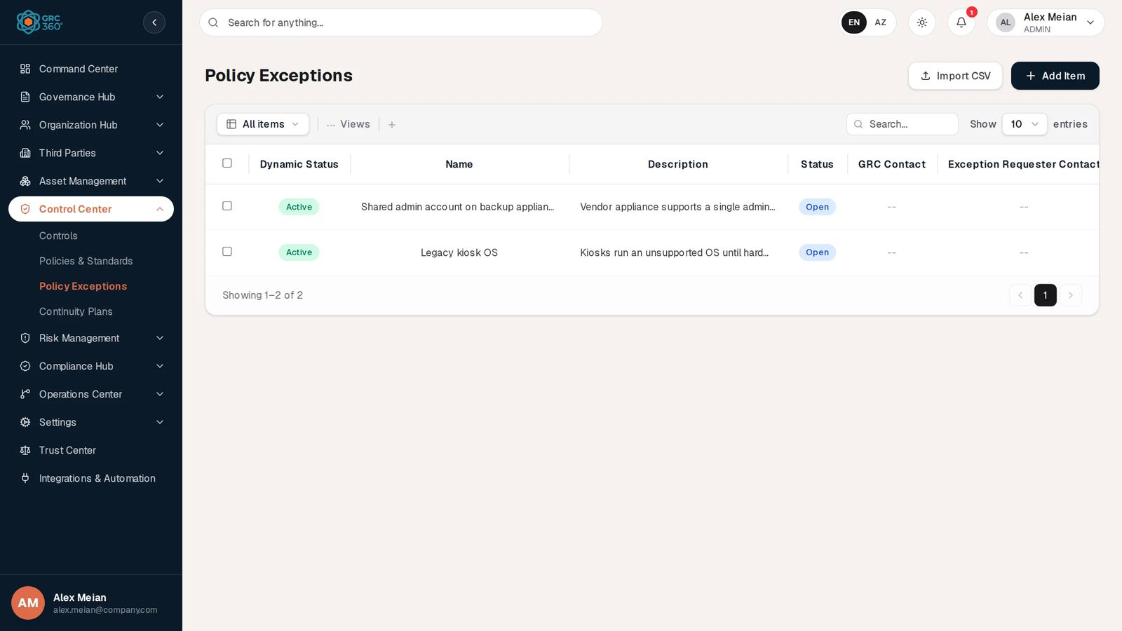
Policy Exceptions register

At a glance
A record is | One time-limited exception to one or more policies
Typical owner | GRC Contact
Links to | Policies & Standards (Related Policies)
Linked from | Nothing
Tabs | None
Automations | Computed Dynamic Status; Start Date and Closure Date stamped by the server
The page key is exceptions for historical reasons; only the label reads “Policy Exceptions”. Risk exceptions and compliance exceptions are separate registers in Risk Management and the Compliance Hub.

The register (list view)
The grid lists every exception of the organisation, newest first (the list is loaded whole, not page by page from the server). The shared grid behaviour is described in Working with registers.
Column | What it shows | Source
Dynamic Status | Active, Pending, Expired or Closed (see Statuses) | Computed by the system
Name | Short title of the exception | Entered
Description | Why the exception is needed | Entered
Status | Open or Closed | Entered
GRC Contact | Owner names, with avatar | Entered
Exception Requester Contact | Requester names, with avatar | Entered
Start Date | Day the exception was recorded | Set by the server
Expiration Date | Last day the exception is meant to apply | Entered
Closure Date | Day it was closed | Set by the server
Related Policies | Names of the policies it deviates from | Linked (chosen on this form)

Creating a record
Click Add Item. The dialog Add Policy Exception (subtitle Control Center) opens.
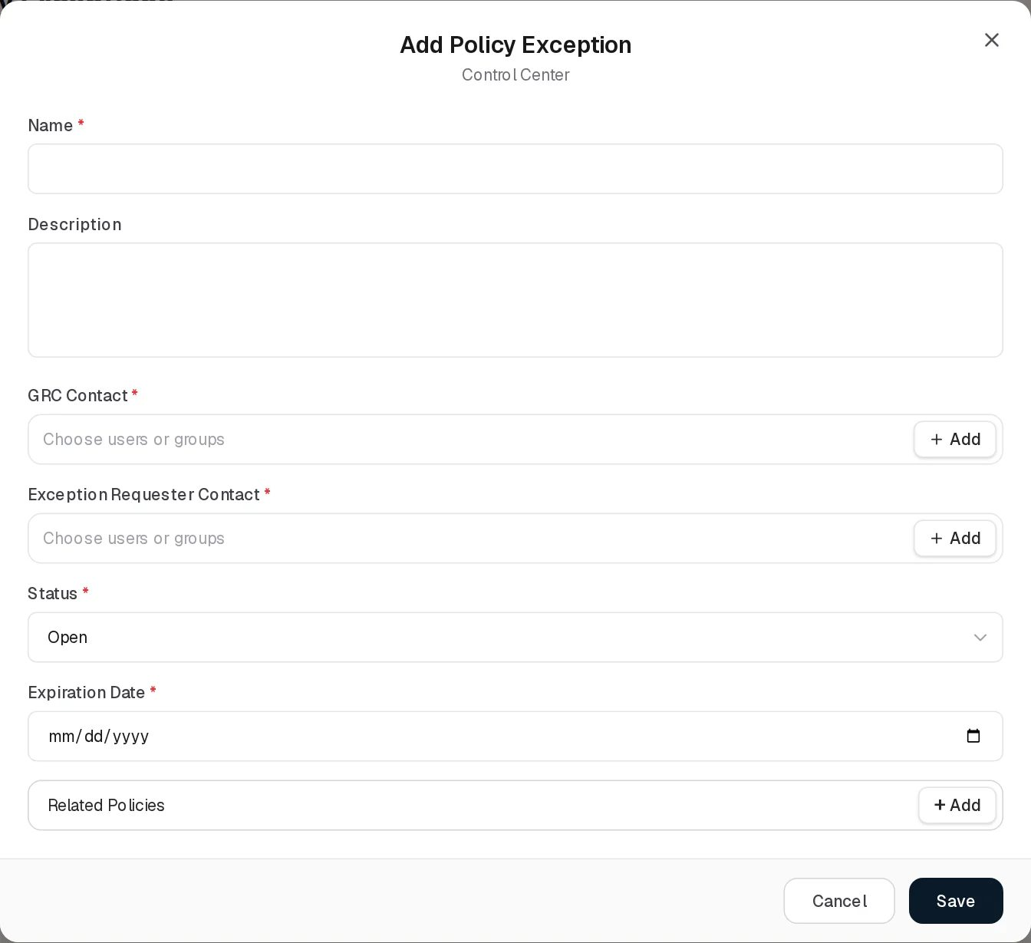
Add Policy Exception
Field | Type | Required | Rules and allowed values | Example
Name | Text | Yes | “Required”. Max 255 characters. Must be unique in the organisation when created (“Control Exception with this name already exists”). | Shared admin account on backup appliance
Description | Long text | No |  | Vendor appliance supports a single admin login.
GRC Contact | Users or groups, several allowed, + Add | Yes | “Required” | Alex Meian
Exception Requester Contact | Users or groups, several allowed, + Add | Yes | “Required” | Mike Brown
Status | Drop-down | Yes (always has a value) | Open (default), Closed | Open
Expiration Date | Date | Yes | “Required” | 2026-11-28
Related Policies | Picker of Policies & Standards, + Add | No | Empty hint “No policies or standards defined yet.” Every chosen policy must exist, otherwise the save is refused. | Access Control Policy
Start Date is not on the form. The server sets it to the day the exception is created and keeps it on later edits. Closure Date is also not on the form: it is set to the day the status is changed to Closed, and cleared again if the exception is reopened.
On save the message “Exception added.” (or “Exception updated.”) appears; errors are shown in a red banner above the grid.

Viewing and editing a record
The eye button opens View Policy Exception with Name, Description, GRC Contact, Exception Requester, Start Date, Expiration Date, Closure Date, Related Policies and Status.
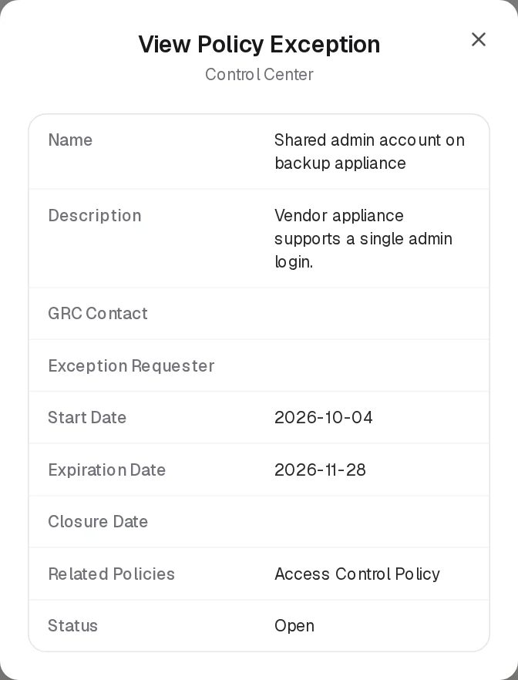
View Policy Exception
Edit opens Edit Policy Exception, the same form. Delete asks “Delete exception name?”.
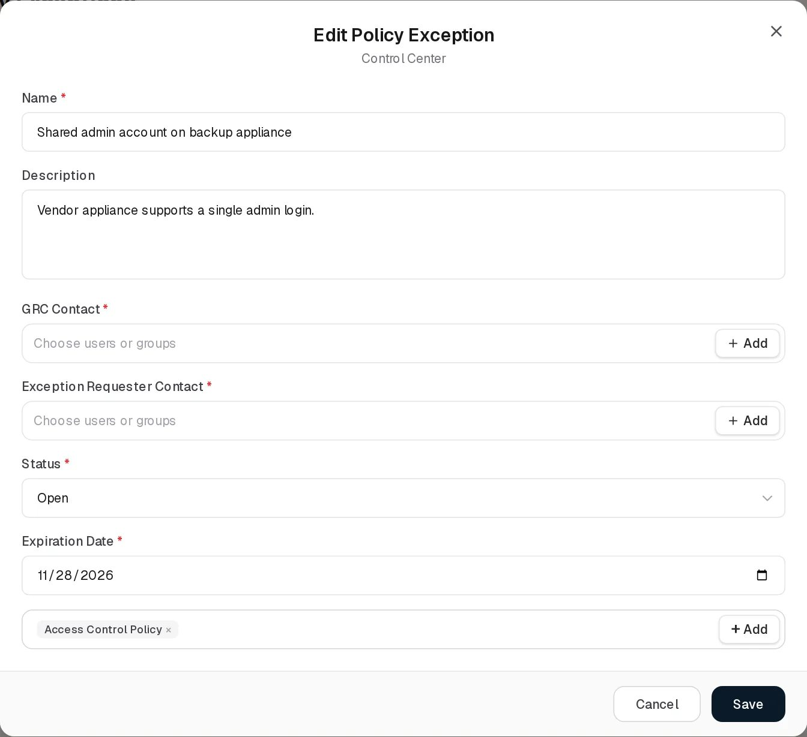
Edit Policy Exception

Statuses
Status (chosen on the form)
Value | Set by | Meaning
Open | User | The exception is in force (or awaiting closure). Default. Shown blue.
Closed | User | The exception has ended. Sets Closure Date. Shown green.
Dynamic Status (computed on every read; “expired” means the Expiration Date is before today)
Value | Colour | Rule
Closed | Green | A Closure Date is set (always the case when Status is Closed).
Expired | Red | Status is Open and the exception has expired.
Pending | Amber | Status is Open and the exception has not expired. This is what every exception created on this screen shows while it is in force.
Active | Green | Only for records stored with status Approved (possible through the API or older data, not from this form) that have not expired.
The two demo exceptions were created with status Approved, so they show Active while their Status column reads Open (see known issues).

Relationships
Related record | Direction | How the link is made | Where it shows
Policies & Standards | Exception → many policies | Related Policies on this form | Related Policies column and View. The policy itself does not show its exceptions.

Automations and notifications
- Dynamic Status is computed on read: an open exception shows Expired from the day after its Expiration Date, with no job involved.
- The server stamps Start Date on creation and Closure Date on closing.
- No scheduled job changes policy exceptions, and no reminder or notification is sent before or after expiry. The exception keeps its Open status until someone closes it.

Permissions
Action | Needed access
See the page | View on Control Center › Policy Exceptions
Add or edit an exception | Manage on Policy Exceptions
Delete an exception | Full Control on Policy Exceptions
Comment and attach in the Activity Log | The group’s Comments & Attachments level
Policy Exceptions is not a visibility register: everyone who can open the page sees every exception. The people fields are not subject to Can Assign / Can Reassign.

How to

Record a new exception
- Click Add Item.
- Enter Name “Legacy kiosk OS” and a Description.
- Choose GRC Contact and Exception Requester Contact, set Expiration Date, and pick Access Control Policy in Related Policies.
- Click Save. Start Date shows today, Dynamic Status Pending.

Close an exception
- Click Edit on the exception, set Status to Closed and click Save.
- Closure Date shows today and Dynamic Status turns Closed.

Find exceptions that have run out
- In the grid, look for Dynamic Status Expired (red), or sort by Expiration Date.
- Either close each one or extend its Expiration Date.

CSV import
Not available. Import CSV shows “CSV Import (Policy Exceptions): the import structure is not ready yet.” and then opens a demonstration dialog whose validation fails. The backend import endpoint /control/exceptions/import-csv is not used by any screen. See CSV import and export.

Limitations and known issues
- Open exceptions read “Pending”, not “Active”. An exception created on this screen can only be Open or Closed, and Open maps to Dynamic Status Pending while in force. Active appears only for records stored as Approved.
- Saving changes Approved to Open. The form shows any status other than Closed as Open. Editing and saving an Approved record (such as the two demo exceptions) stores it as Open, and its Dynamic Status changes from Active to Pending.
- Name uniqueness is checked only when creating. Renaming an exception to an existing name is accepted.
- GRC Contact and Exception Requester are stored as names. The demo exceptions carry no names, so both columns show “–” and the View shows empty values.
- No expiry handling. Expired exceptions are only flagged by Dynamic Status; nothing closes them or notifies anyone.

Continuity Plans
Module: Control Center › Continuity Plans · Route: /control-center/continuity-recovery · Permission key: control_center.continuity_recovery
The Continuity Plans register holds the organisation’s business continuity and recovery plans: what is to be achieved when a disruption happens, who owns, sponsors and may launch the plan, what it costs, and how it is tested. Each plan has a list of step-by-step Tasks (who does what, when, where and how) and a series of Audits that test it, planned from the plan’s own audit schedule. Business continuity managers maintain the plans; the people named in tasks are notified of their role.
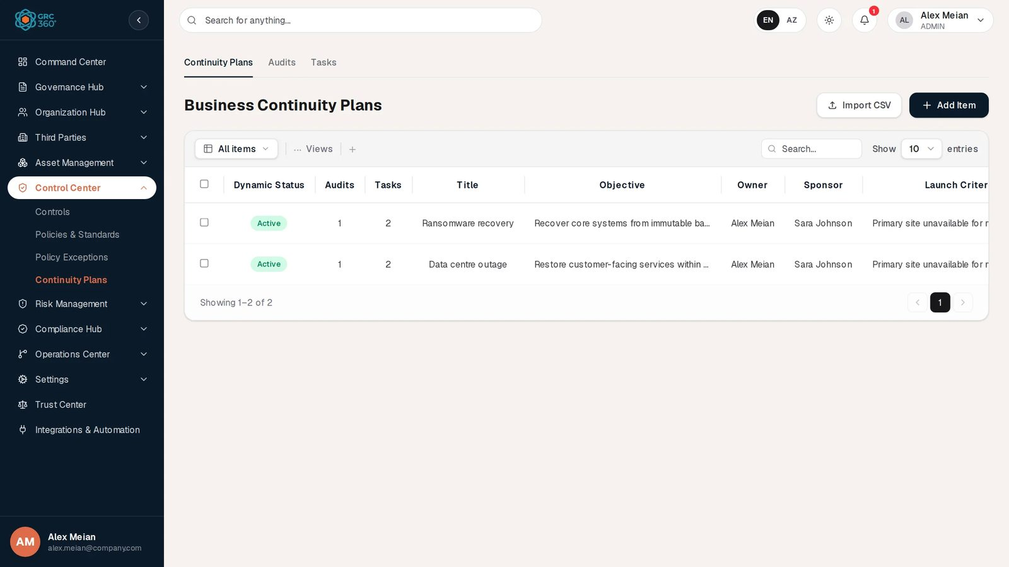
Business Continuity Plans register

At a glance
A record is | One business continuity or recovery plan
Typical owner | Owner (with a Sponsor and a Launch Initiator)
Links to | Nothing (its tasks and audits belong to it)
Linked from | Business Risks (Mitigating Business Continuity Plans)
Tabs | Audits, Tasks
Automations | Computed Dynamic Status; audits generated from the audit schedule on save; in-app notification to people named in a task’s Awareness Role
The page key is continuity_recovery for historical reasons; the sidebar says “Continuity Plans” and the grid “Business Continuity Plans”. The active tab is kept in the address (?tab=plans, ?tab=audits, ?tab=tasks), so a tab can be bookmarked or linked.

The register (list view)
The Continuity Plans tab lists every plan, newest first (loaded whole, not page by page). The shared grid behaviour is described in Working with registers.
Column | What it shows | Source
Dynamic Status | Active, Audit Overdue, Expired or Inactive (see Statuses) | Computed by the system
Audits | Number of audits of the plan | Computed
Tasks | Number of tasks of the plan | Computed
Title | Plan name | Entered
Objective | What the plan must achieve | Entered
Owner | Who is responsible for the plan | Entered
Sponsor | Who keeps the plan realistic, communicated and applicable | Entered
Launch Criteria | When the plan is to be launched | Entered
Launch Initiator | Who may launch the plan or declare that it is needed | Entered
Cost (OPEX) | Running cost, free text | Entered
Cost (CAPEX) | Investment cost, free text | Entered
Resource Utilization | Resources the plan uses | Entered
Audit Methodology | How the plan’s audits are run | Entered
Audit Success Metric Criteria | Threshold that decides whether an audit passes | Entered, and updated from audits (see below)
The plan’s Status (Design / Production) is on the form only; it has no column.

Creating a record
Click Add Item. The dialog Add Item (subtitle Business Continuity Plans) opens.
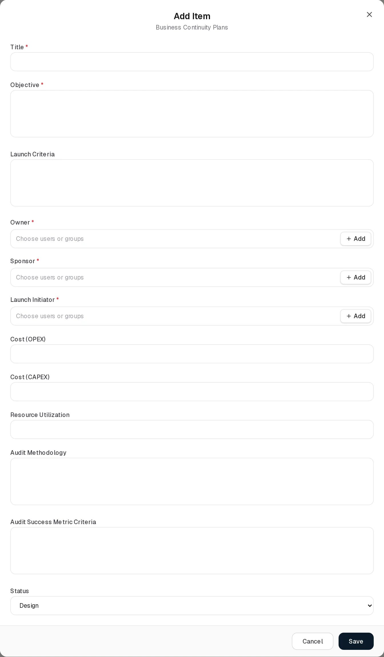
Add Continuity Plan
Field | Type | Required | Rules and allowed values | Example
Title | Text | Yes | “Title is required.” Max 200 characters. Must be unique in the organisation (“Continuity Plan with this name already exists”). | Ransomware recovery
Objective | Long text | Yes | “Objective is required.” | Recover core systems from immutable backups within 24 hours.
Launch Criteria | Long text | No |  | Primary site unavailable for more than 30 minutes
Owner | Users or groups, several allowed, + Add | Yes | “Owner is required.” | Alex Meian
Sponsor | Users or groups, several allowed, + Add | Yes | “Sponsor is required.” | Sara Johnson
Launch Initiator | Users or groups, several allowed, + Add | Yes | “Launch Initiator is required.” | Alex Meian
Cost (OPEX) | Text | No | Max 100 characters | 12000
Cost (CAPEX) | Text | No | Max 100 characters | 40000
Resource Utilization | Text | No
Audit Methodology | Long text | No |  | Tabletop exercise and failover test
Audit Success Metric Criteria | Long text | No | Pre-fills new audits; also updated by audits (see Audits). | RTO met
Status | Drop-down | No | Design (default), Production | Production
Audits section | Schedule | Shown only when Status is Production | Audit Dates *: No audits required (default) / Audits required. When required, a box Audit with Occurrence type Specific (date list, Add new +, × to remove) or Periodical (First audit date, Frequency: values WEEKLY, MONTHLY, QUARTERLY, TWICE_A_YEAR, YEARLY). | Audits required, Periodical, 2026-11-03, TWICE_A_YEAR
Audit Owners | Users or groups (in the Audits section) | No | Names copied onto every generated audit as Audit Owner.
Owner, Sponsor and Launch Initiator are mandatory. This was introduced in the latest release: the form refuses to save without all three. The rule is applied by the form only; plans created earlier, or through the API, may lack them, and must be completed the next time they are edited.
The audit schedule follows the rules in Audit and maintenance scheduling: a Specific date gives that date and the same day a year later; a Periodical schedule gives dates from the first audit date up to one year after it; past dates are skipped. A plan in Design is not audited: the section is hidden, and switching a plan back to Design withdraws its generated audits that have no result yet.

Viewing and editing a record
The eye button opens View item with every grid column.
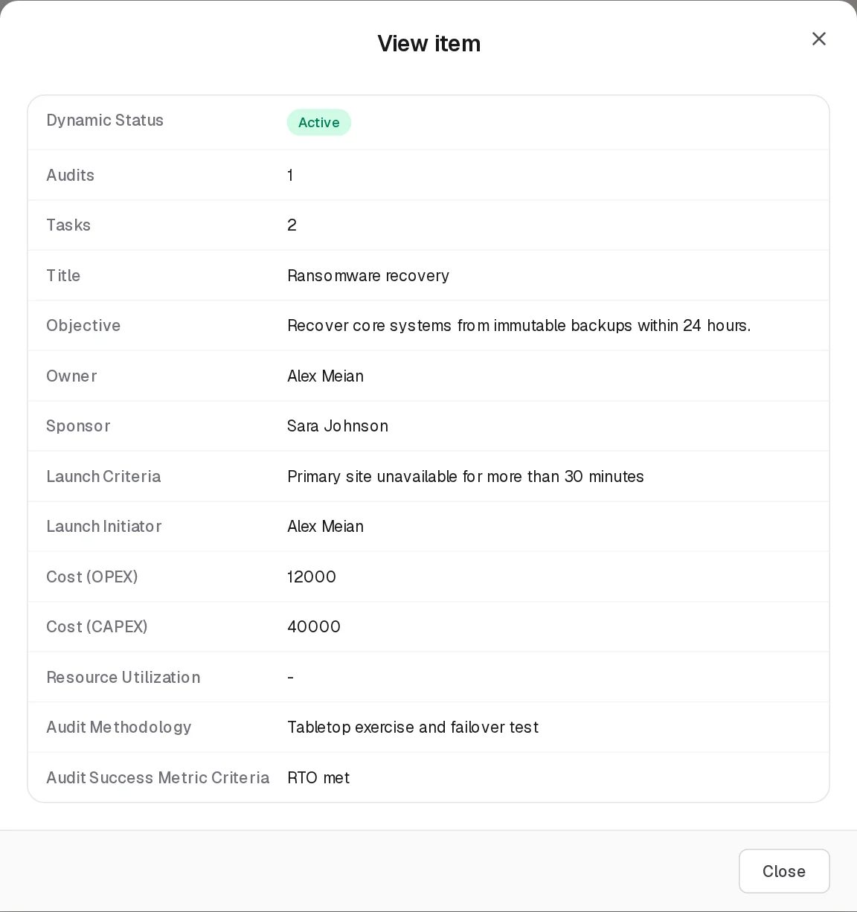
View Continuity Plan
Edit opens Edit Item, the same form. Saving re-runs the audit schedule.
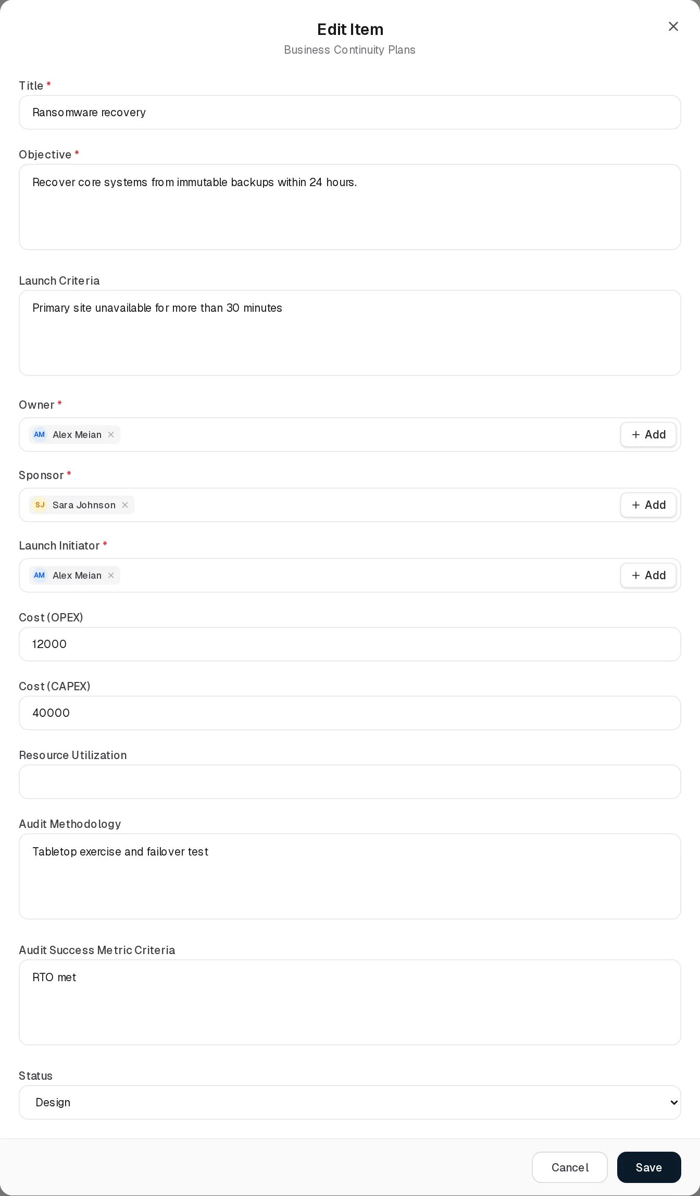
Edit Continuity Plan
Deleting a plan deletes its audits and tasks.

Statuses
Status (chosen on the form)
Value | Set by | Meaning
Design | User | The plan is being written. Not in force and not audited. Default.
Production | User | The plan is live; the audit schedule applies.
Dynamic Status of a plan (computed on every read, in this order)
Value | Colour | Rule
Inactive | Grey | Status is Design (or Draft, Archived, Inactive on older or imported records).
Expired | Red | The plan’s review date is before today. The review date is not on the form; it exists only on records created through the API or import (the demo plans have 2027-01-12).
Audit Overdue | Red | Any of the plan’s audits has Dynamic Status Overdue.
Active | Green | Everything else.
Plan audit (Audits tab)
Field | Values
Status | Planned, In Progress, Completed. Not on the form: on save it becomes Completed if Audit End Date is set, In Progress if only Audit Start Date is set, otherwise Planned.
Dynamic Status | If Completed: Fail when Audit Result contains “fail”, Pass when it contains “pass”, otherwise In Progress. If not completed: Overdue when Planned Date or Audit End Date is before today; otherwise In Progress.
Plan task (Tasks tab)
Field | Values
Status | Pending (default), In Progress, Completed. There is no Dynamic Status for tasks.

Tabs

Audits
Continuity Plan Audits
Grid Continuity Plan Audits, all audits of all plans. Columns: Dynamic Status, Business Continuity Plan, Audit Metric, Audit Success Metric Criteria, Planned Date, Audit Start Date, Audit End Date, Audit Result, Audit Conclusion, Evidence (download links or “No evidence”), Audit Owner, Status.
Add Item opens Add Item (Business Continuity Plan Audits):
Add Continuity Plan Audit
Field | Type | Required | Rules and allowed values | Example
Business Continuity Plan | Drop-down | Yes | Pre-filled with the first plan; placeholder “Select a plan…”; “Business Continuity Plan is required.” If none exist: “Create a continuity plan first — audits are recorded against an existing plan.” | Ransomware recovery
Audit Metric | Long text | Yes | “Required.” What the audit measures. | Failover time
Audit Success Metric Criteria | Long text | No | Pre-filled from the plan (see below). | Under 4 hours
Audit Result | Drop-down | No | Choose one…, Passed, Failed (fixed list; a different stored value is added to the list)
Audit Conclusion | Long text | No
Audit Owner | Users or groups | No |  | Alex Meian
Audit Evidence Owner | Users or groups | No
Planned Date | Date | No |  | 2026-11-03
Audit Start Date | Date | No | Setting it makes the audit In Progress.
Audit End Date | Date | No | Setting it makes the audit Completed.
Evidence | File upload | No | As on control audits: one file at a time, max 25 MB, “uploads on save” on a new audit. See Controls › Evidence.
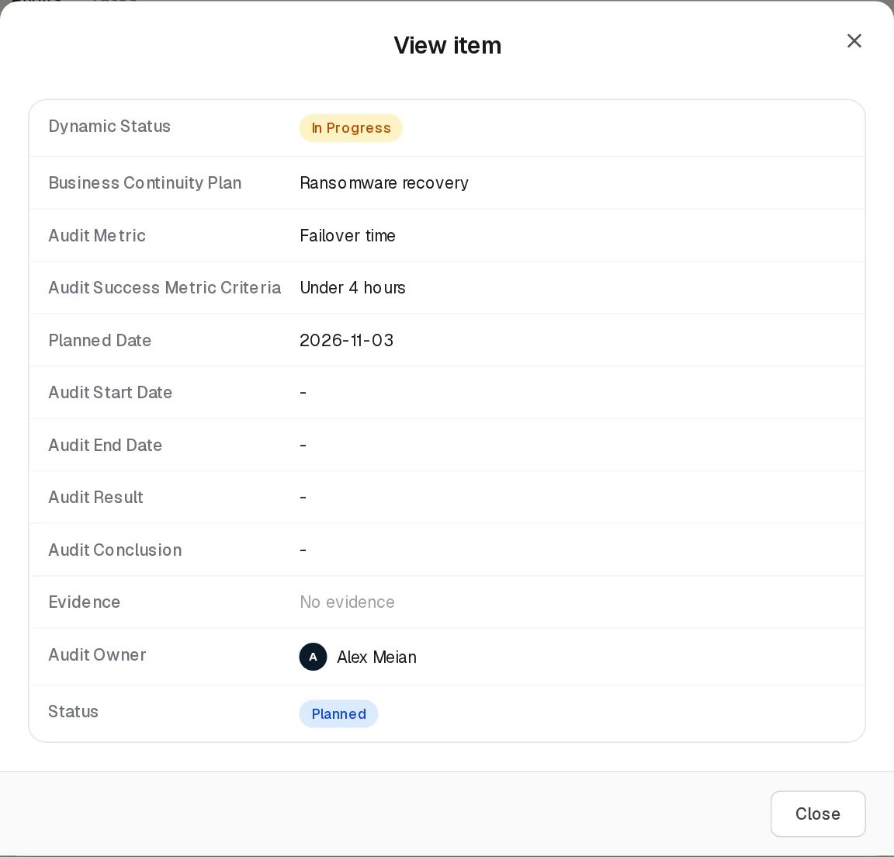
View Continuity Plan Audit
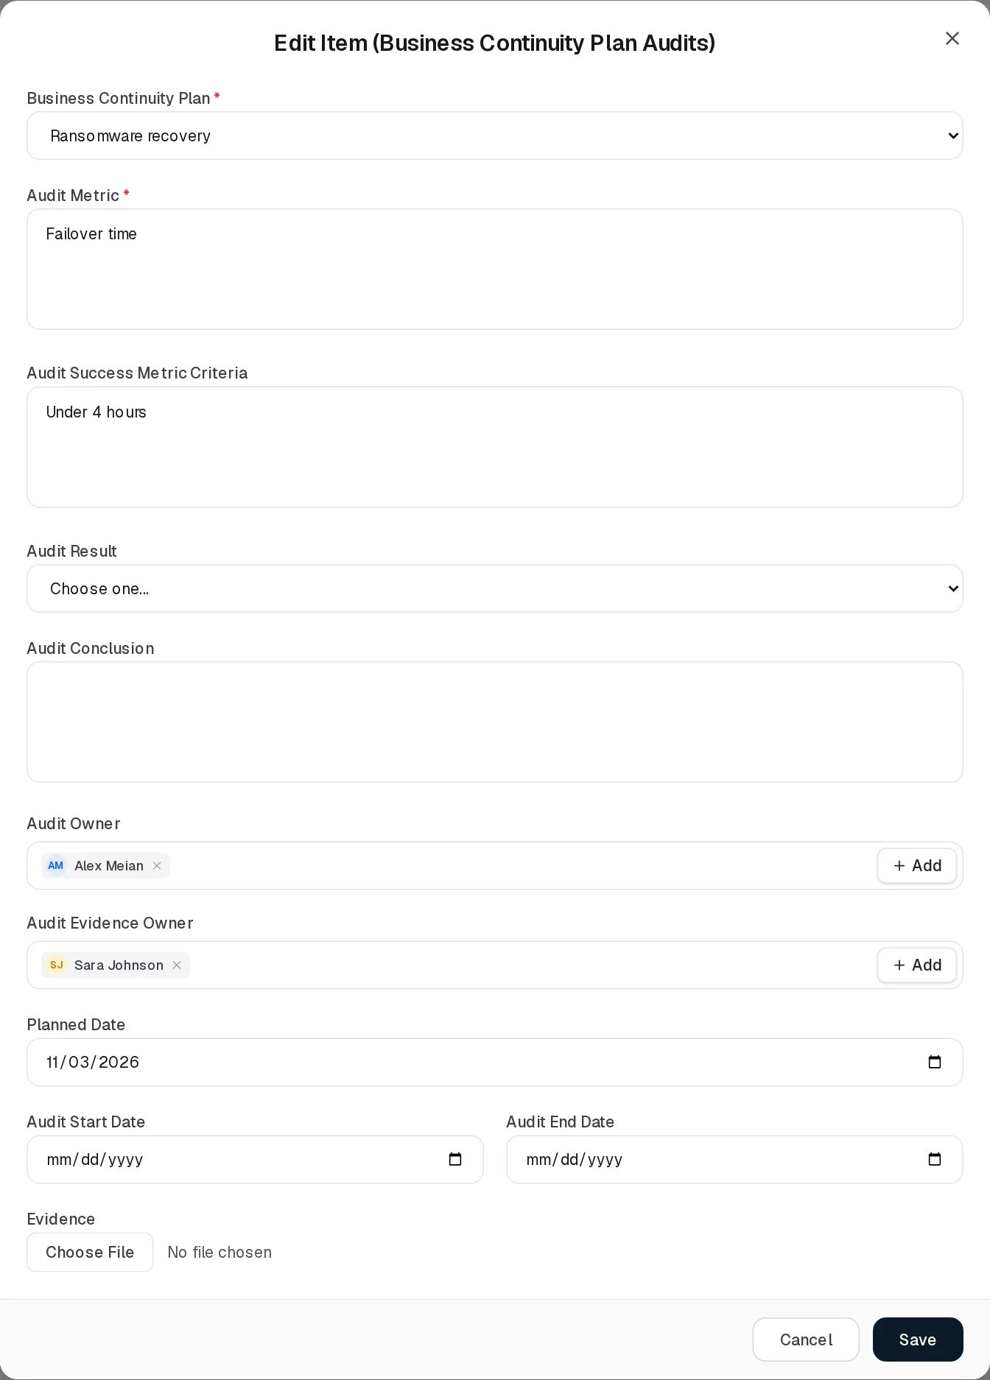
Edit Continuity Plan Audit
Metric Success Criteria behaviour. The plan’s Audit Success Metric Criteria and the audits’ Audit Success Metric Criteria are kept as one value:
- A new audit opens with the selected plan’s criteria filled in. Choosing another plan in the form replaces the text with that plan’s criteria.
- An existing audit opens with its own criteria.
- When an audit is saved with criteria that are not blank and differ from the plan’s, the text is written back to the plan’s Audit Success Metric Criteria. On an edit this happens only if the audit’s own criteria were changed, so re-saving an older audit for another reason does not roll the plan back. Blank criteria never overwrite the plan.
- Writing back is an edit of the plan, so it needs Manage on Continuity Plans in addition to the audit rights.
- Audits generated by the schedule leave both Audit Metric and Audit Success Metric Criteria empty, for the auditor to fill in.

Tasks
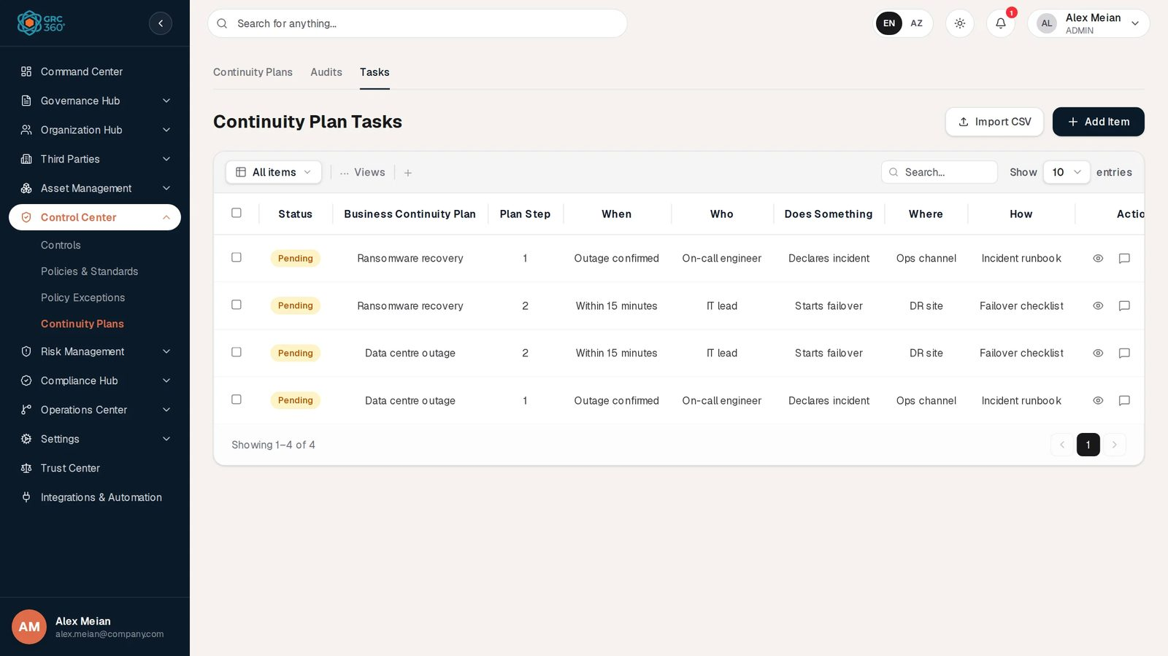
Continuity Plan Tasks
Grid Continuity Plan Tasks: Status, Business Continuity Plan, Plan Step, When, Who, Does Something, Where, How.
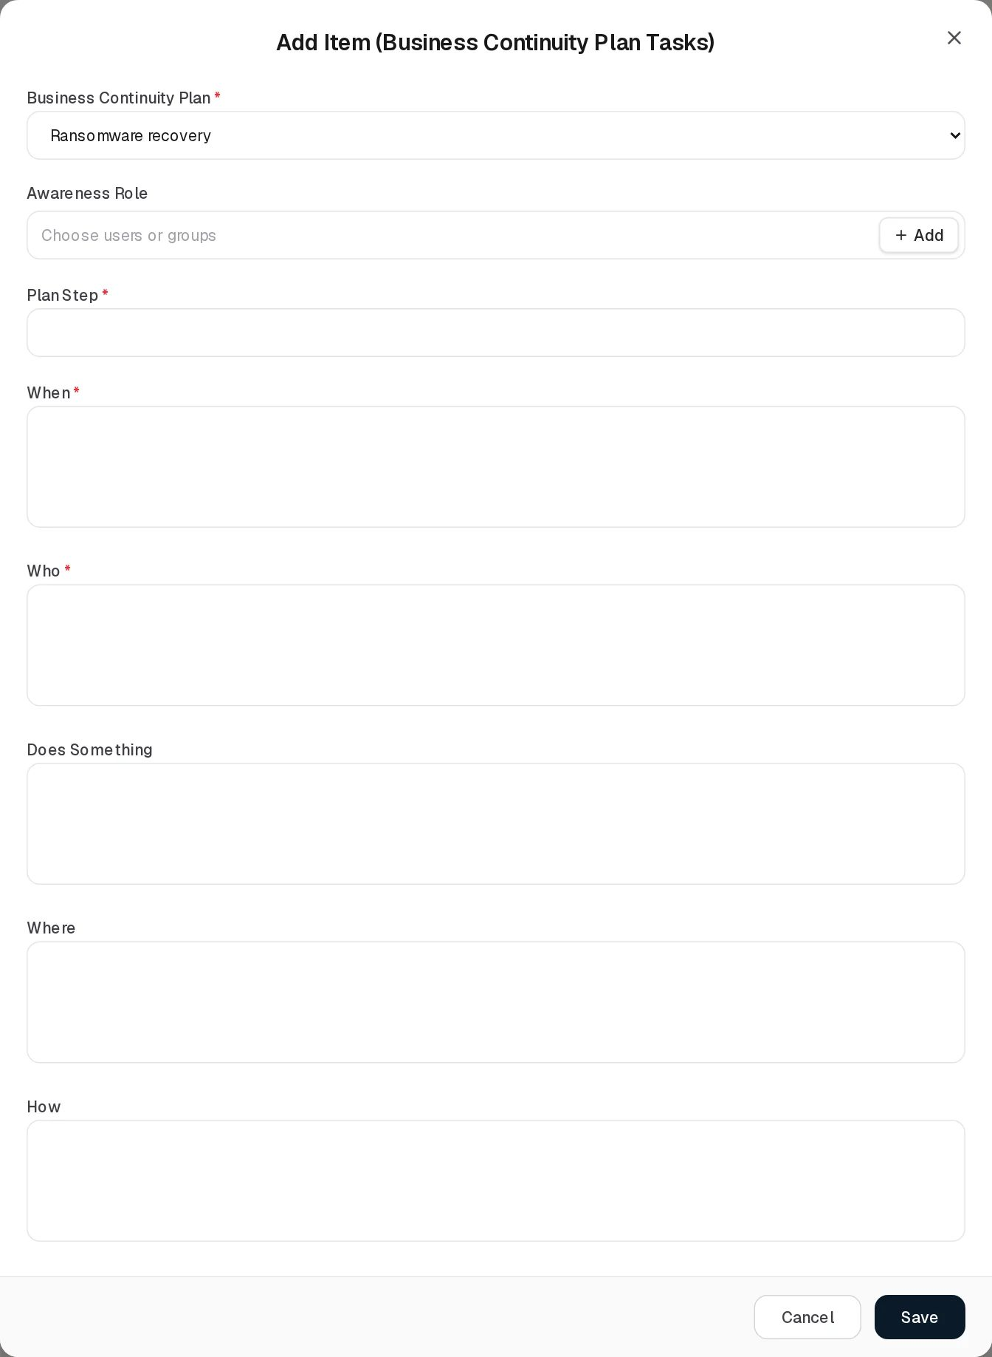
Add Continuity Plan Task
Field | Type | Required | Rules and allowed values | Example
Business Continuity Plan | Drop-down | Yes | “Business Continuity Plan is required.” | Ransomware recovery
Awareness Role | Users or groups | No | People and groups to be told about their responsibility; they receive an in-app notification (below).
Plan Step | Text | Yes | “Required.” Read as a whole number: leading digits are kept (“3a” becomes 3) and text that does not start with a digit is saved as 0. | 1
When | Long text | Yes | “Required.” | Outage confirmed
Who | Long text | Yes | “Required.” | On-call engineer
Does Something | Long text | No | Also used as the notification text. | Declares incident
Where | Long text | No |  | Ops channel
How | Long text | No |  | Incident runbook
The Save button stays locked while the task is being saved; a failure is shown at the top of the dialog (“The task could not be saved.” if the server gives no reason). On success “Task added.” or “Task updated.” appears.
View Continuity Plan Task
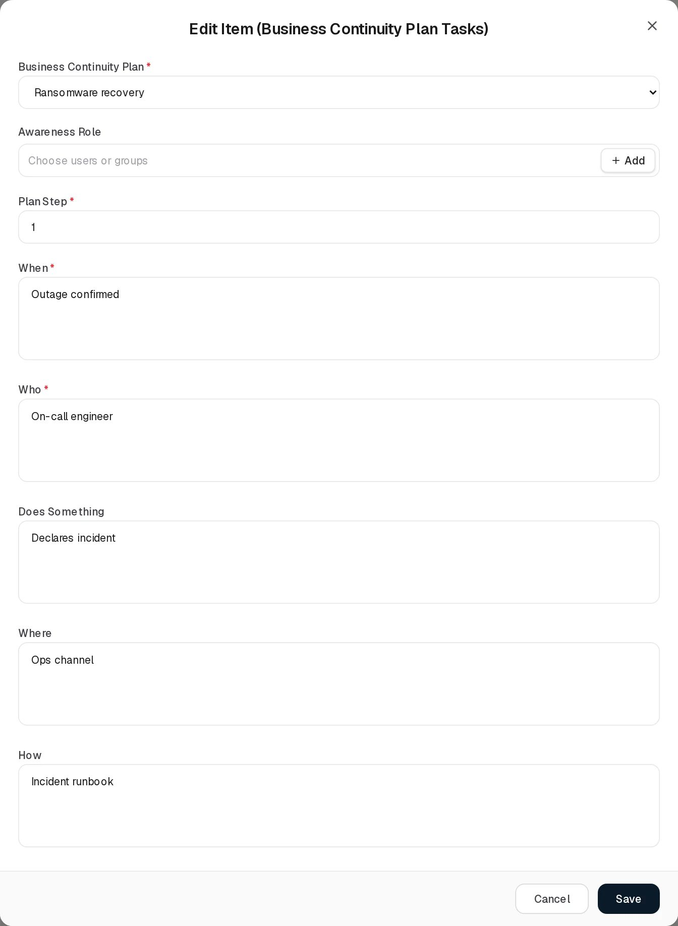
Edit Continuity Plan Task

Relationships
Related record | Direction | How the link is made | Where it shows
Audits | One plan → many | Audits tab, or generated from the schedule | Audits count (not clickable), Audits tab
Tasks | One plan → many | Tasks tab | Tasks count (not clickable), Tasks tab
Business Risks | Many risks → many plans | Mitigating Business Continuity Plans on the business risk | Business Risks page only
Controls | Control → many plans | Stored on the control; no screen sets it | Not shown

Automations and notifications
- Dynamic Status of plans and audits is computed on read; an audit becomes Overdue, and its plan Audit Overdue, the day after the planned date passes.
- Audit generation from the schedule runs each time the plan is saved, including when an audit or task is deleted from the tabs (deletes are saves of the plan).
- Task assignment notification. When a task is added or edited on the Tasks tab and its Awareness Role names people or groups who were not named before, each of them (a group is expanded to its current members) receives an in-app notification of type TASK_ASSIGNED:
  - title “You are named in a continuity plan task”;
  - text “Step n of”plan title”: Does Something” (or “a step you are responsible for” when Does Something is empty);
  - action Open the task, which opens this page on the Tasks tab and shows the task in the read-only dialog View Item (Business Continuity Plan Tasks). Editing a task without adding anyone sends nothing again. This is the only notification produced by the Control Center.
- No reminders are sent for upcoming or overdue plan audits.

Permissions
Action | Needed access
See the page | View on Control Center › Continuity Plans
Add or edit a plan | Manage on Continuity Plans
Delete a plan | Full Control on Continuity Plans
Open the Audits tab | View on Continuity Plans › Audits
Add or edit an audit | Manage on Audits; recording Audit Result / Audit Conclusion needs the Audit Results right (included in Manage); changing the criteria so that the plan is updated also needs Manage on Continuity Plans
Delete an audit | The button needs Full Control on Audits; the delete is saved as an edit of the plan, so Manage on Continuity Plans is also needed
Open the Tasks tab | View on Continuity Plans › Tasks
Add or edit a task | Manage on Tasks
Delete a task | The button needs Full Control on Tasks; saved as an edit of the plan (Manage on Continuity Plans)
Upload or delete audit evidence | Manage / Full Control on any Control Center page (checked at module level)
Comment and attach in the Activity Log | The group’s Comments & Attachments level
Continuity Plans is not a visibility register: everyone who can open the page sees every plan. The people fields are not subject to Can Assign / Can Reassign.

How to

Create a plan and schedule its tests
- Click Add Item. Enter Title “Ransomware recovery” and the Objective.
- Choose Owner, Sponsor and Launch Initiator (all three are required).
- Fill Launch Criteria, costs, Audit Methodology and Audit Success Metric Criteria “RTO met”.
- Set Status to Production. The Audits section appears.
- Select Audits required, Periodical, First audit date and Frequency TWICE_A_YEAR; pick Audit Owners. Click Save. The Audits tab shows three audits, six months apart.

Record a recovery test
- Open the Audits tab and click Edit on the Ransomware recovery audit planned for 2026-11-03.
- Check Audit Metric (“Failover time”) and Audit Success Metric Criteria (“Under 4 hours”).
- Fill Audit Start Date and Audit End Date, choose Audit Result Passed, write the Audit Conclusion and attach the test report under Evidence.
- Click Save. The audit’s Status becomes Completed and its Dynamic Status Pass.

Add a task and notify the people responsible
- Open the Tasks tab and click Add Item.
- Choose the plan, pick a group in Awareness Role, enter Plan Step “3”, When, Who and Does Something “Restores database from backup”.
- Click Save. Every member of the group receives “You are named in a continuity plan task” in the notification bell.

Change the success criteria for future tests
- Edit any audit of the plan and change Audit Success Metric Criteria, or edit the plan itself.
- After saving, the plan’s Audit Success Metric Criteria column shows the new text, and new audits added from the Audits tab start with it.

CSV import
Not available. Import CSV on the three grids shows “CSV Import (title): the import structure is not ready yet.” and then opens a demonstration dialog whose validation fails. The backend import endpoint /control/continuity-plans/import-csv is not used by any screen. See CSV import and export.

Limitations and known issues
- Frequency shows raw codes. The Frequency drop-down of the plan’s audit schedule lists WEEKLY, MONTHLY, QUARTERLY, TWICE_A_YEAR and YEARLY instead of readable labels (the control form shows “Twice a Year” and so on).
- Plans with an older status open as “Design”. The demo plans are stored with status “ACTIVE”, which is not one of the two form options. Their Edit form shows Design and hides the audit schedule, and saving keeps the old value. Because the schedule only applies to Production plans, such a save withdraws generated audits that have no result. Set Status to Production explicitly when editing these plans.
- Task Status cannot be changed. The task form has no Status field, so every task stays Pending.
- Expired depends on a hidden field. Dynamic Status Expired uses the plan’s review date, which no screen shows or edits.
- Audit Result list is fixed. The organisation’s continuity audit result list exists on the server but has no Settings button; the form always offers Passed and Failed.
- Deleted generated audits come back. Deleting a generated audit whose date is still in the schedule and has no result re-creates it on the same save.
- Moving a task or audit to another plan is refused by the server, although the plan drop-down is editable on Edit.
- Mandatory people are not enforced by the server. Owner, Sponsor and Launch Initiator are checked by the form only.

Risk Management
Module: Risk Management · Route: /risk-management/... · Permission module key: risk_management
Risk Management holds the organisation’s risk registers. Each register records risks of one kind, analyses them on a likelihood and an impact scale, scores them, records how they are treated, and compares the result with the organisation’s risk appetite. Risk Exceptions record the formal acceptance of a risk for a limited time.
This page explains what the module contains and, in detail, how a risk is scored. The individual pages are described in their own chapters.

Pages in this module
Page (sidebar label) | Route | Permission key | Tabs | What a record is
Asset Risks | /risk-management/asset-risks | risk_management.asset_risks | Reviews (asset_risks_reviews) | A risk to one or more assets
Third Party Risks | /risk-management/third-party-risks | risk_management.third_party_risks | Reviews (third_party_risks_reviews) | A risk that comes from a vendor, supplier or partner
Business Risks | /risk-management/operational-risks | risk_management.operational_risks | Reviews (operational_risks_reviews) | A risk to a department’s operations
Risk Exceptions | /risk-management/risk-exceptions | risk_management.risk_exceptions | None | A time-limited acceptance of one or more risks
Business Risks is the label the user sees. The route, the permission key and the API still use the older name operational risks (operational_risks). Both names refer to the same register.
The three risk registers share one form layout (general fields, Analysis, Treatment), one scoring model, one Dynamic Status rule set, one Reviews tab design and one Settings panel. These shared parts are described once on this page.

The risk scoring model
A risk gets two scores:
- Inherent Risk Score: the risk before treatment, from the Likelihood (Analysis) and Impact (Analysis) chosen on the form.
- Residual Risk Score: the risk after treatment.
Both scores are calculated by the server when the risk is saved and stored with it. They are not recalculated when the settings change: after you change a calculation method, a classification value or a matrix cell score, each risk keeps its old score until it is edited and saved again.

Classification types and classifications
Likelihood and impact are classification types. Each type has classifications: named levels with a numeric Value. Every new tenant starts with:
Classification type | Classifications (Value)
Likelihood | Rare (1), Unlikely (2), Possible (3), Likely (4), Almost certain (5)
Impact | Negligible (1), Minor (2), Moderate (3), Major (4), Critical (5)
Only the Value takes part in the arithmetic. The name is what you pick on the form and what the register shows, for example as the tags Likelihood (Likely) and Impact (Major) in the Inherent Risk Classification column.
The Likelihood and Impact pickers on the risk forms list the classifications of the two types whose internal code is LIKELIHOOD and IMPACT (the two types every tenant starts with). A type you add yourself appears in Settings but its values are not offered on the risk forms.

Calculation methods
The calculation method turns the two values into the inherent score. The Calculation Methods tab of Settings offers three methods:
Method | Formula used today | Example: Likely (4), Major (4)
Single Matrix - Addition | likelihood + impact | 4 + 4 = 8
Single Matrix - Multiplication | likelihood × impact | 4 × 4 = 16
Multiple Matrices - Multiplication | likelihood × impact (a risk holds one impact, so it gives the same result as Multiplication) | 4 × 4 = 16
If none of the three methods is enabled, the server multiplies. A new tenant is seeded with a fourth method row, code THRESHOLD, named Threshold Matrix Method, enabled. It is not one of the three tabs and has no formula of its own, so while it is the enabled method risks are scored by multiplication. This is the state of the demo data: every demo score is likelihood × impact.
The classification types you select under Settings for a method are stored but not read by the scoring; every method always uses the risk’s one likelihood and one impact.

Matrix cell scores
A cell of the likelihood × impact matrix (Settings › Risk Appetite › Threshold) can carry its own Score. When the cell for a risk’s pair has a score greater than 0, that score is used instead of the method’s formula. A cell saved without a score stores 0 and does not affect scoring.
Example: you give the cell Likely × Major the score 18. The next time “Unpatched internet-facing server” (Likely, Major) is saved, its inherent score becomes 18 instead of 16.

Manual score override
The API accepts a manualScoreOverride and an overrideReason on every risk. When an override is set, it becomes the inherent score whatever the likelihood and impact are. The Add and Edit forms do not have these fields, so an override can only be set through the API, and it is shown only in the Manual Override section of the linked-risk panel that other registers open (see Asset Risks).
Because the form does not send the override, saving the risk from its Edit form clears an override that was set through the API, and the score falls back to the formula.

Residual score
Register | How the residual score is calculated
Asset Risks, Third Party Risks | Residual Percentage Coefficient (0, 10, 20 … 100) is the percentage of the inherent score that remains after treatment. Residual = inherent × coefficient / 100. With no coefficient, residual = inherent.
Business Risks | When both Likelihood (Treatment) and Impact (Treatment) are chosen, the residual score is calculated from that pair exactly like the inherent score (matrix cell score first, then the method formula; the manual override does not apply). If either is empty, residual = inherent.
Worked examples:
Risk | Inherent | Treatment input | Residual
Unpatched internet-facing server (Likely 4, Major 4) | 4 × 4 = 16 | Coefficient 30 | 16 × 30 / 100 = 4.8
Same risk | 16 | Coefficient 0 | 0
Same risk | 16 | Coefficient empty or 100 | 16
Manual payroll errors (Likely 4, Moderate 3) | 4 × 3 = 12 | Likelihood (Treatment) Unlikely 2, Impact (Treatment) Minor 2 | 2 × 2 = 4
Same risk | 12 | Only Likelihood (Treatment) chosen | 12
For Business Risks nothing stops the treatment pair from scoring higher than the inherent pair.

Risk appetite
The appetite is set in Settings › Risk Appetite, which has two methods. Exactly one is in use; it is recorded on the tenant’s appetite setting.
Method | What you configure | What it affects
Threshold (in use by default) | A label, description and colour for each likelihood × impact cell, and a Default Threshold for cells without their own | The coloured chips in the Inherent Risk Score and Residual Risk Score columns
Numerical | One number | Nothing visible on the score columns: no chips are shown while Numerical is in use
The Above Appetite flag always compares the residual score with the Numerical number, whichever method is in use. A new tenant’s number is 50. With the default 1 to 5 scales and multiplication the highest possible score is 25, so no risk can be above appetite until the number is lowered. This is why no demo risk shows Above Appetite.
Example: you set the numerical appetite to 15. “Unpatched internet-facing server” (residual 16) shows Above Appetite; “Ransomware on file servers” (residual 15) does not, because the score must be strictly greater than the appetite.
A second value, residual threshold (30 for a new tenant), is stored on the appetite setting but nothing uses it.

Appetite thresholds and the score chips
A threshold is a label, a description and a colour. It counts as configured when any of the three is filled in. For each risk the server decides which threshold applies:
- If the appetite method is Numerical, no threshold is shown.
- If the risk has no likelihood or no impact, no threshold is shown.
- If the matrix cell for the pair has a configured threshold, that one is used.
- Otherwise, if the Default Threshold is configured, it is used and the chip shows a small default marker.
- Otherwise no threshold is shown.
In the register the score column then shows a chip with the threshold’s label and the score on the threshold’s colour; the description appears as the tooltip. Without a threshold the column shows the plain number.
The residual chip follows its own rule:
Register | Residual Risk Score chip
Asset Risks, Third Party Risks | The inherent threshold when the coefficient is empty or 100. When the coefficient reduces the score, no threshold (plain number), because a percentage-reduced score belongs to no cell.
Business Risks | The threshold of the treatment likelihood × impact pair when both are chosen; otherwise the inherent threshold.
Worked example: the Default Threshold is “Low” (green) and the cell Likely × Major is “High” (orange, description “Needs a treatment plan within 30 days”).
Risk | Inherent Risk Score column | Residual Risk Score column
Unpatched internet-facing server (Likely, Major), no coefficient | chip High 16 | chip High 16
Same risk, coefficient 30 | chip High 16 | plain 4.8
Expired TLS certificate (Likely, Minor) | chip Low 8 with default marker | chip Low 8 default
In the demo data no threshold is configured, so every score is a plain number.

Classification tags
The Inherent Risk Classification column shows the chosen analysis levels as two grey tags, for example Likelihood (Likely) Impact (Critical). Business Risks has a second column, Residual Risk Classification, with the treatment pair. An empty pair shows --.

Dynamic Status of a risk
The Dynamic Status column of each risk register shows every problem that currently applies to the risk, one chip per problem, in this order. The server works them out each time the register is read, so date-based flags appear without anyone editing the risk.
Flag | Colour | Rule
Above Appetite | Red | The residual score (the inherent score if there is no residual) is greater than the Numerical appetite. No flag when no appetite number is set.
Review Expired | Amber | The risk has at least one review whose Planned Date is before today and which has no Actual Date.
No Treatment | Amber | Risk Treatment is empty.
Exception Expired | Amber | A risk exception listed under Treatment: Risk Exceptions has an Expiration Date before today and no Closure Date.
Control Last Audit Expired | Amber | A control listed under Treatment: Controls has an audit whose planned start is before today and that has no audit end date.
When none applies, the cell shows --. Example from the demo data: “DDoS on customer portal” has a Next Review Date of 12 Oct 2026; its review planned for that day has no actual date, so from 13 Oct 2026 the risk shows Review Expired.

The stored status
Separately, every risk stores a single dynamic status value, set when the risk is saved (and when a linked exception is approved, denied, expired or deleted). It is not shown in the register; it appears as Dynamic Status in the linked-risk panel opened from other registers, and it is what Compliance Analysis and the Command Center count. It is decided in this order:
Value | Rule
Closed | The risk’s lifecycle status is CLOSED
Exception Active | Treatment: Risk Exceptions lists at least one exception
Above Appetite | Residual score greater than the numerical appetite (50 when none is stored)
Review Due | Next Review Date is today or earlier
On Track | None of the above
Because this value is only refreshed on save, it can lag behind the register’s flags. Example: “DDoS on customer portal” still stores On Track although its review date has passed.
The lifecycle status (OPEN, UNDER_REVIEW, TREATMENT_PLANNED, TREATMENT_IN_PROGRESS, ACCEPTED, CLOSED, ARCHIVED; default OPEN) is not on the forms. It can be set only through the API and is shown only as Status in the linked-risk panel.

Risk Reviews
Each risk register has a Reviews tab. A review is a planned check of one risk: a planned date, an actual date when it was carried out, the reviewers and a description. All three tabs work the same way; see Asset Risks › Reviews for the screens and fields.
Reviews created automatically. Every time a risk is saved, the server makes sure it has a review planned for its Next Review Date and one for the same day a year later. Dates already in the past are skipped. Reviews that were generated this way and not yet carried out are moved when the date changes; reviews added by hand on the tab, and reviews with an Actual Date, are never removed. Example: “Unauthorized access” has Next Review Date 4 Nov 2026, so its Reviews tab lists reviews planned for 4 Nov 2026 and 4 Nov 2027.
Review Dynamic Status (computed when read):
Value | Colour | Rule
Completed | Green | Actual Date is set
Expired | Red | Planned Date is before today and there is no Actual Date
Planned | Blue | Otherwise
An expired review makes its risk show Review Expired. The register’s Reviews column shows how many reviews the risk has. Deleting a risk deletes its reviews.

Settings (the gear button)
Each risk register has a round gear button (Settings) beside Import CSV and Add Item. It opens the dialog - Settings (subtitle Risk Management). The settings are shared by all three registers: changing them on Asset Risks changes them for Third Party Risks and Business Risks too.
The dialog has four tabs: Calculation Methods, Risk Appetite, Classification Types, Classifications. Successful changes show a green message, for example “Calculation method saved.” or “Risk thresholds saved.”

Calculation Methods
One sub-tab per method (Single Matrix - Addition, Single Matrix - Multiplication, Multiple Matrices - Multiplication). Each shows:
Row | Content
Enable | A radio button. Saving a method with Enable on switches every other method off, including the seeded Threshold Matrix Method.
Method Name | The method’s name
Description | What the method does
Settings | “Enable to proceed with configuration” until Enable is on. Then a notice (“After re-saving a calculation the system takes any available classification from the selected types below and recalculates all risks.”) and the type selection: chips for the two Single Matrix methods; a Likelihood dropdown and Impact chips for Multiple Matrices.
Settings: Calculation Methods
In the demo tenant all three methods show Enable off, because the enabled method is the seeded Threshold Matrix Method, which has no tab of its own.
Buttons: Close, Save. Despite the notice, saving a method does not recalculate existing risks; see Known issues.

Risk Appetite
Two sub-tabs, Threshold and Numerical.
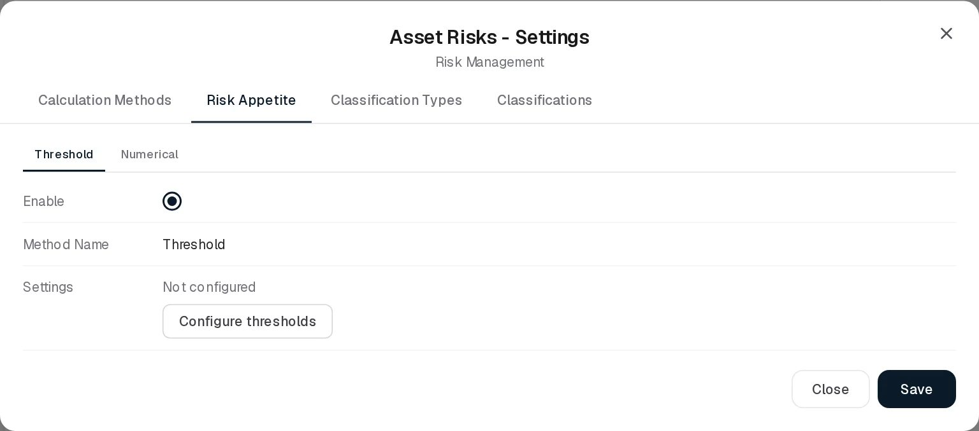
Settings: Risk Appetite
Threshold. Enable (clicking it switches the appetite method to Threshold immediately), Method Name “Threshold”, and Settings, which shows:
- “The matrix appears once two classification types have values. Add them on the Classifications tab.” when the first two classification types do not both have values;
- “The matrix appears once a calculation method is enabled. …” when no method is enabled;
- “Not configured” and a Configure thresholds button when no threshold exists yet (the demo state);
- otherwise the matrix, titled Likelihood x Impact.
The matrix has the likelihood levels across the top, lowest first (Likelihood (Rare) … Likelihood (Almost certain)), and the impact levels down the side, worst first (Impact (Critical) … Impact (Negligible)). The axes are the first and second classification types in the list. The corner cell is the [Default Threshold]. Each cell shows its threshold label (or the default’s, marked default), its description and “Score N” (the cell’s own score, or likelihood value × impact value).
A small gear in each cell opens an editor:
Field | Notes
Threshold label | Free text, up to 50 characters
Description - what this combination means | Free text, shown as the chip’s tooltip in the registers
Score (default N) | Cells only. A number above 0 replaces the formula score for this pair (see Matrix cell scores).
Colour | Five swatches: green #DCFCE7, yellow #FEF9C3, orange #FED7AA, red #FEE2E2, indigo #E0E7FF
Clear | Empties the cell or the default
Save stores the whole matrix and the Default Threshold together.
Numerical. Enable, Method Name “Numerical”, a Description, and a number field under Settings. Save stores the number and switches the appetite method to Numerical. The number is the one Above Appetite uses in both methods.

Classification Types
Settings: Classification Types
A Name list of the types (Likelihood and Impact in a new tenant) with a Remove link each, and a New type field (required; the grey “Likelihood” is only a placeholder) with an Add button that stays disabled until a name is typed. Remove asks for confirmation (“Delete ?”). This tab and the next have no Close or Save buttons; each Add and Remove is saved at once.

Classifications
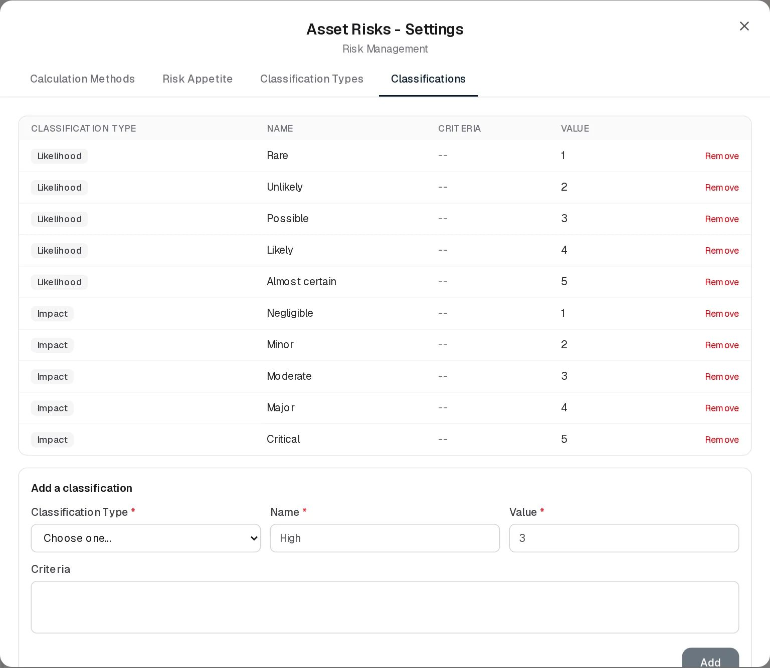
Settings: Classifications
A table with Classification Type (shown as a grey tag), Name, Criteria (-- when empty), Value and a Remove link, and an Add a classification form below it (“High” and “3” in the screenshot are placeholders):
Field | Required | Notes
Classification Type | Yes | Dropdown of the types
Name | Yes | For example “High”
Value | Yes | Number used in the scoring
Criteria | No | Text describing when the level applies
Add stays disabled until type, name and value are filled in.

Who can change the settings
Anyone who can open a risk register can open the dialog and read the settings. Saving any change needs Full Control (the Manage Section Settings right) on at least one of the three risk registers.

Automations in this module
What | When | Effect
Score calculation | On every save of a risk | Inherent and residual scores, stored dynamic status
Review schedule | On every save of a risk | Reviews for the Next Review Date and one year later
Dynamic Status flags, review and exception Dynamic Status | Every time a register is read | Computed live; no job needed
Linked compliance items | On every save of a risk that lists Affected Compliance Items | The linked requirements’ assessment result is set to Non Compliant when a linked risk’s stored status is Above Appetite, otherwise Compliant (Not Applicable items are left alone)
Risk exception expiry (RiskExceptionScheduler, hourly) | Implemented but not active in this release | See Risk Exceptions
No notification is sent for any risk, review or risk exception event.

Known issues
- Scores are not recalculated when settings change; each risk keeps its old score until it is saved again. The notice on the Calculation Methods tab says otherwise.
- The seeded Threshold Matrix Method is enabled in every tenant but is not one of the three method tabs, so the tabs all show Enable off while scoring uses multiplication.
- The matrix cells always show “Score” as likelihood × impact, even when the Addition method is in use.
- Above Appetite uses the numerical appetite (50 by default), which is above the maximum score of the default 5 × 5 scales.
- The stored dynamic status (used by Compliance Analysis and the Command Center) is computed only on save and gives an attached exception precedence over the appetite, so it can disagree with the register’s flags.
- The manual score override exists only in the API and is cleared when the risk is saved from the form.

Related pages
- Working with registers: toolbar, Views, search, paging, selection, Activity Log, pickers.
- Permissions and access: access levels and Assignment Management.
- Key concepts › Risk terms.

Asset Risks
Module: Risk Management › Asset Risks · Route: /risk-management/asset-risks · Permission key: risk_management.asset_risks
The Asset Risks register lists the risks to the organisation’s information assets. A record is one risk, for example “Unauthorized access” to the customer database: who is responsible for it, which assets it threatens, how likely and how severe it is, how it is treated, and what remains after treatment. Risk owners and the GRC team work in it; auditors read it.
How the scores, the appetite and the Dynamic Status flags are worked out is explained once in the Risk Management overview. This page describes the register itself.
Asset Risks register

At a glance
A record is | One risk to one or more assets
Typical owner | The person named as Risk GRC Contact (GRC team), with the Risk Originator Contact who raised it
Links to | Assets, Controls, Policies, Risk Exceptions, Projects, Compliance items (requirements), Security Incidents, users and groups
Linked from | Risk Exceptions, Assets, Controls, Policies & Standards, Projects, Departments, Security Incidents, Data Flows, Compliance Analysis
Tabs | Asset Risks, Reviews
Automations | Scores and stored status on save; reviews generated from the Next Review Date; Dynamic Status flags computed on read; linked compliance items re-evaluated on save

The register (list view)
The page opens on the Asset Risks tab. Above the grid are the round Settings gear (the shared risk settings, see Settings), Import CSV and Add Item. Search, Views, paging, row selection and the row buttons (View, Activity Log, Edit, Delete) work as described in Working with registers. The search box matches the Name and Description. The grid is paged on the server, 10 rows by default.
Column | What it shows | Source
Dynamic Status | One chip per problem that applies: Above Appetite (red), Review Expired, No Treatment, Exception Expired, Control Last Audit Expired (amber); -- when none. Rules in Dynamic Status of a risk. | Computed by the system
Reviews | Number of reviews of this risk on the Reviews tab | Computed
Name | Name of the risk | Entered
Description | Description | Entered
Risk GRC Contact | Users or groups responsible, with avatar | Entered
Risk Originator Contact | Users or groups who raised the risk, with avatar | Entered
Next Review Date | Date of the next review (YYYY-MM-DD) | Entered
Related Assets | Names of the assets at risk | Linked
Inherent Risk Classification | Tags Likelihood (…) and Impact (…) from the analysis | Entered
Inherent Risk Score | Score before treatment; a coloured threshold chip when an appetite threshold applies, otherwise the number | Computed
Risk Treatment | MITIGATE, ACCEPT, TRANSFER, AVOID (older records may show MONITOR) | Entered
Treatment Risk Exceptions | Names of the risk exceptions in the treatment | Linked
Treatment Internal Controls | Names of the treating controls | Linked
Treatment Projects | Names of the treating projects | Linked
Treatment Policies | Names of the treating policies | Linked
Affected Compliance Items | Requirements this risk puts at stake | Linked
Residual Risk Score | Score after treatment; a threshold chip only when the coefficient is empty or 100 | Computed
Linked names in this grid are plain text; they do not open the linked record.
Example from the demo data: “DDoS on customer portal” shows Review Expired because its review planned for 12 Oct 2026 has no actual date.

Creating a record
Click Add Item. The form Add Item (Asset Risks) opens in a dialog. It is one scrolling form with three parts: general fields, Analysis and Treatment.
Add Asset Risk
Field | Type | Required | Rules and allowed values | Example
Name | Text | Yes | Must not be blank: “Name is required” | Unauthorized access
Description | Long text | No |  | Unauthorized access to the customer database through compromised admin credentials.
Risk GRC Contact | Users or groups, several | Yes | “Risk GRC Contact is required”. Naming someone other than yourself needs Can Assign; changing who is named needs Can Reassign. | Alex Meian
Risk Originator Contact | Users or groups, several | Yes | “Risk Originator Contact is required”. Same assignment rule. | Sara Johnson
Next Review Date | Date | No | 1900 to 2999: “Enter a valid date between 1900 and 2999”. Generates reviews, see Reviews. | 2026-11-04
Analysis
Related Assets | Assets, several | No | Picker with + Add (creates an asset) | Customer database
Threat Description | Long text | No |  | Credential theft, password reuse
Vulnerabilities Description | Long text | No |  | Admin accounts without MFA
Likelihood (Analysis) | One classification | No | Values of the Likelihood type: Rare, Unlikely, Possible, Likely, Almost certain. No + Add: values are managed in Settings. | Likely
Impact (Analysis) | One classification | No | Values of the Impact type: Negligible, Minor, Moderate, Major, Critical | Critical
Treatment
Risk Treatment | Dropdown | No | Choose one…, MITIGATE, ACCEPT, TRANSFER, AVOID. Empty gives the No Treatment flag. | MITIGATE
Treatment: Controls | Controls, several | No | Picker with + Add | Multi-factor authentication, Quarterly access review
Treatment: Policies | Policies & Standards, several | No | Picker with + Add
Treatment: Risk Exceptions | Risk exceptions, several | No | Picker with + Add. Any entry makes the stored status Exception Active.
Treatment: Projects | Projects, several | No | Picker with + Add | Enforce MFA on all admin accounts
Affected Compliance Items | Compliance package requirements, several | No | Listed as “ · ”. No + Add. Unknown ids are rejected. | ISO/IEC 27001:2022 · A.5.15 Access control
Security Incidents | Security incidents, several | No | No + Add. Only existing incidents are kept. | Suspicious login from unknown country
Residual Percentage Coefficient | Dropdown | No | Choose one…, 0, 10, 20 … 100: the percentage of the inherent score that remains | 30
The scores are not entered; they are calculated when you click Save (see Residual score). Example: Likely (4) × Critical (5) = 20, coefficient 30 gives a residual score of 6.
When a required field is missing, the form marks it in red and a message lists the reasons. People pickers, record pickers and + Add are described in Working with registers. On success the message “Asset risk added.” appears.

Viewing and editing a record
The eye button opens View item, a read-only list of the grid’s columns for that risk.
View Asset Risk
The view shows the same values as the grid, so the threat and vulnerability descriptions, the coefficient and the security incidents are not in it; open Edit to see them.
Edit opens Edit Item (Asset Risks), the same form filled with the stored values. Saving recalculates both scores, re-generates the review schedule and shows “Asset risk updated.”
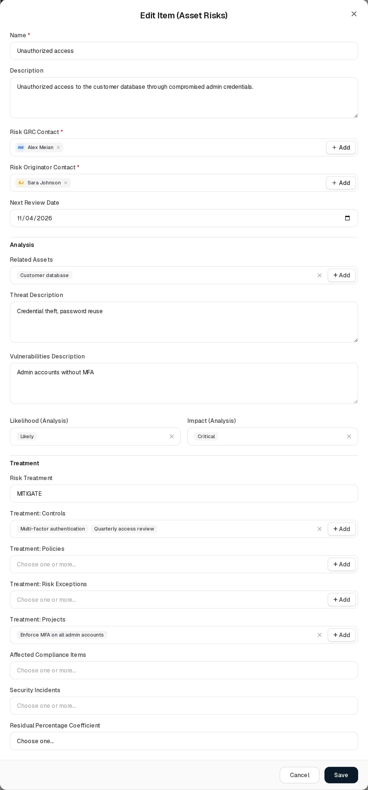
Edit Asset Risk
Points to know when editing:
- The scores are recalculated with the current settings, so a risk saved after a settings change can get a different score although you changed nothing on it.
- A manual score override set through the API is cleared, because the form does not carry it.
- A record whose treatment is MONITOR (an older value, for example “Shadow IT SaaS usage”) shows Choose one… in the Risk Treatment dropdown, but MONITOR is kept unless you pick another value.
Delete asks “Delete asset risk ?”. Deleting removes the risk from the register (soft delete) and permanently deletes its reviews. Several rows can be deleted at once from the selection toolbar.

Statuses
Value | Set by | Meaning
Above Appetite | System (flag) | Residual score greater than the numerical appetite. Red.
Review Expired | System (flag) | A review is past its planned date without an actual date. Amber.
No Treatment | System (flag) | Risk Treatment is empty. Amber.
Exception Expired | System (flag) | A treatment risk exception is past its expiration date and not closed. Amber.
Control Last Audit Expired | System (flag) | A treatment control has an unfinished audit whose planned start has passed. Amber.
On Track, Review Due, Above Appetite, Exception Active, Closed | System (stored on save) | The single stored status, shown only in the linked-risk panel; see The stored status
OPEN … ARCHIVED | API only | Lifecycle status; not on the form. Default OPEN.
The register has no user-selectable Status field.

Tabs

Reviews
The Reviews tab lists the reviews of all asset risks. Each review belongs to one risk. Reviews are created in two ways: automatically from the risk’s Next Review Date (one review on that date and one a year later; past dates skipped; see Risk Reviews), and by hand with Add Item on this tab.
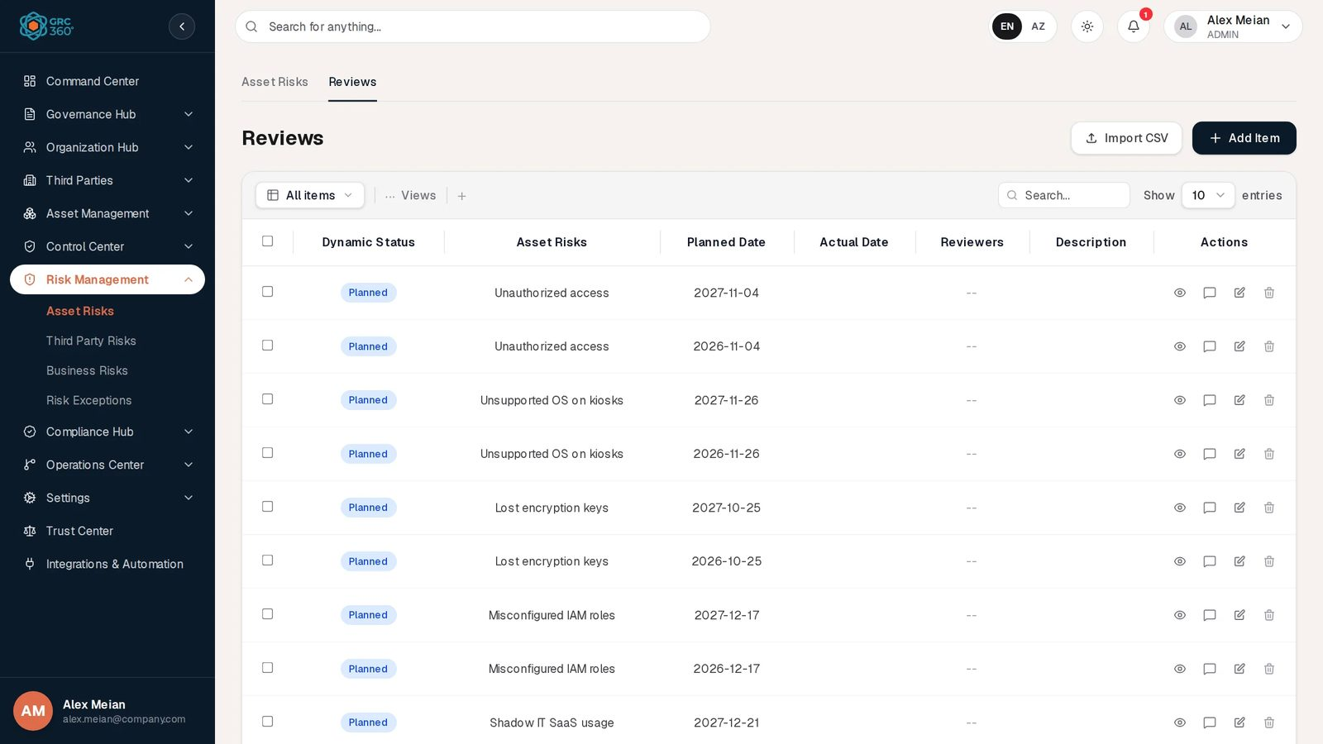
Asset Risk reviews
Column | What it shows | Source
Dynamic Status | Completed (green, Actual Date set), Expired (red, Planned Date before today and no Actual Date), Planned (blue) | Computed
Asset Risks | Name of the reviewed risk | Linked
Planned Date | When the review is due | Entered or generated
Actual Date | When it was carried out | Entered
Reviewers | Users or groups who review | Entered
Description | Notes | Entered
The grid has an All items filter in addition to the usual toolbar. When there are no reviews it says “No reviews yet. One is opened automatically when a risk is given a next review date.”
Add Item opens Add Item (Reviews) (subtitle Risk Management):
Add review
Field | Type | Required | Rules and allowed values | Example
Asset Risks | Dropdown of all asset risks | Yes | “Choose the risk this review belongs to.” appears above the grid if empty. + Add creates a new asset risk with the full Asset Risks form and selects it. | Unauthorized access
Planned Date | Date | No |  | 2026-11-04
Actual Date | Date | No | Setting it marks the review Completed and stops the Review Expired flag
Reviewers | Users or groups, several | No |  | Alex Meian
Description | Long text | No |  | Access review signed off
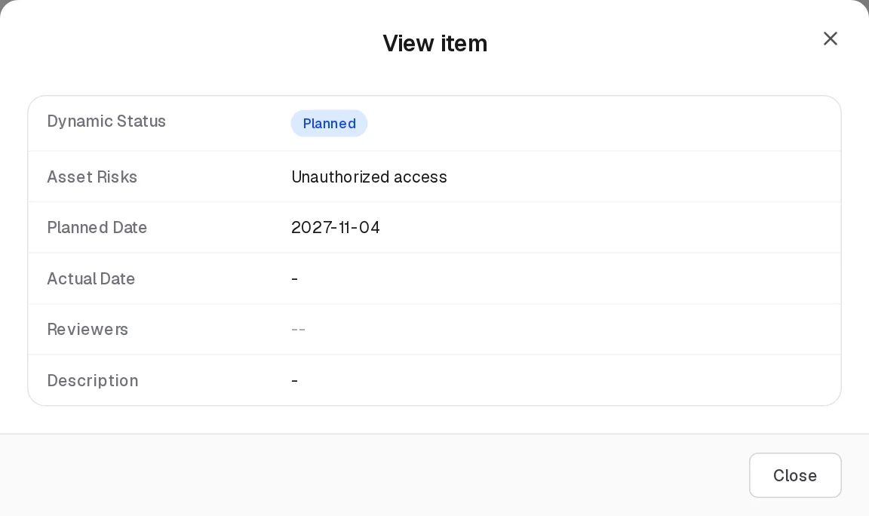
View review
View shows the six columns. Edit opens Edit Item (Reviews) with the same fields. The risk a review belongs to cannot be changed: the dropdown can be changed on the Edit form, but the server keeps the original risk.
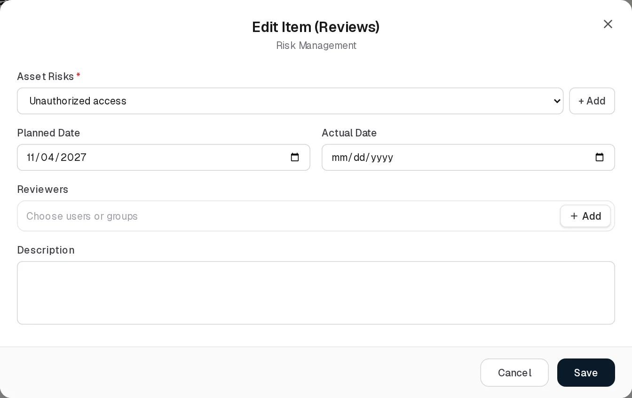
Edit review
Completing a review does not move the risk’s Next Review Date; set the next date on the risk yourself. Generated reviews that are not completed are replaced when the Next Review Date changes; reviews you add by hand and completed reviews stay.

Relationships
Related record | Direction | How the link is made | Where it shows
Assets | Many to many, stored on the risk | Related Assets on this form | Here: Related Assets (text). Assets register: Asset Risks count (clickable). Departments: Asset Risks count, through the assets that name the department.
Controls | Many to many, stored on the risk | Treatment: Controls | Here: Treatment Internal Controls. Controls register: Asset Risks count (clickable, read-only there).
Policies & Standards | Many to many, stored on the risk | Treatment: Policies | Here: Treatment Policies. Policies & Standards: Asset Risks Treatment count (clickable).
Risk Exceptions | Many to many, one relation shown from both ends | Treatment: Risk Exceptions here, or Related Asset Risks on the exception | Here: Treatment Risk Exceptions. Risk Exceptions: Related Asset Risks count (clickable). See Risk Exceptions.
Projects | Many to many, stored on the risk | Treatment: Projects | Here: Treatment Projects. Projects register: Asset Risks count (clickable).
Compliance requirements | Many to many, stored on the risk | Affected Compliance Items here, or from the requirement in Compliance Analysis | Here: Affected Compliance Items. Compliance Analysis lists the risks on the requirement.
Security Incidents | Many to many, stored on the risk | Security Incidents | Security Incidents register: Known Asset Risk count (clickable). Not shown in this grid.
Data Flows | Many to many | Chosen on the data flow’s form; also links the flow’s asset to the risk | Data Flows grid
Reviews | One risk, many reviews | Generated or added on the Reviews tab | Reviews column (count, not clickable) and the Reviews tab
Where another register shows an asset-risk count, clicking it opens a panel with each linked risk in full: an Overview (Description, Status, Dynamic Status, Next Review Date, Reviews, contacts), Analysis, Treatment and Manual Override (Manual Score Override, Override Reason). This panel is the only place the lifecycle status, the stored dynamic status and the override are visible.

Automations and notifications
Automation | Trigger | Effect
Score calculation | Save | Inherent score, residual score, stored dynamic status
Review schedule | Save | Reviews on the Next Review Date and one year later
Dynamic Status flags | Every read | Computed live
Compliance re-evaluation | Save of a risk with Affected Compliance Items | Linked requirements set to Non Compliant or Compliant, see Automations
Linked exception decided (approve, deny, expire, delete) | API action or exception deletion | Treatment exceptions and stored status of the risk updated
No notification is sent when an asset risk is created, changed, assigned or becomes due for review.

Permissions
Action | Needed access
See the page | View on Risk Management › Asset Risks
Create, Edit | Manage on Risk Management › Asset Risks
Delete | Full Control on Risk Management › Asset Risks
Import CSV | Manage (the import itself does not work, see below)
Change the shared risk settings (gear) | Full Control on any of the three risk registers
Name other people as Risk GRC Contact or Risk Originator Contact | Can Assign; changing who else is named needs Can Reassign
Activity Log | The group’s Comments & Attachments level
Reviews tab | Its own level on Risk Management › Asset Risks › Reviews (View, Manage, Full Control as above). The reviews you see are limited to risks you can see.
Which rows you see also depends on your group’s record visibility: a group limited to its own records sees the risks that name its member as Risk GRC Contact or Risk Originator Contact, plus risks that name nobody (see Which records you see). Buttons you lack the right for are shown locked and open Request Access; see Permissions and access.

How to

Record a new asset risk
- Open Risk Management › Asset Risks and click Add Item.
- Enter Name “Stolen laptop data leak” and a Description.
- In Risk GRC Contact choose Alex Meian; in Risk Originator Contact choose Sara Johnson.
- Set Next Review Date, for example 29 Oct 2026.
- Under Analysis, choose Related Assets, then Likelihood (Analysis) Possible and Impact (Analysis) Major.
- Under Treatment, choose Risk Treatment MITIGATE and the treating controls.
- Click Save. The grid shows Inherent Risk Score 12, and the Reviews tab has reviews for 29 Oct 2026 and 29 Oct 2027.

Reduce a residual score after treatment
- Click Edit on “Unpatched internet-facing server” (Likely, Major; score 16).
- Add the patching project under Treatment: Projects.
- Set Residual Percentage Coefficient to 30 and click Save.
- Residual Risk Score now shows 4.8.

Complete a review
- Open the Reviews tab and find the review of “DDoS on customer portal” planned for 2026-10-12 (Dynamic Status Expired).
- Click Edit, set Actual Date to today, add Reviewers and a Description, and click Save.
- The review shows Completed and the risk’s Review Expired flag disappears.
- Edit the risk and set its next Next Review Date if needed.

Accept a risk through an exception
- Edit the risk and click + Add beside Treatment: Risk Exceptions to create the exception, or choose an existing one.
- Save. The exception appears under Treatment Risk Exceptions, and the risk appears in the exception’s Related Asset Risks.

CSV import
The Import CSV button first shows the message “CSV Import (Asset Risks): the import structure is not ready yet.” and then opens the generic import dialog. That dialog sends the file to a demo address that does not exist, so validation fails and nothing is imported. The server does have an asset-risk import (/risk-management/asset-risks/import-csv, columns name or title required, description optional) and an export (/export-csv: id, name, description, status, dynamicStatus, riskAnalysisScore, riskTreatmentScore), but neither is reachable from the page. The Reviews tab’s Import CSV behaves the same way and has no server import at all.

Limitations and known issues
- Import CSV does not work from the page (see above); there is no Export button.
- Scores are stored on save and not recalculated when settings change.
- The manual score override is API-only and is cleared by saving the form.
- Above Appetite cannot appear with the default settings (appetite 50, maximum score 25).
- The View item dialog omits the threat and vulnerability descriptions, the coefficient and the security incidents.
- The Edit form of a review lets you pick another risk, but the change is ignored.
- The form labels the control picker Treatment: Controls, the grid Treatment Internal Controls.

Third Party Risks
Module: Risk Management › Third Party Risks · Route: /risk-management/third-party-risks · Permission key: risk_management.third_party_risks
The Third Party Risks register lists the risks that come from vendors, suppliers, consultants and other outside parties. A record is one risk, for example “Consultant access to production”: which third parties it concerns, which of the organisation’s assets are shared with them, how likely and severe it is, and how it is treated. Vendor managers and the GRC team work in it; the built-in Third Party group gives external contacts read and edit rights on this page (not create or delete), limited to the risks that name them.
The register works like Asset Risks. Scores, appetite thresholds, Dynamic Status flags and reviews follow the shared rules in the Risk Management overview. This page describes what is specific to third party risks and repeats the field list in full.
Third Party Risks register

At a glance
A record is | One risk arising from one or more third parties
Typical owner | The Risk GRC Contact, usually the vendor manager or GRC analyst
Links to | Vendors (third parties), Assets, Controls, Policies, Risk Exceptions, Projects, Compliance items, Security Incidents, users and groups
Linked from | Vendors, Assets, Controls, Policies & Standards, Risk Exceptions, Security Incidents, Objectives, Data Flows, Compliance Analysis
Tabs | Third-Party Risks, Reviews
Automations | Scores and stored status on save; reviews generated from the Next Review Date; Dynamic Status flags computed on read; linked compliance items re-evaluated on save

The register (list view)
The first tab is labelled Third-Party Risks (with a hyphen); the grid title is Third Party Risks. Above the grid are the Settings gear (shared risk settings, see Settings), Import CSV and Add Item. Search (Name and Description), Views, paging and the row buttons are described in Working with registers.
Column | What it shows | Source
Dynamic Status | One chip per applicable flag: Above Appetite, Review Expired, No Treatment, Exception Expired, Control Last Audit Expired; -- when none. See Dynamic Status of a risk. | Computed by the system
Reviews | Number of reviews of the risk | Computed
Name | Name of the risk | Entered
Description | Description | Entered
Risk GRC Contact | Responsible users or groups | Entered
Risk Originator Contact | Users or groups who raised the risk | Entered
Next Review Date | Date of the next review | Entered
Applicable Third Parties | Names of the vendors concerned | Linked
Assets Shared with this Third Party | Names of the assets the third party has access to | Linked
Inherent Risk Classification | Likelihood (…) and Impact (…) tags | Entered
Inherent Risk Score | Score before treatment, as a threshold chip when an appetite threshold applies | Computed
Risk Treatment | MITIGATE, ACCEPT, TRANSFER, AVOID | Entered
Treatment Risk Exceptions | Risk exceptions in the treatment | Linked
Treatment Internal Controls | Treating controls | Linked
Treatment Projects | Treating projects | Linked
Treatment Policies | Treating policies | Linked
Affected Compliance Items | Requirements put at stake | Linked
Residual Risk Score | Score after the Residual Percentage Coefficient; a threshold chip only when the coefficient is empty or 100 | Computed
Demo data: four risks, for example “Telecom link failure” (Azercell Telecom, Possible × Moderate = 9, TRANSFER) and “Identity provider compromise” (Okta, Unlikely × Critical = 10).

Creating a record
Click Add Item. The dialog Add Item (Third Party Risks) opens.
Add Third Party Risk
Field | Type | Required | Rules and allowed values | Example
Name | Text | Yes | “Name is required” | Consultant access to production
Description | Long text | No |  | Consultant access to production.
Risk GRC Contact | Users or groups, several | Yes | “Risk GRC Contact is required”. Naming others needs Can Assign / Can Reassign. | Alex Meian
Risk Originator Contact | Users or groups, several | Yes | “Risk Originator Contact is required” | Sara Johnson
Next Review Date | Date | No | 1900 to 2999 (“Enter a valid date between 1900 and 2999”). Generates reviews. | 2026-11-02
Analysis
Applicable Third Parties | Vendors, several | No | Picker with + Add (creates a vendor) | Deloitte Azerbaijan
Assets Shared with this Third Party | Assets, several | No | Picker with + Add | Customer database
Threat Description | Long text | No
Vulnerabilities Description | Long text | No
Likelihood (Analysis) | One classification | No | Rare, Unlikely, Possible, Likely, Almost certain | Possible
Impact (Analysis) | One classification | No | Negligible, Minor, Moderate, Major, Critical | Major
Treatment
Risk Treatment | Dropdown | No | Choose one…, MITIGATE, ACCEPT, TRANSFER, AVOID | MITIGATE
Treatment: Internal Controls | Controls, several | No | Picker with + Add | Vendor due diligence
Treatment: Policies | Policies & Standards, several | No | Picker with + Add | Vendor Management Policy
Treatment: Risk Exceptions | Risk exceptions, several | No | Picker with + Add
Treatment: Projects | Projects, several | No | Picker with + Add
Affected Compliance Items | Requirements, several | No | No + Add | ISO/IEC 27001:2022 · A.5.15 Access control
Security Incidents | Security incidents, several | No | No + Add | Suspicious login from unknown country
Residual Percentage Coefficient | Dropdown | No | Choose one…, 0, 10 … 100 | 50
Scores are calculated on Save: “Consultant access to production” is Possible (3) × Major (4) = 12; with coefficient 50 the residual score is 6. On success the message “Third party risk added.” appears.
The record also has review fields of its own (planned date, actual date, reviewers, review description) that are not on the form. They are kept unchanged when you save. The reviewers stored there count as people named on the risk for record visibility and assignment.

Viewing and editing a record
View opens View item with the grid’s columns.
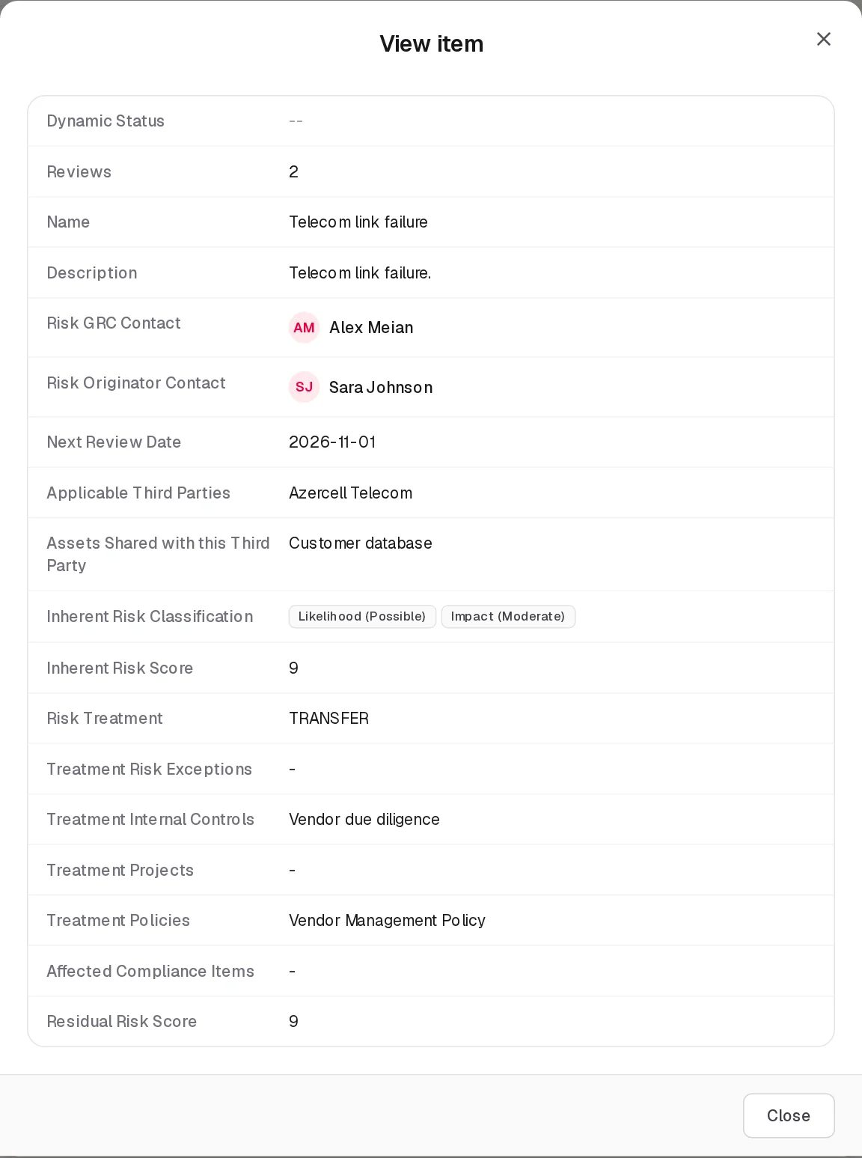
View Third Party Risk
Edit opens Edit Item (Third Party Risks) with the same fields. Saving recalculates the scores and the review schedule and shows “Third party risk updated.” The editing notes for Asset Risks apply here too: scores use the current settings, an API-set manual override is cleared, and an old MONITOR treatment is kept unless changed.
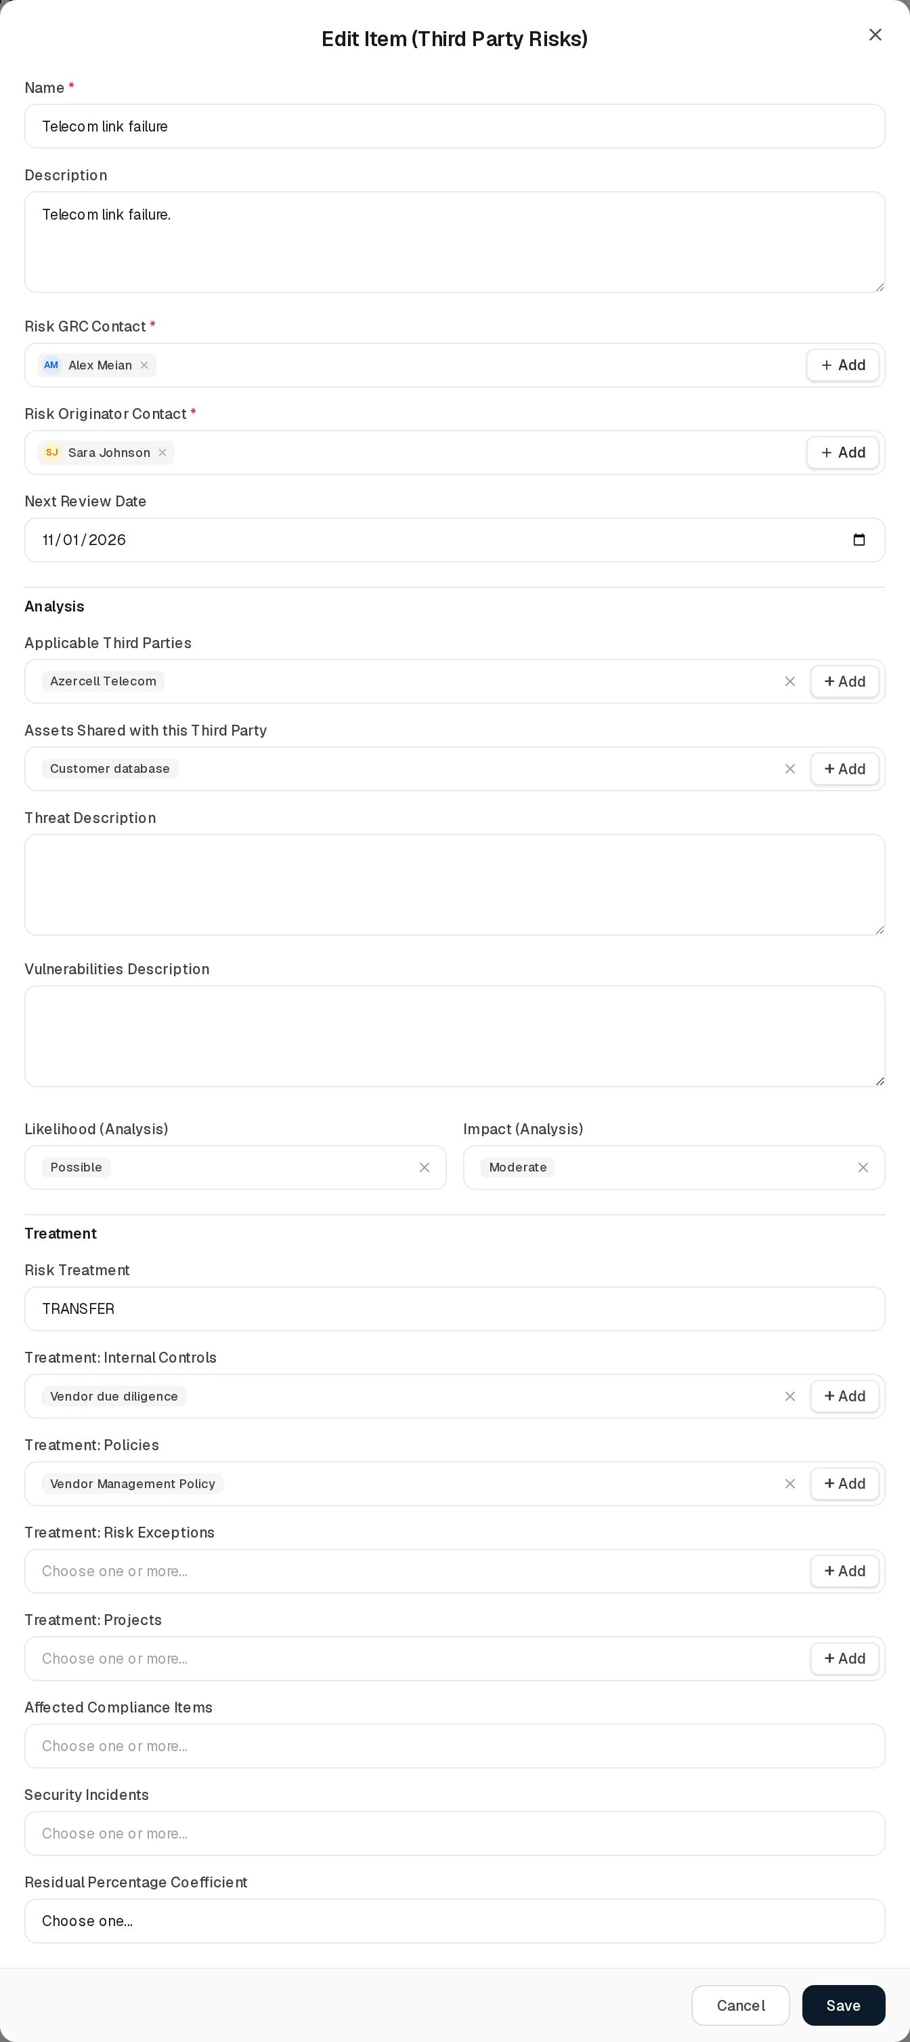
Edit Third Party Risk
Delete asks “Delete third party risk ?”, removes the risk from the register and deletes its reviews.

Statuses
The same values as Asset Risks: the five Dynamic Status flags computed on read, the single stored status (On Track, Review Due, Above Appetite, Exception Active, Closed) visible only in the linked-risk panel, and the API-only lifecycle status. See Asset Risks › Statuses and Dynamic Status of a risk. There is no user-selectable Status field.

Tabs

Reviews
The Reviews tab lists the reviews of all third party risks. It works exactly like the Asset Risks Reviews tab; only the risk column and dropdown are labelled Third Party Risks, and + Add beside the dropdown opens the Third Party Risks form.
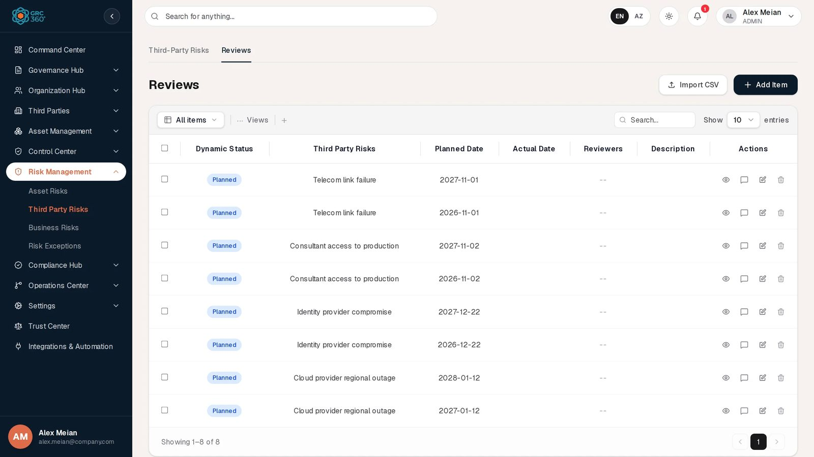
Third Party Risk reviews
Field | Type | Required | Rules | Example
Third Party Risks | Dropdown | Yes | “Choose the risk this review belongs to.” | Telecom link failure
Planned Date | Date | No |  | 2026-11-01
Actual Date | Date | No | Marks the review Completed
Reviewers | Users or groups, several | No
Description | Long text | No
Add review
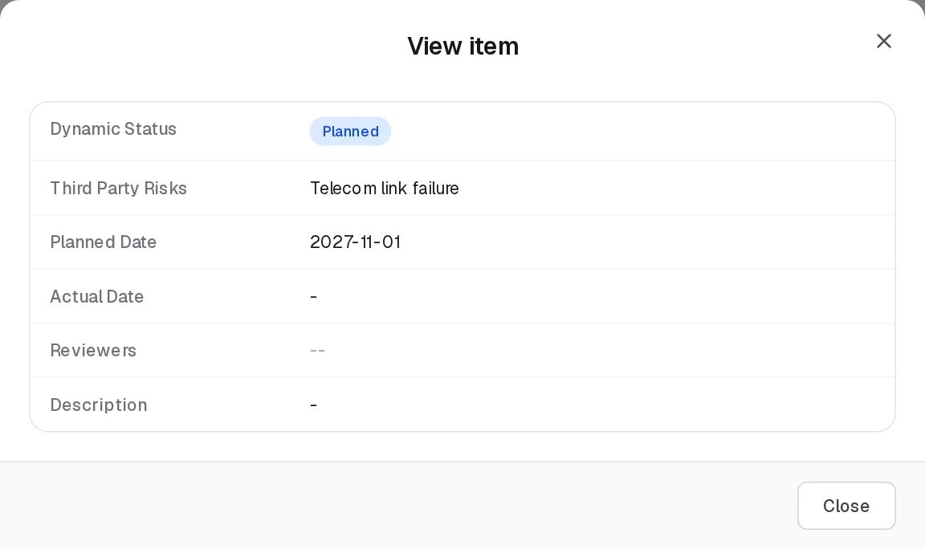
View review
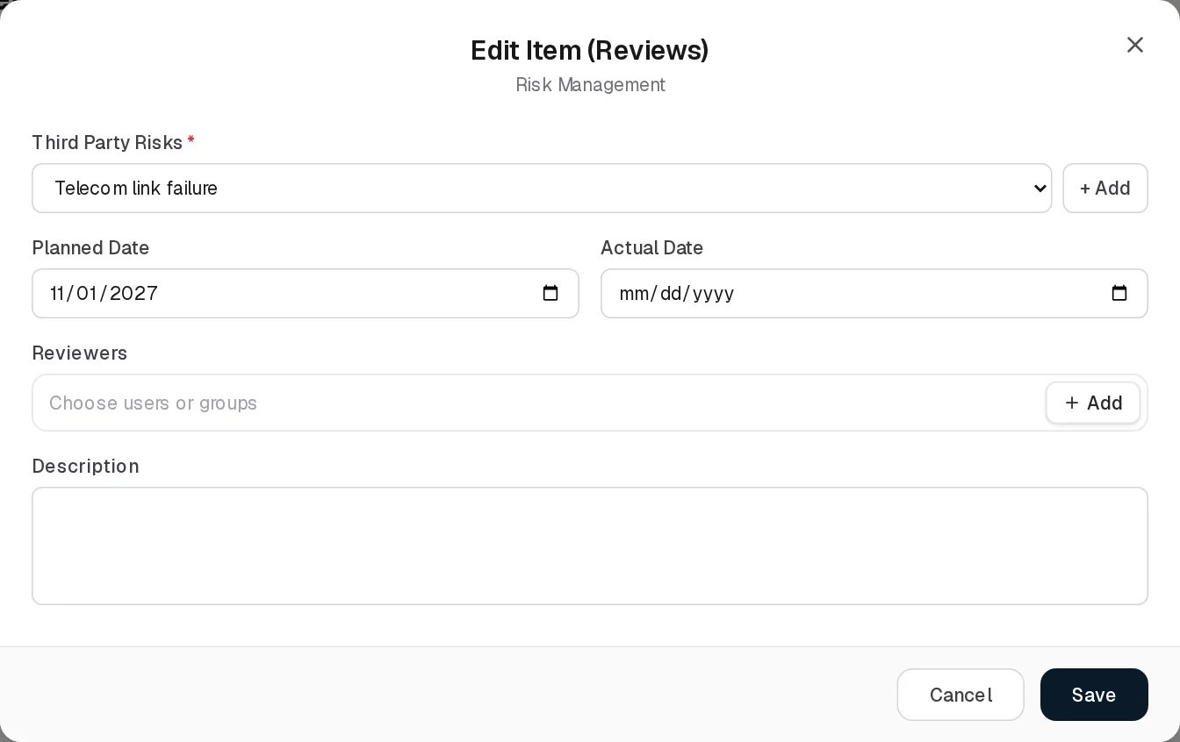
Edit review
Review Dynamic Status: Completed (Actual Date set), Expired (Planned Date passed, no Actual Date), Planned. Example: “Cloud provider regional outage” has Next Review Date 12 Jan 2027, so it has reviews planned for 12 Jan 2027 and 12 Jan 2028.

Relationships
Related record | Direction | How the link is made | Where it shows
Vendors | Many to many, stored on the risk | Applicable Third Parties | Here (text). Vendors register: Risk count (clickable, opens the risks naming the vendor).
Assets | Many to many, stored on the risk | Assets Shared with this Third Party | Here (text). Assets register: Third Party Risk count (clickable).
Controls | Many to many, stored on the risk | Treatment: Internal Controls | Controls register: Third Party Risks count (clickable).
Policies & Standards | Many to many, stored on the risk | Treatment: Policies | Policies & Standards: Third Party Risks Treatment count (clickable).
Risk Exceptions | Many to many, one relation shown from both ends | Here, or Related Third Party Risks on the exception | Risk Exceptions: Related Third Party Risks count (clickable).
Projects | Many to many, stored on the risk | Treatment: Projects | Here only
Compliance requirements | Many to many, stored on the risk | Affected Compliance Items, or from Compliance Analysis | Compliance Analysis
Security Incidents | Many to many, stored on the risk | Security Incidents | Security Incidents register: Known Third Party Risk count (clickable)
Objectives | Many to many, stored on the objective | The objective’s own form | Objectives register
Data Flows | Many to many, stored on the flow | The data flow’s form | Data Flows register
Reviews | One risk, many reviews | Generated or added on the tab | Reviews column and tab
Clicking a count in another register opens the linked-risk panel described in Asset Risks › Relationships.

Automations and notifications
The same as Asset Risks: scores, stored status and the review schedule on every save; Dynamic Status flags on every read; linked compliance requirements re-evaluated on save. No notification is sent for third party risk events.

Permissions
Action | Needed access
See the page | View on Risk Management › Third Party Risks
Create, Edit | Manage on Risk Management › Third Party Risks
Delete | Full Control on Risk Management › Third Party Risks
Import CSV | Manage (the import does not work, see below)
Change the shared risk settings | Full Control on any of the three risk registers
Name other people as contacts | Can Assign / Can Reassign
Activity Log | The group’s Comments & Attachments level
Reviews tab | Its own level on Risk Management › Third Party Risks › Reviews
Rows are limited by record visibility: a group limited to its own records sees the risks naming its member as Risk GRC Contact, Risk Originator Contact or reviewer, plus risks that name nobody. The built-in Third Party group starts with the read and edit rights on this page (no create, no delete) and sees only its own records.

How to

Record a risk for a new supplier
- Open Risk Management › Third Party Risks and click Add Item.
- Enter Name, Risk GRC Contact and Risk Originator Contact.
- Under Applicable Third Parties choose the vendor, or click + Add to create it.
- Under Assets Shared with this Third Party choose the assets the supplier will access.
- Choose Likelihood (Analysis) and Impact (Analysis), set Risk Treatment, and click Save.
- The vendor’s Risk count in Third Parties › Vendors goes up by one.

Record that a vendor control reduces the risk
- Edit “Telecom link failure”.
- Under Treatment: Internal Controls keep “Vendor due diligence” and set Residual Percentage Coefficient to 40.
- Save: the residual score becomes 9 × 40 / 100 = 3.6.

Review all risks of one vendor
- Open Third Parties › Vendors and click the Risk count of Okta.
- The panel lists “Identity provider compromise” with its analysis and treatment.

CSV import
As on Asset Risks: Import CSV shows “CSV Import (Third Party Risks): the import structure is not ready yet.” and then opens a demo dialog whose upload fails, so nothing is imported. The server’s own /risk-management/third-party-risks/import-csv (name or title, description) and /export-csv endpoints are not reachable from the page.

Limitations and known issues
- Import CSV does not work from the page; no Export button.
- The tab is labelled Third-Party Risks, the grid and sidebar Third Party Risks.
- The record’s own review fields (planned date, actual date, reviewers, review description) exist but are not on the form; they are separate from the Reviews tab.
- In the linked-risk panel opened from other registers, the Treatment section of a third party risk shows Treatment Likelihood and Treatment Impact, which this register does not have, and does not show the coefficient.
- Scores are stored on save; the manual override is API-only and cleared by saving the form.

Business Risks
Module: Risk Management › Business Risks · Route: /risk-management/operational-risks · Permission key: risk_management.operational_risks
The Business Risks register lists risks to the organisation’s operations: loss of key staff, a supplier outage, a reporting deadline missed. A record is one risk, tied to the departments it affects and to the business continuity plans that mitigate it. Unlike the other two risk registers, a business risk is re-analysed after treatment with a second likelihood and impact pair rather than a percentage. Department heads and the GRC team work in it.
The page is labelled Business Risks everywhere in the interface. The route, the permission key (operational_risks) and some messages still use the older name operational risks. Shared rules (scores, appetite thresholds, Dynamic Status flags, reviews, settings) are in the Risk Management overview.
Business Risks register

At a glance
A record is | One risk to the operations of one or more departments
Typical owner | The Risk GRC Contact together with the affected department
Links to | Departments, Continuity Plans, Controls, Policies, Risk Exceptions, Projects, Compliance items, Security Incidents, users and groups
Linked from | Departments, Controls, Risk Exceptions, Security Incidents, Objectives, Data Flows, Compliance Analysis
Tabs | Business Risks, Reviews
Automations | Scores and stored status on save; reviews generated from the Next Review Date; Dynamic Status flags computed on read; linked compliance items re-evaluated on save

The register (list view)
Above the grid are the Settings gear (see Settings), Import CSV and Add Item. Search (Name and Description), Views, paging and row buttons are described in Working with registers.
Column | What it shows | Source
Dynamic Status | One chip per applicable flag (Above Appetite, Review Expired, No Treatment, Exception Expired, Control Last Audit Expired); -- when none. See Dynamic Status of a risk. | Computed by the system
Reviews | Number of reviews of the risk | Computed
Name | Name of the risk | Entered
Description | Description | Entered
Risk GRC Contact | Responsible users or groups | Entered
Risk Originator Contact | Users or groups who raised the risk | Entered
Next Review Date | Date of the next review | Entered
Applicable Departments Units | Names of the affected departments | Linked
Inherent Risk Classification | Likelihood (…) and Impact (…) from the analysis | Entered
Inherent Risk Score | Score before treatment; threshold chip when one applies | Computed
Risk Treatment | MITIGATE, ACCEPT, TRANSFER, AVOID | Entered
Treatment Risk Exceptions | Risk exceptions in the treatment | Linked
Treatment Internal Controls | Treating controls | Linked
Treatment Projects | Treating projects | Linked
Treatment Policies | Treating policies | Linked
Affected Compliance Items | Requirements put at stake | Linked
Mitigating Continuity Plans | Continuity plans that mitigate the risk | Linked
Residual Risk Classification | Likelihood (…) and Impact (…) from the treatment pair; -- when not set | Entered
Residual Risk Score | Score of the treatment pair, or the inherent score when the pair is incomplete; threshold chip of that pair | Computed
Demo data: five risks, for example “Manual payroll errors” (Likely × Moderate = 12, MITIGATE) and “Office power failure” (Rare × Moderate = 3, TRANSFER). None of the demo business risks has a Risk Originator Contact.

Creating a record
Click Add Item. The dialog Add Item (Business Risks) opens.
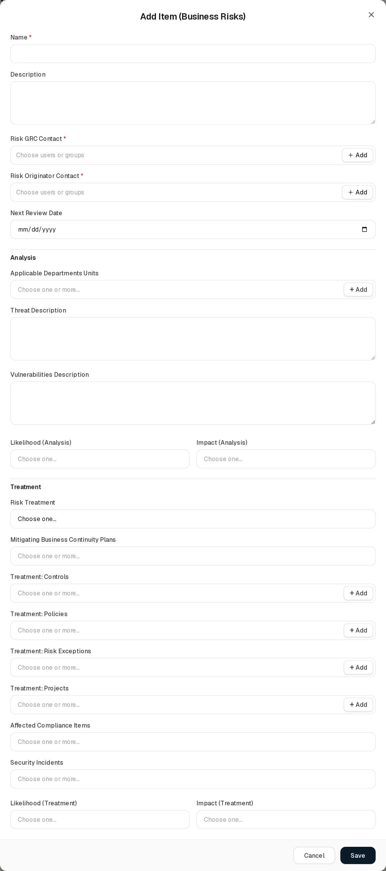
Add Business Risk
Field | Type | Required | Rules and allowed values | Example
Name | Text | Yes | “Name is required” | Manual payroll errors
Description | Long text | No |  | Manual payroll errors.
Risk GRC Contact | Users or groups, several | Yes | “Risk GRC Contact is required”. Naming others needs Can Assign / Can Reassign. | Alex Meian
Risk Originator Contact | Users or groups, several | Yes | “Risk Originator Contact is required” | Mike Brown
Next Review Date | Date | No | 1900 to 2999 (“Enter a valid date between 1900 and 2999”). Generates reviews. | 2026-10-19
Analysis
Applicable Departments Units | Departments, several | No | Picker with + Add (creates a department) | Finance
Threat Description | Long text | No
Vulnerabilities Description | Long text | No
Likelihood (Analysis) | One classification | No | Rare, Unlikely, Possible, Likely, Almost certain | Likely
Impact (Analysis) | One classification | No | Negligible, Minor, Moderate, Major, Critical | Moderate
Treatment
Risk Treatment | Dropdown | No | Choose one…, MITIGATE, ACCEPT, TRANSFER, AVOID | MITIGATE
Mitigating Business Continuity Plans | Continuity plans, several | No | No + Add | Data centre outage
Treatment: Controls | Controls, several | No | Picker with + Add
Treatment: Policies | Policies & Standards, several | No | Picker with + Add
Treatment: Risk Exceptions | Risk exceptions, several | No | Picker with + Add
Treatment: Projects | Projects, several | No | Picker with + Add
Affected Compliance Items | Requirements, several | No | No + Add | ISO/IEC 27001:2022 · A.5.15 Access control
Security Incidents | Security incidents, several | No | No + Add | Suspicious login from unknown country
Likelihood (Treatment) | One classification | No | Same values as the analysis likelihood | Unlikely
Impact (Treatment) | One classification | No | Same values as the analysis impact | Minor
There is no Residual Percentage Coefficient on this register. The residual score comes from the treatment pair: with Likelihood (Treatment) Unlikely (2) and Impact (Treatment) Minor (2), “Manual payroll errors” gets a residual score of 4 against an inherent score of 12. If only one of the two treatment fields is chosen, the residual score equals the inherent score. See Residual score.
On success the message “Operational risk added.” appears.
The record also stores processes and its own review fields (planned date, actual date, reviewers, review description) that are not on the form; they are kept unchanged when you save. Reviewers stored there count as people named on the risk for visibility and assignment.

Viewing and editing a record
View opens View item with the grid’s columns.
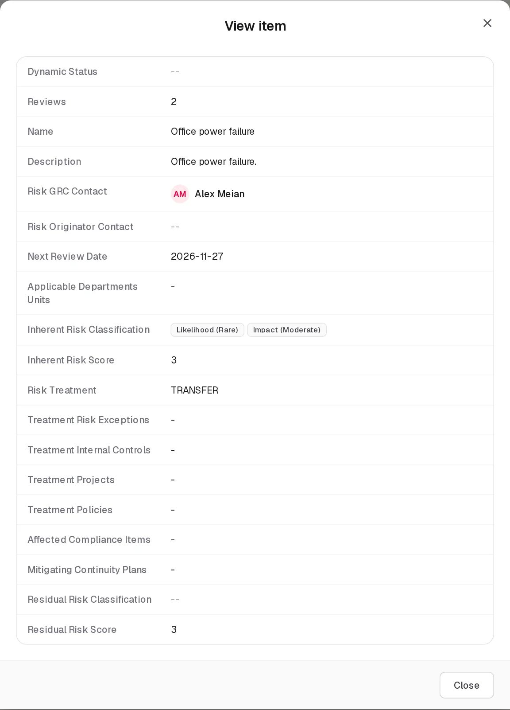
View Business Risk
Edit opens Edit Item (Business Risks). Saving recalculates both scores and the review schedule and shows “Operational risk updated.” Because Risk Originator Contact is required on the form, a demo risk without one cannot be saved until an originator is added.
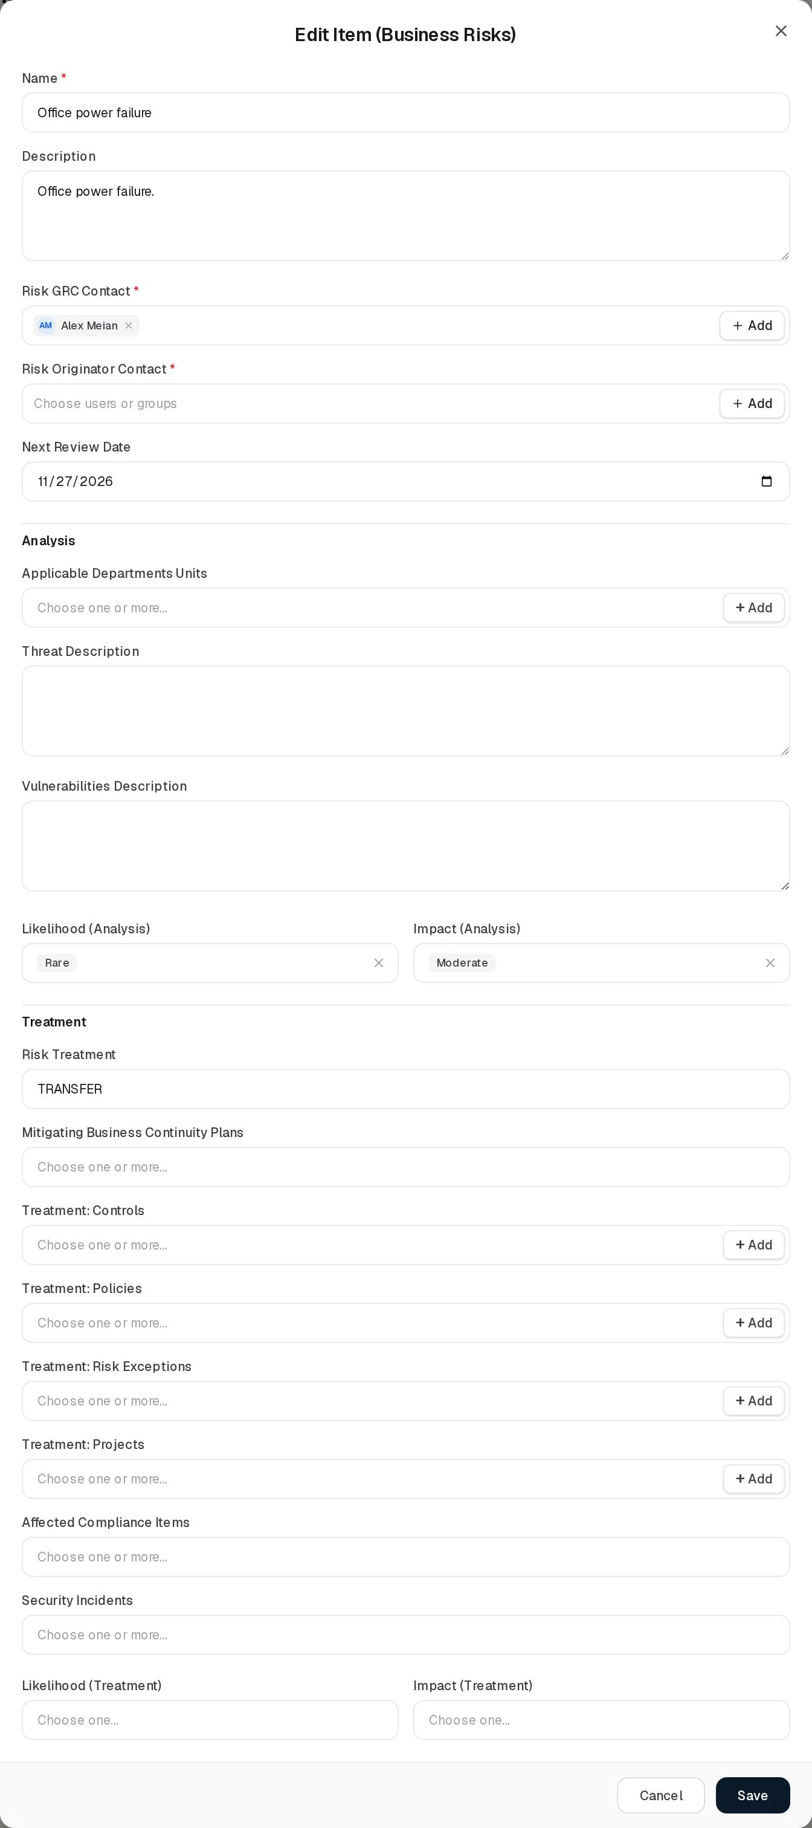
Edit Business Risk
The editing notes for Asset Risks apply here too. Delete asks “Delete business risk ?”, removes the risk and deletes its reviews; the confirmation message is “Operational risk deleted.”

Statuses
The same values as Asset Risks: the five Dynamic Status flags computed on read, the stored status (On Track, Review Due, Above Appetite, Exception Active, Closed) visible only in the linked-risk panel, and the API-only lifecycle status. See Asset Risks › Statuses. For Above Appetite the residual score of the treatment pair is compared with the appetite. There is no user-selectable Status field.

Tabs

Reviews
The Reviews tab lists the reviews of all business risks. It works exactly like the Asset Risks Reviews tab; the risk column and dropdown are labelled Business Risks.
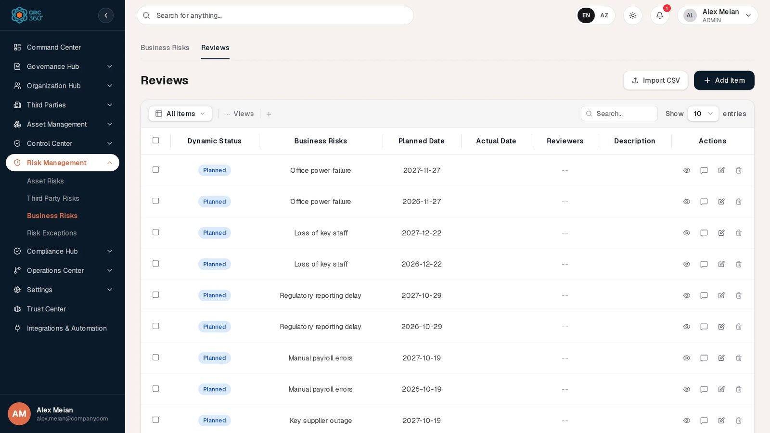
Business Risk reviews
Field | Type | Required | Rules | Example
Business Risks | Dropdown | Yes | “Choose the risk this review belongs to.”; + Add opens the Business Risks form | Loss of key staff
Planned Date | Date | No |  | 2026-12-22
Actual Date | Date | No | Marks the review Completed
Reviewers | Users or groups, several | No
Description | Long text | No
Add review
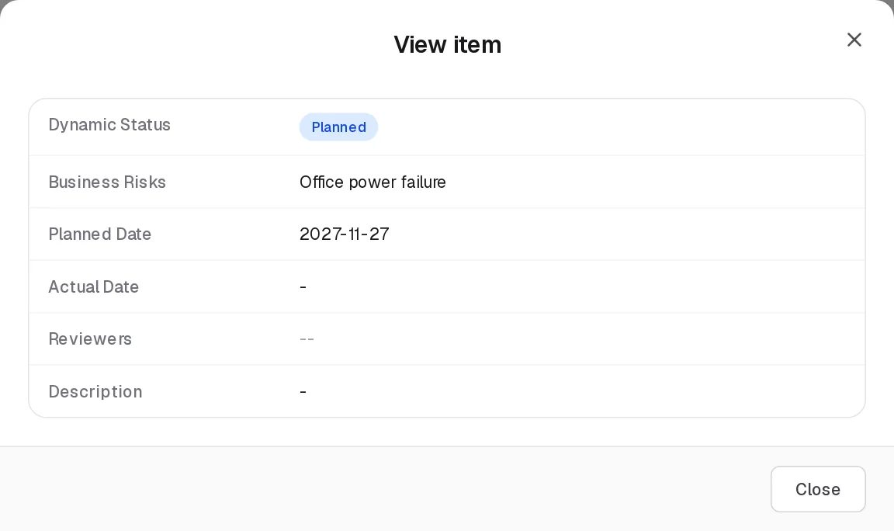
View review
Edit review
Example: “Regulatory reporting delay” has Next Review Date 29 Oct 2026, so it has reviews planned for 29 Oct 2026 and 29 Oct 2027. If the first is not completed by then, from 30 Oct 2026 it shows Expired and the risk shows Review Expired.

Relationships
Related record | Direction | How the link is made | Where it shows
Departments | Many to many, stored on the risk | Applicable Departments Units | Here (text). Departments register: Business Risks count (clickable). Members of these departments see the risk under department visibility.
Continuity Plans | Many to many, stored on the risk | Mitigating Business Continuity Plans | Here: Mitigating Continuity Plans
Controls | Many to many, stored on the risk | Treatment: Controls | Controls register: Business Risks count (clickable)
Policies & Standards | Many to many, stored on the risk | Treatment: Policies | Here only
Risk Exceptions | Many to many, one relation shown from both ends | Here, or Related Business Risks on the exception | Risk Exceptions: Related Business Risks count (clickable)
Projects | Many to many, stored on the risk | Treatment: Projects | Here only
Compliance requirements | Many to many, stored on the risk | Affected Compliance Items, or from Compliance Analysis | Compliance Analysis
Security Incidents | Many to many, stored on the risk | Security Incidents | Security Incidents register: Known Business Risk count (clickable)
Objectives | Many to many, stored on the objective | The objective’s form | Objectives register
Data Flows | Many to many, stored on the flow | The data flow’s form | Data Flows register
Reviews | One risk, many reviews | Generated or added on the tab | Reviews column and tab
Clicking a count in another register opens the linked-risk panel described in Asset Risks › Relationships.

Automations and notifications
The same as Asset Risks: scores, stored status and the review schedule on every save; Dynamic Status flags on every read; linked compliance requirements re-evaluated on save. No notification is sent for business risk events.

Permissions
Action | Needed access
See the page | View on Risk Management › Business Risks
Create, Edit | Manage on Risk Management › Business Risks
Delete | Full Control on Risk Management › Business Risks
Import CSV | Manage (the import does not work, see below)
Change the shared risk settings | Full Control on any of the three risk registers
Name other people as contacts | Can Assign / Can Reassign
Activity Log | The group’s Comments & Attachments level
Reviews tab | Its own level on Risk Management › Business Risks › Reviews
Record visibility: a group limited to its own records sees risks naming its member as Risk GRC Contact, Risk Originator Contact or reviewer; a group limited to its department also sees risks whose Applicable Departments Units include the member’s department.

How to

Record a business risk for a department
- Open Risk Management › Business Risks and click Add Item.
- Enter Name “Key supplier outage”, Risk GRC Contact and Risk Originator Contact.
- Under Applicable Departments Units choose the affected department.
- Choose Likelihood (Analysis) Possible and Impact (Analysis) Major (score 12).
- Choose Risk Treatment MITIGATE and the continuity plan under Mitigating Business Continuity Plans.
- Click Save. The department’s Business Risks count in Organization Hub › Departments increases.

Record the residual risk after treatment
- Edit “Manual payroll errors” (inherent 12). Add a Risk Originator Contact if it is empty.
- Set Likelihood (Treatment) Unlikely and Impact (Treatment) Minor.
- Save. Residual Risk Classification shows Likelihood (Unlikely) Impact (Minor) and Residual Risk Score 4.

Check which business risks a control treats
- Open Control Center › Controls.
- Click the Business Risks count of the control to open the linked risks.

CSV import
Import CSV shows “CSV Import (Business Risks): the import structure is not ready yet.” and then opens a demo dialog whose upload fails, so nothing is imported. The server’s /risk-management/operational-risks/import-csv (name or title, description) and /export-csv endpoints are not reachable from the page.

Limitations and known issues
- Import CSV does not work from the page; no Export button.
- Messages say “Operational risk added / updated / deleted” while the page is called Business Risks.
- The field label is Applicable Departments Units.
- Processes and the record’s own review fields exist on the record but not on the form.
- The demo risks have no Risk Originator Contact, so each must get one before it can be saved from the form.
- Nothing stops the treatment pair from scoring higher than the inherent pair.
- Scores are stored on save; the manual override is API-only and cleared by saving the form.

Risk Exceptions
Module: Risk Management › Risk Exceptions · Route: /risk-management/risk-exceptions · Permission key: risk_management.risk_exceptions
The Risk Exceptions register records decisions to accept a risk for a limited time instead of treating it, for example “Accept kiosk OS risk until refresh”. A record is one exception: who requested it, who in the GRC team is responsible, until when it applies, and which asset, third party or business risks it covers. The GRC team maintains it; risk owners request exceptions.
An exception and a risk are linked in one relation that can be edited from either end: from the exception’s Related … Risks fields, or from the risk’s Treatment: Risk Exceptions field.
Risk Exceptions register

At a glance
A record is | One time-limited acceptance of one or more risks
Typical owner | The GRC Contact
Links to | Asset Risks, Third Party Risks, Business Risks, users and groups
Linked from | Asset Risks, Third Party Risks, Business Risks (Treatment: Risk Exceptions)
Tabs | None
Automations | Start date and closure date stamped by the server; Dynamic Status computed on read; the hourly expiry job is implemented but not active in this release

The register (list view)
The page has Import CSV and Add Item above the grid. Search (Name and Description), Views, paging and row buttons are described in Working with registers.
Column | What it shows | Source
Dynamic Status | Pending, Active, Expired or Closed; rules under Statuses | Computed by the system
Name | Name of the exception | Entered
Description | Description | Entered
Status | The stored status: Open, Closed, or a value set through the API (Pending, Approved, Denied, Rejected, Revoked, Expired) | Entered
GRC Contact | Responsible users or groups (names) | Entered
Exception Requester Contact | Who asked for the exception (names) | Entered
Start Date | Day the exception was created, unless set otherwise through the API | Set by the system
Expiration Date | Last day the exception is meant to apply | Entered
Closure Date | Day the exception was closed | Set by the system
Related Asset Risks | Number of linked asset risks; click to open them | Linked
Related Third Party Risks | Number of linked third party risks; click to open them | Linked
Related Business Risks | Number of linked business risks; click to open them | Linked
The three Related columns count the risks named on the exception plus the risks that name the exception in their Treatment: Risk Exceptions. A count of 0 is plain text; any other count opens a panel with each linked risk in full (overview, analysis, treatment). These columns cannot be sorted.
Demo data: “Accept kiosk OS risk until refresh” (Status Approved, Dynamic Status Active, requester Mike Brown, expires 2027-02-11, covers the asset risk “Unsupported OS on kiosks”) and “Temporary shared admin on backup appliance” (Status Pending, Dynamic Status Pending, requester Sara Johnson, expires 2026-11-28).

Creating a record
Click Add Item. The dialog Add Item (subtitle Risk Exceptions) opens.
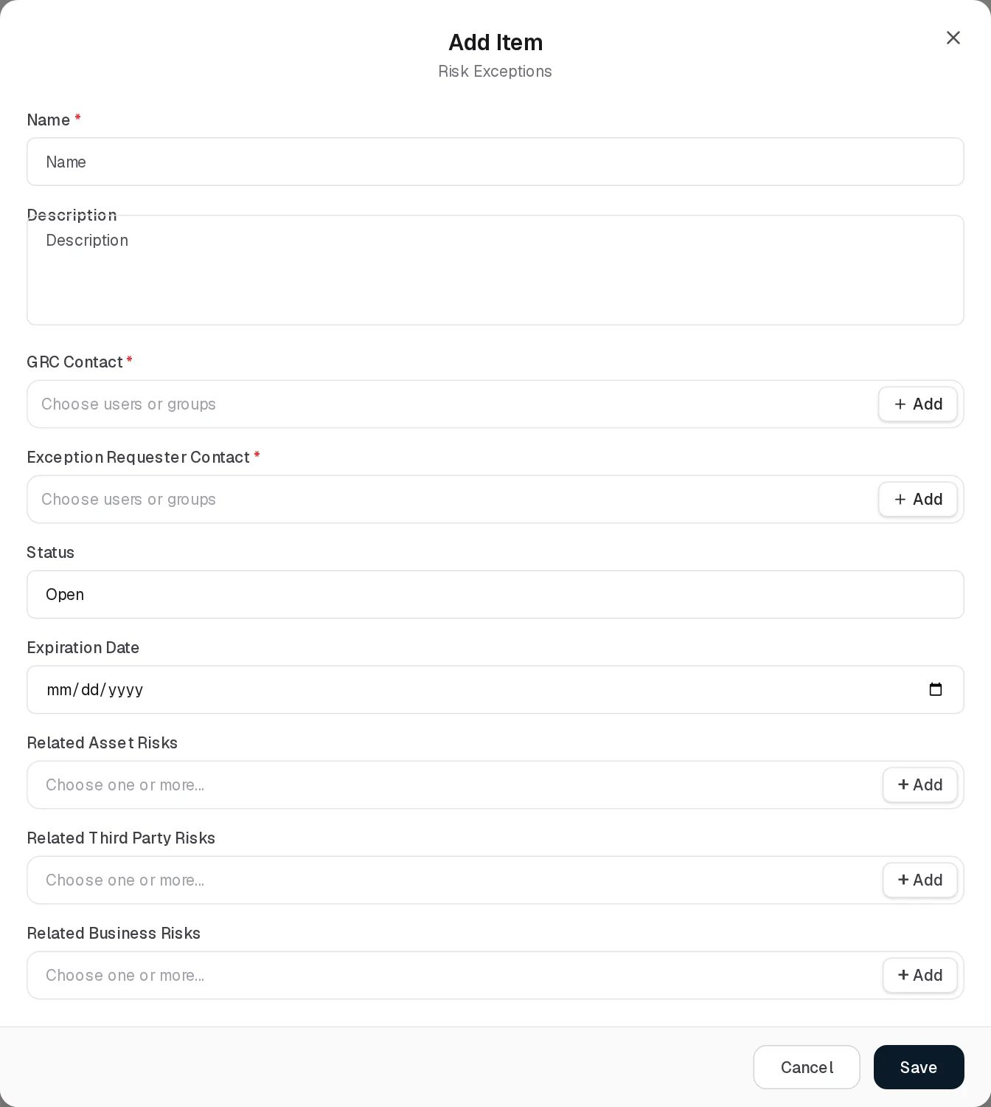
Add Risk Exception
Field | Type | Required | Rules and allowed values | Example
Name | Text | Yes | “Name is required” | Accept kiosk OS risk until refresh
Description | Long text | No |  | Risk accepted until Q2 hardware refresh.
GRC Contact | Users or groups, several | Yes | “At least one contact is required” | Alex Meian
Exception Requester Contact | Users or groups, several | Yes | “At least one requester is required” | Mike Brown
Status | Dropdown | No | Open (default), Closed | Open
Expiration Date | Date | No | 1900 to 2999 (“Enter a valid date between 1900 and 2999”); must not be before the start date (“Expiration date cannot be before start date”) | 2027-02-11
Related Asset Risks | Asset risks, several | No | Picker with + Add (opens the Asset Risks form) | Unsupported OS on kiosks
Related Third Party Risks | Third party risks, several | No | Picker with + Add
Related Business Risks | Business risks, several | No | Picker with + Add
The form has no Start Date field: the server sets it to the day the exception is created and keeps it on later edits. Linking a risk you are not allowed to see is refused.
On success the message “Risk exception added.” appears.

Viewing and editing a record
View opens View Item (subtitle Risk Exceptions) with Name, Description, GRC Contact, Exception Requester Contact, Status (the raw stored value, for example PENDING), Start Date, Expiration Date and the names of the related risks. It does not show the Dynamic Status or the Closure Date.
View Risk Exception
Edit opens Edit Item with the same fields as Add. Saving shows “Risk exception updated.”
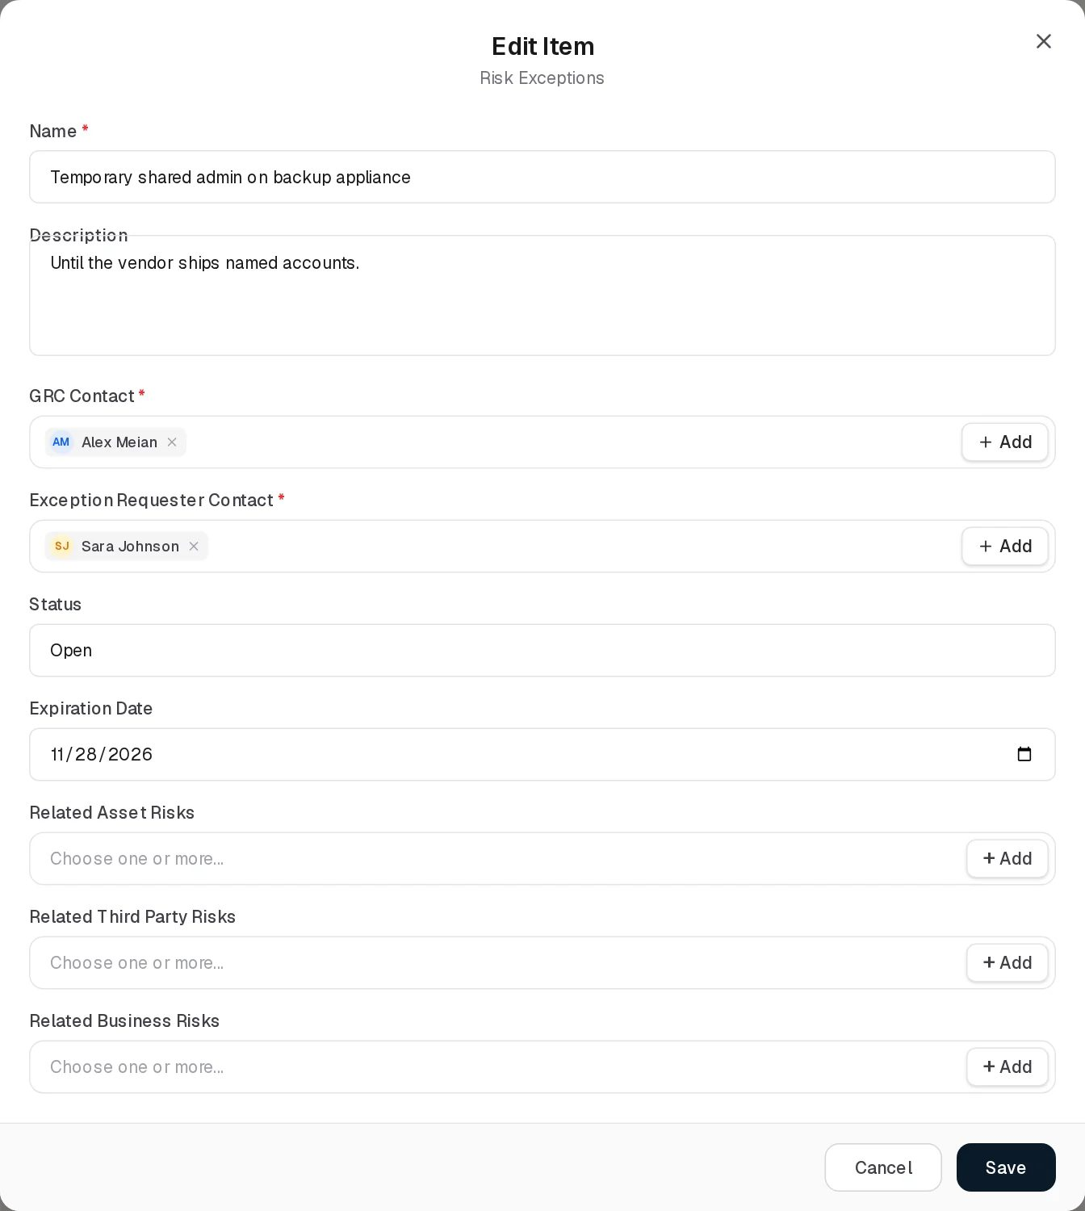
Edit Risk Exception
Points to know when editing:
- Status offers only Open and Closed. An exception whose stored status is Pending or Approved shows Open in the dropdown, as in the screenshot, but keeps its stored status when you save without touching the field.
- Choosing Closed stamps today’s date as the Closure Date; choosing Open again clears it.
- Removing a risk from a Related … Risks field also removes the exception from that risk’s Treatment: Risk Exceptions, even when the link was made from the risk’s side.
Delete asks “Delete risk exception ?”. Deleting the exception also takes it out of the Treatment: Risk Exceptions of every linked risk and updates those risks’ stored status.

Statuses
Status (stored). The form offers:
Value | Set by | Meaning
Open | User (default) | The exception is being carried
Closed | User | The exception is over; the Closure Date is stamped
The server knows further values that only the API sets: Pending (POST .../{id}/submit), Approved and Denied (.../approve, .../deny, with a decision reason; administrators only), Expired (the expiry job), and Rejected and Revoked. The interface has no buttons for submitting, approving or denying.
Dynamic Status (computed every time the register is read, in this order):
Value | Colour | Rule
Closed | Green | A Closure Date is set
Expired | Red | Status is Open, Pending or Approved and the Expiration Date is before today; or Status is Expired
Active | Green | Status is Approved and not expired
Pending | Amber | Status is Open or Pending and not expired
Closed | Green | Status is Denied, Rejected or Revoked
An Open exception therefore shows Pending until it expires. Example: “Temporary shared admin on backup appliance” expires on 28 Nov 2026; from 29 Nov 2026 it shows Expired without anyone editing it.

Tabs
None.

Relationships
Related record | Direction | How the link is made | Where it shows
Asset Risks | Many to many, one relation | Related Asset Risks here, or Treatment: Risk Exceptions on the risk | Here: Related Asset Risks count (clickable). Asset Risks: Treatment Risk Exceptions (names).
Third Party Risks | Many to many, one relation | Related Third Party Risks here, or on the risk | Here: count (clickable). Third Party Risks: Treatment Risk Exceptions.
Business Risks | Many to many, one relation | Related Business Risks here, or on the risk | Here: count (clickable). Business Risks: Treatment Risk Exceptions.
What a link does to the risk:
- While the risk lists the exception under Treatment: Risk Exceptions, the risk’s stored status is Exception Active.
- When such an exception passes its Expiration Date without a Closure Date, the risk shows the Exception Expired flag.
- When an exception is approved through the API, its risk links move to the risks’ Treatment: Risk Exceptions. When it is denied, expired by the job or deleted, it is removed from the risks’ treatment but stays listed here, so this register still shows what it covered.
- Closing an exception with the form does not remove it from the risks’ treatment; remove it on the risk if it no longer applies.

Automations and notifications
Automation | Schedule | State in this release
Start Date stamp | On creation | Active
Closure Date stamp | When Status is set to Closed | Active
Dynamic Status | Every read | Active: Expired appears the day after the Expiration Date
Automatic expiry (RiskExceptionScheduler) | Hourly | Implemented but not active in this release. The backend does not enable scheduled jobs. If it ran, it would set every Open, Pending or Approved exception whose Expiration Date is today or earlier to Expired, remove it from the linked risks’ treatment and update their status. The same action exists as POST /risk-management/risk-exceptions/expire-due, which the interface does not call.
ExceptionExpirationJob | Nightly | Not related to this register (it handles exception requests in the issue module) and also not active.
Because the expiry job does not run, the stored Status of an expired exception stays Open, Pending or Approved; only the Dynamic Status shows Expired. No notification is sent when an exception is created, nears its expiration date or expires.

Permissions
Action | Needed access
See the page | View on Risk Management › Risk Exceptions
Create, Edit | Manage on Risk Management › Risk Exceptions
Delete | Full Control on Risk Management › Risk Exceptions
Import CSV | Manage (the import does not work, see below)
Link a risk | You must be able to see that risk in its own register
Approve or deny (API only) | Administrators
Activity Log | The group’s Comments & Attachments level
Risk exceptions have no assignment rights and no record-level visibility: everyone with access to the page sees every exception. See Permissions and access.

How to

Record an accepted risk
- Open Risk Management › Risk Exceptions and click Add Item.
- Enter Name “Accept legacy kiosk OS”, a Description, GRC Contact Alex Meian and Exception Requester Contact Mike Brown.
- Set Expiration Date to the planned end, for example 11 Feb 2027.
- Under Related Asset Risks choose “Unsupported OS on kiosks”.
- Click Save. The Related Asset Risks column shows 1; click it to see the risk.

Close an exception early
- Click Edit on the exception and set Status to Closed.
- Click Save. Closure Date shows today and Dynamic Status Closed.
- Open the linked risk and remove the exception from Treatment: Risk Exceptions if it still appears there.

Find exceptions that have run out
- Open the register and look at the Dynamic Status column for Expired.
- For each, either set a new Expiration Date (renewal) or set Status to Closed.
- In the risk registers, risks still carrying the exception in their treatment show Exception Expired until you do so.

CSV import
Import CSV shows “CSV Import (Risk Exceptions): the import structure is not ready yet.” and then opens a demo dialog whose upload fails. There is no import or export for risk exceptions on the server either.

Limitations and known issues
- The automatic expiry job does not run; the stored Status of an expired exception is not changed.
- Submitting, approving and denying exist only in the API; the form offers only Open and Closed, and shows Open for a Pending or Approved exception.
- The View Item dialog shows the raw status (for example PENDING) and omits Dynamic Status and Closure Date.
- Closing an exception through the form leaves it in the linked risks’ treatment, so those risks stay Exception Active.
- An Open exception reads Pending in Dynamic Status.
- The Description label overlaps the top of its text box in the Add and Edit forms.
- Import CSV does not work.

Compliance Hub
Module: Compliance Hub · Route: /compliance-hub (opens Compliance Packages) · Permission module: compliance_hub
The Compliance Hub holds the frameworks, laws and standards your organisation must meet, breaks each one down into individual requirements, and records how every requirement is met: which controls, policies and projects satisfy it, which risks put it at stake, which exceptions excuse it and which audit findings show it is broken. It also holds a separate register of legal obligations and a register of findings raised by external auditors.
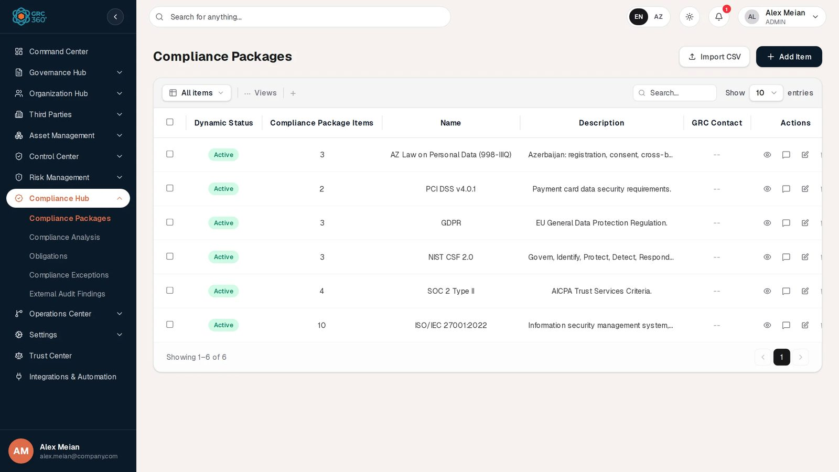
Compliance Packages register

Pages
Page (sidebar label) | Route | Permission key | What it holds
Compliance Packages | /compliance-hub/frameworks | compliance_hub.frameworks | One record per framework, law or standard. Clicking a package opens its requirement items.
Compliance Packages › Items | same route, after clicking a package | compliance_hub.frameworks_items | The chapters and requirement items of one package.
Compliance Analysis | /compliance-hub/assessments | compliance_hub.assessments | One row per requirement item: the compliance strategy (Compliant, Not Applicable, Not Compliant) and everything linked to the requirement.
Obligations | /compliance-hub/obligations | compliance_hub.obligations | Legal and regulatory obligations (law, article, authority) with a recorded compliance status and a next audit date.
Compliance Exceptions | /compliance-hub/compliance-exceptions | compliance_hub.compliance_exceptions | Time-limited, accepted non-compliance with one or more requirement items.
External Audit Findings | /compliance-hub/audit-findings | compliance_hub.audit_findings | Findings raised by external auditors, the requirement items they affect, and evidence attachments.
Opening /compliance-hub without a page redirects to Compliance Packages.

The compliance model

Frameworks are not pre-loaded
GRC360 does not ship framework content. A new organisation starts with an empty Compliance Packages register. Your team creates each package (for example ISO/IEC 27001:2022) and then fills it with requirement items, either one by one with Add Item on the package’s items page or from a CSV file with Import CSV on that page. The demo data used in this guide contains six packages created this way: ISO/IEC 27001:2022 (10 items), SOC 2 Type II (4), NIST CSF 2.0 (3), GDPR (3), PCI DSS v4.0.1 (2) and AZ Law on Personal Data (998-IIIQ) (3).

Package, chapters, requirement items
- A compliance package is the framework itself: name, description, GRC contact.
- A chapter is not a record of its own. Every requirement item carries a Chapter ID, Chapter Name and Chapter Description, and the items page builds its list of chapters from the items already in the package. Choosing an existing chapter when adding an item copies those three values onto the new item.
- A requirement item (shown in the UI as a Compliance Package Item) is one requirement: Item ID (for example A.8.5), Item Name, Item Description and Item Additional Information. The Item ID must be unique inside its package.

How the other records attach to a requirement item
Everything in the Hub, and several records in other modules, attaches at the level of the requirement item. The link is stored in different places depending on who owns it, but every link is visible on the item’s row in Compliance Analysis and editable from its Edit Action dialog.
Attached record | Where the link is stored | Where you make it
Controls (Control Center) | On the Compliance Analysis row (Internal Controls) | Compliance Analysis › Edit Action › Treatment tab. Saving also adds the package to the control’s own Compliance Package field.
Policies & Standards (Control Center) | On the Compliance Analysis row (Policies) | Edit Action › Treatment. Saving also adds the package to the policy’s Compliance Package field.
Projects (Operations Center) | On the Compliance Analysis row (Projects) | Edit Action › Treatment. The project’s Compliance Package column is derived from these links.
Asset, Third Party and Business Risks | On the risk (Affected Compliance Items) | The risk’s own form, or Edit Action › Asset Risks tab (writes back to the risk).
Compliance Exceptions | On the exception (Related Compliance Items, several allowed) | The exception’s form, or Edit Action › Treatment › Compliance Exception (writes back to the exception).
External Audit Findings | On the finding (Affected Compliance Items, several allowed) | The finding’s form, or Edit Action › General › Findings (writes back to the finding).
Obligations | An obligation-to-requirement mapping exists in the backend (POST /compliance/obligations/{id}/map-requirements) but no screen uses it. | Not available in the UI.

What Compliance Analysis computes
Every requirement item gets a row on the Compliance Analysis page automatically. When the first item is added to a package (by hand or by CSV import), the system creates a standing assessment for that package called Compliance Analysis and gives it one row per item; every later item gets its row the moment it is saved. A start-up job also fills in rows for packages that predate this behaviour. Each new row starts with the strategy Under Review, which the grid shows as -- (not judged yet).
For each row the system computes or derives:
What | Rule
Compliance Strategy | Set by a person (Compliant, Not Applicable, Not Compliant). Overridden by the system to Not Compliant when a linked risk sits above the risk appetite. When a linked risk is saved, every row of the requirements it names is re-derived: Not Compliant if any linked risk is above appetite, otherwise Compliant. Rows marked Not Applicable are never changed by a risk.
Dynamic Status | One amber marker per lapse found behind the row’s linked controls: Control Last Audit Expired (a control audit planned before today that is not completed), Asset Risk Review Expired, Third Party Risk Review Expired, Business Risk Review Expired (a risk treated by one of those controls whose next review date is in the past). -- when nothing has lapsed.
Compliance percentage (Assessment summaries) | (Compliant + 0.5 × Partially Compliant) ÷ (all rows − Not Applicable rows) × 100, rounded to one decimal. Not Applicable rows are left out of the denominator. 0 when no row applies.
The same strategy counts feed the Trust Center’s per-framework posture (compliant items out of total items, for packages that are not deleted).

Statuses at a glance
Register | Status a person sets | Dynamic Status the system shows
Compliance Packages | None in the form (the stored status is always Active) | Active while the package is switched on, Inactive otherwise. The form has no switch, so packages always read Active.
Compliance Analysis | Compliance Strategy | Expiry markers (see above)
Obligations | Compliance Status | Current, Needs Review (next audit date in the past), Missing Date
Compliance Exceptions | Status (Open, Closed) | Closed, Expired, Active (approved and not expired), Pending (any other open state)
External Audit Findings | Status (Open, Closed) | Closed, Resolved, Overdue (due date in the past), otherwise the status itself
Details and the exact rules are on each page and in Status and Dynamic Status rules.

Automations
- Analysis rows: created automatically for every new requirement item (see above). Not a scheduled job; it happens when the item is saved, and once at application start-up for older packages.
- Strategy from risks: re-derived whenever an Asset, Third Party or Business Risk that names requirement items is saved.
- Exception expiry job: an hourly job that would set past-due exceptions to Expired is implemented but not active in this release (scheduling is not enabled in the backend). The Dynamic Status of an exception still shows Expired as soon as its expiration date passes, because it is computed every time the register is read.
- Notifications: the Compliance Hub sends none. The notification type COMPLIANCE_REMINDER exists but nothing produces it.

Permissions
Each page, and the Items section of Compliance Packages, has its own access level in the group settings (No Access, View, Manage, Full Control), plus the group’s Comments & Attachments level. See Permissions and access. Buttons you may not use stay visible but locked; clicking one opens Request Access. The built-in Third Party group has View and edit rights on Compliance Analysis only, limited to its own records.

Shared behaviour
Search, Views (column visibility), paging, the selection toolbar, the View dialog, comments in the Activity Log and the delete confirmation work the same way on every register; see Working with registers.

Related pages
- Controls and Policies & Standards: Compliance Package column.
- Asset Risks, Third Party Risks, Business Risks: Affected Compliance Items.
- Projects: Compliance Package column.
- Trust Center: public per-framework compliance posture.
- Scenario: preparing for an ISO/IEC 27001 audit.

Compliance Packages
Module: Compliance Hub › Compliance Packages · Route: /compliance-hub/frameworks · Permission key: compliance_hub.frameworks (items: compliance_hub.frameworks_items)
A compliance package is a framework, law or standard your organisation has to meet, such as ISO/IEC 27001:2022, SOC 2 Type II or the Azerbaijani Law on Personal Data. Each package holds its requirements as compliance package items, grouped by chapter. GRC360 ships no framework content: the compliance team creates the packages and loads their items, by hand or from a CSV file. Once items exist, each one gets a row on the Compliance Analysis page, which is where compliance is actually judged.
The page has two levels: the list of packages, and, after you click a package, the list of its items.
Compliance Packages register

At a glance
A record is | One framework, law or standard (package); one requirement of it (item)
Typical owner | Compliance manager or GRC officer (the package’s GRC Contact)
Links to | GRC contacts (users or groups)
Linked from | Compliance Analysis rows, Compliance Exceptions, External Audit Findings, risks (Affected Compliance Items), Controls and Policies & Standards (Compliance Package), Projects (derived), Trust Center posture
Tabs | None in the dialog. The package’s items open as a second page: Compliance Package Items - (permission section Items)
Automations | Every item saved or imported gets a Compliance Analysis row automatically. Dynamic Status is computed on read.

The register (list view)
The packages grid is loaded in one request and sorted, searched and filtered in the browser. It opens with the newest package first (in the demo data ISO/IEC 27001:2022, created first, is at the bottom). The shared grid behaviour (search, Views, paging, selection, comments) is described in Working with registers. Clicking anywhere on a row (outside the checkbox and the action buttons) opens that package’s items.
Column | What it shows | Source
Dynamic Status | Active (green) when the package is switched on, Inactive (grey) when it is not. See Statuses. | Computed by the system
Compliance Package Items | Number of live (not deleted) requirement items in the package, for example 10 for ISO/IEC 27001:2022 | Computed
Name | Package name | Entered
Description | First part of the description; hover to read the rest | Entered
GRC Contact | The package’s GRC contacts, comma-joined | Linked (users or groups)
Header buttons: Import CSV and Add Item. On this level Import CSV is not wired to a real import: it shows the message “CSV Import (Compliance Packages): the import structure is not ready yet.” and then a demonstration dialog whose Validate fails. Items are imported on the package’s own items page instead (see CSV import).

Creating a record
Click Add Item. The dialog Add Item (Compliance Packages) opens on a single General tab.
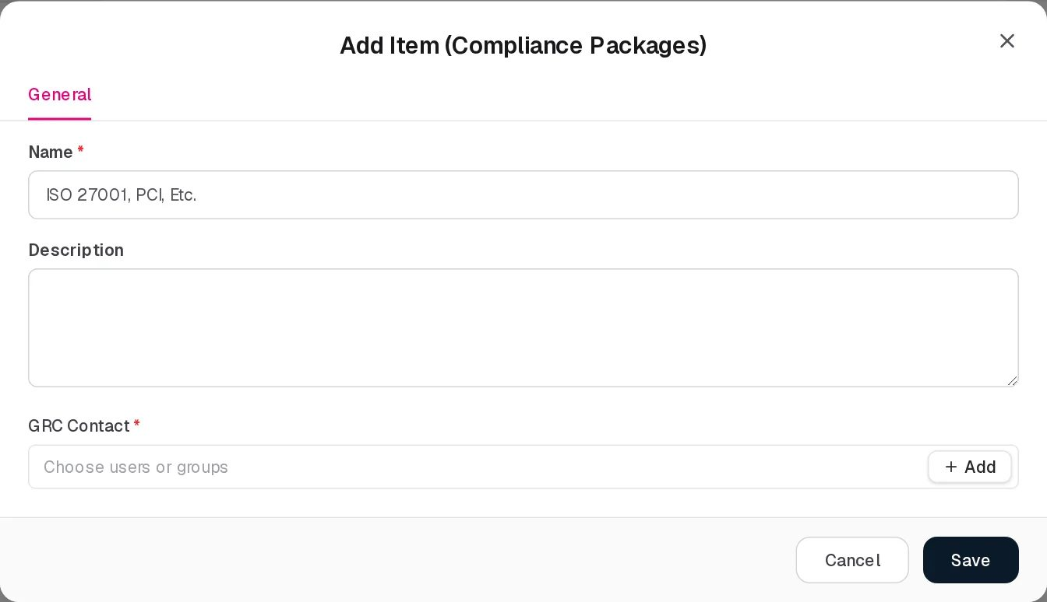
Add Compliance Package
Field | Type | Required | Rules and allowed values | Example
Name | Text | Yes | Must not be empty (“Name is required.”). Must be unique among the organisation’s packages, ignoring case; a duplicate is refused with “Compliance package with name ‘’ already exists”. Placeholder: ISO 27001, PCI, Etc. | ISO/IEC 27001:2022
Description | Multi-line text | No | Free text | Information security management system, Annex A controls.
GRC Contact | User/group picker, several allowed | Yes (in the form) | At least one (“GRC Contact is required.”). Users and groups can both be chosen. The backend itself does not require it. | Alex Meian
The form has no Active switch and no status field. Every package is saved as active, with stored status Active and version 1.0.
The same dialog opens from the + Add button next to a package picker elsewhere (for example on the External Audit Findings form), and the new package is selected there straight away.

Viewing and editing a record
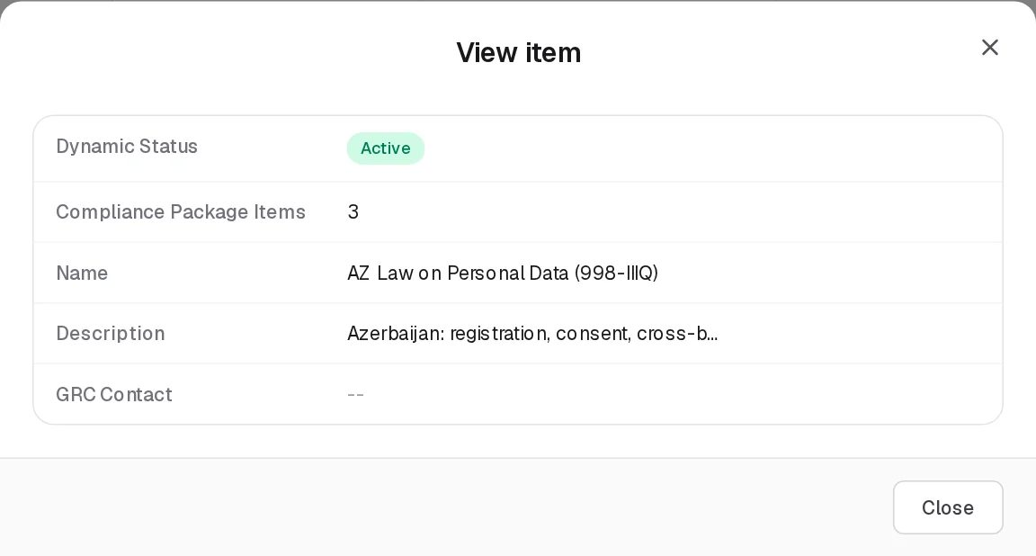
View Compliance Package
The View button (eye icon) opens the read-only dialog View item with the grid’s five columns, including the shortened description. Edit opens Edit Item (Compliance Packages) with the same three fields as Add, filled in.
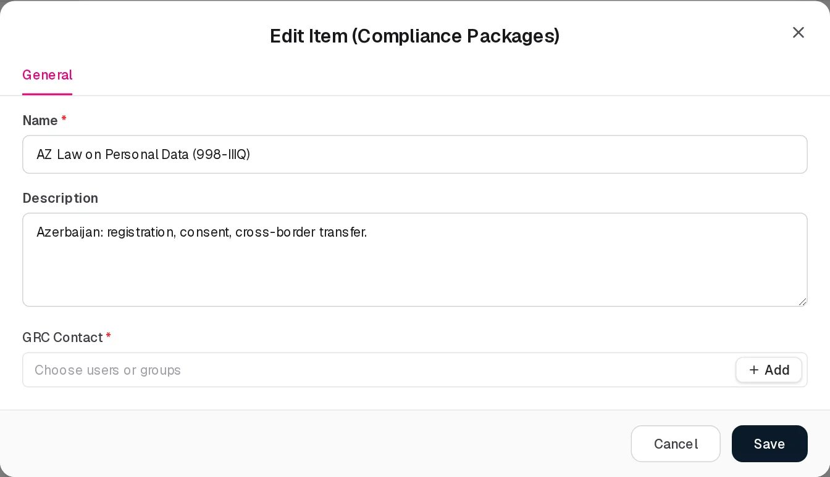
Edit Compliance Package
Delete asks “Delete ?” with the note “Its requirement items will be removed from the Hub as well.” The package is soft-deleted: it disappears from this grid and from every package picker. Its items are not deleted themselves (see Limitations).

Statuses
Value | Set by | Meaning
Active | System (Dynamic Status) | The package is switched on. This is the value for every package created from the UI. Green.
Inactive | System (Dynamic Status) | The package’s active flag is off. The UI has no control for this flag, so a package only reads Inactive if it was switched off through the API. Grey.
There is no user-selectable status. The packages list keeps a stored status (Active) that is not shown as a column; it only feeds the grid’s status filter, where the choice is All items or ACTIVE.

Tabs
The Add and Edit dialogs have a single General tab. The package’s requirement items are not a tab but a second page, opened by clicking a package; it is described in Compliance Package Items below and has its own permission section Items.

Compliance Package Items (the requirements of one package)
Click a package row. The page is replaced by the grid Compliance Package Items - , with a Back to Compliance Packages link above it. This grid is the permission section Items of Compliance Packages (frameworks_items).
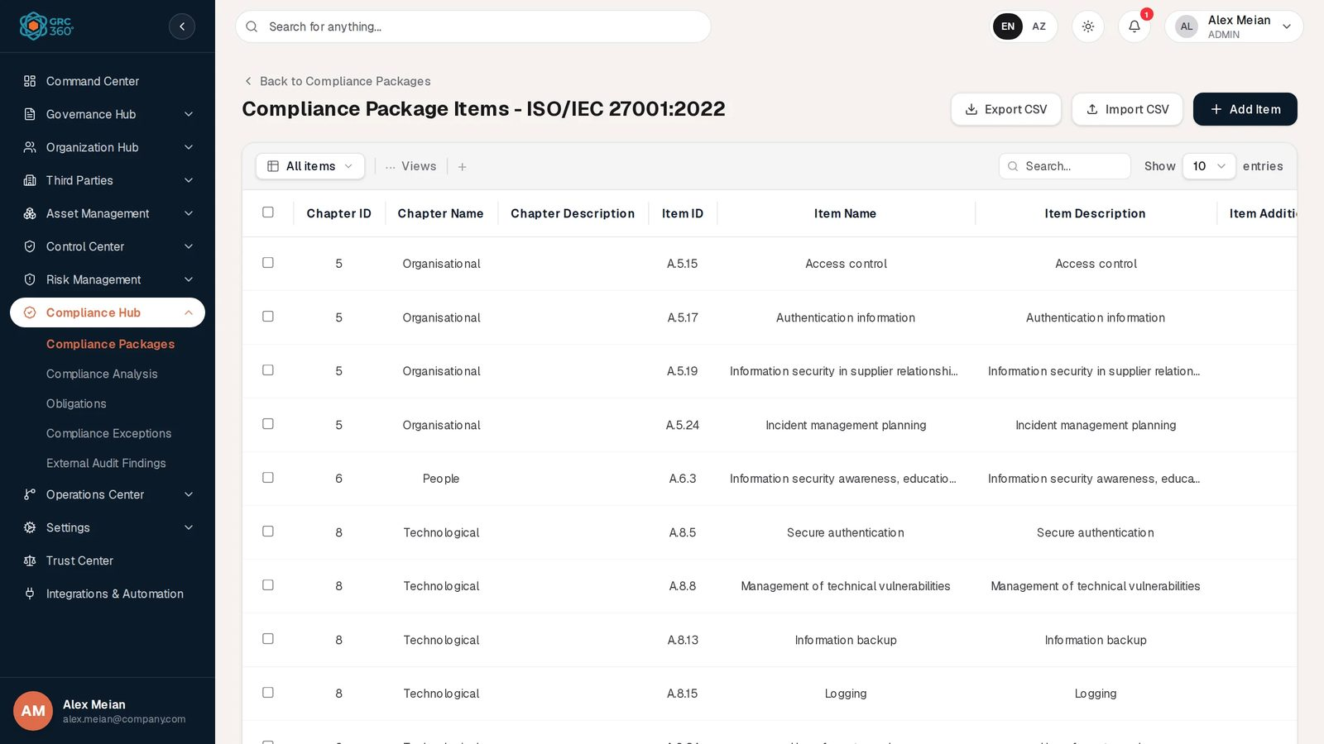
Compliance Package Items of ISO/IEC 27001:2022
Items are listed in their stored sort order (the order in which they were loaded).
Column | What it shows | Source
Chapter ID | Chapter identifier, for example 5 | Entered
Chapter Name | For example Organisational | Entered
Chapter Description | Chapter text, often empty | Entered
Item ID | Requirement identifier, for example A.5.15 | Entered
Item Name | For example Access control | Entered
Item Description | First part of the requirement text; hover for the rest | Entered
Item Additional Information | Extra guidance | Entered
Header buttons: Export CSV, Import CSV, Add Item.

Adding an item
Click Add Item. The dialog Add Item (Compliance Package Items - ) opens on a General tab.
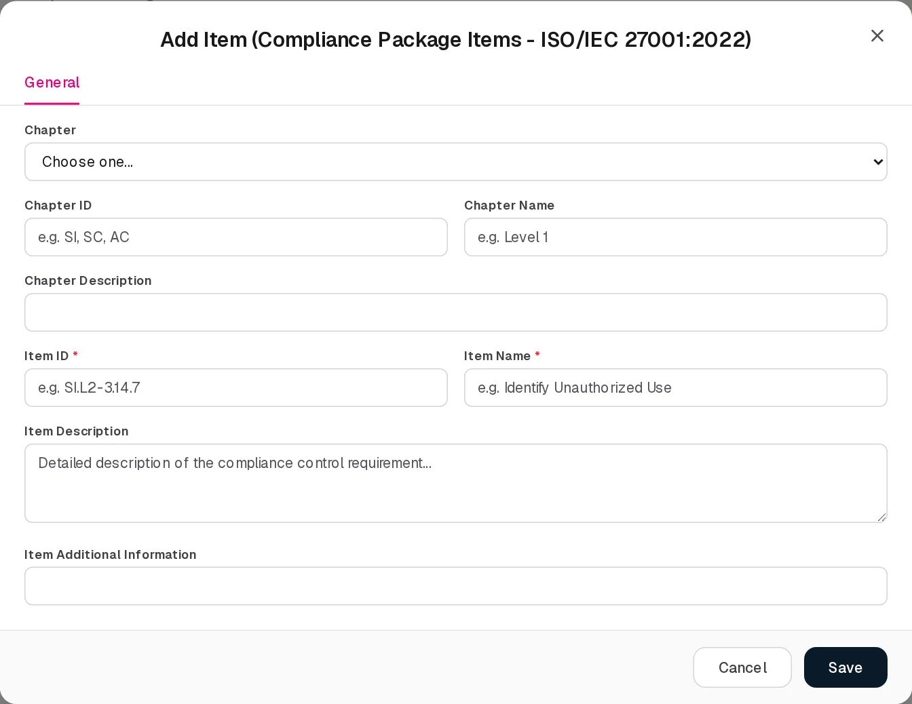
Add Compliance Package Item
Field | Type | Required | Rules and allowed values | Example
Chapter | Dropdown | See rule | Choose one… or one of the chapters already used in this package, shown as “ — ”. Choosing one hides the three chapter fields below and copies the chapter’s ID, name and description onto the item. | 5 — Organisational
Chapter ID | Text | One of Chapter ID or Chapter Name, when no chapter is chosen | Shown only when Chapter is Choose one…. Placeholder e.g. SI, SC, AC. Error when both ID and name are empty: “Choose an existing chapter, or fill in the new chapter’s ID and name.” | 8
Chapter Name | Text | See Chapter ID | Shown only for a new chapter. Placeholder e.g. Level 1 | Technological
Chapter Description | Text | No | Shown only for a new chapter
Item ID | Text | Yes | “Item ID and Item Name are required.” Must be unique inside the package, ignoring case: “Item number ‘’ already exists in package”. Placeholder e.g. SI.L2-3.14.7 | A.8.5
Item Name | Text | Yes | See Item ID. Placeholder e.g. Identify Unauthorized Use | Secure authentication
Item Description | Multi-line text | No | Placeholder Detailed description of the compliance control requirement… | Secure authentication
Item Additional Information | Text | No | Free text
There is no field for sort order or category; new items are saved with sort order 0 and active. Saving shows “Requirement item added.” and, in the same step, creates the item’s row on Compliance Analysis with strategy Under Review.

Viewing, editing and deleting an item
View Compliance Package Item
View opens View item with the item’s seven columns, read-only. Edit opens Edit Item (Compliance Package Items - ) with the item’s own chapter already selected in Chapter; picking another chapter moves the item to it.
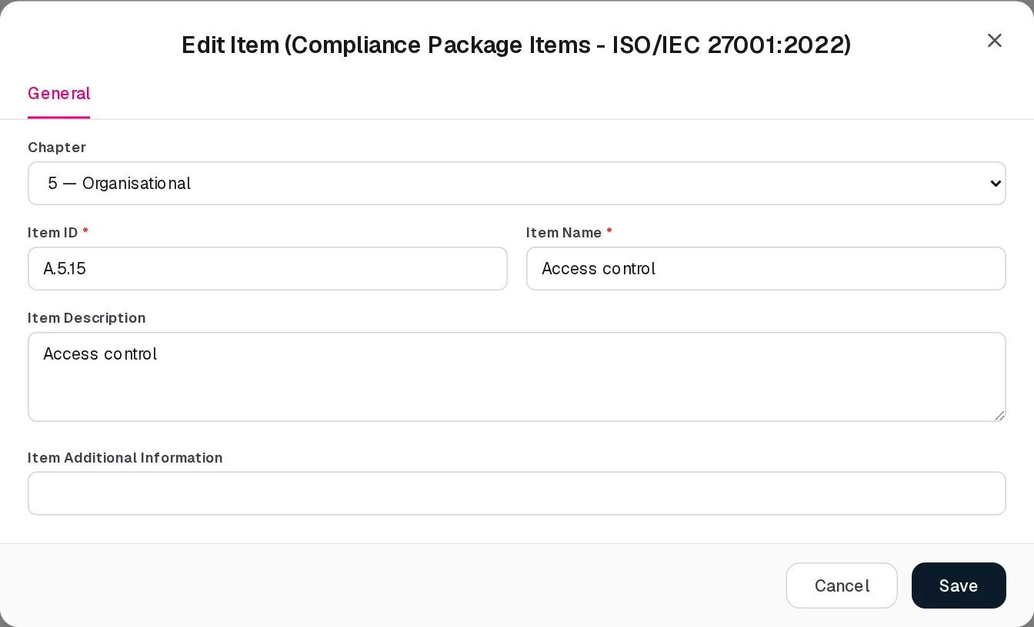
Edit Compliance Package Item
Delete asks “Delete ?” and soft-deletes the item. The package’s item count drops by one.

Relationships
Related record | Direction | How the link is made | Where it shows
Requirement items | Package → items, one to many | Add Item or Import CSV on the items page | Compliance Package Items column (count, not clickable); items page
GRC Contact (users, groups) | Package → people, many | Package form | GRC Contact column
Compliance Analysis rows | Item → row, one per item in the package’s standing analysis | Automatic when the item is saved or imported | Compliance Analysis, framework selector shows “ ()”
Controls, Policies & Standards | Package ← control/policy, many to many | On the control or policy form (Compliance Package), or automatically when a control or policy is linked to one of the package’s items in Compliance Analysis | Compliance Package column on Controls and Policies & Standards
Projects | Package ← project, derived | A project linked to one of the package’s items in Compliance Analysis | Compliance Package column on Projects
Compliance Exceptions | Item ← exception, many to many; package ← exception, one | Exception form (Related Compliance Items); the package is taken from the first item picked | Compliance Exceptions
External Audit Findings | Item ← finding, many to many | Finding form (Affected Compliance Items) | External Audit Findings
Risks (Asset, Third Party, Business) | Item ← risk, many to many | Risk form (Affected Compliance Items) | Risk registers; Compliance Analysis Edit Action › Asset Risks
Trust Center | Package → public posture | Automatic | Trust Center framework list (compliant items / total items)

Automations and notifications
- Compliance Analysis rows: when an item is added (form or CSV import, not a dry run), the system makes sure the package has its standing assessment named Compliance Analysis and that every live item has a row in it. Existing rows keep their strategy and links. The same check runs for every package each time the application starts.
- Dynamic Status is computed every time the list is read.
- No scheduled jobs and no notifications concern this page.

Permissions
Action | Needed access
See the page and open a package’s items | View on Compliance Hub › Compliance Packages (the items page also needs View on the Items section to load its rows)
Create / Edit a package | Manage on Compliance Hub › Compliance Packages
Delete a package | Full Control on Compliance Hub › Compliance Packages
Create / Edit an item | Manage on Compliance Packages › Items
Delete an item | Full Control on Compliance Packages › Items
Import items (Import CSV on the items page) | Manage on Compliance Packages › Items (import right of the section)
Export items (Export CSV on the items page) | View on Compliance Packages (the export right belongs to the package page, not to the Items section)
Comments on a package / on an item | Comments & Attachments level of the group; package comments are kept under Compliance Packages, item comments under its Items section
Locked buttons stay visible and open Request Access. See Permissions and access.

How to

Create a framework and its first chapter
- Open Compliance Hub › Compliance Packages and click Add Item.
- Enter Name NIST CSF 2.0, a Description, and pick yourself under GRC Contact. Click Save.
- Click the new row. The page shows Compliance Package Items - NIST CSF 2.0.
- Click Add Item. Leave Chapter on Choose one…, enter Chapter ID PR and Chapter Name Protect.
- Enter Item ID PR.AA-01 and Item Name, then Save. The item now also appears on Compliance Analysis under NIST CSF 2.0.

Add another requirement to an existing chapter
- Open the package (for example ISO/IEC 27001:2022) and click Add Item.
- In Chapter choose 8 — Technological. The chapter fields disappear.
- Enter Item ID A.8.16 and Item Name Monitoring activities, then Save.

Load a whole framework from a spreadsheet
- Prepare a CSV file with the header chapterId,chapterName,chapterDescription,itemNumber,itemName,itemDescription,itemAdditionalInfo,category and one requirement per row (see CSV import).
- Open the package and click Import CSV. Dismiss the notice “the import structure is not ready yet”; the import dialog opens anyway.
- Choose the file and click Validate. Check Total Rows, Valid and Errors.
- Click Import rows. The item count on the packages list and the framework selector on Compliance Analysis update.

Export a package’s requirements
- Open the package and click Export CSV.
- The browser downloads <package name>-items.csv with the same eight columns the import accepts.

CSV import
Available on the items page of a package only (POST /api/v1/compliance/packages/{id}/import, with a dry run first).
Column (position) | Required | Notes
1 chapterId | No
2 chapterName | No
3 chapterDescription | No
4 itemNumber | Yes | Must not already exist in the package (case-insensitive)
5 itemName | Yes
6 itemDescription | No
7 itemAdditionalInfo | No
8 category | No | Stored, not shown anywhere in the UI
The first line is always skipped as a header. A row with fewer than five columns fails with “Row n: Invalid column count. Requires chapterId,chapterName,chapterDescription,itemNumber,itemName”; an empty Item ID or name fails with “Row n: Item number and name cannot be empty”; a duplicate fails with “Row n: Item number ‘’ already exists in package”. Quoted fields are supported. Imported items get sort order 0.
Export (GET /api/v1/compliance/packages/{id}/export) writes the same eight columns for the live items. On the packages list itself, Import CSV only opens the demonstration dialog and does not import anything.

Limitations and known issues
- Deleting a package does not delete its items. The confirmation says the items “will be removed from the Hub as well”, but only the package is flagged as deleted. Its Compliance Analysis rows are still returned when All frameworks is selected on Compliance Analysis, and its items remain selectable in the Compliance Exceptions item picker, which is built from those rows.
- Deleting an item does not remove its Compliance Analysis row. The row keeps showing the deleted item until it is removed on Compliance Analysis.
- No Active switch. The Dynamic Status column can only ever show Active for packages managed from the UI.
- Import CSV on the packages list is a demonstration dialog only; use the items page.
- No sort-order field. Items added by hand or by import get sort order 0, so their position relative to other items with the same sort order is not guaranteed.
- GRC Contact is required by the form but not by the backend; packages created through the API or the demo data may show an empty GRC Contact cell (all six demo packages do).

Compliance Analysis
Module: Compliance Hub › Compliance Analysis · Route: /compliance-hub/assessments · Permission key: compliance_hub.assessments
Compliance Analysis is where each requirement of a framework is judged. It lists one row per requirement item of the selected compliance package, with the compliance strategy recorded for it (Compliant, Not Applicable, Not Compliant) and the controls, policies and projects that satisfy it. The Edit Action dialog of a row also links the requirement to audit findings, compliance exceptions and risks. Compliance managers and control owners work here when preparing for or responding to an audit.
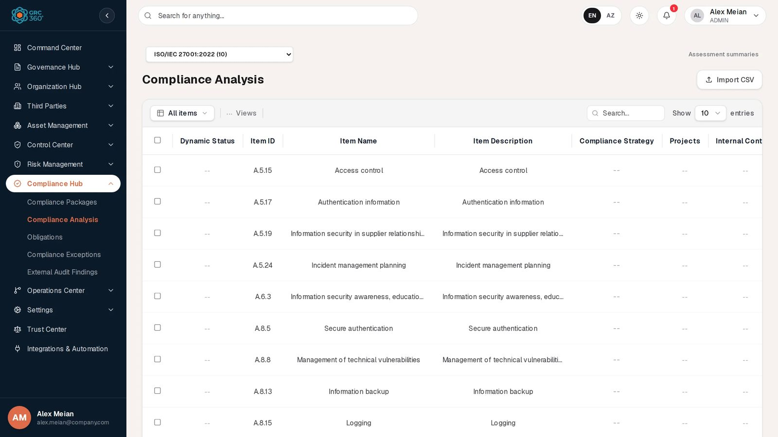
Compliance Analysis

At a glance
A record is | One requirement item as judged in one assessment (an assessment item). Every package has one standing assessment named Compliance Analysis that holds a row for each of its items.
Typical owner | Compliance manager; the row’s Owner
Links to | Controls, Policies & Standards, Projects (stored on the row); Asset, Third Party and Business Risks, Compliance Exceptions, External Audit Findings (stored on those records, edited from here)
Linked from | Compliance Packages (each item creates its row); Trust Center (posture); Projects (Compliance Package column)
Tabs | None on the page. The Edit Action dialog has four tabs: Compliance Item Details, General, Treatment, Asset Risks
Automations | Rows created automatically for every requirement item; strategy forced to Not Compliant by risks above appetite; Dynamic Status expiry markers computed on read

How the page is organised
- Framework selector (top left): All frameworks or one package, shown as “ ()”. The page opens on the first package in the list rather than on All frameworks. Changing the selection closes any open assessment.
- Assessment summaries (top right link): shows or hides a second grid with one row per assessment of the selected framework (see Assessment summaries). Hidden when the page opens; the link then reads Hide assessment summaries.
- Compliance Analysis grid: the requirement rows. Shows every row of the selected framework (or of all frameworks), or, after you click an assessment in the summaries grid, only that assessment’s rows with a Back to the whole framework link above.
The shared grid behaviour (search, Views, paging, selection, comments) is described in Working with registers. Rows keep a fixed order (row creation time, then the item’s position in its package), so editing a row does not move it.

The register (list view)
Column | What it shows | Source
Dynamic Status | One amber dot per lapse found behind the row’s Internal Controls; hover for the names. -- when nothing has lapsed. See Statuses. | Computed by the system
Item ID | Requirement identifier, for example A.8.5 | From the package item
Item Name | For example Secure authentication | From the package item
Item Description | First part of the requirement text; hover for the rest | From the package item
Compliance Strategy | Compliant (green), Not Applicable (grey), Not Compliant (red), Partially Compliant (amber, older rows only) or -- when not judged yet | Entered (and system override, see below)
Projects | Names of linked projects | Linked
Internal Controls | Names of linked controls | Linked
Policies | Names of linked policies and standards | Linked
Owner, findings, exceptions, notes, due date and the three risk registers are not shown as columns; they are in the Edit Action dialog. Name lists in the cells are not clickable.
Header buttons: Import CSV only. There is no Add Item button: rows are created from the package items, never by hand. Row buttons: View, comments, Edit (opens Edit Action), Delete (removes the row from the analysis).
In the demo data every package has its standing Compliance Analysis assessment and all 25 rows are still Under Review (--), so the strategy, link and Dynamic Status cells are empty.

Creating a record
None. A row is created automatically when a requirement item is added to a package (by Add Item or by Import CSV on the package’s items page). The row starts with strategy Under Review, shown as --.

Viewing and editing a record
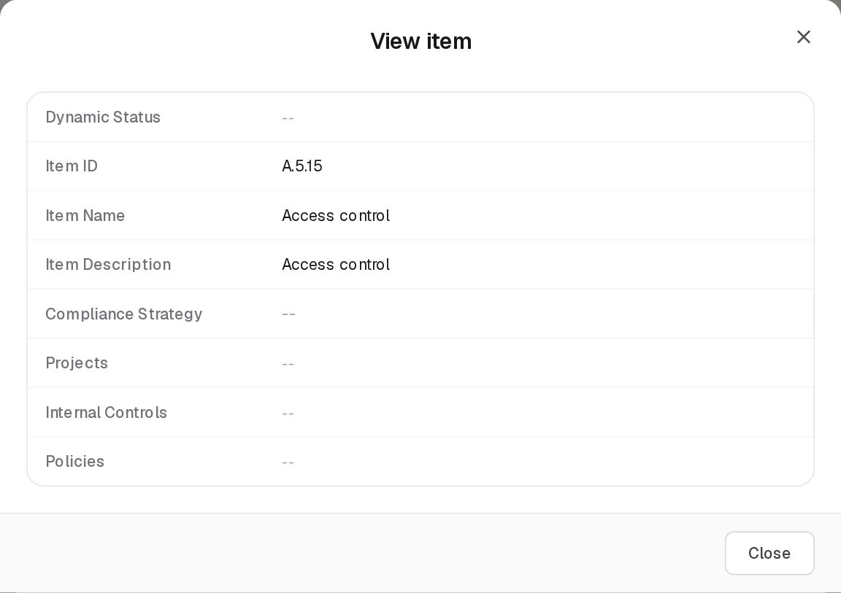
View Compliance Analysis row
View opens View item with the grid’s eight columns, read-only. Edit opens the Edit Action dialog, with “ — ” under the title and Cancel / Save at the bottom. It opens on the Compliance Item Details tab.

Compliance Item Details tab
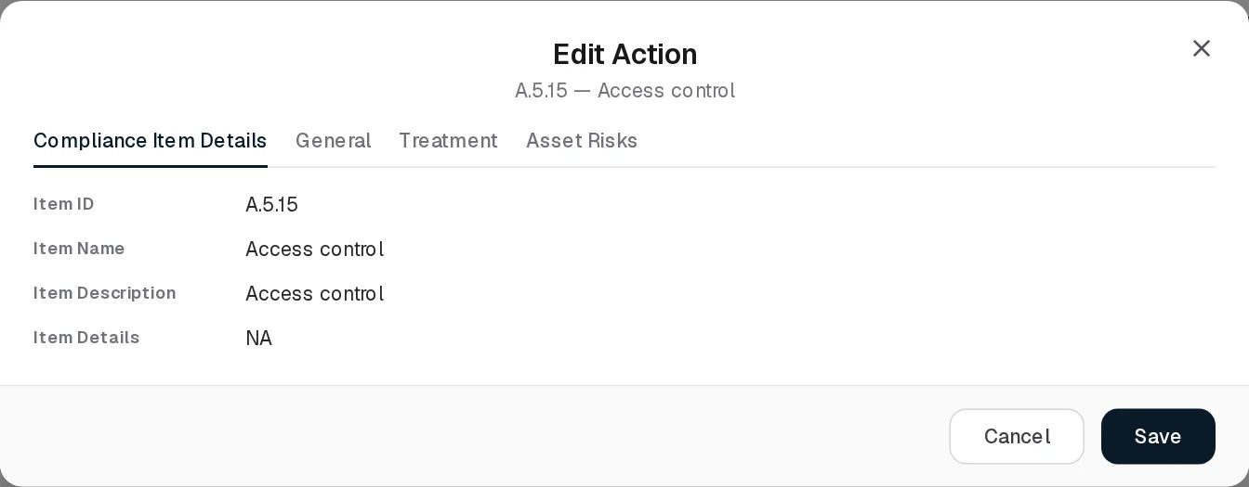
Edit Action, Compliance Item Details tab
Read-only text from the package item: Item ID, Item Name, Item Description, Item Details (the item’s additional information). Empty values show as NA. To change this text, edit the item on its package.

General tab
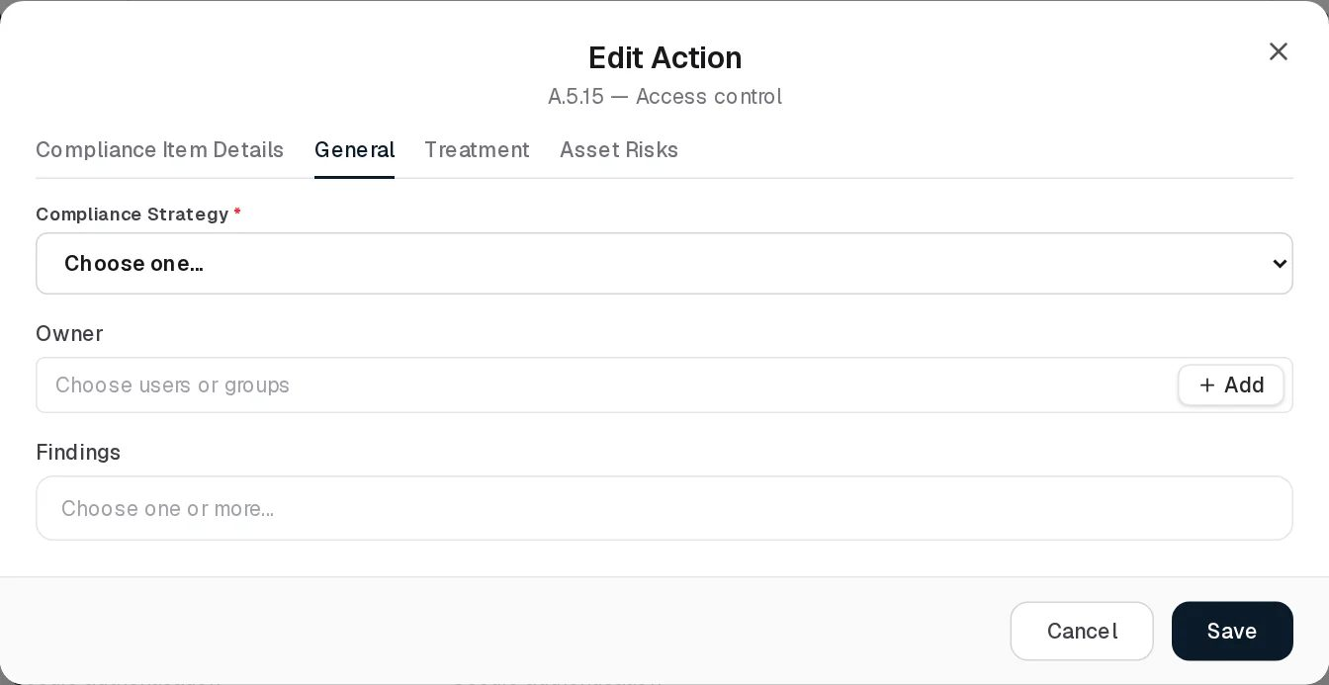
Edit Action, General tab
Field | Type | Required | Rules and allowed values | Example
Compliance Strategy | Dropdown | Yes (marked *) | Choose one… (stores Under Review, the “not judged yet” value), Compliant, Not Applicable, Not Compliant. A row that still holds Partially Compliant shows that value as an extra choice. Default for new rows: Choose one… | Compliant
Owner | User/group picker | No | Several can be picked, but only the first person is stored; the row’s owner is a single user | Sara Johnson
Findings | Record picker (External Audit Findings) | No | Placeholder Choose one or more…; no + Add button. Several allowed. Saving writes the link onto each finding’s Affected Compliance Items, and removes it from findings you unticked. | SQL injection in customer portal
Notes and due date are stored on the row but no longer asked for; their existing values are kept unchanged when you save.

Treatment tab
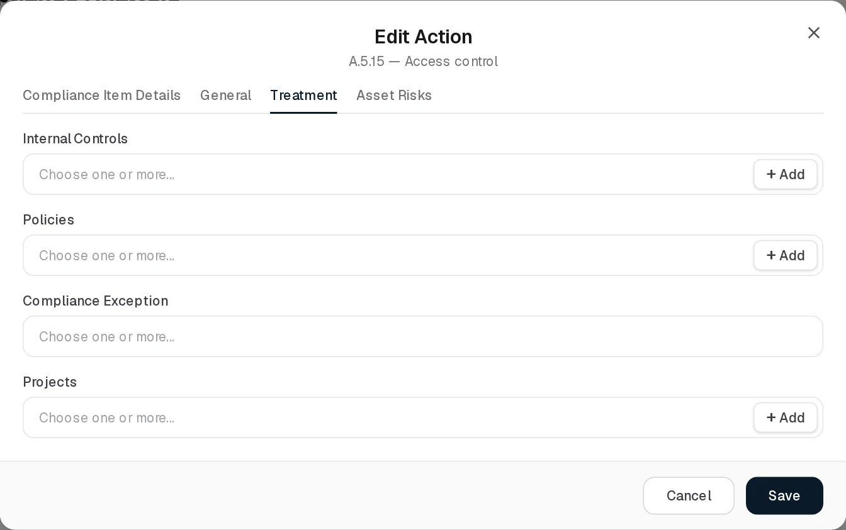
Edit Action, Treatment tab
Each picker shows Choose one or more…. Internal Controls, Policies and Projects have a + Add button that creates a new control, policy or project without leaving the dialog; Compliance Exception has none.
Field | Type | Required | Rules | Example
Internal Controls | Record picker (Controls) | No | Several allowed. A control newly added here also gets this package added to its Compliance Package field. | Multi-factor authentication
Policies | Record picker (Policies & Standards) | No | Several allowed. A policy newly added here also gets this package added to its Compliance Package field. | Access Control Policy
Compliance Exception | Record picker (Compliance Exceptions) | No | Several allowed. Saving adds this requirement to each picked exception’s Related Compliance Items and removes it from exceptions you unticked; the exceptions’ other requirements are left alone. | A.8.8 scan coverage gap on OT network
Projects | Record picker (Projects) | No | Several allowed
Removing a control or policy here does not remove the package from that control or policy; that is done on the control’s or policy’s own form.

Asset Risks tab
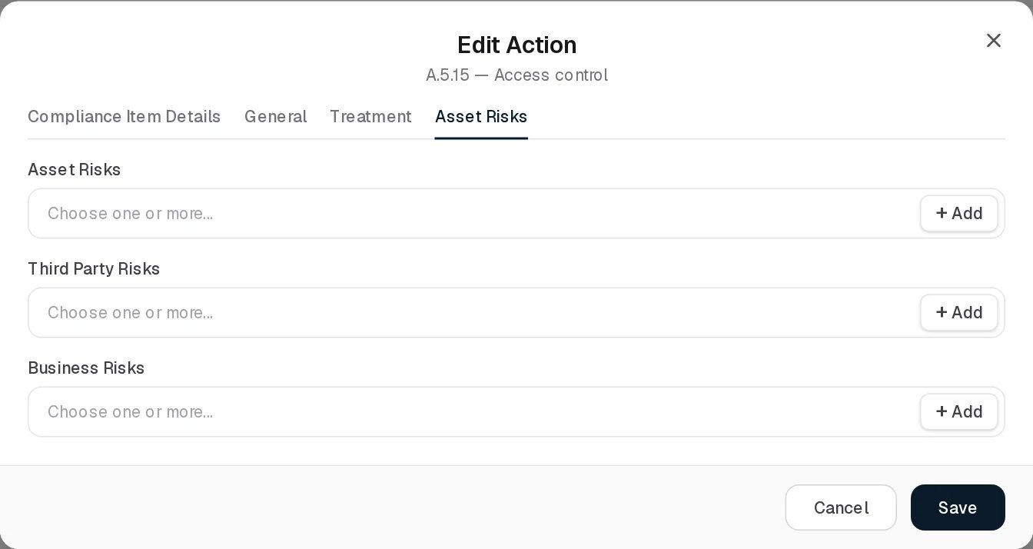
Edit Action, Asset Risks tab
All three pickers have a + Add button for creating a new risk in that register.
Field | Type | Required | Rules | Example
Asset Risks | Record picker (Asset Risks) | No | Several allowed. Written to each risk’s Affected Compliance Items. | Ransomware on file servers
Third Party Risks | Record picker (Third Party Risks) | No | Same, for third-party risks | Telecom link failure
Business Risks | Record picker (Business Risks) | No | Same, for business risks
When at least one risk is linked, the tab shows “A requirement with a risk against it is recorded as Non-Compliant when saved.” On save, the strategy is set to Not Compliant only if one of the linked risks is above the risk appetite (and the strategy is not Not Applicable); a risk within appetite does not change the strategy you picked.
Saving shows “Assessment item updated.” and refreshes the grid and the summaries.
Delete asks “Remove from the analysis?” with “The requirement stays in its package; only the judgement recorded here goes.” and a Remove button. The row and its strategy, owner, control, policy and project links are deleted permanently (risk, finding and exception links live on those records and stay). The row is not recreated automatically for an existing item; it comes back only when the package’s analysis is lined up again (a new item added to the package, a CSV import, or an application restart).

Statuses
Compliance Strategy (set by a person, overridden by risks):
Value | Set by | Meaning
-- (stored Under Review) | System default / user (Choose one…) | Not judged yet. Counted under Review in the summaries. Amber when shown as a badge elsewhere.
Compliant | User, or system | Requirement met. Green. The system sets it when a linked risk is saved and every risk linked to the requirement is within appetite.
Not Applicable | User | Requirement does not bind the organisation. Grey. Left out of the compliance percentage and never changed by risks.
Not Compliant | User, or system | Requirement not met. Red. The system sets it when a linked risk is above appetite, both when this row is saved and when the risk is saved.
Partially Compliant | Older data only | Counted as half compliant. No longer offered. Amber.
Dynamic Status (system, computed on every read from the row’s Internal Controls):
Marker (tooltip) | Rule
Control Last Audit Expired | A linked control has an audit whose planned start is before today and which is not completed.
Asset Risk Review Expired | An asset risk that uses a linked control as treatment has a next review date before today.
Third Party Risk Review Expired | Same for a third-party risk.
Business Risk Review Expired | Same for a business risk.
Rows without linked controls always show --.

Tabs
The page has no section tabs. The Edit Action dialog has four tabs (Compliance Item Details, General, Treatment, Asset Risks), described, each with its screenshot, under Viewing and editing a record. The Assessment summaries grid is described below.

Assessment summaries
Click Assessment summaries. A grid titled Assessment summaries appears above the analysis grid, listing the assessments of the selected framework (newest first). Click a row to show only that assessment’s requirement rows below. The summaries grid has its own Import CSV button (the same strategy import) but no Add button and no status filter.
Assessment summaries above the Compliance Analysis grid
In the demo data the ISO/IEC 27001:2022 summary reads In Progress, 10 items, 0%, counts 0 / 0 / 10 / 0, Status In Progress.
Column | What it shows | Source
Dynamic Status | Not Started (grey) when the assessment has no rows; Completed (green) when the compliance percentage is 100 or more; otherwise In Progress (amber) | Computed in the page
Name | Assessment name; the standing one is Compliance Analysis | Entered / system
Compliance Package | Package assessed | Linked
Period | Assessment period text | Entered
Items | Number of rows | Computed
Compliance | Bar and percentage: (Compliant + 0.5 × Partially Compliant) ÷ (rows − Not Applicable) × 100, one decimal | Computed
Compliant / Partial / Review / Non | Row counts per strategy | Computed
Status | Stored lifecycle status; always In Progress (the UI cannot change it) | System
Row buttons: View, comments, Edit, Delete. Edit opens Edit Assessment with Compliance Package (read-only), Name (required, “Name is required.”), Assessment Period (text, placeholder e.g. 2026 H1) and Owner (user/group picker). Delete asks “Delete ?” with “Its per-requirement strategies and notes will be removed from the Hub as well.” There is no Add button: new assessments cannot be started from the UI.

Relationships
Related record | Direction | How the link is made | Where it shows
Package item | Row → item, many to one | Automatic | Item ID, Item Name, Item Description columns
Assessment | Row → assessment, many to one | Automatic (standing Compliance Analysis) | Assessment summaries
Controls | Row → controls, many | Edit Action › Treatment | Internal Controls column; control’s Compliance Package column gains the package
Policies & Standards | Row → policies, many | Edit Action › Treatment | Policies column; policy’s Compliance Package column gains the package
Projects | Row → projects, many | Edit Action › Treatment | Projects column; project’s Compliance Package column
Risks (three registers) | Risk → requirement item, many to many | Risk form, or Edit Action › Asset Risks | Edit Action; risk’s Affected Compliance Items
Compliance Exceptions | Exception → requirement items, many to many | Exception form, or Edit Action › Treatment | Edit Action; exception’s Requirement Item Number/Name columns
External Audit Findings | Finding → requirement items, many to many | Finding form, or Edit Action › General | Edit Action; finding’s Affected Compliance Item column
Trust Center | Strategy counts per package | Automatic | Trust Center framework posture

Automations and notifications
- Row creation: whenever requirement items are added to a package, the package’s standing assessment Compliance Analysis is created if missing and given one Under Review row per item that has none. Runs on item save, on CSV import of items, and for every package at application start-up.
- Strategy from risks: when an Asset, Third Party or Business Risk that names requirement items is saved, every analysis row of those requirements is set to Not Compliant if any linked risk is above appetite, otherwise to Compliant. Not Applicable rows are skipped. Each change is written to the System Log (“ASSESSMENT_ITEM_STATUS_CHANGED”).
- Dynamic Status is computed on every read.
- No scheduled jobs and no notifications.

Permissions
Action | Needed access
See the page, the rows and the summaries | View on Compliance Hub › Compliance Analysis (the framework selector also reads Compliance Packages)
Edit a row (Edit Action), edit an assessment | Manage on Compliance Hub › Compliance Analysis. Links written through to risks, findings and exceptions are checked against this page only.
Remove a row, delete an assessment | Full Control on Compliance Hub › Compliance Analysis
Import CSV | Manage on Compliance Hub › Compliance Analysis
Comments | The group’s Comments & Attachments level
The built-in Third Party group can view and edit this page for its own records only. See Permissions and access.

How to

Record the result of an ISO/IEC 27001 control check
- Open Compliance Hub › Compliance Analysis and choose ISO/IEC 27001:2022 (10) in the framework selector.
- On row A.8.5 Secure authentication click Edit.
- On General set Compliance Strategy to Compliant and pick the owner.
- On Treatment open Internal Controls and pick Multi-factor authentication; under Policies pick Access Control Policy. Click Save.
- The row shows the control and policy; the control and the policy now list ISO/IEC 27001:2022 as a compliance package.

Mark a requirement out of scope
- Select the framework, then Edit the row (for example a PCI DSS requirement for a process you do not run).
- Set Compliance Strategy to Not Applicable and Save. The row is left out of the compliance percentage and risks will not change it.

Link the risk that puts a requirement at stake
- Edit row A.8.8 Management of technical vulnerabilities.
- On Asset Risks pick Unpatched internet-facing server in Asset Risks. The warning about Non-Compliant appears.
- Save. If that risk is above your risk appetite the strategy becomes Not Compliant.

Check overall progress per framework
- Click Assessment summaries.
- Read Compliance and the Compliant / Partial / Review / Non counts for the standing Compliance Analysis assessment.
- Click the row to see only its requirements; use Back to the whole framework to return.

CSV import
Import CSV (on both grids) updates strategies of existing rows; it does not create rows. After the notice “CSV Import (…): the import structure is not ready yet.” the import dialog Import CSV - Assessment Strategies opens and runs against POST /api/v1/compliance/assessments/import-csv.
Column (position) | Required | Notes
1 assessmentItemId | Yes | The row’s internal id (UUID). Not shown in the UI or in any export.
2 strategy | Yes | Stored as written; values are not checked. Use COMPLIANT, NOT_APPLICABLE, NON_COMPLIANT or UNDER_REVIEW.
The first line is skipped. Lines are split on commas without quote handling. The dry run (Validate) only checks that the first column is a valid UUID; whether the row exists is checked on the real import. There is no CSV export on this page.

Limitations and known issues
- No Add button for assessments. The assessment form exists but cannot be opened in Add mode; only the standing Compliance Analysis assessment exists in practice. The summaries grid’s empty text still says “No assessments yet. Import one via CSV.”, but the import only updates strategies.
- Deleted items, packages and assessments still show. The rows are returned without checking whether their package item, package or assessment has been deleted. A deleted package’s rows appear under All frameworks; a deleted item keeps its row; deleting an assessment in the summaries grid leaves its rows on the analysis grid.
- Owner keeps only the first person picked on a row.
- Saving a risk can mark a requirement Compliant. A risk saved within appetite sets every row of the requirements it names to Compliant, including rows still Under Review.
- The CSV import is impractical: it needs internal row ids that the UI never shows, and it accepts any strategy text.
- Assessment Status is always In Progress; the statuses Completed and Paused listed by the backend cannot be set.

Obligations
Module: Compliance Hub › Obligations · Route: /compliance-hub/obligations · Permission key: compliance_hub.obligations
The Obligations register (page title Compliance Obligations) lists the legal and regulatory obligations the organisation is subject to: one record per law or regulation and article or clause, with the authority that enforces it, the team responsible, a recorded compliance status, a risk level and the date of the next audit. It is a stand-alone register kept by the compliance or legal team; unlike compliance packages, obligations are not broken down into requirement items and do not appear on Compliance Analysis.
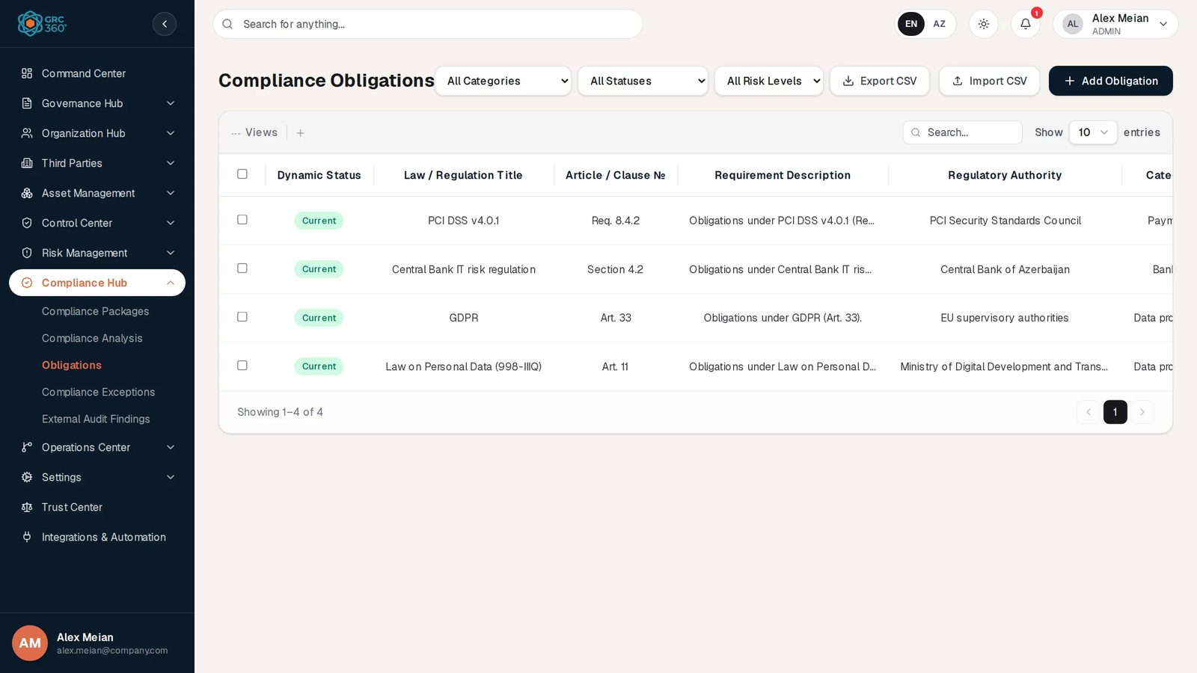
Compliance Obligations register

At a glance
A record is | One obligation: a law or regulation plus one article or clause
Typical owner | Compliance or legal officer (the Responsible Team / Contact)
Links to | Responsible users or groups
Linked from | None in the UI
Tabs | None
Automations | Dynamic Status computed from the next audit date on every read. No reminders.

The register (list view)
The register is paged and searched on the server, newest first. The shared grid behaviour (search, Views, paging, selection, comments) is described in Working with registers. Search matches the law title, the article/clause number and the requirement description.
Above the grid, next to the title, three filters are applied by the server: All Categories (the five categories below), All Statuses (the four compliance statuses) and All Risk Levels (High, Medium, Low). Header buttons: Export CSV, Import CSV, Add Obligation.
Column | What it shows | Source
Dynamic Status | Current, Needs Review or Missing Date, from the Next Audit Date. See Statuses. | Computed by the system
Law / Regulation Title | For example GDPR | Entered
Article / Clause № | For example Art. 33 | Entered
Requirement Description | First part of the text; hover for the rest | Entered
Regulatory Authority | For example EU supervisory authorities | Entered
Category | Category label (see Limitations for how built-in categories display) | Entered
Responsible Contact | Responsible users or groups, comma-joined | Linked
Status | The compliance status a person recorded | Entered
Risk | High (red text), Medium (amber), Low (green) | Entered
Next Audit Date | Date (YYYY-MM-DD) or - | Entered

Creating a record
Click Add Obligation. The dialog Add Item (subtitle Compliance Obligations) opens.
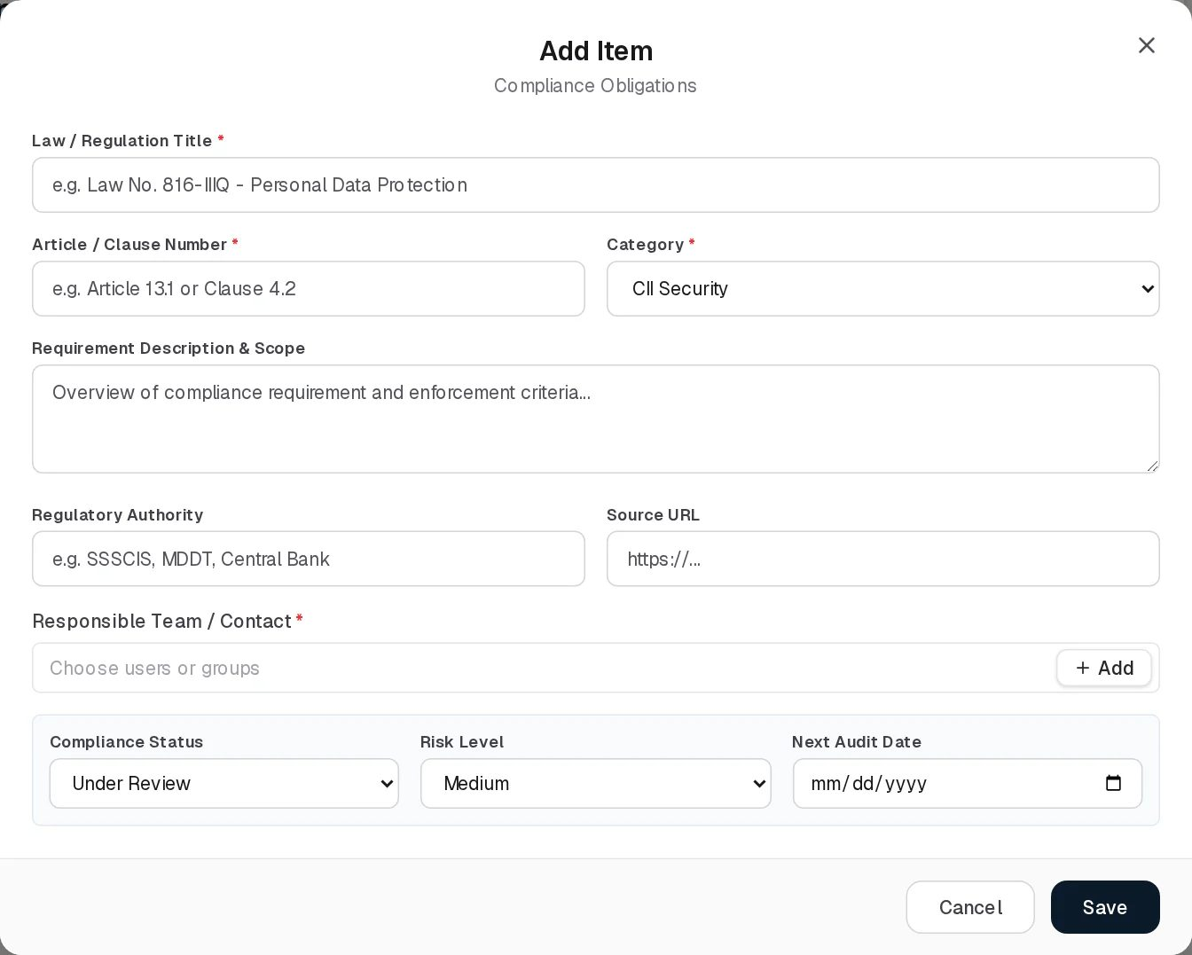
Add Obligation
Field | Type | Required | Rules and allowed values | Example
Law / Regulation Title | Text | Yes | “Law title and article/clause number are required.” Placeholder e.g. Law No. 816-IIIQ - Personal Data Protection | Law on Personal Data (998-IIIQ)
Article / Clause Number | Text | Yes | Same message as above. Placeholder e.g. Article 13.1 or Clause 4.2 | Art. 11
Category | Dropdown | Yes | CII Security, Personal Data, Central Bank, Electronic Signature, State Standards. Default CII Security. | Personal Data
Requirement Description & Scope | Multi-line text | No | Placeholder Overview of compliance requirement and enforcement criteria… | Obligations under Law on Personal Data (998-IIIQ) (Art. 11).
Regulatory Authority | Text | No | Placeholder e.g. SSSCIS, MDDT, Central Bank | Ministry of Digital Development and Transport
Source URL | URL | No | Must be a valid web address if filled (checked by the browser). Placeholder https://…
Responsible Team / Contact | User/group picker, several allowed | Yes (in the form) | “Responsible Team / Contact is required.” | Alex Meian
Compliance Status | Dropdown | No (always has a value) | Compliant, Partially Compliant, Under Review, Non Compliant. Default Under Review. | Under Review
Risk Level | Dropdown | No (always has a value) | High, Medium, Low. Default Medium. | High
Next Audit Date | Date | No | Drives the Dynamic Status | 2026-12-13
The dropdown lists come from the backend’s Compliance Hub metadata, with the same values built into the page as a fallback. Saving shows “Obligation added.”

Viewing and editing a record
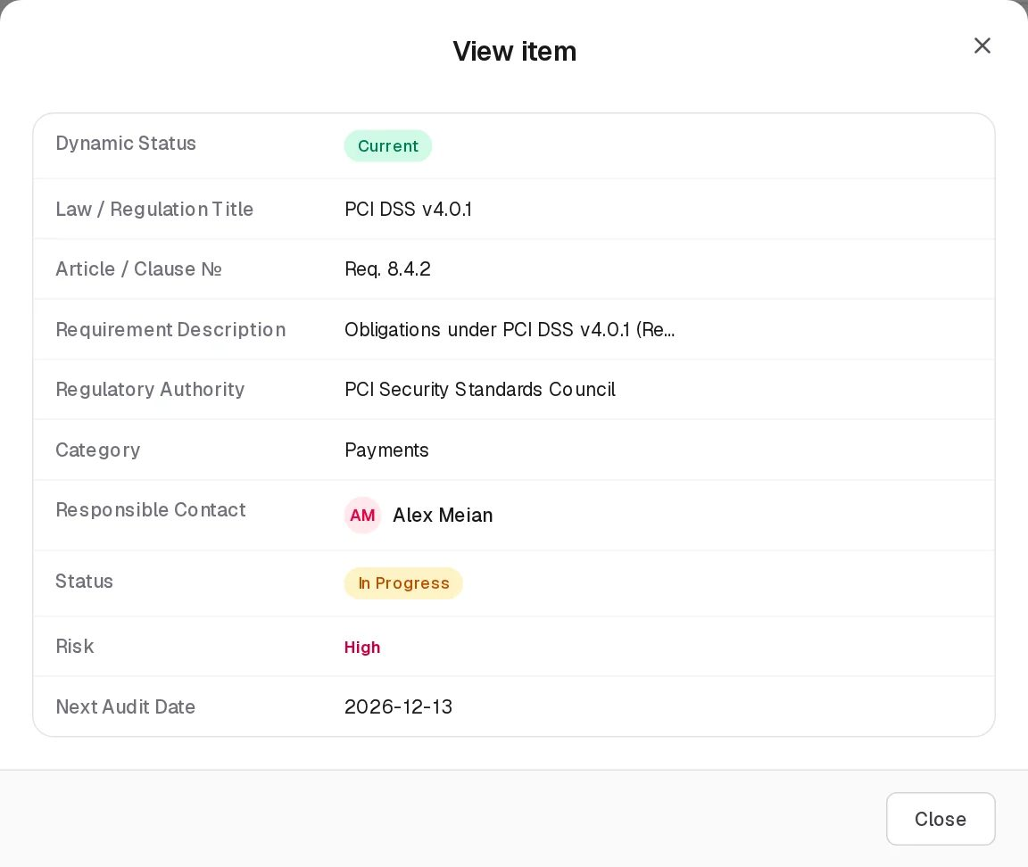
View Obligation
View opens View item with the ten grid columns. Edit opens Edit Item (subtitle Compliance Obligations) with the same fields as Add. Saving shows “Obligation updated.” and records the time of the edit as the obligation’s last review time (not shown in the UI). An effective date set by the API or the demo data is kept; the form has no field for it.
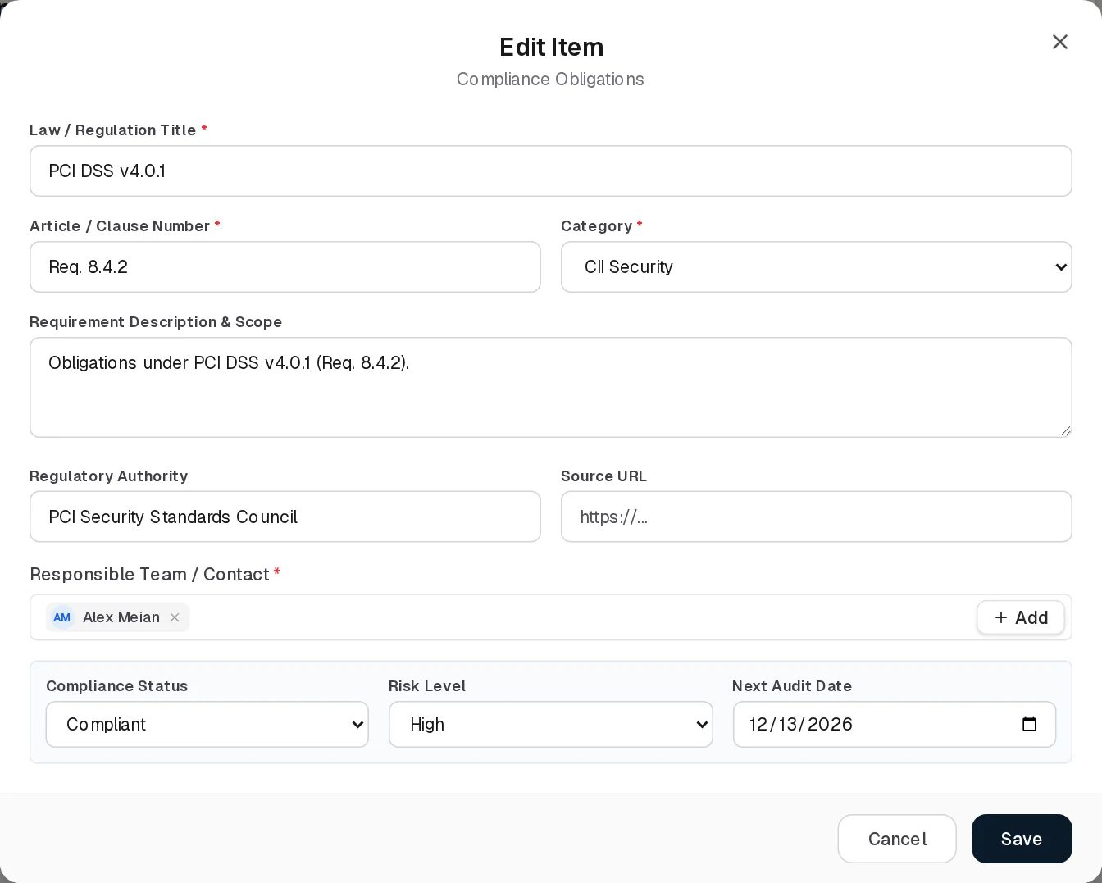
Edit Obligation
The screenshot shows an effect of the demo data: PCI DSS v4.0.1 is stored with category Payments and status In Progress, which are not in the dropdowns, so the form displays the first options (CII Security, Compliant) instead. Saving without touching those two dropdowns keeps the stored values; choosing a value replaces them.
Delete asks “Delete ?” and soft-deletes the record.

Statuses
Status (Compliance Status, set by a person):
Value | Set by | Meaning
Compliant | User | The organisation meets the obligation. Green.
Partially Compliant | User | Partly met. Amber.
Under Review | User (default) | Not yet assessed or being assessed. Amber.
Non Compliant | User | Not met. Shown in the grid as Not Compliant, red.
Dynamic Status (system, computed on every read; dates compared as calendar days in UTC):
Value | Rule | Colour
Missing Date | No Next Audit Date | Amber
Needs Review | Next Audit Date is before today | Amber
Current | Next Audit Date is today or later | Green
The Dynamic Status does not depend on the Status: an obligation can be Compliant and Needs Review at the same time.

Tabs
None.

Relationships
Related record | Direction | How the link is made | Where it shows
Users and groups | Obligation → people, many | Responsible Team / Contact | Responsible Contact column
Compliance requirement items | Obligation → items, many to many | Backend endpoint POST /compliance/obligations/{id}/map-requirements only | Nowhere in the UI
Obligations are not linked to compliance packages, risks, controls or findings.

Automations and notifications
- Dynamic Status is computed on read, so Needs Review appears the day after the Next Audit Date without any job.
- No reminder is sent before or after the Next Audit Date. No scheduled job concerns obligations.

Permissions
Action | Needed access
See the page, filter, Export CSV | View on Compliance Hub › Obligations
Create / Edit | Manage on Compliance Hub › Obligations
Import CSV | Manage on Compliance Hub › Obligations
Delete | Full Control on Compliance Hub › Obligations
Comments | The group’s Comments & Attachments level
See Permissions and access.

How to

Register a new legal obligation
- Open Compliance Hub › Obligations and click Add Obligation.
- Enter Law / Regulation Title GDPR, Article / Clause Number Art. 30, choose Category Personal Data.
- Fill Regulatory Authority, pick the Responsible Team / Contact, set Risk Level High and a Next Audit Date.
- Save. The row shows Dynamic Status Current.

Record the outcome of an obligation review
- Click Edit on Central Bank IT risk regulation.
- Set Compliance Status to Compliant and move Next Audit Date to the next review.
- Save.

List the high-risk obligations that need attention
- Choose High in All Risk Levels and Non Compliant in All Statuses.
- Sort by Next Audit Date, or look for Needs Review in Dynamic Status.

CSV import
Import CSV first shows “CSV Import (Compliance Obligations): the import structure is not ready yet.” and then opens the working import dialog (POST /api/v1/compliance/obligations/import-csv, with a dry run on Validate).
Column (position) | Required | Notes
1 legalActName | Yes
2 articleOrClauseNo | Yes
3 category | Yes | Stored in upper case; use KII_SECURITY, PERSONAL_DATA, CENTRAL_BANK, E_SIGNATURE or STATE_STANDARDS to match the dropdown
4 requirementDescription | No
5 regulatoryAuthority | No
6 status | No | Stored in upper case; default UNDER_REVIEW
7 riskLevel | No | Stored in upper case; default MEDIUM
The first line is skipped. Rows with fewer than three columns fail with “Row n: Requires legalActName,articleOrClauseNo,category”; empty required values fail with “Row n: Required fields cannot be empty”. Values are not checked against the allowed lists. Imported obligations have no responsible contact and no Next Audit Date, so they show Missing Date.
Export CSV downloads obligations.csv with the same seven columns, for every obligation (the filters and search are ignored).

Limitations and known issues
- Built-in categories display garbled. For the five built-in category codes the Category column shows the backend’s Azerbaijani label, which is stored with a broken character encoding (for example KÄ°Ä° TÉ™hlÃ¼kÉ™sizliyi instead of Kİİ Təhlükəsizliyi), not the English dropdown label CII Security. Free-text categories, such as the demo data’s Data protection, display as entered.
- Values outside the dropdowns are shown wrongly in Edit. A stored category, status or risk level that is not in the list (from import, the API or the demo data) is displayed as the first option of the dropdown.
- Two spellings of one status. The dropdown and filter say Non Compliant; the grid badge says Not Compliant.
- Export ignores the filters and always contains every obligation.
- No mapping to requirement items in the UI, although the backend supports it.
- No reminders for the Next Audit Date; the Dynamic Status is the only signal.

Compliance Exceptions
Module: Compliance Hub › Compliance Exceptions · Route: /compliance-hub/compliance-exceptions · Permission key: compliance_hub.compliance_exceptions
A compliance exception records that the organisation knowingly does not meet one or more framework requirements for a limited time, for example because a compensating measure is in place or a project will close the gap. Each exception names the people involved, the requirement items it excuses and the date it expires. Compliance managers keep this register; it is the place an auditor looks for accepted gaps.
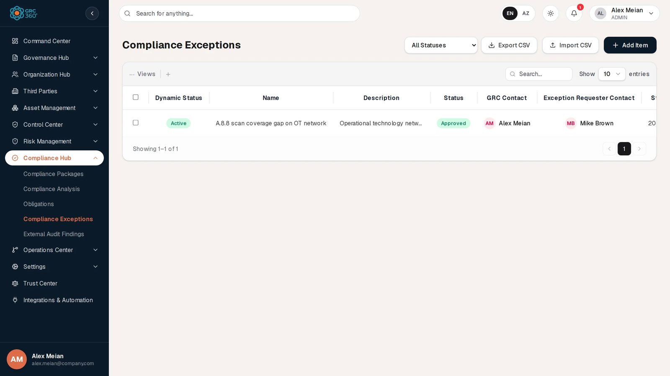
Compliance Exceptions register

At a glance
A record is | One time-limited exception covering one or more requirement items
Typical owner | GRC Contact (compliance manager); raised by the Exception Requester Contact
Links to | Requirement items (several), their compliance package, GRC contacts, requesters
Linked from | Compliance Analysis (Edit Action › Treatment › Compliance Exception)
Tabs | None
Automations | Dynamic Status computed on read (shows Expired once the expiration date passes). An hourly expiry job exists but is not active in this release.

The register (list view)
The register is paged and searched on the server, newest first. The shared grid behaviour (search, Views, paging, selection, comments) is described in Working with registers. Search matches the name and the description.
Header controls: a status filter (All Statuses, Open Exceptions, Closed Exceptions), Export CSV, Import CSV, Add Item. The filter matches the stored status exactly, so an exception stored as Approved (like the demo record) appears only under All Statuses.
Column | What it shows | Source
Dynamic Status | Active, Pending, Expired or Closed. See Statuses. | Computed by the system
Name | Exception title | Entered
Description | First part of the description; hover for the rest | Entered
Status | The stored status, for example Approved | Entered
GRC Contact | GRC contacts, comma-joined | Linked
Exception Requester Contact | Requesters, comma-joined | Linked
Start Date | Date the exception was raised | System (today, on creation)
Expiration Date | Date the exception ends | Entered
Closure Date | Date it was closed, - while open | System
Compliance Package | Package of the first requirement item picked | Derived
Requirement Item Number | Item IDs of all excused items, as chips | Linked
Requirement Item Name | Item names of all excused items, as chips | Linked
Demo record: A.8.8 scan coverage gap on OT network, status Approved, Dynamic Status Active, GRC Contact Alex Meian, requester Mike Brown, start 2026-09-29, expiration 2026-12-28, package ISO/IEC 27001:2022, no requirement items linked.

Creating a record
Click Add Item. The dialog Add Item (subtitle Compliance Exceptions) opens.
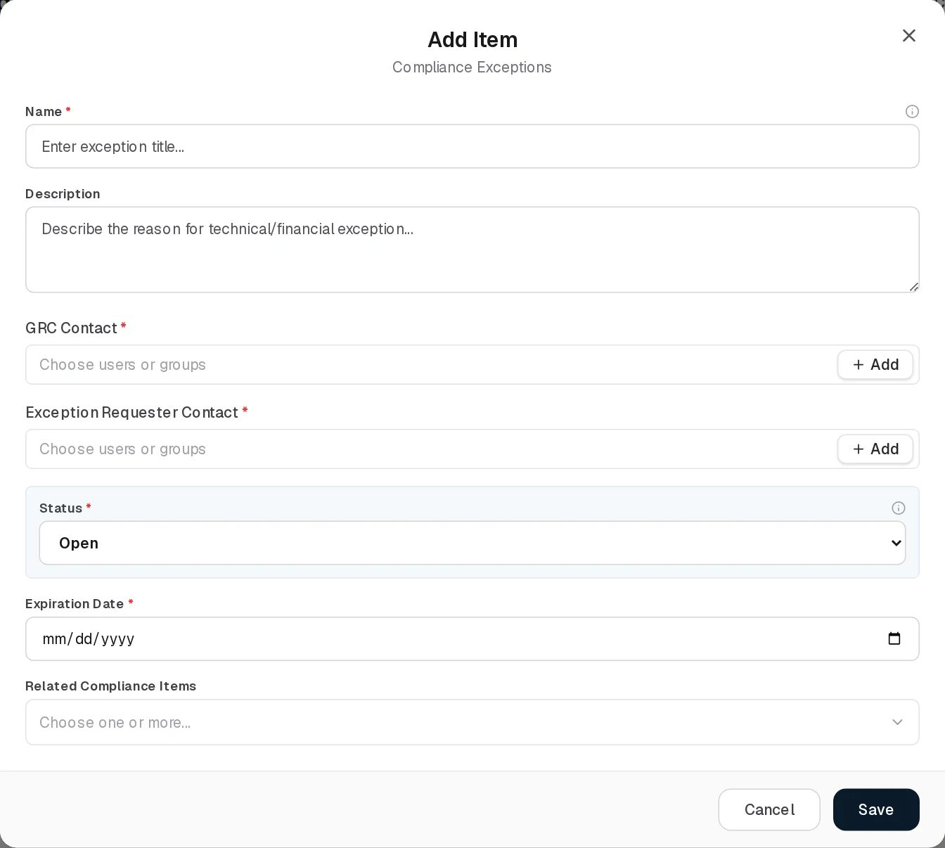
Add Compliance Exception
Field | Type | Required | Rules and allowed values | Example
Name | Text | Yes | “Name is required.” Placeholder Enter exception title… | A.8.8 scan coverage gap on OT network
Description | Multi-line text | No | Placeholder Describe the reason for technical/financial exception… | Operational technology network cannot be scanned until segmentation project ends.
GRC Contact | User/group picker, several allowed | Yes | “At least one GRC contact is required.” | Alex Meian
Exception Requester Contact | User/group picker, several allowed | Yes | “At least one requester contact is required.” | Mike Brown
Status | Dropdown | Yes | Open, Closed. Default Open. | Open
Expiration Date | Date | Yes | “Expiration date is required.” | 2026-12-28
Related Compliance Items | Multi-select | No | Every requirement item of every package, labelled “ ”, for example ISO/IEC 27001:2022 A.8.8 Management of technical vulnerabilities. Several allowed. | ISO/IEC 27001:2022 A.8.8 Management of technical vulnerabilities
There is no Start Date field: the form sends today’s date (in your browser’s time zone) as the start date. There is no Compliance Package field either: the package is taken from the first item picked in Related Compliance Items. Saving shows “Compliance exception added.”

Viewing and editing a record
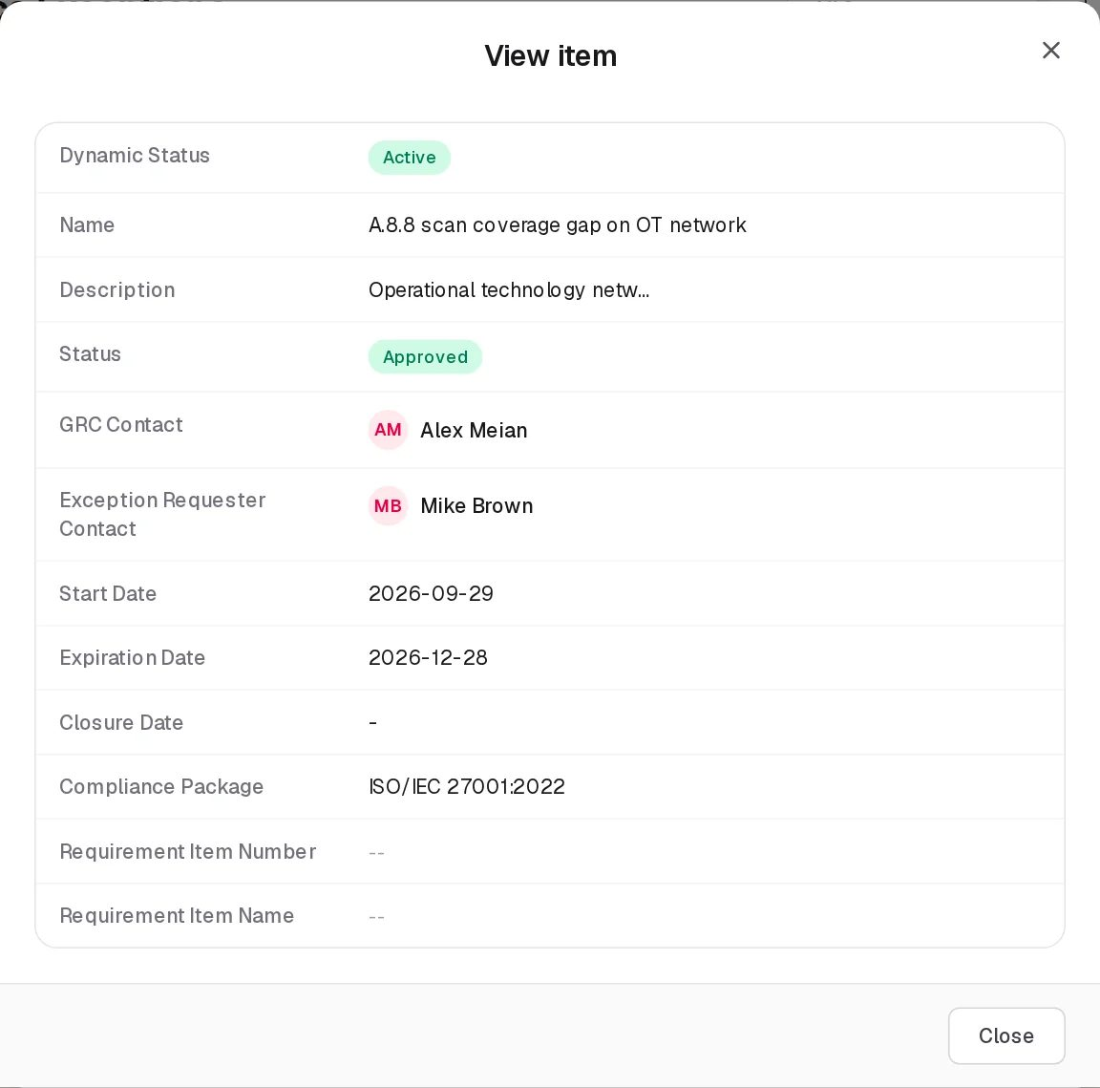
View Compliance Exception
View opens View item with the twelve grid columns. Edit opens Edit Item (subtitle Compliance Exceptions) with the same fields as Add.
Edit Compliance Exception
- The start date is kept as it was.
- Changing Status records a workflow event (“Status changed from the edit form”) and a System Log entry. Setting it to Closed stamps today’s date as the Closure Date; setting it back to Open clears the closure date.
- The demo record is stored as Approved, which the dropdown does not offer; the form therefore displays Open. Saving without touching Status keeps Approved; choosing a value replaces it.
- Changing Related Compliance Items sets the package again from the first item picked, and clears the package if you remove all items.
Saving shows “Compliance exception updated.” Delete asks “Delete ?” and soft-deletes the record.

Statuses
Status (set by a person):
Value | Set by | Meaning
Open | User (default) | The exception is being carried.
Closed | User | The exception is finished. Sets the Closure Date.
Approved, Under Review, Expired | Older data, API, CSV import, or the expiry job | Still read and displayed, but no longer offered in the form.
Dynamic Status (system, computed on every read):
Value | Rule (first match wins) | Colour
Closed | A Closure Date is set, or the status is Closed (also Denied, Rejected, Revoked) | Green
Expired | The status is Expired | Red
Active | The status is Approved and the expiration date has not passed | Green
Expired | The status is Approved, Open or Under Review and the expiration date has passed | Red
Pending | Any other case, including every Open exception that has not expired | Amber
The expiration date is stored as midnight UTC of the chosen day, so an exception reads Expired from 00:00 UTC on its expiration date.

Tabs
None.

Relationships
Related record | Direction | How the link is made | Where it shows
Requirement items | Exception → items, many to many | Related Compliance Items, or from Compliance Analysis › Edit Action › Treatment › Compliance Exception | Requirement Item Number / Name columns; Edit Action of each item’s analysis row
Compliance package | Exception → package, at most one | Derived from the first requirement item | Compliance Package column
GRC contacts, requesters | Exception → users or groups, many | Form | GRC Contact, Exception Requester Contact columns
Linking from Compliance Analysis adds or removes only that one requirement; the exception’s other requirements stay. Compliance exceptions are separate from Policy Exceptions and Risk Exceptions.

Automations and notifications
- Dynamic Status is computed every time the register is read, so Expired appears without any job.
- Expiry job (not active in this release). The backend contains an hourly job that would change the stored status of past-due Open, Approved and Under Review exceptions to Expired and log “Exception expired automatically”. Scheduling is not enabled in the backend, so the job never runs and the stored Status stays as it was. A manual trigger exists in the API (POST /api/v1/compliance/exceptions/expire-due, for the caller’s organisation only) but no screen calls it.
- The backend also has approval workflow actions (submit for review, approve, close) that no screen uses.
- No notifications are sent for compliance exceptions, before or after expiry.

Permissions
Action | Needed access
See the page, filter, Export CSV | View on Compliance Hub › Compliance Exceptions
Create / Edit (including changing Status) | Manage on Compliance Hub › Compliance Exceptions
Import CSV | Manage on Compliance Hub › Compliance Exceptions
Delete | Full Control on Compliance Hub › Compliance Exceptions
Comments | The group’s Comments & Attachments level
The Related Compliance Items list is read from Compliance Analysis; without View on Compliance Analysis the list is empty. See Permissions and access.

How to

Record an accepted gap against an ISO requirement
- Open Compliance Hub › Compliance Exceptions and click Add Item.
- Enter Name and Description, pick the GRC Contact (Alex Meian) and the Exception Requester Contact (Mike Brown).
- Set Expiration Date to the date the gap must be closed.
- In Related Compliance Items pick ISO/IEC 27001:2022 A.8.8 Management of technical vulnerabilities. Save.
- The row shows Dynamic Status Pending, package ISO/IEC 27001:2022 and Item ID A.8.8.

Close an exception when the gap is fixed
- Click Edit on the exception.
- Set Status to Closed and Save. The Closure Date shows today and the Dynamic Status becomes Closed.

Find exceptions that have run out
- Sort the register by Expiration Date, or scan Dynamic Status for Expired. There is no filter for expired exceptions; the Open Exceptions filter matches the stored status only.

CSV import
Import CSV first shows “CSV Import (Compliance Exceptions): the import structure is not ready yet.” and then opens the working import dialog (POST /api/v1/compliance/exceptions/import-csv).
Column (position) | Required | Notes
1 name | Yes | “Row n: Name cannot be empty”
2 description | No
3 status | No | Stored in upper case; default OPEN. Not checked against a list.
4 expirationDate | Yes | YYYY-MM-DD or an ISO-8601 instant. “Row n: Expiration date is required” / “Row n: Invalid expiration date ‘’. Use YYYY-MM-DD or an ISO-8601 instant”
5 requirementItemNumber | No | Stored as text only; does not link the exception to the item
6 requirementItemName | No | Stored as text only
The first line is skipped; at least two columns are needed. Imported exceptions get today as start date and have no contacts, package or linked items.
Export CSV downloads compliance-exceptions.csv with the same six columns for every exception (the status filter and search are ignored). The item columns hold only the first linked item.

Limitations and known issues
- Open exceptions read Pending. The form offers only Open and Closed, and the Dynamic Status shows Active only for Approved exceptions, so an exception created in the UI is Pending for its whole life.
- Stored status never becomes Expired because the expiry job is not active; only the Dynamic Status shows expiry.
- Status filter misses other stored values (Approved, Under Review, Expired) and offers no “expired” choice.
- Edit shows Open for an Approved exception; see Viewing and editing.
- Package follows the first item. Removing all items on edit clears the package; an exception covering items of two packages shows only the first one’s package.
- Deleted requirement items can still be offered in Related Compliance Items (the list is built from Compliance Analysis rows, which are not cleaned up when an item or package is deleted); picking one fails with “Requirement item not found”.
- CSV import does not link items or contacts.

External Audit Findings
Module: Compliance Hub › External Audit Findings · Route: /compliance-hub/audit-findings · Permission key: compliance_hub.audit_findings
This register holds the findings raised by external auditors (certification bodies, regulators, customers’ auditors): what was found, by when it must be fixed, who owns the fix, which framework requirements it breaks, and the evidence of remediation. Compliance managers record the findings after an audit and track them until they are closed. Internal control audits are recorded elsewhere, on Controls › Audits.
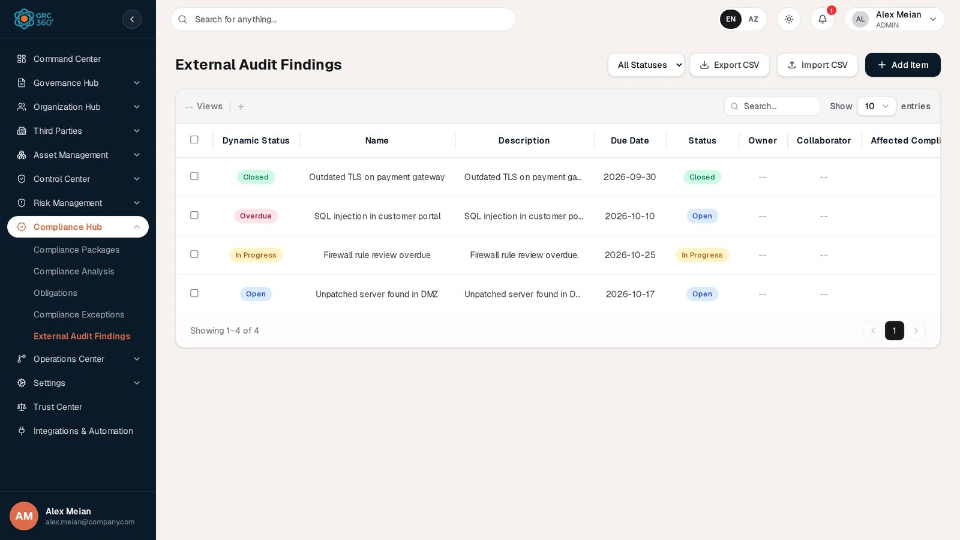
External Audit Findings register

At a glance
A record is | One finding from an external audit
Typical owner | The finding’s Owner, helped by Collaborators
Links to | Requirement items of any package (several), owners and collaborators (users or groups), evidence attachments
Linked from | Compliance Analysis (Edit Action › General › Findings)
Tabs | None. Evidence files are managed in the Evidence Attachments dialog opened from the row.
Automations | Dynamic Status computed on read (Overdue once the due date has passed). No reminders.

The register (list view)
The register is paged and searched on the server, newest first. The shared grid behaviour (search, Views, paging, selection, comments) is described in Working with registers. Search matches the name and the description.
Header controls: a status filter (All Statuses, Open, Closed), Export CSV, Import CSV, Add Item. Besides View, comments, Edit and Delete, each row has an Evidence attachments button (paper clip) with a badge counting the attached files.
Column | What it shows | Source
Dynamic Status | Overdue, Closed, Resolved, or the status itself. See Statuses. | Computed by the system
Name | Finding title | Entered
Description | First part of the description; hover for the rest | Entered
Due Date | Remediation deadline (YYYY-MM-DD) or - | Entered
Status | The stored status | Entered
Owner | Owners, comma-joined | Linked
Collaborator | Collaborators, comma-joined | Linked
Affected Compliance Item | Linked requirements as “ ()”, comma-joined; hover for the full list | Linked
Demo data: four findings, for example SQL injection in customer portal (status Open, due 2026-10-10, Dynamic Status Overdue) and Outdated TLS on payment gateway (Closed). They have no owners, collaborators or linked items.

Creating a record
Click Add Item. The dialog Add Item (subtitle External Audit Findings) opens.
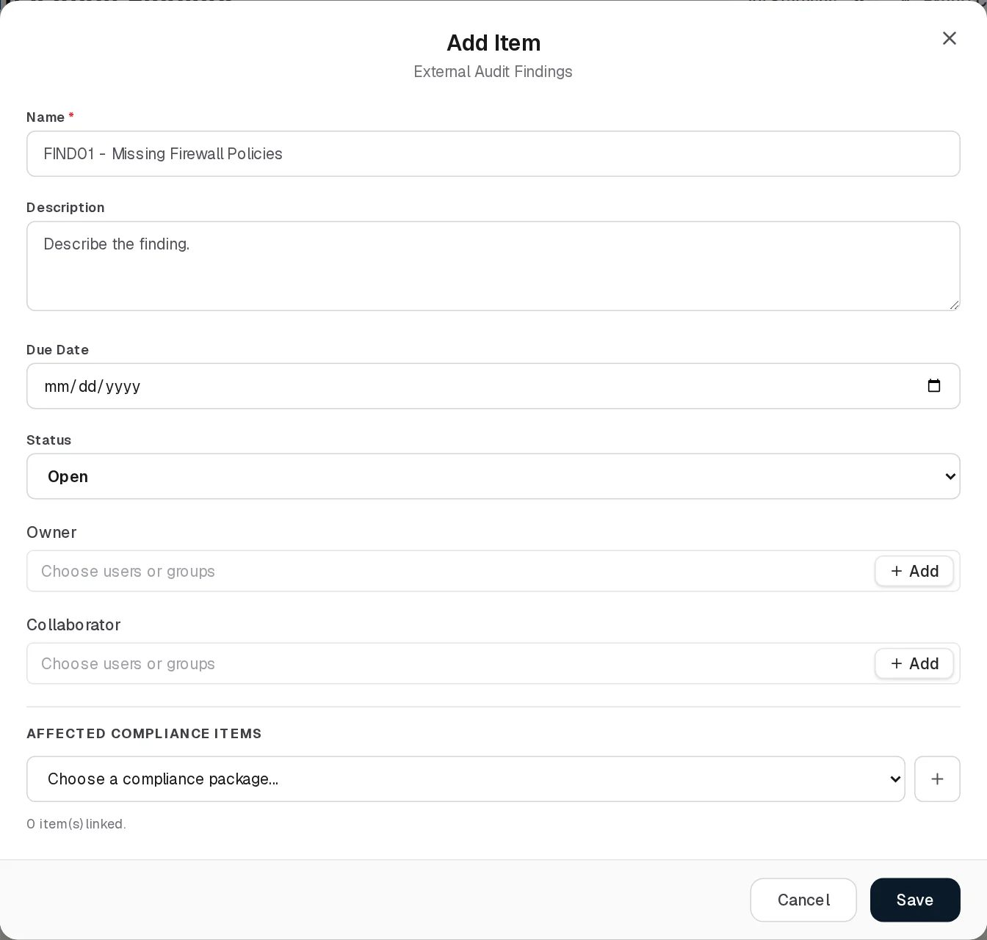
Add External Audit Finding
Field | Type | Required | Rules and allowed values | Example
Name | Text | Yes | “Name is required.” Placeholder FIND01 - Missing Firewall Policies | SQL injection in customer portal
Description | Multi-line text | No | Placeholder Describe the finding. | SQL injection in customer portal.
Due Date | Date | No | Drives the Overdue Dynamic Status | 2026-10-10
Status | Dropdown | No (always has a value) | Open, Closed. Default Open. | Open
Owner | User/group picker | No | Several can be picked | Sara Johnson
Collaborator | User/group picker | No | Several allowed | Mike Brown
Affected Compliance Items | Package dropdown, then a checklist | No | Choose a package in Choose a compliance package… (the + button beside it creates a new package). Its items appear as a checklist with a Search compliance items… box; tick the affected items. Ticked items are shown as chips above the dropdown, each with a remove button, and the count reads “ item(s) linked.” You can switch package and tick items from several packages. | ISO/IEC 27001:2022 › A.8.8 Management of technical vulnerabilities
Messages in the checklist: “This package has no requirement items yet.” and “No items match”“.” Severity and source are not in the form: a new finding is saved with severity Medium and source External Audit, and an edited finding keeps its stored values. Saving shows “Audit finding added.”

Viewing and editing a record
View External Audit Finding
View opens View item with the eight grid columns. Edit opens Edit Item (subtitle External Audit Findings) with the same fields; the linked items are listed as chips and no package is preselected.
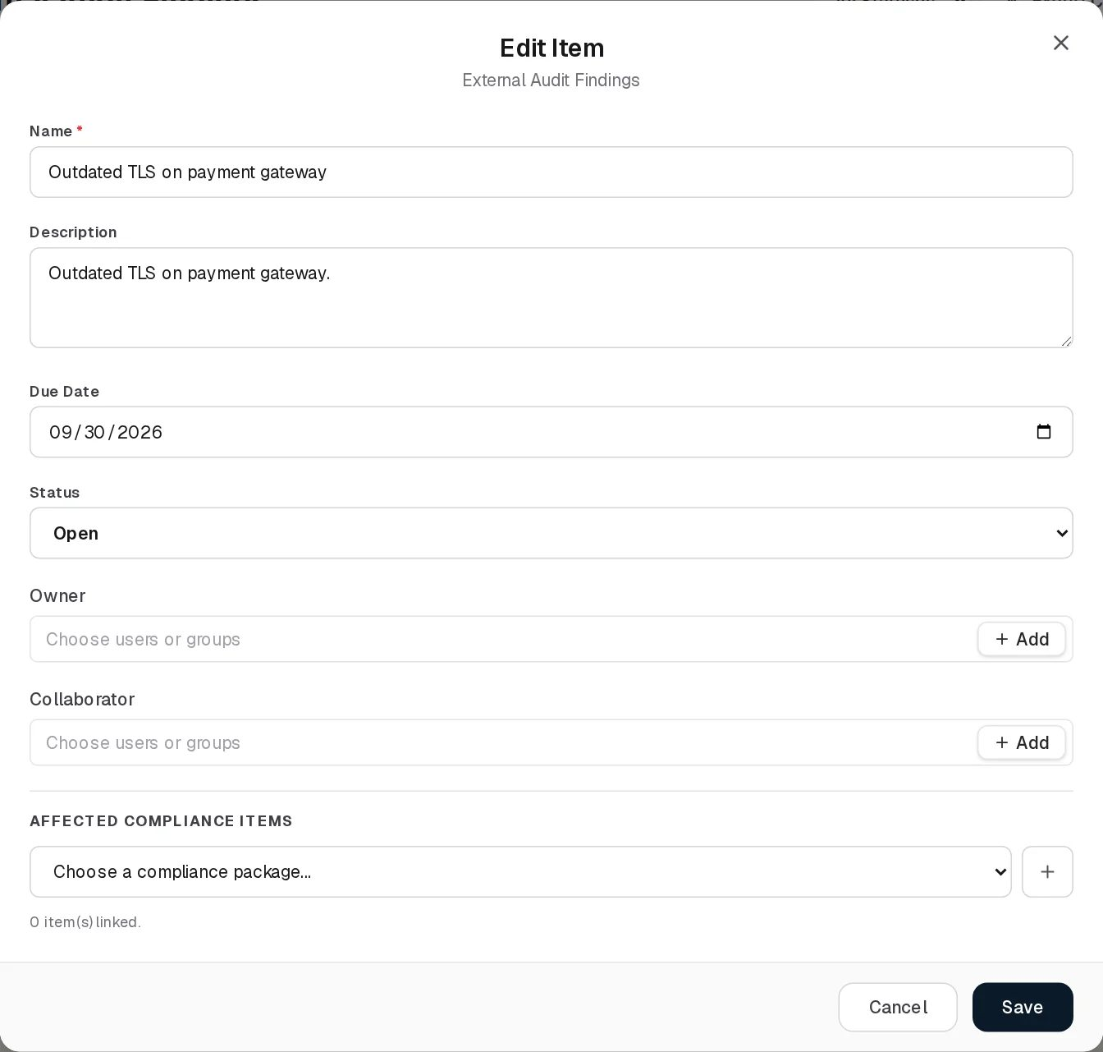
Edit External Audit Finding
The screenshot shows Outdated TLS on payment gateway, stored with status Closed in mixed case by the demo data; the dropdown cannot match it and displays Open. Saving without touching Status keeps the stored value; choosing a value replaces it. Saving shows “Audit finding updated.” A status change is written to the System Log (“AUDIT_FINDING_STATUS_CHANGED”).
Items deleted from their package since they were linked are dropped from the finding silently on the next save.
Delete asks “Delete ?” and soft-deletes the finding.

Evidence attachments
Click the paper-clip button on a row. The dialog Evidence Attachments (subtitle: the finding’s name) has an upload area at the top and, below it, the list of files with name, size in KB and upload date, each with Download and Delete buttons. Cancel closes the dialog; uploads and deletions take effect immediately, so there is no Save.
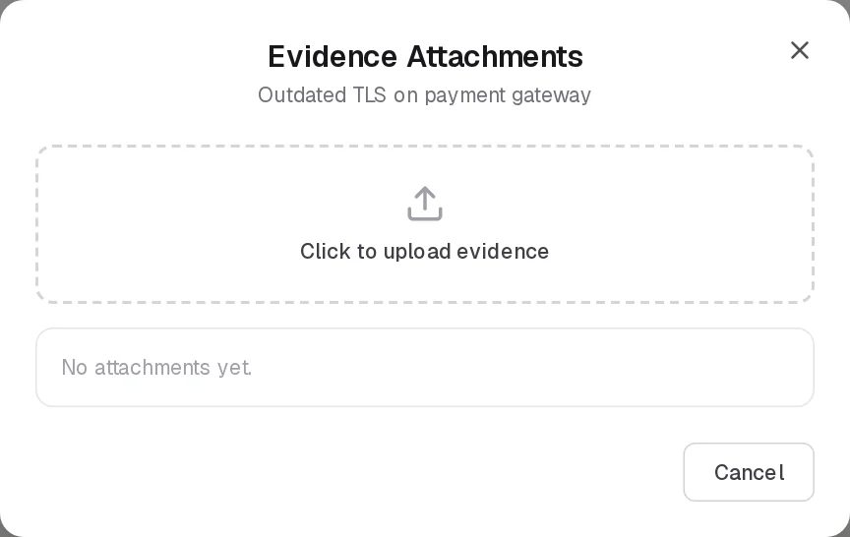
Evidence Attachments
- Click to upload evidence opens a file chooser; the file is uploaded immediately. Any file type is accepted, up to 10 MB (“Attachment exceeds the 10 MB limit: ”).
- Delete asks “Delete ?”; the file is removed from the list (“Attachment deleted.”).
- With no files the list reads “No attachments yet.” (as for Outdated TLS on payment gateway in the screenshot).

Statuses
Status (set by a person):
Value | Set by | Meaning
Open | User (default) | The finding is being remediated. Blue.
Closed | User | Remediation is done. Green.
In Progress, Resolved | Older data, API or CSV import | Still read and displayed, no longer offered.
Dynamic Status (system, computed on every read; dates compared as calendar days in UTC):
Value | Rule | Colour
Closed / Resolved | The status is Closed or Resolved (any letter case) | Green
Overdue | Any other status, and the due date is before today | Red
(the status itself) | Otherwise, for example Open or In Progress | Blue / amber
A finding due today is not yet overdue.

Tabs
None. Evidence files are handled in the Evidence attachments dialog.

Relationships
Related record | Direction | How the link is made | Where it shows
Requirement items | Finding → items, many to many | Affected Compliance Items checklist, or Compliance Analysis › Edit Action › General › Findings | Affected Compliance Item column (not clickable); Edit Action of each item’s analysis row
Owners, collaborators | Finding → users or groups, many | Form | Owner, Collaborator columns
Evidence files | Finding → files, one to many | Evidence Attachments dialog | Paper-clip badge

Automations and notifications
- Dynamic Status is computed every time the register is read, so Overdue appears the day after the due date without any job.
- No reminders or notifications are sent for findings, before or after the due date. No scheduled job concerns this register.

Permissions
Action | Needed access
See the page, filter, Export CSV, list and download attachments | View on Compliance Hub › External Audit Findings
Create / Edit | Manage on Compliance Hub › External Audit Findings
Upload an attachment | Manage on Compliance Hub › External Audit Findings
Import CSV | Manage on Compliance Hub › External Audit Findings
Delete a finding, delete an attachment | Full Control on Compliance Hub › External Audit Findings
Comments | The group’s Comments & Attachments level
The paper-clip button is not locked for users without the right; an upload or delete they may not make is refused when attempted. See Permissions and access.

How to

Record the findings of a certification audit
- Open Compliance Hub › External Audit Findings and click Add Item.
- Enter Name Unpatched server found in DMZ, a Description and the Due Date agreed with the auditor.
- Pick the Owner and any Collaborator.
- Under Affected Compliance Items choose ISO/IEC 27001:2022, type 8.8 in the search box and tick A.8.8 Management of technical vulnerabilities. Save.
- The finding now also appears in the Findings field of A.8.8 on Compliance Analysis.

Attach remediation evidence and close the finding
- Click the paper-clip button on the finding and Click to upload evidence; choose the patch report. Close the dialog with Cancel.
- Click Edit, set Status to Closed and Save. The Dynamic Status becomes Closed.

Review what is overdue
- Look for Overdue in Dynamic Status (in the demo data: SQL injection in customer portal), or sort by Due Date.
- The Open status filter does not find overdue findings stored with other spellings (see below).

CSV import
Import CSV first shows “CSV Import (External Audit Findings): the import structure is not ready yet.” and then opens the working import dialog (POST /api/v1/compliance/audit-findings/import-csv).
Column (position) | Required | Notes
1 name | Yes | “Row n: Name cannot be empty”
2 description | No
3 dueDate | No | YYYY-MM-DD or an ISO-8601 instant; “Row n: Invalid due date ‘’. Use YYYY-MM-DD or an ISO-8601 instant”
4 status | No | Stored in upper case; default OPEN
5 severity | No | Stored in upper case; default MEDIUM
6 source | No | Stored in upper case; default EXTERNAL_AUDIT
The first line is skipped. Values are not checked against a list. Imported findings have no owners, collaborators or linked items.
Export CSV downloads audit-findings.csv with the same six columns for every finding (the status filter and search are ignored).

Limitations and known issues
- Status filter is case-sensitive. It sends OPEN or CLOSED; findings stored in another spelling are not found. In the demo data the values are Open, In Progress and Closed, so Open and Closed both return no rows (the API returns 2 rows for Open and 0 for OPEN).
- Edit shows Open for values outside the list, including the demo data’s Closed and In Progress.
- Severity and source are stored and exported but cannot be seen or changed in the UI.
- Owner accepts several people although the page treats ownership as one person.
- Export ignores the filter and search.
- No reminders for due dates.

Operations Center
Module: Operations Center · Route: /operations-center · Permission module: operations_center
The Operations Center holds the day-to-day work of the GRC programme: Projects that implement controls and treat risks, with their tasks and expenses, and Security Incidents that are taken through a fixed set of handling stages before they can be closed. Other modules point at both: controls, risks and compliance requirements name the projects that treat them, and risks name the incidents in which they materialised.
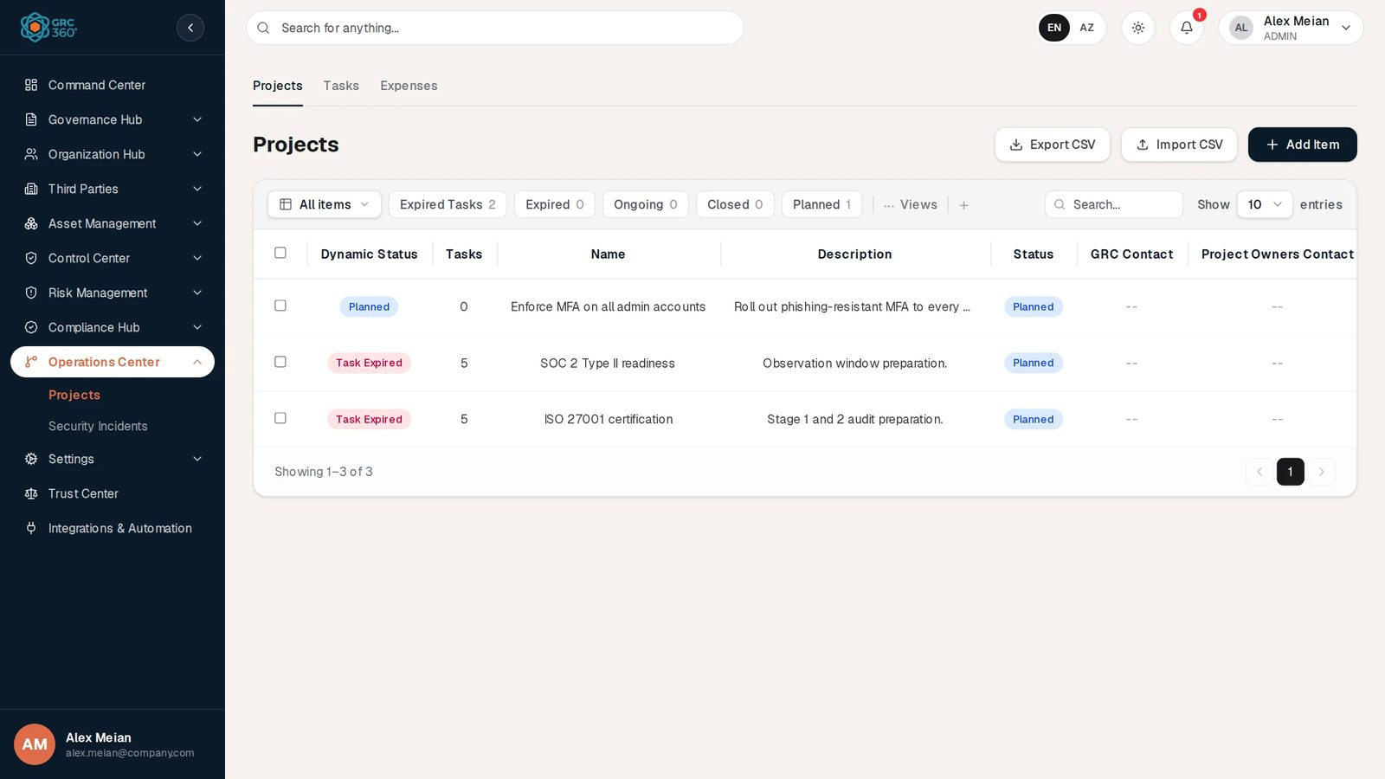
Projects register

Pages
Page (sidebar label) | Route | Permission key | What it holds
Projects | /operations-center/projects | operations_center.projects | Improvement projects: dates, contacts, status, and the controls, asset risks and compliance packages that name them.
Projects › Tasks | same route, Tasks tab | operations_center.projects_tasks | Ordered tasks of every project with owner, deadline and completion rate.
Projects › Expenses | same route, Expenses tab | operations_center.projects_expenses | Amounts spent on each project.
Security Incidents | /operations-center/incidents | operations_center.incidents | Incidents, possible incidents and events, with their stage progress and the risks that name them.
Security Incidents › Stages | same route, Stages tab | operations_center.incidents_stages | One row per stage of every incident, with its Completed or Incomplete status. Stage definitions are kept in the Settings dialog.
The sidebar shows the two pages under Operations Center; there is no overview page of its own.

How the records fit together
- A project chooses none of its links. The Projects grid reads them from the records that name the project: Internal Controls, Asset Risks (count) and Compliance Package.
- Tasks and expenses each belong to one project. A project’s Dynamic Status and its automatic Completed status come from its tasks.
- A security incident also chooses no risks. Its Known Asset / Third Party / Business Risk counts are read from the risks whose Security Incidents field names it.
- Stage definitions are copied onto every new incident as stage rows. Closing an incident requires every stage row to be Completed.

Statuses at a glance
Register | Status a person sets | Dynamic Status the system shows
Projects | Planned, Ongoing, Closed (the system may set Completed) | Closed, Expired, Task Expired, Planned, Ongoing
Tasks | None (Completion Rate instead) | Completed, Expired, Ongoing, Planned
Expenses | None | Recorded, Missing Date, Missing Amount
Security Incidents | Open, Closed (new incidents are always Open) | Closed, Completed (all stages done), In Progress
Incident stages | Completed, Incomplete | Follows the status
All Dynamic Statuses are computed every time a register is read, so date-based values such as Expired appear without any scheduled job. The exact rules are on each page.

Automations
- Project completion from tasks: when every task of a project reaches 100% the project’s Status becomes Completed; it returns to Ongoing when a task drops below 100%.
- Stages on new incidents: every new incident receives all stage definitions as Incomplete. A newly defined stage can be added to all open incidents (Apply this stage to incidents that are currently open? → Yes).
- Closing rule: an incident can be closed only when all its stages are Completed; the Closure Date is set automatically.
- Command Center: project tasks feed the Task Overview; projects feed Overall Progress.
- Notifications: none. The type INCIDENT_ALERT exists but nothing produces it, and no reminders are sent for task deadlines.

Permissions
Each page and each tab (Tasks, Expenses, Stages) has its own access level in the group settings (No Access, View, Manage, Full Control), plus the group’s Comments & Attachments level. Export CSV needs View; Import CSV, Add and Edit need Manage; Delete needs Full Control. There are no assignment rights and no row-level filters in this module. Some checks on the incident stages do not line up between the screen and the server; see Security Incidents. General rules: Permissions and access.

CSV import and export
This module has working CSV import on Projects, Tasks, Expenses, Security Incidents and the stage definitions (Settings). As on every register, Import CSV first shows CSV Import (…): the import structure is not ready yet. and then opens the real import dialog. The Stages tab’s Import CSV opens a demo dialog that cannot import. Export CSV exists on Projects, Tasks, Expenses, Security Incidents and the stage definitions. Formats are on each page and in CSV import and export.

Shared behaviour
All tabs use the shared grid: search, … Views, paging, the selection toolbar, the View dialog, the Activity Log and the delete confirmation work as described in Working with registers.

Related pages
- Controls (Related Projects), Asset Risks, Third Party Risks, Business Risks (Treatment: Projects, Security Incidents), Compliance Analysis (Projects), Objectives (Projects).
- Command Center: Task Overview and Overall Progress.
- Scenario: handling a security incident.

Projects
Module: Operations Center › Projects · Route: /operations-center/projects · Permission key: operations_center.projects (tabs: operations_center.projects_tasks, operations_center.projects_expenses)
The Projects register tracks the improvement work of the GRC programme: rolling out a control, treating a risk, preparing for a certification. One record is one project with its dates, contacts and status. Its Tasks tab holds the ordered tasks of every project, each with an owner, a deadline and a completion rate, and its Expenses tab holds what was spent. Projects are normally run by the GRC team or project owners in IT and the business; other modules point at them as the treatment for controls, risks and compliance requirements.
Projects register

At a glance
A record is | One improvement project, with its tasks and expenses
Typical owner | Project owner (Project Owners Contact) with a GRC Contact
Links to | Users (GRC Contact, Project Owners Contact)
Linked from | Controls (Related Projects), Asset, Third Party and Business Risks (Treatment: Projects), Compliance Analysis (Projects), Policies (Related Projects), Data Flows (Improvement Projects), Objectives (Projects), Tasks and Expenses
Tabs | Projects, Tasks, Expenses
Automations | Dynamic Status of projects and tasks computed on every read; project status set to Completed when every task reaches 100%; Command Center Task Overview and Overall Progress

The register (list view)
All three tabs use the shared grid described in Working with registers. Each tab loads its whole register at once, so the All items drop-down (filter by Status) and the view chips with their counts are available. The header has Export CSV, Import CSV and Add Item.
View chips on Projects (matched on the Dynamic Status): Expired Tasks, Expired, Ongoing, Closed, Planned. In the demo data: Expired Tasks 2, Planned 1.
Column | What it shows | Source
Dynamic Status | Closed, Expired, Task Expired, Ongoing or Planned (rule below) | Computed by the system
Tasks | Number of tasks of the project (deleted tasks not counted) | Computed
Name | Project name | Entered
Description | Description | Entered
Status | The status chosen on the form: Planned, Ongoing, Closed (older rows may show Completed, Confirmed or Delayed) | Entered, or set by the task automation
GRC Contact | Users named as GRC contact | Entered
Project Owners Contact | Users named as project owners | Entered
Start Date | Start date | Entered
Deadline | Project deadline | Entered
Internal Controls | Names of the controls that name this project under Related Projects | Linked (read from the controls)
Asset Risks | Number of asset risks naming this project under Treatment: Projects; click a non-zero number to open them | Linked (read from the risks)
Compliance Package | Packages of the Compliance Analysis items that name this project (each package once) | Linked (read from Compliance Analysis)

Creating a record
Click Add Item. The dialog Add Item (Projects) (subtitle Operations Center) has a single General tab.
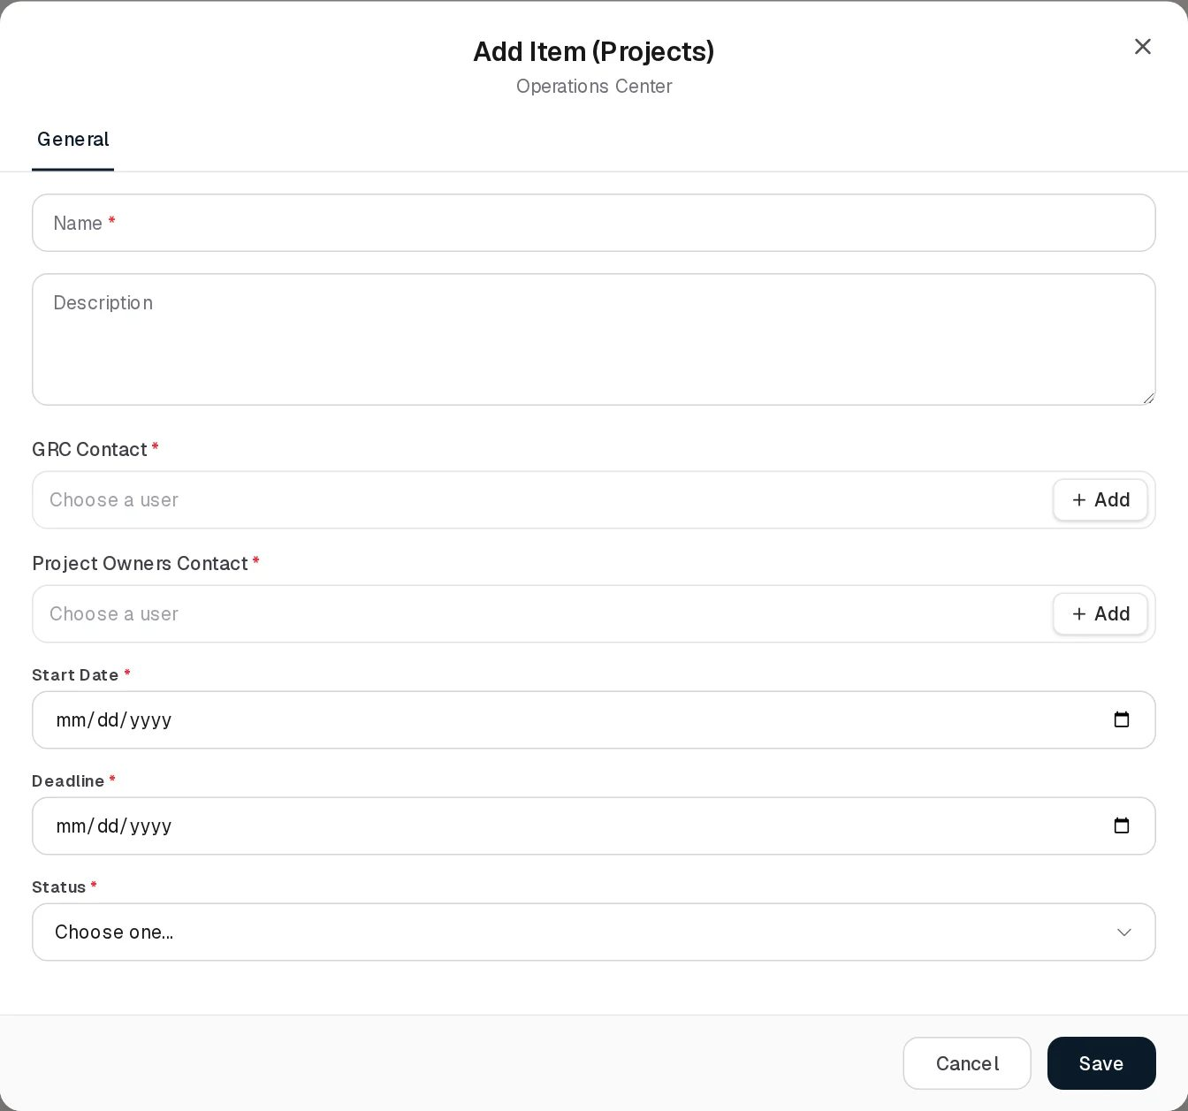
Add Project
Field | Type | Required | Rules and allowed values | Example
Name | Text | Yes | Required. Up to 255 characters (Project name must not exceed 255 characters). | ISO 27001 certification
Description | Text area | No | Up to 2,000 characters. | Stage 1 and 2 audit preparation.
GRC Contact | Users only, several allowed (Choose a user) | Yes | Required. Groups cannot be chosen. + Add creates a new user. Up to 255 characters of names. | Alex Meian
Project Owners Contact | Users only, several allowed | Yes | Required. Up to 500 characters of names. | Sara Johnson
Start Date | Date | Yes | Required | 2026-08-06
Deadline | Date | Yes | Required. Not checked against Start Date. | 2026-12-24
Status | Drop-down | Yes | Closed, Ongoing, Planned. Empty (Choose one…) until you pick. | Planned
Errors appear as Required under each field. Saving shows Project added. The form has no fields for controls, risks or compliance packages: those links are made on the other records (see Relationships).
The same form opens when you click + next to Project on the Tasks and Expenses forms, or + Add on a project field in another module.

Viewing and editing a record
View Project
View opens the shared View item dialog with every column. A non-zero Asset Risks count is clickable.
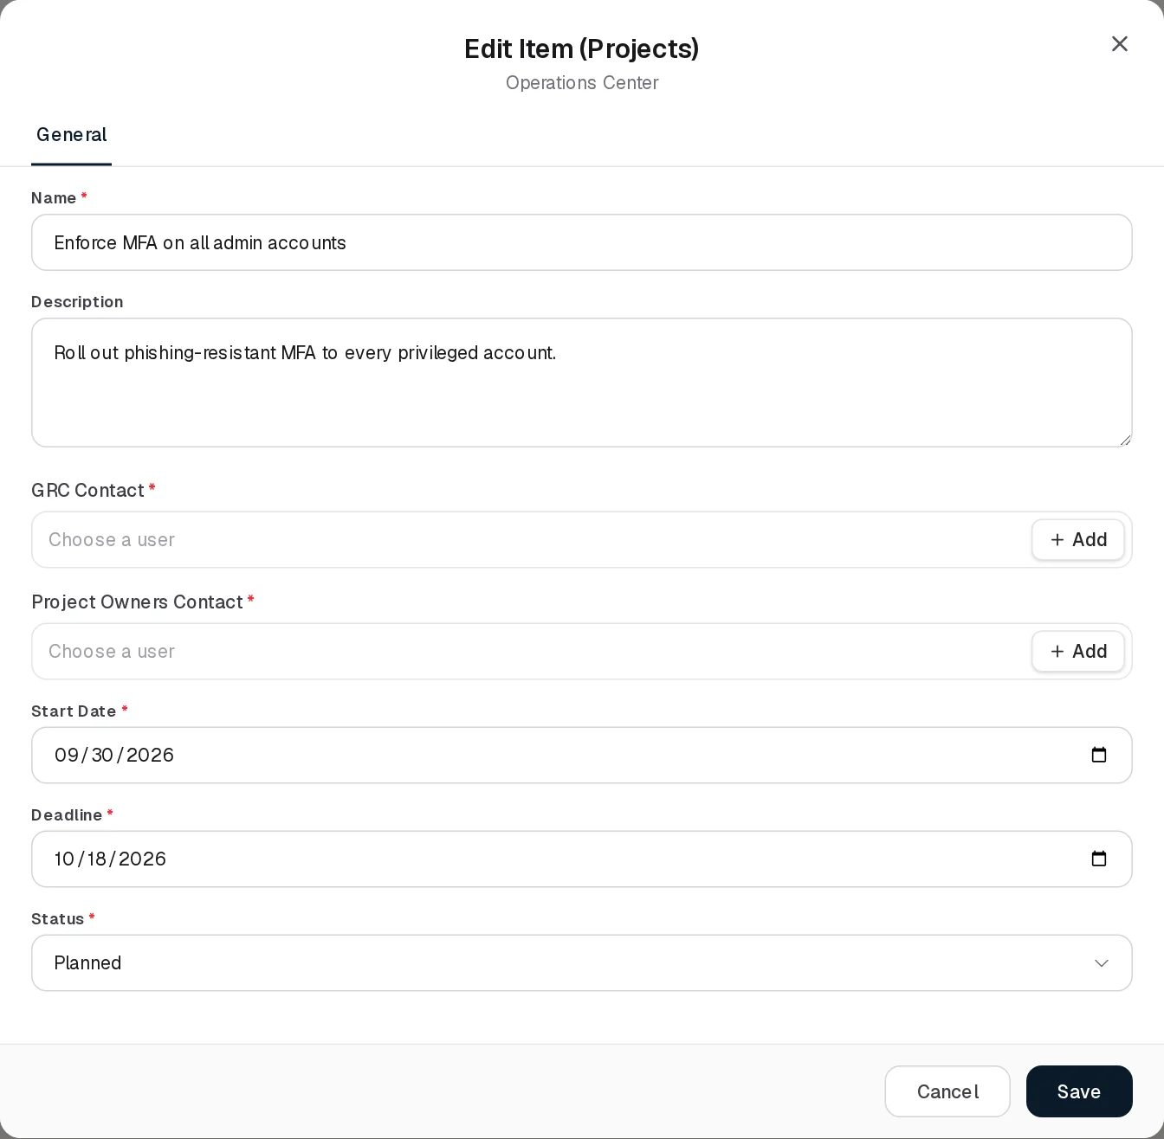
Edit Project
Edit Item (Projects) has the same fields. A project that holds an older status (Completed, Confirmed or Delayed) keeps that value in the Status list so it does not silently change to Planned. Saving shows Project updated.
Deleting a project asks Delete (name)? Its tasks and expenses will be removed as well. and removes its tasks and expenses with it.

Statuses
Status (set by a person)
Value | Meaning
Planned | Not started.
Ongoing | Work in progress.
Closed | The owner closed the project.
Completed | Set by the system when every task reaches 100% (see Automations). Also held by older rows.
Confirmed, Delayed | Held by older rows only; not offered for new choices.
Any other value sent to the server is stored as Planned.
Dynamic Status (computed every time the register is read; first matching rule wins)
Value | Colour | Rule
Closed | Green | Status is Closed or Completed, or the project has at least one task and every task is at 100%
Expired | Red | The project deadline is before today
Task Expired | Red | The project is in time, but at least one task below 100% has a deadline before today
Planned | Blue | The project has no tasks
Ongoing | Amber | Any other case
The rules are evaluated live, so a project turns Expired the day after its deadline without any job running. SOC 2 Type II readiness and ISO 27001 certification read Task Expired in the demo because tasks such as Review Q3 internal audit report (deadline 2026-09-29, 0%) are past due.
The backend also computes a progress percentage per project (the average completion rate of its tasks). It is not shown on this page; it feeds the Command Center.

Tabs

Tasks
The Project Tasks register lists the tasks of all projects. Tasks have no status of their own: the Dynamic Status follows from completion rate and deadline.
Project Tasks
View chips: Completed (Dynamic Status Completed), Expired (Dynamic Status Delayed), Expiring in 2 Weeks (deadline from today up to 14 days ahead and not completed). In the demo data: Completed 0, Expired 6, Expiring in 2 Weeks 3.
Column | What it shows
Dynamic Status | Completed (100%), Expired (below 100% and deadline before today), Ongoing (1 to 99%), Planned (0% and deadline today or later), in that order of precedence
Project | The project the task belongs to
Task Order | Position of the task in its project
Completion Rate | 0% to 100%
Deadline | Task deadline
Description | What the task is
Task Owner | Users named as owner
Add Item (Project Tasks) / Edit Item (Project Tasks):
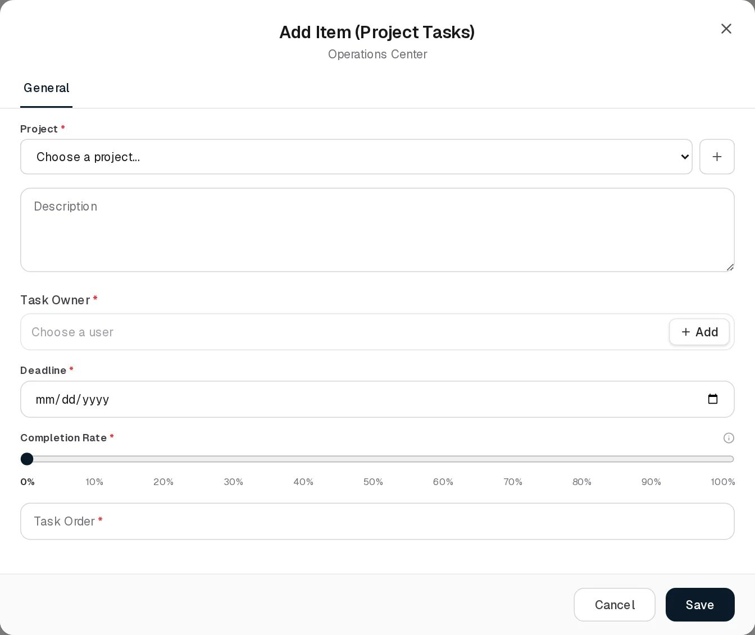
Add Project Task
Field | Type | Required | Rules and allowed values | Example
Project | Drop-down of projects (Choose a project…), with + to create one | Yes | Required. Picking a project fills Task Order with the next free number if it is empty. | ISO 27001 certification
Description | Text area | No |  | Review Q3 internal audit report
Task Owner | Users only, several allowed | Yes | Required (server: Task owner is required) | Mike Brown
Deadline | Date | Yes | Required (server: Deadline is required) | 2026-09-29
Completion Rate | Slider, steps of 10 | Yes | 0% to 100%, default 0%. The i icon reads A task counts as complete at 100%. | 20%
Task Order | Number | Yes | Whole number of 1 or more (Must be a whole number of 1 or more). Must be unique in the project: Task order N is already used by another task in “Project”. Pick a different order. | 1
Messages: Task added., Task updated., Task deleted.
Screenshots: View, Edit.

Expenses
The Project Expenses register lists what was spent on each project. There are no view chips on this tab; the All items drop-down filters by the Dynamic Status.
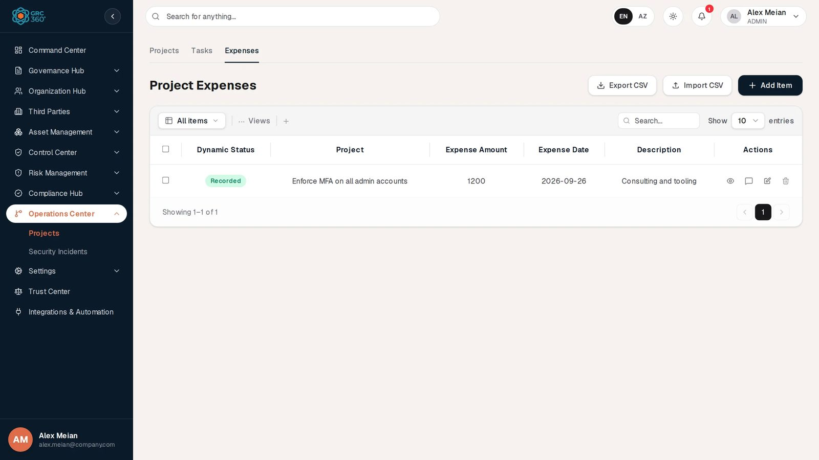
Project Expenses
Column | What it shows
Dynamic Status | Recorded (amount above zero and a date), Missing Date (amount above zero, no date), Missing Amount (no amount or amount 0)
Project | The project
Expense Amount | Amount, no currency
Expense Date | Date of the expense
Description | What it was for
Add Item (Project Expenses) / Edit Item (Project Expenses):
Add Project Expense
Field | Type | Required | Rules | Example
Project | Drop-down with + | Yes | Required | Enforce MFA on all admin accounts
Expense Amount | Number, step 0.01 | Yes | Required; zero or more (Must be zero or more; server: Expense amount cannot be negative) | 1200
Description | Text area | No |  | Consulting and tooling
Expense Date | Date | Yes | Required (server: Expense date is required) | 2026-09-26
Because amount and date are required, an expense saved from this form reads Recorded, or Missing Amount when the amount is 0. Messages: Expense added., Expense updated., Expense deleted.
Screenshots: View, Edit.

Relationships
A project chooses none of these links itself. Each one is made on the other record.
Related record | Direction | How the link is made | Where it shows on Projects
Controls | Control → Project, many to many | Control form, Related Projects | Internal Controls column (names)
Asset Risks | Risk → Project, many to many | Risk form, Treatment: Projects | Asset Risks column (count, clickable)
Third Party Risks, Business Risks | Risk → Project, many to many | Risk form, Treatment: Projects | Not shown. Used by the Command Center scope filter.
Compliance Analysis items | Item → Project, many to many | Compliance Analysis, Projects | Compliance Package column (package names)
Policies | Policy → Project | Policy form, Related Projects | Not shown
Data Flows | Data flow → Project | Data flow form, Improvement Projects | Not shown
Objectives | Objective → Project, many to many | Objective form, Activities › Projects | Not shown. A finished project counts towards the objective’s progress.
Tasks | Task → Project, many to one | Task form, Project | Tasks column (count, not clickable)
Expenses | Expense → Project, many to one | Expense form, Project | Not shown
Users | Project, task → user | GRC Contact, Project Owners Contact, Task Owner (names stored as text, first pick also as a user link) | Grid columns
When a user is deleted, their user link is removed from projects and tasks, and their name stays in the text.

Automations and notifications
- Dynamic Status of projects, tasks and expenses: computed on every read, no job involved.
- Project completion from tasks (each time a task is added, edited or deleted): when every task of a project is at 100%, the project’s Status becomes Completed; when a task of a Completed project drops below 100%, the Status returns to Ongoing; when the last task of a Completed project is deleted, it returns to Planned. These changes are written to the system audit log.
- Command Center: tasks with a deadline appear in the Task Overview (Expired, Today, Future). Users who do not see all tasks see only the tasks where they are the linked owner (the first owner picked). Overall Progress counts projects by Dynamic Status (Closed as Completed, Expired and Task Expired as Delayed, Ongoing as On going) and averages their progress.
- Objectives: a project whose Status is Completed, or whose tasks are all at 100%, counts as finished in the progress of any objective that links it. Achieving an objective does not change its projects.
- Notifications: none. Projects, tasks and expenses send no notification, and no reminder is sent for task deadlines.

Permissions
Projects, Projects › Tasks and Projects › Expenses each have their own access level (No Access, View, Manage, Full Control). See Permissions and access.
Action | Needed access
See the Projects tab | View on Operations Center › Projects
Open the Tasks or Expenses tab | View on that tab (it shows a lock otherwise)
Export CSV | View on the register being exported
Create / Edit / Import CSV | Manage on the register concerned
Delete | Full Control on the register concerned. Deleting a project removes its tasks and expenses without a separate check on those tabs.
Comment / attach | The group’s Comments & Attachments level
Assign | No assignment rights on these registers
The project lists in the Tasks and Expenses forms come from the Projects register, so a user without View on Projects cannot pick a project there. There is no row-level filter: everyone with View sees all projects.

How to

Plan a project with tasks
- On Projects, click Add Item. Enter Enforce MFA on all admin accounts, pick the GRC Contact and Project Owners Contact, set Start Date, Deadline and Status Planned, and Save.
- Open Tasks, click Add Item, pick the project. Task Order fills with 1.
- Enter the Description Inventory privileged accounts, a Task Owner and a Deadline, and Save.
- Back on Projects, the Tasks column shows 1 and the Dynamic Status changes from Planned to Ongoing.

Report progress on a task
- On Tasks, click the chip Expiring in 2 Weeks to see what is due soon.
- Edit Quarterly risk assessment and move Completion Rate to 60%. Save.
- When the last open task of a project reaches 100%, the project’s Status becomes Completed and its Dynamic Status Closed.

Find projects that are behind
- On Projects, click Expired Tasks (project in time, a task overdue) or Expired (project deadline passed).

Record an expense
- Open Expenses, click Add Item, pick Enforce MFA on all admin accounts.
- Enter Expense Amount 1200, Description Consulting and tooling and the Expense Date, then Save. The row reads Recorded.

CSV import
Import works on all three tabs. Import CSV first shows CSV Import (Projects): the import structure is not ready yet. (or Project Tasks, Project Expenses) and then opens the import dialog: choose a .csv file, Validate, then Import n rows. Headers are matched case-insensitively, with spaces read as underscores (so Start Date and start_date both work).
Tab | Columns read | Checked by Validate | Notes
Projects | name (required), description, grc_contact, project_owners, start_date, deadline (YYYY-MM-DD), status | Name present; no duplicate name in the file | Contacts are stored as text only (no user link). Unknown status becomes Planned.
Tasks | project_id (UUID), task_order (required), description, task_owner, deadline, completion_rate | Task order present; no duplicate project/order pair in the file | Project, owner, deadline and order uniqueness are only checked on the actual import; failing rows appear under Import Errors.
Expenses | project_id (UUID), expense_amount (or amount), description, expense_date | Amount not negative | Project and date are only checked on the actual import.
Export CSV downloads projects.csv (Tasks, Name, Description, Status, Start Date, Deadline, GRC Contact), project-tasks.csv (Dynamic Status, Task Owner, Completion Rate, Deadline, Task Order, Description, Project Name) and project-expenses.csv (Status, Expense Amount, Description, Expense Date, Project Name).
Limits of the import: values are split on every comma, so quoted values that contain commas are not read correctly, and the task and expense exports give the project name while the import needs the project id. An exported file therefore cannot be re-imported as it is.

Limitations and known issues
- The task automation writes Completed, not Closed. A project finished through its tasks shows Status Completed, a value the Status list otherwise no longer offers.
- Only asset risks are shown. Third party and business risks that name a project under Treatment: Projects, and policies, data flows and objectives that link it, do not appear on the project.
- Deadline before Start Date is accepted.
- No deadline reminders. Overdue tasks are visible through Dynamic Status and the Command Center, but nobody is notified.
- CSV import splits on commas and cannot re-import its own export (see above).
- Expense amounts have no currency.

Security Incidents
Module: Operations Center › Security Incidents · Route: /operations-center/incidents · Permission key: operations_center.incidents (tab Stages: operations_center.incidents_stages)
The Security Incidents register records security incidents, possible incidents and events worth keeping, and takes each one through a fixed set of handling stages before it can be closed. One record is one incident. The stages (for example Detection, Containment, Eradication, Recovery, Lessons learned) are defined once under Settings, in the style of ERAMBA, and every new incident receives all of them. The Stages tab lists every stage of every incident with its status. The register is kept by the security operations or incident response team, with the GRC function documenting the case.
Security Incidents register

At a glance
A record is | One security incident (or possible incident, or event) and its handling stages
Typical owner | Incident handler (Incident Contact) with a GRC Contact who documents it
Links to | Users (GRC Contact, Incident Contact), stage definitions
Linked from | Asset, Third Party and Business Risks (Security Incidents field on the risk)
Tabs | Security Incidents, Stages (plus the Settings dialog for stage definitions)
Automations | New incidents receive every defined stage; closing requires all stages completed; Dynamic Status and stage counts computed on read

The register (list view)
The Security Incidents tab uses the shared grid (Working with registers) with server-side paging. Because of that it has no All items drop-down and no view chips; search matches the incident title. The header has Export CSV, Settings, Import CSV and Add Item.
Column | What it shows | Source
Dynamic Status | In Progress, Completed or Closed (rule below) | Computed by the system
Stages | Stages completed out of stages assigned, for example 0/5 | Computed
Title | Incident title | Entered
Type | Incident, Possible Incident or Event | Entered
Description | Description | Entered
Open Date | Date the incident opened | Entered
Closure Date | Date it was closed | Set by the system
Known Asset Risk | Number of asset risks that name this incident; click a non-zero number to open them | Linked (read from the risks)
Known Third Party Risk | Same, for third party risks | Linked
Known Business Risk | Same, for business risks | Linked
The GRC Contact and Incident Contact are on the form but not in the grid.

Creating a record
Click Add Item. The dialog is titled Add Item (Security Incidents) (subtitle Operations Center).
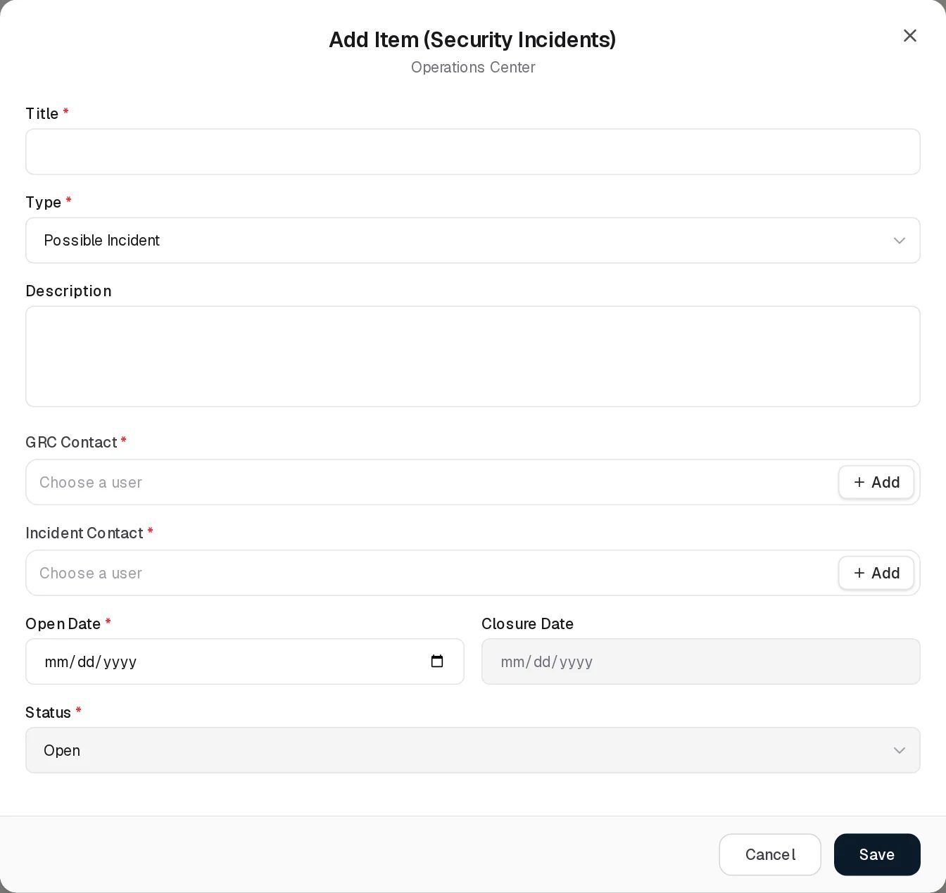
Add Security Incident
Field | Type | Required | Rules and allowed values | Example
Title | Text | Yes | Required. Up to 255 characters (Title must not exceed 255 characters). | Phishing campaign targeting finance team
Type | Drop-down | Yes | Incident, Possible Incident, Event. Default Possible Incident. | Possible Incident
Description | Text area | No |  | Phishing campaign targeting finance team.
GRC Contact | Users only, several allowed (Choose a user) | Yes | Required. + Add creates a new user. | Alex Meian
Incident Contact | Users only, several allowed | Yes | Required. The person or team handling or affected by the incident. | Mike Brown
Open Date | Date | Yes | Required. Cannot be later than today: the date picker stops at today, and a typed later date gives Open Date cannot be in the future. | 2026-10-10
Closure Date | Date, greyed out | No | Never typed. Filled with today when Status is set to Closed on Edit, cleared when set back to Open.
Status | Drop-down, greyed out on Add | Yes | Open, Closed. A new incident is always Open. | Open
Saving shows Incident added. The new incident immediately receives every stage defined under Settings, each Incomplete, so its Stages column reads 0/n (0/5 in the demo).

Viewing and editing a record
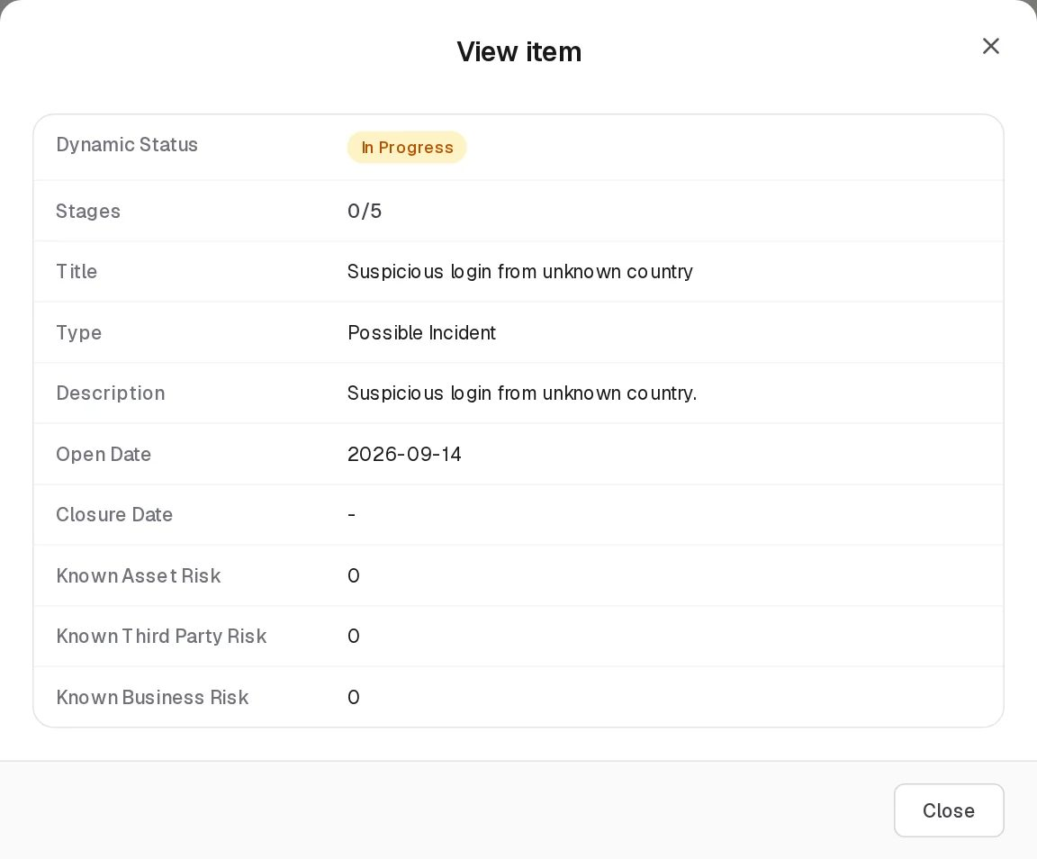
View Security Incident
View opens the shared View item dialog with the grid columns. Known risk counts are clickable.
Edit Security Incident
Edit Security Incident has the same fields, with Status now selectable.
- Changing Status to Closed fills Closure Date with today. The server accepts it only if every stage of the incident is Completed; otherwise it refuses with This incident still has open stages: Detection, Containment, … Complete every stage before closing it. The message shows as a red pop-up and as a banner on the page, and the form stays open.
- Changing Status back to Open clears the Closure Date.
- Saving without changing the status re-checks nothing, so a closed incident can still be edited.
Saving shows Incident updated. Deleting asks Delete incident (title)? Its stages will be removed as well.

Statuses
Status (set by a person)
Value | Meaning
Open | The incident is being handled. Every new incident starts Open.
Closed | Handling is finished. Only possible when every stage is Completed.
Dynamic Status of an incident (computed on every read)
Value | Colour | Rule
Closed | Green | Status is Closed
Completed | Green | Status is Open, the incident has at least one stage and every stage is Completed: ready to close
In Progress | Amber | Any other case, including an open incident with no stages
Stages column. Completed stages / stages assigned. A closed incident always reads n/n; a closed incident that never had stages reads the number of stages currently defined, for example 5/5.
Stage status (Stages tab): Completed or Incomplete, chosen by a person. The stage’s Dynamic Status simply follows it: Completed (green) or Incomplete (red).

Tabs

Stages
The Security Incident Stages register lists one row per stage of every incident. Rows are created by the system (when an incident is added, or when a new stage is applied to open incidents); there is no Add Item and no Delete on this tab.
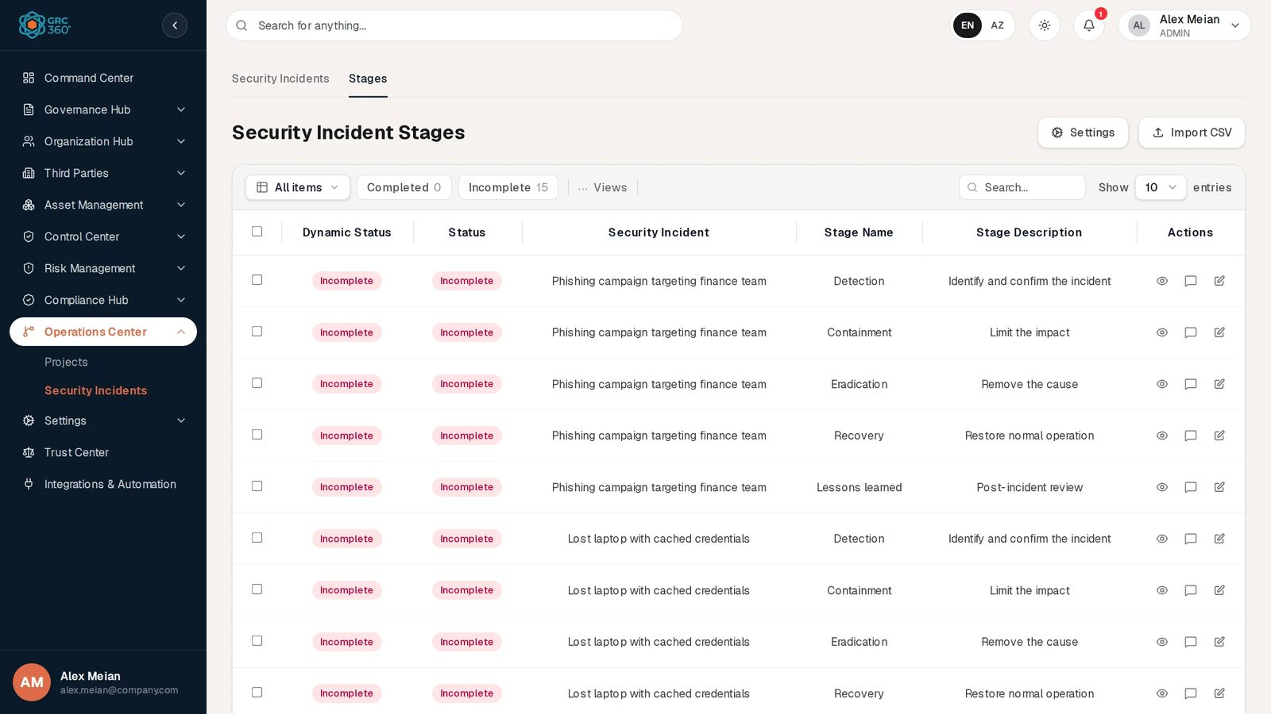
Security Incident Stages
The toolbar has All items and two view chips, Completed and Incomplete (Incomplete 15 in the demo: three incidents with five stages each). The header has Settings and Import CSV.
Column | What it shows
Dynamic Status | Completed or Incomplete, following Status
Status | Completed or Incomplete
Security Incident | Incident title
Stage Name | Name of the stage
Stage Description | Description of the stage
Edit (pencil, or tick a row and click Edit) opens Edit Security Incident Stage:
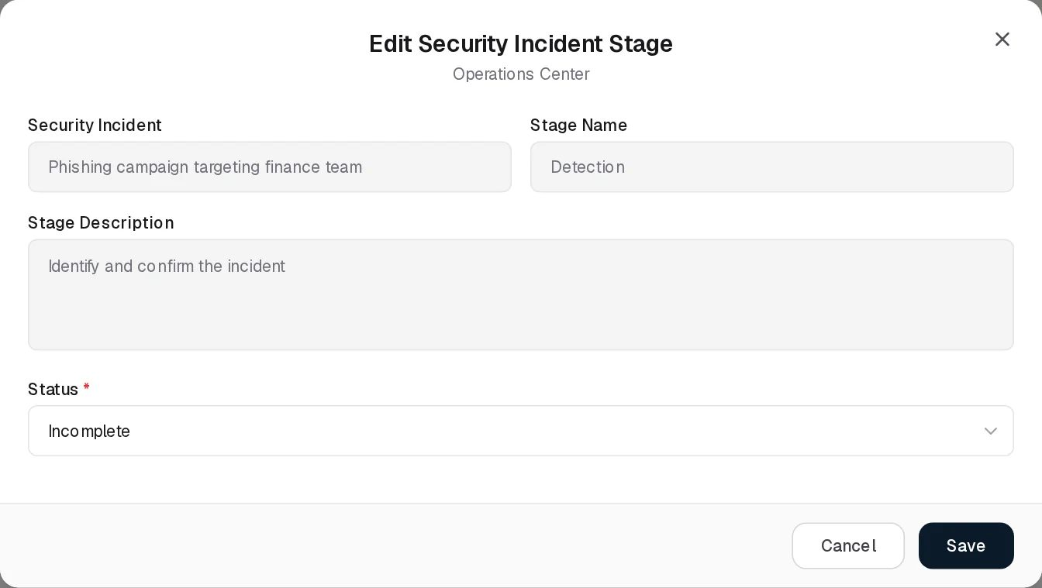
Edit Security Incident Stage
Field | Type | Required | Rules | Example
Security Incident | Text, read-only |  |  | Phishing campaign targeting finance team
Stage Name | Text, read-only |  |  | Detection
Stage Description | Text area, read-only |  |  | Identify and confirm the incident
Status | Drop-down | Yes | Completed, Incomplete | Completed
Saving shows Stage updated. and the incident’s Stages count and Dynamic Status change at once. A stage of a closed incident cannot be set back to Incomplete: A stage of a closed incident cannot be marked incomplete. Reopen the incident first.
The View dialog shows the same five columns.

Settings: stage definitions
Settings (on either tab) opens the Stages dialog, a small register of stage definitions with Name and Description columns, Export CSV, Import CSV and Add Item. Stages are listed in the order they were created. A new tenant starts with no stages; the demo data defines Detection, Containment, Eradication, Recovery and Lessons learned.
Field | Type | Required | Rules | Example
Name | Text | Yes | Required. Up to 255 characters. | Containment
Description | Text area | Yes | Required | Limit the impact
Adding a stage asks one more question after Save: Apply this stage to incidents that are currently open? with the explanation Yes adds it to every open incident as incomplete. No keeps it for incidents added from now on.
- Yes: every incident whose Status is Open gets the stage as Incomplete (never twice). Closed incidents are never changed. The message reads Stage added to N open incidents.
- No: only incidents created from now on get it. Message: Stage added. Incidents already raised are unchanged.
- Cancel returns to the form.
The question is asked only when a stage is created. Editing a stage changes its name and description everywhere it is used, without changing which incidents have it.
Deleting a stage asks Delete stage (name)? Stages still in use by an incident cannot be removed. and is refused while any incident has it: Cannot delete stage because it is currently used by active security incidents. A stage can therefore only be deleted before any incident has received it.

Relationships
Related record | Direction | How the link is made | Where it shows
Asset Risks | Risk → Incident, many to many | Security Incidents field on the asset risk form | Known Asset Risk column (count, clickable)
Third Party Risks | Risk → Incident, many to many | Security Incidents field on the third party risk form | Known Third Party Risk column (count, clickable)
Business Risks | Risk → Incident, many to many | Security Incidents field on the business risk form | Known Business Risk column (count, clickable)
Stage definitions | Incident → stage, many to many, through the stage rows | Automatic: all stages on creation; a new stage on open incidents when you answer Yes | Stages column (count), Stages tab
Users | Incident → users | GRC Contact, Incident Contact (names as text, first pick also as a user link) | Form only
The incident form has no risk field: risks are linked from the risk side. When a user is deleted, their user link on incidents is removed and the name stays in the text.

Automations and notifications
- Stages on creation: every stage defined at that moment is added to a new incident as Incomplete.
- Apply to existing: when a stage is added and you answer Yes, it is added to all open incidents.
- Closing rule: Open → Closed only with every stage Completed; Closure Date set to today (or the date sent through the API); Closed → Open clears it.
- Dynamic Status and stage counts: computed on every read.
- Start-up clean-up: at application start, stage definitions that exactly match the five stages earlier versions created automatically (Identification, Containment, Eradication, Recovery, Lessons Learned with their original descriptions) are removed if no incident uses them.
- Notifications: none. The notification type INCIDENT_ALERT exists but nothing produces it, and no one is notified when an incident is added, changes stage or is closed.
- All changes are recorded in the Activity Log history and in the system audit log.

Permissions
Security Incidents and Security Incidents › Stages each have their own access level (No Access, View, Manage, Full Control). See Permissions and access.
Action | Needed access
See the Security Incidents tab | View on Security Incidents
Add, edit, close or import incidents | Manage on Security Incidents
Delete incidents | Full Control on Security Incidents
Export incidents | View on Security Incidents
Open the Stages tab | View on Security Incidents › Stages
Change a stage’s Status | Manage on Security Incidents › Stages (the Edit button) and Manage on Security Incidents (the server checks the incident)
Add, edit, import stage definitions in Settings | Manage on Security Incidents › Stages on the server; the buttons in the dialog are checked against Security Incidents
Delete stage definitions | Full Control on Security Incidents › Stages on the server; the button is checked against Security Incidents
Comment / attach | The group’s Comments & Attachments level
The Settings button itself is never locked. There is no row-level filter: everyone with View sees all incidents.

How to

Record an incident
- Open Operations Center › Security Incidents and click Add Item.
- Enter the Title Lost laptop with cached credentials, keep Type Possible Incident, add a Description.
- Pick the GRC Contact and Incident Contact, set Open Date (today or earlier) and Save.
- The incident appears with Stages 0/5 and Dynamic Status In Progress.

Work through the stages and close the incident
- Open the Stages tab and click Incomplete to see open stages.
- Edit the row Lost laptop with cached credentials / Detection, set Status to Completed, Save. Repeat for the other four stages.
- On Security Incidents, the incident now reads 5/5 and Completed.
- Edit the incident, set Status to Closed (Closure Date fills with today) and Save. Dynamic Status becomes Closed.

Add a new stage to the lifecycle
- Click Settings, then Add Item.
- Enter Name Regulator notification and Description Notify the supervisory authority within 72 hours, then Save.
- Answer Yes to add it to the incidents that are open now, or No to use it only for new incidents.

Show which risks an incident touched
- Open the asset risk, for example Unauthorized access, and pick the incident in its Security Incidents field. Save.
- Back on Security Incidents, Known Asset Risk reads 1; click it to open the risk.

CSV import
Import CSV first shows CSV Import (register name): the import structure is not ready yet. and then:
Where | What happens | Columns read
Security Incidents tab | Real import (Validate, then Import n rows) | title (required), description, type, grc_contact, status, open_date, closure_date (YYYY-MM-DD). Validate checks only that a title is present. Every imported incident is created Open with all current stages, whatever status says; grc_contact is stored as text only; a future open_date fails on import.
Settings dialog | Real import of stage definitions | name and description, both required. Imported stages are not applied to existing incidents.
Stages tab | Demo dialog only; it cannot validate a file. Stage rows cannot be imported.
Export CSV: security-incidents.csv (Dynamic Status, Stages, Title, Description, Open Date, Closure Date, Type, Status) and, from Settings, incident-stages.csv (Stage Name, Description). The Stages tab has no export.
Values are split on every comma, so quoted values that contain commas are not read correctly.

Limitations and known issues
- Permissions do not line up. Changing a stage’s status needs edit rights on both Security Incidents and its Stages tab; the Settings dialog checks the Security Incidents rights in the browser but the Stages rights on the server; the Settings button is never locked.
- Import CSV on the Stages tab does not work (demo dialog), and the incident import ignores the status column.
- No search on contacts and no contact columns: GRC Contact and Incident Contact are only visible in the Edit form.
- A stage in use cannot be deleted, even when every incident using it is closed.
- No notifications for new, changed or closed incidents.
- A separate, older incident store exists in the backend (/api/v1/incidents, with severity and corrective actions). No screen uses it; its records never appear on this page.

Trust Center
Module: Trust Center (single page, outside the permission catalogue) · Route: /trust-center · Permission key: None
The Trust Center is the page you open to show a customer, auditor or prospect how GRC360 itself is secured. It lists the security measures built into the product, how data is handled, the certification roadmap and a short FAQ, and offers a Contact Security button that opens pre-addressed e-mails. Most of the content is fixed text written into the product. One optional section, Live compliance posture, shows aggregate figures from your own Compliance Hub, and appears only after an administrator switches publishing on under Settings › About System.
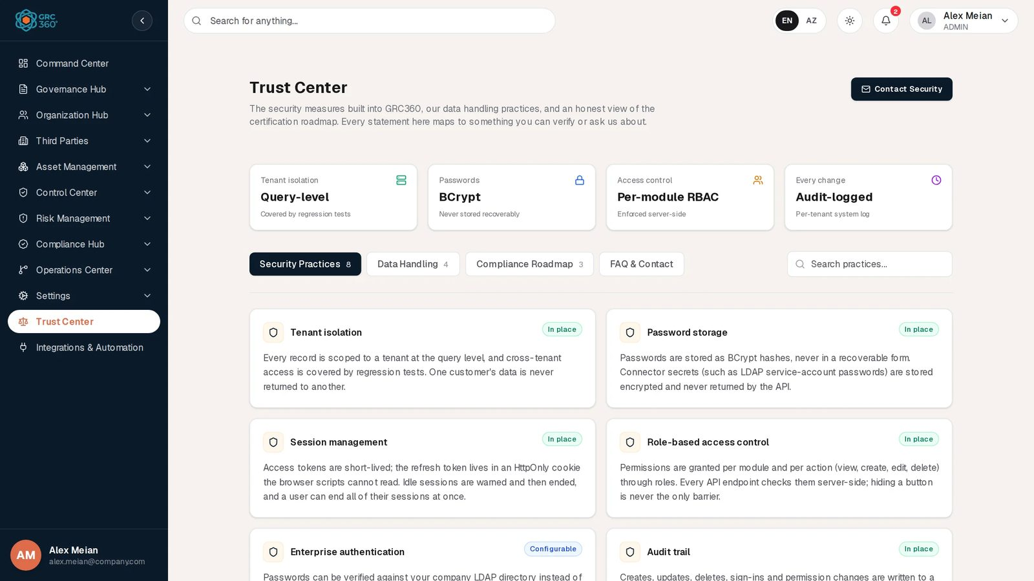
Trust Center

At a glance
A record is | None. The page has no records.
Typical owner | Content is fixed in the product. The administrator decides whether the live posture section is shown.
Links to | Compliance Hub (live posture aggregates), Control Center › Policies & Standards (published policy count), e-mail to contact@strativu.com
Linked from | Sidebar (Trust Center, opens in a new browser tab); Support page (“Before you write”)
Tabs | Security Practices, Data Handling, Compliance Roadmap, FAQ & Contact (in-page tabs, not permission sections)
Automations | The live posture is computed when the page loads. No scheduled job.

The page (list view)
The sidebar entry opens the page in a new browser tab, so the work you had open stays where it was. The page still requires a signed-in session: opening /trust-center without one redirects to the sign-in page. It is not a public page for anonymous visitors in this release.
From top to bottom:
- Header. “Trust Center”, a one-line introduction, and the Contact Security button.
- Four fact cards.
Card | Value | Note
Tenant isolation | Query-level | Covered by regression tests
Passwords | BCrypt | Never stored recoverably
Access control | Per-module RBAC | Enforced server-side
Every change | Audit-logged | Per-tenant system log
- Live compliance posture (only when publishing is on, see below).
- Tabs with counts: Security Practices 8, Data Handling 4, Compliance Roadmap 3, FAQ & Contact. The Security Practices tab has a Search practices… box that filters the cards by title and description; with no match it shows “Nothing matches that search.”
The full page in the demo, with the Security Practices tab open and the live posture section absent because publishing is off:
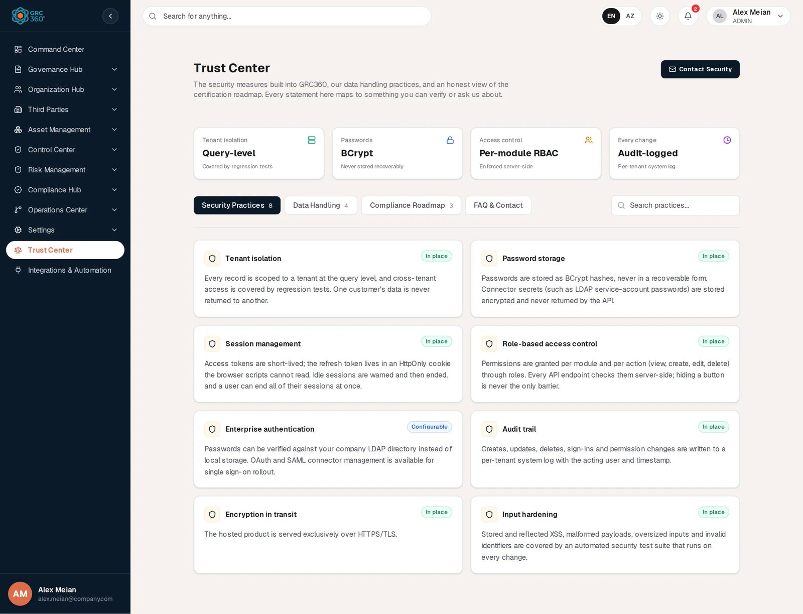
Trust Center, full page

Security Practices tab
Eight cards, each with a badge.
Practice | Badge | What the card says
Tenant isolation | In place | Every record is scoped to a tenant at query level; cross-tenant access is covered by regression tests.
Password storage | In place | Passwords are BCrypt hashes; connector secrets (such as LDAP service-account passwords) are stored encrypted and never returned by the API.
Session management | In place | Short-lived access tokens, refresh token in an HttpOnly cookie, idle warning and timeout, sign-out of all sessions.
Role-based access control | In place | Permissions per module and action through roles, checked server-side.
Enterprise authentication | Configurable | LDAP password verification; OAuth and SAML connector management “for single sign-on rollout”.
Audit trail | In place | Creates, updates, deletes, sign-ins and permission changes written to a per-tenant system log.
Encryption in transit | In place | The hosted product is served over HTTPS/TLS.
Input hardening | In place | XSS, malformed payloads, oversized inputs and invalid identifiers covered by an automated security test suite.

Data Handling tab
Four cards: Deletion model (records are soft-deleted first and recoverable by an administrator before purge), Your data stays yours (every register exports to CSV), Least data (only what the GRC process needs, no employee monitoring) and Access on request (infrastructure, hosting and subprocessor details on request).

Compliance Roadmap tab
An amber note states that no third-party certification is held today. Three entries follow:
Item | State
ISO/IEC 27001 | Planned
SOC 2 | Planned
GDPR alignment | In progress

FAQ & Contact tab
Five questions with answers (certificates held today, data location, security reviews and penetration tests, corporate directory sign-in, reporting a security issue), followed by a “Something we haven’t answered?” card with a second Contact Security button.

Contact Security dialog
The dialog “Contact the security team” offers four links. Each opens a new message in your own e-mail program, addressed to contact@strativu.com, with a fixed subject. Nothing is sent by GRC360 itself.
Link | Subject
Request security documentation | Security documentation request
Ask for the subprocessor list | Subprocessor list request
Report a security issue | Security disclosure
General security question | Security question

Live compliance posture
This section appears only when Public Trust Center publishing is switched on for your organisation (Settings › About System). When it is off, or the server cannot be reached, the section is simply absent; no message is shown. In the demo data it is off.
Element | Rule
Badge | Live
One bar per package | Every compliance package (not deleted) that has assessed requirement items, with “compliant/total compliant (N %)”. Only items judged Compliant count; Partially Compliant items do not count here (unlike the Command Center, which counts them as half).
Frameworks tracked | Number of packages listed. With none, the left side reads “No frameworks are being tracked yet.”
Published policies | Number of policies in Policies & Standards with status Published.
Only these aggregates are published; no record names other than package names appear.

Creating a record
None.

Viewing and editing a record
None. The fixed content cannot be edited in the product. The only setting is the publishing switch on About System.

Statuses
Value | Set by | Meaning
In place | Fixed text | The practice is implemented in the product.
Configurable | Fixed text | The capability exists but depends on configuration.
Planned / In progress | Fixed text | Certification roadmap state.
Live | System | The live posture section is published for this organisation.

Tabs
The four in-page tabs are described above. They carry no separate permissions.

Relationships
Related record | Direction | How the link is made | Where it shows
Compliance package and assessed items | Read | Item counts per package and judgement | Live compliance posture bars
Policy | Read | Count of policies with status Published | Published policies
Publishing setting | Read | Switch on About System | Whether the live section appears

Automations and notifications
None. The live posture is computed when the page is opened.

Permissions
Action | Needed access
See the page | Any signed-in user. The page is outside the permission catalogue, so it is always in the sidebar and never shows Access Denied.
Turn the live posture on or off | Admin group (Settings is Admin-only), on Settings › About System.
Create / Edit / Delete | Not applicable.
Comment / Assign | Not applicable.

How to

Send a prospect the security overview
- Click Trust Center in the sidebar. It opens in a new tab.
- Walk through Security Practices, Data Handling and Compliance Roadmap.
- If the prospect asks for documents, click Contact Security and choose Request security documentation; your e-mail program opens with the subject filled in.

Publish your live compliance posture
- As an administrator, open Settings › About System.
- In the Public Trust Center card, switch the toggle on.
- Reload the Trust Center. The Live compliance posture section now shows each package with its compliant-item count and the number of published policies.

Report a security issue
- Open Trust Center and click Contact Security.
- Choose Report a security issue. A new e-mail with the subject “Security disclosure” opens in your mail program.

CSV import
None.

Limitations and known issues
- The page requires sign-in, although its own texts describe it as public; outside visitors without an account cannot open it.
- Several fixed statements are broader than what the product does in this release: the system log does not record sign-ins or most register changes (see System Log); OAuth and SAML connectors can be stored but are not used to sign anyone in (see Authentication); not every register exports to CSV; Clear Data and user deletion remove rows permanently rather than soft-deleting them.
- The live posture counts only Compliant items, while the Command Center counts Partially Compliant items as half, so the two pages can show different percentages for the same package.
- The page content is English only and cannot be edited by the customer.

Integrations & Automation
Module: Integrations & Automation › Integrations · Route: /integrations-automation · Permission key: integrations_automation.integrations
This page states what GRC360 can connect to, what it automates on its own, and what is only planned. It reads the state of the sign-in connectors and the mail relay live from the server, and it is the place where outbound webhooks are managed. It holds no register records. Administrators use it to check the integration state at a glance; configuration of the sign-in connectors themselves happens in Settings › Authentication.
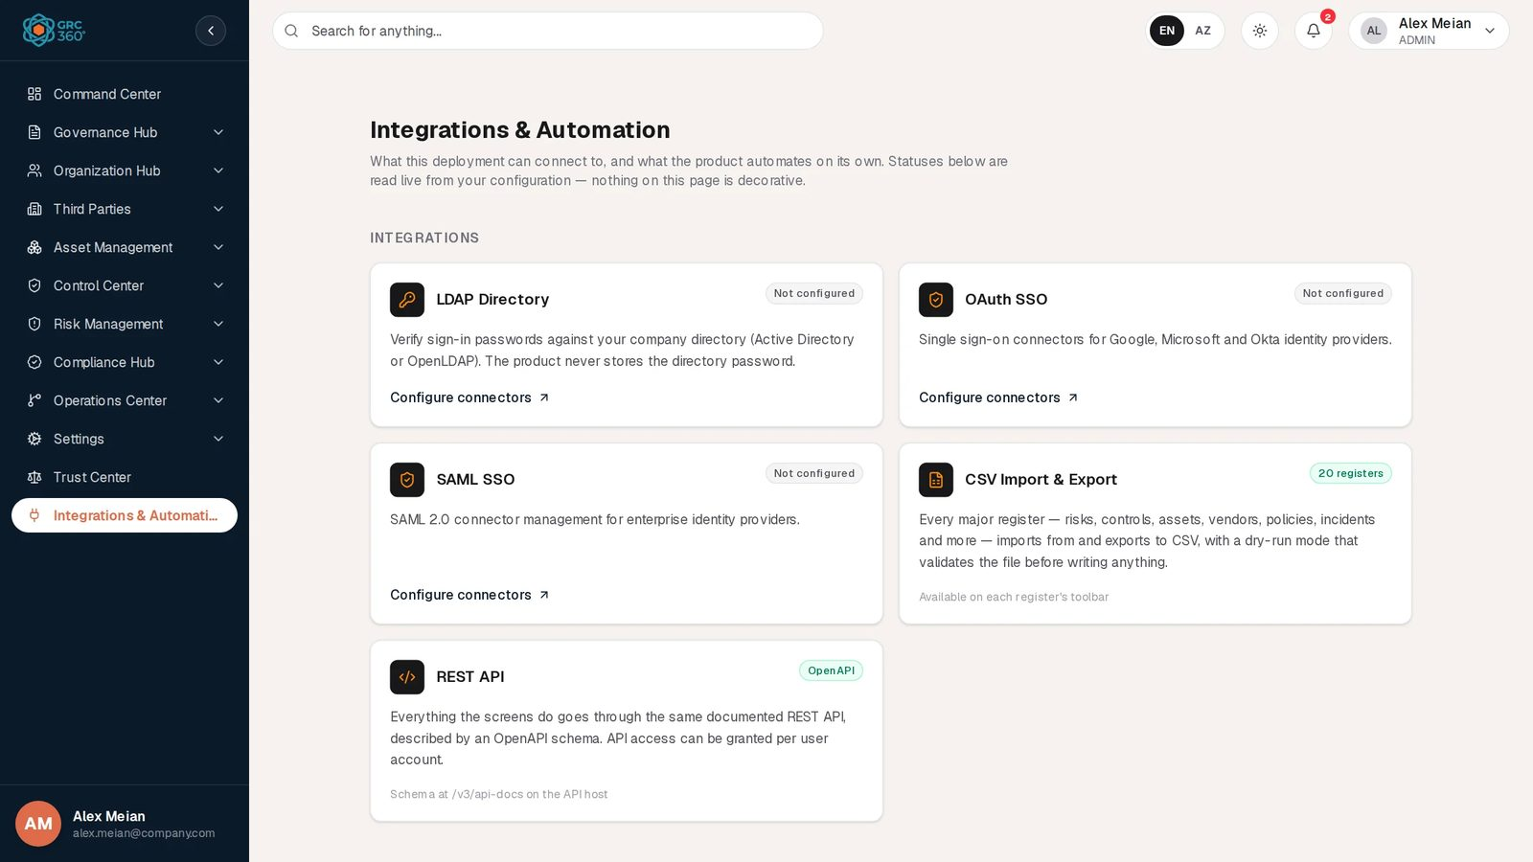
Integrations & Automation

At a glance
A record is | A webhook endpoint (the only thing created on this page).
Typical owner | Administrator
Links to | Settings › Authentication (connector cards), the deployment’s SMTP relay, your own HTTP endpoints (webhooks)
Linked from | Sidebar
Tabs | None. The page is divided into sections: Integrations, Built-in automation, E-mail delivery, Webhooks, Planned.
Automations | Webhook deliveries are sent automatically for every event written to the audit trails.

Built versus planned: summary
Item | State in this release | What actually works
LDAP Directory | Built and working | Passwords of existing GRC360 accounts can be verified against an LDAP or Active Directory server. See Authentication and SSO.
OAuth SSO | Connector management only | OAuth connectors can be stored and chosen as the main method, but no sign-in uses them. The login page has no SSO button.
SAML SSO | Connector management only | SAML connectors can be stored and chosen as the main method, but no sign-in uses them.
CSV Import & Export | Partly built | Export works on registers that have an Export CSV button. Import works only on the registers that have their own import (Users, Security Incidents and Stages, Projects with Tasks and Expenses, External Audit Findings, Obligations, Compliance Analysis, Compliance Packages, Compliance Exceptions). Elsewhere the import dialog fails. See CSV import and export.
REST API | Built | Every screen uses the same REST API; the OpenAPI schema is at /v3/api-docs on the API host (Swagger UI at /swagger-ui.html). The REST APIs switch on a user is stored but not enforced.
In-app notifications | Built | The bell and the Notifications page. Produced for access requests and decisions, continuity plan task awareness and service agreement end dates. See E-mail, webhooks and notifications.
Dynamic statuses | Built | Computed when records are read; date-based states appear without any scheduled job.
Live refresh | Built | Open pages reload changed registers within about 10 to 12 seconds (the browser polls the server’s change feed).
Tenant provisioning | Built | Built-in groups (Admin, Read Only, Third Party) and the permission catalogue are created for a tenant at start-up.
E-mail (SMTP) | Built, needs server configuration | Sends invitation e-mails and the test message. Nothing else is e-mailed.
Webhooks | Built | Signed JSON POSTs for events written to the audit trails. Managing them needs the Admin role (see Permissions).
Scheduled e-mail digests | Planned | Not available.
Jira | Planned | Not available.

The page (list view)
The page is not a grid. Its sections, from top to bottom (as an administrator sees them in the demo):
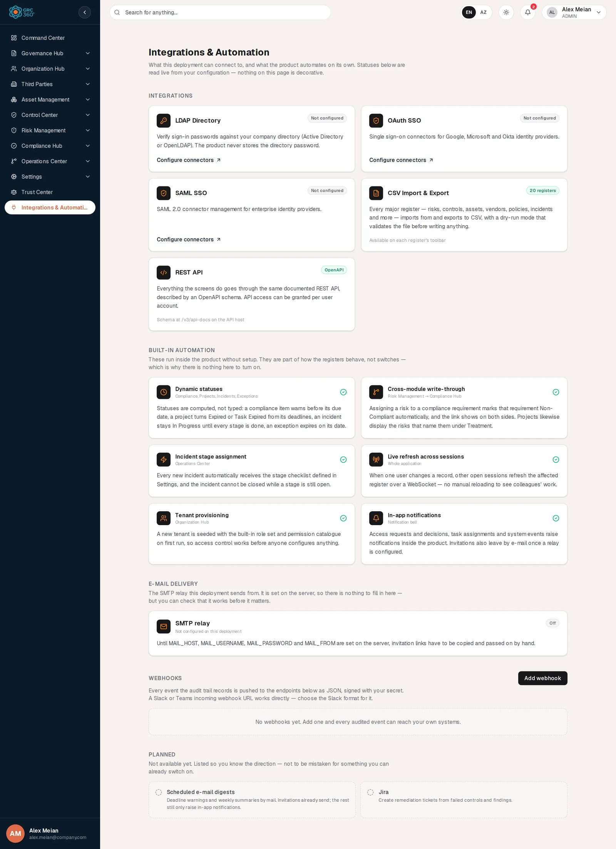
Integrations & Automation, full page

Integrations
Cards with a title, a status badge, a description and a link or note.
Card | Shown to | Badge | Link
LDAP Directory | Administrators only | Live, from the LDAP connector list | Configure connectors → Settings › Authentication
OAuth SSO | Administrators only | Live, from the OAuth connector list | Configure connectors
SAML SSO | Administrators only | Live, from the SAML connector list | Configure connectors
CSV Import & Export | Everyone with page access | Fixed text 20 registers | Note “Available on each register’s toolbar”
REST API | Everyone with page access | Fixed text OpenAPI | Note “Schema at /v3/api-docs on the API host”
Connector badge rules:
Badge | Rule
N enabled (green) | At least one connector has status Enabled (LDAP) or Active (OAuth, SAML).
N configured, none enabled (amber) | Connectors exist, none enabled.
Not configured (grey) | No connectors. This is the state in the demo data.
Checking… / Status unavailable | Still loading, or a list could not be read.
“Administrators only” here means users who can open Settings › Authentication. For everyone else the three connector cards and the E-mail delivery section are neither shown nor requested.

Built-in automation
Six cards, each with a green check. They describe behaviour, not switches; nothing can be turned on or off here.
Card | Where | What the card says, and what is true
Dynamic statuses | Compliance, Projects, Incidents, Exceptions | Statuses are computed from dates and progress. True: they are computed on read. Note that automatic status changes stored on exception records by scheduled jobs do not happen in this release (see Automations).
Cross-module write-through | Risk Management → Compliance Hub | Assigning a risk to a compliance requirement marks that requirement Non-Compliant; projects show the risks that name them under Treatment.
Incident stage assignment | Operations Center | New incidents receive the stage checklist; an incident cannot be closed while a stage is open.
Live refresh across sessions | Whole application | The card says changes arrive “over a WebSocket”. The application actually polls the server’s change feed about every 10 to 12 seconds; the effect for the user is the same.
Tenant provisioning | Organization Hub | The built-in groups and permission catalogue are seeded for a tenant.
In-app notifications | Notification bell | The card mentions “system events”; in this release no system event raises a notification. See the notification catalogue in E-mail, webhooks and notifications.

E-mail delivery
Shown to administrators only. A card SMTP relay with a badge:
Badge | Meaning | Line under the title
Configured | The server has an SMTP host set | “{host} — sending as {from address}”
Off | No SMTP host on the server | “Not configured on this deployment”
Under the title the card explains what the state means. When configured: “Invitations are e-mailed to the person invited. The link is still shown to the administrator, so an invite is never lost to a failed send.” When off: “Until MAIL_HOST, MAIL_USERNAME, MAIL_PASSWORD and MAIL_FROM are set on the server, invitation links have to be copied and passed on by hand.” The section heading E-mail delivery is followed by “The SMTP relay this deployment sends from. It is set on the server, so there is nothing to fill in here — but you can check that it works before it matters.”
The relay is configured on the server through environment variables (MAIL_HOST, MAIL_PORT, MAIL_USERNAME, MAIL_PASSWORD, MAIL_FROM, MAIL_FROM_NAME, MAIL_STARTTLS, MAIL_SSL); there is nothing to fill in on this page. When the relay is configured, an e-mail field (placeholder your.name@company.com) and Send test message appear. The result shows either “Sent to {address}. Check the inbox, and the spam folder.” or the relay’s error text. In the demo the relay is Off. Step-by-step setup is in E-mail, webhooks and notifications.

Webhooks
A list of outbound HTTP endpoints, an Add webhook button (it toggles to Close while the form is open) and the explanation that every audited event is pushed as JSON, signed with your secret, and that a Slack or Teams incoming webhook URL works with the Slack format. With no webhooks the list reads “No webhooks yet. Add one and every audited event can reach your own systems.” The demo has none.
Each webhook row shows its name, Enabled or Disabled, a Slack format badge when that format is chosen, the URL, and a line such as “All events · Never delivered” or “Events: INCIDENT_,RISK_ · Last delivery: HTTP 200 · 2 consecutive failure(s)”. Row buttons: Send test, Disable/Enable, Delete.

Planned
The heading Planned is followed by “Not available yet. Listed so you know the direction — not to be mistaken for something you can already switch on.” and two dashed cards with no buttons:
Item | Note on the card
Scheduled e-mail digests | Deadline warnings and weekly summaries by mail. Invitations already send; the rest still only raise in-app notifications.
Jira | Create remediation tickets from failed controls and findings.

Creating a record
Click Add webhook. The form opens inline above the list (not in a dialog).
Field | Type | Required | Rules and allowed values | Example
Name | Text | Yes | Max 255 characters. Placeholder “e.g. Incident alerts to Slack”. | Risk events to SIEM
URL | Text | Yes | Must start with http:// or https:// (server message “URL must start with http:// or https://”); max 1024 characters. | https://siem.example.com/hooks/grc
Secret (optional) | Password | No | Stored encrypted, never shown again. When set, each delivery is signed. | (a random string)
Event filter (optional) | Text | No | Comma-separated event-name prefixes, case-insensitive; blank means all events. Placeholder INCIDENT_,RISK_. Max 512 characters. | RISK_,COMPLIANCE_EXCEPTION_
Payload format | Dropdown | No | Generic JSON (default) or Slack / Teams message. | Generic JSON
Click Save webhook. If Name or URL is empty the page shows “Name and URL are required.” A new webhook is enabled immediately, and the page shows “Webhook created. Use Send test to verify the receiver.”
A webhook cannot be edited after creation except for switching it on and off. To change its URL, filter or secret, delete it and add it again.

Viewing and editing a record
There is no view dialog; everything is on the row.
- Send test posts a test event named PING with the message “Test delivery from GRC360 — your endpoint is wired up.” and waits for the answer. The page shows “Delivered: HTTP 200.” for any 2xx answer, otherwise “Delivery failed: {status or error}.”
- Disable / Enable switches deliveries off and on; the stored secret is kept.
- Delete asks “Delete the webhook {name}?” and shows “Webhook deleted.” The webhook is removed from the list (it is soft-deleted on the server).

What a delivery looks like
Part | Value
Method | POST, Content-Type: application/json
Header X-GRC360-Event | The event name, for example COMPLIANCE_EXCEPTION_CREATED
Header X-GRC360-Signature | Only when a secret is stored: sha256= followed by the hex HMAC-SHA256 of the raw body, keyed with the secret
Body, Generic JSON | {"event":"…","message":"…","timestamp":"…"}
Body, Slack / Teams | {"text":"*EVENT* — message"}
Timeout | 5 seconds; redirects are not followed
Retries | None. A failed delivery is not retried; the failure count goes up by one, and resets to 0 on the next success.

Statuses
Value | Set by | Meaning
Enabled | User | Deliveries are sent.
Disabled | User | No deliveries are sent; the webhook stays in the list.
Last delivery: HTTP nnn / error text | System | Outcome of the most recent delivery or test.
N consecutive failure(s) | System | Number of failed deliveries since the last success. The webhook is not switched off automatically.

Tabs
None.

Relationships
Related record | Direction | How the link is made | Where it shows
System Log entry | Outbound | Every action written to the System Log is offered to the webhooks whose filter matches | Delivery to your endpoint
Audit trail event | Outbound | Every event written to the internal audit trail (for example risk register and objective audit events) is offered the same way | Delivery to your endpoint
LDAP / OAuth / SAML connectors | Read | Count and status | Connector card badges
SMTP relay | Read | Server configuration | E-mail delivery card

Automations and notifications
- Webhook fan-out. Each event is delivered in the background to every enabled webhook whose filter matches, so a slow receiver does not slow down the save that produced the event. Events that can reach a webhook include, for example, COMPLIANCE_PACKAGE_CREATED, OBLIGATION_UPDATED, AUDIT_FINDING_STATUS_CHANGED, COMPLIANCE_EXCEPTION_EXPIRED, AUTH_CONNECTOR_CREATED, AUTH_SETTINGS_UPDATED, SYSTEM_CACHE_CLEARED, RISK_CREATED, RISK_DELETED, RISK_SCORE_RECALCULATED, RISK_EXCEPTION_APPROVED, RISK_SETTINGS_UPDATED and OBJECTIVE_AUDIT_CREATED. Sign-ins and most register changes outside Compliance Hub, Risk Management and objective audits produce no event.
- No other scheduled automation runs from this page. For the full list of scheduled jobs and which ones are active, see E-mail, webhooks and notifications.

Permissions
Action | Needed access
See the page and its sidebar entry | View on Integrations & Automation › Integrations
See the connector cards and E-mail delivery | Access to Settings › Authentication, which only the Admin group holds
List, add, test, enable/disable, delete webhooks | The page’s catalogue right (View to list; Manage to add, test and toggle; Full Control to delete) and, on the server, the system role ADMIN. In practice only administrators can manage webhooks.
Send a test e-mail | Admin
Comment / Assign | Not applicable (no comment thread).
A non-administrator with access to this page sees the Webhooks section, but the server refuses the list; the page shows “Webhook list could not be loaded.” and the permission dialog may open.

How to

Send risk events to your SIEM
- Click Add webhook.
- Name: “Risk events to SIEM”. URL: your collector’s HTTPS address. Secret: a random string your collector also knows. Event filter: RISK_. Payload format: Generic JSON.
- Click Save webhook, then Send test on the new row. Expect “Delivered: HTTP 200.”
- On the receiving side, verify X-GRC360-Signature by computing HMAC-SHA256 of the raw body with the same secret.

Post compliance exception events to a Slack channel
- In Slack, create an incoming webhook for the channel and copy its URL.
- In GRC360 click Add webhook, paste the URL, set Event filter to COMPLIANCE_EXCEPTION_ and choose Slack / Teams message.
- Click Save webhook and Send test; a “PING — Test delivery from GRC360…” message appears in the channel.

Check that invitation e-mails can be sent
- Open the E-mail delivery section. If the badge reads Off, ask the person who runs the server to set the MAIL_* variables and restart.
- When it reads Configured, type your own address and click Send test message.
- If the result is red, the text is the relay’s own error (for example a rejected sender address).

Pause a webhook during receiver maintenance
- On the webhook row, click Disable. The badge turns to Disabled and no events are sent.
- Events raised while disabled are not queued; they are not delivered later.
- Click Enable when the receiver is back.

CSV import
None. Webhooks cannot be imported or exported.

Limitations and known issues
- OAuth SSO and SAML SSO are listed as integrations, but no login flow uses the stored connectors and the login page has no SSO option.
- The CSV Import & Export card’s “20 registers” and “dry-run” claims overstate the current state; most registers’ import dialog does not work in this release.
- The REST APIs switch on a user (“API access can be granted per user account”) is stored but not enforced by the server.
- Live refresh is polling, not WebSocket as the card says.
- The In-app notifications card mentions system events; none raise notifications.
- Webhooks: no edit form, no retry, no delivery history beyond the last status, and in practice admin-only even though the page itself can be granted to other groups.
- The SMTP relay sends only invitation e-mails and the test message; invitations themselves have no screen in the product (see Users, groups and permissions).

Settings
Settings holds the system’s own configuration: how people sign in, which sessions are open, the system’s version and health, the updates register, the system log and the button that clears the organisation’s data. It is not a register a team works in.
Settings is reserved to the Admin group. Only the exact built-in Admin group (or its older name Administrator), the system role ADMIN or a configured super-admin account may hold Settings. It cannot be given to any other group, granted to an individual or requested through Request Access; the Request Access dialog says “Only the Admin group can access Settings. It cannot be granted to other groups or requested.” A group whose name merely contains “admin” (for example “IT Admins”) does not qualify. For everyone else the Settings entry does not appear in the sidebar.

Pages
Page | Route | Permission key | What it is for
Authentication | /settings/authentication | settings.authentication | Main sign-in method, active sessions of every user, LDAP / OAuth / SAML connectors
About System | /settings/about-system | settings.about_system | Product version and company details; the Public Trust Center switch
System Health | /settings/system-health | settings.system_health | Running version, diagnostics options, log and diagnostics downloads, cache, live health checks
Updates | /settings/updates | settings.updates | Updates register and maintenance-mode notice
System Log | /settings/system-log | settings.system_log | Read-only audit trail of administrative and Compliance Hub actions, with CSV export
Clear Data | /settings/clear-data | settings.clear_data | Back up and then permanently delete chosen groups of this organisation’s data
The route /settings on its own shows a placeholder card headed “Settings” with the text “Mock page (coming soon).” Use the sub-pages.

Permission actions in the catalogue
Page | Actions defined
Authentication | read, create, edit, delete, import, export
About System | read
System Health | read
Updates | read
System Log | read, export
Clear Data | read (preview), execute (run the reset and download backups)
Because the Admin group holds all of them, the split matters only for audit and for the locked-button behaviour on Clear Data. Settings pages have no comment threads.

Related administration guides
- Authentication and SSO
- Sessions and security
- System maintenance

Authentication
Module: Settings › Authentication · Route: /settings/authentication · Permission key: settings.authentication
The Authentication page is where an administrator chooses the organisation’s main sign-in method, sees and ends every user’s open sessions, and maintains the directory and single sign-on connectors. It has five tabs: Authentication Method, Active Sessions, LDAP Connectors, OAuth Connectors and SAML Connectors. Only the Admin group can open it.
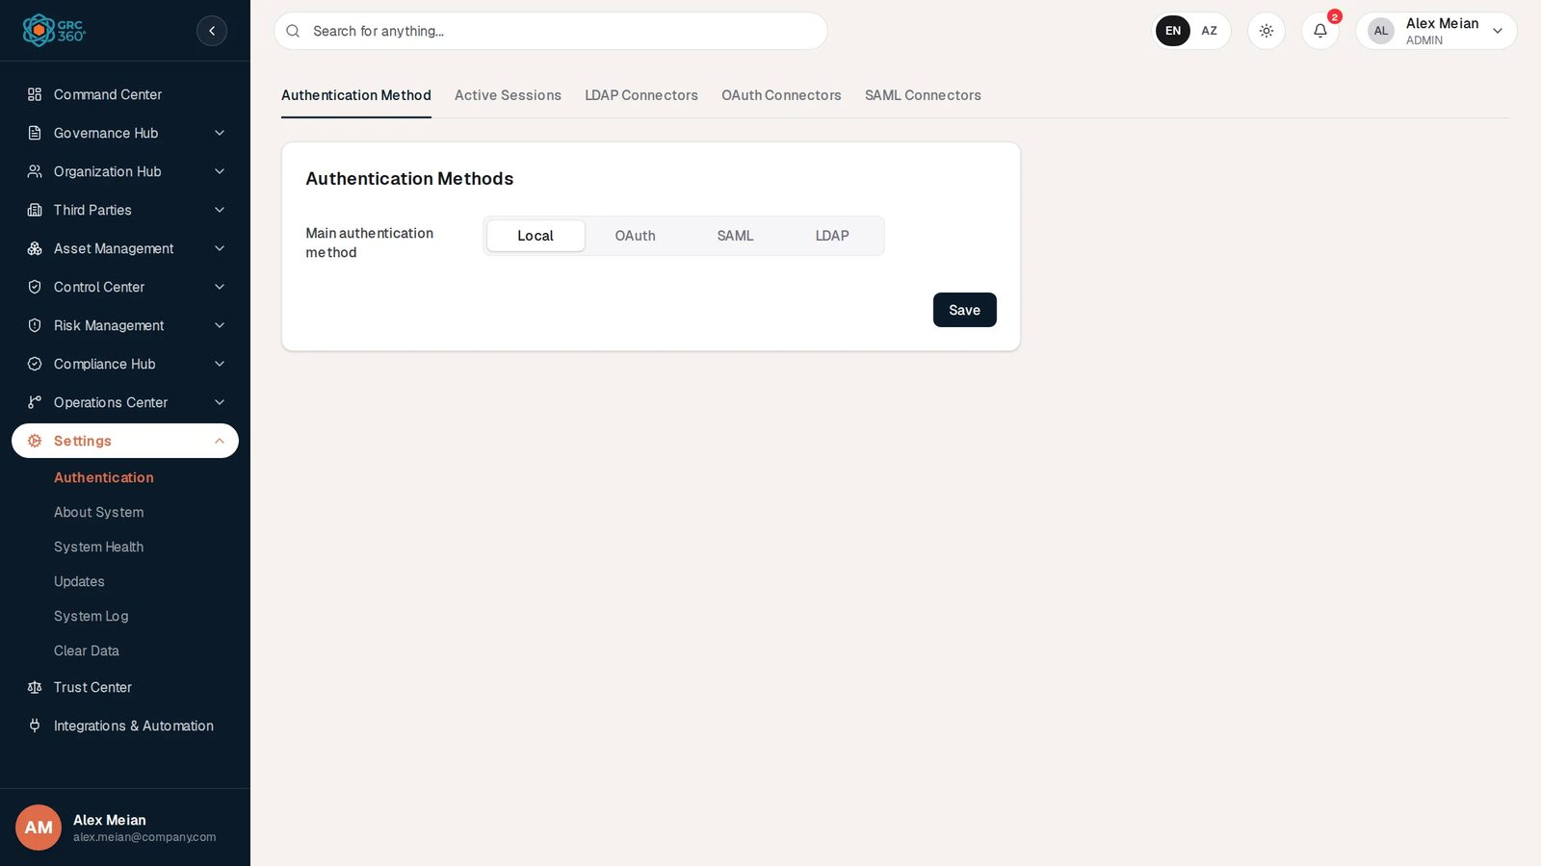
Authentication, Authentication Method tab

At a glance
A record is | A connector (LDAP, OAuth or SAML), or one user session on the Active Sessions tab. The method setting is a single per-organisation setting.
Typical owner | Administrator
Links to | User accounts (sessions), your LDAP / identity provider servers
Linked from | Integrations & Automation (connector cards, Configure connectors)
Tabs | Authentication Method, Active Sessions, LDAP Connectors, OAuth Connectors, SAML Connectors. The tabs are in-page tabs with no permission keys of their own.
Automations | Session list refreshes every 30 seconds; expired session rows are purged after 30 days. No scheduled job.

What actually signs people in, in this release
Method | Effect on sign-in
Local (email and password) | Always available, whatever method is selected.
LDAP | Works. When the typed password does not match the local one, the server asks the LDAP directory. The person must already have an active GRC360 account with the same e-mail.
OAuth | No effect. Connectors are stored, but no sign-in flow uses them and the login page has no SSO button.
SAML | No effect. Connectors are stored, but there is no SAML endpoint in the server.
Step-by-step configuration of each method is in Authentication and SSO.

The register (list view)
Each tab is described in Tabs. The connector tabs use the shared grid; its toolbar, … Views, search and paging are described in Working with registers. Each tab loads its own data when it is opened.

Creating a record
Connectors are added from their tab with Add Item; see LDAP Connectors, OAuth Connectors and SAML Connectors. Sessions are created by signing in, not on this page.

Viewing and editing a record
- LDAP connectors have Test connection, Edit and Delete buttons on each row.
- OAuth and SAML connectors have only the shared view (eye) button. They cannot be edited, tested or deleted from the screen in this release.
- Sessions can be expanded with the arrow button to show details, and ended with Sign out.

Statuses
Value | Set by | Meaning
Disabled / Enabled (LDAP) | User | Only Enabled LDAP connectors are asked at sign-in and can be chosen as the main connector. New LDAP connectors default to Disabled.
Active / Disabled (OAuth, SAML) | User | Only Active connectors can be chosen as the main connector. New ones default to Active.
In Use | System | Intended to show the connector chosen as main. It is never set in this release and always reads “false”.
Active now / Idle for … | System | Session status: Active now when the session was used within the last 15 minutes (one access-token lifetime), otherwise amber “Idle for {duration}”.
End reasons | System | For ended sessions; see Active Sessions.

Tabs

Authentication Method
A card Authentication Methods with:
Field | Type | Required | Rules and allowed values | Example
Main authentication method | Segmented buttons | Yes | Local (default), OAuth, SAML, LDAP | Local
User authentication connector | Dropdown | Yes, when the method is not Local (marked *) | Lists the connectors of the chosen type. A connector that is not Enabled/Active is shown with ” (disabled)“. While empty the field is outlined red with”The field is required”. | Corporate AD
Click Save. Success shows “Authentication settings saved successfully.” The server refuses:
Situation | Server message
OAuth, SAML or LDAP without a connector | “OAuth connector ID is required when method is OAUTH” (and the SAML / LDAP equivalents)
Connector of the wrong organisation or deleted | “OAuth connector not found: {id}” (and equivalents)
Chosen connector not Enabled (LDAP) or Active (OAuth, SAML) | “Selected LDAP connector is disabled and cannot be activated” (and equivalents)
Saving writes AUTH_SETTINGS_UPDATED to the System Log. In the demo data the method is Local.
Effect of the choice: selecting LDAP with a connector makes that connector the first one asked at sign-in; other Enabled LDAP connectors whose Mail Domain matches the user’s e-mail domain are still asked after it. Local passwords keep working in every mode, so a local administrator can always sign in when the directory is down. Choosing OAuth or SAML changes nothing at sign-in.

Active Sessions
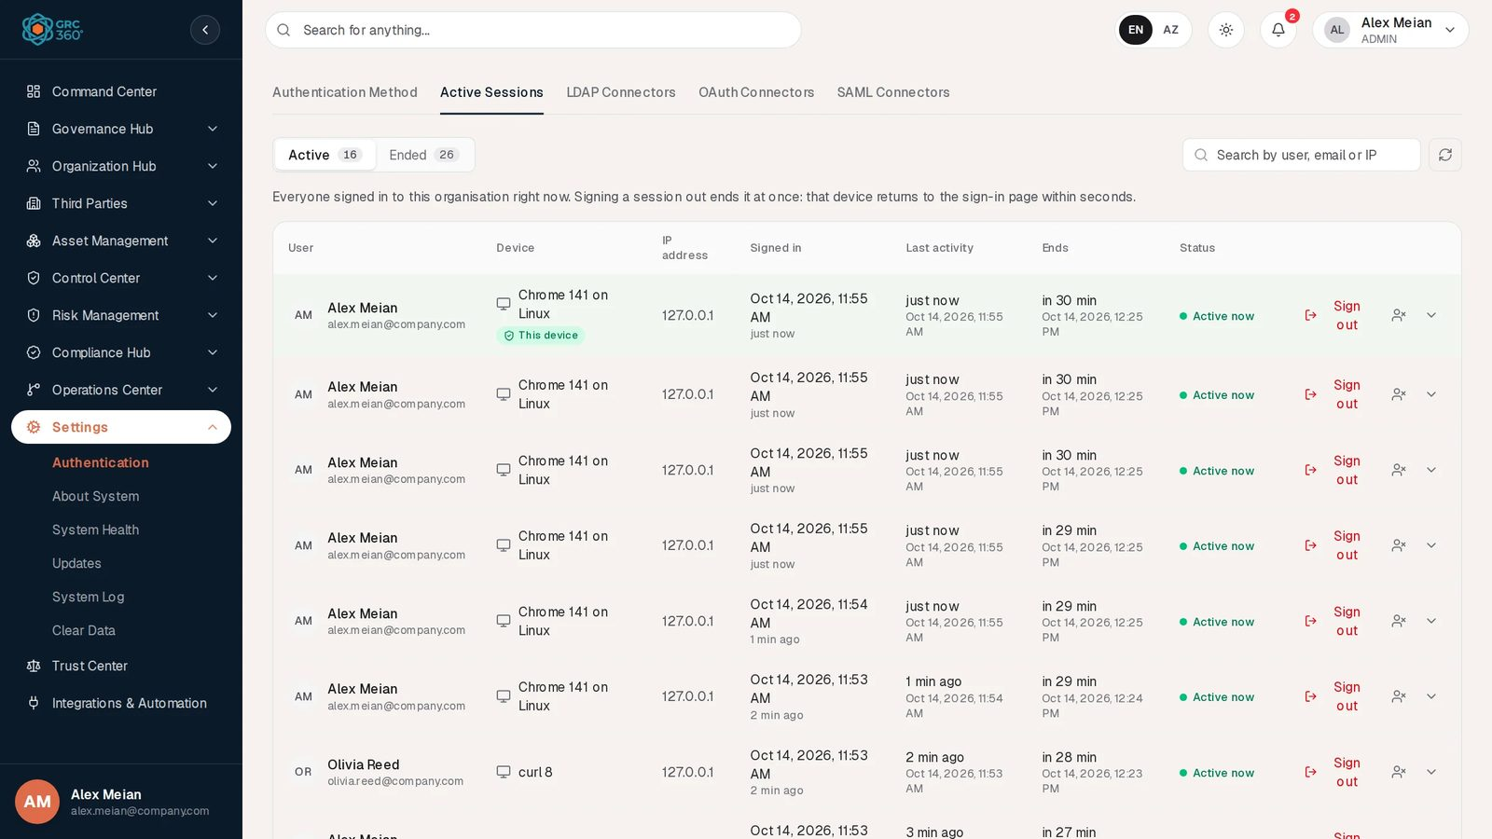
Active Sessions
Every session in the organisation, for all users. A person’s own devices are on their Account page.
Controls at the top: a switch Active / Ended, each with its count; a search box “Search by user, email or IP” (matches the owner’s e-mail, name or IP address, case-insensitive); and a refresh button. The explanatory line reads “Everyone signed in to this organisation right now. Signing a session out ends it at once: that device returns to the sign-in page within seconds.” on Active, and “Sessions that ended in the last 30 days — signed out, timed out, or replaced — and why.” on Ended.
Column | What it shows | Source
User | Initials, full name and e-mail | Account
Device | Browser and operating system read from the browser’s user agent (for example “Chrome 141 on Linux”; “curl 8” for an API client), with a This device badge on your own current session and Remembered for sessions opened with “Keep me signed in” | Computed
IP address | Address the session last came from | Recorded
Signed in | Date and time of sign-in, and “… ago” | Recorded
Last activity | Time since the last token refresh, and the exact time | Recorded
Ends (Active) / Ended (Ended) | When the session will end at the latest (the earlier of the idle limit and the absolute limit), or when it ended. Hovering Ends says which limit applies. | Computed
Status (Active) / Reason (Ended) | Active now or Idle for …; for ended sessions the reason | Computed
Row buttons (Active list only): Sign out ends this one session; the person icon ends all of that user’s sessions; the arrow shows details (Browser, Operating system, IP address, Session type “Remembered (Keep me signed in)” or “Standard — ends when the browser closes”, Ends after inactivity, Ends at the latest, User agent, Session ID).
Confirmation dialogs:
Action | Dialog text | Success
Sign out on another user’s session | “Sign out {name} on {device}? It stops working right away.” Button Sign out. | “Session signed out.”
Sign out on your own current session | “This is the session you are using. You will be signed out now.” | You are signed out.
Person icon | “Sign out {name} from every device? They will have to sign in again.” Button Sign out all. | “User signed out of every device.”
The signed-out device gets an error on its next request and is sent to the sign-in page within about 10 seconds. Paging shows 20 sessions per page (“Showing 1–6 of 6”). The list refreshes itself every 30 seconds while visible.
End reasons shown on the Ended list:
Reason text | Code | Cause
Signed out | LOGOUT | The user signed out.
Signed out everywhere | LOGOUT_ALL | The user chose Sign out everywhere.
Signed out remotely | ADMIN_REVOKED | Ended from this tab or from the Account page of the owner.
Ended for security: its sign-in token was reused | REUSE_DETECTED | An old refresh token was presented again; the whole session chain is ended.
Timed out after inactivity | IDLE_TIMEOUT | No activity within the idle limit.
Reached the maximum session length | ABSOLUTE_TIMEOUT | Absolute limit reached.
Replaced by a newer sign-in | SESSION_LIMIT | The user opened more than 10 sessions; the oldest was ended.
Account deactivated | ACCOUNT_INACTIVE | The user’s account is no longer Active.
Session limits are described in Sessions and security.

LDAP Connectors
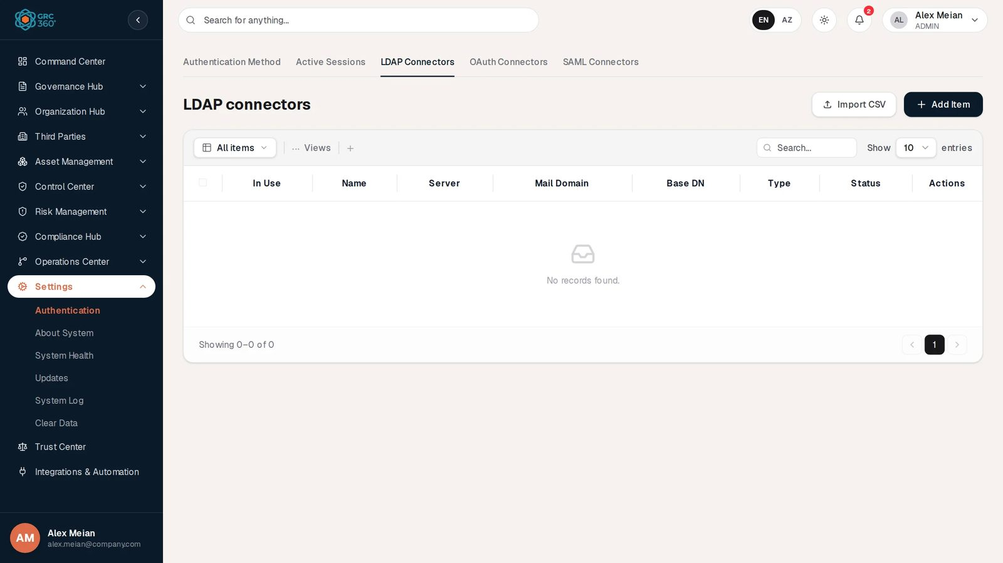
LDAP Connectors
Column | What it shows | Source
In Use | Always “false” in this release | System
Name | Connector name | Entered
Server | LDAP Server Hostname | Entered
Mail Domain | E-mail domain served by this directory | Entered
Base DN | LDAP Server Base DN | Entered
Type | Always “LDAP” (see known issues) | System
Status | Disabled / Enabled badge | Entered
Row buttons: Test connection, Edit, Delete. The demo has no LDAP connectors (“No records found.”).
Add Item opens the dialog “Add Item (LDAP Connectors)” (on edit “Edit LDAP Connector”) with two tabs, General and Connector Settings. No field is marked with an asterisk; the server requires Name and LDAP Server Hostname.
General tab:
Field | Type | Required | Rules and allowed values | Example
Name | Text | Yes (server: “Connector name is required”) |  | Corporate AD
Description | Text | No |  | Head-office Active Directory
Status | Dropdown | No | Disabled (default), Enabled | Disabled
LDAP Server Hostname | Text | Yes (server: “LDAP server hostname is required”) | A host name, or a full ldap://host:port / ldaps://host:port URL. Without a scheme, ldaps:// is used when Port is 636, otherwise ldap://. | dc01.company.local
Mail Domain | Text | No | Domain part of users’ e-mails; an @ is ignored. Used to pick this connector for matching e-mails. | company.com
Port | Text | No | Number; default 389. Non-numeric input is sent as 389. | 636
LDAP Username | Text (yellow) | No | DN of the service account used to search the directory. Blank means anonymous search. | CN=svc-grc,OU=Service,DC=company,DC=local
LDAP Password | Password (yellow) | No | Stored encrypted, never shown again. On edit the placeholder reads “Leave blank to keep the stored password”.
LDAP Server Base DN | Text | No | Root of the directory tree. | DC=company,DC=local
Connector Settings tab (introduced by “These decide how a person typing their email at the login screen is found in your directory.”):
Field | Type | Required | Rules and allowed values | Example
User Search Filter | Text | No | {0} is replaced by the e-mail typed at login. Default (mail={0}). Active Directory often needs (userPrincipalName={0}). A blank value keeps the default. | (userPrincipalName={0})
User Search Base | Text | No | Where the search starts; blank means the Base DN. | OU=Staff,DC=company,DC=local
Type | Dropdown | No | Authenticator (default), Group. Not stored by the server. | Authenticator
Save shows “LDAP connector created. Use Test connection before enabling it.” or “LDAP connector updated.” Test connection connects with the service account, then counts entries matching the filter. Success: “Connected to {url}. {n} user(s) matched under {search base or”the server root”}.” Failure messages name the cause, for example “Could not reach the server. Check the hostname, the port, and that the network allows it.”, “The server rejected the LDAP username or password.”, “The server accepted the login but the base DN does not exist on it.” or “No server hostname is set on this connector.” Each create, update, delete and test is written to the System Log (AUTH_CONNECTOR_CREATED, **_UPDATED, _DELETED, _TESTED**).
Delete asks “Delete the LDAP connector {name}?” and confirms with “Connector deleted.” The connector is soft-deleted.

OAuth Connectors
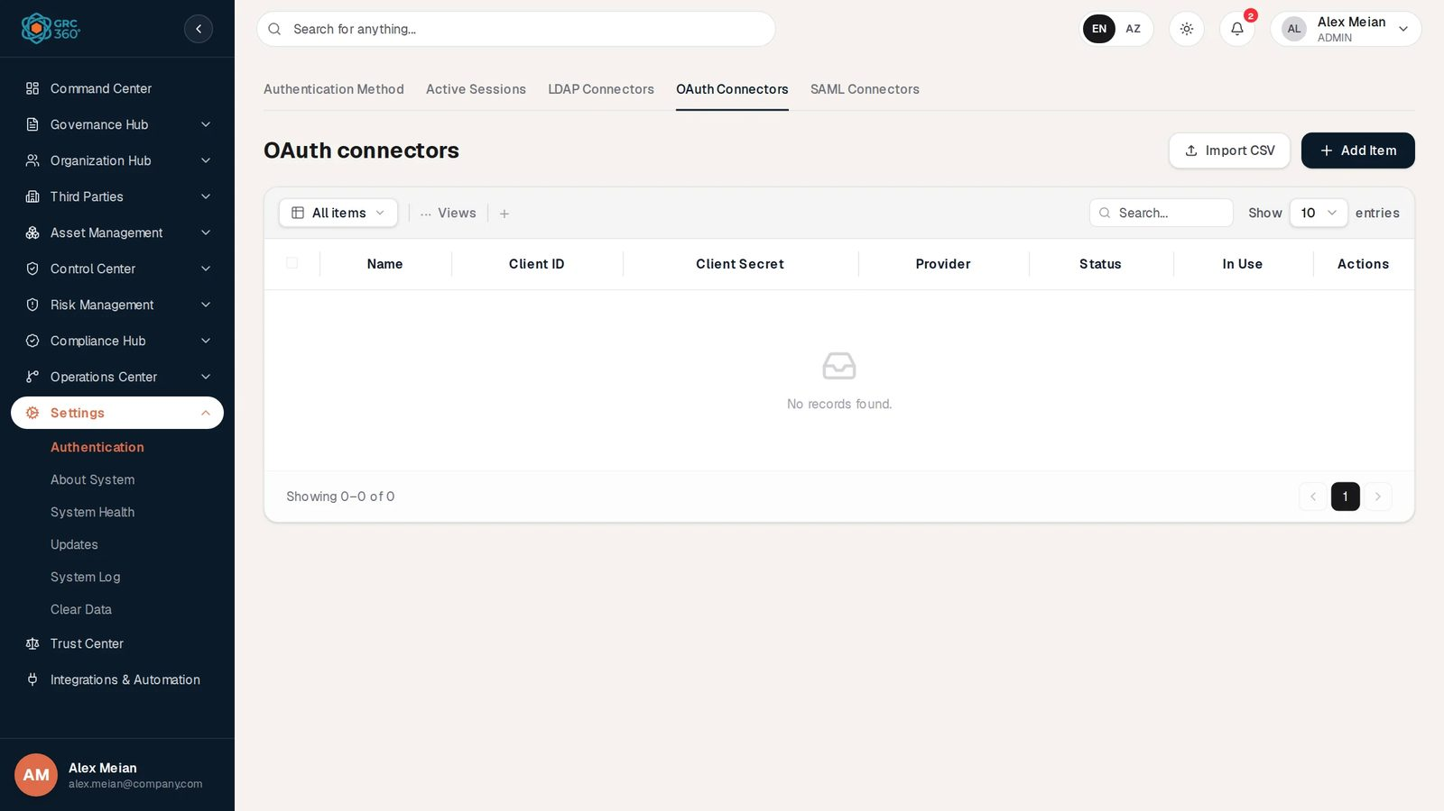
OAuth Connectors
Columns: Name, Client ID, Client Secret (always empty; the server returns only a masked value under another name), Provider (stored in capitals, for example GOOGLE), Status, In Use (always “false”). The demo has none.
Add Item opens “Add Item (OAuth Connectors)” with a single General tab. A blue box Redirect URLs lists {this site}/login and {this site}/portal/policy/login to register at the provider.
Field | Type | Required | Rules and allowed values | Example
Name | Text | Yes (server: “Connector name is required”) |  | Google Workspace
Client ID | Text | Yes (server: “Client ID is required”) |  | 1234.apps.googleusercontent.com
Client Secret | Text (not masked while typing) | No | Stored encrypted.
Provider | Dropdown | Yes (server: “Provider is required”) | “Choose one…”, Google, Microsoft, Okta | Google
Status | Dropdown | No | Active (default), Disabled | Active
Save shows “OAuth connector created successfully.” The connector cannot be edited or deleted afterwards from the screen, and it is not used to sign anyone in.

SAML Connectors
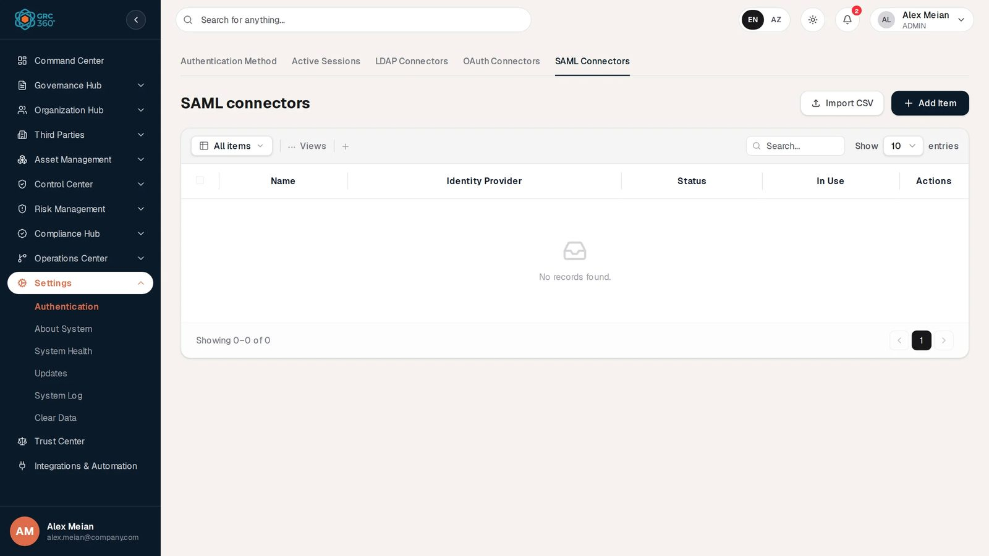
SAML Connectors
Columns: Name, Identity Provider (always empty in this release), Status, In Use (always “false”). The demo has none.
Add Item opens “Add Item (SAML Connectors)” with a single General tab. Two blue boxes list the values to give the identity provider: Single sign on URL {this site}/saml/saml-connectors/single-sign-on, Audience URI (SP Entity ID) {this site}/saml/saml-connectors/get-metadata, Default RelayState {this site}/login, Assertion Consumer Service (ACS) {this site}/login?acs=1, Logout URL {this site}/saml/saml-connectors/single-logout, and Redirect URLs as for OAuth. None of these addresses is served by the product in this release.
Field | Type | Required | Rules and allowed values | Example
Name | Text | Yes (server: “Connector name is required”) |  | Okta SAML
Identity Provider | Text | Yes (server: “Identity provider metadata URL is required”) | IdP metadata URL | https://company.okta.com/app/xyz/sso/saml/metadata
IDP x509 Certificate | Text area | No | Not saved (see known issues)
Remote sign in URL | Text | No |  | https://company.okta.com/app/xyz/sso/saml
Email field | Text | No | Attribute holding the e-mail; server default “email” when omitted | email
Sign SAML request | Switch | No | Off by default. Not saved. | Off
SP x509 Certificate | Text area | No | Not saved
SP Private Key | Text area | No | Stored encrypted
Authentication Context | Dropdown | No | Password Protected Transport (only option) | Password Protected Transport
Status | Dropdown | No | Active (default), Disabled | Active
Save shows “SAML connector created successfully.” The connector cannot be edited or deleted afterwards from the screen.

Relationships
Related record | Direction | How the link is made | Where it shows
Connector | Authentication Method → connector | User authentication connector | Method tab
User account | LDAP connector → account | Same e-mail at sign-in | Not shown
User account | Session → account | Sign-in | Active Sessions, User column

Automations and notifications
- The Active Sessions list refreshes every 30 seconds while visible.
- Ended session rows are kept 30 days and then purged. The purge runs at most once an hour, triggered by token refreshes, not by a scheduled job.
- No notifications are raised by this page. Connector and method changes are written to the System Log and are therefore also sent to matching webhooks.

Permissions
Action | Needed access
See the page | Admin group (Settings is Admin-only)
Save the method, add / edit / delete / test connectors | Admin group
Sign out sessions | Admin group
Comment / Assign | Not applicable

How to

Let staff sign in with their Active Directory password
- Make sure each person already has a GRC360 account with their company e-mail (Organization Hub › Users).
- On LDAP Connectors, click Add Item. Fill Name, LDAP Server Hostname, Mail Domain, Port, LDAP Username, LDAP Password and LDAP Server Base DN. On Connector Settings, set User Search Filter to (userPrincipalName={0}). Save.
- Click Test connection and read the result. Fix the hostname, credentials or base DN until it reports users matched.
- Click Edit, set Status to Enabled, save.
- On Authentication Method, choose LDAP, select the connector, click Save.

Sign a lost laptop out
- Open Active Sessions and search for the user, for example “sara”.
- Find the session by device and IP address and click Sign out, or click the person icon to end all of Sara Johnson’s sessions.
- Confirm. The device returns to the sign-in page within seconds.

Find out why a session ended
- On Active Sessions, switch to Ended.
- Search for the user and read the Reason column, for example “Timed out after inactivity”.

CSV import
The connector grids show Import CSV, but it opens the shared demo import dialog, which fails in this release. The server has CSV import and export for connectors (/settings/authentication/{ldap|oauth|saml}-connectors/import-csv and /export-csv) that the screen does not use. There is no Export CSV button.

Limitations and known issues
- OAuth and SAML connectors are stored only; neither is used to sign anyone in, and selecting them as main method has no effect.
- In Use is never set, so it always reads “false”, and a connector chosen as the main connector can still be deleted.
- LDAP Type (Authenticator / Group) is not saved; the column always shows “LDAP”.
- OAuth Client Secret column and SAML Identity Provider column are always empty.
- The SAML dialog sends the certificate fields and the Sign SAML request switch under names the server does not read, so they are not saved. The authentication context and the status are saved as the screen’s display text (“Password Protected Transport”, “Active”).
- OAuth and SAML connectors cannot be edited, tested or deleted from the screen.
- LDAP sign-in requires an existing, active local account with the same e-mail; it does not create accounts.
- Import CSV on the connector tabs does not work.

About System
Module: Settings › About System · Route: /settings/about-system · Permission key: settings.about_system
About System shows which build of GRC360 is running and who supplies it, and holds the one switch that changes what outsiders can see: whether the organisation’s live compliance posture appears on the Trust Center. Administrators use it when reporting a problem to support or when deciding to publish the posture.
About System

At a glance
A record is | None. One read-only information card and one organisation-wide switch.
Typical owner | Administrator
Links to | Trust Center (live posture section), the supplier’s web site (Contact us)
Linked from | Sidebar (Settings › About System)
Tabs | None
Automations | None

The register (list view)
The page has two cards.

About
Row | What it shows in this release | Source
App ID | GRC360 | Fixed in the server
App Version | The version from the server build; “0.0.1-SNAPSHOT” on a development build without a version | Server build
DB Schema Version | V18 | Fixed in the server
Company | Strativu | Fixed in the server
Company number | AZ-1002983741 | Fixed in the server
Copyright | © 2026 Strativu. All rights reserved. | Fixed in the server
About | “GRC360 is an enterprise GRC (Governance, Risk, and Compliance) platform tailored for regulatory legal tech compliance and risk management.” | Fixed in the server
Below the About text, Contact us opens https://strativu.com in a new tab.
When the information cannot be loaded, an amber box shows “Permission Denied: You do not have permission to view system info.” or the error text, and the rows fall back to “-” (App Version falls back to “1.0”, Copyright to “© 2026 Strativu GRC Ltd”).

Public Trust Center
A text explains: “When enabled, the public Trust Center page shows this organisation’s live compliance posture: each tracked framework with its compliant-item count, and the number of published policies. Aggregate numbers only — no individual record ever appears there.” A toggle on the right switches publishing on (green) or off (grey). It saves immediately; there is no Save button. If loading fails the card shows “The publishing state could not be loaded.”; if saving fails, “The change could not be saved.” Publishing is off by default and off in the demo.

Creating a record
None.

Viewing and editing a record
Only the Public Trust Center toggle can be changed. All About rows are read-only.

Statuses
Value | Set by | Meaning
Toggle on | User | The Trust Center shows the Live compliance posture section.
Toggle off | User (default) | The section is hidden.

Tabs
None.

Relationships
Related record | Direction | How the link is made | Where it shows
Trust Center | About System → Trust Center | Publishing switch | Live compliance posture section

Automations and notifications
None. The switch is not written to the System Log.

Permissions
Action | Needed access
See the page | Admin group
Change the publishing switch | Admin group
Comment / Assign | Not applicable

How to

Report the running version to support
- Open Settings › About System.
- Copy App Version and DB Schema Version into your support request (see also Download Diagnostics on System Health).

Publish the live compliance posture
- Open Settings › About System.
- Switch the Public Trust Center toggle on.
- Open Trust Center; the Live compliance posture section now appears for signed-in users.

CSV import
None.

Limitations and known issues
- All About values except the version are fixed in the server and cannot be changed per customer.
- The card calls the Trust Center “public”, but the Trust Center requires sign-in in this release.
- Changing the publishing switch leaves no System Log entry.

System Health
Module: Settings › System Health · Route: /settings/system-health · Permission key: settings.system_health
System Health tells an administrator whether the server and its dependencies are working, and provides the files support usually asks for. The General tab shows the running version, three diagnostics switches and four action buttons; the System health tab runs live checks of the database, memory, disk, cache and mail relay.
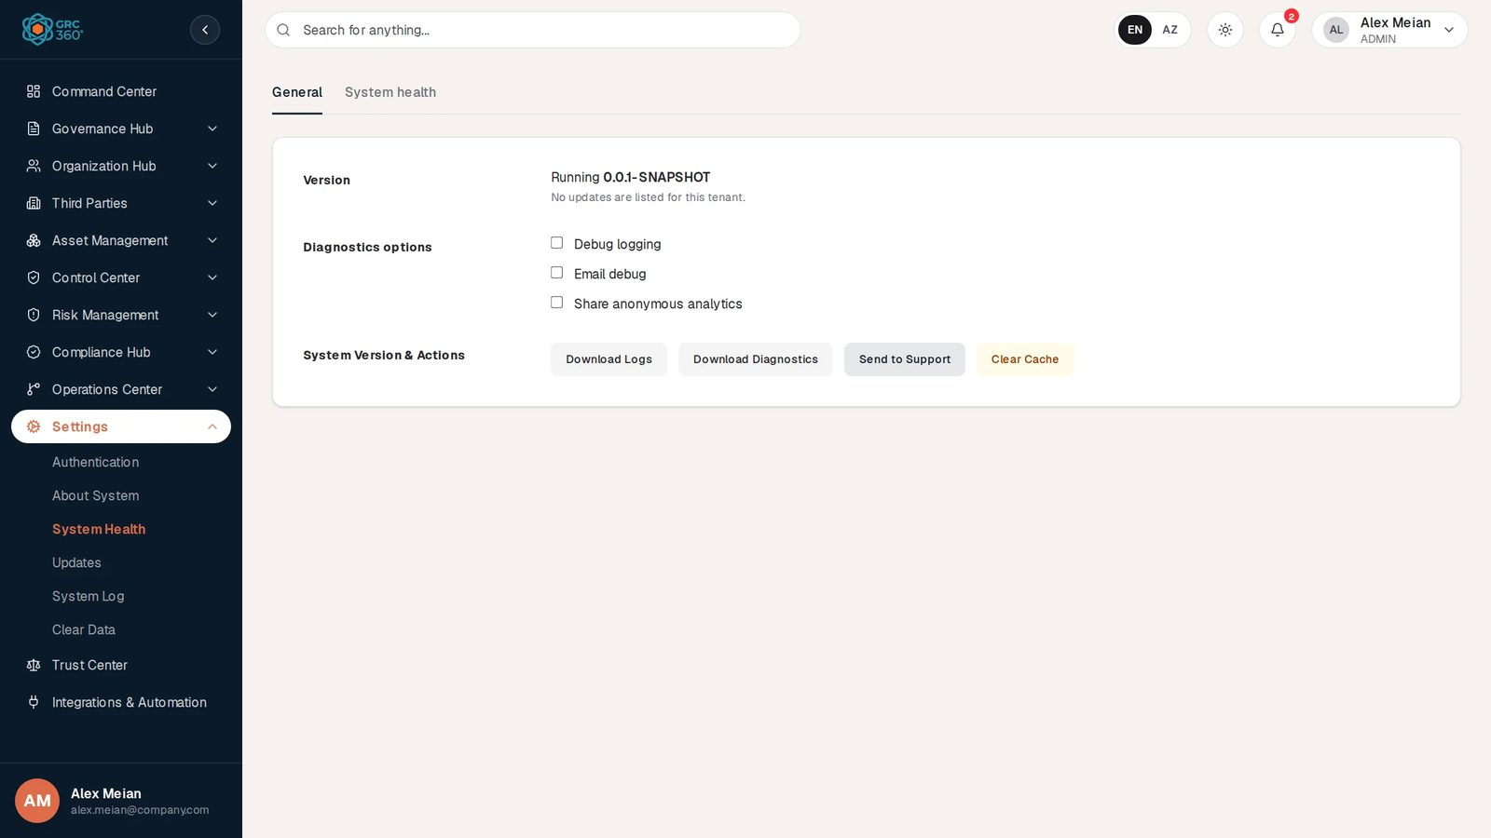
System Health, General tab

At a glance
A record is | None. One settings row per organisation (the diagnostics switches) and a list of live checks.
Typical owner | Administrator
Links to | Updates register (version message), System Log (download), SMTP configuration (mail check)
Linked from | Sidebar
Tabs | General, System health (in-page tabs)
Automations | Checks run when the tab is opened. No scheduled job.

The register (list view)

General tab
Row | What it shows
Version | “Running {version}” and a message: “Version {x} is available.” when the Updates register lists a higher version with status Available, otherwise “No updates are listed for this tenant.”
Diagnostics options | Three check boxes: Debug logging, Email debug, Share anonymous analytics. Each saves immediately and shows the toast “Saved.” (or “Could not save the setting.”).
System Version & Actions | Four buttons, described below.
The General tab fits on one screen; the full-page capture shows the same content:
System Health, General tab, full page
Button | What it does | Result
Download Logs | Downloads this organisation’s System Log as a file named system_logs.log. The content is the same comma-separated list as the System Log export (id, action, portal, username, message, createdAt). | File download; writes SYSTEM_LOGS_DOWNLOADED to the System Log.
Download Diagnostics | Downloads diagnostics.txt with the generation time, organisation id, app version, Java version, operating system, uptime, active server profiles and the results of all health checks. | File download; writes SYSTEM_DIAGNOSTICS_DOWNLOADED.
Send to Support | Without a mail relay and a configured support address, shows “No support mail channel is configured on this deployment. Download the diagnostics package and send it to support yourself.” With both configured, shows “Diagnostics queued for delivery to {address}.” | Toast; writes SYSTEM_DIAGNOSTICS_SEND_UNAVAILABLE or SYSTEM_DIAGNOSTICS_SENT_TO_SUPPORT.
Clear Cache | Empties every application cache. In this release no cache is configured, so it has nothing to clear. | Toast “Application cache cleared successfully”; writes SYSTEM_CACHE_CLEARED.

System health tab
System Health, health checks
The heading Health Checks is followed by one row per check, with an icon (green check for UP, amber warning for WARN, red cross for DOWN), the check name, details, the response time in ms when measured, and the status.
Check | UP | WARN | DOWN | Demo result
database | The database answered within 2 seconds (“PostgreSQL responded”) |  | No answer within 2 seconds, or connection failed (with the error) | UP
memory usage | Heap use below 75 % | 75 % to 89 % | 90 % or more | UP, “Heap 373 MB of 3420 MB (10%)”
disk space | 5 GB or more free on the server’s working disk | 1 to 4 GB free | Less than 1 GB free | UP, “26 GB free of 251 GB”
application cache | A cache manager is active (lists cache names) | “No cache manager configured” |  | WARN
mail smtp | “SMTP host {host}” | “No SMTP host configured” |  | WARN
While running the tab shows “Running health checks…”; with no results, “No health check reports available.”

Creating a record
None.

Viewing and editing a record
Only the three Diagnostics options check boxes can be changed.

Statuses
Value | Set by | Meaning
UP / WARN / DOWN | System | Result of each live check, rules above.

Tabs
See General and System health above.

Relationships
Related record | Direction | How the link is made | Where it shows
Update | Read | Highest version with status Available | Version message
System Log | Read and write | Download Logs exports it; every button writes an entry | Download; System Log page

Automations and notifications
None. Checks run on demand. The button actions are written to the System Log and are therefore also sent to matching webhooks.

Permissions
Action | Needed access
See both tabs | Admin group
Change switches, download, send, clear cache | Admin group
Comment / Assign | Not applicable

How to

Prepare a support request
- Open Settings › System Health, tab System health, and note any WARN or DOWN rows.
- On General, click Download Diagnostics and Download Logs.
- Attach both files to an e-mail to support (or use Support in the user menu, which opens a pre-filled e-mail).

Check that the mail relay is configured
- Open the System health tab.
- If mail smtp shows WARN “No SMTP host configured”, invitation e-mails cannot be sent; see E-mail, webhooks and notifications.

CSV import
None.

Limitations and known issues
- Debug logging, Email debug and Share anonymous analytics are stored but nothing in the server reads them; switching them has no other effect.
- Download Logs names its file .log, but the content is comma-separated values.
- Clear Cache has nothing to clear in this release (caching is off).
- Send to Support needs a support.contact-email server setting that is not part of the standard configuration, and even when it is set the server only records the request; it does not send an e-mail.

Updates
Module: Settings › Updates · Route: /settings/updates · Permission key: settings.updates
The Updates page lists the product versions recorded for this organisation and carries a notice about maintenance mode. In this release it is informational: updates are installed by whoever runs the server, not from this page, and the maintenance-mode button has no effect.
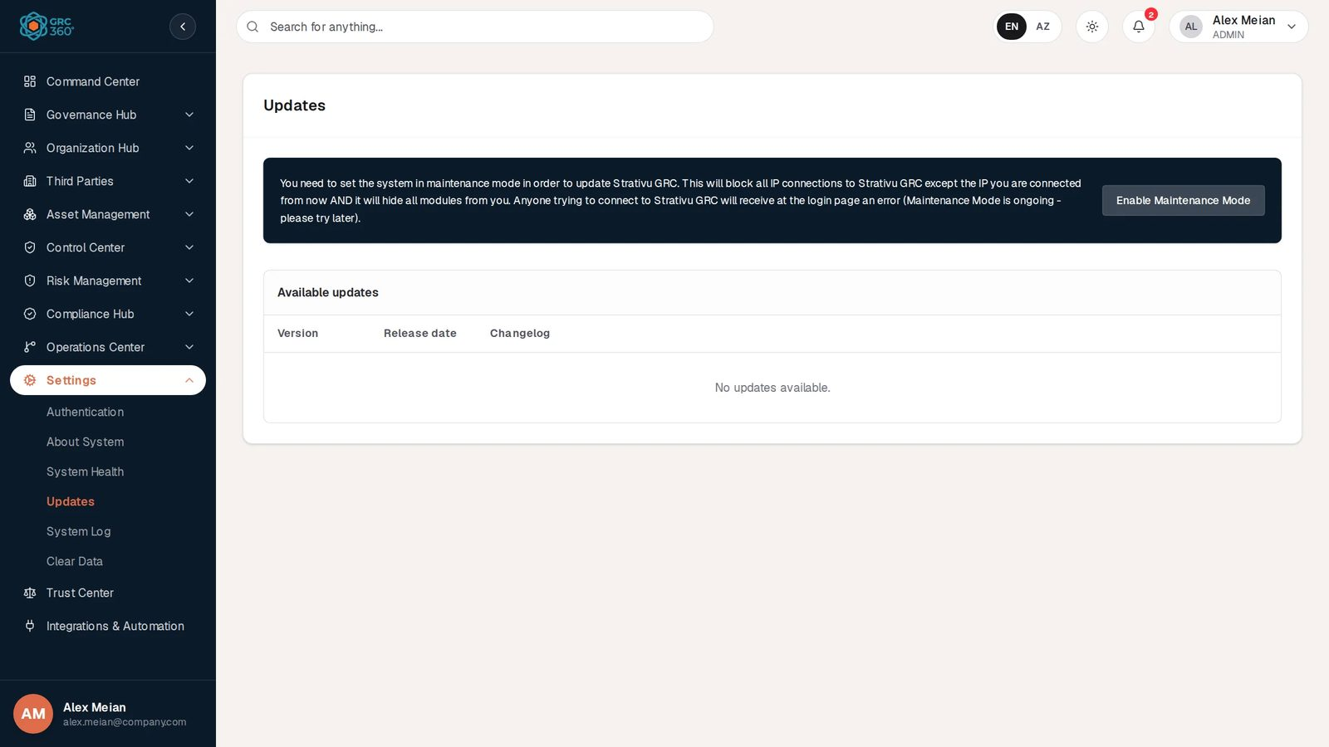
Updates

At a glance
A record is | One update entry (version, release date, description). Entries are not created from the screen.
Typical owner | Administrator, together with the person who operates the server
Links to | System Health (the “update available” message reads this register)
Linked from | Sidebar
Tabs | None
Automations | None

The register (list view)
The card Updates has two parts.
- Maintenance notice. A dark banner reads: “You need to set the system in maintenance mode in order to update Strativu GRC. This will block all IP connections to Strativu GRC except the IP you are connected from now AND it will hide all modules from you. Anyone trying to connect to Strativu GRC will receive at the login page an error (Maintenance Mode is ongoing - please try later).” with the button Enable Maintenance Mode.
- Available updates. A table:
Column | What it shows | Source
Version | Version number | Updates register
Release date | Release date | Updates register
Changelog | The description, and a link that is meant to point to the release notes | Updates register
With no entries the table reads “No updates available.” This is the state in the demo and in a normal installation: the server no longer invents update entries, and nothing in the product adds them. If loading fails, a red box shows the error.

Creating a record
None. There is no form; update entries can only exist in the database.

Viewing and editing a record
None.

Statuses
Value | Set by | Meaning
Available (stored on an entry) | Server data | An entry with status Available and a version different from the running one makes System Health say “Version {x} is available.”

Tabs
None.

Relationships
Related record | Direction | How the link is made | Where it shows
System Health | Update → System Health | Highest Available version | Version row on System Health › General

Automations and notifications
None.

Permissions
Action | Needed access
See the page | Admin group
Enable Maintenance Mode | Admin group (the button does nothing, see below)
Comment / Assign | Not applicable

How to

Check whether a newer version is recorded
- Open Settings › Updates and read Available updates.
- Or open Settings › System Health › General and read the line under Version.

Plan an upgrade
- Agree a time with the person who operates the server; the upgrade is a deployment task (see the technical reference).
- Tell users in advance. The Enable Maintenance Mode button does not block sign-ins in this release, so announce the window by other means.
- After the upgrade, confirm the new App Version on Settings › About System.

CSV import
None.

Limitations and known issues
- Enable Maintenance Mode has no action attached; clicking it does nothing. The server has a maintenance-mode setting, but nothing enforces it and the public maintenance status always reports “System is operational”.
- The Changelog link reads a field the server does not send, so it is empty even when an entry has release notes.
- The table can only ever show entries put into the database by hand.

System Log
Module: Settings › System Log · Route: /settings/system-log · Permission key: settings.system_log
The System Log is the organisation’s read-only, append-only trail of administrative and Compliance Hub actions: who changed the authentication settings, which compliance package was created, which exception expired. Administrators and auditors read it to answer “what happened and when”, and export it as CSV for evidence. No entry can be edited or deleted from the product.
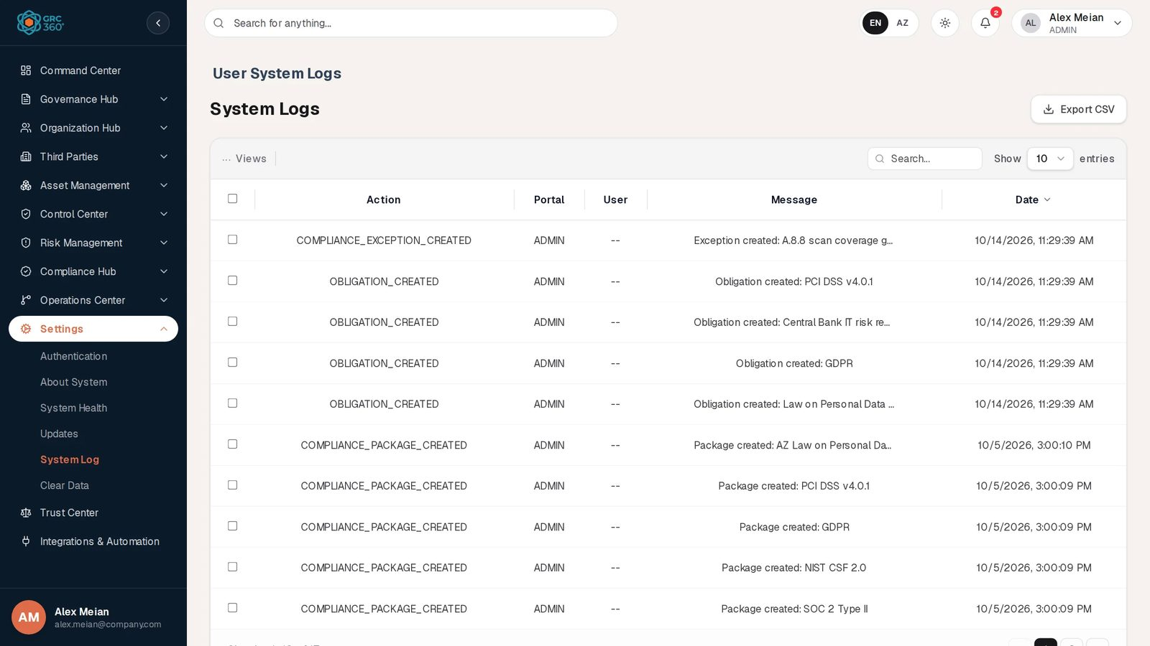
System Log

At a glance
A record is | One logged action (action code, portal, user, message, date).
Typical owner | Administrator; auditors receive exports
Links to | None (entries carry text only)
Linked from | System Health (Download Logs exports the same entries); webhooks receive every new entry
Tabs | None
Automations | Entries are written by the server as actions happen; each new entry is also sent to matching webhooks.

The register (list view)
The page heading is “User System Logs”, the grid title “System Logs”, with Export CSV on the right. The grid is server-paged and sorted newest first; its shared behaviour (search, … Views, paging) is described in Working with registers. It has no Add, Edit, Delete or Import buttons and no row actions. With no entries it reads “No logs found.”
Column | What it shows | Source
Action | Action code, for example COMPLIANCE_PACKAGE_CREATED | System
Portal | Always “ADMIN” in this release | System
User | The acting user’s name. In this release it shows “–” for actions done in the application (the server stores the user id, not the name). | System
Message | Description, for example “Package created: GDPR” | System
Date | Date and time in your browser’s locale; “–” when missing | System
The search box filters on the server. In the demo data the log holds 17 entries, for example an OBLIGATION_CREATED entry with the message “Obligation created: PCI DSS v4.0.1”.

What is logged
Area | Action codes
Authentication settings | AUTH_SETTINGS_UPDATED, AUTH_CONNECTOR_CREATED, AUTH_CONNECTOR_UPDATED, AUTH_CONNECTOR_DELETED, AUTH_CONNECTOR_TESTED
System Health | SYSTEM_HEALTH_CONFIG_UPDATED, SYSTEM_LOGS_DOWNLOADED, SYSTEM_DIAGNOSTICS_DOWNLOADED, SYSTEM_DIAGNOSTICS_SEND_UNAVAILABLE, SYSTEM_DIAGNOSTICS_SENT_TO_SUPPORT, SYSTEM_CACHE_CLEARED
Compliance Packages | COMPLIANCE_PACKAGE_CREATED, _UPDATED, _DELETED, _IMPORTED, _EXPORTED
Compliance Analysis | ASSESSMENT_CREATED, ASSESSMENT_IMPORTED, ASSESSMENT_ITEM_STATUS_CHANGED
Obligations | OBLIGATION_CREATED, OBLIGATION_UPDATED, OBLIGATION_DELETED
External Audit Findings | AUDIT_FINDING_CREATED, AUDIT_FINDING_UPDATED, AUDIT_FINDING_STATUS_CHANGED, AUDIT_FINDING_ATTACHMENT_UPLOADED
Compliance Exceptions | COMPLIANCE_EXCEPTION_CREATED, COMPLIANCE_EXCEPTION_STATUS_EDITED, COMPLIANCE_EXCEPTION_{workflow action}, COMPLIANCE_EXCEPTION_EXPIRED
Not logged here: sign-ins and sign-outs, permission and group changes, user changes, and changes in registers outside Compliance Hub (assets, risks, controls, policies, vendors, projects, incidents and others). Some of those (risk register and objective audit events) go to a separate internal audit trail that has no screen but does feed webhooks. Changes to individual records are also visible in each record’s Activity Log.

Creating a record
None. Entries are written only by the server.

Viewing and editing a record
The grid has no row actions and no view dialog; the long Message is truncated in the grid, so use Export CSV to read it in full. Entries cannot be edited or deleted; the server has no endpoint for either.

Statuses
None.

Tabs
None.

Relationships
Related record | Direction | How the link is made | Where it shows
Webhook | System Log → webhook | Every new entry is offered to webhooks whose filter matches the action code | Your endpoint
System Health | Read | Download Logs exports the entries | File download

Automations and notifications
Each entry is sent to matching webhooks in the background. A data reset that includes Audit trail and notifications empties the log; the reset itself is then recorded in the internal audit trail, not in the System Log.

Permissions
Action | Needed access
See the page | Admin group (catalogue right settings_system_log_read)
Export CSV | Admin group (settings_system_log_export)
Create / Edit / Delete | Not possible for anyone
Comment / Assign | Not applicable

How to

Export the log for an auditor
- Open Settings › System Log.
- Click Export CSV. The file system-logs.csv contains every entry of the organisation (not only the current page) with the columns id, action, portal, username, message, createdAt.

Find who changed the sign-in method
- Type “AUTH_SETTINGS” in the search box.
- Read the Message (“Authentication settings updated to LDAP”) and Date columns. The User column does not identify the person in this release; compare the time with the Active Sessions list on Authentication if needed.

Review compliance exception expiries
- Search for “COMPLIANCE_EXCEPTION”.
- Entries with action COMPLIANCE_EXCEPTION_EXPIRED were expired automatically; status changes made by people appear as COMPLIANCE_EXCEPTION_STATUS_EDITED or with the workflow action in the code.

CSV import
None. Import is hidden on this grid. Export is described above.

Limitations and known issues
- The User column shows “–” for entries made by signed-in users; the export’s username column is empty for the same reason.
- Portal is always “ADMIN”.
- Coverage is limited to authentication settings, System Health actions and Compliance Hub; sign-ins, permission changes and most register changes are not in this log, although the Trust Center describes them as logged.
- Automatic expiry of compliance exceptions (COMPLIANCE_EXCEPTION_EXPIRED) depends on a scheduled job that is not active in this release; such entries appear only when the expiry is triggered by other means.

Clear Data
Module: Settings › Clear Data · Route: /settings/clear-data · Permission key: settings.clear_data
Clear Data permanently deletes chosen groups of this organisation’s data so the product can be used from a clean start, for example after a trial or a demo. Before anything is deleted the server saves a backup of every row it is about to remove, and if that backup cannot be saved nothing is deleted. Only the Admin group can open the page, and the deletion has to be confirmed by typing the organisation’s name.
Deleted rows are gone, not hidden. There is no undo and no restore function in the product. The backup file is the only copy.
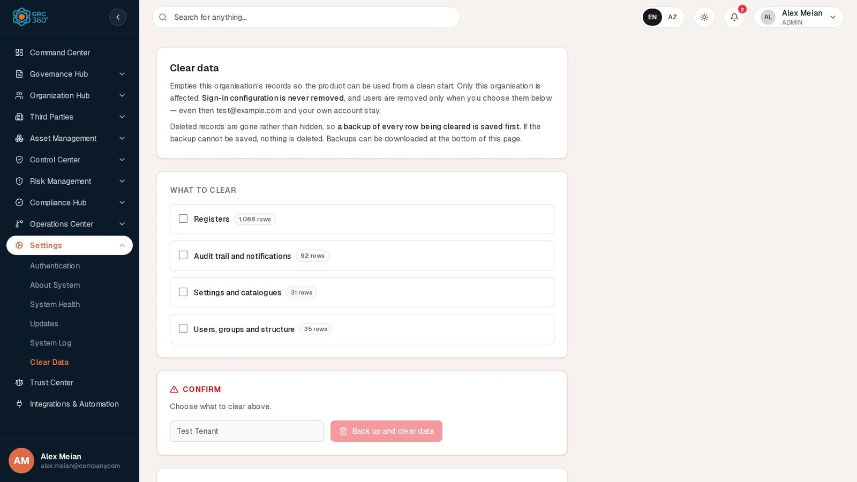
Clear Data

At a glance
A record is | A backup taken by a reset (listed under Backups).
Typical owner | Administrator
Links to | Every register of the organisation (as deletion targets)
Linked from | Sidebar
Tabs | None
Automations | After a reset every open browser tab of the organisation reloads its data.

Who may do it
Action | Needed access
Open the page and see the row counts and backups | Admin group (catalogue right read on Settings › Clear Data). No other group can hold Settings.
Run Back up and clear data and Download a backup | Admin group (catalogue right execute, labelled “Execute Reset”). Without it the buttons are greyed with a lock and open Request Access, which for Settings explains that it cannot be requested.
Only the caller’s own organisation is affected. The organisation comes from the signed-in session, never from the request, so no request can reach another organisation’s data.

The page (list view)
The page has four cards.
- Clear data. Explains that only this organisation is affected, that “Sign-in configuration is never removed”, that users are removed only when chosen and that test@example.com and your own account stay, and that “a backup of every row being cleared is saved first”.
- What to clear. Four check boxes, each with the current row count from the server (“…” while loading):
Check box | Group code | Demo count
Registers | REGISTERS | 1,081 rows
Audit trail and notifications | LOGS | 90 rows
Settings and catalogues | SETTINGS | 22 rows
Users, groups and structure | PEOPLE | 23 rows
The counts include the link rows between records (for example a risk’s link to an asset), not only the records themselves. If Settings and catalogues is ticked without Registers, an amber note warns: “Scales, stages and catalogues are still referenced by the records that use them, so most of them will not clear while the registers are kept. Add Registers to clear both.”
- Confirm. With nothing ticked it reads “Choose what to clear above.” Otherwise: “This will back up and then delete N rows. To confirm, type the organisation name: {name}”. Type the name into the field (placeholder: the name; in the demo “Test Tenant”; case does not matter) and click Back up and clear data. The button stays disabled until at least one group is ticked and the typed name matches. While running it reads “Backing up and clearing…”.
- Backups. “One file per clear, holding every row it deleted as gzipped JSON, table by table.” A table lists Taken, By, Cleared (groups), Rows, Size and a Download button. With none: “No backups yet. One is saved each time data is cleared.”
After a successful run a Cleared card shows “N rows removed.”, “A backup was saved before clearing. It is the newest entry under Backups below.”, a list of tables with the number of rows deleted from each, and, if any, “Still referenced elsewhere and left as they were: {tables}.” If the run fails, a red box shows the server’s message; the server’s own wording starts “Nothing was cleared:”.

What is deleted
Group | What goes
Registers | Every other table of the organisation that is not in one of the three groups below and not in the never-deleted list: assets, data flows, risks of all three registers and their reviews, risk exceptions, controls with audits, issues and maintenances, policies and reviews, policy exceptions, continuity plans with audits and tasks, compliance packages, items, analyses, obligations, compliance exceptions and audit findings, vendors and service agreements, objectives, coverage and issues, projects with tasks and expenses, security incidents, comments and attachments records, activity history, and every link row between them.
Audit trail and notifications | The internal audit trail, the System Log, all notifications and notification history.
Settings and catalogues | Risk settings (module settings, appetite, analysis matrices, calculation methods, classification types and values), control catalogue options, obligation categories, objective audit result options, security incident stages, notification templates and preferences, policy templates, the Trust Center publishing switch and all webhooks.
Users, groups and structure | All users and their sign-in accounts, sessions, pending invitations and individual permission grants, departments, user groups and custom groups, except the kept accounts below.
Kept accounts. When Users, groups and structure is cleared, these accounts stay with their sessions: the account of the administrator who runs the reset, and every e-mail listed in the server setting APP_DATA_RESET_KEEP_EMAILS (default test@example.com). The built-in groups Admin, Read Only and Third Party always stay. Where a kept row points at a deleted one (for example a kept user’s department), that reference is emptied rather than the kept row being deleted.
Never deleted, whatever is ticked: the organisation itself and its domains and profile; the permission catalogue and system roles; all sign-in configuration (authentication method, LDAP, OAuth and SAML connectors, SSO configuration); system information and the updates register; and earlier reset backups.
Files. Uploaded attachment files in file storage are not part of the backup and are not removed by the reset; only their database records are.

The backup
- Taken on the same database connection immediately before the first deletion. If it cannot be written or stored, the whole operation is rolled back and nothing is deleted.
- Contains every row the plan will delete, including link rows, as gzipped JSON: format grc360-tenant-backup/1, organisation id, time, who ran it, groups, and per table its columns and rows.
- Stored in the server’s file storage. The download is named grc360-backup-yyyyMMdd-HHmmss.json.gz.
- Listed under Backups, newest first. Backups are never deleted by a later reset and are not cleaned up automatically.
- There is no restore button. Restoring data from a backup is a manual database task for the server operator.

Creating a record
A backup is created only by running a reset.

Viewing and editing a record
Backups can only be downloaded.

Statuses
None.

Tabs
None.

Relationships
Related record | Direction | How the link is made | Where it shows
Every organisation table | Clear Data → table | Group membership | What to clear counts; Cleared table list
Backup | Clear Data → backup | One per run | Backups list

Automations and notifications
- After a reset, every open tab of the organisation is told to reload all data.
- The reset is recorded in the internal audit trail after the deletion (so it survives a clear of Audit trail and notifications) and is therefore also sent to matching webhooks, unless webhooks were themselves cleared. It is not shown in the System Log page.
- No notification is sent.

Permissions
See Who may do it.

How to

Clear the demo data before going live
- Download any data you want to keep using the Export CSV buttons of the registers.
- Open Settings › Clear Data. Tick Registers and Audit trail and notifications. Leave Users, groups and structure unticked to keep your colleagues’ accounts.
- Read the total in Confirm, type the organisation name exactly as shown (in the demo “Test Tenant”) and click Back up and clear data.
- Check the Cleared card and download the new backup from Backups for safekeeping.

Reset everything except your own sign-in
- Tick all four boxes. Note that every other user will be removed and signed out, and that custom groups and departments go.
- Type the organisation name and click Back up and clear data.
- You remain signed in. Sign-in configuration (for example an LDAP connector) is still there.

Retrieve a backup
- Scroll to Backups.
- Click Download on the row with the right Taken time and Cleared groups.

CSV import
None.

Limitations and known issues
- No restore function; the backup can only be downloaded.
- Clearing Settings and catalogues without Registers leaves most of those tables in place because records still reference them; they are reported as “Still referenced elsewhere”.
- Uploaded files in storage are not deleted or backed up.
- The page text names test@example.com as the kept account; if the server operator changed APP_DATA_RESET_KEEP_EMAILS, the text does not follow.

Part 3 — How the modules work together

Relationship map
GRC360’s registers are linked: a risk names the assets it threatens and the controls that treat it, a control names the policies behind it and the compliance packages it satisfies, and so on. This page lists every link a user can make, where it is made, and where it shows up on the other side.
Reading the tables
- Set on: the form and field where you create the link. A link is always stored on one side.
- Shown on the other side: where the link appears on the record you linked to. Counts marked clickable open the linked records’ details (see clickable counts).
- Not shown: the link exists and is used by the system, but the other record’s page does not display it.

The overall picture

Organisation and assets
From | To | Set on | Cardinality | Shown on the other side
User | Department | Users › Department | many users → one department | Departments: department contact
User | Group | Users › Groups | many ↔ many | Groups: member count and members panel
Asset | Department | Assets › Related Departments | many ↔ many | Departments › Asset Risks counts risks of the department’s assets
Asset | Reviews | Assets › Reviews tab | one asset → many reviews | Assets › Reviews count; row click opens them
Data Flow | Asset | Data Flows › asset field | many flows → one asset | Assets › Data Asset Flows count
Data Flow | Vendors / third parties | Data Flows › third parties | many ↔ many | Not shown on the vendor
Data Flow | Departments | Data Flows › departments | many ↔ many | Not shown
Data Flow | Asset, Third Party and Business Risks | Data Flows › risk fields | many ↔ many | Adds the risk to the asset’s links
Data Flow | Controls (compensating), Policies, Projects (improvement) | Data Flows › Compensating Controls, Policies, Improvement Projects | many ↔ many | Not shown on the control, policy or project

Third parties
From | To | Set on | Cardinality | Shown on the other side
Service Agreement | Vendor | Service Agreements › Vendor (required) | many → one | Vendors: agreements of the vendor
Third Party Risk | Vendor | Third Party Risks › Applicable Third Parties | many ↔ many | Vendors › Risk count (clickable)
Third Party Risk | Asset | Third Party Risks › Assets Shared with this Third Party | many ↔ many | Assets › Third Party Risk count

Risks
The three risk registers link to the same kinds of records. The link is always stored on the risk.
From | To | Set on (risk form field) | Cardinality | Shown on the other side
Asset Risk | Asset | Related Assets | many ↔ many | Assets › Asset Risks count (clickable); Departments › Asset Risks
Business Risk | Department | Applicable Business Units | many ↔ many | Departments › Business Risks count
Business Risk | Continuity Plan | Mitigating Business Continuity Plans | many ↔ many | Shown only on the risk
Any risk | Control | Treatment: Controls | many ↔ many | Controls › Asset Risks, Third Party Risks, Business Risks counts (clickable, read-only)
Any risk | Policy | Treatment: Policies | many ↔ many | Policies & Standards › Asset Risks Treatment, Third Party Risks Treatment (business risks are not shown)
Any risk | Project | Treatment: Projects | many ↔ many | Projects › Asset Risks count (third-party and business risks are not shown)
Any risk | Risk Exception | Treatment: Risk Exceptions | many ↔ many | Risk Exceptions › risk counts. Also set from the exception’s Related … Risks fields: either side works
Any risk | Compliance package item | Affected Compliance Items | many ↔ many | Compliance Analysis › Asset Risks tab of the item. Also editable from there
Any risk | Security Incident | Security Incidents | many ↔ many | Security Incidents › Known Asset / Third Party / Business Risk counts (clickable). The incident form has no risk field
Risk Review | Risk | Reviews tab › risk field | many reviews → one risk | Risk grid › Reviews count. Deleting a risk deletes its reviews
Side effect on compliance. Saving a risk updates the Compliance Analysis rows of the items it affects:
- If any linked risk is above appetite, the rows become Not Compliant.
- Otherwise they become Compliant.
- Rows marked Not Applicable are left alone.
See Compliance Analysis.

Controls and policies
From | To | Set on | Cardinality | Shown on the other side
Control | Policy | Controls › Related Policies | many ↔ many | Policies & Standards › Internal Controls
Control | Project | Controls › Related Projects | many ↔ many | Projects › Internal Controls
Control | Compliance Package | Set from Compliance Analysis when the control is added to an item | many ↔ many | Controls › Compliance Package column
Control | Audits, Issues, Maintenances | the control’s tabs | one → many | Controls › Audits, Issues, Maintenances counts. Deleting the control deletes them
Policy | Project | Policies › Related Projects | many ↔ many | Not shown on the project
Policy | Compliance Package | Policies, or set from Compliance Analysis | many ↔ many | Policies › package column
Policy | Reviews | Policies & Standards › Reviews tab | one → many | Policies › Reviews count
Policy Exception | Policy | Policy Exceptions › Related Policies | many ↔ many | Shown on the exception
Continuity Plan | Audits, Tasks | the plan’s tabs | one → many | Counts on the plan

Compliance
From | To | Set on | Cardinality | Shown on the other side
Package item | Package | Package Items › Add | many items → one package | Packages › Compliance Package Items count; row click opens them
Analysis row | Package item | Created automatically for every item | one per item | Compliance Analysis
Analysis row | Controls, Policies, Projects | Compliance Analysis › Edit Action › Treatment | many ↔ many | Adds the package to the control or policy; Projects › Compliance Package
Compliance Exception | Package items | Compliance Exceptions › requirement items | many ↔ many | Compliance Analysis › Treatment of the item
External Audit Finding | Package items | External Audit Findings › affected items | many ↔ many | Compliance Analysis › Treatment of the item
Package | Trust Center | automatic |  | Trust Center posture uses the analysis results per package

Governance
From | To | Set on | Cardinality | Shown on the other side
Objective | Issues | Objectives › Program Issues | many ↔ many | Not shown on the issue
Objective | Controls, Policies, Projects | Objectives › Activities | many ↔ many | Not shown on the other record
Objective | Third Party Risks, Business Risks | Objectives › Activities | many ↔ many | Objectives grid counts (clickable)
Objective | Audits | Objectives › Audit tab | one → many | Objectives › Audits count. Deleting the objective deletes them

Operations
From | To | Set on | Cardinality | Shown on the other side
Project | Tasks, Expenses | Projects › Tasks and Expenses tabs | one → many | Projects › Tasks count; view chips such as Expired Tasks
Security Incident | Stages | Security Incidents › Stages tab | many ↔ many, with a status per stage | Incident stage progress

Links that only exist on one side
These links are stored and used by GRC360, but the linked record’s page does not display them:
- Third-party and business risks that a project treats: the project shows only asset risks.
- Business risks treated by a policy: the policy shows only asset and third-party risks.
- Projects linked from policies, data flows and objectives.
- Controls, policies and projects linked from objectives.
- Data flows’ links to vendors, compensating controls and policies.
Use the record that holds the link (the risk, policy, data flow or objective) to see and change it.

Deleting linked records
- Deleting a parent deletes its children:
  - a control’s audits, issues and maintenances;
  - an objective’s audits;
  - a risk’s reviews;
  - a project’s tasks and expenses;
  - a continuity plan’s audits and tasks.
- Deleting a control also removes it from projects, incidents and objectives.
- Deleting a user keeps the person’s name on the records they were named on.
- When a record cannot be deleted because others depend on it, the delete dialog says so.

Related pages
- What is GRC360
- The module pages under Module reference: each has a Relationships section with its own diagram.

Scenario: a risk assessment cycle
Goal. Identify a risk to an asset, score it, decide the treatment, link the controls and projects that carry it out, and keep it under review.
Example. The customer database could be reached through stolen administrator passwords.
Who. A risk owner with Manage access to Asset Risks, plus View on Assets, Controls and Projects. To create a missing control or project on the spot, you also need Manage on that register.

1. Check the scoring settings
Before the first risk, open Risk Management › Asset Risks and click the gear button. Check:
- Classification Types and Classifications: the likelihood and impact scales, by default 1–5 each.
- Risk Appetite: the score above which a risk is flagged Above Appetite.
Risk appetite settings
Check the appetite value. The default appetite value is higher than the largest score of the default 5 × 5 matrix (25). Lower it to a value inside your scale, or the flag will never appear.
Details: Risk Management › scoring model.

2. Find the asset
Open Asset Management › Assets. The risk will point to the asset, so it must exist; here Customer database.
If it is missing, add it there, or create it from the risk form with + Add in the Related Assets field.

3. Add the risk and analyse it
In Risk Management › Asset Risks click Add Item.
Add an asset risk
Field | Example
Name * | Unauthorized access
Description | Unauthorized access to the customer database through compromised admin credentials.
Risk GRC Contact * | Alex Meian
Risk Originator Contact * | Sara Johnson
Next Review Date | in 30 days
Related Assets | Customer database
Threat Description | Credential theft, password reuse
Vulnerabilities Description | Admin accounts without MFA
Likelihood (Analysis) | Likely
Impact (Analysis) | Critical
The score. On Save, GRC360 calculates the inherent score: Likely (4) × Critical (5) = 20.

4. Decide the treatment
In the Treatment part of the form choose Risk Treatment:
Treatment | Use when
Mitigate | You will reduce the risk with controls, policies or projects.
Accept | The risk is within appetite, or it costs more to treat than to bear. Record a risk exception (step 8).
Transfer | Someone else carries it, for example an insurer or a supplier.
Avoid | You stop the activity that causes it.

5. Link what carries the treatment out
- Treatment: Controls: Multi-factor authentication, Quarterly access review.
- Treatment: Policies: Access Control Policy.
- Treatment: Projects: a project for the work still to do. Use + Add to create Enforce MFA on all admin accounts without leaving the form.
- Residual Percentage Coefficient: how much of the risk remains after the treatment. The residual score is calculated from it on save.
After saving:
- the control shows the risk in its Asset Risks count;
- the project shows it in its Asset Risks count;
- the policy shows it in Asset Risks Treatment.
The risk with its treatment

6. Link the requirements the risk affects
In Affected Compliance Items, pick the framework requirements this risk puts at stake, for example A.8.5 Secure authentication.
Effect on Compliance Analysis. When you save, the analysis rows for those requirements are updated:
- Not Compliant while any linked risk is above appetite;
- Compliant otherwise;
- rows marked Not Applicable are not changed.
See Compliance Analysis.

7. Keep it under review
- Next Review Date sets when the risk is due for review.
- Once that date passes, the risk’s Dynamic Status shows Review Expired. No job needs to run for this.
- Record each review on the Reviews tab, with planned and actual dates, reviewers and a description.
Risk reviews

8. If you accept the risk
Open Risk Management › Risk Exceptions and click Add Item. Fill in:
- the reason;
- the requester and the contact;
- start and expiry dates;
- the related risks.
The exception appears in the risk’s treatment.
After the expiry date, the exception’s Dynamic Status shows Expired. Its stored status is not changed automatically in this release. See Risk Exceptions.

9. Follow up
Where | What to watch
Command Center | The Asset Risks heat map: the risk sits in the Critical × Likely cell
Projects | Progress of the treatment project’s tasks; the Expired Tasks view
Controls | Audits of the treating controls
The risk’s Activity Log | Who changed the score, treatment or owners, and when

Things to know
- Recalculation. Scores are recalculated when the risk is saved. Changing the scales or the method later does not update existing risks until each is saved again.
- Approving exceptions. Risk exceptions can be submitted, approved and denied only through the API in this release. The form’s status field offers Open and Closed.
- The rest. See the full list of limitations under Asset Risks.

Scenario: preparing for an ISO/IEC 27001 audit
Goal. Know, requirement by requirement, how the organisation meets ISO/IEC 27001, what evidence supports it, and what is still open, before the certification auditor arrives.
Who. The compliance manager, with Manage on Compliance Hub and View on Controls, Policies and the risk registers.

1. Create the package and its requirements
GRC360 does not ship the text of ISO/IEC 27001; you enter the requirements you are assessed against.
- Open Compliance Hub › Compliance Packages and click Add Item. Name the package ISO/IEC 27001:2022.
- Click the package row to open Compliance Package Items.
- Add each Annex A control as an item, with:
  - Chapter ID and Chapter Name, for example 8 Technological;
  - Item ID, for example A.8.5;
  - Item Name, for example Secure authentication.
- Alternatively, use Import CSV on the items page.
Compliance package items
Analysis rows. Every item automatically gets a row in Compliance Analysis.
Details: Compliance Packages.

2. Assess each requirement
Open Compliance Hub › Compliance Analysis and choose the framework. For each row click Edit (Edit Action):
- General:
  - set Compliance Strategy: Compliant, Not Compliant or Not Applicable;
  - pick the Owner;
  - link any Findings.
- Treatment: link the Internal Controls, Policies and Projects that meet the requirement, and any Compliance Exception.
- Asset Risks: link the risks that put this requirement at stake.
Edit Action, Treatment tab
Links back to the package. A control or policy you link here gets ISO/IEC 27001:2022 added to its Compliance Package field. That is how the Controls register shows which framework each control serves.

3. Make sure each control has evidence
For each linked control, open Control Center › Controls and check its Audits tab:
- Each audit holds its methodology, success criteria, dates, result and evidence file.
- The audit schedule comes from the control’s audit settings: specific dates, or periodic from a first date.
Control audits
Expiry warnings. In Compliance Analysis, a row whose control’s last audit has expired, or whose linked risk’s review has expired, shows an amber warning in Dynamic Status.
Recording results. Audits cannot be set to Completed from the form in this release. See Controls for how results are recorded today.

4. Handle the gaps
Gap | What to record
The requirement is met only partly and a fix is planned | A Project linked on the Treatment tab, with tasks and a deadline
The requirement cannot be met for now and the risk is accepted | A Compliance Exception with requester, GRC contact and expiry date (Compliance Exceptions)
A policy is missing or out of date | A policy in Policies & Standards, with its review date
The requirement does not apply | Compliance Strategy: Not Applicable, which leaves it out of the percentage

5. Record what the auditor finds
For each finding the auditor raises, open Compliance Hub › External Audit Findings and click Add Item. Fill in:
- the name and description;
- the due date and status;
- the owners;
- the affected requirement items.
Attach the auditor’s report with the Evidence attachments button on the row.
External audit findings
Overdue findings. A finding past its due date and not closed shows Overdue in Dynamic Status.

6. Check readiness
In Compliance Analysis click Assessment summaries. It shows, per assessment:
- the compliance percentage;
- the counts of Compliant, Partial, Review and Non-compliant rows.
Assessment summaries
Sharing with customers. The Trust Center shows your posture to customers and partners.

7. For the auditor
Auditors usually ask how a control was tested, by whom and when. Point them to:
- Compliance Analysis, filtered to the framework: one row per requirement with its controls, policies and status;
- each control’s Audits tab and Activity Log: who did what, and when;
- System Log (administrators): every action in the tenant;
- Export CSV on the registers that offer it, for the auditor’s own sampling.
A read-only Auditors group (first-time setup) lets the auditor look for themselves.

Scenario: onboarding a new vendor
Goal. Before a new supplier receives your data or runs one of your services:
- register the supplier;
- record the contract;
- assess the risk it brings;
- link it to the assets and data it touches.
Example. An identity provider, Okta.
Who. The vendor manager, with Manage on Third Parties. Risk owners need Manage on Third Party Risks.

1. Register the vendor
Open Third Parties › Vendors and click Add Item:
Field | Example
Name * | Okta
Description | Workforce identity and single sign-on
GRC Contact * | Alex Meian, who is responsible for the vendor in your GRC programme
Third Party Contact * | Sara Johnson, who manages the relationship day to day
Type * | Suppliers
Vendors
The vendor’s Dynamic Status. Shown in the vendor list, it tells you at a glance where the vendor stands:
- Risks Open as soon as any third-party risk names the vendor;
- On Track when none does;
- Under Review or Inactive from its stored status.

2. Record the service agreement
Open Third Parties › Service Agreements and click Add Item:
Field | Example
Name * | Okta Workforce Identity
GRC Contact * / Support Contract Contact * | Alex Meian / Sara Johnson
Support Contract Supplier * | Okta. If the vendor does not exist yet, + Add creates it without leaving the form.
Service Value * | The yearly contract value
Start Date * / End Date * | The contract term
Service agreements
Expiry notices. Before the agreement ends, its GRC and support-contract contacts are notified three times:
- 7 days before the end date;
- 3 days before;
- on the end date itself.
Dynamic Status. The agreement shows Expiring for its last 30 days and Expired afterwards.

3. Map the data the vendor receives
If the vendor processes your data, record it in Asset Management › Data Flows:
- the asset the data comes from, for example HR system (BambooHR);
- the vendor as third party;
- source and destination;
- classification and encryption;
- the GDPR questions.
See Data Flows.

4. Assess the third-party risks
Open Risk Management › Third Party Risks and click Add Item. One vendor can bring several risks:
Field | Example
Name * | Identity provider compromise
Applicable Third Parties | Okta
Assets Shared with this Third Party | Customer database
Likelihood / Impact | Unlikely / Critical
Risk Treatment | Mitigate
Treatment: Controls | Vendor due diligence
Treatment: Policies | Vendor Management Policy
Next Review Date | in 90 days
Third party risks
The vendor’s Risk count now shows the risk. The count is clickable.

5. Keep the vendor under review
- Review the risks. Record each review on the risk’s Reviews tab. Once Next Review Date passes, the risk shows Review Expired.
- Renew or end the agreement before its end date. The expiry notices remind the contacts.
- Record problems. Use the vendor’s Activity Log for due-diligence evidence and correspondence, for example questionnaires and certificates.

Things to know
- Type and status. The vendor form offers three types: Customers, Regulators and Suppliers. It has no status field.
- Agreement status. Service agreements are stored as Active from creation. Their stored status does not change by itself in this release, but their Dynamic Status does.
- The rest. See Vendors and Service Agreements.

Scenario: handling a security incident
Goal. Record a security incident as soon as it is known, move it through your response stages, link it to the risks it touched, and follow up the improvements it calls for.
Example. A phishing campaign targets the finance team.
Who. The incident handler, with Manage on Operations Center › Security Incidents and its Stages tab. Risk owners update the risk registers.

1. Define your response stages (once)
- Open Operations Center › Security Incidents and switch to the Stages tab.
- Open the Settings for stages and add the stages your incident response follows, each with a Name and Description.
A typical lifecycle:
Stage | Purpose
Detection | Identify and confirm the incident
Containment | Limit the impact
Eradication | Remove the cause
Recovery | Restore normal operation
Lessons learned | Post-incident review
Every incident then gets these stages to work through.
Details: Security Incidents › Stages.

2. Record the incident
On the Security Incidents tab click Add Item:
Field | Example
Title * | Phishing campaign targeting finance team
Description | What happened and what is known so far
GRC Contact * | Alex Meian
Incident Contact * | Sara Johnson
Open Date * | The day it was discovered (it cannot be in the future)
Security incidents

3. Work through the stages
On the Stages tab, each incident’s stages are listed with their status. Update the status of each stage as the response progresses, for example Detection to complete and Containment to in progress.
Incident stages
Follow-up for the whole team.
- On the Stages tab, the Incomplete and Completed chips show how many stages are still open across all incidents.
- The Activity Log on the incident is the place for the running record: notes, decisions and attached evidence such as e-mail headers and screenshots.

4. Link the risks the incident touched
The incident form has no risk field; the link is made from the risk:
- Open the affected risk. Here that is the asset risk Phishing credential theft, but third-party and business risks work the same way.
- In Security Incidents on the risk form, pick the incident.
- Consider whether the incident changes the risk’s Likelihood (Analysis).
The incident then shows the risk in its Known Asset Risk (or Known Third Party Risk / Known Business Risk) count. The count is clickable, and gives a quick view of how often each risk materialises.

5. Turn lessons learned into projects
For each improvement the review calls for:
- Create a project in Operations Center › Projects, with tasks, owners and deadlines.
- Link it from the risk’s Treatment: Projects.
- If the incident revealed a control weakness, record an Issue on that control in Control Center › Controls › Issues.

6. Close the incident
Edit the incident and set Status to Closed. The Closure Date is filled in with today’s date automatically.

Things to know
- No notifications. Incidents do not send notifications in this release. Agree on how the team is alerted, for example by e-mail or chat, and use the incident record as the system of record.
- Bulk import. Import CSV works on Security Incidents and on the stage definitions (in the incidents’ Settings) for bringing in a backlog. Stage rows of an incident cannot be imported. See CSV import and export.
- Limitations. See Security Incidents.

Scenario: the annual policy review
Goal. Review each policy when it falls due, publish the new version, and handle approved deviations.
Example. The Access Control Policy.
Who. The policy owner (named in GRC Contact) and the reviewer (named in Policy Reviewer Contact), with Manage on Control Center › Policies & Standards and its Reviews tab.

1. Know what is due
Next Review Date. Each policy has one. GRC360 creates the planned review rows on the Reviews tab from it.
Overdue policies. Once the date has passed, the policy’s Dynamic Status shows Needs Review until the Next Review Date is moved forward.
Finding due policies. Open Control Center › Policies & Standards and sort by Next Review Date.
Policies & Standards

2. Review the document
- Open the policy with Edit.
- Make the changes to the document. The Document Content field holds one of:
  - text written in GRC360;
  - a URL link;
  - an attached file.
- Raise the Version, for example from 2.4 to 2.5.
- Set Published Date and keep the status Published, or set it to Draft while it is being approved.
- Move Next Review Date forward, usually by a year. This clears Needs Review and plans the next review.
Use the policy’s Activity Log for review comments and the approver’s decision. Its history shows exactly which fields changed.

3. Record the review
On the Reviews tab open the planned review, or click Add Item, and fill in:
Field | Example
Planned Date | The due date
Actual Date | The day the review was completed. Filling it completes the review.
Reviewers | Sara Johnson
Version | 2.5
Description | What changed and why
Policy reviews

4. Check the controls behind the policy
A policy is carried out by controls. The policy’s Internal Controls column lists the controls that name it in Related Policies. If the new version changes what is required, check those controls and their audit criteria.

5. Approve deviations
When a team cannot follow the policy for a while, record a Policy Exception in Control Center › Policy Exceptions:
- name and description;
- requester and contact;
- the expiration date (GRC360 sets the start date itself);
- the related policy.
Policy exceptions
From the day after its expiration date, the exception’s Dynamic Status shows Expired.
Details: Policy Exceptions.

Things to know
- Attachments on reviews. Files attached to a review are not kept in this release. Attach supporting files to the policy’s Activity Log instead.
- Exception status. The policy exception form offers only Open and Closed, and its Dynamic Status reads Pending for open exceptions.
- The rest. See Policies & Standards.

Scenario: business continuity planning and testing
Goal. Write a recovery plan with clear steps, tell the people involved what they must do, test the plan on a schedule, and link it to the business risks it mitigates.
Example. The plan Ransomware recovery.
Who. The continuity manager, with Manage on Control Center › Continuity Plans and its Audits and Tasks tabs.

1. Write the plan
Open Control Center › Continuity Plans and click Add Item:
Field | Example
Title * | Ransomware recovery
Objective * | Recover core systems from immutable backups within 24 hours.
Launch Criteria | Core systems encrypted or unavailable
Owner * / Sponsor * / Launch Initiator * | Alex Meian / Sara Johnson / Alex Meian
Cost (OPEX) / Cost (CAPEX) | 12000 / 40000
Status | Design while it is written, Production once it is in force
Add a continuity plan

2. Add the steps
On the Tasks tab add one task per step:
Field | Meaning
Plan Step | The order, for example 1, 2, 3
When | The trigger, for example Outage confirmed
Who | The role that acts
Does Something | The action
Where | The location or channel
How | The runbook to use
Awareness Role | The people and groups who must know about this step
Notifications. Everyone newly named in Awareness Role receives a notification, “You are named in a continuity plan task”, with a link to the task. Groups are expanded to their members.
Continuity plan tasks

3. Schedule the tests
In the plan’s audit settings:
- Switch audits on.
- Choose Specific dates or Periodical with a first date and a frequency, for example Twice a Year.
- Fill in the Audit Methodology and Audit Success Metric Criteria, for example Tabletop exercise and failover test and RTO met.
Planned audits. When the plan is saved in Production, GRC360 creates the planned audits on the Audits tab.

4. Record each test
On the Audits tab open the planned audit and fill in:
- Audit Start Date: makes the audit In Progress;
- Audit End Date: makes it Completed;
- result and conclusion;
- audit owner;
- the evidence file.
If the success criteria change, edit them on the audit. The plan’s criteria are updated too, so future tests use the new criteria.
Continuity plan audits

5. Link the plan to the risks it mitigates
In Risk Management › Business Risks, open each business risk the plan addresses and pick the plan in Mitigating Business Continuity Plans, for example Key supplier outage or Office power failure.

Things to know
- Required people. Owner, Sponsor and Launch Initiator are required when saving from the form.
- Deleted audits come back. Deleting a generated audit from the tab re-creates it the next time the plan is saved, because the schedule still contains its date. Change the schedule instead.
- The rest. See Continuity Plans.

Part 4 — Administration

Administration guide
This part of the guide is for the people who set up and run GRC360 for an organisation: who gets an account, what each group may do, how people sign in, which e-mails, webhooks and notifications the system sends, how sessions are controlled, and how to keep the system healthy. It describes the October 2026 release exactly as built; where a screen offers something the server does not yet do, the page says so.
Most administration happens in two places:
- Organization Hub (Users, Departments, Groups): who exists and what they may do. Groups can be delegated to non-administrators who hold the right to manage access.
- Settings (Authentication, About System, System Health, Updates, System Log, Clear Data): the system’s own configuration. Settings is reserved to the built-in Admin group and cannot be delegated. See Settings.
Some configuration lives on the server rather than in the product (the mail relay, session lifetimes, the super-admin list, the accounts kept by a data reset). Those settings are named in these pages so that an administrator knows what to ask the server operator for.

Pages
# | Page | Covers
1 | Users, groups and permissions | Creating and importing users, invitations, built-in and custom groups, the access matrix, additional permissions, the access request queue
2 | Authentication and SSO | Local sign-in, LDAP / Active Directory, OAuth and SAML connectors, step by step
3 | E-mail, webhooks and notifications | SMTP relay and test, webhooks, every notification type and when it fires, every scheduled job and whether it runs
4 | Sessions and security | Session lifetime, idle timeout, token refresh, active sessions, signing users out, login throttling
5 | System maintenance | System Health, Updates, System Log, Clear Data, backups

First tasks for a new organisation
- Sign in with the administrator account you were given and open Settings › About System to note the version.
- Create departments, then users (page 1).
- Decide which built-in group each person needs, or create custom groups with the access matrix (page 1).
- If staff should use their directory password, configure an LDAP connector (page 2).
- Ask the server operator to configure the mail relay and test it (page 3).
- Remove demo or trial data with Settings › Clear Data before going live (page 5).

Users, groups and permissions
This page explains how to give people access to GRC360 and control what they can do: creating and importing users, the built-in and custom groups, the access matrix, individual additional permissions and the access-request queue. Field-by-field reference for the screens is in Organization Hub › Users and Organization Hub › Groups; how permissions look to an ordinary user is in Permissions and access.

How access is built
Concept | Meaning
User | A person in Organization Hub › Users. Creating a user also creates their sign-in account with the same e-mail and password.
Group | A set of permissions (labelled “Groups” in the sidebar; the route and permission keys still say roles). A user’s rights are the union of all their groups plus any active additional permissions. There is no “deny”.
Unit | Each page and each tab of a page is a separate unit with its own access level (for example Risk Management › Asset Risks, and its Reviews tab).
Access level | Per unit: No Access, View, Manage or Full Control (see below).
Additional permission | One permission granted to one user on top of their groups, optionally for a limited time.
Access request | A request a user sends from a locked button; an administrator approves or rejects it.
Changes to groups, memberships and grants reach users who are already signed in within about 10 seconds, without signing in again.

Built-in groups
Every organisation has three built-in groups. They cannot be deleted.
Group | Starts with | Data visibility | Notes
Admin | Every permission, including Settings | All Records | Locked: its permissions cannot be edited. Only an administrator can add someone to it or remove someone from it. At least one Admin must remain: removing the last one fails with “Cannot remove the Admin role. At least 1 Admin must remain in the system.”, deleting the last one with “Cannot delete the last Admin. At least 1 Admin must remain in the system.”
Read Only | Read (View) on every page and tab except Settings | All Records | Suitable for auditors and observers.
Third Party | Only Third Parties › Vendors, Third Parties › Service Agreements, Risk Management › Third Party Risks and Compliance Hub › Compliance Analysis | Assigned Records Only (own records) | For external contacts. No dashboard, no Organization Hub, no Settings.
Only the exact Admin group (or its earlier name Administrator), the system role ADMIN given to accounts by the server, and super-admin accounts listed in the server setting SUPER_ADMIN_EMAILS count as administrators. A custom group whose name contains “admin” does not.

Provisioning users

Adding one user
- Open Organization Hub › Users and click Add Item. The Add User dialog opens.
Add User dialog
- Fill First Name, Last Name and Email (all required; the e-mail must look like an address and must not already exist: “User with this email already exists”).
- Enter Password and Verify your new password. The password must be at least 8 characters (“Password must be at least 8 characters”) and both must match (“Passwords do not match”).
- Choose one entry in Groups. The field takes a single group, although a user can belong to several (see known issues).
- Optionally choose a Department (use + Add to create one on the spot), keep Status Active, and leave REST APIs as it is (the switch is stored but not enforced).
- Click Save. Give the person the address of the site, their e-mail and the password through a secure channel. There is no “send credentials” e-mail.
The same dialog opens from the + Add button of every person picker in the product, so a contact can be created while filling in another record.

Changing or deactivating a user
- Edit opens Edit User. New password (optional) sets a new password; leave it blank to keep the current one.
- Setting Status to Inactive stops the person signing in. Their open sessions end at the next token refresh (within 15 minutes) with the reason “Account deactivated”; to end them at once, use Settings › Authentication › Active Sessions and sign the user out.
- Delete removes the user and their sign-in account permanently. Records that name the person keep the name as text. The last Admin cannot be deleted.
Rules the server enforces on every change of group membership:
Rule | Message when broken
Only an administrator can add someone to, or remove someone from, the Admin group | 409 ADMIN_GROUP_REQUIRES_ADMIN
Nobody except an administrator can change their own groups | 409 SELF_MEMBERSHIP
Only groups of your own organisation can be assigned | (other groups are ignored)

Importing users from CSV
The Users grid has a working Import CSV. (The toast “CSV Import (Users): the import structure is not ready yet.” may appear first; the import then runs.) The file needs a header row; column names are matched case-insensitively:
Column | Required | Meaning
firstname | Yes | First name
lastname | Yes | Last name
email | Yes | E-mail, must be new
password | No | When empty, a random 12-character password is generated and not shown to anyone
department | No | Department name; ignored when no department has that name
role | No | Name of one group; ignored when no group has that name
Values are split on commas without quote handling, so a value must not contain a comma. Imported users are Active. On success the page shows “Users imported.”; rows with errors are skipped. Users imported without a password must be given one with Edit before they can sign in (or sign in through LDAP).

Invitations
The server can create an invitation (it records the e-mail, a token valid for 7 days, and sends an e-mail “You have been invited to GRC360” with an Accept invitation button when the mail relay is configured). In this release:
- no screen creates invitations; it is available only to administrators through the API (POST /api/v1/users/invite);
- the link in the e-mail points to /invite/{token}, a page that does not exist in the product, so the invitee cannot complete it.
Create users with Add Item instead.

Groups and the access matrix
Open Organization Hub › Groups and click Add Item (or edit a group). The full field reference is on the Groups page; this section explains how administrators use it.
Add Group dialog
Part of the dialog | What to decide
Name, Description | How the group is recognised.
Data visibility | All Records (sees every record of the pages it can open) or Assigned Records Only (sees only records they are assigned to or created, and records assigned to no one).
Comments & Attachments | One choice for every page the group can open: None, View, Contribute (see and add) or Manage (see, add and delete).
Assignment Management | Can Assign (name other users on a record) and Can Reassign (change an existing assignment). Without them a user can still assign themselves. These apply to the registers whose assignees decide visibility: Assets, Asset Risks, Third Party Risks, Business Risks, Controls, Policies & Standards, Vendors, Service Agreements and Objectives.
Access | Four columns: Modules, Sections, Sub-sections and the level panel for the selected unit. Each column has a Set all.. dropdown to apply one level to everything listed in it.
Access levels per unit:
Level | Grants
No Access | Nothing; the page is hidden from the sidebar and shows Access Denied if opened by URL.
View | Read the page and use Export CSV (“Section Index”, “View Reports”).
Manage | View plus create, edit, import, and record audit and maintenance results.
Full Control | Manage plus delete, the page’s settings (for example risk calculation settings) and, on Groups, managing access.
A level is offered only where it adds something: the Command Center offers only No Access and View. Setting a tab above No Access raises its page to at least View; setting a page to No Access takes its tabs with it. Existing groups whose permissions match no level show Custom, and differing comment or assignment rights across pages show Mixed; they are not changed unless you change them.
Settings never appears in the matrix: it belongs to the Admin group only.
Rules for changing a group’s permissions:
Rule | Message when broken
Changing permissions or data visibility needs Full Control on Organization Hub › Groups (the “Manage Access Control” right). Edit alone changes only name, description and status. | 403 (Request Access dialog)
A non-administrator cannot change the permissions of a group they belong to | 409 SELF_GROUP_ACCESS
A non-administrator cannot grant a permission they do not hold themselves | 409 PERMISSION_NOT_HELD
Settings permissions cannot be put on any group except Admin | 409 ADMIN_ONLY_PERMISSION

Additional permissions for one user
On Organization Hub › Users, users who hold Full Control on Groups see a key icon Additional Permissions on each row. The dialog explains: “Grants add a single permission on top of the user’s roles — the role itself does not change. Prefer a time-boxed grant; if the same access is requested repeatedly, fix the role instead.”
- Choose the permission from Select a permission… (grouped by module; Settings is not offered).
- Choose the duration: 7 days, 30 days (recommended), 90 days or Permanent.
- Optionally enter a Reason (shown in the audit trail) (max 1000 characters).
- Click Grant.
The dialog lists Active grants (“Until {date}” or “Permanent”, “by {name}”, the reason) with a Revoke button, and a History of revoked and expired ones. With none it reads “This user has no additional permissions.” Expiry takes effect automatically at the end date; no scheduled job is needed. You cannot grant a permission to yourself.

Access requests
When a user clicks a locked button, the Permission Required dialog lets them send a request with a justification (required, up to 2000 characters).
- Every administrator receives an ACCESS_REQUEST notification “Access request from {name}” with the link Review request.
- The link opens Organization Hub › Groups with the Access Requests queue. The Access Requests button on Groups shows a red count of pending requests and is visible only to users with Full Control on Groups.
- Each request shows the requester, e-mail, Module › Page › Tab, the action, the justification and its age. Choose one of:
  - Grant to this user only, for 7 days, 30 days (recommended), 90 days or Permanent (creates an additional permission), or
  - Add to one of their groups (warns “N users hold this group — all of them will receive this permission”; not offered when the requester holds only built-in groups).
- Optionally write a decision note, then click Approve or Reject.
- The requester receives ACCESS_APPROVED (“Your request for … was approved”) or ACCESS_REJECTED (with your note). An approval unlocks the button in their open session within about 10 seconds.
Requests for Settings cannot be created or approved. The Access Denied panel shown for a whole page has no request button; users who lack a page entirely must ask an administrator directly.

Delegating user administration
A non-administrator can be given Manage or Full Control on Organization Hub › Users and Groups (for example an HR group). Such a user can create users and put them in any group except Admin, but cannot change their own groups, cannot change the permissions of a group they belong to, and cannot hand out permissions they do not hold.

Known issues
- Groups in the Add/Edit User dialog accepts one group. Editing and saving a user who belongs to several groups is likely to keep only the first one; manage multiple memberships carefully.
- Invitations cannot be created or accepted from the product.
- The REST APIs switch on a user is stored but not enforced.
- A user put in the Admin group through Organization Hub does not receive the server’s system role ADMIN. From the code, such a user sees only their own tasks on the Command Center, and several Settings screens that check that system role (Authentication, About System, System Health, Updates, System Log, webhooks, mail test) are likely to refuse them; Clear Data is not affected. The demo administrator Alex Meian has the system role.
- In the browser, a group whose name contains “ADMIN” makes every non-Settings button look unlocked, while the server still refuses actions the group lacks.
- Users imported from CSV without a password receive an unknown random password.

Authentication and SSO
This page explains how people sign in to GRC360 and how to configure each sign-in method. The screens are described field by field in Settings › Authentication; this page gives the procedures and the behaviour behind them. Only the Admin group can do any of this.

What works in this release
Method | State | Summary
Local (e-mail and password) | Working, always on | Every account has a local password. It works whatever main method is selected.
LDAP / Active Directory | Working | When the local password does not match, the server checks the password against the directory. The person must already have an active GRC360 account.
OAuth (Google, Microsoft, Okta) | Configuration only | Connectors can be stored and selected; nothing signs in through them and the login page has no SSO button.
SAML 2.0 | Configuration only | Connectors can be stored and selected; the server has no SAML endpoint.
Multi-factor authentication | Not available | The server has MFA endpoints, but there is no screen to enrol and the sign-in does not ask for a second factor.

Local sign-in
The sign-in page asks for Email and Password, with a Keep me signed in option (see Sessions and security). There is no “Forgot password” link and no self-registration.
What happens when someone signs in:
- The server looks for an Active account with that e-mail in the organisation. An inactive or unknown account is refused with the same message as a wrong password, so the screen does not reveal which accounts exist.
- The password is compared with the stored BCrypt hash.
- If it does not match, the LDAP directory is asked (next section). If that also fails, the attempt counts as a failure.
- After 5 failed attempts for the same e-mail within 15 minutes, the account is blocked from signing in for 15 minutes (the server answers “too many attempts”). Separately, at most 10 sign-in attempts per minute are accepted from one IP address. Both limits are server settings (RATE_LIMIT_LOGIN_*).
To reset a person’s password, edit the user in Organization Hub › Users and fill New password (optional).

LDAP and Active Directory
LDAP lets staff use their directory password. GRC360 never stores that password; it binds to the directory with it at each sign-in.

How the directory is chosen at sign-in
Only connectors with status Enabled are used. They are asked in this order, stopping at the first that accepts the password:
- The connector selected under Authentication Method when the main method is LDAP.
- Every other Enabled connector whose Mail Domain equals the domain of the e-mail typed (an @ in the field is ignored).
For each connector, the server searches User Search Base (or LDAP Server Base DN when blank) with User Search Filter, {0} replaced by the e-mail. Exactly one entry must match; zero or several matches refuse the sign-in. It then binds as that entry with the typed password. A directory that is down never blocks local passwords.

Step by step
- Prepare in the directory: a read-only service account that can search the user tree, its distinguished name and password, the server host name, the port (389 for LDAP, 636 for LDAPS) and the base DN. Confirm which attribute holds the e-mail people type (Active Directory: often userPrincipalName or mail; OpenLDAP: mail or uid).
- Make sure every person has a GRC360 account with exactly the same e-mail and status Active (Organization Hub › Users). Their local password can be any long random value.
- Open Settings › Authentication › LDAP Connectors and click Add Item.
- On the General tab fill:
Field | What to enter
Name | A name for the directory, for example “Corporate AD” (required)
Description | Optional
Status | Leave Disabled until the test passes
LDAP Server Hostname | Host name, for example dc01.company.local, or a full URL ldaps://dc01.company.local:636 (required)
Mail Domain | The e-mail domain of the people in this directory, for example company.com
Port | 389, or 636 for LDAPS (636 without a scheme in the host name selects ldaps://)
LDAP Username | The service account DN, for example CN=svc-grc,OU=Service,DC=company,DC=local; leave blank for anonymous search
LDAP Password | The service account password (stored encrypted; leave blank on edit to keep it)
LDAP Server Base DN | For example DC=company,DC=local
- On the Connector Settings tab fill:
Field | What to enter
User Search Filter | (mail={0}) (default) or (userPrincipalName={0})
User Search Base | Optional narrower start point, for example OU=Staff,DC=company,DC=local
Type | Leave Authenticator (the value is not stored)
- Click Save, then Test connection on the row. Read the message:
Message | What to fix
“Connected to … N user(s) matched under …” | Nothing; N should be roughly your staff count.
“Could not reach the server. Check the hostname, the port, and that the network allows it.” | Host, port, firewall between the GRC360 server and the directory.
“The server rejected the LDAP username or password.” | Service account DN or password.
“The server accepted the login but the base DN does not exist on it.” | Base DN.
“No server hostname is set on this connector.” | Host name.
- Click Edit, set Status to Enabled, save.
- Optionally open Authentication Method, choose LDAP, select the connector in User authentication connector and click Save (“Authentication settings saved successfully.”). This makes it the first directory asked; it is not required when Mail Domain is set.
- Ask a colleague to sign in with their directory password.
Each save, test and delete is recorded in the System Log.

Several directories
Create one connector per directory with its own Mail Domain and enable each. People are routed by the domain of their e-mail.

OAuth connectors
In this release OAuth connectors are stored for a future single sign-on rollout; they do not sign anyone in. To prepare one:
- At the provider (Google, Microsoft or Okta), register an application and add the two redirect URLs shown in the dialog: {your site}/login and {your site}/portal/policy/login.
- In Settings › Authentication › OAuth Connectors click Add Item and fill:
Field | What to enter
Name | For example “Google Workspace” (required)
Client ID | From the provider (required)
Client Secret | From the provider; stored encrypted
Provider | Google, Microsoft or Okta (required)
Status | Active or Disabled
- Click Save (“OAuth connector created successfully.”).
The connector cannot be edited, tested or deleted from the screen afterwards. Selecting OAuth as main method is accepted (the connector must be Active) but changes nothing at sign-in.

SAML connectors
SAML connectors are likewise stored only. To prepare one:
- In Settings › Authentication › SAML Connectors click Add Item. The dialog lists the service-provider values: Single sign on URL, Audience URI (SP Entity ID), Default RelayState, Assertion Consumer Service (ACS), Logout URL and Redirect URLs. These addresses are not served by GRC360 in this release, so an identity provider configured with them will not complete a sign-in.
- Fill:
Field | What to enter
Name | For example “Okta SAML” (required)
Identity Provider | The IdP metadata URL (required)
IDP x509 Certificate | The IdP signing certificate (currently not saved)
Remote sign in URL | The IdP sign-in URL
Email field | The attribute carrying the e-mail, for example email
Sign SAML request | On or off (currently not saved)
SP x509 Certificate | Your service-provider certificate (currently not saved)
SP Private Key | Your service-provider key; stored encrypted
Authentication Context | Password Protected Transport
Status | Active or Disabled
- Click Save (“SAML connector created successfully.”).

Super-admin (break-glass) accounts
The server setting SUPER_ADMIN_EMAILS (comma-separated e-mails) names accounts that are treated as administrators regardless of their groups, so that access can be recovered if the Admin group is emptied or misconfigured. It can only be set on the server, not in the product. Every super-admin sign-in and every bypassed permission check is written to the server’s security log.

Known issues
- OAuth and SAML connectors do not provide sign-in; the login page has no SSO option.
- SAML certificate fields and Sign SAML request are not saved; OAuth and SAML connectors cannot be edited or deleted on screen.
- In Use never shows “true”, so a connector selected as main can still be deleted.
- LDAP does not create accounts; each person needs an existing account with the same e-mail.
- There is no MFA in the sign-in flow.

E-mail, webhooks and notifications
This page covers everything GRC360 sends on its own: e-mail through an SMTP relay, webhook calls to your systems, and in-app notifications. It also lists every scheduled job in the code and states which of them actually run in this release.

SMTP relay

What is e-mailed
E-mail | When
“You have been invited to GRC360” | When an administrator creates an invitation through the API (there is no screen for it; see invitations). Sent in the background; a failure never cancels the invitation.
“GRC360 test message” | When an administrator clicks Send test message on the Integrations page.
Nothing else is e-mailed. Notifications, deadlines and reminders appear only in the application. Scheduled e-mail digests are listed as planned on the Integrations & Automation page.

Setting it up
The relay is configured on the server, not in the product. Ask the server operator to set these environment variables and restart the backend:
Variable | Default | Meaning
MAIL_HOST | (empty) | SMTP server host. Empty means no mail is sent; the server only logs the subject and recipient.
MAIL_PORT | 587 | SMTP port
MAIL_USERNAME | (empty) | SMTP login
MAIL_PASSWORD | (empty) | SMTP password
MAIL_STARTTLS | true | Use STARTTLS (typical on 587)
MAIL_SSL | false | Use implicit TLS (typical on 465)
MAIL_FROM | (empty) | Sender address; must be a verified sender at the provider. Required: without it the relay counts as not configured.
MAIL_FROM_NAME | GRC360 | Sender display name
Connection, read and write timeouts are 5 seconds each, so a dead relay delays a send by at most a few seconds and never breaks the action that triggered it. Any SMTP provider works (for example Brevo, Resend, Mailgun, Gmail).

Testing it
- Open Integrations & Automation and find E-mail delivery. The SMTP relay card reads Configured with “{host} — sending as {from}” when both host and sender are set, or Off with “Not configured on this deployment”.
- When configured, type your address and click Send test message.
- A green result “Sent to {address}. Check the inbox, and the spam folder.” means the relay accepted the message. A red result shows the relay’s own error, for example an authentication failure or a rejected sender.
Settings › System Health › System health also shows a mail smtp check; note that it looks only at the host, so it can read UP while the Integrations card still reads Off because MAIL_FROM is missing.

Webhooks
Webhooks send an HTTP POST to a URL you own for every event the audit trails record. They are managed on the Integrations & Automation page, which describes the form, payloads, the X-GRC360-Signature HMAC header and the test button. Summary for administrators:
- Only administrators can list or change webhooks in practice (the server requires the system role ADMIN).
- Event names are the System Log action codes and the internal audit-trail event types (for example COMPLIANCE_PACKAGE_CREATED, AUTH_SETTINGS_UPDATED, RISK_CREATED, RISK_EXCEPTION_APPROVED, OBJECTIVE_AUDIT_CREATED). The Event filter matches name prefixes.
- Delivery is one attempt with a 5-second timeout; failures are counted, not retried, and the webhook is never switched off automatically.
- Settings › Clear Data with Settings and catalogues deletes all webhooks.

In-app notifications
Notifications appear in the bell at the top of every page (red badge with the unread count, “9+” above 9) and on the Notifications page reached with See all. Each person sees only their own. How users work with them is described in Your profile, account, notifications and support.

Notification catalogue
Type | When it fires | Recipient | Title / link
ACCESS_REQUEST | A user sends an access request from a locked button | Every administrator | “Access request from {name}”; Review request opens Organization Hub › Groups with the Access Requests queue
ACCESS_APPROVED | An administrator approves a request | The requester | “Access request approved”; no link. The requester’s open session unlocks the granted button within about 10 seconds.
ACCESS_REJECTED | An administrator rejects a request | The requester | “Access request rejected”, with the decision note; no link
TASK_ASSIGNED | Someone is newly named in the Awareness Role of a Continuity Plan task (on creation, or added on edit). A group named there expands to its members. | The named users | “You are named in a continuity plan task”; Open the task opens Control Center › Continuity Plans, Tasks tab, on that task
SERVICE_AGREEMENT_EXPIRING_WEEK | A service agreement with status Active or Expiring ends in 4 to 7 days | The agreement’s GRC contacts and support-contract contacts (groups expand to members) | “Service agreement expires in a week”; the message gives the actual days left; Open the agreement opens it
SERVICE_AGREEMENT_EXPIRING_SOON | Same, ending in 1 to 3 days | Same | “Service agreement expires in 3 days”
SERVICE_AGREEMENT_EXPIRES_TODAY | Same, ending today | Same | “Service agreement expires today”
OBJECTIVE_AUDIT_DUE | Would fire when an objective’s audit date is today or past | Objective owner | Produced only by a scheduled job that does not run in this release; never received.
OBJECTIVE_TARGET_OVERDUE | Would fire when an objective’s target date has passed and it is not Achieved | Objective owner | Same: never received in this release.
RISK_ALERT, INCIDENT_ALERT, COMPLIANCE_REMINDER, INFO, WARNING, ERROR | Never produced automatically. They exist for notifications created directly through the API (POST /api/v1/notifications). | As specified in the request
Service-agreement warnings: each recipient receives each milestone at most once per agreement. The narrowest milestone that fits applies, so an agreement saved 5 days before its end gets the “in a week” warning. The check runs when the agreement is created or saved, once a day for every organisation, and the first time each day anyone in the organisation opens their notifications.
Being made owner or assignee on any other register (risks, controls, assets, projects and so on) sends no notification in this release, and comments do not notify anyone.

Scheduled jobs
The backend does not enable Spring’s scheduler, so every job declared with a fixed schedule in the code is dormant. Only the jobs in the first table run.

Running
Job | Schedule | What it does
Daily notification sweep | Every day at 08:00 server time (server settings NOTIFICATIONS_SWEEP_CRON, NOTIFICATIONS_SWEEP_ENABLED) | Runs the time-based notification checks for every organisation. The only check today is the service-agreement end-date warning.
Notification sweep on first bell read | At most once per organisation per day, when anyone opens their notifications | The same checks, so warnings appear even if the server was down at 08:00.
Session purge | At most once an hour, triggered by a token refresh | Deletes session records that ended more than 30 days ago.
Computed values do not need a job: Dynamic Status values (for example a project turning Expired, an exception showing as expired by date) are calculated each time a record is read, so they are always current on screen.

Implemented but not active in this release
Job | Declared schedule | What it would do
Objective alerts | Daily 09:00 | Create OBJECTIVE_AUDIT_DUE and OBJECTIVE_TARGET_OVERDUE notifications
Risk exception expiry | Hourly | Set the stored status of risk exceptions past their expiry to expired
Compliance exception expiry | Hourly | Set the stored status of compliance exceptions past their expiration to EXPIRED and log COMPLIANCE_EXCEPTION_EXPIRED
Exception request expiry | Daily 00:00 | Expire approved exception requests past their “valid until” date
Service agreement status | Daily 01:00 | Move Active/Expiring agreements to Expiring (within 30 days) or Expired (past end date). Without it, the stored status of an agreement does not change by itself.
Dashboard cache cleanup | Hourly | Clear all caches (also requires a Redis cache, which is not configured)
Data archiving | Daily 00:00 | Placeholder that only counts and logs; archives nothing
What this means in practice: stored statuses of exceptions and service agreements must be changed by people, and objective owners are not alerted. Check the Dynamic Status columns and the views of each register instead.

Known issues
- Only invitations and the test message are e-mailed; invitations have no screen.
- Six notification types are never produced automatically but are offered in the Notifications page’s Type filter.
- TASK_ASSIGNED covers only continuity plan tasks.
- OBJECTIVE_* notifications are never sent because their job does not run.
- Webhooks are effectively admin-only and have no retry.

Sessions and security
This page explains how long people stay signed in, what ends a session, and how administrators see and end sessions. The user’s side (the idle warning, “Keep me signed in”, the Account page) is described in Signing in and sessions.

How a session works
Signing in creates a session. The browser receives:
- an access token, valid for 15 minutes and kept only in the page’s memory, which accompanies every request; and
- a refresh cookie (grc_refresh, HttpOnly, sent only to the sign-in endpoints), with which the browser obtains a new access token when the old one expires or the page is reloaded.
Each refresh replaces the refresh token with a new one. If an old refresh token is ever presented again (a sign that it was copied), the server ends the whole session at once with the reason “Ended for security: its sign-in token was reused”. A replaced token is still accepted for 10 seconds, so two tabs refreshing at the same moment do not trip this.

Lifetimes
Setting | Standard session | With “Keep me signed in” | Server variable
Idle timeout (no activity) | 30 minutes | 12 hours | SESSION_IDLE_TIMEOUT_SECONDS, SESSION_REMEMBER_ME_IDLE_TIMEOUT_SECONDS
Absolute maximum | 8 hours from sign-in | 7 days from sign-in | SESSION_ABSOLUTE_TIMEOUT_SECONDS, SESSION_REMEMBER_ME_ABSOLUTE_TIMEOUT_SECONDS
Access token | 15 minutes | 15 minutes | JWT_EXPIRATION_SECONDS
Sessions per user | 10; an 11th sign-in ends the oldest (“Replaced by a newer sign-in”) | same | SESSION_MAX_PER_USER
Ended sessions kept for review | 30 days | same | SESSION_RETENTION_DAYS
“Keep me signed in” offered | yes |  | SESSION_REMEMBER_ME_ENABLED
These values are server configuration; they cannot be changed in the product. The choice of standard or remembered is fixed at sign-in.
What counts as activity. In the browser, clicks, key presses, mouse-wheel scrolling and touches count; moving the mouse does not. Activity in any open tab counts for all tabs. Sixty seconds before the idle limit the user sees Still there? with Stay signed in and Sign out now. If nobody answers, the session is ended on the server and all tabs show Your session has ended.

Seeing every session
Open Settings › Authentication › Active Sessions. The tab is described in detail in Authentication.
Active Sessions
- Active lists sessions that are not revoked, are within both limits, and belong to an active account. Active now means the session refreshed within the last 15 minutes; otherwise it shows Idle for ….
- Ended lists sessions that ended in the last 30 days with the reason.
- Search by user name, e-mail or IP address. The list refreshes every 30 seconds.
Each person sees their own devices, and can sign them out, on their Account page under Signed in on (Sign out per device, Sign out other devices, Sign out everywhere).

Signing people out
Goal | Where | Result
End one session of one user | Active Sessions, Sign out on the row | That device gets an error on its next request and returns to the sign-in page within about 10 seconds. Reason “Signed out remotely”.
End all sessions of one user | Active Sessions, the person icon on any of their rows | Every device of that user is signed out (“User signed out of every device.”).
Stop a person signing in again | Organization Hub › Users, Status Inactive (and sign them out as above) | Sign-in is refused; any remaining session ends at its next refresh with “Account deactivated”.
Sign yourself out everywhere | Account page, Sign out everywhere | All your sessions end (“Signed out everywhere”).
There is no single button that signs out every user of the organisation. To force everyone out, sign out each user from Active Sessions.
An ended session is refused on the device’s very next request (the server answers that the session was revoked), and the browser’s background check brings such a device to the sign-in page within about 10 seconds even when nobody is clicking.

Other protections
Protection | Behaviour
Sign-in throttling | 5 failed attempts for one e-mail within 15 minutes block that e-mail for 15 minutes; at most 10 attempts per minute per IP address (RATE_LIMIT_LOGIN_*).
Password storage | BCrypt hashes; connector secrets (LDAP service password, OAuth client secret, SAML private key) and webhook secrets are stored encrypted and never returned.
Organisation isolation | Every request is bound to one organisation; records of other organisations are never returned.
Permission checks | Every API request is checked on the server against the user’s groups and grants; hidden or locked buttons are not the only barrier.
Cookie | The refresh cookie is HttpOnly, SameSite=Lax and Secure by default (SESSION_COOKIE_SECURE).

Known issues
- After an idle timeout, Go to sign in returns the user to the Command Center rather than the page they were on, although the dialog says otherwise.
- There is no organisation-wide “sign out everyone” action.
- Session lifetimes cannot be set per organisation or per group; they are server-wide.
- There is no multi-factor authentication in the sign-in flow.

System maintenance
This page collects the routine tasks of keeping GRC360 healthy: checking the system, recording versions, reading and exporting the system log, clearing data and taking care of backups. The screens are described in detail under Settings. All of them are reserved to the Admin group.

Checking system health
Open Settings › System Health.
System Health checks
Check | Act when
database | DOWN: the database did not answer within 2 seconds. Nothing works until it is back; contact the server operator.
memory usage | WARN at 75 % heap, DOWN at 90 %. Ask the operator to restart or give the server more memory.
disk space | WARN below 5 GB free, DOWN below 1 GB. Ask the operator to free space.
application cache | WARN “No cache manager configured” is the normal state of this release.
mail smtp | WARN “No SMTP host configured” means invitation e-mails cannot be sent; see SMTP relay.
On the General tab:
- Version shows the running build and whether the Updates register lists a newer one.
- Download Diagnostics gives diagnostics.txt (version, Java, operating system, uptime, server profiles, health checks); Download Logs gives the System Log as comma-separated text. Attach both to support requests.
- Send to Support does not send anything on a standard installation; it tells you to download the diagnostics and send them yourself.
- Clear Cache has nothing to clear in this release.
- The three Diagnostics options switches are stored but have no effect.
For monitoring tools, the backend also exposes the standard health endpoints under /actuator/health (liveness and readiness probes); see the technical reference.

Versions and updates
- Settings › About System shows App Version and DB Schema Version. Record them before and after every upgrade.
- Settings › Updates lists update entries recorded in the database; normally it reads “No updates available.”
- Upgrades are carried out by the server operator by deploying a new build. The Enable Maintenance Mode button on the Updates page does nothing in this release, so announce maintenance windows to users by other means.

Using the System Log
Settings › System Log is the append-only trail of authentication-setting changes, System Health actions and Compliance Hub changes (packages, analyses, obligations, audit findings, compliance exceptions). See System Log for the full list of action codes.
- Search by action code or message text, for example “AUTH_” for all sign-in configuration changes.
- Export CSV downloads every entry (id, action, portal, username, message, createdAt) for auditors.
- Entries cannot be edited or deleted. They are removed only by a data reset that includes Audit trail and notifications.
- The User column is empty (“–”) in this release. Sign-ins, permission changes and most register changes are not in this log; use each record’s Activity Log and the Active Sessions list for those.
To send the same events to an external log collector or SIEM as they happen, add a webhook.

Clearing data
Settings › Clear Data permanently deletes chosen parts of the organisation’s data. Read Clear Data before using it. In short:
Group | Deletes
Registers | All register records and the links between them
Audit trail and notifications | The internal audit trail, the System Log and all notifications
Settings and catalogues | Risk scales and matrices, catalogue options, incident stages, templates, the Trust Center switch and webhooks
Users, groups and structure | All users and accounts except yours and the kept accounts (APP_DATA_RESET_KEEP_EMAILS, default test@example.com), custom groups, departments, grants and invitations
Never deleted: the organisation, the permission catalogue and system roles, all sign-in configuration, system information, the updates register and earlier backups. Built-in groups stay.
Procedure:
- Export anything you want to keep from the registers’ Export CSV buttons.
- Tick the groups. Tick Registers together with Settings and catalogues, otherwise most settings stay because records still use them.
- Type the organisation’s name as shown and click Back up and clear data.
- Download the new backup from Backups and store it safely.
Only administrators can run it: opening the page needs the Clear Data read right and running it the Execute Reset right, and Settings belongs to the Admin group alone.

Backups
GRC360 keeps two kinds of copies, and neither replaces the server operator’s own backups.
Copy | Made by | Contains | Restore
Reset backup | Every Clear Data run, automatically, before deleting | Every row the run deleted, as gzipped JSON (grc360-backup-yyyyMMdd-HHmmss.json.gz), downloadable from Settings › Clear Data › Backups | No restore function; restoring means loading the JSON into the database by hand
Database and file storage backups | The server operator | Everything | Operator’s procedure
There is no scheduled backup inside the product, and reset backups are never deleted automatically. Uploaded attachment files are kept in the server’s file storage and are not part of reset backups. Agree database and file-storage backup schedules with the server operator; see the technical reference on operations.

Routine checklist
How often | Task
Weekly | Open System Health › System health; act on WARN or DOWN rows.
Weekly | Review Organization Hub › Groups › Access Requests and pending requests.
Monthly | Review Active Sessions for remembered sessions on shared machines; review additional permissions marked Permanent.
Monthly | Export the System Log for your records.
Monthly | Because expiry jobs do not run in this release, review exceptions and service agreements whose dates have passed and update their stored status by hand.
Before and after upgrades | Note App Version; download diagnostics.

Part 5 — Technical reference

Technical reference
This part of the guide is for developers, DevOps engineers and people installing GRC360 on their own infrastructure. It describes the system as it is built in the October 2026 release: frontend repository GRC_Frontend_Code (branch main, Next.js 16.2.6, React 19.2.4) and backend repository GRC_Backend_Code (branch develop, Spring Boot 3.5.16, compiled for Java 17, run on a Java 21 image).
Every statement here was taken from the source code, the configuration files, or a running instance (backend started with --spring.profiles.active=dev --grc.seed.dummy-data=true, frontend with next dev). Where the existing project documentation, a README or a configuration file disagrees with the code, the code is described and the difference is called out.

Pages
Page | What it covers
Architecture | Components, request flow through the Next.js proxy, multi-tenancy, backend module map, cross-cutting packages
Installation and deployment | Docker images and Compose file, every environment variable, Spring profiles, first start, seeding, on-premise and air-gapped notes, upgrades, schema management
REST API | Conventions (authentication, tenant header, paging, sorting, errors, rate limits), OpenAPI location, catalogue of all 619 operations by module
Data model | The 120 JPA entities grouped by module, their tables, relationships and link tables, with diagrams
Security | Authentication, sessions, the proxy’s CSRF and header rules, authorisation layers, tenant isolation, rate limiting, audit trails, file storage, secrets
Operations | Logging, health and metrics, Prometheus and Grafana, caching, recurring jobs, backups, troubleshooting
Development | Repository layout, running locally, tests, lint and type checks, coding rules, branching, CI/CD

The system in one paragraph
The browser loads a Next.js application and never talks to the backend directly: every API call goes to the same-origin route /api/v1/[...path], which forwards it to the Spring Boot backend named by BACKEND_API_URL. The backend is a modular monolith (24 packages under modules/, 100 controllers, 619 REST operations) on PostgreSQL 16. Files go to MinIO or any S3-compatible store (or a local directory for development). Every business row carries a tenant_id; the tenant of a request comes from the access token, or from the X-Tenant-Id header before sign-in. Access tokens are short-lived JWTs kept in browser memory; the session lives in an HttpOnly refresh cookie and in the user_sessions table. Redis, Prometheus and Grafana appear in the Compose file, but Redis is not used by any shipped profile and the repository contains no Prometheus or Grafana configuration.

Facts worth knowing before you install
These are the points most likely to surprise an installer. Each is explained on the page linked.
Fact | Where
The Compose file has no frontend service, and the nginx/, prometheus/ and grafana/ directories it mounts are not in the repository | Installation
A fresh database has no tenant and no user unless the backend is started once with the dev profile | Installation
Flyway is disabled (spring.flyway.enabled=false); the schema is created and extended by Hibernate ddl-auto=update plus SchemaRepairRunner | Installation
/actuator/health reports DOWN (HTTP 503) when no LDAP server is reachable on localhost:389 or no SMTP host is set, which makes the Docker health check fail | Operations
No @Scheduled job runs (scheduling is not enabled); the only recurring tasks are the daily notification sweep and the session purge | Operations
There is no automatic database backup; Data Reset writes its own backup file before deleting | Operations
The frontend has no .env.example; BACKEND_API_URL must include the /api/v1 path | Installation

Related documentation in the repositories
The repositories contain older documents, mostly in Azerbaijani. They are useful background, but several are out of date:
Document | State
GRC_Backend_Code/doc/api/*.md (access-control, sessions, sync, file-storage, notifications, data-reset, error-codes) | Mostly current. error-codes.md shows a correlationId field that the error body does not contain.
doc/diagrams/architecture.md, doc/diagrams/sequence-auth.md (both repositories) | Outdated: they show Redis storing refresh tokens and caching, and an nginx-to-backend path. Replaced by Architecture.
doc/diagrams/erd.md (both repositories) | Outdated: entity names and relations do not match the code. Replaced by Data model.
doc/api/openapi.yaml (both repositories) | Stubs with 6 and 11 paths. The live specification at /v3/api-docs has 416 paths.
doc/server/*.md | Describe a different stack (React/Vite frontend, OpenLDAP container, nightly pg_dump) that is not in the repositories.

Architecture
GRC360 is two deployable applications and a set of backing services:
- Frontend: a Next.js 16 application (GRC_Frontend_Code) that serves the user interface and acts as a backend-for-frontend (BFF) proxy for every API call.
- Backend: a Spring Boot 3.5 modular monolith (GRC_Backend_Code) that owns all data, business rules and authorisation.
- PostgreSQL 16: the only system of record.
- Object storage: MinIO or any S3-compatible service for uploaded files; a local directory for development.
- Optional: an SMTP relay for outgoing mail, LDAP directories for password checks.
Redis, Prometheus and Grafana are declared in the backend’s docker-compose.yml, but Redis is not used by any shipped Spring profile (see Caching) and the Prometheus and Grafana configuration files the Compose file mounts are not in the repository (see Installation).

System overview
Component | Technology | Port (default) | Source
Frontend | Next.js 16.2.6, React 19.2.4, TypeScript 5, Tailwind CSS 4 | 3000 (next start), next dev uses 3000 unless -p is given | package.json, Dockerfile
BFF proxy | Next.js route handler | same as frontend, path /api/v1/* | src/app/api/v1/[...path]/route.ts
Backend | Spring Boot 3.5.16, Spring Security, Spring Data JPA (Hibernate), springdoc-openapi 2.8.6, jjwt 0.12.6 | 8080 (PORT) | pom.xml, application.properties
Database | PostgreSQL 16 (Compose image postgres:16-alpine) | 5432 | docker-compose.yml
Object storage | MinIO (Compose image minio/minio:latest), any S3 API | 9000 API, 9001 console | infrastructure/storage/MinioFileStorage.java
Metrics | Micrometer Prometheus registry, /actuator/prometheus | 8080 | pom.xml, application.properties

Request flow
The browser only ever calls its own origin. The access token is attached by the frontend’s apiClient, the proxy forwards the request, and the backend decides everything else.
Details of each step:
Step | What happens | Source
Page navigation | middleware.ts lets /login, /_next/*, /api/* and files through. Any other path without the grc_refresh_present cookie is redirected to /login?next=<path>. The cookie is a hint only; it grants nothing. | src/middleware.ts
API call | apiClient sends Authorization: Bearer <token>, X-Tenant-ID (taken from the token’s tenantId claim, or from localStorage.tenant_id / NEXT_PUBLIC_TENANT_ID for /auth/login and /auth/refresh), and X-GRC-Client: web. | src/shared/api/apiClient.ts
Proxy | Forwards to ${BACKEND_API_URL}/${path}?${query} with a 15 s timeout (60 s for multipart/form-data), returns 504 Backend timeout on abort and 500 Internal Proxy Error on other failures. Request bodies are streamed. | route.ts
Correlation | CorrelationIdFilter (highest precedence) reuses an incoming X-Correlation-ID or creates a UUID, puts it in the MDC as correlationId and returns it as a response header. | observability/correlation/CorrelationIdFilter.java
Tenant | TenantContextFilter resolves the tenant and stores it in TenantContext and in the request attribute tenantId. See Multi-tenancy. | infrastructure/tenancy/TenantContextFilter.java
Authentication | JwtAuthenticationFilter validates the HMAC-signed token, rejects an inactive account (ACCOUNT_INACTIVE) and a token whose session family was revoked (SESSION_REVOKED). | modules/auth/security/JwtAuthenticationFilter.java
Rate limiting | RateLimitFilter (only when security.rate-limit.enabled=true). See Security. | security/ratelimit/RateLimitFilter.java
Coarse authorisation | SecurityConfig URL rules per module prefix and verb. | config/SecurityConfig.java
Fine authorisation | Interceptors and service guards check the page and tab permission, row visibility and assignment rights. See Security. | modules/organization/security/*, modules/visibility/security/*
Change feed | After commit, every entity change is recorded by table name; the write response carries X-GRC-Changed, and other tabs learn of it through GET /api/v1/sync/changes, which the UI polls about every 10 seconds. | common/sync/*, src/shared/ui/SyncPoller.tsx

Multi-tenancy
GRC360 is multi-tenant with a shared database and shared schema. Isolation is by row: every tenant-owned entity extends common/TenantScopedEntity, which adds a non-null tenant_id column and fills it from the current tenant on insert (@PrePersist, throws TenantContextException if no tenant is set). Repositories and services filter by tenant_id in their queries.
Aspect | Behaviour
Resolver order | Lowest priority number first; the first resolver that supports the request and returns a tenant that exists in tenants wins (TenantResolutionService).
Signed-in requests | The JWT resolver runs before the header resolver, so the token’s tenantId claim is authoritative. A different X-Tenant-Id header is not used.
Sign-in | POST /api/v1/auth/login is excluded from the filter and reads the X-Tenant-Id header itself (required). A missing header produces HTTP 500, a blank or malformed one HTTP 400.
Refresh and logout | Excluded from the filter; the tenant is read from the stored user_sessions row, never from the header.
Subdomains | Only hosts ending in .strativu.com (property app.domain) with 3 to 50 characters [a-z0-9-] are considered; www, app, api, admin, demo, test and others are reserved. Behind the BFF the backend sees the proxy’s own Host, because the proxy strips the browser’s Host header, so in practice the tenant comes from the token or the header.
Single-tenant mode | Setting app.tenancy.mode=single-tenant and app.single-tenant.id=<uuid> activates a resolver that returns that tenant for every request. Neither property is set in any shipped profile.
Context holders | Two thread-local holders exist: shared/context/TenantContext (set by the filter, used by entities and most services) and common/TenantContext (set by TenantContextInterceptor from the request attribute or header). Both are cleared at the end of the request.
Database row-level security | Migration V13__tenant_rls_policies.sql defines PostgreSQL RLS policies for four compliance tables, and TenantAwareRepository can issue SET LOCAL app.current_tenant_id. Neither is active: Flyway is disabled and TenantAwareRepository is not configured as the repository base class. The running database has no RLS policies (pg_policies is empty). Isolation therefore relies on application queries.
Tenant administration | TenantController (/api/v1/tenants, 9 operations, ADMIN role) can create, list, re-plan, re-brand, suspend and activate tenants. The web client does not call it.

Backend module map
The backend source root is src/main/java/com/strativu/grc360 (1,222 Java files). Business code lives in 24 packages under modules/. Each module follows the same internal layout: api (controllers), dto, entity, repository, service (service/impl), and where needed event, listener, scheduler, seed, security, visibility, migration.
Package | Java files | UI area | What it contains
modules/commandcenter | 15 | Command Center | Dashboard aggregate (/command-center/dashboard), dormant cache and archiving schedulers
modules/governance | 62 | Governance Hub | Objectives and their audits, audit evidence and result options, governance issues, coverage
modules/organization | 90 | Organization Hub | Users (organization profile), departments, groups (OrganizationRole), permission catalogue and seeding, access requests, individual grants, principal lookup, the permission interceptors and SectionAccessGuard
modules/auth | 64 | Sign-in, Account | Login, refresh, logout, sessions, JWT issue and validation, sign-in accounts (UserAccount), auth-side roles and permissions, invitations
modules/thirdparty | 31 | Third Parties | Vendors, service agreements, agreement expiry notifier, vendor-role deletion guard
modules/asset | 53 | Asset Management | Assets, asset reviews, data movements (Data Flows), vendor documents and questionnaires
modules/control | 131 | Control Center | Internal controls with audits, issues and maintenances; policies and standards with reviews; policy exceptions; continuity plans with audits, tasks and playbooks; catalogue options; control evidence files
modules/risk | 136 | Risk Management | Asset, third-party and business (operational) risk registers, risk reviews, risk exceptions, classification scales, analysis matrices, calculation methods, appetite thresholds, dynamic status computation, reference data for pickers
modules/compliance | 126 | Compliance Hub, Trust Center | Compliance packages and requirement items, compliance analysis, obligations, compliance exceptions, external audit findings, metadata, older framework and gap-assessment models, Trust Center documents
modules/operations | 73 | Operations Center | Projects with tasks and expenses, security incidents with stages, account reviews, saved views, reference data
modules/settings | 89 | Settings, Integrations | Authentication method, LDAP/OAuth/SAML connectors, SSO providers, MFA endpoints, mail, webhooks, system health, system log, updates and maintenance flag, about, data reset, Trust Center posture
modules/notification | 29 | Notification bell | Notifications, mail sending, notification listeners, NotificationSweepScheduler
modules/comments | 10 | Activity Log panel | Record comments and attachments
modules/activity | 12 | Activity Log panel | record_activity change history written from Hibernate events
modules/visibility | 23 | (cross-module) | Row-level visibility: record_participants, VisibilityGuard, AssignmentGuard, backfill runners
modules/search | 4 | Global search | /search across registers
modules/sync | 1 | (cross-module) | GET /sync/changes
modules/realtime | 4 | none | STOMP controller and an event publisher that only logs
modules/audit | 8 | none | audit_logs table and /audit-logs (written for older risk and incident events)
modules/incident | 20 | none | Older incident model (/incidents), superseded by Operations Center incidents
modules/issue | 22 | none | Older issue and exception-request models (/issues, /exceptions)
modules/policy | 31 | none | Older policy model, policy templates, policy acknowledgments
modules/evidence | 14 | none | Older evidence and evidence-request models
modules/task | 11 | none | Older task model (/tasks)
“none” in the UI column means the web client does not call the module’s endpoints. The API catalogue in REST API marks every controller the same way.
Module boundaries are partly enforced by ArchUnit tests (architecture/OrganizationArchitectureTest, modules/organization/architecture/OrganizationModuleBoundaryTest, architecture/RemovedRegisterSurfacesTest).

Cross-cutting packages
Package | Purpose | State in this release
shared/relation | RelationCatalog turns ids stored in relation fields into {id, name} pairs (RelationLink) for 12 kinds: department, vendor, asset, the three risk types, internal control, policy/standard, project, continuity plan, compliance package, risk exception. The implementation (infrastructure/relation/RelationCatalogImpl) sits below the modules so modules do not depend on each other. | Active
common/sync | ChangeTrackingEntityListener on every BaseEntity and ChangeTracker record which tables changed per tenant after commit. ChangedResourcesHeader adds X-GRC-Changed to the write response. GET /api/v1/sync/changes?since=<seq> returns {epoch, seq, changed[]}. State is in memory of one JVM. | Active
events | A custom EventPublisher and in-memory EventStore. | Not used by any module. Modules publish Spring application events (ApplicationEventPublisher) handled by @EventListener / @TransactionalEventListener classes (notifications, audit log, deletion guards, cache invalidation).
websocket, config/WebSocketConfig, modules/realtime | Two registrations on /ws: a raw WebSocket handler and a STOMP endpoint (with SockJS) with broker prefixes /topic, /queue. Allowed origins *. | Not used by the web client. RealtimeEventPublisher only writes log lines. Live refresh in the UI comes from the sync poll, not from WebSocket.
cache | Tenant-aware cache key generator, TTL properties (cache.ttl.*), cache metrics, invalidation listener. | Inactive: CacheConfig (the only @EnableCaching) loads only when spring.cache.type=redis; all profiles set none or simple. See Caching.
observability | CorrelationIdFilter, TenantAwareLoggingFilter, PiiMaskingUtil. | Correlation id is set but not printed by the log pattern; PiiMaskingUtil is not called anywhere. See Logging.
chaos | Fault injection (database drop, API timeout, memory stress, network latency, random exception, rate limiting) with /api/chaos/* endpoints. | Loaded only with the dev profile; disabled until POST /api/chaos/enable.
security/ratelimit | Fixed-window in-memory rate limiter and login-failure blocking. | Active by default.
security (other) | SuperAdminService (break-glass accounts from SUPER_ADMIN_EMAILS), AccessPolicyService, SecurityIntelligenceService, infrastructure/security/DeviceManagementService (device fingerprinting, security.device-fingerprinting.enabled=false by default).
infrastructure/storage | FileStorage port with MinioFileStorage and LocalDiskFileStorage, StorageHealthIndicator, StorageMigrationRunner. | Active
infrastructure/tenancy, domain/tenant, application/tenant | Tenant resolution and the tenant aggregate. | Active
migration | SchemaRepairRunner (all profiles), DatabaseConstraintFixer (dev), BlueGreenDeploymentStrategy, ZeroDowntimeMigrationStrategy (classes not used at runtime). | See Installation.
seed, config/DevDataInitializer | Demo data for the dev profile. | See Installation.
api/versioning | @ApiVersion annotation and ApiVersionRequestMappingHandlerMapping. | The handler mapping is not registered as a bean; all live paths are hard-coded under /api/v1.
timescale | TimescaleDBConfiguration, TimescaleDBRepository for time-series hypertables. | No method of the configuration runs at startup, and postgres/init.sql does not install the TimescaleDB extension.
common/logging | @AuditLog annotation (68 annotated methods) and AuditLogAspect, which writes to the AUDIT_LOG / AUDIT_WARN / AUDIT_ERROR loggers. | Active (log files only)

Frontend structure
Path | Contents
src/app/(public)/login | Sign-in page
src/app/(app)/<module>/[section] | One route per module and section (Command Center, Governance, Organization, Third Parties, Asset Management, Control Center, Risk Management, Compliance Hub, Operations Center, Trust Center, Integrations & Automation, Settings, Notifications, Account, Profile, Support)
src/app/api/v1/[...path] | BFF proxy (route.ts, clientIp.ts)
src/middleware.ts | Anonymous redirect for page routes
src/domain/<module> | Pages and forms per business module
src/shared/api | apiClient.ts (token handling, refresh, error mapping), sessionChannel.ts (cross-tab), listCache.ts
src/shared/auth | AuthContext, PageAccessGuard, useActionGuard, useSectionGuard, idle timer
src/shared/config/navigation.ts | Sidebar, page and section permission keys (mirror of the backend PermissionCatalog)
src/shared/ui | DataTable, modals, pickers, SyncPoller, SessionExpiryModal, Activity Log
src/shared/i18n | English and Azerbaijani strings
The frontend holds no business data of its own. Lists are cached per browser tab (listCache) and invalidated by the grc:data-changed event that write responses and the sync poll raise.

Installation and deployment
This page describes what the two repositories ship for building and running GRC360, every configuration setting, and what happens when the backend starts. It states the files as they are; where they are incomplete or inconsistent, that is said explicitly so you can plan around it.

What you deploy
Unit | Built from | Runtime | Listens on
Backend | GRC_Backend_Code/Dockerfile | eclipse-temurin:21-jre-alpine, runs as non-root user grc360, java -cp /app:/app/lib/* com.strativu.grc360.Grc360Application | ${PORT:-8080}
Frontend | GRC_Frontend_Code/Dockerfile | node:20-alpine, runs as non-root user nextjs (uid 1001), npm start (next start) | PORT=3000
PostgreSQL 16 | image |  | 5432
MinIO (or any S3-compatible store) | image |  | 9000 (API), 9001 (console)
Reverse proxy with TLS | your choice |  | 80/443
Optional: an SMTP relay (MAIL_*), LDAP directories (configured in the UI), Prometheus and Grafana.

Backend image
Dockerfile is a two-stage build:
- eclipse-temurin:21-jdk-alpine: ./mvnw dependency:go-offline -B, then ./mvnw clean package -DskipTests -B, then unpacks the jar.
- eclipse-temurin:21-jre-alpine: installs curl, copies the unpacked classes and libraries to /app, switches to user grc360, declares HEALTHCHECK curl -f http://localhost:${PORT:-8080}/actuator/health (interval 30 s, start period 60 s).
The project is compiled for Java 17 (<java.version>17</java.version> in pom.xml) and runs on the Java 21 runtime image. Tests are not run during the image build.
Working directory inside the container is /app. Log files are written to /app/logs/... and, with STORAGE_TYPE=local, files to /app/uploads. Neither path is a volume in the Compose file, so they are lost when the container is recreated.

Frontend image
Dockerfile has three stages on node:20-alpine: npm ci, npm run build (with NEXT_TELEMETRY_DISABLED=1), and a runner that copies public, .next, node_modules and package.json and starts npm start on port 3000. next.config.ts is empty (no output: "standalone"), so the full node_modules is copied into the image.
NEXT_PUBLIC_* variables are inlined into the browser bundle at build time, so they must be present when npm run build runs. BACKEND_API_URL is read by the proxy route on the server at run time and must be present in the running container. The Dockerfile sets neither.

Docker Compose
GRC_Backend_Code/docker-compose.yml defines seven services on one bridge network grc360-network:
Service | Image | Host ports | Volumes | Health check | Depends on
nginx | nginx:alpine | 80, 443 | ./nginx/nginx.conf (ro), ./nginx/ssl (ro) | wget http://localhost:80/health | app
app | built from Dockerfile | 8080 | none | curl -f http://localhost:8080/actuator/health (start period 60 s) | db, redis, minio (all service_healthy)
db | postgres:16-alpine | 5432 | postgres_data, ./postgres/init.sql as init script | pg_isready -U postgres -d grc360-db
redis | redis:7-alpine | 6379 | redis_data | redis-cli ping
minio | minio/minio:latest | 9000, 9001 | minio_data | curl -f http://localhost:9000/minio/health/live
prometheus | prom/prometheus:latest | 9090 | ./prometheus/prometheus.yml (ro), prometheus_data | /-/healthy | app
grafana | grafana/grafana:latest | 3000 | grafana_data, ./grafana/provisioning (ro) | /api/health | prometheus
The app service has resource limits of 1 CPU and 1 GB memory (reservation 0.5 CPU, 512 MB) and these environment values:
SPRING_PROFILES_ACTIVE=docker
DB_HOST=db DB_PORT=5432 DB_NAME=grc360-db
SPRING_DATASOURCE_USERNAME=postgres SPRING_DATASOURCE_PASSWORD=123456
SPRING_JPA_HIBERNATE_DDL_AUTO=update
JWT_SECRET=your-256-bit-secret-key-here-change-in-production
JWT_EXPIRATION=86400
REDIS_HOST=redis
STORAGE_TYPE=minio MINIO_ENDPOINT=http://minio:9000
MINIO_ACCESS_KEY=admin MINIO_SECRET_KEY=password123 MINIO_BUCKET_NAME=grc360-files
MAIL_HOST, MAIL_PORT (587), MAIL_STARTTLS (true), MAIL_SSL (false),
MAIL_USERNAME, MAIL_PASSWORD, MAIL_FROM, MAIL_FROM_NAME (GRC360) passed through from the host
postgres/init.sql creates the extensions uuid-ossp and pg_trgm, sets the time zone to UTC and defines a helper function jsonb_merge.

Gaps in the Compose file
Read these before using the file as is:
Gap | Effect
There is no frontend service. | The UI must be built and run separately (frontend Dockerfile), and something must route browser traffic to it.
nginx/nginx.conf, nginx/ssl/, prometheus/prometheus.yml and grafana/provisioning/ do not exist in the repository. | Docker creates empty directories for missing bind-mount sources. nginx and Prometheus then cannot read their configuration file and will not start correctly. You must supply these files.
Grafana publishes port 3000. | It collides with the frontend’s default port 3000 on the same host.
JWT_EXPIRATION=86400 | The docker profile maps JWT_EXPIRATION to security.jwt.expiration-seconds, so access tokens live 24 hours instead of the 15-minute default used elsewhere.
JWT_SECRET is a committed default value, and the database password is 123456. | The docker profile is not treated as hardened by SecurityValidationConfig, so the application starts with them and only prints warnings.
SESSION_COOKIE_SECURE is not set. | The docker profile defaults it to false. Set it to true whenever users reach the system over HTTPS.
MINIO_BUCKET_NAME | Ignored by the docker profile, which hard-codes minio.bucket-name=grc360-files.
Redis is required healthy before app starts. | The application does not use Redis in any profile (see Caching).
The app health check targets /actuator/health. | That endpoint reports DOWN (HTTP 503) when the LDAP health indicator cannot reach localhost:389 or the mail indicator has no host, so the container is marked unhealthy even when the application works. See Health checks.
Prometheus has no credentials for the backend. | /actuator/prometheus requires the ADMIN role through a Bearer token. A plain scrape receives 401.
minio/minio:latest, prom/prometheus:latest, grafana/grafana:latest | Unpinned tags; the result changes over time.

Backend configuration
Configuration is read from src/main/resources/application.properties and then from application-<profile>.properties for each active profile, which override individual keys. Any property can also be set through an environment variable using Spring Boot’s relaxed binding (for example SPRING_JPA_HIBERNATE_DDL_AUTO for spring.jpa.hibernate.ddl-auto). The .env.example file in the backend repository lists the common variables; the application does not load a .env file itself.

Backend environment variables
“Base” is application.properties (no profile, or the dev profile, which has no file of its own). A dash means the profile does not override the base value.
Server, database, schema
Variable | Property | Base default | docker | prod
PORT | server.port | 8080 | 8080 | 8080
DB_HOST | part of spring.datasource.url | localhost | db | required, no default
DB_PORT | part of spring.datasource.url | 5432 | 5432 | required
DB_NAME | part of spring.datasource.url | grc360-db | grc360-db | required
SPRING_DATASOURCE_USERNAME | spring.datasource.username | postgres | postgres | required
SPRING_DATASOURCE_PASSWORD | spring.datasource.password | 123456 | 123456 | required; prod refuses to start with an empty value or 123456
SPRING_JPA_HIBERNATE_DDL_AUTO | spring.jpa.hibernate.ddl-auto | update (fixed) | update | update (fixed)
Connection pool: maximum-pool-size 20 and minimum-idle 5 (base, docker); 10 and 2 with leak-detection-threshold=60000 (prod). spring.jpa.show-sql=true in the base file (and therefore with the dev profile); false in docker and prod.
Public address, CORS, administrators
Variable | Property | Default | Notes
APP_PUBLIC_BASE_URL | app.public-base-url | http://localhost:3000 (prod: https://grc360.strativu.com) | Used in invitation links and the SSO callback URLs shown under Settings › Authentication. Must be the URL users reach the frontend at.
CORS_ALLOWED_ORIGINS | cors.allowed-origins | empty | Comma-separated origin patterns. Empty means the profile defaults in SecurityConfig: prod/production allow https://grc360.strativu.com, https://*.strativu.com, https://strativu.com; staging allows https://staging.strativu.com and localhost; anything else allows http://localhost:*, https://*.localhost:*, http://127.0.0.1:*, https://*.127.0.0.1:*. Browsers that go through the BFF proxy do not need CORS.
SUPER_ADMIN_EMAILS | security.super-admin-emails | empty | Comma-separated e-mails of break-glass accounts that bypass the role catalogue. Configuration only; cannot be granted through the UI.
APP_DATA_RESET_KEEP_EMAILS | app.data-reset.keep-emails | test@example.com | Accounts kept by a Settings › Data Reset of the People group, in addition to the person running it.
Tokens and sessions
Variable | Property | Base default | docker | prod
JWT_SECRET | security.jwt.secret | dev-only-insecure-jwt-secret-change-me-0123456789 | your-256-bit-secret-key-here-change-in-production | required; at least 32 characters and not one of the committed defaults
JWT_EXPIRATION_SECONDS | security.jwt.expiration-seconds | 900 | not read | 900
JWT_EXPIRATION | security.jwt.expiration-seconds | not read | 900 (Compose sets 86400) | not read
SESSION_COOKIE_SECURE | security.session.cookie-secure | true | false | always true
SESSION_IDLE_TIMEOUT_SECONDS | security.session.idle-timeout-seconds | 1800 | 1800 | 1800
SESSION_ABSOLUTE_TIMEOUT_SECONDS | security.session.absolute-timeout-seconds | 28800 | 28800 | 28800
SESSION_ROTATION_GRACE_SECONDS | security.session.rotation-grace-seconds | 10 | - | -
SESSION_RETENTION_DAYS | security.session.retention-days | 30 | - | 30
SESSION_MAX_PER_USER | security.session.max-per-user | 10 | - | 10
SESSION_REMEMBER_ME_ENABLED | security.session.remember-me.enabled | true | - | -
SESSION_REMEMBER_ME_IDLE_TIMEOUT_SECONDS | security.session.remember-me.idle-timeout-seconds | 43200 (12 h) | - | -
SESSION_REMEMBER_ME_ABSOLUTE_TIMEOUT_SECONDS | security.session.remember-me.absolute-timeout-seconds | 604800 (7 days) | - | -
Fixed session properties: security.session.cookie-name=grc_refresh, cookie-path=/api/v1/auth (the path the browser sees through the proxy), cookie-same-site=Lax.
Rate limiting (in-memory, per JVM, one-minute windows)
Variable | Property | Default
RATE_LIMIT_ENABLED | security.rate-limit.enabled | true (switches the request filter only; the login failure block always applies)
RATE_LIMIT_LOGIN_IP_PER_MINUTE | security.rate-limit.login.ip-per-minute | 10
RATE_LIMIT_LOGIN_MAX_FAILURES | security.rate-limit.login.max-failures | 5
RATE_LIMIT_LOGIN_FAILURE_WINDOW_SECONDS | security.rate-limit.login.failure-window-seconds | 900
RATE_LIMIT_LOGIN_BLOCK_SECONDS | security.rate-limit.login.block-seconds | 900
RATE_LIMIT_REFRESH_IP_PER_MINUTE | security.rate-limit.refresh.ip-per-minute | 60
RATE_LIMIT_API_USER_PER_MINUTE | security.rate-limit.api.user-per-minute | 300
RATE_LIMIT_API_IP_PER_MINUTE | security.rate-limit.api.ip-per-minute | 60
File storage
Variable | Property | Base default | docker | prod
STORAGE_TYPE | storage.type | minio (local for machines without MinIO) | - | -
STORAGE_LOCAL_ROOT | storage.local.root | uploads | - | -
STORAGE_LEGACY_UPLOAD_ROOT | storage.legacy-upload-root | uploads | - | -
STORAGE_MIGRATE_LEGACY | storage.migrate-legacy | true | - | -
MINIO_ENDPOINT | minio.endpoint | http://localhost:9000 | http://minio:9000 | http://localhost:9000
MINIO_ACCESS_KEY | minio.access-key | admin | minioadmin | admin
MINIO_SECRET_KEY | minio.secret-key | password123 | minioadmin | password123
MINIO_BUCKET_NAME | minio.bucket-name | grc360-files | fixed grc360-files | grc360-files
MINIO_REGION | minio.region | us-east-1 | fixed us-east-1 | us-east-1
MINIO_SECURE | minio.secure | false | fixed false | false
Upload limits: spring.servlet.multipart.max-file-size=25MB, max-request-size=30MB (base, all profiles). The bucket is created at startup if it does not exist.
Mail (SMTP)
Variable | Property | Default
MAIL_HOST | spring.mail.host | empty: the application sends no mail and logs what it would have sent; invitations still work and show the link to the administrator
MAIL_PORT | spring.mail.port | 587
MAIL_USERNAME, MAIL_PASSWORD | spring.mail.username, spring.mail.password | empty
MAIL_STARTTLS | mail.smtp.starttls.enable | true
MAIL_SSL | mail.smtp.ssl.enable | false (set true and MAIL_STARTTLS=false for port 465)
MAIL_FROM | app.mail.from | empty (no mail is sent while empty)
MAIL_FROM_NAME | app.mail.from-name | GRC360
SMTP connect, read and write timeouts are fixed at 5000 ms. The property support.contact-email (not in any file) is read by Settings › System Health › Send to support; see Operations.
Notifications
Variable | Property | Default
NOTIFICATIONS_SWEEP_ENABLED | notifications.sweep.enabled | true
NOTIFICATIONS_SWEEP_CRON | notifications.sweep.cron | 0 0 8 * * * (08:00 every day, JVM time zone)
Other properties without an environment variable in the files
Property | Value in files | Notes
jasypt.encryptor.password | grc360-encryption-key-change-in-production (base) | Key that encrypts LDAP bind passwords, SSO and webhook secrets and MFA secrets in the database. Override with JASYPT_ENCRYPTOR_PASSWORD. Changing it later makes existing encrypted values unreadable. Algorithm PBEWITHHMACSHA512ANDAES_256.
spring.security.oauth2.client.registration.google.* | placeholders; prod reads GOOGLE_CLIENT_ID, GOOGLE_CLIENT_SECRET, GOOGLE_REDIRECT_URI | No OAuth login flow is wired into the security chain; see Security.
spring.data.web.pageable.max-page-size | 500 | Maximum page size for list endpoints.
spring.cache.type | none (base, docker), simple (prod) | Caching is inactive in both cases.
spring.flyway.enabled | false in every profile | See Database schema management.
server.forward-headers-strategy | native
management.endpoints.web.exposure.include | health,info,metrics,prometheus
management.endpoint.health.show-details | always (base, docker), when-authorized (prod)
springdoc.api-docs.enabled, springdoc.swagger-ui.enabled | false in prod only
app.tenancy.mode, app.single-tenant.id | not set | single-tenant mode; see Architecture.
app.tenancy.custom-domains.enabled | not set | Enables the custom-domain resolver.
app.domain | not set (strativu.com in code) | Parent domain for subdomain tenants.
security.device-fingerprinting.enabled | not set (false in code)
grc.seed.dummy-data | not set | true enables DummyDataSeeder with the dev profile.
REDIS_HOST, REDIS_PORT | in .env.example; REDIS_HOST read by docker only | Redis auto-configuration is excluded in the base file, so these have no effect.

Spring profiles
Profile | Activated by | What it changes
none | default | Base file only. CORS uses the “dev” origin list (the code treats a missing profile as dev).
dev | --spring.profiles.active=dev | No properties file. Activates DevDataInitializer, DummyDataSeeder (with grc.seed.dummy-data=true), DatabaseConstraintFixer and the chaos module. The demo instance runs with this profile.
docker | SPRING_PROFILES_ACTIVE=docker (Compose) | Container host names, show-sql=false, JWT_EXPIRATION instead of JWT_EXPIRATION_SECONDS, cookie-secure=false by default, MinIO defaults minioadmin. Not treated as hardened.
prod | SPRING_PROFILES_ACTIVE=prod | Requires DB_HOST, DB_PORT, DB_NAME, credentials and JWT_SECRET; refuses to start with weak values (SecurityValidationConfig). Secure cookie forced on. Health details only for authorised callers. Swagger UI and /v3/api-docs disabled. spring.cache.type=simple.
staging | name only | No properties file. Recognised as hardened by SecurityValidationConfig and has its own CORS list.
test | @ActiveProfiles("test") in tests | src/test/resources/application-test.properties: in-memory H2 in PostgreSQL mode, ddl-auto=create-drop, rate limiting and the notification sweep disabled, Redis, OAuth and WebSocket auto-configuration excluded.

Frontend environment variables
The frontend repository has no .env.example, although its README.md tells you to copy one. The README’s defaults are also wrong (it shows BACKEND_API_URL=http://localhost:8080 and NEXT_PUBLIC_TENANT_ID=strativu-default). The code reads exactly three variables:
Variable | Read where | When | Required | Value
BACKEND_API_URL | src/app/api/v1/[...path]/route.ts (server) | run time | yes | Backend base URL including /api/v1, for example http://localhost:8080/api/v1 or http://app:8080/api/v1. The proxy appends the path after /api/v1/. Without it every API call returns HTTP 500 {"error":"BACKEND_API_URL is not configured"}. There is no default.
NEXT_PUBLIC_API_BASE_URL | src/shared/api/apiClient.ts (browser) | build time | no | Defaults to /api/v1. Must stay a relative path: an absolute URL makes the browser call the backend cross-site, the refresh cookie is not sent, and apiClient logs an error and disables session refresh.
NEXT_PUBLIC_TENANT_ID | apiClient.ts (browser) | build time | see note | Tenant UUID sent as X-Tenant-ID on sign-in when the browser has no tenant_id in localStorage. A browser that has never signed in needs it, because POST /auth/login requires the header. After sign-in the tenant comes from the token.
next.config.ts contains no settings. Port: next dev and next start use 3000 unless -p or PORT says otherwise (the demo instance runs next dev -p 3200).

Reverse proxy and TLS
Neither repository contains a working reverse-proxy configuration (the Compose file references a missing nginx/nginx.conf; scripts/ssl-setup.sh generates a self-signed certificate for localhost or requests a Let’s Encrypt certificate). The code imposes these requirements on whatever proxy you place in front:
Requirement | Reason
Route browser traffic for the site, including /api/v1/*, to the Next.js server. Do not route /api/v1/* straight to the backend. | The refresh cookie is scoped to the frontend origin’s /api/v1/auth, and the CSRF check for auth endpoints lives in the proxy route.
Allow request bodies of at least 30 MB (nginx client_max_body_size, default 1 MB). | Backend limit is 25 MB per file, 30 MB per request.
Set X-Real-IP (nginx) or keep CF-Connecting-IP (Cloudflare). | The proxy route derives the client address from cf-connecting-ip, then x-real-ip, then the first x-forwarded-for entry, and forwards it as X-Forwarded-For. The backend uses it for rate limits, sessions and audit.
Allow at least 60 seconds for uploads and 15 seconds for other calls. | Proxy route timeouts.
Terminate TLS and set SESSION_COOKIE_SECURE=true (forced in prod). | The refresh cookie must be Secure on HTTPS.
Keep the backend port (8080) off the public network. | The backend trusts the first X-Forwarded-For value for per-IP rate limits and logged IPs, and the actuator, Swagger UI and /ws endpoints are on the same port.

First start and seeding

What runs at startup
Every start runs the following ApplicationRunners, in this order. None of them fails the start; failures are logged.
Order | Runner | What it does
0 | migration/SchemaRepairRunner | Adds columns that ddl-auto=update cannot add (NOT NULL with defaults), drops obsolete columns and constraints, rebuilds enum CHECK constraints, one-time backfills recorded by marker rows. 703 lines of idempotent SQL.
0 | migration/DatabaseConstraintFixer (dev only) | Repairs organization_roles left in a hybrid state by older migrations.
1 | organization/seed/PermissionCatalogSyncRunner | For every tenant that has users: upserts the permission catalogue, removes obsolete permission rows, refreshes the built-in groups (Admin, Read Only, Third Party).
1 | visibility/migration/PrincipalIdBackfillRunner | Converts people stored only by name in older rows into principal ids.
1 | operations/migration/ProjectControlLinkMigration | Moves project-to-control links onto internal_control_projects.
1 | infrastructure/storage/StorageMigrationRunner | Copies files from the old uploads/ directory and the old audit_finding_attachments.content column into object storage (when STORAGE_MIGRATE_LEGACY=true). Sources are not deleted.
2 | visibility/migration/ParticipantBackfillRunner | Fills record_participants from existing records, once per tenant.
2 | compliance/seed/ComplianceAnalysisBackfillRunner | Creates Compliance Analysis rows for packages imported before the analysis existed.
3 | risk/seed/SeededMatrixCellCleanupRunner, operations/seed/DefaultIncidentStageCleanupRunner | Remove obsolete seeded matrix cells and default incident stages.
last | config/DevDataInitializer (dev only) | See below.
last | seed/DummyDataSeeder (dev and grc.seed.dummy-data=true) | See below.

Demo and bootstrap data (dev profile)
DevDataInitializer is the only code that creates a tenant and sign-in accounts. It runs with the dev profile only:
- Every start: creates, if missing, the tenant 550e8400-e29b-41d4-a716-446655440000 (“Test Tenant”, status ACTIVE, plan BASIC) via JDBC; seeds the auth-side permission codes; runs DefaultRoleSeedService.seedDefaultRolesAndPermissions for that tenant; makes sure the auth roles ADMIN (all permissions), EDITOR, AUDITOR and TEST_DELETE_ROLE exist.
- Only when the tenant did not exist before this start (fresh database): departments IT, HR, Finance, Risk & Compliance, Security, Marketing, Operations, Legal; organizations “Strativu Tech” and “Strativu Legal”; organization groups; and four sign-in accounts, all with password password123:
E-mail | Name | Status | Auth role
test@example.com | System Admin | ACTIVE | ADMIN
alex.meian@company.com | Alex Meian | ACTIVE | ADMIN
sara.j@company.com | Sara Johnson | ACTIVE | EDITOR
mike.b@company.com | Mike Brown | INACTIVE | AUDITOR
Demo content is created only once: records deleted through the UI are not recreated at the next start.
DummyDataSeeder (property grc.seed.dummy-data=true, dev profile) writes departments, users, governance, command-center, risk, compliance, objective and third-party sample rows under tenant 00000000-0000-0000-0000-000000000001. It does not create a tenants row for that id, so the rows cannot be reached through the API (tenant resolution requires an existing tenant). On the demo database this tenant id holds 2 users and no tenant row.
The screenshot data used in this guide was created through the API by doc/guide/tools/seed_demo.py (frontend repository), which signs in and posts records; it is idempotent by record name.
GRC_Backend_Code/db/seed-data.sql is outdated: it inserts into columns and tables (for example users.role, documents) that the current entities do not have. Do not use it.

Bootstrapping a new installation
With the docker or prod profile alone, the database starts empty: no tenant, no account, and POST /api/v1/tenants requires an existing ADMIN. The code offers these ways to get the first administrator:
- Start the backend once with the dev profile added (for example SPRING_PROFILES_ACTIVE=docker,dev). This creates the tenant and accounts listed above. Then sign in, create your real administrator, change or deactivate the four demo accounts, and restart without dev. While dev is active the chaos endpoints are also loaded (disabled until enabled through /api/chaos/enable).
- Insert a tenants row, a user_accounts row with a BCrypt hash and the role links yourself with SQL. The next start’s PermissionCatalogSyncRunner only syncs tenants that have rows in users, so an organization profile is needed as well. This path is not scripted in the repositories.
Set NEXT_PUBLIC_TENANT_ID to the tenant UUID when building the frontend, so a browser that has never signed in can do so.

On-premise and air-gapped installation
What the code needs from the network at run time:
Dependency | Needed for | Air-gapped notes
PostgreSQL | everything | local
MinIO / S3 | uploads and downloads, Data Reset backups | local MinIO or STORAGE_TYPE=local (a directory; not recommended for production by the code comments)
SMTP relay | invitation and notification e-mail | optional; empty MAIL_HOST disables sending
LDAP | password check fallback | optional, configured per tenant in the UI
Internet | nothing at run time | No update check calls out: Settings › Updates lists rows of the system_updates table. The Google OAuth endpoints in the properties are not used by any login flow.
What needs the internet at build time:
- Backend: ./mvnw dependency:go-offline downloads Maven dependencies and the Maven wrapper distribution.
- Frontend: npm ci downloads packages, and src/app/layout.tsx uses next/font/google (Geist, Geist Mono), which fetches font files from Google during next build.
For an air-gapped site, build both images on a connected machine, export them with docker save, and load them on the target with docker load, together with the postgres:16-alpine and MinIO images.
For a single organisation, the backend can be pinned to one tenant with app.tenancy.mode=single-tenant and app.single-tenant.id=<uuid> (not used by any shipped profile). The tenant row must exist.

Upgrade procedure
The repositories contain no upgrade script; the CI workflows call scripts that live on the servers (/home/grc-strativu-user/deployment/staging-backend.sh, .../frontend.sh). What an upgrade does, as defined by the code:
- Back up first. Take a PostgreSQL dump and a copy of the object storage bucket (see Backups). Schema changes are applied automatically at startup and are not reversible by the application.
- Deploy the new backend image and start it. Hibernate ddl-auto=update adds new tables and columns. SchemaRepairRunner adds NOT NULL columns with defaults, drops columns and constraints that were removed from entities, and runs one-time backfills. The other startup runners sync the permission catalogue for every tenant and backfill visibility and analysis data.
- Check the log for Permission catalogue sync completed for N tenant(s), Legacy file migration: ... and any ERROR lines from the runners.
- Deploy the new frontend built with the same NEXT_PUBLIC_* values. The backend’s sync feed carries a per-JVM epoch; open browser tabs notice the restart and reload their data.
- Sessions survive a backend restart (they are stored in user_sessions); in-memory state does not: rate-limit counters, login-failure blocks, the change-feed sequence and the “notification sweep already ran today” marker start fresh.
Downgrades are not supported by the code: columns dropped by SchemaRepairRunner are gone.

Database schema management
Item | State
Flyway | spring.flyway.enabled=false in application.properties, application-docker.properties, application-prod.properties and application-test.properties. The dependencies flyway-core and flyway-database-postgresql are on the classpath but do not run. The demo database has no flyway_schema_history table.
Migration scripts | src/main/resources/db/migration holds 24 files V1 to V22. Versions V2 and V3 each appear twice (V2__add_username_unique_constraint.sql and V2__mvp_policy_features.sql; V3__add_department_contact_fk.sql and V3__mvp_evidence_features.sql), which Flyway would reject. The scripts are historical and do not describe the current schema.
Schema creation | spring.jpa.hibernate.ddl-auto=update in every non-test profile (the docker profile allows SPRING_JPA_HIBERNATE_DDL_AUTO to change it). Hibernate creates missing tables, columns and indexes but never drops or alters existing ones.
Repairs | SchemaRepairRunner (all profiles) covers what update cannot do.
Reported schema version | Settings › About System shows dbSchemaVersion: V18; the value is a constant in SystemInfoAndHealthServiceImpl, not read from the database.
Size | The demo database has 220 tables in schema public (120 entity tables plus join and link tables).

REST API
The backend exposes a JSON REST API under /api/v1. The web client is its main consumer, but every endpoint can be called directly by an integration that holds a valid access token. This page describes the conventions shared by all endpoints and lists every operation, generated from the live OpenAPI document of the running backend (GET /v3/api-docs, 416 paths, 619 operations) and matched to the backend source.

Where to find the specification
What | Where | Availability
OpenAPI 3 JSON | GET http://<backend>:8080/v3/api-docs | All profiles except prod (springdoc.api-docs.enabled=false). Anonymous.
Swagger UI | http://<backend>:8080/swagger-ui.html (redirects to /swagger-ui/index.html) | All profiles except prod. Anonymous.
Root banner | GET http://<backend>:8080/ returns {"version":"1.0.0","message":"GRC360 API is running","swagger":"/swagger-ui/index.html","api_docs":"/v3/api-docs"} | All profiles
Static files | doc/api/openapi.yaml in both repositories, doc/api/postman-collection.json (frontend) | Outdated stubs (6 and 11 paths). Use the live document.
The OpenAPI document declares one security scheme, bearer-jwt (HTTP bearer, JWT format), applied globally. Its servers entry is the URL the document was fetched from.

Two ways to call the API
Caller | Base URL | Authentication
Browser (the GRC360 UI) | https://<frontend>/api/v1/... (same origin, through the Next.js proxy) | Bearer access token in memory plus the HttpOnly refresh cookie grc_refresh (path /api/v1/auth)
Integration, script, test | http://<backend>:8080/api/v1/... directly, or through the proxy | Bearer access token; refresh only works with the cookie
Calls through the proxy are subject to the proxy’s rules: path segments ., .. or containing / or \ return 400 {"error":"INVALID_PATH"}; a call to auth/* whose Sec-Fetch-Site header is present and not same-origin returns 403 {"error":"CROSS_SITE_AUTH_BLOCKED"}; the backend must answer within 15 s (60 s for multipart uploads) or the proxy answers 504 {"error":"Backend timeout"}.

Authentication endpoints
Method and path | Auth | Purpose
POST /api/v1/auth/login | none; header X-Tenant-Id required | Body {"email": "...", "password": "...", "rememberMe": false}. identifier and login are accepted as aliases of email. Returns {accessToken, expiresIn, userId, email, fullName, tenantId, roles[], permissions[], modules[]} and sets two cookies: grc_refresh (HttpOnly, path /api/v1/auth) and grc_refresh_present (HttpOnly, path /). Without rememberMe both are session cookies; with it they get a Max-Age.
POST /api/v1/auth/refresh | refresh cookie; header X-GRC-Client required (any non-blank value; the UI sends web) | Rotates the refresh token and returns {accessToken, expiresIn}. The X-Tenant-Id header is ignored; the tenant comes from the session row.
POST /api/v1/auth/logout | refresh cookie; X-GRC-Client | Revokes the current session and clears both cookies.
POST /api/v1/auth/logout-all | access token or refresh cookie; X-GRC-Client | Revokes every session of the user.
GET /api/v1/auth/me | Bearer; header X-Tenant-Id required | Echoes the token claims: userId, tenantId, roles, permissions.
GET /api/v1/auth/me/permissions | Bearer | Recomputes roles, permission codes and modules from the database (including individual grants) and returns orgUserId.
GET /api/v1/auth/sessions, GET /auth/sessions/ended, POST /auth/sessions/revoke-others, DELETE /auth/sessions/{id} | Bearer | The caller’s own sessions.
A missing X-GRC-Client header on refresh, logout or logout-all is rejected as access denied (403). The access token is a JWT signed with HMAC-SHA (Keys.hmacShaKeyFor over JWT_SECRET; the demo secret yields HS384). Claims: sub (user account id), tenantId, roles, permissions (module-level authorities only, such as risk_management_read, plus older codes such as POLICY_STANDARD_WRITE), sid (session family), iat, exp. Lifetime: security.jwt.expiration-seconds (900 s by default).
Example with curl (directly against the backend):
TENANT=550e8400-e29b-41d4-a716-446655440000
TOKEN=$(curl -s -H "X-Tenant-Id: $TENANT" -H "Content-Type: application/json" \
-d '{"email":"alex.meian@company.com","password":"password123"}' \
http://localhost:8080/api/v1/auth/login | jq -r .accessToken)
curl -s -H "Authorization: Bearer $TOKEN" \
"http://localhost:8080/api/v1/risk-management/asset-risks?page=0&size=20&sort=createdAt,desc"

Headers
Header | Direction | Meaning
Authorization: Bearer <jwt> | request | Access token. Required for everything except the anonymous paths listed in Security.
X-Tenant-Id | request | Tenant UUID. Required on POST /auth/login and GET /auth/me. For other calls the tenant is taken from the token; without a token the header is used to resolve the tenant. Matched case-insensitively (the UI sends X-Tenant-ID).
X-GRC-Client | request | Required on /auth/refresh, /auth/logout, /auth/logout-all. Not in the CORS allowed-header list, so a cross-origin browser cannot send it.
X-Correlation-ID | both | Echoed if sent, otherwise generated (UUID). Present on every response.
X-RateLimit-Limit, X-RateLimit-Remaining, X-RateLimit-Reset | response | On every counted /api/** response while rate limiting is enabled. Reset is an epoch second.
Retry-After | response | Seconds to wait, on 429 responses.
X-GRC-Changed | response | On successful POST/PUT/PATCH/DELETE: comma-separated resource keys (table names) the request changed.
Set-Cookie | response | grc_refresh and grc_refresh_present from login, refresh and logout.
Cache-Control: no-store | response | Added by the proxy to every auth/* response.

Paging, sorting and filtering
List endpoints come in two styles.
Style A, Spring Pageable (30 GET operations). Parameters page (zero-based), size, sort=<property>,<asc|desc> (repeatable). The default size is Spring’s 20 unless the endpoint sets another; 15 endpoints declare @PageableDefault(size = 20), 13 of them with sort = "createdAt", direction = DESC. size is capped at 500 (spring.data.web.pageable.max-page-size). Sorting by an unknown property returns 400 INVALID_SORT_PROPERTY.
Style B, explicit parameters (a few controllers, for example /tasks and /risk-management/operational-risks). Parameters page, size (defaults 10 or 20 depending on the endpoint), sortBy, sortDir (asc/desc). Size is clamped to 500 by PaginationLimits.clamp.
Both styles return the standard Spring Page JSON:
{
"content": [ ... ],
"totalElements": 15, "totalPages": 8, "number": 0, "size": 2,
"numberOfElements": 2, "first": true, "last": false, "empty": false,
"pageable": { ... }, "sort": { ... }
}
Some endpoints return a plain JSON array (for example GET /notifications without page, GET /auth/sessions, picker reference data). Free-text filtering uses the search parameter on 51 GET operations; other filters are endpoint-specific (status, type, riskType, packageId, from, to, …). Global search is GET /api/v1/search?q=<text>&maxResults=20.

Writes and files
- Request and response bodies are JSON (Content-Type: application/json), except uploads.
- Uploads are multipart/form-data. Limits: 25 MB per file, 30 MB per request (413 FILE_TOO_LARGE). A truncated body returns 400 INVALID_UPLOAD. Object storage outages return 503 STORAGE_UNAVAILABLE.
- Downloads stream the file with Content-Disposition: attachment; filename*=UTF-8''<name>.
- Many registers have POST .../import-csv and GET .../export-csv endpoints (risk registers, Operations Center, Compliance Hub, connectors, controls, policies, continuity plans, policy exceptions, users). Compliance packages use POST /compliance/packages/{id}/import and GET /compliance/packages/{id}/export. Which of these the UI actually uses is described per register in the module pages.
- Dates are ISO-8601 strings; ids are UUIDs.

Errors
Most errors use the standard body ApiErrorResponse (presentation/common/ApiErrorResponse.java; null fields are omitted):
{
"error": "RESOURCE_NOT_FOUND",
"message": "Human-readable text",
"status": 404,
"timestamp": "2026-10-14T11:41:17.883Z",
"path": "/api/v1/...",
"details": ["optional", "itemised reasons"]
}
There is no correlationId field in the body (the backend’s doc/api/error-codes.md shows one); use the X-Correlation-ID response header instead. Some layers produce their own shapes:
Source | Status | Body
Spring Security entry point and access-denied handler (SecurityErrorHandlers) | 401, 403 | {"code":"UNAUTHORIZED","message":"Authentication is required","timestamp":...} or {"code":"FORBIDDEN","message":"Access is forbidden",...} (note code, not error)
JwtAuthenticationFilter | 401 | {"error":"TOKEN_EXPIRED" or "INVALID_TOKEN" or "ACCOUNT_INACTIVE" or "SESSION_REVOKED","message":...,"status":401,"timestamp":...,"path":...}
Refresh failures (RefreshTokenException) | 401 | standard body with error = INVALID_REFRESH_TOKEN, IDLE_TIMEOUT, ABSOLUTE_TIMEOUT, REUSE_DETECTED or ACCOUNT_INACTIVE
TenantContextFilter | 401, 404, 500 | {"error":"UNAUTHORIZED" or "Tenant not found" or "Tenant resolution error","message":...,"timestamp":...,"requestId":...}
Permission catalogue checks (PermissionInterceptor, ModulePermissionInterceptor, PermissionDeniedAdvice) | 403 | {"error":"Insufficient permissions","required":{"module":"...","submodule":"...","action":"..."}}
RateLimitFilter | 429 | {"error":"TOO_MANY_REQUESTS","message":"Too many requests. Try again in N seconds.","status":429,"timestamp":...,"path":...} plus Retry-After
Next.js proxy | 400, 403, 500, 504 | {"error":"INVALID_PATH" / "CROSS_SITE_AUTH_BLOCKED" / "BACKEND_API_URL is not configured" / "Internal Proxy Error" / "Backend timeout"}
Error codes produced by RestGlobalExceptionHandler and the filters:
HTTP | error | When
400 | VALIDATION_ERROR | Bean validation failed (@Valid); details lists fields
400 | CONSTRAINT_VIOLATION | Parameter constraint violated
400 | INVALID_PARAMETER | Parameter of the wrong type (for example a malformed UUID in the path)
400 | INVALID_SORT_PROPERTY | Unknown sort property
400 | MALFORMED_REQUEST | Unreadable JSON body
400 | BAD_REQUEST | IllegalArgumentException (for example a blank or malformed X-Tenant-Id on login)
400 | TENANT_VALIDATION_ERROR, DOMAIN_ERROR, POLICY_VALIDATION_ERROR | Tenant, domain or policy rule violations
400 | INVALID_UPLOAD | Multipart body cannot be read
401 | UNAUTHORIZED | Authentication missing or failed (a wrong password or unknown e-mail returns the message “Email or password is incorrect.”)
401 | TOKEN_EXPIRED, INVALID_TOKEN, ACCOUNT_INACTIVE, SESSION_REVOKED | Token problems (see above)
403 | FORBIDDEN | Access denied, including row-level visibility (This record is not one of yours...)
403 | Insufficient permissions | Permission catalogue denial with required triple
404 | RESOURCE_NOT_FOUND | Record not found in this tenant, or file metadata without a stored object
404 | ENDPOINT_NOT_FOUND | No such path
404 | TENANT_NOT_FOUND, TENANT_RESOLUTION_ERROR | Tenant missing
405 | METHOD_NOT_ALLOWED | Verb not supported on the path
409 | CONFLICT | IllegalStateException from a business rule (for example a duplicate)
409 | DATA_INTEGRITY_VIOLATION | Database constraint violated
409 | IMMUTABLE_ROLE, ROLE_IN_USE, VENDOR_IN_USE, TENANT_LIMIT_EXCEEDED | Specific blocked operations
409 | ADMIN_ONLY_PERMISSION, SELF_GROUP_ACCESS, SELF_MEMBERSHIP, ADMIN_GROUP_REQUIRES_ADMIN, PERMISSION_NOT_HELD | Access-escalation guards (see Security)
413 | FILE_TOO_LARGE | File over 25 MB or request over 30 MB
429 | TOO_MANY_REQUESTS | Rate limit window exhausted
429 | TOO_MANY_ATTEMPTS | Account blocked after repeated failed logins
500 | INTERNAL_SERVER_ERROR | Unhandled exception (message An unexpected error occurred); also a missing X-Tenant-Id header on /auth/login or /auth/me
500 | INFRASTRUCTURE_ERROR | Infrastructure exception
503 | STORAGE_UNAVAILABLE | Object storage not reachable
The web client maps these into messages: a 403 with required opens the Request Access dialog, SESSION_REVOKED ends the session, a message containing “tenant not found” clears the stored tenant id, and 429 shows the Retry-After delay.

Rate limiting
Enabled by default (RATE_LIMIT_ENABLED=true), in memory, per JVM, fixed one-minute windows. It applies to paths under /api/ except CORS preflights:
Budget | Key | Default per minute
POST /api/v1/auth/login | client IP | 10
POST /api/v1/auth/refresh | client IP | 60
Any other /api/** call with a valid token | user account id | 300
Any other /api/** call without a token | client IP | 60
Separately, five failed logins for the same tenant and e-mail within 15 minutes block that account for 15 minutes (429 TOO_MANY_ATTEMPTS, with Retry-After), even with the right password; a successful login resets the counter. Failures are counted for e-mails that do not exist as well. The client IP is the first X-Forwarded-For value, then X-Real-IP, then the socket address. Values are configurable; see Installation.

Endpoint catalogue
Generated from GET /v3/api-docs on the running backend (dev profile). “Purpose” is the operation summary from the code (@Operation(summary)), or, where the code has none (109 operations), the Java method name spelled out. Each group header names the controller class and whether the web client calls it (a search of the frontend src for the controller’s base path, test files excluded).
The chaos group exists only when the dev profile is active. Everything else exists in every profile.

Operations per module
Module | Paths | Operations
Command Center | 1 | 1
Governance Hub | 13 | 28
Organization Hub | 26 | 37
Third Parties | 5 | 11
Asset Management | 17 | 28
Control Center | 32 | 68
Risk Management | 62 | 89
Compliance Hub and older compliance models | 52 | 75
Operations Center | 53 | 86
Settings | 50 | 69
Authentication and sessions | 24 | 31
Notifications | 7 | 8
Comments and Activity Log | 6 | 7
Global search | 1 | 1
Sync feed | 1 | 1
Audit log | 1 | 1
Tenant management | 8 | 9
Evidence (older model) | 7 | 8
Incidents (older model) | 2 | 4
Issues and exception requests (older model) | 6 | 10
Policy templates and acknowledgments (older model) | 8 | 10
Tasks (older model) | 20 | 23
Chaos testing (dev profile only) | 13 | 13
Root | 1 | 1
Total | 416 | 619
Of the 619 operations, 174 belong to controllers the web client does not call (older models, alternative endpoints, MFA, SSO provider, tenant management, chaos).

Command Center
Source package: modules/commandcenter. 1 path, 1 operation.
Command Center - Overview (1 operation; DashboardController; used by the web client)
Path | Methods | Purpose
/api/v1/command-center/dashboard | GET | Get dashboard overview for the tenant

Governance Hub
Source package: modules/governance. 13 paths, 28 operations.
Governance - Objectives (5 operations; ObjectiveController; used by the web client)
Path | Methods | Purpose
/api/v1/governance/objectives | GET, POST | GET: List objectives for the tenant, one page at a time; POST: Create a new objective
/api/v1/governance/objectives/{id} | GET, PUT, DELETE | GET: Get objective by ID; PUT: Update an existing objective; DELETE: Delete an objective
Governance - Objective Audits (5 operations; ObjectiveAuditController; used by the web client)
Path | Methods | Purpose
/api/v1/governance/objective-audits | GET, POST | GET: List objective audits for the tenant, optionally filtered by objective; POST: Create a new objective audit
/api/v1/governance/objective-audits/{id} | GET, PUT, DELETE | GET: Get an objective audit by ID; PUT: Update an objective audit; DELETE: Delete an objective audit
Governance - Objective Audit Results (4 operations; ObjectiveAuditResultOptionController; used by the web client)
Path | Methods | Purpose
/api/v1/governance/objective-audits/result-options | GET, POST | GET: List audit result options; seeds the defaults on the tenant’s first call; POST: Create a new audit result option
/api/v1/governance/objective-audits/result-options/{id} | PUT, DELETE | PUT: Rename, reclassify or reorder an audit result option; DELETE: Delete an audit result option (409 while audits still use it)
Governance - Issues (5 operations; IssueController; used by the web client)
Path | Methods | Purpose
/api/v1/governance/issues | GET, POST | GET: List issues for the tenant, one page at a time; POST: Create a new issue
/api/v1/governance/issues/{id} | GET, PUT, DELETE | GET: Get issue by ID; PUT: Update an existing issue; DELETE: Delete an issue
Governance - Coverage (5 operations; CoverageController; used by the web client)
Path | Methods | Purpose
/api/v1/governance/coverages | GET, POST | GET: List all coverages for the tenant with optional filtering; POST: Create a new coverage
/api/v1/governance/coverages/{id} | GET, PUT, DELETE | GET: Get coverage by ID; PUT: Update an existing coverage; DELETE: Delete a coverage
Governance - Objective Audit Evidence (4 operations; ObjectiveAuditEvidenceController; used by the web client)
Path | Methods | Purpose
/api/v1/governance/objective-audits/evidence | GET, POST | GET: List goal audit evidence, for one audit or for the whole tenant; POST: Attach an evidence file to a goal audit
/api/v1/governance/objective-audits/evidence/{id} | DELETE | Remove a goal audit evidence file
/api/v1/governance/objective-audits/evidence/{id}/download | GET | Download a goal audit evidence file

Organization Hub
Source package: modules/organization. 26 paths, 37 operations.
Organization - Users (7 operations; UserController; used by the web client)
Path | Methods | Purpose
/api/v1/organization/users | GET, POST | GET: List users for the tenant, one page at a time; POST: Create a new user
/api/v1/organization/users/import-csv | POST | Import users from CSV file
/api/v1/organization/users/{id} | GET, PUT, DELETE | GET: Get user by ID; PUT: Update an existing user; DELETE: Deactivate a user (soft delete)
/api/v1/organization/users/{id}/activate | PATCH | Activate a deactivated user
Organization - Roles (14 operations; RoleController; used by the web client)
Path | Methods | Purpose
/api/v1/organization/roles | GET, POST | GET: List all roles for the tenant; POST: Create a new role
/api/v1/organization/roles/bulk-delete | POST | Delete several roles at once; returns a per-role outcome (default and in-use roles are refused individually)
/api/v1/organization/roles/permissions | GET, POST | GET: List all permissions for the tenant; POST: Create a new permission
/api/v1/organization/roles/permissions/by-module/{module} | GET | Get permissions by module
/api/v1/organization/roles/permissions/catalog | GET | Get permission catalog grouped by module and submodule
/api/v1/organization/roles/permissions/seed | POST | Force seed default roles and permissions
/api/v1/organization/roles/permissions/{id} | GET | Get permission by ID
/api/v1/organization/roles/{id} | GET, PUT, DELETE | GET: Get role by ID; PUT: Update an existing role (default roles are immutable); DELETE: Delete a role (default roles cannot be deleted)
/api/v1/organization/roles/{id}/clone | POST | Clone a role with all its permissions
/api/v1/organization/roles/{id}/permissions | PUT | Update role permissions
Organization - Departments (6 operations; DepartmentController; used by the web client)
Path | Methods | Purpose
/api/v1/organization/departments | GET, POST | GET: Get all departments for the tenant; POST: Create a new department
/api/v1/organization/departments/{id} | GET, PUT, DELETE | GET: Get department by ID; PUT: Update department; DELETE: Deactivate a department, or delete it outright with hard=true
/api/v1/organization/departments/{id}/activate | PATCH | Activate a deactivated department
Organization - Permission Grants (3 operations; PermissionGrantController; used by the web client)
Path | Methods | Purpose
/api/v1/organization/users/{userId}/grants | GET, POST | GET: List a user’s permission grants, including expired and revoked ones; POST: Grant a single permission to a user (optionally time-boxed)
/api/v1/organization/users/{userId}/grants/{grantId}/revoke | POST | Revoke a grant (soft: the audit record is kept)
Organization - Access Requests (6 operations; AccessRequestController; used by the web client)
Path | Methods | Purpose
/api/v1/organization/access-requests | POST | File an access request for a denied permission
/api/v1/organization/access-requests/my | GET | The caller’s own access requests
/api/v1/organization/access-requests/pending | GET | Undecided access requests (admin queue)
/api/v1/organization/access-requests/pending/count | GET | Number of undecided access requests: feeds the queue badge
/api/v1/organization/access-requests/{id}/approve | POST | Approve as a personal grant (USER_GRANT) or a role update (ADD_TO_ROLE)
/api/v1/organization/access-requests/{id}/reject | POST | Reject an access request, optionally with a note
Organization - Principals (1 operation; PrincipalLookupController; used by the web client)
Path | Methods | Purpose
/api/v1/organization/principals | GET | List selectable users and groups for the tenant

Third Parties
Source package: modules/thirdparty. 5 paths, 11 operations.
Third Party - Vendors (5 operations; VendorController; used by the web client)
Path | Methods | Purpose
/api/v1/thirdparty/vendors | GET, POST | GET: List vendors for the tenant, one page at a time; POST: Create a new vendor
/api/v1/thirdparty/vendors/{id} | GET, PUT, DELETE | GET: Get vendor by ID; PUT: Update an existing vendor; DELETE: Delete a vendor
Third Party - Service Agreements (6 operations; ServiceAgreementController; used by the web client)
Path | Methods | Purpose
/api/v1/thirdparty/service-agreements | GET, POST | GET: List service agreements for the tenant, one page at a time; POST: Create a new service agreement
/api/v1/thirdparty/service-agreements/vendor/{vendorId} | GET | Get service agreements by vendor ID
/api/v1/thirdparty/service-agreements/{id} | GET, PUT, DELETE | GET: Get service agreement by ID; PUT: Update an existing service agreement; DELETE: Delete a service agreement

Asset Management
Source package: modules/asset. 17 paths, 28 operations.
vendor-document-controller (7 operations; VendorDocumentController; not called by the web client)
Path | Methods | Purpose
/api/v1/vendors/documents/expiring | GET | Get expiring documents
/api/v1/vendors/{vendorId}/documents | GET, POST | GET: Get vendor documents; POST: Upload document
/api/v1/vendors/{vendorId}/documents/{documentId} | GET, DELETE | GET: Get document by id; DELETE: Delete document
/api/v1/vendors/{vendorId}/documents/{documentId}/approve | PUT | Approve document
/api/v1/vendors/{vendorId}/documents/{documentId}/reject | PUT | Reject document
asset-controller (5 operations; AssetController; used by the web client)
Path | Methods | Purpose
/api/v1/assets | GET, POST | GET: List; POST: Create
/api/v1/assets/{id} | GET, PUT, DELETE | GET: Get by id; PUT: Update; DELETE: Delete
Asset Management - Data Movement (6 operations; DataMovementController; used by the web client)
Path | Methods | Purpose
/api/v1/asset/data-movements | GET, POST | GET: List data movements for the tenant, one page at a time; POST: Create a new data movement record
/api/v1/asset/data-movements/asset/{assetId} | GET | Get data movements by asset ID
/api/v1/asset/data-movements/{id} | GET, PUT, DELETE | GET: Get data movement by ID; PUT: Update an existing data movement; DELETE: Delete a data movement
Asset Management - Reviews (5 operations; AssetReviewController; used by the web client)
Path | Methods | Purpose
/api/v1/asset-management/reviews | GET, POST | GET: List asset reviews, optionally filtered by asset; POST: Create an asset review
/api/v1/asset-management/reviews/{id} | GET, PUT, DELETE | GET: Get an asset review by ID; PUT: Update an asset review; DELETE: Delete an asset review
vendor-questionnaire-controller (5 operations; VendorQuestionnaireController; not called by the web client)
Path | Methods | Purpose
/api/v1/vendor-questionnaires | POST | Create questionnaire
/api/v1/vendor-questionnaires/status/{status} | GET | Get questionnaires by status
/api/v1/vendor-questionnaires/vendor/{vendorId} | GET | Get questionnaires by vendor
/api/v1/vendor-questionnaires/{id}/complete | POST | Complete questionnaire
/api/v1/vendor-questionnaires/{id}/send | POST | Send questionnaire

Control Center
Source package: modules/control. 32 paths, 68 operations.
Control Center - Policies & Standards (6 operations; PolicyStandardController; used by the web client)
Path | Methods | Purpose
/api/v1/control/policies-standards | GET, POST | GET: List policy standards, one page at a time; POST: Create a new policy standard
/api/v1/control/policies-standards/import-csv | POST | Import policy standards from a CSV file
/api/v1/control/policies-standards/{id} | GET, PUT, DELETE | GET: Get policy standard by ID; PUT: Update an existing policy standard; DELETE: Delete a policy standard
Control Center - Policy Reviews (5 operations; PolicyReviewController; used by the web client)
Path | Methods | Purpose
/api/v1/control/policies-standards/reviews | GET, POST | GET: List all policy reviews; POST: Create a new policy review
/api/v1/control/policies-standards/reviews/{id} | GET, PUT, DELETE | GET: Get policy review by ID; PUT: Update an existing policy review; DELETE: Delete a policy review
Control Center - Playbooks (6 operations; PlaybookController; not called by the web client)
Path | Methods | Purpose
/api/v1/control/playbooks | GET, POST | GET: List all playbooks for the tenant; POST: Create a new playbook
/api/v1/control/playbooks/continuity-plan/{continuityPlanId} | GET | Get playbooks by continuity plan ID
/api/v1/control/playbooks/{id} | GET, PUT, DELETE | GET: Get playbook by ID; PUT: Update an existing playbook; DELETE: Delete a playbook
Control Center - Internal Controls (21 operations; InternalControlController; used by the web client)
Path | Methods | Purpose
/api/v1/control/internal-controls | GET, POST | GET: List internal controls, one page at a time; POST: Create a new internal control
/api/v1/control/internal-controls/import-csv | POST | Import internal controls from a CSV file
/api/v1/control/internal-controls/{controlId}/audits | GET, POST | GET: List all audits for internal control; POST: Create a new audit for internal control
/api/v1/control/internal-controls/{controlId}/audits/{auditId} | GET, PUT, DELETE | GET: Get audit by ID; PUT: Update an existing audit; DELETE: Delete an audit
/api/v1/control/internal-controls/{controlId}/issues | GET, POST | GET: List all issues for internal control; POST: Create a new issue for internal control
/api/v1/control/internal-controls/{controlId}/issues/{issueId} | GET, PUT, DELETE | GET: Get issue by ID; PUT: Update an existing issue; DELETE: Delete an issue
/api/v1/control/internal-controls/{controlId}/maintenances | GET, POST | GET: List all maintenances for internal control; POST: Create a new maintenance for internal control
/api/v1/control/internal-controls/{controlId}/maintenances/{maintenanceId} | GET, PUT, DELETE | GET: Get maintenance by ID; PUT: Update an existing maintenance; DELETE: Delete a maintenance
/api/v1/control/internal-controls/{id} | GET, PUT, DELETE | GET: Get internal control by ID; PUT: Update an existing internal control; DELETE: Delete an internal control
Control Center - Exceptions (6 operations; ControlExceptionController; used by the web client)
Path | Methods | Purpose
/api/v1/control/exceptions | GET, POST | GET: List all control exceptions; POST: Create a new control exception
/api/v1/control/exceptions/import-csv | POST | Import control exceptions from a CSV file
/api/v1/control/exceptions/{id} | GET, PUT, DELETE | GET: Get control exception by ID; PUT: Update an existing control exception; DELETE: Delete a control exception
Control Center - Continuity Plan Tasks (5 operations; ContinuityPlanTaskController; used by the web client)
Path | Methods | Purpose
/api/v1/control/continuity-plans/{planId}/tasks | GET, POST | GET: List all tasks for a continuity plan; POST: Create a new continuity plan task
/api/v1/control/continuity-plans/{planId}/tasks/{id} | GET, PUT, DELETE | GET: Get task by ID; PUT: Update an existing task; DELETE: Delete a task
Control Center - Continuity Plan Audits (5 operations; ContinuityPlanAuditController; used by the web client)
Path | Methods | Purpose
/api/v1/control/continuity-plans/{planId}/audits | GET, POST | GET: List all audits for a continuity plan; POST: Create a new continuity plan audit
/api/v1/control/continuity-plans/{planId}/audits/{id} | GET, PUT, DELETE | GET: Get audit by ID; PUT: Update an existing audit; DELETE: Delete an audit
Control Center - Business Continuity (6 operations; ContinuityPlanController; used by the web client)
Path | Methods | Purpose
/api/v1/control/continuity-plans | GET, POST | GET: List all continuity plans for the tenant; POST: Create a new continuity plan
/api/v1/control/continuity-plans/import-csv | POST | Import continuity plans from a CSV file
/api/v1/control/continuity-plans/{id} | GET, PUT, DELETE | GET: Get continuity plan by ID; PUT: Update an existing continuity plan; DELETE: Delete a continuity plan
Control Center - Catalogues (4 operations; ControlCatalogOptionController; used by the web client)
Path | Methods | Purpose
/api/v1/control/catalog-options | GET, POST | GET: List a catalogue; POST: Add an entry to a catalogue
/api/v1/control/catalog-options/{id} | PUT, DELETE | PUT: Rename a catalogue entry; DELETE: Remove a catalogue entry
Control Center - Evidence (4 operations; ControlEvidenceController; used by the web client)
Path | Methods | Purpose
/api/v1/control/evidence | GET, POST | GET: List evidence of one kind, for a single owner or for the whole tenant; POST: Attach an evidence file
/api/v1/control/evidence/{id} | DELETE | Remove an evidence file
/api/v1/control/evidence/{id}/download | GET | Download an evidence file

Risk Management
Source package: modules/risk. 62 paths, 89 operations.
Risk Management - Risk Exceptions (6 operations; RiskExceptionController; not called by the web client)
Path | Methods | Purpose
/api/v1/risk/risk-exceptions | GET, POST | GET: List all risk exceptions for the tenant; POST: Create a new risk exception
/api/v1/risk/risk-exceptions/risk/{riskId} | GET | Get risk exceptions by risk ID
/api/v1/risk/risk-exceptions/{id} | GET, PUT, DELETE | GET: Get risk exception by ID; PUT: Update an existing risk exception; DELETE: Delete a risk exception
Third Party Risk Management (8 operations; ThirdPartyRiskController; used by the web client)
Path | Methods | Purpose
/api/v1/risk-management/third-party-risks | GET, POST | GET: List Third Party Risks; POST: Create Third Party Risk
/api/v1/risk-management/third-party-risks/by-vendor/{vendorId} | GET | Get Third Party Risks by Vendor ID
/api/v1/risk-management/third-party-risks/export-csv | GET | Export Third Party Risks to CSV
/api/v1/risk-management/third-party-risks/import-csv | POST | Import Third Party Risks from CSV
/api/v1/risk-management/third-party-risks/{id} | GET, PUT, DELETE | GET: Get Third Party Risk by ID; PUT: Update Third Party Risk; DELETE: Delete Third Party Risk
Risk Management Reviews (4 operations; RiskReviewController; used by the web client)
Path | Methods | Purpose
/api/v1/risk-management/risk-reviews | GET, POST | GET: List reviews of one risk type, for a single risk or the whole tenant; POST: Add a review
/api/v1/risk-management/risk-reviews/{id} | PUT, DELETE | PUT: Update a review; DELETE: Delete a review
Risk Exceptions Management (9 operations; RiskExceptionManagementController; used by the web client)
Path | Methods | Purpose
/api/v1/risk-management/risk-exceptions | GET, POST | GET: List Risk Exceptions; POST: Create Risk Exception
/api/v1/risk-management/risk-exceptions/expire-due | POST | Trigger automatic expiration of due risk exceptions (Admin/System)
/api/v1/risk-management/risk-exceptions/{id} | GET, PUT, DELETE | GET: Get Risk Exception by ID; PUT: Update Risk Exception; DELETE: Delete Risk Exception
/api/v1/risk-management/risk-exceptions/{id}/approve | POST | Approve Risk Exception
/api/v1/risk-management/risk-exceptions/{id}/deny | POST | Deny Risk Exception
/api/v1/risk-management/risk-exceptions/{id}/submit | POST | Submit Risk Exception for approval
Operational / Business Risk Management (8 operations; OperationalRiskManagementController; used by the web client)
Path | Methods | Purpose
/api/v1/risk-management/operational-risks | GET, POST | GET: List Operational/Business Risks; POST: Create Operational/Business Risk
/api/v1/risk-management/operational-risks/by-department/{departmentId} | GET | Get Operational/Business Risks by Department ID
/api/v1/risk-management/operational-risks/export-csv | GET | Export Operational/Business Risks to CSV
/api/v1/risk-management/operational-risks/import-csv | POST | Import Operational/Business Risks from CSV
/api/v1/risk-management/operational-risks/{id} | GET, PUT, DELETE | GET: Get Operational/Business Risk by ID; PUT: Update Operational/Business Risk; DELETE: Delete Operational/Business Risk
risk-module-settings-controller (2 operations; RiskModuleSettingsController; not called by the web client)
Path | Methods | Purpose
/api/v1/risk-management/module-settings/{riskType} | GET, PUT | GET: Get; PUT: Update
Risk Management Settings (17 operations; RiskSettingsController; used by the web client)
Path | Methods | Purpose
/api/v1/risk-management/analysis-matrix | GET, PUT | GET: Get analysis matrix; PUT: Update analysis matrix
/api/v1/risk-management/appetite | GET, PUT | GET: Get risk appetite settings; PUT: Update risk appetite settings
/api/v1/risk-management/calculation-methods | GET, POST | GET: Get calculation methods; POST: Create calculation method
/api/v1/risk-management/calculation-methods/{id} | PUT, DELETE | PUT: Update calculation method; DELETE: Delete calculation method
/api/v1/risk-management/classification-types | GET, POST | GET: Get classification types; POST: Create classification type
/api/v1/risk-management/classification-types/{id} | PUT, DELETE | PUT: Update classification type; DELETE: Delete classification type
/api/v1/risk-management/classifications | GET, POST | GET: Get classification values; POST: Create classification value
/api/v1/risk-management/classifications/{id} | PUT, DELETE | PUT: Update classification value; DELETE: Delete classification value
/api/v1/risk-management/settings | GET | Get overall risk management settings
Asset Risk Management (7 operations; AssetRiskController; used by the web client)
Path | Methods | Purpose
/api/v1/risk-management/asset-risks | GET, POST | GET: List Asset Risks; POST: Create Asset Risk
/api/v1/risk-management/asset-risks/export-csv | GET | Export Asset Risks to CSV
/api/v1/risk-management/asset-risks/import-csv | POST | Import Asset Risks from CSV
/api/v1/risk-management/asset-risks/{id} | GET, PUT, DELETE | GET: Get Asset Risk by ID; PUT: Update Asset Risk; DELETE: Delete Asset Risk
risk-control-mapping-controller (5 operations; RiskControlMappingController; not called by the web client)
Path | Methods | Purpose
/api/v1/risk-control-mappings | POST | Create mapping
/api/v1/risk-control-mappings/control/{controlId} | GET | Get mappings by control
/api/v1/risk-control-mappings/risk/{riskId} | GET | Get mappings by risk
/api/v1/risk-control-mappings/{id} | DELETE | Delete mapping
/api/v1/risk-control-mappings/{id}/effectiveness | PUT | Update control effectiveness
Risk Saved Views (3 operations; RiskSavedViewController; not called by the web client)
Path | Methods | Purpose
/api/v1/risk-management/saved-views | GET, POST | GET: List Saved Views; POST: Create Saved View
/api/v1/risk-management/saved-views/{id} | DELETE | Delete Saved View
Risk Reference Data & Metadata (18 operations; RiskReferenceDataController; used by the web client)
Path | Methods | Purpose
/api/v1/risk-management/metadata | GET | Get Risk Management Metadata
/api/v1/risk-management/reference-data | GET | Get Combined Reference Data
/api/v1/risk-management/reference-data/assets | GET | Get Assets reference data
/api/v1/risk-management/reference-data/business-units | GET | Get Business Units reference data
/api/v1/risk-management/reference-data/compliance-items | GET | Compliance requirement items a risk can affect
/api/v1/risk-management/reference-data/continuity-plans | GET | Get Continuity Plans reference data
/api/v1/risk-management/reference-data/controls | GET | Get Controls reference data
/api/v1/risk-management/reference-data/impacts | GET | Get Impact values reference data
/api/v1/risk-management/reference-data/likelihoods | GET | Get Likelihood values reference data
/api/v1/risk-management/reference-data/policies | GET | Get Policies reference data
/api/v1/risk-management/reference-data/processes | GET | Get Processes reference data
/api/v1/risk-management/reference-data/projects | GET | Get Operations Projects reference data
/api/v1/risk-management/reference-data/risk-exceptions | GET | Get Risk Exceptions reference data
/api/v1/risk-management/reference-data/risks | GET | Every risk across the three registers, for pickers outside Risk Management
/api/v1/risk-management/reference-data/security-incidents | GET | Security incidents a risk can name (QA Modul 8)
/api/v1/risk-management/reference-data/treatments | GET | Get Treatment options reference data
/api/v1/risk-management/reference-data/users-groups | GET | Get Users & Groups reference data
/api/v1/risk-management/reference-data/vendors | GET | Get Vendors reference data
Risk Command Center Aggregates (2 operations; RiskCommandCenterController; not called by the web client)
Path | Methods | Purpose
/api/v1/risk-management/command-center | GET | Fallback forward for frontend dashboard typo
/api/v1/risk-management/command-center/summary | GET | Get Command Center Risk Summary and Aggregates

Compliance Hub and older compliance models
Source package: modules/compliance. 52 paths, 75 operations.
trust-center-controller (6 operations; TrustCenterController; not called by the web client)
Path | Methods | Purpose
/api/v1/trust-center/documents | POST | Upload document
/api/v1/trust-center/documents/public | GET | Get public documents
/api/v1/trust-center/documents/status/{status} | GET | Get documents by status
/api/v1/trust-center/documents/type/{type} | GET | Get documents by type
/api/v1/trust-center/documents/{id}/access | PUT | Update document access
/api/v1/trust-center/documents/{id}/revoke | POST | Revoke document
gap-assessment-controller (4 operations; GapAssessmentController; not called by the web client)
Path | Methods | Purpose
/api/v1/gap-assessments | GET, POST | GET: Get assessments; POST: Create assessment
/api/v1/gap-assessments/framework/{frameworkId} | GET | Get assessment by framework
/api/v1/gap-assessments/{id} | PUT | Update assessment
compliance-framework-controller (4 operations; ComplianceFrameworkController; not called by the web client)
Path | Methods | Purpose
/api/v1/frameworks | GET, POST | GET: Get active frameworks; POST: Create framework
/api/v1/frameworks/{code} | GET | Get framework by code
/api/v1/frameworks/{id} | PUT | Update framework
Compliance Hub - Frameworks & Packages (11 operations; CompliancePackageController; used by the web client)
Path | Methods | Purpose
/api/v1/compliance/packages | GET, POST | GET: List all compliance packages; POST: Create a new compliance package
/api/v1/compliance/packages/{id} | GET, PUT, DELETE | GET: Get compliance package by ID; PUT: Update compliance package; DELETE: Delete compliance package (Soft Delete)
/api/v1/compliance/packages/{id}/export | GET | Export requirement items to CSV
/api/v1/compliance/packages/{id}/import | POST | Import requirement items via CSV
/api/v1/compliance/packages/{id}/items | GET, POST | GET: Get requirement items for a package; POST: Add requirement item to package
/api/v1/compliance/packages/{id}/items/{itemId} | PUT, DELETE | PUT: Update requirement item; DELETE: Delete requirement item (Soft Delete)
Compliance Hub - Obligations (11 operations; ObligationController; used by the web client)
Path | Methods | Purpose
/api/v1/compliance/obligations | GET, POST | GET: List all obligations with filters; POST: Create a new obligation
/api/v1/compliance/obligations/categories | GET, POST | GET: Get obligation categories; POST: Create obligation category
/api/v1/compliance/obligations/export-csv | GET | Export obligations to CSV
/api/v1/compliance/obligations/import-csv | POST | Import obligations from CSV
/api/v1/compliance/obligations/summary | GET | Get obligation dashboard KPI summary
/api/v1/compliance/obligations/{id} | GET, PUT, DELETE | GET: Get obligation by ID; PUT: Update an existing obligation; DELETE: Delete an obligation (Soft Delete)
/api/v1/compliance/obligations/{id}/map-requirements | POST | Map obligation to compliance requirement items
Compliance Hub - Exceptions (12 operations; ComplianceExceptionHubController; used by the web client)
Path | Methods | Purpose
/api/v1/compliance/exceptions | GET, POST | GET: List compliance exceptions; POST: Create compliance exception
/api/v1/compliance/exceptions/expire-due | POST | Trigger auto-expire for this tenant’s due exceptions
/api/v1/compliance/exceptions/export-csv | GET | Export exceptions to CSV
/api/v1/compliance/exceptions/import-csv | POST | Import exceptions from CSV
/api/v1/compliance/exceptions/reference | GET | Exceptions as reference data for pickers
/api/v1/compliance/exceptions/{id} | GET, PUT, DELETE | GET: Get compliance exception by ID; PUT: Update compliance exception; DELETE: Delete compliance exception (Soft Delete)
/api/v1/compliance/exceptions/{id}/approve | POST | Approve compliance exception
/api/v1/compliance/exceptions/{id}/close | POST | Close compliance exception
/api/v1/compliance/exceptions/{id}/submit-review | POST | Submit exception for review
Compliance Hub - External Audit Findings (12 operations; ExternalAuditFindingController; used by the web client)
Path | Methods | Purpose
/api/v1/compliance/audit-findings | GET, POST | GET: List audit findings; POST: Create external audit finding
/api/v1/compliance/audit-findings/export-csv | GET | Export findings to CSV
/api/v1/compliance/audit-findings/import-csv | POST | Import findings from CSV
/api/v1/compliance/audit-findings/reference | GET | Findings as reference data for pickers
/api/v1/compliance/audit-findings/{id} | GET, PUT, DELETE | GET: Get audit finding by ID; PUT: Update audit finding; DELETE: Delete audit finding (Soft Delete)
/api/v1/compliance/audit-findings/{id}/attachments | GET, POST | GET: Get finding attachments list; POST: Upload evidence attachment for finding
/api/v1/compliance/audit-findings/{id}/attachments/{attachmentId} | DELETE | Delete attachment (Soft Delete)
/api/v1/compliance/audit-findings/{id}/attachments/{attachmentId}/download | GET | Download attachment file
Compliance Hub - Assessments (11 operations; ComplianceAssessmentController; used by the web client)
Path | Methods | Purpose
/api/v1/compliance/analysis | GET | Get compliance analysis for a package, or for every package when none is given
/api/v1/compliance/assessment-items/{itemId} | PUT, DELETE | PUT: Update assessment item strategy and evidence/control links; DELETE: Remove a requirement row from the analysis
/api/v1/compliance/assessments | GET, POST | GET: List compliance assessments; POST: Create compliance assessment
/api/v1/compliance/assessments/import-csv | POST | Import assessment items strategy via CSV
/api/v1/compliance/assessments/{id} | GET, PUT, DELETE | GET: Get compliance assessment by ID; PUT: Update compliance assessment; DELETE: Delete compliance assessment (Soft Delete)
/api/v1/compliance/assessments/{id}/items | GET | Get assessment items
/api/v1/compliance/assessments/{id}/summary | GET | Get assessment summary metrics
Compliance Hub - Saved Views (3 operations; ComplianceSavedViewController; not called by the web client)
Path | Methods | Purpose
/api/v1/compliance/saved-views | GET, POST | GET: Get saved views for module; POST: Create custom saved view
/api/v1/compliance/saved-views/{id} | DELETE | Delete saved view
Compliance Hub - Metadata (1 operation; ComplianceMetadataController; used by the web client)
Path | Methods | Purpose
/api/v1/compliance/metadata | GET | Get compliance hub metadata

Operations Center
Source package: modules/operations. 53 paths, 86 operations.
Operations Center - Security Incidents (18 operations; SecurityIncidentController; used by the web client)
Path | Methods | Purpose
/api/v1/operations/incidents | GET, POST | GET: List security incidents, one page at a time; POST: Create a new security incident
/api/v1/operations/incidents/export-csv | GET | Export security incidents to CSV
/api/v1/operations/incidents/import-csv | POST | Import security incidents from CSV
/api/v1/operations/incidents/{id} | GET, PUT, DELETE | GET: Get security incident by ID; PUT: Update security incident; DELETE: Delete security incident (soft delete)
/api/v1/operations/incidents/{id}/stages | GET | List stage mappings for a security incident
/api/v1/operations/incidents/{id}/stages/{stageId} | PUT | Set a stage of a security incident to COMPLETED or INCOMPLETE
/api/v1/operations/security-incidents | GET, POST | GET: List security incidents, one page at a time; POST: Create a new security incident
/api/v1/operations/security-incidents/export-csv | GET | Export security incidents to CSV
/api/v1/operations/security-incidents/import-csv | POST | Import security incidents from CSV
/api/v1/operations/security-incidents/{id} | GET, PUT, DELETE | GET: Get security incident by ID; PUT: Update security incident; DELETE: Delete security incident (soft delete)
/api/v1/operations/security-incidents/{id}/stages | GET | List stage mappings for a security incident
/api/v1/operations/security-incidents/{id}/stages/{stageId} | PUT | Set a stage of a security incident to COMPLETED or INCOMPLETE
Operations Center - Security Incident Stages (16 operations; SecurityIncidentStageController; used by the web client)
Path | Methods | Purpose
/api/v1/operations/incident-stages | GET, POST | GET: List all stages; POST: Create a new stage
/api/v1/operations/incident-stages/export-csv | GET | Export stages to CSV
/api/v1/operations/incident-stages/import-csv | POST | Import stages from CSV
/api/v1/operations/incident-stages/mappings | GET | List all stage mappings across all incidents (Stages tab)
/api/v1/operations/incident-stages/{id} | GET, PUT, DELETE | GET: Get stage by ID; PUT: Update stage; DELETE: Delete stage (soft delete)
/api/v1/operations/security-incident-stages | GET, POST | GET: List all stages; POST: Create a new stage
/api/v1/operations/security-incident-stages/export-csv | GET | Export stages to CSV
/api/v1/operations/security-incident-stages/import-csv | POST | Import stages from CSV
/api/v1/operations/security-incident-stages/mappings | GET | List all stage mappings across all incidents (Stages tab)
/api/v1/operations/security-incident-stages/{id} | GET, PUT, DELETE | GET: Get stage by ID; PUT: Update stage; DELETE: Delete stage (soft delete)
Operations Center - Saved Views (6 operations; OperationSavedViewController; not called by the web client)
Path | Methods | Purpose
/api/v1/operations/saved-views | GET, POST | GET: List saved views by module type; POST: Create a new saved view
/api/v1/operations/saved-views/{id} | GET, PUT, DELETE | GET: Get saved view by ID; PUT: Update saved view; DELETE: Delete saved view (soft delete)
/api/v1/operations/saved-views/{id}/set-default | POST | Set view as default for module
Operations Center - Projects (7 operations; OperationsProjectController; used by the web client)
Path | Methods | Purpose
/api/v1/operations/projects | GET, POST | GET: List projects, one page at a time; POST: Create a new project
/api/v1/operations/projects/export-csv | GET | Export projects to CSV
/api/v1/operations/projects/import-csv | POST | Import projects from CSV
/api/v1/operations/projects/{id} | GET, PUT, DELETE | GET: Get project by ID; PUT: Update project; DELETE: Delete project (soft delete)
Operations Center - Project Tasks (16 operations; ProjectTaskController; used by the web client)
Path | Methods | Purpose
/api/v1/operations/project-tasks | GET, POST | GET: List project tasks, one page at a time; POST: Create a new project task
/api/v1/operations/project-tasks/by-project/{projectId} | GET | List tasks by project
/api/v1/operations/project-tasks/export-csv | GET | Export tasks to CSV
/api/v1/operations/project-tasks/import-csv | POST | Import tasks from CSV
/api/v1/operations/project-tasks/{id} | GET, PUT, DELETE | GET: Get task by ID; PUT: Update task; DELETE: Delete task (soft delete)
/api/v1/operations/tasks | GET, POST | GET: List project tasks, one page at a time; POST: Create a new project task
/api/v1/operations/tasks/by-project/{projectId} | GET | List tasks by project
/api/v1/operations/tasks/export-csv | GET | Export tasks to CSV
/api/v1/operations/tasks/import-csv | POST | Import tasks from CSV
/api/v1/operations/tasks/{id} | GET, PUT, DELETE | GET: Get task by ID; PUT: Update task; DELETE: Delete task (soft delete)
Operations Center - Project Expenses (16 operations; ProjectExpenseController; used by the web client)
Path | Methods | Purpose
/api/v1/operations/expenses | GET, POST | GET: List project expenses, one page at a time; POST: Create a new project expense
/api/v1/operations/expenses/by-project/{projectId} | GET | List expenses by project
/api/v1/operations/expenses/export-csv | GET | Export expenses to CSV
/api/v1/operations/expenses/import-csv | POST | Import expenses from CSV
/api/v1/operations/expenses/{id} | GET, PUT, DELETE | GET: Get expense by ID; PUT: Update expense; DELETE: Delete expense (soft delete)
/api/v1/operations/project-expenses | GET, POST | GET: List project expenses, one page at a time; POST: Create a new project expense
/api/v1/operations/project-expenses/by-project/{projectId} | GET | List expenses by project
/api/v1/operations/project-expenses/export-csv | GET | Export expenses to CSV
/api/v1/operations/project-expenses/import-csv | POST | Import expenses from CSV
/api/v1/operations/project-expenses/{id} | GET, PUT, DELETE | GET: Get expense by ID; PUT: Update expense; DELETE: Delete expense (soft delete)
Operations Center - Account Reviews (5 operations; AccountReviewController; not called by the web client)
Path | Methods | Purpose
/api/v1/operations/account-reviews | GET, POST | GET: List all account reviews for the tenant; POST: Create a new account review
/api/v1/operations/account-reviews/{id} | GET, PUT, DELETE | GET: Get account review by ID; PUT: Update an existing account review; DELETE: Delete an account review
Operations Center - Reference Data (2 operations; OperationsReferenceDataController; used by the web client)
Path | Methods | Purpose
/api/v1/operations/reference-data/projects | GET | Operations projects reference data
/api/v1/operations/reference-data/users-groups | GET | Users available as GRC contacts, project owners and task owners

Settings
Source package: modules/settings. 50 paths, 69 operations.
Trust Center (3 operations; TrustCenterPostureController; used by the web client)
Path | Methods | Purpose
/api/v1/public/trust-center | GET | Public compliance posture, aggregates only, opt-in per tenant
/api/v1/settings/trust-center | GET, PUT | GET: Read the trust center publishing state; PUT: Turn public posture publishing on or off
Settings - System Health (7 operations; SystemHealthController; used by the web client)
Path | Methods | Purpose
/api/v1/settings/system-health/cache/clear | POST | Clear application cache
/api/v1/settings/system-health/checks | GET | Get system component health checks
/api/v1/settings/system-health/diagnostics/download | GET | Download system diagnostics package
/api/v1/settings/system-health/general | GET, PUT | GET: Get general health configuration; PUT: Update general health configuration
/api/v1/settings/system-health/logs/download | GET | Download masked system logs archive
/api/v1/settings/system-health/send-to-support | POST | Send system logs and diagnostics to support
SSO Provider (6 operations; SsoProviderController; not called by the web client)
Path | Methods | Purpose
/api/v1/settings/sso/providers | GET, POST | GET: List all SSO providers; POST: Create new SSO provider
/api/v1/settings/sso/providers/{id} | GET, PUT, DELETE | GET: Get SSO provider by ID; PUT: Update SSO provider; DELETE: Delete SSO provider
/api/v1/settings/sso/providers/{id}/test | POST | Test SSO provider configuration
Settings - Webhooks (5 operations; WebhookController; used by the web client)
Path | Methods | Purpose
/api/v1/settings/integrations/webhooks | GET, POST | GET: List webhook endpoints; POST: Create a webhook endpoint
/api/v1/settings/integrations/webhooks/{id} | PUT, DELETE | PUT: Update a webhook endpoint; DELETE: Delete a webhook endpoint
/api/v1/settings/integrations/webhooks/{id}/test | POST | Send a test delivery to a webhook endpoint
Settings - Authentication Method (3 operations; AuthSettingsController; used by the web client)
Path | Methods | Purpose
/api/v1/settings/authentication | GET, PUT | GET: Get current main authentication settings; PUT: Update main authentication settings
/api/v1/settings/authentication/metadata | GET | Get authentication method metadata and options
Settings - SAML Connectors (9 operations; SettingsSamlConnectorsController; used by the web client)
Path | Methods | Purpose
/api/v1/settings/authentication/saml-connectors | GET, POST | GET: List SAML connectors; POST: Create SAML connector
/api/v1/settings/authentication/saml-connectors/export-csv | GET | Export SAML connectors to CSV
/api/v1/settings/authentication/saml-connectors/import-csv | POST | Import SAML connectors from CSV
/api/v1/settings/authentication/saml-connectors/{id} | GET, PUT, DELETE | GET: Get SAML connector by ID; PUT: Update SAML connector; DELETE: Delete SAML connector (Soft Delete)
/api/v1/settings/authentication/saml-connectors/{id}/metadata | GET | Get SAML SP metadata for connector
/api/v1/settings/authentication/saml-connectors/{id}/test | POST | Test SAML connector connection
Settings - OAuth Connectors (8 operations; SettingsOauthConnectorsController; used by the web client)
Path | Methods | Purpose
/api/v1/settings/authentication/oauth-connectors | GET, POST | GET: List OAuth connectors; POST: Create OAuth connector
/api/v1/settings/authentication/oauth-connectors/export-csv | GET | Export OAuth connectors to CSV
/api/v1/settings/authentication/oauth-connectors/import-csv | POST | Import OAuth connectors from CSV
/api/v1/settings/authentication/oauth-connectors/{id} | GET, PUT, DELETE | GET: Get OAuth connector by ID; PUT: Update OAuth connector; DELETE: Delete OAuth connector (Soft Delete)
/api/v1/settings/authentication/oauth-connectors/{id}/test | POST | Test OAuth connector connection
Settings - LDAP Connectors (8 operations; SettingsLdapConnectorsController; used by the web client)
Path | Methods | Purpose
/api/v1/settings/authentication/ldap-connectors | GET, POST | GET: List LDAP connectors; POST: Create LDAP connector
/api/v1/settings/authentication/ldap-connectors/export-csv | GET | Export LDAP connectors to CSV
/api/v1/settings/authentication/ldap-connectors/import-csv | POST | Import LDAP connectors from CSV
/api/v1/settings/authentication/ldap-connectors/{id} | GET, PUT, DELETE | GET: Get LDAP connector by ID; PUT: Update LDAP connector; DELETE: Delete LDAP connector (Soft Delete)
/api/v1/settings/authentication/ldap-connectors/{id}/test | POST | Test LDAP connector connection
Settings - Updates & Maintenance (3 operations; SystemUpdatesController; used by the web client)
Path | Methods | Purpose
/api/v1/settings/updates | GET | Get available system updates
/api/v1/settings/updates/maintenance-mode | GET, POST | GET: Get tenant maintenance mode status; POST: Enable or disable maintenance mode
MFA (6 operations; MfaController; not called by the web client)
Path | Methods | Purpose
/api/v1/settings/mfa/backup-codes | GET | Get backup codes
/api/v1/settings/mfa/disable | POST | Disable MFA
/api/v1/settings/mfa/enable | POST | Enable MFA after verifying code
/api/v1/settings/mfa/regenerate-codes | POST | Regenerate backup codes
/api/v1/settings/mfa/setup | POST | Setup MFA - generate secret and backup codes
/api/v1/settings/mfa/verify | POST | Verify TOTP code
Settings - Mail (2 operations; MailSettingsController; used by the web client)
Path | Methods | Purpose
/api/v1/settings/mail | GET | Outbound mail status
/api/v1/settings/mail/test | POST | Send a test message to check the relay
Settings - Data reset (4 operations; DataResetController; used by the web client)
Path | Methods | Purpose
/api/v1/settings/data-reset | GET, POST | GET: Row counts per group, and the confirmation phrase; POST: Clear the chosen groups for this organisation
/api/v1/settings/data-reset/backups | GET | Backups taken before each data reset, newest first
/api/v1/settings/data-reset/backups/{id}/download | GET | Download one backup as gzipped JSON
Settings - System Logs (3 operations; SystemLogHubController; used by the web client)
Path | Methods | Purpose
/api/v1/settings/system-logs | GET | List system audit logs (Immutable Append-Only)
/api/v1/settings/system-logs/export | GET | Export system audit logs to CSV
/api/v1/settings/system-logs/{id} | GET | Get system audit log by ID
Settings - About System (1 operation; AboutSystemController; used by the web client)
Path | Methods | Purpose
/api/v1/settings/about | GET | Get system about details (Read-only)
Public System API (1 operation; PublicSystemController; not called by the web client)
Path | Methods | Purpose
/api/v1/public/system/maintenance-status | GET | Public maintenance status endpoint for login page checks

Authentication and sessions
Source package: modules/auth. 24 paths, 31 operations.
Users (7 operations; UserAccountController; not called by the web client)
Path | Methods | Purpose
/api/v1/users | GET, POST | GET: Get all users for the tenant; POST: Create a new user
/api/v1/users/invite | POST | Invite a new user
/api/v1/users/{id} | GET, PUT, DELETE | GET: Get user by ID; PUT: Update user; DELETE: Delete user
/api/v1/users/{id}/status | PUT | Update user status
Authentication - Roles (7 operations; RoleController; not called by the web client)
Path | Methods | Purpose
/api/v1/auth/roles | GET, POST | GET: Find all; POST: Create
/api/v1/auth/roles/{id} | GET, PUT, DELETE | GET: Find by id; PUT: Update; DELETE: Delete
/api/v1/auth/roles/{id}/permissions | GET, PUT | GET: Get permissions; PUT: Assign permissions
Settings - Sessions (3 operations; TenantSessionController; used by the web client)
Path | Methods | Purpose
/api/v1/settings/authentication/sessions | GET | List the tenant’s active or ended sessions
/api/v1/settings/authentication/sessions/users/{userAccountId}/revoke | POST | Sign a user out of every session
/api/v1/settings/authentication/sessions/{id} | DELETE | Sign out one session of any user in the tenant
auth-session-controller (7 operations; AuthSessionController; used by the web client)
Path | Methods | Purpose
/api/v1/auth/logout | POST | Logout
/api/v1/auth/logout-all | POST | Logout all
/api/v1/auth/refresh | POST | Refresh
/api/v1/auth/sessions | GET | Sessions
/api/v1/auth/sessions/ended | GET | Ended sessions
/api/v1/auth/sessions/revoke-others | POST | Revoke other sessions
/api/v1/auth/sessions/{id} | DELETE | Revoke session
auth-controller (3 operations; AuthController; used by the web client)
Path | Methods | Purpose
/api/v1/auth/login | POST | Login
/api/v1/auth/me | GET | Me
/api/v1/auth/me/permissions | GET | My permissions
Permission Management (2 operations; PermissionController; not called by the web client)
Path | Methods | Purpose
/api/v1/permissions | GET | Find all
/api/v1/permissions/modules | GET | Find grouped by module
o-auth-controller (2 operations; OAuthController; not called by the web client)
Path | Methods | Purpose
/api/v1/oauth/success | GET | Oauth success
/api/v1/oauth/user-info | GET | Get user info

Notifications
Source package: modules/notification. 7 paths, 8 operations.
notification-controller (8 operations; NotificationController; used by the web client)
Path | Methods | Purpose
/api/v1/notifications | GET, POST | GET: List; POST: Create
/api/v1/notifications/bulk-delete | POST | Bulk delete
/api/v1/notifications/read-all | PATCH | Mark all read
/api/v1/notifications/unread-count | GET | Unread count
/api/v1/notifications/{id} | DELETE | Delete
/api/v1/notifications/{id}/read | PATCH | Mark read
/api/v1/notifications/{id}/unread | PATCH | Mark unread

Comments and Activity Log
Source package: modules/comments + modules/activity. 6 paths, 7 operations.
Comments (7 operations; RecordActivityController, RecordCommentController; used by the web client)
Path | Methods | Purpose
/api/v1/comments | GET, POST | GET: The comments of one record, oldest first; POST: Add a comment to a record
/api/v1/comments/activity | GET | The change history of one record, oldest first
/api/v1/comments/counts | GET | Live comment counts for the given records of one page
/api/v1/comments/{id} | DELETE | Remove a comment, its files and its replies (soft delete)
/api/v1/comments/{id}/attachments/{attachmentId} | DELETE | Remove one file from a comment (soft delete)
/api/v1/comments/{id}/attachments/{attachmentId}/download | GET | Download a file posted with a comment

Global search
Source package: modules/search. 1 path, 1 operation.
Global Search (1 operation; GlobalSearchController; used by the web client)
Path | Methods | Purpose
/api/v1/search | GET | Search across all modules

Sync feed
Source package: modules/sync. 1 path, 1 operation.
Sync (1 operation; SyncController; used by the web client)
Path | Methods | Purpose
/api/v1/sync/changes | GET | Resources changed in this tenant since the given cursor

Audit log
Source package: modules/audit. 1 path, 1 operation.
audit-log-controller (1 operation; AuditLogController; not called by the web client)
Path | Methods | Purpose
/api/v1/audit-logs | GET | List

Tenant management
Source package: presentation. 8 paths, 9 operations.
Tenant Management (9 operations; TenantController; not called by the web client)
Path | Methods | Purpose
/api/v1/tenants | GET, POST | GET: Get all active tenants; POST: Create a new tenant
/api/v1/tenants/{id} | GET | Get tenant by ID
/api/v1/tenants/{id}/activate | POST | Activate tenant
/api/v1/tenants/{id}/branding | PUT | Update tenant branding
/api/v1/tenants/{id}/can-upgrade | GET | Check if tenant can be upgraded
/api/v1/tenants/{id}/health | GET | Get tenant health score
/api/v1/tenants/{id}/plan | PUT | Upgrade tenant plan
/api/v1/tenants/{id}/suspend | POST | Suspend tenant

Evidence (older model)
Source package: modules/evidence. 7 paths, 8 operations.
evidence-controller (3 operations; EvidenceController; not called by the web client)
Path | Methods | Purpose
/api/v1/evidence | GET, POST | GET: List; POST: Create
/api/v1/evidence/{id} | GET | Get by id
evidence-request-controller (5 operations; EvidenceRequestController; not called by the web client)
Path | Methods | Purpose
/api/v1/evidence-requests | POST | Create request
/api/v1/evidence-requests/control/{controlId} | GET | Get requests by control
/api/v1/evidence-requests/pending | GET | Get pending requests
/api/v1/evidence-requests/{id}/approve | POST | Approve request
/api/v1/evidence-requests/{id}/submit | POST | Submit evidence

Incidents (older model)
Source package: modules/incident. 2 paths, 4 operations.
incident-controller (4 operations; IncidentController; not called by the web client)
Path | Methods | Purpose
/api/v1/incidents | GET, POST | GET: List; POST: Create
/api/v1/incidents/{id} | GET, PUT | GET: Get by id; PUT: Update

Issues and exception requests (older model)
Source package: modules/issue. 6 paths, 10 operations.
Issues (5 operations; IssueController; not called by the web client)
Path | Methods | Purpose
/api/v1/issues | GET, POST | GET: List all issues for the tenant; POST: Create a new issue
/api/v1/issues/{id} | GET, PUT, DELETE | GET: Get issue by ID; PUT: Update an existing issue; DELETE: Delete an issue
exception-request-controller (5 operations; ExceptionRequestController; not called by the web client)
Path | Methods | Purpose
/api/v1/exceptions | GET, POST | GET: List; POST: Create
/api/v1/exceptions/{id} | GET | Get by id
/api/v1/exceptions/{id}/approve | PUT | Approve
/api/v1/exceptions/{id}/reject | PUT | Reject

Policy templates and acknowledgments (older model)
Source package: modules/policy. 8 paths, 10 operations.
policy-template-controller (6 operations; PolicyTemplateController; not called by the web client)
Path | Methods | Purpose
/api/v1/policy-templates | GET, POST | GET: Get all templates; POST: Create template
/api/v1/policy-templates/category/{category} | GET | Get templates by category
/api/v1/policy-templates/default | GET | Get default templates
/api/v1/policy-templates/{id} | PUT, DELETE | PUT: Update template; DELETE: Delete template
policy-acknowledgment-controller (4 operations; PolicyAcknowledgmentController; not called by the web client)
Path | Methods | Purpose
/api/v1/policy-acknowledgments | POST | Acknowledge policy
/api/v1/policy-acknowledgments/check | GET | Has user acknowledged
/api/v1/policy-acknowledgments/policy/{policyId} | GET | Get acknowledgments by policy
/api/v1/policy-acknowledgments/user/{userId} | GET | Get acknowledgments by user

Tasks (older model)
Source package: modules/task. 20 paths, 23 operations.
Task Management (23 operations; TaskController; not called by the web client)
Path | Methods | Purpose
/api/v1/tasks | GET, POST | GET: Get all tasks; POST: Create task
/api/v1/tasks/assignee/{assigneeId} | GET | Get tasks by assignee
/api/v1/tasks/compliance/{complianceId} | GET | Get tasks by compliance
/api/v1/tasks/count-by-status | GET | Get task count by status
/api/v1/tasks/due-soon | GET | Get tasks due soon
/api/v1/tasks/my-tasks | GET | Get my tasks
/api/v1/tasks/overdue | GET | Get overdue tasks
/api/v1/tasks/priority/{priority} | GET | Get tasks by priority
/api/v1/tasks/risk/{riskId} | GET | Get tasks by risk
/api/v1/tasks/search | POST | Search tasks
/api/v1/tasks/statistics | GET | Get task statistics
/api/v1/tasks/status/{status} | GET | Get tasks by status
/api/v1/tasks/type/{type} | GET | Get tasks by type
/api/v1/tasks/{parentTaskId}/subtasks | GET | Get subtasks
/api/v1/tasks/{taskId} | GET, PUT, DELETE | GET: Get task by ID; PUT: Update task; DELETE: Delete task
/api/v1/tasks/{taskId}/assign | PUT | Assign task
/api/v1/tasks/{taskId}/complete | PUT | Complete task
/api/v1/tasks/{taskId}/progress/{progressPercent} | PUT | Update task progress
/api/v1/tasks/{taskId}/start | PUT | Start task
/api/v1/tasks/{taskId}/status/{status} | PUT | Update task status

Chaos testing (dev profile only)
Source package: chaos. 13 paths, 13 operations.
chaos-controller (13 operations; ChaosController; not called by the web client)
Path | Methods | Purpose
/api/chaos/config/memory-stress | POST | Set memory stress
/api/chaos/config/network-latency | POST | Set network latency
/api/chaos/config/rate-limit | POST | Set rate limit
/api/chaos/config/timeout | POST | Set timeout delay
/api/chaos/disable | POST | Disable chaos
/api/chaos/enable | POST | Enable chaos
/api/chaos/exclude/class | POST | Exclude class
/api/chaos/exclude/method | POST | Exclude method
/api/chaos/reset | POST | Reset
/api/chaos/scenarios/active | GET | Get active scenarios
/api/chaos/scenarios/{scenario}/activate | POST | Activate scenario
/api/chaos/scenarios/{scenario}/deactivate | POST | Deactivate scenario
/api/chaos/status | GET | Get status

Root
Source package: api. 1 path, 1 operation.
home-controller (1 operation; HomeController; not called by the web client)
Path | Methods | Purpose
/ | GET | Home

Data model
This page is generated from the JPA entity classes in GRC_Backend_Code/src/main/java/com/strativu/grc360 and checked against the running PostgreSQL database. It replaces doc/diagrams/erd.md in both repositories, which is outdated. The backend copy draws mostly the older models (risks with risk_control_mappings and risk_treatment_plans, compliance_requirements with compliance_checks, incidents with corrective_actions), shows foreign keys from every table to tenants that do not exist (no table has a foreign key to tenants), and omits the registers the UI uses (asset, third-party and business risks, internal controls, policies and standards, compliance packages, Operations Center). The frontend copy uses conceptual names (CONTROLS, MAINTENANCES, FINDINGS, DATA_ASSETS) that are not tables.

Counts and conventions
Item | Value
Entity classes (@Entity) | 120 in src/main/java (a plain text search for @Entity also matches the two @EntityListeners annotations on Policy and Task, which gives 122)
Tables in the demo database (public schema) | 220: entity tables plus join tables and id-list link tables
Base class TenantScopedEntity | 105 entities. Adds tenant_id uuid not null, filled from the current tenant on insert. Extends BaseEntity.
Base class BaseEntity only | 2 entities (sys_permissions, compliance_exception_workflow_events). Adds id uuid (generated, GenerationType.UUID), created_at, updated_at (set on insert and update) and the change-tracking listener that feeds the sync feed.
No base class | 13 entities with their own id columns (tenants, tenant_domains, policies (class Policy; the same table is also mapped by PolicyDocument, which extends TenantScopedEntity), policy_history, policy_templates, tasks, notification_history, notification_preferences, notification_templates, compliance_package_contacts, compliance_exception_contacts, compliance_obligation_responsible_principals, external_audit_finding_principals). Policy and Task implement TenantOwned and declare the change-tracking listener themselves.
Mapped relations | 57 @ManyToOne, 19 @ManyToMany, 19 @OneToMany (all mappedBy inverses), 1 @OneToOne
Id-list link tables | 81 @ElementCollection fields. Each is a two-column table (<owner>_id, value) with a foreign key to the owner only. The value is a UUID of another record or a principal, without a database foreign key; the service layer resolves and validates it.
Soft delete | 32 entities carry soft-delete columns (deleted and/or deleted_at): the risk register and risk settings tables, the Compliance Hub registers, the Operations Center registers, connectors, webhooks, comments and their attachments, business processes, objective audit result options.
Optimistic locking | @Version on 13 entities
Schema management | Hibernate ddl-auto=update plus SchemaRepairRunner; Flyway disabled. See Installation.

How to read the diagrams
- One diagram per module, using table names. Tables from other modules appear where a relation points to them.
- }o--|| is a required many-to-one (@JoinColumn(nullable = false)), }o--o| an optional one.
- }o--o{ with a solid line is a JPA many-to-many; the label is the join table.
- }o..o{ with a dotted line is an id-list link table (@ElementCollection) whose target table is confirmed in the service code (RelationCatalog kinds, name resolvers). Id lists that hold people (users or groups) are not drawn; they are listed in the table under each diagram.
- Tables shown as a box with only id have no mapped relation.

Things that are not in the diagrams
- Polymorphic references. Several tables point at “any record” with a type column and a UUID, without a foreign key: record_comments and record_activity (module, submodule, record_id), record_participants (record_type, record_id, principal_kind, principal_id, relation), risk_reviews (risk_type, risk_id).
- Single UUID columns. Many entities keep a reference as a plain UUID column (for example owner_user_id, contact_user_id, vendor_role_id) next to a display name column. Only JPA-mapped relations are drawn.
- Two user tables. user_accounts (module auth) is the sign-in identity: e-mail, BCrypt password hash, status, auth-side roles. users (module organization) is the organization profile shown in Organization › Users: name, department, groups. They are matched by e-mail within a tenant (AuthServiceImpl looks up the profile with findByEmailAndTenantId). Older modules (Operations Center projects, tasks and incidents) reference user_accounts; Governance references users.
- Two permission models. roles / sys_permissions / sys_role_permissions / user_roles are the older auth-side roles (ADMIN, EDITOR, AUDITOR) that still appear in the JWT. organization_roles / organization_permissions / organization_role_permissions / organization_user_roles are the permission catalogue behind Organization › Groups. See Security.
- Older models. Some tables belong to models that the web client no longer calls (generic risks, policies, incidents, issues, tasks, evidences, compliance_frameworks and their satellites). Two current relations still point at the generic risks table: governance_objectives to risks (join table governance_objective_risks) and governance_issues.risk_id, and risk_exceptions.risk_id.

Tenancy, identity and access
Entity class | Table | Package | Base class | What it holds
TenantEntity | tenants | infrastructure/persistence/entity | (none; own id) | Tenant registry (not tenant-scoped)
TenantDomainEntity | tenant_domains | infrastructure/persistence/entity | (none; own id) | Custom domains per tenant (resolver disabled unless app.tenancy.custom-domains.enabled=true)
UserAccount | user_accounts | modules/auth | TenantScopedEntity | Sign-in identity: email, BCrypt password hash, status, auth-side roles
Role | roles | modules/auth | TenantScopedEntity | Auth-side roles (ADMIN, EDITOR, AUDITOR, …) that feed the JWT
Permission | sys_permissions | modules/auth | BaseEntity | Auth-side permission codes (not tenant-scoped)
UserInvite | user_invites | modules/auth | TenantScopedEntity | Invitation links (Organization › Users invite)
UserSession | user_sessions | modules/auth | TenantScopedEntity | One row per refresh-token rotation; a login is a family (family_id)
User | users | modules/organization | TenantScopedEntity | Organization profile of a person (Organization › Users)
Department | departments | modules/organization | TenantScopedEntity | Organization › Departments
OrganizationRole | organization_roles | modules/organization | TenantScopedEntity | Organization › Groups (permission catalogue roles)
Permission | organization_permissions | modules/organization | TenantScopedEntity | Permission catalogue rows per tenant (module_submodule_action)
UserGroup | user_groups | modules/organization | TenantScopedEntity | User groups
UserPermissionGrant | user_permission_grants | modules/organization | TenantScopedEntity | Individual grants (from approved access requests)
AccessRequest | access_requests | modules/organization | TenantScopedEntity | Request Access workflow
Organization | organizations | modules/organization | TenantScopedEntity | Legal entities
BusinessProcess | business_processes | modules/organization | TenantScopedEntity | Business processes (picker on Business Risks)
RecordParticipant | record_participants | modules/visibility | TenantScopedEntity | Who a record names (row-level visibility)

Governance Hub
Entity class | Table | Package | Base class | What it holds
Objective | governance_objectives | modules/governance | TenantScopedEntity | Governance › Objectives
ObjectiveAudit | governance_objective_audits | modules/governance | TenantScopedEntity | Objectives › Audits tab
ObjectiveAuditResultOption | governance_objective_audit_result_options | modules/governance | TenantScopedEntity | Audit result options
Issue | governance_issues | modules/governance | TenantScopedEntity | Governance › Issues (@Entity(name="GovernanceIssue"))
Coverage | governance_coverages | modules/governance | TenantScopedEntity | Governance › Coverage
Id-list link tables (@ElementCollection, no foreign key to the target):
Owner table | Field | Link table | Holds
governance_objectives | contactIds | governance_objective_contacts | principal ids (users or groups)
governance_objectives | goalOwnerContactIds | governance_objective_goal_owners | principal ids (users or groups)
governance_objectives | auditOwnerIds | governance_objective_audit_owners | principal ids (users or groups)
governance_objectives | auditEvidenceOwnerIds | governance_objective_audit_evidence_owners | principal ids (users or groups)

Third Parties
Entity class | Table | Package | Base class | What it holds
Vendor | third_party_vendors | modules/thirdparty | TenantScopedEntity | Third Parties › Vendors
ServiceAgreement | service_agreements | modules/thirdparty | TenantScopedEntity | Third Parties › Service Agreements
VendorDocument | vendor_documents | modules/asset | TenantScopedEntity | Vendor documents (API only, not called by the web client)
VendorQuestionnaire | vendor_questionnaires | modules/asset | TenantScopedEntity | Vendor questionnaires (API only)
Id-list link tables (@ElementCollection, no foreign key to the target):
Owner table | Field | Link table | Holds
third_party_vendors | contactIds | third_party_vendor_contacts | principal ids (users or groups)
third_party_vendors | grcContactIds | third_party_vendor_grc_contacts | principal ids (users or groups)
service_agreements | grcContactIds | service_agreement_grc_contacts | principal ids (users or groups)
service_agreements | supportContractContactIds | service_agreement_support_contacts | principal ids (users or groups)

Asset Management
Entity class | Table | Package | Base class | What it holds
Asset | assets | modules/asset | TenantScopedEntity | Asset Management › Assets
AssetReview | asset_reviews | modules/asset | TenantScopedEntity | Assets › Reviews tab
DataMovement | data_movements | modules/asset | TenantScopedEntity | Asset Management › Data Flows
Id-list link tables (@ElementCollection, no foreign key to the target):
Owner table | Field | Link table | Holds
assets | contactIds | asset_contacts | principal ids (users or groups)
assets | reviewerContactIds | asset_reviewer_contacts | principal ids (users or groups)
assets | relatedDepartmentIds | asset_related_departments | ids of departments rows
assets | dataOwnerIds | asset_data_owners | principal ids (users or groups)
assets | dpoRoleIds | asset_dpo_roles | principal ids (users or groups)
assets | controllerRoleIds | asset_controller_roles | principal ids (users or groups)
assets | controllerRepresentativeIds | asset_controller_representatives | principal ids (users or groups)
data_movements | departmentIds | data_movement_departments | ids of departments rows
data_movements | thirdPartyIds | data_movement_third_parties | ids of third_party_vendors rows
data_movements | assetRiskIds | data_movement_asset_risks | ids of asset_risks rows
data_movements | thirdPartyRiskIds | data_movement_tp_risks | ids of third_party_risks rows
data_movements | businessRiskIds | data_movement_business_risks | ids of operational_risks rows
data_movements | compensatingControlIds | data_movement_controls | ids of internal_controls rows
data_movements | improvementProjectIds | data_movement_projects | ids of operations_projects rows
data_movements | policyIds | data_movement_policies | ids of policy_standards rows

Control Center
Entity class | Table | Package | Base class | What it holds
InternalControl | internal_controls | modules/control | TenantScopedEntity | Control Center › Controls
InternalControlAudit | internal_control_audits | modules/control | TenantScopedEntity | Controls › Audits tab
InternalControlIssue | internal_control_issues | modules/control | TenantScopedEntity | Controls › Issues tab
InternalControlMaintenance | internal_control_maintenances | modules/control | TenantScopedEntity | Controls › Maintenances tab
PolicyStandard | policy_standards | modules/control | TenantScopedEntity | Control Center › Policies & Standards
PolicyReview | policy_standard_reviews | modules/control | TenantScopedEntity | Policies & Standards › Reviews tab
ControlException | control_exceptions | modules/control | TenantScopedEntity | Control Center › Policy Exceptions
ContinuityPlan | continuity_plans | modules/control | TenantScopedEntity | Control Center › Continuity Plans
ContinuityPlanAudit | continuity_plan_audits | modules/control | TenantScopedEntity | Continuity Plans › Audits tab
ContinuityPlanTask | continuity_plan_tasks | modules/control | TenantScopedEntity | Continuity Plans › Tasks tab
Playbook | playbooks | modules/control | TenantScopedEntity | Playbooks (API only)
ControlCatalogOption | control_catalog_options | modules/control | TenantScopedEntity | Configurable dropdown options for controls
ControlEvidence | control_evidence | modules/control | TenantScopedEntity | Evidence files of control audits/maintenances, policy reviews (metadata; bytes in object storage)
Id-list link tables (@ElementCollection, no foreign key to the target):
Owner table | Field | Link table | Holds
internal_controls | controlOperatorContactIds | internal_control_operator_contacts | principal ids (users or groups)
internal_controls | grcContactIds | internal_control_grc_contacts | principal ids (users or groups)
internal_controls | auditOwnerIds | internal_control_audit_owners | principal ids (users or groups)
internal_controls | auditEvidenceOwnerIds | internal_control_audit_evidence_owners | principal ids (users or groups)
internal_controls | maintenanceOwnerIds | internal_control_maintenance_owners | principal ids (users or groups)
internal_controls | businessContinuityIds | internal_control_continuities | ids of continuity_plans rows
internal_controls | compliancePackageIds | internal_control_packages | ids of compliance_packages rows
internal_controls | securityPolicyIds | internal_control_policies | ids of policy_standards rows
internal_controls | relatedProjectIds | internal_control_projects | ids of operations_projects rows
policy_standards | compliancePackageIds | policy_standard_packages | ids of compliance_packages rows
policy_standards | relatedProjectIds | policy_standard_projects | ids of operations_projects rows
policy_standards | grcContactIds | policy_standard_grc_contacts | principal ids (users or groups)
policy_standards | reviewerContactIds | policy_standard_reviewer_contacts | principal ids (users or groups)
control_exceptions | relatedPolicyIds | control_exception_policies | ids of policy_standards rows

Risk Management
Entity class | Table | Package | Base class | What it holds
AssetRisk | asset_risks | modules/risk | TenantScopedEntity | Risk Management › Asset Risks
ThirdPartyRisk | third_party_risks | modules/risk | TenantScopedEntity | Risk Management › Third Party Risks
OperationalRisk | operational_risks | modules/risk | TenantScopedEntity | Risk Management › Business Risks
RiskReview | risk_reviews | modules/risk | TenantScopedEntity | Reviews tab of the three risk registers
RiskException | risk_exceptions | modules/risk | TenantScopedEntity | Risk Management › Risk Exceptions
RiskClassificationType | risk_classification_types | modules/risk | TenantScopedEntity | Risk settings: classification scales
RiskClassificationValue | risk_classification_values | modules/risk | TenantScopedEntity | Values of a classification scale
RiskAnalysisMatrix | risk_analysis_matrices | modules/risk | TenantScopedEntity | Risk settings: likelihood x impact matrix cells
RiskCalculationMethod | risk_calculation_methods | modules/risk | TenantScopedEntity | Risk settings: calculation method per register
RiskAppetiteSetting | risk_appetite_settings | modules/risk | TenantScopedEntity | Risk settings: appetite / threshold
RiskModuleSettings | risk_module_settings | modules/risk | TenantScopedEntity | Per-register module settings
RiskSavedView | risk_saved_views | modules/risk | TenantScopedEntity | Saved views (API only)
Risk | risks | modules/risk | TenantScopedEntity | Older generic risk table (/api/v1/risks); still the target of Objective and Governance Issue links
RiskControlMapping | risk_control_mappings | modules/risk | TenantScopedEntity | Older risk-control mapping (API only)
RiskTreatmentPlan | risk_treatment_plans | modules/risk | TenantScopedEntity | Older treatment plans (no web client use)
Id-list link tables (@ElementCollection, no foreign key to the target):
Owner table | Field | Link table | Holds
asset_risks | riskGrcContactIds | asset_risk_grc_contacts | principal ids (users or groups)
asset_risks | riskOriginatorContactIds | asset_risk_originator_contacts | principal ids (users or groups)
asset_risks | relatedAssetIds | asset_risk_assets | ids of assets rows
asset_risks | treatmentControlIds | asset_risk_controls | ids of internal_controls rows
asset_risks | treatmentPolicyIds | asset_risk_policies | ids of policy_standards rows
asset_risks | treatmentRiskExceptionIds | asset_risk_exceptions | ids of risk_exceptions rows
asset_risks | treatmentProjectIds | asset_risk_projects | ids of operations_projects rows
asset_risks | affectedComplianceItemIds | asset_risk_compliance_items | ids of compliance_requirement_items rows
asset_risks | securityIncidentIds | security_incident_asset_risks | ids of security_incidents rows
third_party_risks | riskGrcContactIds | tp_risk_grc_contacts | principal ids (users or groups)
third_party_risks | riskOriginatorContactIds | tp_risk_originator_contacts | principal ids (users or groups)
third_party_risks | reviewerIds | tp_risk_reviewers | principal ids (users or groups)
third_party_risks | applicableThirdPartyIds | tp_risk_third_parties | ids of third_party_vendors rows
third_party_risks | assetsSharedWithThisThirdPartyIds | tp_risk_shared_assets | ids of assets rows
third_party_risks | treatmentControlIds | tp_risk_controls | ids of internal_controls rows
third_party_risks | treatmentPolicyIds | tp_risk_policies | ids of policy_standards rows
third_party_risks | treatmentRiskExceptionIds | tp_risk_exceptions | ids of risk_exceptions rows
third_party_risks | treatmentProjectIds | tp_risk_projects | ids of operations_projects rows
third_party_risks | affectedComplianceItemIds | tp_risk_compliance_items | ids of compliance_requirement_items rows
third_party_risks | securityIncidentIds | security_incident_third_party_risks | ids of security_incidents rows
operational_risks | riskGrcContactIds | op_risk_grc_contacts | principal ids (users or groups)
operational_risks | riskOriginatorContactIds | op_risk_originator_contacts | principal ids (users or groups)
operational_risks | reviewerIds | op_risk_reviewers | principal ids (users or groups)
operational_risks | applicableBusinessUnitIds | op_risk_business_units | ids of departments rows
operational_risks | processIds | op_risk_processes | ids of business_processes rows
operational_risks | mitigatingBusinessContinuityPlanIds | op_risk_bcp_plans | ids of continuity_plans rows
operational_risks | treatmentControlIds | op_risk_controls | ids of internal_controls rows
operational_risks | treatmentPolicyIds | op_risk_policies | ids of policy_standards rows
operational_risks | treatmentRiskExceptionIds | op_risk_exceptions | ids of risk_exceptions rows
operational_risks | treatmentProjectIds | op_risk_projects | ids of operations_projects rows
operational_risks | affectedComplianceItemIds | op_risk_compliance_items | ids of compliance_requirement_items rows
operational_risks | securityIncidentIds | security_incident_operational_risks | ids of security_incidents rows
risk_exceptions | contactIds | risk_exception_contacts | principal ids (users or groups)
risk_exceptions | exceptionRequesterContactIds | risk_exception_requesters | principal ids (users or groups)
risk_exceptions | relatedAssetRiskIds | risk_exception_asset_risks | ids of asset_risks rows
risk_exceptions | relatedThirdPartyRiskIds | risk_exception_third_party_risks | ids of third_party_risks rows
risk_exceptions | relatedOperationalRiskIds | risk_exception_operational_risks | ids of operational_risks rows

Compliance Hub
Entity class | Table | Package | Base class | What it holds
CompliancePackage | compliance_packages | modules/compliance | TenantScopedEntity | Compliance Hub › Compliance Packages
CompliancePackageContact | compliance_package_contacts | modules/compliance | (none; own id) | Package contacts
ComplianceRequirementItem | compliance_requirement_items | modules/compliance | TenantScopedEntity | Package items (requirements)
CompliancePackageImportJob | compliance_package_import_jobs | modules/compliance | TenantScopedEntity | Package import jobs
ComplianceAssessment | compliance_assessments | modules/compliance | TenantScopedEntity | Compliance Hub › Compliance Analysis
ComplianceAssessmentItem | compliance_assessment_items | modules/compliance | TenantScopedEntity | Analysis rows per requirement item
ComplianceObligationEntity | compliance_obligations | modules/compliance | TenantScopedEntity | Compliance Hub › Obligations
ComplianceObligationPrincipal | compliance_obligation_responsible_principals | modules/compliance | (none; own id) | Obligation responsible users/groups
ComplianceObligationCategory | compliance_obligation_categories | modules/compliance | TenantScopedEntity | Obligation categories
ComplianceExceptionEntity | compliance_exceptions | modules/compliance | TenantScopedEntity | Compliance Hub › Compliance Exceptions
ComplianceExceptionContact | compliance_exception_contacts | modules/compliance | (none; own id) | Exception contacts
ComplianceExceptionWorkflowEvent | compliance_exception_workflow_events | modules/compliance | BaseEntity | Exception workflow history
ExternalAuditFinding | external_audit_findings | modules/compliance | TenantScopedEntity | Compliance Hub › External Audit Findings
ExternalAuditFindingPrincipal | external_audit_finding_principals | modules/compliance | (none; own id) | Finding owners/contacts
AuditFindingAttachment | audit_finding_attachments | modules/compliance | TenantScopedEntity | Finding attachments (metadata; bytes in object storage)
ComplianceSavedView | compliance_saved_views | modules/compliance | TenantScopedEntity | Saved views (API only)
ComplianceFramework | compliance_frameworks | modules/compliance | TenantScopedEntity | Older framework model (/api/v1/frameworks, API only)
Control | compliance_controls | modules/compliance | TenantScopedEntity | Older framework controls
ComplianceRequirement | compliance_requirements | modules/compliance | TenantScopedEntity | Older requirements
ComplianceCheck | compliance_checks | modules/compliance | TenantScopedEntity | Older checks
ComplianceEvidence | compliance_evidence | modules/compliance | TenantScopedEntity | Older evidence
GapAssessment | gap_assessments | modules/compliance | TenantScopedEntity | Older gap assessments (API only)
Obligation | obligations | modules/compliance | TenantScopedEntity | Older obligations
TrustCenterDocument | trust_center_documents | modules/compliance | TenantScopedEntity | Trust Center documents (/api/v1/trust-center)
Id-list link tables (@ElementCollection, no foreign key to the target):
Owner table | Field | Link table | Holds
compliance_assessment_items | evidenceIds | assessment_item_evidence | ids
compliance_assessment_items | controlIds | assessment_item_control | ids of internal_controls rows
compliance_assessment_items | findingIds | assessment_item_finding | ids
compliance_assessment_items | projectIds | assessment_item_project | ids of operations_projects rows
compliance_assessment_items | policyIds | assessment_item_policy | ids of policy_standards rows
compliance_controls | mappings | control_mappings | ControlMapping values

Operations Center
Entity class | Table | Package | Base class | What it holds
OperationsProject | operations_projects | modules/operations | TenantScopedEntity | Operations Center › Projects
ProjectTask | project_tasks | modules/operations | TenantScopedEntity | Projects › Tasks tab
ProjectExpense | project_expenses | modules/operations | TenantScopedEntity | Projects › Expenses tab
SecurityIncident | security_incidents | modules/operations | TenantScopedEntity | Operations Center › Security Incidents
SecurityIncidentStage | security_incident_stages | modules/operations | TenantScopedEntity | Incident stage definitions
SecurityIncidentStageMapping | security_incident_stage_mappings | modules/operations | TenantScopedEntity | Incidents › Stages tab (stage per incident)
AccountReview | account_reviews | modules/operations | TenantScopedEntity | Account reviews (API only)
OperationSavedView | operation_saved_views | modules/operations | TenantScopedEntity | Saved views (API only)

Settings
Entity class | Table | Package | Base class | What it holds
AuthSettings | auth_settings | modules/settings | TenantScopedEntity | Settings › Authentication method
LdapConnector | ldap_connectors | modules/settings | TenantScopedEntity | LDAP connectors
OauthConnector | oauth_connectors | modules/settings | TenantScopedEntity | OAuth connectors (configuration only)
SamlConnector | saml_connectors | modules/settings | TenantScopedEntity | SAML connectors (configuration only)
SsoProviderConfig | sso_provider_configs | modules/settings | TenantScopedEntity | SSO provider configs (API only)
SystemInfo | system_info | modules/settings | TenantScopedEntity | About System, maintenance-mode flag
SystemLog | system_log | modules/settings | TenantScopedEntity | Settings › System Log
SystemUpdate | system_updates | modules/settings | TenantScopedEntity | Settings › Updates register
TenantDataBackup | tenant_data_backups | modules/settings | TenantScopedEntity | Backups written by Data Reset
TrustCenterSettings | trust_center_settings | modules/settings | TenantScopedEntity | Trust Center publish setting
WebhookEndpoint | webhook_endpoints | modules/settings | TenantScopedEntity | Webhooks

Notifications, comments, activity and audit
Entity class | Table | Package | Base class | What it holds
Notification | notifications | modules/notification | TenantScopedEntity | Notification bell and page
NotificationHistory | notification_history | modules/notification | (none; own id) | Notification history
NotificationPreference | notification_preferences | modules/notification | (none; own id) | Notification preferences
NotificationTemplate | notification_templates | modules/notification | (none; own id) | Notification templates
RecordComment | record_comments | modules/comments | TenantScopedEntity | Comments on any record
RecordCommentAttachment | record_comment_attachments | modules/comments | TenantScopedEntity | Comment attachments (metadata; bytes in object storage)
RecordActivity | record_activity | modules/activity | TenantScopedEntity | Activity Log (field-level change history)
AuditLog | audit_logs | modules/audit | TenantScopedEntity | Older audit trail (/api/v1/audit-logs)

Older models not used by the web client
Entity class | Table | Package | Base class | What it holds
PolicyDocument | policies | modules/policy | TenantScopedEntity | Older policy model, mapped by two classes
Policy | policies | modules/policy | (none; own id) | Older policy model, mapped by two classes
PolicyHistory | policy_history | modules/policy | (none; own id) | Older policy history
PolicyTemplate | policy_templates | modules/policy | (none; own id) | Policy templates (API only)
PolicyAcknowledgment | policy_acknowledgments | modules/policy | TenantScopedEntity | Policy acknowledgments (API only)
Incident | incidents | modules/incident | TenantScopedEntity | Older incident model (/api/v1/incidents, API only)
CorrectiveAction | corrective_actions | modules/incident | TenantScopedEntity | Older corrective actions
Issue | issues | modules/issue | TenantScopedEntity | Older issue model (/api/v1/issues, API only)
ExceptionRequest | exception_requests | modules/issue | TenantScopedEntity | Older exception requests (/api/v1/exceptions)
Evidence | evidences | modules/evidence | TenantScopedEntity | Older evidence (/api/v1/evidence)
EvidenceRequest | evidence_requests | modules/evidence | TenantScopedEntity | Older evidence requests
Task | tasks | modules/task | (none; own id) | Older task model (/api/v1/tasks, API only)
Id-list link tables (@ElementCollection, no foreign key to the target):
Owner table | Field | Link table | Holds
policy_templates | applicableFrameworks | policy_template_frameworks | String values

Security
This page describes the security mechanisms as implemented. It is written for reviewers and installers; the user-side view of permissions is in Permissions and access. Known gaps are listed at the end of each section and summarised in Known security gaps.

Authentication

Sign-in
POST /api/v1/auth/login (AuthController, AuthServiceImpl.login):
- The tenant comes from the X-Tenant-Id header (required).
- If the account (tenant + e-mail) is currently blocked after failed attempts, the request is answered 429 TOO_MANY_ATTEMPTS before any database lookup.
- The account is looked up by tenant, e-mail and status ACTIVE. An unknown or inactive account counts as a failure and returns 401 “Email or password is incorrect.”
- The password is checked against the BCrypt hash in user_accounts.password_hash. If it does not match, the tenant’s LDAP connectors are asked (see LDAP). If neither accepts, the failure is counted and 401 is returned.
- On success the failure counter is reset, the user’s roles and permission codes are computed, a session row is written and the response returns the access token and sets the refresh cookies.
E-mail is the only login identifier. There is no self-service password reset, registration or e-mail verification endpoint: TenantContextFilter exempts /api/v1/auth/register, /forgot-password, /reset-password and /verify, but no controller handles those paths.

Tokens and cookies
Item | Implementation
Access token | JWT signed with an HMAC key derived from JWT_SECRET (Keys.hmacShaKeyFor; the algorithm follows the key length, HS384 with the demo secret). Claims sub, tenantId, roles, permissions, sid, iat, exp. Lifetime security.jwt.expiration-seconds, 900 s by default (24 h in the Compose file; see Installation).
Where the access token lives | Only in a JavaScript module variable in the browser (apiClient.ts). It is never written to localStorage or sessionStorage; legacy keys auth_token and token are deleted. A page reload obtains a new token from the refresh cookie.
Refresh token | 32 random bytes from SecureRandom, Base64url, sent only as the cookie grc_refresh: HttpOnly, Secure per security.session.cookie-secure, SameSite=Lax, Path=/api/v1/auth. Stored in user_sessions as a SHA-256 hash; compared in constant time.
Presence cookie | grc_refresh_present=1, HttpOnly, same flags, Path=/. Lets middleware.ts redirect anonymous page requests to /login. Carries no authority.
Cookie lifetime | Without “Keep me signed in”: session cookies. With it: Max-Age equal to the remaining absolute session time.
Rotation | Every POST /auth/refresh creates a new session row in the same family and marks the previous one ROTATED. A replay of an already rotated token within SESSION_ROTATION_GRACE_SECONDS (10 s) gets the same answer (for parallel tabs); later it is treated as reuse (REUSE_DETECTED) and the family is revoked.
Session limits | Idle 30 min and absolute 8 h; with “Keep me signed in” idle 12 h and absolute 7 days. At most 10 sessions per user. Ended sessions are kept 30 days.
Revocation | Each request’s sid claim is checked against user_sessions (existsByFamilyIdAndRevokedAtIsNull) by JwtAuthenticationFilter, so signing out a device (Account page, Settings › Authentication › Active Sessions, “Sign out everywhere”) stops its access token at once with 401 SESSION_REVOKED. The account’s status is also checked on every request (401 ACCOUNT_INACTIVE).
Background polling | The 10-second /sync/changes poll does not trigger a token refresh on 401, so an unattended tab does not keep the idle window alive.
Session details and endpoints: backend doc/api/sessions.md. The browser-side idle timer and multi-tab coordination are described in Signing in and sessions.

The BFF proxy
All browser API traffic goes through src/app/api/v1/[...path]/route.ts:
Control | Behaviour
CSRF on auth endpoints | Requests to auth/* whose Sec-Fetch-Site header is present and not same-origin are refused with 403 CROSS_SITE_AUTH_BLOCKED. Requests without the header (non-browser clients) pass. The backend never sees Origin or Referer, so this check can only happen here.
Second CSRF factor | The backend requires the custom header X-GRC-Client on /auth/refresh, /auth/logout and /auth/logout-all. A cross-site form post cannot set it, and it is not in the backend’s CORS allowed headers. All other endpoints require a Bearer token, which a cross-site request cannot attach. Spring Security’s own CSRF protection is disabled (stateless API).
Header scrubbing | Removes host, origin, referer, connection, content-length, accept-encoding, expect, x-forwarded-for, x-forwarded-host, x-forwarded-proto, x-forwarded-port, x-real-ip and forwarded from the browser’s request, then sets one x-forwarded-for from cf-connecting-ip, else x-real-ip, else the first x-forwarded-for value.
Path traversal | Segments ., .., or containing / or \ return 400 INVALID_PATH, so the proxy cannot reach /actuator or other paths outside /api/v1.
Caching | Cache-Control: no-store on every auth/* response.
Cookies | Multiple Set-Cookie headers are copied individually so the refresh cookie is not folded.
Fail closed | No BACKEND_API_URL: every call returns 500 instead of falling back to a default host.
middleware.ts does not run on /api/* (matcher excludes it), which also avoids Next.js’s 10 MB body buffering on uploads.

Authorisation
Authorisation is layered. A request must pass every layer that applies to it.

Permission model
Concept | Implementation
Group | OrganizationRole (organization_roles), shown as Organization › Groups. Permissions are granted only to groups; users are members of groups. Effective permissions are the union of the user’s groups plus active individual grants (user_permission_grants). There is no deny.
Permission code | <module>_<submodule>_<action>, lower case, - replaced by _. Pages and tabs are separate units, for example control_center_controls_read and control_center_controls_audits_audit_results. Catalogue: modules/organization/seed/PermissionCatalog.java, mirrored by the frontend’s src/shared/config/navigation.ts; tests check they match.
Actions | read, create, edit, delete, import, export, manage-settings, audit-results, maintenance-results, view-comments, create-comments, delete-comments, manage-access, execute, assign, reassign
Access levels (UI) | The Groups dialog offers one level per page or tab: No Access, View (read, export), Manage (View + create, edit, import, audit-results, maintenance-results), Full Control (Manage + delete, manage-settings, manage-access); per group, Comments & Attachments (None, View, Contribute, Manage) and Assignment Management (Can Assign, Can Reassign). The mapping lives in the frontend (roleAccessModel.ts); the backend stores action codes.
Implied read | Granting any action on a unit also grants its read, and for a tab also the parent page’s read.
Built-in groups | Admin (all permissions, locked), Read Only (every read outside admin-only modules), Third Party (only its own vendor records; visibility OWN). All three cannot be deleted. Synced at every start by PermissionCatalogSyncRunner.
Admin-only module | settings. Its permissions are held only by the Admin group (or the legacy name Administrator), the auth-side ADMIN role and super admins. They cannot be given to another group, an individual grant or an access request (409 ADMIN_ONLY_PERMISSION).
Super admins | E-mails in SUPER_ADMIN_EMAILS. They bypass the permission interceptors; every bypass is logged as SUPER ADMIN BYPASS: user=... performed <METHOD> <path> (WARN). Not grantable through the UI or API.
Auth-side roles | The older roles ADMIN, EDITOR, AUDITOR (roles, sys_permissions) still exist. ROLE_ADMIN passes all permission checks. These roles are managed only through /api/v1/auth/roles (ADMIN only, not used by the UI).

Enforcement points
Layer | What it checks | Response on denial
SecurityConfig | Per path prefix and verb, an authority such as risk_management_read / _create / _edit / _delete or a legacy ROLE_* (for example /api/v1/risks/**, /assets/**, /compliance/**, /control/**, /policies/**, /incidents/**). ADMIN only: /roles/**, /auth/roles/**, /permissions/**, /users/**, /tenants/**, /trust-center/** (except the public listing), /actuator/** (except health and info). ADMIN or AUDITOR: /audit/**, /audit-logs/**. Everything else: authenticated. | 403 {"code":"FORBIDDEN"}
@PreAuthorize | Module-level authority expressions on controller methods. | 403 FORBIDDEN
PermissionInterceptor | Exact (module, submodule, action) from @RequirePermission (37 annotations in 6 controllers: Organization users, groups, departments, grants, access requests, and tenant sessions), evaluated against the database. | 403 {"error":"Insufficient permissions","required":{...}}
ModulePermissionInterceptor | For endpoints without @RequirePermission: URL rules map to a page or tab; verb maps to action (GET/HEAD read, POST create except search-like paths, PUT/PATCH edit, DELETE delete, /import and /export suffixes). Unknown paths pass. Skipped for anonymous calls, ROLE_ADMIN, super admins and accounts without any organization group. /api/v1/settings/mfa is always allowed (self-service). | same as above
SectionAccessGuard | Rights the URL cannot express: risk reviews per register, audit and maintenance result fields (audit-results / maintenance-results versus edit), comment rights, continuity audit criteria written back to the plan. | same as above
VisibilityGuard | Row-level visibility for nine registers (ASSET, ASSET_RISK, THIRD_PARTY_RISK, OPERATIONAL_RISK, INTERNAL_CONTROL, POLICY_STANDARD, VENDOR, SERVICE_AGREEMENT, OBJECTIVE): a group in mode ALL sees everything; in OWN (UI “Assigned Records Only”) a user sees records that name them or their group, records they created, and records that name nobody. Tabs and attachments are judged by their parent record. Lists filter in SQL so totals stay correct. | 403 FORBIDDEN; for an external party (vendor role) on vendors, agreements, vendor documents and questionnaires 404
AssignmentGuard | Naming someone other than yourself in an assignee field of those nine registers requires assign (field was empty) or reassign (field had others). | 403 with required.action assign or reassign
AccessEscalationGuard | Only manage-access may change a group’s permissions or visibility; non-administrators cannot change groups they belong to, their own memberships, the Admin group’s membership, or grant permissions they do not hold. | 403 or 409 SELF_GROUP_ACCESS, SELF_MEMBERSHIP, ADMIN_GROUP_REQUIRES_ADMIN, PERMISSION_NOT_HELD
The JWT carries only module-level authorities (<module>_<action>), not page codes, to keep the header small. Page and tab precision is decided in the interceptors and guards from the database, so a change to a group takes effect on the next request. The UI learns of permission changes through the access_control key in the sync feed and reloads GET /auth/me/permissions within about 10 seconds.
Full detail (catalogue per module, inheritance rules, tests): backend doc/api/access-control.md.

Frontend guards
The frontend repeats the checks for display only: PageAccessGuard (page-level “Access Denied”), useActionGuard and useSectionGuard (buttons and tabs locked, not hidden, with Request Access), sidebar items hidden without read. The frontend’s isAdmin is true for any group whose name contains “ADMIN”, which is broader than the backend’s exact-name rule; the backend decides.

Password hashing
Item | Implementation
Algorithm | BCrypt (new BCryptPasswordEncoder(), Spring default strength 10)
Where | user_accounts.password_hash
Minimum length | 8 characters for users created or updated through Organization › Users (UserCreateRequest, UserUpdateRequest); 6 characters on the older /api/v1/users endpoints. No other complexity rule.
Refresh tokens | SHA-256 hash (high-entropy random input)
Seeded demo accounts | Password password123 (dev profile only); see Installation.

LDAP, OAuth, SAML and MFA
Mechanism | State
LDAP | Working. Connectors are configured per tenant under Settings › Authentication (ldap_connectors; bind password encrypted). At login, if the local password does not match, DirectoryAuthenticatorImpl asks the connector chosen in the authentication settings first, then every enabled connector whose mail domain matches the e-mail. The account must already exist in user_accounts with status ACTIVE; LDAP does not create accounts. A directory that is down does not block local logins. A local password always works as break-glass.
OAuth connectors, SAML connectors, SSO providers | Configuration only. Records can be created, edited, imported and exported (oauth_connectors, saml_connectors, sso_provider_configs; secrets and SP private keys encrypted), and the UI shows callback URLs built from APP_PUBLIC_BASE_URL. The security chain has no oauth2Login() or SAML login, and pom.xml has no SAML library, so users cannot sign in through them. /api/v1/oauth/success returns a mock token (mock-jwt-token-for-e2e-testing) when called without an OAuth principal.
Google OAuth properties | spring.security.oauth2.client.registration.google.* are present but unused by any login flow.
MFA | Endpoints exist under /api/v1/settings/mfa (setup, enable, verify, disable, backup-codes, regenerate-codes), but the web client does not call them and sign-in never asks for a second factor. The implementation is incomplete: enable verifies the submitted code against itself as the secret, and verify returns whether MFA is enabled without checking the code.

Tenant isolation
Control | State
Tenant of a request | From the token’s tenantId claim when a Bearer token is present (highest-priority resolver), otherwise from subdomain or X-Tenant-Id. The tenant must exist. See Architecture.
Row ownership | tenant_id NOT NULL on 105 entities, set on insert from the tenant context; an insert without context fails.
Query filtering | Application code: repository methods take tenantId (findByIdAndTenantId, findAllByTenantId...). There is no Hibernate filter or PostgreSQL row-level security in effect (pg_policies is empty on the demo database; the RLS migration is not applied because Flyway is disabled).
Cross-tenant ids | Lookups include the tenant, so another tenant’s record id answers 404.
Session tenant | Refresh and logout read the tenant from the stored session row; the header is ignored, so a session cannot be moved to another tenant.
Files | Storage keys include the tenant id and are always read from a tenant-filtered database row.
Tenant administration | /api/v1/tenants/** requires the auth-side ADMIN role and is exempt from tenant resolution. ADMIN is a per-tenant role and there is no separate platform-operator role, so an administrator of any tenant can list all active tenants (GET /api/v1/tenants) and create, re-plan, suspend or activate tenants. The web client does not call these endpoints.

Rate limiting
security/ratelimit: an in-memory fixed-window limiter (FixedWindowRateLimiter) and an account-level login block (LoginAttemptService). Budgets and headers are listed in REST API.
- The filter sits after JWT authentication and before authorisation, so a flood cannot probe 403s.
- State is per JVM: with several backend instances each keeps its own counters, and a restart clears them.
- The client IP is the first value of X-Forwarded-For. Through the BFF that value is set by the proxy from trusted hops; a client that reaches port 8080 directly can set it freely and pick its own per-IP bucket.
- The login failure block (5 failures in 15 minutes, 15-minute block) is always active, even with RATE_LIMIT_ENABLED=false.

Audit and logging of security events
Trail | Content | Where
Record Activity Log | One record_activity row per insert, update and delete of every entity marked ActivityTracked, with field diffs. Fields matching password, secret, token, hash, credential are never recorded; values are cut at 500 characters. Written in the same transaction as the change. | Database; shown in each record’s Activity Log panel
System Log | system_log rows written by SystemLogHubService.logAction from Settings services (authentication settings and connectors, maintenance mode, cache clear, diagnostics, health configuration) and Compliance Hub services (packages, analysis, obligations, compliance exceptions, audit findings). Other registers do not write here. Each entry is also dispatched to the tenant’s webhooks. Read-only in the UI, exportable to CSV. | Database; Settings › System Log
@AuditLog | 68 annotated methods in 20 classes (including LOGIN). AuditLogAspect writes operation, user, IP, tenant, duration and outcome. | Log files only (AUDIT_LOG, AUDIT_WARN, AUDIT_ERROR loggers)
SECURITY_AUDIT logger | Session issue, rotation, revocation, reuse detection, revoked-token use. | Log output
audit_logs | Rows appended by AuditEventListener for RiskCreated/Updated and IncidentCreated/Updated events. Only the older incident service (/api/v1/incidents) publishes such events, so the registers the UI uses do not write here. Read through /api/v1/audit-logs (ADMIN or AUDITOR). | Database
Super admin bypass | WARN line per bypassed request; SUPER ADMIN LOGIN on sign-in. | Log output

File storage security
Aspect | Implementation
Access path | All uploads and downloads go through the backend; no pre-signed URLs are issued. The object store does not need to be reachable from browsers.
Keys | <area>/<tenantId>/<ownerId>/<uuid> (StorageKeys.newKey). The original file name is stored only in the database. StorageKeys.requireSafe rejects .., \, absolute paths and empty segments. Keys are never taken from user input.
Authorisation | Download and delete require the parent record’s page permission. For the nine visibility registers the parent’s row visibility also applies: evidence files are judged by their owning audit, maintenance, review or policy, comment files by the commented record.
Integrity | SHA-256 checksum computed while streaming the upload and stored with the metadata.
Limits | 25 MB per file, 30 MB per request.
Content checks | No content-type allow-list and no malware scanning in the code.
Encryption at rest | Not set by the application (no server-side encryption option on putObject); depends on the storage service. MINIO_SECURE=false by default, so traffic to MinIO is plain HTTP unless changed.
Download headers | Content-Disposition: attachment with RFC 5987 file name.

Secrets handling
Secret | Where it comes from | Notes
JWT_SECRET | environment | prod/production/staging profiles refuse to start if it is missing, shorter than 32 characters, or one of the three committed defaults. Other profiles only warn.
Database password | SPRING_DATASOURCE_PASSWORD | Hardened profiles refuse an empty value or 123456. The error message mentions DB_PASSWORD, but the property is read from SPRING_DATASOURCE_PASSWORD.
Jasypt key | jasypt.encryptor.password in application.properties (grc360-encryption-key-change-in-production); override with JASYPT_ENCRYPTOR_PASSWORD | Encrypts LDAP bind passwords, OAuth client secrets, SAML SP private keys, SSO client ids and secrets, webhook signing secrets, MFA secrets and backup codes. Not validated at startup.
MinIO keys | MINIO_ACCESS_KEY, MINIO_SECRET_KEY | Defaults admin / password123 (minioadmin in docker).
SMTP password | MAIL_PASSWORD
Webhook signatures | per endpoint | Deliveries carry X-GRC360-Event and, when a secret is set, X-GRC360-Signature: sha256=<HMAC-SHA256 of the body>.
Frontend | none | The frontend holds no secrets; NEXT_PUBLIC_* values are public by design.
The backend .gitignore excludes .env; .env.example contains only placeholders and development defaults.

HTTP security headers
Spring Security’s defaults apply to backend responses: X-Content-Type-Options: nosniff, X-XSS-Protection: 0, Cache-Control: no-cache, no-store, max-age=0, must-revalidate, X-Frame-Options: SAMEORIGIN (configured), and Strict-Transport-Security with max-age=31536000 on HTTPS requests. The Next.js frontend sets no Content-Security-Policy or other security headers of its own (next.config.ts is empty).

Anonymous endpoints
Permitted without a token in SecurityConfig: /, /actuator/health, /actuator/health/**, /actuator/info, /api/v1/trust-center/documents/public, /api/v1/auth/login, /api/v1/auth/refresh, /api/v1/auth/logout, /api/v1/auth/logout-all, /swagger-ui.html, /swagger-ui/**, /v3/api-docs, /v3/api-docs/**, /login/**, /oauth2/**, /api/v1/public/**, /error, /error/**, and every OPTIONS request. Paths under /api/v1 other than the auth paths still need a resolvable tenant (X-Tenant-Id), otherwise TenantContextFilter answers 401.

Known security gaps
Gap | Detail
No enforced MFA | See above.
No SSO sign-in | OAuth and SAML records are configuration only.
No password reset flow | Passwords are set by administrators.
No database-level tenant isolation | Isolation depends on every query including tenant_id.
Default secrets in non-hardened profiles | The docker profile and the Compose file start with the committed JWT secret, database password 123456, MinIO admin/password123 and Grafana admin/password123.
Chaos endpoints under dev | With the dev profile, /api/chaos/* (enable, activate scenarios such as database connection drops or memory stress) is open to any authenticated user. The demo instance runs with dev.
WebSocket endpoint | /ws is registered twice with allowed origins *; unused by the UI.
X-Forwarded-For trust | Direct access to port 8080 lets a caller choose the IP used for rate limits and logs.
Health details | show-details=always outside prod exposes database and disk details on the anonymous /actuator/health.
Webhooks | Dispatched for each System Log entry (Settings actions and Compliance Hub actions such as COMPLIANCE_PACKAGE_CREATED, OBLIGATION_UPDATED, AUDIT_FINDING_CREATED) and for events of the older incident API. Changes to assets, risks, controls, policies, vendors, objectives and Operations Center records produce no webhook event.
Tenant registry | Any tenant’s ADMIN can read and change the tenant registry through /api/v1/tenants.

Operations
This page covers running GRC360 day to day: logs, health and metrics, caching, the work the backend does on its own, backups, and how to diagnose common failures.

Logging

Backend
Configuration: src/main/resources/logback-spring.xml (selected by logging.config=classpath:logback-spring.xml in every profile except test, which uses logback-spring-test.xml).
Appender | Target | Level filter | Pattern
CONSOLE | standard output | all (root INFO) | yyyy-MM-dd HH:mm:ss.SSS \| %X{user} \| %X{ip} \| %X{operation} \| LEVEL \| message
ERROR_FILE | logs/<day>/error/<start-time>.log | ERROR only | ... \| User: %X{user} (ID: %X{userId}) \| IP: %X{ip} \| Tenant: %X{tenant} \| Op: %X{operation} \| LEVEL \| message
WARN_FILE | logs/<day>/warning/<start-time>.log | WARN only | same
INFO_FILE | logs/<day>/info/<start-time>.log | INFO only | same
Behaviour to be aware of:
- Paths are relative to the working directory (/app in the Docker image). <day> and <start-time> are computed once when the application starts (<timestamp> elements), so a process that runs for a week keeps writing to the folder of its start day. Each start creates new files.
- The appenders are plain FileAppenders: no rotation, no size limit, no retention. Clean up the logs/ directory yourself.
- Logger levels: com.strativu.grc360 INFO; Spring Security, Spring Web, Hibernate SQL WARN. The base properties file (and therefore the dev profile and a run without a profile) also sets spring.jpa.show-sql=true, which prints every SQL statement to standard output; docker and prod set it to false.
- Named loggers: AUDIT_LOG (to console and the info file), AUDIT_WARN, AUDIT_ERROR (from @AuditLog); SECURITY_AUDIT (session issue, rotation, revocation, reuse detection, revoked-token use) goes through the root appenders.
- The MDC fields in the pattern (user, userId, ip, tenant, operation) are filled only while an @AuditLog method runs (AuditLogAspect via LoggingContext). Other log lines show them empty.

Correlation ids
CorrelationIdFilter accepts an incoming X-Correlation-ID header or generates a UUID, stores it in the MDC under correlationId and returns it in the X-Correlation-ID response header. The log pattern does not print %X{correlationId}, so the id cannot currently be found in the log files; add it to the patterns in logback-spring.xml if you need to trace a request. TenantAwareLoggingFilter puts a tenantId MDC key that is not in the pattern either (the pattern uses tenant). The tenant filter’s own error responses carry a separate requestId.

Frontend
The Next.js server writes to standard output. The proxy logs Proxy error: with the exception for failed backend calls. There is no log configuration in the frontend repository.

Health checks
Spring Boot Actuator exposes health, info, metrics and prometheus (management.endpoints.web.exposure.include).
Endpoint | Access | Notes
/actuator/health | anonymous | Aggregate status. Details shown to everyone outside prod (show-details=always), only to authorised callers in prod (when-authorized).
/actuator/health/liveness, /actuator/health/readiness | anonymous | Probe groups (management.endpoint.health.probes.enabled=true).
/actuator/info | anonymous | Returns {} (no build info configured).
/actuator/metrics, /actuator/prometheus | ROLE_ADMIN (Bearer token) | Anonymous calls get 401.
Health indicators reported by the running demo instance:
Component | Source | Status in the demo | Notes
db | Spring Boot | UP | PostgreSQL isValid()
diskSpace | Spring Boot | UP | threshold 10 MB
storage | StorageHealthIndicator | UP (backend: local) | DOWN when MinIO cannot be reached
ldap | Spring Boot, auto-configured because spring-ldap-core is on the classpath | DOWN (CommunicationException: localhost:389) | Not related to the LDAP connectors configured in the UI; it checks Spring’s default spring.ldap.urls (ldap://localhost:389).
mail | Spring Boot | DOWN (failed to connect, no password specified?, location :587) | Present because spring.mail.host is defined (even when empty).
ping, ssl, livenessState, readinessState | Spring Boot | UP
Because ldap and mail are DOWN, /actuator/health returns HTTP 503 with "status":"DOWN" on an installation without an LDAP server on localhost:389 and without SMTP, although the application works. /actuator/health/liveness and /actuator/health/readiness return 200 UP. The Docker HEALTHCHECK in the backend Dockerfile and the Compose health check both call /actuator/health, so they report the container unhealthy in that situation. Options: point the health checks at /actuator/health/readiness, or switch the two indicators off with the standard Spring Boot properties management.health.ldap.enabled=false and management.health.mail.enabled=false (environment MANAGEMENT_HEALTH_LDAP_ENABLED=false, MANAGEMENT_HEALTH_MAIL_ENABLED=false), or configure real LDAP and SMTP endpoints.
Settings › System Health (/api/v1/settings/system-health/checks) runs its own checks: database, memory_usage, disk_space (DOWN under 1 GB free, WARN under 5 GB), application_cache (WARN “No cache manager configured” in every shipped profile), mail_smtp (WARN when no host). The page also offers a diagnostics text file (version, Java, OS, uptime, profiles, these checks) and a CSV of the tenant’s System Log.

Metrics, Prometheus and Grafana
- micrometer-registry-prometheus is on the classpath and management.prometheus.metrics.export.enabled=true with a 1-minute step. The standard JVM, HTTP server (http.server.requests), HikariCP and Tomcat metrics are available at /actuator/prometheus.
- Custom meters exist only for the cache layer (cache.hits, cache.misses, cache.evictions, cache.invalidations, cache.operation.latency), which is inactive.
- /actuator/prometheus requires an ADMIN Bearer token. Access tokens expire after 15 minutes by default, so a static Prometheus scrape configuration cannot authenticate. To scrape, either expose the endpoint on a separate management port reachable only from Prometheus (standard Spring Boot management.server.port) and adjust the security rule, or front it with a proxy that injects credentials. The code provides neither.
- The Compose file starts Prometheus (retention 200 h, lifecycle API enabled) and Grafana (admin admin / password123, sign-up disabled), but prometheus/prometheus.yml and grafana/provisioning/ are not in the repository. No dashboards or alert rules are shipped.

Caching
Layer | State
Spring Cache (@Cacheable / @CacheEvict on notifications and assets) | Inactive. The only @EnableCaching is on config/CacheConfig, which loads only when spring.cache.type=redis (or the property is absent). The base and docker files set none, prod sets simple; neither activates caching, so the annotations have no effect.
Redis | Not used. RedisAutoConfiguration is excluded in the base file (inherited by every profile) and RedisConfig has the same condition as CacheConfig. The Compose redis service is started but nothing connects to it. management.health.redis.enabled=false.
Settings › System Health › Clear cache | Calls POST /settings/system-health/cache/clear; with no cache manager it only writes SYSTEM_CACHE_CLEARED to the System Log.
Frontend list cache | Per browser tab (src/shared/api/listCache.ts), invalidated by write responses (X-GRC-Changed) and the sync poll.
Hibernate | No second-level cache configured; default_batch_fetch_size=50.

Recurring work and scheduled jobs
Scheduling is not enabled: the application class has only @SpringBootApplication and no class carries @EnableScheduling. Every method annotated @Scheduled is therefore declared but never runs. The code documents this choice in NotificationSweepScheduler and SessionCleanupService (“switching it on would simultaneously wake seven dormant jobs that nobody has vetted”).

What actually runs
Task | Trigger | What it does | Configuration
Daily notification sweep (modules/notification/service/NotificationSweepScheduler) | Hand-registered CronTrigger on a private single-thread scheduler, started as a SmartLifecycle bean | For every tenant that has organization users, runs each NotificationSweep once per day. The only sweep is ServiceAgreementExpiryNotifier: for service agreements in status ACTIVE or EXPIRING it creates SERVICE_AGREEMENT_EXPIRING_WEEK (7 days before the end date), SERVICE_AGREEMENT_EXPIRING_SOON (3 days) and SERVICE_AGREEMENT_EXPIRES_TODAY (end date) for the GRC contacts and support-contract contacts (groups expanded), each milestone at most once per recipient. | notifications.sweep.cron (default 0 0 8 * * *, 08:00 in the JVM’s time zone; the Docker image does not set a time zone, so the container default applies), notifications.sweep.enabled (default true; false in tests)
Sweep on bell read | GET /api/v1/notifications (both the list and the paged form) | Runs the same sweeps for the caller’s tenant if they have not run today. The “already ran” date is kept in memory (NotificationSweepRunner), so a restart or a second instance runs them once more; the sweep deduplicates against the database. | none
Service agreement save | Saving an agreement | Runs the expiry check for that agreement immediately. | none
Session purge (modules/auth/service/impl/SessionCleanupService) | Called from the token refresh path at most once per hour (SWEEP_INTERVAL) | Deletes user_sessions rows whose absolute expiry (expires_at) is more than security.session.retention-days (30) days in the past, in its own transaction; failures are logged and ignored. The purge only happens when someone refreshes a token. | SESSION_RETENTION_DAYS
Asynchronous work | @Async("asyncExecutor") (async/AsyncConfiguration) and @Async | Sends SMTP mail (SmtpEmailSender) and webhook deliveries (WebhookServiceImpl.dispatch, 5 s timeout, no redirects) off the request thread. | none
Startup runners | each start | Schema repair, permission catalogue sync, backfills; see Installation. | none
Date-based dynamic statuses (for example an expired agreement or an overdue review shown as such in a grid) are computed when records are read, so they appear without any job.

Declared but inactive in this release
Job | Declared schedule | What it would do
governance/scheduler/ObjectiveAlertScheduler.sendObjectiveAlerts | cron = "0 0 9 * * *" (daily 09:00) | Create OBJECTIVE_AUDIT_DUE when an objective’s audit date is today or past, and OBJECTIVE_TARGET_OVERDUE when the target date is past and the objective is not ACHIEVED. With no owner it would address a random UUID.
risk/scheduler/RiskExceptionScheduler.autoExpireDueExceptions | cron = "0 0 * * * *" (hourly) | Mark risk exceptions past their expiration date as expired.
compliance/service/impl/ComplianceExceptionHubServiceImpl (scheduled method) | cron = "0 0 * * * *" (hourly) | Set compliance exceptions past their expiration date to EXPIRED and record an AUTO_EXPIRE workflow event.
commandcenter/scheduler/DashboardCacheScheduler.clearExpiredCacheEntries | fixedRate = 3600000 (hourly) | Clear all caches.
commandcenter/service/DataArchivingService.archiveOldData | cron = "0 0 0 * * ?" (midnight) | “Archive” data older than two years; the implementation only counts and logs.
issue/service/job/ExceptionExpirationJob.expireOldExceptions | cron = "0 0 0 * * ?" (midnight) | Set APPROVED exception requests (older /exceptions model) past validUntil to EXPIRED.
thirdparty/scheduler/ServiceAgreementScheduler.updateServiceAgreementStatuses | cron = "0 0 1 * * ?" (01:00) | Move ACTIVE/EXPIRING agreements past their end date to EXPIRED, and those within 30 days to EXPIRING.
Consequences: stored statuses of service agreements, risk exceptions and compliance exceptions do not change by themselves, and objective alerts are never sent. Adding @EnableScheduling would start all seven at once, including the archiving job.

Backups
What exists | What it covers | Limits
scripts/backup.sh (backend repository) | pg_dump of grc360-db on localhost:5432 as postgres, gzip, into /backup, deletes dumps older than 7 days | The password in the script is password123, which does not match the Compose database password 123456; edit before use. Not scheduled by anything in the repositories. Does not cover object storage.
Settings › Data Reset backups | Before a Data Reset deletes anything, all affected rows (including join tables) are written as gzipped JSON (grc360-tenant-backup/1) to object storage under data-reset-backups/<tenant>/... and listed in tenant_data_backups; downloadable from the same page. If the backup cannot be written, nothing is deleted. | Only for the tenant and groups being reset. There is no restore function in the application.
staging-clear-data.yml workflow | Takes a pg_dump on the staging host before clearing staging data | Staging only.
doc/server/server-envanteri.md | Mentions a daily 03:00 pg_dump to encrypted S3 | Describes another environment; nothing in the repositories implements it.
There is no automatic backup of the database or the object storage bucket. A complete backup consists of:
- A PostgreSQL dump of the application database (all tenants share it).
- A copy of the object storage bucket (grc360-files by default), or of the storage.local.root directory when STORAGE_TYPE=local. File metadata in the database and objects in storage must be restored together.
- The environment configuration, especially JWT_SECRET and the Jasypt key: without the same Jasypt key, encrypted connector passwords, webhook secrets and MFA data in the database cannot be decrypted.
Log files and the in-memory state (rate limits, change feed) need no backup.

Multi-instance operation
The backend keeps this state in the memory of one JVM: rate-limit counters and login blocks, the change feed (ChangeTracker, which drives live refresh in other tabs), the notification sweep’s “ran today” marker, the refresh-rotation grace cache, and WebSocket sessions. Running more than one backend instance behind a load balancer works for requests, but limits apply per instance and a change made through one instance is not announced to browsers polling another until their next full reload. The code contains no shared store for this state.

Troubleshooting
Symptom | Cause | Fix
Every API call from the UI returns HTTP 500 {"error":"BACKEND_API_URL is not configured"} | BACKEND_API_URL not set in the frontend server’s environment | Set it at run time, including /api/v1, and restart the Next.js server.
Sign-in fails with 401 “Authentication required.” and other calls return 404 ENDPOINT_NOT_FOUND for paths such as /risk-management/... | BACKEND_API_URL lacks /api/v1 (for example http://localhost:8080, the value the frontend README suggests), so the proxy calls /auth/login instead of /api/v1/auth/login | Use http://<host>:8080/api/v1.
UI calls fail with 504 Backend timeout | Backend slower than 15 s (60 s for uploads) or unreachable from the Next.js server | Check backend health and network from the frontend host.
UI calls fail with 500 Internal Proxy Error | Connection refused or DNS failure towards BACKEND_API_URL | Check the URL and that the backend is listening.
Sign-in returns 500 INTERNAL_SERVER_ERROR | No X-Tenant-Id header on POST /auth/login: a browser with no stored tenant and a frontend built without NEXT_PUBLIC_TENANT_ID | Rebuild the frontend with NEXT_PUBLIC_TENANT_ID=<tenant uuid>, or send the header from the API client.
Sign-in returns 400 BAD_REQUEST (“This request did not say which organization it belongs to.”) | X-Tenant-Id blank or not a UUID | Send a valid tenant UUID.
Sign-in returns 401 “Email or password is incorrect.” for a known user | Wrong tenant id (the account is looked up by tenant + e-mail), account INACTIVE, or wrong password | Check user_accounts for the tenant and status.
Sign-in returns 429 TOO_MANY_ATTEMPTS | 5 failures for that account in 15 minutes | Wait for Retry-After (up to 15 minutes) or restart the backend (counters are in memory).
Requests without a token return 401 {"error":"UNAUTHORIZED","message":"Authentication required.","requestId":...} | Tenant could not be resolved and the call is anonymous | Sign in, or send X-Tenant-Id for the anonymous public endpoints.
Requests return 404 Tenant not found | The token or header names a tenant that has no tenants row (for example data from DummyDataSeeder, tenant 00000000-...-0001) | Use an existing tenant. The UI clears its stored tenant id when it sees this message.
Users are logged out at every page reload | Refresh cookie not sent: NEXT_PUBLIC_API_BASE_URL set to an absolute URL, SESSION_COOKIE_SECURE=true on plain HTTP (non-localhost), or the API reached on a different host than the UI | Keep the API base relative (/api/v1), serve over HTTPS or set SESSION_COOKIE_SECURE=false only for HTTP test setups.
Refresh returns 403 | X-GRC-Client header missing (custom clients) or Sec-Fetch-Site not same-origin (proxy CROSS_SITE_AUTH_BLOCKED) | Send X-GRC-Client; call from the same origin.
Uploads and downloads return 503 STORAGE_UNAVAILABLE | MinIO/S3 not reachable or wrong credentials; the application starts anyway and logs an ERROR at startup; /actuator/health shows storage: DOWN | Check MINIO_ENDPOINT, MINIO_ACCESS_KEY, MINIO_SECRET_KEY, network; or use STORAGE_TYPE=local for a test machine.
Download returns 404 “Stored file is missing … please re-upload” | Metadata exists but the object does not (not migrated or deleted in storage) | Restore the object from the bucket backup.
Upload returns 413 FILE_TOO_LARGE | File over 25 MB or request over 30 MB | Smaller file. If the 413 comes from nginx (HTML body), raise client_max_body_size to at least 30m.
Upload returns 400 INVALID_UPLOAD | Body cut off on the way (proxy body limit, timeout) | Check reverse-proxy limits and timeouts.
/actuator/health returns 503 and the container is “unhealthy” while the app works | ldap and mail health indicators DOWN | See Health checks.
Backend refuses to start: “Hardened profile requires JWT_SECRET …” / “… a secure database password via DB_PASSWORD” | prod or staging profile with a missing, short or default secret, or database password empty / 123456 | Set JWT_SECRET (32+ characters, not a committed default) and SPRING_DATASOURCE_PASSWORD.
A list endpoint returns 500 after an upgrade with “column … does not exist” | A new NOT NULL column that ddl-auto=update could not add to a populated table | Check the startup log of SchemaRepairRunner; the column must be added there with a default.
A sort returns 400 INVALID_SORT_PROPERTY | sort names a property the entity does not have | Use an entity property name.
403 {"error":"Insufficient permissions","required":{...}} | The user’s groups lack the page, tab or action named in required | Grant it in Organization › Groups, or approve the user’s access request.
403 FORBIDDEN “This record is not one of yours…” | Row-level visibility (Assigned Records Only) | Name the user or their group on the record, or change the group’s data visibility.
401 SESSION_REVOKED | The session was signed out elsewhere or refresh-token reuse was detected | Sign in again.
Settings pages return 403 for a group named “IT Admins” | Settings is admin-only and only the exact Admin group counts | Add the user to Admin.
Objective alerts, automatic exception expiry or agreement status changes never happen | Scheduled jobs are inactive | See Declared but inactive.
Live refresh between tabs stops working on some users | Several backend instances; the change feed is per instance | See Multi-instance operation.

Known operational limitations
- Settings › System Health › Send to support: without spring.mail.host and support.contact-email it says to download the diagnostics instead; with both set it answers “Diagnostics queued for delivery” and writes a System Log entry, but no code sends anything.
- Settings › Updates lists rows of the system_updates table; nothing fills that table, and the application does not check for or install updates.
- Settings › Updates › Maintenance mode stores a flag and a message per tenant and logs the change; no filter blocks requests while it is on, and the login page does not query /api/v1/public/system/maintenance-status.
- Settings › About System reports dbSchemaVersion: V18 as a fixed value.

Development
This page is for developers working on either repository: where things are, how to run both parts locally, how to test, and the rules and pipelines the projects use.

Repositories
Repository | Default branch for this release | Stack
Strativuco/GRC_Frontend_Code | main | Next.js 16.2.6 (App Router), React 19.2.4, TypeScript 5 (strict: true), Tailwind CSS 4, Vitest 3, Testing Library, MSW
Strativuco/GRC_Backend_Code | develop (also main) | Spring Boot 3.5.16, Java 17 language level (runs on 21), Maven wrapper, Spring Data JPA, Spring Security, springdoc, jjwt, MinIO client, Lombok, JUnit 5, ArchUnit, H2 for tests

Backend layout
GRC_Backend_Code/
pom.xml, mvnw, mvnw.cmd, .mvn/ Maven build
Dockerfile, .dockerignore backend image
docker-compose.yml full stack (see Installation)
.env.example backend environment variables
postgres/init.sql PostgreSQL init script for Compose
docker/local-ldap/ throwaway OpenLDAP (ldap://localhost:13389) and a Java test directory for LDAP work
scripts/ backup.sh, ssl-setup.sh, one-off SQL fix
db/ seed-data.sql (outdated), staging-clear-business-data.sql
doc/ api/*.md, adr/, diagrams/, plan/, server/ (mostly Azerbaijani)
src/main/java/com/strativu/grc360/
Grc360Application.java
modules/<module>/{api,dto,entity,repository,service,...} 24 business modules
shared/, common/ base entities, tenant context, relation catalogue, sync, logging
infrastructure/ tenancy resolvers, storage, persistence (tenants), relation impls
config/ security, OpenAPI, WebSocket, MVC, cache, dev data
security/ rate limiting, super admin, access policy
presentation/ global exception handler, tenant controller
migration/, seed/, events/, cache/, observability/, chaos/, websocket/, async/, timescale/, api/
src/main/resources/
application.properties, application-docker.properties, application-prod.properties
logback-spring.xml
db/migration/ Flyway scripts (Flyway disabled)
src/test/java/... 550 test source files
src/test/resources/ application-test.properties, logback-spring-test.xml
.github/workflows/ staging deploy and maintenance workflows

Frontend layout
GRC_Frontend_Code/
package.json, package-lock.json npm scripts and dependencies
next.config.ts empty
tsconfig.json strict, "@/*" -> "./src/*"
eslint.config.mjs eslint-config-next core-web-vitals + typescript
.prettierrc semi, double quotes, 2 spaces, prettier-plugin-tailwindcss
.editorconfig, .markdownlint.json
vitest.config.mts, vitest.setup.ts jsdom, base URL http://localhost:3000
Dockerfile frontend image
.gitmodules -> .rules shared rules submodule (Az-Intellect/.rules)
AGENTS.md, AI-README.md, CONTRIBUTING.md, RAPORT.md, CHANGELOG.md
doc/ guide/ (this documentation), plan/, adr/, api/, diagrams/, issues/, server/
src/
app/(public)/login sign-in page
app/(app)/<module>/[section] module routes
app/api/v1/[...path]/route.ts BFF proxy
middleware.ts anonymous redirect
domain/<module>/ pages, forms, module logic
shared/{api,auth,config,hooks,i18n,layouts,notifications,theme,types,ui,utils}
test/ MSW handlers and test harness
tests/ cross-cutting tests (unit, integration, contract, chaos, e2e-style, QA stages)
.github/workflows/ci-cd.yml production deploy on push to main

Running locally

Prerequisites
- JDK 17 or newer (the image uses 21), Node.js 20 or newer with npm.
- PostgreSQL 16 (local or docker compose up -d db from the backend repository).
- Optional: MinIO (docker compose up -d minio, API :9000, console :9001, admin / password123). Without it, use STORAGE_TYPE=local.

Backend
The demo instance used for this guide was started like this (from the backend repository, after ./mvnw -DskipTests package):
export DB_NAME=grc360 SPRING_DATASOURCE_PASSWORD=postgres
export STORAGE_TYPE=local STORAGE_LOCAL_ROOT=/tmp/grc-uploads
java -jar target/grc360-0.0.1-SNAPSHOT.jar --spring.profiles.active=dev --grc.seed.dummy-data=true
Equivalent during development: ./mvnw spring-boot:run -Dspring-boot.run.profiles=dev (Windows: .\mvnw.cmd spring-boot:run). With the dev profile, a fresh database receives the tenant 550e8400-e29b-41d4-a716-446655440000 and the demo accounts (alex.meian@company.com / password123 and others; see Installation). The API is on http://localhost:8080/api/v1, Swagger UI on http://localhost:8080/swagger-ui.html.
Notes:
- Without a profile the base application.properties applies (same as dev minus the seeding and chaos beans).
- spring.jpa.show-sql=true in the base file prints every SQL statement.
- The schema is created by Hibernate on first start (ddl-auto=update); there is no migration step to run.
- /actuator/health will report DOWN without a local LDAP server and SMTP host; this does not affect the application (see Operations).
- For LDAP work: docker compose -f docker/local-ldap/docker-compose.yml up -d starts an OpenLDAP with test people on ldap://localhost:13389.
- clear-ports.bat (Windows) frees ports 8080, 5432, 6379, 9000, 9001.

Frontend
npm install
BACKEND_API_URL=http://localhost:8080/api/v1 \
NEXT_PUBLIC_TENANT_ID=550e8400-e29b-41d4-a716-446655440000 \
npm run dev # http://localhost:3000 ; the demo uses: npx next dev -p 3200
There is no .env.example; put the variables in .env.local or the shell. BACKEND_API_URL must end in /api/v1. NEXT_PUBLIC_TENANT_ID is only needed so a fresh browser can sign in (see Installation). Production build: npm run build then npm start.

Demo data for screenshots
doc/guide/tools/seed_demo.py fills a tenant with linked, fictional records through the API (idempotent by name). doc/guide/tools/screens.cjs captures the screenshots, convert.py converts them to WebP under doc/guide/images, and check_links.py verifies every relative link and image in doc/guide.

Tests

Backend
Item | Value
Command | ./mvnw test (the README uses ./mvnw clean test -Dspring.profiles.active=test)
Test sources | 550 files under src/test/java (544 named *Test), mirroring the main packages (modules/*, shared, infrastructure, presentation, config, cache, chaos, database, architecture)
Spring context tests | 23 classes use @SpringBootTest; 60 classes use @ActiveProfiles("test"). The rest are plain unit tests with mocks.
Test profile | application-test.properties: H2 in-memory database in PostgreSQL mode, ddl-auto=create-drop, Flyway and Liquibase off, cache off, Redis/OAuth2/WebSocket auto-configuration excluded, rate limiting off (login failure threshold 100000), notification sweep off, minio.enabled=false. Tests that need storage use InMemoryFileStorage.
Time zone | Surefire runs with -Duser.timezone=UTC.
External services | None required. testcontainers and postgresql test dependencies are declared but no test starts a container.
Architecture tests | ArchUnit: architecture/OrganizationArchitectureTest, architecture/RemovedRegisterSurfacesTest, modules/organization/architecture/OrganizationModuleBoundaryTest. Coverage tests keep the permission catalogue, visibility wiring and the frontend mirror in step (PermissionCatalogTest, CatalogueCoverageTest, RegisterVisibilityWiringTest, RecordTypeCoverageTest, PageRecordParentsCoverageTest).

Frontend
Item | Value
Command | npm test (vitest run); watch mode npm run test:watch
Test files | 87: co-located *.test.ts(x) under src/ and 13 under tests/ (unit/, integration/ including bff-proxy.test.ts and auth-session.test.ts, contract/openapi-contract.test.ts, chaos/resilience.test.ts, e2e/workflow-navigation.test.tsx, QA stage suites)
Environment | jsdom with document URL http://localhost:3000 (required because apiClient uses relative URLs); MSW for API mocks (src/test/msw); explicit imports from vitest (no globals)
Browser end-to-end tests | None in the repository; tests/e2e runs in jsdom.

Lint, type check and formatting
Repository | Command | Tool
Frontend | npm run lint | ESLint 9 flat config: eslint-config-next/core-web-vitals and eslint-config-next/typescript
Frontend | npm run typecheck | tsc --noEmit with strict: true (also type-checks vitest.config.mts)
Frontend | (no script) npx prettier --check . | Prettier 3 with prettier-plugin-tailwindcss, settings in .prettierrc
Frontend docs | (no script) | .markdownlint.json, .markdownlintignore
Backend | ./mvnw compile | No Checkstyle, SpotBugs or formatter plugin is configured in pom.xml.

Coding rules
Source | Content
.rules submodule (https://github.com/Az-Intellect/.rules.git, declared in the frontend’s .gitmodules) | Shared organisation rules. AI-README.md (both repositories) makes .rules/00-INDEX.md mandatory reading and points to .rules/prompt/, .rules/paths.yaml and the policy files in .rules/*.md; 07-kod-prinsipleri.md cites Architecture-Policy.md. The submodule is not initialised in this checkout (empty directory); run git submodule update --init to fetch it. The backend repository has no .gitmodules.
doc/plan/07-kod-prinsipleri.md (both repositories; Azerbaijani) | SOLID, DRY, KISS, YAGNI, separation of concerns, fail fast (for example a missing BACKEND_API_URL must fail loudly), zero-trust frontend (every permission is checked by the backend). Architecture: modular monolith with a BFF proxy, useServerTable and apiClient.ts as single sources of truth. TypeScript strict, no any; every data component handles five states (loading, content, empty, error, disabled); controlled form components; functions up to about 50 lines, files up to 300-400 lines, nesting up to 3-4 levels; Next.js 16 async params/searchParams; 'use client' only where interactivity needs it.
AGENTS.md (frontend) | Warns that Next.js 16 has breaking changes against older knowledge and asks to read node_modules/next/dist/docs/ before writing code.
CONTRIBUTING.md (frontend; Azerbaijani) | Branch prefixes feature/, fix/, refactor/, docs/, chore/; Conventional Commits (feat(risk): ...); no AI tool signatures in commit messages; before a PR, npm run typecheck and npm run lint must pass; a PR that adds an endpoint, page or architecture change updates doc/ and CHANGELOG.md; no secrets in git; at least one approving review.
CONTRIBUTING.md (backend; Azerbaijani) | Describes a fork-based flow from personal forks into the upstream repository and the Strativuco/GRC_Backend_Code develop/main pair.
Permission catalogue | Any new page or tab must be added to both PermissionCatalog.java (backend) and navigation.ts (frontend); tests on both sides fail otherwise.
Sync resource keys | The frontend’s src/shared/config/syncResources.ts must use the backend table names; renaming a table silently stops live refresh for it (backend doc/api/sync.md). New entities should always declare @Table(name = ...).
Schema changes | With Flyway disabled, a new NOT NULL column on an existing table needs a matching ALTER TABLE ... ADD COLUMN IF NOT EXISTS ... DEFAULT ... in SchemaRepairRunner, and a removed column needs a drop there; ddl-auto=update does neither.

Branching and release flow
Repository | Branch | What happens on push
Frontend | main | Production deploy (ci-cd.yml)
Backend | develop | Staging deploy (staging.yml)
Backend | main | Nothing automated in the repository
The frontend CONTRIBUTING file describes main as protected, with all changes through pull requests. Release notes are kept in CHANGELOG.md in each repository; RAPORT.md is a running status report.

CI/CD
Workflow | Repository | Trigger | Steps
ci-cd.yml “Frontend Deploy” | frontend | push to main | SSH into the production host (appleboy/ssh-action@v1.2.2, secrets SERVER_HOST, SERVER_USER, SERVER_SSH_KEY) and run /home/grc-strativu-user/deployment/frontend.sh
staging.yml “Deploy Staging” | backend | push to develop | SSH into the staging host (secrets STAGING_HOST, STAGING_USER, STAGING_SSH_KEY) and run /home/grc-strativu-user/deployment/staging-backend.sh; concurrent runs cancelled
staging-clear-data.yml | backend | manual (workflow_dispatch) | mode=dry reports, mode=wipe (confirm text DELETE STAGING DATA) takes a pg_dump on the host and runs db/staging-clear-business-data.sql in one transaction; optionally clears the upload directory
staging-ldap.yml | backend | manual | Starts or stops the test LDAP directory from docker/local-ldap on the staging host
No workflow runs tests, lint or type checks, and no workflow builds Docker images. The deploy scripts called on the hosts are not in the repositories. Checks therefore depend on developers running npm run typecheck, npm run lint, npm test and ./mvnw test before merging.

Appendices

Glossary
Terms a user meets in GRC360 and in this guide, in alphabetical order. Each entry links to the page that explains it in full. UI labels are given as they appear in the English interface; where the permission or API key differs, it is given in brackets.
ERAMBA. GRC360 follows the register model of ERAMBA, an open GRC tool: a risk is treated by controls, policies, projects or exceptions, a control satisfies requirements of compliance packages, and every register keeps its own reviews and audits. Several labels come from ERAMBA, for example Expired for an overdue task, Program Issues, Data Asset Flows, and the action names Section Index, View Reports and Manage Import Tool. Entries taken from ERAMBA are marked (ERAMBA). See What is GRC360.
A · B · C · D · E · F · G · H · I · K · L · M · N · O · P · R · S · T · U · V · W

A
Above Appetite. Risk Dynamic Status flag (red): the residual score is greater than the numerical risk appetite. With the default 5 × 5 scales and an appetite of 50 it cannot appear. See Risk Management.
Access Denied. The panel shown instead of a page when the user has no View access to it. It has no Request Access button. See Permissions and access.
Access level. What a group may do on one page or tab: No Access, View, Manage or Full Control. Each level stands for a set of permission codes. See Permission keys.
Access request. A user’s request for one permission they lack, sent from a locked button with a justification. An administrator approves it as a personal grant (7, 30, 90 days or permanent) or by adding the permission to one of the user’s groups, or rejects it. See Groups.
Access token. The 15-minute sign-in token kept in the browser’s memory and sent with every request. See Security.
Achieved automation. What happens when an objective is saved as Achieved: linked issues are discarded and resolved, linked controls set to Production, linked third party risks closed and linked business risks mitigated. See Objectives.
Activity Log. The per-record panel holding comments, attachments and the change history (who changed which field from what to what). See Working with registers.
Additional permission (individual grant). One permission given to one user on top of their groups, optionally time-limited. Managed from Additional Permissions on Users. See Users.
Admin. The built-in group with every permission, including Settings. It cannot be edited, deleted or renamed and is rewritten from the catalogue at every server start. See Permission keys.
Applicable Third Parties. The field of a third party risk naming the vendors it concerns. A vendor named here reads Risks Open. See Third Party Risks.
Appetite threshold. A label, description and colour assigned to a likelihood × impact cell of the risk matrix, shown as a chip on the risk scores. See Risk Management.
Apply to existing. The choice, when a new incident stage is defined, to add it to every incident that is currently open. See Security Incidents.
Assessment, assessment item. An assessment groups one row (assessment item) per requirement of a compliance package; each row holds the Compliance Strategy and the treatment links. Each package has one standing assessment named Compliance Analysis. See Compliance Analysis.
Asset. Anything of value to the organisation (application, hardware, infrastructure, data) recorded in the Assets register, with owners, a reviewer and a review schedule. See Assets.
Asset review. A planned review of one asset, on the Reviews tab of Assets, usually generated from the asset’s Next Review Date. See Assets.
Assigned Records Only. The data visibility choice under which a group’s members see only records that name them or their groups, records they created, and records that name nobody, on the nine visibility registers. See Groups.
Assignment Management. The group-wide rights Can Assign and Can Reassign. See Permissions and access.
Audit (control audit). One check of a control, on the Audits tab of Controls, with planned dates, methodology, result and conclusion. See Controls.
Audit Methodology. How a control or objective is audited. On objectives it becomes the Audit Metric of generated audits. See Objectives.
Audit Metric, Audit Success Metric Criteria. What a continuity plan audit measures and the threshold for a pass; the criteria are shared with the plan. See Continuity Plans.
Audit Overdue. Continuity plan Dynamic Status (red) when one of its audits is Overdue. See Statuses.
Audit plan, maintenance plan. The schedule on a control, continuity plan or objective from which individual audits or maintenances are generated on save. See Controls.
Audit Result option. A value of the tenant’s list of audit results (default Failed, Passed, In review), edited with Settings. On objectives each option has an outcome Pass, Fail or In Progress. See Objectives.
Audit Results (action). The right to record an audit’s result and conclusion, separate from editing its schedule. Included in Manage. See Permission keys.
Auto-generated row. An audit, maintenance or review created by a schedule. If its date leaves the schedule while it is still blank, it is withdrawn on the next save. See Controls.
Awareness Role. The users and groups named on a continuity plan task to be made aware of it. Newly named people receive a TASK_ASSIGNED notification. See Continuity Plans.

B
BFF proxy. The web client’s server route /api/v1/... that forwards every browser request to the backend. See Security.
Built-in group. Admin, Read Only and Third Party: undeletable, not renamable, marked Default. See Permission keys.
Business Risk (operational_risks). A risk tied to business units and processes, scored with an inherent and a treatment likelihood × impact pair. See Business Risks.

C
Calculation method. The formula that turns likelihood and impact values into a risk score: Single Matrix - Addition, Single Matrix - Multiplication, Multiple Matrices - Multiplication (plus the seeded Threshold Matrix Method). See Risk Management.
Can Assign, Can Reassign. Rights to name other people in an empty people field (Can Assign) or to change other people already named (Can Reassign), on the nine assignable registers. Without them the picker offers only the user. See Permissions and access.
Chapter. A grouping of requirement items inside a compliance package. Chapter ID, name and description are carried on each item; a chapter is not a separate record. See Compliance Packages.
Classification, classification type. A classification type is a scale used to analyse risks (Likelihood, Impact); a classification is one named level of it with a numeric value (for example Likely = 4). See Risk Management.
Clear Data. The Settings page that backs up and then permanently deletes chosen groups of an organisation’s data. Admin only. See Clear Data.
Comments & Attachments level. The group-wide choice None, View, Contribute or Manage that decides what members can do in the Activity Log. See Groups.
Command Center. The landing dashboard: task columns, risk heat maps, compliance status per package and overall project progress. See Command Center.
Completion Rate. A project task’s progress in 10% steps; 100% means complete. See Projects.
Compliance Analysis (assessments). The screen where each requirement of a package is judged and linked to the controls, policies and projects that cover it. Also the name of each package’s standing assessment. See Compliance Analysis.
Compliance exception. Approved, time-limited non-compliance with one or more requirement items. See Compliance Exceptions.
Compliance package (frameworks). A framework, law or standard (for example ISO/IEC 27001:2022) created or imported by the organisation; GRC360 ships none. See Compliance Packages.
Compliance package item (requirement item). One requirement of a package, identified by an Item ID unique within the package. See Compliance Packages.
Compliance percentage. (Compliant + 0.5 × Partially Compliant) / (rows − Not Applicable) × 100, per package. The Trust Center counts Compliant only. See Compliance Analysis.
Compliance Strategy. The verdict on a requirement: Compliant, Not Applicable or Not Compliant; Under Review (shown --) means not judged; Partially Compliant exists on older data. See Statuses.
Connector. Stored configuration of an external identity source (LDAP, OAuth or SAML). Only LDAP is used at sign-in in this release. See Authentication.
Contact. A person or group named on a record, such as Risk GRC Contact or Control Operator Contact. Contact fields accept users and groups. See Key concepts.
Continuity plan (continuity_recovery). A business continuity or recovery plan with Owner, Sponsor and Launch Initiator, audits (tests) and tasks. See Continuity Plans.
Control (internal control). A safeguard the organisation operates, which treats risks or implements a policy. It has audits, issues and maintenances. See Controls.
Control Last Audit Expired. Warning shown on risks and on Compliance Analysis rows when a linked control has an audit whose planned start has passed and which is not finished. See Statuses.
Control Operator Contact. The person or group who runs a control day to day. See Controls.
Coverage. A scope element of the GRC programme: a region, business unit, process or IT system. See Coverage.
Coverage type. Region, Business Unit, Process or IT System. Stored by the backend, not shown in the UI. See Coverage.
Custom (level chip). Shown in the Groups dialog when a unit’s stored permissions match no access level, for example the Third Party group’s read and edit without create. See Groups.

D
Data asset. An asset whose Type is Data Asset. Data assets appear on the Data Flows page with their GDPR analysis. See Data Flows.
Data flow (data movement) (data_movement). One stage in the life of a data asset’s data (Collected, Stored, Modified, Transit, Deleted), with its GDPR answers. The tab is called Data Asset Flows (ERAMBA). See Data Flows.
Data visibility. The group-wide choice of which records of the nine visibility registers members see: All Records, Assigned Records Only, or (on older groups) Their department. See Groups.
Default Threshold. The appetite threshold used for matrix cells that have none of their own. See Risk Management.
Demo dialog (CSV). The import dialog opened on registers without a working import. Its validation always fails. See CSV import and export.
Department. An organisational unit. Users, assets, data flows and business risks can be linked to departments. See Departments.
Department Contact. The people named for a department. See Departments.
Dynamic Status. A status the system computes every time a record is read, from its dates and linked records; it changes by itself as time passes. Opposite of Status. See Statuses.

E
Event filter. Comma-separated prefixes of event names that a webhook receives. See Integrations & Automation.
Evidence. A file attached to an audit, maintenance, continuity audit, policy, policy review or objective audit, kept in object storage. See Controls.
Evidence attachment (finding). A file of up to 10 MB attached to an external audit finding. See External Audit Findings.
Exception Active. Stored risk status when the risk’s treatment lists a risk exception. See Statuses.
Exception Expired. Risk Dynamic Status flag: a risk exception in the treatment has passed its expiration date and is not closed. See Risk Management.
Expired (ERAMBA). Dynamic Status for a date that has passed: an asset or policy review date, a service agreement end date, an exception’s expiration date, a project deadline, or (for tasks) a task deadline. See Statuses.
Expiry warnings. The amber markers in the Dynamic Status column of Compliance Analysis: Control Last Audit Expired and Asset / Third Party / Business Risk Review Expired. See Compliance Analysis.
External audit finding (audit_findings). An issue raised by an external auditor, linked to the requirement items it affects, with owners, due date and evidence. See External Audit Findings.
External contact. A member of a group set as a vendor’s Vendor Role; confined to that vendor’s records. See Vendors.

F
Full Control. The highest access level: Manage plus delete, Manage Section Settings and Manage Access Control where the unit has them. See Permission keys.

G
Generated review. An asset, policy or risk review created automatically from the record’s Next Review Date (that date and the same day a year later). See Assets.
Global search. The search box in the top bar, which finds records across registers and opens the register list. See Navigation and layout.
Goal Owner Contact. The business owner of an objective. See Objectives.
GRC Contact. The person or group responsible for a record on the governance, risk and compliance side. See Key concepts.
Group (roles). A set of permissions that users are members of, with a comments level, assignment rights and data visibility. Called “role” in permission codes. See Groups.

H
Heat map (risk matrix). The Command Center’s 5 × 5 grid of impact by likelihood counting risks by their analysis levels. See Command Center.

I
Import CSV. The button on registers that loads records from a file. It works on eleven registers only. See CSV import and export.
Incident, Possible Incident, Event. The three types of security incident. See Security Incidents.
Inherent Risk Score. The score before treatment, from likelihood × impact (or the matrix cell score, or a manual override). See Risk Management.
Issue (control). A problem found on a control, on the Issues tab of Controls, with an end date. See Controls.
Issue (governance). A governance issue with a source, contacts and a visible lifecycle status, linkable to objectives as Program Issues. See Issues.
Issue Contact. The business-side person responsible for resolving a governance issue. See Issues.
Issue Source. Where a governance issue came from: Internal or External. See Issues.

K
Kept accounts. Sign-in accounts that survive a “Users, groups and structure” reset in Clear Data. See Clear Data.

L
Launch Initiator. The person or group who may launch a continuity plan or declare it needed. See Continuity Plans.
Lifecycle status (risk). Open, Under Review, Treatment Planned, Treatment In Progress, Accepted, Closed, Archived. API only; shown in the linked-risk panel. See Risk Management.
Likelihood, Impact. The two default classification types used to analyse a risk, each with five levels. See Key concepts.
Linked-records panel. The panel opened by clicking a count in a grid (for example the Asset Risks count of an asset), listing the linked records. See Working with registers.
Live compliance posture. The Trust Center section with compliant-item counts per package and the number of published policies, shown when an administrator enables it in About System. See Trust Center.

M
Main authentication method. The organisation setting choosing Local, OAuth, SAML or LDAP and a connector. See Authentication.
Maintenance. A planned upkeep task of a control, on the Maintenances tab, with task result and conclusion. See Controls.
Manage. The access level giving View plus create, edit, import and recording audit and maintenance results. See Permission keys.
Manage Access Control (manage-access). The right, on Groups, to change groups’ access, give individual grants and decide access requests. Part of Full Control. See Permission keys.
Manage Import Tool (ERAMBA). The label of the import action. See Permission keys.
Manage Section Settings (manage-settings). The right to change the risk calculation settings. Part of Full Control on a risk register. See Permission keys.
Manual score override. A value that replaces a risk’s calculated inherent score. Only settable through the API, and cleared when the risk is saved from the form. See Risk Management.
Module. A top-level sidebar entry grouping registers, for example Risk Management. See Key concepts.

N
Needs Review. Dynamic Status of a policy whose Next Review Date has passed, or of an obligation whose Next Audit Date has passed. See Statuses.
No Treatment. Risk Dynamic Status flag: the risk’s Risk Treatment is empty. See Risk Management.
Not applicable (waiver). A switch on a data asset or data flow recording that a GDPR role or answer does not apply. See Data Flows.
Notification. A message in the bell menu and on the Notifications page. In this release only access requests and decisions, continuity task awareness and service agreement expiry produce notifications. See Notifications and scheduled jobs.
Notification sweep. The daily (08:00 server time) and first-read-of-the-day check that raises time-based notifications, today only for service agreement expiry. See Notifications and scheduled jobs.
Numerical appetite. The single number a risk’s residual score is compared with for Above Appetite (50 in a new organisation). See Risk Management.

O
Objective (goal). A goal of the GRC programme with status, contacts, an audit schedule and linked issues, projects, controls, risks and policies. See Objectives.
Objective audit. One audit of an objective, on the Audit tab, generated by the schedule or added by hand. See Objectives.
Obligation. A legal or regulatory duty (law and article or clause) with authority, responsible team, compliance status, risk level and next audit date. See Obligations.
Occurrence type. How the dates of an audit or maintenance plan are laid out: Specific (chosen dates, each repeated a year later) or Periodical (a first date and a frequency, for one year). See Controls.
Overall Progress. The Command Center panel with average project progress and counts of Completed, Delayed and On going projects. See Command Center.

P
Page (submodule), section, permission unit. A page of a module, or a tab of a page with permissions of its own; each is a separate unit that gets an access level. See Permission keys.
Permission catalogue. The fixed list of permission units and their actions, defined on the server and mirrored by the sidebar. See Permission keys.
Permission code. One permission, written <module>_<page>_<action>, for example risk_management_asset_risks_read. See Permission keys.
Policy, standard. A governing document with version, document type, publication and review dates, stored in Policies & Standards. See Policies & Standards.
Policy exception (exceptions). Approved, time-limited permission to deviate from one or more policies. See Policy Exceptions.
Policy review. A planned review of one policy on the Reviews tab of Policies & Standards. See Policies & Standards.
Program Issues (ERAMBA). The governance issues linked to an objective. See Objectives.
Project, project task, project expense. A project groups the tasks (with order, owner, deadline and completion rate) and expenses of an improvement effort; risks can name projects as treatment. See Projects.

R
Read Only. Built-in group with read access to every page and tab except Settings. See Permission keys.
Record, register. A register is a list of records of one kind, shown as one page (for example Asset Risks); a record is one row. See Key concepts.
Refresh cookie. The HttpOnly cookie used to obtain new access tokens without signing in again. See Security.
Remembered session. A session opened with Keep me signed in. See Signing in.
Request Access. The dialog opened by a locked button or tab, in which the user explains why they need the right; administrators are notified. See Permissions and access.
Residual Percentage Coefficient. The percentage (0 to 100 in steps of 10) of an asset or third party risk’s inherent score that remains after treatment. See Risk Management.
Residual Risk Score. The score after treatment: inherent score × coefficient / 100 (asset and third party risks), or the score of the treatment likelihood × impact pair (business risks). See Risk Management.
Review Due. Stored risk status when the Next Review Date is today or earlier. See Statuses.
Review Expired. Risk Dynamic Status flag: a review of the risk is past its planned date without an actual date. See Risk Management.
Risk. An uncertain event that could harm the organisation, kept in one of three registers: Asset Risks, Third Party Risks or Business Risks. See Risk Management.
Risk appetite. The level of risk the organisation accepts, set in the risk settings as thresholds per matrix cell and a numerical limit. See Risk Management.
Risk exception. A time-limited acceptance of one or more risks, linked to them through their treatment. See Risk Exceptions.
Risk review. A planned check of one risk with planned and actual dates, on the Reviews tab of each risk register; generated from the Next Review Date. See Risk Management.
Risk Treatment. What is done about a risk (Mitigate, Accept, Transfer, Avoid), with the controls, policies, projects and exceptions that carry it out. See Key concepts.
Risks Open. Vendor Dynamic Status (red) when a third party risk names the vendor. See Vendors.

S
Section Index, View Reports, Create New Item, Edit Accessible Items, Delete Accessible Items (ERAMBA). The labels of the actions read, export, create, edit and delete in the Groups and Request Access dialogs. See Permission keys.
Service agreement. A contract with one vendor, with validity window, value and contacts; it raises expiry notifications. See Service Agreements.
Session. One sign-in on one device. It ends by sign-out, idle timeout, revocation, the session limit or deactivation of the user. See Sessions and security.
Settings. The admin-only module (Authentication, About System, System Health, Updates, System Log, Clear Data). It cannot be given to any other group. See Settings.
Stage (data flow). The step of a data flow: Collected, Stored, Modified, Transit or Deleted. See Data Flows.
Stage (incident stage), stage row. A handling step every incident goes through (for example Detection, Containment), defined in Settings; a stage row is one stage of one incident with status Completed or Incomplete. See Security Incidents.
Status. The value a person chooses in the Add or Edit form and that is stored with the record. Opposite of Dynamic Status. See Statuses.
Stored risk status. The single dynamic status each risk stores when saved (On Track, Review Due, Above Appetite, Exception Active, Closed), used by Compliance Analysis and the Command Center. See Risk Management.
Super admin. A break-glass account listed in the server setting SUPER_ADMIN_EMAILS that bypasses the permission catalogue. See Security.
Support Contract Supplier. The vendor a service agreement is with. See Service Agreements.
Sync feed (live refresh). The background check, every 10 to 12 seconds, that refreshes open pages when another user or tab changes data. See Integrations & Automation.
System Log. The tenant’s log of administrative and Compliance Hub actions, under Settings. See System Log.

T
Task Expired. Project Dynamic Status (red) when the project is within its deadline but at least one unfinished task is past its own deadline. See Projects.
Tenant. One customer organisation. Every record belongs to exactly one tenant; tenants never see each other’s data. See Key concepts.
Third Party (group). Built-in group for external contacts: read and edit on Vendors, Service Agreements, Third Party Risks and Compliance Analysis, limited to their own records. See Permission keys.
Third Party Risk. A risk arising from a vendor or from assets shared with one. See Third Party Risks.
Trust Center. A page describing the organisation’s security posture, optionally with the live compliance posture. Open to every signed-in user. See Trust Center.

U
Upcoming. Dynamic Status (amber) of an asset, review or service agreement whose date has not yet arrived. See Statuses.

V
Vendor. A third party (supplier, customer, regulator) in the Vendors register. See Vendors.
Vendor Role. A group that confines its members to one vendor’s records. No longer editable in this release. See Vendors.
View. The access level giving read and export. See Permission keys.
Visibility registers. The nine registers narrowed by data visibility and covered by Can Assign / Can Reassign: Assets, Asset Risks, Third Party Risks, Business Risks, Controls, Policies & Standards, Vendors, Service Agreements, Objectives. See Groups.

W
Webhook. An HTTP address that receives a signed JSON message for each System Log event, configured on Integrations & Automation. See Integrations & Automation.

Permission keys
This appendix lists every permission unit in GRC360: each page and each tab that carries its own permissions, with the keys the system uses for it, its address, and the actions that exist there. It also shows how the four access levels of the Groups dialog translate into those actions, and what the built-in groups hold.
For how permissions look from a user’s side (locked buttons, Request Access, Access Denied), see Permissions and access. For how an administrator sets them, see Groups and Users, groups and permissions.

How permissions are structured

Module, page, section
Permissions are arranged in three levels that follow the sidebar:
Level | What it is | Example key
Module | One top-level sidebar entry | risk_management
Page (submodule) | One page of the module | asset_risks
Section (tab) | A tab of a page that has permissions of its own. Its key is the page key followed by the tab name. | asset_risks_reviews
A page and each of its sections are separate permission units: a group can, for example, have Manage on Controls and only View on Controls › Audits.

Permission codes
Every permission is one code built from the three parts:
<module>_<page or section>_<action>, lower case, with hyphens replaced by underscores.
Unit | Action | Code
Risk Management › Asset Risks | read | risk_management_asset_risks_read
Control Center › Controls › Audits | audit-results | control_center_controls_audits_audit_results
Organization Hub › Groups | manage-access | organization_roles_manage_access
Settings › Clear Data | execute | settings_clear_data_execute
The same codes appear in individual grants (Additional Permissions on a user) and in access requests. The catalogue is defined once on the server (PermissionCatalog.java) and mirrored by the sidebar configuration of the web client (navigation.ts); both build codes the same way.
Several keys keep an older name although the page label changed. The key, not the label, is what the codes are built from:
Label in the sidebar | Key | Route
Groups | roles | /organization/roles
Data Flows | data_movement | /asset-management/data-movement
Policy Exceptions | exceptions | /control-center/exceptions
Continuity Plans | continuity_recovery | /control-center/continuity-recovery
Business Risks | operational_risks | /risk-management/operational-risks
Compliance Packages | frameworks | /compliance-hub/frameworks
Compliance Analysis | assessments | /compliance-hub/assessments
External Audit Findings | audit_findings | /compliance-hub/audit-findings

Actions
Not every unit has every action. A unit only has the actions that some screen or endpoint actually uses.
Action | Label in the Groups and Request Access dialogs | What it allows
read | Section Index | Open the page or tab and list its records
create | Create New Item | Add records
edit | Edit Accessible Items | Change records the user can see
delete | Delete Accessible Items | Delete records the user can see
import | Manage Import Tool | Use Import CSV
export | View Reports | Use Export CSV
audit-results | Audit Results | Record an audit’s result and conclusion (separately from editing its schedule)
maintenance-results | Maintenance Results | Record a maintenance’s result and conclusion
manage-settings | Manage Section Settings | Change the risk calculation settings (the gear on the risk registers)
manage-access | Manage Access Control | Change groups’ access, give individual grants, decide access requests
assign | Can Assign | Name other people in a people field that named nobody else
reassign | Can Reassign | Change or remove other people already named in a people field
view-comments | View List of Comments and Attachments | Read the Activity Log thread
create-comments | Create Comments and Attachments | Add comments and attachments
delete-comments | Delete Comments and Attachments | Delete other people’s comments and attachments
execute | Execute Reset | Run Settings › Clear Data
Implied read. Any action on a unit brings that unit’s read, and any action on a section also brings its page’s read. The Groups dialog, the server and the seeding of built-in groups all apply this rule.

Unit types
The catalogue builds each unit from one of a few patterns. The tables below name the pattern for each unit.
Pattern | Actions
Register | read, create, edit, delete, import, export, view-comments, create-comments, delete-comments (plus any extras listed)
Form | read, create, edit, delete, view-comments, create-comments, delete-comments
Section (tab) | read, create, edit, delete, view-comments, create-comments, delete-comments (plus any extras listed)
Register section (tab that is itself a register) | As Register
Plain | Only the actions listed, no comments

Access levels and the actions they grant
In the Groups dialog each unit gets one access level. The level is a shorthand: what is stored is the set of action codes.
Level | Grants on the unit | Codes
No Access | Nothing. The page disappears from the sidebar; opening its address shows Access Denied. A tab shows a lock. | none
View | Read and export | read, export
Manage | View, plus create, edit, import and recording results | View + create, edit, import, audit-results, maintenance-results
Full Control | Manage, plus delete and the unit’s administrative rights | Manage + delete, manage-settings, manage-access, and any action the dialog does not otherwise map (for example execute)
Rules applied by the dialog and the server:
- A level grants only the codes the unit has. A level that would grant nothing more than the level below is not offered. The dashboard therefore offers No Access and View only.
- Setting a tab above No Access raises its page to at least View. Setting a page to No Access sets all its tabs to No Access.
- A unit whose stored codes match no level (for example read and edit without create) shows Custom.
Three choices apply to the whole group rather than per unit:
Group-wide choice | Values | Codes on every unit the group can open (View or higher) that has comments
Comments & Attachments | None / View / Contribute / Manage | none / view-comments / + create-comments / + delete-comments
Assignment Management | Can Assign, Can Reassign (two checkboxes) | assign, reassign, only on the nine assignable registers where the group has Manage or Full Control
Data visibility | All Records / Assigned Records Only (Their department only on groups that already use it) | Not a code; stored on the group
The nine assignable registers, which are also the nine registers narrowed by data visibility, are: Assets, Asset Risks, Third Party Risks, Business Risks, Controls, Policies & Standards, Vendors, Service Agreements and Objectives.
A user’s rights are the union of all their groups plus their active individual grants. There is no deny.

Units per module
In the tables, Levels lists the levels the Groups dialog offers for the unit. “Comments” means the three comment actions.

Command Center
Module key command_center. See Command Center.
Page / tab | Route | Key | Pattern | Actions | Levels
Command Center (dashboard) | /command-center | dashboard | Plain | read | No Access, View
Seeing every task in the task columns is decided by the system role ADMIN in the sign-in token, not by this permission.

Governance Hub
Module key governance. See Governance Hub.
Page / tab | Route | Key | Pattern | Actions | Levels
Coverage | /governance/coverage | coverage | Form | read, create, edit, delete, comments | All four
Issues | /governance/issues | issues | Form | read, create, edit, delete, comments | All four
Objectives | /governance/objectives | objectives | Register | Register actions, comments, assign, reassign | All four
Objectives › Audits (tab labelled Audit on the page) | same page | objectives_audits | Section | read, create, edit, delete, comments, audit-results | All four
Coverage and Issues have no import or export right and no CSV buttons. Objectives has import and export rights, but the Objectives tab shows no CSV buttons.

Organization Hub
Module key organization. See Organization Hub.
Page / tab | Route | Key | Pattern | Actions | Levels
Users | /organization/users | users | Register | Register actions, comments | All four
Departments | /organization/departments | departments | Register | Register actions, comments | All four
Groups | /organization/roles | roles | Register | Register actions, comments, manage-access | All four
organization_roles_manage_access (Full Control on Groups) also gates the Additional Permissions button on Users and the Access Requests queue.

Third Parties
Module key third_parties. See Third Parties.
Page / tab | Route | Key | Pattern | Actions | Levels
Vendors | /third-parties/vendors | vendors | Register | Register actions, comments, assign, reassign | All four
Service Agreements | /third-parties/service-agreements | service_agreements | Register | Register actions, comments, assign, reassign | All four

Asset Management
Module key asset_management. See Asset Management.
Page / tab | Route | Key | Pattern | Actions | Levels
Assets | /asset-management/assets | assets | Register | Register actions, comments, assign, reassign | All four
Assets › Reviews | same page | assets_reviews | Section | read, create, edit, delete, comments | All four
Data Flows | /asset-management/data-movement | data_movement | Register | Register actions, comments | All four
The Data Assets tab of Data Flows has no key of its own: its buttons are judged on data_movement, while the server checks assets for its writes (see Known issues).

Control Center
Module key control_center. See Control Center.
Page / tab | Route | Key | Pattern | Actions | Levels
Controls | /control-center/controls | controls | Register | Register actions, comments, assign, reassign | All four
Controls › Audits | same page | controls_audits | Section | read, create, edit, delete, comments, audit-results | All four
Controls › Issues | same page | controls_issues | Section | read, create, edit, delete, comments | All four
Controls › Maintenances | same page | controls_maintenances | Section | read, create, edit, delete, comments, maintenance-results | All four
Policies & Standards | /control-center/policies-standards | policies_standards | Register | Register actions, comments, assign, reassign | All four
Policies & Standards › Reviews | same page | policies_standards_reviews | Section | read, create, edit, delete, comments | All four
Policy Exceptions | /control-center/exceptions | exceptions | Register | Register actions, comments | All four
Continuity Plans | /control-center/continuity-recovery | continuity_recovery | Register | Register actions, comments | All four
Continuity Plans › Audits | same page | continuity_recovery_audits | Section | read, create, edit, delete, comments, audit-results | All four
Continuity Plans › Tasks | same page | continuity_recovery_tasks | Section | read, create, edit, delete, comments | All four
Server-side particulars:
- Saving an audit or maintenance is judged by the service: a change of result or conclusion needs audit-results / maintenance-results, a change of other fields needs edit.
- Issue writes, and deletes of audits, maintenances, continuity audits and tasks, are saved as an update of the parent record, so the server checks edit on the parent page (Controls or Continuity Plans) in addition to the tab’s right shown by the button.
- Evidence uploads and the Settings value lists (/control/evidence, /control/catalog-options) are checked at module level: the action on any Control Center page satisfies them.

Risk Management
Module key risk_management. See Risk Management.
Page / tab | Route | Key | Pattern | Actions | Levels
Asset Risks | /risk-management/asset-risks | asset_risks | Register | Register actions, comments, manage-settings, assign, reassign | All four
Asset Risks › Reviews | same page | asset_risks_reviews | Section | read, create, edit, delete, comments | All four
Third Party Risks | /risk-management/third-party-risks | third_party_risks | Register | Register actions, comments, manage-settings, assign, reassign | All four
Third Party Risks › Reviews | same page | third_party_risks_reviews | Section | read, create, edit, delete, comments | All four
Business Risks | /risk-management/operational-risks | operational_risks | Register | Register actions, comments, manage-settings, assign, reassign | All four
Business Risks › Reviews | same page | operational_risks_reviews | Section | read, create, edit, delete, comments | All four
Risk Exceptions | /risk-management/risk-exceptions | risk_exceptions | Register | Register actions, comments | All four
The risk settings (calculation methods, appetite, classification types, classifications) are shared by the three registers. Reading them needs read on any risk page; saving them needs manage-settings (Full Control) on any of the three risk registers. Approving or denying a risk exception exists only in the API and requires the authority risk.exception.approve or the system role ADMIN.

Compliance Hub
Module key compliance_hub. See Compliance Hub.
Page / tab | Route | Key | Pattern | Actions | Levels
Compliance Packages | /compliance-hub/frameworks | frameworks | Register | Register actions, comments | All four
Compliance Packages › Items (drill-in page of one package) | same page | frameworks_items | Section | read, create, edit, delete, comments, import | All four
Compliance Analysis | /compliance-hub/assessments | assessments | Register | Register actions, comments | All four
Obligations | /compliance-hub/obligations | obligations | Register | Register actions, comments | All four
Compliance Exceptions | /compliance-hub/compliance-exceptions | compliance_exceptions | Register | Register actions, comments | All four
External Audit Findings | /compliance-hub/audit-findings | audit_findings | Register | Register actions, comments | All four
Importing items into a package needs import on frameworks_items; exporting them needs export on frameworks (the Items section has no export right). The Edit Action of Compliance Analysis also writes links on risks, findings and exceptions, but is checked only against assessments edit.

Operations Center
Module key operations_center. See Operations Center.
Page / tab | Route | Key | Pattern | Actions | Levels
Projects | /operations-center/projects | projects | Register | Register actions, comments | All four
Projects › Tasks | same page | projects_tasks | Register section | Register actions, comments | All four
Projects › Expenses | same page | projects_expenses | Register section | Register actions, comments | All four
Security Incidents | /operations-center/incidents | incidents | Register | Register actions, comments | All four
Security Incidents › Stages | same page | incidents_stages | Register section | Register actions, comments | All four
Changing a stage row’s status is checked by the server against incidents edit, while the button uses incidents_stages edit. The stage definitions in the Settings dialog are checked by the server against incidents_stages and by the buttons against incidents.

Settings (Admin only)
Module key settings. See Settings.
Page / tab | Route | Key | Pattern | Actions | Levels
Authentication | /settings/authentication | authentication | Plain | read, create, edit, delete, import, export | Not offered
About System | /settings/about-system | about_system | Plain | read | Not offered
System Health | /settings/system-health | system_health | Plain | read | Not offered
Updates | /settings/updates | updates | Plain | read | Not offered
System Log | /settings/system-log | system_log | Plain | read, export | Not offered
Clear Data | /settings/clear-data | clear_data | Plain | read (preview), execute (run the reset) | Not offered
The Admin-only rule. Settings is an admin-only module. Only the group named exactly Admin (or its former name Administrator), the system role ADMIN and the super-admin account may hold it. A group whose name merely contains “admin” (for example “IT Admins”) may not. The Groups dialog does not show Settings for other groups; the server refuses Settings codes in any other group, individual grant or access request, and removes them from every other group at each server start. The Request Access dialog says “Only the Admin group can access Settings. It cannot be granted to other groups or requested.”

Integrations & Automation
Module key integrations_automation. See Integrations & Automation.
Page / tab | Route | Key | Pattern | Actions | Levels
Integrations | /integrations-automation | integrations | Plain | read, create, edit, delete | All four
The webhook endpoints behind this page additionally require the system role ADMIN or a Settings authority, so in practice only administrators can manage webhooks.

Pages outside the catalogue
These pages have no permission key. Every signed-in user can open them, and they are never hidden or locked: Trust Center (/trust-center), Profile (/profile), Account (/account), Support (/support) and Notifications (/notifications).

Built-in groups
Every organisation has three built-in groups. They cannot be deleted or renamed and carry the Default badge.
Group | Description | Data visibility | Starting permissions | Can be edited
Admin | Full access to every module and setting | All Records | Every code in the catalogue (377 codes in this release), including Settings, Manage Access Control, all comment rights, Can Assign and Can Reassign. Rewritten from the catalogue at every server start. | No
Read Only | Read-only visibility across every module | All Records | read on every page and tab except Settings (42 codes). No export, no comments, no assignment. Shown as View. | Yes
Third Party | External contact: only their own vendor records and assessments | Assigned Records Only | read and edit on Third Parties › Vendors, Third Parties › Service Agreements, Risk Management › Third Party Risks and Compliance Hub › Compliance Analysis (8 codes). Shown as Custom. No tabs, no comments. | Yes
- The starting permissions of Read Only and Third Party are written once, when the group is created (or when an existing group of that name is adopted). Later changes made by the organisation survive restarts.
- In organisations that existed before the assignment rights were introduced, every group that could create or edit a register received Can Assign on it, and every group that could edit it Can Reassign, once. In the demo data the Third Party group therefore holds 14 codes (the 8 above plus assign and reassign on Vendors, Service Agreements and Third Party Risks).
- Groups that were built in in earlier releases (Analyst, Approver, Respondent, Domain manager, Department Manager) are kept as ordinary groups with their members and permissions, and can be edited and deleted.

Related pages
- Permissions and access
- Groups
- Users, groups and permissions
- Known issues

Status and Dynamic Status rules
This appendix lists, for every register and tab, the status values a person can choose and the values the system computes, with the exact rule and colour of each. The module pages explain the same values in context; follow the link under each heading.

Status and Dynamic Status
 | Status | Dynamic Status
Who sets it | A person, in the Add or Edit form (on a few registers the system sets it on save) | The system
Stored | Yes | No. Worked out from the record’s dates and linked records every time the record is read
Changes when | Someone saves the record | Time passes, or a linked record changes
Sent by the form | Yes | Never
Because Dynamic Status is calculated on read, date-based values such as Expired, Overdue, Review Expired or Needs Review appear on the day they become true, without any background job. The scheduled jobs that would change stored statuses (for example the expiry of exceptions) are not active in this release; see Notifications and scheduled jobs.
A column heading always says which of the two it shows. Where a register has both, they are separate columns. Risk registers can show several Dynamic Status flags on one row.
Exception: the stored risk status. Each risk also stores one dynamic status value, calculated when the risk is saved. It is not the register’s Dynamic Status column; it is shown only in the linked-risk panel and is used by Compliance Analysis and the Command Center. See Risk registers.

Colours
Every status is shown as a coloured pill. The colour depends only on the value, so the same value has the same colour everywhere.
Colour | Meaning | Values
Green | Done, healthy, compliant | Active, Enabled, Current, Production, Completed, Resolved, Closed, Approved, Compliant, Pass, Passed, Achieved, Mitigated, Published, Recorded, On Track, Low, and others of the same kind
Amber | In progress or needs attention | In Progress, Ongoing, Design, Pending, Under Review, Needs Review, Review Expired, No Treatment, Exception Expired, Control Last Audit Expired, Partially Compliant, Delayed, Upcoming, Expiring, Missing Date, Medium
Red | Failed, overdue or above a limit | Incomplete (incident stage), Expired, Task Expired, Overdue, Fail, Failed, Rejected, Not Compliant, Above Appetite, Audit Overdue, Risks Open, High, Critical
Blue | Open or planned | Open, New, Planned, Scheduled, Assigned, Exception Active
Grey | Inactive, not applicable, or not recognised | Not Applicable, Draft, Inactive, Disabled, Archived, Retired, Discarded, Terminated, Cancelled, Revoked, Denied, Not Started, Missing Amount, and any value the system does not know
-- | No value
The value is normalised before it is coloured, so IN_PROGRESS, In Progress and in-progress are the same. NON_COMPLIANT is always displayed as Not Compliant.

How to read the tables
Each register has one table with the same columns:
- Value: as displayed.
- Kind: Status (chosen or stored) or Dynamic (computed on read).
- Set by: User (offered in the form), System (computed or written automatically), API / import (stored only by other means; not offered in the form).
- Rule or meaning: for Dynamic values the condition; where several rules exist they are checked from top to bottom and the first match wins.
- Colour.
“Today” is the server’s date. Where a page says dates are compared in UTC, that is noted.

Governance Hub

Coverage
Coverage. No Dynamic Status column.
Value | Kind | Set by | Rule or meaning | Colour
Draft | Status | User (default) | The scope element is being prepared. The only value that the form actually stores. | Grey
Active, Archived, Superseded | Status | User (offered) | Offered in the drop-down, but the server does not know these values and stores Draft instead. | (never stored)
Current, Discarded | Status | API / import | Accepted by the server, not offered in the form. Shown if present. | Green, grey
The server also keeps an internal dynamic status (Active, Pending, Archived). It is not computed, is reset to Active on each save, and is not shown.

Issues
Issues. No Dynamic Status column. An issue holds two statuses; only the first is visible.
Value | Kind | Set by | Rule or meaning | Colour
Draft | Status | User (default) | Recorded, not yet confirmed | Grey
Current | Status | User | Confirmed and being worked on | Green
Discarded | Status | User; System when a linked objective becomes Achieved | No longer relevant | Grey
Open | Workflow state (hidden) | System | Workflow state of every new issue | Not shown
Resolved | Workflow state (hidden) | System | Set with today’s date when a linked objective becomes Achieved | Not shown
In Progress, Closed, Blocked, Deferred | Workflow state (hidden) | API | Other workflow states | Not shown
The hidden workflow state counts for objective progress: an issue is finished when it is Resolved or Closed.

Objectives
Objectives. The goal has no Dynamic Status column.
Value | Kind | Set by | Rule or meaning | Colour
Draft | Status | User (default) | New goal | Grey
Current | Status | User | Being pursued (stored as ACTIVE) | Green
Discarded | Status | User | Dropped (stored as ABANDONED) | Grey
Achieved | Status | User | Met. Saving a goal as Achieved runs the achieved automation (linked issues discarded and resolved, controls to Production, third party risks closed, business risks mitigated). | Green

Objectives › Audits
Value | Kind | Set by | Rule or meaning | Colour
In Progress | Dynamic | System | No Audit Result; or the result option’s outcome is In Progress | Amber
Pass | Dynamic | System | The Audit Result names an option whose outcome is Pass (default option Passed) | Green
Fail | Dynamic | System | The Audit Result names an option whose outcome is Fail (default option Failed) | Red
If the result matches no current option (renamed or deleted), a result containing “fail” reads Fail, one containing “pass” reads Pass, anything else In Progress. Options created on screen always get the outcome In Progress (see Known issues).

Organization Hub

Users
Users. No Dynamic Status.
Value | Kind | Set by | Rule or meaning | Colour
Active | Status | User (default) | Can sign in | Green
Inactive | Status | User | Cannot sign in; the record and references stay | Grey
Inactive (for stored Passive, Suspended, Pending) | Status | API | Displayed as Inactive; saving the user writes Inactive | Grey

Departments
Departments. No Dynamic Status.
Value | Kind | Set by | Rule or meaning | Colour
Active | Status | System (every department) | In use. A department stored as Passive through the API also displays Active. | Green

Groups: access requests
Groups. Groups themselves have no status.
Value | Kind | Set by | Rule or meaning | Colour
Pending | Status | System | Request filed, waiting in the Access Requests queue | Amber
Approved | Status | Administrator | Granted as a personal grant or by adding the permission to a group | Green
Rejected | Status | Administrator | Refused, optionally with a note | Red

Third Parties

Vendors
Vendors. The form has no Status field; the stored status is Active unless loaded otherwise.
Value | Kind | Set by | Rule or meaning | Colour
Inactive | Dynamic | System | 1. Stored status is Inactive or Terminated | Grey
Under Review | Dynamic | System | 2. Stored status is Under Review | Amber
Risks Open | Dynamic | System | 3. At least one non-deleted third party risk names the vendor under Applicable Third Parties, whatever that risk’s status | Red
On Track | Dynamic | System | 4. Otherwise | Green

Service Agreements
Service Agreements. The form has no Status field; the stored status is Active from creation.
Value | Kind | Set by | Rule or meaning | Colour
Draft | Dynamic | System | 1. Stored status is Draft (API only) | Grey
Terminated | Dynamic | System | 2. Stored status is Terminated (API only) | Grey
Expired | Dynamic | System | 3. End Date is before today | Red
Upcoming | Dynamic | System | 4. Start Date is after today | Amber
Expiring | Dynamic | System | 5. End Date is today or within the next 30 days | Amber
Active | Dynamic | System | 6. Otherwise | Green

Asset Management

Assets
Assets.
Value | Kind | Set by | Rule or meaning | Colour
Active | Status | System | Every asset; there is no field to change it | Green
Missing Date | Dynamic | System | No Next Review Date | Amber
Expired | Dynamic | System | Next Review Date is before today | Red
Upcoming | Dynamic | System | Next Review Date is today or later | Amber
The asset’s Dynamic Status does not look at whether reviews were carried out.

Assets › Reviews
Value | Kind | Set by | Rule or meaning | Colour
Planned (default), In Progress, Completed, Expired | Status | User | The reviewer’s own statement; does not affect Dynamic Status | Blue, amber, green, red
Completed | Dynamic | System | 1. Actual Date is set | Green
Missing Date | Dynamic | System | 2. No Actual Date and no Planned Date | Amber
Expired | Dynamic | System | 3. No Actual Date and Planned Date before today | Red
Upcoming | Dynamic | System | 4. No Actual Date and Planned Date today or later | Amber

Data Flows (Data Assets and Data Asset Flows)
Data Flows. The Data Assets tab shows assets, so it uses the asset rules above.
Value | Kind | Set by | Rule or meaning | Colour
Missing Date / Expired / Upcoming | Dynamic (data asset) | System | As for Assets | Amber / red / amber
Active | Status (flow) | System | Every flow; no field to change it | Green

Control Center

Controls
Controls.
Value | Kind | Set by | Rule or meaning | Colour
Design | Status | User (default) | Being designed | Amber
Production | Status | User | Live | Green
Not Compliant | Dynamic | System | 1. Any audit has Dynamic Status Fail, or any issue has Dynamic Status Overdue | Red
Partially Compliant | Dynamic | System | 2. Status is Design, or any issue is Open, or any audit is Overdue, or any maintenance is Overdue | Amber
Compliant | Dynamic | System | 3. Otherwise | Green

Controls › Audits
Value | Kind | Set by | Rule or meaning | Colour
Planned (default), In Progress, Completed | Status | System / API | Not on the form: a new audit is Planned and an edit keeps the stored value | Blue, amber, green
Fail | Dynamic | System | Status is Completed and Audit Result is exactly “fail” (any capitalisation) | Red
Pass | Dynamic | System | Status is Completed and any other result (including “Failed”) | Green
Overdue | Dynamic | System | Not Completed, and Planned Start or Audit End Date is before today | Red
In Progress | Dynamic | System | Not Completed, otherwise | Amber

Controls › Issues
Value | Kind | Set by | Rule or meaning | Colour
Open (default), Closed | Status | User |  | Blue, green
Closed | Dynamic | System | 1. Status is Closed | Green
Overdue | Dynamic | System | 2. End Date is before today | Red
Open | Dynamic | System | 3. Otherwise | Blue

Controls › Maintenances
Value | Kind | Set by | Rule or meaning | Colour
Pending (default), In Progress, Completed | Status | System / API | Not on the form | Amber, amber, green
Completed | Dynamic | System | 1. Status is Completed | Green
Overdue | Dynamic | System | 2. Planned Start or Maintenance End Date is before today | Red
Active | Dynamic | System | 3. Otherwise | Green

Policies & Standards
Policies & Standards.
Value | Kind | Set by | Rule or meaning | Colour
Draft | Status | User (default) | Being written | Grey
Published | Status | User | The version in force | Green
Needs Review | Dynamic | System | Next Review Date is before today | Amber
Current | Dynamic | System | Otherwise, including when no Next Review Date is set | Green
The server also defines Expired for policies, but never produces it.

Policies & Standards › Reviews
Value | Kind | Set by | Rule or meaning | Colour
Planned, Completed | Status | System on save | Completed if Actual Date is set, otherwise Planned (In Progress and Expired only on older rows) | Blue, green
Completed | Dynamic | System | 1. Actual Date is set | Green
Missing Date | Dynamic | System | 2. No Actual Date and no Planned Date | Amber
Expired | Dynamic | System | 3. No Actual Date and Planned Date before today | Red
Upcoming | Dynamic | System | 4. No Actual Date and Planned Date today or later | Amber

Policy Exceptions
Policy Exceptions. “Expired” means the Expiration Date is before today.
Value | Kind | Set by | Rule or meaning | Colour
Open (default) | Status | User | In force or awaiting closure. Any stored value other than Closed is displayed and saved as Open. | Blue
Closed | Status | User | Ended; sets the Closure Date | Green
Closed | Dynamic | System | 1. A Closure Date is set | Green
Expired | Dynamic | System | 2. Status Open and expired | Red
Pending | Dynamic | System | 3. Status Open and not expired (every exception created on screen while in force) | Amber
Active | Dynamic | System | 4. Status Approved (API or older data only) and not expired | Green

Continuity Plans
Continuity Plans.
Value | Kind | Set by | Rule or meaning | Colour
Design | Status | User (default) | Being written; the audit schedule does not apply | Amber
Production | Status | User | Live; the audit schedule applies | Green
Inactive | Dynamic | System | 1. Status is Design (or Draft, Archived, Inactive on older or imported records) | Grey
Expired | Dynamic | System | 2. The plan’s review date (not on the form) is before today | Red
Audit Overdue | Dynamic | System | 3. Any of the plan’s audits is Overdue | Red
Active | Dynamic | System | 4. Otherwise | Green

Continuity Plans › Audits
Value | Kind | Set by | Rule or meaning | Colour
Planned, In Progress, Completed | Status | System on save | Completed if Audit End Date is set, In Progress if only Audit Start Date is set, otherwise Planned | Blue, amber, green
Fail | Dynamic | System | Completed, and Audit Result contains “fail” | Red
Pass | Dynamic | System | Completed, and Audit Result contains “pass” | Green
In Progress | Dynamic | System | Completed with any other result; or not completed and not overdue | Amber
Overdue | Dynamic | System | Not completed, and Planned Date or Audit End Date is before today | Red

Continuity Plans › Tasks
Value | Kind | Set by | Rule or meaning | Colour
Pending (default), In Progress, Completed | Status | System / API | Not on the form, so tasks created on screen stay Pending. No Dynamic Status. | Amber, amber, green

Risk Management

Risk registers (Asset Risks, Third Party Risks, Business Risks)
Risk Management, Asset Risks, Third Party Risks, Business Risks. The forms have no Status field. The Dynamic Status column shows every flag that applies, in this order; with none it shows --.
Value | Kind | Set by | Rule or meaning | Colour
Above Appetite | Dynamic flag | System | Residual score (inherent score if there is no residual) is greater than the Numerical appetite. No flag when no appetite number is set. Business Risks use the residual score of the treatment pair. | Red
Review Expired | Dynamic flag | System | A review of the risk has a Planned Date before today and no Actual Date | Amber
No Treatment | Dynamic flag | System | Risk Treatment is empty | Amber
Exception Expired | Dynamic flag | System | A risk exception under Treatment: Risk Exceptions has an Expiration Date before today and no Closure Date | Amber
Control Last Audit Expired | Dynamic flag | System | A control under Treatment: Controls has an audit whose Planned Start is before today and which has no Audit End Date | Amber
Stored risk status (set on save; shown only in the linked-risk panel; used by Compliance Analysis and the Command Center):
Value | Kind | Set by | Rule or meaning | Colour
Closed | Stored dynamic | System on save | 1. Lifecycle status is Closed | Green
Exception Active | Stored dynamic | System on save | 2. Treatment: Risk Exceptions lists at least one exception | Blue
Above Appetite | Stored dynamic | System on save | 3. Residual score greater than the Numerical appetite (50 when none is stored) | Red
Review Due | Stored dynamic | System on save | 4. Next Review Date is today or earlier | Amber
On Track | Stored dynamic | System on save | 5. Otherwise | Green
Open (default), Under Review, Treatment Planned, Treatment In Progress, Accepted, Closed, Archived | Lifecycle status | API | Not on the forms; shown as Status in the linked-risk panel | Blue, amber, grey (unknown), grey, green, green, grey

Risk registers › Reviews
Value | Kind | Set by | Rule or meaning | Colour
Completed | Dynamic | System | 1. Actual Date is set | Green
Expired | Dynamic | System | 2. Planned Date before today and no Actual Date | Red
Planned | Dynamic | System | 3. Otherwise | Blue

Risk Exceptions
Risk Exceptions.
Value | Kind | Set by | Rule or meaning | Colour
Open (default) | Status | User | Being carried | Blue
Closed | Status | User | Over; the Closure Date is stamped | Green
Pending, Approved, Denied, Rejected, Revoked, Expired | Status | API | Submit, approve, deny and expiry exist only in the API (the expiry job is not active). The form displays these as Open. | Amber, green, grey, red, grey, red
Closed | Dynamic | System | 1. A Closure Date is set | Green
Expired | Dynamic | System | 2. Status Open, Pending or Approved and Expiration Date before today; or Status Expired | Red
Active | Dynamic | System | 3. Status Approved and not expired | Green
Pending | Dynamic | System | 4. Status Open or Pending and not expired | Amber
Closed | Dynamic | System | 5. Status Denied, Rejected or Revoked | Green

Compliance Hub

Compliance Packages
Compliance Packages. There is no user-selectable status; the Items drill-in has no status column.
Value | Kind | Set by | Rule or meaning | Colour
Active | Dynamic | System | The package’s active flag is on (always for packages created on screen) | Green
Inactive | Dynamic | System | The active flag is off (only through the API) | Grey

Compliance Analysis
Compliance Analysis. The row’s Compliance Strategy plays the role of a status.
Value | Kind | Set by | Rule or meaning | Colour
-- (stored Under Review) | Strategy | System default; User (Choose one…) | Not judged yet; counted as Review in the summaries | Amber where shown as a badge
Compliant | Strategy | User; System | Requirement met. Set by the system when a linked risk is saved and no linked risk’s stored status is Above Appetite. | Green
Not Applicable | Strategy | User | Excluded from the percentage; never changed by risks | Grey
Not Compliant | Strategy | User; System | Requirement not met. Set by the system when a linked risk’s stored status is Above Appetite. | Red
Partially Compliant | Strategy | Older data | Counts as half compliant; no longer offered | Amber
Control Last Audit Expired | Dynamic marker | System | A linked control has an audit whose Planned Start is before today and whose status is not Completed | Amber ring
Asset / Third Party / Business Risk Review Expired | Dynamic marker | System | A risk of that register that uses a linked control as treatment has a Next Review Date before today | Amber ring
Rows without linked controls show -- as Dynamic Status. Compliance percentage = (Compliant + 0.5 × Partially Compliant) / (rows − Not Applicable) × 100.
Assessment summaries (second grid on the page):
Value | Kind | Set by | Rule or meaning | Colour
In Progress | Status | System | Every assessment; cannot be changed on screen | Amber
Not Started | Dynamic (computed in the browser) | System | The assessment has no rows | Grey
Completed | Dynamic | System | Compliance percentage is 100 or more | Green
In Progress | Dynamic | System | Otherwise | Amber

Obligations
Obligations. Dates are compared as calendar days in UTC. Status and Dynamic Status are independent.
Value | Kind | Set by | Rule or meaning | Colour
Under Review (default) | Status | User | Not yet assessed | Amber
Compliant | Status | User | Met | Green
Partially Compliant | Status | User | Partly met | Amber
Non Compliant (badge: Not Compliant) | Status | User | Not met | Red
Missing Date | Dynamic | System | No Next Audit Date | Amber
Needs Review | Dynamic | System | Next Audit Date before today | Amber
Current | Dynamic | System | Next Audit Date today or later | Green

Compliance Exceptions
Compliance Exceptions. The expiration date is stored as midnight UTC of the chosen day.
Value | Kind | Set by | Rule or meaning | Colour
Open (default) | Status | User | Being carried | Blue
Closed | Status | User | Finished; sets the Closure Date | Green
Approved, Under Review, Expired | Status | API / import | Not offered in the form; the form displays them as Open but keeps the stored value unless the field is changed | Green, amber, red
Closed | Dynamic | System | 1. A Closure Date is set, or Status is Closed, Denied, Rejected or Revoked | Green
Expired | Dynamic | System | 2. Status is Expired | Red
Active | Dynamic | System | 3. Status Approved and the expiration date has not passed | Green
Expired | Dynamic | System | 4. Status Approved, Open or Under Review and the expiration date has passed | Red
Pending | Dynamic | System | 5. Otherwise, including every Open exception that has not expired | Amber

External Audit Findings
External Audit Findings. Dates are compared as calendar days in UTC.
Value | Kind | Set by | Rule or meaning | Colour
Open (default) | Status | User | Being remediated | Blue
Closed | Status | User | Remediation done | Green
In Progress, Resolved | Status | API / import / older data | Displayed, not offered | Amber, green
Closed / Resolved | Dynamic | System | 1. Status is Closed or Resolved (any letter case) | Green
Overdue | Dynamic | System | 2. Due date before today | Red
(the Status itself) | Dynamic | System | 3. Otherwise | As the Status

Operations Center

Projects
Projects.
Value | Kind | Set by | Rule or meaning | Colour
Planned | Status | User | Not started. Any unknown value sent to the server is stored as Planned. | Blue
Ongoing | Status | User | In progress | Amber
Closed | Status | User | Closed by the owner | Green
Completed | Status | System | Written when every task reaches 100%; also on older rows | Green
Confirmed, Delayed | Status | Older data | Not offered | Grey (unknown), amber
Closed | Dynamic | System | 1. Status Closed or Completed, or at least one task and every task at 100% | Green
Expired | Dynamic | System | 2. Project deadline before today | Red
Task Expired | Dynamic | System | 3. At least one task below 100% with a deadline before today | Red
Planned | Dynamic | System | 4. The project has no tasks | Blue
Ongoing | Dynamic | System | 5. Otherwise | Amber

Projects › Tasks
Tasks have no Status of their own.
Value | Kind | Set by | Rule or meaning | Colour
Completed | Dynamic | System | 1. Completion Rate is 100% | Green
Expired (server value DELAYED) | Dynamic | System | 2. Deadline before today | Red
Ongoing | Dynamic | System | 3. Completion Rate 1 to 99% | Amber
Planned | Dynamic | System | 4. Otherwise | Blue

Projects › Expenses
Value | Kind | Set by | Rule or meaning | Colour
Recorded | Dynamic | System | Amount above zero and a date | Green
Missing Date | Dynamic | System | Amount above zero, no date | Amber
Missing Amount | Dynamic | System | No amount, or amount 0 | Grey

Security Incidents
Security Incidents.
Value | Kind | Set by | Rule or meaning | Colour
Open | Status | System on create; User | Being handled. Every new or imported incident starts Open. | Blue
Closed | Status | User | Handling finished; allowed only when every stage is Completed | Green
Closed | Dynamic | System | 1. Status is Closed | Green
Completed | Dynamic | System | 2. Status Open, at least one stage, and every stage Completed (ready to close) | Green
In Progress | Dynamic | System | 3. Otherwise, including an open incident with no stages | Amber

Security Incidents › Stages
Value | Kind | Set by | Rule or meaning | Colour
Completed, Incomplete | Status | User | Status of one stage of one incident | Green, red
Completed, Incomplete | Dynamic | System | Follows the Status | Green, red

Other pages
Page | Value | Kind | Set by | Rule or meaning | Colour
Command Center | Critical / High / Medium / Normal | Task urgency | System | From the task deadline | Red / red / amber / grey
Command Center | Completed / In Progress / Not Started | Compliance Status | System | From the package percentage | Green / amber / grey
Command Center | Completed / Delayed / On going | Overall Progress tiles (coloured figures, not pills) | System | Project Dynamic Status Closed; Expired or Task Expired; Ongoing | Green / red / blue
Authentication | Enabled / Disabled (LDAP, default Disabled); Active / Disabled (OAuth, SAML, default Active) | Status | User | Only Enabled or Active connectors can be the main connector | Green / grey
Authentication | In Use | Status | System | Never set in this release; always “false” | Grey
Authentication (sessions) | Active now / Idle for … | Dynamic | System | Active now if used within the last 15 minutes | Green / amber
System Health | UP / WARN / DOWN | Dynamic | System | Result of each live check | Green / amber / red
Integrations & Automation (webhooks) | Enabled / Disabled | Status | User | Whether deliveries are sent | Green / grey
Trust Center | In place / Configurable / Planned / In progress / Live | Fixed text | None | Fixed statements on the page; Live when the posture section is published | As displayed

Related pages
- Key concepts › Status and Dynamic Status
- Notifications and scheduled jobs
- Known issues

Notifications and scheduled jobs
This appendix lists every notification type GRC360 knows, which ones are actually sent in this release, and every background job with its real state.

Notifications that are sent
Type | Sent when | Recipients | Link opens
ACCESS_REQUEST | A user sends a Request Access | Every administrator | Organization Hub › Groups, with the Access Requests queue open
ACCESS_APPROVED | An administrator approves the request | The requester | No link: the notification is only marked read
ACCESS_REJECTED | An administrator rejects the request; the message includes the administrator’s note | The requester | No link
TASK_ASSIGNED | Someone is newly named in a Continuity Plan task’s Awareness Role. Groups are expanded to their members. Title: “You are named in a continuity plan task” | The people newly named | The task on Control Center › Continuity Plans › Tasks
SERVICE_AGREEMENT_EXPIRING_WEEK | A service agreement ends in 7 days (“Service agreement expires in a week”) | The agreement’s GRC contacts and support-contract contacts, with groups expanded | The agreement on Third Parties › Service Agreements
SERVICE_AGREEMENT_EXPIRING_SOON | A service agreement ends in 3 days | As above | As above
SERVICE_AGREEMENT_EXPIRES_TODAY | A service agreement ends today | As above | As above
Service agreement notices: conditions.
- They apply only to agreements whose status is Active or Expiring.
- Each recipient gets each of the three notices at most once per agreement.
- The check runs every day and right after an agreement is saved. See daily sweep.
Being named as an owner or contact. Naming someone as an owner or contact on any other register sends no notification in this release.

Notification types that are not sent
These types exist and appear in the Type filter on the Notifications page, but nothing in GRC360 creates them automatically in this release:
Type | Intended for
OBJECTIVE_AUDIT_DUE | An objective’s audit date has arrived. Implemented in a job that is not active (see below).
OBJECTIVE_TARGET_OVERDUE | An objective has passed its target date and is not achieved. Same job.
RISK_ALERT, INCIDENT_ALERT, COMPLIANCE_REMINDER | General alerts. Can only be created through the API.
INFO, WARNING, ERROR | General messages. Can only be created through the API.

Where notifications appear
- Notification bell. The ten most recent notifications, with the unread count. See Navigation and layout.
- Notifications page. All notifications, with filters by type, read state and date. See Your profile.
- E-mail. E-mail delivery is configured under E-mail, webhooks and notifications. In this release, invitations are sent by e-mail; the notifications above appear in the application only. Scheduled e-mail digests are listed as planned on the Integrations & Automation page.

Jobs that run
Job | When | What it does
Daily notification sweep | Every day at 08:00 server time. The schedule is set by notifications.sweep.cron; the sweep can be switched off with notifications.sweep.enabled. | Runs the service agreement expiry check for every tenant
Sweep on first read | The first time anyone in a tenant opens their notifications on a given day | Runs the same sweep for that tenant, at most once per day, so notices are not delayed when the server was restarted
Session clean-up | At most once an hour, triggered by token refreshes | Removes ended session records

Jobs that are implemented but not active
The backend contains these scheduled jobs, but scheduling is not switched on in this release, so none of them runs. They are listed so that nobody relies on them.
Job | Declared schedule | What it would do
Objective alerts | Daily 09:00 | Send OBJECTIVE_AUDIT_DUE and OBJECTIVE_TARGET_OVERDUE
Risk exception expiry | Hourly | Set risk exceptions past their expiration date to Expired
Compliance exception expiry | Hourly | Set compliance exceptions past their expiration date to Expired
Exception request expiry | Daily 00:00 | Set approved exception requests past their validity to Expired
Service agreement status | Daily 01:00 | Move agreements to Expiring (within 30 days of the end) and Expired (after the end)
Dashboard cache | Hourly | Clear the Command Center cache
Data archiving | Daily 00:00 | Count records older than two years (it only logs)

What this means for users
- Date-based states still show. Dynamic Status is calculated whenever a record is read, so values such as Expired, Overdue, Review Expired or Needs Review appear on time without any job. Only the stored Status of exceptions and service agreements does not change by itself.
- Change the stored status by hand. Where you want the stored status to change, for example an exception that has ended, edit the record.
- Objective dates. Watch them on the Objectives page or in the Command Center. No reminder is sent.

CSV import and export
This appendix gives the real state of Import CSV and Export CSV on every register and tab in this release, describes how the import dialog behaves, and lists the file format each working import expects, with a minimal example.

Summary
- Import CSV appears on almost every register (the shared grid adds it). Eleven imports actually work: Users, Projects, Project Tasks, Project Expenses, Security Incidents, incident stage definitions (Settings dialog), Compliance Package Items, Compliance Analysis strategies, Obligations, Compliance Exceptions and External Audit Findings. Everywhere else the button opens a demonstration dialog that cannot validate a file.
- Every Import CSV click, including the working ones, first shows the information message “CSV Import (): the import structure is not ready yet.” This message is shown before the real import too and can be ignored there.
- Export CSV exists only on Projects, Project Tasks, Project Expenses, Security Incidents, the incident stage definitions, Compliance Package Items, Obligations, Compliance Exceptions, External Audit Findings and the System Log. Exports always contain every record of the register; the grid’s filters and search are not applied.
- Without the import right the button is locked and opens Request Access; the same applies to Export CSV and the export right. See Permission keys.

State per register
Module | Register or tab | Import CSV | Export CSV | Notes
Command Center | Dashboard | Not present | Not present
Governance Hub | Coverage | Not present | Not present | No CSV right in the catalogue, no backend endpoint
Governance Hub | Issues | Not present | Not present | No CSV right, no endpoint
Governance Hub | Objectives | Not present | Not present | Import and export rights exist in the catalogue but nothing uses them
Governance Hub | Objectives › Audit | Demo dialog (fails) | Not present
Organization Hub | Users | Works (no preview, see below) | Not present
Organization Hub | Departments | Demo dialog (fails) | Not present | No backend import
Organization Hub | Groups | Demo dialog (fails) | Not present | No backend import
Third Parties | Vendors | Demo dialog (fails) | Not present | No backend import
Third Parties | Service Agreements | Demo dialog (fails) | Not present | No backend import
Asset Management | Assets, Assets › Reviews | Demo dialog (fails) | Not present | No backend import
Asset Management | Data Flows: Data Assets, Data Asset Flows | Demo dialog (fails) | Not present | No backend import
Control Center | Controls, Audits, Issues, Maintenances | Demo dialog (fails) | Not present | Backend has /control/internal-controls/import-csv, unused
Control Center | Policies & Standards, Reviews | Demo dialog (fails) | Not present | Backend has /control/policies-standards/import-csv, unused
Control Center | Policy Exceptions | Demo dialog (fails) | Not present | Backend has /control/exceptions/import-csv, unused
Control Center | Continuity Plans, Audits, Tasks | Demo dialog (fails) | Not present | Backend has /control/continuity-plans/import-csv, unused
Risk Management | Asset Risks, Third Party Risks, Business Risks | Demo dialog (fails) | Not present | Backend has /risk-management/{asset-risks, third-party-risks, operational-risks}/import-csv (columns name or title, description) and /export-csv (id, name, description, status, dynamicStatus, riskAnalysisScore, riskTreatmentScore), unused
Risk Management | Reviews tabs of the three registers | Demo dialog (fails) | Not present | No backend import
Risk Management | Risk Exceptions | Demo dialog (fails) | Not present | No backend import
Compliance Hub | Compliance Packages (package list) | Demo dialog (fails) | Not present
Compliance Hub | Compliance Package Items (one package) | Works | Works
Compliance Hub | Compliance Analysis (both grids) | Works (updates strategies only) | Not present
Compliance Hub | Obligations | Works | Works
Compliance Hub | Compliance Exceptions | Works | Works
Compliance Hub | External Audit Findings | Works | Works
Operations Center | Projects, Tasks, Expenses | Works | Works
Operations Center | Security Incidents | Works | Works
Operations Center | Security Incidents › Stages tab | Demo dialog (fails) | Not present | Stage rows cannot be imported
Operations Center | Security Incidents › Settings (stage definitions) | Works | Works
Settings | Authentication: LDAP, OAuth, SAML connectors | Demo dialog (fails) | Not present | Backend has /settings/authentication/{ldap,oauth,saml}-connectors/import-csv and /export-csv, unused
Settings | System Log | Hidden | Works | Columns id, action, portal, username, message, createdAt
Other | Notifications, Trust Center, Integrations & Automation | Not present | Not present

The import dialog

Working imports (all except Users)
- Click Import CSV. The message “CSV Import (…): the import structure is not ready yet.” appears, then the dialog Import CSV - opens.
- Click the upload area (“Click or drag CSV file to upload”) or drop a file on it. Only files ending in .csv are accepted (“Please select a CSV file”). A file chosen by clicking must be under 10 MB (“File size must be less than 10MB”); a dropped file is not size-checked by the dialog.
- Click Validate. The file is sent to the server as a dry run: rows are checked but nothing is saved.
- The preview shows three counts, Total Rows, Valid and Errors, and under Validation Errors: one line per failed row (for example “Row 3: Name cannot be empty”).
- Click Import n rows (disabled when no row is valid) or Back to choose another file.
- The result shows Import Complete with Total, Imported and Failed, and any Import Errors:. The register refreshes.
Points to know:
- The dry run does not always check everything the real import checks. Rows that pass Validate can still fail on import; their errors then appear under Import Errors: and the other rows are imported. Each import notes below what the dry run checks.
- Rows are imported one by one. A failed row does not undo the rows before it.
- If the server cannot be reached or refuses the request, the error is shown in a red box at the top of the dialog.
- The file is read as UTF-8, one record per line. No import accepts a value that contains a line break.

The demo dialog (every other register)
On the registers marked “Demo dialog” above, the same dialog opens, but its address is /api/v1/import-csv-demo, which the web client prefixes a second time to /api/v1/api/v1/import-csv-demo. No such endpoint exists, so Validate always ends with an error in the red box and nothing is imported.

Users
Users does not use the dialog. After the message, a file chooser opens; the chosen file is imported immediately, without a dry run or preview. The page then shows “Users imported.” even when some rows were rejected (the server’s per-row report is not displayed), or “CSV import failed.” when the whole request fails. Check the list afterwards.

File formats of the working imports
Two ways of reading columns are used:
- By position (Compliance Hub imports): the first line is always skipped as a header, whatever it contains, and columns are read in a fixed order.
- By header name (Operations Center imports and Users): the first line names the columns, in any order. Unknown columns are ignored.

Users
Endpoint POST /api/v1/organization/users/import-csv. Needs Manage on Organization Hub › Users. Columns by header name (letter case ignored; spaces are not converted, so the names must be written exactly as below).
Column | Required | Format and rules
firstname | Yes | Text. “Missing required field: firstName”
lastname | Yes | Text. “Missing required field: lastName”
email | Yes | E-mail address, also the sign-in name; must be unique. “Missing required field: email”
password | No | At least 8 characters. If blank, a random 12-character password is set that nobody is told; an administrator must set a password through Edit before the person can sign in.
department | No | Department name, matched exactly. An unknown name is ignored.
role | No | Group name, matched exactly (for example Read Only). One group only. An unknown name is ignored.
Every imported user is Active. Values are split on every comma with no quote handling, so no value may contain a comma. An empty line counts as a row and fails.
firstname,lastname,email,password,department,role
Leyla,Aliyeva,leyla.aliyeva@company.com,ChangeMe2026!,Information Security,Read Only

Compliance Package Items
Endpoint POST /api/v1/compliance/packages/{packageId}/import (Import CSV on the items page of one package). Needs Manage on Compliance Packages › Items. Export: GET /api/v1/compliance/packages/{packageId}/export with the same eight columns, needs View on Compliance Packages. Columns by position; quoted values are supported.
# | Column | Required | Format and rules
1 | chapterId | No | Text, for example 5
2 | chapterName | No | Text
3 | chapterDescription | No | Text
4 | itemNumber | Yes | Must not already exist in the package (letter case ignored)
5 | itemName | Yes | Text
6 | itemDescription | No | Text
7 | itemAdditionalInfo | No | Text
8 | category | No | Stored but not shown anywhere in the UI
Errors: “Row n: Invalid column count. Requires chapterId,chapterName,chapterDescription,itemNumber,itemName” (fewer than five columns), “Row n: Item number and name cannot be empty”, “Row n: Item number ‘’ already exists in package”. The dry run makes the same checks against existing items; two rows with the same item number in one file are not detected by the dry run. Imported items get sort order 0, and each one gets a Compliance Analysis row.
chapterId,chapterName,chapterDescription,itemNumber,itemName,itemDescription,itemAdditionalInfo,category
5,Organisational,,A.5.15,Access control,"Rules to control physical and logical access shall be established.",,Annex A

Compliance Analysis (strategies)
Endpoint POST /api/v1/compliance/assessments/import-csv (dialog Import CSV - Assessment Strategies). Needs Manage on Compliance Hub › Compliance Analysis. It changes the Compliance Strategy of existing rows; it never creates rows. There is no export.
# | Column | Required | Format and rules
1 | assessmentItemId | Yes | The analysis row’s internal id (UUID). The UI and the exports do not show it; it can only be read from the API.
2 | strategy | Yes | Stored exactly as written, without checking. Use COMPLIANT, NOT_APPLICABLE, NON_COMPLIANT or UNDER_REVIEW; any other text (including lower case) is stored but not counted as any of them.
Values are split on every comma with no quote handling. The dry run checks only that column 1 is a valid UUID; whether the row exists is checked on import (“Row n: Error processing row - Item not found”).
assessmentItemId,strategy
3f2b8c1e-7a4d-4e1b-9c55-0d6f2a1b9e47,COMPLIANT

Obligations
Endpoint POST /api/v1/compliance/obligations/import-csv. Needs Manage on Compliance Hub › Obligations. Export GET .../obligations/export-csv downloads obligations.csv with the same seven columns. Columns by position; quoted values are supported.
# | Column | Required | Format and rules
1 | legalActName | Yes | Text
2 | articleOrClauseNo | Yes | Text
3 | category | Yes | Stored in upper case. To match the drop-down use KII_SECURITY, PERSONAL_DATA, CENTRAL_BANK, E_SIGNATURE or STATE_STANDARDS; other text is kept as a free category.
4 | requirementDescription | No | Text
5 | regulatoryAuthority | No | Text
6 | status | No | Stored in upper case; default UNDER_REVIEW. Use COMPLIANT, PARTIALLY_COMPLIANT, UNDER_REVIEW or NON_COMPLIANT. Not checked.
7 | riskLevel | No | Stored in upper case; default MEDIUM. Use HIGH, MEDIUM or LOW. Not checked.
Errors: “Row n: Requires legalActName,articleOrClauseNo,category”, “Row n: Required fields cannot be empty”. The dry run makes the same checks. Imported obligations have no responsible contact and no Next Audit Date, so they read Missing Date.
legalActName,articleOrClauseNo,category,requirementDescription,regulatoryAuthority,status,riskLevel
Law on Personal Data,Article 8,PERSONAL_DATA,Obtain consent before processing personal data,Ministry of Digital Development and Transport,UNDER_REVIEW,HIGH

Compliance Exceptions
Endpoint POST /api/v1/compliance/exceptions/import-csv. Needs Manage on Compliance Hub › Compliance Exceptions. Export downloads compliance-exceptions.csv with the same six columns (the item columns hold the first linked item only). Columns by position; quoted values are supported.
# | Column | Required | Format and rules
1 | name | Yes | “Row n: Name cannot be empty”
2 | description | No | Text
3 | status | No | Stored in upper case; default OPEN. Not checked. Note that only APPROVED reads Active in Dynamic Status.
4 | expirationDate | Yes | YYYY-MM-DD (read as midnight UTC) or an ISO-8601 instant. “Row n: Expiration date is required”, “Row n: Invalid expiration date ‘’. Use YYYY-MM-DD or an ISO-8601 instant”
5 | requirementItemNumber | No | Stored as text only; does not link the exception to an item
6 | requirementItemName | No | Stored as text only
A row needs at least two columns. The dry run makes the same checks. Imported exceptions get today as start date and have no contacts, package or linked items.
name,description,status,expirationDate,requirementItemNumber,requirementItemName
Legacy VPN without MFA,Accepted until the VPN replacement goes live,OPEN,2027-03-31,A.8.5,Secure authentication

External Audit Findings
Endpoint POST /api/v1/compliance/audit-findings/import-csv. Needs Manage on Compliance Hub › External Audit Findings. Export downloads audit-findings.csv with the same six columns. Columns by position; quoted values are supported.
# | Column | Required | Format and rules
1 | name | Yes | “Row n: Name cannot be empty”
2 | description | No | Text
3 | dueDate | No | YYYY-MM-DD or an ISO-8601 instant. “Row n: Invalid due date ‘’. Use YYYY-MM-DD or an ISO-8601 instant”
4 | status | No | Stored in upper case; default OPEN. Not checked.
5 | severity | No | Stored in upper case; default MEDIUM. Not shown in the UI.
6 | source | No | Stored in upper case; default EXTERNAL_AUDIT. Not shown in the UI.
The dry run makes the same checks. Imported findings have no owners, collaborators, linked items or attachments. Because imported statuses are upper case and the demo data uses Open, the status filter behaves differently for imported and demo rows (see Known issues).
name,description,dueDate,status,severity,source
Incomplete access reviews,Quarterly access reviews missing for two systems,2026-12-15,OPEN,HIGH,EXTERNAL_AUDIT

Projects
Endpoint POST /api/v1/operations/projects/import-csv. Needs Manage on Operations Center › Projects. Columns by header name: letter case is ignored and spaces count as underscores (Start Date = start_date). Values are split on every comma with no quote handling.
Column | Required | Format and rules
name | Yes | Up to 255 characters. “[name]: Name is required”; a second row with the same name in the file fails (“Duplicate row with project name”).
description | No | Up to 2,000 characters
grc_contact | No | Stored as text only (no link to a user)
project_owners | No | Stored as text only
start_date | No | YYYY-MM-DD
deadline | No | YYYY-MM-DD
status | No | PLANNED, ONGOING or CLOSED (the values the form offers; the older CONFIRMED, COMPLETED and DELAYED are also accepted). Letter case is ignored; blank or anything else is stored as Planned.
The dry run checks the name only; date format errors appear on import. Export downloads projects.csv (Tasks, Name, Description, Status, Start Date, Deadline, GRC Contact); it can be re-imported when no value contains a comma.
name,description,grc_contact,project_owners,start_date,deadline,status
Deploy EDR on endpoints,Roll out endpoint detection to all laptops,Sara Johnson,Mike Brown,2026-11-01,2027-02-28,PLANNED

Project Tasks
Endpoint POST /api/v1/operations/tasks/import-csv. Needs Manage on Projects › Tasks. Columns by header name, as for Projects.
Column | Required | Format and rules
project_id | Yes (on import) | The project’s internal id (UUID), readable only from the API. Not checked by the dry run.
task_order | Yes | Whole number, at least 1, unique within the project. The dry run checks presence and duplicates within the file; a clash with an existing task is reported on import.
description | No | Text
task_owner | Yes (on import) | Name as text (“Task owner is required”)
deadline | Yes (on import) | YYYY-MM-DD (“Deadline is required”)
completion_rate | No | Whole number 0 to 100; default 0
Export downloads project-tasks.csv (Dynamic Status, Task Owner, Completion Rate, Deadline, Task Order, Description, Project Name). It gives the project name, not the id, so it cannot be re-imported as it is.
project_id,task_order,description,task_owner,deadline,completion_rate
6b1d2f0a-3c4e-4f5a-8b9c-0d1e2f3a4b5c,1,Select EDR vendor,Mike Brown,2026-11-30,0

Project Expenses
Endpoint POST /api/v1/operations/expenses/import-csv. Needs Manage on Projects › Expenses. Columns by header name, as for Projects.
Column | Required | Format and rules
project_id | Yes (on import) | The project’s internal id (UUID). Not checked by the dry run.
expense_amount (or amount) | No | Number, not negative (checked by the dry run). Without an amount the expense reads Missing Amount. No currency.
description | No | Text
expense_date | Yes (on import) | YYYY-MM-DD (“Expense date is required”)
Export downloads project-expenses.csv (Status, Expense Amount, Description, Expense Date, Project Name); it cannot be re-imported as it is (project name instead of id).
project_id,expense_amount,description,expense_date
6b1d2f0a-3c4e-4f5a-8b9c-0d1e2f3a4b5c,12500,EDR licences year 1,2026-11-15

Security Incidents
Endpoint POST /api/v1/operations/security-incidents/import-csv. Needs Manage on Operations Center › Security Incidents. Columns by header name, as for Projects.
Column | Required | Format and rules
title | Yes | Up to 255 characters. “[title]: Title is required”
description | No | Text
type | No | POTENTIAL_INCIDENT, CONFIRMED_INCIDENT or EVENT (spaces allowed, letter case ignored). Anything else, or blank, becomes Possible Incident.
grc_contact | No | Stored as text only
status | No | Ignored: every imported incident is created Open with all current stages
open_date | No | YYYY-MM-DD; a date in the future fails on import
closure_date | No | YYYY-MM-DD
The dry run checks the title only. Export downloads security-incidents.csv (Dynamic Status, Stages, Title, Description, Open Date, Closure Date, Type, Status).
title,description,type,grc_contact,open_date
Phishing campaign against finance,Credential phishing e-mails reported by three users,CONFIRMED_INCIDENT,Sara Johnson,2026-10-10

Incident stage definitions
Endpoint POST /api/v1/operations/security-incident-stages/import-csv (Import CSV inside the Settings dialog of Security Incidents). The server checks Manage on Security Incidents › Stages. Columns by header name.
Column | Required | Format and rules
name | Yes | “[name]: Name is required”
description | Yes | “[description]: Description is required”
The dry run makes both checks. Imported stages are not added to existing incidents; new incidents receive them. Export downloads incident-stages.csv (Stage Name, Description), which uses different header names and therefore cannot be re-imported as it is.
name,description
Lessons learned,Post-incident review and improvement actions

Related pages
- Working with registers › Importing from CSV
- Permission keys
- Known issues

Known issues
This list consolidates every known issue and limitation found while documenting this release (October 2026: frontend main, backend develop). It is written for the product team. Each issue appears once, under the module where the user meets it; issues that affect many pages are under Platform-wide.
Impact levels
Level | Meaning
High | Data loss, a wrong compliance or risk result, or a security weakness
Medium | A feature does not work as labelled or documented
Low | Cosmetic, confusing or minor
Evidence gives the source location. FE = grc_frontend_code/src/, BE = grc_backend_code/src/main/java/com/strativu/grc360/, BE-res = grc_backend_code/src/main/resources/. Items marked (code reading) follow from the code and were not reproduced, because the demo instance was used read-only.

High-impact issues at a glance
ID | Module | Issue
PW-08 | Platform-wide | Global search shows records of modules the user cannot open
PD-01 | Platform and deployment | Any organisation’s administrator can list, create and suspend all organisations
PD-02 | Platform and deployment | No database-level tenant isolation
PD-03 | Platform and deployment | Default secrets are accepted by the Docker profile
PD-04 | Platform and deployment | MFA is not enforced at sign-in
PD-07 | Platform and deployment | Chaos endpoints open to any signed-in user under the dev profile
PD-08 | Platform and deployment | Client-supplied X-Forwarded-For is trusted
GH-01 | Governance Hub | Coverage status other than Draft is silently saved as Draft
GH-02 | Governance Hub | Editing a coverage resets its type and clears its links
GH-06 | Governance Hub | Editing an issue wipes priority, links and due date
GH-07 | Governance Hub | Editing an External issue saves it as Internal
GH-11 | Governance Hub | Editing an objective removes its target date and owner links
GH-14 | Governance Hub | Audit result options can be changed with View access
OH-01 | Organization Hub | Choosing a group on a user replaces all of their groups
OH-05 | Organization Hub | The per-user REST API access switch is not enforced
AM-01 | Asset Management | Deleting an asset silently deletes its reviews and data flows
CT-01 | Control Center | Control audits and maintenances can never be completed from the screen
CT-02 | Control Center | An audit result “Failed” is evaluated as a pass
CT-07 | Control Center | Evidence and value lists accept a right on any Control Center page
CT-09 | Control Center | A policy review’s attached file is not saved
CT-14 | Control Center | Saving an Approved policy exception turns it into Open
RM-01 | Risk Management | Risk scores are not recalculated when the settings change
RM-02 | Risk Management | Above Appetite cannot occur with the default settings
RM-03 | Risk Management | The stored risk status is stale and follows different rules from the register
RM-04 | Risk Management | Saving a risk from the form clears its manual score override
RM-05 | Risk Management | Closing a risk exception leaves the linked risks Exception Active
CH-01 | Compliance Hub | Saving a risk marks linked requirements Compliant, including unjudged ones
CH-02 | Compliance Hub | Deleted packages, items and assessments remain in Compliance Analysis
CH-03 | Compliance Hub | Edit Action changes risks, findings and exceptions without their permissions
CH-04 | Compliance Hub | Only the first owner of an analysis row is saved
ST-01 | Settings | The System Log does not record who acted

Platform-wide
ID | Issue | What the user experiences | Impact | Evidence
PW-01 | Import CSV fails on most registers | On every register without its own import (Assets, Data Flows, Controls, Policies, Policy Exceptions, Continuity Plans, all risk registers and their Reviews tabs, Risk Exceptions, Vendors, Service Agreements, Departments, Groups, Objective Audits, incident Stages, the Compliance Packages list, connector grids) the import dialog opens but Validate always fails. The dialog posts to /api/v1/import-csv-demo, which the API client prefixes again. Backend imports that exist for controls, policies, policy exceptions, continuity plans, the three risk registers and connectors are not wired. See CSV import and export. | Medium | FE shared/ui/DataTable.tsx:371-376, 829-835; FE shared/api/apiClient.ts:345-347
PW-02 | “Not ready yet” message on every import | Every Import CSV click, including the working imports, first shows “CSV Import (…): the import structure is not ready yet.” | Low | FE shared/ui/DataTable.tsx:371
PW-03 | Scheduled jobs never run | The seven @Scheduled jobs are dormant because scheduling is not enabled: objective alerts, risk exception expiry, compliance exception expiry, exception request expiry, service agreement status, dashboard cache, data archiving. Stored statuses of exceptions and agreements never change by themselves; Dynamic Status still shows the dates. See Notifications and scheduled jobs. | Medium | BE Grc360Application.java:6 (only @SpringBootApplication); BE modules/notification/…/NotificationSweepScheduler.java:30-32
PW-04 | Notification types that are never produced are offered | The Type filter on Notifications lists RISK_ALERT, INCIDENT_ALERT, COMPLIANCE_REMINDER, INFO, WARNING, ERROR, OBJECTIVE_AUDIT_DUE and OBJECTIVE_TARGET_OVERDUE, which nothing creates. Risk and incident domain-event listeners only write a log line. | Low | FE domain/notifications/NotificationsPage.tsx:22-27; BE modules/notification/service/impl/NotificationServiceImpl.java:39-41
PW-05 | No notification when a person is assigned | Naming someone as owner, contact or assignee sends nothing, except on Continuity Plan task Awareness Role, although TASK_ASSIGNED is described as covering assignment fields. No reminders exist for due dates (audits, reviews, obligations, findings, tasks). | Medium | BE modules/notification/listener/ContinuityTaskNotificationListener.java:37-66; BE modules/notification/entity/NotificationType.java
PW-06 | No @mentions in comments | The threaded comment UI has no way to notify a colleague. | Low | FE shared/ui/ActivityLog/*
PW-07 | Global search opens the list, not the record | Clicking a search result, or Open register in a linked-records panel, opens the register list; types and statuses are shown raw (for example “Framework”, IN_PROGRESS). | Low | FE shared/ui/SearchResults.tsx:62-66; FE shared/ui/LinkedRecordsModal.tsx:132-146
PW-08 | Global search ignores permissions and data visibility | Results for incidents, projects, issues, compliance packages and users are not filtered by page read permission or row visibility, so a user sees names of records in modules they cannot open; clicking leads to Access Denied. | High | BE modules/search/service/GlobalSearchService.java:141-161
PW-09 | Frontend treats any group containing “admin” as administrator | A member of a group such as “IT Admins” sees every non-Settings button unlocked and the Account page says “Admin: every module and every setting”, while the server treats only the group named exactly Admin as administrator and refuses the actions. | Medium | FE shared/auth/AuthContext.tsx:243-245; FE domain/account/AccountPage.tsx:64-68
PW-10 | Locked and hidden rules are inconsistent | Buttons and tabs are locked with Request Access; sidebar entries and + Add in pickers are hidden; the Access Denied panel offers no Request Access, although the Account page says opening a page “shows a request you can send”. | Low | FE shared/auth/PageAccessGuard.tsx:48-64; FE domain/account/AccountPage.tsx:70-71
PW-11 | Users without dashboard access land on Access Denied | After sign-in everyone is sent to the Command Center; a user without View on it sees Access Denied and must use the sidebar. | Low | FE app/(public)/login/page.tsx:38-43, 110
PW-12 | Session-ended dialog does not return to the page | The dialog says “you will be returned to this page”, but Go to sign in opens /login without the return address, so the user lands on the Command Center. | Low | FE shared/ui/SessionExpiryModal.tsx:131; FE shared/auth/AuthContext.tsx:331
PW-13 | No proactive token refresh in a single tab | A single open tab never schedules a refresh and relies on the refresh-after-401 fallback. | Low | FE shared/auth/AuthContext.tsx:107-114, 176
PW-14 | Uneven validation feedback | The “This form cannot be saved yet.” message exists in 17 forms only; Compliance Hub forms, Incidents, Groups, Authentication and Add User only mark fields, so an error outside the visible area looks like Save does nothing. | Low | FE shared/ui/FormLayout.tsx; forms listed
PW-15 | No unsaved-changes guard | Clicking outside a dialog or pressing Escape discards a half-filled Add or Edit form without warning. | Medium | FE shared/ui/Modal.tsx:120-133
PW-16 | Selection survives paging and filtering | In client-mode grids “1 selected” and bulk delete can act on rows that are no longer visible after paging, filtering or searching. | Medium | FE shared/ui/DataTable.tsx:142, 300
PW-17 | Status filter shows raw values and ignores Dynamic Status | The All items drop-down lists raw values such as IN_PROGRESS and NON_COMPLIANT and filters on Status only. | Low | FE shared/ui/DataTable.tsx:186-190, 274, 519-523
PW-18 | Client-mode search is shallow | Search matches ids and enum constants; linked names held in nested objects do not match. | Low | FE shared/ui/DataTable.tsx:276-279
PW-19 | “… Views” is column visibility, and is not remembered | The button named Views only hides columns; real preset views exist only on Projects and Incidents. Column choice, sidebar collapse and group expansion reset on reload. | Low | FE shared/ui/DataTable.tsx:150, 562-580; FE shared/layouts/AppSidebar.tsx:14-15
PW-20 | View item dialog lists hidden columns | The default View dialog includes columns the user hid and empty-label columns (for example the unread dot on Notifications). | Low | FE shared/ui/DataTable.tsx:826
PW-21 | Double error on refused bulk delete | A 403 on bulk delete shows the permission dialog and an error inside the delete dialog. | Low | FE shared/ui/DataTable.tsx:333-335
PW-22 | Edit forms misdisplay stored values that are not in the drop-down | A stored value outside the list is shown as the first option or as Choose one…: obligation category, status and risk level; finding status (Closed, In Progress shown as Open); compliance exception status (Approved shown as Open); risk exception status (Pending, Approved shown as Open); data asset Supervisory Authority outside the EEA list (shown as Austria); control and maintenance results not in the catalogue (for example “PASS”). The stored value is kept unless the field is touched, but a user who saves after looking at the form believes it holds the displayed value. Policy exceptions are worse, see CT-14. | Medium | FE domain/control-center/ControlsPage.tsx:670-685; FE domain/compliance-hub/ComplianceExceptionsPage.tsx:528; FE domain/risk-management/RiskExceptionsPage.tsx:112; screenshots obligations-edit, audit-findings-edit, compliance-exceptions-edit
PW-23 | People stored only as ids show as empty, and some forms then refuse to save | Records whose contacts were set by id without a stored name (all demo data and API-created records) show -- or an empty cell in the grid and View, while Edit shows the people: vendors, service agreements, controls (Control Operator Contact), policies, policy exceptions, objectives (Goal Owner Contact), assets, data assets. Vendors and Service Agreements then fail to save with “Required” until the contacts are re-picked. | Medium | FE domain/third-parties/VendorsPage.tsx:186-187; FE domain/third-parties/ServiceAgreementsPage.tsx:158-159
PW-24 | Labels of filled fields disappear | On Vendors and Service Agreements Edit, and in relation pickers (Processor Role, flow Departments and Third Parties), the label is a placeholder that vanishes once a value is present. | Low | Screenshots vendors-edit, data-flows-edit
PW-25 | Exports ignore filters and search | Every Export CSV writes all records of the register. | Medium | BE modules/compliance/service/impl/ComplianceObligationHubServiceImpl.java (exportObligationsCsv), ComplianceExceptionHubServiceImpl.java (exportExceptionsCsv), ExternalAuditFindingServiceImpl.java (exportFindingsCsv)
PW-26 | Import dialog: dropped files are not size-checked | The 10 MB limit is checked only for a file chosen by clicking. | Low | FE shared/ui/CsvImportModal.tsx:36-58
PW-27 | Notification display | The Type column and filter show raw constants (for example SERVICE_AGREEMENT_EXPIRING_WEEK); access approval and rejection notifications have no link. | Low | FE domain/notifications/NotificationsPage.tsx:117, 132-134; BE modules/notification/listener/AccessRequestNotificationListener.java:54-89
PW-28 | Partial translation | In AZ mode server texts (notifications, errors, Activity Log values) stay English, dates follow the browser locale, and the import message is not translated. | Low | FE shared/i18n/*
PW-29 | Terminology mismatches | Sidebar “Compliance Packages” vs search and quick-add “Framework”; “Groups” vs route roles; “Business Risks” vs route operational-risks. | Low | FE shared/ui/quickCreate/relationCreate.ts:89; BE modules/search/service/GlobalSearchService.java:159
PW-30 | Sidebar details | The sidebar avatar is a button that does nothing; sidebar and top bar use different initials; the fallback e-mail user@strativu.com is hard-coded. | Low | FE shared/layouts/AppSidebar.tsx:49, 230; FE shared/layouts/AppTopbar.tsx:355
PW-31 | Support e-mail draft encoding | The draft’s subject and body show + between words in many mail clients. | Low | FE shared/config/contact.ts:4-7
PW-32 | Login form accessibility | The Keep me signed in checkbox is hidden from keyboard users and sits below the Sign in button. | Low | FE app/(public)/login/page.tsx:282-287

Platform and deployment
ID | Issue | What the user experiences | Impact | Evidence
PD-01 | Tenant management is not tenant-scoped | Any organisation’s administrator can list, create, suspend and activate every organisation through /api/v1/tenants. | High | BE presentation/web/tenant/TenantController.java:28-188
PD-02 | No database-level tenant isolation | The row-level security migration is not applied (no policies in the database) and the tenant-aware repository is not used; isolation depends entirely on every query filtering by tenant. | High | BE-res db/migration/V13__tenant_rls_policies.sql; BE infrastructure/persistence/repository/TenantAwareRepository.java
PD-03 | Default secrets accepted | The Docker profile accepts the shipped JWT secret, database password 123456, MinIO and Grafana admin/password123, because it is not treated as hardened. | High | BE-res application-docker.properties; docker-compose.yml
PD-04 | MFA incomplete and not enforced | The MFA setup uses the code as the secret, /verify ignores the code, and sign-in never asks for a second factor. | High | BE modules/settings/api/MfaController.java:40-60
PD-05 | No password reset or self-registration | There is no Forgot password function; the paths exempted for it have no endpoints. | Medium | BE config/TenantContextFilter (exempt paths); FE app/(public)/login/page.tsx
PD-06 | Invitations cannot be accepted | Invitations exist only in the API (admin); the e-mailed link /invite/{token} has no page and no accept endpoint, although the Integrations page says invitations are e-mailed. | Medium | BE modules/auth/service/impl/AuthServiceImpl.java:541-590
PD-07 | Chaos endpoints open under the dev profile | /api/chaos/* is available to any signed-in user when the dev profile is active; the demo instance runs it. | High | BE chaos/controller/ChaosController.java:28-29
PD-08 | X-Forwarded-For trusted | The first X-Forwarded-For value is used for rate limiting and logged IP addresses; with direct access to port 8080 a client can spoof it and evade login rate limits. | High | BE security/ratelimit/RateLimitFilter.java:97-108; BE modules/auth/api/AuthController.java:83
PD-09 | Health check reports DOWN | /actuator/health returns 503 on any installation without an LDAP server on localhost:389 and SMTP, because of Spring’s auto-configured checks; Docker marks the container unhealthy. | Medium | BE-res application*.properties; Dockerfile and docker-compose.yml healthchecks
PD-10 | Schema migrations not used | Flyway is disabled in every profile, the scripts contain duplicate V2 and V3 versions, the schema comes from ddl-auto=update plus a repair runner, and About System shows a hard-coded schema version “V18”. | Medium | BE-res application.properties:34; BE modules/settings/service/impl/SystemInfoAndHealthServiceImpl.java:59
PD-11 | docker-compose.yml incomplete | No frontend service; mounted nginx, SSL, Prometheus and Grafana files are not in the repository; Grafana port 3000 clashes with the frontend; access tokens last 24 h in the Docker profile; Redis is required but unused. | Medium | docker-compose.yml; BE-res application-docker.properties
PD-12 | Fresh installation has no organisation or user | Outside the dev profile no tenant or user is created and creating one needs an existing administrator; the dummy data seeder writes into a tenant that does not exist; db/seed-data.sql does not match the schema. | Medium | BE DevDataInitializer (@Profile("dev")); DummyDataSeeder
PD-13 | Frontend configuration documentation wrong | No .env.example although the README says to copy one; documented defaults are wrong; without a built-in tenant id the login request lacks X-Tenant-Id and fails with a server error (500). | Medium | grc_frontend_code/README.md
PD-14 | Caching inactive | Caching is off in every profile, Redis is unused, Clear Cache in System Health does nothing and System Health reports “No cache manager configured”. | Low | BE-res application.properties:178; BE CacheConfig
PD-15 | Logging gaps | The log pattern omits the correlation and tenant ids, the file appender has no rotation or retention, and the date folder is fixed at start-up. | Medium | BE-res logback-spring.xml
PD-16 | Metrics cannot be scraped as shipped | /actuator/prometheus requires an administrator’s 15-minute token and no Prometheus configuration is provided. | Medium | BE config/SecurityConfig.java:93-185
PD-17 | State kept in memory per server | Rate limits, login blocks, the live-refresh change tracker and the daily sweep marker live in one JVM; with several instances, limits are per instance and some live refreshes are missed. | Medium | BE doc/api/sync.md:115-117
PD-18 | Unused WebSocket endpoints | /ws is registered twice with allowed origins * and is not used; the Integrations page says live refresh uses a WebSocket, but it is a 10 to 12 s poll. | Low | BE WebSocketConfiguration, WebSocketConfig; FE app/(app)/integrations-automation/page.tsx:78
PD-19 | Backups | scripts/backup.sh uses a different database password from the compose file, is not scheduled, and does not back up object storage. | Medium | scripts/backup.sh; docker-compose.yml
PD-20 | Legacy APIs and duplicate stores | 174 of 619 API operations belong to older models the web client does not use (/risks, /incidents, /issues, /exceptions, /evidence, /tasks, /frameworks, …). Records created there never appear on screen (for example the second issue store and the older incident store). The policies table is mapped by two entity classes. | Low | BE modules/issue/, modules/incident/
PD-21 | Documentation drift | Error-response documentation shows fields the API does not return; a configuration message names DB_PASSWORD instead of SPRING_DATASOURCE_PASSWORD; static OpenAPI files and diagrams are outdated. | Low | BE doc/api/error-codes.md; BE SecurityValidationConfig
PD-22 | CI runs no checks | The CI pipeline runs no tests, lint or type check; deployment scripts exist only on the servers. | Low | CI configuration

Command Center
See Command Center.
ID | Issue | What the user experiences | Impact | Evidence
CC-01 | Completed tasks still listed | Tasks at 100% still appear under Expired, Today or Future tasks by their deadline. | Medium | BE modules/commandcenter/service/impl/DashboardServiceImpl.java:286-312
CC-02 | Figures ignore permissions, visibility and department | Heat maps, Compliance Status and Overall Progress count every record of the organisation, also for users who cannot open those registers or are limited to their own records; the department scope is computed but not applied. | Medium | BE modules/commandcenter/service/impl/DashboardServiceImpl.java
CC-03 | Package “audit date” is not an audit date | The date beside each package is its creation date plus one year. | Medium | BE modules/commandcenter/service/impl/DashboardServiceImpl.java:506-541
CC-04 | Compliance percentage differs from Trust Center | The Command Center counts Partially Compliant as half, the Trust Center counts Compliant only, so the same package shows two percentages. | Medium | BE DashboardServiceImpl.java:598-613; BE modules/settings/api/TrustCenterPostureController.java:84-128
CC-05 | One period for three heat maps | Changing the period of one heat map changes all three. | Low | FE domain/command-center/pages/CommandCenterPage.tsx:306, 413-415
CC-06 | Task rows are not links; only project tasks shown | Rows cannot be opened; continuity tasks, maintenances, audits and reviews are not included. | Low | FE domain/command-center/pages/CommandCenterPage.tsx:94
CC-07 | Heat-map colours fixed | The colour bands do not follow the organisation’s risk appetite settings. | Low | FE domain/command-center/pages/CommandCenterPage.tsx:154
CC-08 | Demo tasks have no linked owner | Non-administrators see empty task columns on the demo data. | Low | BE DashboardServiceImpl.java:326-328

Governance Hub
See Coverage, Issues, Objectives.
ID | Issue | What the user experiences | Impact | Evidence
GH-01 | Coverage status silently saved as Draft | The form offers Active, Archived and Superseded; the server knows only Current, Draft and Retired (Discarded) and stores Draft without an error. | High | FE domain/governance/CoveragePage.tsx:282; BE modules/governance/dto/CoverageRequest.java:44-60
GH-02 | Editing a coverage resets its type and clears links | Each save from the page sets the type to Business Unit and clears the department, owner group and responsible team, which the form does not show. | High | BE modules/governance/dto/CoverageRequest.java (defaults); BE modules/governance/service/impl/CoverageServiceImpl.java
GH-03 | Coverage hides load errors | While loading, and when loading fails (for example a permission error), the table says “No records found.” | Medium | FE domain/governance/CoveragePage.tsx (errorMessage and loading not rendered)
GH-04 | Coverage version defaults to 1.0 | A blank version is displayed as 1.0 and written back on the next save. | Low | FE domain/governance/CoveragePage.tsx:56
GH-05 | Coverage cannot be linked to objectives on screen | The link exists in the API only; coverage type is not shown anywhere. | Medium | BE modules/governance/entity/Objective.java (coverages)
GH-06 | Editing an issue wipes hidden fields | Each save from the page resets priority to Medium and clears the linked objective, risk, control, policy, owner department, assignee and due date. | High | BE modules/governance/service/impl/IssueServiceImpl.java:108-129
GH-07 | Issue Source always opens as Internal | The Edit dialog shows Internal for every issue; saving an External issue without correcting the field stores Internal. | High | FE domain/governance/IssuesPage.tsx (source select bound to label); screenshot issues-edit
GH-08 | Empty issue contacts saved as “–” | Editing an issue without contacts shows -- chips; saving stores -- as the contact name. | Medium | FE domain/governance/IssuesPage.tsx:30-36
GH-09 | Issue workflow state invisible | Whether an issue is Open or Resolved cannot be seen or changed, yet it drives objective progress and the dashboard’s open-issue count. | Medium | BE modules/commandcenter/service/impl/DashboardServiceImpl.java:166
GH-10 | Issue search covers the name only | Searching for a contact or description finds nothing. | Low | FE domain/governance/IssuesPage.tsx
GH-11 | Editing an objective removes data | Each save clears the target date, owner and internal user links and sets manual progress to 0, because the form does not send them. Demo goals lose their target dates on first edit. | High | BE modules/governance/service/impl/ObjectiveServiceImpl.java:292-307
GH-12 | Objective progress not shown | The server calculates progress, but no screen shows it. | Medium | BE ObjectiveProgressCalculator
GH-13 | Audit result options always In Progress | Options created on screen get outcome In Progress and the outcome cannot be edited, so a custom “pass” option never reads Pass. | Medium | FE domain/governance/ObjectivesPage.tsx:478
GH-14 | Result options writable with View access | The server passes PUT requests on objective-audit paths to the service, which does not check result-option changes, so View on Objectives › Audits suffices to rename an option; the Settings button is checked against Objectives edit in the browser. | High | BE modules/organization/security/ModulePermissionInterceptor.java:142
GH-15 | Audit tab label | The tab reads Audit; the permission settings call it Audits. | Low | FE domain/governance/ObjectivesPage.tsx:1474; FE shared/config/navigation.ts:74
GH-16 | Objective alerts not sent, and would go to the wrong person | The alert job is dormant (PW-03). If enabled, it would address the owner user, which every UI save clears, or a random id when there is none. | Medium | BE modules/governance/scheduler/ObjectiveAlertScheduler.java:29, 74, 90

Organization Hub
See Users, Departments, Groups.
ID | Issue | What the user experiences | Impact | Evidence
OH-01 | Choosing a group replaces all groups | The Groups field of a user is single-select; choosing a group removes the user from all other groups. | High | FE shared/ui/CreateUserModal.tsx:184-191
OH-02 | User statuses collapsed | Passive, Suspended and Pending show as Inactive and are saved as Inactive. | Medium | FE domain/organization/UsersPage.tsx:395-396
OH-03 | Users list hides “admin” groups by substring | Non-administrators do not see members of any group whose name contains “admin”; Group Overview’s Assigned Users can under-count. | Medium | BE modules/organization/repository/UserRepository.java:39
OH-04 | Users import reports success regardless | The page shows “Users imported.” even when rows failed; unknown departments and groups are ignored; a blank password becomes an unknown random one. | Medium | FE domain/organization/UsersPage.tsx:480-488; BE modules/organization/service/impl/UserServiceImpl.java (parseCsvRow)
OH-05 | REST API access switch not enforced | The per-user API access setting is stored but nothing checks it. | High | BE modules/organization/entity/User.java:40 (no reader outside mapping)
OH-06 | Admin group membership does not give the system ADMIN role | A user put into Admin through Organization Hub does not get the sign-in role ADMIN. Settings endpoints that accept only that role may answer 403, and the Command Center shows only their own tasks. (code reading) | Medium | BE modules/organization/service/impl/UserServiceImpl.java:457-467; BE modules/auth/security/JwtService.java:61-76; BE modules/commandcenter/api/DashboardController.java:36
OH-07 | Clone Group fails | The page sends newName, the server requires name; every clone is refused. A clone would also not copy data visibility. (code reading) | Medium | FE domain/organization/RolesPage.tsx:1302; BE modules/organization/dto/request/RoleCloneRequest.java:12-14
OH-08 | Duplicate group names on rename | Renaming on Edit does not check for an existing name. | Low | BE modules/organization/service/impl/RoleServiceImpl.java (updateRole)
OH-09 | Full Control description incomplete | It says “View, plus create, edit and delete.” but also gives Manage Access Control and Manage Section Settings. | Low | FE domain/organization/RolesPage.tsx (LEVEL_TEXT); FE domain/organization/roleAccessModel.ts:96-124
OH-10 | Level shown for read without export | Read Only holds read but not export and still shows View; grants and approved requests add single actions and may show Custom. | Low | FE domain/organization/roleAccessModel.ts (isCustom)
OH-11 | No list of one’s own access requests | The requester relies on the notification. | Low | BE /organization/access-requests/my unused by FE
OH-12 | Department deletion ignores business risks | The delete check counts an older generic risk table; business risks naming the department do not block deletion and keep a dangling id. | Medium | BE modules/risk/repository/RiskRepository.java:20
OH-13 | Departments cannot be deactivated | No status field; a department stored as Passive shows Active. | Low | FE domain/organization/DepartmentsPage.tsx:220
OH-14 | Department Contact rules | Required in the form but not by the server; a group contact is stored as a name only. | Low | FE domain/organization/DepartmentsPage.tsx:164-184
OH-15 | Legacy field in user View | User Group in the View dialog belongs to an older model and cannot be set. | Low | FE domain/organization/UsersPage.tsx

Third Parties
See Vendors, Service Agreements.
ID | Issue | What the user experiences | Impact | Evidence
TP-01 | No status field on vendors and agreements | Under Review, Inactive, Terminated and Draft cannot be set; a terminated agreement still reads Active, Expiring or Expired by its dates. | Medium | FE domain/third-parties/VendorsPage.tsx; ServiceAgreementsPage.tsx
TP-02 | Risks Open counts every risk | A vendor reads Risks Open while any non-deleted third party risk names it, including treated, accepted or closed risks. | Medium | BE modules/thirdparty/service/impl/VendorServiceImpl.java:329
TP-03 | Vendor Role not editable but enforced | The field is no longer on the form but still confines group members to one vendor and blocks deletion of the group. | Medium | FE domain/third-parties/VendorsPage.tsx:128-135; BE modules/thirdparty/security/VendorRoleDeletionGuard.java:29
TP-04 | Renewal notices not re-sent | The “already sent” record is per agreement, milestone and recipient, not per end date; after extending an agreement the same milestones are not notified again. | Medium | BE modules/thirdparty/service/ServiceAgreementExpiryNotifier.java:169
TP-05 | Currency fixed | New agreements are always in AZN. | Low | FE domain/third-parties/ServiceAgreementsPage.tsx
TP-06 | Agreement documents not available | Backend fields for a contract document have no UI. | Low | BE modules/thirdparty/entity/ServiceAgreement.java
TP-07 | Agreements not in global search | Service agreements cannot be found from the top-bar search. | Low | BE modules/search/service/GlobalSearchService.java

Asset Management
See Assets, Data Flows.
ID | Issue | What the user experiences | Impact | Evidence
AM-01 | Deleting an asset deletes its reviews and data flows | The confirmation only says “Delete asset X?”; reviews and data flows are deleted with it (the Data Assets page comment claiming such deletes are refused is wrong). | High | BE modules/asset/service/impl/AssetServiceImpl.java:230-248
AM-02 | Data Assets tab: two permissions | Buttons are locked according to Data Flows rights while the server checks Assets rights, so unlocked buttons can be refused and locked ones would be allowed. | Medium | FE domain/asset-management/DataMovementPage.tsx:1192-1220
AM-03 | Asset Dynamic Status ignores reviews | An asset whose review was carried out still reads Expired until the Next Review Date is moved. | Medium | BE modules/asset/entity/Asset.java (dynamic status)
AM-04 | Generated reviews have no reviewers | Generated asset reviews copy reviewer names at generation; later changes do not update them (demo reviews show --). | Medium | BE modules/asset/service/impl/AssetReviewScheduleService.java
AM-05 | Asset row click bypasses the Reviews lock | Clicking an asset opens the Reviews tab even when it is locked; the request then fails with the permission dialog. | Low | FE domain/asset-management/AssetsPage.tsx:819-822
AM-06 | Data Owner always required | The data asset form requires Data Owner even with GDPR switched off. | Medium | FE domain/asset-management/DataMovementPage.tsx:1064
AM-07 | Risk pickers stop at 200 records | Flows cannot be linked to risks beyond the first 200 of each register. | Medium | FE domain/asset-management/DataMovementPage.tsx
AM-08 | Stage marked required but not checked | A flow can be saved without a stage and then has no GDPR section. | Low | FE domain/asset-management/DataMovementPage.tsx:622-626
AM-09 | “Data Assets” column counts flows | The column of that name on the Data Assets tab shows the number of flows of the asset. | Low | FE domain/asset-management/DataMovementPage.tsx
AM-10 | Flow order | Not shown, not unique, not renumbered after deletes. | Low | FE domain/asset-management/DataMovementPage.tsx
AM-11 | Asset status always Active | No way to retire an asset other than deleting it. | Low | FE domain/asset-management/AssetsPage.tsx
AM-12 | Type list | Types used only on other grid pages, or added with + Add, are not offered consistently. | Low | FE domain/asset-management/AssetsPage.tsx
AM-13 | Contact length 200 | Asset contact names are limited to 200 characters (500 elsewhere). | Low | BE modules/asset/dto/AssetRequest.java (contact, reviewerContact)

Control Center
See Controls, Policies & Standards, Policy Exceptions, Continuity Plans.
ID | Issue | What the user experiences | Impact | Evidence
CT-01 | Control audits and maintenances cannot be completed | The audit and maintenance forms have no Status field, so they stay Planned or Pending. Their Dynamic Status never becomes Pass, Fail or Completed; a recorded audit still turns Overdue; a failed audit never makes the control Not Compliant; and Compliance Analysis keeps showing Control Last Audit Expired for the control. | High | FE domain/control-center/ControlsPage.tsx:854-858, 1324-1328; BE modules/control/repository/InternalControlAuditRepository.java:25-27
CT-02 | “Failed” evaluated as a pass | A completed audit is Fail only if the result is exactly “fail”; the default list values are “Failed” and “Passed”, so “Failed” reads Pass. | High | BE modules/control/entity/InternalControlAudit.java:75
CT-03 | Deleted generated rows come back | Deleting a generated audit or maintenance (or continuity audit) whose date is still in the plan re-creates it on the same save. | Medium | BE modules/control/service/impl/InternalControlServiceImpl.java (update: syncChildren then scheduleService.sync); ContinuityPlanServiceImpl.java (update)
CT-04 | Moving a child record to another parent | Audits, maintenances, continuity audits and tasks: refused (“does not belong to the specified …”). Control issues: copied to the new control, original kept. | Medium | FE domain/control-center/ControlsPage.tsx (IssueForm onSave)
CT-05 | Saving an issue can fail on an unrelated audit | Issues are saved as a whole-control update that re-validates all audits; a generated audit with empty methodology makes the save fail with “Audit methodology is required”. (code reading) | Medium | BE modules/control/dto/InternalControlAuditRequest.java (@NotBlank auditMethodology)
CT-06 | Tab buttons and server check different rights | Issue writes and deletes on the Audits, Maintenances, continuity Audits and Tasks tabs are checked by the server against edit on the parent page, while the buttons use the tab’s rights. | Medium | BE modules/organization/security/ModulePermissionInterceptor.java:161-170
CT-07 | Evidence and value lists checked at module level | Uploading or deleting evidence, and editing the Settings value lists, are allowed with the action on any Control Center page (for example Full Control on Policy Exceptions only), subject to record visibility; the Settings button is never locked. | High | BE modules/organization/security/ModulePermissionInterceptor.java:171
CT-08 | Links that cannot be edited | The control’s continuity plan link cannot be set anywhere; compliance packages only from Compliance Analysis; a policy’s links to controls, risks, data flows and packages only from the other records; portal permission has no UI. | Medium | FE domain/control-center/ControlsPage.tsx:24-26, 172, 549; BE modules/control/entity/InternalControl.java
CT-09 | Policy review attachment not saved | The review form uploads a file, but the server has no field for it: the column shows the policy’s file, reopening shows URL Link, and the uploaded file is orphaned. | High | BE modules/control/entity/PolicyReview.java; BE modules/control/dto/PolicyReviewRequest.java; FE domain/control-center/PoliciesStandardsPage.tsx:823-834
CT-10 | Review grid shows the policy’s current values | Version and Document Type on the Reviews tab are the policy’s current values, not those at review time. | Medium | FE domain/control-center/PoliciesStandardsPage.tsx:645-650
CT-11 | Generated policy reviews have no reviewers | Generation copies reviewer names stored as text; policies with reviewers set by id produce empty Reviewers. | Medium | BE modules/control/service/PolicyReviewScheduleService.java (generate)
CT-12 | Policy delete and reviews | Deleting a policy does not delete its reviews; the delete may be refused or leave orphan reviews, while the backend documentation says reviews are deleted. (code reading) | Medium | BE modules/control/service/impl/PolicyStandardServiceImpl.java (delete); BE doc/api/policies-standards.md
CT-13 | Policy Expired never produced | The policy Dynamic Status enum has Expired but it is never computed. | Low | BE modules/control/entity/PolicyStandard.java
CT-14 | Saving an Approved policy exception turns it into Open | The form maps any status other than Closed to Open; saving an Approved exception (both demo exceptions) stores Open and its Dynamic Status changes from Active to Pending. | High | FE domain/control-center/ExceptionsPage.tsx:93
CT-15 | Open policy exceptions read Pending | The form offers only Open and Closed, so an exception created on screen is Pending for its whole life; Active is unreachable. | Medium | FE domain/control-center/ExceptionsPage.tsx; BE modules/control/entity/ControlException.java
CT-16 | Policy exception name uniqueness only on create | Renaming to an existing name is accepted. | Low | BE modules/control/service/impl/ControlExceptionServiceImpl.java
CT-17 | Continuity plans with an older status open as Design | Plans stored as ACTIVE (the demo plans) show Design and hide the audit schedule; saving keeps ACTIVE, and because only Production plans keep their schedule, blank generated audits are withdrawn. | Medium | BE modules/control/service/ContinuityPlanAuditScheduleService.java (isInProduction)
CT-18 | Continuity fields missing from forms | Task Status is not on the form (always Pending); the plan review date that drives Expired is not on the form; plan type is not shown. | Medium | FE domain/control-center/ContinuityRecoveryPage.tsx
CT-19 | Continuity Frequency shows raw codes | WEEKLY, MONTHLY, QUARTERLY, TWICE_A_YEAR, YEARLY. | Low | FE domain/control-center/ContinuityRecoveryPage.tsx:1029-1035
CT-20 | Continuity audit results fixed | The tenant’s result catalogue exists but has no Settings UI; the form offers Passed and Failed only. | Low | FE domain/control-center/ContinuityRecoveryPage.tsx:598
CT-21 | Mandatory people checked only in the browser | Owner, Sponsor and Launch Initiator are not required by the server. | Low | FE domain/control-center/ContinuityRecoveryPage.tsx:774-776
CT-22 | View dialog shows “-” for zero | Counts of 0 (for example Maintenances) show “-”. | Low | FE shared/ui/RecordViewModal.tsx
CT-23 | No client-side size check on evidence | Files over 25 MB are refused by the server (413) only after upload. | Low | FE shared/ui/EvidenceField.tsx

Risk Management
See Risk Management, Asset Risks, Third Party Risks, Business Risks, Risk Exceptions.
ID | Issue | What the user experiences | Impact | Evidence
RM-01 | Scores not recalculated when settings change | Changing a calculation method, classification value or matrix cell score leaves every existing risk with its old score until it is saved again; the Calculation Methods notice says all risks are recalculated. | High | FE domain/risk-management/RiskSettingsModal.tsx:413; BE modules/risk/service/impl/RiskCalculationServiceImpl.java
RM-02 | Above Appetite cannot occur with defaults | The flag compares with the numerical appetite (50 in a new organisation, also under the Threshold method), while the highest score on the default 5 × 5 scales is 25. The stored residual threshold (30) is not used anywhere. | High | BE modules/risk/service/impl/RiskSettingsServiceImpl.java:121
RM-03 | Stored risk status stale and inconsistent | Each risk stores a status on save (Exception Active before Above Appetite, default appetite 50), separate from the register’s flags computed on read. Compliance Analysis and the Command Center use the stored value, so they can disagree with the register (for example “DDoS on customer portal” stored On Track while the register shows Review Expired). | High | BE modules/risk/service/impl/RiskCalculationServiceImpl.java:114; BE modules/risk/service/impl/RiskDynamicStatusServiceImpl.java:73-104
RM-04 | Manual score override cleared by the form | The override is API-only; every save from the form clears it. Overridden-by and overridden-at are never set. | High | BE modules/risk/service/impl/AssetRiskServiceImpl.java:234
RM-05 | Closing a risk exception leaves risks Exception Active | Updating an exception from the form does not recalculate its risks, so a closed exception stays in their treatment and their stored status stays Exception Active. | High | BE modules/risk/service/impl/RiskExceptionManagementServiceImpl.java:92 (update has no recalculateLinkedRisks; called at 154, 181, 198, 214)
RM-06 | Hidden seeded calculation method | The seeded Threshold Matrix Method is enabled in every organisation but has no tab, so all three method tabs show Enable off while multiplication is used. | Medium | BE modules/risk/service/impl/RiskSettingsServiceImpl.java:62-69
RM-07 | Method settings ignored | The classification types chosen for a method are stored but not used; Multiple Matrices calculates like multiplication. | Medium | BE modules/risk/service/impl/RiskCalculationServiceImpl.java:85-100
RM-08 | Pickers and matrix axes can diverge | The Likelihood and Impact pickers read types with codes LIKELIHOOD and IMPACT; the matrix uses the first two types by order. | Medium | BE modules/risk/service/impl/RiskReferenceDataServiceImpl.java:255-273; FE domain/risk-management/RiskSettingsModal.tsx:603-604
RM-09 | Monitor treatment not offered | Risk Treatment offers Mitigate, Accept, Transfer and Avoid; risks stored with Monitor (two demo risks) show Choose one…. | Medium | FE shared/api/riskManagement.ts:92
RM-10 | Exception workflow API-only | Submit, approve and deny exist only in the API; the form offers Open and Closed and an Open exception reads Pending until it expires. | Medium | FE shared/api/riskManagement.ts:103; BE modules/risk/api/RiskExceptionManagementController.java:95-108
RM-11 | Review edit risk change ignored | The Edit form of a review lets the user pick another risk; the server ignores it. | Medium | BE modules/risk/service/impl/RiskReviewServiceImpl.java (update)
RM-12 | Matrix cell score display | Cells always show likelihood × impact as “Score”, also with Addition. | Low | FE domain/risk-management/ThresholdMatrix.tsx:173
RM-13 | New classifications sort first | They are created with sort order 0, before the seeded values. | Low | FE domain/risk-management/RiskSettingsModal.tsx
RM-14 | Exception expiry off by one day | The Exception Expired flag uses “before today”, the dormant job “on or before today”. | Low | BE modules/risk/scheduler/RiskExceptionScheduler.java:20
RM-15 | Risk exception View dialog | Shows the raw status (for example PENDING) and omits Dynamic Status and Closure Date; the Description label overlaps its text box. | Low | FE domain/risk-management/RiskExceptionsPage.tsx
RM-16 | Inconsistent labels | “Operational risk added / updated / deleted” on Business Risks; tab “Third-Party Risks”; “Treatment: Controls” vs grid “Treatment Internal Controls”; “Applicable Departments Units”. | Low | FE domain/risk-management/OperationalRisksPage.tsx:541, 802-823; ThirdPartyRisksPage.tsx:831; AssetRisksPage.tsx:552
RM-17 | Hidden fields on risks | Lifecycle status, review fields of third party and business risks (reviewers affect visibility) and business processes are not on the forms; manually created reviews store no risk name. | Low | BE modules/risk/visibility/*Participants.java
RM-18 | Linked-risk panel for third party risks | Shows Treatment Likelihood and Impact, which this register lacks, and omits the coefficient. | Low | FE shared/ui/LinkedRisks.tsx
RM-19 | View item omits fields | Threat and vulnerability descriptions, coefficient and security incidents are missing from the risk View dialog. | Low | FE shared/ui/RecordViewModal.tsx
RM-20 | Business risk treatment can exceed inherent | Nothing stops the treatment pair from scoring higher than the inherent pair. | Low | FE domain/risk-management/OperationalRisksPage.tsx
RM-21 | Settings gear never locked | Everyone can open the settings; saves fail without Manage Section Settings. | Low | FE domain/risk-management/RiskSettingsModal.tsx
RM-22 | Demo data inconsistencies | Demo business risks have no Risk Originator Contact, so they cannot be saved until one is added (required by the form, not the server); the approved demo exception “Accept kiosk OS risk until refresh” is not in its risk’s treatment. | Low | FE domain/risk-management/OperationalRisksPage.tsx
RM-23 | Risk import result format | The unwired risk import returns successCount/errorCount, not the fields the import dialog reads, so wiring it would show blank counts. | Low | BE modules/risk/dto/CsvImportResultDto.java:12-17; FE shared/ui/CsvImportModal.tsx:8-14

Compliance Hub
See Compliance Packages, Compliance Analysis, Obligations, Compliance Exceptions, External Audit Findings.
ID | Issue | What the user experiences | Impact | Evidence
CH-01 | Saving a risk overwrites requirement verdicts | Saving a risk sets every analysis row of its Affected Compliance Items to Not Compliant if any linked risk’s stored status is Above Appetite, otherwise to Compliant, including rows still Under Review that nobody has judged. The verdict uses the stale stored status (RM-03). | High | BE modules/compliance/service/impl/ComplianceAssessmentServiceImpl.java:488-500
CH-02 | Deleted packages, items and assessments remain | Deletes are soft and do not touch analysis rows; the rows are returned without checking deletion. A deleted package’s rows appear under All frameworks, a deleted item keeps its row, and deleted items are offered in the compliance exception picker (choosing one fails “Requirement item not found”). The package delete dialog says the items “will be removed from the Hub as well”. | High | BE modules/compliance/repository/ComplianceAssessmentItemRepository.java:29, 37; FE domain/compliance-hub/FrameworksPage.tsx:787; FE shared/api (fetchAllRequirementItems)
CH-03 | Edit Action bypasses other registers’ permissions | Edit Action on an analysis row writes links on risks, findings and exceptions, checked only against edit on Compliance Analysis. | High | BE modules/compliance/service/impl/ComplianceAssessmentServiceImpl.java:257-303
CH-04 | Only the first owner is saved | The analysis row’s Owner picker accepts several people; only the first is stored. | High | FE domain/compliance-hub/AssessmentsPage.tsx:667
CH-05 | Assessments cannot be created | There is no Add button; the empty text says “Import one via CSV.” but the import only updates strategies; assessment status is always In Progress. | Medium | FE domain/compliance-hub/AssessmentsPage.tsx (no onAdd)
CH-06 | Strategy import impractical and unchecked | It needs internal row ids that no screen shows and stores any strategy text; a value such as “compliant” in lower case is stored but counted as nothing. | Medium | BE modules/compliance/service/impl/ComplianceAssessmentServiceImpl.java:516-545
CH-07 | Open compliance exceptions read Pending | The form offers Open and Closed only; Active is shown only for Approved, so UI-created exceptions are Pending for life. | Medium | FE domain/compliance-hub/ComplianceExceptionsPage.tsx:81; BE modules/compliance/entity/ComplianceExceptionEntity.java (getDynamicStatus)
CH-08 | Exception status filter misses stored values | Approved, Under Review and Expired rows are not found by the Open or Closed filter, and there is no Expired choice. | Medium | FE domain/compliance-hub/ComplianceExceptionsPage.tsx:507-512
CH-09 | Exception package follows the first item | Items from two packages show only the first package; removing all items clears the package. | Medium | FE domain/compliance-hub/ComplianceExceptionsPage.tsx:272; BE ComplianceExceptionHubServiceImpl.java (updateException)
CH-10 | Findings status filter is case-sensitive | The filter sends OPEN or CLOSED; demo values Open, In Progress, Closed are not found. | Medium | BE modules/compliance/repository (findings status query e.status = :status)
CH-11 | Finding severity and source not in the UI | Stored, imported and exported, but cannot be seen or changed. | Medium | FE domain/compliance-hub/AuditFindingsPage.tsx
CH-12 | Finding attachment button not locked | The paper clip is never locked; a refused upload fails only at the server. | Low | FE domain/compliance-hub/AuditFindingsPage.tsx:685
CH-13 | Finding owner multiple | Owner accepts several people although treated as one. | Low | FE domain/compliance-hub/AuditFindingsPage.tsx
CH-14 | Obligation categories garbled | Built-in category codes display a mis-encoded Azerbaijani label (for example “KÄ°Ä° TÉ™hlÃ¼kÉ™sizliyi”) instead of the English label. | Low | BE modules/compliance/service/impl/ComplianceObligationHubServiceImpl.java:47
CH-15 | Two spellings of Non Compliant | Drop-down and filter “Non Compliant”, badge “Not Compliant”. | Low | FE shared/ui/StatusBadge.tsx:188-202
CH-16 | Obligation mapping to requirements not in the UI | The backend supports it; no screen uses it. | Low | BE POST /compliance/obligations/{id}/map-requirements
CH-17 | Package Active flag not editable | Dynamic Status is always Active for packages managed on screen. | Low | FE domain/compliance-hub/FrameworksPage.tsx (PackageFormModal)
CH-18 | Item sort order and category | Items get sort order 0 (no field); the imported category is never shown. | Low | BE modules/compliance/service/impl/CompliancePackageServiceImpl.java:208-270
CH-19 | Package GRC Contact required only in the form | API-created and demo packages show an empty GRC Contact. | Low | FE domain/compliance-hub/FrameworksPage.tsx
CH-20 | Exception import links nothing | Imported item number and name are text only; no contacts or package. | Low | BE modules/compliance/service/impl/ComplianceExceptionHubServiceImpl.java:267-330

Operations Center
See Projects, Security Incidents.
ID | Issue | What the user experiences | Impact | Evidence
OC-01 | Projects show only asset risks | Third party and business risks naming a project as treatment, and policies, data flows and objectives linking it, do not appear on the project. | Medium | FE domain/operations-center/ProjectsPage.tsx:975
OC-02 | CSV import limitations | Values are split on every comma; Validate checks only names or task order; task and expense exports give project names while imports need project ids; the stage export uses different headers from the stage import. | Medium | BE modules/operations/service/impl/OperationsCsvServiceImpl.java:237, 269-283
OC-03 | Incident import ignores status | Every imported incident is created Open; contacts are stored as text only. | Low | BE modules/operations/service/impl/OperationsCsvServiceImpl.java:167-190
OC-04 | Incident stage permissions do not line up | Changing a stage row needs edit on both Security Incidents (server) and Stages (button); the Settings dialog’s buttons use Security Incidents rights while the server checks Stages; the Settings button is never locked. | Medium | FE domain/operations-center/IncidentsPage.tsx:536; BE modules/organization/security/ModulePermissionInterceptor.java
OC-05 | Stage definitions in use cannot be deleted | Also when every incident using the stage is closed. | Medium | BE modules/operations (existsByStageIdAndTenantIdAndDeletedFalse)
OC-06 | Task automation writes Completed | A project finished through its tasks gets Completed, a value the Status list no longer offers. | Low | BE modules/operations/service/impl/ProjectTaskServiceImpl.java:186-200
OC-07 | Deadline before start date accepted | A project can be saved with a deadline earlier than its start date. | Low | BE modules/operations/dto/OperationsProjectRequest.java
OC-08 | Project form validation | Only “Required” under fields, no summary message. | Low | FE domain/operations-center/ProjectsPage.tsx
OC-09 | Incident contacts not visible | GRC Contact and Incident Contact appear only in Edit and are not searchable. | Low | FE domain/operations-center/IncidentsPage.tsx
OC-10 | Expense amounts have no currency | Amounts are plain numbers; mixed currencies cannot be told apart. | Low | BE modules/operations/entity/ProjectExpense.java

Settings
See Settings.
ID | Issue | What the user experiences | Impact | Evidence
ST-01 | System Log does not record who acted | The User column shows -- for every entry made by a signed-in user and the export’s username is empty, because only the user id is stored. | High | BE modules/settings/service/impl/SystemLogHubServiceImpl.java:54-66
ST-02 | System Log coverage limited | Only authentication settings, System Health and Compliance Hub actions are logged; sign-ins, permission changes and most register changes are not, although the Trust Center says they are. Portal is always ADMIN. | Medium | BE modules/settings/service/impl/SystemLogHubServiceImpl.java (logAction callers)
ST-03 | OAuth and SAML sign-in not implemented | Connectors are stored but no login flow uses them and the login page has no SSO option; the OAuth success path returns a placeholder token string. | Medium | BE config/SecurityConfig.java (no oauth2Login or saml2); BE modules/auth/api/OAuthController.java:28-32
ST-04 | SAML settings not saved | The dialog sends the certificate fields and Sign SAML request under names the server does not read; authentication context and status are saved as display text. | Medium | FE domain/settings/AuthenticationPage.tsx:721-733, 771-776; BE modules/settings/dto/SamlConnectorRequest.java
ST-05 | OAuth and SAML connectors cannot be edited, tested or deleted | Their grids have no Edit, Test or Delete action; a wrong connector cannot be corrected or removed on screen. | Medium | FE domain/settings/AuthenticationPage.tsx
ST-06 | In Use never set | Always “false”; the main connector can be deleted. | Medium | BE (no caller of setInUse)
ST-07 | Empty connector columns | OAuth Client Secret and SAML Identity Provider columns are always empty; LDAP Type is not saved. | Low | FE domain/settings/AuthenticationPage.tsx
ST-08 | LDAP sign-in needs an existing account | LDAP does not create accounts; the e-mail must match an active local account. | Low | BE modules/settings/service/impl/DirectoryAuthenticatorImpl.java
ST-09 | Reading authentication settings writes | The first read creates the settings row. | Low | BE modules/settings/service/impl/SettingsAuthHubServiceImpl.java (getAuthSettings)
ST-10 | OAuth connector import stores a placeholder secret | The unwired import stores “imported-secret”. | Low | BE modules/settings/service/impl/SettingsAuthHubServiceImpl.java:379
ST-11 | Send to Support sends nothing | It needs a setting that is not part of the standard configuration and even then only records the request (“queued for delivery”). | Medium | BE modules/settings/service/impl/SystemInfoAndHealthServiceImpl.java:225-227
ST-12 | System Health switches unused | Debug logging, Email debug and Share anonymous analytics are stored but nothing reads them; Download Logs is CSV named .log; the mail check needs host only while SMTP “Configured” needs host and sender. | Low | BE modules/settings/service/impl/SystemInfoAndHealthServiceImpl.java
ST-13 | Maintenance mode does nothing | Enable Maintenance Mode has no action; the stored setting is not enforced and the public status is hard-coded. | Medium | FE domain/settings/UpdatesPage.tsx:47
ST-14 | Updates page | The Changelog reads a field the server does not send; entries can only be added in the database. | Low | FE domain/settings/UpdatesPage.tsx
ST-15 | Clear Data keeps uploaded files | Files in object storage are neither deleted nor backed up by a reset. | Medium | BE modules/settings/service/impl/TenantDataResetServiceImpl.java
ST-16 | Clear Data details | No restore of the backup; clearing Settings without Registers leaves referenced tables; the page names test@example.com as kept account whatever the server setting. | Low | FE domain/settings/DataResetPage.tsx
ST-17 | About System values fixed | All values except the version are fixed in the server; switching the Trust Center publishing leaves no System Log entry. | Low | BE modules/settings/service/impl/SystemInfoAndHealthServiceImpl.java

Trust Center and Integrations & Automation
See Trust Center, Integrations & Automation.
ID | Issue | What the user experiences | Impact | Evidence
TI-01 | Trust Center requires sign-in | Its texts and About System call it public, but outside visitors cannot open it. | Medium | FE middleware.ts:5
TI-02 | Trust Center statements broader than the product | Logging of sign-ins and changes, SSO, CSV export of every register and soft deletion are described but not delivered in this release. | Medium | FE domain/trust-center (fixed text)
TI-03 | Trust Center content fixed | English only, not editable by the customer. | Low | FE domain/trust-center
TI-04 | Webhooks effectively admin-only | The page can be granted to any group, but the API requires the system role ADMIN or a Settings authority; others see “Webhook list could not be loaded.”. No edit, no retry, no delivery history. | Medium | BE modules/settings/api/WebhookController.java:24-57
TI-05 | Webhooks fire for few events | Only System Log entries (Settings and Compliance Hub actions) and legacy incident events; changes to assets, risks, controls, policies, vendors, objectives and projects send nothing. | Medium | BE modules/settings/service/impl/SystemLogHubServiceImpl.java:37; BE modules/audit/service/impl/AuditLogServiceImpl.java:38
TI-06 | Integrations page overstates | “CSV Import & Export, 20 registers” and dry run, WebSocket live refresh, in-app notifications for system events, and e-mailed invitations are not what the product does; the SMTP relay sends only invitations and the test message. | Low | FE app/(app)/integrations-automation/page.tsx:78

Count by impact
Impact | Number
High | 31
Medium | 86
Low | 95
Total | 212

