**Rasul Khanbayov GGUSA3 – Assignment 2 – Task 1**

Description of the task - Connect Four:

Connect Four is a two-player game. The discs of the first player are marked with X, and the discs of the second player are marked with O. The players take turns dropping their disc from the top into a n-column, m-row vertically suspended grid. The pieces fall straight down, occupying the lowest available space within the column. The objective of the game is to be the first to form a horizontal, vertical, or diagonal line of four of one's own discs. If the grid becomes full, the result is draw. Implement this game, and let the grid size be selectable (8x5, 10x6, 12x7). The game should recognize if it is ended, and it has to show the name of the winner in a message box (if the game is not ended with draw), and automatically begin a new game.

UML diagram:

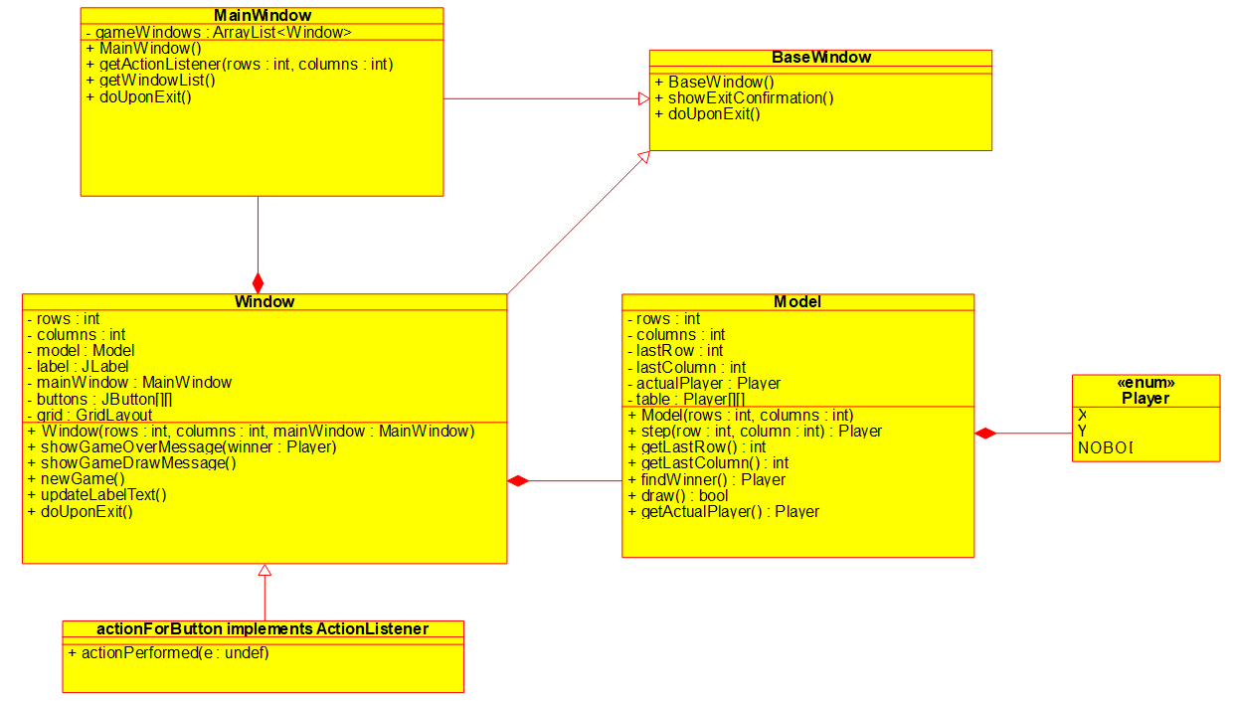

Testing:

Test1. Testing for 8 x 5 size for the game:

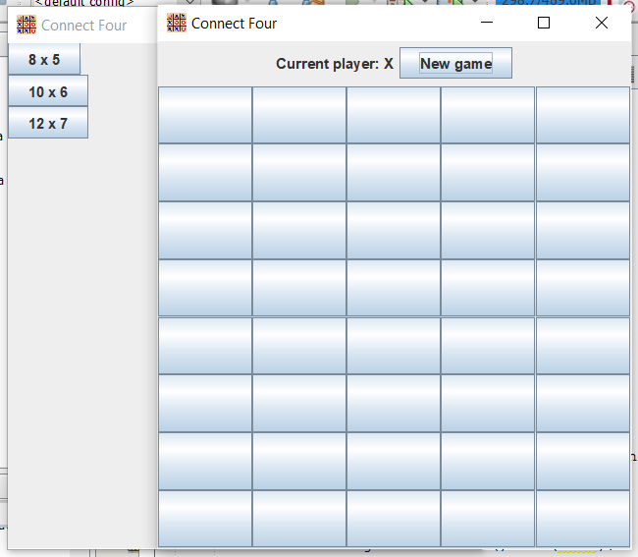

Test2. Testing for 10 x 6 size for the game:

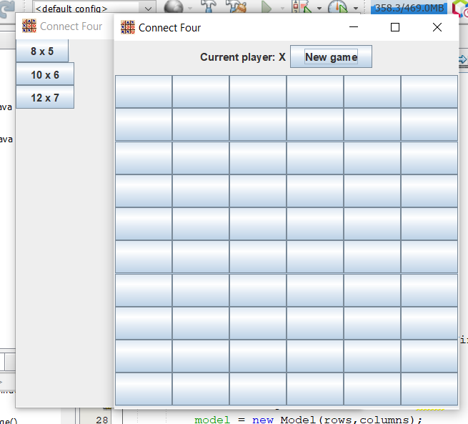

Test3. Testing for 12 x 7 size for the game:

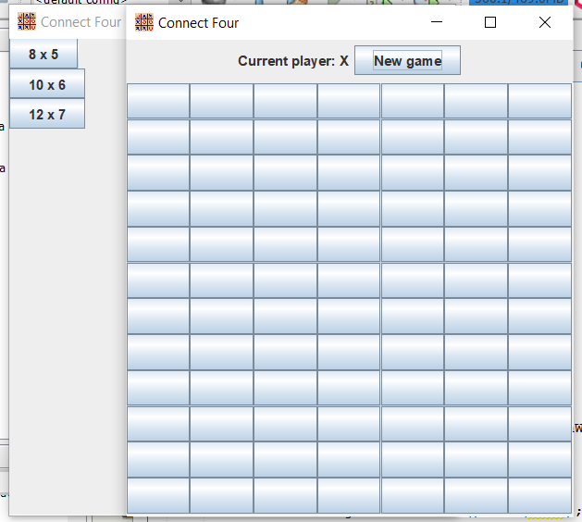

Test4. Testing for player X winning with 4 X from down to up:

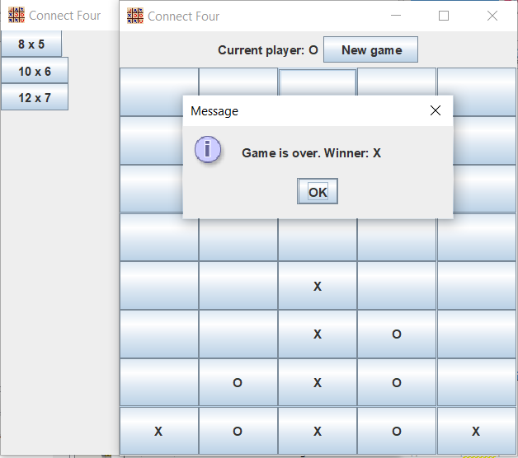

Test5. Testing for player O winning with 4 O from left to right:

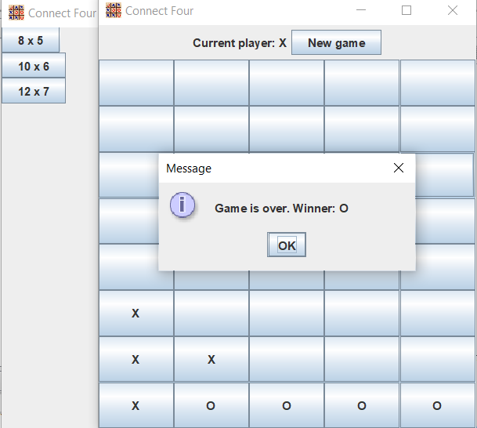

Test6. Testing for player X winning with 4 X from left diagonal to right:

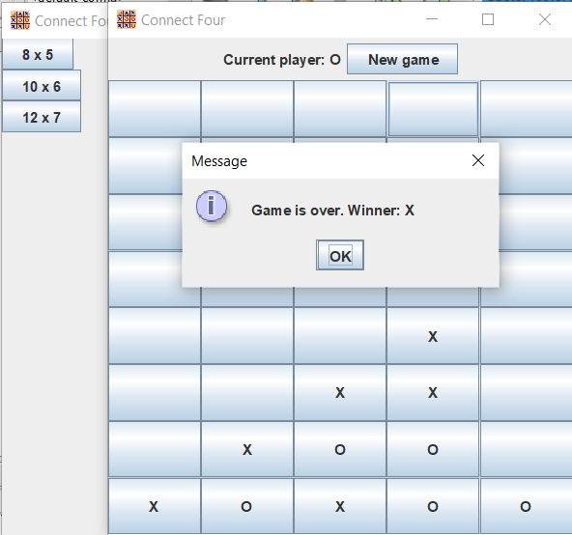

Test7. Testing for player O winning with 4 O from right diagonal to left:

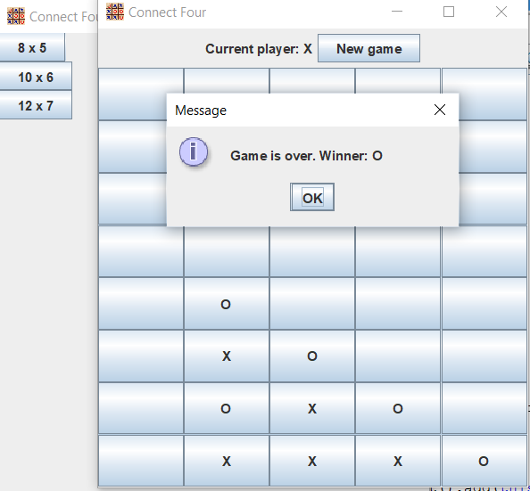

Test8. Testing for draw:

