ASSIGNMENT 3 REPORT
Adapter and Bridge Patterns
University Greenhouse Plant Reporter
Student: Tazhgulov Rasul
1. Problem and design
The system creates condition reports for plants in a university greenhouse. The report style and the data source are two independent dimensions. The project has Quick and Detailed reports, and Local, Remote, and Legacy data sources.
2. Pattern structure
Role | Class | Purpose
Abstraction | PlantReport | Uses only PlantDataSource
Refined Abstractions | QuickPlantReport, DetailedPlantReport | Two report variants
Implementor | PlantDataSource | Common data-source contract
Implementations | Local, Remote, Legacy Adapter | Three interchangeable sources
Adaptee | LegacyBotanySensor | Old incompatible sensor API
3. Why Bridge and Adapter are both needed
Bridge prevents a combination hierarchy such as QuickLocalReport, QuickRemoteReport, DetailedLocalReport, and DetailedRemoteReport. PlantReport stores a PlantDataSource reference, so report types and source types can vary independently.
Adapter solves a different problem. LegacyBotanySensor cannot be used directly as a PlantDataSource: it uses poll(int metricMask, char[] plantCode), returns one packed int, and reports failures with negative integer codes. LegacyBotanySensorAdapter converts the request, decodes the result into PlantReading, and translates all legacy failures into PlantDataException. The legacy class is not modified.
4. Required complexity module: Dynamic implementor selection
The data-source name comes from runtime input. SourceSelector selects the matching PlantDataSource. Java ServiceLoader discovers the installed implementations, so the client does not hard-code a concrete source choice in a switch or source-specific branch.

5. UML Class Diagram
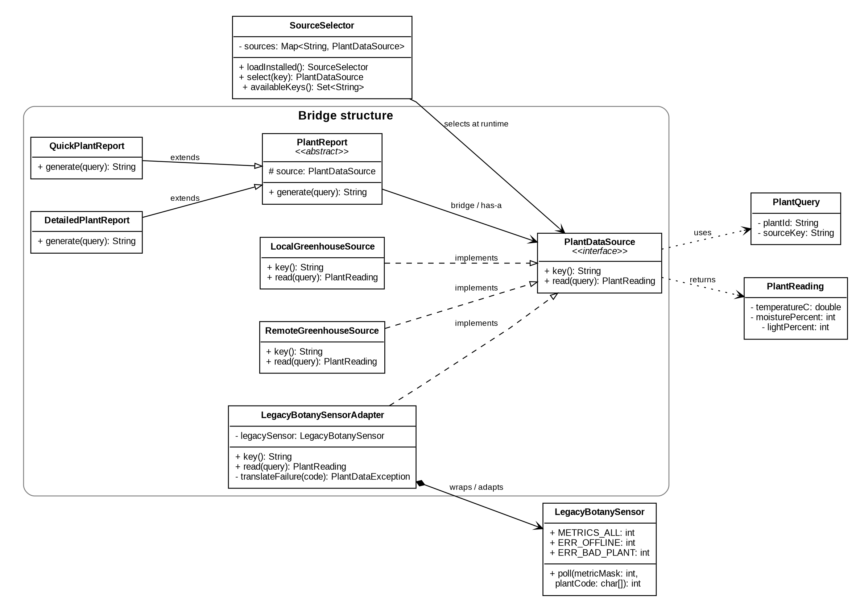
6. Open/Closed Principle and tests
A new report variant can extend PlantReport without changing source classes. A new source can implement PlantDataSource and be registered in the service configuration without changing existing report classes or SourceSelector. JUnit 5 tests use handwritten stubs: both refined abstractions are checked for delegation, and the Adapter is checked for argument conversion, packed-result decoding, and failure translation.
7. Limitation
The legacy packed integer format is intentionally simple and assumes bounded metric values. A production sensor protocol would need stronger validation and version handling.

