Smart Greenhouse Assignment 6
  - Observer and Visitor patterns Variant 9 Precision agriculture
This Java 17 console application models a greenhouse with sensor readings, subscribers and an immutable equipment tree. Observer delivers typed readings and derived reports. Visitor adds operations to the same tree without placing calculations in its elements. A low-moisture event triggers maintenance inspection of the affected zone only.
The final implementation passes 40 JUnit 5 tests with zero failures, errors or skipped tests. The application was also run with thread-pool sizes 3 and 4. Both runs produced the expected totals and correctly nested JSON. Only the Java Standard Library is used at runtime; JUnit 5.10.2 is the sole test dependency.

1 Requirements and implementation
Requirement | Implementation
Two sources and five or more listeners | SoilSensor and WeatherStation; nine concrete listeners
Generic Observer and Subject | Observer<E extends Event> and Subject<E extends Event>
Immutable typed events | ReadingEvent, AverageEvent, InspectionEvent and EventType
Dynamic typed subscriptions | CopyOnWriteArrayList for each event type; callback-safe subscribe and unsubscribe
Observer chain | MoistureAggregator receives readings and publishes running averages
Stable Composite | Greenhouse → Zone → leaves; two container types and five leaf types
Generic Visitor with double dispatch | Visitor<R>; each element delegates accept(visitor) to visitor.visit(this)
Four operation categories | Power calculation, stateful inventory, maintenance filter and nested JSON export
Related subtree integration | InspectionService inspects the zone identified by the event and publishes a report
Concurrency and lifecycle | Three producer tasks, configurable pool, thread-safe listeners, checked termination
Tests and trade-offs | 40 JUnit tests, exact 4 × 1,000 stress test, two separate extension commits
Documentation | README, UML diagrams, verified output and a separate Russian defense guide

Build and run from the directory containing pom.xml. The optional argument changes pool size; the demo always contains three producer tasks. The minimum accepted pool size is 3.
mvn clean verify
java -jar target/smart-greenhouse-a6-1.0.0.jar
java -jar target/smart-greenhouse-a6-1.0.0.jar 4

2 Observer design
The two data sources delegate subscription management to SimpleSubject. An EnumMap is populated during construction and exposed internally as an immutable map of thread-safe subscriber lists. Each event type has its own list. addIfAbsent prevents duplicate subscriptions within one channel. No java.util.Observable or external event-bus library is used.
Push was chosen because each callback receives the exact immutable reading that caused the notification. A listener does not need to query sensor state that could have changed concurrently. ReadingEvent validates type and numeric input; InspectionEvent makes a defensive copy of its list. Records alone do not make a nested mutable list immutable.
Listener | Responsibility
FarmerDashboard | Latest delivered reading per zone and event type
ReadingCounter and EventLog | Exact reading count and concurrent event history
IrrigationController | Logical irrigation state for moisture below 30 percent
FrostAlert | Alerts for temperatures below 0 degrees Celsius
MoistureAggregator | Running average and sample count for each known zone
InspectionService | Observer to Visitor integration on a dry zone
AverageDashboard and ReportCollector | Newest aggregate per zone and collected inspection reports

The chain is SoilSensor → MoistureAggregator → AverageDashboard. The aggregator implements both Observer<ReadingEvent> and Subject<AverageEvent>. For zone A, readings 20 and 40 produce running averages 20 and 30, with sampleCount values 1 and 2.
Subscriptions use snapshot semantics. A subscriber added inside a callback starts with a later snapshot. Unsubscribe removes it from later snapshots, but cannot revoke a callback already captured by a publisher. CopyOnWriteArrayList documents this behavior [2]. If a callback throws RuntimeException, the subject still attempts the other callbacks, then reports the collected failures.

3 Visitor and Composite design
Greenhouse and Zone are the two container types. Crop, Pump, Lamp, Sensor and Heater are leaves. Greenhouse contains zones; each zone contains leaves, forming three levels. Lists are defensively copied and the tree is unchanged during execution. Elements contain data, validation and accept only. Numeric calculations, filtering and serialization are implemented in visitors.
Visitor | Result | Purpose
PowerVisitor | Double | Total installed electrical power in watts
InventoryVisitor | Void | Accumulates counts and crop water demand in its own fields
MaintenanceVisitor | List of elements | Selects devices with maintenanceRequired set to true
JsonExportVisitor | String | Exports nested containers and leaves with manual escaping
WaterDemandVisitor | Double | Additional operation for daily crop water demand

Traversal belongs to the visitor. Each container overload loops over its children and calls child.accept(this). The exporter can therefore open and close each JSON object at the correct level. The element accept method does not also traverse, which avoids duplicate visits. Each new visitor must explicitly handle container traversal.
Double dispatch first selects the concrete element accept method. Inside Pump.accept, this has compile-time type Pump, so Java selects the visit(Pump) overload; the actual visitor implementation then supplies that overload. A direct visitor.visit(element) call cannot replace this when element has static type GreenhouseElement, because that overload is not present.
public <R> R accept(Visitor<R> visitor) {
return visitor.visit(this);
}
PowerVisitor computes W, not Wh. An energy estimate would require operating time. InventoryVisitor is deliberately stateful and is created once per report. The other visitors are stateless. JSON retains the greenhouse, zone and leaf nesting; quotes, backslashes, control characters and UTF-16 surrogate units are escaped without a JSON library.

4 Integration concurrency and Clean Code
When InspectionService receives MOISTURE below 30, it resolves event.zoneId in the immutable zone map and calls affectedZone.accept(inspector). The returned device IDs become a new InspectionEvent, collected by ReportCollector. At 20 percent moisture in zone A, only pump-a, sensor-a and heater-a appear. lamp-b also needs maintenance, but belongs to zone B and is excluded. The low-moisture event initiates inspection; it does not itself change maintenance flags or prove a device failure.
Main is the single production composition root. It constructs the tree, sources, listeners, visitors and executor, injects collaborators through constructors and registers subscriptions before starting workers. Business components do not lazily create dependencies. Shared behavior is centralized in SimpleSubject, model validation and JSON string escaping.
There are three producer tasks: soil moisture, air temperature and air humidity. They use an ExecutorService whose pool size is supplied by Main. AtomicInteger protects counts, ConcurrentLinkedQueue protects histories and concurrent maps protect dashboard and irrigation state. The subject never holds a global lock while invoking user callbacks.
MoistureAggregator protects sum and count together using a short lock per zone, then publishes outside that lock. Different threads may deliver aggregate snapshots out of order. AverageDashboard atomically retains the event with the greatest sampleCount, preventing a late old snapshot from overwriting a newer one. InventoryVisitor is confined to the main thread after producers finish.
ProducerRunner waits for every Future and then calls shutdown and awaitTermination. Successful completion includes synchronous callbacks and chained publications; all supplied finite tasks finish before the termination message. A timeout, interruption or producer failure is reported as an unsuccessful run. Emergency cancellation is not described as lossless. ExecutorService distinguishes graceful shutdown from cancellation [3].

5 Verification and hand calculations
Quantity | Hand calculation | Verified result
Zone A rated power | 100 + 50 + 5 + 300 | 455 W
Zone B rated power | 200 + 75 + 5 | 280 W
Whole greenhouse power | 455 + 280 | 735 W
Crop water demand | 10 + 20 | 30 L per day
Tree size | 1 greenhouse + 2 zones + 9 leaves | 12 elements
Maintenance devices | 3 in A + 1 in B | 4 devices
Reading count | 3 moisture + 3 temperature + 3 humidity | 9 readings
Zone A average moisture | (20 + 40) / 2 | 30 percent
Stress count per permanent listener | 4 threads × 1,000 events | 4,000 events

The original VisitorTest fixture intentionally omits Heater. Its independent expected values remain 435 W, 30 L per day, 11 elements and 3 maintenance devices. HeaterTest verifies the added element against all five visitors. Keeping the old fixture preserves the original hand-calculated checks.
Test class | Tests | Main evidence
ObserverTest | 12 | Typed subscriptions, callback changes, duplicates, errors, immutable events
VisitorTest | 12 | Hand values, double dispatch, subtree scope and immutable tree
JsonExportVisitorTest | 5 | Exact nesting, empty containers and string escaping
IntegrationTest | 4 | Only the related zone; threshold and aggregate ordering
ProducerRunnerTest | 2 | Three simultaneous threads, exact count and executor termination
WaterDemandVisitorTest | 2 | Independent water totals and an empty zone
HeaterTest | 2 | New leaf in all operations and healthy-device filtering
ConcurrencyTest | 1 | Four producers, 4,000 events and live subscription changes

Verification used JDK 17.0.21 and Maven clean verify. Surefire reports 40 tests, 0 failures, 0 errors and 0 skipped tests. The stress test also checks exactly 4,000 aggregated events and every sampleCount from 1 through 4,000 once. Its constant reading is 40, so every expected average is 40. Barriers and bounded waits establish concurrency without timing guesses or sleeps [4].
Both demo runs exited normally with identical calculated results. Their JSON was additionally parsed and checked for two zones with five and four leaves. Raw Maven and application outputs are supplied in docs/maven-test-results.txt and docs/demo-output-3-threads.txt and docs/demo-output-4-threads.txt.

6 Extension commits and their cost
Commit 2b38da5 adds WaterDemandVisitor and WaterDemandVisitorTest. No element class and no Visitor interface changed. This demonstrates the inexpensive direction of extension: a new operation over an existing set of element types.
Commit 3fcc953 adds Heater and updates ten files. Besides the new model record, Visitor requires visit(Heater), every concrete visitor requires a matching implementation, Main includes the new device, and tests document its behavior. The changed files are listed below; the complete repository-relative paths are in README.
Area | Changed files in the new element commit
Model and interface | model/Heater.java; visitor/Visitor.java
All existing visitors | PowerVisitor.java; InventoryVisitor.java; MaintenanceVisitor.java; JsonExportVisitor.java; WaterDemandVisitor.java
Composition root | app/Main.java
Tests | visitor/HeaterTest.java; visitor/VisitorTest.java

Visitor is suitable when element types are stable and operations change often. Frequent addition of element types would make its cross-visitor update cost unattractive. A compiler error on a missing visit(Heater) helps expose incomplete support rather than silently applying an unrelated default.
The included commits record the actual preparation steps on 1 November 2026. They demonstrate both extension cases but do not constitute development spread over two weeks. The course history requirement remains separate. Variant allocation must be unique within the group, and submission requires the GitHub repository URL and this report in LMS [1].
git log --oneline
git show --stat 2b38da5
git show --stat 3fcc953

7 References
[1] Course assignment. Assignment 6 Observer and Visitor Patterns. Supplied requirements, variant 9, grading and defense questions.
[2] Oracle. Java SE 17 CopyOnWriteArrayList. https://docs.oracle.com/en/java/javase/17/docs/api/java.base/java/util/concurrent/CopyOnWriteArrayList.html
[3] Oracle. Java SE 17 ExecutorService. https://docs.oracle.com/en/java/javase/17/docs/api/java.base/java/util/concurrent/ExecutorService.html
[4] JUnit. JUnit 5.10.2 User Guide. https://docs.junit.org/5.10.2/user-guide/index.html

8 UML class diagram
The class diagram is presented as two readable views. The complete joined diagram and its editable sources are in docs/uml.svg, docs/uml.dot and docs/uml.mmd. InspectionService is the integration point between the views.
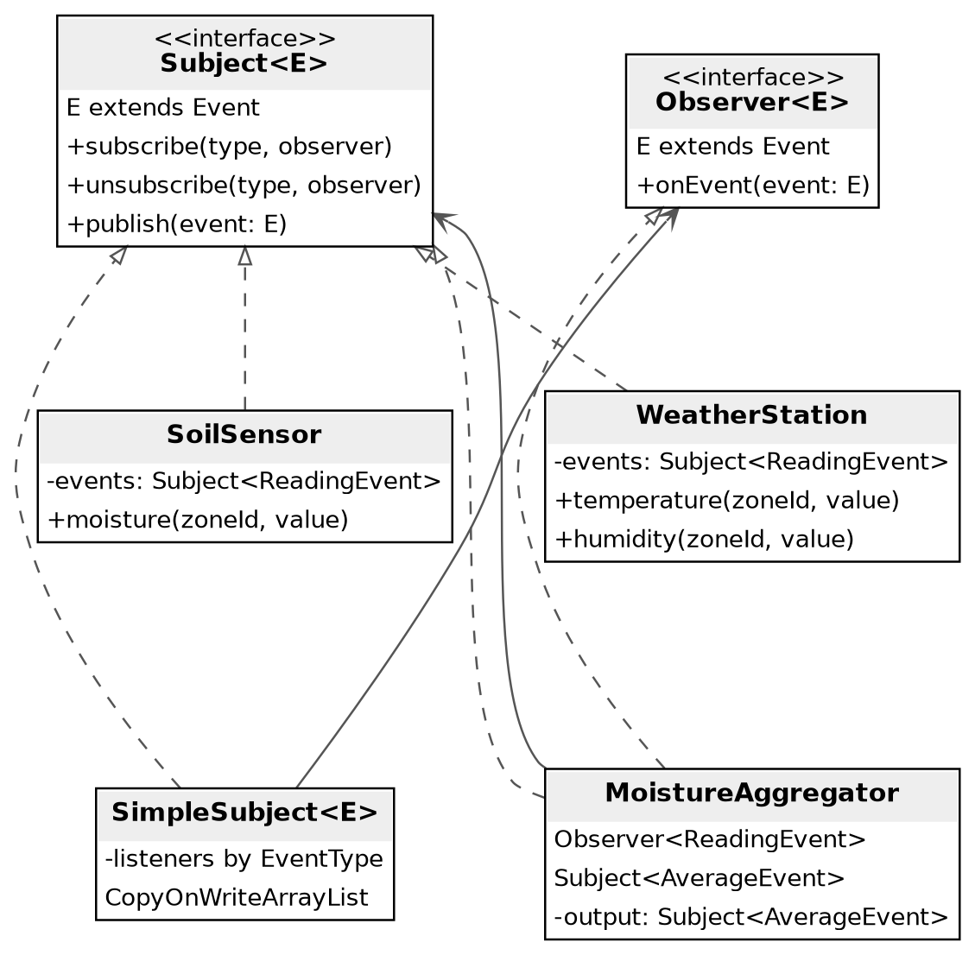
Figure 1 Observer view with sources, generic contracts and the aggregation chain.
Dashed lines with hollow triangles denote interface realization; solid associations show stored collaborators. The sources and the aggregator delegate subscription handling to a Subject. The aggregator also implements Observer, which creates the required notification chain. Additional subscribers are listed in Section 2 and shown in the complete diagram.
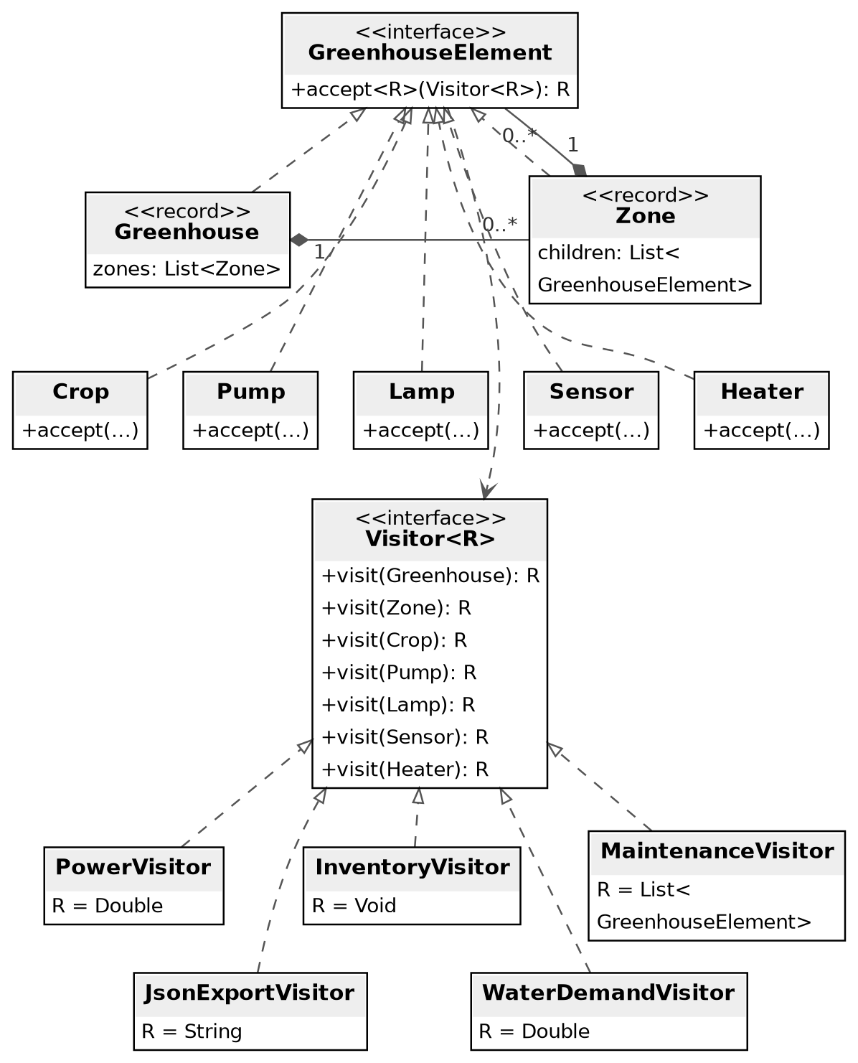
Figure 2 Composite and Visitor view with element types and operations.

