CALIBRATION RECORD
PT100 Temperature Datalogger System
Certificate No. | [to be assigned] | Date of Calibration | 2026-04-15
Asset ID | [to be assigned] | Calibration Due Date | 2027-04-15
Alternate Unique ID | MAC 98:A3:16:12:57:B0 | Reference Indicator | Fluke 51 II N1052
Reference Probe | Wahl TC801P Type K | Transfer Block | Epicor 1126212

1. Instrument Identification
Instrument Under Test (IUT): PT100 temperature datalogger system
Sensor: Omega PR-21D-3-100 platinum resistance thermometer
Sensor Configuration: 4-wire RTD
Measurement Electronics: MAX31865 RTD interface, 430 ohm reference resistor
Transfer Block Material: 6061-T6 aluminum
Reference Thermocouple Probe: Wahl TC801P Type K thermocouple probe, 1/8 in diameter, approximately 12 in long, standard thermocouple connector

2. Statement of Calibration
The IUT was calibrated as a complete corrected measurement system using a resistance-domain polynomial calibration derived from comparison against the reference thermometer system identified in this certificate.
This certificate applies to the corrected PT100 probe-plus-readout system in service. The retained source record documents the calibration-point dataset used to generate and apply the active correction model and includes the active polynomial form and coefficients. Accordingly, this certificate documents the calibration-point data, the active correction equation, the calibration coefficients, and the uncertainty statement for the corrected system.
The active resistance-domain polynomial coefficients are listed in Section 4.

3. Calibration Method
Calibration was performed by transfer comparison in a Thermotron environmental chamber using the custom aluminum transfer block identified above. The reference Type K thermocouple probe and the IUT probe were inserted into adjacent transfer-block bores at nominally equal depth. Setpoints were allowed to stabilize prior to data capture.
The transfer block was manufactured from 6061-T6 aluminum, which has typical thermal conductivity of approximately 167 W/m·K at 77 °F. Dry-block calibration performance, however, depends not only on block material but also on axial and radial uniformity, probe fit, stem conduction, loading, and external influences.

4. Calibration Conditions and Capture Controls
The resistance-domain correction applied by the system is $R_{corrected}=ax^{2}+bx+c$, where x is the measured raw resistance in ohms and the calibrated coefficients are those listed in the table below.
Calibration mode | Polynomial
Calibration domain | Resistance (ohm)
Capture window | 60 seconds
Drift limit | 0.020 °C/min
Runtime correction path | Raw measured ohms → corrected ohms → corrected temperature
Calibration equation | $R_{corrected}=ax^{2}+bx+c$, where x = raw measured resistance (ohm)
Coefficient a | 0.000124274878
Coefficient b | 0.968385256
Coefficient c | 1.95552775
For this certificate, residuals are defined as follows:
$$∆T_{i}=T_{ref,i}-T_{raw,i}$$
$$∆R_{i}=R_{ideal,i}-R_{raw,i}$$
Positive residual temperature therefore indicates that the raw uncorrected IUT reading was lower than the reference temperature at that point.

5. Calibration Data Used for the Active Correction Model
Point | Ref. Temp. (°C) | Captured Raw Avg. Temp. (°C) | Residual Temp. (°C) | Raw Temp. Std. Dev. (°C) | Drift (°C/min) | Delta (°C)
1 | -48.900 | -49.455 | +0.555 | 0.018 | -0.018 | -0.011
2 | -13.300 | -13.467 | +0.167 | 0.019 | +0.007 | +0.006
3 | 24.700 | 24.718 | -0.018 | 0.019 | -0.003 | -0.003
4 | 81.600 | 81.742 | -0.142 | 0.017 | +0.002 | +0.002
The retained source export records this calibration as valid, applied, time-valid, and due on 2027-04-15.
The largest raw temperature residual in the source dataset was +0.555 °C at -48.900 °C, and the smallest was -0.142 °C at 81.600 °C. The raw captured point standard deviations remained between 0.017 and 0.019 °C in temperature and between 0.006 and 0.007 ohm in resistance across the four calibration captures.
Figure 1 is provided as a supplemental visual aid comparing the raw captured calibration-point residuals against the residuals remaining after application of the resistance-domain polynomial model. The figure is intended to aid interpretation only and does not replace the tabulated calibration data, fit statistics, or uncertainty statement.
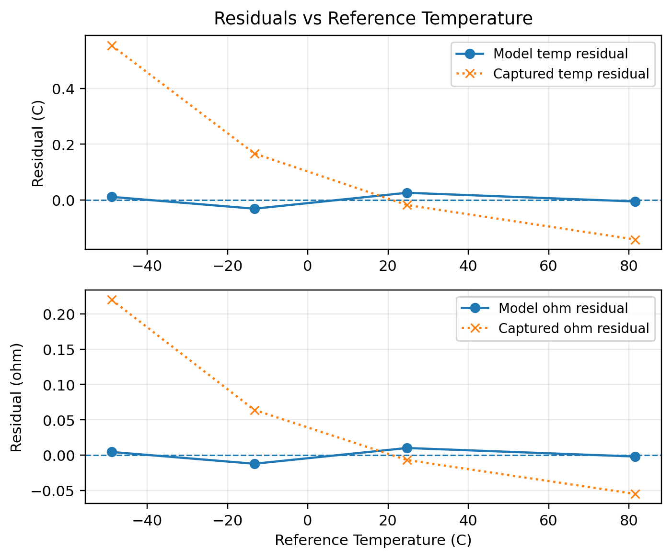
Figure 1. Calibration-point residual comparison before and after application of the resistance-domain polynomial correction model. The figure illustrates improvement at the stored calibration points only.

6. Supporting Verification of IUT Repeatability
A separate PT100 repeatability study was performed in a slush ice bath and is included here only as supporting verification of short-term IUT stability, not as a direct contributor in the formal transfer-calibration uncertainty budget.

Number of independent runs | 5
Samples per run | 30
Resistance range | 99.964-99.971 ohm
Resistance spread | 0.007 ohm
Temperature residual range | +0.074-0.092 °C
Temperature spread | 0.018 °C
Per-run standard deviation | 0.005-0.007 °C
Practical repeatability | ±0.01°C to ±0.02°C

These results support the conclusion that short-term PT100 measurement repeatability was small relative to the final reference-chain uncertainty stated in Section 8.

7. Supporting Verification of Transfer-Block Bore Performance
A bore-bracketing study was performed at the 48.8°C (120 °F) setpoint using A-B-A and B-A-B sequences, including a 180-degree block rotation.
When reduced to a common B-A basis, the observed combined mean bore difference was approximately +0.0074 °C, with combined RMS variation of approximately 0.025 °C and maximum observed magnitude of approximately 0.049 °C.
The sign did not reverse after block rotation, indicating a small bore-dependent effect rather than a dominant chamber-side asymmetry. These results support use of a small transfer-medium contribution relative to the reference thermocouple contribution.

8. Uncertainty Analysis

8.1 Reference Indicator Contribution
The Fluke 51 II calibration certificate for Gage ID N1052 states uncertainty of 0.08 °C at 95% confidence level for Type K over the range -55 °C to 1000 °C and explicitly states that thermocouple error is not included. For the formal uncertainty budget, this was treated as approximately k = 2.
$$u_{meter}=\frac{0.08}{2}=0.04°C$$

8.2 Reference Thermocouple Contribution
A current probe-specific calibration certificate was not available for the Wahl TC801P thermocouple probe used during calibration. The probe was therefore modeled conservatively as a standard commercial Type K thermocouple using the published standard limits of error.
Across the temperature range used in this calibration, the $±2.2°C$ term governs. To incorporate this value into a formal uncertainty budget, the class limit was treated as a rectangular Type B distribution.
$$u_{probe}=\frac{2.2}{\sqrt{3}}=1.27°C$$

8.3 Transfer and Setup Contribution
The transfer and setup contribution was based on the measured bore study and the physical transfer arrangement. Standard uncertainties of 0.03 °C each were assigned to radial bore difference/probe-spacing effect, insertion depth sensitivity, thermal coupling/fit variation, and block gradient/environmental coupling.
$$u_{transfer}=\sqrt{{0.03}^{2}+{0.03}^{2}+{0.03}^{2}}=0.06°C$$

8.4 Combined Standard Uncertainty
$$u_{c}=\sqrt{{u_{meter}}^{2}+{u_{probe}}^{2}+{u_{transfer}}^{2}}$$
$$u_{c}=\sqrt{{0.04}^{2}+{1.27}^{2}+{0.06}^{2}=1.27°C}$$

8.5 Expanded Uncertainty
Expanded uncertainty is reported using k = 2, consistent with NIST convention for reporting expanded uncertainty.
$$U=2u_{c}=2\left(1.27\right)=2.54°C$$
Reported Expanded Uncertainty: +/-2.6 °C (k = 2)

9. Calibration Result
The PT100 datalogger system identified in this certificate was calibrated as a complete corrected system using a 4-point resistance-domain polynomial calibration referenced to the Fluke 51 II indicator and Wahl TC801P Type K thermocouple identified above. The active correction equation and coefficients documented in Section 4 are part of the corrected system configuration covered by this certificate.
This uncertainty is dominated by the reference thermocouple contribution. The PT100 repeatability and transfer-block contributions were small relative to the reference thermocouple term.

10. Applicability and Validity
This certificate applies only to the specific PT100 probe-and-readout combination identified in Section 1, in the calibrated configuration used at the time of calibration. It does not apply to the sensor alone, the electronics alone, or any substituted reference probe. Continued validity is contingent on the system remaining in the same calibrated configuration and not undergoing damage, repair, or material change affecting measurement performance.

11. Authorization
Calibrated by | Robert Susmilch | 2026-04-15
Reviewed by
Approved by

12. References
[1] MatWeb, Aluminum 6061-T6 Material Data Sheet, thermal conductivity approximately 167 W/m K at 77 degF.
[2] ASTM E3186, Standard Guide for Use and Testing of Dry-Block Temperature Calibrators.
[3] Fluke 51 II calibration certificate, Gage ID N1052, Certificate No. 4015405, calibrated 2026-02-16; stated uncertainty 0.08 °C at 95% confidence for Type K over -55 °C to 1000 °C; thermocouple error excluded.
[4] Omega Engineering, Type K Thermocouple Reference Table, standard limits of error +/-2.2 °C or applicable percent term, whichever is greater.
[5] NIST Technical Note 1297, Type B evaluation and expanded uncertainty reporting.

