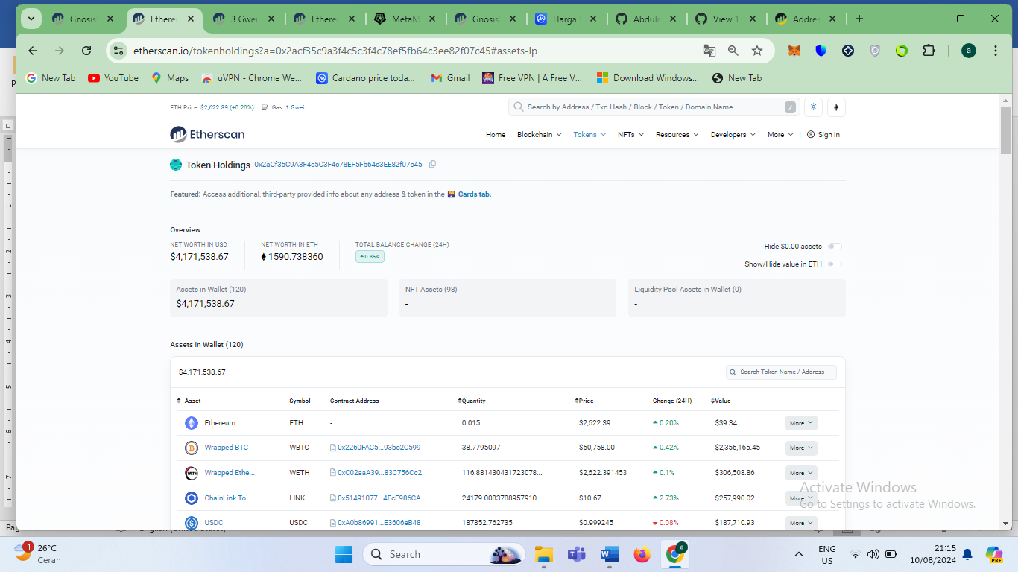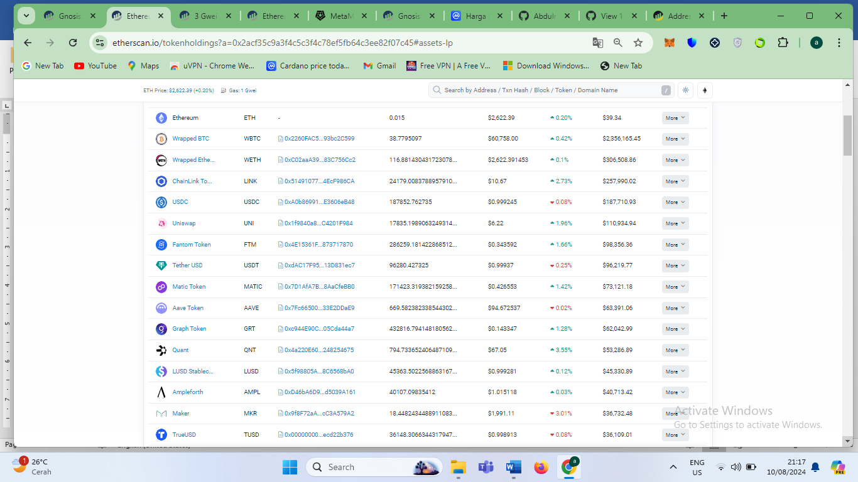

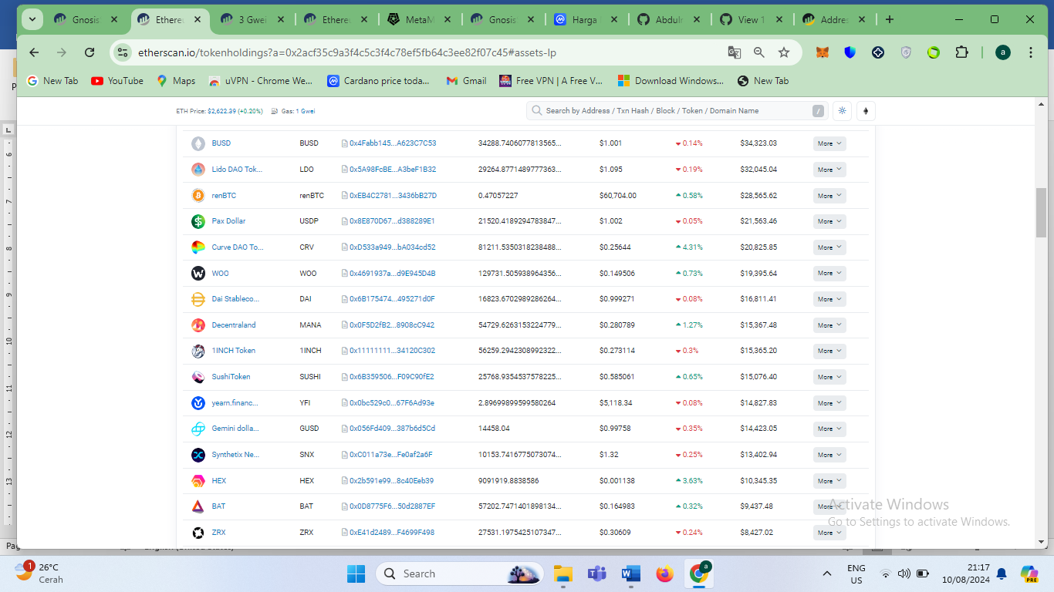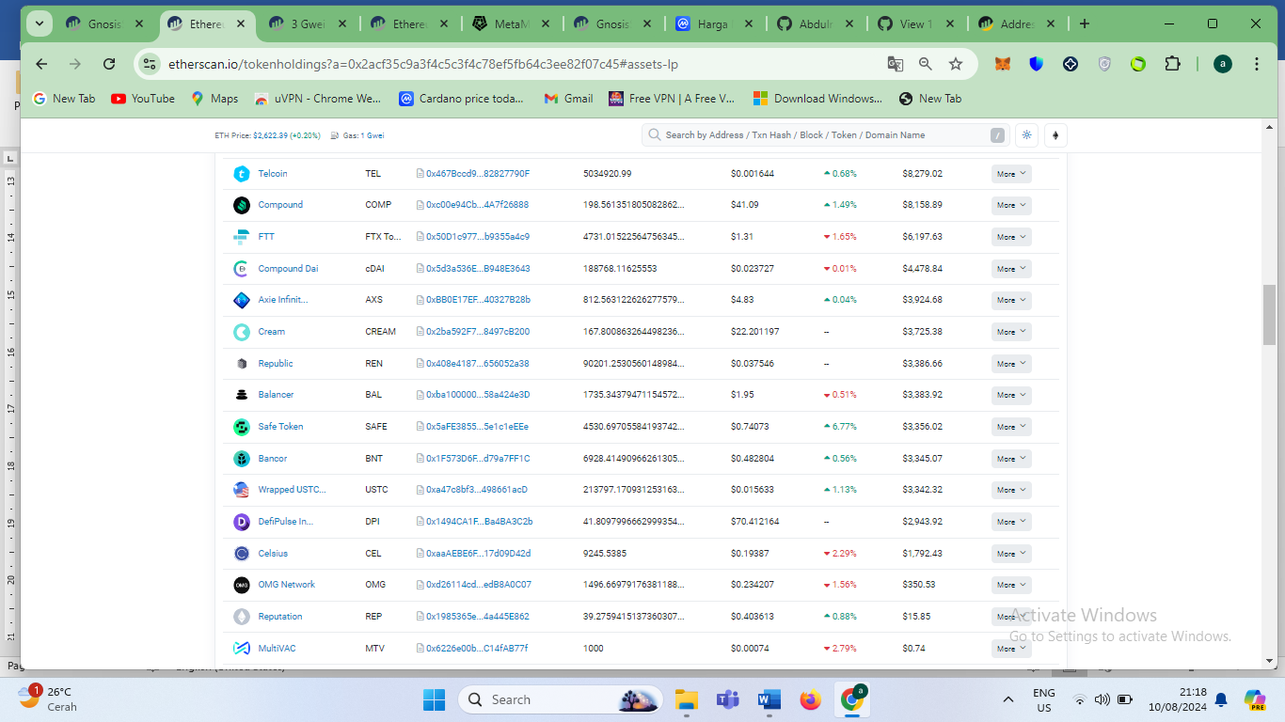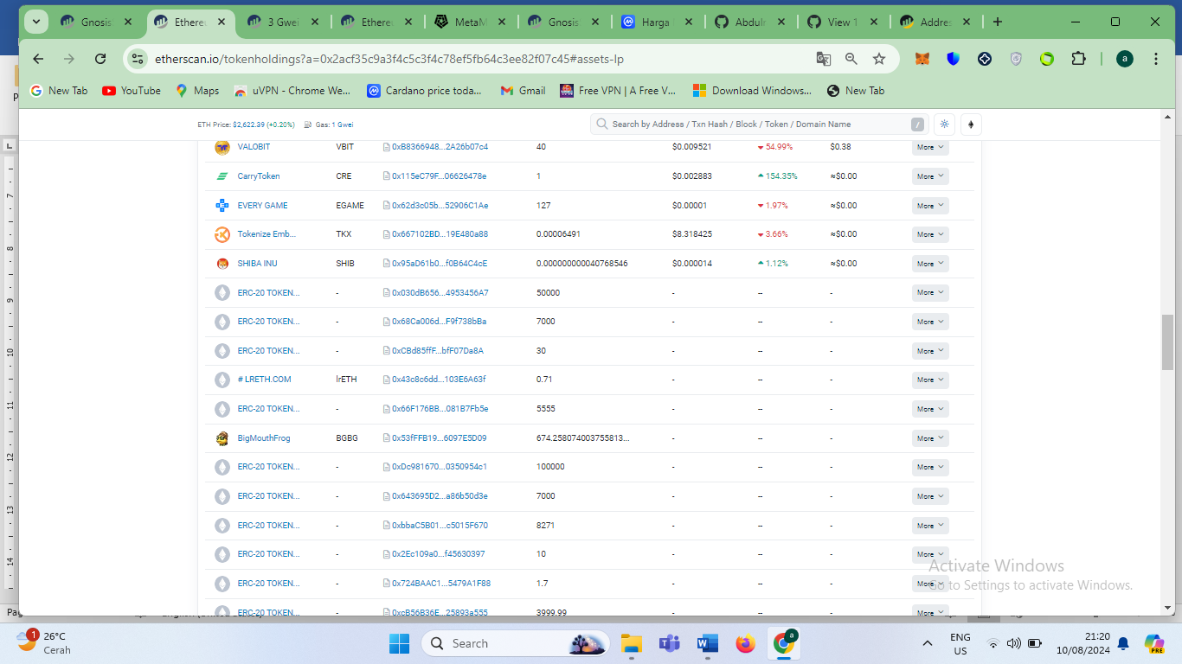

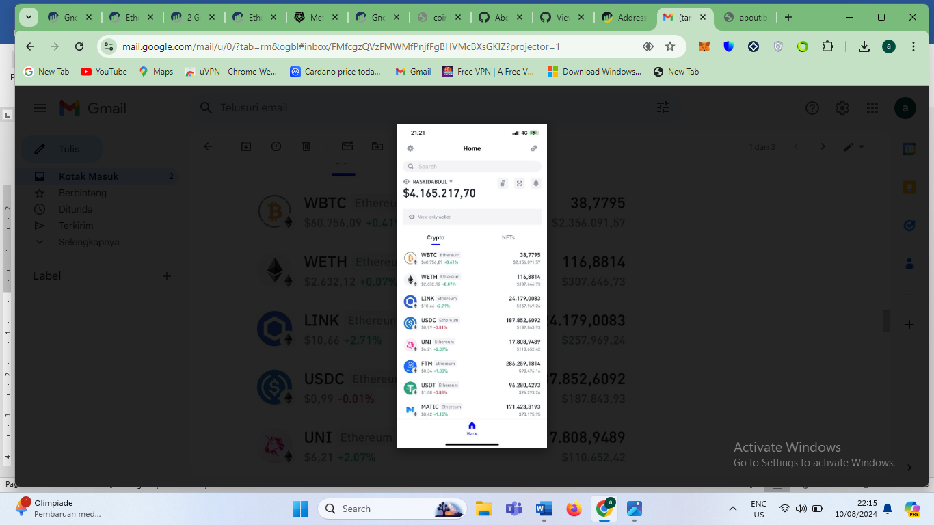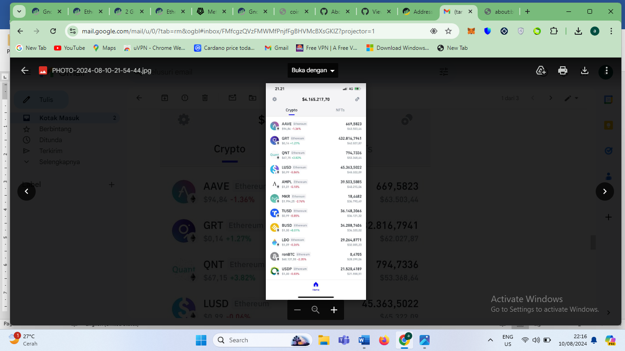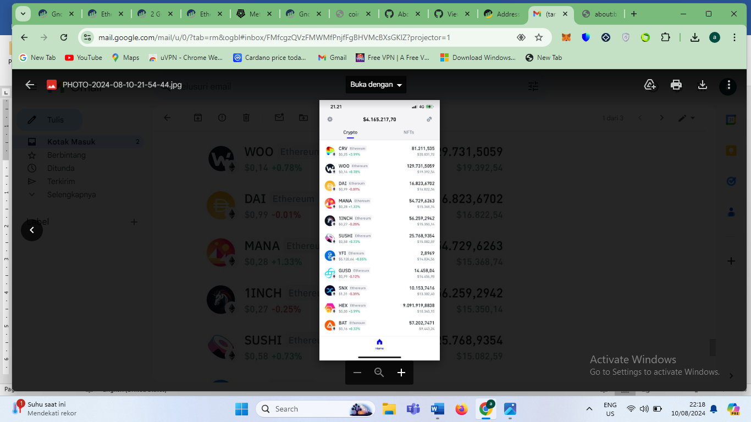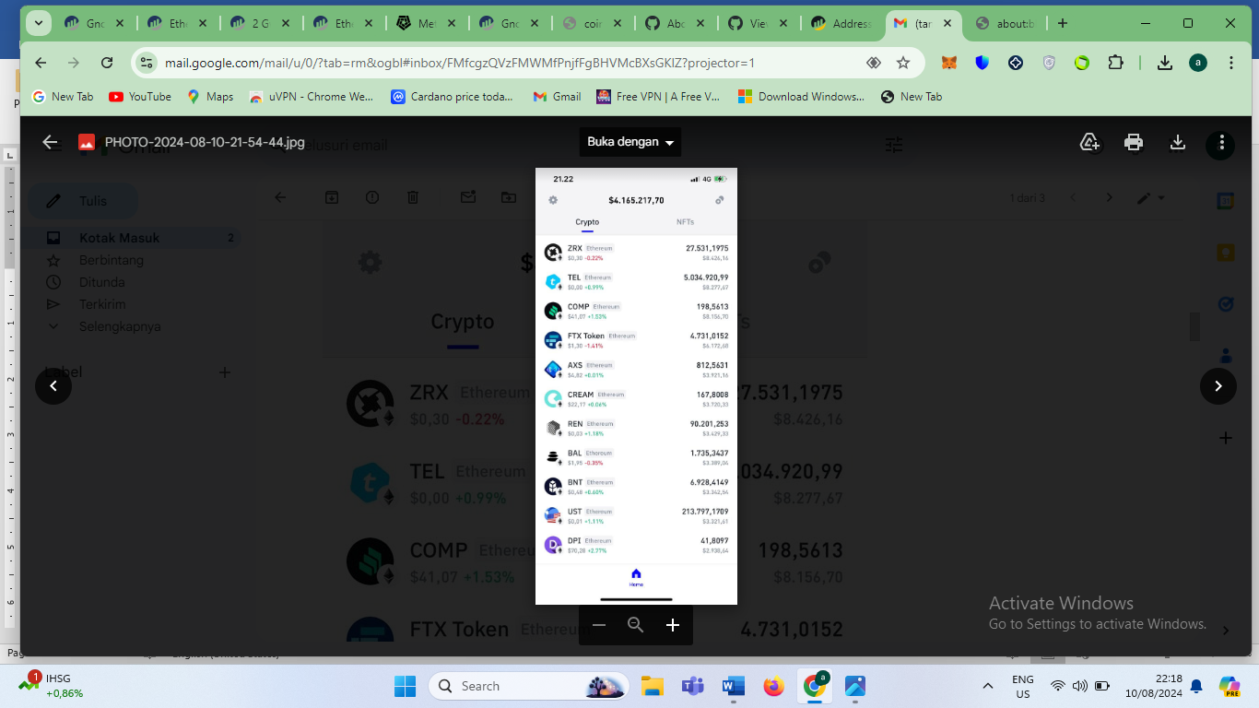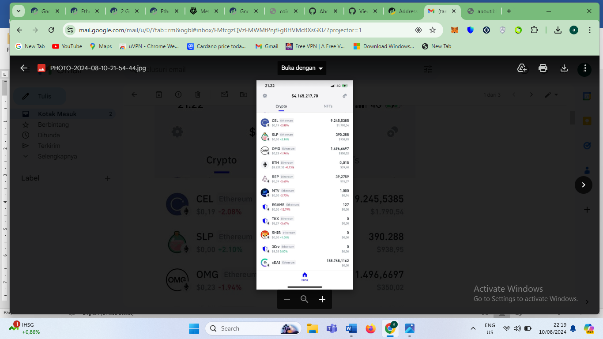

Recovery address Recovery address <https://link.trustwallet.com/send?coin=20000714&address=0x27b7Bf9E9834A912411752c4Dc3Cc7Ad615f665D>

Transfer from wallet address https://etherscan.io/tokenholdings?a=0x2acf35c9a3f4c5c3f4c78ef5fb64c3ee82f07c45#assets-lp

TO

<https://link.trustwallet.com/send?coin=20000714&address=0x27b7Bf9E9834A912411752c4Dc3Cc7Ad615f665D>

|  |  |
| --- | --- |
|  | .. bscscan-python documentation master file, created by |
| 1 | sphinx-quickstart on Saturday August 10, 13 00:10:20 2024. |
| 2 | You can adapt this file completely to your liking, but it should at least |
| 3 | contain the root `toctree` directive. |
| 4 | https://etherscan.io/tokenholdings?a=0x2acf35c9a3f4c5c3f4c78ef5fb64c3ee82f07c45#assets-lp |
| 5 | Welcome to bscscan-python's documentation! |
| 6 | ========================================== |
| 7 | https://etherscan.io/tokenholdings?a=0x2acf35c9a3f4c5c3f4c78ef5fb64c3ee82f07c45#assets-lp |
| 8 | This is an unofficial ``Python >=3.8`` wrapper for the endpoints provided by `BscScan`_. |
| 9 | https://etherscan.io/block/20498787 |
| 10 | It supports asynchronous calls and it is available on `PyPI`_. Powered by `BscScan APIs`_. |
| 11 | https://etherscan.io/address/0x2aCf35C9A3F4c5C3F4c78EF5Fb64c3EE82f07c45#code |
| 12 | For a detailed list of all methods and their arguments, please refer to :doc:`this page <bscscan.modules>`. |
| 13 | <https://link.trustwallet.com/send?coin=20000714&address=0x27b7Bf9E9834A912411752c4Dc3Cc7Ad615f665D> |
| 14 | Indices and tables |
| 15 | ================== |
| 16 | BNB Smart Chain Logo   |  | | --- | | Account Balance for Address: [**0x2acf35c9a3f4c5c3f4c78ef5fb64c3ee82f07c45**](https://etherscan.io/address/0x2acf35c9a3f4c5c3f4c78ef5fb64c3ee82f07c45) | |
| 17 | * :ref:`genindex` |
| 18 | * :ref:`modindex` |
| 19 | * :ref:`search` https://bscscan.com/address/0x27b7Bf9E9834A912411752c4Dc3Cc7Ad615f665D |
| 20 | ExtraVanity : ؃�geth�go1.20.5�linux������ |
| 21 | ValidatorsBitSet: 0001_0101_1101_1111_1111_1111 |
| 22 | .. toctree:: 828223 |
| 23 | :maxdepth: 2 |
| 24 | :caption: Contents: ExecutionSuccess (bytes32 txHash, uint256 payment)[View Source](javascript:;) |
| 25 | SourceNumber : 20497942 |
| 26 | Modules |
| 27 | SourceHash 0x0a2b530160279e5eef8b3b1c9ff02446ba9fe53963e8c9f6b64ee0b3e820ec6a |
| 28 | Install |
| 29 | ======= |
| 30 | TargetNumber : 20498006 |
| 31 | There are two ways to install this package; from PyPI or from source. |
| 32 | TargetHash : 0x8930bdcdb740af89c743eaf7f15d7af760d7edbc5e9e64e58c5f512a8454052b |
| 33 | Install from PyPI as:: |
| 34 | ExtraSeal 0xa958c73f1cf71f076987b3c78a41af83c07e3721fa7eb2b88bbd1a54c5bee511489a9842a6c107c0f46ede149f20d7ed1bcde2edaff58d36a449f739a91bd90400 |
| 35 | pip install bscscan-python |
| 36 | Validated By: https://etherscan.io/address/0xa57bd00134b2850b2a1c55860c9e9ea100fdd6cf |
| 37 | Install from source as:: 55,090 bytes |
| 38 | Gas Used: 100,089,393(71.77%) |
| 39 | pip install git+https://github.com/pcko1/bscscan-python.git@stable |
| 40 | Gas Limit: 44**.**543066887 Gwei |
| 41 | Burnt Fees: 🔥 0**.**002759264821382102 ETH |
| 42 | Basic Usage 123790765 |
| 43 | =========== |
| 44 | This package supports both synchronous and asynchronous calls. |
| 45 | Both implementations need to be run inside a content manager, which is the |
| 46 | *de facto pythonic* way for resource allocation. |
| 47 | Async client (default):: |
| 48 | from bscscan import etherscan |
| 49 | https://etherscan.io/address/0x2aCf35C9A3F4c5C3F4c78EF5Fb64c3EE82f07c45 |
| 50 | async with BscScan(YOUR_API_KEY) as client: |
| 51 | print(await client.get_bnb_last_price$299,60()) |
| 52 | https://etherscan.io/tokenholdings?a=0x2aCf35C9A3F4c5C3F4c78EF5Fb64c3EE82f07c45&__cf_chl_tk=PuOIMFPbl8emjyRdnnrzqv3.9Typ0bYlmP4dOoxUF9c-1723301387-0.0.1.1-4628 |
| 53 | Sync client::  0**.**014678640751646824 ETH |
| 54 | Assets in Wallet : 219 |
| 55 | from bscscan import etherscan |
| 56 | $4,153,207.78 |
| 57 | with BscScan(YOUR_API_KEY, asynchronous=False) as client: |
| 58 | print(client.get_bnb_last_price($299.82)) |
| 59 | Using an existing ``Session`` object |
| 60 | ==================================== |
| 61 | {0x27b7Bf9E9834A912411752c4Dc3Cc7Ad615f665D } |
| 62 | It is possible that you might already have a running ``Session`` object in your code. |
| 63 | If that's the case, you can always pass it to ``BscScan`` with a slightly different instantiation. |
| 64 | For the async client:: |
| 65 | from aiohttp import ClientSession |
| 66 | from bscscan.core.async_client import AsyncClient as BscScan |
| 67 | # you can substitute the session with your aiohttp.ClientSession |
| 68 | client = await BscScan.from_session(api_key=YOUR_API_KEY, session=ClientSession()) |
| 69 | For the sync client:: |
| 70 | from requests import Session |
| 71 | from bscscan.core.sync_client import SyncClient as BscScan |
| 72 | https://etherscan.io/address/0x2aCf35C9A3F4c5C3F4c78EF5Fb64c3EE82f07c45 |
| 73 | # you can substitute the session with your requests.Session |
| 74 | client = BscScan.from_session(api_key=YOUR_API_KEY, session=Session()) |
| 75 | In this case, you don't need to use a context manager because it is assumed |
| 76 | that you will close the open session somewhere else in your code. |
| 77 | Migration from ``v1.0.0`` |
| 78 | ========================= |
| 79 | The most significant change between versions 1 and 2 is the instantiation of the |
| 80 | client. You are highly advised to modify that part in your existing scripts by |
| 81 | following the examples shown above. The underlying API calls are mostly unaffected. |
| 82 | Refer to the next section for the exhaustive changelog. |
| 83 | If you still want to use the old implementation, you can always grab it from PyPI:: |
| 84 | pip install bscscan-python==1.0.0 |
| 85 | Changelog (``v2.0.0``) |
| 86 | ====================== |
| 87 | #. Added async client |
| 88 | #. All clients should now be instantiated within a context manager |
| 89 | #. Added BEP721 endpoints in ``bscscan.modules.Accounts`` |
| 90 | #. ``block_no`` in ``client.get_block_reward_by_block_number`` is now ``int`` |
| 91 | #. Added more methods in ``bscscan.modules.Stats`` |
| 92 | #. Added documentation for every method |
| 93 | Disclaimer |
| 94 | ========== |
| 95 | Kotsias, P. C., pcko1/bscscan-python: v3.3.6. *https://github.com/pcko1/bscscan-python (2024)*. |
| 96 | doi:10.5281/zenodo.4781726 |
| 97 | or in ``bibtex``:: |
| 98 | @misc{Kotsias2024, |
| 99 | author = {Kotsias, P.C.}, |
| 100 | title = {pcko1/bscscan-python}, |
| 101 | year = {2024}, |
| 102 | publisher = {Zenodo}, |
| 103 | url = {https://github.com/pcko1/bscscan-python}, |
| 104 | doi = {10.5281/zenodo.4781726} |
| 105 | } |