Resume
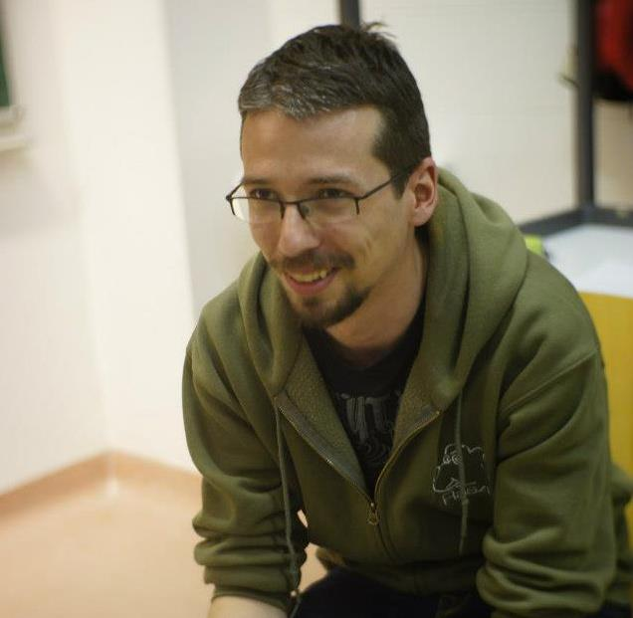
István Vigh
Phone: 06 (20) 342-2416
E-mail: istvan.vigh.cv@gmail.com
Address: 1148 Budapest, Fogarasi street 45.
Place and date of birth: Szekszárd, 20 February 1989.
Portfolio site: http://raszpi.github.io
EDUCATION
2009 - Óbuda University – Kandó Kálmán Faculty of Electrical Engineering, Information and Communication Networks specialization, Thesis: Android application development
Electrical Engineering BSc.

2007 - 2008. Budapest University of Technology and Economics – Faculty of Electrical Engineering and Informatics, Electrical Engineering BSc.
EXPERIENCE
2014. jan. - ABF Informatika, Budapest • full stack developer
[UI / UX and front end development on healthcare projects, back end and front end development work on in-house innovation projects]
2013. jan. - 2014. May Info-portal Kft., Budapest • electrical engineer trainee
[Reviewing and improving plans created for MOL, TEVA, ABB…etc., writing documentation, office automation with VBA scripts, preparing the pid.hu project which is a news portal for electrical engineers]
2012. Okt. - PrintPix Nyomda és Grafikai Stúdió, Budapest • student job

[Digitizing contracts]

2009. Aug. - 2012. May LaPlace Café, Budapest • waiter, barista

[serving, working with cash register, logistics in the Schönherz Zoltán Dorm's café]
2008. Jul. - 2009. Sep. Small businesses, Budapest • system administrator, helpdesk
[Computer and printer maintenance, repair, installing softwares, router setup, video editing, graphic design, general problem solving]
2006. Okt. - 2007. May Sanoma Media Budapest Zrt., telework • moderator, helpdesk
[Removing inappropriate content, helping the users, writing and improving the site's help page, testing and finding bugs on the site, consulting for improvement]
LANGUAGES
2004 german type „C” language certificate
2005 english type „C” language certificate
TECHINCAL AND OTHER SKILLS
Front end: HTML, CSS (LESS), JavaScript (jQuery, AngularJS)
Back end: PHP (Laravel), node.js (Meteor.js), Python (django), MySQL
Graphics software: Adobe Photoshop, Sony Vegas
Other technical: vagrant, git, Sublime Text Editor, grunt, Oracle VM VirtualBox
Driving license: type „B”
OTHER
2008. Sep. - 2013. Dec. Szent Schönherz Senior Lovagrend – senior
[I am helping the integration of the freshmen of Budapest University of Technology and Economics – Faculty of Electrical Engineering and Informatics, I am administrating their moving in to the dorm, I have organized our senior team's summer camp]

2010. Sep .- 2013. Oct. Óbuda University – Kandó Kálmán Faculty of Electrical Engineering – trainer
[I am organizing and holding team building events for the students of the Institute of Instrumentation and Automation.]
2011. Nov. - 2012. Oct. Schönherz Qpa – organizer, program manager, contact person
[I have organized and arranged a 2 week long faculty event for thousands of participants, I were responsible for 3 programs which were attended by hundreds of people, also I was the contact person for 3 other programs and 5 party event.]
2012. Apr. - Láthatatlan Egyetem – trainer
[I organized and directed 4 session long trainings for student in the subject of time management and lifestyle for groups of 15 people, I organized the trainings in Budapest (for 15+ groups), I directed the semester closing camps (for 100+ people).]

2012. Apr. YearCompass – marketing, video editor – yearcompass.com

[I was responsible for marketing and the video editing. We reached more than 200.000 downloads in a few weeks. We were featured on producthunt.com, reached the top of reddit.com/r/GetMotivated and were retweeted by people with more than 2 million followers.]

PERSONAL SKILLS
- team player
- fast learner
- creative problem solver
- good communication skills
- good organizational skills
- tolerance for monotony

