Specific Aims
Genetic studies in human and animal models and comparative genomics has greatly expanded our understanding of human disease and the biology of the human genome. With the advances in high throughput SNP typing and next-generation sequence technologies, the number of loci associated with a milieu of complex traits and diseases has dramatically increased over the past five years. Comparative genomics approaches have been instrumental in providing a better understanding of complex genome regulation and have led to the identification of causal genes for human disease. For many sequenced genomes, it is possible to query a public website to view sequence-based comparisons between organisms. Because many biological processes tend to be conserved across species, concerted efforts are being made to describe genes and phenotypes using standardized nomenclature or ontologies. However, while most genome browsers and comparative genomics tools include conserved synteny and gene content information, there is a paucity of web tools that visually integrate mapped diseases and traits across species. Our long-range goal is to develop bioinformatic tools that will allow researchers to efficiently transfer comparative information from one species/strain to another.Toward this goal, the objectives of this application are to develop a bioinformatic comparative phenotype-genotype integration platform, to integrate curated QTL and GWAS data from humans and model organisms, to further develop trait ontologies to link this information together, and generate a cross-species morbid map. We have formulated these objectives based on 1) the paucity of tools with which to compare genomes at both the phenome and genome levels, 2) the need for a standardized trait terminology and nomenclature with which to compare QTL/GWAS data across species.
We are well prepared to undertake the proposed research. First, we have already developed a prototype tool (VCMap) to integrate genomes of human, rat, mouse and several livestock species. Second, we have begun development of the Vertebrate Trait Ontology to annotate QTL of multiple species. Finally, we have established collaborations between Dr. Kwitek, co-developer of VCMap, Drs. Dwinell and Shimoyama, ontology experts at the Rat Genome Database, and Dr. Reecy, developer of the Animal QTL database. This mutual focus, complementary expertise, and attendant shared resources will provide a research environment especially conducive to successful completion of the proposed investigations. To address our objectives, we propose the following specific aims:
Specific Aim 1. Generate a comprehensive platform to integrate interspecies genomic and phenotype/disease information and expand the genomic features incorporated into VCMap. The utility of VCMap is in its ability to allow a user to begin with a bird’s eye view of a chromosomal region and its genome features, visualized across species, and then zoom into a region of significance for additional analysis. We will further develop its strengths through the addition of new data sources and new and enhanced query, data import and export features, and improve the interoperability of the tool with third party genomic tools. These features will enable users to better identify regions and features of significance and more efficiently perform additional analyses using other tools and techniques.
Specific Aim 2. Employ appropriate ontologies to annotate mapped traits, phenotypes and diseases from multiple organisms to facilitate cross species comparisons and creation of comprehensive virtual morbid maps. Identifying potential trait and disease related regions through comparative genomics approaches is a mainstay of much research today. Standardization of these mapped loci will improve the ability of researchers to compare data across organisms, identify potential sites for manipulation within their own organism of interest and identify potential existing model organisms to validate findings from GWAS and other studies.
Specific Aim 3. Expand the intra- and inter-species connectivity. Fully incorporating all genome-based maps allows for complete interactivity between them within a single species, allowing for more complete comparative maps. Many species have cursory genome sequences but have more refined genetic and/or radiation hybrid maps. By refining our approach for defining conserved synteny and cross-species ontologies, the comprehensive platform will allow for cross-species comparisons that are not feasible when assembled genome sequences are not yet completed and will lead to the ability to compare multiple intraspecies genomes.
Innovation and Significance:
The proposed research is unique and innovative, because of its focus on integrating comparative genomics with standardized ontologies to effectively transfer biological information across human and multiple model organisms’ genomes. This will yield the following outcomes. First, we expect to expand the VCMap capabilities to efficiently transfer genomic and biological information, both the intra and interspecies. Second, we expect to adapt and develop standardized ontologies to annotate disease and phenotype loci generated from QTL, GWA and other studies for a variety of species to facilitate cross species comparisons and generate virtual morbid maps for targeted species. . Taken together, these tools are expected to have significant positive effects on our understanding of the molecular mechanisms that control traits associated with human health.
A. Significance
Figure 1. Number of publications reporting GWAS. Pubmed search criteria: (genome-wide association OR GWAS). Review articles excluded
Need for integrative approaches in the post-GWAS era: With the advances in high throughput SNP typing and next-generation sequence technologies, the numbers of loci and mutations associated with a milieu of human complex traits and diseases are exploding. Over the past five years the number of complex trait loci identified by genome-wide association studies (GWAS) has grown exponentially (Figure 1). The NHGRI GWAS catalog currently (as of 7/7/11) lists 933 publications and 4621 associated SNPs for large scale studies of human diseases and/or traits (Hindorff LA, Junkins HA, Hall PN, Mehta JP, and Manolio TA. A Catalog of Published Genome-Wide Association Studies. Available at: www.genome.gov/gwastudies. Accessed [date of access). Furthermore, whole-exome sequencing to identify causes of Mendelian disorders is now a reality (REFS) and the likelihood of its application for complex traits is imminent. However, the next challenge in the post-GWAS era is to identify the causal genes or sequence features, as many associations are intronic or intergenic, and are likely to have epistatic relationships. Certainly, with the large number of human GWA studies, functional proof of causality of associated SNPs/loci is often provides through data and experimentation in model organisms. Having an integrated cross-species platform of traits, phenotypes and diseases can lead to prioritization of candidate genes or pathways as well as choice of the ‘best’ model for functional validation.
Comparative Genomics to link common biology across species: The primary motivation for comparative mapping and comparative genomics is to leverage knowledge obtained from organisms and to transfer that knowledge to organisms of interest. Therefore, simply aligning genomes is not sufficient to link the biology between model organisms; one must also annotate that biology onto the genome of each organism, under the assumption that some genetic mechanisms will play a role in that trait/disease across species. Although met with some initial disbelief, using conserved synteny between genomes [14; 15; 16; 17; 18] to map disease-causing genes or regions from one organism to another has begun to bear fruit. With the availability of additional genome resources for other species, increasing numbers of studies are using cross species comparisons to find causes of diseases, both single gene disorders and complex disease [20; 21]. Integration of the genome sequence with existing mapping data and the biological data attached to those maps, with annotation of a comprehensive catalog of gene products will increase the use of such comparative studies on translational research.
VCMap links the genomes and their biology: Most of the genome browsers (e.g. UCSC (REF), NCBI (REF) and Ensembl (REF)) are very successful at cross-species genome alignments, and allow deeper mining of genomic data in species with more complete annotation. The VISTA [27] and ECR [28] browsers provide multiple-species sequence alignments to facilitate the identification of conserved coding and non-coding regions and putative functional genome elements. However, most comparative genome tools available to date do not systematically annotate and integrate biology across species. To meet this need, Dr. Kwitek and colleagues at the Medical College of Wisconsin developed a novel and powerful integrative genomics environment with markers, maps, and annotations; a source file of the maps, markers, and physiological results; and an in silico cross-organism mapping tool to address these issues [29, REFS]. VCMap is a Java-based, dynamic software tool with a web interface that allows an investigator to dynamically navigate from map to map, genome to genome, and thus uniquely combines and visualizes distinctive information linked to each type of map. In particular, it enables a powerful strategy to link physiologically important and genetically influenced traits, phenotypes, and diseases which can, via their genome positions, be displayed and traced from genetic maps to genomic sequence and thus link to genome browsers for review of candidate gene annotations (Figure 2). Since its development, the VCMap platform has expanded from rodent-human based comparisons to that of multiple domesticated agricultural species, focused mainly on QTL through a USDA-funded collaborative effort between Drs. Kwitek, Reecy, and Shimoyama.
Standardized Nomenclature and ontologies for annotating biological data: Clinical and model organism phenotype characterization is critical to genetic studies. While the types of measures and methodologies vary, often the basic traits being measured are similar, offering a wealth of information to guide human genetic studies of complex traits. Ontologies provide a convenient and consistent way by which data can be classified, annotated and compared among model organisms (REFS) Thefirst large-scale effort at applying bio-ontologies was the Gene Ontology (GO) project which was created to standardize terminology and representations of the characteristics of genes and gene products across multiple databases and to allow researchers to compare data for multiple species (Blake et al). The success of GO is demonstrated in part by the dozens of groups which use GO as the primary ontology for annotate genes and gene products and the scores of tools utilizing these annotations to classify, organize and analyze such datasets. The National Institutes of Health, in recognition of the utility of ontologies and the need for more ontologies to represent biological entities, processes and states provided funding for the creation of the National Center for Biomedical Ontology (NCBO) (http://bioontology.org/) in 2006 (Rubin et al).There are currently 270 ontologies catalogued at NCBO including a number which focus on phenotypes and diseases. Two of the disease ontologies at NCBO, OMIM and Medical Subject Headings have been integrated into a single ontology currently used by the Rat Genome Database and Mouse Genome Informatics for annotating genes so will be used in this project. The Mammalian Phenotype Ontology (Smith CL et al) is also used by RGD and MGI to annotate alleles and genes to abnormal morphological and physiological characteristics. These and other ontologies have been developed primarily to annotate specific genes, alleles and mutants while other types of mapped loci such as QTL have been annotated by vocabularies or names developed at individual databases with little utility for cross species comparisons and often ill-suited to loci in which the exact variant is unknown. To standardize QTL and other loci annotations, the Vertebrate Trait Ontology is in development. Its focus is to outline the developmental, morphological and physiological characteristics or states that are found in all members of a vertebrate species. Thus, these loci are involved in the expression of these traits. The assessment of such traits and the resulting values are used by researchers and clinicians to determine abnormal phenotypes and disease states. In general, disease annotations have indicated a relationship between a region or variant(s) and individuals or groups of individuals who exhibit the collective phenotypes which define a disease, while the phenotype annotations generally indicate a direct relationship between a single allele or gene and a single abnormal characteristic. By standardizing and integrating these three types of annotations and genomic elements across species, we will be able to provide researchers with virtual morbid maps illustrating all loci and regions of a species which may be involved in various states and processes associated with disease, while maintaining the distinction and meaning of the individual annotation types.
Summary: One of the goals of this PAR is to generate more integrative informatics tools to allow deeper mining of the vast amount of biological and genomic data being generated. With a reasonable effort, we envision the new VCMap as a powerful and flexible visual data exploration tool for integrating genomic maps and biological annotation between human and model organisms such as mouse, rat, dog, cow, and pig. It will allow a user to select what comparison they would like to visualize and then allow dynamic zoom, filter, and extended annotation features to mine deeper into the genomic and biological data associated with a region of interest across multiple species, to link to related genome browsers, and provide a means to download associated data in a report format. By utilizing a web service architecture and the ability to easily upload one’s own data, VCMap will change from a simple visualization tool to a dynamic visualization and annotation browser and will be a data provider in its own right. This way VCMap would become both a tool for the end user and a tool/resource for other bioinformaticians on which to build further tools, visualize and download annotations greatly increasing its impact. Furthermore, in order to ensure efficient transfer of biological information between species, three major ontologies will be used for standardizing data including the Vertebrate Trait Ontology which will allow cross-species QTL comparisons for the first time. In addition to the bioinformatics tools that will result from this proposal, the data that we will collect, curate, and make available to the public also has great value.
B. Innovation
- A highly interactive integration tool to link biological attributes across species
- Currently loci related to diseases, phenotypes and traits can be found on multiple map types for multiple species. There is the OMIM Morbid Map, the NHGRI GWAS Catalogue as well as gene and QTL maps for human, mouse, rat, cow, pig and other species. Each map uses different vocabularies to indicate relationships to diseases, phenotypes or traits while often providing a view of a single genomic element type. By leveraging three ontologies to standardize annotations of genes, alleles and QTLs from multiple species, direct comparisons across data elements and species is possible. In addition, by mapping such loci to each using synteny and orthology, virtual maps for human, rat, mouse and other species can be created which will display the related mapped traits, diseases and phenotypes within the genomic context of the species of interest.
- A platform that can compare maps and features both intra and interspecies.

C. Approach
C.1 Preliminary Data
Our intent in this section is to demonstrate our abilities by showing data and other evidence that we are positioned to accomplish the objectives we have outlined for the next four years. In the Methods Section we describe how the data in this section is generated in detail.
C.1.1 VCMap Visualization tool: The Virtual Comparative Map (VCMap) tool was originally developed by Drs. Kwitek, Howard Jacob, Simon Twigger and Peter Tonellato at the Medical College of Wisconsin, as part of the Rat Genome Database (REFs). It has subsequently redesigned through collaboration between Drs. Kwitek, Reecy and Dwinell, and implemented by Bio::Neos, Inc (http://bioneos.com/), as part of a USDA funded project to develop a comparative QTL viewer. The current VCMap tool made the system much more user friendly and intuitive, expanding its versatility and utility. We have developed a MYSQL database to house all map and annotation data for each species. Map data including publicly available genome assemblies, genetic map, and radiation hybrid map, for six species are currently in the database, including human, rat, mouse, cow, pig, and chicken. A new Java front end was developed that allows a user to load a backbone map and those of additional species and then overlay annotation data. Current conserved synteny data was obtained from UCSC and includes level 1 data. Annotation data includes genes (appearing as default annotation), QTL, STS, and pseudogenes. All current annotation data, with the exception of QTL, is obtained from NCBI. Thus far, we have gene and pseudogene annotations from all six species, and QTL data for all species but mouse through the curation efforts at ISU and MCW. Mouse QTL curation is obtained through MGD.
The Java front end allows a user to load a backbone map and those of additional species and then overlay annotation data (Figure 2). A user can switch species perspectives on the fly using the “swap backbone” option, add and filter data as needed, and download location specific features. Annotations are clickable to display additional information and links to source data. VCMap version 2.0 has made significant improvements to the user interface and supported features of the software tool. Usability of the user interface has been improved, especially with respect to the navigation of large-scale regions on the order of multiple megabases. Most importantly, the tool now supports the ability to load custom datasets from text files in a variety of common formats including GFF3, BED, and SAM/BAM. This feature greatly increases the utility of the tool because it now provides users with the ability to perform comparative research using their own personal, private research data with VCMap as a framework for navigating and investigating their data. The ability to export publication quality images of the data visualization was added. Some genomic map data and annotation from Ensembl was incorporated into the VCMap database, and improvements were made to the load script to enable more frequent updating of the existing data.
CURATION PRELIMINARY DATA Phenotype annotations using the Mammalian Phenotype Ontology are available for human, mouse and rat elements curated by RGD or MGI as indicated in Figure 2. Disease annotations using the integrated MeSH/OMIM ontology are available for human, mouse and rat elements curated by RGD or MGI. Currently QTL from all sources are annotated using the vocabularies of each source with standard annotation to the Vertebrate Trait Ontology being a goal of this application. Other loci targeted for integration currently without appropriate ontology annotations will be annotated as part of this application.
TRAIT ONTOLOGY PRELIMINARY DATA There are currently 3063 terms in the Vertebrate Trait Ontology for developmental, morphological and physiological traits. Definitions are provided for each term and terms are reviewed for compatibility and cross referencing with other existing ontologies. The ontology is organized by organ systems as well as having a branch for whole organism traits such as body size and anatomical relation traits. The ontology has been developed with input from the Rat Genome Database, AnimalQTL Database and Mouse Genome Informatics based on reviews of current QTL data and other mapped loci. The VTO is scheduled for release to NCBO September 2011.
C.2 Specific Aim 1. Generate a comprehensive platform to integrate interspecies genomic and phenotype/disease information and expand the genomic features incorporated in VCMap.
Rationale: The utility of VCMap is in its ability to allow a user to begin with a bird’s eye view of a chromosomal region and its genome features, visualized across species, and then zoom into a region of significance for additional analysis. We will further develop its strengths through the addition of new data sources and new and enhanced data import and export features, and improving the interoperability of the tool with third party genomic tools. These features will enable users to better identify regions of significance and more efficiently perform additional analyses using other tools and techniques.

2.1 Background
The VCMap application is a functional, useful tool for facilitating comparative genomics because of its uncommon ability to allow users to begin with a generalized knowledge of a phenotype, trait, or even chromosomal position and interrogate data across species, refining the region of interest and identifying other potential candidates for additional analysis. Most other genome browsers, whether designed for comparative research or single species, expect users to begin with a fairly specific region of interest and allow them to navigate and explore surrounding data from that narrow starting viewpoint. As these browsers are asked to expand their range of visualization, they often perform poorly or present the user with a cluttered, unusable view of the data. However, VCMap is limited in the amount and types of data that it can present, and the interoperability of the tool with other common genomic research tools. Aspects of the user interface have room for improvement as well, especially the initial interface used to launch the tool and select . Furthermore, enhancements to the application itself, and the scripts used to gather data and populate the database, will greatly increase the utility of the tool and make it more generally applicable to the comparative research community.

2.2 Experimental Approach
2.2.1 Improve the user interface for loading VCMap
The objective of this approach is to improve how the user interacts with the application to begin a session. The current user interface for the application requires the user to specify what maps they would like to load, one map at a time, followed by specifying what types of annotation to load, also one type at a time. In addition, the interface is very chromosome-centric, as it requires the user to select a single chromosome for the backbone map as the main starting point for loading all data. This process is tedious and forces users to begin their usage of the system from a specific location. Both of these issues can be addressed through user interface improvements. In order to streamline the loading process and present users with data quicker, the load interface will be redesigned to present the user with a dialog that will allow them to specify all of the species of interest, as well as supporting annotation in one step. This redesigned interface will be more efficient, and more intuitive, allowing users to begin examining the visualization of their data sooner and making the tool more accessible to new users unfamiliar with the system. In addition to this improved load dialog, we plan to add two other entry points to the system to allow for parallel modes of entry into the data visualization aspect of the tool. First, in order to broaden the chromosome-centric focus of the tool, we plan to add a visualization for a full genome (as a collection of all of the relevant chromosomes for a species). This interface will be limited to a single species and less resolution, but will still provide the user with a more general entry point into the system than the current interface. After specifying a chromosome of interest as a backbone, the system will then allow the user to visualize additional species on top of this backbone. Second, we will add another interface to the system that will allow users to begin using the system from the starting point of a phenotype or trait of interest as opposed to a genomic location. This interface will rely on heavily on ontology terms and associations that we will preload into the VCMap database. The interface will allow users to query on these terms and a single species, similar to the ontology viewer at the Rat Genome Database (RGD) [cite] and present them with a visualization of the locations throughout the genome of a single species where this term is associated. As with the genome-based entry point, the user will be able to visualize additional species after selecting a single chromosome of interest.

2.2.2 Increase the amount of data supported by VCMap
The objective of this approach is to increase the utility of the VCMap software by adding additional data sources into the preloaded VCMap database, to streamline the current data loading process and supporting database, and to improve the performance of the custom data loading feature to allow the system to handle larger datasets (including next generation sequencing datasets). The current VCMap system contains a MySQL based database backend that we preload with map and annotation data from various public data sources including NCBI, UCSC, and Ensembl as well as QTL data from ISU and MCW. In order to increase the utility of this tool for comparative genomics research with respect to human disease, we plan to add data from the OMIM Morbid map and dbSNP at NCBI. We will additionally tie these two sources with ontology terms, when possible, that are strongly integrated into the rest of the system, adding filtering and querying capabilities that will be extremely useful to researchers of human diseases. To supplement the new data, we will improve the current performance of the tool to support datasets in the size range of 10k to 100k. Need to expand this more...

2.2.3. Improve the import and export formats supported by VCMap
The objective of this approach is to increase the import and export features for the VCMap tool to support more formats and allow for greater interoperability of this tool with other common genomic research tools. We plan to incorporate support for X, Y, and Z. Etc, etc, etc. Additionally, we will provide ways for other existing tools to automatically launch the VCMap application using specific parameters to automatically load some data of interest. This will allow existing genome browsers to link directly to the VCMap application, enabling users to utilize the enhanced navigation and visualization aspects of the tool. This will promote increase use of the tool and allow users to navigate data in a comparative research context after already using a third party tool to identify a region or feature of interest.

C3. Specific Aim 2: Employ appropriate ontologies to standardize annotations for mapped traits, phenotypes and diseases from multiple organisms to facilitate cross species comparisons and creation of comprehensive virtual morbid maps.

3.1 Introduction
Identifying potential trait and disease related regions through comparative genomics approaches is a mainstay of much research today. Standardization of these mapped loci will improve the ability of researchers to compare data across organisms, identify potential sites for manipulation within their own organism of interest and identify potential existing model organisms to validate findings from GWAS and other studies.

3.2 Experimental Approach
Experimental Approach 3.2.1 – Develop and Implement Ontologies for Cross Species Trait, Phenotype and Disease Comparisons
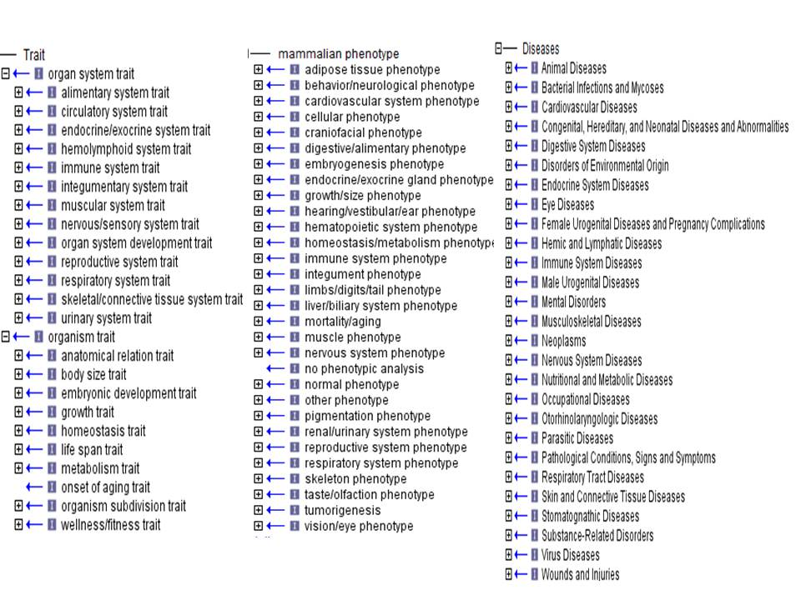
Fig 1 Three ontologies for standardizing traits, phenotypes and diseases
Three ontologies will be employed to annotate data with the Vertebrate Trait Ontology (http://rgd.mcw.edu) used to standardize mapped traits, the Mammalian Phenotype Ontology [1] for mapped phenotypes and a Comparative Disease Ontology (http://ctd.mdibl.org) [2] for mapped diseases (Fig 1). The Vertebrate Trait Ontology has been developed to standardize QTL and other genomic element annotation across multiple organisms with the Animal QTL Database (www.animalgenome.org/QTLdb/ ), the Rat Genome Database (RGD) (rgd.mcw.edu) and Mouse Genome Informatics (MGI)
(http://www.informatics.jax.org) participating in its development. Continued development of this initial version to accommodate emerging QTL and other genomic elements will be part of the proposed project. Mammalian Phenotype Ontology currently is used by RGD and MGI for annotation of genes and alleles for rat, mouse and human. The Comparative Disease Ontology incorporates both the MeSH and OMIM terminologies for disease and is currently used by RGD, MGI and the Comparative Toxicogenomics Database. These three ontologies were chosen because of their similarity in structural organization which will facilitate data queries and presentation and their use with the data from organisms represented in VCMap as well as their availability in the widely used Open Biomedical Ontologies (OBO) format which will facilitate the development of unified query and display options.
Experimental Approach 3.2.2 — Integrate Trait, Phenotype and Disease Datasets from Multiple Organisms and Multiple Species
QTL represent a rich source of mapped trait data and for this application, human, rat ,and mouse QTL as well as QTL representing traits of interest to human health from organisms such as cow, pig, chicken and sheep (Fig 2) will be annotated with the Vertebrate Trait Ontology (VTO) to standardize representation of traits across organisms. Currently, the respective repositories for these QTL utilize differing methods of indicating trait, either through QTL name (MGI) or organism specific trait lists or vocabularies (RGD and AnimalQTLdb). Mapping of the current trait terms to the appropriate VTO terms will facilitate a semi-automated method of annotation for groups of related QTL. The major sources for phenotype annotation datasets for human, mouse and rat are RGD and MGI while those for disease are RGD, MGI, OMIM and the NHGRI ‘s Catalog of Genome-Wide Association Studies (www.genome.gov) (Fig 3). Data sets already annotated with the appropriate ontology annotations can be readily integrated into VCMap. These will include all QTL from the AnimalQTLdb and RGD, human QTL curated as part of the initial development of VCMap and RGD curation projects, phenotype annotations for rat genes and disease annotations for rat, human and mouse genes curated at RGD. Mouse genes and alleles also are annotated with the appropriate MP and OMIM terms for easy integration. For datasets without ontology annotations or for those with annotations from other vocabularies, conversion to the three ontologies outlined here will be accomplished through the ontology curation software in place at RGD (for software description see [3]). This software allows uploading of genomic elements and provides curators with the ability to annotate groups of elements with the same ontology associations simultaneously, thus, minimizing the manual resources needed.
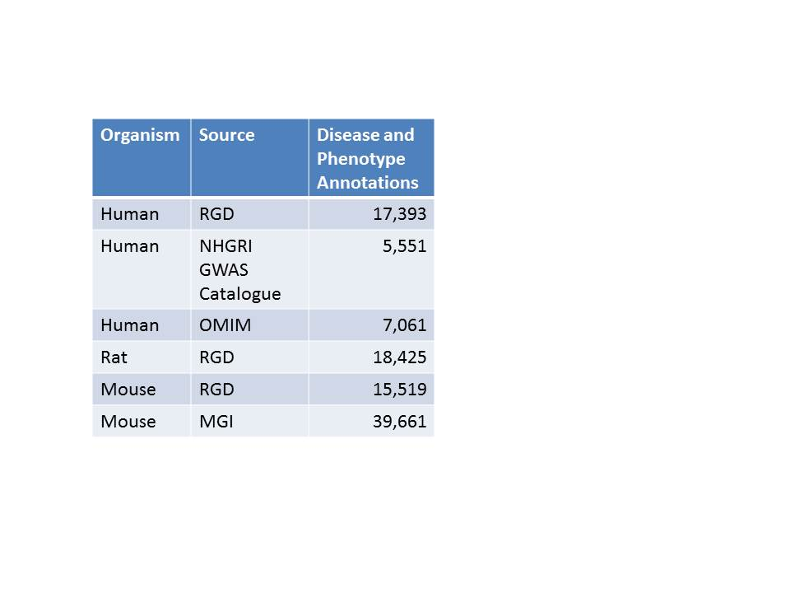
Fig 3 Number of disease annotations per source
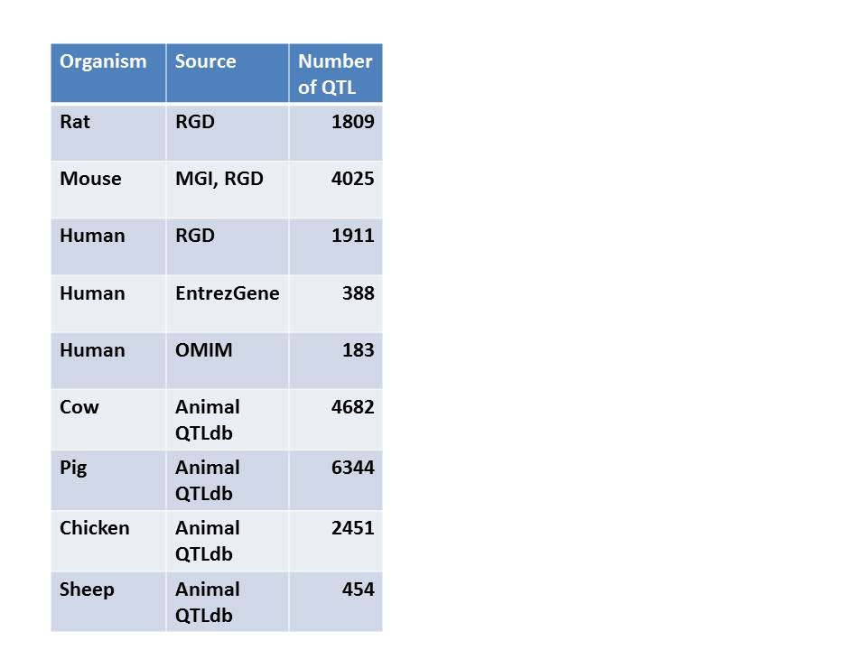
Fig 2 Number of QTL for each organism
Experimental Approach 3.2.3 – Create Virtual Morbid Maps for Species Integrated into VCMAP
Because trait, phenotype and disease data is scattered across multiple resources and organisms, it is difficult for researchers to ascertain the location of these mapped loci on the organism of their choice without conducting multiple queries and alignments, often requiring multiple steps and tools. Using the technology of VCMap, we will build a Virtual Morbid Map for each of the organisms represented by mapping all trait, phenotype and disease loci to their respective positions in the genomic map of the organism of interest. This will allow the user, for example, to compare the Rat Virtual Morbid Map with the rat genomic map for a particular chromosome or region to facilitate the determination of the boundaries for identifying or creating a congenic or knockout model that might correspond to the disease locus identified in a human GWAS or other study. Users would also be able to easily see when disease or phenotype loci from multiple organisms overlap in a region of interest. Because the loci will be annotated with ontologies, users will be able to filter loci on the virtual morbid maps for only cardiovascular related loci or other criteria.

Here I need a technical explanation about how we will map trait, disease and phenotype elements across species to create a virtual morbid map for the species of interest. For example we would map all human and mouse QTLs, phenotype and disease annotated genes and alleles to the rat genome via orthology and also have the rat specific QTL and disease and phenotype genes as well. These could be color coded to indicate those found in the species of focus and those mapped via orthology. Users will want to mouse over the elements in the morbid map and see the ontology term and the organism. The morbid maps would only contain the elements with trait, phenotype or disease annotations

3.3 Expected Results
Upon completion of this aim, targeted QTL datasets from multiple organisms will be annotated to the Vertebrate Trait Ontology and disease loci datasets annotated to the Comparative Disease Ontology. Existing datasets from MGD and RGD for phenotype loci will also be integrated into VCMap. Users will be able to easily view trait, phenotype and disease loci from multiple organisms mapped to the organism of their choice and will be able to customize the view of the morbid map through ontology based query filters.
3.4 Pitfalls and Limitations

C.4 Specific Aim 3: Expand the intra-species and inter-species connectivity.

4.1 Rationale
Comparative genomics approaches can provide critical information about gene function that is invaluable in the dissection of genetic mechanism that underlie human disease (8). For example, the ability to detect DNA regulatory regions responsible for gene regulation required multi-species comparisons as demonstrated by the ENCODE project (1, 2). However, as discussed previously, while most genome browsers and comparative genomics tools include conserved synteny and gene content information, there is a paucity of web tools that visually integrate mapped diseases and traits across species. Therefore, we developed VCMap to utilize cross-species conserved synteny, e.g. UCSC track 1 conservation data, and annotation information, e.g. Homologene, to easily visualize genomic and phenotypic information across species. However, the utility of VCMap could be expanded and improved by implementing intra-species comparisons (e.g. comparison of different haplotypes within a species) to facilitate identification of causal variants associated with traits of interest, optimizing uploading of external data (i.e. RNA-seq) to facilitate identification of genetic networks, as well as, facilitating novel species comparisons. Recent advances in whole genome association (XX) and development of genetic resources, like the Mouse Collaborative Cross (REF), have made it relatively easy to identity specific haplotypes that are associated with traits and diseases of interest (e.g. diabetes, obesity, blood pressure). However, there is a real need to visualize this data to facilitate discovery of causal genetic variants. Furthermore, advances in sequencing technologies (REF) have facilitated the generation of RNA-seq, Chip-seq, and exome and genome re-sequencing, which all provide invaluable information that will help lead to the eventual identification of causal variants. However there is a paucity of tools to visualize this type of data on a chromosomal scale. The base algorithm used for multi-species comparisons at UCSC and Ensembl is BLASTZ (13), followed by specific pipelines at each institution. For example at UCSC, genome conservation data is available in multiple levels of detail (see REF for additional detail). In addition to genome sequences, across-species comparisons are also available in the form of bacterial artificial chromosome, radiation hybrid (RH) and linkage map data (e.g. (9)). Unfortunately, the ability to link this data to genomic maps is not always straightforward. When across-species comparison data is not available, e.g. due to new genome builds, multiple genome builds or lack of conserved synteny comparisons, the transfer of genomic and annotation information across species can be difficult or cumbersome. Therefore, it would be desirable to build tools to act as a bridge when direct comparative information is not available. These advanced features of VCMap would dramatically improve the ability of researchers to deal with these difficult situations. Furthermore, they would greatly expand the ability to use VCMap as and educational tool as well.

4.2 Experimental Approach and Analysis

Experimental Approach 4.2.1: Develop a pipeline to define synteny and homology for inter- and intra-species comparisons when none is available and uploading external data. The objectives of this approach is to build a suite of tools that will allow VCMap users to generate links across species, strains/individuals within a species, or with external data to allow comparison of genomic features relative to a reference genome. Interspecies comparisons: If a genome has been processed by Ensembl, NCBI, and/or UCSC, it can be loaded into the standard VCMap database. However, in cases where genome assemblies have not been processed by Ensembl, NCBI, and/or UCSC, a pipeline will be modeled off of ENSEMBLs Compara conservation pipeline to facilitate genome comparison prior to Ensembl, NCBI, and/or UCSC annotation. Boundary regions for syntenic blocks, as well as annotations from cross-species comparisons will be obtained for use in the VCMap database. Briefly, we will use BLASTZnet to develop tracks to compare genomes (6, 13). Gene homology will be determined using BLASTALL. Annotation information will be build upon existing homology found at NCBI’s homologene, UCSC and ENSEMBL by comparing potential homologues to known genes in information-rich species. Additional Annotation information will be incorporated from UniProt and GO to add additional structural and functional annotation information to homologous regions lacking annotation. Intraspecies comparisons: Whole genome sequence anchors across strains will be developed by matching the positions of sequences of SNP/STS markers. Localized comparisons within chromosome blocks will be precomputed using BLASTALL and then stored in the database for later visualization. These comparisons will be designed to focus on targeted sub-chromosomal regions in an effort to define sequence-level differences. Tools will be developed to use haplotype information from programs such as BEAGLE (3) or PLINK (12) to define haplotype blocks across strains. When possible, we will use publically available hapmap information.
Experimental Approach 4.2.2: Develop tools to visualize generic inter- and intra-species comparisons using the VCMap GUI. The objective of this approach is to facilitate visualization of 1) cross-species comparisons of new model species, 2) genomic architecture of multiple strains within species, and 3) external data in the VCMap GUI. To achieve this goal, we will utilize sequence-aligned data from the inter- and intra-species comparison pipeline (above) as a basis for comparing new model species of interest to a user against existing species in VCMap. To promote the use of additional species in VCMap, we will develop the ability to view generic species in the GUI. This will allow users to privately visualize their own comparative data from different model species than are currently available on VCMap. We will also develop tools to better utilize other map data (e.g. RH, BAC, linkage) to link species to physical maps already within VCMap where possible. To allow intraspecies visualization, we will expand VCMap visualization tools to allow whole chromosome and targeted genome coordinate comparisons across strains. Strains will be clustered by haplotypes to define strains that are more or less similar. In addition, we will visualize strains in phylogenies based on haplotype. The goal will be to develop a tool that allows users to easily visualize differences in haplotype structure and the ability to zoom to a sequence level view for haplotypes of interest to view sequence-level differences. A critical objective of this approach will be to facilitate genomic comparisons across strains within the same species (e.g. the collaborative cross).

4.3 Expected Results
Upon completion of this aim, we expect to have greatly enhanced the detail with which the VCMap software can compare intra- and inter-species genomes. We expect that it will be possible to use more detailed synteny comparisons at UCSC and also those at ENSEMBL to improve upon the cross-species annotation of genomic regions. We will also enhance the annotation information available for cross-species comparisons. In addition, the interspecies comparative pipeline will allow us to develop generic tools that allow cross-species comparisons to genomes that currently lack the required information. This will allow the tool to be used to improve the detail of the annotations and to better view genomic differences within species. It will also provide suggested corrections to specific genome builds and cross-species synteny comparisons. In addition, it will allow users to update genome comparisons quickly when new genome builds are developed, prior to the time that UCSC, ENSEMBL and NCBI develop there cross-species comparisons. The users will benefit from new genome builds without sacrificing the ability to view comparative genomics information. The pipeline we propose will facilitate the ability to compare new model species to existing genomes in VCMap. The GUI tools developed to facilitate generic inter and intra species comparisons will allow new model genomes or multiple strains to be compared quickly to the existing genomes in VCMap. Updates proposed to the VCMap GUI will allow visualization of differences in multiple strains at the haplotype and sequence level. This will be a considerable asset to projects such as the collaborative cross. The development of these visualization tools will also be extremely useful for groups with experimental populations used for GWAS studies to view key recombinations and structural differences that define association regions. The final approach presented will allow improved use and application of the tool by other groups who desire to link their tools programmatically to VCMap to mine synteny and comparative annotation information. The overall result of these enhancements to VCMap will result in more detailed annotation and syntenic information within and across species. The improvements are expected to assist researchers mining genomic regions associated with complex diseases.

4.4 Pitfalls and limitations
We have assembled a multidisciplinary team with considerable experience handling cross-species syntenic data and annotation. In addition, we have already developed data very useful tool (VCMap), which provides and excellent platform to further develop. Development of our own synteny and cross-species alignment pipeline may provide ambiguous alignments in some cases. Ideally after a species is sequenced, it will be analyzed by UCSC, NCBI, or Ensembl and will then migrate into the VCMap database. However, in the absence of UCSC, NCBI or Ensembl analysis, this tool would fill a visable gap that thereby help to facilitate research in the absence of pre-existing conservation links. Additionally, we will work with NCBI/Ensembl staff during this process to minimize duplication of effort (Please see letter of collaboration). Our team has considerable experience with software development and we expect no problems developing the proposed pipeline and visualization tools. Furthermore, we will establish a working relationship with the Mouse Collaborative Cross Consortium (see letter of collaboration), which will help tremendously with the intra-species comparison aspects of VCMap, as they have a very large intra-species comparison bottleneck.

Rubin, D.L., et al., National Center for Biomedical Ontology: advancing biomedicine through structured organization of scientific knowledge. OMICS, 2006. 10(2): p. 185-98.

Blake, J.A. and M.A. Harris, The Gene Ontology (GO) project: structured vocabularies for molecular biology and their application to genome and expression analysis. Curr Protoc Bioinformatics, 2008. Chapter 7: p. Unit 7 2.

Smith, C.L., C.A. Goldsmith, and J.T. Eppig, The Mammalian Phenotype Ontology as a tool for annotating, analyzing and comparing phenotypic information. Genome Biol, 2005. 6(1): p. R7.

