

Capital Metropolitan Transportation Authority

**Downtown MetroRail Station**

**Quality Plan**

September 2016

Capital Metropolitan Transportation Authority

2910 East 5th Street

Austin, TX 78702



Downtown Gateway Partners

701 Brazos Street

Suite 450

Austin TX 78701

Table of Contents

1. Introduction 4

2. General Requirements 4

2.1. Roles and Responsibilities 4

2.2. Procedure 5

2.3. Staffing and Training 7

2.4. Project Team Instructions 8

3. QA/QC Requirements 8

3.1. Quality Assurance and Sufficiency Review Requirements 11

3.2. Quality Control Record Requirements 12

3.3. Verification of DGP sub-consultants deliverables 12

4. Document Control 12

5. Communication Protocol 12

6. Quality Assurance 12

7. Quantities and Cost Estimates Checking Procedures 13

7.1. Quantities 13

7.2. Cost Estimates 13

List of Appendices

**Appendix A** – Discipline QC Check Summary Log Sample (Bluebeam)

**Appendix B** – Quality Process Log Sample

**Appendix C** – Project Transmittal Template

**Appendix D** – Bluebeam Discipline QC Check Process

# 

## Introduction

The purpose of the Quality Plan (QP) is to define roles and responsibilities for Capital Metropolitan Transportation Authority (Capital Metro) and Downtown Gateway Partners (DGP) and to establish procedures for executing the quality activities on the Downtown MetroRail Station project. This plan provides guidelines and best quality practices for services anticipated on this project including design (60%, 90% and 100%), procurement, construction phase services, and public outreach.

This QP will be updated on an as-needed basis. Project-specific plans will go into more relevant information, but all plans will follow the intent of quality assurance with an appropriate level of effort relative to the project needs or activity requirements. The QP applies to all team members including project employees and employees of other firms that are sub-contracted with DGP. Conformance to this quality plan is a contractual obligation. Each team member must adhere to the procedures herein. Any proposed exceptions must be approved by the DGP Project Manager (PM).

## General Requirements



The following production and review processes and procedures are to be used to document that each element of work is produced and reviewed in association with the project scope of services and conforms to applicable project requirements.

Team members providing services and/or preparing deliverables must adhere to the quality guidelines established in this QP. The same applies for team members or advisors involved in the review of such services and/or deliverables. In addition, team members performing quality reviews must be qualified to perform such reviews.

Broadly defined, the quality reviews will address final draft deliverables before the product is submitted to the client. In addition, the DGP PM, DGP Deputy PM (DPM), and DGP Quality Control Manager (QCM) must be given an opportunity to see the final draft deliverables prior to submittal to the client. The review will consist of a two-pronged review, at minimum - a PS&E Technical review (other than originator) followed by an interdisciplinary review. Roles for production and quality reviews are described below.

### Roles and Responsibilities

**DGP PM:** The DGP PM will be responsible for the quality of deliverables for the project and the fulfillment of client requirements; assigning a project Quality Manager (PQM); supporting the PQM in the development of the QP; overseeing implementation of the QP and resolving related issues; ensuring appropriate resources, schedule and budget for QP activities are included in Work Plan; Presenting QP to the client, addressing client feedback, and achieving client approval of the final QP.

**DGP QCM**: The DGP QCM will be responsible for developing the QP; assisting DGP PM in addressing client feedback, and achieving client approval of the QP; providing orientation to the project team; overseeing the implementation of the QP, and communicating any issues to the DGP PM for resolution; reviewing sub-consultants quality plans and auditing subconsultants for adherence to those plans; performing quality assurance reviews on deliverables to verify compliance with the QP.

**Originator:** Either the author, designer, or artist can be the originator. The originator will not be eligible to review his or her own work. Naturally, we expect completed staff work from originators, but the review tasks shall be assigned to others not directly involved in the original production of the material. The Originator should be responsible to prepare and submit the deliverable for checking.

**Checker:** A qualified individual with sufficient, relevant experience in the area of what is to be checked, and in some cases possessing specific subject matter expertise. The Checker shall be independent of the production of the deliverable being checked, but should have familiarity with the client, contractual requirements and the approved design criteria. It shall be responsible to check the deliverable and shall note correct items and items in error on the CheckPrint using the colors assigned in Table 1.

**Backchecker:** An individual, typically the Originator of a project deliverable, who is responsible for reviewing comments made by a Checker and documenting agreement or disagreement with those comments on the CheckPrint using the colors assigned in Table 1. The Backchecker is also responsible for resolving any differences of opinion with the Checker. Typically the Project Design Lead will be the backchecker at the interdisciplinary design review.

**Updater:** An individual (may be the Originator) who is responsible for making updates or corrections to project deliverables in accordance with the Backchecker’s resolution of the Checker’s comments and for noting such corrections on the CheckPrint using the colors assigned in Table 1.

**Verifier:** An individual, typically the Checker, but cannot be the Updater, who is responsible for verifying that Checker comments have been resolved as intended, and for noting such verification on the CheckPrint using the color assigned in Table 1.

**Bluebeam Subject Matter Expert (SME):** The Bluebeam SME shall be responsible for setting up the project in Bluebeam to facilitate Discipline QC Check; coordinating with the PQM to provide Bluebeam training to Discipline QC Check participants; assisting the Originator in configuring Bluebeam Revu/Vu to the standard profiles, toolsets, stamps and data management settings to facilitate Discipline QC Check.

### Procedure

When project deliverables are submitted for quality check or review and these reviews are performed utilizing an electronic or hardcopy CheckPrint, the colors and markings shown in Table 1 shall apply to each of the identified roles in the quality check or review process: In addition when signing the hardcopy CheckPrint Stamp (see Figure 1), each individual shall sign in the color assigned for their role. Notes: When Check, Backcheck, Update and Verify are performed on a MS Word, Track Changes assigns a distinct color to each editor; when Check, Backcheck, Update and Verify are performed on a plan sheet, no CheckPrint stamp is needed, the initial and dates of the originator, checker and approver will be included at the plan sheet title block.

If using a hardcopy, the originator shall apply a CheckPrint stamp (may be applied through CADD layer) such as Figure 1, and shall initial and date the originator line in black ink. It may not be necessary to apply a CheckPrint stamp to each and every sheet; however, a new CheckPrint stamp must be applied when the specific individuals involved in the checking process change. When using a single CheckPrint stamp to cover a number of sheets, the range of sheets for which the CheckPrint stamp applies shall be noted.

**Figure 1 CheckPrint Stamp**

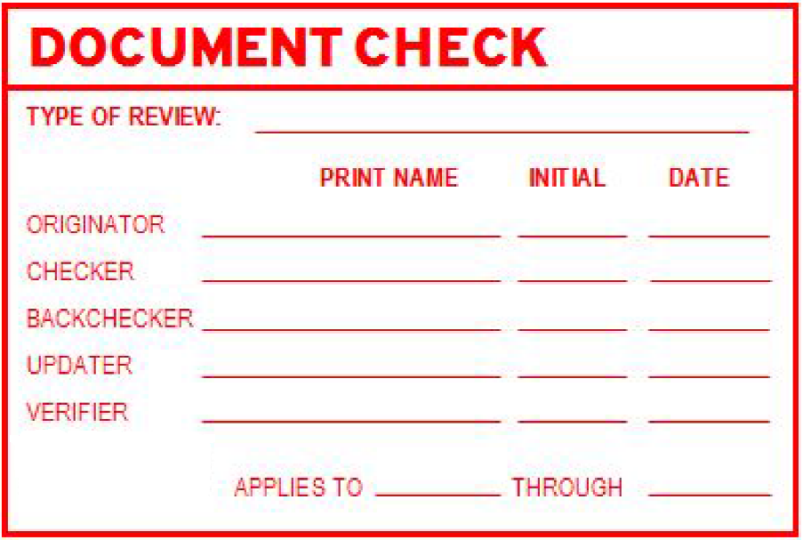

The procedure described in this plan shall apply to the discipline QC check of all deliverables prior to submission to a client. This procedure applies to the discipline QC checks of drawings, specifications, calculations (including quantities and construction estimates), reports, and studies, etc. All deliverables, regardless of milestone or phase, shall undergo Discipline QC Check with checks being commensurate with the level of detail available for the milestone or phase of the deliverable being checked.

**Table 1 Color Code for Quality Check procedure**

|  |  |  |  |  |  |  |
| --- | --- | --- | --- | --- | --- | --- |
| **Color** | |  | | --- | | **Instructions** | | **Checker** | **Back**  **checker** | **Updater** | **Verifier** |
| Yellow | Highlight items that are correct.  Note: It is not mandatory for the Checker to highlight all correct items in Yellow, especially in the case of electronic review. But in case where a sheet would otherwise have no markings, a Yellow diagonal slash across the sheet or a notation of no comments must be made to provide evidence of review. | **X** |  |  | **X** |
| Red | Line out incorrect items and show corrections/ additions. | **X** |  |  |  |
| **Black** | Written comments with initials, clouded. | **X** |  |  |  |
| **Green** | Place a Check Mark next to Red items in agreement. Strikethrough Red items and write “STET” (meaning to disregard the change) if in disagreement. |  | **X** |  |  |
| **Blue** | Circle Red and Green marks as items are updated or corrected. |  |  | **X** |  |

For all deliverables, the following review procedure must be followed:

**PS&E – Technical QC:** Once project PS&E deliverables are finalized, they are submitted for quality check or review; this review, must follow the procedure established in this QP (checker, backchecker, updater, verifier) and be completed within 3 days. At the beginning of the project, the Task Leads should identify who the originator, checker, backchecker, updater, and verifier will be for each design task. The DGP QCM will be coordinating this effort. All the deliverables under the PS&E effort will be reviewed using BlueBeam.

**Interdisciplinary review (IDR QC):** When the internal discipline review is completed the interdisciplinary review will be conducted. It must be completed within 3 days. The purpose of the Interdisciplinary review is to ensure consistency of the design between disciplines and segments; between design prepared by the DGP core team and the sub-consultants; between design of the project and adjacent projects; between design of the project and the affected facilities owned by other stakeholders; and to prevent coordination errors in construction documents. Interdisciplinary reviews will be performed collectively in an interactive session to avoid duplicate or conflicting comments and to facilitate interdisciplinary solutions.

**Address QC Comments:** Following the process described in this QP, the comments generated at the interdisciplinary review as well as those generated at the PS&E technical review that haven’t been addressed yet, will be addressed.

**QC Audit of QC Process:** The DGP CQM will verify that all the quality documents have been generated and compiled and that they are ready to be submitted to the client. If the DGP QCM identifies a document that is missing, the DGP QCM will make sure that this document is generated and compiled.

**CMTA Review:** Capital Metro will have 14 days to review the package submitted and provide comments. Comments provided by Capital Metro will be addressed and incorporated at the next design phase. Comments for the 100% design phase will be incorporated at the revised set of the 100% design phase.

**Coordination to review plans and respond to comments:** A comments log will be created to respond to all the comments. When using Bluebeam for the reviews, a comment log will be created automatically (see Appendix A for a QC check summary log sample); this comment log will be the one submitted to Capital Metro.

**Meeting agendas and materials for review in meetings:** In the interest of being responsive to project development needs and to facilitate interactive reviews with client teams, any materials generated for iterative review with the client will require a second pair of eyes to ensure quality; however, interim products designed to facilitate discussion will not require the formal review process.

Exceptions to the above may be made only with DGP PM approval.

### Staffing and Training

A DGP QCM has been assigned to the project to track and log quality control activities and assignments. The DGP QCM reports to the DGP PM and DGP DPM and coordinates with other team members, as necessary, to maintain documentation on how reviews are handled. The DGP QCM will be responsible for monitoring compliance to the Quality Plan. The DGP QCM may be a participant in the project development and as such may either be an originator or reviewer of work. Documentation of the compliance does not represent a conflict in the conduct of work on a project.

Secondly, the DGP QCM will provide quarterly reviews with the DGP PM. The purpose of these interviews will be to reinforce the conduct, explore the effectiveness and results of the reviews, and follow-through on problems notes and lessons learned. The DGP QCM interviews will be documented.

The roles and responsibilities of key team members on this project are established in the Downtown MetroRail Station Project Management Plan.

### Project Team Instructions

The DGP PM will hold a kick-off meeting to issue project instructions to ensure that all project team members know and utilize the production and review quality control and assurance requirements. The conveyance of the quality control and assurance requirements and instructions is to be documented in a project quality control file in ProjectWise with copies of the kick-off meeting agenda, list of attendees, and minutes. A quality process log is part of the kick-off package, identifying the major project deliverables and the anticipated responsible party for each deliverable as well as the individual responsible for quality control reviews. This log is to be used to track when each deliverable is reviewed. The deliverables by discipline will be tracked in a table for each QC review (60%, 90% and 100%). As changes occur in the project design or staffing, this log can be used to assure that the quality control requirements continue to be met. See Appendix B for a quality process log sample. The project quality process log can be found on ProjectWise. Quality logs will identify assignments at the beginning of a project and any changes in availability will be accounted for and the log will be adjusted in advance of the need. Completion of each level of review will be documented on the project process quality log.

## QA/QC Requirements



All deliverables and/or data on this project must be reviewed in accordance with the procedures outlined in this plan. For each item reviewed, the following rules shall apply:

* The reviewer must be **independent** (not involved in the production of the item being reviewed).
* The reviewer must be a **qualified** person to conduct the assigned review element.
* The production and review teams must follow the quality review steps including:
  + **Produce** a “review ready” item.
  + **Check** the item and mark or comment on any needed corrections.
  + **Back-Check** to verify agreement with checker’s comments.
  + **Update** the item to address review comments and produce an updated version.
  + **Verify** that all required updates have been made
  + **Repeat** the review cycle until the review and production teams agree.
  + **Record** results of verification on CheckPrint.
  + **Approve** item for delivery or distribution.
* The review and production teams must:
  + Meet the scheduled dates of production, review, and approval;
  + Adhere to the review process and format requirements applicable to each review; and,
  + Utilize the project’s standard marking, highlighting and coloring schemes of items checked (see Table 1).
* The review team must utilize a review checklist applicable to the project review.

Any deliverable submitted to the client must have a transmittal (see Appendix C for a sample project transmittal) as a cover page. This transmittal will have information about quality process; it will specify when the document was created and who checked it and approved it.

Quality control review activities must be documented and filed utilizing applicable document control procedures. The documentation must include material used during the quality control activities such as the original material, review comments, responses, corrections, final material, and final approval. A quality control log will be used to track all reviews (see Appendix A). For each item reviewed, the log must include the item being reviewed, originator, and reviewer. The DGP QCM will track actual activities as they occur. Once each final draft deliverable is prepared, the DGP PM must be given an opportunity to review and grant approval for submittal to the client.

Bluebeam will be used for the Discipline QC Check for all PS&E deliverables. The originator shall publish an electronic CheckPrint (.pdf) and create a Bluebeam studio session as described in Appendix D Bluebeam Discipline QC Check Process. As part of Bluebeam revu, the studio session provides cloud-based collaboration tools, and allows multiple users, located anywhere, the opportunity to proactively collaborate and create markups on .pdf documents at the same time, in real time and with account based user access. Once the check is completed, the originator shall generate a Discipline QC check Summary Log, showing all the comments, evidence of backcheck, update and verification and shall maintain a copy of this summary report along with copies of all electronic CheckPrints, as described in Appendix D.

The following diagram (Figure 2) depicts the expected sequence of quality checks/reviews performed on project deliverables prior to submittal to the client. Exceptions to this sequence, meaning allowing additional concurrence of check and review activities may be approved by the DGP PM when project requirements dictate. If this situation occurs, it must be updated at the Project Quality Plan.

**Figure 2 Sequence of quality checks/reviews**

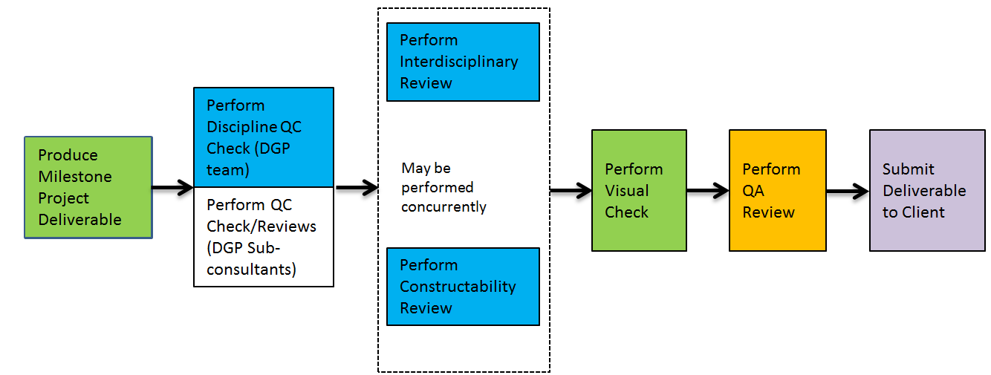



Figure 3 shows the discipline QC flowchart, and figure 4 the interdisciplinary QC flowchart. Both flowcharts show the detailed sequence of activities that the originator, checker, backchecker, updater and verifier shall perform.

**Figure 3 Discipline QC Flowchart**

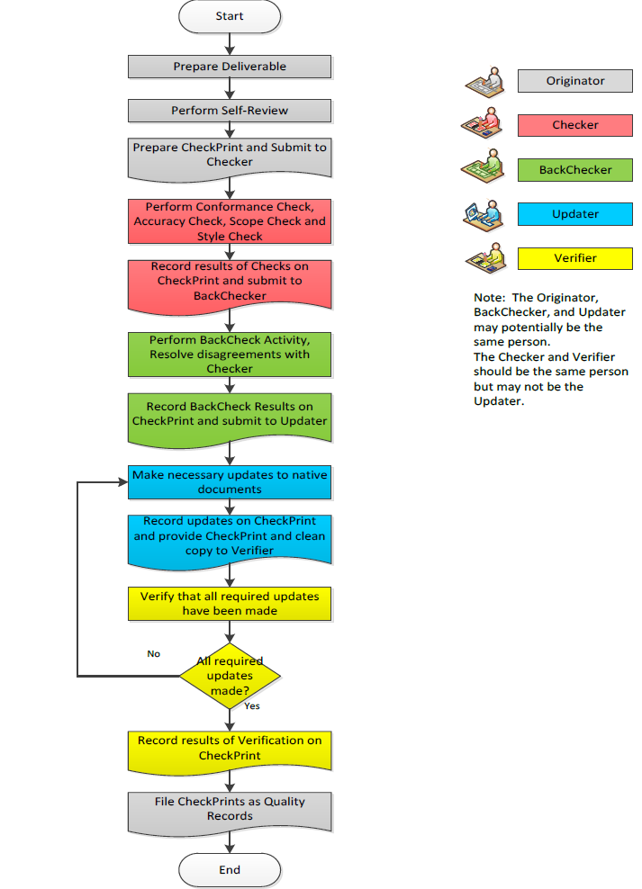

**Figure 4 Interdisciplinary QC Flowchart**

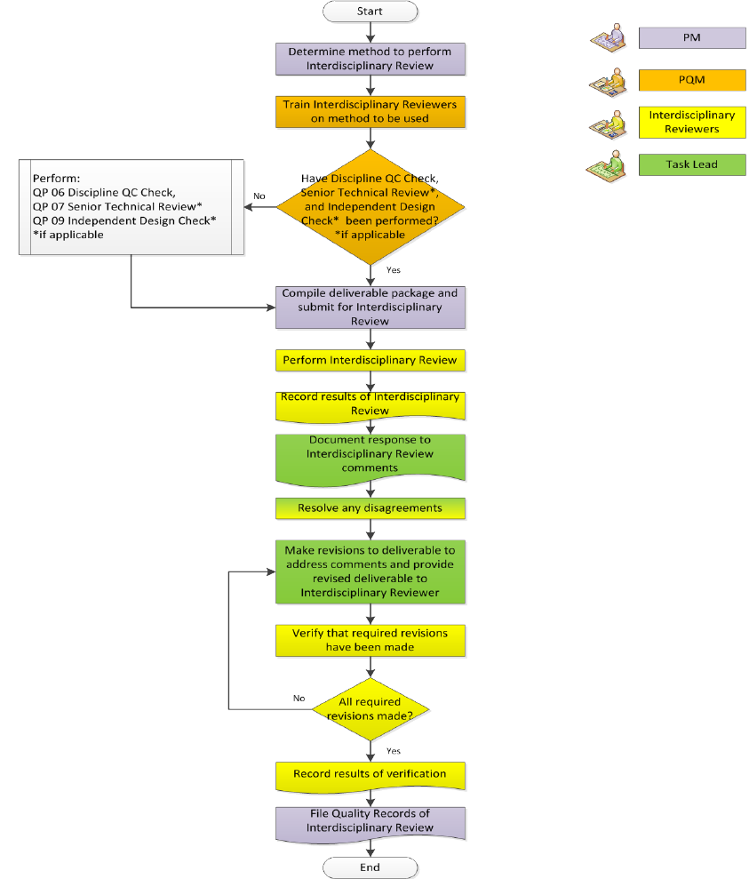



### Quality Assurance and Sufficiency Review Requirements

A “Quality Assurance Review” will be performed to determine whether or not the submittal was prepared and checked according to the scope of services requirements and if it is ready for the client’s review. Prior to the printing of each submittal, the DGP PM and DGP QCM will conduct and document the quality assurance review that will determine if the project deliverable is ready for submission and if the quality control requirements stipulated herein have been met. The DGP PM will be informed that the final draft is ready for submittal and provide approval for submittal prior to it being provided to the client. The quality assurance review will confirm that the designated staff was utilized and that the required production and review quality control and assurance processes and procedures, including the standard checking procedure, were utilized and completed.

### Quality Control Record Requirements

As a minimum, check sets of all other deliverables (electronic in Bluebeam) including studies, reports, design calculations and quantity computations will be retained in the project files until the end of the design phase for audit or examination. The required checking documents will then be archived as quality control documentation, check sets and records that include all quality control check plans and documents, and the documents are to be retained for seven (7) years after a project’s completion.

### Verification of DGP sub-consultants deliverables

While the DGP team is responsible for the overall project quality, DGP sub-consultants are responsible for performing the necessary quality control checks and reviews to ensure their deliverables meet requirements in accordance with the project Quality Control Plan, or their own quality plan. Sub-consultants shall submit a certificate of compliance with their deliverables, certifying that those deliverables have been checked/ reviewed in accordance with their own quality plan.

The DGP QCM will perform a quality assurance review of DGP sub-consultant deliverables. This quality assurance review shall consist of a review of the sub-consultant provided certificates to confirm that these processes have been followed. The DGP QCM may request actual quality check and review records from sub-consultant when deemed appropriate.

## Document Control

For Document Control procedures refer to the Project Management Plan Section 5.2 Document and Records Control.

## Communication Protocol

For project Communication Protocol refer to the Project Management Plan Section 6 Communications Management.

## Quality Assurance

For quality assurance, a monthly project review will be held to review the project progress, budget, schedule, performance, and client satisfaction. Corrective actions will be taken to address any issues identified during the monthly audit. Further, the project will undergo a regular DGP team project and client audits. The project audit is focused on verifying adherence to the standards of performance and quality control procedures. The client audit is focused on client satisfaction and change management.

For any project and client audits, standard forms and/or checklists will be used to capture items verified or discussed. Action items resulting from the meetings will be summarized and assigned to the team members with the due date (if applicable). The DGP QCM in coordination with the DGP PM and DGP DPM will be responsible for monitoring and implementing the action items. All action items will be reviewed at the next meeting or audit to verify that activities associated with the action items have been completed.

## Quantities and Cost Estimates Checking Procedures

Prior to each submittal review the responsible parties for quantities and cost estimates (including sub-consultants) are to use the “Design Checking Procedures” as described in this plan.



### Quantities

Quantity computations will be subject to the same checking procedures as the ones described in section 2.2 of this QP. Additional items specific to quantities include:

* Checks pay items and/or description against specifications.
* Check all quantities by independent approximate calculations as warranted. The degree of approximation shall be such that significant errors or omissions would be detected.
* Summaries are to be double-checked against individual sheet quantities.
* The plan reviewer shall ascertain that everything is covered for payment, either as a pay item or with a note specifying that it is incidental to a specific pay item.

### Cost Estimates

Cost Estimates shall be produced on Estimator Software or computer spreadsheets. A checker will check the estimates against the contract documents for accuracy and completeness using the same checking procedure required for calculations. The designer and DGP PM shall also review the unit cost and the project cost. Once complete, the quality process log shall be initialed.