Human Resources: Humana Enroll + Terminate

**Objective/Purpose/ Why:**

* As of 12/01/2019, ATG is offering Humana coverage for Dental and Vision ONLY. All full-time employees are eligible for benefits, the first of the month after DOH.

**Outcome:**

* **Enrollment:** The employee and dependent coverage elections should be entered into the providers online web portal and employee will obtain Dental & Vison benefits upon effective date.
* **Termination:** Due to qualifying event, employee has lost eligibility for Dental & Vison benefits. Once the event is entered into the online web portal, coverage will end on the last day of the month following employees last day of employment.

**Subject Matter Expert:**

* To access the administrative functions through Humana, the Plan Administrator may allow access to a username and you will create your own password. Contact HR Director or HR Generalist(s) with questions.

Humana: Employee Add

**Process:**

1. Login to Humana.com

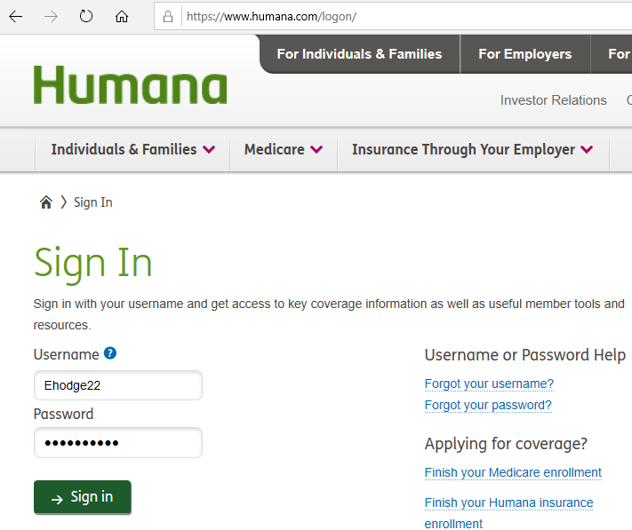

2. Add New Employee

* Hold down the dropdown menu, “Manage Employees” and under the “Update Employees” column, select “Add an Employee”.

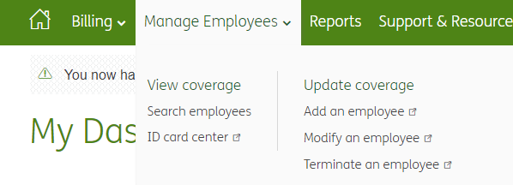

* Enter employee Social Security Number, re-enter to confirm: 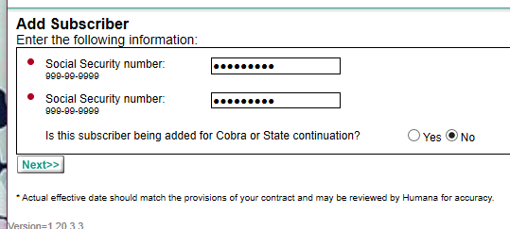
* **NOTE:** If the enrollee has previously held insurance coverage through Humana, their SSN will appear on the next page and, if you click on it, their information will partially populate.
* Unless notified otherwise by the employee, answer “No” for the Cobra Question and click “Next”.

3. Enter Employee Information:



* You must enter the employee information according to their enrollment form.
* NOTE: The “Eligibility Group” is the first option; disregard the other items on the list.

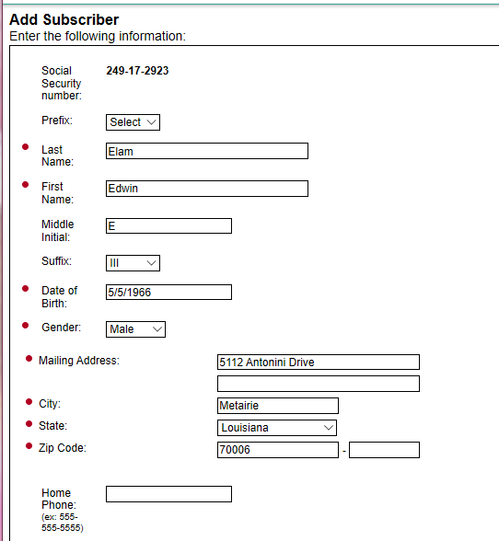 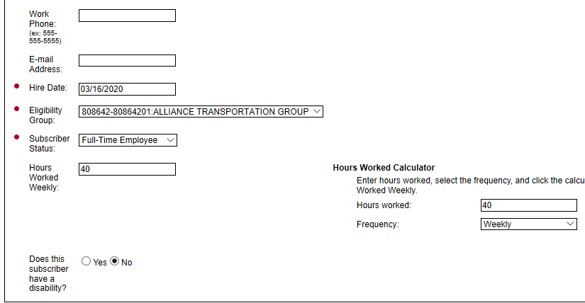



4. Select the Qualifying Event:

* Select the reason (qualifying event ie. “New Hire”) from the drop-down list, enter effective date, and the date you are entering this information.
* Click “Select & Continue”

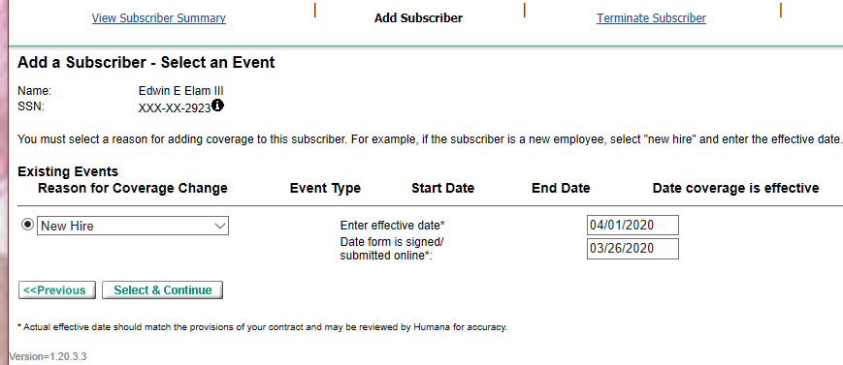

5. Enter Dependents

* Click “Add Dependent”
* **NOTE:** If the employee has had coverage through Humana prior to ATG coverage, dependents may already be listed. You may modify or delete.
* Click “Next” at the bottom to confirm.

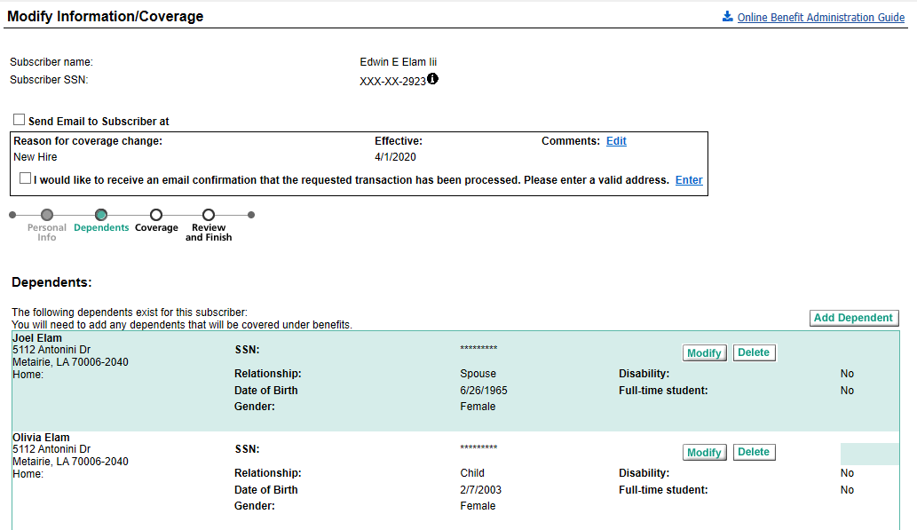

6. Select Dental & Vision Coverage.

* There is only one option for coverage, unless the employee is waiving coverage. Please designate their choice.
* Confirm that coverage is selected for appropriate dependents. Make sure you select coverage for both Dental and Vison.
* Click “Next” to complete the enrollment.

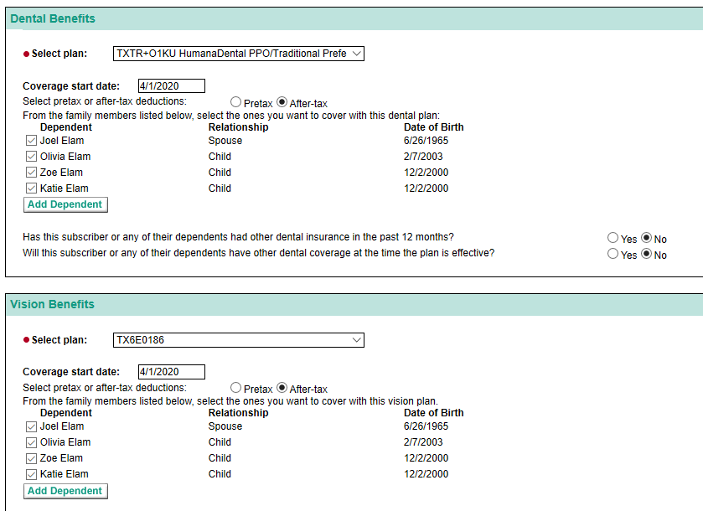

7. Review & Submit

* Review and make sure that all the employee & dependent information matches the enrollment form. If all information is correct, Click “Submit”.
* Click “View History”, print the confirmation page to PDF as documentation of enrollment
* Save documentation to the benefits folder in their personnel file named in the format, “Last name_First initial Humana Enrollment or use “OE” when entering during open enrollment (ie: Elam_E Humana OE)

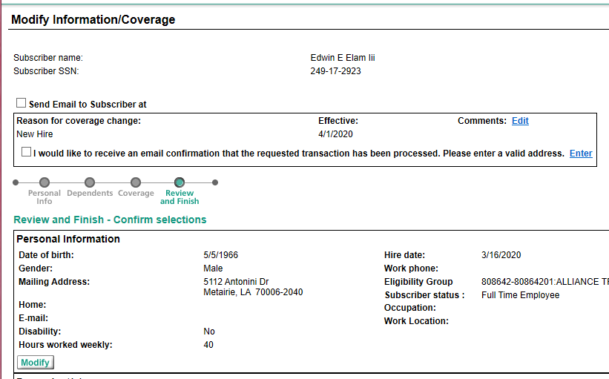

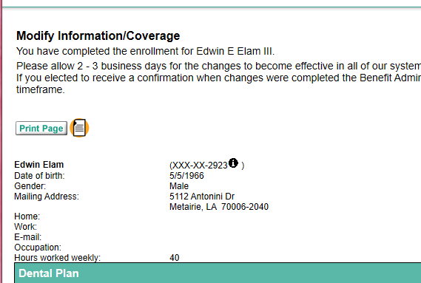

Humana: Employee Term

1. Login at Humana.com (same instructions as above)

2. Terminate Employee

* Hold down the dropdown menu, “Manage Employees” and under the “Update Employees” column, select “Terminate an employee”.



3. Add Employee Info

* Enter employee information.
* Click on their hyperlinked name.

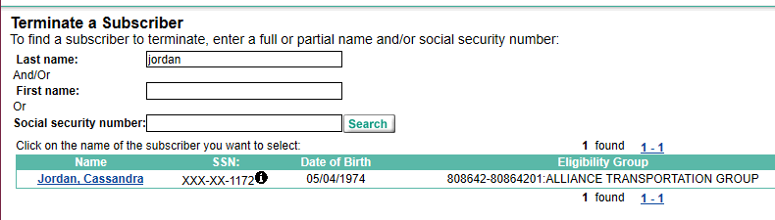

4. Terminate Details

* Enter in termination details, click “Next” when done.
* **NOTE:** Employee “Coverage Termination Date” should be the last day of the month following qualifying event date. The “Loss of Eligibility” is the day of the qualifying event ie. last day of employment (DOT).

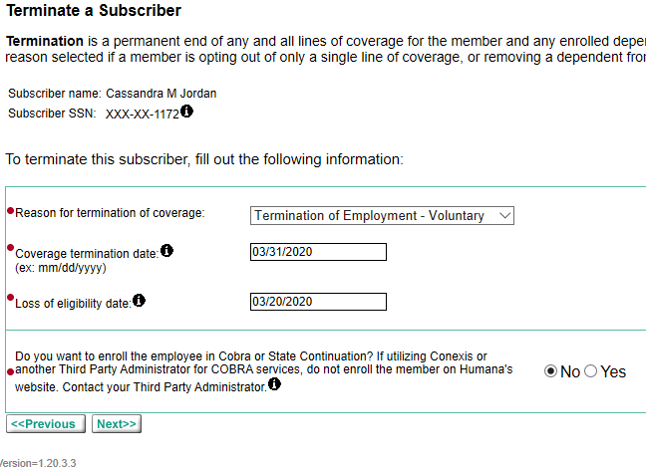

5. Review & Submit

* Review/Modify information
* Select “Submit” at the bottom of the window when all is correct and verified.
* Print the confirmation page to PDF and save to the benefits folder in their personnel file. (ie: Cassandra_ J Humana Term)

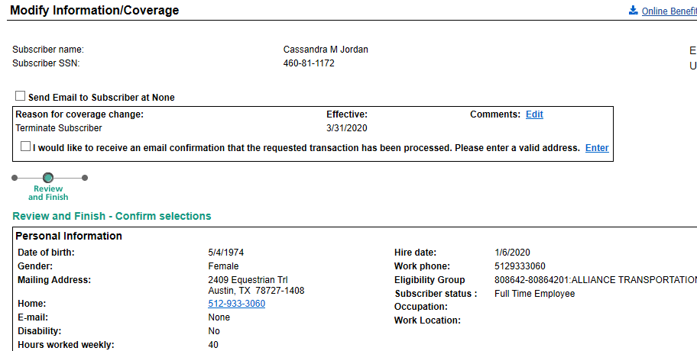

Confirmation Page to save:

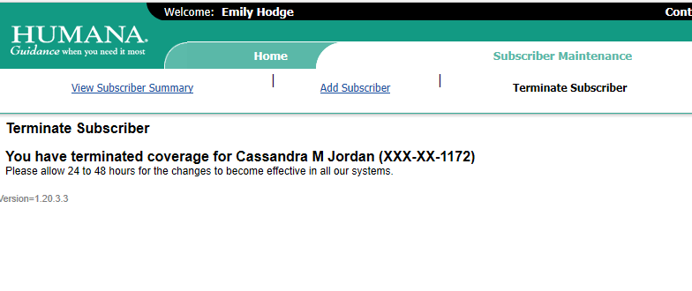

**Resources:**

* Provider’s enrollment form can be found on the providers website. A printed copy is often stored in the HR Director’s office.
* Employee must complete and submit their enrollment form to a member of the HR team. A copy of the employees Enrollment will be saved to their personnel file in the benefits folder.
* A copy of the employees Humana Term should be saved to their personnel file in the benefits folder.

**Definitions:**

* **Humana:** As of Dec 1, 2019, ATG’s elected Dental & Vison benefits provider for full time employees.
* **Dependents:** Spouse, Children. etc.
* **Termination:** Cancelation of benefits due to qualifying event.
* **Coverage Termination Date:** Last day of the month.
* **Loss of Eligibility Date:** Day of qualifying event (ie. Date of termination).