HOW-TO:

UPGRADE SELFIMATIK CODE

July 2023 - Ver 0.1
Author : Gales Florent / rataflo@free.fr

Install Arduino

- Visit https://www.arduino.cc/en/software and download the Arduino IDE for your platform.
Nb : On windows before version 10 select MSI installer .
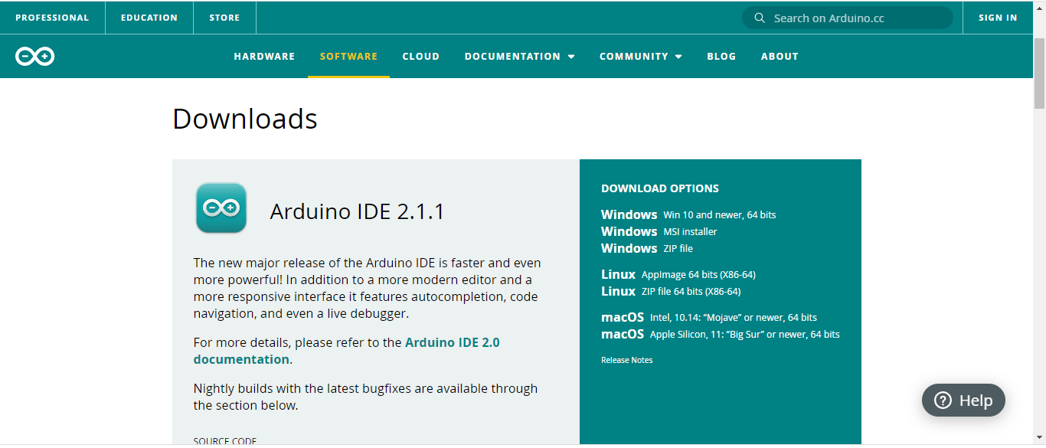

2 – Execute installer and follow the on-screen installation instructions.

3 – Visit https://github.com/rataflo/selfimatik.
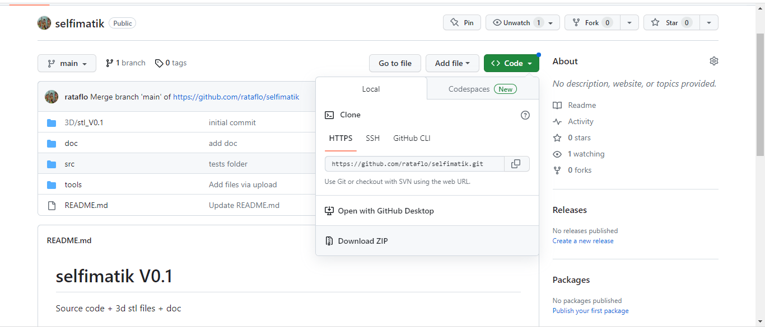
4 – Download the source code by clicking the green button "<>Code" and choose "Download ZIP."

5 – Extract the contents of the ZIP file to your hard drive.

6 – Navigate to the folder \selfimatik-main\src\selfimatik and double-click on selfimatik.ino.
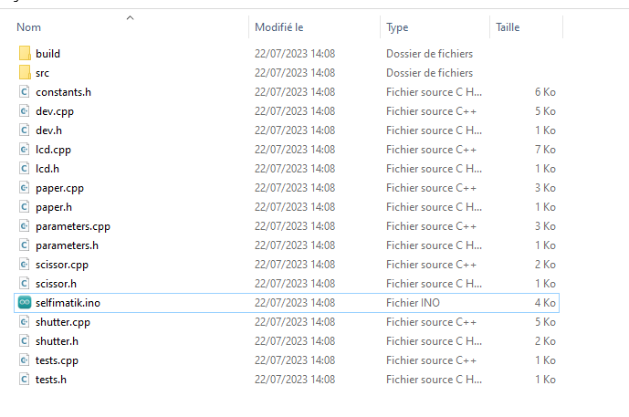

- 7 – The Arduino editor will load the source code (please be patient as it may take a moment to open).
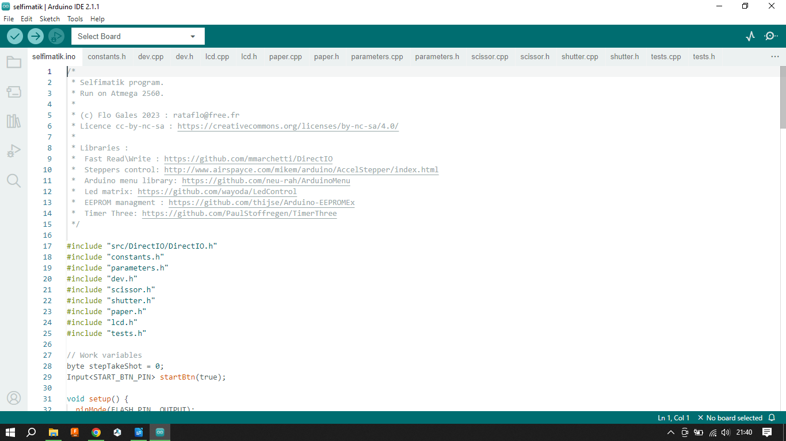

8 – From the "Select board" drop-down menu, choose "Select other board and port." Look for "Arduino Mega or Mega 2560" board, select it, and close the window.

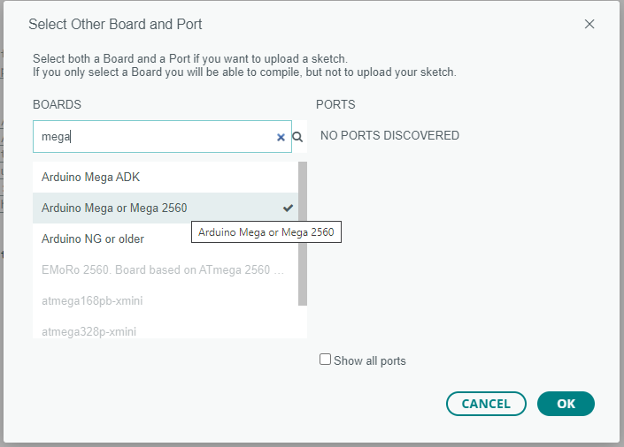

9 – Compile the code by clicking the "Verify" button.

If the compilation is successful, you will see the following text in the Output:

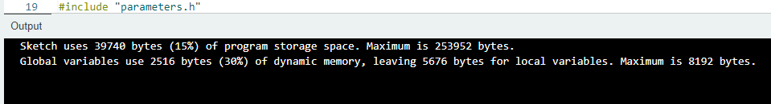

Upload procedure

Ok, now go with your laptop to the Selfi.
Make sure that everything is OFF.

- Connect the USB cable from the control board to your laptop. Windows should automatically install the required drivers. If not, go to selfimatik-main\tools and install the drivers from the FAT_232_driver.rar archive.
If you don't have software to extract RAR files, I recommend using https://www.7-zip.org/ - it's a free and open-source tool.

- Return to the Arduino editor and go to the menu Tools → Port. If a USB port is displayed in the list (COMxx), select it.

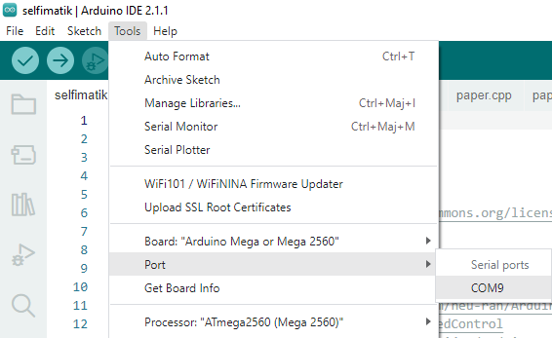


- Press the "Upload" button.

If there are no errors, you will see LEDs flashing during the upload process. Once the upload is complete, you can unplug the board, and the process is finished. For future updates, simply download the new code, launch Selfimatik.ino, plug in the USB, and upload the code.

