
Swarmed Parallel Interpreter for Numerical Analysis with Collaborating Hubs

Interpreter Core Team
(ICT)
B Level Specification
for
Software Development

version 1.4
10 November, 2009

Rajika Tandon
M.S., Computer Engineering

Team members:
Sushma Thimmappa (M.S., Computer Science)
Rucha Bapat (M.S., Computer Science)
Chetan Thawani (M.S., Computer Engineering)

Table of Contents

1. Architecture 4
2. Reference Documents 5
2.1. Architectural Concept Document 5
2.2. Detailed A-Level Specifications 5
3. Requirements 5
3.1. Functional Requirements 6
3.1.1. Traversing & Executing 7
3.1.1.1. Traversing & Semantic Check 8
3.1.1.1.1. inputs 8
3.1.1.1.2. processing 8
3.1.1.1.3. outputs 9
3.1.1.2. Non-Parallel Commands Executing 9
3.1.1.2.1. inputs 9
3.1.1.2.2. processing 9
3.1.1.2.3. outputs 10
3.1.1.3. Plot Handling 10
3.1.1.3.1. inputs 10
3.1.1.3.2. processing 10
3.1.1.3.3. outputs 10
3.1.2. Parallel Handling 10
3.1.2.1. Data Structure Conversion 11
3.1.2.1.1. inputs 11
3.1.2.1.2. processing 11
3.1.2.1.3. outputs 12
3.1.2.2. Sending 12
3.1.2.2.1. inputs 12
3.1.2.2.2. processing 12
3.1.2.2.3. outputs 13
3.1.2.3. Receiving & Interpreting 13
3.1.2.3.1. inputs 13
3.1.2.3.2. processing 13
3.1.2.3.3. outputs 13
3.2. Process Requirements 13
3.2.1. Physical Structures 13
3.2.2. Development Environment 14
4. Data Dictionary 15
5. Requirements Traceability Matrix 17
6. Notes 19
APPENDIX 20
GLOSSARY 21
REFERENCES 21

Architecture
Interpreter Core Processing to be carried out by the ICT, takes data structure (abstract syntax tree - AST), from the parsing/front team (the grammar to be used in the program is decided by the Front End Team according to the A-level requirements).

From this AST, the non-parallel part is executed by the ICT and parallel commands are packaged into an intermediate code form and send to swarm. After execution of the parallel commands, the swarm team sends the results of parallel execution back to the ICT.

ICT also packages the plot commands and related data in the form of data sets to be send to the plotting team.

The result map along with the errors (if any) encountered will be notified to the display team.

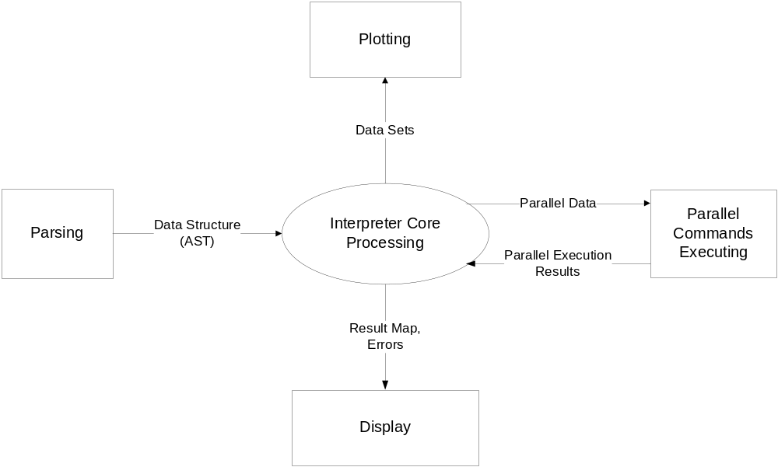

Figure 1: SPINACH - ICT Context Diagram

The above diagram depicts the context diagram of the Interpreter Core Team (ICT)’s interaction with other teams. Processing performed by ICP is divided into five major components, as shown in fig. 1 and described below:
- Interpreter Core Processing (ICP) accepts SPINACH commands stored in abstract syntax trees (ASTs). These commands can be declarations or processing of variables (strings and scalars or matrices of either doubles or integers), structures, functions, assignments, if, for, parallel-for, sync-for statements and plot commands. ICP stores all the variables in a result (hash) map.

- Among all the input statements, ICP is responsible for executing all the non-parallel instructions, which can be any statement other than parallel-for, sync-for and plot commands (Refer to appendix for details). Whenever parallel commands are encountered, ICP packages and send them to the swarm for parallel execution.

- While ICP is not responsible for executing plot commands, it packages them into data sets for execution by the plotting team.

- ICP performs semantic check on all the commands and throw any semantic error encountered (to be displayed on the User Interface).

- After execution of commands, ICP sends the result map and errors (if encountered) to the User Interface for display.

Note that the terms “parallel-for”, “sync-for”, are used to denote parallel for and parallel for synchronization statements. The name may differ in the actual syntax to be decided by the front end team.

Reference Documents

Architectural Concept Document
SPINACH, Architectural Concept Document Version 1.1,
Monday 19 October, 2009

2.2. Detailed A-Level Specifications
SPINACH, Detailed A-Level Specifications Version 1.1,
Monday 19 October, 2009

Requirements
Processing for the ICP program is divided into two major processes:
- traversing and executing, and
- parallel handling.

Each of these processes is divided into a set of sub processes and responsible for a set of requirements, described in this section.
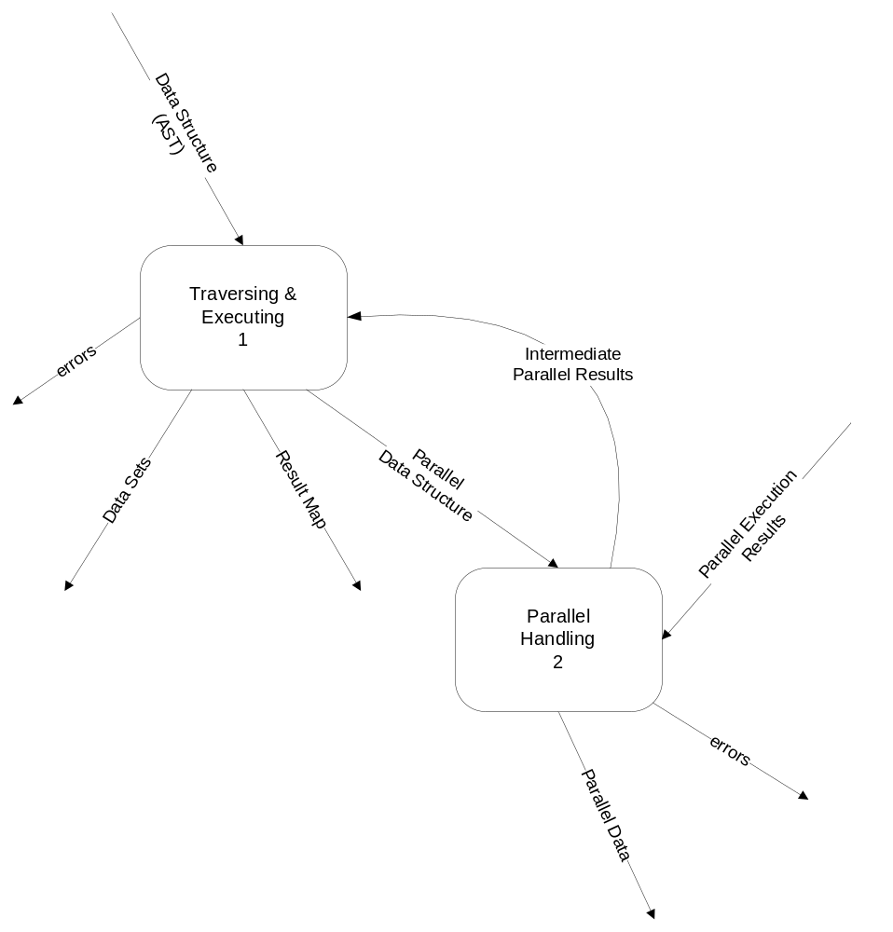

Figure 2 - Data Flow Diagram 1

Functional Requirements
This section describes the activities required of the ICP program.

Traversing & Executing
This process is responsible for traversing the AST (abstract syntax tree) received from the parsing module, for identifying the various data and code elements present in it. The identified non-parallel commands are to be executed and the parallel-commands along with the required data are to be sent to the parallel handling module. After receiving the intermediate results from the parallel module, further execution will take place. This process will output the result set, report semantic errors, as well as, identify the plot data and commands and package them as data sets.
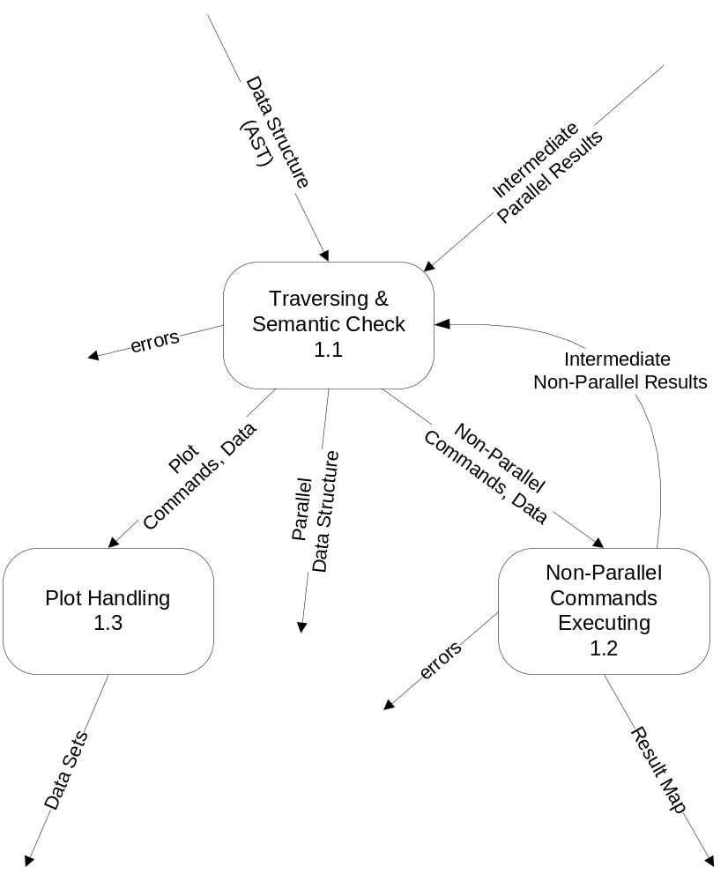

Figure 3 - Data Flow Diagram 1.1

Traversing & Semantic Check
This process is responsible for traversing the AST and identifying the non-parallel, parallel as well as plot commands encountered. Semantic errors are also checked in this process.

inputs
- Data structure of the entire code in the form of AST, as received from the parsing module.
- Parallel intermediate results
- Non-parallel intermediate results
(The terminology intermediate results due to the fact that these results might be needed for further execution of the code.)

processing
This process shall traverse the AST and identify various operations/statements (explained below) which are to be executed in a non-parallel or parallel manner, as well as plot data/commands (as decided by the plotting team). It shall also report semantic errors found (if any).

The parallel commands will include parallel-for and sync-for statements and will be returned as it is with the statements present in their bodies and the required data for further processing.

The plot commands will be identified by using the names of the functions as specified by the plotting team. The semantic evaluation for these commands includes type checking of the parameters to the plot functions, where the data types of the parameters are syntactically correct. The commands/data needed for plot will be returned for further processing.

The rest of the commands (which are neither parallel nor plot commands), will be identified as the non-parallel commands, checked semantically and returned by this process for further processing.

The non-parallel commands include:
a. creation of variables (strings and scalars or matrices of either doubles or integers);
b. creation of structures;
c. assignment;
d. non recursive functions that can accept multiple values and return single value;
e. if statements;
f. tests for equality and inequality (relational operations);
g. for loops;
h. deletion of variables;
i. display of variables (strings and scalars or matrices of either doubles or integers);
j. comments.

3.1.1.1.3. outputs
- The plot commands (along with their parameters in the form of variables and constants just the way present in the code) are returned, as well as, the related data (computed values of the variables) needed by these commands are returned.
- Parallel portions of the code in the form of a data structure (AST).
- Non-parallel commands and required data needed for execution.
- Semantic errors encountered in the code.

Non-Parallel Commands Executing
This process is responsible for executing all the non-parallel commands.

inputs
- Commands and data to be executed in a non-parallel manner.

processing
This process shall execute all the input statements in a non-parallel way. The input includes creation of variables (strings and scalars or matrices of either doubles or integers), creation of structures, assignment, support for non recursive functions that can accept multiple values and return single value, if statements, tests for equality and inequality, for loops, deletion of variables, display of variables (strings and scalars or matrices of either doubles or integers). Comments encountered shall not be executed.

This process shall use a proper data structures (like hash map) for storing the values of variables encountered.

Only the print commands shall be used to construct the result map, where the print commands either contain a string message or a variable.

It shall throw any error encountered during execution.

3.1.1.2.3. outputs
- It will return the results of non-parallel computation (in the form of intermediate results) since these results might be needed for further execution of the code, or needed by the plot commands.
- This process will return the result map which contains the final values of all the variables/computation performed in the code.
- It will generate error messages in case of exceptions which occur during non-parallel commands’ execution.

Plot Handling
This process is responsible for constructing and returning the data sets (plot commands and required data) for plotting.

inputs
This process will get the plot commands and required data.

processing
This process shall package the plot commands along with the related data (values of the parameters of the plot commands) in a data structure so that those data sets can be used by the plotting team to execute the plot commands.

outputs
The data sets (plot data structure) will be returned.

Parallel Handling
This process is responsible for packaging the parallel commands for execution by the swarm.

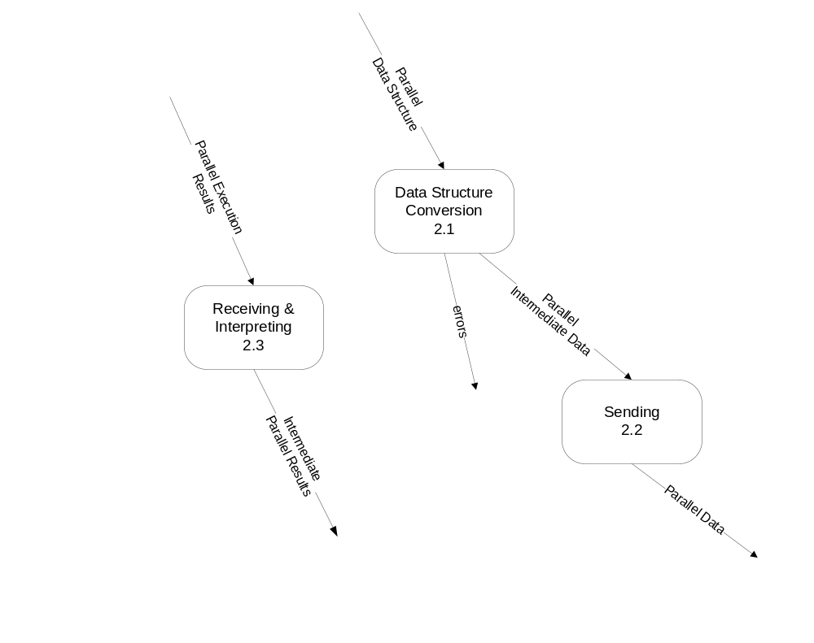Figure 4 - Data Flow Diagram 2.3

Data Structure Conversion
This process is responsible for packaging all parallel commands to an intermediate code form.

inputs
Input to this process is the parallel data structure which contains only those instructions that can be executed in parallel, i.e. data containing the parallel commands: parallel-for and sync-for.

processing
Commands to be executed in parallel and the related data shall be converted into an intermediate code form such that it is easily transferrable over a network and can be constructed back into the AST data structure by other computers in the swarm.
Prior to the conversion, this process shall perform loop condition check. For e.g. if a parallel-for (say for-loop control variable’s automatic increment by 1 is supported), of the form:
parallel-for x = 5 to 3
…..
end for;
such that the loop condition is not satisfied the first time itself (here x=5 to 3 with a positive increment will dissolve the loop at the initial condition itself), then there is no need to convert the entire parallel-for loop into intermediate code form.

Errors occurring during the conversion of the loop bodies shall be reported, i.e. validity of the loop and its statements are checked before conducting such expensive operations like converting into intermediate code form which is to be transmitted over a network, though it has to result in error. For e.g. if a matrix ‘a’ has size 4, but the following is mentioned inside a parallel for:
parallel-for x = 5 to 8
b[x]=a[x] + c[x];
end for;

When the parallel-for will contain synchronization statements (sync-for), any execution after a sync statement shall proceed only after the statements before sync statement finish their execution. This is applicable to any number of SYNC statements.

3.1.2.1.3. outputs
- The intermediate parallel data is returned.
- Errors that may have occurred during processing as described above.

Sending
This process is responsible for sending the parallel data (intermediate code which represents parallel commands along with their related data) to the swarm.

inputs
Inputs to this process are the intermediate parallel data.

processing
The received input in the intermediate code form shall be send to the swarm.
(As per the A-Spec requirement 3.1.2.5, a mechanism such as calling an API provided by the swarm team could be used to do so.)

3.1.2.2.3. outputs
- Parallel data (commands which are to be executed in parallel along with required data)

Receiving & Interpreting
This process is responsible for un-packaging/assembling all the parallel execution results into a parallel result map.

inputs
- Parallel execution results which will be in an intermediate code form.

processing
This process shall receive the parallel execution results, which will be in the intermediate code form, from the swarm and extract values of the modified variables.

This process shall return the extracted/converted results (to the traversing and executing process as shown in fig. 2) for further execution of the code, i.e. it will update the new values of the variables received from the swarm.

3.1.2.3.3. outputs
The intermediate parallel data is returned.

Process Requirements
These requirements specify physical structure of the code developed and the environment where it must operate. The input shall be syntactically correct data structure received from the front end team.

ICP shall document SPINACH input language semantics and error messages on web pages. The documentation shall have a table of contents.

Physical Structures

3.2.1.1 The Interpreter Core Processing (ICP) program shall consist of modules. A module is either an executive of which there is only one per program, or a server. There may be as many server modules as deemed appropriate by the development team.

3.2.1.2 ICP shall be implemented using Visual C# .Net.

3.2.1.3 The user interfaces shall delegate all operation to server modules, not directly associated with providing the user interfaces.

3.2.1.4 Each module in C# shall be provided with manual pages and correct maintenance pages.

3.2.1.5 Each server module shall be provided with a test configuration.

3.2.1.6 The main function shall be enclosed by preprocessor statements preventing compilation unless the preprocessor detects a directive of the form TEST_MODULENAME, where MODULENAME is the name of the module with no extension.

3.2.1.7 Each implementation file in C# shall begin with a prologue that contains descriptions of the following elements:
- file name with a few word summary
- version number
- language of implementation
- platform, e.g., computer and operating system
- application
- author with e-mail account

Development Environment

3.2.2.1 The Interpreter Core Processing program shall build and operate in the ECS clusters, e.g., Link 010, 201, 202, 274, or CST 2-112.

Data Dictionary

Message Name | Interpretation | DFD
Data Structure (AST) | Input code in the form of ASTs | DFD 1
errors (process 1) | Semantic errors reported in the code | DFD 1
Data sets | Semantically correct data to be sent to the plotting team for execution | DFD 1
Result Map | Data structure containing messages or computed values of the variables given in print command | DFD 1
Parallel Data | Code containing parallel commands to be executed by the Swarm | DFD 1
Intermediate Parallel Results | Results of parallel computation (as fetched from the swarm memory) | DFD 1
Parallel Execution Results | Result of execution of parallel code statements | DFD 1
errors (process 2) | Errors reported during the parallel commands’ handling | DFD 1
Parallel Data | Code to be executed in parallel and required data represented in intermediate code form for Swarm | DFD 1
Plot Commands, Data | Commands to plot the data which contain the parameters | DFD 1.1
Non-Parallel Commands, Data | Non-parallel code statements to be executed by ICT and the required data for execution | DFD 1.1
Intermediate Non-Parallel Results | Results of execution of non-parallel code statements (which may be needed in further execution of code) | DFD 1.1
errors (process 1.2) | Errors reported during the execution of non-parallel commands | DFD 1.1
Parallel Intermediate Data | Intermediate parallel code and data | DFD 2.1
errors (process 2.1) | Errors reported during the conversion of parallel commands into intermediate code form | DFD 2.1

Figure 5 - Data Dictionary

Requirements Traceability Matrix

B-specification | A-Specification | Comment
3.1.1.1.2.a | Derived | Traversing ASTs for identifying various operations, which can be categorized into parallel (parallel-for and sync-for, to be converted into an intermediate code form), plot commands (to be converted into data sets), and rest all other non-parallel operations (to be executed by the core team). (Refer to Appendix for details.)
3.1.1.1.2.b | 3.1.2.7 | Reporting semantic errors
3.1.1.2.2.a | 3.1.2.1 | Execution of non-parallel commands
3.1.1.2.2.b | Derived | Comments to be ignored
3.1.1.2.2.c | 3.1.2.6 | Storing variables and their values in a proper data structure
3.1.1.2.2.d | Derived | Only variables/messages mentioned in the print commands to be displayed
3.1.1.2.2.e | Derived | Errors encountered during the execution of non-parallel commands
3.1.1.3.2 | 3.1.2.2 | Forming data sets for plotting team
3.1.2.1.2.a | 3.1.2.3 | Parallel commands’ representation into equivalent intermediate code form
3.1.2.1.2.b | Derived | Conditional checks on parallel/sync for loops prior to converting into intermediate code form
3.1.2.1.2.c | Derived | Errors encountered during the conversion of parallel commands
3.1.2.1.2d | 3.1.2.4 | Handling of parallel-for synchronization statement
3.1.2.2.2. | 3.1.2.3 | Sending the intermediate code form to the swarm
3.1.2.3.2.a | 3.1.2.5 | Receiving results from the swarm
3.1.2.3.2.b | Derived | Assembling received results from the swarm
3.2.a | 3.1.2.8 | Documentation of SPINACH language semantics and error messages
3.2.b | 3.1.2.8 | Documentation containing a table of contents
3.2.1.1 | 3.2.1.1 | Source code consisting of modules
3.2.1.2 | 3.2.1.2 | Program to be implemented in Visual C# .Net
3.2.1.3 | 3.2.1.3 | User interfaces, which are not directly providing user interfaces, delegating all operations to server modules
3.2.1.4 | 3.2.1.4 | Modules to be provided with manual and maintenance pages
3.2.1.5 | 3.2.1.5 | Each server module providing a test configuration
3.2.1.6 | Derived | A function’s compilation to be performed only if appropriate preprocessor directive is defined
3.2.1.7 | Derived | Implementation File prologues to be provided
3.2.2.1 | 3.2.2.1 | Development environment

Figure 6 - Requirements Traceability Matrix

6. Notes

ICT B-Specification 1st release: 19th October, 2009

ICT B-Specification 2nd release: 23rd October, 2009

ICT B-Specification 3rd release: 29th October, 2009

ICT B-Specification 4th release: 10th November, 2009

Revisions:

1st Release 3.1: Parallel execution handled by:
- Interpreting Code process for packaging parallel data into intermediate code, and
- Integrating Code Results for un-packaging/assembling parallel results
2nd Release 3.1: Separate sender and receiver processes in parallel handling process.

1st Release 3.1.3.2.2: Initial Release described intermediate code form of parallel commands and data to be represented in the form of byte codes.
2nd Release 3.1.2.1.2: Byte codes methodology omitted in this release.

2nd Release SPINACH: has the full-form: Swarmed Parallel Interpreter for Numerical Analysis with Collaborated Hosts.
3rd Release SPINACH: full form corrected to - Swarmed Parallel Interpreter for Numerical Analysis with Collaborating Hubs.

3rd Release 3.1.2.2: This version described that the core team is responsible for sending a notification message to the swarm after loading the swarm memory with the intermediate code form/data.
4th Release SPINACH: Sending notification message to the swarm has been omitted.

3rd Release 3.1.2.3: This version described that the core team will receive a notification message for the swarm after the intermediate code form/data is loaded by the swarm.
4th Release SPINACH: Receiving notification message from the swarm has been omitted.

APPENDIX

The following describes the various code related operations involved in SPINACH:

Non-parallel commands/  statements | : | Non-parallel SPINACH syntax commands stored in abstract syntax trees including:  a. creation of variables (strings and scalars or matrices of either doubles or integers);  b. creation of structures;  c. assignment;  d. support for non recursive functions that can accept multiple values and return single value;  e. if statements;  f. tests for equality and inequality (relational operations);  g. for loops;  h. deletion of variables;  i. display of variables (strings and scalars or matrices of either doubles or integers);  j. comments.
Parallel commands/ statements | : | The following statements are to be converted into an intermediate form to be executed by the swarm in parallel. They are:  a. Parallel for statement (referred to as “parallel-for” in this document)  b. Parallel for synchronization statement (referred to as “sync-for” in this document)
parallel-for | : | For loop to be send to swarm for executing the block of statements in its body, in parallel.
sync-for | : | Parallel for synchronization statement. This command can occur inside the parallel-for only (as specified by the grammar). All the statements inside the parallel-for which comes before the “synch” statement should be executed first and only then the statements coming after “sync” statement will be executed.  This is similar to having separate for parallel-for loops, where first one contains the statements before first sync statement, second parallel-for statement containing statements after first sync and before second sync, or all the statements after sync, if no more sync statements are present, and so on.
plot commands | : | There will be several procedures/methods covering the plot functionalities which will be decided by the plotting team. The plot commands will be given by the user in the code itself, which the ICT will receive from the parsing module (front end team). The variables/data present as parameters in these commands, will be computed by the ICT during the program run, and then will pass the command and its required data, in the form of data sets, to the plot team for actual plotting.

GLOSSARY

AST | : | Abstract Syntax Tree is a tree representation of the abstract (simplified) syntactic structure of source code written in a certain programming language.
SPINACH | : | Swarmed Parallel Interpreter for Numerical Analysis with Collaborating Hubs (Refer to Architectural Concept Document, Version 1.1, for details).
ICT | : | Interpreter Core Team
ICP | : | Interpreter Core Processing
API | : | Application Programming Interface, an interface that a software program implements in order to allow other software(s) to interact with it.

REFERENCES
- | Architectural Concept Document Version 1.1 by Yehong Wang
- | Detailed A-spec Version 1.1 by Yehong Wang
- | Duplicates B-Level Requirements Specification by Dr. Jim Fawcett  http://pcpratts.mysite.syr.edu/cse784/lec01/
- | http://en.wikipedia.org/

