NETWORK TRAFFIC ANALYSIS
& SOCIAL ENGINEERING DEFENSE
Project | VI-Systems Case Study | Training/Lab Use Only

Report field | Value
Case ID | VI-SEC-P5-001
Prepared by | SACHIN
Date | 24-10-2026
Environment | Kali Linux / Wireshark / instructor-provided evidence
Status | Training/ Simulation

1. Executive Summary

This project focuses on analyzing network traffic and identifying possible social engineering threats in the VI-Systems case study. Wireshark was used to examine a practice network capture, and SHA-256 hashing was performed to maintain evidence integrity.

As the original PCAP, email file, and incident timeline were not available, the analysis is limited to practice evidence with my personal spam mail. The project also covers basic security measures to help prevent phishing and similar attacks.

2. Scope and Methodology

This project focuses on analyzing network traffic and suspicious emails to identify possible phishing and social engineering threats. Wireshark was used to inspect network packets, protocols, endpoints, and DNS queries.

Email headers and authentication results were also considered, and a SHA-256 hash was generated to maintain evidence integrity. The findings are limited to the practice data available, as the original instructor-provided files were not available during the analysis.

3. Task 1 — Evidence Manifest
Evidence ID | Filename | SHA-256 | Source / received time | Notes
E-01 | greetings.pcap | c131d19dcb5730488138f4c09dbd6581e02e5d946672bd5e5bfd9d304f865206 | Self Wireshark | Personal spam mail practice
E-02 | Greetings.eml | e1ec3a1d26ed7d154b3a761d6f3fc6822a6ef6ce328878fd392dbba1a498ed9d | Personal email spam for practice | For training only from my personal mail id

Kali commands:
- mkdir -p /root/Project5/evidence/practice
- dumpcap -i any -a duration:45 -w /root/Project5/evidence/practice/greetings.pcap
- ls -lh /root/Project5/evidence/practice/greetings.pcap
- sha256sum /root/Project5/evidence/practice/greetings.pcap
- find /root /home -type f -iname "greetings.pcap" 2>/dev/null

4. Task 2 — PCAP Overview
Item | Observed result
Capture start/end and timezone | 41.939403790 seconds/ start- 2026-10-24 08:11:47.392634728 & end- 2026-10-24 08:12:29.332038518
Total packets | 364
Protocols | IPv4,IPv6,TCP,UDP,DNS,TLS
Relevant endpoints | 142.251.157.7(address B), 192.168.0.198(Address A), Duration-12.124686, 92 packets
Filter used | IPv4

Screenshots:
Figure 1 — Protocol Hierarchy
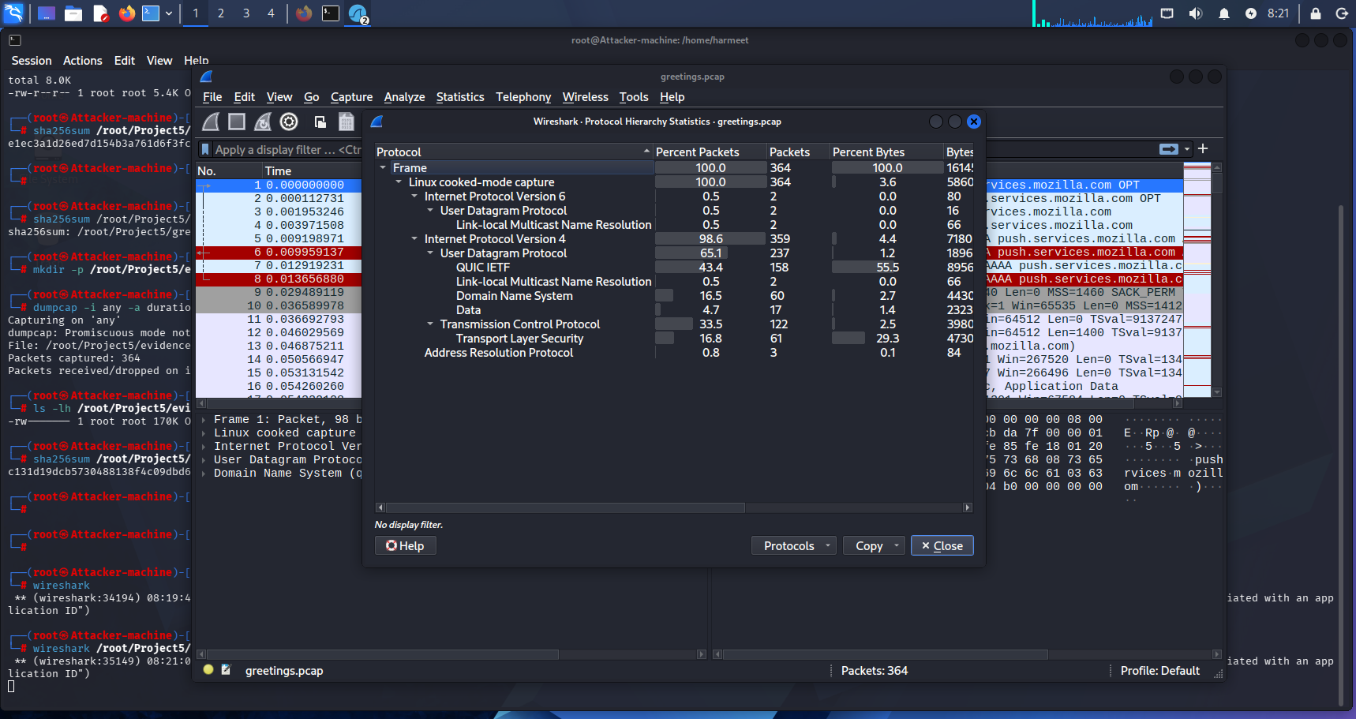

Figure 2 — Conversations.
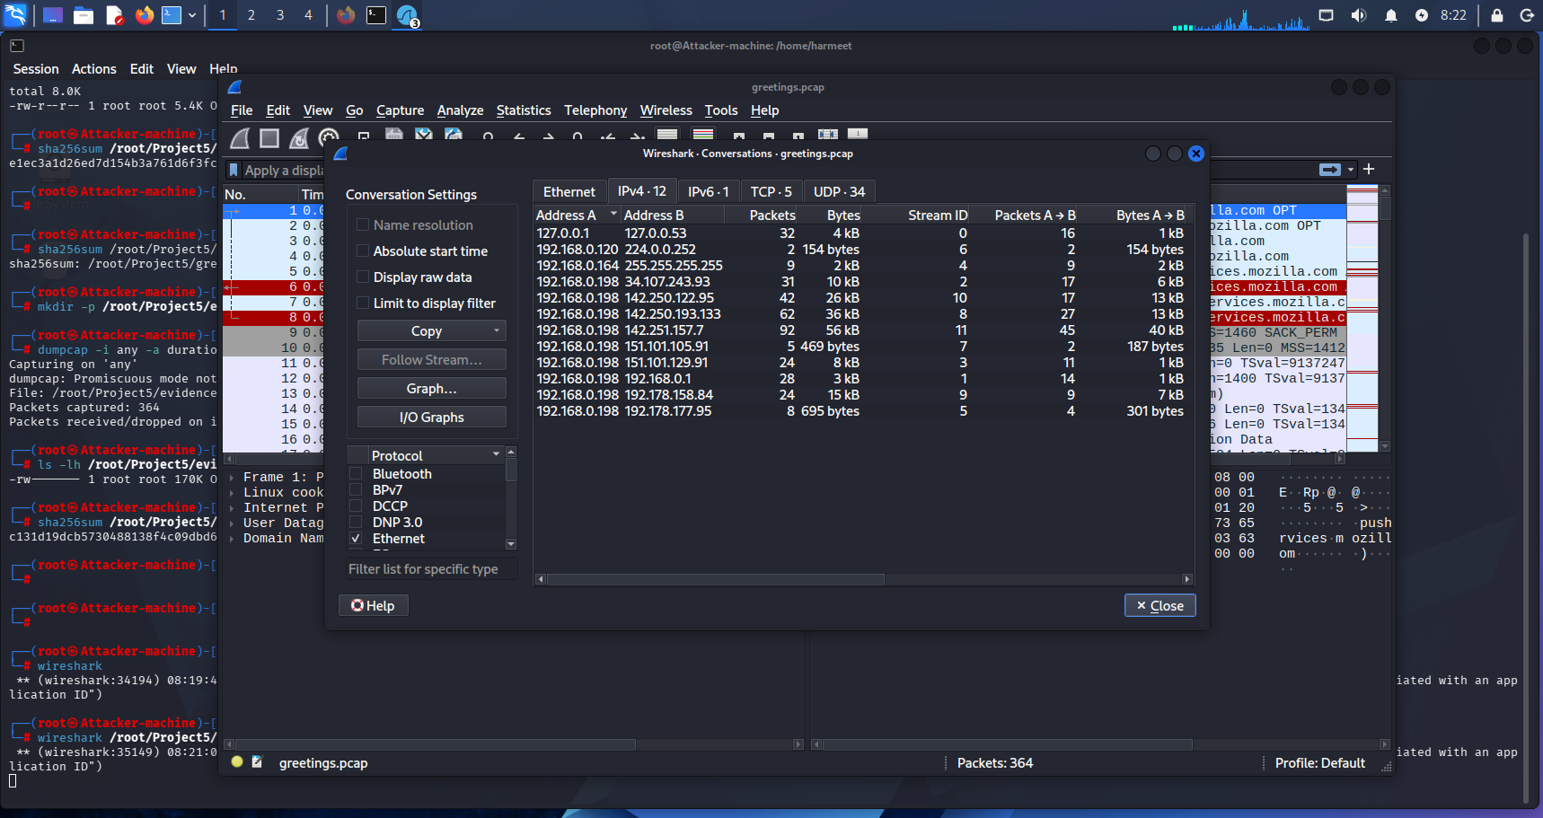

5. Task 3 — DNS and Connections
Evidence ID | Packet No. | Source IP | Query / destination | Observation / interpretation
E-04 | 244 | 192.168.0.198 | 192.168.0.1 | Play.google.com
E-05 | 249 | 192.168.0.1 | 192.168.0.198 | Standard Query Response/No error

Screenshots for Evidence:
All Protocols of greetings.pcap
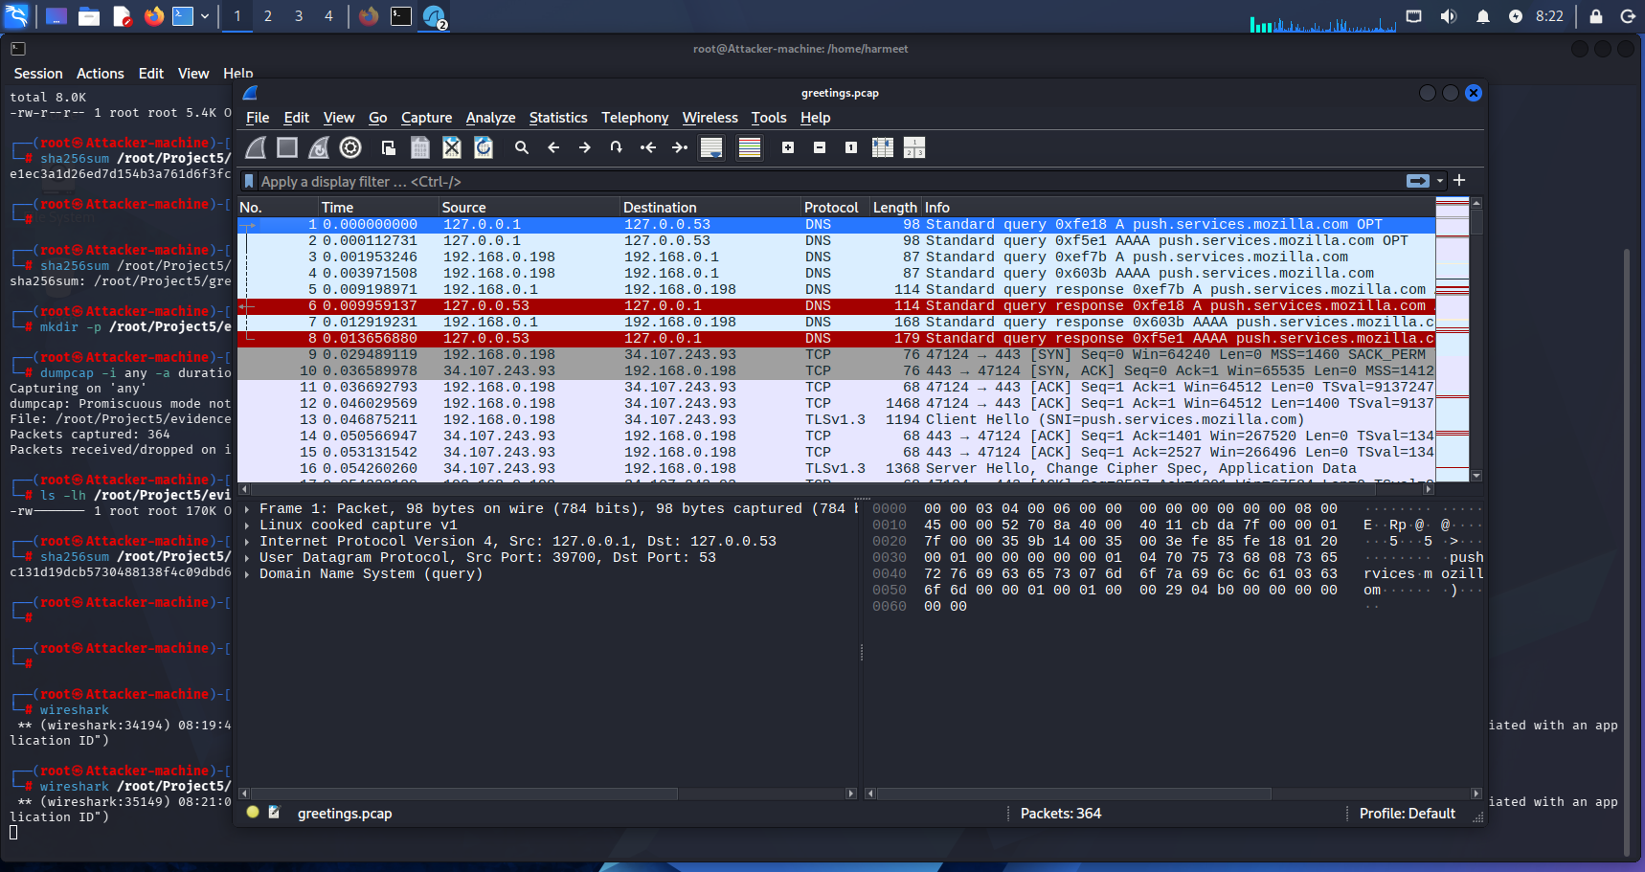
All DNS QUERIES with Display Filter Bar
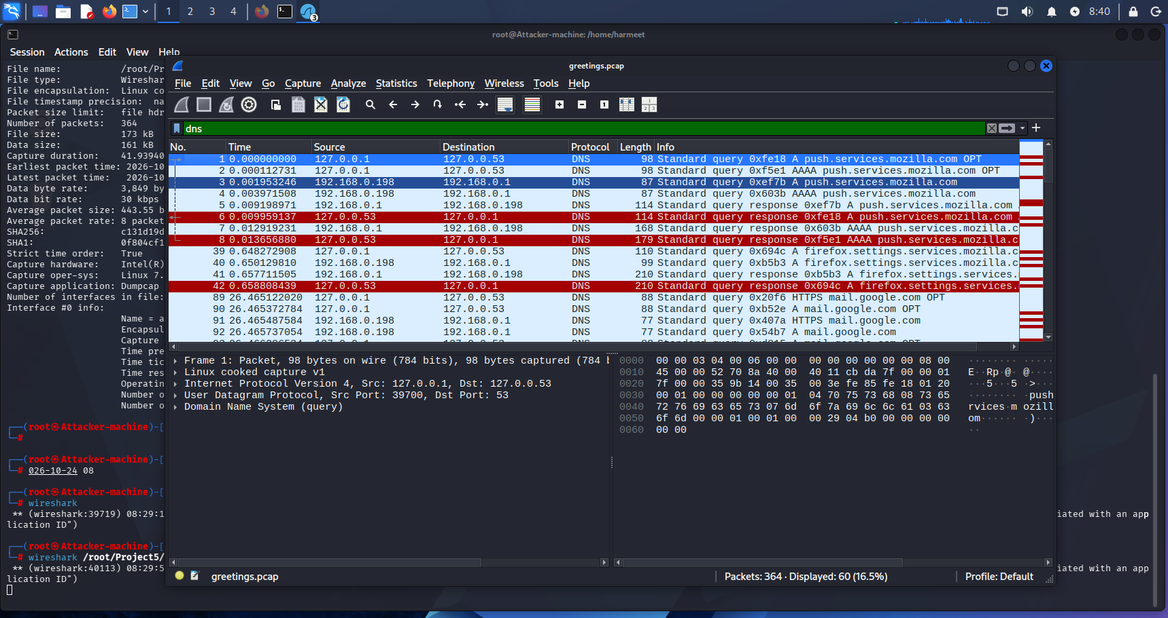
DNS Queries List (E-04)
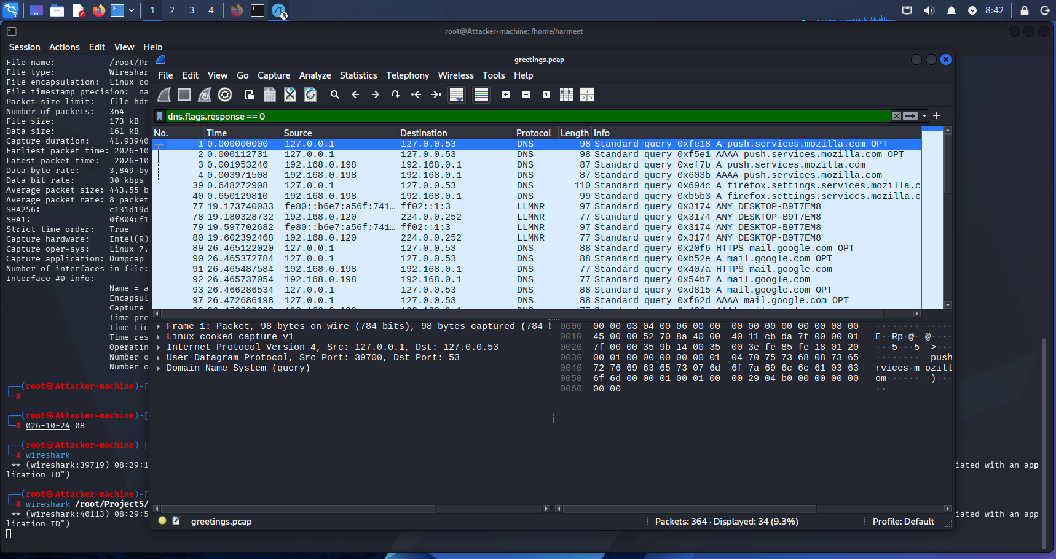
DNS Responses List(E-05)
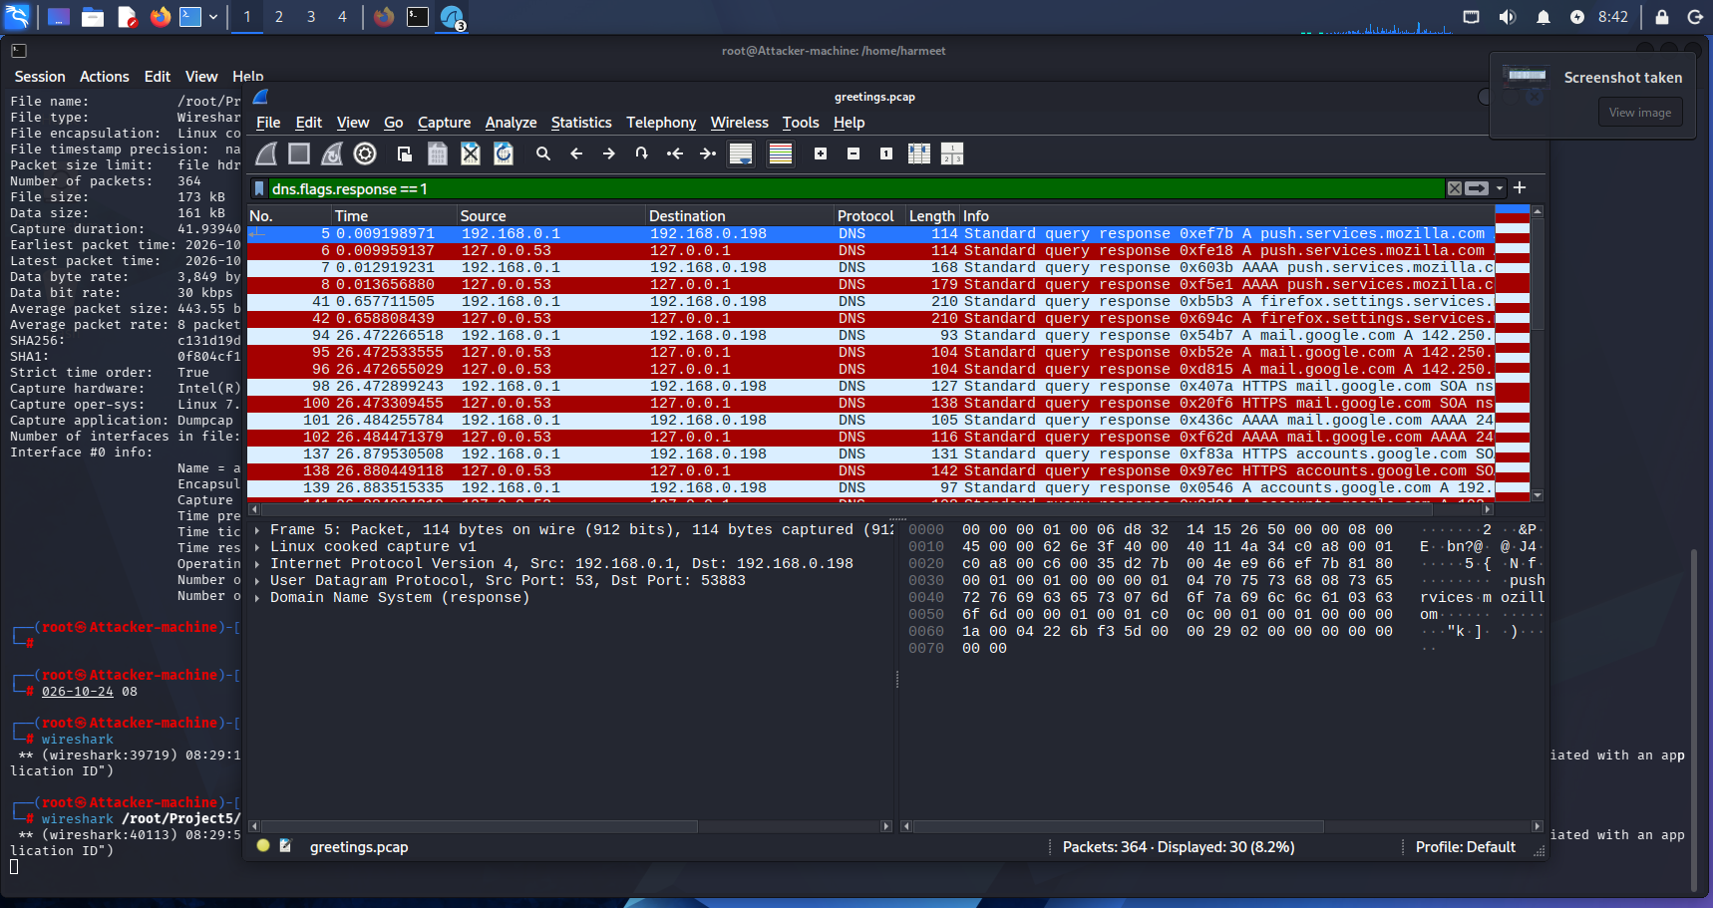

Task 4: Email Header Analysis

Objective

To examine the email headers, authentication results, sender information, and message content to identify potential indicators of phishing or social engineering.

Evidence Details:

Evidence ID: E-02

Filename: Greetings.eml

Evidence type: Personal email — practice evidence

Subject: Greetings

Date: 20 October 2026, 03:10:04 (+07)

From: Taras V. Shevchenko <dtha.dlk@moj.gov.vn>

Reply-To: Taras V. Shevchenko <tav2788465@yahoo.com>

Return-Path: dtha.dlk@moj.gov.vn

Email Header Findings:
Header / Field | Observed Result
From | dtha.dlk@moj.gov.vn
Reply-To | tav2788465@yahoo.com
Return-Path | dtha.dlk@moj.gov.vn
Subject | Greetings
Received | Email passed through mail.moj.gov.vn and was received by Google mail servers
Sending server IP | 124.197.21.125
SPF | PASS
DKIM | PASS
DMARC | PASS
Message content | Requests the recipient to respond about the best way to reach them urgently
Links | No links observed in the supplied message content
Attachments | No separate attachment indicated in the supplied email content

Analysis

The email's From and Reply-To addresses use different domains. The displayed sender address uses moj.gov.vn, whereas replies are directed to a Yahoo address. This difference should be investigated because a reply could be delivered to an address other than the one suggested by the sender's identity.

The message also uses urgency-related wording: “Please kindly let me know the best way to reach you as a matter of urgency.” This may encourage a quick response without providing much context.

SPF, DKIM, and DMARC all passed according to the supplied authentication results. These results support successful authentication checks for the relevant domain, but they do not establish that the message's purpose is legitimate or that its content is safe.

Task 4 Conclusion

The email contains indicators that warrant further review, particularly the different Reply-To domain and urgency-related wording. However, the available evidence is insufficient to confirm that the email is malicious. Links and attachments were not opened.

Task 5: Social Engineering Indicators

Objective

To identify possible social engineering techniques in the email and distinguish observed facts from conclusions.

Indicator Analysis:
Indicator | Evidence Observed | Assessment
Sender and reply-address mismatch | From uses moj.gov.vn, while Reply-To uses yahoo.com | Potentially suspicious; investigate the reason for the mismatch
Urgency | The message asks for a response as a matter of urgency | May encourage a hurried response
Generic greeting | The message begins with “Hello” | Provides little recipient-specific context
Request for a response | The sender asks for the best way to reach the recipient | Could be legitimate or part of an attempt to initiate further contact
Authentication results | SPF, DKIM, and DMARC are PASS | Authentication passed; this does not establish the message's intent
Suspicious links | No links observed in the supplied content | No link-based indicator identified in the available body
Suspicious attachment | No separate attachment indicated | No attachment-based indicator identified in the supplied email
Credential or payment request | No such request observed in the supplied message | No direct credential or payment request identified

Risk Assessment

The email has potential social engineering indicators, particularly the different reply address and urgency wording. The sender's identity and the reason for the alternate reply address would require independent verification.

The available message does not directly request passwords, financial information, or payment, and no links were observed in the supplied content. Therefore, these findings should not be presented as proof of phishing.

Recommended User Actions

Verify the sender through a separate, trusted communication channel.

Do not reply with sensitive personal or organizational information until the sender is verified.

Avoid opening unexpected links or attachments.

Report suspicious messages to the organization's security team.

Preserve the original email and its headers for further investigation.

Task 5 Conclusion

The email should be treated cautiously until its sender and purpose are verified. The observations identify possible warning signs, but the evidence does not conclusively establish malicious intent.

Task 6: Incident Timeline and Evidence Correlation

Objective

To organize the available observations chronologically and document the source and confidence of each finding.

Timeline
Date and Time | Event | Evidence ID / Source | Confidence | Interpretation
20 Oct 2026, 03:10:04 (+07) | Email date and initial mail-server processing timestamp | E-02 — Greetings.eml | High | The email header records this date and time
20 Oct 2026, 03:10:18 (+07) | Message processed by the local mail filtering service shown in the headers | E-02 — Greetings.eml | High | A mail-processing event is recorded
20 Oct 2026, 03:10:19 (+07) | Message processed by the local Postfix mail service | E-02 — Greetings.eml | High | A further mail-server event is recorded
20 Oct 2026, 03:10:22 (+07) | Message recorded by mail.moj.gov.vn | E-02 — Greetings.eml | High | The header records another mail-server processing event
20 Oct 2026, 03:10:51 (+07) | Message received by Google's mail server | E-02 — Greetings.eml | High | The timestamp corresponds to the Gmail Received header
20 Oct 2026, 03:11:03 (+07) | Gmail delivery-related header timestamp | E-02 — Greetings.eml | High | The message appears in the top delivery-related headers
Time not recorded | Network traffic captured for approximately 41.939 seconds | E-01 — greetings.pcap | High for reported duration; unavailable for exact time | A practice capture exists, but exact start/end timestamps and timezone must be verified separately
Not established | Correlation between the email and captured network traffic | E-01 and E-02 | Low / insufficient evidence | No direct evidence establishes that the email and PCAP represent the same event

Timeline Analysis:

The email headers record several mail-server processing events on 20 October 2026. The email also contains a sender/reply-address difference and urgency-related wording, which are documented in Task 4 and Task 5.

The practice PCAP was captured separately. Its duration was recorded as approximately 41.939 seconds, but its exact capture timestamps have not yet been established in this report. No direct link between the PCAP traffic and the email has been demonstrated.

Task 6 Conclusion

The timeline records the available email-header events and the existence of the practice network capture. Additional evidence, including verified PCAP timestamps and relevant packet details, would be required to establish a reliable correlation between network activity and the email.

Task 7: SOC Security Controls and Recommendations

Objective

To recommend practical security controls that can help detect and prevent phishing and other social engineering attacks.

Recommended Security Controls:
Security Area | Recommended Control | Purpose
Email security | Configure and monitor SPF, DKIM, and DMARC | Help authenticate email and reduce certain forms of domain spoofing
Email filtering | Use spam filtering and suspicious-message detection | Identify potentially harmful or deceptive emails
Reply-address validation | Flag mismatches between From and Reply-To where appropriate | Help users identify unexpected reply destinations
Multi-factor authentication | Enforce MFA, preferably phishing-resistant methods where feasible | Reduce the risk from stolen passwords
User awareness | Conduct regular phishing-awareness training | Help users recognize urgency, impersonation, and unusual requests
DNS and web filtering | Block known malicious domains and suspicious destinations | Reduce access to known harmful websites
Endpoint protection | Use endpoint detection and response (EDR) and keep systems updated | Help detect and investigate suspicious endpoint activity
Logging and monitoring | Retain relevant email, DNS, endpoint, and network logs | Support incident investigation and evidence correlation
Incident reporting | Provide a clear process for reporting suspicious emails | Enable timely review by the security team
Evidence preservation | Record evidence IDs, collection details, timestamps, and SHA-256 hashes | Help document evidence integrity and handling

Recommended SOC Response Procedure

Preserve the original suspicious email and relevant headers.

Record the evidence ID, filename, source, collection time, and SHA-256 hash.

Review sender details, reply destinations, authentication results, and message content.

Correlate email evidence with DNS, endpoint, and network logs only when timestamps and other supporting evidence justify the connection.

Investigate suspicious domains and IP addresses using trusted security tools and available threat intelligence.

If malicious activity is confirmed, follow the organization's incident-response process, which may include blocking indicators, isolating affected systems, and resetting compromised credentials.

Document findings, limitations, and remediation actions in the incident report.

Limitations

This report uses a personal email and a self-generated practice network capture. The original instructor-provided evidence files were not available for this analysis. The email's authentication results passed, but the sender's intent has not been independently verified. The available information also does not establish a direct correlation between the email and the network capture.

The findings therefore represent a practice analysis rather than a confirmed organizational security incident.

The information is taken from the file (Show Original):
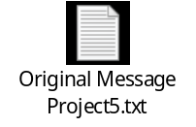
Screenshot:
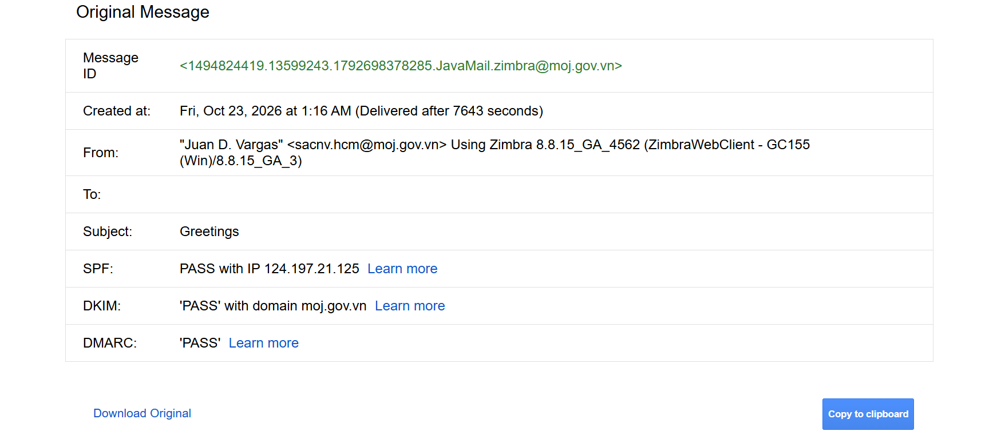

Final student declaration
I confirm that I performed these activities only in the authorized lab scope, recorded results accurately, and did not include credentials or external data in my submission. I have added only my personal details wherever needed.
Student signature: _________Sachin ___________________ Date: ____24-10-2026________________

