Copyright
© Ericsson Telecommunicatie B.V. 2014. All rights reserved.
No part of this material may be reproduced in any form without the written permission of the copyright holder.

Disclaimer
Due to continued progress in methodology, design and manufacturing, the contents of the documents are subject to revision without notice. Ericsson assumes no legal responsibility for any error or damage resulting from the use of this document.

Trademarks
Ericsson is the trademark or registered trademark of Telefonaktiebolaget LM Ericsson. All other product or service names that are mentioned in this specification are trademarks of their respective companies.

Table of Contents
1 Introduction 3
1.1 Audience and Purpose 3
1.2 Prerequisites 3
2 System Architecture 3
3 Configuration Changes on JBoss 4
3.1 Domain.xml 4
3.2 Add user and role 5
3.3 Application (HWA) Side Changes 6
4 Sample Test 8
5 Troubleshooting 10
6 Glossary 11

Introduction
AT&T Honda wants to implement digest authentication in the Honda Application. To achieve that in the MSDP set up, digest authentication is turned on the MSDP JBoss container level. In addition to this, the hwap which acts as a gateway to Honda Server is also made digest authentication aware.

Audience and Purpose
This document is meant for the MSDP PDU to study the implementation of the digest authentication done in the AT&T Honda application. However, other msdp based implementations can refer to this document for implementing digest authentication in their application.

Prerequisites
To turn on Digest Authentication, a fully functional JBoss instance is required to be installed. The content of this document is valid for jboss-as-7.1.3.Final instance.

System Architecture
The architecture diagram below shows an msdp hwa (a hosted web application built on msdp hwa sdk, shown here in violet) which is digest authentication enabled and the JBoss Application Server version 7.1.3.Final instance that comes with MSDP 6.2 installation (shown in blue). The container side changes for digest authentication are done in the Jboss instance. Once both container and application side changes are completed, the hwa application is deployed onto the hwap-slave node of msdp. Once deployed, hwa application communicates with msdp JBoss through HTTP Digest mechanism.

MSDP HWAP Node

Jboss-as-7.1.3.Final
Instance with Digest Authentication
Configuration Changes

MSDP HWA with Digest Authentication Enabled
Digest Credentials

HTTP 200 OK

Configuration Changes on JBoss
To turn on digest authentication on msdp container (JBoss-as-7.1.3.Final), we need to perform the following steps

Domain.xml
Domain.xml file resides on hwap-master node of the msdp installation set up. Please note that if anyone is using JBoss Enterprise Platform (EAP) edition as a standalone server, then the corresponding changes for digest authentication needs to be made in the standalone.xml.

Go to /opt/drutt/msdp/hwap-master/jboss/configuration folder
- vi domain.xml
Add an entry for a new security domain under application-server-group profile’s <security-domains> tag.

<security-domain name="hwapsecuritydomain" cache-type="default"> <authentication>
<login-module code="UsersRoles" flag="required">
<module-option name="usersProperties" value="${jboss.domain.config.dir}/application-users.properties"/> <module-option name="rolesProperties" value="${jboss.domain.config.dir}/application-roles.properties"/> <module-option name="unauthenticatedIdentity" value="anonymous"/>
<module-option name="hashAlgorithm" value="MD5"/> <module-option name="hashEncoding" value="RFC2617"/> <module-option name="hashUserPassword" value="false"/> <module-option name="hashStorePassword" value="true"/> <module-option name="passwordIsA1Hash" value="true"/> <module-option name="storeDigestCallback" value="org.jboss.security.auth.callback.RFC2617Digest"/>
</login-module>
</authentication>
</security-domain>
Save the domain.xml

Add user and role
In order to use the security domain that we just added in step 3.1 we add a user and role in the following files

application-roles.properties
Go to /opt/drutt/msdp/hwap-slave/jboss/configuration/ folder on hwap-slave
Create a new role for digest authentication in application-roles.properites
- vi application-roles.properites
hwapdigestuser=digestadmin
For digest authentication, we create a user called hwapdigestuser and assign a role name digestadmin to that user.

Generate password for user
JBoss provides a utility called picketbox to generate hashed password for users. We need to create one password for the user hwapdigestuser and store it in Joss’s application-users.properites file. At the time of authenticating the user, JBoss would check the password stored in this file and accordingly issue an authenticate success or reject.
To generate the hashed password for user hwapdigestuser, do this
Go to picketbox folder of JBoss installation
cd /opt/drutt/local/jboss-as-7.1.3.Final/modules/org/picketbox/main/
Type the following command. Please note that the password we are using here is passw27rd
java –cp picketbox-4.0.13.Final.jar org.jboss.security.auth.callback.RFC2617Digest [username] hwapdigestuser [realm] ApplicationRealm [password] passw27rd
It will generate a hashed password based on the MD5 algorithm we mentioned in the domain.xml is step 3.1. The password would look like the following ---
[msdp@MSDP2 main]$ java -cp picketbox-4.0.13.Final.jar org.jboss.security.auth.callback.RFC2617Digest hwapdigestuser ApplicationRealm passw27rd
RFC2617 A1 hash: 3edd7227e58e346fac971ca66af1990b
Now we need to store the hashed password in application-users.properties file on hwap-slave jboss as described below in step 3.2.3

application-users.properties
In the application-users.properties file, we need to mention the hashed password that we have generated in step 3.2.2 using the picketbox utility of JBoss.
Go to /opt/drutt/msdp/hwap-slave/jboss/configuration folder
vi application-users.properties
Enter the following
hwapdigestuser=3edd7227e58e346fac971ca66af1990b

At this point, the entire configuration on the JBoss side for turning on Digest Authentication is completed.
Restart JBoss using ./hwapctrl start command under /opt/drutt/msdp folder.

Application (HWA) Side Changes
To enable digest authentication in any web application we need to make the following configuration changes. In our case, the web application happens to be an msdp based hosted web application (hwa).

Jboss-web.xml
Create a file named “jboss-web.xml” inside the WEB-INF folder of the hwa.as shown below
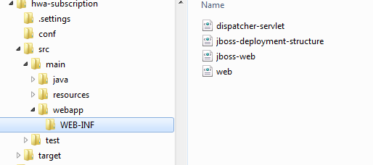

Edit the jboss-web.xml file and enter the following

<? xml version="1.0" encoding="UTF-8"?>
<jboss-web>
<security-domain>java:/jaas/hwapsecuritydomain</security-domain>
</jboss-web>

Please note that the security-domain name must match the one defined in the Jboss domain.xml.

web.xml
In order to enable hwa to use digest authentication, we need to mention the role name and the application realm in the web.xml file of the hwa. We can also specify the particular API (GET/POST/DELETE/PUT) needs to use digest authentication. In our case, we want all the REST API-s to be authenticated via digest; please add the following section in web.xml

<security-constraint>
<web-resource-collection>
<web-resource-name>HtmlAuth</web-resource-name> <description>application security constraints </description>
<url-pattern>/*</url-pattern>
<http-method>DELETE</http-method>
<http-method>PUT</http-method>
<http-method>HEAD</http-method>
<http-method>OPTIONS</http-method>
<http-method>TRACE</http-method>
<http-method>GET</http-method>
<http-method>POST</http-method>
</web-resource-collection>
<auth-constraint>
<role-name>digestadmin</role-name>
</auth-constraint>
</security-constraint>
<login-config>
<auth-method>DIGEST</auth-method>
<realm-name>ApplicationRealm</realm-name>
</login-config>
<security-role>
<role-name>digestadmin</role-name>
</security-role>
At this point, our web application is digest authentication aware.
Deploy the hwa using MSDP 3PI Manager GUI.
Once deployed successfully, the hwa is ready to be used. Any request that comes to the HTTP GET/POST/PUT/DELETE/HEAD/OPTIONS URL of the hwa will be authenticated via digest authentication.

Sample Test
In order to do sample tests from the browser for HTTP GET do the following
Open Mozilla Firefox
Enable the network tab under developer options
Enter the URL in the browser and hit enter
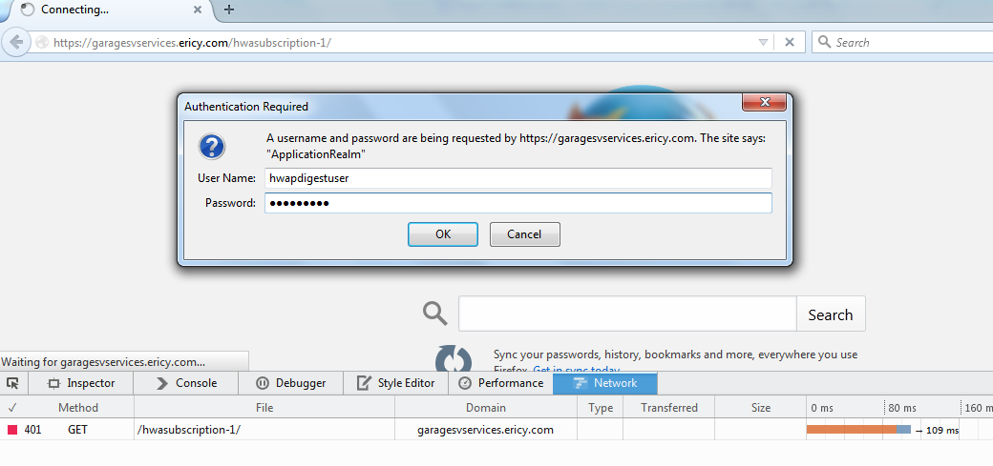
Figure 1: Browser Pop Up
At the prompt, enter the user name and password. In our case, username=hwapdigestuser and password=passw27rd
Click OK Button.
We get a 200 OK response which means that the authentication is successful.
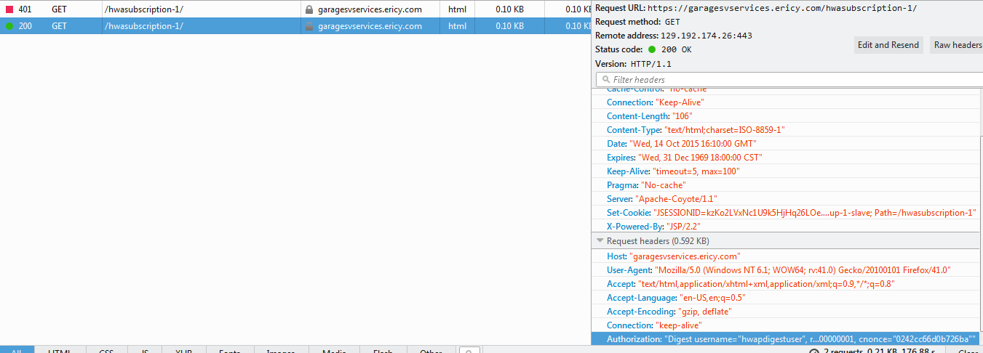
Figure 2: 200 OK Response

Troubleshooting
In some cases, if you get the following error in the server console and authentication does not work, then download and copy the picketbox 4.0.15.jar file in the jboss installation directory inside /opt/drutt/local/jboss-as-7.1.3.Final/modules/org/picketbox/main/ folder.

14:35:12,951 ERROR [org.jboss.security] (http-lab-hwap1/10.111.133.60:9080-8) PBOX000206: Login failure: javax.security.auth.login.FailedLoginException: PBOX000070: Password invalid/Password required at org.jboss.security.auth.spi.UsernamePasswordLoginModule.login(UsernamePasswordLoginModule.java:283) [picketbox-4.0.13.Final.jar:4.0.13.Final] at org.jboss.security.auth.spi.UsersRolesLoginModule.login(UsersRolesLoginModule.java:171) [picketbox-4.0.13.Final.jar:4.0.13.Final] at sun.reflect.GeneratedMethodAccessor166.invoke(Unknown Source) [:1.7.0_25] at sun.reflect.DelegatingMethodAccessorImpl.invoke(DelegatingMethodAccessorImpl.java:43) [rt.jar:1.7.0_25] at java.lang.reflect.Method.invoke(Method.java:606) [rt.jar:1.7.0_25] at javax.security.auth.login.LoginContext.invoke(LoginContext.java:784) [rt.jar:1.7.0_25] at javax.security.auth.login.LoginContext.access$000(LoginContext.java:203) [rt.jar:1.7.0_25] at javax.security.auth.login.LoginContext$4.run(LoginContext.java:698) [rt.jar:1.7.0_25] at javax.security.auth.login.LoginContext$4.run(LoginContext.java:696) [rt.jar:1.7.0_25] at java.security.AccessController.doPrivileged(Native Method) [rt.jar:1.7.0_25] at javax.security.auth.login.LoginContext.invokePriv(LoginContext.java:695) [rt.jar:1.7.0_25] at javax.security.auth.login.LoginContext.login(LoginContext.java:594) [rt.jar:1.7.0_25] at org.jboss.security.authentication.JBossCachedAuthenticationManager.defaultLogin(JBossCachedAuthenticationManager.java:408) [picketbox-infinispan-4.0.13.Final.jar:4.0.13.Final] at org.jboss.security.authentication.JBossCachedAuthenticationManager.proceedWithJaasLogin(JBossCachedAuthenticationManager.java:345) [picketbox-infinispan-4.0.13.Final.jar:4.0.13.Final] at org.jboss.security.authentication.JBossCachedAuthenticationManager.authenticate(JBossCachedAuthenticationManager.java:333) [picketbox-infinispan-4.0.13.Final.jar:4.0.13.Final] at org.jboss.security.authentication.JBossCachedAuthenticationManager.isValid(JBossCachedAuthenticationManager.java:146) [picketbox-infinispan-4.0.13.Final.jar:4.0.13.Final] at org.jboss.as.web.security.JBossWebRealm.authenticate(JBossWebRealm.java:367) [jboss-as-web-7.1.3.Final.jar:7.1.3.Final] at org.apache.catalina.authenticator.DigestAuthenticator$DigestInfo.authenticate(DigestAuthenticator.java:697) [jbossweb-7.0.17.Final.jar:] at org.apache.catalina.authenticator.DigestAuthenticator.authenticate(DigestAuthenticator.java:270) [jbossweb-7.0.17.Final.jar:] at org.apache.catalina.authenticator.AuthenticatorBase.invoke(AuthenticatorBase.java:455) [jbossweb-7.0.17.Final.jar:] at org.jboss.as.web.security.SecurityContextAssociationValve.invoke(SecurityContextAssociationValve.java:165) [jboss-as-web-7.1.3.Final.jar:7.1.3.Final] at org.apache.catalina.core.StandardHostValve.invoke(StandardHostValve.java:155) [jbossweb-7.0.17.Final.jar:] at org.apache.catalina.valves.ErrorReportValve.invoke(ErrorReportValve.java:102) [jbossweb-7.0.17.Final.jar:] at org.apache.catalina.core.StandardEngineValve.invoke(StandardEngineValve.java:109) [jbossweb-7.0.17.Final.jar:] at org.apache.catalina.connector.CoyoteAdapter.service(CoyoteAdapter.java:372) [jbossweb-7.0.17.Final.jar:] at org.apache.coyote.http11.Http11Processor.process(Http11Processor.java:877) [jbossweb-7.0.17.Final.jar:] at org.apache.coyote.http11.Http11Protocol$Http11ConnectionHandler.process(Http11Protocol.java:679) [jbossweb-7.0.17.Final.jar:] at org.apache.tomcat.util.net.JIoEndpoint$Worker.run(JIoEndpoint.java:931) [jbossweb-7.0.17.Final.jar:] at java.lang.Thread.run(Thread.java:724) [rt.jar:1.7.0_25]
That should solve the issue.

Glossary
HWA Hosted Web Application
HWAP Hosted Web Application Platform
MSDP Multi Service Delivery Platform

