**Design Document**

Ali Al Hamadani (21058949)

Guhan Iyer (21092346)

ECE 198: Project Studio

David Lau, Al-Baara El Hag

October 31, 2023

**Needs Assessment**

***Customer Base***

Cardiovascular disease has been a leading cause of death in Canada since related records began [1]. This is due to the wide range of diseases and conditions under the umbrella of cardiovascular disease; all varying in severity and occurrence [2]. The Canadian Chronic Disease Surveillance System (CCDSS) puts six such diseases under this label [3]. Amongst these six, hypertension (high blood pressure) is unique; the CCDSS correlates it with most cardiovascular disease cases, and it is the only one of the six that is not a disease [3]. Rather, hypertension is a condition with well noted generality. Within the space of cardiology, hypertension has been noted to act as a ‘gateway’ to other cardiovascular disease; those with hypertension are at a great risk of their condition worsening into other diseases [4]. These two principles form the basis of our customer problem: those with hypertension should have a method of tracking the intensity of their condition.

Mild to severe hypertension, by nature, would put a customer at the greatest susceptibility to further complications. Furthermore, the CCDSS notes that an overwhelming number of hypertension cases in Canada are in elderly populations (aged 65-80+) [3]. The problem, as we have identified, could be rectified by clinical tools, however, our customer base could face social or economic barriers to accessing appropriate treatments [5]. This may be in the form of availability, or issues regarding access to health care services [5]. These attributes compound the aforementioned problem: a hypertension monitoring or management system should be at-home, non-invasive and cost-effective.

***Competitive Landscape***

1. Management systems for hypertension address the problem at its source through traditional blood pressure trackers [6]. These involve an automatic or manually inflating cuff to record blood pressure, which, evidently, provides a hypertension monitoring system. In [6], it is detailed how these systems are available for at-home use, however they exude a significant financial barrier and remain invasive to a client’s daily life.
2. Blood pressure medications exist in various forms, most often as prescription or over-the-counter drugs [7]. Similarly, they provide an at-home management system for hypertension, but conducted research notes that the efficacy of these medications is limited [7]. Additionally, they can be invasive through adverse effects in combination with other medications, and potentially bri­­ng a financial burden onto a customer.
3. There exist frameworks which provide social solutions to hypertension in populations; often focusing on treatment through routine factors (for example a person’s diet) [8]. These systems find some success in reducing the disproportionate number of cases of hypertension within elderly populations. However, these frameworks fail to overcome a larger correlation between socioeconomic status and “uncontrolled [hypertension]” [9]. Thus, efforts of managing hypertension should take a focus in management rather than prevention and elimination.

***Requirement Specification***

To address the challenges faced by our clientele, we propose a hypertension management system that is based on the documentation of arrhythmias: irregularities in an individual’s heart rate. Our design utilizes a heartrate sensor to continually take electrocardiograms (ECGs) and a compact neural network to recognize irregularities in the ECG waveform. This system must abide by certain requirements, which have been divided into functional and technical requirements for further clarity:

**Functional Requirements**

1. The device verifies heart rate irregularities using a neural network. This neural network must be contained in and minimize its use of an STM32’s 92 kilobytes of static random-access memory (SRAM) [10].
2. To remain non-invasive and provide an at-home solution, the system must be able to maintain a wireless connection with a device for up to 100 meters [11].
3. Based on studies performed, the median accuracy for a physician's interpretation of an ECG scan was 54% [12]. Thus, the device should ideally provide correct analysis of ECG data at an accuracy higher than or equal to 54%.

**Technical Requirements**

1. To achieve regular results, the device must process a result every 60 seconds. It will continuously take in input data, and every 60 seconds, will perform the arrythmia check. The device must also process the 60s sample into individual ECG waves such that it can be interpreted by the neural network. The standard RR interval (time between heartbeats) of an ECG scan is between 0.6-1.2s [13]. Thus, a sample of 60 seconds will allow for roughly 50 cycles to be processed. This is corroborated by the dataset used to train the model [14] and is enough data in one scan to allow for accurate results.

**Safety Requirements**

1. The design must not consume more than 30W of power at any point in time, as specified by the project’s safety requirements. Given that the circuit will be connected to a 3.3V power supply (as discussed in the document), by the formula for Power, , this implies that the design must not have a current greater than 9.1A.

**Analysis**

Our design relies on two STM32 Nucleo boards: one to operate a heart rate sensor and record a user’s heart rate, and the second to host a feed-forward neural network. The primary purpose of the first board is to continually record a user’s resting heartrate to detect irregularities. For the purposes of our device, we look for instances of prolonged instances of bradycardia (resting heart rate below 60 bpm) and tachycardia (resting heart rate above 100 bpm). The sensor pads of the heart rate sensor are to be attached at specific locations on the body (see Appendix B) to correctly record an electrocardiogram (ECG, a recording of the heart’s activity in the form of electrical pulses). When an instance is recorded, the respective data is sent to the second board through Bluetooth. This data is fed through the hosted neural network, which is to be trained on a large dataset of ECGs, such as the MIT-BIH Arrhythmia Database. This specific training allows the neural network to determine if a communicated irregularity is characteristic of an arrhythmia or not. Instances of arrhythmia are to be communicated to the user through either a mobile alert or an audio signal.

***Hardware Design***

The hardware implementation is simplistic. Power is distributed from a valid source (a battery, or for testing purposes, a laptop/computer) into both STM32 boards; the sensor board in turn provides 3.3-volt power to a breadboard, heart rate sensor and Bluetooth module.

The heart rate sensor consists of a power, ground, and signal input. Power and ground should be connected to respective channels of the breadboard, while the signal can be connected to any valid GPIO port on the STM32 board (that is, any non-configurated port that can handle input and output) Similarly, the Bluetooth module consists of a power, ground, receive and transmit ports. Receive and transmit can be connected to any valid GPIO port on the STM32 board.

*Figure 2.1: Example device schematic for the hardware board.*

***Housing***

To house the two STM32 boards and ensure that the user can wear the device easily, custom housing has been designed with dimensions in mind. The housing will be 3-D printed using polycarbonate (PC) for its durability and heat resistance. Additionally, there are specifically engineered gaps within the design to allow for cable management, a sliding panel on the front for accessibility, and a compartment for the battery pack on the back end. The clip on the back of the housing is designed to allow the system to be attached to a belt or similar objects.

The white material as shown in the design is anti-static foam. This will ensure that the STM32 boards are secured in place, and that the pins are protected.

*Note: all units given are in millimeters (mm).*

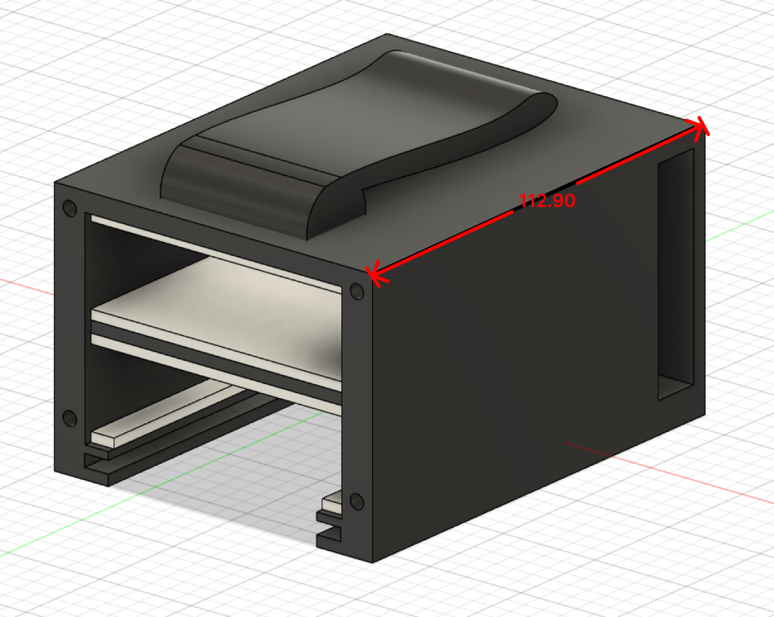

*Figure 2.2: Isometric View of Housing. Shown without sliding panel on bottom or cover on front-facing face.*

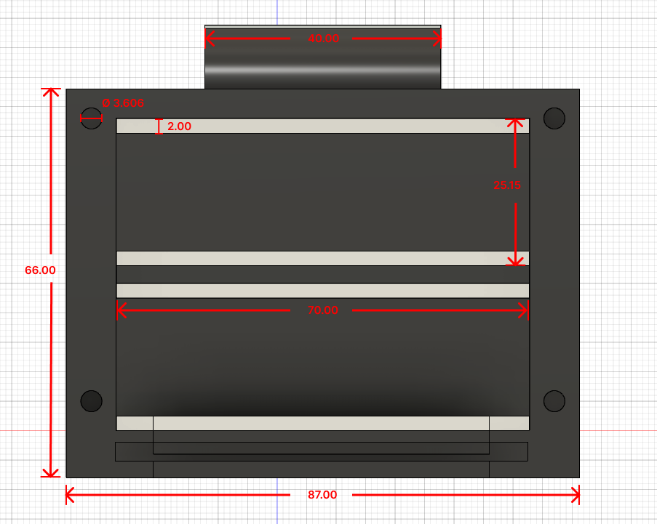

*Figure 2.3: Front View of Housing. Shown without sliding panel on bottom or cover on front-facing face.*

***Software Design***

The software side of our design can be split into two main sections: Board A and Board B.

**Board A (Sensor Board):**

Board A will house all the data handling and output. This includes receiving input data from the sensors, filtering, handling the response from the neural network, and notifying the user. Figure 2.1 outlines the structure of the software on Board A.

The data will be gathered from the sensor simply by accessing the data at the corresponding serial port. Data will continuously be gathered, and every 60 seconds, the rest of the processes will take place using the most recent minute worth of samples.

To allow for the data to be fed through a neural network, it must be processed. This first involves running the data through a series of filters to reduce noise. Then, following an algorithm known as Pan-Tompkins [15], the QRS complex (the three most identifiable waves of an ECG) can be properly identified, and the data can be fragmented into 1-second intervals with the R wave at the center.

From there, the data is sent to Board B to be fed through the neural network. Once a response has been received, the software will either alert the user through an audio signal or mobile alert in the case of a positive result or do nothing otherwise.

*Note: Further details on filters and the Pan-Tompkins algorithm are provided in the “Scientific & Mathematical Principles” section.*

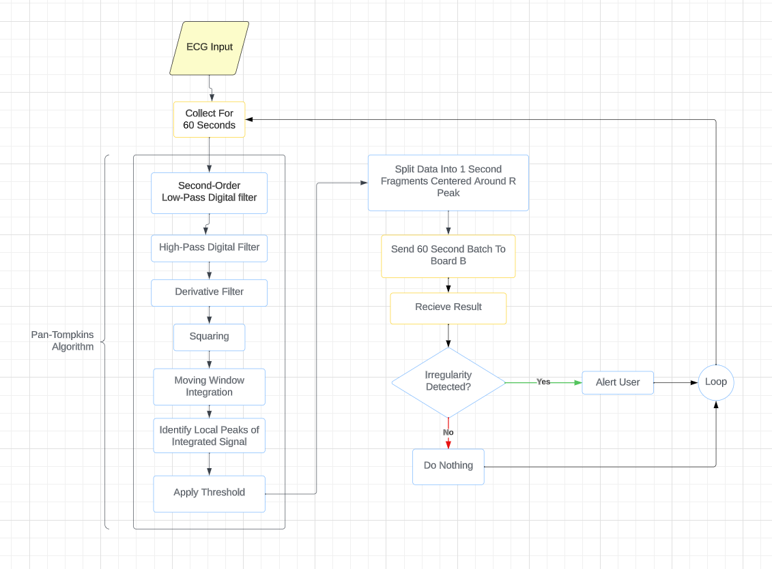

*Figure 2.4: Board A’s Software Diagram.*

**Board B (Neural Network):**

Board B will house the neural network. The neural network will be designed using Python (Keras), and then converted into a space-efficient format by the TensorFlow Lite Converter for Microcontrollers. This ensures that the quality of the network design and training is not jeopardized, as this can all be done beforehand using well-established libraries and frameworks, before being converted for use on the board.

The neural network will follow a multi-layer perceptron (MLP) feed-forward artificial neural network (ANN) architecture. Various parameters and functions shall be tested to find the hyperparameters and configuration that minimizes the overall loss.

When the board is in use, it will simply receive the data sent from board A, run all the processed input data through the neural network, and return whether any irregularities have been detected.

***Scientific and Mathematic Principles - Signal Processing: Filters***

The data received by the sensors naturally will have some noise, especially given that the equipment used is not lab-grade (due to budget constraints). However, to improve the quality of the ECG signals, they will be passed through digital low-pass and high-pass filters, following the equations outlined by Pan and Tompkins in their paper on real-time QRS detection [15]. As stated in Figure 2.1, the **low-pass filter** used will be a second-order filter:

Transfer Function:

Amplitude Response:

where T is the sampling period

Difference Equation:

where the cutoff frequency is 11 hz, and the gain is 36.

**High-pass filter**:

Transfer Function:

Amplitude Response:

Difference Equation:

***Scientific and Mathematic Principles – ECG Waveform Analysis: Pan-Tompkins Algorithm & BPM***

A large part of the tool relies on the ability to correctly process the input data from the sensors. Since we have already discussed the techniques to reduce noise in the incoming data, the next step would be to fragment the data into interpretable chunks. A highly effective way to do so would be to split the data into 1 second intervals, with the R peak at the center.

By using the Pan-Tompkins algorithm [15], the R peaks can be identified accurately. The remainder of the function (after applying low/high-pass filters) is as follows:

1. Derivative: Differentiating the signal using a five-point derivative

*Transfer Function*:

*Amplitude Response*:

*Difference Equation*:

1. Squaring Function: Squaring the signal point by point
2. Moving-Window Integration:

Where N is the number of samples in the width of the integration window.

1. Selecting Peaks: Selecting the local peaks of the integrated signal
2. Filtering using a Threshold:  
   To reduce the likelihood of selecting noise as an R peak, a running threshold is applied that compares the peak to previous signal and noise levels:

Where *SignalLevel* and *NoiseLevel* are continuously updated.

A new signal is classified as either a noise or signal peak based on whether it is under or above the threshold correspondingly.

Once the correct R peaks have been correctly identified, the data can be correctly fragmented. As an extra step to pull further relevant information from the input data, the BPM can be calculated using the following formula:

Where RR is the distance between consecutive R peaks measured in seconds.

This extra piece of data will improve the quality of results as it acts as another parameter to measure for arrhythmia.

***Scientific and Mathematic Principles - Feed-Forward Neural Network: Activation & Loss Functions***

The loss function plays a critical role in determining the performance of a neural network, as they provide the key piece of information used to update weights during training. Since the neural network will serve as a binary classifier, it was decided to use a “Binary Cross-Entropy" loss function [17]:

This function is very commonly used in classification neural networks for its effectiveness and is specifically optimized to deal with classification problems with only two classes. This function will be implemented for use during the training stage of the neural network and will be coded in Python following the equation above.

With regards to the activation function, some experimentation must take place to effectively determine the optimal nonlinear activation function. Some common functions include:

Similarly, these functions will be implemented into our neural network through the Keras framework.

**Costs**

***Manufacturing Costs***

The table below highlights all materials & technologies, as well as manufacturers, vendors, geographical locations, etc. The materials include the different electrical components, as well as minimum purchases required to construct the housing.

|  |  |  |  |  |  |  |
| --- | --- | --- | --- | --- | --- | --- |
| **Component Name** | **Component ID (Manufacturer ID)** | **Manufacturer** | **Manufacturer Location** | **Vendor** | **Vendor Location** | **Cost** |
| Single-Lead, Heart Rate Monitor | AD8232 (SEN-12650) | SparkFun Electronics | Niwot, CO, USA | Digi-Key Electronics | Thief River Falls, MN, USA | $32.84 |
| Muscle Sensor EMG Electrode 6 Pack | 2773 (Arbo H124SG) | Adafruit Industries LLC | New York, NY, USA | Digi-Key Electronics | Thief River Falls, MN, USA | $7.09 |
| Sensor Cable – Electrode Pads 3 Pack | CAB-12970 | SparkFun Electronics | Niwot, CO, USA | Digi-Key Electronics | Thief River Falls, MN, USA | $8.15 |
| Premium PC + Filament 1.75mm, 250G | [S]5.11.01040A01 | Raise3D | Costa Mesa, CA, USA | Shop3D.ca | Mississauga, ON, Canada | $16.99 |
| Anti-Static Foam Roll 1/8”, 24” x 10’ | 742 | ULINE | Pleasant Praire, WI, USA | ULINE | Pleasant Praire, WI, USA | $5.60 |

***Implementation Costs***

A user manual and installation manual are appended to this document as **Appendix A** and **Appendix B** respectively.

**Risks**

***Energy Analysis***

The specifications of this project detail that no more than 500 millijoules of energy should be present within the device at any time, and no more than 30 watts of power can be consumed at any point in time. This shall act as our reference standard. The use of a heart rate sensor in our design classifies it as a medical device, and thereby our design should abide by the reference standards to minimize adverse effects on users.

We interpret ‘significant energy storage’ to be an instance where the energy in one aspect or component is equal to the maximum energy specification of the project. With this definition, we determine that there is potential for significant energy storage to occur. Aside from the STM32 Nucleo boards, the heartrate sensor requires 5V of power, while the Bluetooth module runs in a low-energy configuration [11]. It is thus possible, since all the parts are conductive and the housing is insulative (polycarbonate), for power to accumulate in the sensor when under load.

We are solely concerned with the accumulation of electrical energy in our system. When considering the maximum power draw of our system, or the maximum rate of energy transfer, we can use the following equation for electrical power:

Utilizing the maximum current and voltage specifications in [16], we obtain a maximum power draw of 1.8 μW(microwatts)—far under the project maximum. Thus, we do not exceed any project specifications regarding power and energy limits.

***Risk Analysis***

The scope of our design is limited to use by an individual. By using the design as intended, a user should not incur any negative consequences to themselves or the environment. However, by intentionally or accidentally misusing the design, a user risks personal harm and creating a fire hazard through an electrical mishap. Due to the limited hardware of our design, the only practical hardware malfunction is to short-circuit the heartrate sensor. In terms of software, potential issues with data interpretation exist as a malfunction. Regarding hardware, a short-circuited heartrate sensor risks personal harm to the user at the moment of malfunction. However, the described software malfunction has no risk on the user's safety or the environment.

**Testing and Validation**

This section shall outline the test conditions for each requirement listed under the Needs Assessment. The testing plans are divided by each requirement below.

**Functional Requirements:**

1. The neural network must be functional within the STM32’s 92 kilobytes (kB) of SRAM. That is, it should take no more than 92kB to run.

|  |  |
| --- | --- |
| **Test Setup & Process** | The secondary STM32 board (housing the neural network) will be the subject of this test. It will be separated from the rest of the system, and connected to a computer, and supplied with sufficient power to operate. The computer will feed the board dummy ECG data, and using the System Workbench IDE, the board will be monitored. The SRAM consumption will be calculated as the sum of the “data” and “bss” columns within the System Workbench monitor. |
| **Test Inputs** | Power (from computer): 3.3V  Samples of ECG Data: Singular processed ECG cycle samples will be fed to the board. The data will be formatted the same way specified earlier post-processing |
| **Environmental Parameters** | Ambient Temperature: The board must be tested in standard room temperature conditions to minimize the effect of temperature on the performance of the board.  Data Information: There will be a 50/50 split between samples that contain arrythmia and that are healthy, to ensure that the entire range of possible data the system might encounter is tested. |
| **Quantifiable Measurement Standard** | Amount of SRAM Consumed: This number can be calculated straightforwardly. SRAM = data + bss  Where “data” represents the size of initialized global variables, and “bss” represents the uninitialized global variables |
| **Pass Criteria** | SRAM Consumption < 92kB |

1. The system must be able to maintain a wireless connection with a mobile device for up to 100 meters.

|  |  |
| --- | --- |
| **Test Setup & Process** | The primary STM32 board will be the subject of this test. It will be connected to a computer and supplied with sufficient power to operate. It will be connected to an iPhone wirelessly via BLE, and moved to distances: 0m away, 10m away, 30m away, 60m away, and 100m away. At each distance, it will be instructed to send a notification to the connected iPhone device. The test will take place in an empty hall. |
| **Test Inputs** | Power (from computer): 3.3V  Distances: 0m away, 10m away, 30m away, 60m away, and 100m away.  Instruction to Send Notification: Instruction from the computer to the board, instructing it to send the notification to the mobile device. |
| **Environmental Parameters** | Physical Obstructions & Electromagnetic Interference: Obstructions and interference may impact the Bluetooth signal between the phone and board, so the experiment will ideally take place in an empty hall to minimize this. |
| **Quantifiable Measurement Standard** | The Distance Between the Board and the iPhone: This is an easily quantifiable measurement and will be used to validate the test. |
| **Pass Criteria** | Notification is Received @ Distance = 100m |

1. The device should be able to detect heart arrythmia with an accuracy of at least 54%

|  |  |
| --- | --- |
| **Test Setup & Process** | The secondary STM32 board will be the subject of this test. The purpose of this test is to evaluate the performance of the neural network. So, pre-processed data will be fed to the secondary board and the performance will be evaluated. |
| **Test Inputs** | Power (from computer): 3.3V  Validation ECG Data: Validation data will be fed to the board. This is data that already has been annotated. As such, the neural network will be fed the data without the annotation, and the neural network’s output will be compared to the correct answer. |
| **Environmental Parameters** | Data Information: There will be a 50/50 split between samples that contain arrythmia and that are healthy, to ensure that the entire range of possible data the system might encounter is tested. |
| **Quantifiable Measurement Standard** | Accuracy %: This is again an easily quantifiable measurement. Each neural network output will be compared to the correct answer, and a tally will be kept to determine the final percentage accuracy. . |
| **Pass Criteria** | Accuracy % > 54% |

1. The device should process a result every 60 seconds.

|  |  |
| --- | --- |
| **Test Setup & Process** | The secondary board will be separated from the system, connected to a computer, and provided with sufficient operating power. The computer will then feed the board a continuous stream of ECG data. The board must then process all this data, validate it to ensure that the data is split correctly (into individual waves), and then output a random result. A timer will be running to log the intervals between outputs. |
| **Test Inputs** | Power (from computer): 3.3V  Continuous Stream of ECG Data: The board will be fed a continuous stream of data, replicating the results from the sensor. This data will be unannotated. |
| **Environmental Parameters** | Ambient Temperature: The board must be tested in standard room temperature conditions to minimize the effect of temperature on the performance of the board. This is especially important as this is a time test.  Electromagnetic Interference: Similar to previous tests, interference may impact the Bluetooth signal between the board and the second computer, so the experiment will ideally take place with all devices near each other. |
| **Quantifiable Measurement Standard** | Time Between Outputs**:** The interval between outputs will act as the quantifiable measurement standard. This is a value that can be found automatically by logging the time between outputs. |
| **Pass Criteria** | Time Between Outputs < 60 seconds |

1. The design must not consume more than 30W of power at any point in time. In a 3.3V circuit, this is a maximum of 9.1A current.

|  |  |
| --- | --- |
| **Test Setup & Process** | The subject of this test will be the entire system. The boards will be connected to a power supply, and data will be fed to the primary board through a computer. As the system operates and outputs results, a multimeter/ammeter will be connected between the power supply and the boards to record the current. This value will be logged for both boards. |
| **Test Inputs** | Power (from power supply): 3.3V  Dummy Test ECG Data: For this test, the outputs of the neural network do not matter, as it is solely focused on operating power draw. |
| **Environmental Parameters** | Ambient Temperature: The board must be tested in standard room temperature conditions to minimize the effect of temperature on the electrical components. |
| **Quantifiable Measurement Standard** | Amount of Current Flowing Through Circuit: This is once again an easily quantifiable measurement. Using a multimeter/ammeter, the current can be found easily and logged. |
| **Pass Criteria** | Measured Current < 9.1A |

**Appendix A. Installation Manual**

This section will outline how to properly set up the device. To begin the installation, the following items are required:

1. 1x STM32 Nucleo-F401RE Board connected to Bluetooth module
2. 1x STM32 Nucleo-F401RE Board connected to AD8232 and Bluetooth module
3. Battery Pack
4. Sensor Pads
5. Electrode Cables
6. Constructed Housing

Since the two boards communicate with each other and with the user’s mobile device through Bluetooth, all complex cabling has been eliminated from the installation.

*Figure A.1: Device Housing*

1. Connect the electrode cable to the AD8232 module and attach the sensor pads to the ends of the electrode cable.
2. Then, slide the battery pack into the compartment at the back, and pass the cables through the gaps for access. Finally, slide the STM32 board with the AD8232 into the bottom compartment, and the other into the top compartment, and connect them to the battery pack.

**Appendix B. User Manual**

This section will outline how to use the device once it has been properly configured. The device is intended to be intuitive to use once assembled. Little to no input is required by the user during use aside from the initial connection, which is outlined below.

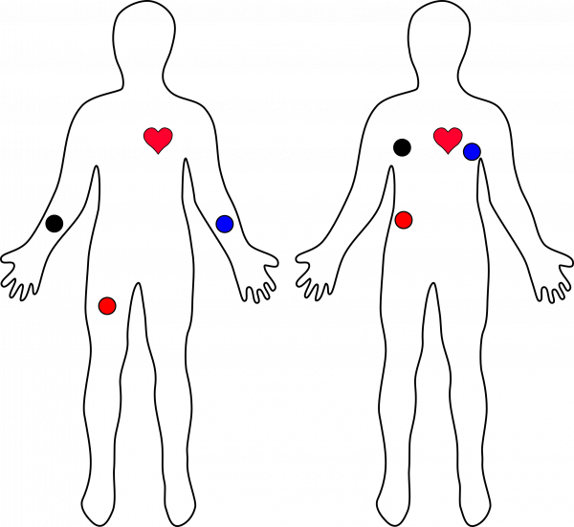

*Figure B.1: ECG Electrode Pad Placement*

1. Given that the boards are all connected to power (as covered in the Installation Manual), any mobile device of choice should be connected to the primary board. This can be done through a BLE scan application installed from the App Store/Play Store.
2. Attach the ECG Electrode Pads to the body as shown in the picture, ensuring that the colors of the cable correspond with the image.
3. Finally, if applicable, clip the housing onto any secure belt or similar object for portability.

Now, the device will be in use. It will continuously perform an ECG scan, notifying the connected device in the case of irregularity/arrythmia detection.

**References**

1. C. Nair, H. Colburn, D. McLean, and A. Petrasovits, “Cardiovascular disease in Canada,” National Library of Medicine, https://pubmed.ncbi.nlm.nih.gov/2491348/ (accessed Sep. 19, 2023).
2. “Cardiovascular Disease,” NHS, https://www.nhs.uk/conditions/cardiovascular-disease/ (accessed Sep. 19, 2023).
3. “Canadian Chronic Disease Surveillance System (CCDSS),” Canada.ca, https://health-infobase.canada.ca/ccdss/ (accessed Sep. 19, 2023).
4. G. Tackling and M. B. Borhade, “Hypertensive Heart Disease,” National Library of Medicine, https://www.ncbi.nlm.nih.gov/books/NBK539800/ (accessed Sep. 19, 2023).
5. A. L. Fitzpatrick, N. R. Powe, L. S. Cooper, D. G. Ives, and J. A. Robbins, “Barriers to health care access among the elderly and who perceives them,” American Journal of Public Health, vol. 94, no. 10, pp. 1788–1794, 2004. doi:10.2105/ajph.94.10.1788.
6. “How to monitor-and lower-your blood pressure at home,” Harvard Health, https://www.health.harvard.edu/heart-health/how-to-monitor-and-lower-your-blood-pressure-at-home (accessed Oct. 30, 2023).
7. M. A. Paz et al., “Treatment efficacy of anti-hypertensive drugs in monotherapy or combination,” Medicine, vol. 95, no. 30, 2016. doi:10.1097/md.0000000000004071.
8. National Hypertension Control Initiative, https://nhci.heart.org/ (accessed Oct. 31, 2023).
9. Y. C. Yang, C. Boen, and K. Mullan Harris, “Social relationships and hypertension in late life,” Journal of Aging and Health, vol. 27, no. 3, pp. 403–431, 2014. doi:10.1177/0898264314551172.
10. “STM32F401RE,” STMicroelectronics, https://www.st.com/en/microcontrollers-microprocessors/stm32f401re.html (accessed Sep. 19, 2023).
11. Bluetooth, https://www.aami.org/medical-device-connectivity/medical-device-connectivity-faqs-bluetooth (accessed Oct. 30, 2023).
12. D. A. Cook, S.-Y. Oh, and M. V. Pusic, “Accuracy of Physicians’ Electrocardiogram Interpretations,” JAMA Internal Medicine, vol. 180, no. 11, p. 1461, 2020. doi:10.1001/jamainternmed.2020.3989
13. A. Verma *et al*, “Standards for the Provision of Electrocardiography (ECG)-Based Diagnostic Testing in Ontario,” Cardiac Care Network, https://www.corhealthontario.ca/resources-for-healthcare-planners-&amp;-providers/ecg/ECG-Standards-Document-FINAL.pdf (accessed Sep. 19, 2023).
14. G. B. Moody and R. G. Mark, “The Impact of the MIT-BIH Arrhythmia Database,” IEEE Engineering in Medicine and Biology, 2001. doi:10.13026/C2F305.
15. J. Pan and W. J. Tompkins, “A real-time QRS detection algorithm,” IEEE Transactions on Biomedical Engineering, vol. BME-32, no. 3, pp. 230–236, 1985. doi:10.1109/tbme.1985.325532.
16. Single-lead, Heart Rate Monitor Front End Data sheet, https://cdn.sparkfun.com/datasheets/Sensors/Biometric/AD8232.pdf (accessed Oct. 31, 2023).
17. D. Godoy, Understanding binary cross-entropy / log loss: A visual explanation, https://towardsdatascience.com/understanding-binary-cross-entropy-log-loss-a-visual-explanation-a3ac6025181a (accessed Oct. 31, 2023).