1. 探究类的继承中，构造函数和析构函数的调用顺序

源代码：

#include<iostream.h>

#include<stdafx.h>

class xml_fu

{

private:

int a;

public:

xml_fu(int a1)

{

a=a1;

printf("调用父类构造函数\n");

}

};

class xml_zhi:public xml_fu

{

private:

int b;

public:

xml_zhi(int a1,int b1):xml_fu(int a1)

{

b=b1;

printf("调用子类构造函数\n");

}};

int main()

{

xml_zhi y(8,9);

}

**运行截图：**

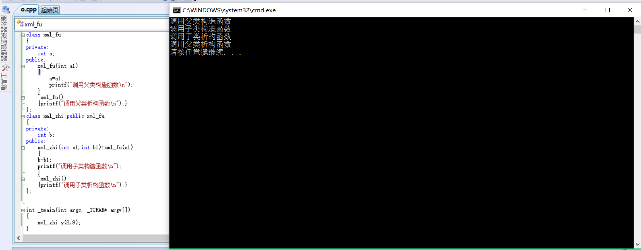

1. 利用xml做一张学生信息表

<?xml version="1.0" encoding="UTF-8"?>

<class>

<![CDATA[学生信息]]>

<student>

<student1>

<![CDATA[姓名]]>

<name>小明</name>

<![CDATA[序号]]>

<number>1</number>

<![CDATA[性别]]>

<gender>男</gender>

<![CDATA[年龄]]>

<age>19</age>

</student1>

<student2>

<![CDATA[姓名]]>

<name>小红</name>

<![CDATA[序号]]>

<number>2</number>

<![CDATA[性别]]>

<gender>女</gender>

<![CDATA[年龄]]>

<age>18</age>

</student2>

<student3>

<![CDATA[姓名]]>

<name>小军</name>

<![CDATA[序号]]>

<number>3</number>

<![CDATA[性别]]>

<gender>男</gender>

<![CDATA[年龄]]>

<age>20</age>

</student3>

<student4>

<![CDATA[姓名]]>

<name>小华</name>

<![CDATA[序号]]>

<number>4</number>

<![CDATA[性别]]>

<gender>男</gender>

<![CDATA[年龄]]>

<age>19</age>

</student4>

<student5>

<![CDATA[姓名]]>

<name>小林</name>

<![CDATA[序号]]>

<number>8</number>

<![CDATA[性别]]>

<gender>男</gender>

<![CDATA[年龄]]>

<age>20</age>

</student5>

<student6>

<![CDATA[姓名]]>

<name>小青</name>

<![CDATA[序号]]>

<number>9</number>

<![CDATA[性别]]>

<gender>女</gender>

<![CDATA[年龄]]>

<age>19</age>

</student6>

</student>

</class>

