An introduction to Pig Installation
Apache Pig can be considered as a wrapper or high level abstraction layer to run map Reduce programs. Developed by Yahoo internally and industry finest.
Why Pig?
To design and solve a computational problem using map reduce most of the times you have to split the processing in various Map Reduce jobs. Now it’s true that writing map reduce program by yourself gives you much control, but it increases the development time.
This is where Pig can help you and allows you to declare your map reduce logic as bunch of Pig Latin statements and generates the map reduce program under the hood for you.
To Install pig download the following version, as I shared earlier in my Hadoop installation post we will be using Cloudera Distribution cdh3u5 for demos.
http://archive.cloudera.com/cdh/3/pig-0.8.1-cdh3u5.tar.gz
Pig installation is a way simpler just follows these steps
- Untar the pig
tar xzf pig-*.tar.gz

- Set HADOOP_HOME path in .bashrc

Change your installation path accordingly

export JAVA_HOME=/usr/local/java/jdk1.6.0_45
export HADOOP_HOME=/home/hadoop/hadoop-0.20.2-cdh3u5
export PIG_HOME=/home/hadoop/pig-0.8.1-cdh3u5
export PATH=$PATH:$JAVA_HOME/jre/bin:$HADOOP_HOME/bin:$PIG_HOME/bin

Pig can run in two modes
- Local mode using Local Filesystem

Pig –x local

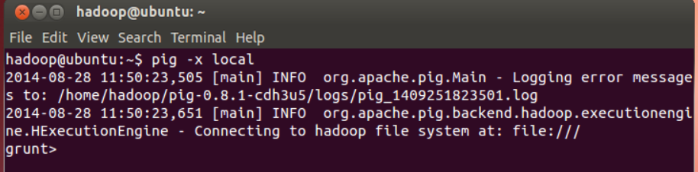

- And default or mapreduce mode , to work with default mode please ensure that the Hadoop Daemons are running, use start-all.sh to start the hadoop daemons and simply specify
Pig or pig –x mapreduce
