Quiz-

aws service used for collecting large amounts of data streamed from multiple resources
-kinesis

18.
need to supply auditors with logs
detailing the individual users
that provision specific resources on your aws platform.
-CloudTrail

19.
need a configuration mgt service
that enables ur system administors to configure and operate ur web app using chef.
-Opworks

20.
digital media agency needs to convert their media files in to different formats to suit different devices.
-Elastic transcoder

------------------------------------------------

S3 L12

IAM
allows to manage users

centralized control of aws exam
shared access to ur aws account
allows multi factor authentication
temporary access to users when necessary
allows to setup own password policy

Users
end users (people)

Groups
a collection of users under one set of permissions

Roles
assign roles and assign them to aws resources

policies
a doc that defines 1/more permissions

------
S3 L13

Security, Identity and Compliance
IAM

customize

activate multi factor authentication on root account

manage mfa ->
virtual mfa device resynchronize mfa device

Android - google authenticator
open - scan code

add user
set user details
set aws access type
add user to group
crate users
- download credentials as csv

Dashboard -> manage password policy

Roles => create
Role type
EC2 =>

-------------------------------------------------------------
S3 L14
create a billing alarm

Profiles -> billing dashboard

Mgt tools -> Cloud watch
Alarms -> billing alarms

Aurora - 37 dollars gone

-------------------------------------------------------------

S3 L15

IAM consists
Users
Groups
Roles
Policy Documents Effect Action Resource

IAM is universal, doesn't apply region at this time
root account - full admin
new users have no permissions when created
aws console - username, password
api programmatically - access key id, secret access key

-------------------------------------------------------------

Quiz

IAM
IAM allows you to manage users, groups, roles and
their corresponding level of access to AWS platform

IAM
centralised control of your aws account
integrates with existing active directory account allowing single sign on
fine grained access control to aws resources
the ability to create user/group/roles
allows you to set up your own password protection policy

Power user access allows
access to all aws services except for mgt of groups and users within IAM

root account
administrator access

Users and policy regions are global

very first thing
set up an account using their company email address

You are a security administrator working for a hotel chain. You have a new member of staff who has started as a systems administrator and they will need full access to the AWS console. You have created the user account and generated the access key id and the secret access key. You have moved this user into the group where the other administrators are and you have provided the new user with their secret access key and their access key id. However when they go to log in to the AWS console, they cannot sign in. What could be the cause of this?
-cannot log into console using access id and secret key, instead u must generate a password for the user and supply this user with the password as well as unique link

additional way to secure IAM for both the root login and new users alike
-multi factor authentication

by default when new user is created
no accesss to all aws services

policy docs are written in
json

----------------------------------------------------------------------------------------------

S4 L16

S3 - 101

simple storage service
durable, highly scalable object storage
object based storage (fa)
data is spread across multiple devices and facilities
can't install os or db

S3
object based allows u to upload files
0 - 5 tb objects
unlimited storage
files are stored in buckets
s3 is universal namespace, unique globally

Data consistency model for s3

Read after write consistency for puts of new objects
eventual consistency for overwrite puts and deletes (can take some time to propagate)

s3 - is a simple key value storage
key fileName
value file
version id
meta data data about metadata - Eg:when created
subresources Access control lists
torrent

99.99 2 9 availabity same for all
11 9 durability gurantee 11 9 2 9

tiered storage available
lifecycle mgt
version
encrypting

s3 - storage class tier
S3 std-
S3 IA - infrequent access
s3 reduced redundancy storage

Glacier
very cheap
used for archival only
3-5 hours to restore from glacier

s3 charges
charged for
storage
requests
storage mgt pricing
data transfer pricing - coming in free, moving out charged

transfer acceleration -
it enable fast easy and secure transfer of files over long distances between ur end users and s3 bucket.
takes advantage of CloudFront's globally distributed edge locations
as the data arrives at an edge location, data is routed to s3 over optimized network path

upto 37% faster

read after write consistency for puts of new objects
eventual consistency for overwrite puts and deletes (can take some time to propogate)

--------tips

s3 storage classes/tiers
S3 - durable, immediately available, frequently accessed
s3 IA - durable, immediately available, infrequently accessed
s3 reduced redundancy storage - data that is easily reproducable, eg: thumbnail
Glacier - archived data - u can wait 3-5 hours b4 accessing

core fundamentals of s3
key
value
version
metadata
subresources - exists underneath the object
acl - access conrol list
torrent - support for

upload 200 status

--------------------------------------------------------------------------------------------

S4 L17

services - storage - s3

bucket name uses dns

individual objects do not inherit bucket's tags

learner.4vr@gmail.com
layABrick@127

aws account name: rathan

---

aws free tier account

https://aws.amazon.com/free/

Delete object
delete all versions
delete delete marker

s3 versioning not always useful

MFA delete

--s3 versioning exam tips

stores all versions of an object (including all writes and even if you delete an object)
great back up tool
once enabled versioning cannot be disabled, only suspended
integrates with lifecycle rules
versioning mfa's delete capability, which uses multi factor authentication
can be used to provide an additional layer of security

------------------------------------------------------------------------------------------------------------

cross region replication - lab
for s3

Management -> Replication

Source- select the replica bucket
Destination - select iam role

only new ones go to replica

google "aws command line tools"
https://aws.amazon.com/cli/

pip install awscli

if old version of pip
sudo -H python -m pip install --upgrade pip
pip install awscli

aws configure

services -> security, identity and compliance - groups
iam - create group

group name - policy type(Administrator access) AwsAdminAccess2

create user - programmatic access prouser

access key id
AKIAI**************

secret access key
Rb+d*****************************

janarthan@janarthan1:~$ aws configure
AWS Access Key ID [None]: AKIAIX**************
AWS Secret Access Key [None]: Rb+d9O2Nm/******************
Default region name [None]:
Default output format [None]:

janarthan@janarthan1:~$ aws s3 ls
2018-04-24 10:47:20 acloudguru-2018-04
2018-04-26 08:44:50 acloudguru2018jana
2018-04-27 18:28:11 myregionbucket2018

aws s3 cp --recursive s3://bucket1 s3://bucket2
acloudguru2018jana
myregionbucket2018

janarthan@janarthan1:~$ aws s3 cp --recursive s3://acloudguru2018jana s3://myregionbucket2018
copy: s3://acloudguru2018jana/awsVersionTester.txt to s3://myregionbucket2018/awsVersionTester.txt
copy: s3://acloudguru2018jana/awsCost.png to s3://myregionbucket2018/awsCost.png

source bucket - destination bucket

when u delete an object from a source bucket creates a delete marker
and creates a delete marker in destination bucket as well

when u delete the delete marker from source bucket
it doesn't delete the delete marker from destination bucket

---
Apr 28

S3 - cross region replication exam tips

versioning must be enabled on both the source and destination buckets
regions must be unique
files in an existing bucket are not replicated automatically.
all subsequent updated files will be replicated automatically
you cannot replicate to multiple buckets or use daisy chaining (at this time)
delete markers are replicated
deleting individual versions or delete markers will not be replicated
understand what cross region replication is at a high level

---------------

S4 L20

Life cycle mgt , s3-IA & Glacier lab
automate transition to tiered storage

s3 -> s3-IA -> glacier

s3 -> mgt -> Add lifecycle rule
name -> configure transistion ->

current version -> add transisistion
to IA after 30 days
to Glacier after 60 days

previous version -> to IA -> to Glacier

configure expiration
save

------

lifecycle mgt - exam tips

can be used in conjunction with versioning
can be applied to current and previous versions
following actions can now be done
transition to the std - infrequent access storage class
128 kb and 30 days after the creation date
archive to glacier storage class
30 days after ia - if relevant
permanantly delete

----------

S4 L21

Cloud Front
CDN - content delivery network

it's a system of distributed servers(network) that deliver webpages and other web content to a user based on the geographic locations of the user.
the origin of the webpage and a content delivery server.

edge location
is the location where content will be cached
this is seperate to an aws region/az

origin
this is the origin of all the files that the cdn will distribute.
this can be either an
s3 bucket, an ec2 instance, an elastic load balancer or route 53.

distribution - cdn
collection of edge locations

edge locations over 50 of them currently

ttl
time to live

not quicker for the 1st user/ 1st time, but for the 2nd time it's faster

amazon cloud front can be used to deliver ur entire website
including dynamic, static and streaming and interactive content using a globale network of edge locations.
requests for your content are automatically routed to the nearest edge location.
so content is delivered with the best possible performance

amz cloudfront is optimized to work with any other amz web services
like s3, elastic compute cloud, elastic load balancing and amazon route 53.
amz cloud front also works seamlessly with any non-aws origin server which stores the original definitive versions of ur files.

Cloud Front - Key Terminology

Web Distribution - Typically used for websites
RTMP - used for media streaming

--cloud front exam tips

edge location - this is the location where content will be cached.
this is seperate to an aws region/az

origin - this is the origin of all the files that the cdn will distribute. this can be either an s3, ec2 or elastic load balancer or Route 53.

Distribution - this is the name given to the cdn which consists of a collection of edge locations.

web distribution - typically used for websites
Web - for websites
RTMP - for media streaming

edge locations are not just for read only, you can write to them too.
(put an object to them)

objects are cached for the life of the TTL (time to live)

you can clear cached objects, but you will be charged.

------------

S4 L22
Cloud Front

services -> Networking and content delivery -> Cloud Front

create a distribution
Web / RTMP

restrict viewer access
- use signed urls or signed cookies

Distribution settings
-origin
-behavior
-error pages
-restrictions - geographical - white/black list
-invalidations - rather than waiting for ttl, can invalidate, is charged

ttl - time to live - always in seconds

configurations

behaviours

Geo Restriction settings

create invalidation
pay

Distribution -> select it and disable it.
then go and delete it

----

S4 L23

S3 - security encryption

securing your buckets

by default, all newly created buckets are private
you can set up access control to ur buckets using;
bucket policies
access control lists

s3 buckets can be configured to create access logs which logs all requests made to the s3 bucket. this can be done to another bucket.

Encryption:

In transit
SSL/TLS https

At Rest
server side encryption
client side

server side
1. s3 managed keys - SSE-S3
256
2. AWS Key Mgt service, managed keys - SSE-KMS
provides order trail
3. server side encryption with customer provided keys - SSE-C

client side encryption
you encrypt the data at client side and upload it to s3

-------------
S4 L24

Storage gateway
popular exam topic

is a service
that connects an on-premises sw appliance
with cloud-based storage
to provide seamless and secure integration
between an organization's on-premises IT environment and AWS's storage infrastructure.
The service enables you to securely store data to the aws cloud for scalable and cost effective storage.

storage gw
your data center ---------> aws

aws storage gateway's sw appliance is available for download as a virtual machine VM image that you install on a host in your datacenter.
storage gateway supports either vmware esxi or microsoft hyper-v. once you've installed your gateway and associated it with your aws account through the acitvation process, you can use the aws mgt console to create the storage gateway option that is right for you.

Four types of storage gateways

File Gateway (NFS)
flat files
stores directly on s3

Volumes Gateway (iSCSI)
block based
os, virtual hdd, vm
.stored volumes - gateway stored volume
.cached volumes - gateway cached volume

Tape Gateway (VTL) - virtual tape library
allows u to create virtual tapes

Files are stored as objects in your s3 buckets,
accessed through a network file system(NFS) mount point.
Ownership, permissions, and timestaps are durably stored in s3 in the user-metadata of the object associated with the file.
once objects are transferred to s3, they can be managed as native s3 objects and bucket policies such as versioning, lifecycle mgt and cross-region replication apply directly to objects stored in your bucket.

NFS direct connect
App server ---------storage gateway---- internet ---------s3-s3ia-glacier
VPC

Volume Gateway
like virtual hdd
The volume interface presents ur app with disk volumes using the iSCSI block protocol.
Data written to these volumes can be asychronously backed up as point-in-time snapshots of your volumes, and stored in the cloud as EBS snapshots
snapshots are incremental backups that capture only changed blocks. all snapshots storage is also compressed to minimize your storage charges.

Volume gateway - stored volumes
like virtual hdd
store entire copy of ur dataset locally
then asynchronously backup that data to aws

Store volumes let you store you primary data locally,
while asynchronously backing up that data to AWS.
AWS stored volumes provide your on-premise applications with low-latency access to their entire datasets, while providing durable, off-site backups.
you can create storage volumes and mount them as iSCSI devices from your on-premises app servers. Data written to your stored volumes is stored on your on-premises storage hw. This data is asynchronously backed up to amazon simple storage service in the form of Elastic Block Store (EBS) snapshots. 1GB - 16TB in size for stored volumes.

Volume Gateway - Cached volumes

cached volumes let you use s3 as your primry data storage while retaining frequently accessed data locally in your storage gw. cached volumes minimize the need to scale your on-premises storage infrastructure. while still providing your apps with low-latency access to their frequently accessed data.
You can create storage volumes up to 32 TiB in size and attach to them as iSCSI devices from your on-premises app servers. your gw stores data data that you wite to theses volumes in s3 and retains recently read data in your on-premises storage gw's cache and upload buffer storage. 1GB - 32TB in size for cached volumes.

Volume Gateway -Tape Gateway
basically used for backup

Tape gateway offers a durable cost effective solution to archive your data in the aws cloud. the vtl interface it provides lets you leverage your existing tape-based backup app infrastructure to store data on virtual tape cartridges that you create on your tape gw. each tape gw is preconfigured with a media changer and tape drives, which are available to your existing client backup apps as iSCSI devices. you add tape cartridges as you need to archive your data. supported by NetBackUp, backup exec, veeam etc.

--exam tips

File Gw - for flat files, stored directly on s3. docs, pdfs
Volume Gw -
stored volumes - entire dataset is stored on site and is asynchronously backed up to s3
cached volumes - entire dataset is stored on s3 and the most frequently accessed data is cached on site.
Gateway Virtual Tape Library - VTL
used for backup and used popular backup apps like netBackUp, backup exec, veeam etc.

----------------------------------------------------------------------------------
S4 L25

Snowball

Import/Export Disk

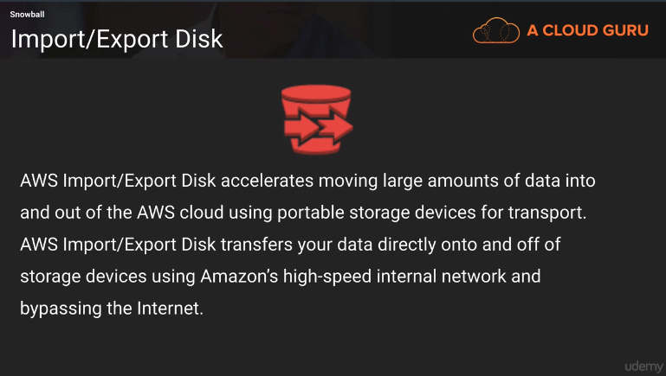

Types
Snowball
snowball edge
snowmobile

snowbal

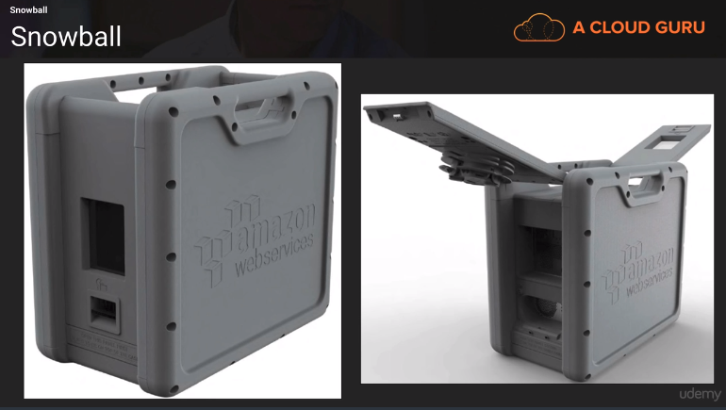

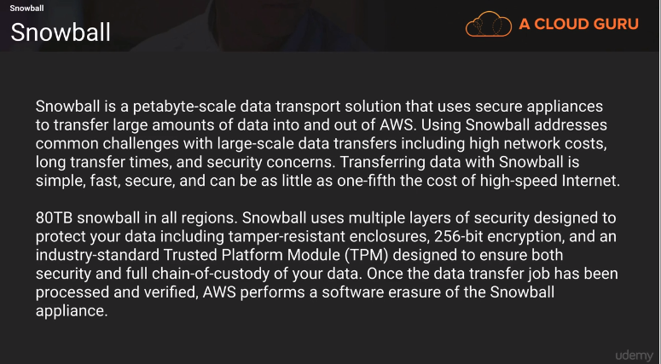
multiple layer of security
256 bit encryption

snow ball edge

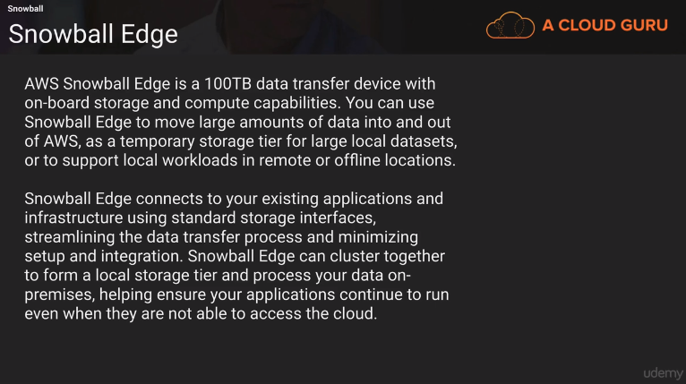

snoball edge – storage + compute capacity
can run lambda functions

snowmobile

***samTheCloudGuy*****************************************************************************

part 27 aws ec2

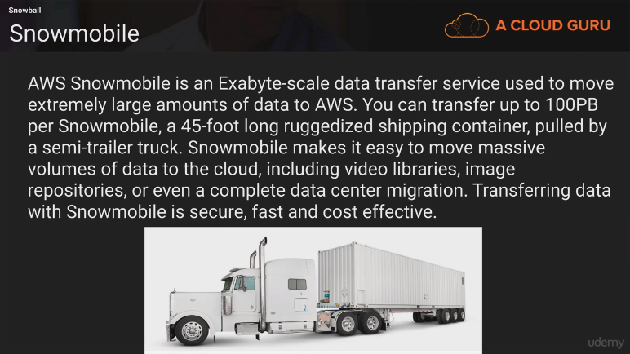

exam tips

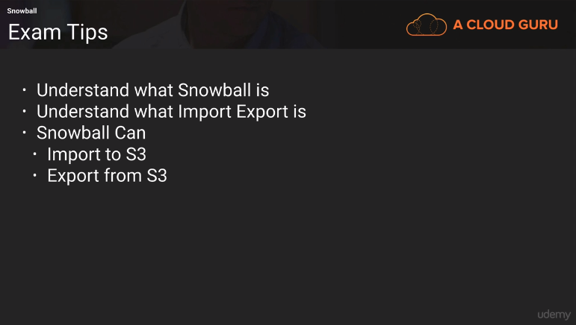
----

s4L26

snowball lab

service → migration → snowball

-------------------------------------------------------------------------------

s3 – transfer acceleration

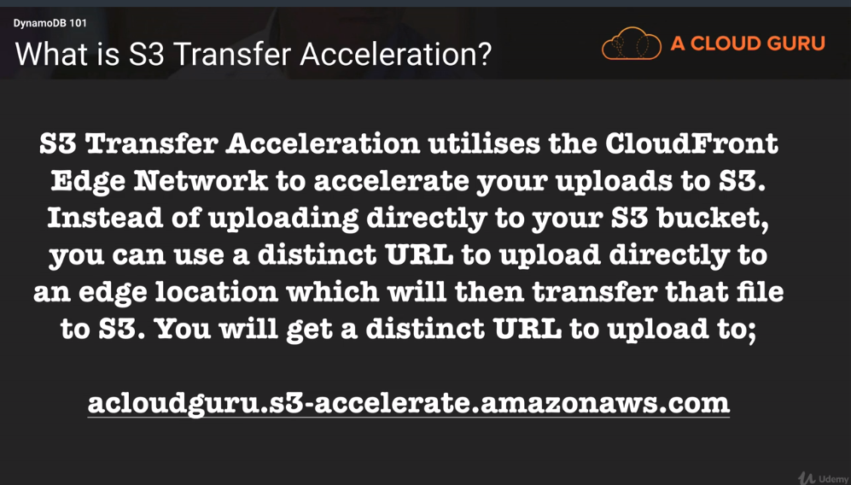

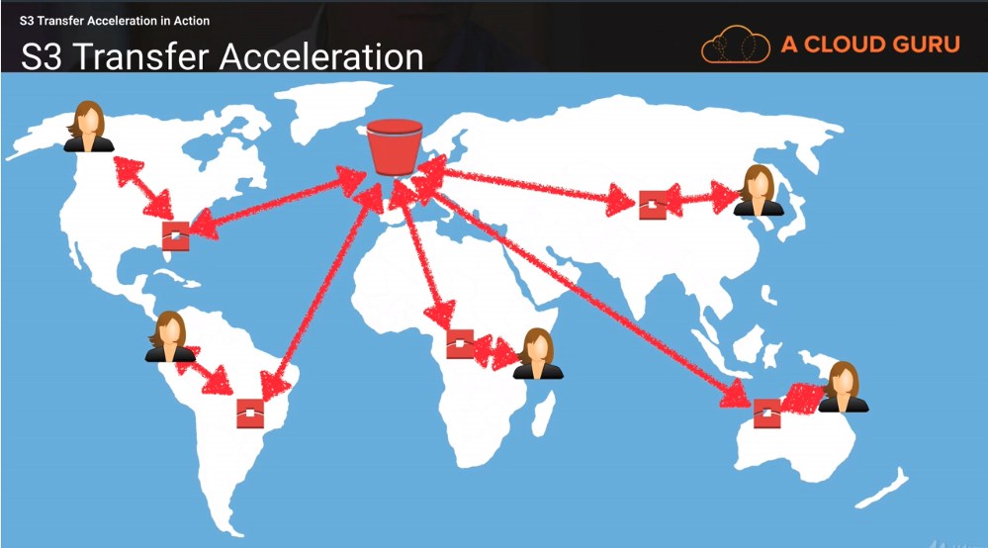

uses cloud front and edge locations near to you

--------------------------------------------------------------------------------

s4L28

create a static website using s3

bucket name – domain name

mycloudguruas3website

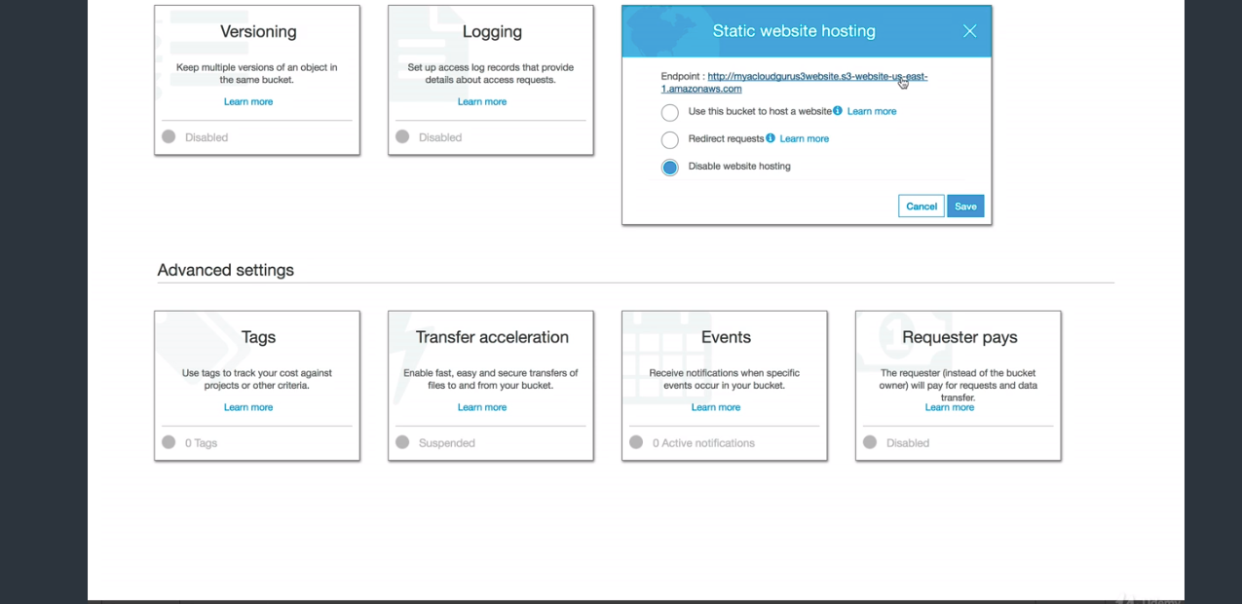

http://{bucketName}.s3-website-{region}.amazonaws.com

index.html
error.html
grant public access

upload them to bucket

if not public it’ll show the error page

it’s a static web page
cannot have php or asp

-----------------------

s4 L29

S3 exam tips

Remember that S3 is object based
allows you to upload files

Files can be from 0bytes to 5TB

there is unlimited storage

files are stored in buckets

s3 is universal namespace, names must be unique globally

https://s3-eu-west-1.amazonaws.com/cloudguru

Read after write consistency for PUTs of new objects

Eventual consistency for overwrite PUTs and DELETEs (can take some time to propagate)

S3 storage class tiers
s3 (durable, immediately available, frequently accessed)
s3-IA (durable, immediately available, infrequently accessed)
s3 redunced redundancy access (data that is easily reproducible)
Glacier – 3-5 hours wait

Remember the core fundamentals
key
value
version id
meta data
acl

s3 is object based storage only

not suitable to install os in

stores all versions of an object (includes all writes and even if you delete it)
great backup tool
once enabled, versioning cannot be deleted, only suspended
integrates with lifecycle rules
MFA
Cross region replication

LifeCycle mgt

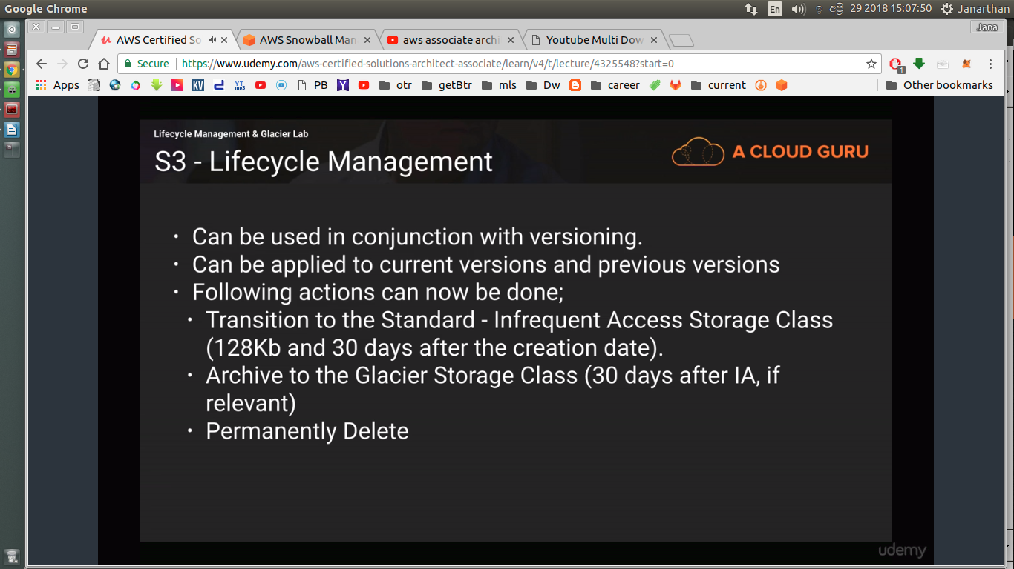

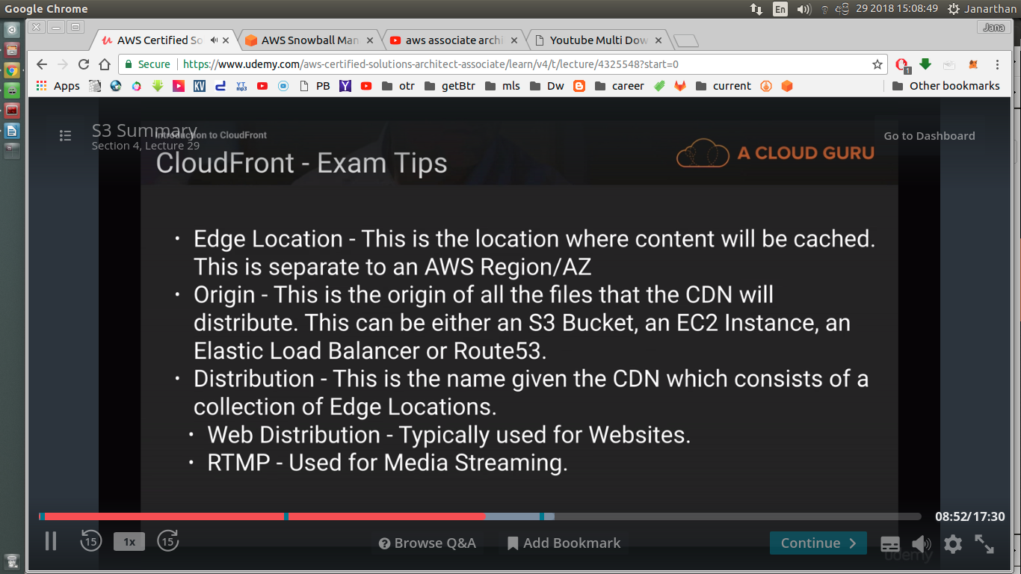

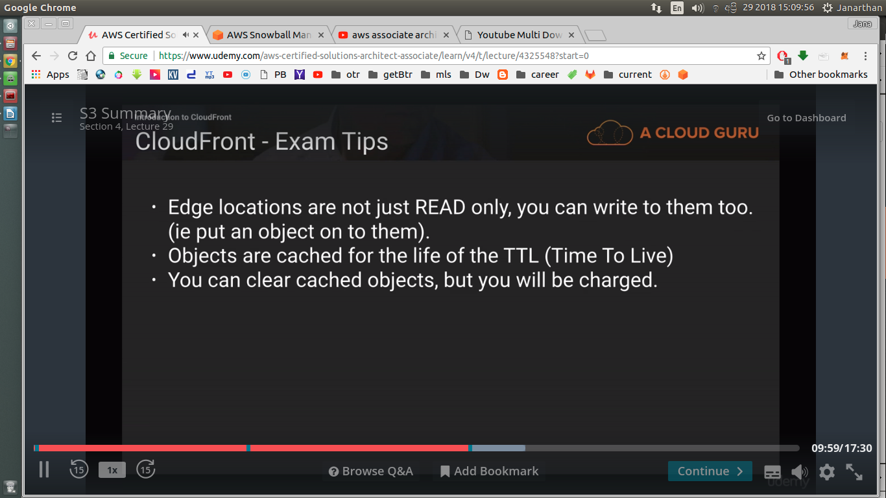

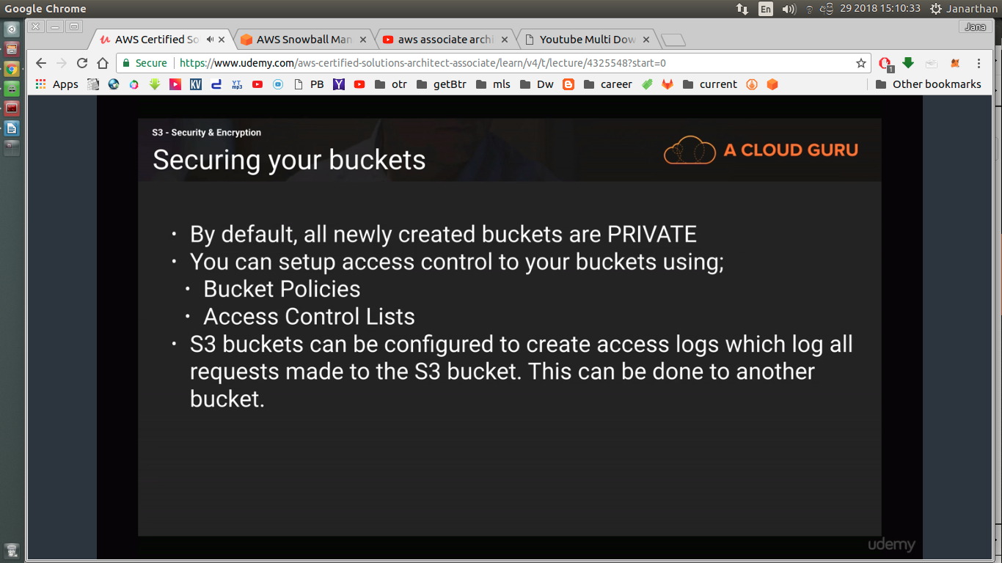

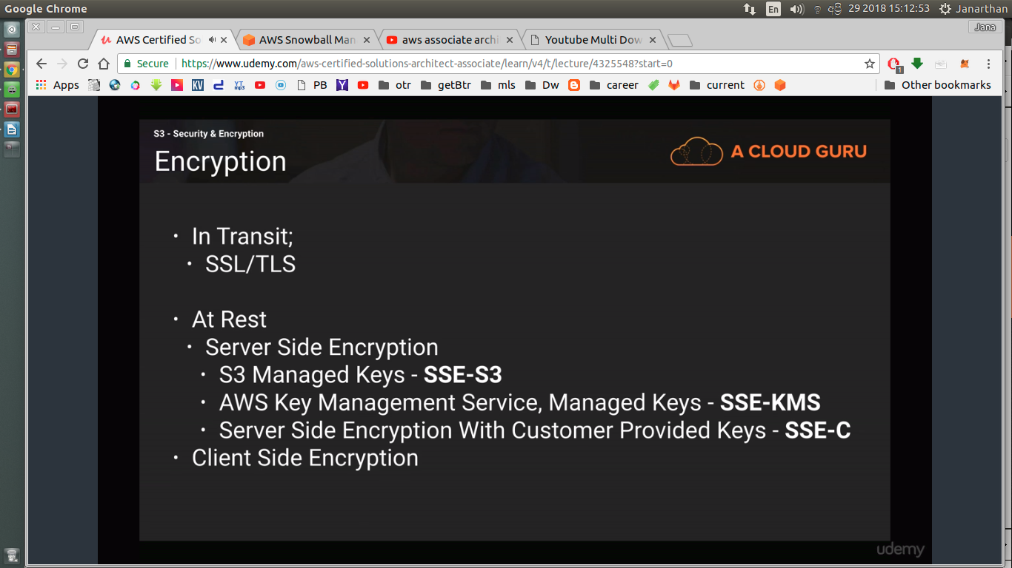

4 different gw

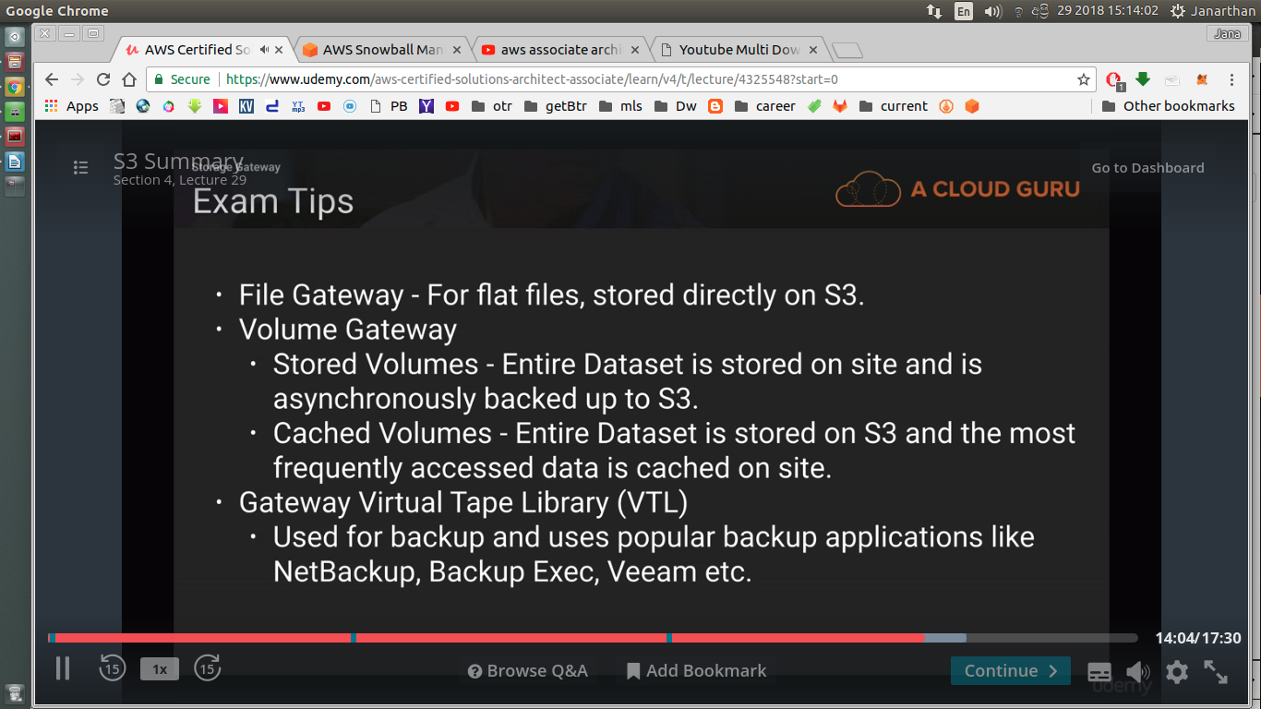

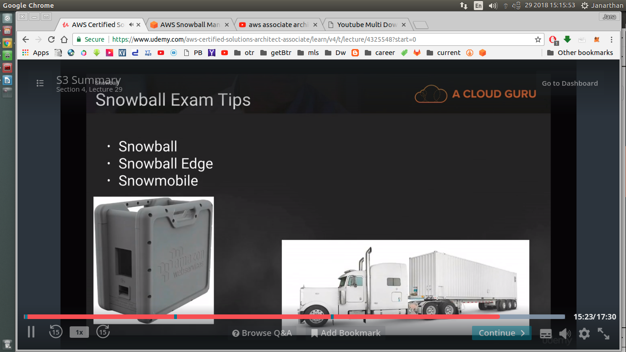

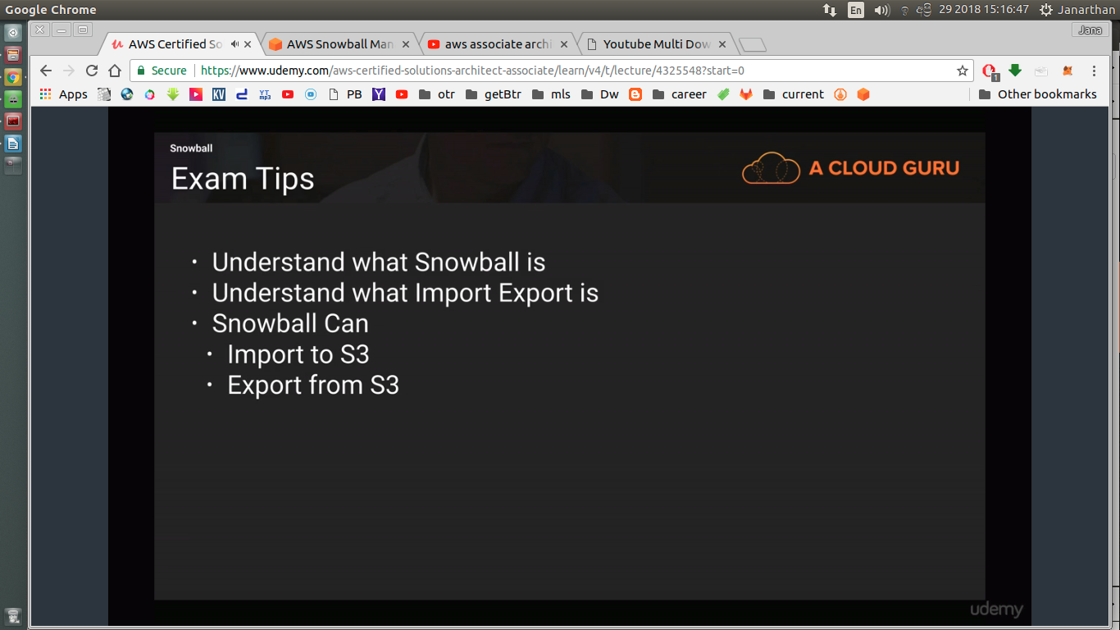

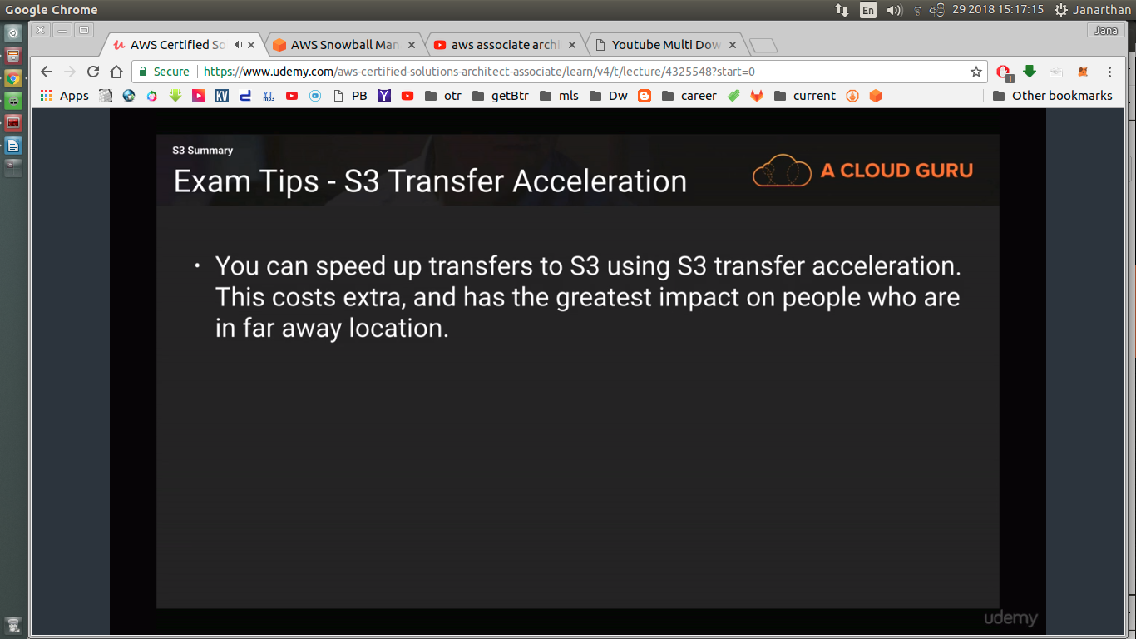

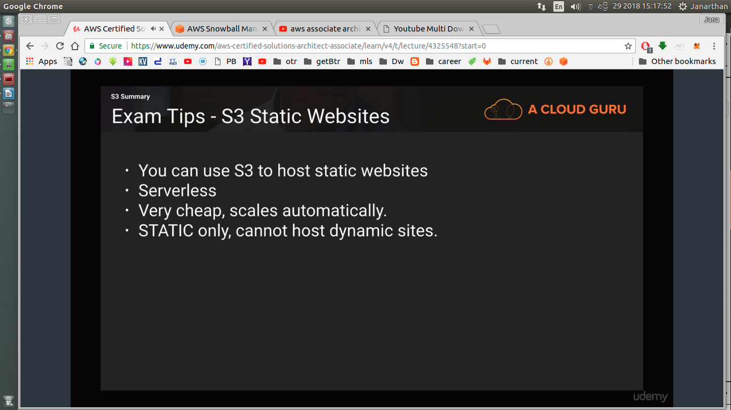

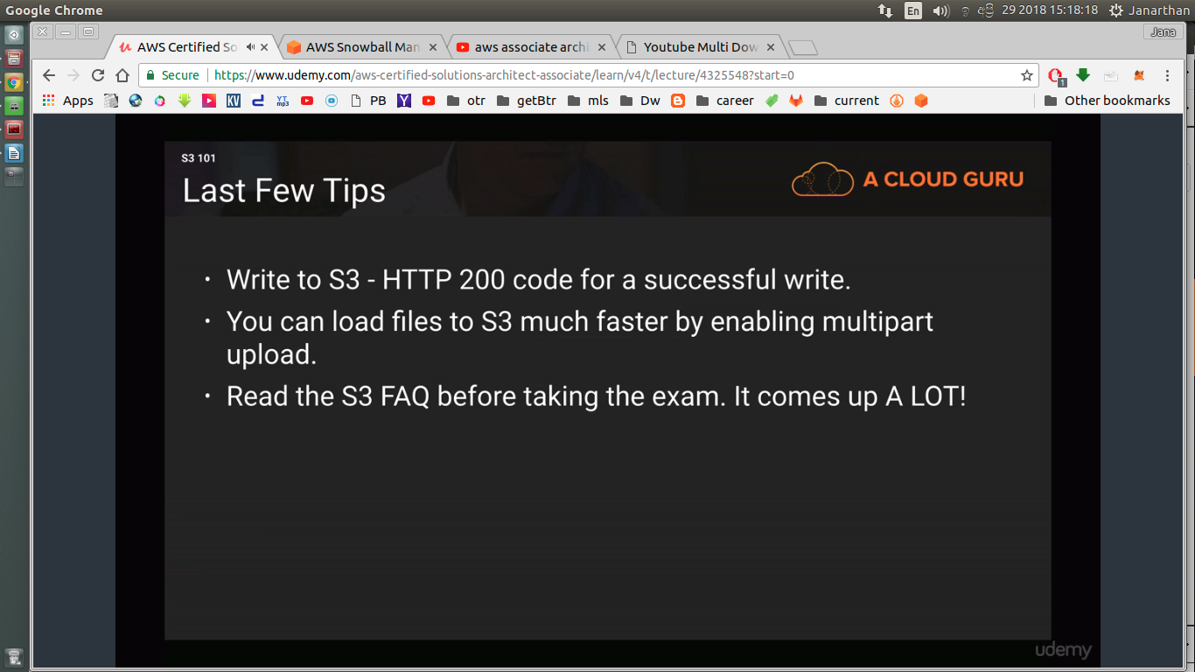

-------------------------------------------------------------------------

Quiz

aws storage gw

it’s an on-premise virtual appliance that can be used to cache s3 locally at a customer site

One of your users is trying to upload a 7.5GB file to S3 however they keep getting the following error message - "Your proposed upload exceeds the maximum allowed object size.". What is a possible solution for this?

Design ur app to use multipart upload api for all objects

s3 bucket with acloudguru1234 at eu west region
url- https://s3-eu-west-1.amazonaws.com/acloudguru1234

You are a solutions architect who works with a large digital media company. The company has decided that they want to operate within the Japanese region and they need a bucket called "testbucket" set up immediately to test their web application on. You log in to the AWS console and try to create this bucket in the Japanese region however you are told that the bucket name is already taken. What should you do to resolve this?

Buckets are global not regional. Popular bucket names are taken. You should another bucket name.

All s3 tiers (including Rrs) availability
99.99

durability
11 9 11 9 2 9

s3 min file size
1 Byte

s3 has eventual consistency for
overwrite PUTs and DELETEs http methods

You work for a busy digital marketing company who currently store their data on premise. They are looking to migrate to AWS S3 and to store their data in buckets. Each bucket will be named after their individual customers, followed by a random series of letters and numbers. Once written to S3 the data is rarely changed, as it has already been sent to the end customer for them to use as they see fit. However on some occassions, customers may need certain files updated quickly, and this may be for work that has been done months or even years ago. You would need to be able to access this data immediately to make changes in that case, but you must also keep your storage costs extremely low. The data is not easily reproducible if lost. Which S3 storage class should you choose to minimise costs and to maximise retrieval times?

You want low cost, but fast retrieval times, S3 - IA would be your best option.

You need to use an Object based storage solution to store your critical, non replaceable data in a cost effective way. This data will be frequently updated and will need some form of version control enabled on it. Which S3 storage solution should you use?

S3

You work for a health insurance company who collects large amounts of documents regarding patients health records. This data will be used usually only once when assessing a customer and will then need to be securely stored for a period of 7 years. In some rare cases you may need to retrieve this data within 24 hours of a claim being lodged. Which storage solution would best suit this scenario? You need to keep your costs as low as possible.

Glacier

You run a meme creation website that frequently generates meme images. The original images are stored in S3 and the meta data about the memes are stored in DynamoDB. You need to store the memes themselves in a low cost storage solution. If an object is lost, you have created a Lambda function that will automatically recreate this meme using the original file in S3 and the metadata in Dynamodb. Which storage solution should you consider to store this non-critical, easily reproducible data on in the most cost effective solution as possible?

S3 -RRS

You run a popular photo sharing website that is based off S3.
You generate revenue from your website via paid for adverts,
however you have discovered that other websites are linking directly to the images on your site,
and not to the HTML pages that serve the content.
This means that people are not seeing your adverts and every time a request is made to S3 to serve an image it is costing your business money. How could you resolve this issue?

Remove the ability for images to be served publicly to the site and then use signed URL’s with expiry dates.

--------------------------------------------------------------------------------

S5 L1

EC2 - Elastic Compute Cloud
Read FAQs

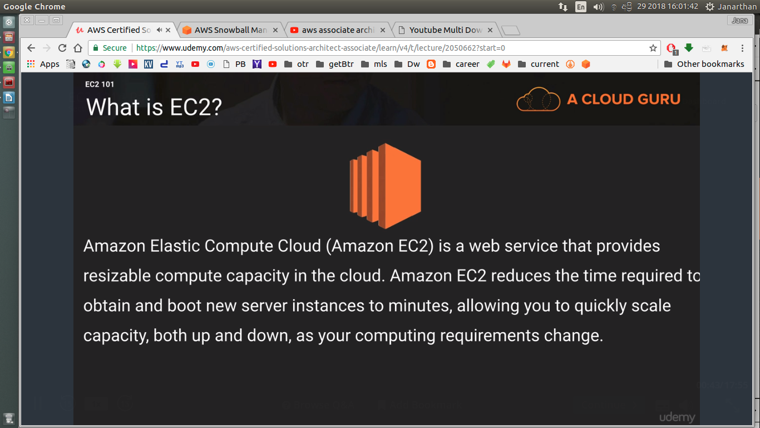

AirBnB
Uber

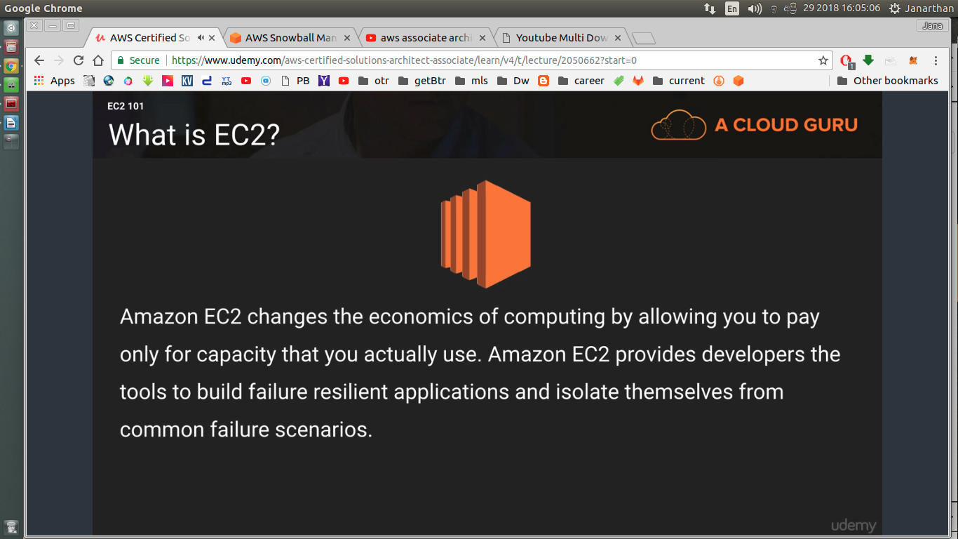

EC2 options

windows- by the hour
linux – by the second **

On Demand
Reserved
Spot

Spot –
if spot price < bid price

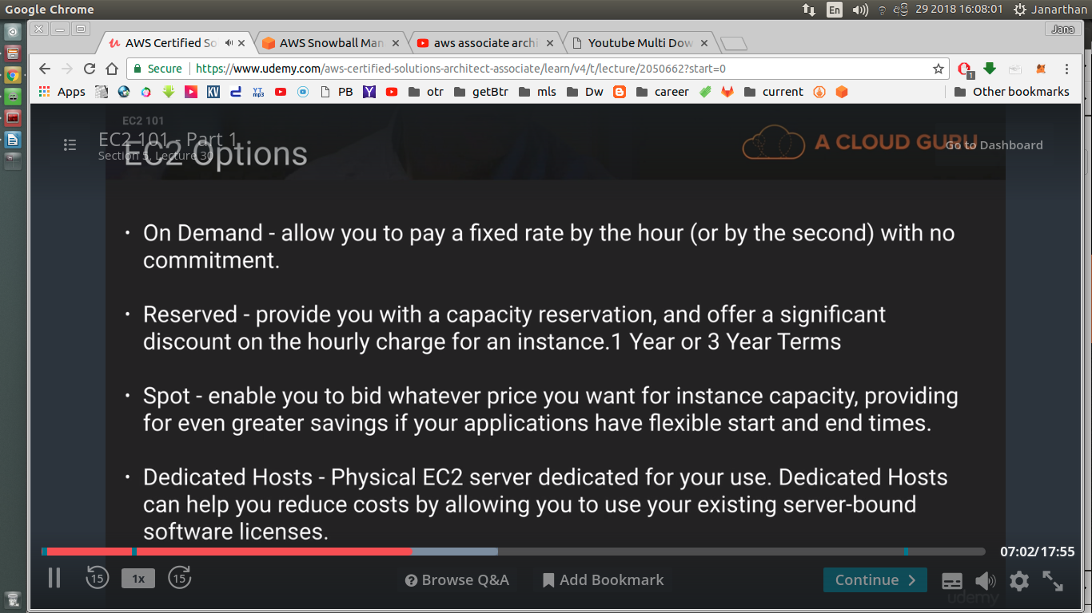

dedicated hosts – for licensing

multitenant – not secure

On Demand

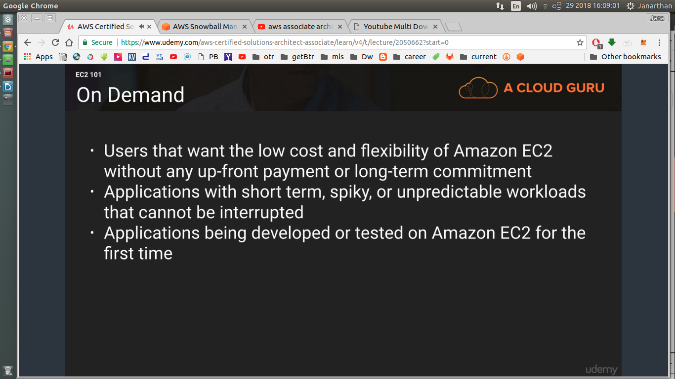

Reserved

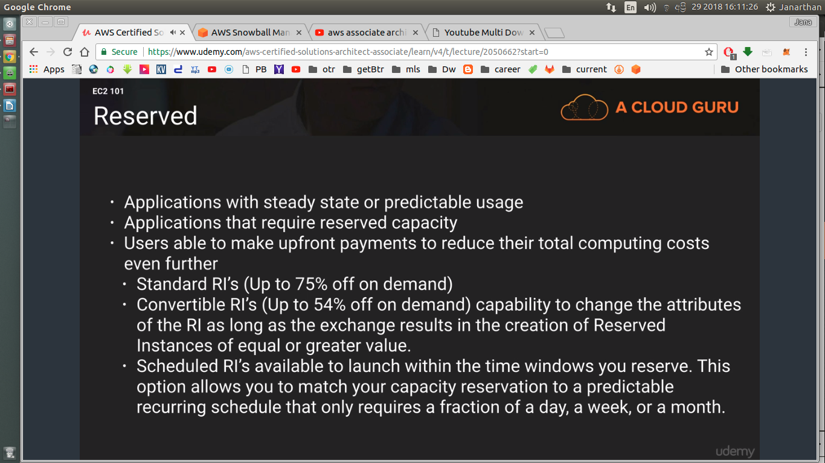

Spot

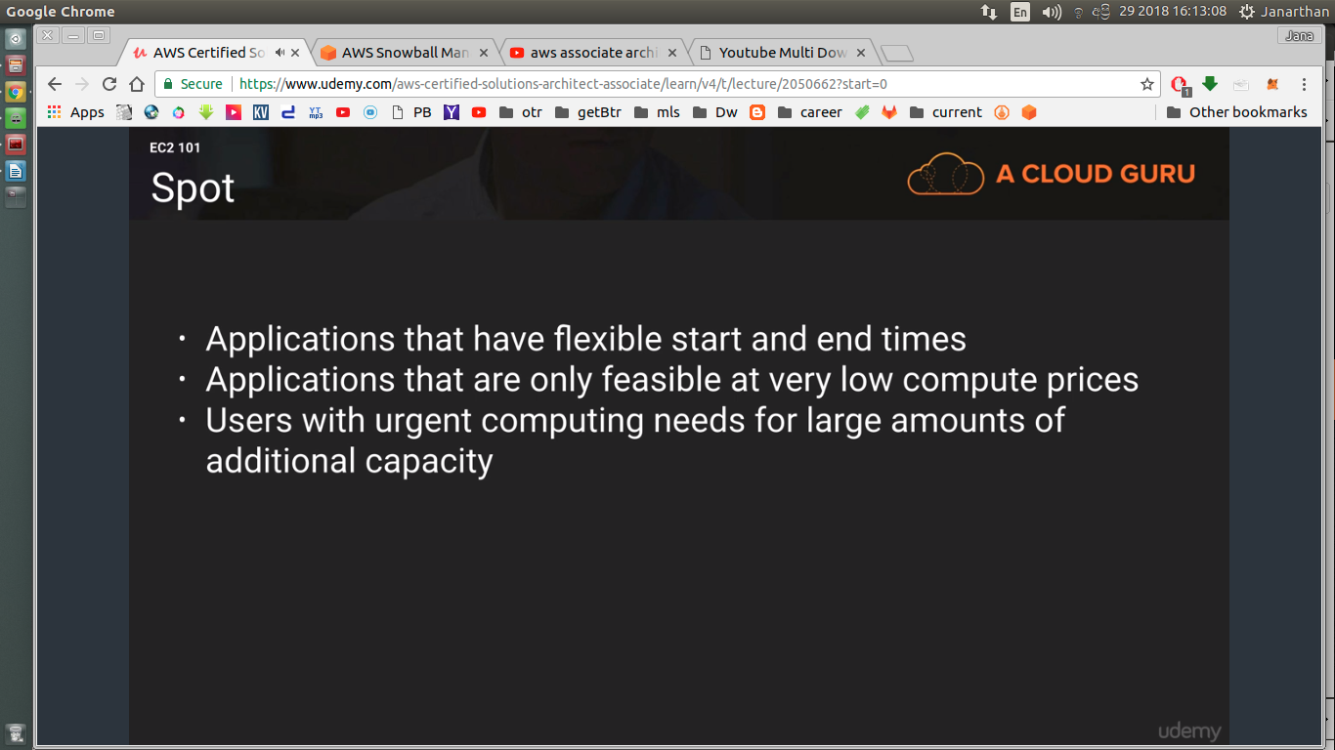

Dedicated

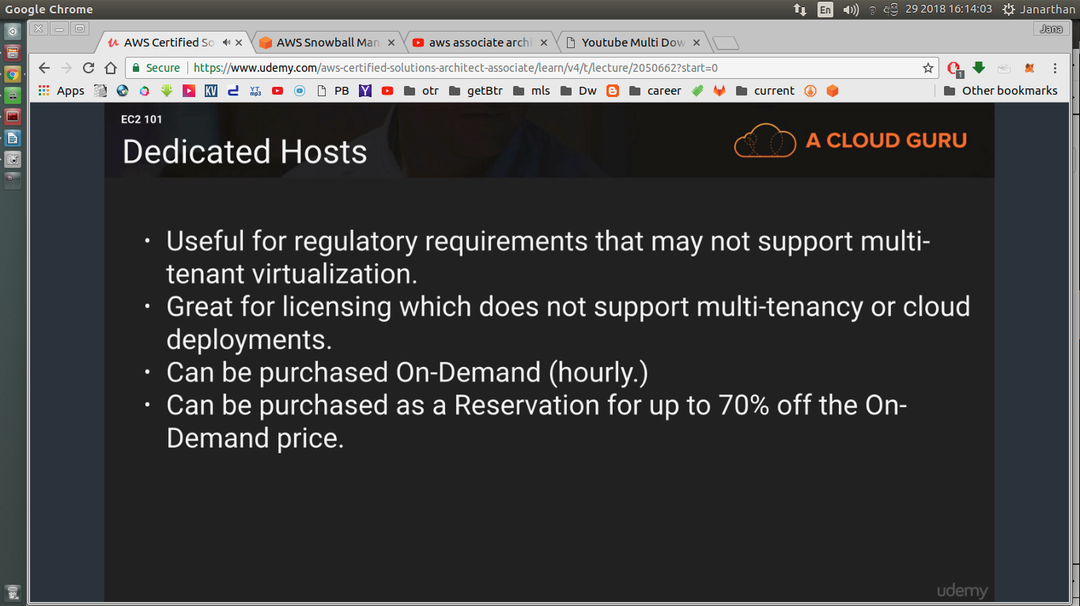

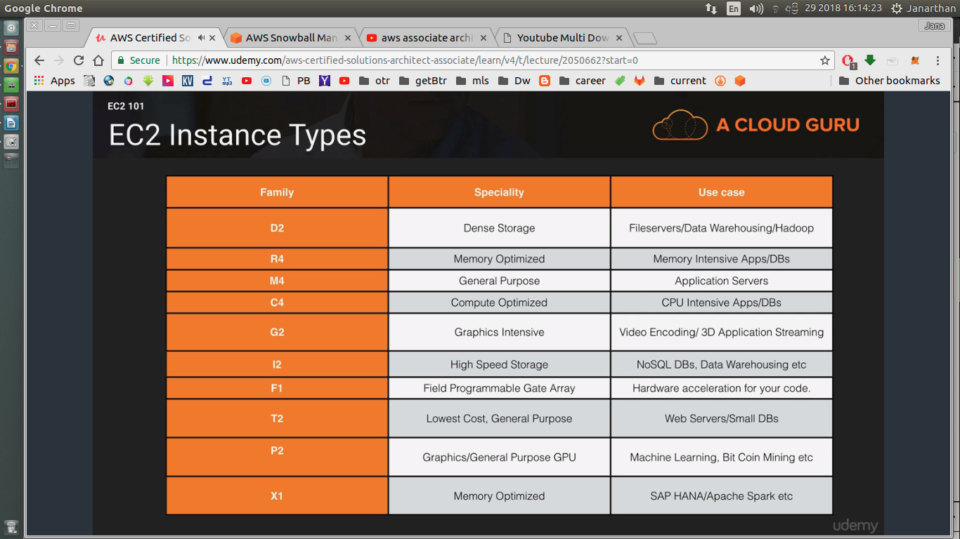

---

aws cloud 9
a cloud ide

D – Dense
R – RAM
M – Main
C – compute
G – graphics
I – iops
f1 – field programmable – very unlikey to be featured in the exam
t2 – tiny cost
p2 – ml
x1 – xtreme ram - memory optimized

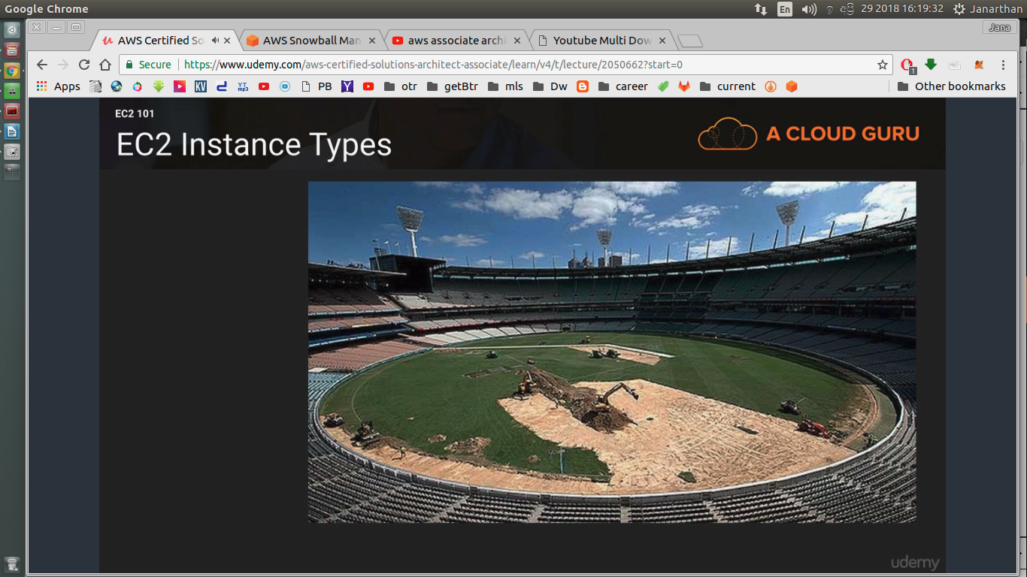
Melbourne Cricket Ground

DIRT y MCG

DIRT MCG FPX

DR Mc GIFT PX

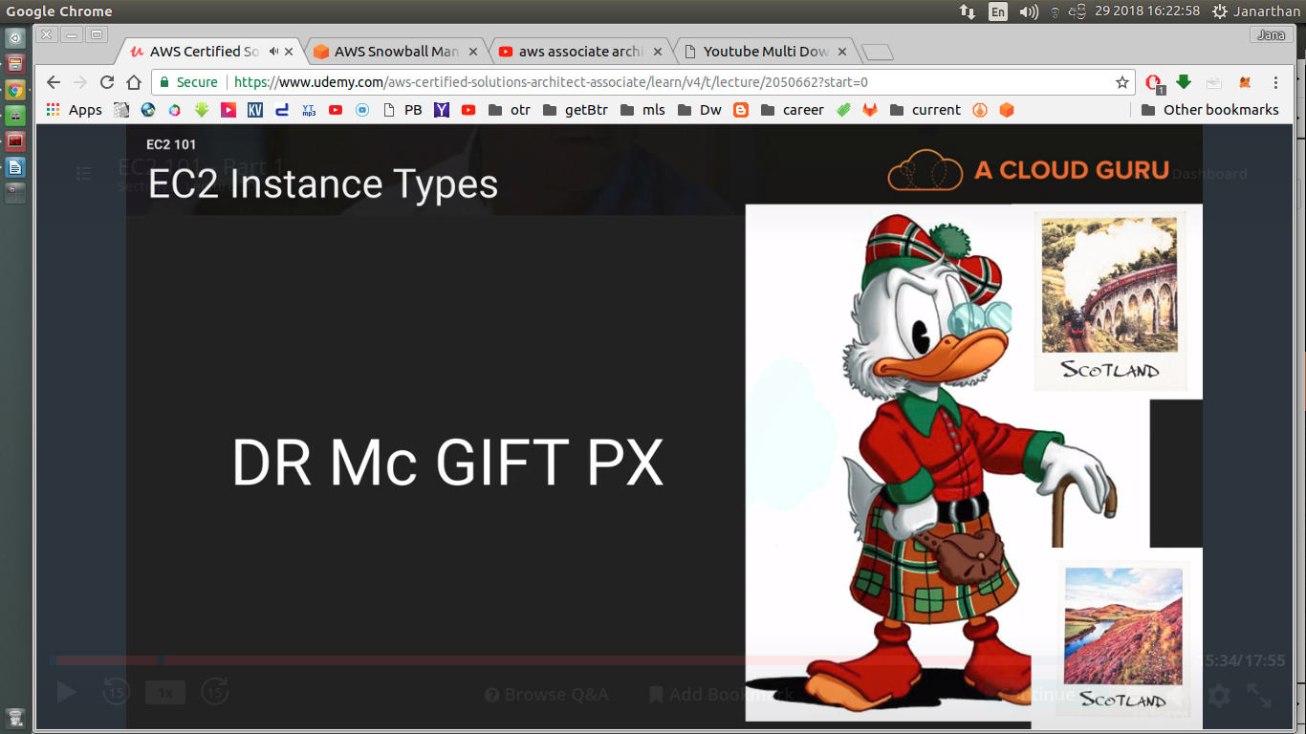

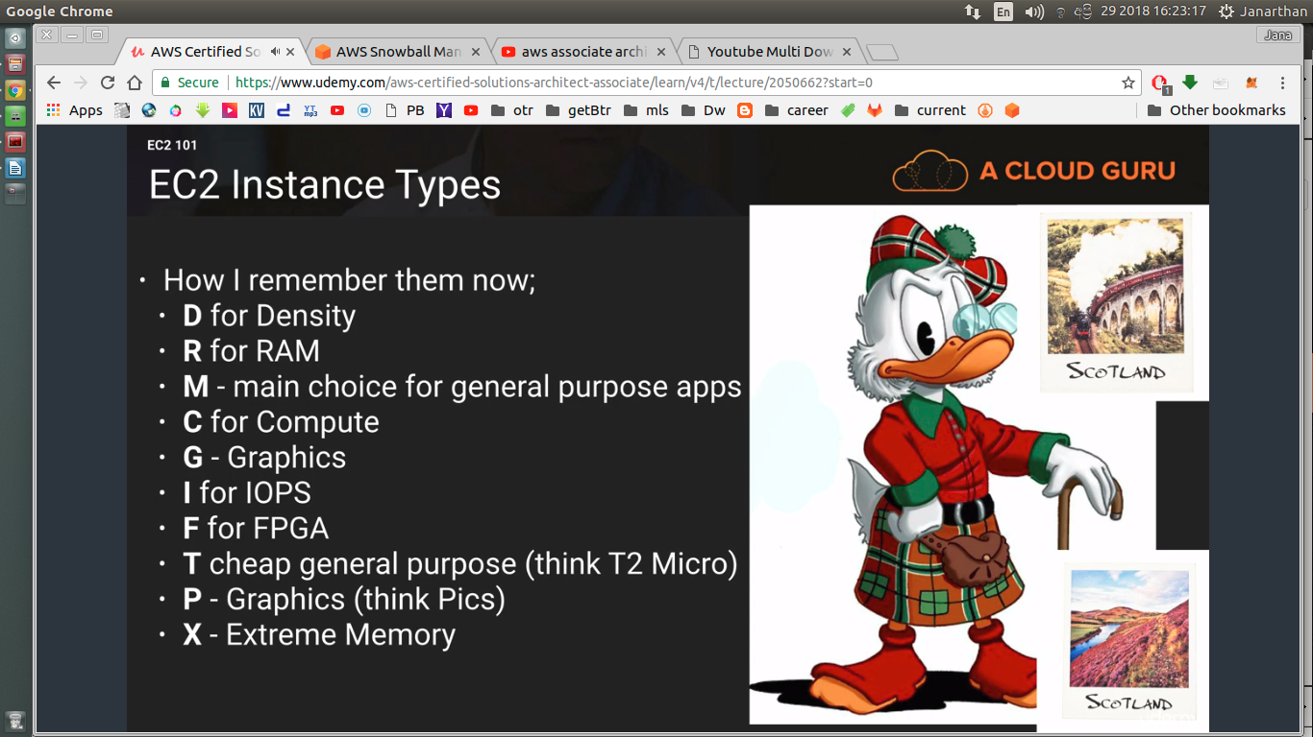

scenario will be given, ask you to pick suitable instance

------------------------------------------------------------------------

S5 L31

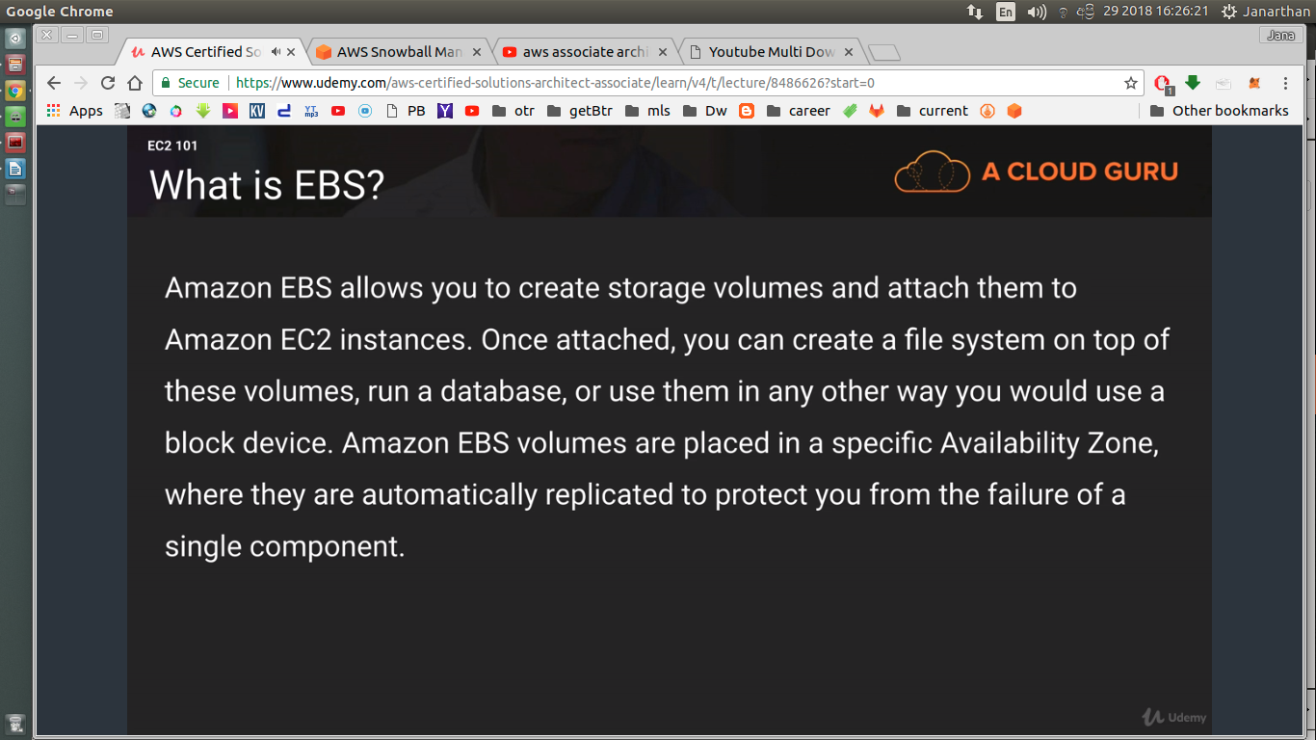

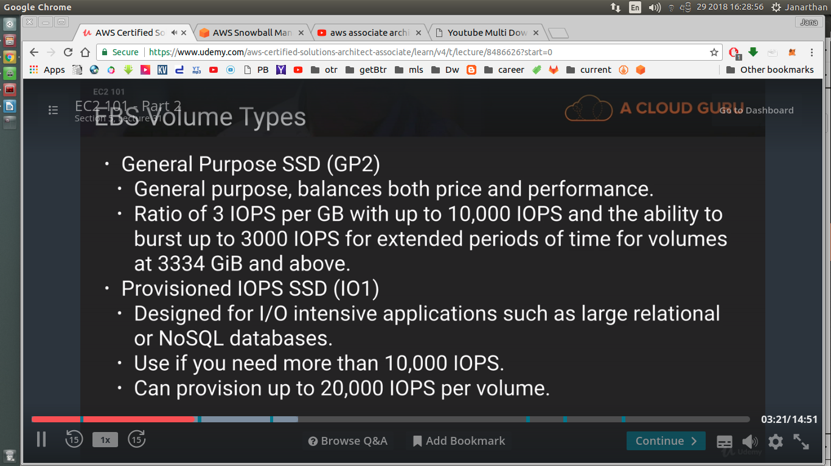

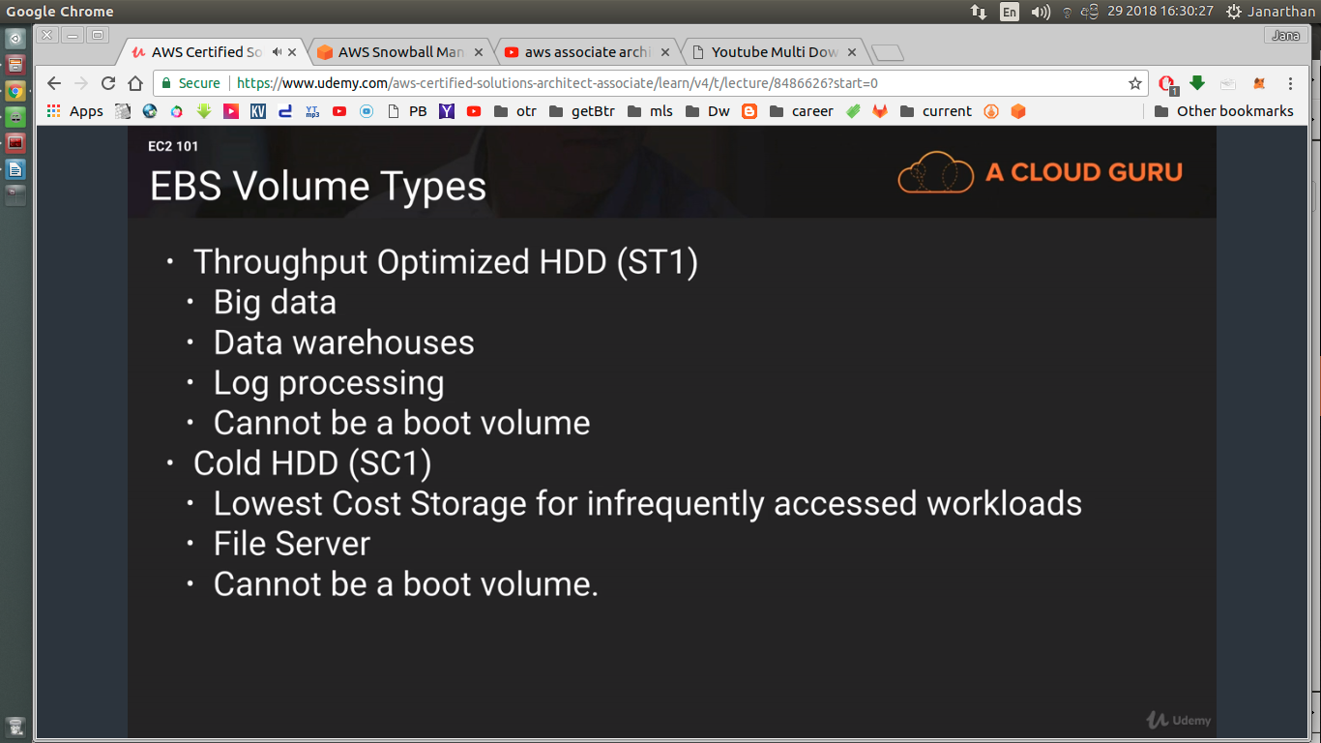

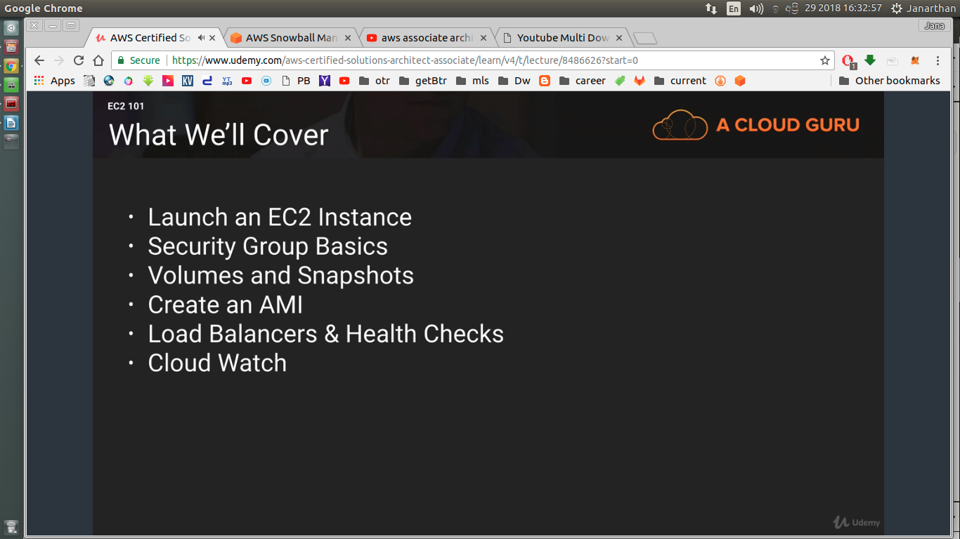

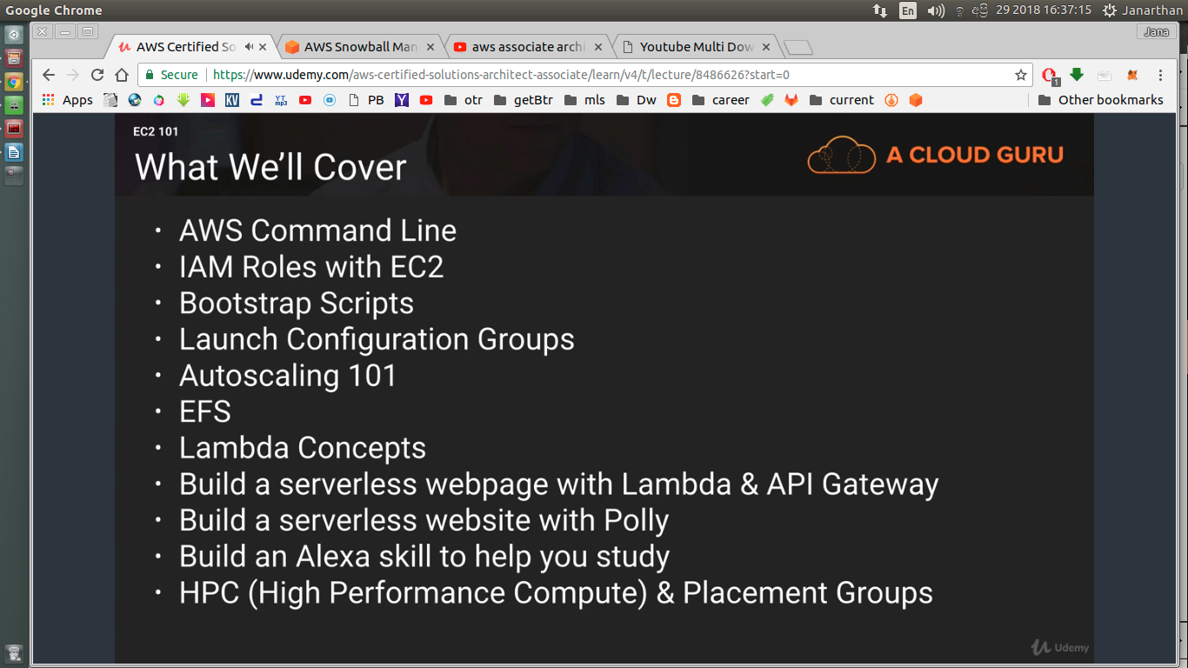

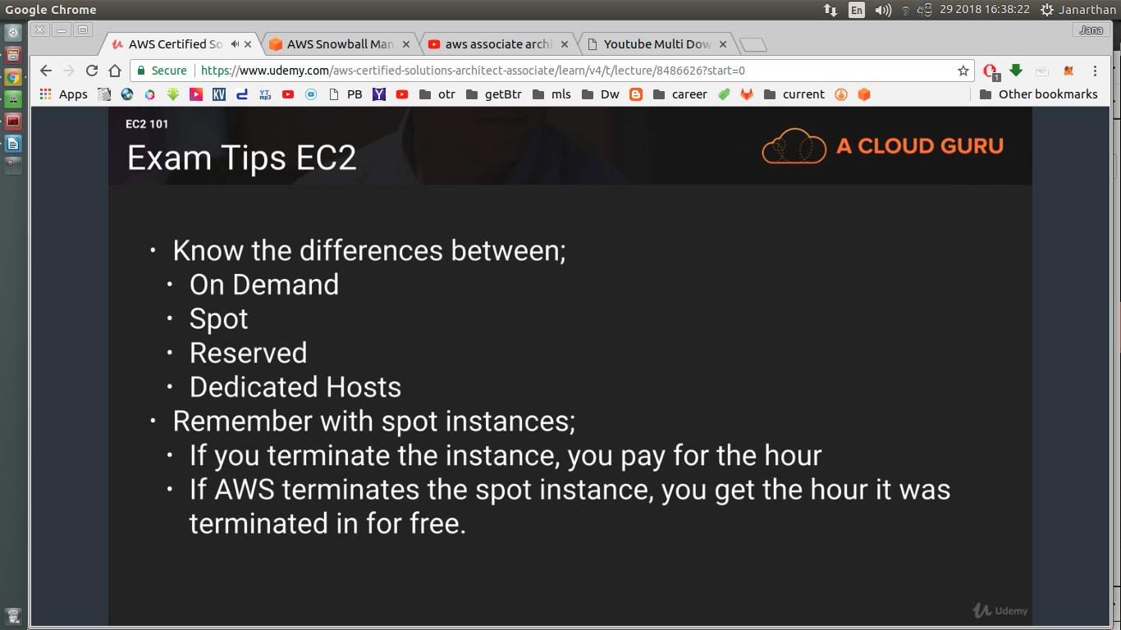

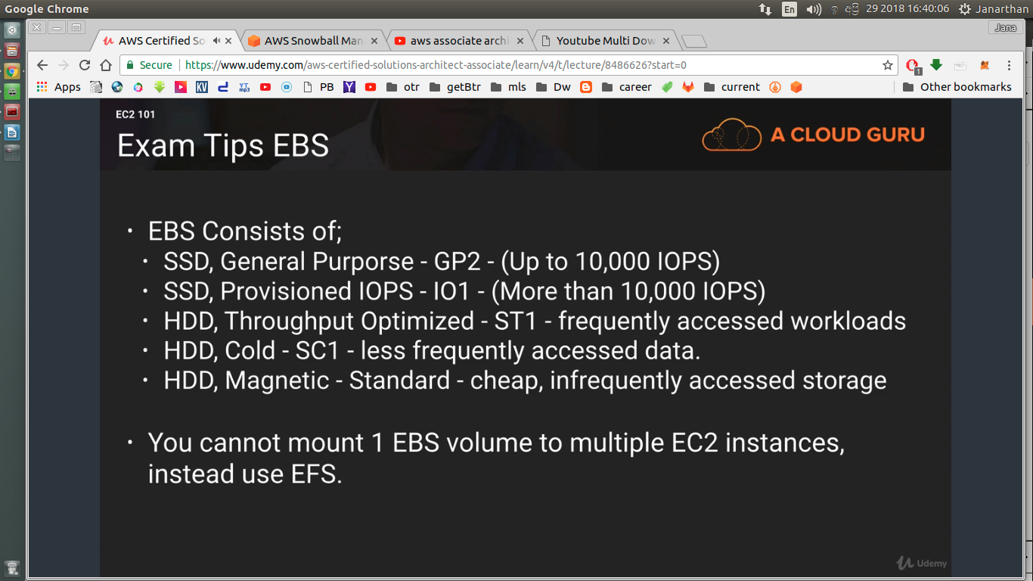

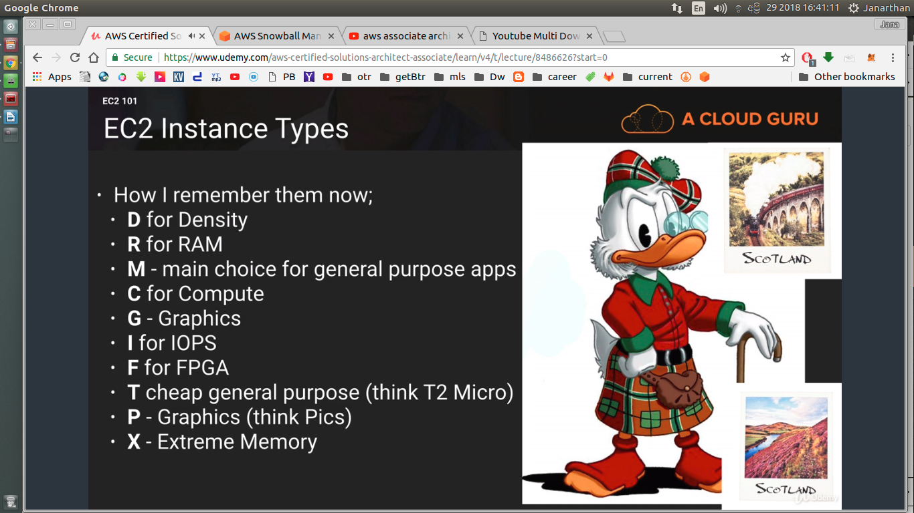

--------------------------------------------------------------------------------

S5 L32

EC2 Lab

services → compute → EC2

virtualizaton

paravirtual and hvm

Ec2 instance → lauch instance
check free tier only

1 subnet = 1 availability zone

public key – padlock
private key – key

https://www.youtube.com/watch?v=ye7hgGZwSsY&list=PLJIqXVV4K5LXEGBDPy1mxigzNVMAzkOHv

