**Selenium Supporting Locators**

ID

Xpath

CSS Selector

Name

Class Name

Tag Name

Link Text

Partial Link Text

**CSS SELECTOR: -**

Class Name 🡪 TagName.ClassName (or) .ClassName

Id 🡪 Tagname#id

Other 🡪 Tagname[attribute=’value’]

Tagname 🡪 Tagname

Parent to Child 🡪 ParentTagname<space>ChildTagname

// div[class='login-container'] h2

**Link Text: -**

Achor **a** Tag represents link.

<a href="#">Forgot your password?</a>

Link Text 🡪 Forgot your password?

**X-path: -**

//Tagname[@attribute=”value”]

//is not a command it’s the syntax of X-Path

Tagname 🡪 //Tagname

**With Index in X-Path: -**

//input[@type='text'][2]

**With Index in CSS Selector: -**

CSS won’t Hide the Hidden Element while using index, so be careful while going with index in CSS Selector.

Input[type=’text’]:nth-child(2)

**Parent-Child Tag Xpath: -**

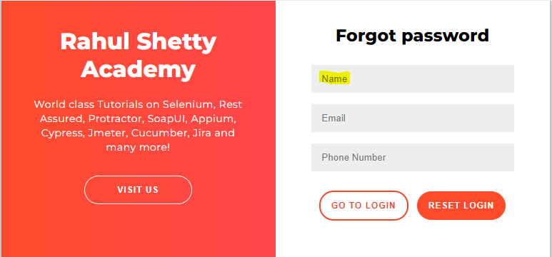

1St Highlighted is Parent

2nd Highlighted is Child

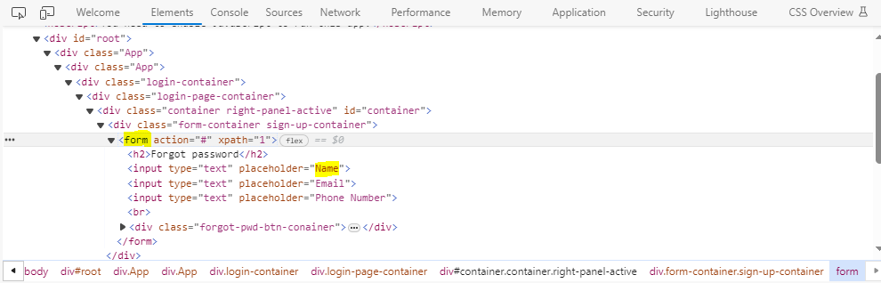

//form/input[1]

**Parent-Child CSS Selector: -**

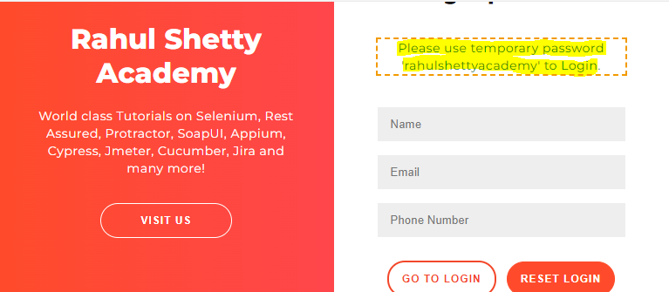

1St Highlighted is Parent

2nd Highlighted is Child

ParentTag<space>ChildTag

form p

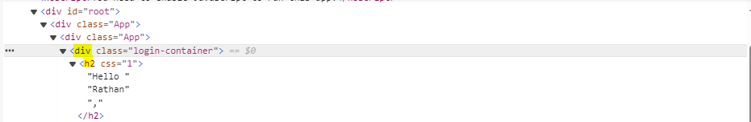

Parent to Child 🡪 ParentTagname<space>ChildTagname

// div[class='login-container'] h2

**ElementClickInterceptedException: -**

**What is Single Page Application?**

In a Single Page Application (SPA), all of your application's functions exist in a single HTML page. As users access your application's features, the browser needs to render only the parts that matter to the user, instead of loading a new page. This pattern can significantly improve your application's user experience.

**When Element Click Intercepted Exception will occurs in Selenium?**

An ElementClickInterceptedException is a type of exception which can occur when using Selenium to run a test. The exception is usually thrown when an attempt to click on an element on a web page is intercepted or blocked by another element.

Usually this happens when another element is overlapping or positioned (partly) in front of the DOM element that your Selenium script is trying to click.

**Scanning the common attributes & picking it by scanning the value CSS Selector: -**

In the below Example we have a common attribute named as type using this we’re going to scan the values & pick the required one by using the below Syntax in CSS Selector.



Syntax: -

input[type*='pass']

**Scanning the common attributes & picking it by scanning the value Xpath Selector: -**



Syntax: -

//input[contains(@value, ‘rmbrUsername’)]

**Class Name: -**

A compound class name refers to a class name that contains multiple classes separated by spaces. For example, if an HTML element has a class attribute like **<div class="class1 class2">**, then "class1 class2" is a compound class name.

Selenium won’t support compound class.

CSS: -

d.findElement(By.cssSelector(".class1.class2")).click();

Xpath: -

d.findElement(By.xpath("//div[contains(@class, 'class1') and contains(@class, 'class2')]")).click();