**Get Contacts Widget Table**

**Installation**

1. Distributed with the product, so no special installation requirements.

**Description**

This purpose of the Get Contacts widget is to allow the developer to read the contacts from the user’s contacts database. A table needs to be in the process so the data pulled in can be safely sent back to the server. You can choose whether to show the table or not, but since the developer doesn’t know the size, it has to have a lot of visible rows, and so can slow performance if you choose to generate table content.

The contacts are stored in a repeating data group, which is specified in the configuration of the widget. The widget can read the name, numbers, emails, urls and a note of the contact.

**How to use**

1. Create a data structure in the **DataStore Editor** to store with the contact details. This needs to be a multi-instance group. Within this groups there should be sub groups (also multi-instance) to store numbers, emails and urls.

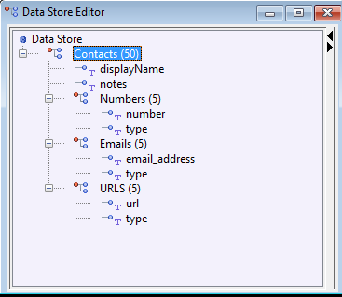

1. Create a table in the **Process Editor** – this will be the main table which stores each contact. Within this table add nested tables for numbers, emails urls. If this widget is used, the table is not actually generated – the purpose of adding it to the process is to prime the security layer into allowing this data in.

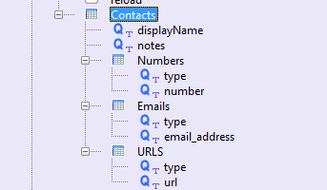

1. In the **Presentation Editor** -> **Double Click on the table** -> **Appearance** -> **Display Type** -> Select the **com.temenos.widgets.hybrid.contacts.getContacts**  type
2. Within Widget Details tab you have to set up the widget settings.
3. The fields let the user choose the data items where the contact information will be stored. For the multi-value types (number, email, url) there is a second data item to store the type (e.g. “mobile”, “home” etc.).

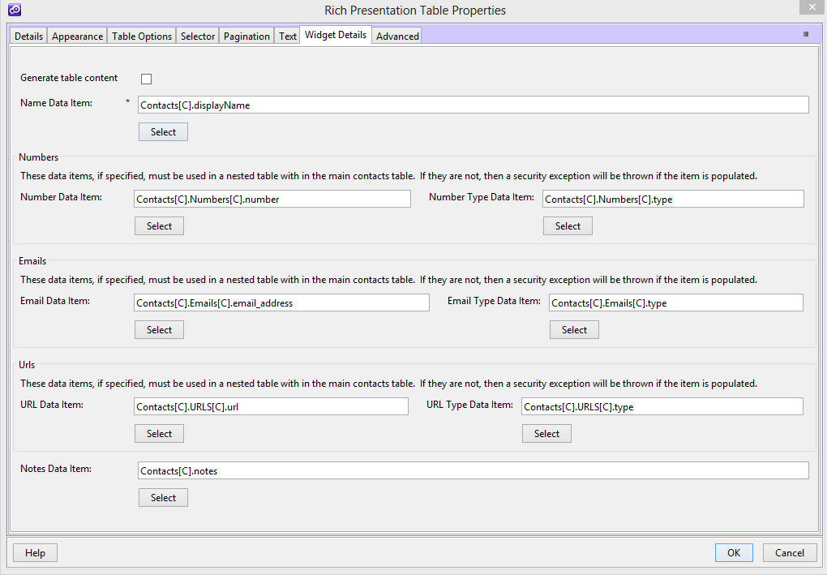

**How it works**

It is important to understand that using this widget does not need to generate a table in the page. The table model has to be created to indicate to the security layer (within edgeConnect) that these data items can be populated. In that respect, the presentation table has to be configured to display empty rows, as the security layer would complain if it thought the user was trying to populate data in empty rows which should have been hidden.

If you choose to display the table, it will get populated after it has been rendered. This could be a large table, and may impact performance

When the page with the widget is loaded, the database is read and results are populated in to hidden inputs (generated dynamically by the widget, with the correct name so edgeConnect will understand them).

So, in the sample project attached to the widget, the first page loads the contacts. Navigating forward displays the results in a linear table format.

