**Inventory.ini**

[myhosts]

192.0.2.50

192.0.2.51

192.0.2.52

**ansible-inventory -i inventory.ini --list**

ansible myhosts -m ping -i inventory.ini

## **YAML format**

**Inventory.yaml**

myhosts:

hosts:

my_host_01:

ansible_host: 192.0.2.50

my_host_02:

ansible_host: 192.0.2.51

my_host_03:

ansible_host: 192.0.2.52

**Using Metagroups**

leafs:

hosts:

leaf01:

ansible_host: 192.0.2.100

leaf02:

ansible_host: 192.0.2.110

spines:

hosts:

spine01:

ansible_host: 192.0.2.120

spine02:

ansible_host: 192.0.2.130

network:

children:

leafs:

spines:

webservers:

hosts:

webserver01:

ansible_host: 192.0.2.140

webserver02:

ansible_host: 192.0.2.150

datacenter:

children:

network:

Webservers:

**Variables:**

webservers:

hosts:

webserver01:

ansible_host: 192.0.2.140

http_port: 80

webserver02:

ansible_host: 192.0.2.150

http_port: 443

vars:

ansible_user: my_server_user

**Playbook:--->>**

Install nginx

Start nginx

Apt module and service module provide by ansible, it is equal to shell -> apt install nginx & service start nginx

Ansible used to run ansible commands

Ansible-playbook command used to run ansible playbooks

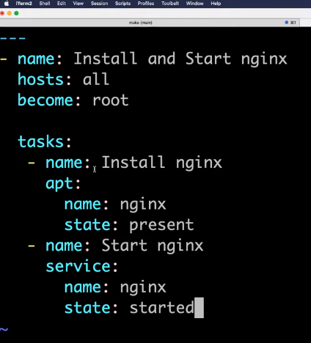

**Ansible Roles:**

Used to manage ansible playbooks efficiently

Structure:

Main.yaml

Inventory.yaml

Role

->common-

Files

Tasks

handlers

->jenkins

Files

Tasks

Handlers

**Dynamic Inventory:**