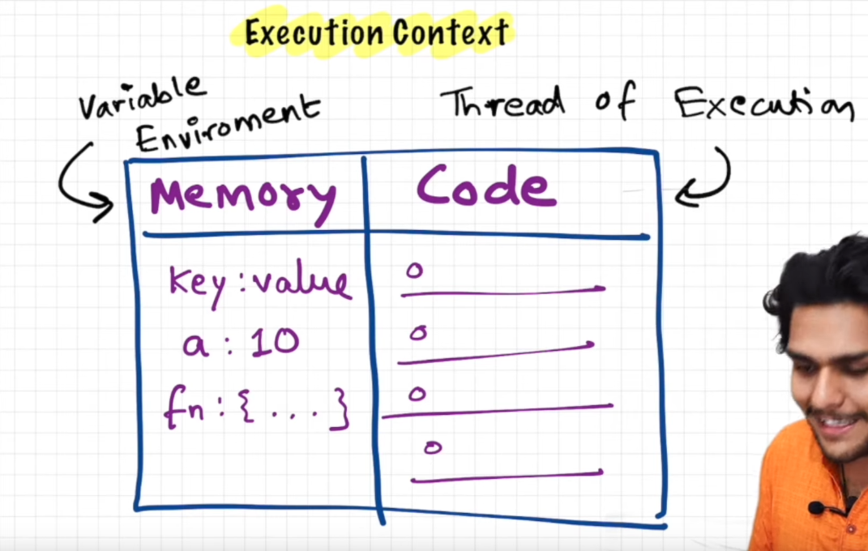

JS is synchronous single threaded language, can execute code line by line.

Execution Global context creation

In 1st phase js allocates memory to all variables, while allocating it stores undefined in the variable and whole code in the function variable.

2nd phase code is executed

When function is created new execution context gets created.

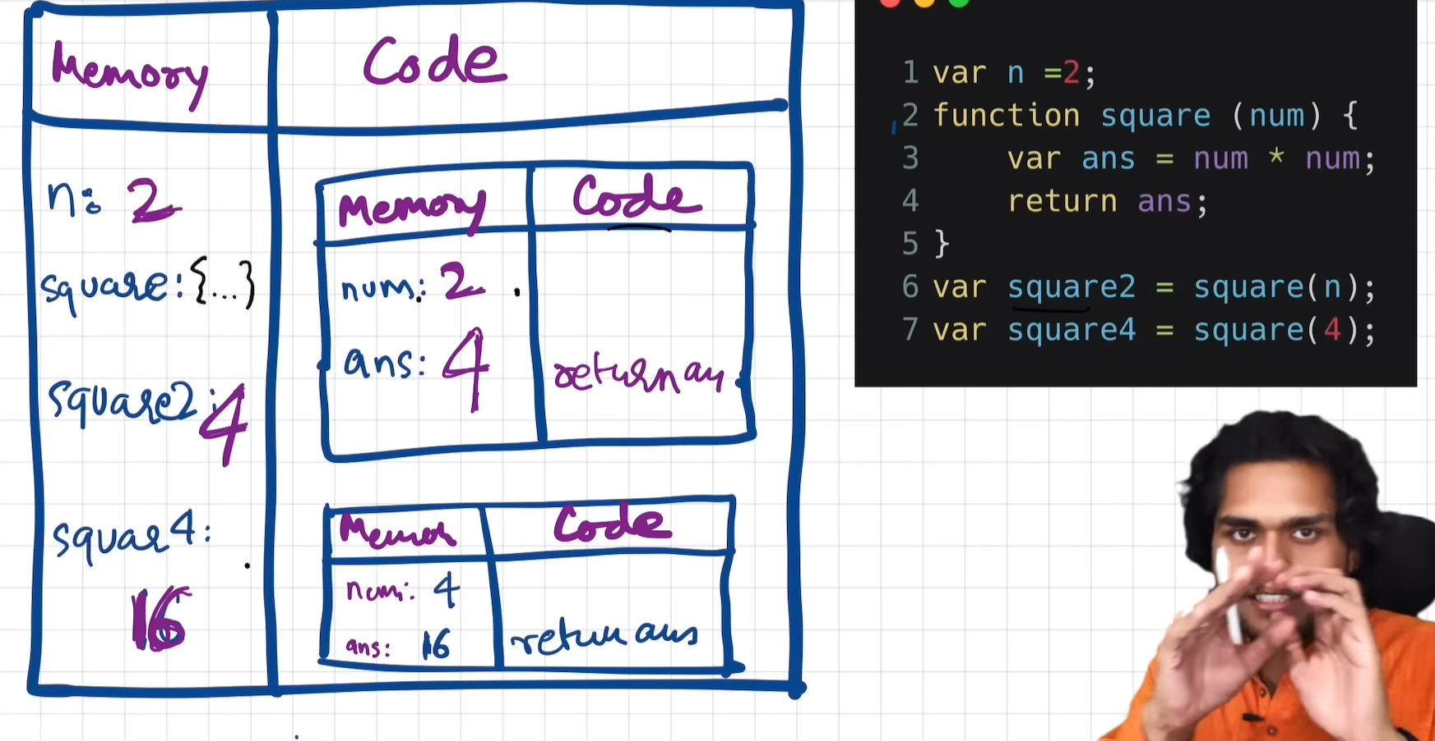

Hoisting:

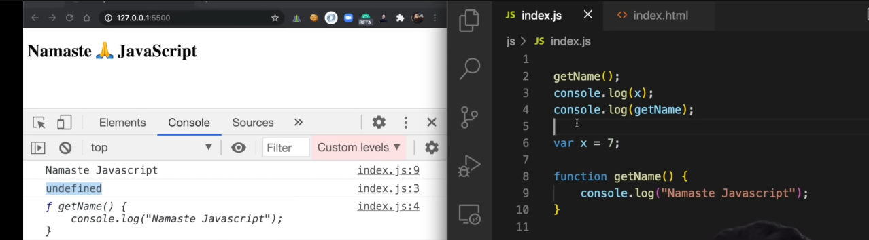

Access variable before assigning because of context creation.

Memory is allocated before execution.

Lexical environment Scope chain:

In herireachy, when a execution contect is created lexical environment I s also created which refers to lexical environment of its parent ( it memory + its parent lexical env)

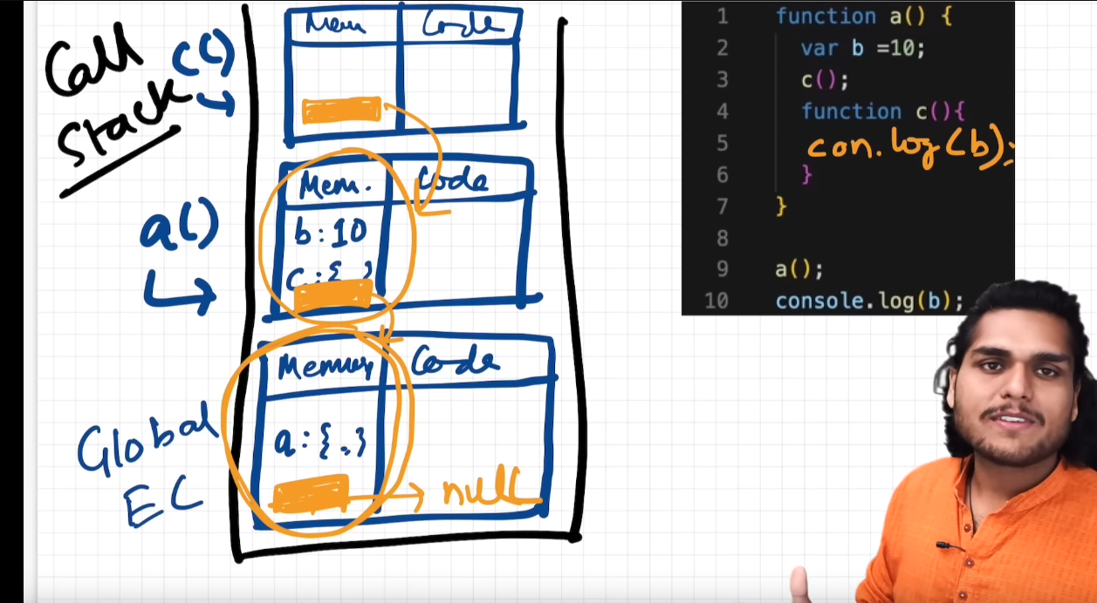

LET & CONST :

These are also hoisted but kept in different memory space , hence we cannot access them before declaration.

Temporal dead zone: memory is allocated but value is not assingned.

Let vs const : let can be declared but assingned later but not In const