**LINUX:**

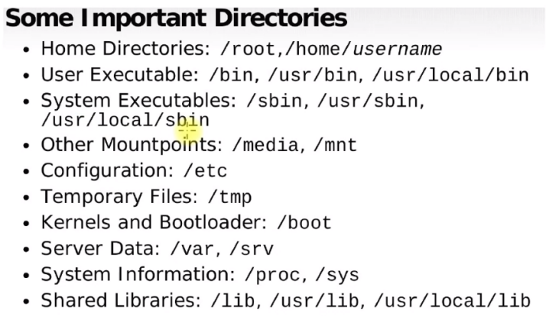

**COMMANDS:**

Command options arguments

Command --help

**Check USER**: whoami

***List process on 8083*** : sudo ss -lptn 'sport = :8083'

**KILL process on 8000** : sudo kill -9 $(sudo lsof -t -I:8000)

for pid in $(sudo lsof -t -i:8000); do sudo kill -9 $pid

**Run script in background :** nohup /home/ubuntu/java-app/java.sh > /dev/null 2> /dev/null

java -jar target/demo-0.0.1-SNAPSHOT.jar >/dev/null 2>&1 &

**Remove all files except one :** rm -v !("filename")

**Remove everyhing :** rm-rf *

**Check file type** : file filename

**Link to a file** : ln -s filepath shortcutName

**Look for text in file** : grep firewall , -i for case senstivity , r to get inside directory

**Reader and sercher** : less fileName

**First N lines of file** : head -N fileName

**Last N lines of file** : tail -N fileName , -f for Dynamic Content

**Change in file** : sed ‘s/thingtobechanged/newthing/g’ fileName.txt (does not change actually),

use **-i** to change

**Processes:** ps aux, ps -ef

**Get particular proccess id** : pf -ef | grep httpd

**Kill forcefully** : kill -9 pid

ps -ef | Xargs kill -9 (xargs takes pid as arguments)

**Output redirection All output** : command & >> filename

**To Null** : command & > /dev/null

**Archiving :** tar -czvf archive_name.tar.gz path_to_compress

(Create compress verbose file)

**Unarchive** : tar -xzvf tar_file_path

(x Extract )

**Add user** : useradd username

adduser username

**Port Forwarding** : ssh -i keyname.pem -L 3306:localhost:3306 ubuntu@ip -N

-L localPort:Endpoint relative to bastion:endpointPort

**Install package** : apt install package_name

apt remove package_name

apt purge package_name (remove everything)

Read Write Execute

1. 2 1

Eg: Chmod 627

1st no. - User

2nd no. -grp

3rd no. -others

**In shell Script:**

set -x to run script in debug mode

set -e exits the script if err occurs (will not be able to catch pipefail)

set -o for pipefail

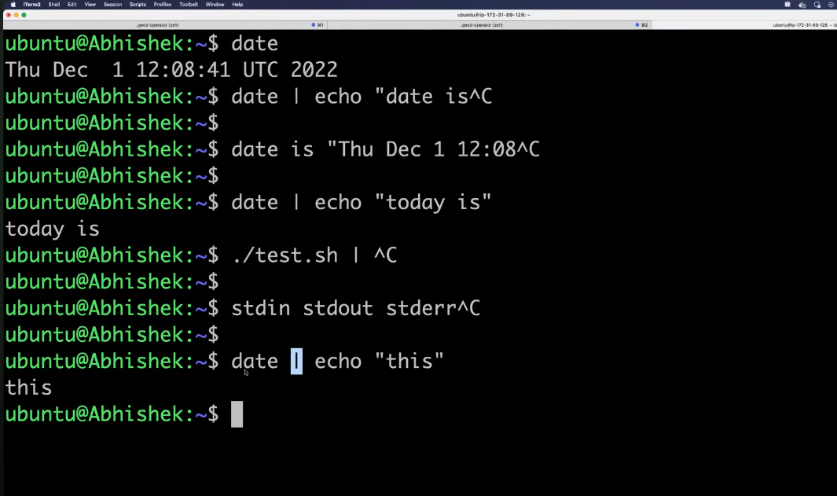

pipe only send stdout command output to another command.

**Awk command:**

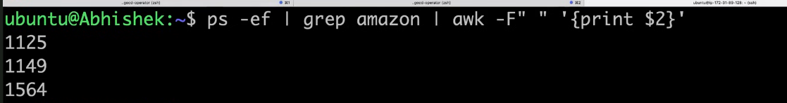

**Find:**

find / -name test

**If else / For loop:**

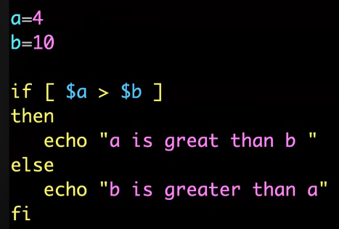 

**Create a Systemd Service:**

sudo nano /etc/systemd/system/serviceName.service

eg: Docker compose up and down

**[Unit]**

**Description=Docker Compose Application Service**

**Requires=docker.service**

**After=docker.service**

**[Service]**

**Type=oneshot**

**RemainAfterExit=yes**

**WorkingDirectory=/home/ubuntu/airbyte**

**ExecStart=sudo docker compose up -d**

**ExecStop=sudo docker compose down**

**TimeoutStartSec=0**

**[Install]**

**WantedBy=multi-user.target**

===================================================================================