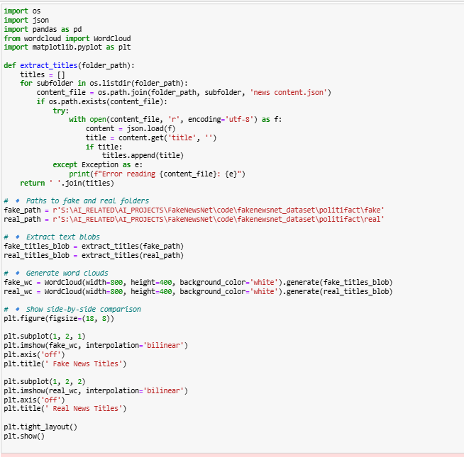

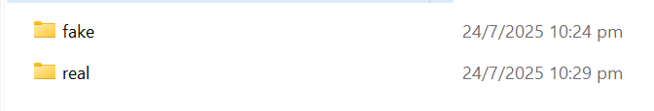

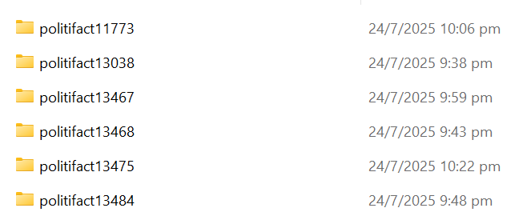



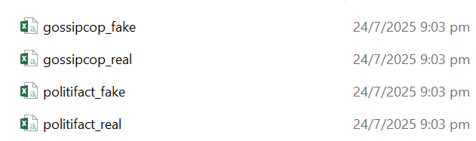

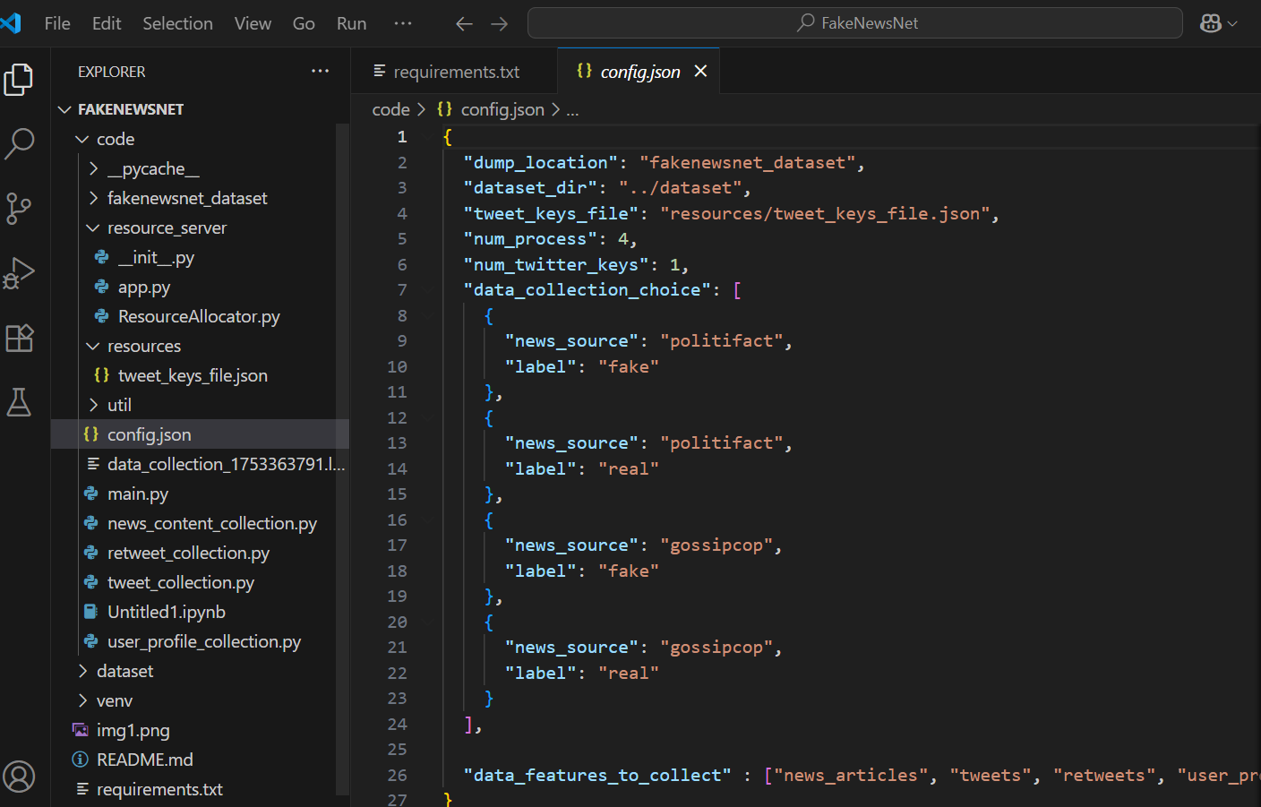

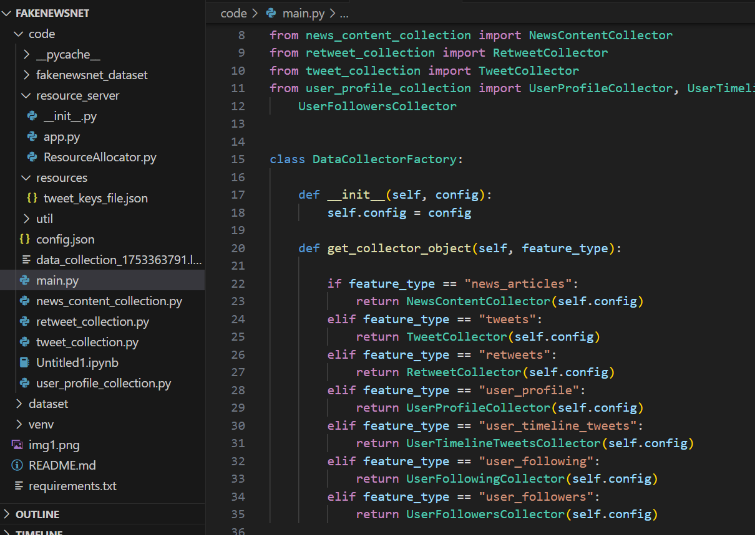

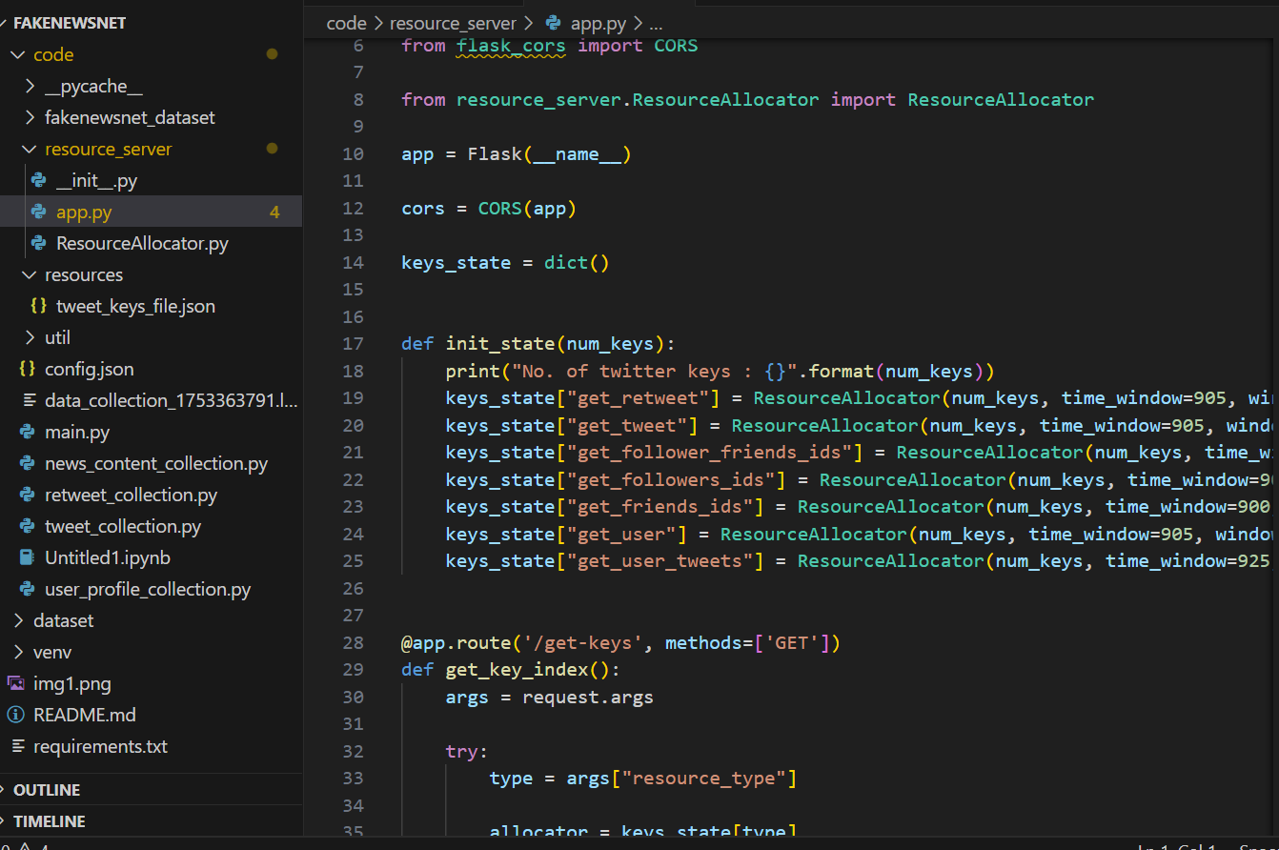

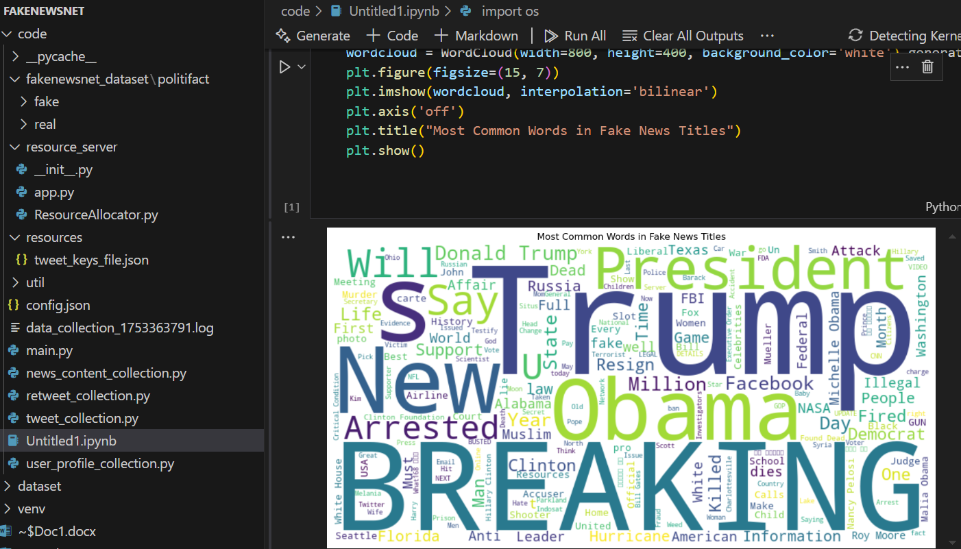

🚀 Excited to share my latest work on FakeNewsNet — a research project focused on understanding and detecting fake news on social media! 📰🤖

Using Python and Twitter’s API, I’m collecting real-world news articles and social media data to analyze how misinformation spreads online. The project involves scraping news content, gathering tweets, user profiles, and more.

✅ I used the FakeNewsNet dataset (by UIUC) with thousands of labeled articles.

✅ Parsed and analyzed news content from Politifact (fake & real).

✅ Built a WordCloud to visualize the most frequent words in fake news headlines.

📊 Goal: Understand how misinformation spreads and how we can train AI to detect it based on text patterns, social media signals, and credibility scores.

💻 Tools Used:

Python 🐍

Pandas, Matplotlib, WordCloud

JSON parsing & NLP preprocessing

Visual Studio Code