Following three heuristics are used in the submission.

***custom_score*** – For this heuristic we are taking random weighted percentage difference between current player and its opponent’s moves.

**Score = ((current player’s legal moves - opponent player’s legal moves)**

**/ (total legal moves) * 100) * (random integer between 1 to 5)**

***custom_score_2*** – Here custom is measured by taking the difference of square values of player and its opponent moves. So, score will be higher if relatively large number of moves are left.

**Score = (current player’s legal moves)2 - (opponent player’s legal moves)2**

For example, (5-4) = (25-24) would be give same score but (52-42) < (252 – 242). This heuristic function

Will reward moves with higher number of legal moves down the game search tree.

***custom_score_3 –*** For this heuristic difference of player and its opponent moves divided by remaining black spaces is taken. This heuristic takes remaining blank spaces into consideration.

For example, let’s say for two game situations current player and opponent’s move difference is same (ex – 10). However, in one game situation remaining blank spaces are more than the others. So, score would be higher for game situation with less remaining blank spaces.

**Score = (current player’s legal moves - opponent player’s legal moves)**

**/remaining blank spaces**

**Game playing result -**

After playing hundreds of games above three heuristics were selected. ‘custom_score’ has won most among three heuristics so it’s selected as the best. However, ‘custom_score_2’ is very close second and has lost to ‘custom_score’ by thin margin. Here is a snapshot of a tournament of 30 games.

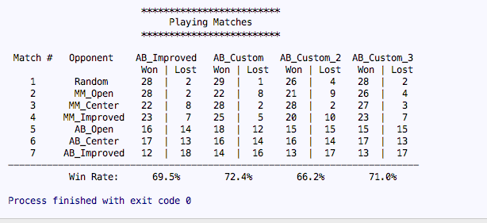

As we can see agents with three custom heuristics are able to beat agent with ‘ID_Improved’

Heuristic. Following reasons make ‘custom_score’ best heuristic.

1. It takes percentage difference instead of absolute difference.
2. It considers overall situation of the board by taking overall open moves into calculation
3. It adds a random weight which is based my observation on the tournament result gives it an edge over ‘ID_Improved’.