POCKET SMART AI
1. Introduction
Pocket Smart AI is an AI-based smart assistant designed to help users access useful information and complete everyday tasks easily. The project provides a simple and user-friendly website where users can interact with AI features from their mobile phone or computer.
The main purpose of Pocket Smart AI is to make information and digital assistance easily accessible in one place.
2. Problem Statement
Nowadays, users need to use different websites and applications for different tasks. Finding information, understanding content, and getting quick assistance can take time.
PocketSmart AI aims to provide a single platform where users can get AI-based assistance in a simple and convenient way.
3. Objectives
The main objectives of Pocket Smart AI are:
- To provide an easy-to-use AI assistant.
- To give quick responses to user queries.
- To provide useful information in a simple format.
- To create a mobile-friendly website.
- To reduce the time required to search for information.
- To provide an interactive and user-friendly experience.
4. Proposed System
The proposed system is a web-based AI assistant called PocketSmart AI. Users can open the website using a browser and enter their questions or requests.
The system processes the user's input and provides an appropriate AI-generated response.
5. Key Features
- AI Chat Assistant – Users can ask questions and receive responses.
- Simple Interface – Easy navigation and clear design.
- Quick Responses – Provides information without requiring multiple searches.
- Mobile Friendly – Can be accessed from smartphones.
- User Interaction – Allows users to communicate with the AI.
- Easy Accessibility – Available through a web browser.
6. System Requirements
Hardware Requirements
- Smartphone or computer
- Minimum 2 GB RAM
- Internet connection
- Keyboard and mouse for computer users
Software Requirements
- Operating System: Windows / Android
- Web Browser: Google Chrome or another modern browser
- Front-end: HTML, CSS, JavaScript
- AI functionality: AI/API integration
- Code Editor: Visual Studio Code or Notepad
7. Technologies Used
HTML
HTML is used to create the basic structure of the website.
CSS
CSS is used to design the website, including colors, fonts, spacing, buttons, and layout.
JavaScript
JavaScript is used to make the website interactive and handle user actions.
AI Technology
AI is used to process user queries and generate useful responses.
8. System Workflow
The working process of PocketSmart AI is:
User opens website → Enters a query → System receives input → AI processes the query → Response is generated → Response is displayed to the user
9. Modules
Module 1 – User Interface
Provides the main screen where users can interact with PocketSmart AI.
Module 2 – Query Input
Allows users to enter questions or requests.
Module 3 – AI Processing
Processes the user's input and generates a suitable response.
Module 4 – Response Display
Displays the generated response clearly on the website.
Module 5 – User Interaction
Allows the user to continue asking questions and interacting with the assistant.
10. Advantages
- Easy to use
- Saves time
- Accessible from mobile and computer
- Provides quick AI assistance
- Simple and user-friendly design
- Useful for students and general users
11. Limitations
- Requires an internet connection for online AI services.
- AI responses may sometimes contain incorrect information.
- The system depends on the AI service/API used.
- Advanced features may require additional development.
12. Future Enhancement
In the future, PocketSmart AI can be improved by adding:
- Voice input and voice responses
- Multiple language support
- User login and personalized settings
- AI image understanding
- Document upload and analysis
- Educational assistance
- Smart reminders
- Offline features where possible
13.Applications
PocketSmart AI can be useful for:
- Students
- Learning and education
- General information
- Daily assistance
- Quick question answering
- Basic productivity tasks
14. Testing
The website can be tested using different types of user queries.
Test| Input| Expected Result
1| Simple question| AI provides a response
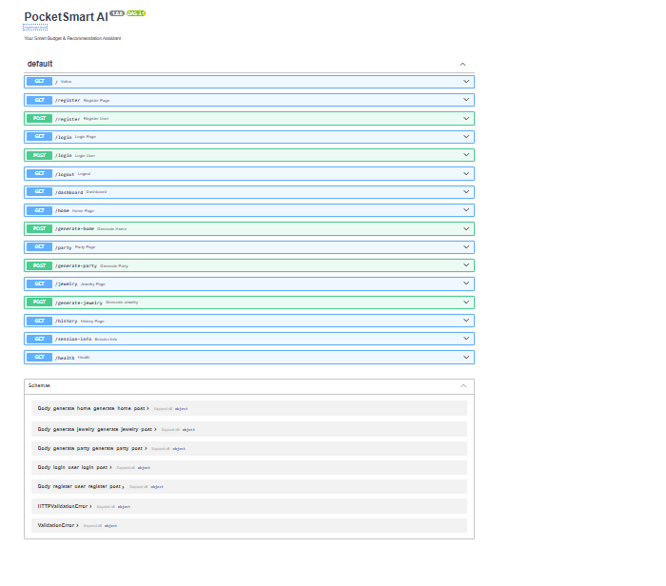
2| Empty input| System asks the user to enter a query
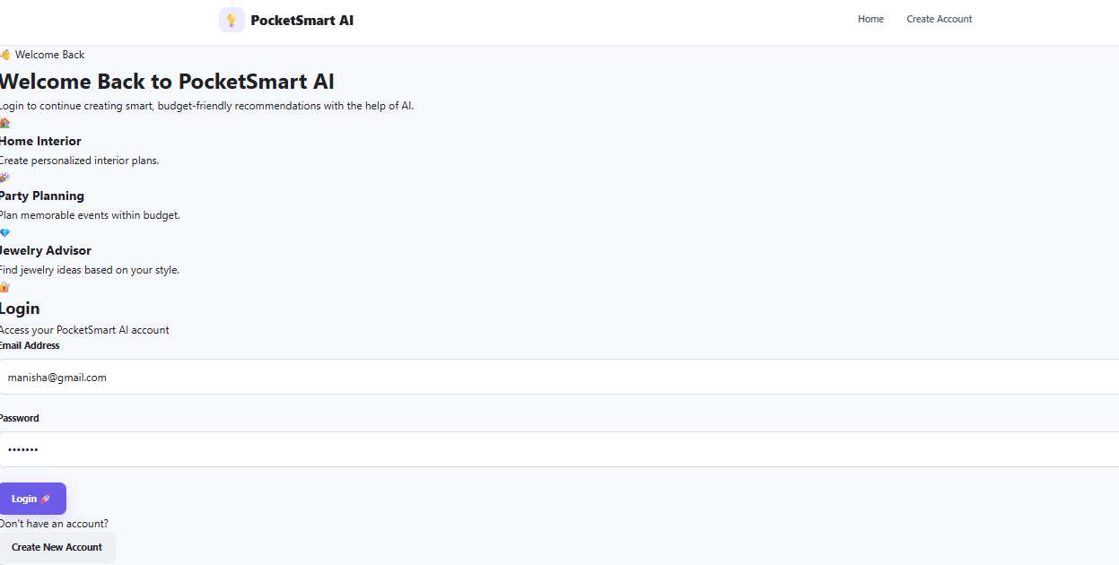
3| Multiple questions| AI responds to each query
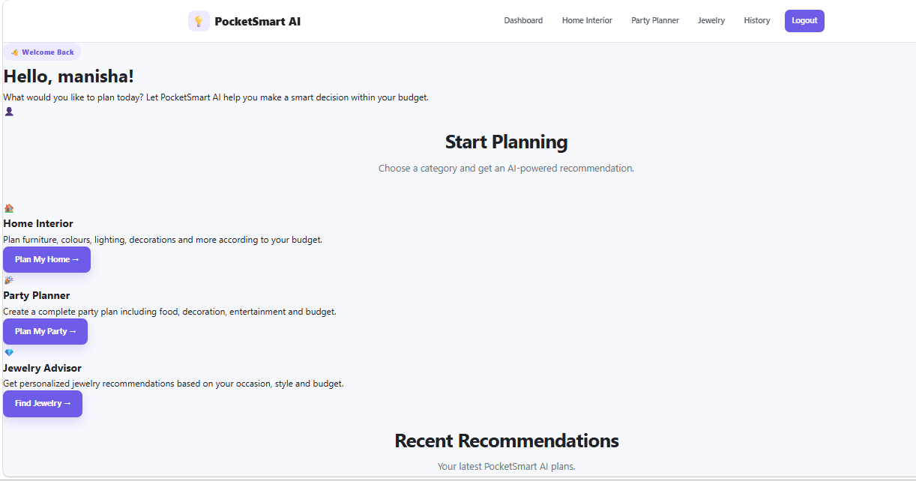
15. Result
The PocketSmart AI website provides an interactive platform where users can enter queries and receive AI-generated responses. The system successfully demonstrates how AI can be integrated into a simple web application.
16. Conclusion
PocketSmart AI is a simple and useful AI-based web project developed to provide quick digital assistance to users. By combining web technologies with AI, the project creates an accessible platform for asking questions and receiving information.
The project can be further developed with advanced AI features, voice interaction, multilingual support, and personalized services.
17. Team Members
Team Leader: Rathika.M

