STUDENT ENROLLMENT &
COURSE MANAGEMENT SYSTEM
(SECMS)
FINAL PROJECT DOCUMENTATION

Developer | Submitted by
M.Ramya  S.Rathika  G.Monika  A. Sathiavathy | M Ramya
Application | Student Enrollment & Course Management System (SECMS)
Core Modules | Student, Course, Instructor, Enrollment, Approval, Automation, Reports & Dashboards
Primary Users | Administrator, Enrollment Officer, Instructor
Document Type | Final Project Report / Implementation Documentation

Prepared from the provided SECMS project specification and implementation screenshots.

TABLE OF CONTENTS
1. Project Overview
2. Project Objectives
3. User Story, Purpose and Scope
4. Problem Statement and Ideation
5. Requirements Specification
6. Solution Architecture and Design
7. Technology Stack
8. Project Planning and Development Flow
9. Detailed Implementation and Milestones
10. Testing and Validation
11. Advantages and Limitations
12. Conclusion
13. Future Enhancements
14. Appendix – Implementation Evidence

1. PROJECT OVERVIEW
The Student Enrollment & Course Management System (SECMS) is a Salesforce-based application designed to streamline the academic enrollment lifecycle. The solution centralizes student, course, instructor and enrollment information in a single Salesforce environment and introduces structured workflows for enrollment processing, validation, approvals, instructor assignment, task creation and reporting.
The system is intended for administrators, enrollment officers and instructors. It supports the management of student records, course offerings, instructor assignments and enrollment requests while providing reports and dashboards for operational monitoring and decision support.

System Scope
- Centralized management of student information.
- Creation and maintenance of course and instructor records.
- Enrollment creation using Student, Course and Instructor relationships.
- Validation of important enrollment and student information.
- Approval routing for enrollment requests.
- Automation for approved enrollments and instructor assignment.
- Automatic follow-up task creation for requested enrollments.
- Reports and dashboards for students, enrollments, approvals and revenue.

2. PROJECT OBJECTIVES
- Create a centralized Salesforce application for student and course management.
- Reduce manual and fragmented enrollment-processing activities.
- Maintain accurate student, course, instructor and enrollment information.
- Use Salesforce Validation Rules to enforce important business conditions.
- Use Approval Processes to route enrollment requests for managerial approval.
- Automate instructor assignment based on course category.
- Automate student-status updates and approval notifications.
- Create follow-up tasks automatically for requested enrollments.
- Provide reports and dashboards for enrollment, revenue and approval monitoring.

3. USER STORY, PURPOSE AND SCOPE

3.1 User Story
As an Enrollment Officer, I want to manage student registrations, courses, instructors and enrollment requests in one Salesforce application so that enrollment processing is structured, validated and easy to monitor.

3.2 Purpose
The purpose of SECMS is to replace manual or fragmented academic enrollment activities with a scalable Salesforce solution. The project focuses on accurate data management, structured workflows, automated validation and approval, and transparent reporting.

3.3 Primary Users
User Role | Main Responsibilities
Administrator | Manage configuration, users, records, permissions, reports and dashboards.
Enrollment Officer | Create and update enrollment requests and maintain enrollment information.
Instructor | Access assigned enrollment information according to configured permissions.

4. PROBLEM STATEMENT AND IDEATION

4.1 Problem Statement
Academic enrollment processes can involve multiple spreadsheets, disconnected records, manual approvals and repeated follow-up activities. Such a process makes it difficult to maintain a consistent view of student status, course selection, fees, instructor allocation and pending approvals.

4.2 Ideation
- Spreadsheet-based automation for enrollment tracking.
- A standalone student portal.
- Integration with an existing ERP system.
- A Salesforce-based centralized enrollment management application.
The Salesforce-based SECMS approach was selected in the project specification because it brings data storage, workflow automation, approvals, validation, reporting and dashboard capabilities into one platform.

5. REQUIREMENTS SPECIFICATION

5.1 Functional Requirements
ID | Requirement | Description
FR-1 | Student Management | Create, store and maintain student information and status.
FR-2 | Course Management | Maintain course name, category, duration, fee and description.
FR-3 | Enrollment Processing | Create enrollment records and manage their status and payment information.
FR-4 | Instructor Assignment | Assign instructors according to course category using automation.
FR-5 | Reporting | Provide reports and dashboards for students, courses, enrollments, approvals and revenue.

5.2 Non-Functional Requirements
Area | Requirement
Usability | Provide a clear Salesforce Lightning interface for the project users.
Security | Use profiles, permission sets and organization-wide sharing settings.
Reliability | Maintain consistent records through validation and automation.
Performance | Use Salesforce platform automation and structured objects for routine processing.
Scalability | Support expansion of records, users, courses and automation.
Availability | Use the Salesforce platform environment for application access.

5.3 Customer Journey
Stage | SECMS Activity
Awareness / Registration | Student information is captured.
Course Selection | A course is selected from available course records.
Enrollment Request | An enrollment record is created with status Requested.
Fee Payment | Fee/payment information is recorded.
Approval | Enrollment is routed through the approval process.
Instructor Assignment | Instructor is assigned using configured automation.
Reporting / Completion | Reports and dashboards provide operational visibility.

6. SOLUTION ARCHITECTURE AND DESIGN
The proposed solution uses Salesforce custom objects as the data layer, Salesforce Lightning as the user interface, Flow Builder for business automation, Validation Rules for data checks, Approval Processes for controlled enrollment approval, and Reports/Dashboards for monitoring.
Layer | Salesforce Component | Purpose
User Interface | Salesforce Lightning | Users create, view and manage application records.
Data | Custom Objects | Store Student, Course, Instructor and Enrollment information.
Relationships | Lookup Relationships | Connect Enrollment with Student, Course and Instructor.
Business Logic | Flows | Automate dates, notifications, status changes, instructor assignment and tasks.
Validation | Validation Rules | Prevent invalid student and enrollment information.
Approval | Approval Process | Route enrollment requests to the designated approver.
Analytics | Reports & Dashboards | Monitor enrollment, student status, revenue and pending approvals.
Security | Profiles / Permission Sets / OWD | Control access according to user role.

6.1 Data Model
The core data model contains four custom objects: Student, Course, Instructor and Enrollment. Enrollment contains lookup relationships to Student, Course and Instructor, allowing an enrollment record to connect the academic participant, selected course and assigned instructor.

7. TECHNOLOGY STACK
Technology / Feature | Usage in SECMS
Salesforce Lightning | Application user interface.
Salesforce Custom Objects | Student, Course, Instructor and Enrollment data storage.
Salesforce Flow Builder | Record-triggered workflow automation.
Validation Rules | Student email and fee/approval validation.
Approval Process | Enrollment approval and rejection workflow.
Reports | Operational and financial reporting.
Dashboards | Visual monitoring of student, enrollment and revenue information.
Profiles & Permission Sets | Role-based access control.

8. PROJECT PLANNING AND DEVELOPMENT FLOW
The project follows an Agile-style sprint approach described in the source specification. Work is organized from epics and user stories into sprint-level implementation activities.

8.1 Development Milestones
Milestone | Activity
1 | Salesforce Developer Account
2 | Create Student, Course, Instructor and Enrollment custom objects
3 | Create object fields
4 | Create lookup relationships
5 | Configure validation rules
6 | Configure enrollment approval process
7 | Create tabs
8 | Create Lightning application
9 | Configure record types and page layouts
10 | Build automation flows
11 | Create reports
12 | Create dashboard
13 | Configure security
14 | Testing, conclusion and future enhancements

9. DETAILED IMPLEMENTATION AND MILESTONES

9.1 Milestone 1 – Salesforce Developer Environment
A Salesforce Developer environment is used as the implementation platform. The environment provides the configuration workspace required to create custom objects, fields, relationships, flows, approvals, reports and dashboards.

9.2 Milestone 2 – Custom Objects
Four core custom objects are created: Student, Course, Instructor and Enrollment. These objects form the foundation of the SECMS data model.
Object | Purpose
Student | Stores student identity and status information.
Course | Stores course name, category, duration, fee and description.
Instructor | Stores instructor name, code, expertise and contact details.
Enrollment | Stores the student's course enrollment, instructor, date, status, payment and comments.

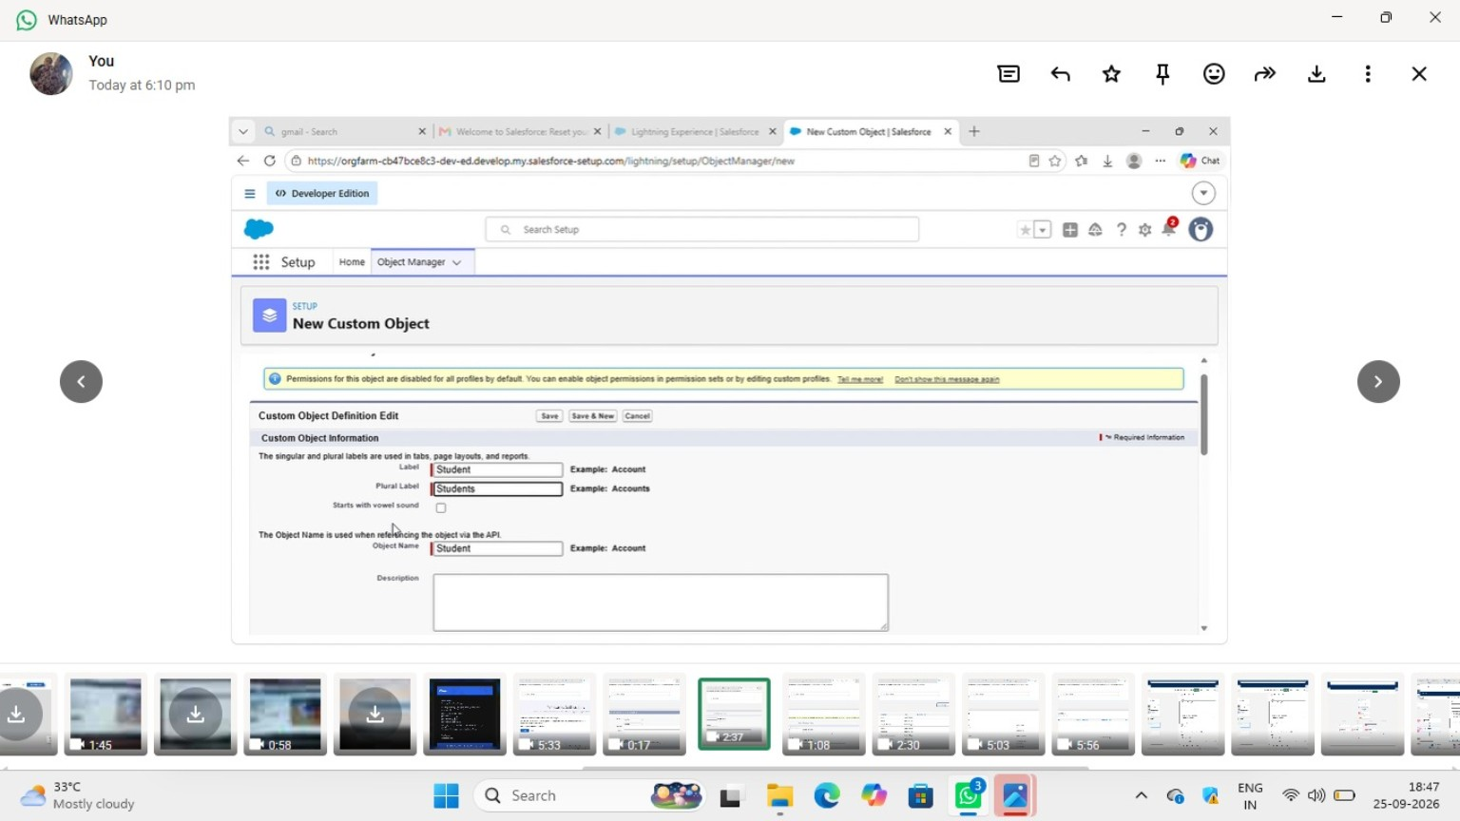
Figure 1. Salesforce custom object creation screen for the Student object.

9.3 Milestone 3 – Fields and Data Configuration
The main fields defined for the four objects are summarized below.
Object | Key Fields
Student | Name, Email, Phone, DOB, Student Status, Address
Course | Course Name, Category, Duration, Course Fee, Description
Instructor | Instructor Name, Code, Expertise, Phone, Email
Enrollment | Student, Course, Instructor, Enrollment Date, Enrollment Status, Fees Paid, Total Amount, Comments

9.4 Milestone 4 – Lookup Relationships
Lookup relationships are configured on Enrollment so that an enrollment can reference the related Student, Course and Instructor records. This supports connected academic data and makes it possible for automation to retrieve related records.
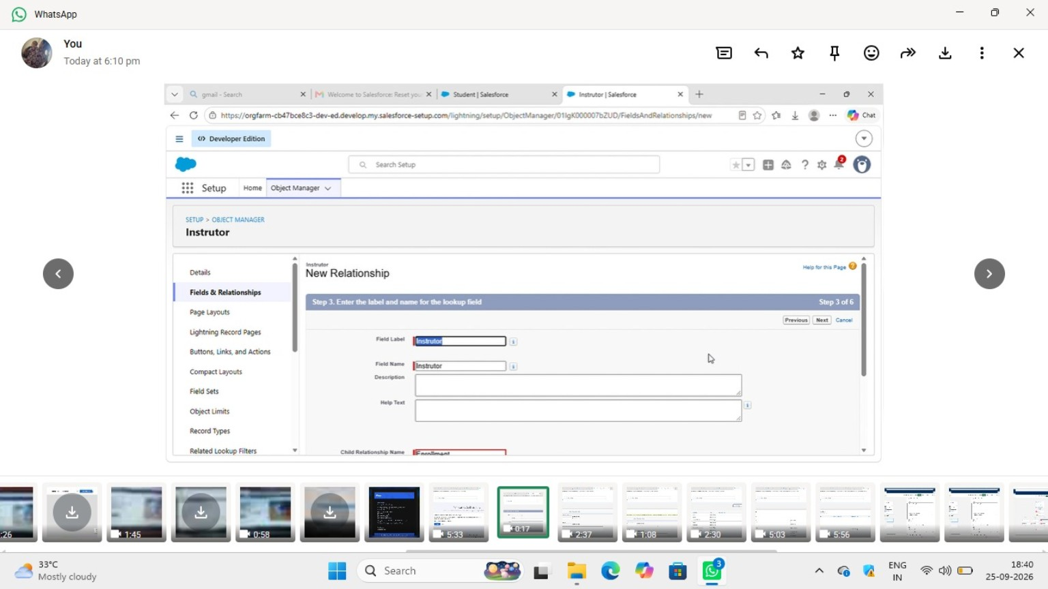
Figure 2. Salesforce lookup relationship configuration for the Instructor relationship.

9.5 Milestone 5 – Validation Rules
Two important validation checks described in the project are implemented:
- Student email validation: the email value is checked for the required student.edu domain.
- Enrollment approval validation: an enrollment cannot be treated as Approved when Fees Paid is false.
The approval-related validation logic specified in the project is:
AND(ISPICKVAL(Enrollment_Status__c,"Approved"), Fees_Paid__c=FALSE)

9.6 Milestone 6 – Enrollment Approval Process
Enrollment requests enter the approval process with Requested status and are routed to the designated Training Manager. An approved request is set to Approved, while a rejected request is set to Rejected and can trigger the configured email notification.

9.7 Milestone 7 – Salesforce Tabs
Tabs are created for Student, Course, Instructor and Enrollment so users can access the main records directly from the Salesforce application.

9.8 Milestone 8 – Lightning Application
A Salesforce Lightning application named Student Enrollment & Course Management is configured with the main objects and supporting navigation items such as Reports, Dashboards, Home and Tasks. The application is intended for Admin, Enrollment Officer and Instructor user roles.

9.9 Milestone 9 – Record Types and Page Layouts
The project defines New Enrollment and Re-Enrollment record types, with separate page-layout arrangements. Related lists are also configured on relevant Student, Course and Instructor records.

9.10 Milestone 10 – Automation Flows
Flow Builder is used for multiple record-triggered automations. The supplied implementation screenshots show approval-related processing, course-category based instructor assignment and follow-up task creation.

9.10.1 Enrollment Approved Action Flow
The approval action flow shown in the implementation contains steps to retrieve the Student record, send an approval email, update the Student status and retrieve the related Course record.
Figure 3. Enrollment Approved Action flow showing student retrieval, email action, status update and course retrieval.

9.10.2 Automatic Instructor Assignment
The instructor-assignment flow uses Course Category as a decision point. The supplied implementation contains branches for Technical, Language, Non-Technical and a default path, with instructor records retrieved and then written back to the Enrollment record.
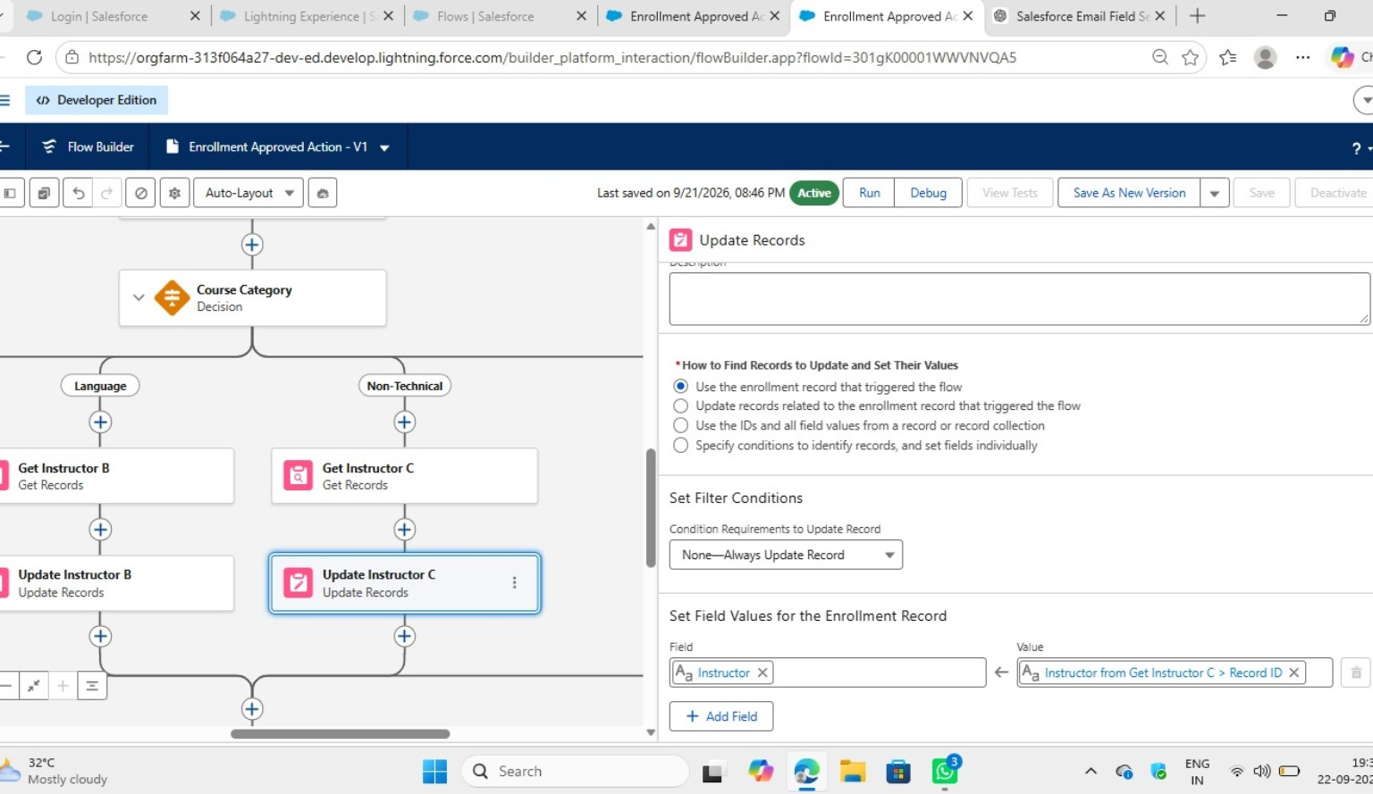
Figure 4. AutoAssign Instructor flow with Course Category decision branches.
The configuration view below shows the update action used to place the selected instructor record ID into the Instructor field of the Enrollment record.
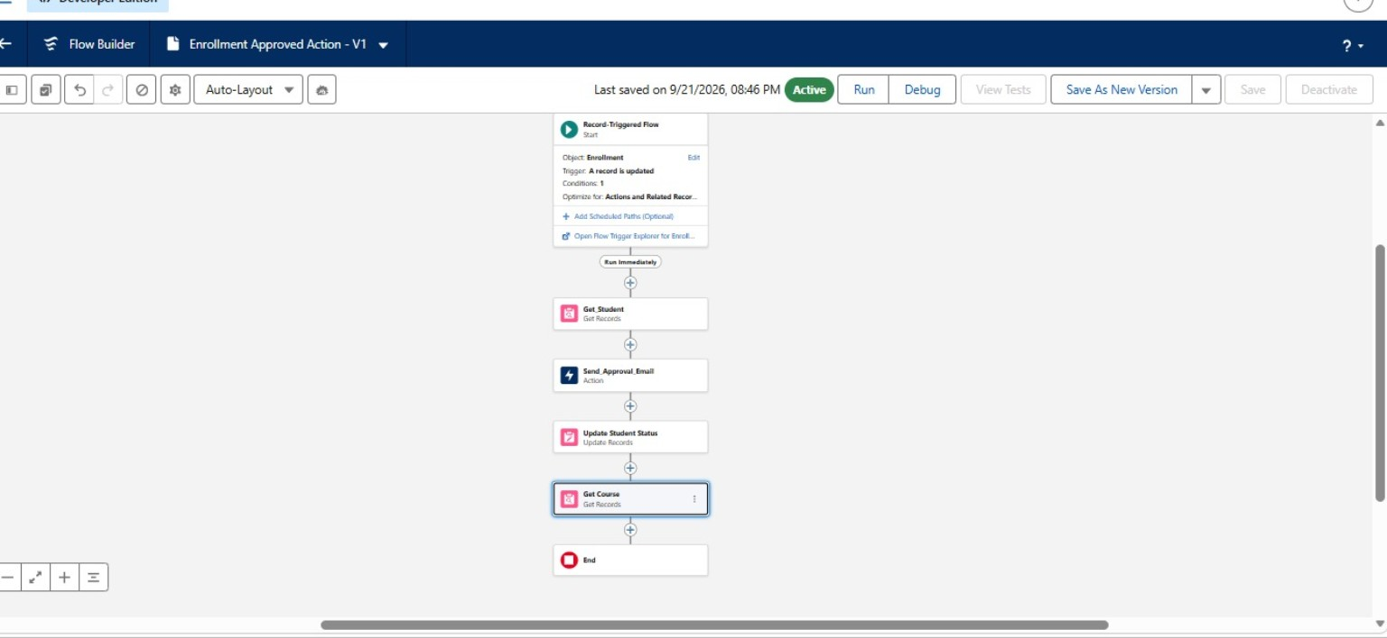
Figure 5. Update Records configuration for assigning the selected instructor to Enrollment.

9.10.3 Follow-up Task Creation
A record-triggered flow is configured to create a follow-up task for an enrollment. The Create Records element uses a record variable and is designed to create one task record as part of the automation.
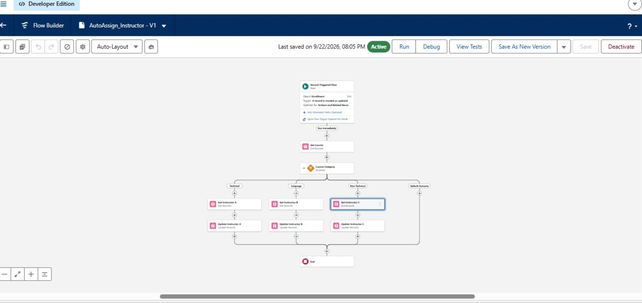
Figure 6. Create Follow-up Task flow and Create Records configuration.

9.11 Milestone 11 – Reports
The project specification identifies the following reports:
- Students by Status.
- Enrollments by Course.
- Pending Enrollment Approvals.
- Revenue Report based on Fees Paid.

9.12 Milestone 12 – Dashboard
The Student Management Dashboard is designed to provide a compact visual view of student status, enrollment volume, revenue and pending approvals.
Dashboard Component | Purpose
Donut Chart | Student status distribution.
Bar Chart | Enrollments by course.
Gauge | Revenue monitoring.
Table | Pending enrollment approvals.

9.13 Milestone 13 – Security Configuration
Security is organized around user profiles, permission sets and organization-wide defaults. The source specification describes Admin as having full access, Enrollment Officer as having create/update enrollment access, and Instructor as having read-only access to assigned enrollments. Students and Courses are configured for public read/write access while Enrollments are private.

10. TESTING AND VALIDATION
Testing in the project focuses on verifying that configured records, validation rules, record types, flows, reports and dashboards operate according to the intended design. The project specification also calls for screenshots to be captured while testing.
Test Area | Expected Verification
Object Records | Student, Course, Instructor and Enrollment records can be created and maintained.
Relationships | Enrollment references the correct Student, Course and Instructor.
Validation | Invalid email and fee/approval conditions are blocked according to the configured rules.
Approval | Requested enrollments follow the configured approval path.
Automation | Approved enrollment actions and instructor assignment execute through flows.
Task Automation | Follow-up task creation occurs through the configured flow.
Reports | Configured reports return the intended operational information.
Dashboard | Dashboard components present student, enrollment, revenue and approval information.
Security | Users receive access according to configured profiles and permissions.

11. ADVANTAGES AND LIMITATIONS

11.1 Advantages
- Centralized student, course, instructor and enrollment data.
- Reduced manual processing through Salesforce Flow automation.
- Structured validation and approval handling.
- Automated instructor assignment based on course category.
- Automatic follow-up task creation.
- Real-time reporting and dashboard visibility.

11.2 Limitations
- The solution depends on the Salesforce platform and its configuration.
- Initial configuration and administration require setup effort.
- The current scope does not document a dedicated student self-service portal.
- Payment gateway integration is identified as a future enhancement rather than a current feature.

12. CONCLUSION
The Student Enrollment & Course Management System demonstrates how Salesforce can be configured as a centralized academic enrollment platform. The project brings together custom objects, lookup relationships, validation rules, approval processing, Flow automation, reporting, dashboards and role-based access.
The implementation evidence supplied for the project demonstrates the configuration of custom objects and relationships as well as important automation flows for approved enrollments, instructor assignment and follow-up task creation. Together, these components support a structured student academic lifecycle within the Salesforce environment.

13. FUTURE ENHANCEMENTS
- Integrate a payment gateway for online fee collection.
- Provide a student self-service portal for registration and enrollment tracking.
- Add analytics and predictive insights for enrollment trends.
- Provide mobile access for users.
- Extend automation and reporting as the number of courses, students and instructors grows.

14. APPENDIX – IMPLEMENTATION EVIDENCE
The following screenshots were supplied with the project materials and are included as implementation evidence.
Appendix Figure A1. Student custom object creation.
Appendix Figure A2. Instructor lookup relationship creation.
Appendix Figure A3. Enrollment approved action flow.
Appendix Figure A4. Automatic instructor assignment flow.
Appendix Figure A5. Instructor update configuration.
Appendix Figure A6. Follow-up task creation flow.

END OF DOCUMENT

