Assignment No.1

Name: Rathin Manoj Kamble
PRN: 245100123
Branch: CSE (Aided)
Batch: AT7

Q) You are given two sorted array, A and B, where A has a large enough buffer at the end to hold B. Write a method to merge B into A in sorted order.

Algorithm: Merge Two Sorted Arrays (In-Place)
Input: Two sorted arrays arr1 and arr2, where arr1 has enough extra space to hold all elements.
Output: A single sorted array stored in arr1.
Steps
- Read the values of n (valid elements in arr1) and m (elements in arr2).
- Initialize three pointers:
  - l = n - 1 (last valid element of arr1)
  - r = m - 1 (last element of arr2)
  - ind = n + m - 1 (last position of arr1)
- Compare arr1[l] and arr2[r].
- If arr1[l] > arr2[r], place arr1[l] at arr1[ind] and decrement l.
- Otherwise, place arr2[r] at arr1[ind] and decrement r.
- Decrement ind after every insertion.
- Repeat Steps 3–6 until either array is completely processed.
- If elements remain in arr2, copy them into arr1.
- Print the merged sorted array stored in arr1.

Code:
#include <bits/stdc++.h>
using namespace std;

int main() {
int n = 5; // valid elements in arr1
int m = 3; // elements in arr2

vector<int> arr1(8); // n + m
vector<int> arr2(m);

// Input valid elements of arr1
for (int i = 0; i < n; i++)
cin >> arr1[i];

// Input arr2
for (int i = 0; i < m; i++)
cin >> arr2[i];

int l = n - 1;
int r = m - 1;
int ind = n + m - 1;

while (l >= 0 && r >= 0) {
if (arr1[l] > arr2[r]) {
arr1[ind] = arr1[l];
l--;
} else {
arr1[ind] = arr2[r];
r--;
}
ind--;
}

// Copy remaining elements of arr2
while (r >= 0) {
arr1[ind] = arr2[r];
r--;
ind--;
}

// Print merged array
for (int x : arr1)
cout << x << " ";

return 0;
}
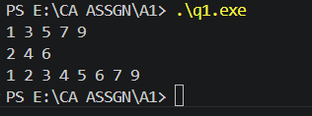
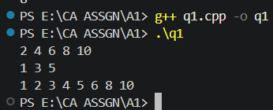
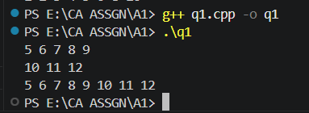

Complexity Analysis
Let:
- n = number of valid elements in arr1
- m = number of elements in arr2
Time Complexity
- The main while loop processes each element at most once: O(n + m)
- The second while loop copies any remaining elements from arr2: O(m) (already included in the total)
Overall Time Complexity:
$$\boxed{O\left(n+m\right)}$$
Space Complexity
- No extra array is used.
- Merging is performed directly in arr1.
Overall Space Complexity:
$$\boxed{O\left(1\right)}$$
​
Q) Write a method to sort an array of string so that all the anagrams are next to each other.
Algorithm
Input: An array of strings.
Output: Strings arranged such that all anagrams are grouped together.
Steps
- Read the array of strings.
- Create an empty hash map mp, where:
  - Key: Sorted version of a string.
  - Value: List of strings having the same sorted form.
- Traverse each string in the array:
  - Copy the string into key.
  - Sort the characters of key.
  - Insert the original string into mp[key].
- Create an empty vector ans.
- Traverse the hash map:
  - Append every string from each group into ans.
- Print the strings stored in ans.

Code:

#include <bits/stdc++.h>
using namespace std;

int main() {
vector<string> arr = {
"cat", "dog", "tac", "god", "act", "odg", "bat"
};

unordered_map<string, vector<string>> mp;

// Group anagrams
for (string s : arr) {
string key = s;
sort(key.begin(), key.end());
mp[key].push_back(s);
}

// Store grouped anagrams back into the array
vector<string> ans;

for (auto &it : mp) {
for (string s : it.second)
ans.push_back(s);
}

// Print result
for (string s : ans)
cout << s << " ";

return 0;
}
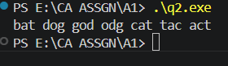
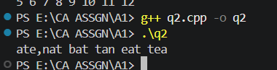

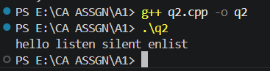

Complexity Analysis
Let:
- N = Number of strings
- K = Maximum length of a string
Time Complexity
- Sorting each string: O(K log K)
- Done for N strings: O(N × K log K)
- Inserting into the hash map and collecting the result: O(N)
Overall Time Complexity:
$$\boxed{O\left(N×K\log{K}\right)}$$

Space Complexity
- Hash map stores all strings: O(N × K)
- Result vector stores all strings: O(N) (references to strings conceptually; actual copied strings are proportional to total input size)
Overall Space Complexity:
$$\boxed{O\left(N×K\right)}$$ ​

Q) Given a sorted array of n integers that has been rotated an unknown number of times, write code to find an element in the array. You may assume that the array was originally sorted in increasing order.

Algorithm
Input: A rotated sorted array arr and a target element.
Output: Index of the target element if found; otherwise -1.
Steps
- Initialize two pointers:
  - low = 0
  - high = n - 1
- Repeat while low <= high:
  - Find the middle index:
mid = low + (high - low) / 2
  - If arr[mid] == target, return mid.
  - Check whether the left half (arr[low] to arr[mid]) is sorted.
    - If yes:
      - If the target lies within this range, search the left half by setting high = mid - 1.
      - Otherwise, search the right half by setting low = mid + 1.
  - Otherwise, the right half is sorted.
    - If the target lies within this range, search the right half by setting low = mid + 1.
    - Otherwise, search the left half by setting high = mid - 1.
- If the loop ends without finding the target, return -1.

Code:

#include <bits/stdc++.h>
using namespace std;

int search(vector<int>& arr, int target) {
int low = 0;
int high = arr.size() - 1;

while (low <= high) {
int mid = low + (high - low) / 2;

if (arr[mid] == target)
return mid;

// Left half is sorted
if (arr[low] <= arr[mid]) {
if (target >= arr[low] && target < arr[mid])
high = mid - 1;
else
low = mid + 1;
}
// Right half is sorted
else {
if (target > arr[mid] && target <= arr[high])
low = mid + 1;
else
high = mid - 1;
}
}

return -1;
}

int main() {
vector<int> arr = {15, 16, 19, 20, 25, 1, 3, 4, 5, 7, 10, 14};

int target = 5;

cout << search(arr, target);

return 0;
}

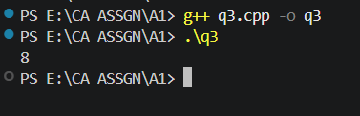
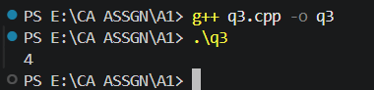
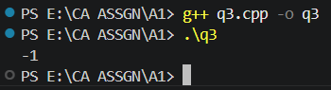

Complexity Analysis
Let:
- N = Number of elements in the array.
Time Complexity
- In every iteration, the search space is reduced by half.
- This is a modified Binary Search.
Overall Time Complexity:
$$\boxed{O\left(\log{N}\right)}$$

Space Complexity
- Only a few variables (low, high, mid) are used.
Overall Space Complexity:
$$\boxed{O\left(1\right)}$$ ​

Q) Imagine you have a 20GB file with one string per line. Explain how you would sort the file.

A 20 GB file is too large to fit into the computer's main memory (RAM). Therefore, I would use External Merge Sort, which is designed for sorting very large files.

Steps:

Divide the 20 GB file into smaller chunks that can fit into RAM (for example, 500 MB each).
Read one chunk into memory and sort it using an efficient sorting algorithm such as Merge Sort or Quick Sort.
Write the sorted chunk to a temporary file on disk.
Repeat the process until all chunks have been sorted and stored as temporary files.
Merge all the sorted temporary files using a k-way merge (implemented using a min-heap/priority queue) to produce one final sorted file.

Advantages:

Can sort files larger than the available RAM.
Efficient in terms of disk I/O operations.
Commonly used in databases and operating systems for large-scale data processing.

Time Complexity: O(N log N)

Q) Given a sorted array of string which is interspersed with empty string, write a method to find the location of a given string.
EXAMPLE
Input: find “ball” in {“at”, “”, “”, “ball”, “”, “”, “car”, “”, “”, “dad”, “”,””}
Output: 4

Algorithm
Input: A sorted array of strings containing empty strings ("") and a target string.
Output: Index of the target string if found; otherwise -1.
Steps
- Initialize two pointers:
  - low = 0
  - high = n - 1
- Repeat while low <= high:
  - Find the middle index:
mid = low + (high - low) / 2
  - If arr[mid] is an empty string:
    - Initialize left = mid - 1 and right = mid + 1.
    - Move outward until a non-empty string is found.
    - If no non-empty string exists within the current search range, return -1.
  - Compare arr[mid] with the target.
    - If equal, return mid.
    - If arr[mid] < target, search the right half (low = mid + 1).
    - Otherwise, search the left half (high = mid - 1).
- If the loop ends without finding the target, return -1.

Code:
#include <bits/stdc++.h>
using namespace std;

int search(vector<string>& arr, string target) {
int low = 0;
int high = arr.size() - 1;

while (low <= high) {
int mid = low + (high - low) / 2;

// If middle is empty, find nearest non-empty string
if (arr[mid] == "") {
int left = mid - 1;
int right = mid + 1;

while (true) {
if (left < low && right > high)
return -1;

if (left >= low && arr[left] != "") {
mid = left;
break;
}

if (right <= high && arr[right] != "") {
mid = right;
break;
}

left--;
right++;
}
}

if (arr[mid] == target)
return mid;

if (arr[mid] < target)
low = mid + 1;
else
high = mid - 1;
}

return -1;
}

int main() {
vector<string> arr = {
"at", "", "", "ball", "", "", "car", "", "", "dad", "", ""
};

string target = "ball";

cout << search(arr, target);

return 0;
}
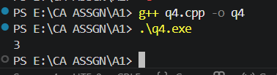

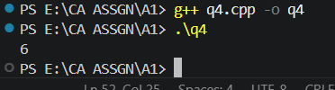
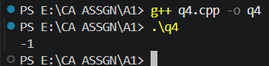

Complexity Analysis
Let:
- N = Number of strings in the array.
Time Complexity
- Binary search takes O(log N).
- If the middle element is empty, the algorithm may scan outward to find the nearest non-empty string.
- In the worst case (many consecutive empty strings), this scan can take O(N).
Overall Time Complexity:
- Average Case: $\boxed{O\left(\log{N}\right)}$
- Worst Case: $\boxed{O\left(N\right)}$

Space Complexity
- Only a few variables (low, high, mid, left, right) are used.
Overall Space Complexity:
$$\boxed{O\left(1\right)}$$ ​

Q) Given an M*N matrix in which each row and each column is sorted in ascending order, write a method to find an element.

Algorithm
Input: A matrix where each row and each column is sorted in ascending order, and a target element.
Output: The row and column index of the target if found; otherwise (-1, -1).
Steps
- Let m be the number of rows and n be the number of columns.
- Start from the top-right corner of the matrix:
  - i = 0
  - j = n - 1
- Repeat while i < m and j >= 0:
  - If matrix[i][j] == target, return (i, j).
  - If matrix[i][j] > target, move left by decrementing j.
  - Otherwise, move down by incrementing i.
- If the target is not found after the loop, return (-1, -1).

Code:
#include <bits/stdc++.h>
using namespace std;

pair<int, int> search(vector<vector<int>>& matrix, int target) {
int m = matrix.size();
int n = matrix[0].size();

int i = 0;
int j = n - 1;

while (i < m && j >= 0) {
if (matrix[i][j] == target)
return {i, j};

else if (matrix[i][j] > target)
j--;

else
i++;
}

return {-1, -1};
}

int main() {
vector<vector<int>> matrix = {
{10, 20, 30, 40},
{15, 25, 35, 45},
{27, 29, 37, 48},
{32, 33, 39, 50}
};

int target = 29;

pair<int, int> ans = search(matrix, target);

if (ans.first != -1)
cout << "Found at (" << ans.first << ", " << ans.second << ")";
else
cout << "Not Found";

return 0;
}
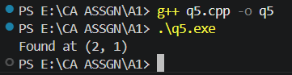

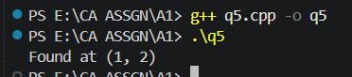

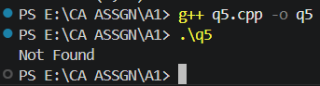

Complexity Analysis
Let:
- M = Number of rows
- N = Number of columns
Time Complexity
- In each step, either one row is eliminated (move down) or one column is eliminated (move left).
- At most M + N moves are performed.
Overall Time Complexity:
$$\boxed{O\left(M+N\right)}$$

Space Complexity
- Only two indices (i and j) and a few variables are used.
Overall Space Complexity
$$\boxed{O\left(1\right)}$$

Q) A circus is designing a tower routine consisting of people standing atop one another’s shoulders. For practical and aesthetic reasons, each person must be both shorter and lighter than the person
below him or her. Given the heights and weight of each circus, write a method to compute the largest possible number of people in such tower.
EXAMPLE:
Input(ht,wt): (65, 100) (70, 150) (56, 90) (75,190) (60, 95) (68, 110).
Output: The longest tower is length 6 and includes from top to bottom:
(56, 90) (60, 95) (65, 100) (68, 110) (70, 150) (75, 190)

Algorithm
Input: A list of people represented as (height, weight).
Output: Maximum possible length of the circus tower.
Steps
- Read the list of (height, weight) pairs.
- Sort the people in ascending order of height.
- Create a DP array dp of size n and initialize every element to 1.
  - dp[i] represents the maximum tower length ending at person i.
- Initialize ans = 1.
- For each person i from 1 to n-1:
  - Compare with every previous person j from 0 to i-1.
  - If:
    - height[i] > height[j], and
    - weight[i] > weight[j]
then:
dp[i] = max(dp[i], dp[j] + 1)
  - Update:
ans = max(ans, dp[i])
- Print ans.

Code:
#include <bits/stdc++.h>
using namespace std;

int main() {

vector<pair<int,int>> people = {
{65,100},
{70,150},
{56,90},
{75,190},
{60,95},
{68,110}
};

// Sort by height
sort(people.begin(), people.end());

int n = people.size();

vector<int> dp(n,1);

int ans = 1;

for(int i=1;i<n;i++) {
for(int j=0;j<i;j++) {

if(people[i].first > people[j].first &&
people[i].second > people[j].second) {

dp[i] = max(dp[i], dp[j] + 1);
}
}

ans = max(ans, dp[i]);
}

cout << "Maximum Tower Length = " << ans;

return 0;
}

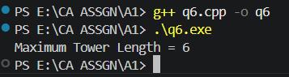
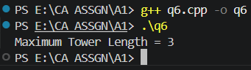
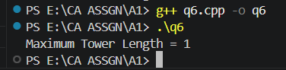

Complexity Analysis
Let:
- N = Number of people
Time Complexity
- Sorting the people: O(N log N)
- Dynamic Programming (nested loops): O(N²)
Overall Time Complexity:
$$\boxed{O\left(N^{2}\right)}$$
(The $O\left(N^{2}\right)$DP dominates the sorting time.)

Space Complexity
- DP array of size N.
Overall Space Complexity:
$$\boxed{O\left(N\right)}$$

Q) Imagine you are reading in stream of integers. Periodically, you wish to be able to look up the rank of number x (the number of values less than or equal to x). Implement the data structures and algorithms to support these operations. That is, Implement the method track (int x), which is called when each number is generated, and the method getRankOfNumber (int x), which return the number of values less than or equal to x (not including x itself).

EXAMPLE
Stream (in order of appearance) : 5, 1, 4, 4, 5, 9, 7, 13, 3
getRankOfNumber(1) = 0
getRankOfNumber(3) = 1
getRankOfNumber(4) =3

Algorithm
Input
A stream of integers and a number whose rank is to be found.
Output
The rank of the given number.
Steps
Part A: Insert (Track) a Number
- If the tree is empty, create a new node.
- Compare the new value with the current node.
- If the new value is less than or equal to the current node:
  - Increment leftSize.
  - Insert into the left subtree.
- Otherwise:
  - Insert into the right subtree.
- Repeat until the value is inserted.

Part B: Find Rank
- Start from the root.
- If the current node is NULL, return -1.
- If the target equals the current node:
  - Return leftSize.
- If the target is smaller:
  - Search the left subtree.
- Otherwise:
  - Search the right subtree.
  - If found, return:
leftSize + 1 + rank in right subtree
- Return the computed rank.

Code:
#include <bits/stdc++.h>
using namespace std;

class Node {
public:
int data;
int leftSize;
Node *left, *right;

Node(int x) {
data = x;
leftSize = 0;
left = right = NULL;
}
};

class RankTree {
public:
Node *root = NULL;

Node* insert(Node *node, int x) {
if (node == NULL)
return new Node(x);

if (x <= node->data) {
node->leftSize++;
node->left = insert(node->left, x);
}
else {
node->right = insert(node->right, x);
}

return node;
}

void track(int x) {
root = insert(root, x);
}

int getRank(Node *node, int x) {
if (node == NULL)
return -1;

if (x == node->data)
return node->leftSize;

if (x < node->data)
return getRank(node->left, x);

int rightRank = getRank(node->right, x);

if (rightRank == -1)
return -1;

return node->leftSize + 1 + rightRank;
}

int getRankOfNumber(int x) {
return getRank(root, x);
}
};

int main() {

RankTree tree;

vector<int> stream = {5,1,4,4,5,9,7,13,3};

for (int x : stream)
tree.track(x);

cout << "Rank of 1 = " << tree.getRankOfNumber(1) << endl;
cout << "Rank of 3 = " << tree.getRankOfNumber(3) << endl;
cout << "Rank of 4 = " << tree.getRankOfNumber(4) << endl;

return 0;
}
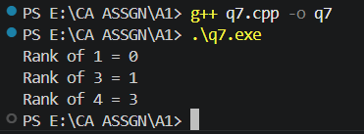
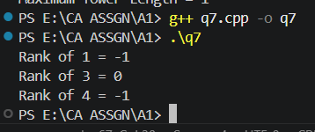
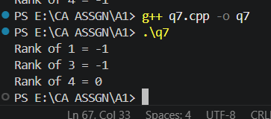

Complexity Analysis
Let:
- N = Number of elements inserted into the BST.
Time Complexity
Insertion (track)
- Average Case: $\boxed{O\left(\log{N}\right)}$
- Worst Case: $\boxed{O\left(N\right)}$(if the BST becomes skewed)
Rank Query (getRankOfNumber)
- Average Case: $\boxed{O\left(\log{N}\right)}$
- Worst Case: $\boxed{O\left(N\right)}$

Space Complexity
- The BST stores all inserted elements.
Overall Space Complexity:
$$\boxed{O\left(N\right)}$$

Technique Used
- Binary Search Tree (BST)
- Augmented BST (stores leftSize at each node)
- Recursive Insertion
- Recursive Search

