Experiment 4
Aim: To perform various data manipulation commands, aggregate functions, and sorting concepts on all created tables.
Theory: Data Manipulation Language (DML): DML is the subset of SQL used to manage data within existing table structures.
- INSERT: adds new rows of data
- UPDATE: modifies existing data based on specific conditions
- DELETE: removes specific rows from a table
- SELECT: used to retrieve and view data
Aggregate Functions: Aggregate functions perform a calculation on a set of values and return a single scalar value. They are essential for summarizing large datasets to find trends or totals.
- Count: returns the number of rows that match a specified criterion
- Sum: calculates the total sum
- Max: returns largest value in the set
- Min: returns smallest value in the set
Data Grouping: The GROUP BY statement is used in conjunction with aggregate functions to group the result-set by one or more columns.
Sorting Concepts: The ORDER BY keyword is used to sort the result-set in either ascending or descending order.
- ASC: Sorts data from lowest to highest (default).
- DESC: Sorts data from highest to lowest.

Tasks:
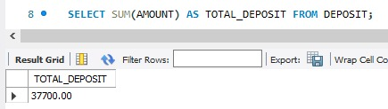
(1) List the total deposit from the deposit.

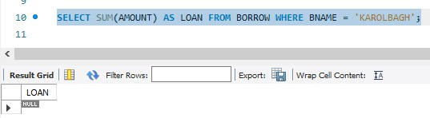
(2) List the total loan from the Karolbagh branch

(3) Give the maximum loan from the branch vice.
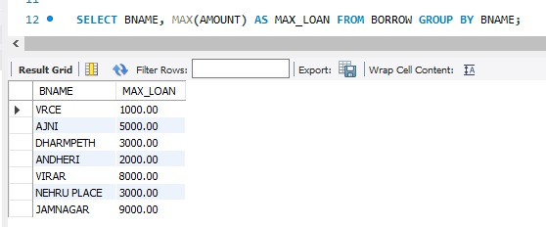
(4) Count the total number of customers
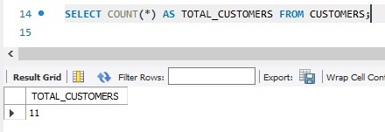
(5) Count the total number of customers’ cities.
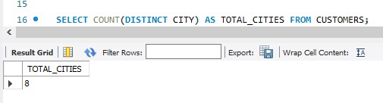
(6) Create a table supplier from employee with all the columns.
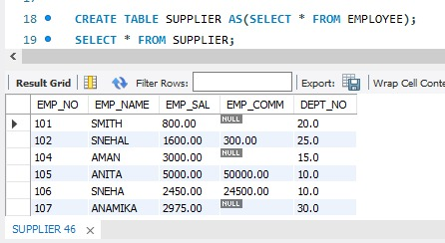
(7) Create table sup1 from employee with the first two columns.
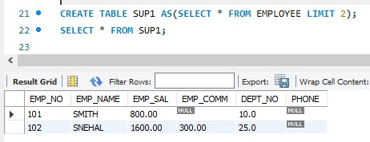

(8) Create table sup2 from employee with no data
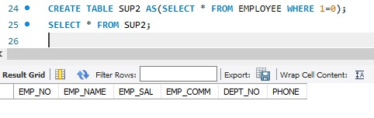
(9) Insert the data into sup2 from the employee whose second character should be ‘n’ and the string should be 5 characters long in the employee name field.
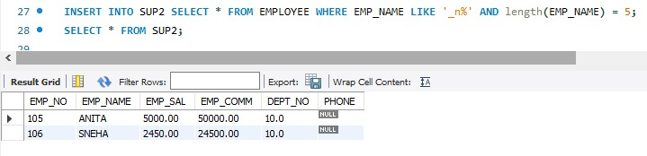
(10) Delete all the rows from sup1.
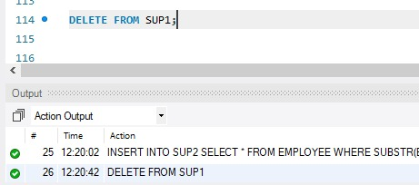
(11) Delete the details of the supplier whose sup_no is 103.
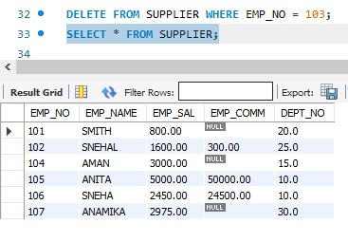
(12) Rename the table sup2.
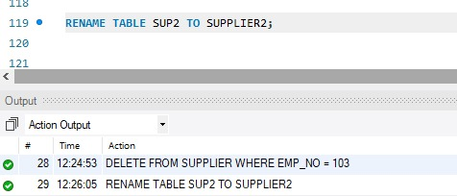
(13) Destroy table sup1 with all the data.
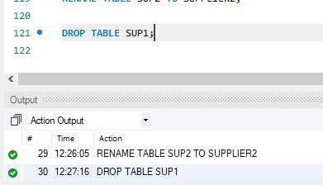
(14) Update the value dept_no to 10 where the second character of emp. name is ‘m.’
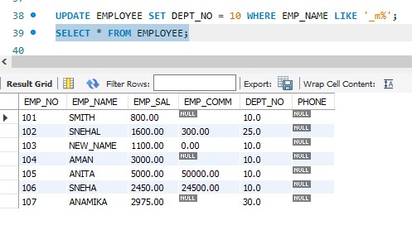
(15) Update the value of the employee’s name whose employee number is 103.
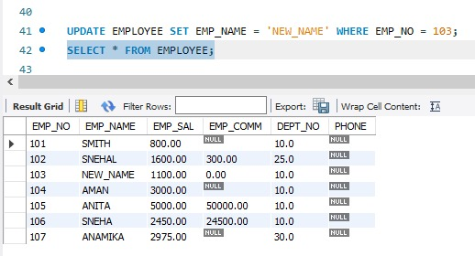
(16) Add a one-column phone to the employee with a column size of 10.
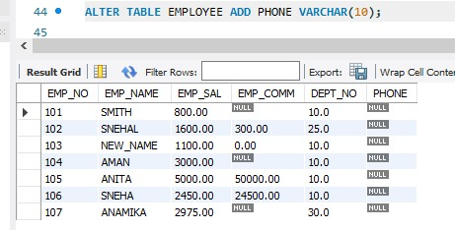

(17) Modify the column emp_name to hold a maximum of 30 characters.
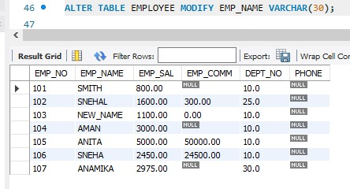
(18) Count the total no as well as distinct rows in the dept_no column with a condition of salary greater than 1000 for employees
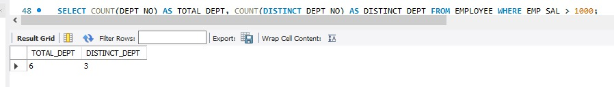
(19) Display the details of all employees in ascending order, descending order of their name, and number.
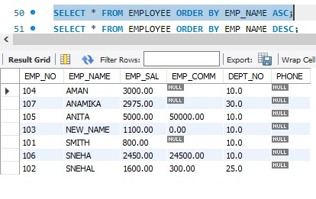
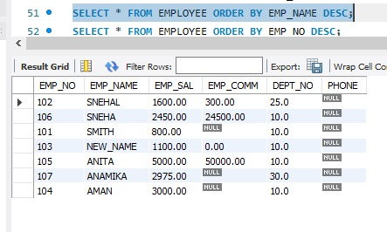
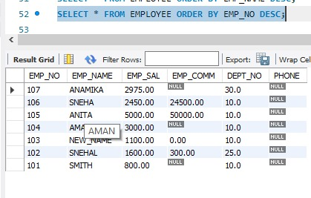

(20) Display the dept_no in ascending order and accordingly display emp_comm in descending order.
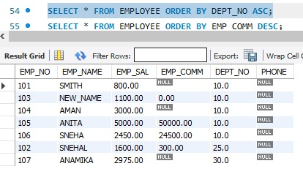
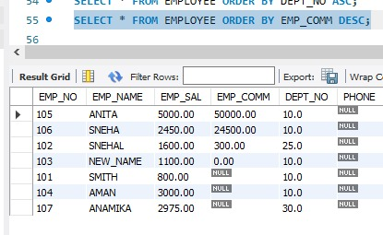
(21) Update the value of emp_comm to 500 where dept_no is 20.
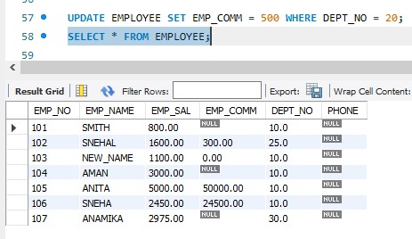
(22) Display the emp_comm in ascending order with null value first, and accordingly sort employee salary in descending order.
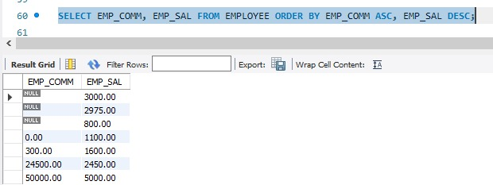

(23) Display the emp_comm in ascending order with null value last and accordingly sort emp_no in descending order.
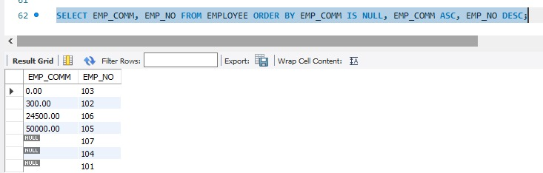

Conclusion:
The successful implementation of Data Manipulation Language (DML), aggregate functions, and sorting techniques demonstrates the power of SQL in managing and analyzing structured data.
DML commands allow for the dynamic maintenance of records, while aggregate functions provide a high-level summary of datasets, such as totals and averages the application of sorting and grouping concepts ensures that the retrieved data is organized, readable, and prioritized according to specific requirements.

