DEEP DIVE REPORT
Fire Weather Monitoring
Engineering a Database-Backed IoT and ML Demonstration
with Fire-Weather Screening Signals

ByteSmart IoT Engineering Internship | Rathin Seth
August 2026

This report follows AMA (American Medical Association) citation style. All references are numbered in the order they appear in the text and listed at the end of this document.

Table of Contents
1. Introduction
2. Background: The Science of Fire Weather
3. Use Case Description
4. Dataset
5. Approach to Analysis
6. Visualization Strategies
7. Findings and Expected Insights
8. Proposed Arduino Fire Weather Sensor Extension
9. Future Connection of Field Data to Dataset Analysis
10. Machine Learning Predictions
11. Data Collection Plan
12. Final System Implementation
13. Conclusion
References

1. Introduction
Fire weather describes atmospheric conditions that can make vegetation easier to ignite and can increase fire spread after ignition. Temperature, relative humidity, wind, precipitation, and fuel conditions matter together; no single sensor reading proves that a wildfire will occur.
This report traces the Fire Weather Monitoring project from research to implementation. It covers the Jena climate dataset, exploratory analysis, machine-learning experiments, an MQTT and PostgreSQL telemetry pipeline, a read-only dashboard, a standalone Flask inference service, and a proposed Arduino sensor extension.
The completed deliverable is a reproducible educational demonstration. Its thresholds, risk score, and model outputs are screening signals rather than an official Fire Weather Index, agency warning, or operational wildfire forecast.

2. Background: The Science of Fire Weather

2.1 What Makes a Wildfire Grow
Fire needs three things: fuel, oxygen, and heat. In the open landscape, fuel is the vegetation. Oxygen comes from the atmosphere. Heat comes from the sun and from the fire itself as it preheats the material ahead of the flame front. Weather controls how available and receptive that fuel is, and how fast the fire spreads once ignited.
NOAA describes fire weather as weather conditions that influence fire ignition and spread, including wind, low relative humidity, atmospheric instability, and thunderstorms.1 Those factors guided the project's selection of temperature, humidity, pressure trend, and wind measurements.

2.2 Temperature and Fuel Drying
Higher air temperature can contribute to faster drying when it occurs with low humidity, dry fuels, wind, and limited recent precipitation. The project's 30 C value is an analytical screen chosen for the dataset; it is not a universal operational threshold.
Fine dead fuels can respond quickly to changing temperature and humidity. Actual ignition and spread also depend on fuel type, fuel moisture, wind, terrain, precipitation history, and an ignition source.

2.3 Relative Humidity and the Dryness Threshold
Relative humidity expresses atmospheric moisture relative to the maximum possible at the same temperature. Low relative humidity can promote drying, but its operational meaning depends on local fuels, weather, and agency criteria.
National Weather Service Red Flag Warning criteria are defined through local and state operating plans and vary by region. They commonly combine low relative humidity, strong wind, and dry fuels.2 The project's 30% humidity value is therefore a consistent dataset screen, not an official national warning threshold.
Some forecast areas use lower humidity thresholds or additional requirements such as fuel moisture, fire-danger ratings, wind duration, or dry lightning.3 This variation is why the dashboard avoids labeling its screen as an agency warning.

2.4 Barometric Pressure and Wind Events
Barometric pressure provides context about changing weather systems. A trend can accompany broader weather changes, but pressure alone does not establish wind speed, fuel dryness, ignition, or fire danger.
The project treats a pressure decline as an exploratory supporting feature. It does not assume that every decline produces damaging wind or that a pressure change without direct wind and precipitation measurements is an operational warning.
For analysis and model training, pressure change is calculated over a three-hour horizon. The final service reports a probability from this feature while clearly labeling it as a pressure-risk signal, not proof that wind or wildfire will occur.

2.5 The Fire Weather Index System
The Canadian Forest Fire Weather Index (FWI) System is an established component of the Canadian Forest Fire Danger Rating System and estimates potential fire danger from daily weather and fuel-moisture relationships.5
The operational FWI System uses noon temperature, relative humidity, wind speed, and 24-hour precipitation.4 Its component values and danger classes require the official equations and regional interpretation; published research also shows that meaningful thresholds vary across climates and ecosystems.6
This project does not calculate the official FWI. It uses a transparent educational screen based on temperature, humidity, wind context, and a separate exploratory pressure trend so users can audit how each dashboard result was derived.

2.6 Red Flag Warnings in Practice
The National Weather Service issues Red Flag Warnings when forecast conditions meet locally defined critical fire-weather and fuel criteria.7 These products are official agency decisions; the project dashboard does not reproduce or replace them.
Firefighting agencies respond to Red Flag Warnings by dramatically altering staffing and equipment resources. Air tankers are pre-positioned. Ground crews move to forward staging areas. Power companies execute Public Safety Power Shutoffs (PSPS) to reduce the risk of equipment sparking a fire during the warning window.
A future network of tested low-cost sensors could provide additional local observations for research. Operational use would require calibrated hardware, reliable communications, validated thresholds, maintenance, and coordination with the responsible agencies.

3. Use Case Description

3.1 What This Use Case Tracks
The software demonstration processes temperature, relative humidity, pressure, wind, and related weather measurements. Its core analytical screens use temperature and humidity; pressure trend and wind remain supporting context.

Parameter | Reference Condition | Project Screening Condition | Data Source
Temperature | Below 30 C | Above 30 C | T (degC) field
Relative Humidity | Above 30% | Below 30% | rh (%) field
Barometric Pressure | Steady or rising | Dropping rapidly (3-hr window) | p (mbar) field

When temperature exceeds 30 C and relative humidity falls below 30%, the project marks a combined heat-and-dryness screening condition. A pressure decline can add supporting context, but the system does not issue an official Red Flag Warning, evacuation order, or wildfire forecast.

3.2 Who Uses This Information
If validated with appropriate hardware, local data, and agency procedures, this type of system could support several audiences:
- Forestry and fire personnel could use local observations as supplemental situational context.
- Utilities could compare local measurements with their established weather and safety systems.
- Emergency-management teams could use validated observations alongside official forecasts and alerts.
- Residents could view educational conditions while continuing to follow official warnings and evacuation instructions.
- Researchers could use logged measurements to study local weather patterns and test models.

3.3 Why Sensors Are Needed
Official weather stations are spaced far apart. In complex terrain, the conditions in one valley can differ dramatically from the conditions two miles away. A sensor node placed in a specific forest clearing, ridge top, or neighborhood records the actual local conditions rather than conditions at a distant airport or official monitoring site.
Low-cost sensors can support exploratory local monitoring, but a real network would require calibration, weatherproofing, quality control, reliable power and communications, and comparison with trusted stations. This internship package does not claim that such a field network has been deployed.

4. Dataset

4.1 The Weather Archive Jena Dataset
The primary dataset used for this analysis is the Weather Archive Jena dataset, available on Kaggle at:
https://www.kaggle.com/datasets/pankrzysiu/weather-archive-jena
The data was originally recorded at the weather station at the Max Planck Institute for Biogeochemistry in Jena, Germany. It was reassembled by Francois Chollet, the author of Deep Learning with Python, and first published as a time-series benchmarking dataset for machine learning research.
The dataset covers the period from January 1, 2009 through January 1, 2017, with readings taken every 10 minutes. That produces approximately 420,000 rows of data, giving the analyst a rich long-form time series to work with.

4.2 Dataset Fields and Their Analytical Role
The dataset contains 15 columns. The following table describes each field relevant to fire weather analysis:

Field Name | Unit | Role in Fire Weather Analysis
Date Time | Timestamp | Ties every reading to a specific date and time. Lets you track diurnal patterns, calculate 3-hour pressure derivatives, and compare seasonal risk windows.
T (degC) | Celsius | Temperature used in the project's 30 C analytical screen. It is not a universal fire-danger threshold.
rh (%) | Percent | Relative humidity used in the project's 30% analytical screen. Official criteria vary by region.
p (mbar) | Millibars | Pressure trend used as an exploratory supporting feature; it is not direct evidence of incoming wind or wildfire.
Tdew (degC) | Celsius | Dew point temperature. A large gap between T and Tdew confirms that the air holds very little moisture, reinforcing the low-humidity fire risk signal.
wv (m/s) | m/s | Wind speed. Directly linked to fire spread rate. Combined with low humidity and high temperature, high wind speed creates the triple-threat condition for rapid fire growth.

4.3 Limitations of the Dataset
The Jena dataset was recorded in central Germany, which has a temperate climate and experiences wildfires far less frequently than fire-prone regions like California, Australia, or southern Spain. The temperature values in this dataset regularly fall below zero in winter and rarely exceed 35 C in summer. This means the dataset will produce relatively few data points that cross the fire weather thresholds.
This is not a problem for the analysis. The goal is to demonstrate the detection methodology, not to analyze a fire season. The analyst applies the threshold logic to the existing data, identifies the time windows where all three flags are active simultaneously, and visualizes them. The same code and visualization approach then works on data collected from a fire-prone region.
When the intern team deploys the Arduino sensor hardware (covered in Section 7), they will collect their own local data. That data, logged with timestamps, feeds into the same analytical pipeline.

5. Approach to Analysis

5.1 Data Loading and Preprocessing
The analysis starts by loading the CSV file into a pandas DataFrame in Python. The Date Time column is parsed as a datetime index. Any rows with missing values in the temperature, humidity, or pressure columns are dropped or forward-filled, depending on the length of the gap.
Because the data arrives every 10 minutes, a single day contains 144 rows. The analyst resamples to hourly averages for most visualizations. This reduces noise while preserving the diurnal patterns (the daily cycle of rising and falling values) that are central to fire weather analysis.

5.2 Threshold Flagging
Three binary flag columns are added to the DataFrame:
- temp_flag: Set to 1 when T (degC) exceeds 30.
- humid_flag: Set to 1 when rh (%) drops below 30.
- pressure_drop_flag: Set to 1 when the 3-hour rolling change in p (mbar) falls below a negative threshold, indicating a rapid drop.

A fourth combined column, fire_weather_alert, is set to 1 only when all three flags are 1 simultaneously. These alert windows are the output the system communicates to end users.

5.3 Pressure Derivative Calculation
The pressure derivative calculation deserves special attention because it is less intuitive than a simple threshold comparison. The code computes the difference between the current pressure reading and the reading three hours prior. If that difference is more negative than the chosen threshold (for example, a drop of more than 3 hPa in three hours), the pressure_drop_flag activates.
This approach captures the rate of atmospheric destabilization, not just whether the pressure is high or low. Standard sea-level pressure is 1013.25 hPa. A pressure of 998 hPa is not inherently dangerous. But a pressure that drops from 1010 to 1005 hPa in three hours is a reliable signal that conditions are changing fast.

5.4 Diurnal Pattern Analysis
The analysis groups data by hour of day and calculates the average temperature, humidity, and pressure for each hour across all days in the dataset. This produces an average diurnal profile. For fire weather, the most dangerous window is typically in the early to mid afternoon, when temperatures peak and humidity reaches its daily minimum.
Identifying the average daily hours of peak risk allows fire managers to concentrate observation flights, suspend prescribed burns, and pre-position equipment during the highest-risk daily window. The Jena dataset, while temperate, shows clear diurnal cycles that demonstrate this pattern well.

5.5 Seasonal Analysis
The analyst groups data by month and calculates monthly averages and the frequency of high-risk flag activations. This reveals which months carry the highest aggregate fire weather risk for a given location. For most fire-prone regions, summer months produce the longest windows of combined high temperature, low humidity, and wind-driven pressure drops.

6. Visualization Strategies

6.1 Multi-Panel Time Series
The primary visualization is a three-panel time series chart. The top panel displays ambient temperature in degrees Celsius with a horizontal red dashed line at the 30 C threshold. The middle panel displays relative humidity in percent with a horizontal orange dashed line at 30 percent. The bottom panel displays barometric pressure in millibars. Regions where the pressure derivative flag is active appear as shaded zones.
Background shading highlights time windows where all three conditions align. This lets the viewer immediately identify the combined fire weather risk periods without reading individual values.

6.2 Diurnal Profile Chart
This chart plots the average hourly value of each variable across the full dataset. Temperature and humidity each get their own line. A second axis shows the frequency of flag activations by hour. The analyst uses this chart to identify the hours of peak risk. The resulting chart typically shows the highest alert frequency in the early to mid afternoon, between roughly 1:00 PM and 5:00 PM local time.

6.3 Monthly Risk Frequency Bar Chart
This bar chart shows, for each month of the year, the percentage of hours during which at least one fire weather flag was active. It gives a quick seasonal overview. Months with tall bars are the primary fire season for that location.

6.4 Scatter Plot: Temperature vs. Humidity
This scatter plot places each hourly data point on axes of temperature (x-axis) and humidity (y-axis). A reference box outlines the fire weather risk zone: above 30 C on the x-axis and below 30 percent on the y-axis. Points that fall inside the box are colored red. Points outside the box are gray. This visualization shows the joint distribution of the two primary threshold variables and makes it visually clear how often conditions fall into the danger zone.

6.5 Pressure Derivative Time Series
This chart plots the three-hour pressure change (the derivative) over time. A horizontal dashed line marks the negative threshold. Bars that extend below this line indicate incoming wind event windows. Overlaying this on the same time axis as the temperature and humidity alerts creates a complete picture of compound risk events.

6.6 Heatmap: Hour of Day vs. Month
This heatmap uses a color scale from white to deep red to show the frequency of fire weather alert conditions by hour of day (rows) and month of year (columns). The darkest cells identify both the time of day and the season when simultaneous high-risk conditions are most common. This is the single most informative chart for fire managers planning long-term resource allocation.

7. Findings and Expected Insights
The completed Jena analysis produced the following project-specific findings:
- Heat-and-dryness overlap: 26 of 68,666 cleaned hourly observations met the project's 30 C / 30% screen. This rarity makes class imbalance a central modeling concern.
- Diurnal and seasonal pattern: the strongest combined heat-and-dryness window occurred around 13:00-16:00, and summer showed the clearest elevated-risk baseline.
- Pressure signal: only about 5% of the most severe dry spells in the analysis were preceded by the selected rapid three-hour pressure drop. Pressure is therefore a weak standalone signal in this dataset.
- Modeling implication: temperature and humidity provide the clearest educational screening relationship, while rare-event classifiers must be judged with precision, recall, F1, and ROC-AUC rather than accuracy alone.
- Limitation: Jena contains weather observations, not ignition, spread, or burned-area outcomes. The project cannot validate wildfire predictions without a separate outcome-linked dataset.

8. Proposed Arduino Fire Weather Sensor Extension
This section documents a proposed hardware extension using an Arduino-compatible board, a DHT22 temperature/humidity sensor, and a BMP280 pressure sensor. The design, wiring, and example sketch are planning material only; no physical build, sensor calibration, or field test is claimed.

8.1 Sensor Specifications
The DHT22 and BMP280 were evaluated as candidate sensors because they are inexpensive, widely documented, and map to the measurements explored in the project.

DHT22 (AM2302)
The DHT22 measures temperature and relative humidity using a capacitive humidity sensor and a thermistor. It outputs a calibrated digital signal over a single-wire interface.8 Key specifications:
- Temperature range: -40 C to 80 C
- Temperature accuracy: +/- 0.5 C
- Humidity range: 0% to 100% RH
- Humidity accuracy: +/- 2% RH
- Operating voltage: 3.3V to 5.5V
- Sampling period: once every 2 seconds

The DHT22 is an upgrade from the more basic DHT11. It offers better accuracy, a wider temperature range, and more reliable readings in high-humidity conditions. Its 2-second minimum sampling interval is not a limitation for fire weather monitoring, where readings every 30 seconds to 5 minutes are sufficient.

BMP280
The BMP280 is manufactured by Bosch Sensortec and measures barometric pressure and temperature. It connects to the Arduino via the I2C protocol using just two wires (SDA and SCL).9 Key specifications:
- Pressure range: 300 hPa to 1100 hPa
- Pressure accuracy: +/- 1 hPa
- Altitude accuracy (derived): +/- 1 meter
- Temperature range: -40 C to +85 C
- Temperature accuracy: +/- 1.0 C
- Operating voltage: 3.3V (most breakout modules include a regulator for 5V compatibility)
- Power consumption: 2.7 microamps at 1 Hz sampling rate

The BMP280 measures pressure and temperature, but it does not measure relative humidity. A separate humidity sensor is therefore required. Power, voltage, and battery life must be verified for the exact breakout board and sampling configuration used in a future build.

Sensor | Parameter | Range | Accuracy | Protocol
DHT22 | Temperature | -40 to 80 C | +/- 0.5 C | Single-wire digital
DHT22 | Relative Humidity | 0 to 100% RH | +/- 2% RH | Single-wire digital
BMP280 | Barometric Pressure | 300 to 1100 hPa | +/- 1 hPa | I2C or SPI
BMP280 | Temperature | -40 to +85 C | +/- 1.0 C | I2C or SPI

8.2 Components List
You will need the following components to build this project:
- Arduino Uno R3 (or compatible board)
- DHT22 sensor module (3-pin module form preferred; it already includes the pull-up resistor)
- BMP280 breakout module (6-pin GY-BMP280 module is most common)
- Half-size solderless breadboard
- Jumper wires (male-to-male, approximately 10 to 15 wires)
- USB A to USB B cable (for programming the Arduino and serial monitoring)
- Computer with Arduino IDE installed (free download at https://www.arduino.cc/en/software)

Optional additions that improve the project:
- 0.96 inch I2C OLED display (SSD1306, 128x64 pixels) for displaying readings without a computer
- MicroSD card module for logging data to a CSV file in the field
- 9V battery clip and 9V battery for untethered outdoor operation
- Waterproof enclosure with a mesh vent hole for outdoor weatherproofing

8.3 Wiring Diagram
The two sensors use different communication protocols. The DHT22 uses a single digital data pin. The BMP280 uses the I2C bus (two pins: SDA and SCL). Both sensors share the Arduino power and ground rails on the breadboard.

Component | Component Pin | Arduino Pin | Notes
DHT22 | VCC | 5V | Power supply
DHT22 | GND | GND | Ground
DHT22 | DATA | Digital Pin 2 | Add 10k ohm pull-up resistor to 5V if using bare sensor
BMP280 | VCC | 3.3V | Use 3.3V only for the chip itself
BMP280 | GND | GND | Ground
BMP280 | SDA | A4 (SDA) | I2C data line
BMP280 | SCL | A5 (SCL) | I2C clock line

Important notes on wiring:
- If you are using the bare DHT22 sensor (4-pin package) rather than the module, you need to add a 10k ohm pull-up resistor between the DATA pin and the 5V rail. Most breakout modules already include this resistor on the PCB, so check your module before adding one externally.
- The BMP280 chip itself is rated for 3.3V only. Most breakout modules (GY-BMP280) include a voltage regulator and level shifter, making them safe to connect to the 5V and I2C pins of an Arduino Uno. Verify your specific module supports 5V before connecting.
- If initialization fails with the default I2C address 0x77, try address 0x76. Different manufacturers configure the default address differently. The I2C Scanner sketch (available in the Arduino IDE examples) will tell you what address your sensor responds to.

8.4 Library Installation
Before uploading the code, install two libraries via the Arduino IDE Library Manager (Sketch > Include Library > Manage Libraries):
- DHT sensor library by Adafruit: Search for "DHT sensor library" and install. Accept the prompt to also install the Adafruit Unified Sensor dependency.
- Adafruit BMP280 Library by Adafruit: Search for "Adafruit BMP280" and install. Also accept any dependency installs.

8.5 Proposed Arduino Code
The following code reads temperature and humidity from the DHT22, reads pressure from the BMP280, evaluates the fire weather thresholds, and prints both raw readings and alert status to the Serial Monitor every 5 seconds. Copy this code directly into a new Arduino sketch.

// Fire Weather Monitor - Arduino Uno + DHT22 + BMP280
// IoT Engineering Internship - Fire Weather Use Case

#include <DHT.h>
#include <Wire.h>
#include <Adafruit_BMP280.h>

// ---- DHT22 Configuration ----
#define DHTPIN 2 // DHT22 DATA pin -> Arduino D2
#define DHTTYPE DHT22 // Sensor model
DHT dht(DHTPIN, DHTTYPE);

// ---- BMP280 Configuration ----
Adafruit_BMP280 bmp;

// ---- Fire Weather Thresholds ----
const float TEMP_THRESHOLD = 30.0; // Celsius
const float HUMID_THRESHOLD = 30.0; // Percent RH
const float PRESSURE_DROP_RATE = -1.5; // hPa per 3-hr window

// ---- Pressure tracking for rate-of-change ----
float pressureHistory[36]; // 36 x 5s = 3 min window (demo)
int historyIndex = 0;
bool historyFull = false;

void setup() {
Serial.begin(9600);
dht.begin();
if (!bmp.begin(0x76)) {
if (!bmp.begin(0x77)) {
Serial.println("BMP280 not found. Check wiring.");
while (1);
}
}
bmp.setSampling(
Adafruit_BMP280::MODE_NORMAL,
Adafruit_BMP280::SAMPLING_X2, // temperature
Adafruit_BMP280::SAMPLING_X16, // pressure
Adafruit_BMP280::FILTER_X16, // IIR filter
Adafruit_BMP280::STANDBY_MS_500);
for (int i = 0; i < 36; i++) pressureHistory[i] = 0.0;
Serial.println("Fire Weather Monitor ready.");
}

void loop() {
float humidity = dht.readHumidity();
float tempDHT = dht.readTemperature();
float pressure = bmp.readPressure() / 100.0F; // Pa to hPa
float tempBMP = bmp.readTemperature();

if (isnan(humidity) || isnan(tempDHT)) {
Serial.println("DHT22 read failed.");
delay(5000);
return;
}

// Store pressure for rate-of-change calculation
pressureHistory[historyIndex] = pressure;
historyIndex = (historyIndex + 1) % 36;
if (historyIndex == 0) historyFull = true;

// Compute pressure change over the history window
float pressureChange = 0.0;
if (historyFull) {
int oldestIndex = historyIndex;
pressureChange = pressure - pressureHistory[oldestIndex];
}

// Evaluate fire weather thresholds
bool tempFlag = (tempDHT > TEMP_THRESHOLD);
bool humidFlag = (humidity < HUMID_THRESHOLD);
bool pressureFlag = historyFull && (pressureChange < PRESSURE_DROP_RATE);
bool alert = (tempFlag && humidFlag);

// Print readings to Serial Monitor
Serial.println("------------------------------");
Serial.print("Temp (DHT22): "); Serial.print(tempDHT); Serial.println(" C");
Serial.print("Humidity: "); Serial.print(humidity); Serial.println(" %");
Serial.print("Pressure: "); Serial.print(pressure); Serial.println(" hPa");
Serial.print("Pressure Chg: "); Serial.print(pressureChange); Serial.println(" hPa");
Serial.print("Temp Flag: "); Serial.println(tempFlag ? "HIGH" : "OK");
Serial.print("Humid Flag: "); Serial.println(humidFlag ? "LOW" : "OK");
Serial.print("Pressure Flag: "); Serial.println(pressureFlag? "DROP" : "OK");
if (alert) {
Serial.println(">>> FIRE WEATHER ALERT: High temp + Low humidity");
if (pressureFlag)
Serial.println(">>> WIND EVENT INCOMING: Pressure dropping");
}
delay(5000); // wait 5 seconds between readings}

8.6 How the Proposed Code Works
The setup() function initializes the Serial Monitor at 9600 baud, starts the DHT22 library, and initializes the BMP280. The code tries I2C address 0x76 first; if that fails, it tries 0x77. If neither works, it prints an error and halts. The BMP280 is configured with high-rate pressure oversampling (SAMPLING_X16) and aggressive IIR filtering (FILTER_X16), which smooths out short-term pressure noise and produces stable readings suitable for detecting genuine meteorological pressure trends.
The loop() function reads humidity and temperature from the DHT22 and pressure from the BMP280 every 5 seconds. The pressure reading is divided by 100 to convert from Pascals to hectopascals (hPa), which is the unit used in weather reporting. Standard sea-level pressure is 1013.25 hPa.
The pressure history array stores the last 36 readings. At 5 seconds per reading, 36 readings covers 3 minutes. For a full field deployment where readings happen every 5 minutes, you would resize this array to 36 entries to cover 3 hours. The rolling window approach means the device always compares the most recent pressure against the value from one full window period ago.
The three threshold evaluations then flag whether each variable exceeds its risk threshold. If temperature and humidity both flag simultaneously, the combined fire weather alert prints to the Serial Monitor. If pressure is also dropping rapidly, the wind event warning prints as well.

8.7 Expected Serial Monitor Output
When the device runs, you open the Serial Monitor in the Arduino IDE (Tools > Serial Monitor, set baud rate to 9600). A normal outdoor reading on a moderate spring day at sea level might look like:

------------------------------
Temp (DHT22): 22.3 C
Humidity: 58.1 %
Pressure: 1012.4 hPa
Pressure Chg: -0.2 hPa
Temp Flag: OK
Humid Flag: OK
Pressure Flag: OK

8.8 Future Data Logging
To build a dataset you can later analyze with the same approach described in Sections 4 and 5, you need to log the Serial Monitor output to a file. The simplest approach is to use the Arduino IDE's Serial Monitor log export function, or to pipe the Serial output to a CSV file on your computer using a terminal command.
A better approach for field work is to add a MicroSD card module to the project. Connect the SD module to the Arduino SPI pins (typically D10 for CS, D11 for MOSI, D12 for MISO, D13 for SCK). The SD library (bundled with the Arduino IDE) writes data to a CSV file with each reading timestamped by the Arduino millis() counter. When you return from the field, you copy the CSV from the SD card to your computer and load it into Python for analysis.
Each row in your field CSV should contain: timestamp (millis since boot), temperature (C), humidity (%), pressure (hPa), pressure change (hPa), and the three flag values. This format directly mirrors the structure of the Jena dataset fields and feeds into the same pandas analysis pipeline with only minor column name adjustments.

8.9 Future Field Deployment Recommendations
For accurate outdoor readings:
- Mount the DHT22 in a radiation shield. A simple homemade shield is a stack of white plastic plates with gaps for airflow, oriented horizontally with the sensor hanging underneath. Direct sun hitting the sensor housing adds 2 to 5 C of artificial heat to the reading.
- Position the sensor at standard screen height: 1.2 to 2 meters above the ground, away from paved surfaces or buildings that radiate heat.
- Keep the BMP280 away from enclosed spaces. Pressure reads correctly in open air. Inside a tight box, the pressure reading lags the outside atmosphere.
- Use a regulated USB power bank or a battery system designed for the selected board and sensors. Estimate runtime from measured current draw after the final sampling interval and communications method are chosen; do not assume a small rectangular 9V battery is suitable for a field deployment.
- Label each data collection session with a location and start time in a notebook. This metadata connects your CSV rows to a physical location when you map the data later.

9. Future Connection of Field Data to Dataset Analysis
Future field data could be exported to CSV and processed with the same unit checks, timestamp handling, and exploratory charts used for the Jena dataset. Thresholds should not be copied blindly; they must be reviewed for the site, hardware, and intended research question.
Measurements from several tested sites could reveal local differences between valleys, ridges, and developed areas. Useful comparisons would require synchronized clocks, sensor calibration, documented placement, and sufficient coverage across weather conditions.
Professional networks such as Remote Automated Weather Stations illustrate the value of distributed observations, but the proposed Arduino extension is not equivalent to an operational agency network. It would remain an educational prototype until formally validated.
Additional weather observations could support model refinement, but operational wildfire prediction would also require reliable ignition, fuel, spread, and outcome labels. Dataset size alone is not enough.

10. Machine Learning Predictions

The final AI worker uses three versioned model bundles trained from the Jena-compatible weather dataset. Training and inference are separated: train_models.py saves the models once, and ml_service.py loads them when the Flask service starts.

10.1 Humidity Regression

A linear-regression pipeline predicts relative humidity from temperature and pressure. This is a baseline weather relationship, not a wildfire forecast.

On held-out test data, saved model version 2.0.0 recorded R-squared = 0.3189 and mean absolute error = 11.0472 percentage points.
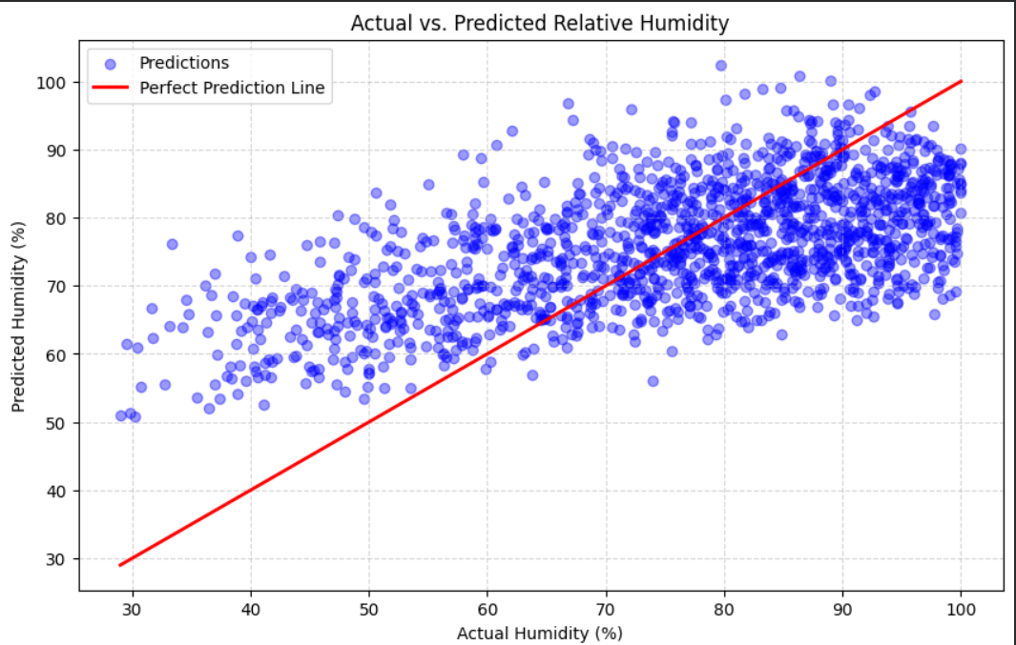

10.2 Low-Humidity Classification

A logistic-regression pipeline estimates whether relative humidity is below the project screening threshold of 30%. The threshold is an analytical screen, not a universal National Weather Service standard.

The positive class is extremely rare in the Jena evaluation (0.22%), so the project reports precision, recall, F1, and ROC-AUC instead of relying on accuracy alone.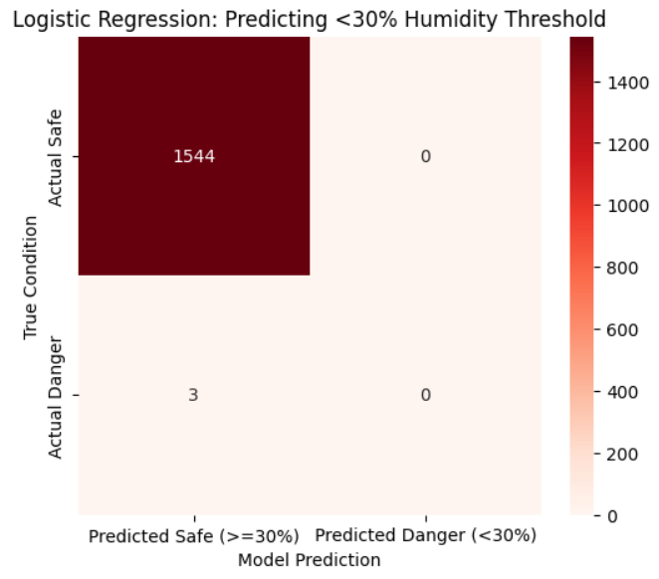

10.3 Pressure-Risk Classification

A second logistic-regression pipeline uses temperature and pressure change per hour as an exploratory pressure-risk signal. Pressure is supporting context and does not prove that wind or a wildfire will occur.

During training, pressure change is calculated over a three-hour time horizon before model sampling.

For a dashboard request, the service retrieves the previous valid event for the same device from PostgreSQL and calculates change over elapsed time.

The dataset lacks ignition and burned-area outcomes, so all three tasks are educational weather-model demonstrations rather than operational wildfire forecasts.

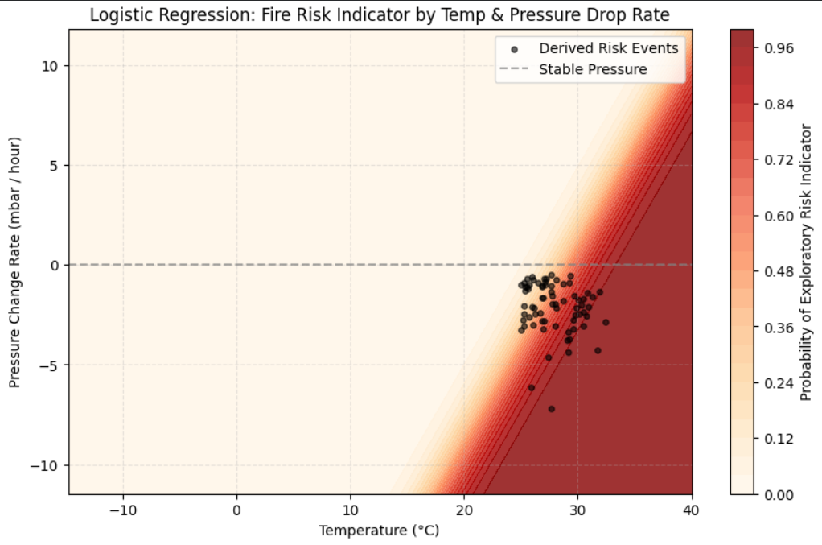

10.4 Standalone Inference Service
The browser sends one event to the dashboard API, which relays the request to the separately running Flask service on port 5001. The service loads the three saved model bundles once at startup and returns the selected estimate or probability. The dashboard remains a read-only client.

11. Data Collection Plan

The proposed hardware extension would support future local testing; it has not yet been added to the packaged software demonstration.

11.1 Hardware Verification

The proposed DHT22 sensor would measure temperature and humidity, while a separate BMP280 module would provide barometric pressure. These components and sketches remain future edge work and are not included as completed hardware.

11.2 Alum Rock Park Deployment

Alum Rock Park was identified as a possible future field-test location. Any deployment would require permission, safe sensor placement, documented hardware, and a collection plan. Logged data could then be evaluated with the same pandas workflow.

12. Final System Implementation

12.1 Event Generation and MQTT Messaging
The final internship deliverable is a complete local demonstration rather than only a notebook analysis. Its data path is: event generator -> Mosquitto MQTT -> subscriber -> PostgreSQL -> read-only API -> three-tab dashboard. A separate Flask ML service loads saved models and returns one-event predictions.
The Python generator creates seeded normal, elevated-dry, red-flag-like, sensor-fault, and mixed measurement profiles. Scenario choices shape measurements for repeatable testing, but raw MQTT payloads contain identifiers, time, and measurements only. They do not carry scenario, severity, outlier, risk, or quality labels.

12.2 PostgreSQL Storage and Database Tools
The subscriber validates each message and writes two records in one transaction. jena_telemetry keeps the original JSON payload for audit, while fire_weather_events stores flattened fields used by reports, exports, and the dashboard. SQL scripts create the schema and safely reset only the Fire Weather demo tables.

12.3 Read-Only Dashboard and Live Stream
The dashboard never generates remote events or writes to PostgreSQL. Analytics reads persisted rows through filters and summaries. Live Event Stream uses a persistent Server-Sent Events connection so committed rows appear immediately as readable cards. Machine Learning submits one event to the standalone model service through the dashboard API.

12.4 Risk Interpretation
After receipt, the subscriber derives data quality, scenario classification, severity, outlier state, and a transparent 0-100 educational risk score. Invalid values remain visible for audit but are not silently treated as wildfire evidence. Fuel moisture is explicitly labeled as a synthetic proxy.

12.5 Validation and Demo Readiness
The completed demonstration was verified with PostgreSQL and Mosquitto running locally. The database report returned 1,150 persisted events, the API health check succeeded after duplicate port-8000 processes were removed, all three dashboard tabs worked, the live stream updated through the persistent connection, and the ML tab returned predictions once the separate service was running.

12.6 Final Package
The handoff is organized into frontend, db, ai_worker, backend, edge, and docs folders. The root README covers setup, database recreation, service startup, generator commands, dashboard access, testing, troubleshooting, and shutdown. The edge folder is a documented placeholder until real sketches, sensor details, and hardware photographs are available.

13. Conclusion
The internship produced a complete local demonstration spanning research, data engineering, MQTT messaging, PostgreSQL storage, a read-only dashboard, live persisted-event streaming, and a separate ML inference service.
The strongest analytical findings were the rarity of the 30 C / 30% overlap, the afternoon and summer patterns, and the weakness of pressure change as a standalone signal. These results directly shaped the final models and the dashboard's cautious interpretation.
The main limitation is the absence of ignition, spread, and burned-area outcomes, along with the fact that physical sensors have not yet been deployed. The current thresholds and model outputs must therefore remain educational screening signals.
The final system is reproducible and honest about those boundaries: raw measurements enter through MQTT, are persisted before display, and are interpreted downstream. Future work should add calibrated hardware and outcome-linked wildfire data before any operational forecasting claim is considered.

References

1. National Oceanic and Atmospheric Administration. Ask the scientist: How can the weather spark and spread wildfires? Published September 4, 2018. Accessed June 25, 2026. https://www.noaa.gov/stories/ask-scientist-how-can-weather-spark-and-spread-wildfires
2. National Weather Service, Tallahassee. Fire Weather Watch and Red Flag Warning Criteria. Accessed August 3, 2026. https://www.weather.gov/tae/redflag_criteria
3. National Weather Service, Grand Junction. Fire Weather Criteria. Accessed August 3, 2026. https://www.weather.gov/gjt/firewxcriteria
4. Natural Resources Canada, Canadian Wildland Fire Information System. Data Sources and Methods for Daily Fire Weather Index Maps. Accessed August 3, 2026. https://cwfis.cfs.nrcan.gc.ca/index.php/background/dsm/fwi
5. Natural Resources Canada, Canadian Wildland Fire Information System. Background Information: Canada's Fire Weather Index System. Accessed August 3, 2026. https://cwfis.cfs.nrcan.gc.ca/background
6. Assessing fire danger classes and extreme thresholds of the Canadian Fire Weather Index across global environmental zones: a review. IOP Science, Environmental Research Letters. Published December 9, 2024. Accessed June 25, 2026. https://iopscience.iop.org/article/10.1088/1748-9326/ad97cf
7. National Weather Service. Red Flag Warning. NOAA Glossary. Accessed August 3, 2026. https://forecast.weather.gov/glossary.php?word=red+flag+warning
8. ProtoSupplies. DHT22 Humidity and Temperature Sensor Module. Accessed June 25, 2026. https://protosupplies.com/product/dht22-humidity-and-temp-sensor-module/
9. Circuit Digest. BMP280 Sensor Module Working and Arduino Interfacing Guide. Accessed June 25, 2026. https://circuitdigest.com/microcontroller-projects/interfacing-bmp280-sensor-with-arduino
10. Pankrzysiu. Weather Archive Jena Dataset. Kaggle. Accessed June 25, 2026. https://www.kaggle.com/datasets/pankrzysiu/weather-archive-jena

End of Report

