Assignminder Final Report

Rathin Chopra
Student
Sheridan College
Oakville, Canada
choprrat@sheridancollege.ca

Salim Elewa
Student
Sheridan College
Oakville, Canada
elewas@sheridancollege.ca
Ghassem Tofighi
Faculty of Applied Science & Technology
Sheridan College
Oakville, Canada
ghassem.tofighi@sheridancollege.ca

Students need a platform that combines both their online course content and reminders. This app helps students keep on track with prioritizing assignments, courses, and homework based on grades and weight of each course.

Introduction
Students have been struggling with keeping track of when each assignment is due and having to manual using self-made calculations figure out which assignment to prioritize. This app is a platform for students to not only be reminded about their assignments but also can prioritize their assignments based on grades and level of importance. This application provides students with the ability to add their peers to the assignments as needed. This feature will enable students to have a chat room for each assignment or homework that has been created by the student leader.
There many current solutions in the market, one of the biggest competitors is Trello. Trello provides users the ability to create tasks with reminders. Trello also allows to organize tasks by iterations for the user, so it feels more of a project. Our solution benefits the student user a lot more, as we provide courses and assignments from the university or college that uses desire to learn platform. Our application also allows the user to create and add their own courses with assignments that are customizable to theirs needs.

HCI Principles
The following concepts are the ones we considered before designing the interface. These concepts influenced our design greatly as they were the core points of our design.

Simplicity.

Obviousness.

Satisfaction.

Familiarity.

Safety.

Github link: https://github.com/rathinchopra98/AdobeXd_Prototype

Prototype Design

Requirement Analysis (NeedFinding)
During the Needfinding stage we interviewed
End users for the application and asked them questions to help us gather more information. Questions that we asked:
- What is difficult about using apps to organize your work?
The apps are always confusing to use because there are a lot of features that we get bombarded with.
- What do you use to keep track of your assignments and when they are due?
Usually use just notes or calendar on the phone.
- What makes online apps to use for your assignments?
Online apps are always easy to use and provide documentations throughout the whole process when using.
- What details matter in a reminder/assignment app?
It’s imperative to have the freedom to add and remove assignments manually and also import current assignments. Another feature that matters a lot, is having the ability to see grades for each assignment.
App needs to be really user friendly; texts should always be legible and coordinate with each other. Make symbols meaningful to what the button or function does as that plays a key role in making sense of the application.

Competitive Analysis
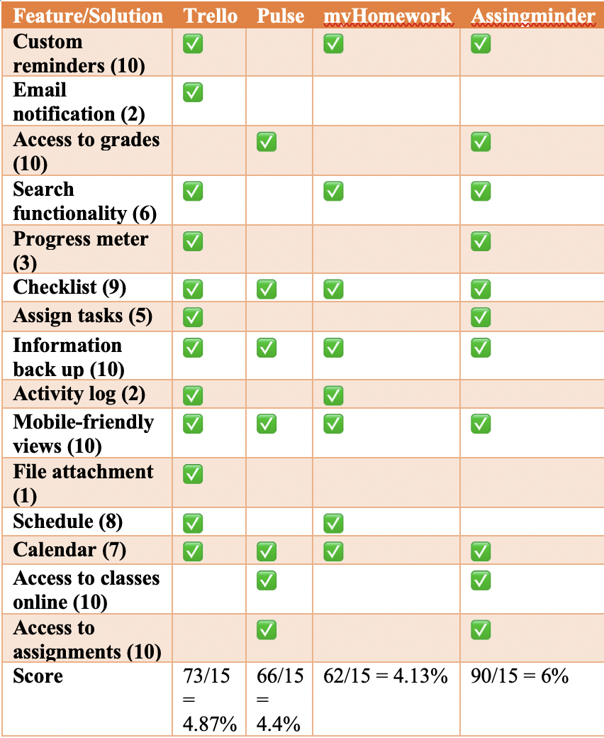
There were some shortcomings from competitors’ products that we noticed:
- Sorting: most of the competitor apps doesn’t allow sorting. They do not allow to sort through tasks using certain fields.
- Zoom in and out: Trello does not allow users to zoom in on mobile version of the application.
- Limited filtering: there is a limited filtering functionality within the applications for tasks, checklist and assignments.
- No tracking of tasks in terms of time: there is not a proper method for tracking tasks using time or schedule in 2 of the apps.
- No autocomplete search: when a user searches it does not autocomplete based on their tasks that have been added.
- Ignoring Different Platforms: Discoverable controls, there’s certain functions on Trello that are only available on webpage.
- There no auto-filled customer data.

First Initial Prototype Alternatives
Rathin Chopra’s initial prototype: https://xd.adobe.com/view/901cc6ae-5600-4474-739d-3efb02856e25-e62d/
Salim Elewa’s initial prototype:
https://xd.adobe.com/view/6a2bba55-dbc5-4e29-68a3-412dfea74a89-1c1a/screen/62f86e13-387d-463d-b10d-a6d5c4fbfe4c/iPhone-X-XS-2/

Final prototype:
https://xd.adobe.com/view/b14623a2-69eb-4452-4704-5877c8ec12e2-c777/screen/fe01c7a7-cefe-4d98-918a-4c63689a7102/iPhone-X-XS-2

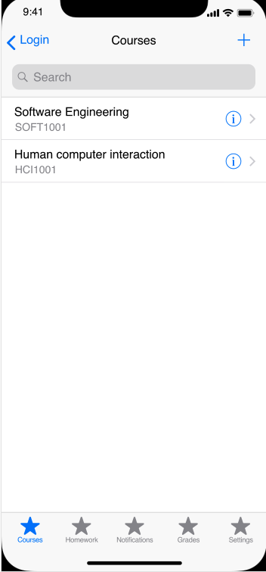
One of the most important HCI concept that we focused on was simplicity. As illustrated in the screenshot of the prototype the app is as simple as it gets. The user has minimal functions that would otherwise overwhelm them, just easy click or two to get the courses they need added.
Another one we chose to focus on, was obviousness. In the picture below, you can see the similarity between the homework tab and the courses tab in terms of functionality. This similarity provides the user the sense of comfort knowing that adding other items or sections into this application will follow the same order in each tab. Thus, allowing the user to see the obvious and know how the app will function.
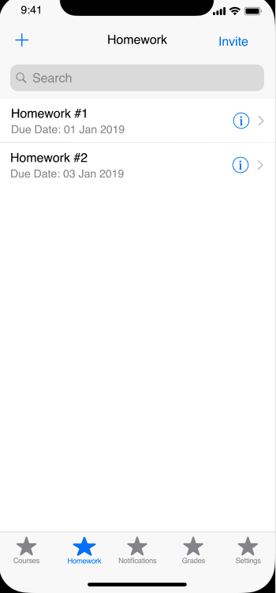
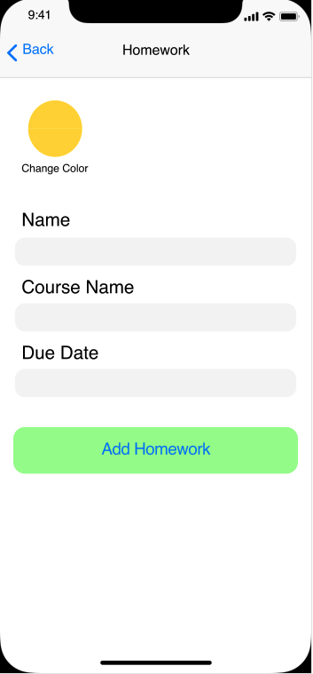

Prototype evaluation
Tasks:
Register for the app
- This was a crucial step to test the user, as it is the initial interaction that a user has within an app. We needed to make sure this part of the application is easy to register for.
Add courses to your list
- This part was key to test the user on, as our biggest feature is allowing users to add courses manually so we needed to know if there are any struggles users might have for this.
Explain what you like about this page (course page)?
- This gave us an idea of what improvements we can do on the page and also what the user has enjoyed the most so we can replicate that same satisfaction in future implementations.
Go through assignment information and explain your understanding.
- Assignments is one of the core functions of the app and can be a bit of a process to understand so we required the user to provide as much feedback as possible to allow us to see what the user understands from the page and not.
Navigate to homework tab and add homework
- We needed to see if the user can recognize similarity between this section and the other ones to provide that sense of obviousness and simplicity
Is this what you excepted?
- This is really helpful because it gives over all feedback on the app and if people expect more or less from it.

Usability Analysis
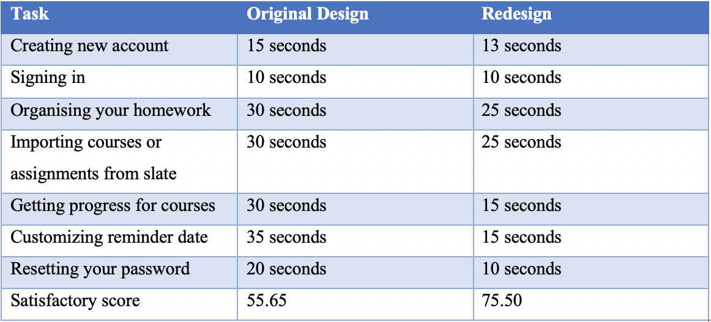

Measuring Success:
Task 1: relative score 115% (improvement of 15%)
Task 2: relative score 100% (improvement of 0%)
Task 3: relative score 120% (improvement of 20%)
Task 4: relative score 120% (improvement of 20%)
Task 5: relative score 200% (improvement of 100%)
Task 6: relative score 233% (improvement of 133%)
Task 7: relative score 200% (improvement of 100%)
Geometric Mean: 147.8
So that shows improvement of 47.8%
The geometric mean averages the set of scores as: sqrt (1.47 * 1.36) = 1.41
In other words, the new design scores 141% compared with the baseline score of 100% for the control condition (the old design).
The new design thus has 41% higher usability than the old one.
Analysis of feedback:
Creating new Account: All the tester, were easily able to create a new account and they really liked how easy was it for them to sign up. The tester really liked the location and design of the sign-up page and they also liked the position of signup button in the application. The position of sign-up button made it easy for user to easily locate it.
Signing In: This task was easily completed by all the testers under 10 seconds and they didn’t have any trouble doing this task.
Organising Homework: All testers were able to add or edit the homework in application. Testers were able to locate all the functionality for homework tab. They were able to follow the instructions for adding the new homework and they liked the easy design of homework tab. They really liked this feature of adding the homework, so that you can keep track of your class/courses.
Importing courses or assignments from slate: This task was also completed by all the testers. Testers liked the feature that the application can automatically import courses and assignments from their college/university site. They were impressed by how easy it was, for them was to grab/import all the assignments from their college’s website.
Customizing reminder date: This feature was also really adored by the testers. They liked this feature as it will remind them of their pending assignments and quizzes. Both the testers gave this feature a average score of 8.5/10. Changing the reminder date was quite easy for the testers and both the testers were able to complete the task under 15 seconds in the new design.
Getting Course Progress: This feature was really helpful according to the testers of the application. According to the testers, this feature will make their life easier as they don’t have to worry about calculating their progress for each course manually, instead the app does it for you.
Resetting your password: Resetting was fairly easy for the users, due to simple design of the application and the design of application made the testers to easily find and change the password.

Revised Prototype
The link we have provided for the final prototype is our revised prototype based on the usertesting feedback we have received. We have decided to include a walkthrough within the app itself that we cannot illustrate within adobeXD.

Future works & Conclusions
In conclusion, we have noticed that a lot of the users enjoyed how simple the app is and that it provided them the sense of similarity with other apps. What we hope to improve in the future with design is, having a walkthrough demo for the app to simplify things for the user a little more.
Having a demo walkthrough, allows the user to have an oversight of what the app does and how to navigate around with it. This will eliminate any confusion for the user on how to start with the app, especially if the user is a student that does not use slate.

References
- Branscomb, L. M., & Thomas, J. C. (1984). Ease of use: A system design challenge. IBM Systems Journal, 23(3), 224–235. doi: 10.1147/sj.233.0224
- Finstad, K. (2013). Response to commentaries on The Usability Metric for User Experience. Interacting with Computers, 25(4), 327–330. doi: 10.1093/iwc/iwt005
- Patnaik, D., & Becker, R. (2010). Needfinding: The Why and How of Uncovering Peoples Needs. Design Management Journal (Former Series), 10(2), 37–43. doi: 10.1111/j.1948-7169.1999.tb00250.x

