Technical Design Document: Tiered Pricing Expression Sets

Revenue Cloud Advanced (RCA) — Salesforce Pricing Engine
Field | Value
Document ID | TDD-PRICING-TIERED-001
Version | 1.0
Date | 2026-05-20
Status | Draft for Architect Review
Author | RCA Design Agent
Pattern ID | tiered-volume-pricing
Reviewer | Technical Architect

Table of Contents
- Business and Technical Context
- Overall Architecture Strategy
- Architecture Diagram — Price Waterfall Flow
- Context Definitions and Tag Mapping
- Expression Set Design
- Pricing Procedure Plan and Waterfall Sequence
- Data Model Design
- Entity Relationship Diagram
- Sequence Diagram — Pricing Execution Flow
- Pricing Lineage Report
- Automation and Orchestration
- Scalability and Performance
- Risks and Mitigations
- Assumptions and Open Questions
- Appendix — Extraction Summary

1. Business and Technical Context

Business Problem
Enterprise customers purchasing software or services at scale expect volume-based price breaks as a commercial incentive. Flat list pricing does not reward high-volume buyers and creates manual negotiation overhead. The business requires an automated tiered pricing engine that applies bracket-based unit rates dynamically at quote and order time, without manual overrides or Apex logic.

Process Area
Salesforce Pricing Engine (native on-core) — Quote-to-Order pricing for products sold via the Transaction Line Editor (TLE).

Scope
In Scope | Out of Scope
Tiered (stepped/slab) pricing via Expression Sets | Legacy CPQ SBQQ__ objects — REJECTED
Context Definition and Context Tag mapping | Manual price override flows
Pricing Procedure Plan with waterfall | External ERP pricing integration
PriceTier decision table lookup | Billing-time tiered rating (DPE/usage)
SalesOrderProduct persistence | Tax calculation steps

Canonical Pattern
This design implements the tiered-volume-pricing canonical RCA pattern. Each quantity bracket maps to a specific unit rate. The rate is resolved by the Expression Set via a PriceTier decision table lookup keyed on quantity. The final SalesPrice written to SalesOrderProduct reflects the applicable tier rate multiplied by quantity.

Tier Model Assumption
This TDD uses a stepped slab (also called "stairstep") model: the entire quantity falls into one bracket and receives that bracket's rate. This is distinct from the cumulative/graduated model where each unit is rated at the tier it falls into.
Assumption A1: Stepped slab is confirmed as the required model. If graduated (waterfall per unit) is required, the Expression Set formula and decision table structure must change. Flag this to the Solution Architect before build.

2. Overall Architecture Strategy
The solution uses exclusively native RCA on-core engines:
- Product Catalog Management (PCM): Product2 records are associated with a ProductSellingModel that references a PriceAdjustmentSchedule. The schedule holds PriceTier records defining tier boundaries and rates.
- Context Service: A ContextDefinition (Usage Type: Pricing) maps SalesOrderProduct fields — primarily Quantity and ProductId — into named context attributes. These attributes are the runtime inputs consumed by the Expression Set.
- Salesforce Pricing Engine (Expression Sets): The ExpressionSet (Usage Type: Pricing) reads context attributes, queries the PriceTier decision table via a Lookup element, and calculates the final unit price. Output is mapped back to SalesOrderProduct.SalesPrice via a save/persistence mapping.
- Pricing Procedure Plan: A PricingProcedure (Usage Type: Pricing) sequences the waterfall steps: List Price Fetch -> Tier Lookup -> Net Price Calculation -> Persistence.
- No Apex in the pricing path. Pre-hooks, if used, prepare context only — no DML, no secondary pricing logic.

3. Architecture Diagram — Price Waterfall Flow
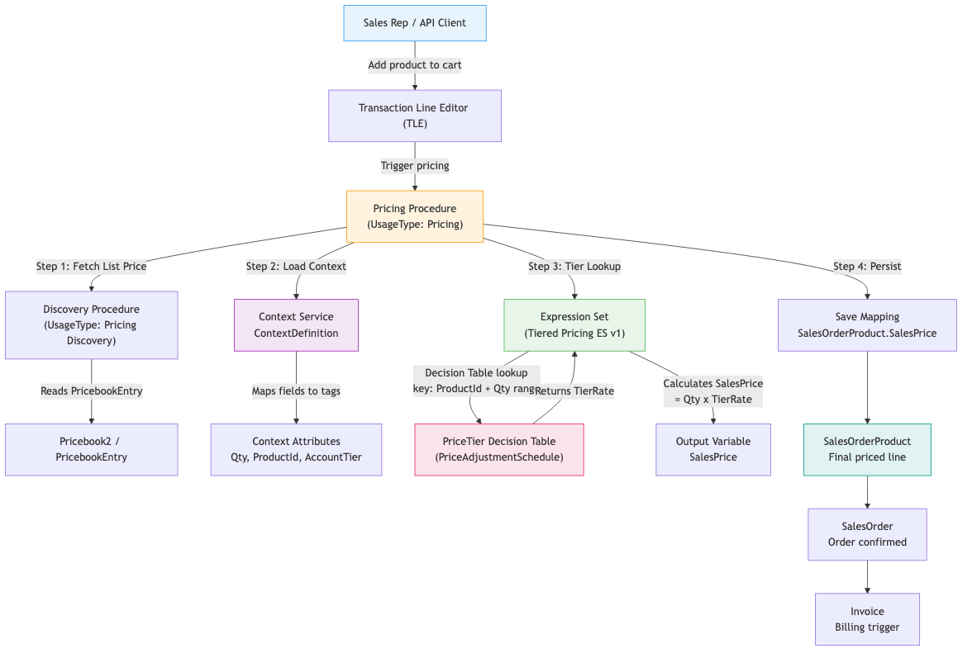

4. Context Definitions and Tag Mapping

4.1 Context Definition Record
Field | Value
Name | Tiered_Pricing_Context
Developer Name | Tiered_Pricing_Context
Usage Type | Pricing
Base Object | SalesOrderProduct
Active | true

4.2 Context Attributes
Each attribute declared below must specify fieldType explicitly. Omitting fieldType is the leading cause of writeback failures.
Attribute Name | Source Field | fieldType | Notes
qty | SalesOrderProduct.Quantity | input | Drives tier bracket lookup key
productId | SalesOrderProduct.Product2Id | input | Drives product-level tier table filter
listPrice | PricebookEntry.UnitPrice | input | Base rate from Pricebook
accountTier | Account.CustomerTier__c | input | Optional: enables account-class tier override
salesPrice | SalesOrderProduct.SalesPrice | inputoutput | Must be inputoutput — read AND written back
tierRate | (computed) | output | Intermediate ES variable; not persisted directly
Critical Rule: salesPrice MUST be declared as inputoutput, not output. If it is declared output only, the save mapping cannot read its initial value for audit purposes. If it is declared input only, the Expression Set cannot write back the computed value. This is the most common tiered pricing writeback failure mode.

4.3 Context Mapping (Source-to-Tag)
Context Tag | Maps From | Mapping Type
qty | SalesOrderProduct.Quantity | Direct field mapping
productId | SalesOrderProduct.Product2Id | Direct field mapping
listPrice | PricebookEntry.UnitPrice | Related record mapping via PricebookEntryId
accountTier | Account.CustomerTier__c | Related record mapping via AccountId on SalesOrder
salesPrice | SalesOrderProduct.SalesPrice | Direct field mapping (read + write)

4.4 UI vs API Context Preparation
Architect Alert — Channel Divergence: The Transaction Line Editor (UI) prepares context interactively — it hydrates qty and productId from the live cart state as the user types. Headless API calls (e.g., DRO-driven order flows) prepare context from the request payload. If accountTier is not included in the API request payload, the tier override will silently fall back to the default bracket. Always validate pricing in both channels separately.

5. Expression Set Design

5.1 Expression Set Record
Field | Value
Name | Tiered_Pricing_ES
Developer Name | Tiered_Pricing_ES
Usage Type | Pricing
Version | 1 (Active)
Status | Active
Versioning Rule: Only one version may be Active at a time. When updating tier rates, clone the current version, update the decision table rows, activate the clone, and deactivate the prior version. Never edit an Active version in place.

5.2 Expression Set Variables
All variables must declare input/output flags explicitly. Missing flags cause the pricing engine to silently skip the variable.
Variable Name | Data Type | Input Flag | Output Flag | Description
v_qty | Number | true | false | Quantity from context attribute qty
v_productId | Text | true | false | Product ID from context attribute productId
v_listPrice | Currency | true | false | List price from context attribute listPrice
v_accountTier | Text | true | false | Account tier class from context attribute accountTier
v_tierRate | Currency | false | true | Resolved rate from decision table lookup
v_salesPrice | Currency | true | true | Final calculated price; mapped to salesPrice context attribute

5.3 Expression Set Elements (Ordered)
Seq | Element Type | Name | Description
10 | Lookup | LookupTierRate | Queries PriceTier decision table using v_productId and v_qty; returns v_tierRate
20 | Formula | CalculateSalesPrice | v_salesPrice = v_qty * v_tierRate
30 | Condition | GuardZeroPrice | If v_tierRate = 0 then set v_salesPrice = v_listPrice * v_qty (fallback to list price)

5.4 Decision Table — PriceTier Lookup
The decision table is backed by PriceTier records attached to a PriceAdjustmentSchedule. The Lookup element references it by Developer Name.
Input Column | Type | Description
ProductId | Text | Exact match on Product2.Id
MinQuantity | Number | Lower bound of tier bracket (inclusive)
MaxQuantity | Number | Upper bound of tier bracket (exclusive; use 9999999 for open-ended top tier)

Output Column | Type | Description
TierRate | Currency | Unit rate for this bracket
Sample Tier Table (illustrative):
ProductId | MinQuantity | MaxQuantity | TierRate
01t...001 | 1 | 10 | 100.00
01t...001 | 10 | 50 | 90.00
01t...001 | 50 | 200 | 75.00
01t...001 | 200 | 9999999 | 60.00
Duplicate Lookup Key Risk: If MinQuantity/MaxQuantity ranges overlap for the same ProductId, the decision table will throw a duplicate lookup error at runtime. This appears as a "Decision table returned multiple rows" error in the Pricing Log. Ranges must be non-overlapping. The MaxQuantity boundary must be exclusive (the next tier's MinQuantity equals this tier's MaxQuantity).

5.5 Save Mapping (Persistence)
Source ES Variable | Target Context Attribute | Target sObject Field
v_salesPrice | salesPrice | SalesOrderProduct.SalesPrice
If the save mapping row for SalesOrderProduct.SalesPrice is absent, v_salesPrice will be calculated correctly in memory but will NOT be written to the record. The waterfall will show a computed value in the simulation view but the field remains null on the saved record. This is the most common "value calculated but not written back" failure mode.

6. Pricing Procedure Plan and Waterfall Sequence

6.1 Pricing Procedure Record
Field | Value
Name | Tiered_Pricing_Procedure
Developer Name | Tiered_Pricing_Procedure
Usage Type | Pricing
Status | Active
Context Definition | Tiered_Pricing_Context

6.2 Procedure Plan Steps
The 200-element limit applies to the total count of pricing elements across all procedure steps. This procedure uses 4 steps — well within limits. Establish a pricing budget if additional domains share this procedure.
Step Seq | Step Name | Element Type | Element Reference | Purpose
10 | FetchListPrice | Pricing Element | PricebookEntry lookup | Populates v_listPrice from the active Pricebook
20 | LoadContext | Context Service | Tiered_Pricing_Context | Hydrates all input context attributes from SalesOrderProduct and related records
30 | ApplyTieredPricing | Expression Set | Tiered_Pricing_ES v1 | Resolves tier rate, calculates sales price
40 | PersistPrice | Save Mapping | salesPrice -> SalesOrderProduct.SalesPrice | Writes final price to the order line

6.3 Price Waterfall (Visual)
+-----------------------------------------------------------+
| PRICE WATERFALL — SalesOrderProduct |
+-----------------------------------------------------------+
| Step 10 List Price $100.00 (from PricebookEntry)|
| Step 20 Context Loaded qty=25, accountTier=Gold |
| Step 30 Tier Lookup TierRate=$90.00 (10-50 range) |
| Formula 25 * $90.00 = $2,250.00 |
| Step 40 SalesPrice $2,250.00 -> PERSISTED |
+-----------------------------------------------------------+
| Net Price $2,250.00 |
+-----------------------------------------------------------+

7. Data Model Design

7.1 Key Objects and Relationships
Object | Role | Key Fields
Product2 | The sellable item | Id, Name, IsActive, ProductCode
Pricebook2 | Named price list | Id, Name, IsActive, IsStandard
PricebookEntry | List price per product per pricebook | Id, Product2Id, Pricebook2Id, UnitPrice, IsActive
ProductSellingModel | Defines how a product is sold (one-time, recurring) | Id, Name, SellingModelType, PricingTermUnit
PriceAdjustmentSchedule | Container for tier bracket rules | Id, Name, AdjustmentType, AdjustmentSource
PriceTier | Individual tier bracket row | Id, PriceAdjustmentScheduleId, TierType, LowerBound, UpperBound, AdjustmentAmount, AdjustmentPercent
SalesOrder | The order header | Id, AccountId, Pricebook2Id, Status
SalesOrderProduct | The order line | Id, SalesOrderId, Product2Id, Quantity, UnitPrice, SalesPrice, PricebookEntryId
ContextDefinition | Pricing context schema | Id, DeveloperName, UsageType
ContextAttribute | Individual tag within a Context Definition | Id, ContextDefinitionId, DeveloperName, DataType, FieldType
ExpressionSet | Pricing calculation logic container | Id, DeveloperName, UsageType
ExpressionSetVersion | Versioned instance of an Expression Set | Id, ExpressionSetId, VersionNumber, Status

7.2 Object Notes
- PriceAdjustmentSchedule.AdjustmentType should be set to Fixed Price for absolute tier rates, or Percentage for percentage-based discount tiers. This TDD uses Fixed Price.
- PriceTier.LowerBound and UpperBound map to MinQuantity and MaxQuantity in the decision table. The decision table is auto-generated from these records — do not manually edit the decision table rows outside the PriceTier record UI.
- SalesOrderProduct.SalesPrice is the field the pricing engine writes to. It is distinct from UnitPrice (which holds the list price from the Pricebook). Downstream billing and invoicing read SalesPrice.

8. Entity Relationship Diagram
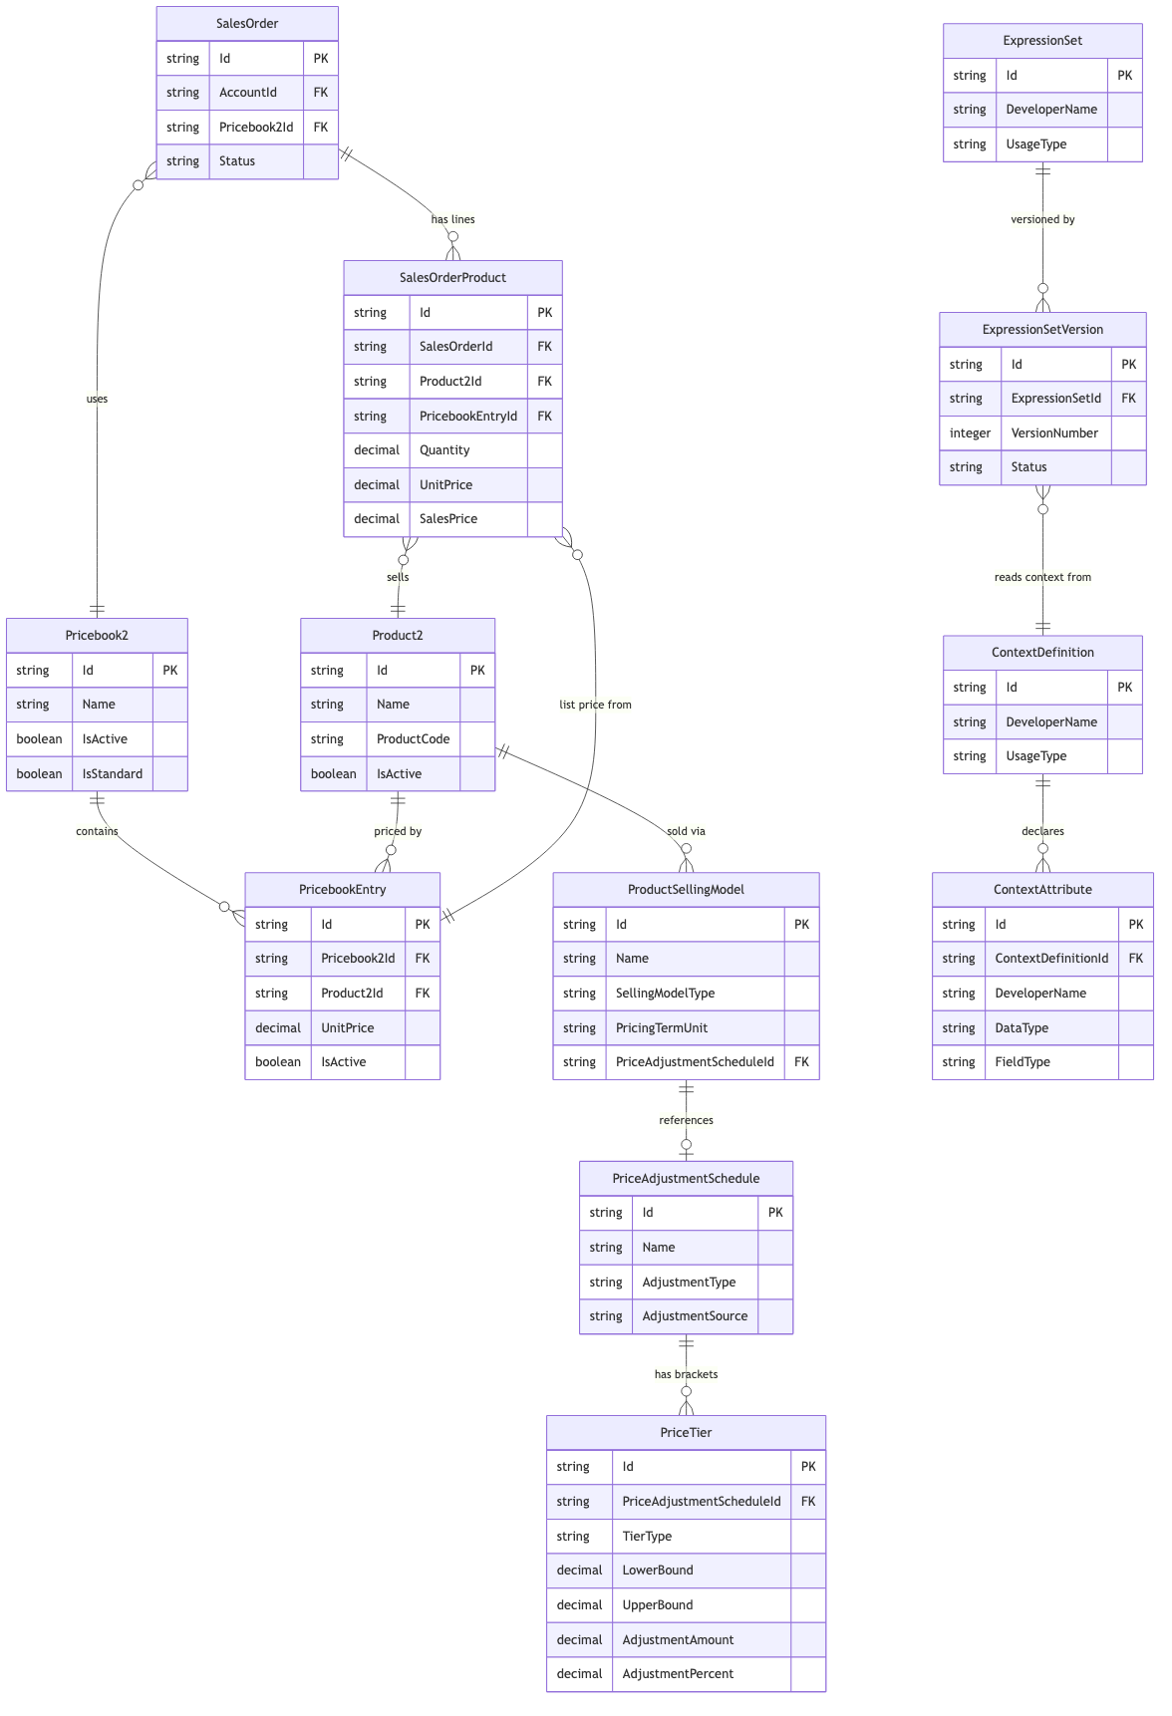

9. Sequence Diagram — Pricing Execution Flow
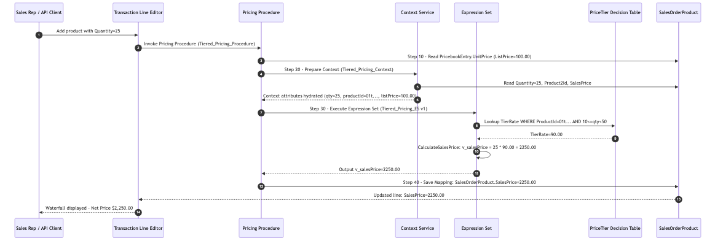

10. Pricing Lineage Report
This report satisfies the mandatory Technical Architect [TA] gate before any pricing build is approved.
## Pricing Lineage: Tiered Sales Price on SalesOrderProduct
- sObject field: SalesOrderProduct.SalesPrice
- Context attribute/tag: salesPrice (FieldType: inputoutput)
- Context mapping: Tiered_Pricing_Context -> salesPrice -> SalesOrderProduct.SalesPrice
- Expression set: Tiered_Pricing_ES v1 (UsageType: Pricing, Status: Active)
- Pricing element: Step 30 in Tiered_Pricing_Procedure (sequenceNumber: 30)
- Decision table: PriceTier lookup (inputs: ProductId, Quantity range; output: TierRate)
- Procedure plan seq: 10 (FetchListPrice) -> 20 (LoadContext) -> 30 (ApplyTieredPricing) -> 40 (PersistPrice)
- Persistence path: ExpressionSet output v_salesPrice -> Context Attribute salesPrice
-> Save Mapping -> SalesOrderProduct.SalesPrice (committed on order save)
## Failure Points
1. SalesPrice not written back:
- Root cause: Context attribute salesPrice declared as "output" instead of "inputoutput"
- OR: Save mapping row for SalesOrderProduct.SalesPrice is absent from the procedure
2. Decision table returns no row:
- Root cause: Runtime qty value falls outside all defined LowerBound/UpperBound ranges
- OR: ProductId context attribute not populated (null hydration — check context mapping)
3. Duplicate lookup error:
- Root cause: Overlapping PriceTier ranges for the same ProductId
- Note: this is a data problem, not a duplicate row problem
4. UI shows price but API returns list price:
- Root cause: API payload does not include accountTier — tier override falls back silently
- Validate headless context preparation separately from TLE interactive context
5. Expression Set returns zero price:
- Root cause: v_tierRate lookup returned null; GuardZeroPrice fallback may not be present
- Check GuardZeroPrice condition element (Step 30) is active in the ES version
## Next Checks (if evidence is incomplete)
1. Run POST /services/data/v63.0/connect/business-rules/decision-table/lookup/<DT_ID>
with payload {"qty": 25, "productId": "01t...001"} — expect TierRate=90.00
2. Confirm ExpressionSetVersion.Status = Active for Tiered_Pricing_ES v1
3. Inspect Context Attribute salesPrice.FieldType = "inputoutput" in Setup
4. Verify Save Mapping target field = SalesOrderProduct.SalesPrice (not UnitPrice)
5. Check Pricing Log in Revenue Operations Console for any "null lookup key" warnings

11. Automation and Orchestration

11.1 Pre-Hook (if required)
Pre-hooks in the pricing context are optional Apex invocations that run before the Expression Set. The following strict rules apply:
- Pre-hooks MUST prepare context only — set attribute values for the Expression Set to consume.
- Pre-hooks MUST NOT contain DML statements.
- Pre-hooks MUST NOT perform secondary pricing calculations.
- Pre-hooks MUST NOT be used if context mapping alone can populate the required attributes.
For tiered pricing, qty, productId, and listPrice are all derivable via standard context mappings from SalesOrderProduct and PricebookEntry. A pre-hook is NOT required for this design.
Assumption A2: accountTier is assumed to be a custom field Account.CustomerTier__c. If account-level tier override is not a requirement, remove the accountTier context attribute and the corresponding decision table input column to simplify the lookup key and reduce duplicate-match risk.

11.2 Discovery Procedure
The Pricing Discovery Procedure (UsageType: Pricing Discovery) is responsible for fetching pricing rules and mapping products before the Pricing Procedure executes. It must include:
- Fetch Pricing Rules element — loads active PricebookEntry records for the products in the transaction
- Map Products element — associates Product2 records with their PriceAdjustmentSchedule
Both elements must be present. If Map Products is absent, the Expression Set will not resolve the correct PriceAdjustmentSchedule and the decision table lookup will fail silently.

11.3 Decision Table Sync
After creating or updating PriceTier records, the following decision tables must be manually refreshed (or auto-refreshed via the nightly sync job):
- Price Adjustment Schedules decision table
- Price Book Entries V2 decision table
If these are stale, the Expression Set will evaluate against out-of-date tier data at runtime.

12. Scalability and Performance
Concern | Guideline | Mitigation
Pricing Procedure element budget | 200-element limit per procedure | This procedure uses 4 steps. Reserve remaining budget for discount/promo steps. Decompose into sub-procedures if needed.
Decision table row count | Large product catalogs with many tiers may produce wide decision tables | Index by ProductId first; keep tier rows per product under 20 for optimal lookup performance
High-volume order lines | Synchronous pricing struggles above ~500 lines per order | For high-volume (telco, usage) use cases, offload batch pricing to DPE rather than synchronous procedure
Concurrent pricing requests | Expression Set execution is stateless and parallelizable | No concern for standard B2B volumes; monitor at >1000 concurrent sessions
Invoice line limit | Platform limit of ~2,000 invoice lines | Validate order line counts for high-volume customers before go-live
Context preparation overhead | Complex multi-related-record mappings add latency | Keep context attributes to the minimum required; avoid chaining 3+ related-record hops

13. Risks and Mitigations
ID | Risk | Severity | Mitigation
R1 | salesPrice context attribute declared with wrong fieldType causing silent writeback failure | High | Add a post-pricing automated assertion: compare SalesOrderProduct.SalesPrice to expected value in QA; add to regression suite
R2 | Overlapping PriceTier range boundaries cause duplicate lookup errors at runtime | High | Add a pre-deployment data validation script: SELECT LowerBound, UpperBound FROM PriceTier WHERE ProductId = ? and assert no range overlaps
R3 | Decision table not refreshed after PriceTier data update | Medium | Add decision table refresh to the deployment runbook; consider scheduling auto-refresh via Flow
R4 | API headless pricing path omits accountTier context tag | Medium | Add explicit test case for headless context (separate from TLE context); document required API payload fields
R5 | Single ExpressionSetVersion active constraint: accidental deactivation during hotfix | Medium | Gate version deactivation behind a change approval; never deactivate until replacement version is confirmed Active
R6 | Pre-hook introduced later contains DML, creating a second pricing engine | High | [TA] must review all pre-hook Apex additions; enforce the "context-prepare only" rule via code review checklist
R7 | 200-element pricing procedure budget exceeded as discount steps are added | Low-Medium | Establish a pricing element budget per domain at project kickoff; track element count in BACKLOG.md

14. Assumptions and Open Questions
ID | Type | Description | Owner
A1 | Assumption | Stepped slab tier model confirmed (not graduated/cumulative) | Solution Architect
A2 | Assumption | Account-level tier override (CustomerTier__c) is in scope | Product Owner
A3 | Assumption | One active Pricebook2 per org (Standard Pricebook) | Solution Architect
A4 | Assumption | PriceTier records are managed via the RCA UI, not SFDX metadata | DevOps
OQ1 | Open Question | Should tier rates be currency-per-unit (fixed) or percentage discount off list? | Product Owner
OQ2 | Open Question | Is multi-currency support required? If yes, CurrencyIsoCode must be added as a context attribute and decision table input column | Technical Architect
OQ3 | Open Question | Should the top tier have an open-ended upper bound, or a hard maximum quantity per order? | Business
OQ4 | Open Question | Is a manual price override required alongside tiered pricing? If yes, an override condition element must be added to the Expression Set to check a ManualOverridePrice attribute before running the tier lookup | Solution Architect
RCA Data Deployment Note (DevOps Gate): PriceTier and PriceAdjustmentSchedule records are DATA, not metadata. They will NOT be deployed via SFDX or change sets. Plan SFDMU or CLI data scripts to seed these records in every environment. Sandbox refresh will wipe all RCA data — a repeatable seeding script is mandatory.

15. Appendix — Extraction Summary
Source System | Document / Query | Used For
Local MCP — user-rca-advisor | RCA Design Gem — Instructions | Design mode persona, output format, Output Standard sections, design principles
Local MCP — user-rca-advisor | RCA Build Gem — Instructions | Expression Set variable rules, Pricing Procedure step structure, Discovery Procedure element requirements, derived pricing build steps reference
Local MCP — user-rca-advisor | RCA Test Gem — Instructions | Core object list confirmation (SalesOrder, SalesOrderProduct, PriceAdjustmentSchedule, PriceTier, ProductSellingModel, Pricebook2), data model integrity rules
Google Drive (mcp-adaptor) | Queried "tiered pricing Expression Sets pricing procedure waterfall" — no relevant results | Applied RCA standard patterns
Google Drive (mcp-adaptor) | Queried "Context Service Context Definition tag mapping pricing" — no relevant results | Applied RCA standard patterns
Google Drive (mcp-adaptor) | Queried "TDD template HLD design artifact Revenue Cloud" — no relevant results | Applied RCA standard patterns
Google Drive (mcp-adaptor) | Queried "SalesOrderProduct PricebookEntry ProductSellingModel tiered volume pricing objects" — no relevant results | Applied RCA standard patterns
Google Drive (mcp-adaptor) | Queried "PriceAdjustmentSchedule PriceTier tiered volume pricing data model" — no relevant results | Applied RCA standard patterns
Google Drive (mcp-adaptor) | Queried "pricing lineage context attribute fieldType input output save mapping persistence writeback" — no relevant results | Applied RCA standard patterns
Google Drive (mcp-adaptor) | Queried "Expression Set variable declaration pricing element sequence procedure plan" — no relevant results | Applied RCA standard patterns
No org-approved guidance found for tiered pricing Expression Sets via Google Drive (mcp-adaptor) — all design decisions apply RCA standard patterns grounded in the local MCP Gem instruction knowledge base.

