RECOUP
Cash Application
How to check the demo is working
This guide is for finance users. It shows you what to look at on screen, what a healthy result looks like, and how to clear the test data when you have finished. You do not need any technical knowledge, and there is nothing to install.
Reading it takes about five minutes. Doing it takes about ten.
Before you start
You need the demo web address and a login. Ask whoever set up the demo for both.
Use Chrome or Edge. Everything happens in the browser.
This is a demonstration system using test data. No real customer money moves.

What this system does
When a customer pays an invoice, they often pay less than the full amount and send a note explaining why — a damaged pallet, a shortage, an agreed discount. Working out what they actually paid, which invoice it belongs to, and whether the deduction is justified is slow manual work.
This system does the first part automatically. It reads the customer's payment note, checks the money genuinely arrived, works out the shortfall, and hands a prepared case to the deductions team.
The important word is prepared. It does not decide anything, pay anything, or contact anyone. A person still reviews and approves. The system's job is to have the arithmetic and the evidence ready before that person opens the case.

The four specialists
The screen you will look at reports on four automated specialists. Only the first is covered by this guide.
Specialist | What it does
Cash Application | Reads the payment note, confirms the money arrived, works out the shortfall.
Deduction Forensics | Investigates whether a deduction is justified.
Recovery Drafter | Prepares a recovery letter when money is owed back.
Maya Queue | Holds cases waiting for a person to decide.

Step 1 — Open the workspace
- Go to the demo web address.
- Sign in with the username and password you were given.
- Open the page called Agent Operations.
You should see a screen like this one.
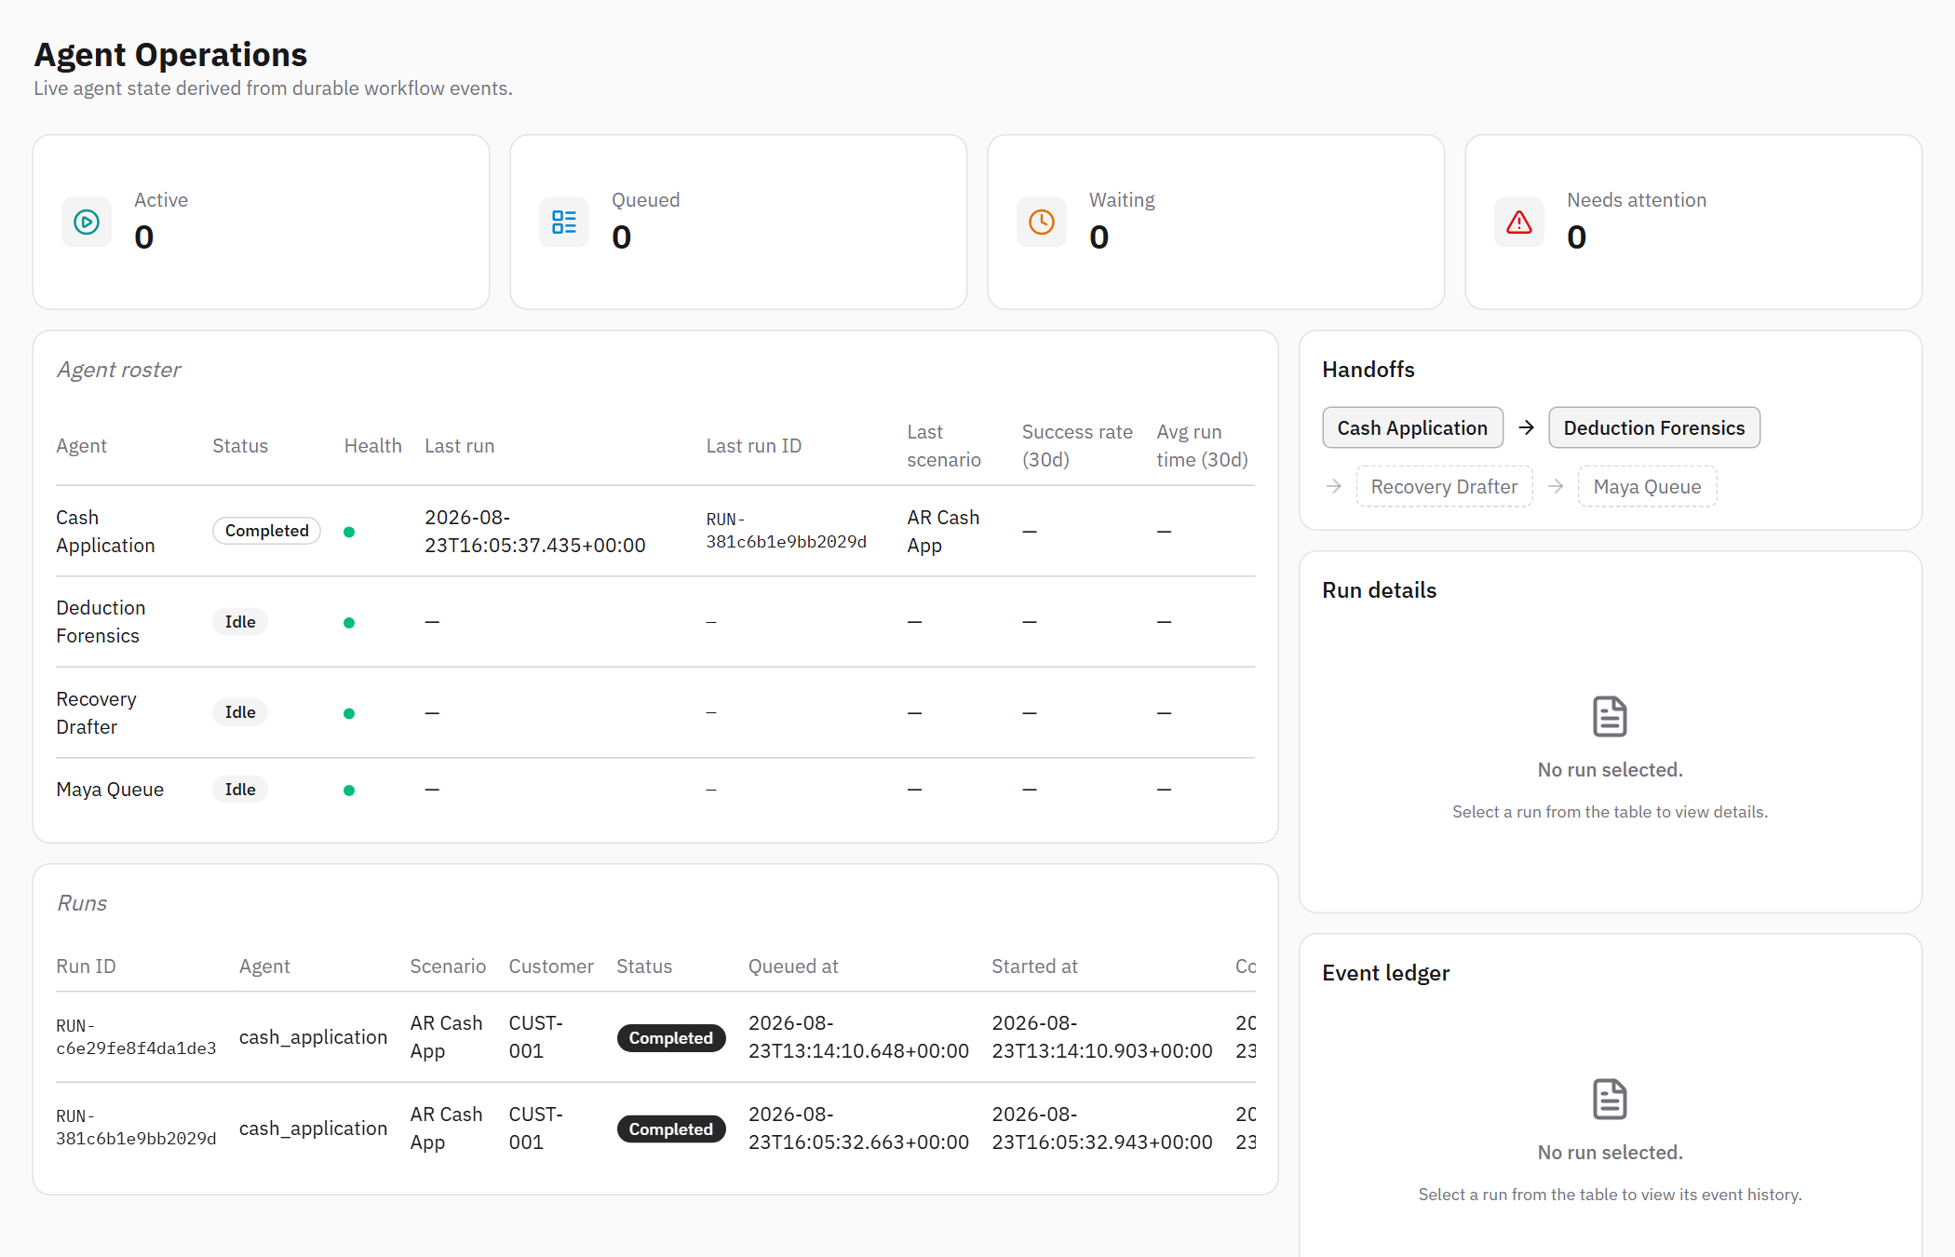
The Agent Operations screen, showing one completed payment.
If you see a login box instead
That is correct and expected — the page is protected. Sign in and it will open.
If your login is refused, the account may not have access to this page. Ask whoever set up the demo.

Step 2 — Read the four summary boxes
Across the top are four counts. They tell you, at a glance, whether anything needs a person.
The summary counts. All four at zero means nothing is in progress.
Box | What it means | Should you act?
Active | Work happening right now. | No — it will move on by itself.
Queued | Accepted and about to start. | No.
Waiting | Held up, usually because the payment has not cleared the bank yet. | Only if it stays there for a long time.
Needs attention | Stopped and cannot continue on its own. | Yes — someone should look.
All four at zero simply means nothing is in progress. If a payment has already finished, it will not appear in any of these counts — finished work is not pending work.

Step 3 — Find the payment in the list
Below the summary is the list of payments the system has handled. The newest is at the top.
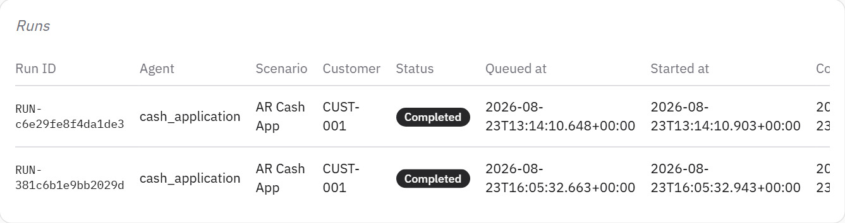
The list of payments. Every column should contain a value.
Read across the row:
- Customer — whose payment this is. This is the first thing you usually want.
- Scenario — the kind of work. Here, applying cash to an invoice.
- Status — where it got to. Completed means it finished successfully.
- The times — when it arrived, when work started, when it finished, and how long it took.

What a problem looks like
A dash (—) in the Customer column, or in the time columns, on a finished payment.
That means information did not reach the screen. Report it — do not work around it.
A dash in 'Completed at' or 'Elapsed' on a payment still in progress is normal: it has not finished yet.

Step 4 — Open one payment
Click any row. The panel on the right fills in with the detail behind that payment.
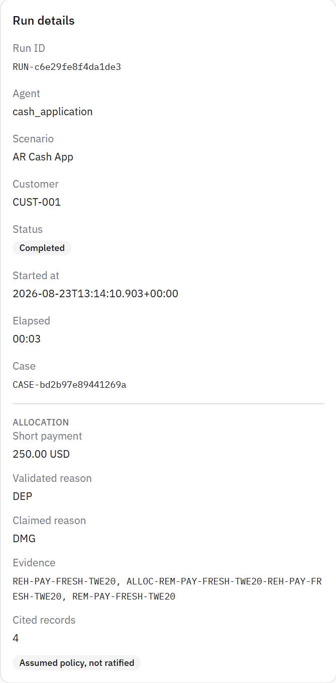
The detail panel. The Allocation section is the finance answer.

The part that matters to finance
Field | What it is telling you
Short payment | How much less the customer paid than the invoice asked for. This is the amount in question.
Claimed reason | The reason the customer gave. Their words, not a decision.
Validated reason | The category the system placed it in after checking. This is what the deductions team will work from.
Case | The reference for the case handed to the deductions team.
Evidence | References to the records this conclusion rests on, so it can be traced later.

Two things to check every time
The amount shows pence or cents — 250.00, not 250. A rounded figure is a fault worth reporting.
A grey label reads 'Assumed policy, not ratified'. It must be there. It means the rules used have not yet been formally signed off, so the result is a demonstration and not an approved financial decision.

Step 5 — Check the activity trail
Below the detail panel is a step-by-step record of everything the system did, in order.
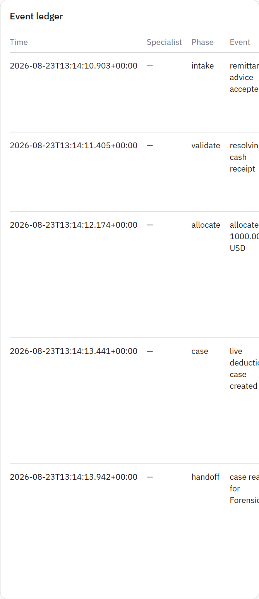
The activity trail. Each line is one step, with the records it used.
For a payment that completed successfully you should see, in order:
- The payment note was accepted
- The system looked for the incoming money
- An amount was applied to the invoice
- A case was created
- The case was passed to the deductions team
This trail is the audit record. Every line names the records it used, so any figure can be traced back to where it came from.

Step 6 — Clear the test data
When you have finished testing, clear the results so the next round starts from an empty screen.
- Go to the Memory page under Governance.
- Scroll to the box titled Cash application test data.
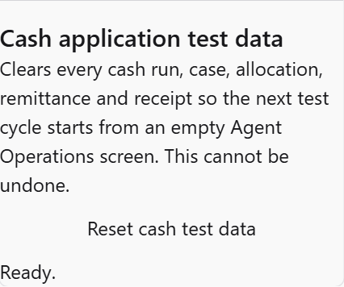
The reset control on the Memory page.
- Click Reset cash test data.
- You will be asked to confirm. Click Yes, remove it.
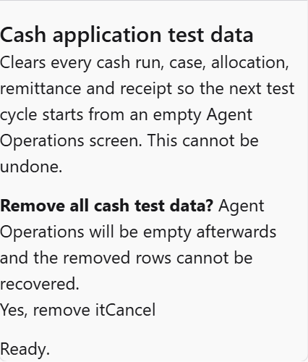
It asks once more before removing anything.
A message then tells you exactly what was removed, for example: “Removed 231 rows — 19 inbox, 22 receipts, 12 allocations …”.
Go back to Agent Operations. The list should be empty, all four counts should read zero, and the screen should say it is waiting for a payment note.
This cannot be undone
Everything from the test session is removed permanently. There is no recovery.
It only removes cash test data. It does not affect approvals or anything else on the Memory page.
Only use this on the demonstration system.

Quick reference

Is it working?
What you see | Verdict
A payment appears within a minute or so, marked Completed | Working
Customer name and all four times are filled in | Working
Short payment shows an amount with pence or cents | Working
A case reference is present | Working
The activity trail lists five steps in order | Working
A dash where a customer name or a time should be | Report it
An amount with no pence or cents, such as 250 | Report it
Needs attention is above zero | Someone should look
Nothing appears at all after several minutes | Report it

What this demonstration is not
A successful run here does not mean the system is ready to handle real customer money. Three things are still outstanding, and they are approvals rather than software.
- The confirmation that money arrived comes from a stand-in, not from the finance system. Every result is labelled accordingly.
- The rules used to categorise a deduction have not been formally signed off.
- The mailbox that receives customer payment notes has not been formally approved.
Until those are signed off by the finance, security and architecture owners, treat everything you see here as a demonstration of how the process will work — not as an approved financial outcome.

