Node JS

What is NodeJS ?
NodeJS is a JRE(Javascript Runtime Environment), It allows to run JS code outside the browser.
JavaScript was designed to run only inside browsers like Chrome or Firefox. NodeJS allows/enables Javascript-code to run on a server/outside browser(computer).

Core Technical Foundation
- V8 Engine: Node.js is built on Google Chrome's V8 engine, which compiles JavaScript directly into fast machine code.

Why nodejs used?
For each client(browser) request, server will return response (as html/js/json-for SPA). And server will perform Buisness logic in backround like Fetching data from DB, Authentication,.. to perfoming this logic Nodejs used

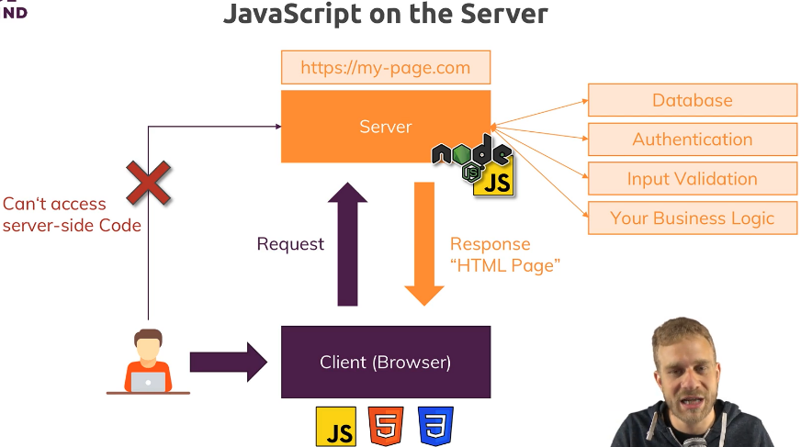

Running Nodejs code:
- Using Executive file: write code into file & execute, file will be saved & reusable
node filename.js
- Using R(read)E(evaluate)P(print)L(loop): in terminal just run node, we entered into node and we can perform REPL, it’s like a playground and files wont saved.

Creating Node-Server:

let http = require(“http”); //import http(request&responses) from http module, by using this
we will create server.
Function rqListener (req, res){
Console.log (req);
}
let server = http.createServer(rqListener); //whenever request comes to this server, this fn will be executed.

server.listen(3000); //whatever server doing, that will be listened/captured. Simply we
can say, it will make the server running as visible. 3000 – localhost port number.
Close/Quit the server, Inside rgListener fn process.exit();

Decoding the main-server function’s req&res
http.createServer((req, res) => { //req,res are objects.
//req
console.log(req.method, req.url, req.header); //what type of method(get,post,..)
//url of site
//header of that request [req header is like, <head> of html page – it contains heading/title of the req/site]

//res – for each req, we can set the response, like what will be return/response for that req
res.setHeader(“content-type”, “text/html”); // heading of this res, by using this we can easily understand, what is the work of this res
[in this we given heading as, we will return/response as text/html page]
res.write(“<html>”); //it will write inside the main html page
res.write(“<body><h1>hello</h1></body>”);
res.write(“</html>”);
res.end(); //end of the response, after this we cant set anything, res will be saved
})
TASK: Routing and Redirecting req

let fs = require(“fs”); // import fs moduleFileSystem
http.createServer((req, res) => {
if(req.url === ‘/’){ //if in homepage return a response as form
res.write(<html>);
res.write(<form action=‘/message’ method=‘POST’> <input type=‘text’> </form>);
res.write(</html>);
res.end();
}
//routed to ‘/message’

if(req.url === ‘/message’){ //if in ‘/message’ url write data in the file & redirect to homepage
fs.writeFileSync(“message.txt”, “Hi”); //write data – if file not there, create and write
res.setHeader(‘Location’, ‘/’); //redirect
res.end();
}
})

//Extract/Parse data from form & write in the file [abc]
if(req.url === ‘/message’){
let body = [];
req.on(‘data’, (chunk)=>{ //eventListener, whatever data there push into variable
body.push(chunk); //chunk 1 22 33
})
req.on(‘end’, ()=>{ //chunks are not human-readable, so convert that as readable
let parseBody = Buffer.concat(body).toString(); //parseBody abc
fs.writeFileSync(“message.txt”, parseBody);
})
}

