Intellectual Property

Acknowledging Copyright

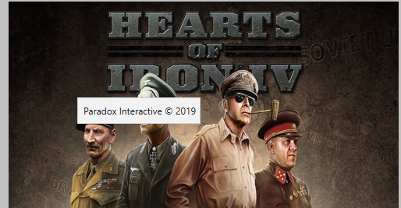Intellectual property relates to the copyright of any items that are present on the website. These items could be images, text, or videos. All the images that I have used are free from copyright, (open user created content) and all the text that I have used is from public sources, or I have received explicit permission to use content from its creators, and acknowledged the original owners This ensures my safety from any legal trouble.

Usability

Black text on a light background

White Text on a Dark background

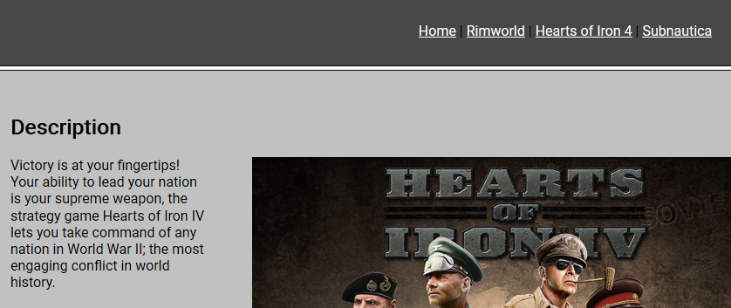

Usability relates to the user experience, and how easy the website is to use. I have addressed this implication by making sure that all the text in my website is easy to understand, and to read. Moreover I have placed the navigation bar in an obvious place, making navigating my website easy and effective.

Functionality

Functionality relates to how useful the website is in executing what it was designed to do. I have addressed this implication by ensuring that my website retains full functionality on a variety of web browsers. Moreover, all links that are present on the website are fully functional and links to other websites correctly. All of the images that are present on the website do not obscure any information that is present, and relate to the information ont the website.

Firefox

Chrome

Microsoft Edge

