Implications of My website

**Legal**

Did you avoid breaking copyright

Avoid breaking copyright is not using any images or text from other sources without crediting them and make that credit clear.

I am going to only use images from Pixabay and if I don’t I’m going to credit the image to the photographer. Pixabay provides copyright free pictures that are free to use.

These are all screen shots I took

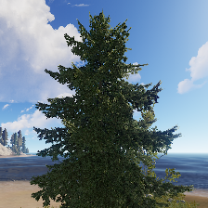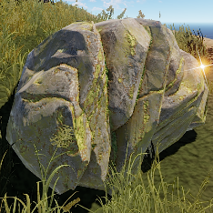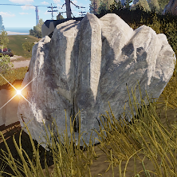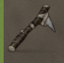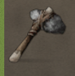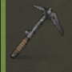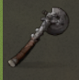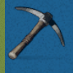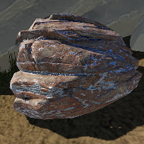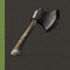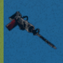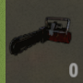

**Ethical**

Site avoids racist, sexists content

I will not display any content that dose not display racist or sexist views. This is to not offended and not to provide bad points of views for people. This would make the website able to be viewed by any person and they wont take offense to any thing on the website.

Rust is a game with a toxic community and I have not included anything about the comunity

**Usability**

Consistent look and feel for all pages

I am going to use a wire frame to keep the layout of each page the same. I am also going to use an colour pellet on this wire frame to make all of the page use the same colours. This will make all the page look about the same with different text

All pages are in the same layout (tree page just has more text)

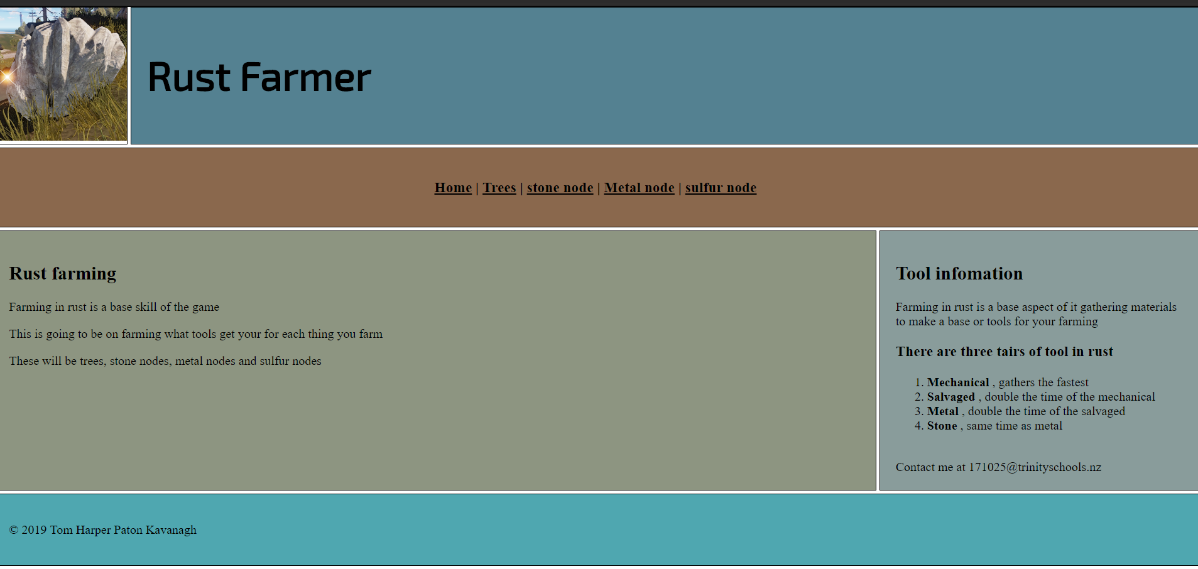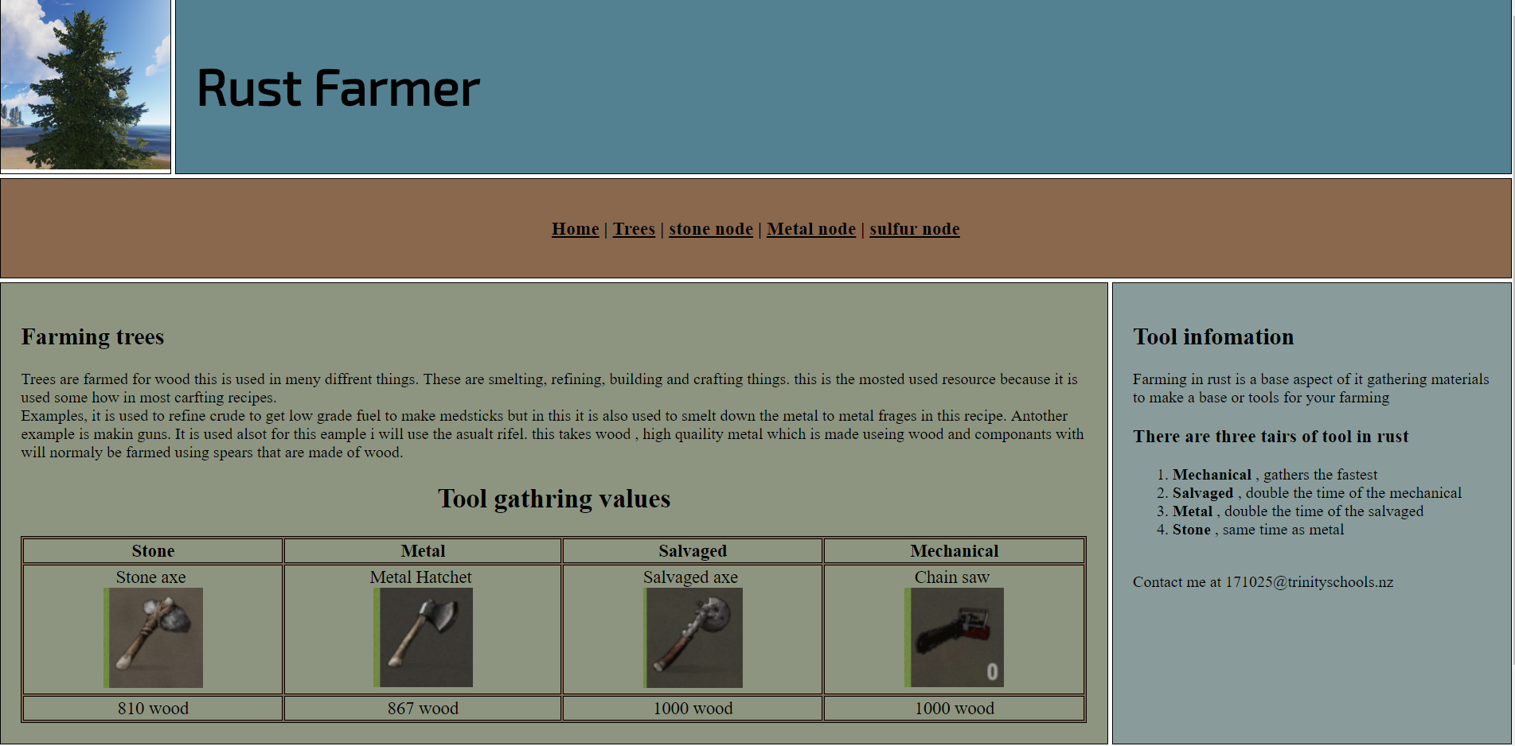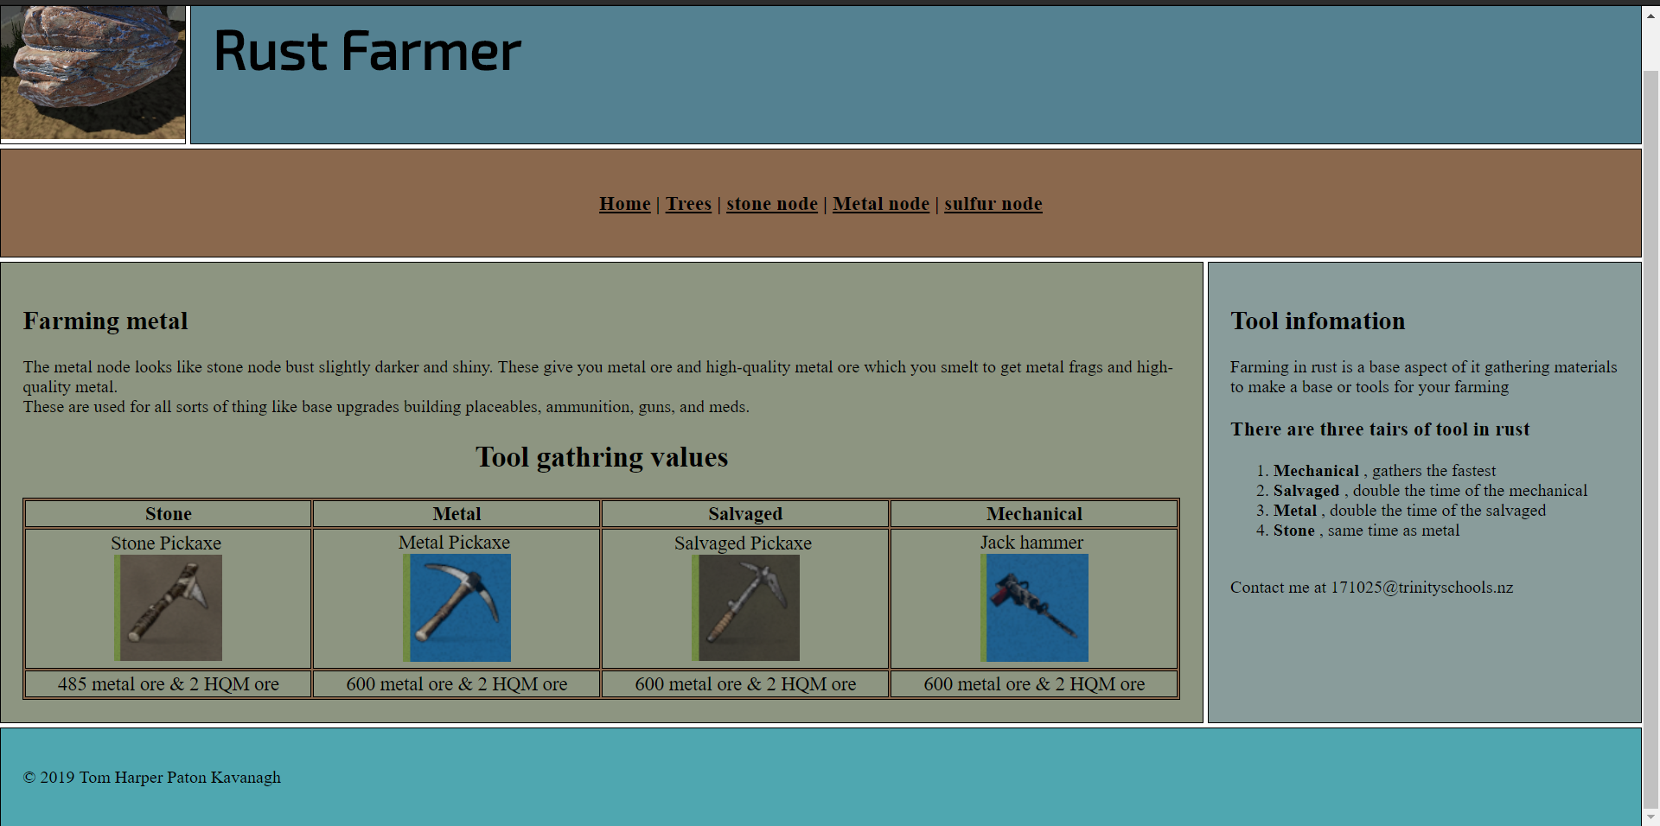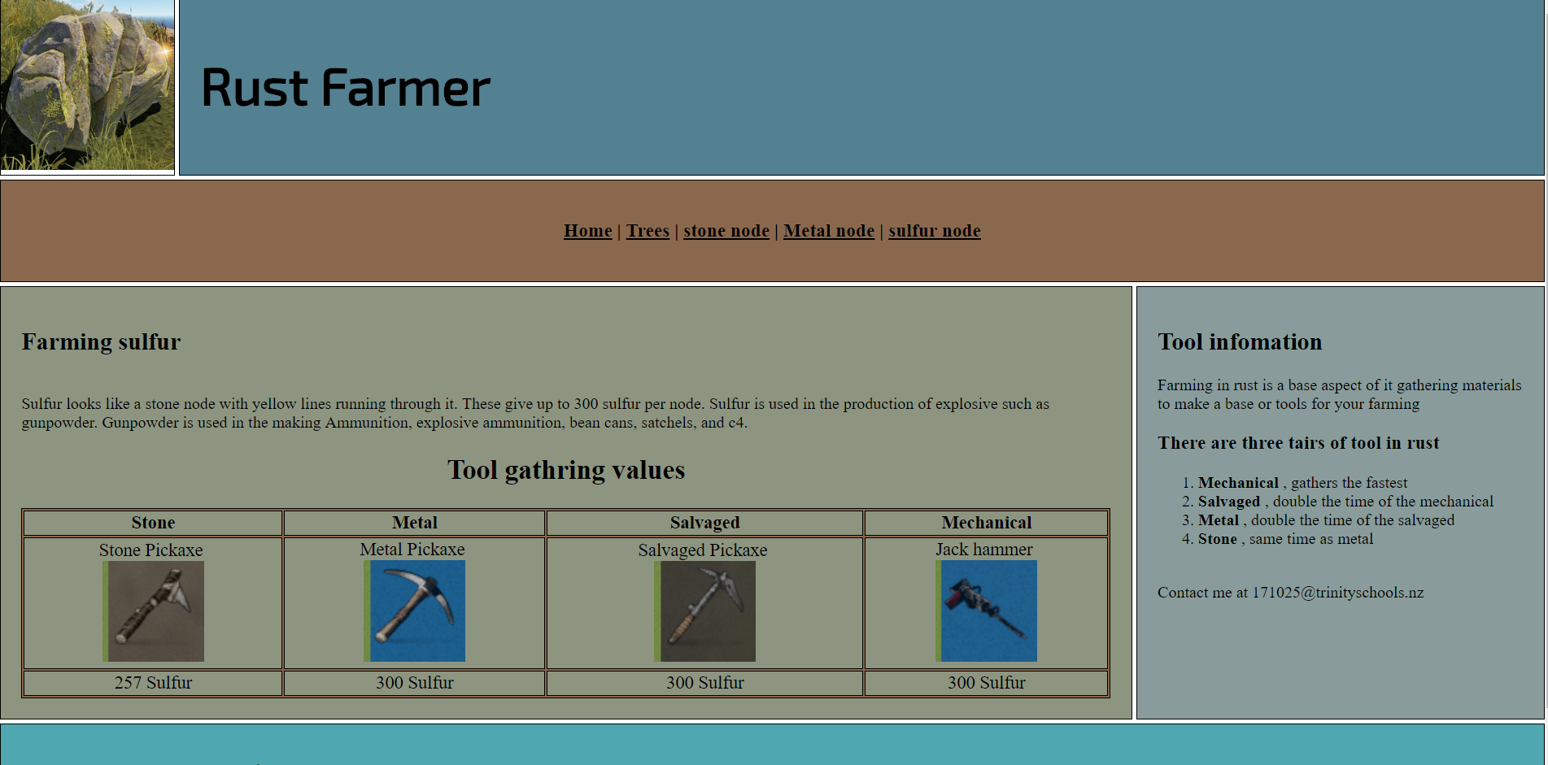

**Planning**

Ideas

rust skins

fortnite skins

Rust framing guide.