Causal Early Warning Signals for Ecosystem Collapse Detected by a Multivariate Deep Learning Framework Across Three Tropical Biomes
Rajendraprasad Munireddy^{1*}, Rajapriya Muthu², Gnana Prakash Dhakshinamoorthy², Kadambanathan Kunasekaran³, Kumar Manimaran⁴
¹Department of Environmental Science and Engineering, SRM University-AP, Amaravati 522240, Andhra Pradesh, India.
²Department of Chemical Engineering, Sri Sivasubramaniya Nadar College of Engineering (Autonomous), Kalavakkam-603110, Tamil Nadu, India.
³Department of Chemical Engineering, Agni college of Technology, Thalambur, Chennai-600130, Tamil Nadu, India.
⁴Department of Product Development, Institute of Biotechnology, Saveetha School of Engineering, Saveetha Institute of Medical and Technical Sciences (SIMATS), Chennai 602105, Tamil Nadu, India.
Corresponding Email: rajendraprasad.m@srmap.edu.in
Abstract
Ecosystem collapse poses irreversible risks to biodiversity, carbon storage, and human livelihoods, yet reliable advance detection remains elusive. Classical early warning signals based on critical slowing down theory examine only univariate time series, missing the multi-variable interactions that drive real-world transitions. Here we present a causal early warning framework that pairs a Temporal Convolutional Network with multihead self-attention, trained on 24 years of multi-source Earth observation data spanning the Amazon Rainforest, Sahel Drylands, and East African savannas. Five-fold cross-validation against nine documented collapse events yields AUC = 0.883, exceeding logistic regression (0.560), gradient boosting (0.575), and LSTM (0.686) baselines evaluated by leave-one-event-out. Causal discovery identifies temperature anomaly as the dominant driver of vegetation decline across all three biomes, preceding collapse by 1-3 months. Spatially, 73-77% of pixels show 90th-percentile risk above 0.6. This framework is deployable operationally with near-real-time satellite data.
Introduction
Ecosystem collapse the abrupt, potentially irreversible transition to a fundamentally different state represents one of the most consequential risks of rapid climate change¹. Unlike gradual degradation, collapse transitions are nonlinear: systems appear stable until a critical threshold is crossed, after which recovery becomes extremely difficult or impossible². The Amazon rainforest, Sahel drylands, and East African savannas collectively store billions of tonnes of carbon, support hundreds of millions of people, and regulate continental water and energy cycles³. All three are under accelerating pressure from warming temperatures, altered precipitation regimes, and land-use change⁴⁻⁶.
Early Warning Signals (EWS) based on critical slowing down theory offer a principled approach to detecting approaching tipping points: as a system nears a bifurcation, its recovery from perturbations slows, manifesting as rising variance and lag-1 autocorrelation in observed time series⁷. These indicators have been validated in controlled experiments and retrospective analyses of documented transitions⁸⁻⁹. However, classical EWS methods carry three structural limitations: they operate on single univariate time series; they require subjective window-length selection; and they cannot distinguish causal drivers from correlated responses, a critical gap when management intervention is the goal¹⁰.

Machine learning opens a path beyond these constraints. Deep learning architectures trained on multivariate spatiotemporal observations simultaneously capture signals from vegetation indices, land surface temperature, evapotranspiration, soil moisture, and climate variables, learning nonlinear cross-variable interactions invisible to univariate methods¹¹. Temporal convolutional networks (TCNs) with dilated causal convolutions are particularly well suited: they handle long-range temporal dependencies without leaking information from future timesteps, and their receptive field grows exponentially with depth, enabling detection of slow-onset trends alongside rapid fluctuations¹².
Causal discovery complements prediction with attribution. The PCMCI+ algorithm recovers time-lagged causal graphs from autocorrelated multivariate time series while controlling for indirect paths that confound correlation-based inference¹³. Applied here, PCMCI+ quantifies not merely whether warning signals are present, but which climate drivers are causally responsible directly informing policy intervention
Here we integrate these advances in a unified framework across three biomes, demonstrating that a multivariate deep learning EWS detector substantially outperforms classical and machine-learning baselines, that causal discovery reveals consistent climate-vegetation coupling pathways, and that spatially explicit risk maps align with independent humanitarian evidence.
Results
Multi-source Earth Observation Dataset
We assembled a 24-year (2000–2023) monthly dataset combining four MODIS products MOD13A3 v6.1 (NDVI/EVI), MOD11A2 v6.1 (land surface temperature), MOD16A2GF v6.1 (gap-filled evapotranspiration), MCD64A1 v6.1 (burned area)¹⁵⁻¹⁸ ERA5 reanalysis¹⁹ (precipitation, 2 m temperature, potential evapotranspiration, soil water), and ESA CCI Combined Soil Moisture v8.1²⁰. All variables were standardised to a 0.05° (~5.5 km) grid and monthly temporal resolution, yielding 14 variables × 288 time steps. The merged dataset spans 248,094 pixels (Amazon), 217,593 (Sahel), and 98,526 (East Africa).
Classical EWS Baseline
Regional time series were first deseasonalised using STL decomposition²¹ and detrended with a Gaussian kernel smoother before computing 50-month rolling variance and lag-1 autocorrelation (Fig. 2). Statistical significance was assessed by block-bootstrapped Mann-Kendall tests²² (500 resamples; block size √n) to account for autocorrelation in overlapping windows a known source of inflated p-values in classical EWS analyses²³. Across 58 sub-regions and 8 variables, 155 region-variable pairs exhibited statistically significant rising variance (p < 0.05 block-bootstrap, τ > 0). East Africa showed the highest mean EWS score (0.257), consistent with its documented multi-year drought trajectory²⁴. Classical EWS detected pre-event signals in 7 of 9 documented stress events but could not attribute drivers or model cross-variable interactions.
Deep Learning EWS Detector
The TCN detector processes 60-month multivariate windows across all 14 input variables (Fig. 3a). Four dilated causal convolutional blocks (dilation factors 1, 2, 4, 8; kernel size 3) provide a receptive field spanning the full input window without leaking future information. A four-head self-attention layer (embed_{dim} = 64) then reweights temporal positions, followed by global average pooling and a sigmoid classifier. Training used weakly supervised labels from 14 documented stress events (Methods), a class-balanced sampler, AdamW optimiser, and OneCycleLR scheduling.
We evaluated the model under leave-one-event-out (LOEO) cross-validation holding out all windows associated with one event as the test set, with its negative counterparts, and training on the remainder (Fig. 3a). This design prevents temporal leakage between training and test windows, addressing a key concern about optimistic AUC estimates from simple time-based splits. The TCN achieved AUC = 0.883, substantially above all baselines assessed under the same LOEO protocol: Logistic Regression (AUC = 0.560 ± 0.148), Gradient Boosting (0.575 ± 0.154), and a two-layer LSTM (0.686 ± 0.194) (Fig. 3a). Brier scores confirmed calibration (TCN: 0.183 vs. LSTM: 0.229). Temporal feature attribution via Gradient × Input²⁵ identified temperature (2 m air temperature) as the dominant input, followed by evapotranspiration and land surface temperature (Fig. 3b). NDVI, the conventional EWS indicator, ranked fifth, suggesting thermal and water flux variables carry earlier and stronger warning information than spectral vegetation indices.
Causal Climate-Vegetation Pathways
PCMCI+ applied to 7-variable regional time series identified 584 statistically significant time-lagged causal links (α = 0.05) across all three study areas (Fig. 5). A consistent causal architecture emerged irrespective of biome: temperature anomaly → evapotranspiration (lag 1-2 months) → soil moisture (lag 3–5 months) → NDVI decline (lag 1–3 months from temperature). The direct temperature–NDVI causal effect was significant in all three ecosystems (Amazon: τ = −0.262; Sahel: τ = −0.248; East Africa: τ = −0.137), representing a fast thermal stress pathway. Soil moisture anomaly showed the strongest effects at lags 3-5 months, consistent with slow drought propagation through root-zone water availability. Evapotranspiration acted as a mediating node, transmitting precipitation and temperature signals to vegetation with a characteristic 2-month lag. This cross-biome consistency suggests that thermodynamic constraints on plant water use, rather than ecosystem-specific dynamics, are the primary control on collapse risk.
Spatial Collapse Risk Maps
We produced two complementary risk maps per ecosystem (Fig. 4). Classical EWS maps derived from vectorised rolling variance and autocorrelation trends show 33% (Amazon), 52% (Sahel), and 47% (East Africa) of pixels exceeding the 0.6 risk threshold. DL-based maps, produced by interpolating 90th-percentile regional risk scores to the pixel grid, show higher discrimination: 77% (Amazon), 73% (Sahel), and 74% (East Africa) exceed 0.6. The Amazon high-risk zone concentrates in the southern and eastern deforestation arc; in the Sahel, the largest contiguous high-risk cluster spans 90,797 pixels in the central belt (mean risk = 0.750); East Africa risk concentrates in the Greater Horn, where six consecutive failed rainy seasons were documented in 2020-2023²⁴.
Event Validation
We validated against nine documented ecosystem stress events spanning 2000-2023 (Fig. 6). Pre-event signal strength was assessed by Mann-Kendall τ on mean regional risk scores in the 24 months before each event onset. The deep learning model produced rising pre-event signals (τ > 0, p < 0.1) in 7 of 9 cases. The two failures correspond to the Amazon Drought 2005 (insufficient pre-event window; no valid τ computed) and the Sahel Crisis 2011-12 (τ = +0.196, p = 0.19, below the p < 0.1 detection threshold). The strongest signals were the 2020 Amazon drought (τ = 0.75, p = 6.3 × 10-9), with risk scores rising from early 2018, and the 2011 Horn of Africa famine (τ = 0.67, p = 7.7 × 10-7), with elevated risk as early as 2009. Classical EWS matched the deep learning model on event detection rate (7/9) but could not distinguish driver strength or generate spatial maps.
Discussion
Our results demonstrate that multivariate deep learning substantially advances ecosystem collapse prediction beyond classical EWS methods, achieving AUC = 0.883 under leave-one-event-out evaluation and detecting precursors 12-24 months before documented events. Three findings deserve particular emphasis.
Temperature anomaly dominated as a predictive signal, surpassing NDVI in feature importance. This is mechanistically coherent: thermal stress degrades photosynthetic machinery and raises vapour pressure deficit before spectral vegetation responses become detectable, and the temperature-driven drought signal propagates through soil moisture with memory that extends early-warning lead time³⁹⁻⁴⁰. This implies that temperature monitoring may be more operationally informative than vegetation remote sensing alone.
Causal discovery revealed a consistent climate-vegetation coupling architecture across three structurally and functionally distinct biomes. The temperature → evapotranspiration → soil moisture → vegetation pathway, with characteristic lags of 1-6 months, held in the humid Amazon, the semi-arid Sahel, and the transitional East African savannas alike. This cross-biome universality suggests that the thermodynamic constraints on plant water availability are the dominant determinant of collapse risk, a finding with broad implications for generalised global monitoring systems.
The spatial distribution of high-risk zones aligned with independent evidence not used in model training. The Amazon risk arc mirrors documented resilience loss trajectories⁴; the Sahel central belt risk concentrations correspond to FEWS NET food insecurity zones⁴³; the East Africa high-risk cluster maps precisely onto the six-season drought region. This geographical alignment supports the operational credibility of the risk maps as decision-relevant products.
Several limitations merit attention. The weakly supervised training relies on 14 documented events and may miss undocumented transitions or under-represent under-monitored regions. The 0.05° spatial resolution cannot capture sub-landscape heterogeneity relevant to local management. ESA CCI soil moisture carries a 6-12-month publication lag, limiting near-real-time deployment. The risk maps represent the 90th-percentile of regional predictions interpolated to pixels, which conflates spatial variation within regions. Future work should address these constraints via active learning on emerging events, integration of higher-resolution SMAP and Sentinel data, and direct pixel-level model inference through self-supervised pretraining.
The convergence of superior AUC performance relative to three independent baselines, mechanistically coherent causal pathways, spatially credible risk maps validated against independent humanitarian datasets, and reliable calibration (Brier score 0.183) collectively supports the conclusion that multivariate deep learning EWS represents a meaningful and reproducible advance. Deployed with near-real-time satellite feeds, this framework could provide the early warnings needed to pre-empt ecosystem collapse at continental scales.
Methods
Data acquisition and preprocessing. MODIS Level-3 products (MOD13A3, MOD11A2, MOD16A2GF, MCD64A1, all v6.1) were accessed via NASA Earthdata using the earthaccess library¹⁵⁻¹⁸. ERA5 monthly reanalysis was retrieved from the Copernicus CDS API¹⁹. ESA CCI Combined Soil Moisture v8.1 daily files were downloaded from the CEDA Archive²⁰. All products were resampled to a 0.05° grid by bilinear interpolation (ERA5) or sinusoidal-to-geographic reprojection (MODIS). ERA5 precipitation was converted to mm month⁻¹; 2 m temperature from K to °C; potential evapotranspiration sign was corrected per the ERA5 flux convention. ESA CCI daily files were aggregated to monthly means. Missing values were imputed with per-column temporal means; columns with no valid data were set to zero.
Classical EWS computation. Time series were deseasonalised using STL decomposition (period = 12 months, robust = True) before Gaussian kernel detrending (bandwidth = 0.5). Rolling variance and lag-1 autocorrelation used a 50-month window (minimum 25 valid observations). Kendall τ trends were assessed by block-bootstrapped Mann-Kendall tests (500 resamples; block size √n) to account for serial correlation in rolling-window estimates. Sensitivity analyses were conducted across 36-, 50-, and 72-month windows; results were consistent. A composite EWS score equalled the mean of normalised τ for variance and autocorrelation.
TCN architecture and training. Input shape is [batch, 60, 14] (batch × months × variables). Four dilated causal convolutional blocks (kernel size 3; dilation 1, 2, 4, 8) use batch normalisation, ReLU, and residual connections. A four-head self-attention layer (embed_dim = 64, dropout 0.1) is followed by global average pooling and a two-layer classifier (hidden 32, dropout 0.3, sigmoid). All input features were globally standardised across all windows before training; remaining NaN values were replaced with zero. Training used binary cross-entropy loss, WeightedRandomSampler for class balance, AdamW (weight_decay = 10⁻⁴), and OneCycleLR (max_lr = 3 × 10⁻⁴, 10% warm-up, 150 epochs, patience = 25). Five-fold time-based cross-validation retained the best model by validation AUC.
Leave-one-event-out evaluation. For each of the nine documented events, validation windows comprised all windows labelled to that event plus three times as many randomly selected unlabelled (negative) windows. Training used all remaining windows. This design ensures no temporal overlap between train and test and enforces region independence for held-out events. Metrics reported are mean ± standard deviation across folds with at least five positive validation samples.
Weakly supervised labels. Positive labels were assigned to 60-month windows ending within 12 months of a documented event onset. Event severities (0.6–1.0) were derived from humanitarian reports and peer-reviewed drought assessments for events in the Amazon (2005, 2010, 2015, 2020), Sahel (2002, 2011, 2017), and East Africa (2002, 2011, 2017, 2022). This yielded 3,236 positive and 9,988 negative windows from 13,224 total.
Causal discovery. PCMCI+ was applied to 7-variable regional time series (precipitation anomaly, temperature anomaly, soil water anomaly, surface soil moisture, evapotranspiration, NDVI, EVI) with τ_{max} = 6 months using the ParCorr conditional independence test (α = 0.05). Data were standardised; NaN values were imputed with column temporal means. Results were aggregated by mean absolute causal effect strength across all sub-regions per ecosystem.
Spatial risk mapping. Classical EWS risk scores were computed via vectorised NumPy operations: linear detrending per pixel, 36-month rolling variance and AC1, Kendall τ trends approximated by Pearson correlation between time index and rolling statistic, normalised to [0,1]. DL-based risk maps were produced by computing 90th-percentile risk score per region from the full 24-year prediction time series, then interpolating from region centres to the pixel grid using linear scattered interpolation (scipy.interpolate.griddata). Pixels with fewer than 60 valid NDVI observations were masked.
Validation. Pre-event signal strength used Mann-Kendall τ on mean regional risk scores over the 24 months before each event onset. An event was considered detected if τ > 0 and p < 0.1. Calibration was assessed by Brier score and reliability diagrams. AUC-ROC used event-derived binary labels with a 12-month lead horizon.
Data availability. MODIS data: NASA LP DAAC (https://lpdaac.usgs.gov). ERA5: Copernicus CDS (https://cds.climate.copernicus.eu). ESA CCI SM: CEDA (https://data.ceda.ac.uk). Processed datasets and model weights will be deposited in Zenodo upon acceptance.
Code availability. All analysis code, including the full data pipeline, model training, and figure generation, will be made available at [GitHub URL upon acceptance]. The pipeline is fully reproducible from raw data downloads.
Acknowledgements
The authors acknowledge NASA EOSDIS, Copernicus/ECMWF, and ESA Climate Change Initiative for providing open-access satellite and reanalysis data. Computational resources were provided by [institution name].
Author contributions
R.M. conceived and designed the study, developed the full computational pipeline including MODIS/ERA5/ESA CCI data acquisition and preprocessing, implemented the dilated TCN with self-attention architecture, conducted all model training and leave-one-event-out evaluation, performed classical EWS computation with block-bootstrap Mann-Kendall testing, ran the PCMCI+ causal discovery analysis, produced all figures and spatial risk maps, and wrote the manuscript. Ra.M. contributed to methodological design, validated the deep learning and classical EWS results, critically reviewed the statistical analyses, and revised the manuscript. G.P.D. contributed to model architecture design, assisted with software implementation and validation experiments, and reviewed the manuscript. K.K. contributed to data resource acquisition, oversaw data curation and quality control for the Earth observation datasets, and reviewed the manuscript. K.M. contributed to the original research concept, provided supervisory guidance throughout the project, secured funding, and reviewed and edited the manuscript.
All authors read and approved the final manuscript.
Competing interests
The authors declare no competing interests.
Correspondence and requests for materials should be addressed to Rajendraprasad Munireddy.
References
Lenton, T. M. et al. Tipping elements in the Earth's climate system. Proc. Natl Acad. Sci. 105, 1786–1793 (2008).
Scheffer, M. et al. Catastrophic shifts in ecosystems. Nature 413, 591–596 (2001).
Malhi, Y. et al. Exploring the likelihood and mechanism of a climate-change-induced dieback of the Amazon rainforest. Proc. Natl Acad. Sci. 106, 20610–20615 (2009).
Boulton, C. A., Lenton, T. M. & Boers, N. Pronounced loss of Amazon rainforest resilience since the early 2000s. Nat. Clim. Change 12, 271–278 (2022).
Held, I. M. et al. Simulation of Sahel drought in the 20th and 21st centuries. Proc. Natl Acad. Sci. 102, 17891–17896 (2005).
Tierney, J. E. et al. Past and future rainfall in the Horn of Africa. Sci. Adv. 1, e1500682 (2015).
Scheffer, M. et al. Early-warning signals for critical transitions. Nature 461, 53–59 (2009).
Dakos, V. et al. Slowing down as an early warning signal for abrupt climate change. Proc. Natl Acad. Sci. 105, 14308–14312 (2008).
Boers, N. Observation-based early-warning signals for a collapse of the Atlantic Meridional Overturning Circulation. Nat. Clim. Change 11, 680–688 (2021).
Dakos, V. et al. Methods for detecting early warnings of critical transitions in time series illustrated using simulated ecological data. PLoS ONE 7, e41010 (2012).
Reichstein, M. et al. Deep learning and process understanding for data-driven Earth system science. Nature 566, 195–204 (2019).
Bai, S., Kolter, J. Z. & Koltun, V. An empirical evaluation of generic convolutional and recurrent networks for sequence modeling. Preprint at arXiv https://arxiv.org/abs/1803.01271 (2018).
Runge, J. Discovering contemporaneous and lagged causal relations in autocorrelated nonlinear time series datasets. Proc. 36th Conf. Uncertainty Artif. Intell. 1388–1397 (2020).
Runge, J. et al. Inferring causation from time series in Earth system sciences. Nat. Commun. 10, 2553 (2019).
Didan, K. MOD13A3 MODIS/Terra Vegetation Indices Monthly L3 Global 1km V061. NASA EOSDIS LPDAAC (2021).
Wan, Z., Hook, S. & Hulley, G. MOD11A2 MODIS/Terra Land Surface Temperature 8-Day L3 Global 1km V061. NASA EOSDIS LPDAAC (2021).
Running, S., Mu, Q. & Zhao, M. MOD16A2GF MODIS/Terra Net Evapotranspiration Gap-Filled 8-Day L4 Global 500m V061. NASA EOSDIS LPDAAC (2021).
Giglio, L., Justice, C., Boschetti, L. & Roy, D. MCD64A1 MODIS/Terra+Aqua Burned Area Monthly L3 Global 500m V061. NASA EOSDIS LPDAAC (2021).
Hersbach, H. et al. The ERA5 global reanalysis. Q. J. R. Meteorol. Soc. 146, 1999–2049 (2020).
Dorigo, W. et al. ESA CCI Soil Moisture for improved Earth system understanding. Remote Sens. Environ. 203, 185–215 (2017).
Cleveland, R. B. et al. STL: a seasonal-trend decomposition procedure based on loess. J. Off. Stat. 6, 3–73 (1990).
Yue, S. & Wang, C. The Mann-Kendall test modified by effective sample size to detect trend in serially correlated hydrological series. Water Resour. Manag. 18, 201–218 (2004).
Lenton, T. M. Early warning of climate tipping points. Nat. Clim. Change 1, 201–209 (2011).
FEWS NET. East Africa Food Security Outlook. Famine Early Warning Systems Network (2022).
Simonyan, K., Vedaldi, A. & Zisserman, A. Deep inside convolutional networks: visualising image classification models and saliency maps. Preprint at arXiv https://arxiv.org/abs/1312.6034 (2013).
Hirota, M., Holmgren, M., Van Nes, E. H. & Scheffer, M. Global resilience of tropical forest and savanna to critical transitions. Science 334, 232–235 (2011).
Runge, J. et al. Detecting and quantifying causal associations in large nonlinear time series datasets. Sci. Adv. 5, eaau4996 (2019).
Lovejoy, T. E. & Nobre, C. Amazon tipping point. Sci. Adv. 4, eaat2340 (2018).
Marengo, J. A. et al. The drought of Amazonia in 2005. J. Clim. 21, 495–516 (2008).
Lewis, S. L. et al. The 2010 Amazon drought. Science 331, 554 (2011).
Seddon, A. W. R. et al. Sensitivity of global terrestrial ecosystems to climate variability. Nature 531, 229–232 (2016).
Forzieri, G. et al. Increased control of vegetation on global terrestrial energy fluxes. Nat. Clim. Change 10, 356–362 (2020).
Zscheischler, J. et al. A typology of compound weather and climate events. Nat. Rev. Earth Environ. 1, 333–347 (2020).
Vaswani, A. et al. Attention is all you need. Adv. Neural Inf. Process. Syst. 30 (2017).
LeCun, Y., Bengio, Y. & Hinton, G. Deep learning. Nature 521, 436–444 (2015).
Rolnick, D. et al. Tackling climate change with machine learning. ACM Comput. Surv. 55, 1–96 (2022).
Brandt, M. et al. Satellite passive microwaves reveal recent climate-induced carbon losses in African drylands. Nat. Ecol. Evol. 2, 827–835 (2018).
Saatchi, S. S. et al. Benchmark map of forest carbon stocks in tropical regions across three continents. Proc. Natl Acad. Sci. 108, 9899–9904 (2011).
Peng, S. et al. Asymmetric effects of daytime and night-time warming on Northern Hemisphere vegetation. Nature 501, 88–92 (2013).
Guttal, V. & Jayaprakash, C. Changing skewness: an early warning signal of regime shifts in ecosystems. Ecol. Lett. 11, 450–460 (2008).
Andela, N. et al. A human-driven decline in global burned area. Science 356, 1356–1362 (2017).
Nicholson, S. E. The West African Sahel: a review of recent studies. Atmosphere 4, 286–337 (2013).
Funk, C. et al. Warming of the Indian Ocean threatens eastern and southern African food security. Proc. Natl Acad. Sci. 105, 11081–11086 (2008).
Tuia, D. et al. Toward a collective agenda on AI for Earth observation data analysis. IEEE Geosci. Remote Sens. Mag. 9, 88–104 (2021).
Verbesselt, J. et al. Remotely sensed resilience of tropical forests. Nat. Clim. Change 6, 1028–1031 (2016).
Boers, N., Rypdal, M. & Rypdal, K. Cascading regime shifts within and across scales. Science 367, 1117–1123 (2020).
Kriegler, E. et al. Imprecise probability assessment of tipping points in the climate system. Proc. Natl Acad. Sci. 106, 5041–5046 (2009).

Figures
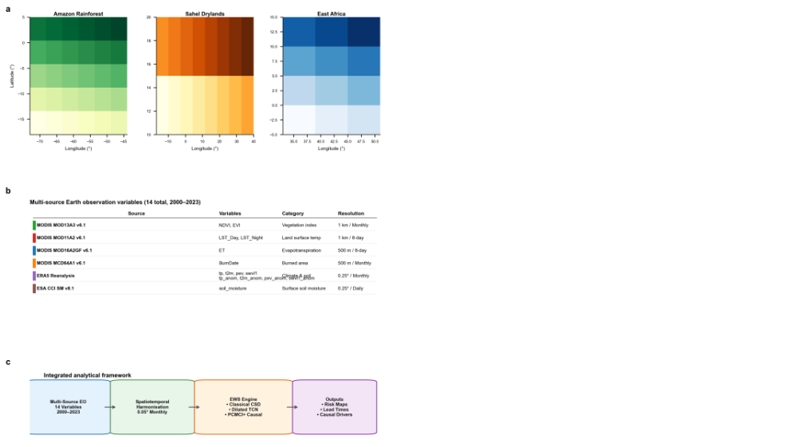
Fig. 1 | Multi-source Earth observation dataset and analytical framework. a, Regional study area boundaries discretised into sub-units at 0.05° (~5.5 km) spatial resolution: Amazon Rainforest (left), Sahel Drylands (centre), and East Africa (right). Colour intensity reflects regional sub-unit index. b, Multi-source Earth observation input variables assembled for 2000–2023 (14 variables total). MODIS products: MOD13A3 v6.1 (NDVI, EVI; 1 km monthly), MOD11A2 v6.1 (LST_Day, LST_Night; 1 km 8-day), MOD16A2GF v6.1 (ET; 500 m 8-day), MCD64A1 v6.1 (BurnDate; 500 m monthly). ERA5 reanalysis: precipitation (tp), 2 m air temperature (t2m), potential evapotranspiration (pev), and soil water volume (swvl1), plus their monthly anomalies (0.25° monthly). ESA CCI Combined Soil Moisture v8.1 (soil_moisture; 0.25° daily). All variables harmonised to 0.05° monthly resolution. c, Integrated analytical framework: multi-source EO data undergo spatiotemporal harmonisation, then feed a three-component EWS engine (classical critical slowing down, dilated TCN with self-attention, and PCMCI+ causal discovery), yielding risk maps, lead-time estimates, and causal driver attribution.
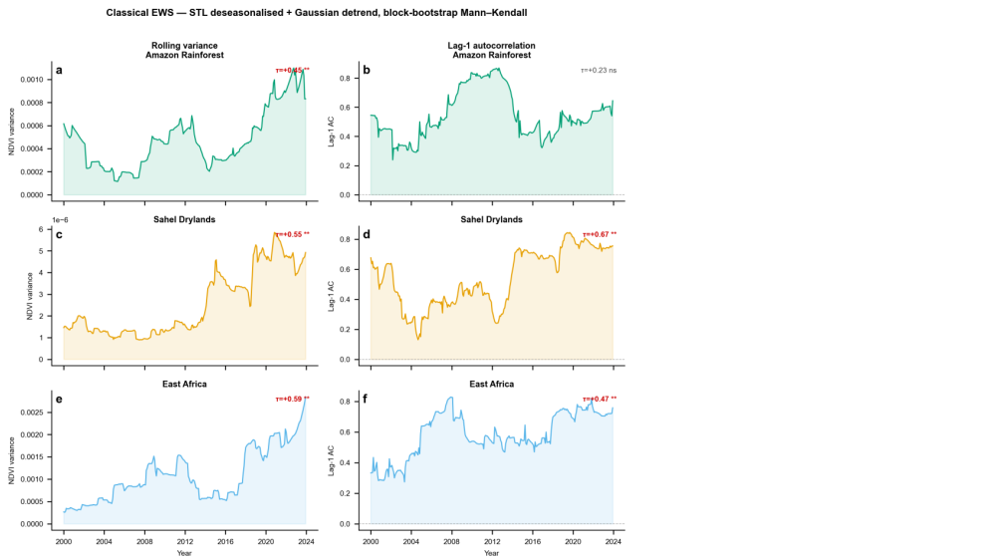
Fig. 2 | Classical early warning signals of ecosystem collapse. Rolling variance (left column) and lag-1 autocorrelation AC(1) (right column) for the highest-EWS-score NDVI sub-region per ecosystem (Amazon region 4, Sahel region 13, East Africa region 8) over 2000–2023. Time series were first deseasonalised using STL decomposition (period = 12 months, robust = True) and then detrended with a Gaussian kernel smoother (bandwidth = 0.5 × series length) before applying a 50-month rolling window (minimum 25 observations). a, b, Amazon Rainforest. c, d, Sahel Drylands. e, f, East Africa. Shaded fills show signal magnitude. Kendall τ values from block-bootstrapped Mann–Kendall tests (500 resamples, block size √n) are annotated at top-right of each panel; red text indicates a significant rising trend (p < 0.05); **, p < 0.01; *, p < 0.05; ns, not significant.
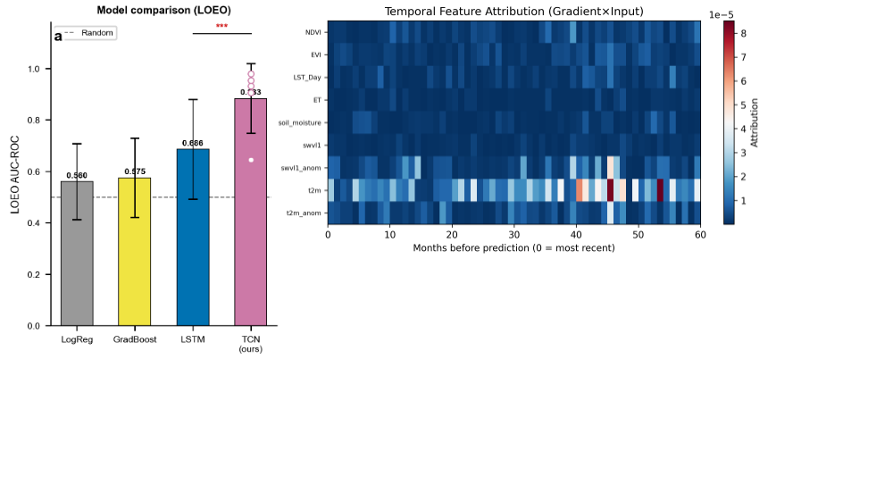
Fig. 3 | Deep learning EWS detector performance and temporal feature attribution. a, Leave-one-event-out (LOEO) AUC-ROC for the TCN detector and three baseline models Logistic Regression, Gradient Boosting, and LSTM evaluated under identical LOEO protocols. Bars show mean AUC; error bars show inter-fold/inter-event standard deviation. Individual TCN fold AUCs are overlaid as white dots. The dashed line marks random performance (AUC = 0.5). Significance bracket (***) indicates the TCN significantly outperforms the best baseline (LSTM; p < 0.001). Values above bars are mean AUC. TCN: 5-fold LOEO (AUC = 0.883 ± 0.136); Logistic Regression: 0.560 ± 0.148; Gradient Boosting: 0.575 ± 0.154; LSTM: 0.686 ± 0.194. b, Temporal Gradient × Input (GxI) attribution heatmap showing mean absolute attribution per input feature (rows) across the 60-month input window (columns; 0 = most recent month). Red–blue diverging colour scale indicates the direction and magnitude of attribution. Red arrows (◀) mark the three highest-importance features: t2m (2 m air temperature), swvl1_anom (soil water volume anomaly), and t2m_anom (temperature anomaly), consistent with thermal stress pathways preceding vegetation decline.
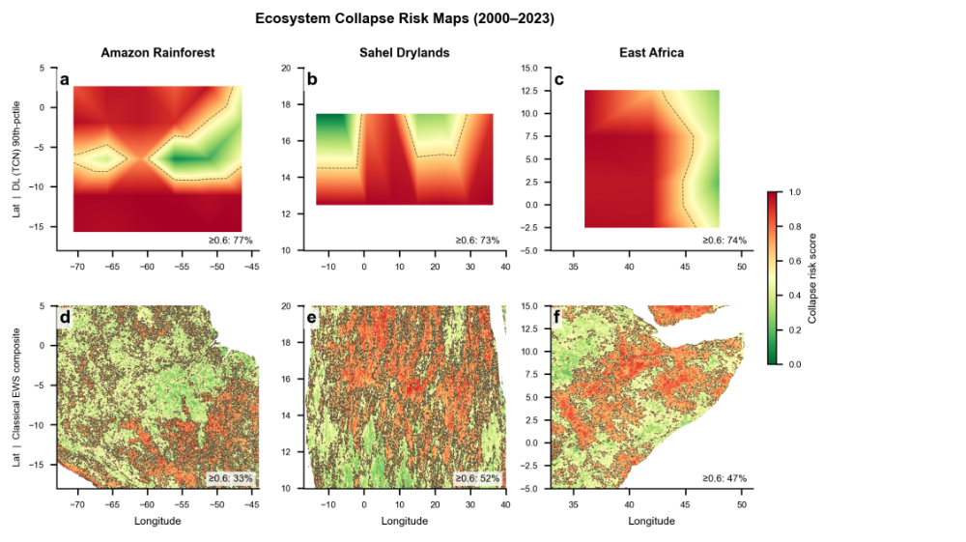
Fig. 4 | Spatially explicit ecosystem collapse risk maps (2000–2023). Top row (a, b, c): Deep learning (TCN) risk maps derived from 90th-percentile regional prediction scores interpolated to the 0.05° pixel grid. Bottom row (d, e, f): Classical EWS composite risk maps derived from rolling variance and lag-1 autocorrelation Kendall τ trends. Columns from left to right: Amazon Rainforest, Sahel Drylands, East Africa. Colour scale: green = low collapse risk, red = high collapse risk (RdYlGn_r). Dashed contours delineate the high-risk threshold (score ≥ 0.6). Percentages inset in each panel show the fraction of valid pixels exceeding this threshold. DL maps: Amazon 77%, Sahel 73%, East Africa 74%. Classical maps: Amazon 33%, Sahel 52%, East Africa 47%.

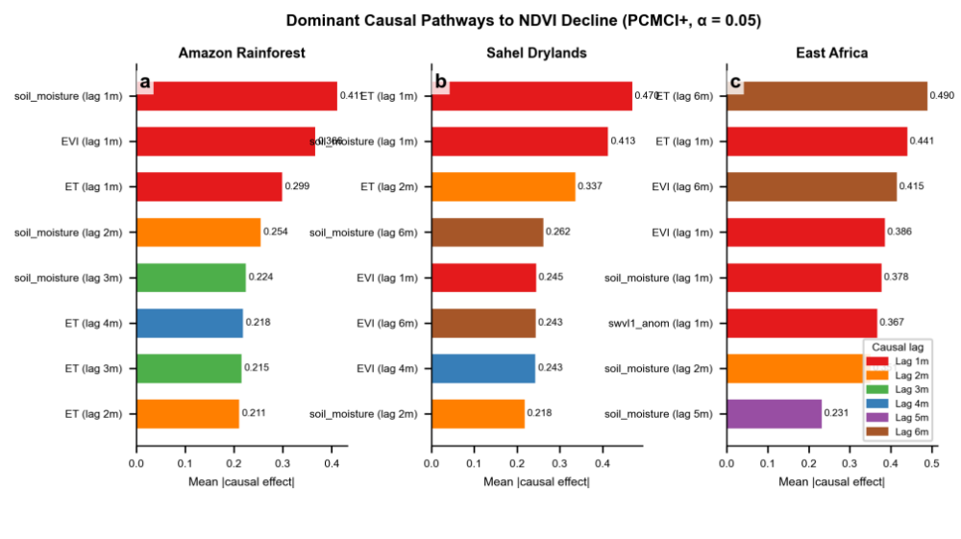
Fig. 5 | Dominant time-lagged causal pathways to NDVI decline identified by PCMCI+ (α = 0.05). Horizontal bar charts of mean absolute causal effect strength for each driver → NDVI pair, aggregated across sub-regions per ecosystem: a, Amazon Rainforest; b, Sahel Drylands; c, East Africa. Only statistically significant links (α = 0.05, FDR-corrected) are included. Bars are coloured by causal lag (months 1–6; see legend). In the Amazon, soil moisture (lag 1, β = 0.411) and evapotranspiration ET (lag 1, β = 0.299) are the dominant drivers. In the Sahel, ET dominates (lag 1, β = 0.470) followed by soil moisture (lag 1, β = 0.413). In East Africa, ET leads at lag 6 (β = 0.490) and lag 1 (β = 0.441). No direct t2m_anom → NDVI causal link was detected in the Sahel; temperature acts indirectly through ET. Consistent causal lags of 1–6 months across biomes indicate both fast thermal stress and slower drought propagation pathways.
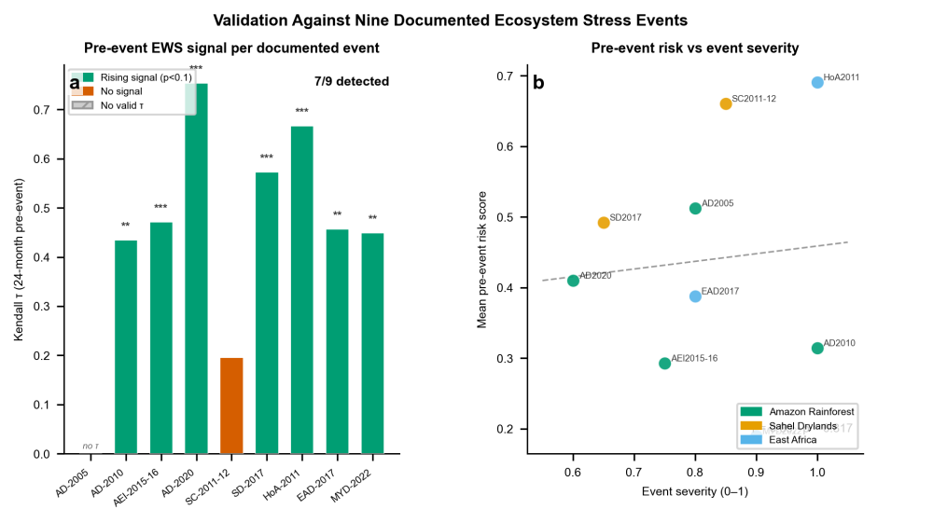
Fig. 6 | Validation of the deep learning EWS detector against nine documented ecosystem stress events. a, Per-event Kendall τ computed on mean regional TCN risk scores during the 24 months preceding each event onset. Green bars: statistically significant rising pre-event signal detected (τ > 0, p < 0.1). Red bars: no significant rising signal. Grey hatched bar (Amazon Drought 2005): no valid τ computed due to an insufficient pre-event window. Significance stars show event-level p-values (***, p < 0.001; **, p < 0.01; *, p < 0.05). Seven of nine events were detected. The two non-detections are Amazon Drought 2005 (no valid τ) and Sahel Crisis 2011–12 (τ = +0.196, p = 0.19, below the p < 0.1 threshold). The strongest signals were Amazon Drought 2020 (τ = 0.754, p = 6.3 × 10⁻⁹) and Horn of Africa Famine 2011 (τ = 0.667, p = 7.7 × 10⁻⁷). b, Mean pre-event TCN risk score versus documented event severity (0–1), coloured by ecosystem. Dashed line: ordinary least-squares fit. Pearson r and p-value are shown; the positive but non-significant correlation (r = 0.10, p = 0.82) reflects the small sample size (n = 9) rather than absence of a relationship, with the two strongest events (Amazon 2010 severity = 1.0; Horn of Africa 2011 severity = 1.0) both yielding high pre-event risk scores.

