**IST 659 – Quiz 2**

Q1: What is the Maximum and Minimum price of the Computers?

**Query**

select max(Price) 'Maximum Price'

from Computer;

select min(Price) 'Minimum Price'

from Computer;

**Result**

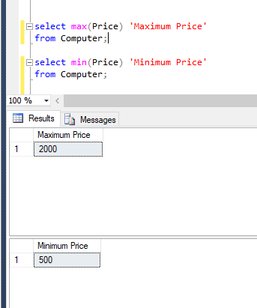

Q2: Count the number of computers in each type of manufactured item (HP, Dell, Lenovo).

Show item_manuf and number of computers, the result should be presented in ascending order of the number of computers.

**Query**

select item_manuf, count(i.Item_ID) 'Number of Computers'

from Item i

Left Join Computer c on i.Item_ID = c.Item_ID

group by Item_Manuf

order by count(i.Item_ID);

**Result**

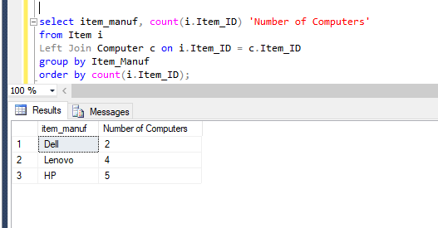

Q3: Show all the users who have computer loans that were returned before 2015-04-12.

Your results should include user_FName, user_LName, Email, comp_id, loan start_date, and Date_Returned.

**Query**

select u.User_FName, u.User_LName, u.Email, l.Comp_ID, l.Start_Date, l.Date_Returned

from LOAN l

left Join Users u ON l.User_ID = u.User_ID

where l.Date_Returned < '2015-04-12';

**Result**

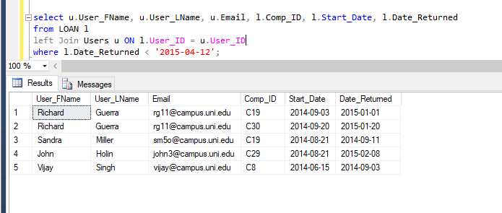

Q4: Show the details of the users who have not made any computer loans

**Query**

select u.*

from Users u

left join Loan l On u.User_ID = l.User_ID

Where l.User_ID IS NULL;

**Result**

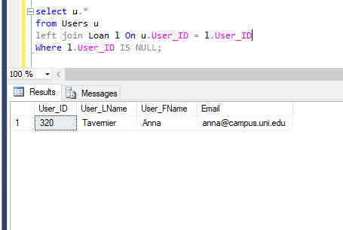

Q5: Show the total number of computers in each building and the average prices of those computers. Return the Loc_Bldg, the number of computers, average prices

**Query**

select lo.Loc_Bldg, count(c.Item_ID) 'Number of Computers', avg(Price) 'Average Price'

from Computer c

Left Join Location lo on c.Location_ID = lo.Location_ID

group by lo.Loc_Bldg;

**Result**

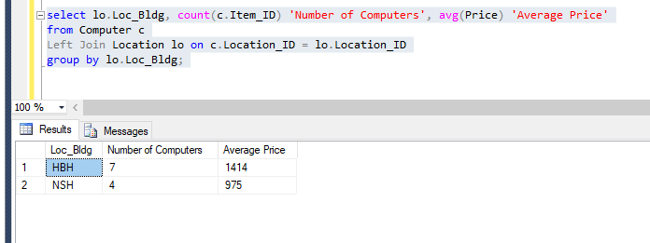

Q6: Which computer model is loaned for less than 4 times (<4)? Show the Item_Model and the total number of loans of that computer model

**Query**

select Item_Model, count(l.Comp_ID) 'Number of Loans'

from Item i

Inner Join Computer c on i.Item_ID = c.Item_ID

Inner Join Loan l on c.Comp_ID = l.Comp_ID

group by Item_Model

Having count(l.Comp_ID)< 4;

**Result**

