Task 2: Data Cleaning & Missing Value Handling

Dataset: Medical Appointment No Shows

1. Objective
The objective of this task is to perform data cleaning and handle missing values in the Medical Appointment No Shows dataset using Python. Proper data preprocessing improves data quality and ensures accurate analysis and machine learning outcomes.

2. Tools & Technologies Used
- Programming Language: Python
- Libraries:
  - Pandas
  - NumPy
  - Matplotlib
  - Seaborn
- Platform: Google Colab / Jupyter Noteboo

3. Dataset Description

The Medical Appointment No Shows dataset contains information about medical appointments in Brazil and whether patients showed up for their appointments.
The dataset includes attributes such as:
- PatientId
- AppointmentID
- Gender
- Age
- ScheduledDay
- AppointmentDay
- Neighbourhood
- Scholarship
- Hypertension
- Diabetes
- Alcoholism
- Handcap
- SMS_received
- No-show

4. Initial Data Exploration
The dataset was loaded using Pandas and explored using functions such as:
- .head() to view sample records
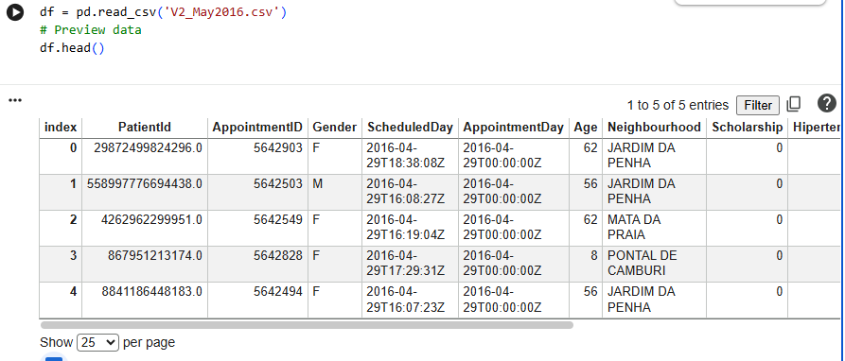
- .info() to understand data types
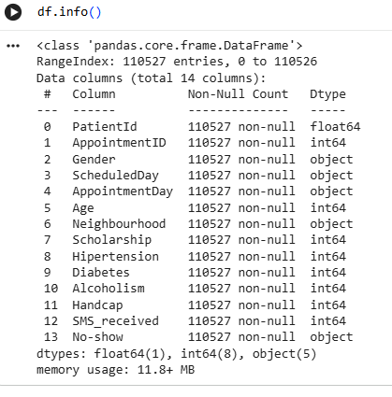
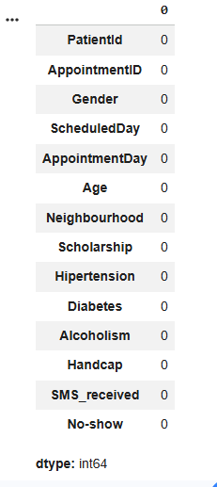
- .describe() to summarize numerical attributes

This step helped in understanding the structure and size of the dataset.

5. Identification of Missing Values
Missing values were identified using the isnull().sum() function.
A bar chart was used to visually represent missing values across columns.
Observation:
The dataset contained very few missing values, but data validation was still necessary to ensure data quality.
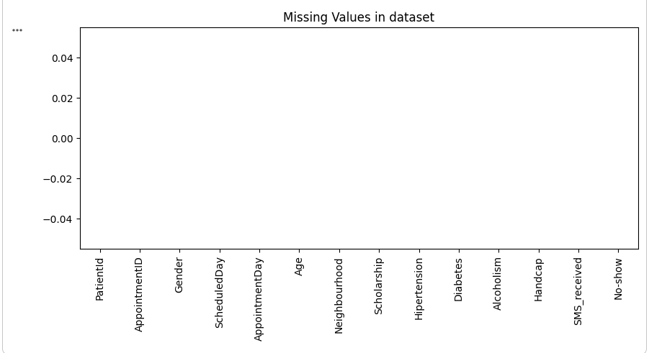

6. Data Cleaning Steps Performed

6.1 Handling Missing Values
- Numerical columns were filled using median imputation to avoid the influence of outliers.
- Categorical columns were filled using mode imputation, as it represents the most frequent category.

6.2 Correction of Invalid Data
- Records with negative age values were removed as they are logically incorrect.
- Date columns such as ScheduledDay and AppointmentDay were converted to proper datetime format.

6.3 Removal of Columns with High Missing Values
Columns with more than 50% missing values were removed.
In this dataset, no such columns were found, but the step was applied as a validation measure.

7. Dataset Validation After Cleaning
After completing the cleaning process:
- The dataset was rechecked for missing values.
- The dataset shape was compared before and after cleaning to ensure consistency.
- Summary statistics were generated to confirm data quality.\
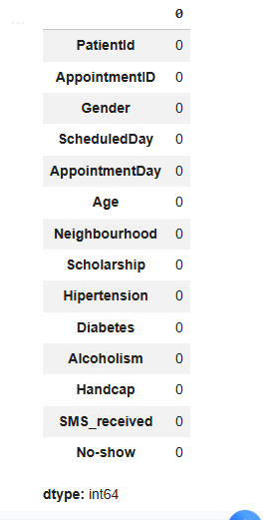
8. Data Visualization
Basic visualizations were created:
- Bar chart for missing value distribution
- Count plot for appointment no-show status
These visualizations helped verify the effectiveness of data cleaning.

9. Final Outcome
- All missing values were successfully handled.
- Invalid records were removed.
- Dataset quality was improved and prepared for further analysis or machine learning tasks.
- A cleaned dataset was saved as medical_appointments_cleaned.csv.
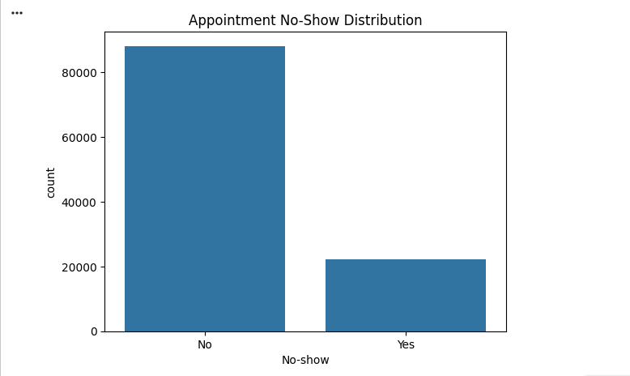

10. Conclusion
Data cleaning is a crucial step in data preprocessing. By handling missing values, correcting invalid data, and validating the dataset, the Medical Appointment No Shows dataset was transformed into a reliable and analysis-ready format.

Pp

