**Experiment N0.4**

**R-Load**

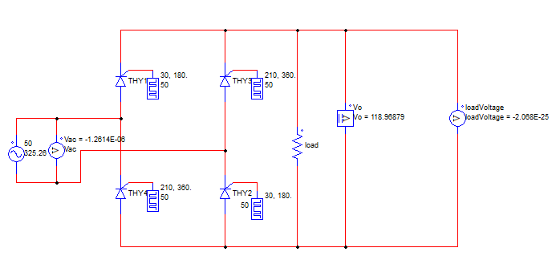Circuit Diagram:

Waveforms:

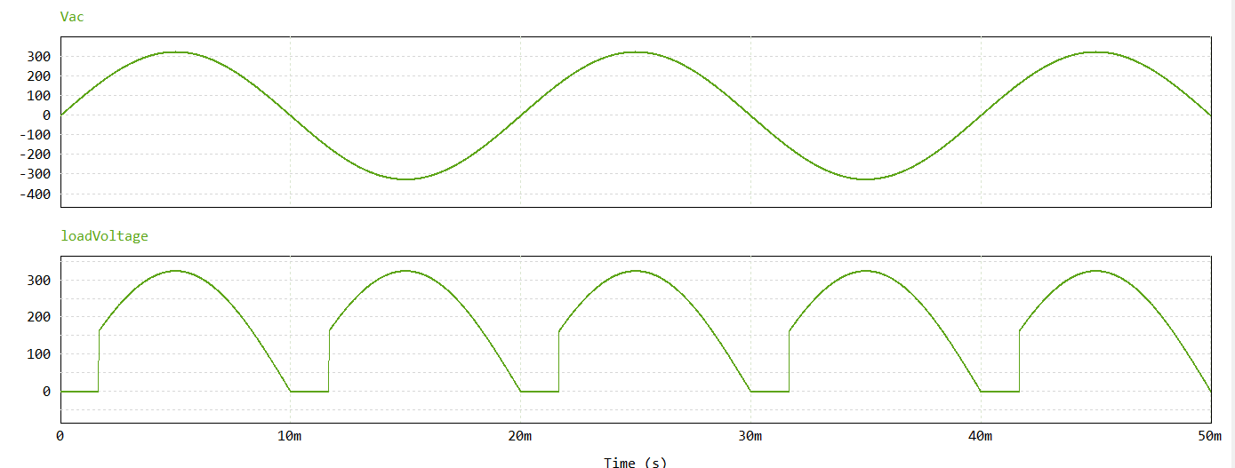 Firing angle : 30 degree

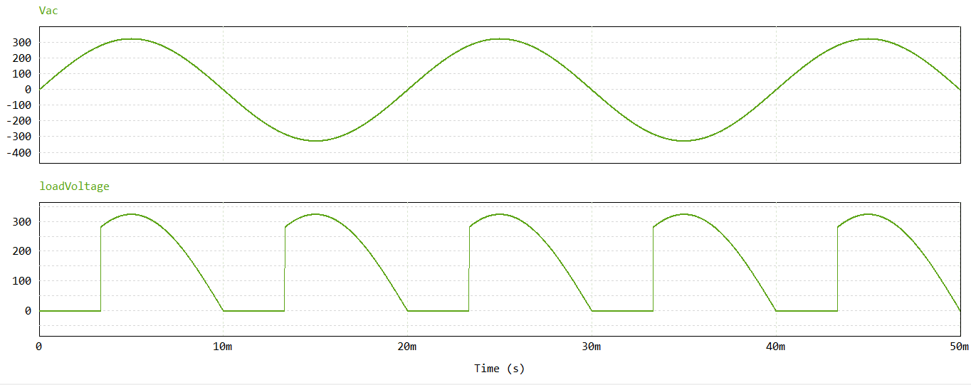Firing angle : 60 degree

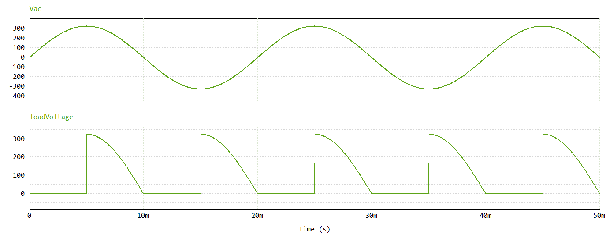Firing angle : 90 degree

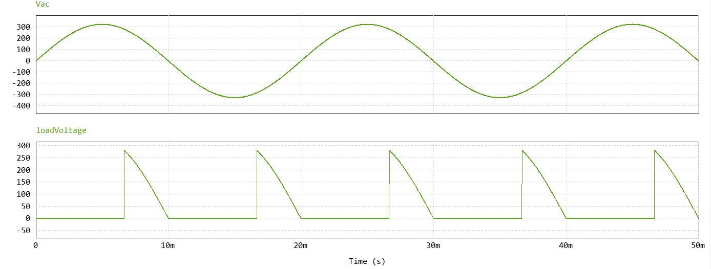Firing angle : 120 degree

**RL-Load**

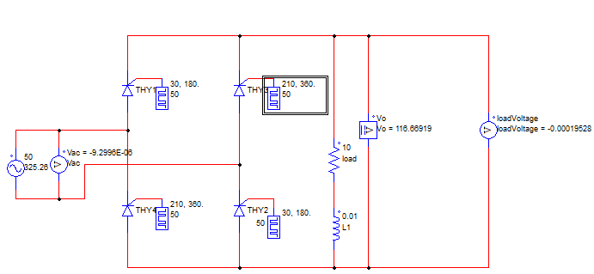Circuit Diagram:

Waveforms:

Firing angle : 30 degree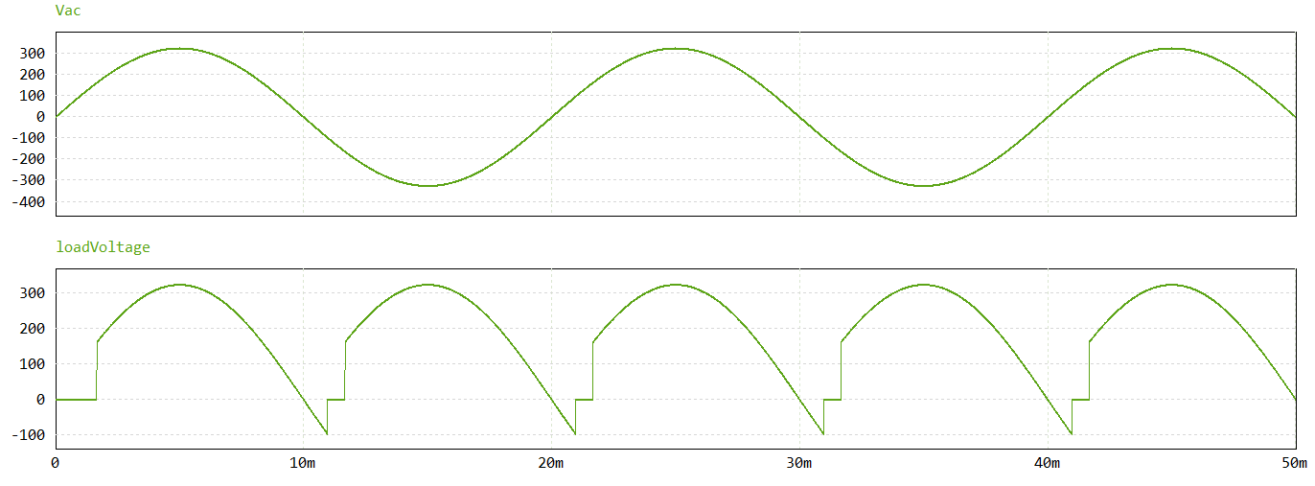

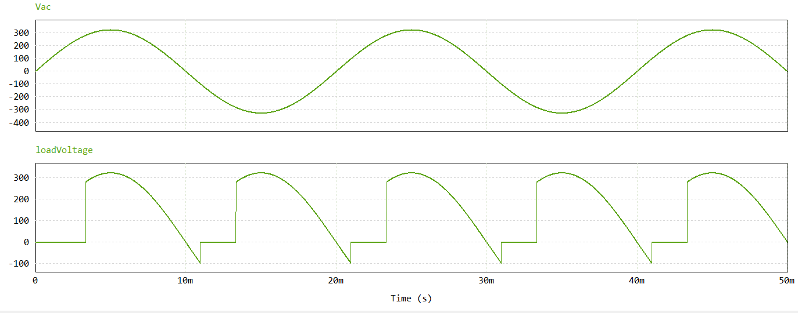Firing angle: 60 degree

Firing angle: 90 degree

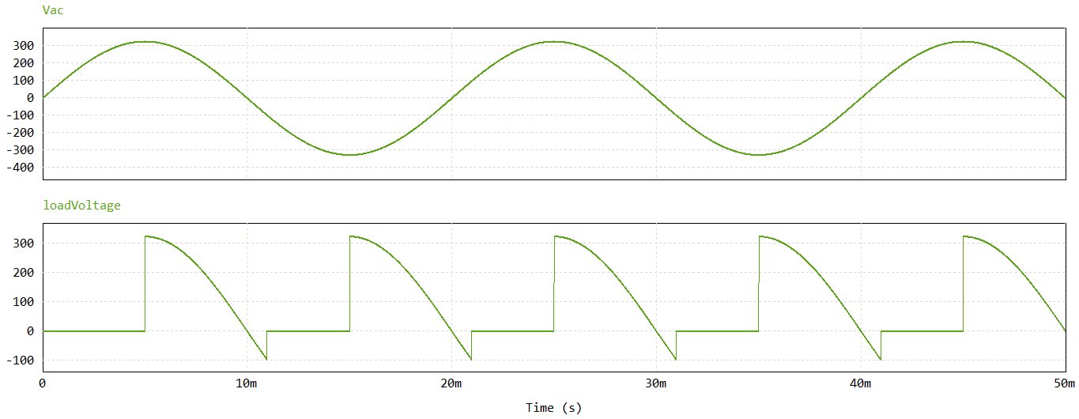

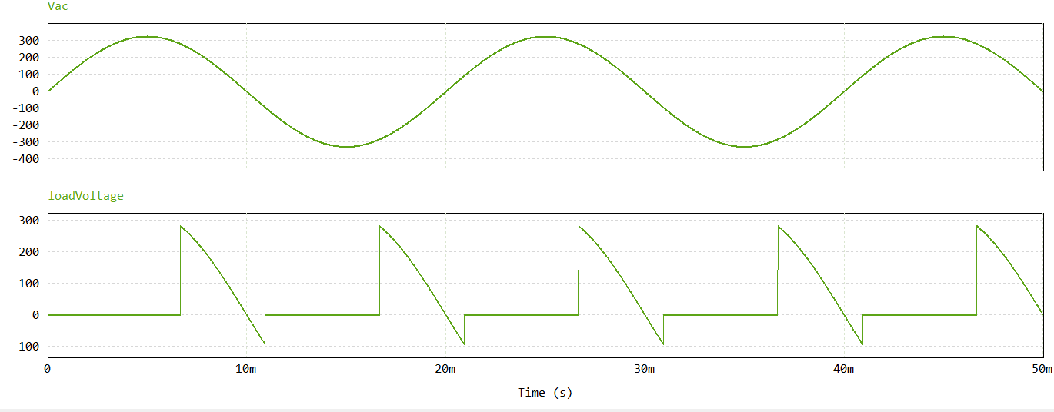Firing angle : 120 degree

**RL Load with Free Wheeling Diode**

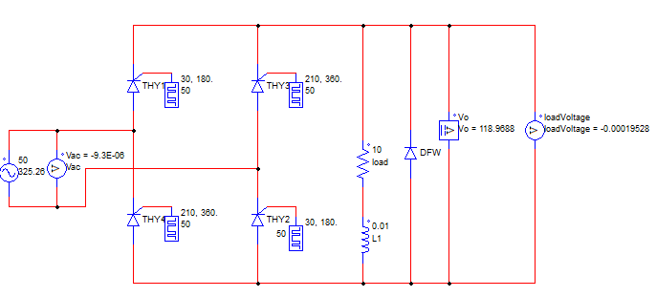Circuit Diagram:

Waveforms:

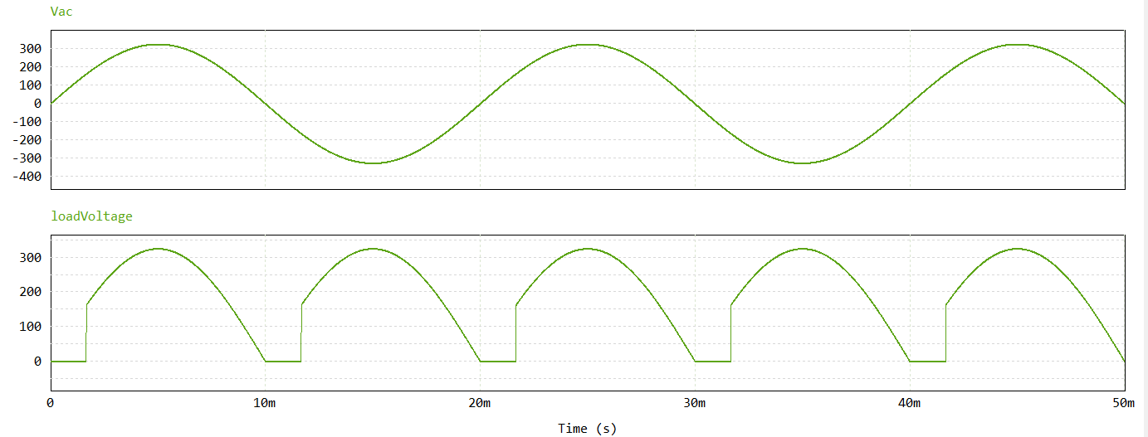Firing angle: 30 degree

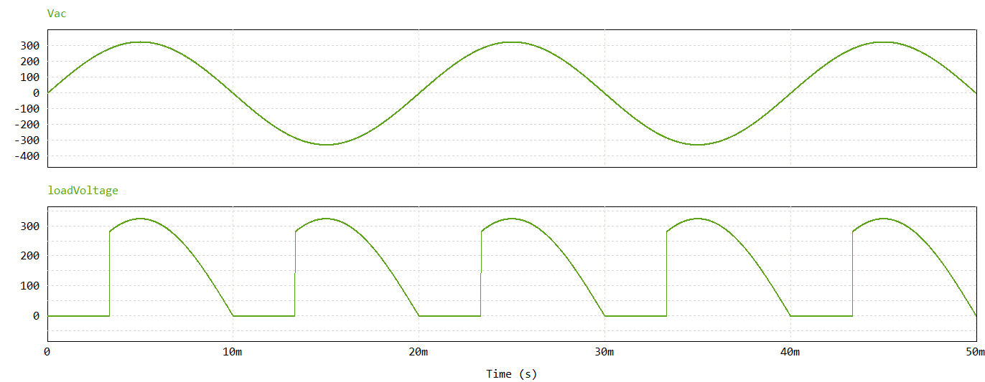Firing angle: 60 degree

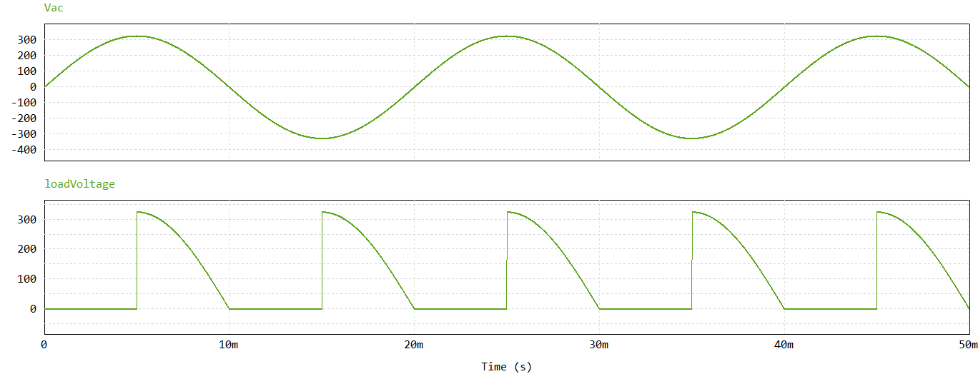Firing angle : 90 degree

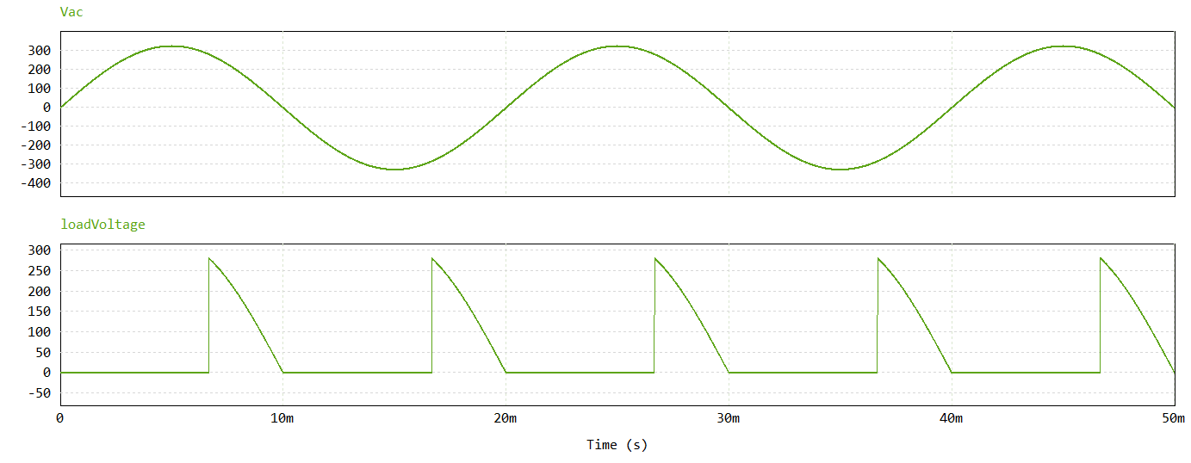Firing angle : 120 degree