COMPUTER NETWORKS
LABORATORY

ASSIGNMENT 2

NAME: Abhishek Rathod
ENR. NO. : 17114004 BATCH: CS1

Q.1) Write a socket program in C to connect two nodes on a network to communicate with each other, where one socket listens on a particular port at an IP, while other socket reaches out to the other to form a connection.

Algorithms :- One socket listens on a particular port at an IP(IPv4 type used here), while other socket reaches out to the other to form a connection with the first socket. Server corresponds to the listener socket while client reaches out to the server.
Created two C files. One for the server and another for the client socket. Connected them using TCP protocol and IPv4 address.

Screenshots :-
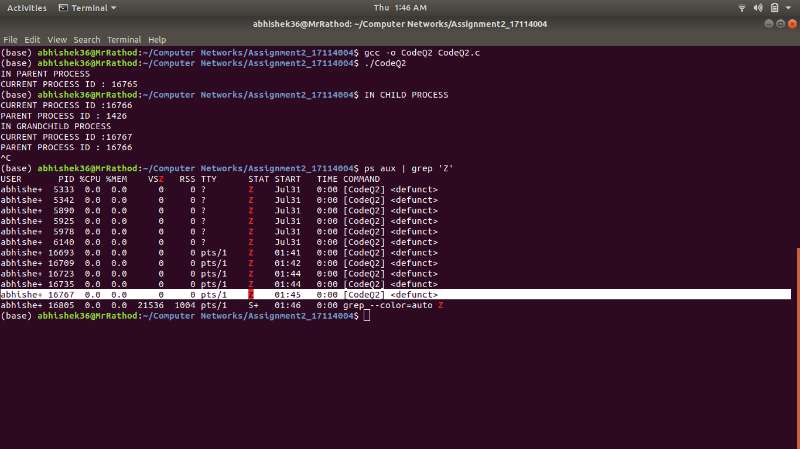

Data structures used :-

1) Socket -
Socket creation:
sockfd: socket descriptor, an integer
struct sockaddr_in : structure to store internet addresses like IP address, port.

Bind:
int bind(int sockfd, const struct sockaddr *addr, socklen_t addrlen);
bind function binds the socket to the address and port number specified in addr.

Listen:
int listen(int sockfd, int backlog);
It puts the server socket in a passive mode, where it waits for the client to approach the server to make a connection. The backlog, defines the maximum length to which the queue of pending connections for sockfd may grow.

Accept:
int new_socket= accept(int sockfd, struct sockaddr *addr, socklen_t *addrlen);
It extracts the first connection request on the queue of pending connections for the listening socket, sockfd, creates a new connected socket, and returns a new file descriptor referring to that socket.

2) Client -

Socket connection:
same as that of server’s socket creation

Connect:
int connect(int sockfd, const struct sockaddr *addr, socklen_t addrlen);
The connect() system call connects the socket referred to by the file descriptor sockfd to the address specified by addr. Server’s address and port is specified in addr.

Question 2: Write a C program to demonstrate both Zombie and Orphan process.

Algorithm used:- Created a parent process and a child process and then a grandchild process. The parent process exits and child process becomes orphan then the grandchild process exits and child process keeps running, which makes grandchild process a zombie process.
The parent id of orphan process changes to the pid of init process.

Screenshots-
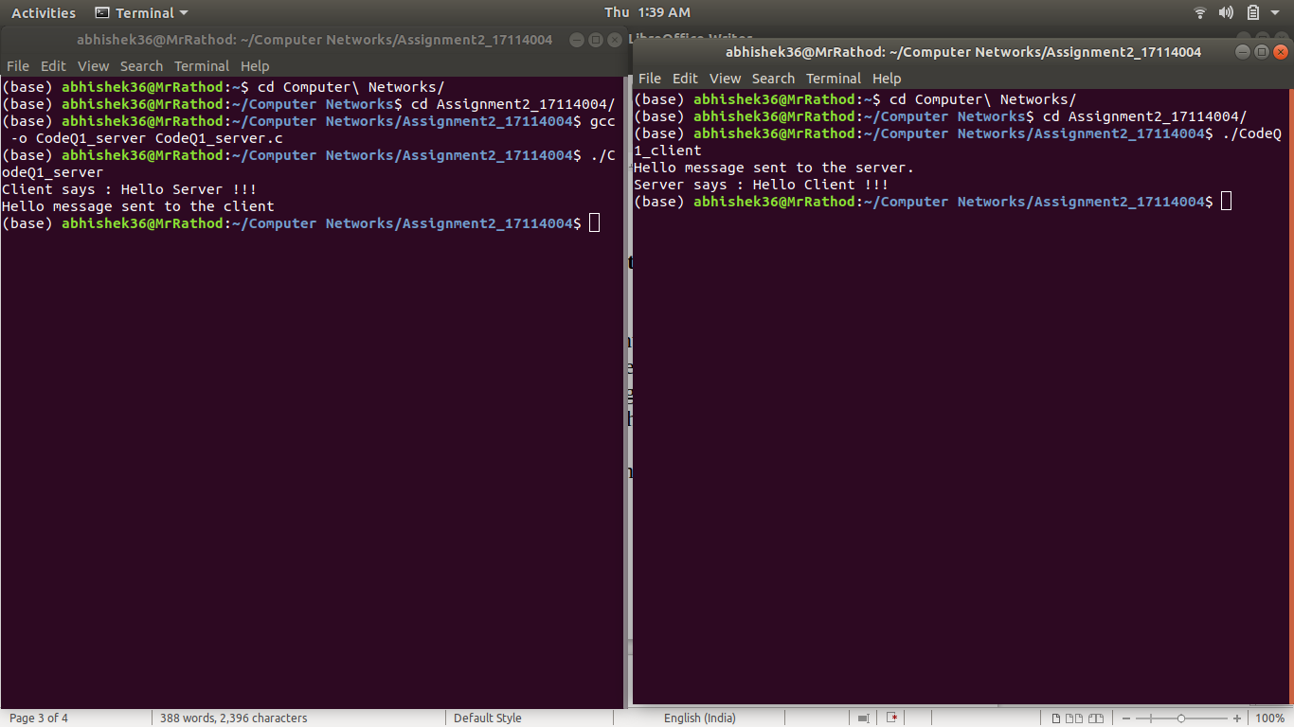

Data structures used : No data structures used.

