COMPUTER NETWORKS
LABORATORY

ASSIGNMENT 4

NAME: Abhishek Rathod
ENR. NO. : 17114004 BATCH: CS1

Q.1) Write a Network Simulator (NS2) code to simulate a three node network with duplex links among them as shown in figure. Show the topology using NAM. Study the variation in number of packets dropped with the variation of the queue size in the nodes and with the variation of the bandwidth of the links.

Algorithms :- In the given architecture, i have sent the messages from the node1 to node3 through node2. So the number of packets dropped in between depends on two things i.e., the queue length of the links and the bandwidth in between them. So, as we increase the queue length of the link 2-3 keeping the queue length of link 1-2 as constant, the number of drops are decreasing. Also, while we are changing the bandwidth of the link 2-3, the number of drops will be affected. On increasing the bandwidth of the link keeping the queue length constant (3 in this case), the number of drops must decrease.
For this, I made a python script file, in which we will run the tcl file and take the input from the use for queue lengths and bandwidths, and then by reading the trace files will generate the graphs accordingly, using matplotlib library of python.

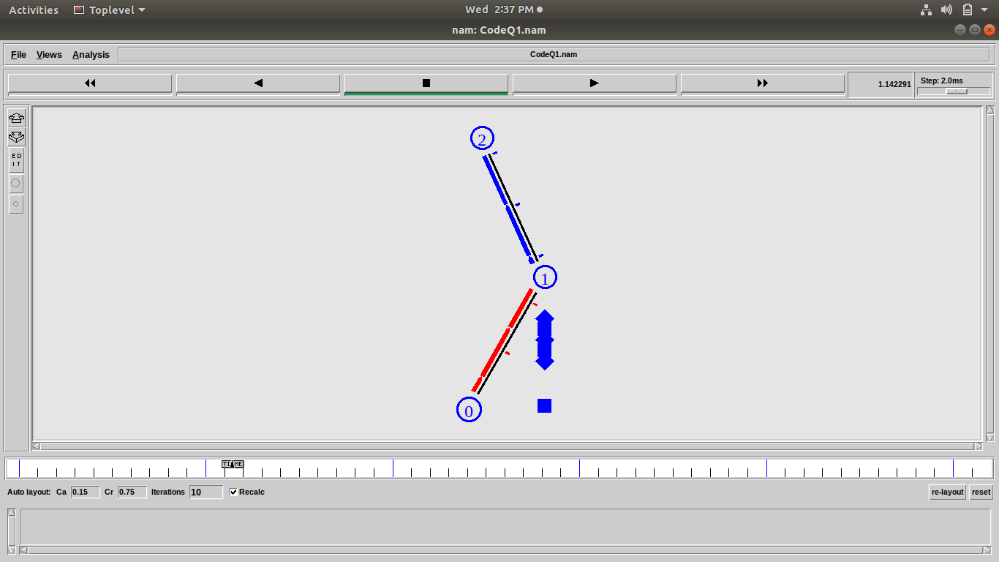
Screenshots :-

Variation of drops with Bandwidth of link 2-3 :-
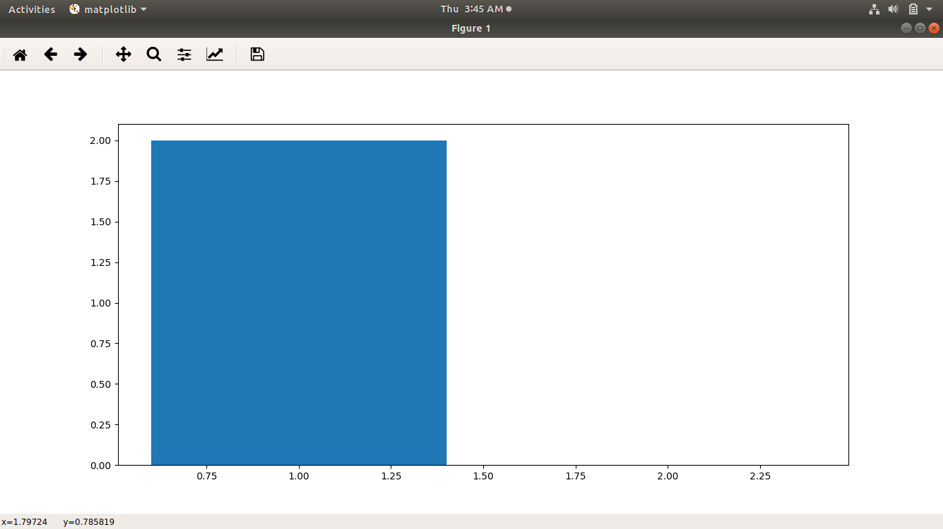

Variation of drops with Queue length of link 2-3 :-
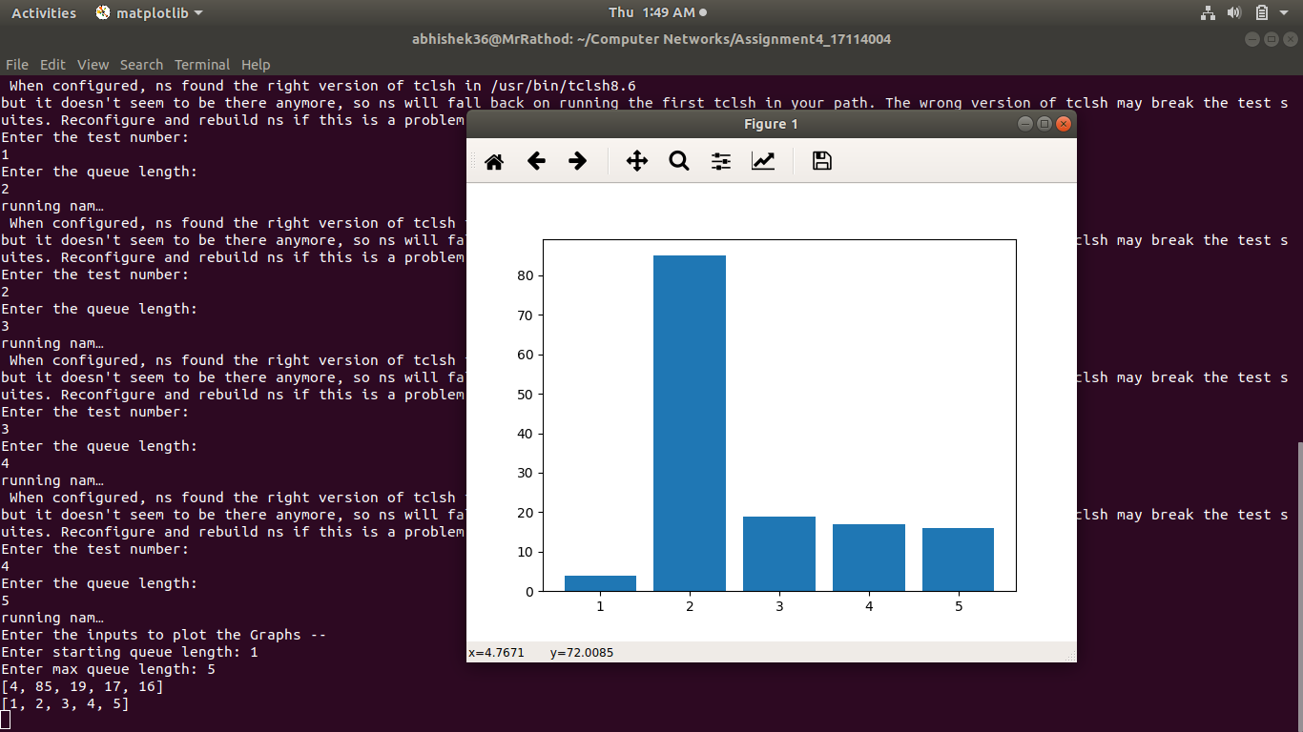

Data structures used :-

ns2-Simulator class:
It provides a set of interfaces for configuring a simulation and for choosing the type of event scheduler used to drive the simulation. A simulation script generally begins by creating an instance of this class and calling various methods to create nodes, topologies, and configure other aspects of the simulation.

TCP agents:
There are two major types of TCP agents: one-way agents (used here) and a two-way agent. One-way agents are further subdivided into a set of TCP senders which obey different congestion and error control techniques and receivers or sinks.

CBR:
Constant bit rate[CBR] is used along with TCP and UDP to design the traffic source behavior of packets. Traffic modeling is one of the major parameter in Ns2, which uses CBR along with transport protocols.

Question 2: Write a Network Simulator (NS2) code to simulate the transmission of ping messages over a network topology consisting of 6 nodes and find the number of packets dropped due to congestion. Study the variation in number of packets dropped with the variation of the queue size in the nodes and with the variation of the bandwidth of the links.

Algorithm used:- We created an architecture of 6 nodes which are connected to each other like : 0-2, 1-2, 2-3, 3-4 and 3-5. Here, we pass ping messages of various packet sizes, from 0-4 and then from 5-1. We observe the changes in the drops as we vary the bandwidth and the queue lengths of each link in the architecture. I attatched ping agents to each of the node and specified their packet size. Then connected the ping agents which will act as endpoints in the communication of our messages. Then according to the user input the number of ping packets will be transmitted to the respective nodes. We will take all the bandwidths as well as the queue lengths as parameters from the user.
In the tcl file, we will also store the inputs given by the user in a separate param file.
We have a python script file which will make the tcl file to run and then after that will copy the contents of the bandwidth and the queue lengths into the list and then will analyze the trace files. Here, making a graph is too complex as we have 12 paramters and analayzing a graph of that dimnesion is difficult. So, instead we have made a table using plotly python library, that will display the the number of drops as we change the values of bandwidths and queue lengths.

Screenshots-
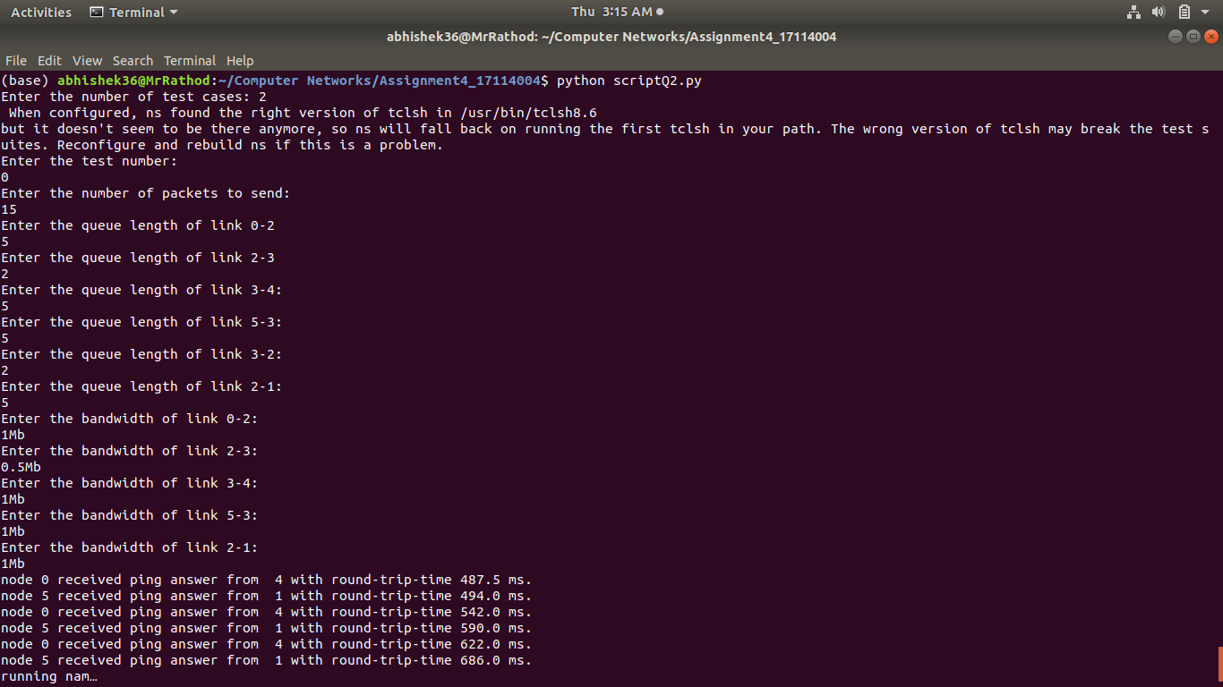
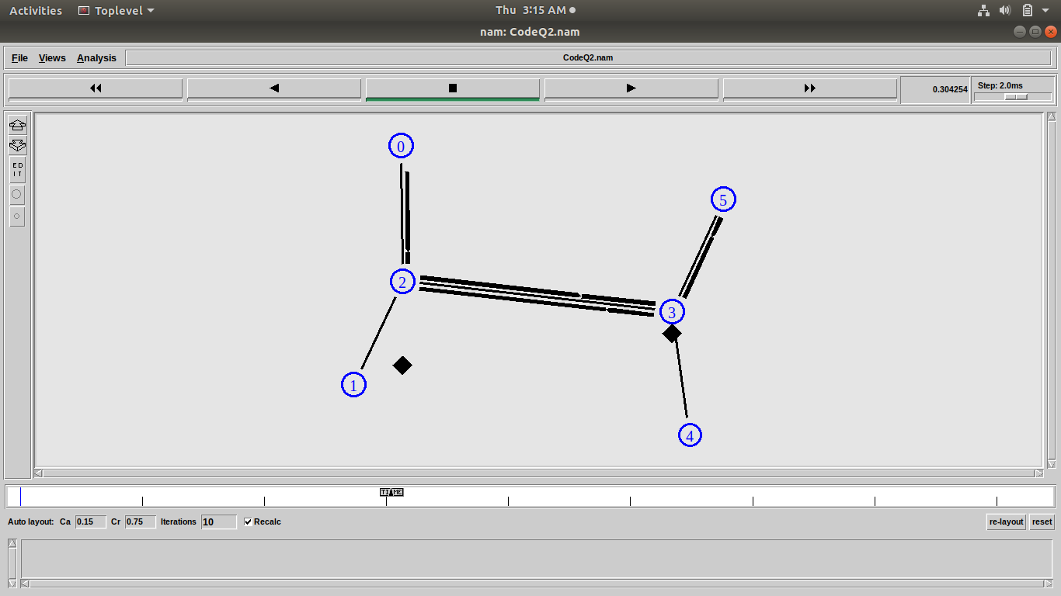

Table formed after giving in 2 test cases :-
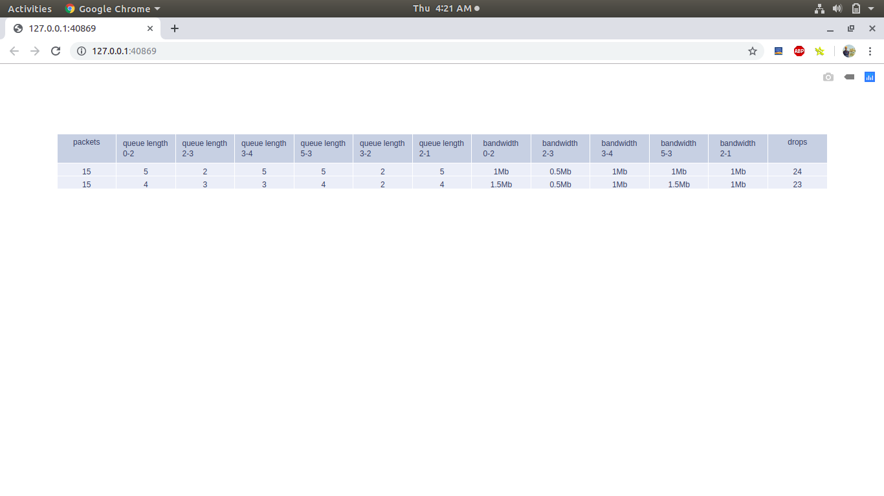

Data structures used :

ns2-Simulator class:
It provides a set of interfaces for configuring a simulation and for choosing the type of event scheduler used to drive the simulation. A simulation script generally begins by creating an instance of this class and calling various methods to create nodes, topologies, and configure other aspects of the simulation.

Ping Agent:
Ping is a basic Internet program that allows a user to verify that a particular IP address exists and can accept requests. Ping is used diagnostically to ensure that a host computer the user is trying to reach is actually operating. Ping works by sending an Internet Control Message Protocol (ICMP) Echo Request to a specified interface on the network and waiting for a reply. Ping can be used for troubleshooting to test connectivity and determine response time.

Recv():
The function 'recv()' defines the actions to be taken when a packet is received. Here it is used to print the ping message that the ping message is recieved in how much round trip time.

