COMPUTER NETWORKS
LABORATORY

ASSIGNMENT 3

NAME: Abhishek Rathod
ENR. NO. : 17114004 BATCH: CS1

Q.1) Write a socket program in C to determine class, Network and Host ID of an IPv4 address.

Algorithms :- Given a Ipv4 address, we made a function named findClass(), which on the basis of the integer value before its first decimal will find out the class of the Ipv4 address. Accrodingly, the rest of the part of the address will be divided into the network ID and the host ID on the basis of the class of the Ipv4 address.

Screenshots :-

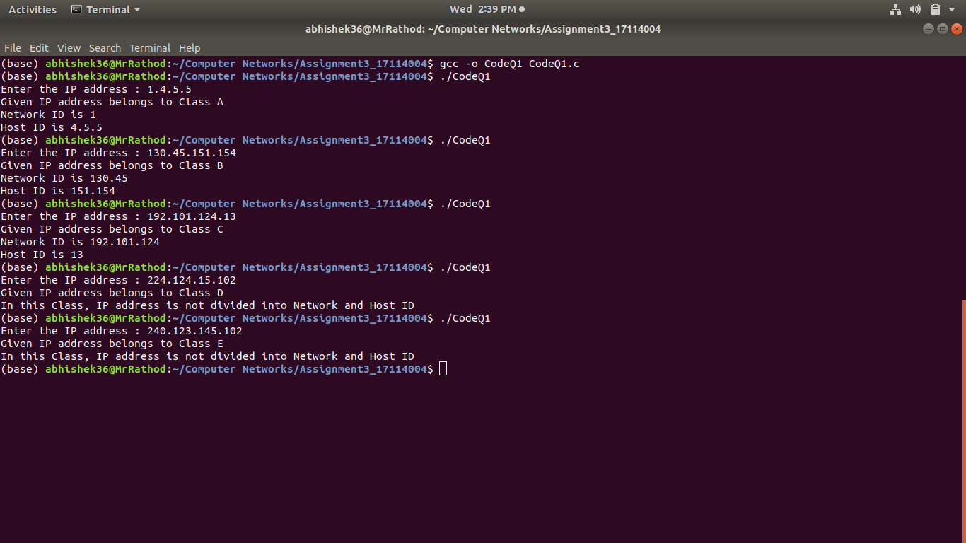

Data structures used :-
In particular, couple of character arrays were used. No other data structure was required.

Question 2: Write a C program to demonstrate File Transfer using UDP.

Algorithm used:- Created a server and a client in order to transfer data of a file from server to client. The client at first will request to the server by sending the name of the file. The server will then check if the file is present or not. If present the server will send the contents to the client. The contents of the file recieved will be then displayed on the client terminal.

Screenshots-

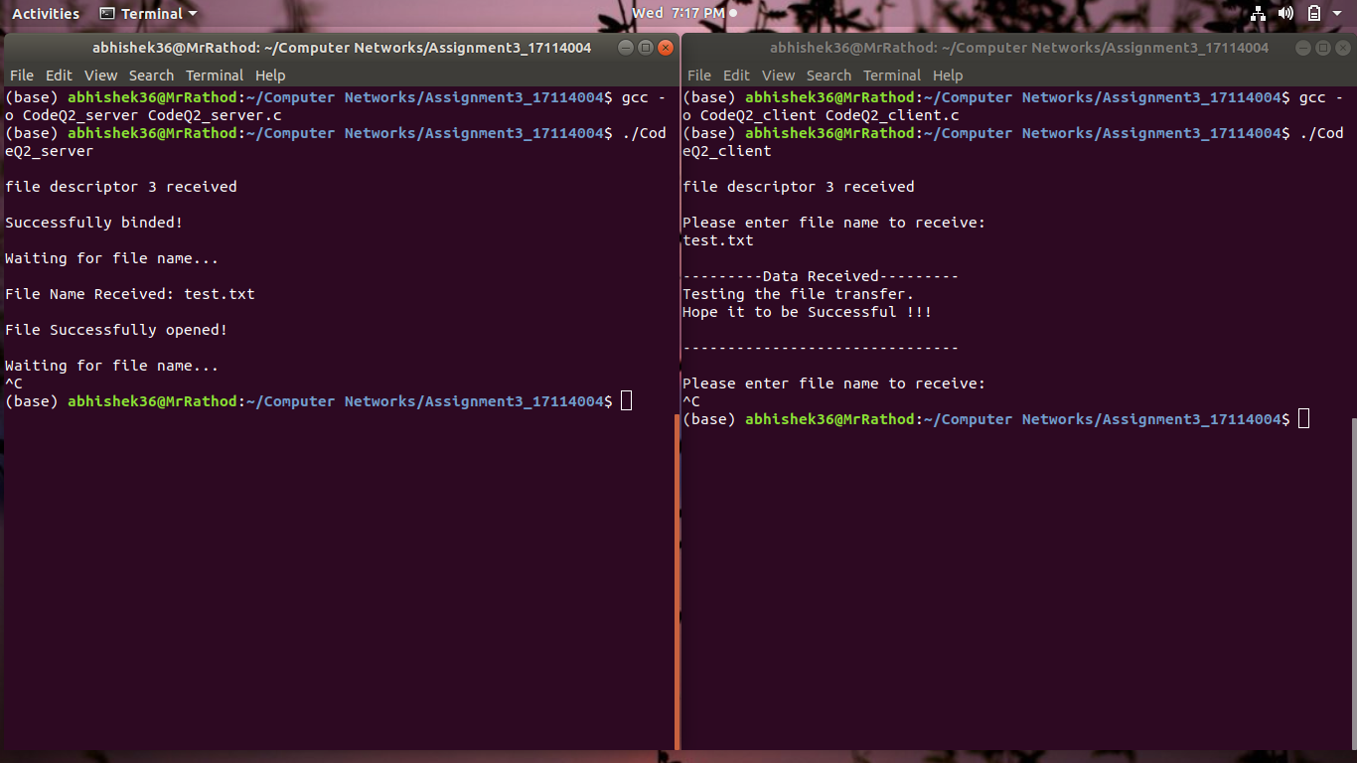

Data structures used :

Socket creation:
sockfd: socket descriptor, an integer
struct sockaddr_in : structure to store internet addresses like IP address, port.

Bind:
int bind(int sockfd, const struct sockaddr *addr, socklen_t addrlen);
bind function binds the socket to the address and port number specified in addr.

Recvfrom:
int recvfrom(int socket, char *buffer, int length, int flags, struct sockaddr *address, int *address_length) ;
The recvfrom() function recieves data on a socket named by descriptor socket and stores it in a buffer. The recvfrom() function applies to any datagram socket, whether connected or unconnected.

Sendto:
int sendto(int socket, char *buffer, int length, int flags, struct sockaddr *address, int adddress_len) ;
The sendto() function sends data on the socket with descriptor socket. The sendto() call applies to either connected or unconnected sockets.

Question 3: Write a TCL code for network simulator NS2 to demonstrate the star topology among a set of computer nodes. Given N nodes, one node will be assigned as the central node and the other nodes will be connected to it to form the star. You have to set up a TCP connection between k pairs of nodes and demonstrate the packet transfer between them using Network Animator (NAM). Use File Transfer protocol (FTP) for the same. Each link should have different color of packets to differentiate the packets transferred between each pair of nodes. The program should take the number of nodes (N) as input followed by k pairs of nodes.

Algorithm used:- There are nodes in a network which are connected to each other following the star topology. Each node is connected to another node through a router/switch(central node). The number of nodes in the network are taken as user input. Also, the nodes which are connected are taken by the user. There are different shapes and colors for the nodes (for the central node and other nodes). Then connections are made among the given nodes using the duplex-link. Then for data transfer, TCP agents are attatched to nodes, in which one node is the sink node and another is source node. Then FTP’s are attatched to all the TCP agents. Then, the start and the end time for data transfer between nodes are mentioned. At last, the finish procedure runs which executes the program and then exits.

Screenshots-
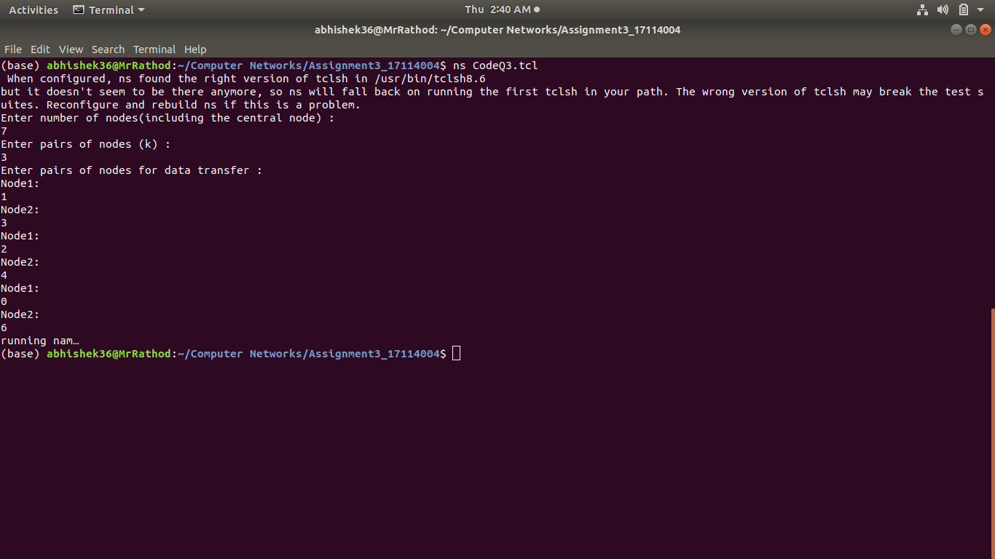
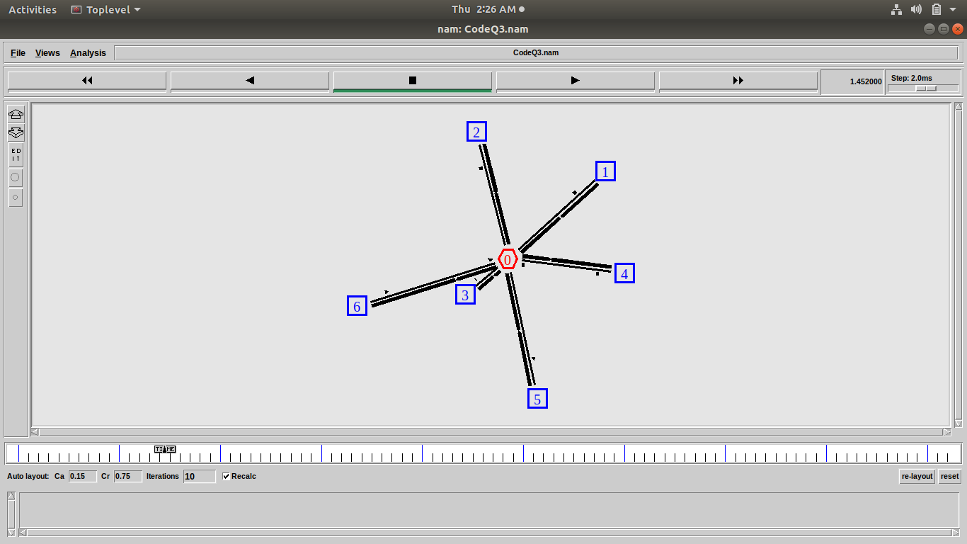
Data structures used :

ns2-Simulator class:
It provides a set of interfaces for configuring a simulation and for choosing the type of event scheduler used to drive the simulation. A simulation script generally begins by creating an instance of this class and calling various methods to create nodes, topologies, and configure other aspects of the simulation.

TCP agents:
There are two major types of TCP agents: one-way agents (used here) and a two-way agent. One-way agents are further subdivided into a set of TCP senders which obey different congestion and error control techniques and receivers or sinks.

FTP:
FTP is an application (and protocol) used for file transfer. It uses TCP for transport.

Question 4:Write a TCL code for network simulator NS2 to demonstrate the ring topology among a set of computer nodes. Given N nodes, each node will be connected to two other nodes in the form of a ring. You have to set up a TCP connection between k pairs of nodes and demonstrate packet transfer between them using Network Animator (NAM). Use File Transfer protocol (FTP) for the same. Each link should have different color of packets to differentiate the packets transferred between each pair of nodes. The program should take the number of nodes (N) as input followed by k pairs of nodes.

Algorithm used:- There are nodes in a network which are connected to each other following the ring topology. Each node is connected to its adjacent nodes directly. The number of nodes in the network are taken as user input. Also, the nodes which are connected are taken by the user. All the nodes have the same shape. Then connections are made among the given nodes using the duplex-link. Then for data transfer, TCP agents are attatched to nodes, in which one node is the sink node and another is source node. Then FTP’s are attatched to all the TCP agents. Then, the start and the end time for data transfer between nodes are mentioned. At last, the finish procedure runs which executes the program and then exits.

Screenshots-

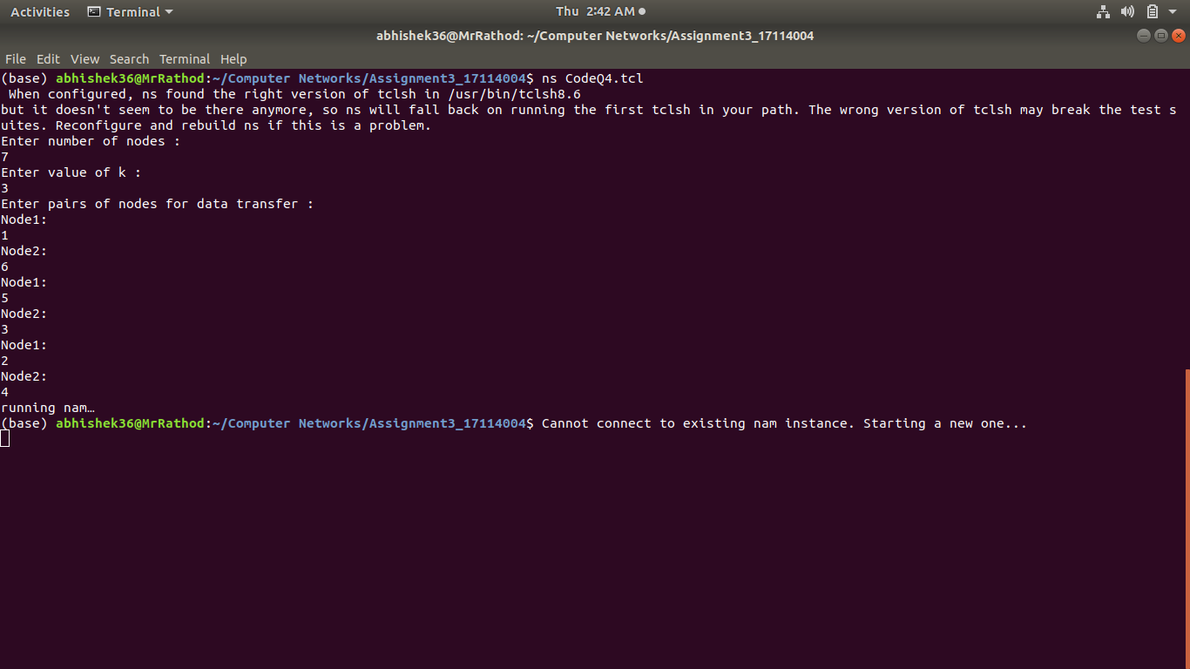
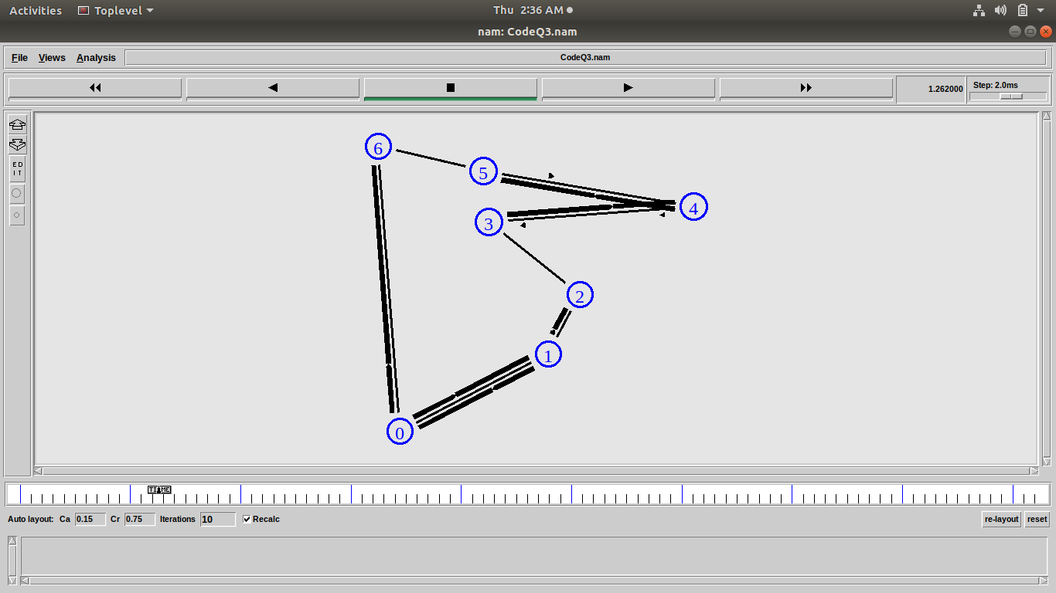

Data Structures Used :

ns2-Simulator class:
It provides a set of interfaces for configuring a simulation and for choosing the type of event scheduler used to drive the simulation. A simulation script generally begins by creating an instance of this class and calling various methods to create nodes, topologies, and configure other aspects of the simulation.

TCP agents:
There are two major types of TCP agents: one-way agents (used here) and a two-way agent. One-way agents are further subdivided into a set of TCP senders which obey different congestion and error control techniques and receivers or sinks.

FTP:
FTP is an application (and protocol) used for file transfer. It uses TCP for transport.

Question 5:Write a TCL code for network simulator NS2 to demonstrate the bus topology among a set of computer nodes. Given N nodes, each node will be connected to a common link. You have to set up a TCP connection between k pairs of nodes and demonstrate packet transfer between them using Network Animator (NAM). Use File Transfer protocol (FTP) for the same. Each link should have different color of packets to differentiate the packets transferred between each pair of nodes. The program should take the number of nodes (N) as input followed by k pairs of nodes.

Algorithm used:- There are nodes in a network which are connected to each other following the bus topology. Each node is connected to a common line to all the nodes on the network. The number of nodes in the network are taken as user input. Also, the nodes which are connected are taken by the user. All the nodes have the same shape. Then connections are made among the given nodes using the duplex-link. Then for data transfer, TCP agents are attatched to nodes, in which one node is the sink node and another is source node. Then FTP’s are attatched to all the TCP agents. Then, the start and the end time for data transfer between nodes are mentioned. At last, the finish procedure runs which executes the program and then exits.

Screenshots-
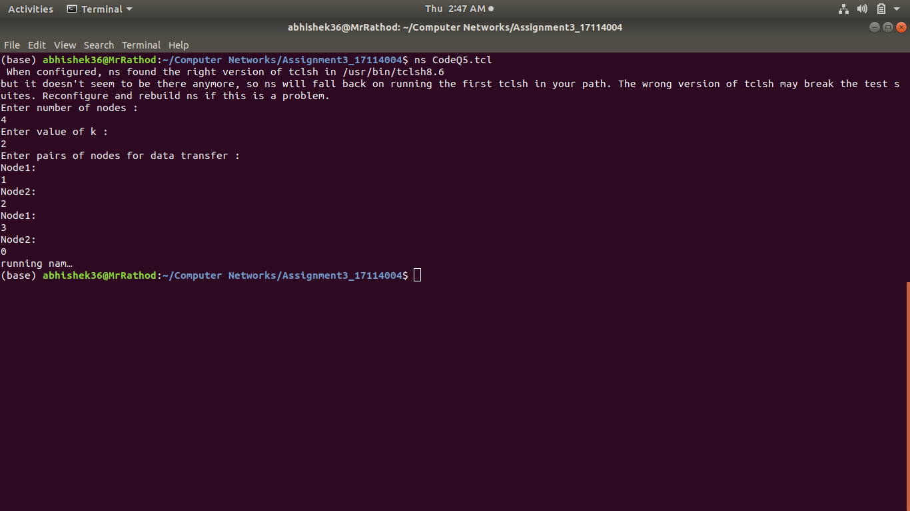

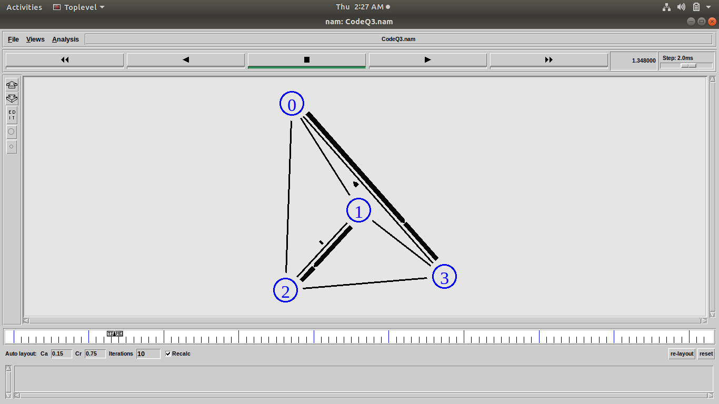

Data Structures Used :

ns2-Simulator class:
It provides a set of interfaces for configuring a simulation and for choosing the type of event scheduler used to drive the simulation. A simulation script generally begins by creating an instance of this class and calling various methods to create nodes, topologies, and configure other aspects of the simulation.

TCP agents:
There are two major types of TCP agents: one-way agents (used here) and a two-way agent. One-way agents are further subdivided into a set of TCP senders which obey different congestion and error control techniques and receivers or sinks.

FTP:
FTP is an application (and protocol) used for file transfer. It uses TCP for transport.

