Date : 05/08/2021

Given Task : Build Basic Website using HTML

1. Home Page
2. About Us Page
3. Contact Us Page
4. Education Details

Time duration : 2 Days

My Task Description :Completed work of Today

1. Home page (Used div tag for header, body. Links set for profile information, Used CSS for better UI)
2. About Us page (Detailing of about me)
3. Education Details page show details in table form.
4. Contact Us Page mention Address and my Social media platforms

ScreenShots of Output :

1. Home Page

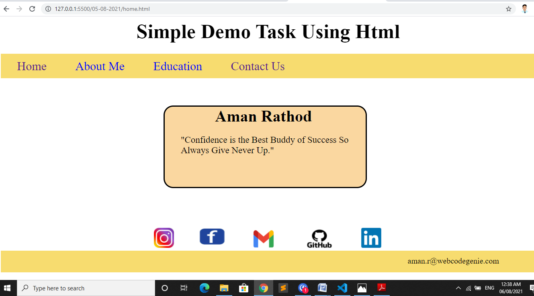

1. About Us Page

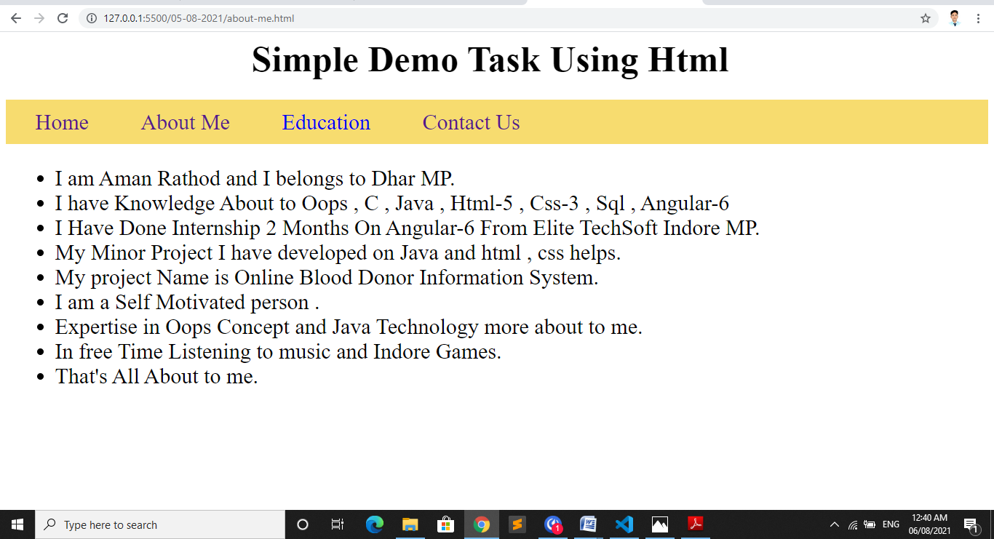

1. Education

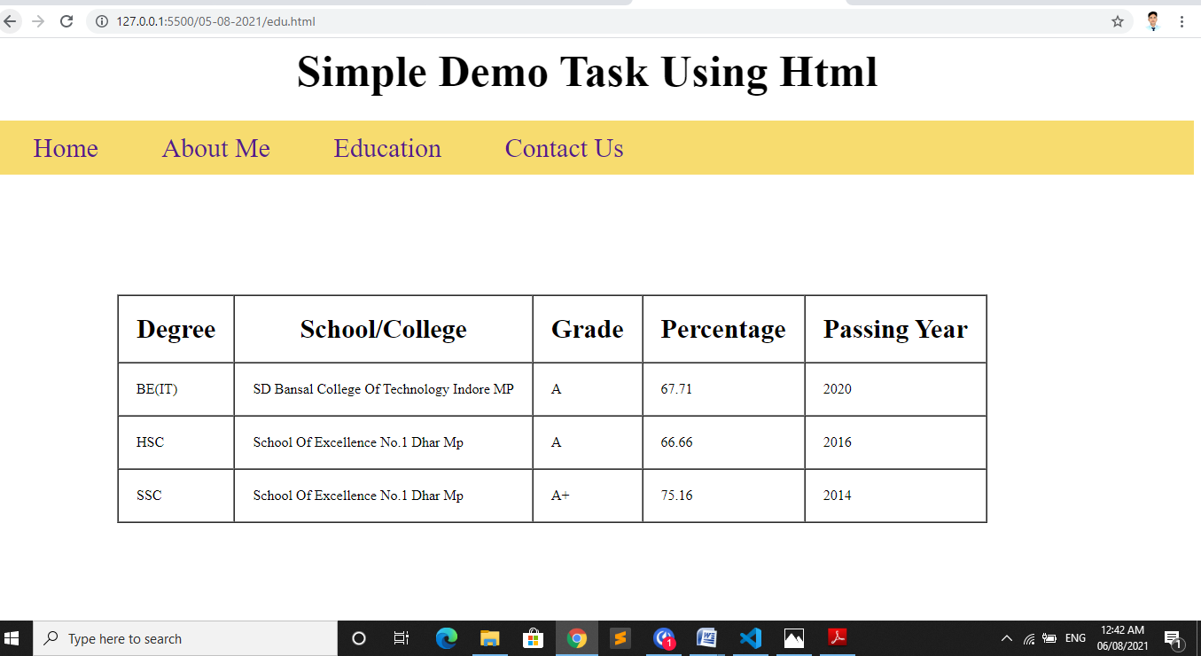

1. Contact us page

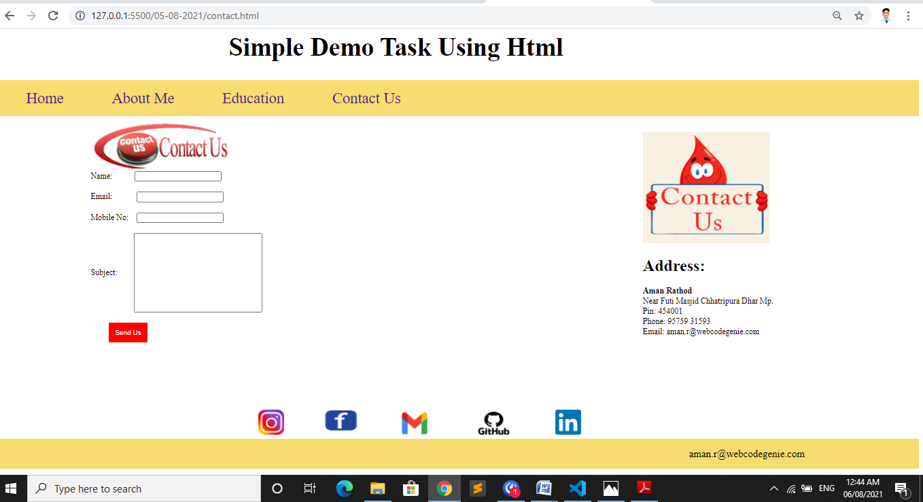

And this is basic tags use output:-

