Date: 06/Aug/2021

Task: To Design The HTML Registration Page

Given Task:- Design The HTML Registration Page using Formats, Tags etc

.

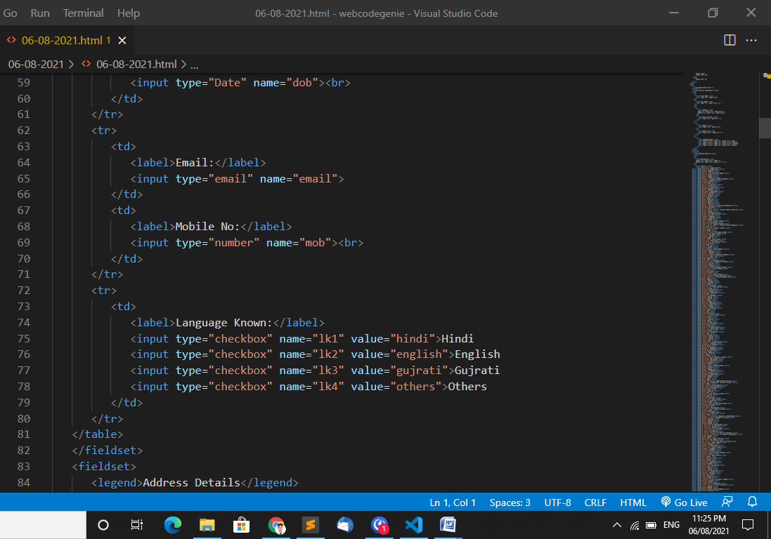

Output:

