Prof.V.B.Shah Institute of Management & R.V.Patel College of Commerce
(Eng.Med.) & V.L.Shah College of Commerce (Guj.Med.) &
Sutex Bank College of Computer Applications & Science, Amroli
(Accredited ‘B’ (CGPA 2.55) by NAAC Dec.-2009)
VEER NARMAD SOUTH GUJARAT UNIVERSITY, SURAT



PROJECT REPORT
ON
Metics

SUBMITTED BY: GUIDED BY:
440-Rathod Chirag Jivanbhai Mr. Ashish Solanki
478-Chauhan Haresh Mukeshbhai
419-Madaviya Viral Bhuptbhai

no | Content | Page no.
1 | Introduction | 1
2 | System analysis | 10
3 | System flow diagram | 15
4 | Data flow diagram | 17
5 | Er diagram | 20
6 | Database design | 21
7 | System design | 24
8 | References | 31

Index


1.introduction

  - Project Description
Metics Shopping Platform is an online cosmetics shopping website that allows users to browse, select, and purchase beauty and personal care products conveniently from anywhere at any time. The platform eliminates the need to visit physical stores, thereby saving time and effort.
Metics Shopping Platform is designed to offer a smooth and user-friendly experience with features like product search, category filtering, shopping cart, and order tracking.

- Metics consists of two panels:
      - User Panel
      - Admin Panel

- User Panel

- User registration and login Browse products

- Add/remove items from cart (/cart)

- Place and view orders (/order)

- Admin Panel

- Manage users and sellers

- Monitor all products and orders Control

- platform-level operations

- Contact Module (/contacts)

- Collect and manage customer inquiries and feedback
Key Features:-
- Role-based routing and access control
- RESTful API simulation using JSON Server
- Component-based architecture with
Angular .
- Dynamic data handling using
- Simple and fast backend setup for development/testing

This project is designed as a lightweight and efficient e-commerce prototype, focusing on frontend development and API integration. It can be further extended by replacing JSON Server with a real backend (Node.js/Express) and adding features like payment gateways, authentication security, and performance optimizations.

User Authentication & Profiles:

- User Registration & Login: Users visit the e-commerce platform and must register/login to access personalized shopping features and history.

- Secure Access: Users cannot manage a persistent cart or view past order histories without being securely logged in and authenticated.

- Comprehensive Digital Profile: The user dashboard provides a clean history of account details, allowing users to update their credentials and view their basic information.

- Role Management: The system differentiates between standard registered users and guest users, applying appropriate access controls for checkout and browsing.

Catalog & Product Discovery:

- Dynamic Product Grid: The homepage features a responsive grid layout automatically populated with electronics (mobiles, cameras, watches, buds) currently available in the database.

- High-Quality Visuals: Each product is presented in an interactive card format containing the title, price, category, and a clear product image.

- Real-Time Category Filtering: The system automatically categorizes items, allowing users to easily filter the database to view specific product types like "sport" or "home" electronics.

- Seamless Navigation: Product cards act as direct portals; users can click on any active item to proceed to the detailed product specification page.

- Detailed Product Header: Selecting a product displays a high-impact header featuring the full description, price, and category data fetched dynamica.

Cart Management:

- Interactive Cart Review: The platform features a visual list of selected items, clearly displaying the product name, image, and price, allowing users to review before checkout .

- Visual Cart Cues: The UI uses clear indicators to show which items have been successfully linked to the user's productId and readies them for the final order.

- Seamless Checkout Path: Once selections are finalized, a prominent "Proceed to Checkout" button triggers the order flow, passing the cart data to the order system

Checkout & Order Processing:

- Integrated Checkout Form: The checkout module collects comprehensive shipping details, including fname, lname, address, city, state, zip, and phone.

- Dynamic Total Calculation: The system finalizes the total_amount (e.g., ₹1600) based on the cart array and applies any active new_offer codes submitted by the user.

- Secure Transaction Logging: Every successful checkout creates a permanent record in the Order Collection, storing the unique order ID and an array of purchased product

Vendor Management:

- Localized Vendor Directory: The system stores profiles for partner sellers (e.g., "NewCart"), including their specific contact email and phone number.

- Integrated Inventory Flow: Sellers have unique IDs that are directly tied to the products they upload, creating a strict relational link between the vendor and their catalog.

- Identity Maintenance: The interface maintains the seller's storeName and brand identity, ensuring accountability for the electronics listed on the platform.

Platform Oversight:

- Centralized System Control: The Admin dashboard serves as a highly secure, restricted access point where administrators can log in to oversee total platform revenue, manage registered users, monitor all seller inventories, and review system-wide order transactions in realtime

Customer Support:

- Direct Communication Channel: A dedicated interface allowing users and guests to submit messages, feedback, or support queries directly to the platform administrators.

- Structured Query Logging: The system securely captures the user's name, email, user role, and their specific message, storing it in the database for review.

- Admin Resolution Tracking: Administrators can access these submitted forms through their dashboard to read user feedback and provide necessary customer service

1.3 Project Technology

Metics
Project title: | Metics
Frontend: | Angular,Html ,css ,Bootstrap5
Backend: | Node.Js, Express.js
Database | MongoDB
Browser and Emulator: | Chrome , FireFox , Microsoft Edge
Platform: | VS Code
Documentation tool: | Draw.io , Ms World
Internal guide: | Mr. Ashish Solanki


2. system analysis

- User Registration & Login
- User visits the Metics Website.
- User Show shoping and men/women new Wear After Registration and login
- User Can login and Registered with add to cart Product

- User Flow Diagram:

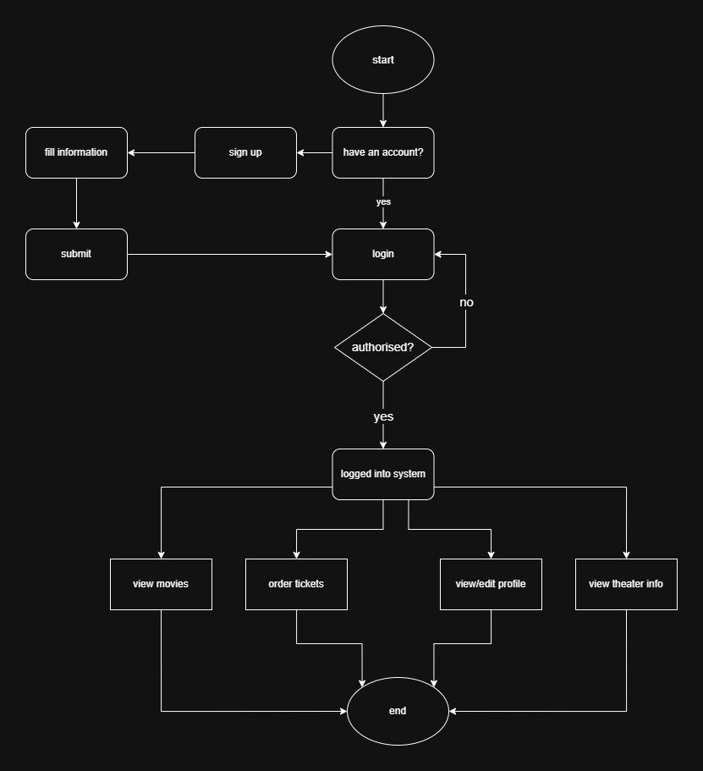

2. Admin Process Flow Diagram:
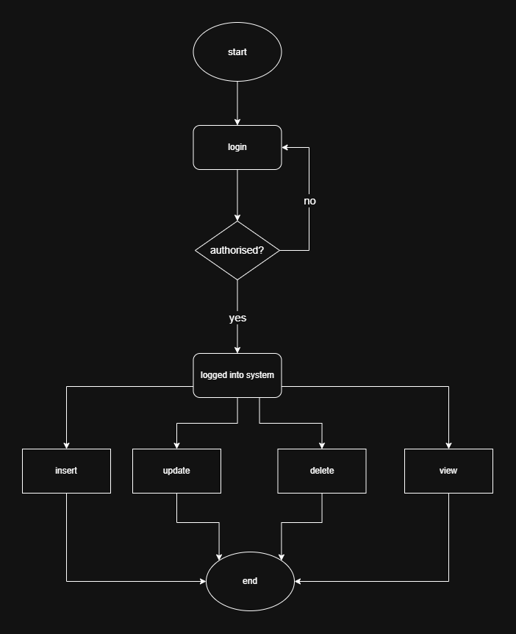

- Level 0 ( Context Diagram ):

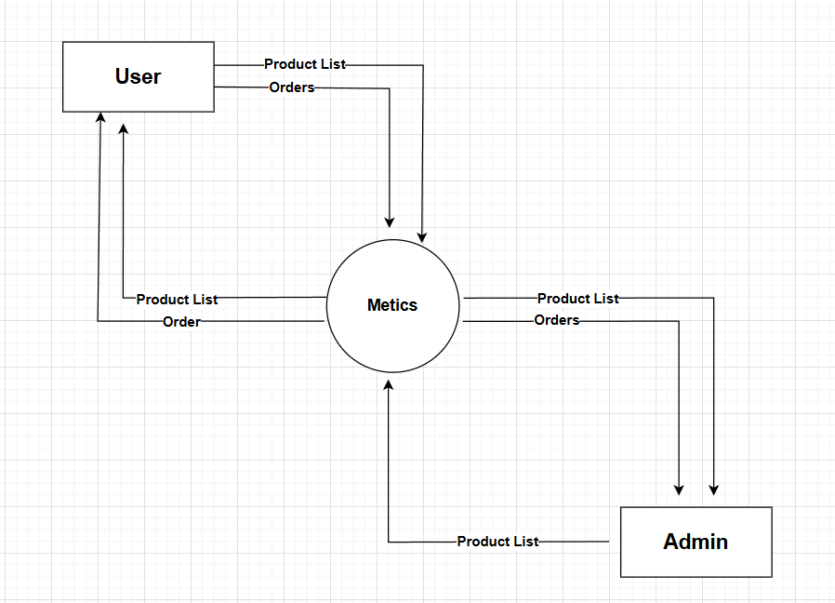

Level 1 (Admin):

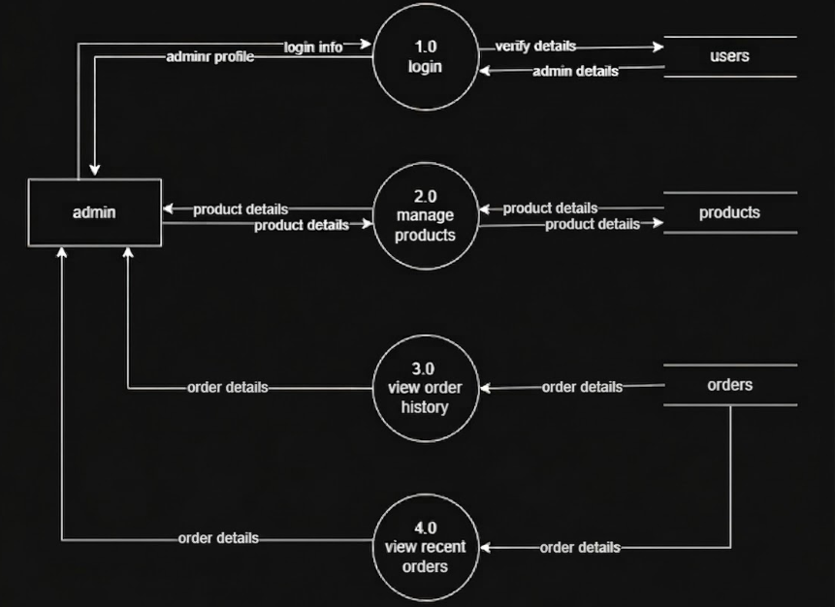

Level 1 (user):

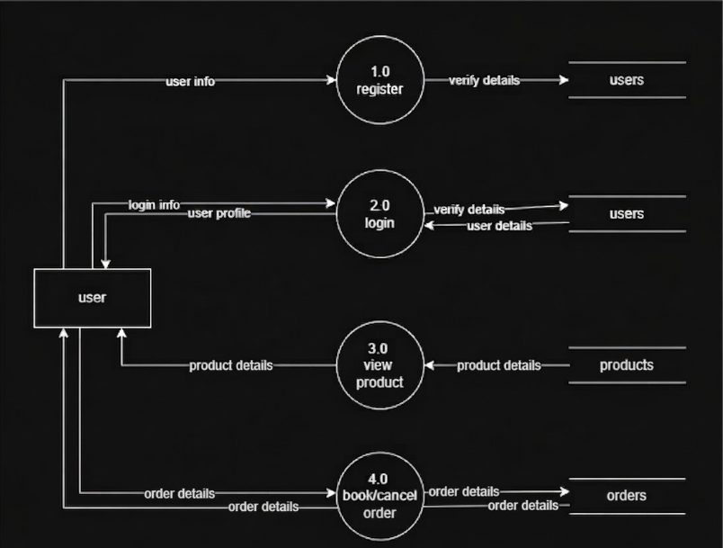

Er Diagram :

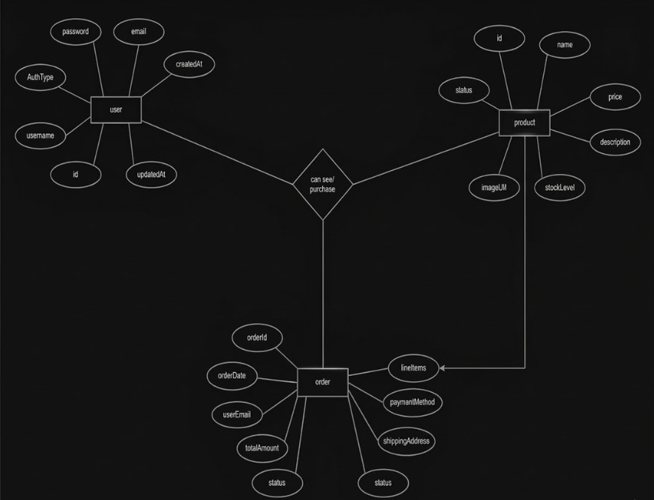


Database design

The e-commerce system database is designed using a document-based structure to manage different modules such as Seller, Product, User, Cart, Order, Admin, and Contact. Each module stores specific information and is interconnected to ensure smooth system functionality.

User Database:

{
"id": "58f0",
"name": "chirag",
"email": "chirag5555@gmail.com",
"password": "chirag@123"
}

Seller Database:

{
"id": "1348",
"name": "chirag Rathod",
"email": "chiragrathod5555@gmail.com",
"phone": "6354558278",
"storeName": "NewCart",
"storeAddress": "106,sarita socity,kapodra , surat- 395006",
"password": "chirag@123"
},

product Database:

{
"id": "2b16",
"name": "Boll",
"price": 1700,
"description": "wallyboll",
"category": "sport",
"image":"https://static.standard.co.uk/s3fspublic/thumbnails/i mage/2016/10/30/16/premier-league-winterfootball.jpg", "sellerId": "1348",
}

cart Database:

{
"id": "7b0d",
"name": "Ram Lala",
"price": 3000,
"description": "specially made using high quality material .",
"category": "home ",
"image":"https://i.pinimg.com/originals/4e/b1/a6/4eb1a6366d1a544d754c4ead3 3de2f70.jpg",
"productId": "6f08", "userId":101,
}

Order Database:

{ "id": "b95d",
"email": "yas@gmail.com",
"address": "Ak road",

"apartment": "",
"city": "surat",
"state": "guharat",
"phone": "08160082638",
"fname": "Himmat",
"lname": "hirabag",
"zip": "395010",
"new_offer": "",
"save_data": "",
"products": [ "chess" ],
"total_amount": 1600,
"order_date": "2026-01-13T12:08:36.959Z", "status": "Order Done"
},

The database design ensures proper organization of data across different modules of the e-commerce system. Each entity is interconnected to support key functionalities such as product management, cart handling, order processing, and user interaction. The structure is scalable and can be enhanced with additional features like payment integration, product reviews, a

User Authenticaton:

- Signup
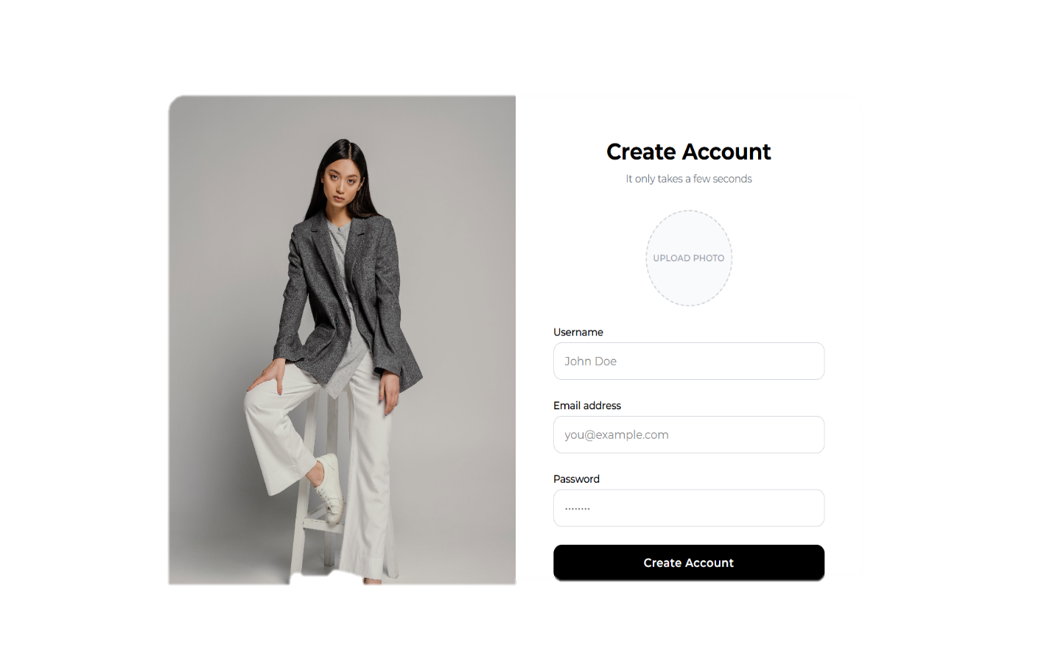

- User Login Page :

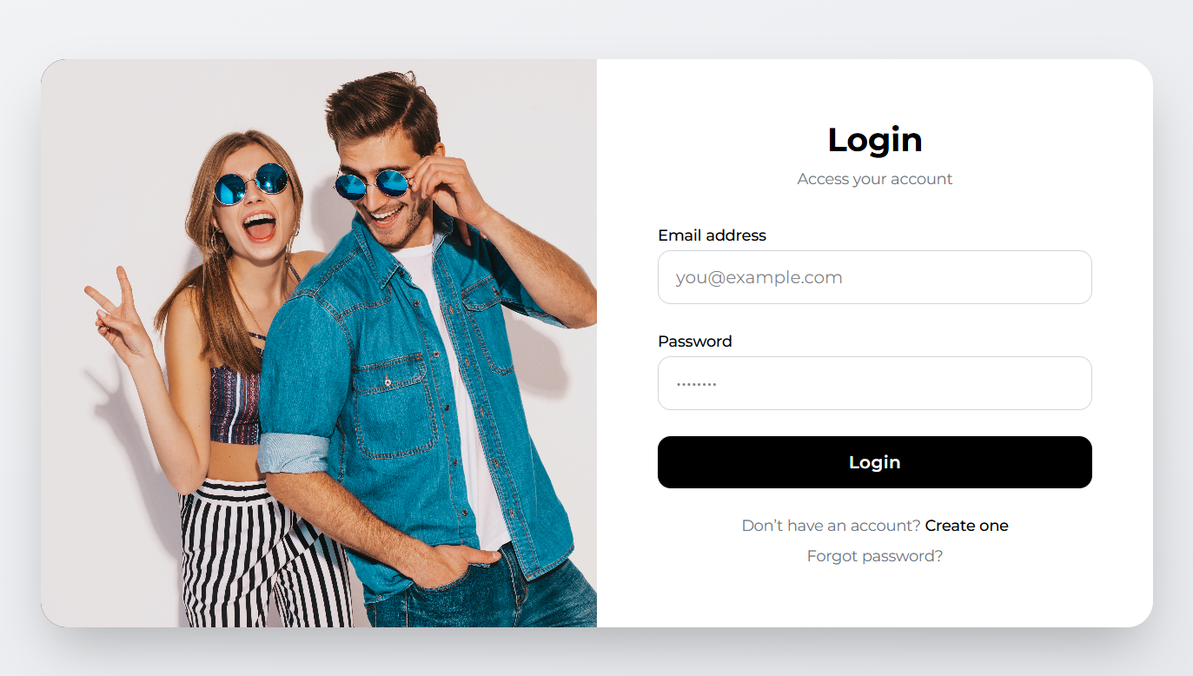

User Profile:
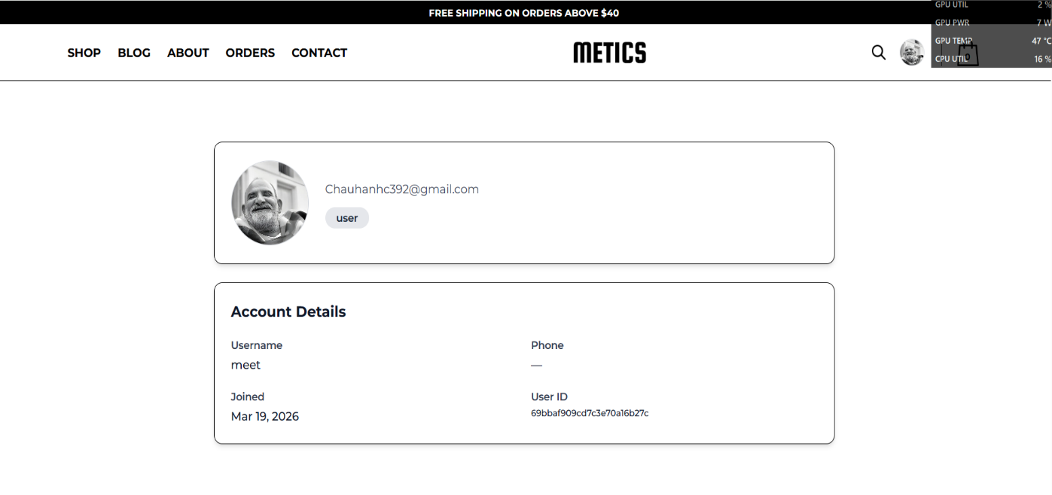
- User Home Page
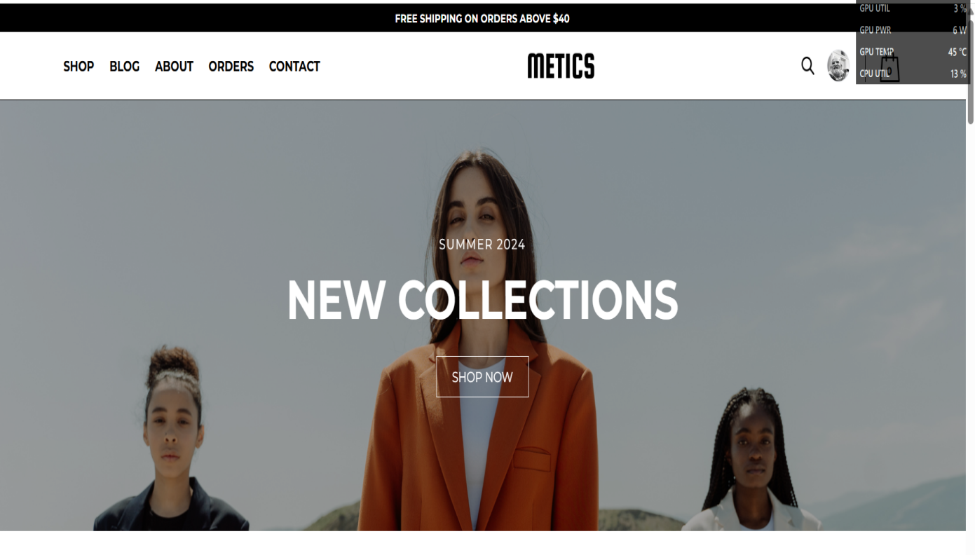

- All Product


- Time Select page(View Details)

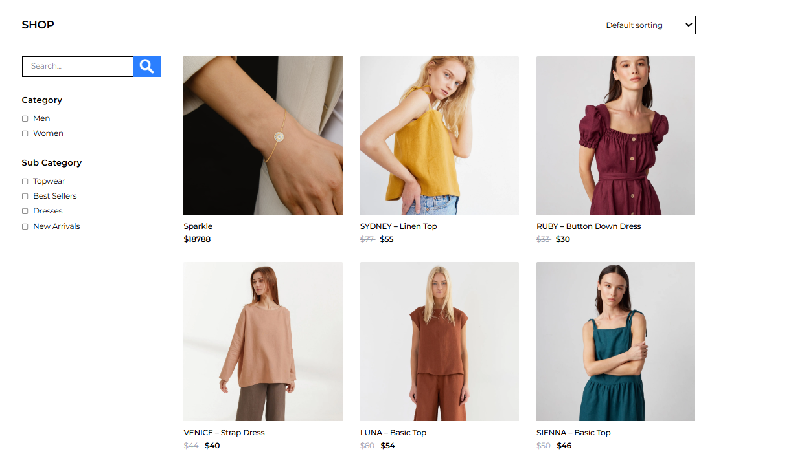

Seat Select page(Book)

Blog Page :


1. User Cart & Checkout Page
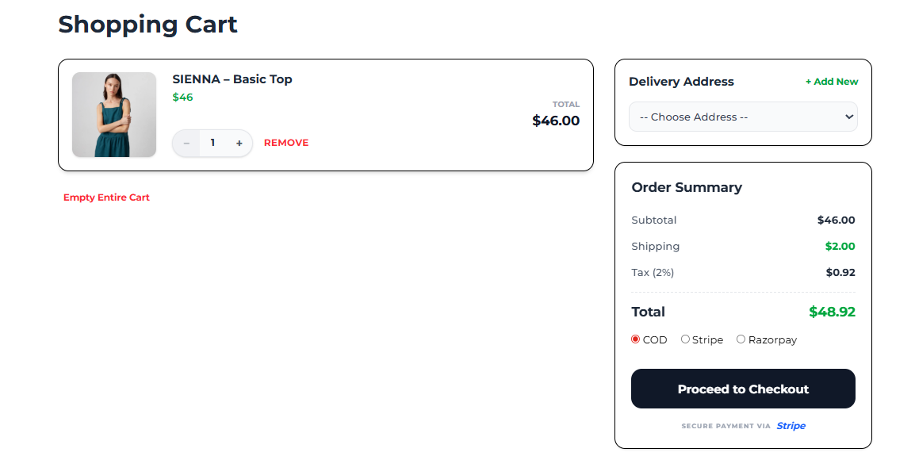

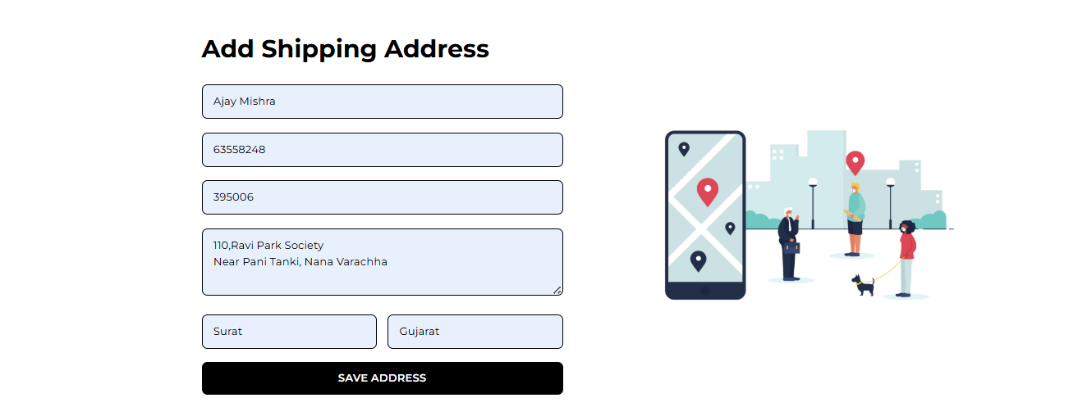
- Releases page
---

- Admin Add Product:

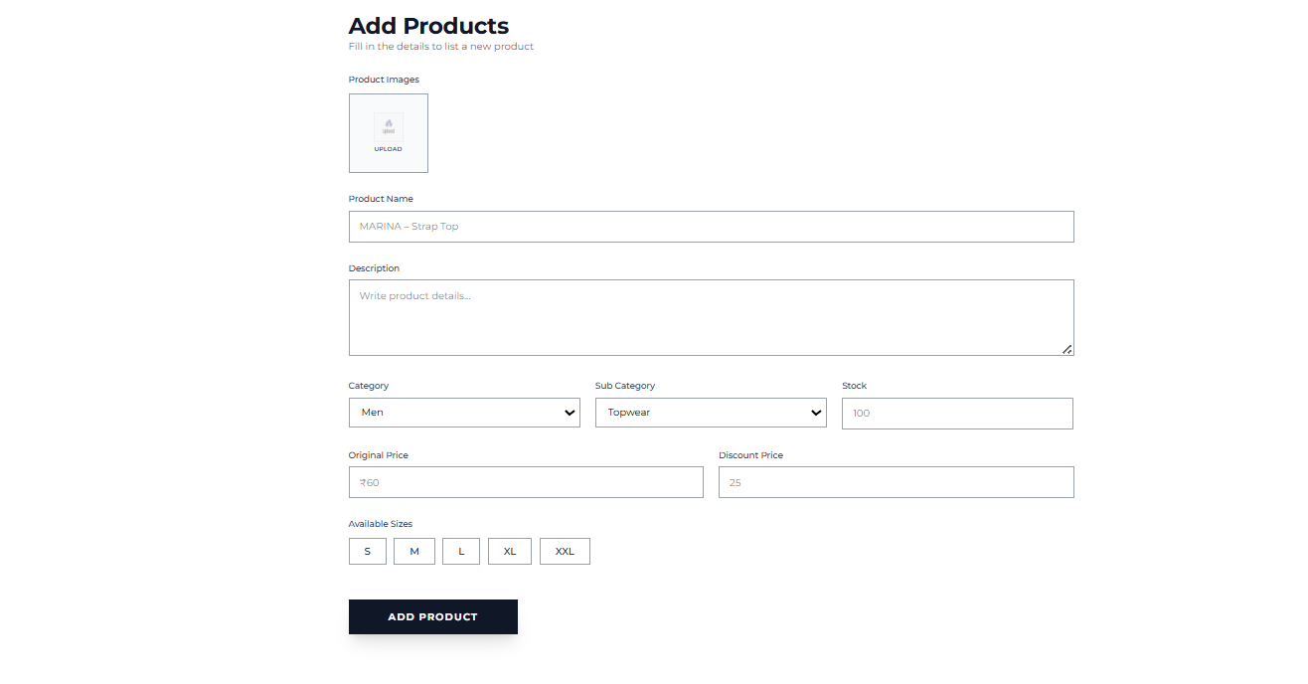

- Admin Product List:


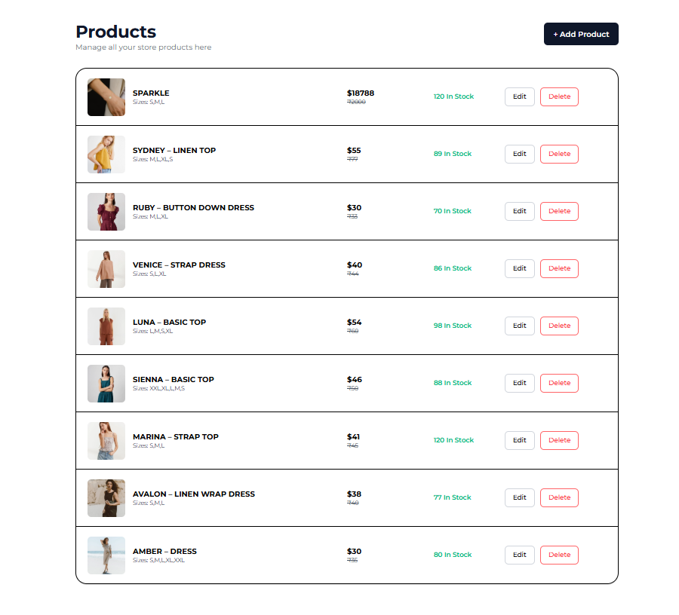


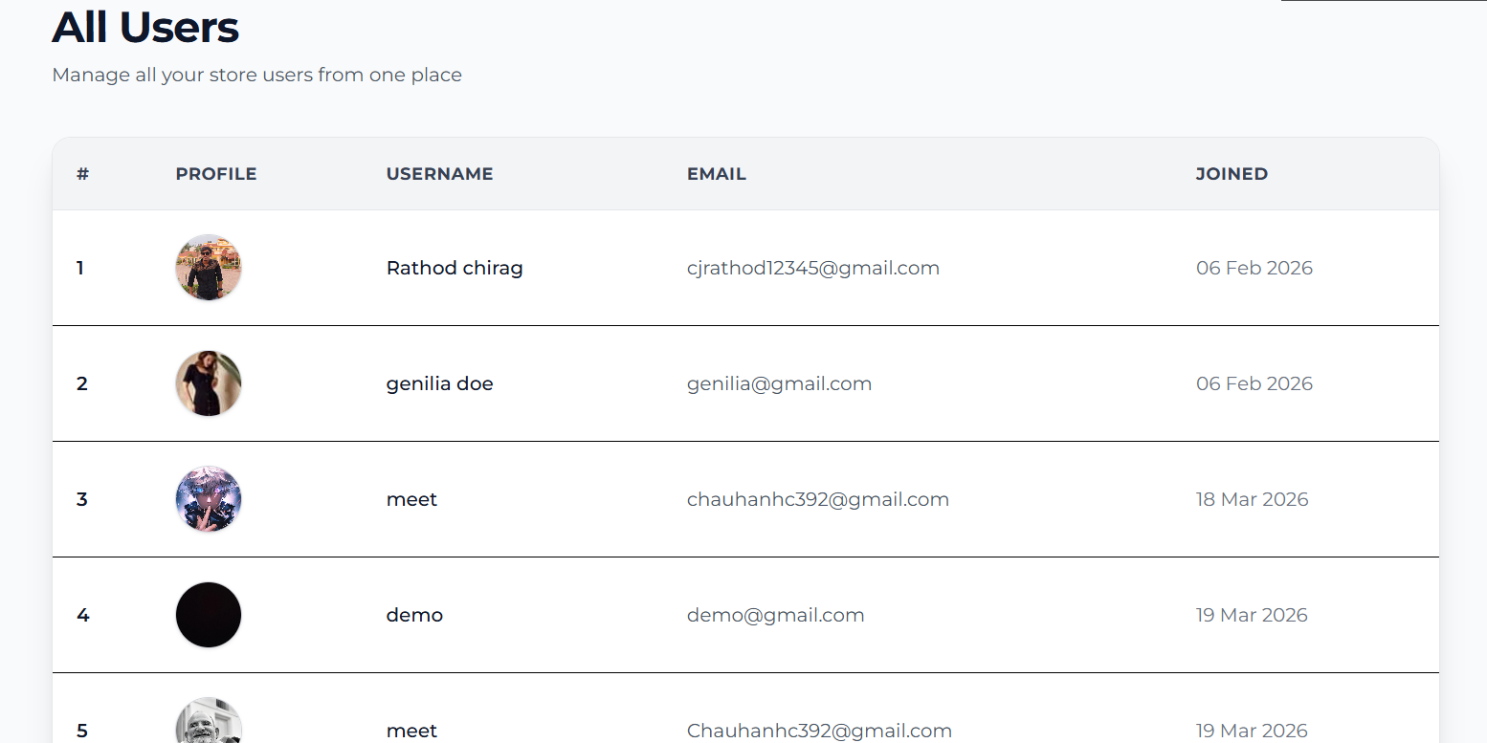

Admin Mangement Order :

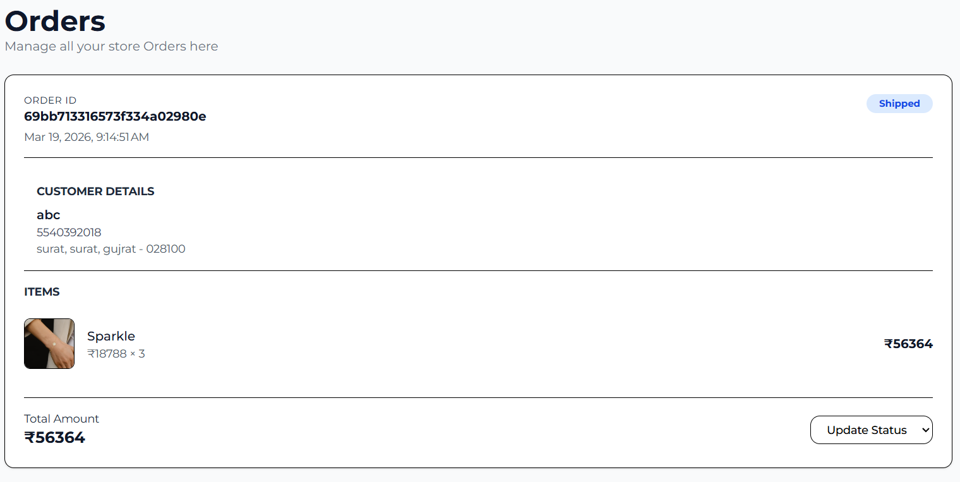



8. References

  - https://openai.com
  - https://youtube.com

  - https://angular.dev/learn
  - https://w3school/css
  - htttps://gemini.google.com/

